The curvature effect:
a comparison between preference tasks.
Letizia Palumbo and Marco Bertamini
Department of Psychological Sciences, University of Liverpool, UK

l.palumbo@liverpool.ac.uk
m.bertamini@liverpool.ac.uk

Correspondence:
Letizia Palumbo
Department of Psychological Sciences, University of Liverpool
Eleanor Rathbone Building
Bedford Street South
L69 7ZA, Liverpool, UK
Fax: +44 1517942172
l.palumbo@liverpool.ac.uk

Abstract

Empirical work on visual aesthetics has found a strong preference for smooth curvature. The use of different tasks and exposures can clarify whether such a preference reflects immediate visual responses or higher cognitive processes, such as semantic associations. In three experiments we used abstract irregular shapes and manipulated the contour (polygons vs. smoothed versions of polygons), but matched the stimuli for number of vertices (vertices or curvature extrema) and number of concavities. In Experiment 1 a shape was presented for 120ms and observers produced a 2-alternative forced-choice response (like or dislike). In Experiment 2 and 3 we used rating scales measuring liking and attractiveness respectively, and the stimulus was presented until response. Overall smooth curved contours were preferred over angular contours, especially with immediate responses (Experiment 1). Moreover, shapes were preferred when contained a balance between number of vertices and concavities (middle level of complexity). However, a preference for shapes with the highest number of vertices and the least number of concavities occurred in the two-alternative forced choices task (Experiment 1). In contrast, the reverse combination (star-like shapes) emerged with rating scales (Experiment 2 and 3). We conclude that the curvature effect is stable across tasks, although some parametric variations (vertices and concavities) related to visual complexity introduced subtle modulations.

Keywords: shape-contour effect, forced choice responses, rating scale, preference formation, aesthetics.

- Introduction

It has been suggested that smoothly curved contours contain something special that is processed as pleasant. We refer to this phenomenon as the smooth curvature effect on preference (Bertamini, Palumbo, Gheorghes, and Galatsidas, 2015). Although it is still debated what makes curvature special, these findings confirm Hogarth’s analysis (1973) of the curved lines as an expression of grace and beauty. In this study we employed abstract irregular polygons with different contours (more angular vs. curved), but matched in other aspects. Previous work used rating scales for explicit liking (Bertamini et al., 2015) as well as implicit indirect measures of preference, such as the Implicit Association Test and the Manikin task (Palumbo, Ruta, and Bertamini, submitted). The main outcomes from these studies are summarized in 4 points: (1) observers tend to like curvature, either when it forms the contour of an abstract shape or as an element embedded within a pattern of lines; (2) preference for curvature is present relative to angular lines, but also relative to straight lines; (3) observers show an approach response to curved shapes and not an avoidance of angular shapes; (4) preference for curvature is not directly linked to visual complexity (obtained by varying the number of vertices).
Taken together these findings are in contrast with the hypothesis that angles convey a sense of threat due to their spiky transitions and as a consequence observers tend to dislike them (Bar and Neta, 2006; 2007). The threat hypothesis for angular stimuli is supported by fMRI data showing a bilateral activation of the amygdala (Bar and Neta; 2007; Larson, Aronoff, and Stearns, 2007; Larson, Aronoff, Sarinopoulos, and Zhu, 2009), which in addition to the processing of positive emotions is also involved in the processing of fear (Ledoux, 2003; Morris, Ohman, and Dolan, 1999). In their study Bar and Neta (2006) used meaningful stimuli as well as abstract shapes. They presented the stimulus for a brief duration (85ms) and used a two-forced choice response (“like” or “dislike”). The rational was that this paradigm is appropriate to capture immediate responses in preference formation, namely responses which are not mediated by higher cognitive processes. Therefore, although participants attended to the stimulus presentation, they were not necessarily aware of how the features of the stimulus influenced their impression. In this case preference would be directly instantiated by low-level sensory information (Bar, 2003). They interpreted the dislike response for angularity as an immediate “aversive” reaction to the angles as potential “dangerous” stimuli.
More recently Vartanian et al. (2013) reported a curvature effect using a two-alternative forced-choice task with fMRI. Observers were asked to judge whether curvilinear or rectilinear architectural environments were ‘“beautiful” or “not beautiful”. The advantage for curvature was confirmed with ecologically-valid stimuli from architecture and design. Moreover, the authors found activation of the anterior cingulate cortex, which is typically involved in the processing of emotional aspects of stimuli and reward. The effect of curvature in interior design applies also to cars (Leder and Carbon, 2005) and across the last two decades car design has moved towards more curvilinear appearance. However, in the Vartanian’s study the stimuli were presented for a long duration (3sec). Therefore it is difficult to ascribe such as a preference solely to the visual properties of the stimuli. In the study by Leder and Carbon (2005) observers judged attractiveness using a rating scale.
So far the results on the curvature effect were obtained with different class of stimuli and with different procedures. The main focus of the present work was to compare the use of a two-alternative forced-choice response (“like” or “dislike”) with the use of rating scales to measure preference for the same abstract shapes. The aim is to disentangle the role played by immediate visual responses and by higher cognitive processes in preference formation.

The current study: preference for curvature comparing different tasks
In the current study the curvature effect was tested using abstract irregular shapes, which varied in terms of contour (angular vs. curved), but were matched for number of vertices and concavities. We used abstract stimuli because they minimise the role of valance, familiarity or semantic meaning (see Leder, Tinio, and Bar 2011). Three experiments were performed: in Experiment 1 the shape was presented for 120ms and observers performed a forced-choice response (like or dislike). In Experiment 2 and 3 we used rating scales measuring liking and attractiveness respectively, and the stimulus was presented until response. This comparison would inform whether these two concepts measure the same aesthetic dimension. For instance, attractiveness also defined as “appealing to the senses” might be associated to arousal or arousing interest in aesthetics (Berlyne, 1974).
There were two research aims. The first aim was to compare the curvature effect using the same stimuli but three different tasks. This will test the robustness of the effect and also whether the same parameters affect all types of responses. Bertamini et al. (2015; see also Palumbo et al., submitted) found a preference for curvature using explicit (rating scales) and implicit (indirect measure of preference) measures. They concluded that this effect did not derive from a dislike for angularity. We reasoned that liking should increase for shapes with a “blobby” appearance (i.e. fewer vertices or concavities). Conversely, liking should decrease for shapes with a “spikier” appearance (i.e. more vertices or concavities). However, if a modulation of the number of vertices or concavities occurs only for curved shapes then this would strengthen the claim that smooth curvature is preferred because it is visually pleasant.
The second research question relates to visual complexity. Different number of vertices and concavities affect visual complexity and complexity can modulate aesthetic evaluations (Nadal, Munar, Marty, and Cela-Conde, 2010). Typically observers prefer low/middle levels of visual complexity when this concerns details, amount of information to process or arousal (Berlyne, 1970; 1974), especially for naïve observers (Silvia and Barona, 2009). A recent study by Friedenberg and Bertamini (2015) showed that irregular polygons with more concavities were rated as more attractive. This result suggests a preference for greater complexity but the polygons used were extremely simple.
To our knowledge, this is the first attempt to study the curvature effect by comparing different explicit responses. This is important to understand the underlying processes of preference formation. Moreover, it has relevant implications for the empirical study of the Art as similar processes are likely to apply to other aesthetics dimensions.

Experiment 1. Curved or angular shapes: thumbs up or thumbs down?

In Experiment 1 we tested immediate liking responses. Each shape was flashed on the screen for 120ms. Participants indicated if they liked the shape or if they disliked it by pressing one of two buttons. A specific feature of this study is that we varied the number of vertices so that for each contour type (curved or angular) there were three sets of vertices (10, 20 and 30). Moreover, for each set the relative percentage of convexities and concavities was varied. Concavities were 30%, 40% or 50%. For instance for 30 vertices the concavities were either 9, 12, or 15. Therefore, depending on the combination of numbers of vertices and concavities the shapes were more angular or rounded. We formulated two predictions.
We reasoned that if the curvature is preferred for its configuration then we expect the number of liking responses to increase for shapes with a “blobby” appearance (i.e. fewer vertices and fewer concavities), especially if the combination of vertices and concavities would only modulate the liking response for smooth curvature. An alternative prediction is based on visual complexity. In line with a recent study using polygons we expected that the most preferred shapes would be those with more concavities (Friedenberg and Bertamini, 2015).

Method
Participants. Twenty-four participants took part in the experiment (age range: 19 – 23, average age 19.9 years, 19 females; 4 left handed). All participants had normal or corrected to normal vision. They provided a written consent for taking part and received course credits. The experiment was approved by the Ethics Committee of the University of Liverpool and was conducted in accordance with the Declaration of Helsinki (2008).

Stimuli and apparatus. Stimuli consisted of irregular shapes with a black contour of 0.5 px and a grey fill. The outline could be curved or angular (straight edges). Stimuli and experiment were created using python and Psychopy (Peirce, 2007). The stimuli were generated starting from polygons that were based on sampling points along a function.
The Cassini oval was chosen as the starting function as in Bertamini et al. (2015). However the parameters chosen reduced this function to a circle. That means that points were selected at random from a circumference, but for every point the radius was chosen randomly between 110 (min) and 170 pixels (max). This procedure created unique polygons with a different number of vertices (10, 20 and 30). We controlled the number of concavities within each set of vertices. Specifically, shapes with 10 vertices contained 3, 4 or 5 concavities; shapes with 20 vertices contained 6, 8 or 9 concavities and finally shapes with 30 vertices contained 10, 12 or 15 concavities. Because the increase in number of concavities is proportional to the number of vertices we can distinguish 3 levels of concavities across the three sets of vertices: 30%, 40% and 50%.
For each polygon a cubic spline generated a curve through the vertices thus transforming the angular vertices in their smoothed version. To exclude possible effects of memory and familiarity each trial used a different stimulus. Participants sat at approximately 60cm from the screen. Stimuli were presented on a CTX Vl 950T 19" CRT monitor (1600 X 1200 at 75Hz).

Figure 1. Experiment 1: Examples of the stimuli. These are chosen to illustrate the conditions, in the experiment each trial presented a different shape. Panel A: Angular polygons with Vertices (10, 20, 30) and Concavity (30%, 40%, 50%). Panel B: Curved polygons with Vertices (10, 20, 30) and Concavity (30%, 40%, 50%).

Procedure. A 2x3x3 within-subjects design was employed with Contour (angular vs. curved), Vertex (10 vs. 20 vs. 30) and Concavity (30%, 40%, 50%) as the within-subjects factors.
Each trial started with a fixation cross which was presented at the centre of the screen for 500ms. The shape was presented for 120ms, and masked by a grey rectangle that covered the whole shape for 120ms. As soon as the shape disappeared participants needed to indicate whether they liked or disliked it (see figure 2). Half of participants pressed key “A” for liking and key “L” for disliking on a keyboard. The response mapping was reversed for the other half of the sample. Participants were instructed to give the response as fast as possible. The experiment started with a practice block (8 trials) followed by 162 experimental trials randomized within one block. The experiment took 15 minutes to complete.
Figure 2. Experiment 1: The structure of a trial.

Data analysis
The data were analyzed with a repeated measures ANOVA. The dependent variable was the proportion of liking responses out of the total amount of responses (like/like + dislike). The Greenhouse-Geisser correction was applied if sphericity was not assumed.

Results
Results are illustrated in Figure 3. The ANOVA confirmed a main effect of Contour (F(1, 23) = 47.94, p= .000 η_{p}² = .676), meaning that the proportion of liking responses was higher for curved shapes (M=.74, SD=.04) as compared to angular ones (M=.31, SD=.04). All the other main effects were not significant.
Importantly, the interaction Contour by Vertex was statistically significant (F(2, 46)=7.02, p=.002 η_{p}² =.234). Post-hoc analyses revealed that the curved shape with 10 vertices were preferred over those with 20 or 30 vertices (10 vs. 20: t(1,23)=3.19, p=.004; 10 vs. 30: t(1,23)=2.78, p=.01). Therefore, as predicted, for the curved shapes the majority of liking responses were found for the shapes with a more “blobby” appearance (10 vertices: M=.80, SD=.04; 20 vertices: M=.74 , SD=.04 ; 30 vertices: M=.67, SD=.05). Crucially, there was no modulation of the number of vertices on the liking response for the angular shapes (10 vertices: M=.31, SD=.05; 20 vertices: M=.29, SD=.04; 30 vertices: M=.33, SD=.05) (all ps>.05). This is visually illustrated in the heat map that shows changes of colour according to the distribution of the proportion of liking responses (Figure 3, panel B).
The two-way interaction of Vertices by Concavity was significant (F(2, 46)=3.77, p=.007 η_{p}² =.141). In both curved and angular conditions when the shapes contained 30 vertices observers preferred 30% as compared to 50% concavities (t(1,23)=2.21, p=.031). All other interactions were not significant. Finally it is worth to mention that responses (in sec) for the curved shapes (M=.51, SD=.18) were faster compared to responses for the angular shapes (M=.55, SD=.20) (t(1,23)=3.30, p=.003).

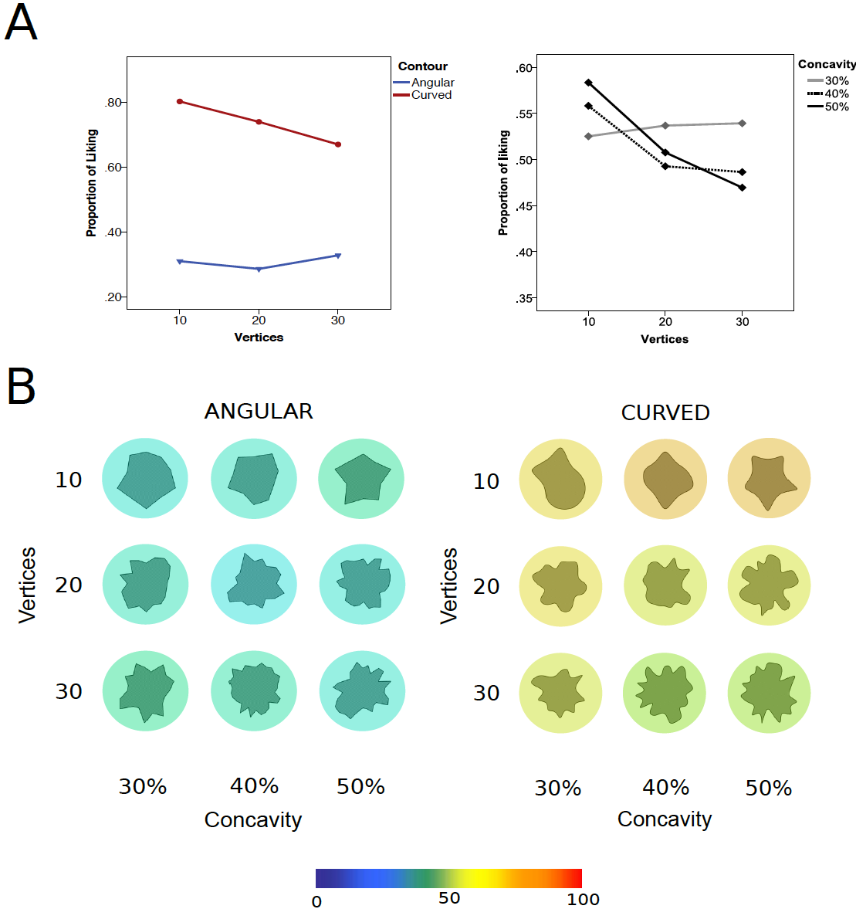
Figure 3. Results of Experiment 1. Results of Experiment 2. Panel A: Liking rating (y axis) as a function of vertices (10, 20, 30; x axis) and concavity (30%, 40%, 50%; separate lines). Panel B: the heat map illustrating the distribution of the liking responses across the stimuli (green: low proportion of liking responses, yellow: high proportion of liking responses).

Discussion
The use of a forced-choice procedure in Experiment 1 confirmed the well-established and systematic preference for curved shapes. In addition, the combination of different numbers of vertices and concavities revealed interesting interaction effects. The proportion of liking responses increased for the shapes with fewer vertices as compared to those with more vertices. This suggests that preference for curvature is related to the amount of smoothness in the shape. As predicted, the modulation of number of vertices only occurred for smooth curvature, in other words it did not influence preference for the angular shapes. This finding does not support the threat hypothesis related to angles (Bar and Neta, 2006; 2007). If angles signals a threat than this should be more evident with shapes containing more vertices (as they would appear spikier). The other interaction effect between vertices and concavities suggests that when shapes contain many vertices (and therefore are perceived as more complex, see Bertamini et al. 2015) observers tend to appreciate them more if they contain fewer concavities. In line with Berlyne’s model this result can be read as a tendency of the observers to prefer shapes with a balanced/middle level of complexity.

Experiment 2. Liking responses on the rating scale

In Experiment 2 we tested the same hypotheses using the same stimuli as for Experiment 1, but a different task. Here the shapes were displayed until participants provided a response on a scale ranging from 0=dislike to 100=like. The comparison between the two tasks is important. In a forced choice task the liking response is immediate and perhaps based on basic sensory information. In contrast the use of a rating scale could reflect a response mediated by higher order cognitive factors. We cannot exclude that these two ways of measuring preference might reveal some inconsistency, although we predict that differences will be small.

Method
Participants. Sixteen participants took part in the experiment (age range: 18 – 40, average age 20.8 years, 13 females; 2 left handed). All participants had normal or corrected to normal vision. They provided a written consent for taking part and received course credits. The experiment was approved by the Ethics Committee of the University of Liverpool and was conducted in accordance with the Declaration of Helsinki (2008).

Stimuli and apparatus. The stimuli and the apparatus were the same as for Experiment 1.

Experimental Design and Procedure. The experimental design was the same as for Experiment 1. Each trial started with a fixation cross which was presented at the centre of the screen for 500ms. Following the shape was displayed and remained on screen until participants expressed how much they liked the pattern using a rating scale (0=dislike to 100=like), see Figure 4. The experiment started with a practice block (8 trials) followed by 162 experimental trials randomized within one block. The experiment lasted 20 minutes.

Figure 4. Experiment 2: Illustration of the trial.

Data analysis
The data were analyzed with a repeated-measures ANOVA. The dependent variable was the mean ratings on the liking scale. The Greenhouse-Geisser correction was applied if sphericity was not assumed.

Results
Results on the liking ratings are illustrated in Figure 5. The ANOVA confirmed a main effect of Contour (F(1, 15) = 13.63, p= .002 η_{p}² = .476). Participants liked curved shapes (M=51.75, SD=2.42) more than angular shapes (M=37.75, SD=2.78). The effect of Concavity was also significant (F(1, 15) = 6.30, p= .005 η_{p}² = .296). Overall participants preferred shapes with more concavities (50%: M=47.15; SD=1.84) than those with fewer concavities (30%: M=42.58; SD=1.82). Finally the Vertices by Concavities interaction was also significant (F(4, 60) = 11.34, p= .000 η_{p}² = .431). In both curved and angular shapes with 10 vertices we found a linear effect of concavity. Observers preferred those with 50% concavity as compared to those with 30% (t(1,15)=-6.33, p=.000) and with 40% (t(1,15)=-6.50, p=.000). This pattern of results was only found with shapes containing the least number of vertices.

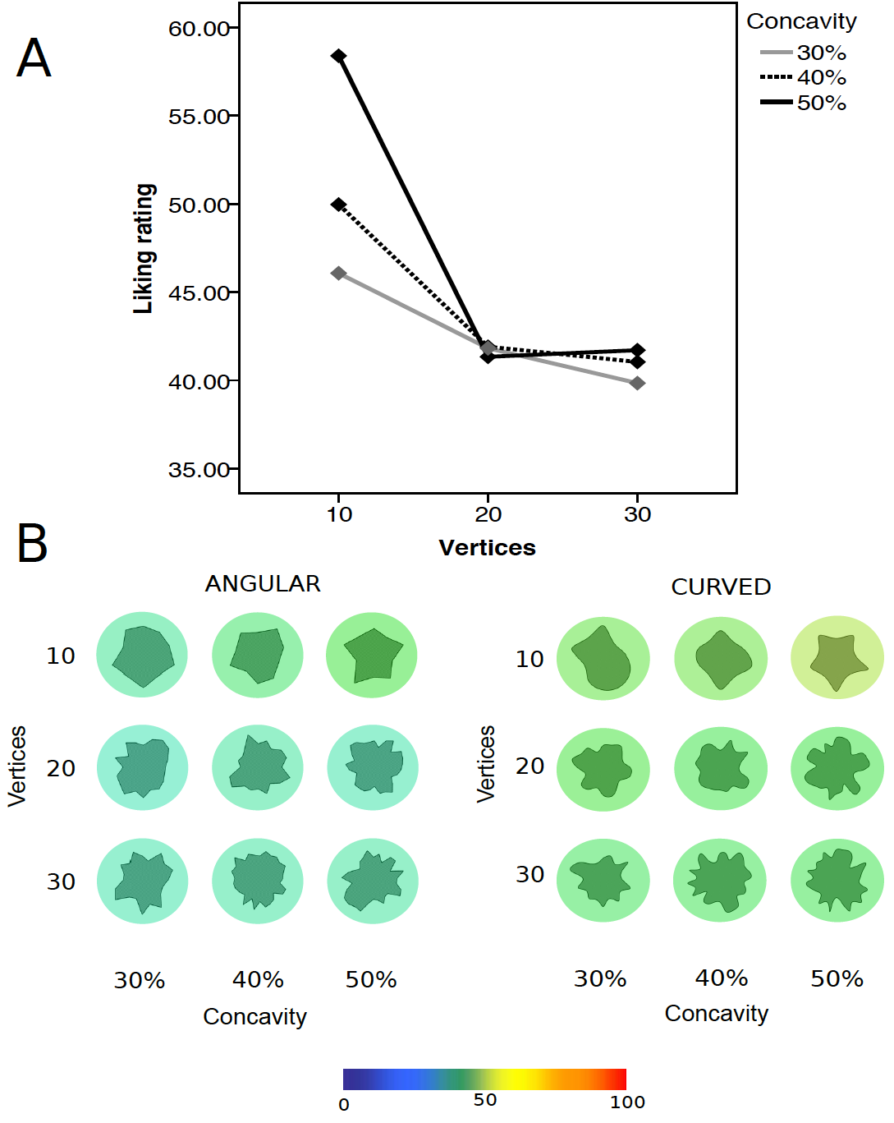
Figure 5. Results of Experiment 2. Panel A: Liking rating (y axis) as a function of vertices (10, 20, 30; x axis) and concavity (30%, 40%, 50%; separate lines). Panel B: the heat map illustrating the distribution of the liking responses across the stimuli (green: low liking ratings, yellow: high liking ratings).

Discussion
The results of Experiment 2 partially overlap those found in Experiment 1. The curvature effect was confirmed, although with the two-alternative forced-choice task (Experiment 1) the effect was stronger. Possible explanations are reported in the general discussion as they also apply to Experiment 3.
As in Experiment 1 the interaction of vertex by concavity was significant in Experiment 2. However, the direction of the effect is slightly different. In Experiment 2 the most preferred shapes were those with the least number of vertices (10) and the most number of concavities (50%). Looking at panel B in Figure 5, this cluster of shapes can be defined as “star-like” shapes (Friedenberg and Bertamini, 2015). In contrast, Experiment 1 showed a preference for shapes with the reverse vertices-concavity combination, although a (no-significant) tendency for a star-like effect was present also in Experiment 1 (see the heat map in Figure 3). Why did the star-like shape effect emerge more prominently in Experiment 2? It is possible that the number of vertices was not per se playing a major role in determining the liking rates. It seems that participants appreciated more subtle changes and differences conveyed by the concavity factor as reflected by the main effect of concavity, which was found only in Experiment 2.
- Overall in terms of visual complexity the results of the two experiments go hand in hand: observer preferred middle levels of complexity, whether this was generated by increasing the number of vertices (Experiment 1) or the number of concavities (Experiment 2).

Experiment 3. Attractiveness responses on the rating scale

In Experiment 3, all the parameters and stimuli were the same as for Experiment 2, with the exception that we used a rating scale measuring attractiveness instead of liking. This was done to clarify whether the liking response can be ascribed to the concept of attractiveness and vice versa. Assuming the link between attractiveness and arousal, it is plausible that more complex shapes might increase attractiveness rating (Friedenberg and Bertamini, 2015). The use of abstract, meaningless stimuli, which prevent memory or familiarization effects, might shed light on this issue. If the results of Experiment 2 and 3 overlap than these two scales may measure the same underlying response.

Method
Participants. Sixteen participants took part in the experiment (age range: 18 – 24, average age 20.4 years, 11 females; 2 left handed). All participants had normal or corrected to normal vision. They provided a written consent for taking part and received course credits. The experiment was approved by the Ethics Committee of the University of Liverpool and was conducted in accordance with the Declaration of Helsinki (2008).

Stimuli and apparatus. The stimuli and the apparatus were the same as for the previous experiments.

Experimental Design and Procedure. The experimental design and the procedure were similar as for Experiment 2. The only exception concerned the task. Participants were asked to rate attractiveness instead of liking for each shape, using a similar scale (0=unattractive to 100=attractive), see Figure 4.

Data analysis.
A repeated-measures ANOVA with Shape (Angular vs. Curved), Vertices (10 vs. 20 vs. 30) and Concavities (30%, 40%, 50%) as the within-subjects factors was performed on the attractiveness rates.

Results
Results are illustrated in Figure 6. The ANOVA reported a main effect of Contour (F(1, 15) = 10.86, p= .005 η_{p}² = .420), reflecting the curvature effect (curved contour: M=50.36, SD=4.43; angular contour (M=33.51, SD=3.86). All the other main effects were not significant. The interaction Vertices by Concavity was significant (F(4, 60) = 9.31, p= .000 η_{p}² = .383. In both curved and angular shapes with 10 vertices we found a linear effect of concavity. Observers preferred 50% concavities as compared to 30% (t(1,15)=-3.22, p=.006) and with 40% (t(1,15)=-3.24, p=.005). This result reflects the star-like effect (see the heat map in Figure 6, panel B). All other two-way interactions were not significant.
Finally the three-way interaction Contour by Vertices by Concavities was significant (F(4, 60) = 4.71, p= .002 η_{p}² = .239). For both angular and curved shapes the most attractive were those with 10 vertices and 50% concavities (the star-like effect). However, this effect appeared clearer for the angular shapes than for the curved ones. For the other two levels of vertices (20, 30), concavity influenced the attractiveness response in a slightly different way depending on the shape (see the heat map in Figure 6).

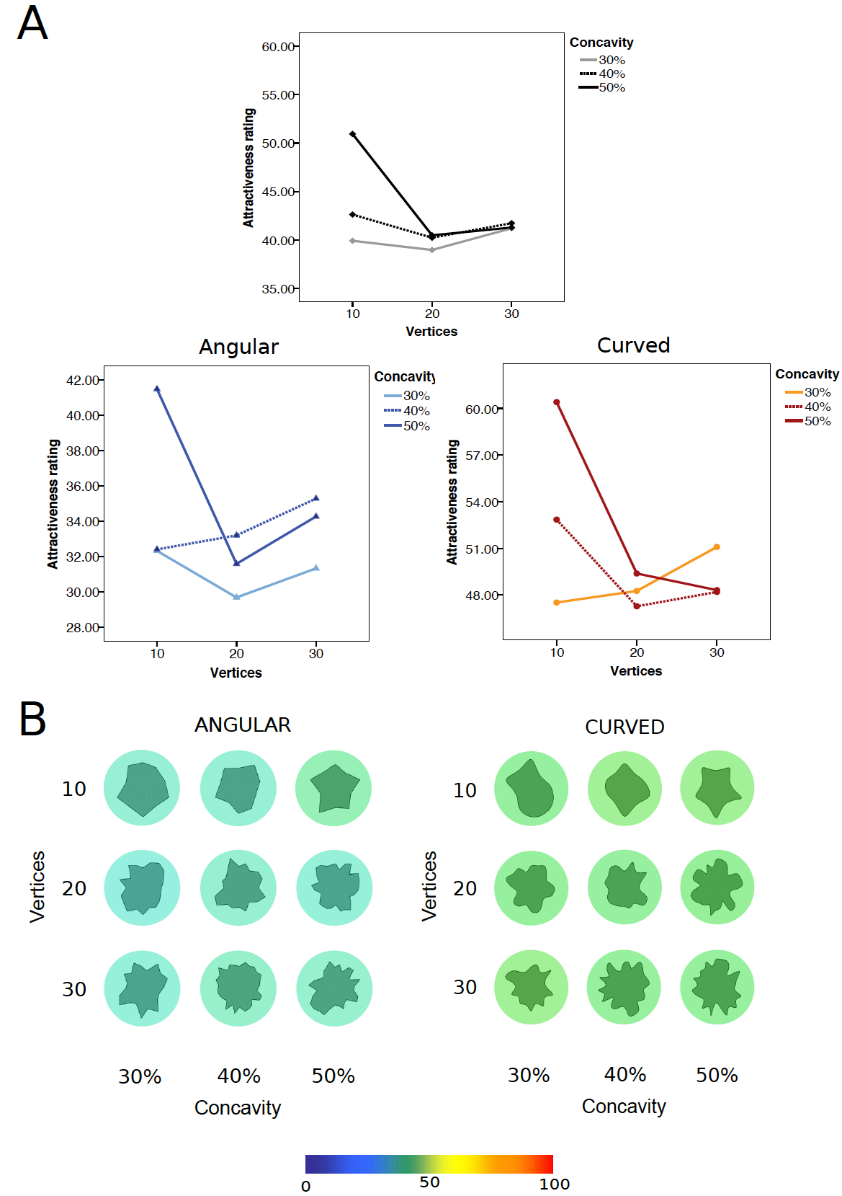
Figure 6. Results of Experiment 3. Liking rating (y axis) as a function of vertices (10, 20, 30; x axis) and concavity (30%, 40%, 50%; separate lines). Panel B: the heat map illustrating the distribution of the liking responses across the stimuli (green: low attractiveness ratings, yellow: high attractiveness ratings).

Discussion
Experiment 3 assessed whether asking observers to rate attractiveness instead of liking would generate the same pattern of results as found in Experiment 2. The answer is that there is a clear similarity in the two outcomes, although with the attractiveness scale we found a more complex pattern. The main finding is that, similarly to what we found with the liking response, curved shapes were rated as more attractive than the angular shapes. Another result concerns the star-like effect: observers found the shapes with fewer vertices and more concavities as more attractive. In both Experiment 2 and 3 this effect was significant. Finally the more complicated three-way interaction found with the attractiveness scale might be explained by a less clear definition of attractiveness as compared to the definition of liking which is reflected in more variability in the data.

General discussion

In empirical aesthetics the preference for smooth curvature is a phenomenon which has been confirmed with a variety of visual stimuli from abstract meaningless shapes or patterns (Bertamini et al., 2015; Silvia and Barona, 2009) to more articulated displays such as pictures or drawings of interior design spaces (Leder and Carbon, 2005; Vartanian et al., 2013) or even familiar objects (Bar and Neta, 2006). The majority of these studies made use of different explicit measures of preference. For example, Bertamini et al. (2015) used mainly rating scales of liking; Leder and Carbon (2005) also used a rating scale measuring attractiveness. Vartanian et al. (2013) opted for a two-alternative forced-choice response on beauty, similarly Bar and Neta (2006) used a two-alternative forced-choice response on liking.
Although preference for curvature over angularity was consistent across these studies there were some claims about the critical importance of the procedure. Bar and Neta (2006) highlighted the importance of using brief presentations and forced-choice responses to examine immediate gut reactions. This would minimise effects of cognitive processes on preference formation. The authors described the angles as primitives as they can be extracted quickly from the image.
However, the use of such methodology is not always feasible, especially when the stimulus material entails complex scenes. The general aim of the current study was to verify whether in the preference formation for curvature, forced-choice response methods differ from rating scales, and whether it matters whether the question is about liking or about attractiveness.
- In Experiment 1 we presented abstract curved or angular shapes for a short duration (120ms) and observers indicated whether they liked or disliked each shape. The polygons varied in terms of number of vertices (10, 20 and 30) and concavities (30%, 40% and 50%). In Experiment 2 we used the same stimuli but participants indicated how much they liked each shape on a visual scale ranging from 0=dislike to 100=like. The stimuli were on screen until participant provided the response. Finally Experiment 3 had the same procedure of Experiment 2 with the exception that we asked participants to rate attractiveness.
In relation to the shapes used in our design, the combination of number of vertices and concavities allowed us to test two important issues on preference for smooth curvature.
The first one relates to the question whether observers like curvature or dislike angularity. More precisely we verified (1) whether curvature is preferred even more when its appearance becomes more rounded (i.e. fewer vertices and concavities); (2) whether the angular shapes are disliked more when they appear “spikier” (i.e. more vertices and concavities); or whether only (1) or (2) would occur. This would clarify if smooth curvature is preferred for its visual properties (Bertamini et al., 2015; Palumbo et al., submitted) and to what extent the threat hypothesis related to angles is a plausible explanation for liking curved objects (Bar and Neta, 2006; 2007). The second aspect relates to visual complexity. The shapes with more vertices and concavities presented a complex configuration (Bertamini et al., 2015). One prediction is that observers prefer shapes middle levels of complexity (Berlyne, 1970). However, Friedenberg and Bertamini (2015) found that observers rated the shapes with more concavities as the most attractive ones.
We start with the discussion of the first issue. In all three experiments we found that curved shapes were preferred. This confirmed previous reports (Bar and Neta, 2006, 2007; Bertamini et al., 2015; Friedenberg and Bertamini, 2015; Leder and Carbon, 2005; Vartanian et al., 2013). However there were some differences across experiments. As shown in the heat map, the strength of preference in Experiment 1 (forced-choice task) was higher in comparison to Experiments 2 and 3 (liking and attractiveness ratings respectively) (see Figures 3, 5 and 6, panel B). There are two possible explanations for this. The first one concerns the nature of forced-choice response methods: the lack of middle range selection boosts the preference response. The second concerns statistical power, as in Experiment 2 and 3 we tested fewer participants. However, this explanation is unlikely. In previous studies (see Bertamini et al., 2015) we tested the same number of participants as in Experiment 1, with the same scale and similar stimuli and the liking ratings (and effects sizes) were similar to those reported in Experiment 2 and 3. Therefore there is consistency across experiments using the rating scales. What is interesting is that only the preference for curvature was more enhanced in Experiment 1 (0.74; SD=.04) than in Experiment 2 (51.75; SD=2.42) and Experiment 3 (50.36; SD=4.43). In contrast the dislike for angularity was similar across experiments. This suggests that when participants are forced to select between two options, it is curvature that drives their response. This is consistent with the finding that participants tend to approach curved shapes and not to avoid angular ones (Palumbo et al., submitted). Another interesting effect was that in Experiment 1 number of vertices or concavities only mattered for curved shapes (see point 2 in the predictions section). Together these results confirm a preference for curvature based on visual structure.
The second issue concerned the combined effect of vertices and concavities. In Experiment 1 observers preferred shapes containing the highest number of vertices (30) with the least number of concavities (30%). In line with Friedenberg and Bertmini (2015), in Experiment 2 as well as in Experiment 3, we obtained a star-like effect: observers liked more the shapes with less vertices (10) but only if they contained more concavities (50%). Despite this difference on preference for shape-configuration across tasks, which requires further investigation, these results confirm a preference for shapes with a balance between number of convexities and concavities. Overall these data support previous evidence for an inverted U-shape relation between visual complexity and preference (Berlyne, 1970).
Finally we found some isolated effects that should be interpreted with caution. For example, the effect of concavity was only present in Experiment 2. The shapes with more concavities were liked more than those with fewer concavities independently of type of contour or number of vertices. The fact that this result was only found with the liking scale is surprising in relation to Friedenberg and Bertmini’s study, where the effect on polygons was found using an attractiveness scale. More investigations are needed to shed light on this issue.

Conclusions
Preference for smooth curvature was confirmed using irregular abstract shapes with different procedures (forced-choice task on liking with brief presentation, and rating scales on liking and attractiveness with longer presentation). Overall the results across experiments confirmed the preference for smooth curvature, and this was most evident with immediate gut reactions (Experiment 1). The combination of number of vertices and concavities revealed that shapes with a balanced number of vertices and concavities (middle level of complexity) were preferred across tasks. However, a preference for more concavities (star-like shapes) emerged only with the use of rating scales (Experiment 2 and 3). We conclude that the curvature effect is stable across tasks, and that parametric manipulations of complexity produce small but interesting effects. In particular more concavities within smooth shapes introduce more changes in curvature (and higher curvature magnitude) which decrease liking,

Acknowledgements

This work was supported by the Economic and Social Research Council (ESRC, Ref. ES/K000187/1)

References
Bar, M. (2003). A cortical mechanism for triggering top-down facilitation in visual object recognition. Journal of Cognitive Neuroscience, 15, 600-609.
Bar, M. and Neta, M. (2006). Humans Prefer Curved Visual Objects. Psychological Science, 17(8), 645-648.
Bar, M. and Neta, M. (2007). Visual elements of subjective preference modulate amygdala activation. Neuropsychologia, 45(10), 2191-2200.
Berlyne, D. E. (Ed.). (1974). Studies in the new experimental aesthetics: steps toward an objective psychology of aesthetic appreciation. London:Wiley.
Berlyne, D. E. (1970). Novelty, complexity, and hedonic value. Perception and Psychophysics, 8, 279-286.
Bertamini, M. Helmy M.S. and Bates, D. (2013). Attention is allocated preferentially to corners of surfaces (not just locations near a corner). Attention, Perception and Psychophysics, 75, 1748-1760.
Bertamini, M., Palumbo, L., Gheorghes, T. N., and Galatsidas, M. (in press). Do observers like curvature or do they dislike angularity? British Journal of Psychology.
Cole, G. G., Skarratt, P. A., and Gellatly, A. R. H. (2007). Object and spatial representations in the corner enhancement effect. Perception and Psychophysics, 69, 400-412.
Friedenberg, J. and Bertamini, M. (2015). Contour Variation and Perceived Attractiveness of Polygon Shape. Empirical Studies of the Art.
Gómez-Puerto, G., Munar, E., Acedo, C., and Gomila, A. (2013). Is the human initial preference for rounded shapes universal? Preliminary results of an ongoing cross-cultural research. Perception, 42, ECVP Abstract Supplement, 102.
Hogarth, W. (1753). The analysis of Beauty: written with a view of fixing the fluctuating. Ideas of Taste, London: Reeves.
Larson, C. L., Aronoff, J., Sarinopoulos, I. C., and Zhu, D. C. (2009). Recognizing threat: A simple geometric shape activates neural circuitry for threat detection. Journal of cognitive neuroscience, 21(8), 1523-1535.
Larson, C.L., Aronoff, J., and Stearns, J. (2007). The shape of threat: Simple geometric forms evoke rapid and sustained capture of attention. Emotion, 7, 526- 534.
Leder, H., and Carbon, C. C. (2005). Dimensions in Appreciation of Car Interior Design. Applied Cognitive Psychology, 19, 603-618.
Leder, H., Tinio, P. P., and Bar, M. (2011). Emotional valence modulates the preference for curved objects. Perception, 40(6), 649.
Ledoux, J. (2003). The Emotional Brain, Fear, and the Amygdala. Cellular and Molecular Neurobiology, 23 (4/5), 727–38.
Morris, J. S., Ohman, A., Dolan, R. J. (1999). A Subcortical Pathway to the Right Amygdala Mediating ‘Unseen Fear’. Proceedings of the National Academy of Sciences, 96(4), 1680–5.
Nadal, M., Munar, E., Marty, G., and Cela-Conde, C. J. (2010). Visual complexity and beauty appreciation: explaining the divergence of results. Empirical Stud Arts 28, 173–191. doi: 10.2190/EM.28.2.d
Palumbo, L., Gheorghes, T. N., Galatsidas, M., Bertamini, M. (2014). Do observers like curvature or do they dislike angularity? International Association of Empirical Aesthetics (IAEA). New York, USA. 22-24 August.
Palumbo, L., Ruta, N., Bertamini, M. Comparing angular and curved shapes in terms of implicit associations and approach/avoidance responses. Manuscript submitted.
Silvia, P. J., and Barona, C. M. (2009). Do people prefer curved objects? Angularity, expertise, and aesthetic preference. Empirical studies of the arts, 27, 25-42.
Vartanian, O., Navarrete, G., Chatterjee, A., Brorson Fich, L., Leder, H., Modroño, C., Nadal, M., Rostrup, N., and Skovi, M. (2013). Impact of contour on aesthetic judgments and approach-avoidance decisions in architecture. PNAS, 110, 10446-10453.

