Who are they listening to? An exploration of the influences on the religious faith of young people in the UK

Abstract
This empirical study used the narrative identity model to facilitate exploration of the influences on the religious faith of young people, with specific interest in the Christian faith. There is minimal research regarding the impact of online influences on religious faith of young people, which is the gap this project sought to contribute to. Empirical data was collected from 155 young people and 120 youth leaders using group interviews and online surveys. They were asked about their perceptions of influence on themselves and the extent to which they influenced one another in relation to beliefs and faith matters. The findings revealed that the young people exhibited minimal sense of agency or control over the influences upon them, and that whilst the influences occur across the hybrid reality of their everyday lives, family and church are deemed by the young people to be the strongest influences on their religious faith formation. However, the youth leaders indicated different perceptions, emphasising the need for enhanced dialogue between youth leaders and young people regarding influences and how the young people can be best supported in this hybrid context.

Keywords
Religious faith, influences, youth, online, in person

Introduction
Adolescence is arguably the most important stage of an individual’s formation of identity. A young person’s identity formation entails the assimilation of personal and social experience whilst maintaining integrity and subjectivity in the changing external world. Forming individuality and identity can be challenging for young people due to the constant transformations in society, diversity of social relations, expectations on them for continuous self-development and the need to meet social expectations. Neurobiological insights indicate that due to being highly malleable and oriented towards the social context, the adolescent brain has heightened susceptibility to social influences. This aligns with the ecological systems theory, observing spheres of influence on individuals. These influences on a young person may be explicit or implicit, and the young person may be conscious or unaware of them, although the meaning and method of communication determine whether such influence is ethical.

Since 97% of UK homes containing under 18’s had access to the internet in 2022, the online world will inevitably be a significant influence on young people. Increased time spent on social media increases the opportunities for identity formation in the online world. The marketing sector is acutely aware of the power of these online influences and interaction, since there is evidence that 75% of people use social media for purchasing advice and 69% of consumers trust influencer recommendations. In Instagram alone there are approximately 64 million influencer accounts. Da Silva asserted that all of these changes constitute a digital metanoia, since digital technology impacts upon the very essence of humanity and the ability to communicate, relate, and know. Beaudoin observed that the virtual realm impacts faith and spirituality. Yet there is minimal research regarding the impact of online influences on religious faith of young people, which is the gap this project sought to contribute to. The aims of this paper are to explore i) the perceptions of young people’s influences related to religious faith, ii) the extent to which they perceive they influence others, and iii) compare perceptions of youth workers about influences on young people with the perceptions of the young people themselves. Ultimately, it is hoped that these findings will serve to inform and consequently enhance the work of Christian youth workers working amongst young people.

This study sought to gather insights into the lived experiences and perceptions of young people in the UK regarding their influences, particularly on their religious beliefs. We were interested to establish the extent to which they were aware of the influences on their religious faith, and also to explore the preferences of young people from whom they would obtain advice or influence from and whether that would be preferred online or in person. Firstly, interviews were carried out with 88 young people aged 8 to 16 years old, who had varied religious involvement or church attendance. We sought to get a spread of demographics, age, involvement with church and religious affiliation. Subsequently, an online survey was carried out amongst a further 67 young people who again had a variety of association with religion. The final strand was an online survey of youth leaders (n=120) to ask about their perceptions of the influences on the young people they worked with. For all of these strands, open invitations were disseminated through social media, organisational newsletters and networks, so that the participants were all self-selecting. The preliminary findings were that the hybrid reality of young people’s influences is complex and largely not in the consciousness of young people, with them feeling a distinct lack of agency in their own narrative identity formation. The factors which the young people deem to influence their religious beliefs most are family and church, although youth leaders perceive this differently, since they cite social media, friends and influencers as having greater influence on young people. It is evident that there is a need to research this more comprehensively to better inform those working with children and young people of this age group, although it is acknowledged that there are significant challenges of researching this area.

Background
Influences on young people
Adolescent identity formation is a consequence of an individual’s separation of themselves from the surrounding environment, leading to a sense of wholeness and self-identity. It is determined primarily by one’s internal characteristics and the influence of the social environment. Influences can be deliberate and explicit, but are often implicit, unintentional and unwitting. The bioecological theory captured the influences of all of the systems which play a role in impacting an individual no matter how remote the influence. Yet, young people’s contemporary experiences of the digital world in relation to the physical one have transformed these systems and influences since their offline life is extensively interwoven with online contexts. The boundaries between the virtual and physical realms are no longer clear, so that Bronfenbrenner’s depiction of discrete physical locations, such as the child’s home or school no longer reflect the flexibility of digital arenas where an individual may participate in two microsystems simultaneously. Granic, Morita, & Scholten identified the need for a single holistic ecosystem referred to as hybrid reality to aid more comprehensive understanding of the influences on young people. In this vein, Navarro and Tudge proposed adaptations to Bronfenbrenner’s bioecological theory in light of the technologized world, developing their own adapted model named neo-ecological theory. Namely, they suggested the need for two types of microsystem —physical and virtual, reflecting the contemporary everyday reality of young people. In addition, it is critical to be aware that virtual contexts are dynamic and constantly changing cultural spaces, where norms are created, shared and transmitted to others.

Social interactions of young people occur on a continuum, ranging from face-to-face (namely physically in person) to ‘Web 1.0’ (namely read- and write-only applications such as text messaging and email), to ‘Web 2.0’ (namely interactive applications with programming features such as social media). The full range of this continuum is operational amongst young people with 97% of adolescents estimated to use at least one social media platform. Ofcom revealed that YouTube was the most-used platform among ages 3-17 years in the UK for watching videos (83%), although those over eight years old used a greater range of platforms such as TikTok (62%) and Instagram (54%). Social media platforms allow users to interact and self-present in real time or asynchronously to reach a desired audience. However, engagement may increase or decrease in different ways across different platforms in response to religious or promotional cues, showing the complexity of online and social media influences. Authenticity, accessibility, and relatability are essential parts of a social media influencer’s persona, and differentiates them from a celebrity. In addition to being influenced by social media and online content, 89% of 3-17 year olds in the UK are involved in playing video games. The type of video game involvement impacts upon whether it leads to prosocial behaviour, greater social satisfaction, social functioning, and well-being or not. Ofcom reported that a key reason those aged 3-17 years old played video games was to ‘hang out with friends.’ Whilst this was often found to be interaction with those already known to them, 25% of 8-17 year olds stated that they played with or talked to people whom they did not know.

Within the microsystem of the physical world, parents often do not realise the crucial background and subconscious role and influence they have for their child. Children are equally unaware of the power of their parents in shaping their lives and belief systems since they view themselves as being autonomous and independent information-processors and decision-makers. Nevertheless, adolescent religiosity generally follows parent religiosity, although this differed according to the level of religiosity of the parents. Beyond the remit of immediate carers in the child’s microsystem, such as parents, school, grandparents and meaningful church workers have been shown to be markedly influential on a child’s beliefs. For those children or young people with a non-religious upbringing in the home context, there tends to be less presence of religious influences in the spheres beyond the microsystem, so that the child tends to be surrounded by non-religious people and a general non-presence of religion in their broader ecological system also.

Influencing religious faith
Since today’s young people are digital natives, there is a need for the church to reformulate models of faith formation so that they align adequately with the language, communication, relationship, and learning characteristics of contemporary young people. Indeed, popular culture can serve as a starting point for many young people's faith formation, and the role of Christian youth work within this is often seen to raise the consciousness of core values and internal vulnerabilities, nurturing them in a manner so as to contribute to society. Soukup argued that religious organizations supply some of what might be called the "public narratives" of religion. Indeed, influencer marketing is widely used as an advertising tactic for reaching Christians on social media since social media is found to be a more frequent arena than family and church for many in terms of religious ideas and values. For example, Facebook was found to be utilised in four ways relating to faith; ministering, spiritual enlightenment, religious information, and entertainment. Smith et al. found that reaching others became a central theme of influence amongst religious social media influencers, with particular attention to interpersonal connections and community building. This links with the possibility afforded by the likes of Facebook for affiliation with like-minded individuals, in the form of faith-based users, for the purpose of providing support and spiritual guidance.

The religious faith of young people is significantly influenced by their peers, and social media plays a significant part in this as it provides a platform for engaging three functions of religion – the social, the existential, and the transcendent. Those who frequently use Facebook for posting, liking, commenting, and sharing faith-based content are more likely to minister to others. Sharing religious beliefs online is notably easier than in offline settings because of the reduced social barriers that might otherwise inhibit sharing personal beliefs. Interpersonal sharing of beliefs can occur through social media via ‘one-to-one’, or ‘one-to-many’, approaches. This all shows the complex and multi-variant influences upon young people’s faith within a hybrid world.

A theoretical framework for analysing hybrid influences on young people
Granic, Morita and Scholten developed the narrative identity model (figure 1). It encapsulates a sense of the hybrid reality of contemporary life, whereby young people are simultaneously interacting with both physical (‘in-person’) spaces and online (virtual) contexts. Figure 1 depicts awareness of factors impacting a young person at the intrapersonal, interpersonal, and cultural levels. They described intrapersonal factors as those which operate within individuals and enable them to construct their narrative identities with purpose and coherency. Two key factors within the intrapersonal level are agency (asserting one’s own perspectives, interests, values and decisions) and communion (a sense of belonging, acceptance, emotional bonding, being cared for and caring for others). Granic, Morita and Scholten argue that optimal development is achieved where these two factors are in balance. Interpersonal factors are explained as an individual’s social interactions which influence the formation of their narrative identities. Storytelling partners are highlighted as key in influencing, reinforcing and altering an individual’s narrative identities at this level. Cultural factors on figure 1 symbolise the extent to which individuals construct their own narrative identities to fit with their societal context and values. Granic, Morita and Scholten highlighted that intrapersonal, interpersonal, and cultural factors are continuously interacting across and within the young person’s hybrid context to build, express and transform their narrative identity. This model will therefore form the framework for analysing data collected in this research project.

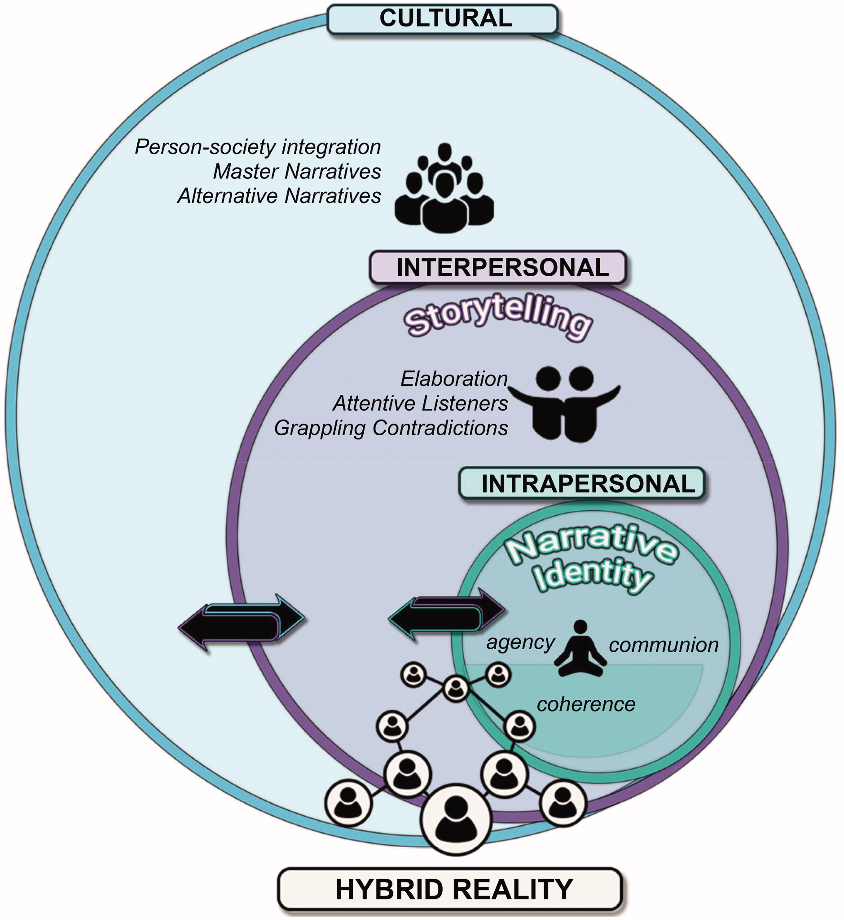
Figure 1: Narrative identity model, with embedded factors at the intrapersonal, interpersonal, and cultural levels

Methodology
This project took an exploratory approach to gain insights into the experiences of young people of influences, being influenced and influencing others. Data was collected in three distinct strands. The first sought to explore in a very open-ended manner the experience and perceptions of influence amongst young people who were not connected with church or Christianity. These interviews took place in eleven groups of four or five each, in the child’s school setting or online (zoom) so that it was a neutral and familiar setting. The group interviews were semi-structured since the researcher had a list of possible questions (figure 2) to prompt discussion, although they followed the lead and discussion flow of the participants. They were audio-recorded to aid analysis. The research invitation initially targeted young people who did not describe themselves as Christian since the research team wanted to find out about perceived influences on these young people and how this might impact their view of Christianity. This brought distinct challenges to recruit participants since gatekeepers in non-faith settings (such as schools, uniformed organisations, youth clubs) did not grant consent to speak with their young people. It had been hoped for the full cohort to be young people who were not self-described as Christian faith, but in light of the challenges, once 25 young people in this category were recruited, it was opened out to also include those who attended church, bringing the total interview participants to 88. The questions explored how participants might explore faith and questions of spirituality and what impact friends and family may have on a child’s faith.

In the second strand, themes identified from the group interviews were further explored amongst the separate group of participants using an online survey (see questions in figure 2), particularly relating to participant awareness of the influences upon them. Many in strand one intimated that the absence of religious input in their lives did not influence them about religion, so the online surveys sought to explore this further. In addition, it seemed that they were unaware of the influences upon them so different language was used in the online survey, such as asking the young people who they would intentionally access for support in different areas, since this would indicate who was influencing them without using the language of that. For this strand, young people who attended a Christian church were invited to take part, since this would provide the ability to compare the perceptions of the two participant groups to add further interest to the data collected. There were 67 respondents, 80% of which said that they attended church most of the time and 20% occasionally. The third strand comprised an online survey of youth workers (n=120). This survey intentionally included identical questions as in strand two, although slightly reworded to be appropriate. This was to enable analysis of how closely youth workers and young people aligned in their perceptions and experiences of influences.

These three research strands were subject to the scrutiny and approval of the Ethics Committee at Liverpool Hope University. This ensured that the data collected was stored safely and securely and that all participant involvement was confidential and anonymous (Wiles et al., 2008). Informed consent was obtained from gatekeepers, parents and the young people themselves. Throughout data collection, care was taken to ensure ethical and appropriate sensitivity to participant experience and feelings around religious faith (Powell et al., 2018). All participants were assured that all questions were optional and that they had the right to withdraw (BERA, 2024).

The open-ended data was analysed using narrative analysis since it enabled the exploration of the individual stories of the young people participating in this research, uncovering how they viewed themselves and what had shaped these views. Narrative analysis was a good fit for this project since it facilitated consideration of the cultural influences upon a person’s narrative. The process of interpretation followed that suggested by Gee, whereby a structural model of five levels were used to organise the text, identify and analyse key points, and then relate the key points and plots to other influences such as family and social contexts and wider societal discourses about the topic being explored. Once these processes of analysis had occurred to establish the themes within the data, a second stage of analysis took place to frame the themes identified into the theoretical framework of the narrative identity model discussed above and shown in figure 1. This enabled comprehensive understanding of the extent to which the experiences and perceptions of participants’ influences were in the domains of cultural, interpersonal and intrapersonal levels and illuminated the complex interplay between the online and ‘in person’ arenas.

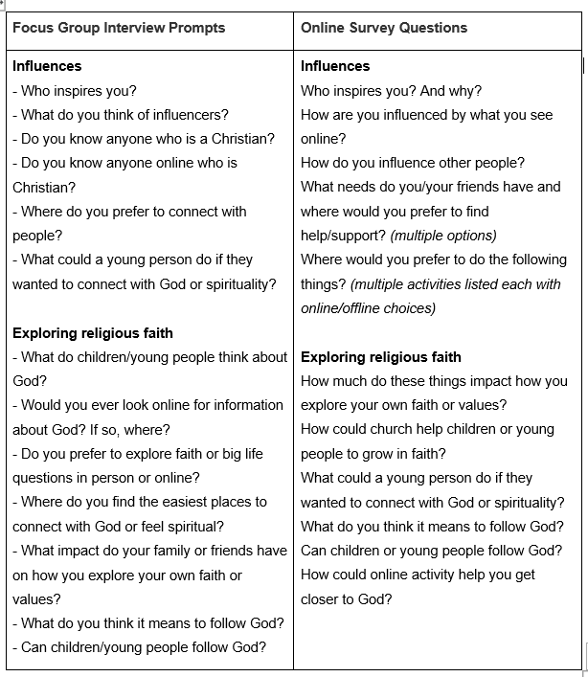Figure 2: Data collection questions and discussion prompts

Results
Group interviews of young people
‘Inspire’ was perceived as universally positive and largely referring to family members, particularly parents, and sometimes sporting champions, friends, celebrities and teachers. Conversely, there was caution and wariness about online influencers. No participants viewed ‘influencers’ entirely positively; but deemed them fundamentally negative or a blend of positive and negative. This may reflect an instilled distrust as a result of online safety education which seeks to safeguard young people online.

There was a difference in tone regarding online influencers or others who were similarly distant from the young people, for example sports champions or famous authors. They were referred to in a more matter of fact manner, whilst individuals with whom the young people had a personal relationship were spoken about more warmly. This may again reflect cultural messaging about boundaries of trusting those outside of the immediate context of the young person. Whilst most young people named a particular individual or known group of people who inspired them, such as ‘Mum’ or ‘friends,’ a few responded by naming a people group, such as, ‘people who are disabled,’ or ‘footballers.’ This reflects societal norms, whereby family and those known by name are deemed to be more trustworthy. This may transcend across generations and apply equally to both digital natives and digital immigrants since it seems to be a reality drawn from the in-person world to the virtual space. There was a dominant view that where a parent, family member or friend had a faith of their own, they would positively impact their child’s faith. For example,

‘My friends definitely do, because they're Christians’ (participant 401).

‘My family does influence it, we go to church as much as we can’ (participant 404).

‘I wouldn't have been a Christian if it wasn't for my family, because when my mum was little she went to church’ (participant 502).

This perhaps reflects family context, whereby if the parent has faith, they will most likely set the family ethos to accept that religious faith is a positive trait. It would be interesting to examine the role of school in this, particularly if the young person attends a faith school. For example, how positively would the young person view a teacher who exhibits a religious faith. This would show whether the young person’s views are context specific or deeply held, and therefore transferable across contexts.

There was also a generally accepted perspective amongst participants that if a child’s parents had no faith of their own, that did not mean that they impacted the child’s faith negatively, or a child’s decision not to have a faith, but rather, there was a perceived absence of influence, for example,

‘My family don't because they aren't Christians and they don’t like talking about it’ (participant 402).

‘My mum's side wants to raise us as atheists to begin with and if we want to go off and explore it later, we can. She doesn't want us to be influenced by that’ (participant 201).
This perhaps reflects a pervasive societal understanding that family is to be trusted and usually offspring would align with their parental beliefs, at least until an age when they would consider this more critically and openly. However, the notion of grappling with ideas was not evident in the data. Rather, the young people seemed to simply accept that they aligned with the religious views of their parents, whether that be leaning towards religious faith or away. This type of understanding and narrative will undoubtedly continue to adjust and change as the UK is increasingly secular.

The perceptions regarding young people’s agency in their own narrative identity formation were interesting. Only three participants explained that they were encouraged to explore their own beliefs and faith choices, whilst most of the young people demonstrated an absence of agency in their own explorations of faith, identifying influences or forces outside of themselves as taking the control, for instance,

‘Hey guys, I just thought: I watch Young Sheldon and his mum is a real big Christian. Goes to church everyday. I watch that and that pushes me to God. So I’m half and half. Because she literally cries when she prays, so that pushes me back. She makes them pray for dinner and about the dinner in the mornings and that. So that pushes me back to being closer to God’ (participant 105).

This sense of acceptance of cultural narratives without critiquing them implies that the young person is firstly open to this idea, and it is not at odds with their existing belief, but also that sources such as TV programmes are viewed by these young people as a way of gathering information and ideas to integrate into their developing sense of identity and belief system. One particular interview group articulated a more developed, rounded understanding of influencers. They appeared to be more aware of potential influences generally and returned to this theme throughout the interview, both explicitly and implicitly. When asked what they thought of influencers, rather than simply expressing that they may be positive or negative, they gave a clearer justification;
‘I think it depends what they're trying to influence you in’ (participant 102).

‘Some influencers influence things that aren't needed or healthy’ (participant 106).

There was also an understanding that the object of being an influencer was to the benefit of the influencer themselves and suggested that questions should be asked about how an influencer uses their following. It was interesting to note the level of suspicion and criticality which the young people expressed regarding influencers, which was not present in their views about TV programmes for example. This may reflect contemporary societal contexts, whereby educators and parents are often critical and cautionary about trusting social media influencers.

It was apparent that this particular group also understood ‘influence’ in faith development, raising the idea themselves. When asked for their perceptions about what young people thought about faith or spirituality, several responded that the child’s faith was dependent on the influence of their parents, such as:

‘I think children might be religious because it might be the influence of their parents to stop you or to make you join. I've heard that’ (participant 304).

This again indicates that this part of the child’s narrative is derived from the home and family rather than wider society. Several comments made by this group indicated that the young people viewed these influences as negative or something to be fought against and possessed a more developed understand of their own agency;

‘One friend had one parent Catholic and the other protestant and when she's with her mum, she tries to influence her to follow that’ (participant 303).

‘Some people might try to stop you but it's important that you do believe if it’s important to you’ (participant 305).

However, when asked how family and friends may influence your faith, this particular group spoke positively about their experiences again demonstrating the idea mentioned previously that a person’s relationship with the person they were influenced by may colour their perception of the way they are being influenced, and their responses to this question did not speak with the same level of critique that had been present in their responses to other questions,

‘My family encourage me to explore it but they don't mind if I change my religion’ (participant 203).

‘Everyone can have an impact on what you believe or don't believe and because they believe it, they might encourage you’ (participant 204).

These views exhibit more openness than many of the other responses, and almost a sense of permission being granted to grapple and explore with alternative ideas. They also reveal a sense of being slightly more aware of their developing belief system and the influences upon it.

Online survey of young people and youth workers
Most of the participant young people said that family (80%) and friends (65%) influence them, with 50% identifying sports champions and 35% teachers. Only 5% chose youth leaders, scientists or fictional characters. This contrasts with the perception of youth workers who identified far more influences on the lives of the young people they work with. They identified family (88%) and friends (76%) as the most influential, but also believed others to be far more influential on young people; selecting celebrities (76%), sports champions (70%), entrepreneurs (29%), teachers (24%) and a small percentage selected youtubers or influencers as a distinctive group.
Reasons the young people gave for these people being inspirational were all positive and included a sense of personal connection and influence, for example;
‘because they inspire me to do what they do’ (participant C10).
‘They are all determined, hard-working and never give up even when they fail’ (participant C13).
This narrative indicates young people’s awareness of the broader picture and a notion that what is evident is not the only truth but there are reasons behind something, such as significant hard work and determination. This again reflects the contemporary societal context which seeks to view people authentically and not only their online persona. The responses of youth workers were more detached, observational and reflective, perhaps reflecting the nature of the youth worker role; for example;
‘They are seen as people to emulate or aspire to be. They appear attractive and successful and have done something significant or meaningful’ (participant L1).
Regarding how the young people were influenced by online content, 63% felt that they were influenced by what they saw online, whilst 21% felt that they were not, and 16% did not know. Analysing the narratives revealed that some viewed these influences as positive; for example:
‘Helps me learn stuff’ (participant C20).
‘Seeing good things, you think you can do it too’ (participant C7).
However, some indicated a negative judgement of online influence and therefore a decision, not necessarily by the young person themselves, not to engage with it, such as:
‘I'm not allowed online too much. If I see a programme or toy advertised this interests me’ (participant C3).
In contrast, the youth workers perceived that online content had a greater influence on young people; with 87% stating that young people were influenced by what they saw online, although 13% were unsure. Most of the comments identified online influences as positive and negative, but indicated that the young people they worked with were drawn to things which attract a large following, and encompass many aspects of their lives from clothing choices, language, opinion and worldview.
There were similar variations in the perspectives regarding influencing one another. Fifty-two percent of the young people felt that they did not influence others whilst only 6% of youth workers felt that young people did not influence others. Conversely, only 30% of young people felt that other people copy their behaviour and 15% felt that other people were influenced by the way they spoke. However, 71% of youth workers felt that young people copied one another’s behaviour and 59% felt that they copied one another's way of talking. Young people were more positive about the influence they had by sharing their faith story (20%) and showing others how to be a Christian at school (15%) whereas only 12% of youth workers felt their young people influenced others by sharing their faith story and none of them identified that the young people showed others how to be a Christian at school. Some of the youth workers also described in more detail the way in which young people influenced one another’s behaviour, for instance;
‘They provide limits and permission. In other words, they watch where each other ‘draws the line,’ and copies or transgress that line’ (participant L7).
Others identified some specific contextual ways in which young people influenced their peers;
‘They come from different school contexts so tend to bring their school identity and influences into the church youth group with them’ (participant L17).
Further to these narrative responses, some multiple choice questions were included in the survey regarding the degree to which young people felt they were impacted in exploring their values and beliefs, in addition to youth worker perceptions of this. Scaled responses were selected by participants to indicate their opinion (figure 3). The young people (68%) deemed that church had a strong influence on their formation of beliefs and values, whilst only 13% of youth workers agreed. Similarly, more young people (65%) than youth leaders (44%) expressed that family had a strong influence on their beliefs. Conversely, youth leaders expressed that social media (35%), friends (47%) and influencers (29%) strongly influencers beliefs, whereas the young people viewed these aspects as having much less influence.
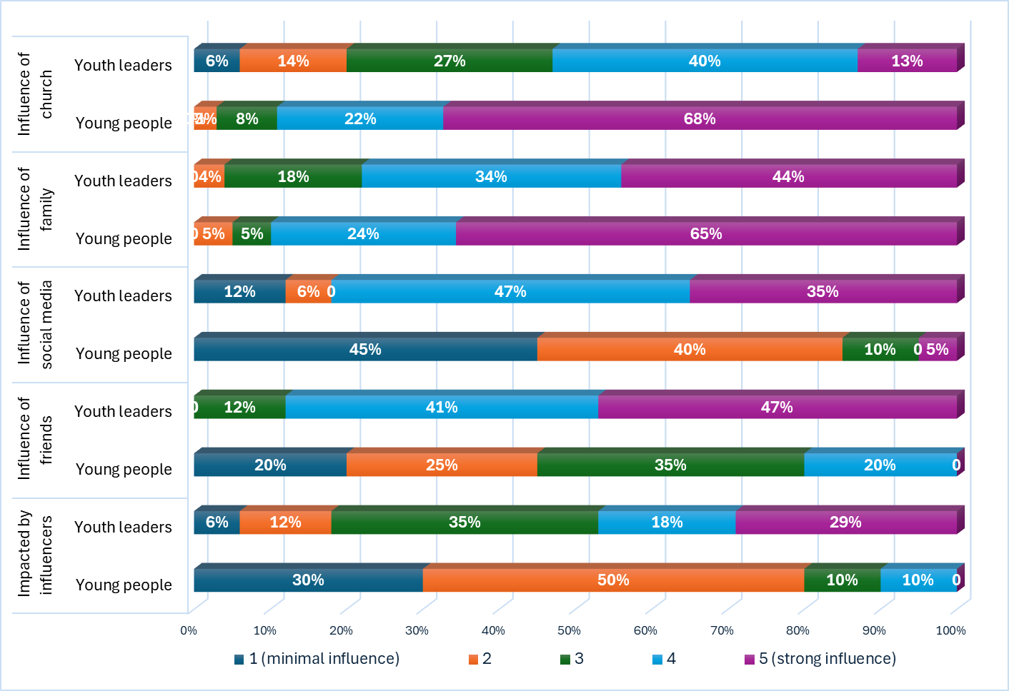
Figure 3: Youth leaders and young people’s responses to the question, ‘How much do these things impact how you (or young people) explore your faith or values?’ 1 = not influenced much and 5 = influenced a lot

Discussion
There were three notable perceptions identified in the responses of the young people who participated in both the survey and focus groups. Firstly, to them influence was viewed as a negative thing. Some viewed it as a blend of positive and negative, but never wholly positive. They were cautious about being influenced by anyone or anything. However, those who inspired the young people were viewed in a very positive manner. The second notable understanding was that the participants only noted a sense of influence on them if someone had visible and active beliefs. The young people did not believe that an absence of beliefs would influence them. Thirdly, the lack of agency expressed by the young people about the things which influence them was marked, since they felt they had no control over influences on them and they were passive agents.
When considering this data through the lens of the narrative identity model, the young people who participated in this study seemed very unaware of intrapersonal factors occurring as part of their formation of identity and beliefs. They clearly stated that they felt no sense of agency in the influences upon them and as they were developing their own beliefs. However, they did express a strong sense of their own areas of interest and activity and it was evident that these interests shaped and were a conduit for influences of a specific nature upon them. So that if they were interested in sport, sports stars would inevitably influence them. Likewise, if they were connected with a church, people within the church community would inevitably influence them. In this way, the young people had agency in decision making about their own interests and activity and this by consequence selected the groups of people who would influence them more. It is key to note that peers and families provide an opportunity for social adjustment, with the potential to redirect negative trajectories and increase positive outcomes. When the young people were asked about their values, they seemed very resolute and firm and often these were values, boundaries or ways of behaving (and living) expected within their school or other settings. Hence, again the young people participants exhibited minimal sense of agency and decision-making about their own values formation in this intrapersonal space.
The other aspect of the intrapersonal domain is communion. The participants exhibited clear evidence that a sense of belonging, acceptance, emotional bonding and being cared for were significant factors in their influences and narrative identity formation. In the spaces and places they felt accepted and felt that they belonged, they were willing to accept the influences (often subconsciously) and take on the values and beliefs of these people. This was often within their friends and family, but also spaces such as church and school. Granic, Morita and Scholten asserted that optimal narrative identity development is achieved when agency and communion are in balance. Our study showed minimal evidence of a healthy balance between agency and communion as the young people participants expressed so strongly the notion that they were passive players in the intrapersonal space of their narrative identity development. However, building community and ‘sticking together,’ with a pervading sense of hybrid spaces being of shared ownership and contribution in terms of content and interaction are key to reflect this sort of balance. This is a significant area of need for those working with young people to consider how to equip and empower young people to have more sense of agency in this way.
It is interesting to compare the perceptions of youth leaders. The participant youth leaders were not asked about the level of consciousness of young people about the influences on them, although they were asked about the degree to which different aspects influenced young people. In relation to the ‘communion’ element of the intrapersonal domain, the leaders expressed much more than the young people themselves perceived about how much they influenced one another. The sense of the young people feeling emotionally bonded with peers and being cared for and caring for others did not seem to equate in the minds of the youth participants with influencing one another. Yet the youth leaders strongly observed and reported that they did influence one another. This again points to this sense of lack of awareness of the young people about who and how they are being influenced. This sense of agency relating to how young people themselves are influencing others and how their peers are influencing them would be valuable to unpick in future research to establish in more depth insights into the agency and dynamics of peer influence of identity development.
Reflecting on the interpersonal factors evident within this data, our data exhibited the influence which social interactions have upon the formation of their narrative identities. The notion of storytelling partners was observed, as the young people spoke of having their own beliefs and narrative identity influenced by those around them and they did speak about a sense of dialogue in their expression of the ‘push and pull’ interplay of influences in their social environment. Granic, Morita and Scholten observed the reinforcing and altering of an individual’s narrative identities at this level and our data would concur with this, with strong evidence of the personal contacts and connections of the young people (namely family friends and others in their social network) influencing their narrative identity development significantly. These interactions are perceived as genuine and impactful whether they are in-person relationships or online, since they represent real connections, conveying real affection and caring. Furthermore, Telzer et al. documented that social influence is an opportunity for promoting social adjustment, redirecting negative trajectories and helping young people to thrive. This possibility to be an agent for positive change is interesting in relation to the young person’s nature of listening or receiving the influence. Whilst the narrative identity model includes the notion of attentive listeners, and youth leaders reported that the young people are hearing and being influenced by these interactions, there was minimal evidence of the young people being attentive and active in their listening. It seemed to be more passive and inevitable that due to who the young people were interacting with, they would be influenced rather than them opting to actively listen. Equally, the notion of Granic, Morita, & Scholten of grappling contradictions was less evident throughout our data. In all strands of the data collected, there was this sense of passivity about acceptance of influence from their social interactions, and few expressed angst, struggle or grappling about any contradictions or decisions they had to make. A small number of youth leaders did talk about young people influencing one another’s boundaries, ethics and limits but did not talk about the process of how this came to be.

Overall, our data contained most evidence and discussion about the third domain of the narrative identity model, which are cultural factors. Overwhelmingly both the young people and youth leader participants expressed that cultural factors were the most significant influences on a young person’s narrative identity formation. The factors which participants tended to speak about were largely in the form of social media and online influences rather than in their physical world, although the influence of societal values from school was evident. This would be a fascinating area to explore further in terms of the balance and interplay of the hybrid reality of the determinants of societal context and values for young people’s narrative identities relating to religious faith. This may or may not be connected or defined by denominational contexts, since Smith et al. observed that often religious social media influencers are not tied to a specific denomination and in fact intentionally target a broad range of contacts and followers. The young people seemed to be less aware than youth leaders of the ways in which cultural factors were influencing their narrative identity development. A helpful future piece of research could explore the master and alternative narratives present in the hybrid reality of young people relating to religious belief. This information would enable those working in religious faith settings to more fully understand the context in which they are working.

The underlying notion of the model, that intrapersonal, interpersonal, and cultural factors are continuously interacting across and within the young person’s hybrid context to build, express and transform their narrative identity was evident within our data. Within all of our data, this complexity and dynamicness of interactions and influences was apparent, concurring with observations that identity is a complex, multidimensional phenomenon. However, the responses of the youth workers indicated that they were less aware of the nuances and complexities involved in a young person’s narrative identity formation. These influences can be one directional or bi-directional, with each agent simultaneously influencing the other in multi-directional networks. It is therefore recommended that those working to support young people should actively engage in dialogue with the young people to aid them in becoming more aware of the influences upon them and equipping and empowering them to have more sense of agency and decision in the factors which they allow to influence their forming values and beliefs. This may serve to support a sense of general wellbeing in the young people since this sense of empowerment of themselves to have agency in their own development rather than being ‘pushed and pulled’ without their consent could be highly beneficial. Indeed, Granic, Morita, & Scholten asserted that digital contexts which support identity-relevant processes rather than development can promote resilient mental health outcomes, whereas digital contexts which disrupt or poorly direct these processes can contribute to the development of mental health problems. Da Silva called for the Church to reformulate its methodologies, theology, ecclesiologies and pedagogy to more appropriately relate to the language, communication, relationship, and learning characteristics of present generations.

Conclusion & Recommendations
This paper asks who, in relation to religious faith, young people are listening to and how. Whilst the findings cannot claim to be representative, since the sample is self-selecting and limited, the observations can inform those working in the sector. The influences on these young people reflect the hybrid reality of their lives and those who work with young people therefore need to be aware and attentive to this reality so that they can support young people in their identity and beliefs formation in the most helpful ways possible. Often, practitioners only work amongst the in-person realm, and there is suspicious or ambiguity about the online world. Yet our findings reveal that this hybrid reality is very much a reality of contemporary young people and must therefore be given more attention. Support may be provided by aiding the young people in being more aware and attentive to the factors which are influencing them, and empowering them to have a greater sense of agency as they form their identity and beliefs system. Rather than overlooking or disregarding the online world, ministry workers need to explore how to equip young people to be more critical and open minded will enable them to integrate ideas into their own values and beliefs in a more intentional and controlled manner.

In terms of the influences on the young people, they stated that family has a significant influence upon them, which was not what the youth workers expected. It is therefore recommended that parents and families are equipped with how to use this influence to positively support young people in shaping their developing belief systems. Whilst the young people did recognise that they are influenced by social media, peers and influencers, they also expressed their caution regarding these influences, particularly influencers. They seem to be acutely aware that these influences can be simultaneously positive and negative. This resonates strongly with cultural narratives, although it is clear that the influences and formation of beliefs occurs throughout the young person’s intrapersonal and interpersonal realms. The narrative identity model provides a helpful lens through which to view such activities and realities of young people and how they encounter faith and spirituality. It is imperative that churches must be attentive to ensuring high standards of safeguarding are adhered to when interacting with young people in this domain. However, once these foundations are in place, dialogue is essential between young people and youth leaders to understand one another's positionality much more and hence forge greater understanding of the other.

Acknowledgements

References
BERA, (2024) Ethical Guidelines for Educational Research, fifth edition. https://www.bera.ac.uk/publication/ethical-guidelines-for-educational-research-fifth-edition-2024

Beaudoin, T., 2000. Virtual faith: The irreverent spiritual quest of Generation X.

Brubaker, P., & Haigh, M. M. (2017). The religious Facebook experience: Uses and gratifications of faith-based content. Social Media + Society, 3(2), 205630511770372.

Bronfenbrenner, U. (1979). The ecology of human development: Experiments by nature and design. Harvard University Press.

Clarke, V. and Braun, V., 2017. Thematic analysis. The journal of positive psychology, 12(3), pp.297-298.

Da Silva, A.A., 2019. Catechesis in the digital age: From transmission to sharing. Communication Research Trends, 38(4), pp.11-20.

Erikson EH (1968). Identity: Youth and crisis. New York: Norton.

Gee, J.P. (1991), A linguistic approach to narrative. Journal of Narrative and Life History, 1(1), 15-39. As cited in Emerson, P., & Frosch, S. (2004). Criticial narrative analysis. London: Palgrave Macmillon

Goodman, M.A. and Dyer, W.J., 2020. From parent to child: Family factors that influence faith transmission. Psychology of Religion and Spirituality, 12(2), p.178.

Granic, I., Morita, H., & Scholten, H. (2020). Beyond Screen Time: Identity Development in the Digital Age. Psychological Inquiry, 31(3), 195–223. https://doi.org/10.1080/1047840X.2020.1820214

Grim, P., & Rescher, N. (2023) Influence theory. Synthese 201, 211. https://doi.org/10.1007/s11229-023-04163-w

McFarland, L. A., & Ployhart, R. E. (2015). Social media: A contextual framework to guide research and practice. Journal of Applied Psychology, 100(6), 1653–1677. https://doi.org/10.1037/a0039244

McFeeters, M., Hammond, M. and Taylor, B.J., (2022). Christian faith-based youth work: systematic narrative review. Journal of Beliefs & Values, 43(4), pp.448-460.

Myers, S., Syrdal, H.A., Mahto, R.V. and Sen, S.S., (2023). Social religion: A cross-platform examination of the impact of religious influencer message cues on engagement–The Christian context. Technological Forecasting and Social Change, 191, p.122442.

Navarro, J.L. and Tudge, J.R., (2023). Technologizing Bronfenbrenner: neo-ecological theory. Current Psychology, 42(22), pp.19338-19354.

Ofcom (2023). Children and Parents: Media Use and Attitudes. https://www.ofcom.org.uk/__data/assets/pdf_file/0027/255852/childrens-media-use-and-attitudes-report-2023.pdf

Plackett, R., Sheringham, J. and Dykxhoorn, J., (2023). The longitudinal impact of social media use on UK adolescents' mental health: longitudinal observational study. Journal of medical Internet research, 25, p.e43213.

Powell, M.A., McArthur, M., Chalmers, J., Graham, A., Moore, T., Spriggs, M. and Taplin, S., 2018. Sensitive topics in social research involving children. International journal of social research methodology, 21(6), pp.647-660.

Schweiker, W. and Clairmont, D.A., 2020. Religious Ethics: Meaning and Method. John Wiley & Sons.

Shoshani, A., Braverman, S. and Meirow, G., 2021. Video games and close relations: Attachment and empathy as predictors of children's and adolescents' video game social play and socio-emotional functioning. Computers in Human behavior, 114, p.106578.

Smith, C. and Adamczyk, A., (2020). Handing down the faith: How parents pass their religion on to the next generation. Oxford University Press.

Smith, B.G., Hallows, D., Vail, M., Burnett, A. and Porter, C., (2021). Social media conversion: lessons from faith-based social media influencers for public relations. Journal of Public Relations Research, 33(4), pp.231-249.

Soukup, P. A. (2019). Coming to faith through popular theology: A communication reflection. Communication Research Trends, 38 (4). 6–10.

Subrahmanyam, K., & Smahel, D. (2010). Digital youth: The role of media in development. Springer Science & Business Media. https://doi.org/10.5860/choice.48-5768

Telzer, E.H., Van Hoorn, J., Rogers, C.R. and Do, K.T., (2018). Social influence on positive youth development: A developmental neuroscience perspective. Advances in child development and behavior, 54, pp.215-258.

Tervo-Niemelä, K., (2021). Religious upbringing and other religious influences among young adults and changes in faith in the transition to adulthood: A 10-year longitudinal study of young people in Finland. British journal of religious education, 43(4), pp.443-457.

Vynar, V., (2022). Development of youth identity and I-concept. The Modern Higher Education Review, (7), pp.41-52.

Weatherhead, S., 2011, February. Narrative analysis: An often overlooked approach. In Clinical Psychology Forum (Vol. 218, pp. 47-52).

Wiles, R., Crow, G., Heath, S. and Charles, V., 2008. The management of confidentiality and anonymity in social research. International journal of social research methodology, 11(5), pp.417-428.

Zak, S. and Hasprova, M., (2020). The role of influencers in the consumer decision-making process. In SHS web of conferences (Vol. 74, p. 03014). EDP Sciences.

Erikson EH (1968). Identity: Youth and crisis. New York: Norton.
Vynar, V., (2022). Development of youth identity and I-concept. The Modern Higher Education Review, (7), pp.41-52.
Vynar, V., (2022). Development of youth identity and I-concept. The Modern Higher Education Review, (7), pp.41-52.
Telzer, E.H., Van Hoorn, J., Rogers, C.R. and Do, K.T., (2018). Social influence on positive youth development: A developmental neuroscience perspective. Advances in child development and behavior, 54, pp.215-258.
Bronfenbrenner, U. (1979). The ecology of human development: Experiments by nature and design. Harvard University Press.
Grim, P., & Rescher, N. (2023) Influence theory. Synthese 201, 211. https://doi.org/10.1007/s11229-023-04163-w
Schweiker, W. and Clairmont, D.A., 2020. Religious Ethics: Meaning and Method. John Wiley & Sons.
Ofcom (2023). Children and Parents: Media Use and Attitudes. https://www.ofcom.org.uk/__data/assets/pdf_file/0027/255852/childrens-media-use-and-attitudes-report-2023.pdf
Myers, S., Syrdal, H.A., Mahto, R.V. and Sen, S.S., (2023). Social religion: A cross-platform examination of the impact of religious influencer message cues on engagement–The Christian context. Technological Forecasting and Social Change, 191, p.122442.
https://digitalmarketinginstitute.com/blog/20-influencer-marketing-statistics-that-will-surprise-you
https://trendhero.io/blog/how-many-influencers-are-there/#:~:text=There%20are%20more%20than%2064,and%20trends%20cannot%20be%20overstated
Da Silva, A.A., 2019. Catechesis in the digital age: From transmission to sharing. Communication Research Trends, 38(4), pp.11-20.
Beaudoin, T., 2000. Virtual faith: The irreverent spiritual quest of Generation X.
Erikson EH (1968). Identity: Youth and crisis. New York: Norton.
Vynar, V., (2022). Development of youth identity and I-concept. The Modern Higher Education Review, (7), pp.41-52.
Grim, P., & Rescher, N. (2023) Influence theory. Synthese 201, 211. https://doi.org/10.1007/s11229-023-04163-w
Bronfenbrenner, U. (1979). The ecology of human development: Experiments by nature and design. Harvard University Press.
Navarro, J.L. and Tudge, J.R., (2023). Technologizing Bronfenbrenner: neo-ecological theory. Current Psychology, 42(22), pp.19338-19354.
Granic, I., Morita, H., & Scholten, H. (2020). Beyond Screen Time: Identity Development in the Digital Age. Psychological Inquiry, 31(3), 195–223. https://doi.org/10.1080/1047840X.2020.1820214
Navarro, J.L. and Tudge, J.R., (2023). Technologizing Bronfenbrenner: neo-ecological theory. Current Psychology, 42(22), pp.19338-19354.
Subrahmanyam, K., & Smahel, D. (2010). Digital youth: The role of media in development. Springer Science & Business Media. https://doi.org/10.5860/choice.48-5768
McFarland, L. A., & Ployhart, R. E. (2015). Social media: A contextual framework to guide research and practice. Journal of Applied Psychology, 100(6), 1653–1677. https://doi.org/10.1037/a0039244
https://www.pewresearch.org/internet/2018/11/28/teens-social-media-habits-and-experiences/
Ofcom (2023). Children and Parents: Media Use and Attitudes. https://www.ofcom.org.uk/__data/assets/pdf_file/0027/255852/childrens-media-use-and-attitudes-report-2023.pdf
Plackett, R., Sheringham, J. and Dykxhoorn, J., (2023). The longitudinal impact of social media use on UK adolescents' mental health: longitudinal observational study. Journal of medical Internet research, 25, p.e43213.
Myers, S., Syrdal, H.A., Mahto, R.V. and Sen, S.S., (2023). Social religion: A cross-platform examination of the impact of religious influencer message cues on engagement–The Christian context. Technological Forecasting and Social Change, 191, p.122442. ; Smith, B.G., Hallows, D., Vail, M., Burnett, A. and Porter, C., (2021). Social media conversion: lessons from faith-based social media influencers for public relations. Journal of Public Relations Research, 33(4), pp.231-249.
Shoshani, A., Braverman, S. and Meirow, G., 2021. Video games and close relations: Attachment and empathy as predictors of children's and adolescents' video game social play and socio-emotional functioning. Computers in Human behavior, 114, p.106578.
Ofcom (2023). Children and Parents: Media Use and Attitudes. https://www.ofcom.org.uk/__data/assets/pdf_file/0027/255852/childrens-media-use-and-attitudes-report-2023.pdf
Smith, C. and Adamczyk, A., (2020). Handing down the faith: How parents pass their religion on to the next generation. Oxford University Press.
Goodman, M.A. and Dyer, W.J., 2020. From parent to child: Family factors that influence faith transmission. Psychology of Religion and Spirituality, 12(2), p.178.
Bronfenbrenner, U. (1979). The ecology of human development: Experiments by nature and design. Harvard University Press; Tervo-Niemelä, K., (2021). Religious upbringing and other religious influences among young adults and changes in faith in the transition to adulthood: A 10-year longitudinal study of young people in Finland. British journal of religious education, 43(4), pp.443-457..
Tervo-Niemelä, K., (2021). Religious upbringing and other religious influences among young adults and changes in faith in the transition to adulthood: A 10-year longitudinal study of young people in Finland. British journal of religious education, 43(4), pp.443-457.
Da Silva, A.A., 2019. Catechesis in the digital age: From transmission to sharing. Communication Research Trends, 38(4), pp.11-20.
Soukup, P. A. (2019). Coming to faith through popular theology: A communication reflection. Communication Research Trends, 38 (4). 6–10.
McFeeters, M., Hammond, M. and Taylor, B.J., (2022). Christian faith-based youth work: systematic narrative review. Journal of Beliefs & Values, 43(4), pp.448-460.
Soukup, P. A. (2019). Coming to faith through popular theology: A communication reflection. Communication Research Trends, 38 (4). 6–10.
Myers, S., Syrdal, H.A., Mahto, R.V. and Sen, S.S., (2023). Social religion: A cross-platform examination of the impact of religious influencer message cues on engagement–The Christian context. Technological Forecasting and Social Change, 191, p.122442. ; Smith, B.G., Hallows, D., Vail, M., Burnett, A. and Porter, C., (2021). Social media conversion: lessons from faith-based social media influencers for public relations. Journal of Public Relations Research, 33(4), pp.231-249.
Brubaker, P.J. and Haigh, M.M., 2017. The religious Facebook experience: Uses and gratifications of faith-based content. Social Media+ Society, 3(2), p.2056305117703723.
Smith, B.G., Hallows, D., Vail, M., Burnett, A. and Porter, C., (2021). Social media conversion: lessons from faith-based social media influencers for public relations. Journal of Public Relations Research, 33(4), pp.231-249.
Brubaker, P.J. and Haigh, M.M., 2017. The religious Facebook experience: Uses and gratifications of faith-based content. Social Media+ Society, 3(2), p.2056305117703723.
https://content.scriptureunion.org.uk/story/new-research-influencers-peer-evangelism-amongst-young-people-uk
Smith, B.G., Hallows, D., Vail, M., Burnett, A. and Porter, C., (2021). Social media conversion: lessons from faith-based social media influencers for public relations. Journal of Public Relations Research, 33(4), pp.231-249.
Brubaker, P.J. and Haigh, M.M., 2017. The religious Facebook experience: Uses and gratifications of faith-based content. Social Media+ Society, 3(2), p.2056305117703723.
Smith, B.G., Hallows, D., Vail, M., Burnett, A. and Porter, C., (2021). Social media conversion: lessons from faith-based social media influencers for public relations. Journal of Public Relations Research, 33(4), pp.231-249.
Smith, B.G., Hallows, D., Vail, M., Burnett, A. and Porter, C., (2021). Social media conversion: lessons from faith-based social media influencers for public relations. Journal of Public Relations Research, 33(4), pp.231-249.
Granic, I., Morita, H., & Scholten, H. (2020). Beyond Screen Time: Identity Development in the Digital Age. Psychological Inquiry, 31(3), 195–223. https://doi.org/10.1080/1047840X.2020.1820214
Granic, I., Morita, H., & Scholten, H. (2020). Beyond Screen Time: Identity Development in the Digital Age. Psychological Inquiry, 31(3), 195–223. https://doi.org/10.1080/1047840X.2020.1820214
Granic, I., Morita, H., & Scholten, H. (2020). Beyond Screen Time: Identity Development in the Digital Age. Psychological Inquiry, 31(3), 195–223. https://doi.org/10.1080/1047840X.2020.1820214
Granic, I., Morita, H., & Scholten, H. (2020). Beyond Screen Time: Identity Development in the Digital Age. Psychological Inquiry, 31(3), 195–223. https://doi.org/10.1080/1047840X.2020.1820214
Weatherhead, S., 2011, February. Narrative analysis: An often overlooked approach. In Clinical Psychology Forum (Vol. 218, pp. 47-52).
Weatherhead, S., 2011, February. Narrative analysis: An often overlooked approach. In Clinical Psychology Forum (Vol. 218, pp. 47-52).
Gee, J.P. (1991), A linguistic approach to narrative. Journal of Narrative and Life History, 1(1), 15-39. As cited in Emerson, P., & Frosch, S. (2004). Criticial narrative analysis. London: Palgrave Macmillon
Granic, I., Morita, H., & Scholten, H. (2020). Beyond Screen Time: Identity Development in the Digital Age. Psychological Inquiry, 31(3), 195–223. https://doi.org/10.1080/1047840X.2020.1820214
Telzer, E.H., Van Hoorn, J., Rogers, C.R. and Do, K.T., (2018). Social influence on positive youth development: A developmental neuroscience perspective. Advances in child development and behavior, 54, pp.215-258.
Granic, I., Morita, H., & Scholten, H. (2020). Beyond Screen Time: Identity Development in the Digital Age. Psychological Inquiry, 31(3), 195–223. https://doi.org/10.1080/1047840X.2020.1820214
Smith, B.G., Hallows, D., Vail, M., Burnett, A. and Porter, C., (2021). Social media conversion: lessons from faith-based social media influencers for public relations. Journal of Public Relations Research, 33(4), pp.231-249.
Granic, I., Morita, H., & Scholten, H. (2020). Beyond Screen Time: Identity Development in the Digital Age. Psychological Inquiry, 31(3), 195–223. https://doi.org/10.1080/1047840X.2020.1820214
Smith, B.G., Hallows, D., Vail, M., Burnett, A. and Porter, C., (2021). Social media conversion: lessons from faith-based social media influencers for public relations. Journal of Public Relations Research, 33(4), pp.231-249.
Telzer, E.H., Van Hoorn, J., Rogers, C.R. and Do, K.T., (2018). Social influence on positive youth development: A developmental neuroscience perspective. Advances in child development and behavior, 54, pp.215-258.
Granic, I., Morita, H., & Scholten, H. (2020). Beyond Screen Time: Identity Development in the Digital Age. Psychological Inquiry, 31(3), 195–223. https://doi.org/10.1080/1047840X.2020.1820214
Granic, I., Morita, H., & Scholten, H. (2020). Beyond Screen Time: Identity Development in the Digital Age. Psychological Inquiry, 31(3), 195–223. https://doi.org/10.1080/1047840X.2020.1820214
Smith, B.G., Hallows, D., Vail, M., Burnett, A. and Porter, C., (2021). Social media conversion: lessons from faith-based social media influencers for public relations. Journal of Public Relations Research, 33(4), pp.231-249.
Granic, I., Morita, H., & Scholten, H. (2020). Beyond Screen Time: Identity Development in the Digital Age. Psychological Inquiry, 31(3), 195–223. https://doi.org/10.1080/1047840X.2020.1820214
Vynar, V., (2022). Development of youth identity and I-concept. The Modern Higher Education Review, (7), pp.41-52.
Grim, P., & Rescher, N. (2023) Influence theory. Synthese 201, 211. https://doi.org/10.1007/s11229-023-04163-w
Plackett, R., Sheringham, J. and Dykxhoorn, J., (2023). The longitudinal impact of social media use on UK adolescents' mental health: longitudinal observational study. Journal of medical Internet research, 25, p.e43213.
Granic, I., Morita, H., & Scholten, H. (2020). Beyond Screen Time: Identity Development in the Digital Age. Psychological Inquiry, 31(3), 195–223. https://doi.org/10.1080/1047840X.2020.1820214
Da Silva, A.A., 2019. Catechesis in the digital age: From transmission to sharing. Communication Research Trends, 38(4), pp.11-20.

