Creativity-related Elements of Cognition and Emotions Influenced by Videogames

Chloe Shu-Hua Yeh¹, Neil Harrison², Thomas Howard Morris¹
¹ School of Education, Bath Spa University, England
² Department of Psychology, Liverpool Hope University, England

Contact details:
Dr. Chloe Shu-Hua Yeh
School of Education
Bath Spa University
Newton Park
Bath, BA2 9BN
England
Tel: +44 (0)1225 875367
E-Mail: c.yeh@bathspa.ac.uk
https://orcid.org/0000-0002-8717-0568

Dr. Neil R. Harrison
Department of Psychology
Liverpool Hope University
Liverpool, L16 9JD
England
Tel: +44 (0) 151 291 3504
E-Mail: harrisn@hope.ac.uk
https://orcid.org/0000-0002-2181-2046

Dr. Thomas Howard Morris (corresponding author)
School of Education
Bath Spa University
Newton Park
Bath, BA2 9BN
England
Tel: +44 (0)1225 875489
E-Mail: t.morris@bathspa.ac.uk
https://orcid.org/0000-0002-0100-6434

Creativity-related Elements of Cognition and Emotions Influenced by Videogames

Abstract
To date, the impact of various types of videogame stimuli on creativity-related elements of cognition and emotions is unknown. The current research investigated the effects of action and non-action visual videogame stimuli on cognitive load, attentional breadth, and emotional processes. To measure cognitive load, participants responded to a red fixation cross during videogame presentation (RT task). Following the stimuli, the effects on attentional breadth were measured using the Navon letter task and emotional responses were obtained using a self-report scale. Results from the simple RT task showed that viewing the action videogame stimuli were associated with greater cognitive load compared to the no game condition. The Navon task revealed that attentional breadth was similar in the action game and the no-game condition, but that attentional breadth was narrowed in the non-action game condition. The emotional responses after viewing action videogame stimuli were less pleasant than viewing non-action videogame visual stimuli but more arousing than a no game control condition. These findings show that visual stimuli used in action and non-action videogames differentially affect creativity-related elements of cognition and emotions.
Key words: Creativity, Cognitive Load, Attentional Breadth, Emotions, Videogame play

Introduction
Until now, there has been a dearth of interdisciplinary research that has addressed the interplay between the effects of videogames on creativity-related cognitive processes (e.g., cognitive load and attentional breadth), and the role of emotions that are involved in this process (cf. Bennett et al., 2008; Blanco-Herrea et al., 2019; O'Neil et al., 2021). In media research, Bowman (2018) emphasized the interactive and multifaceted demand of playing videogames, which includes cognitive, emotional, physical and social dimensions of gaming experiences. Previous videogame research has highlighted the point that high cognitive demand is triggered during gameplay (Dale et al., 2020; Bediou et al., 2023; Green & Bavelier, 2012; Spence & Feng, 2010), which could affect subsequent cognitive processes at different levels, such as critical thinking, attentional breadth, and creativity (Angelelli et al., 2023; Blanco-Herrea et al., 2019; Chandler & Sweller, 1991; Mercier, & Lubart, 2023; O'Neil et al., 2021; Sweller, 1988). In addition, the role of emotional elements of videogame play are significant in affecting gameplayers’ cognitive processes (e.g., Grodal, 2000; Ivarsson, et al., 2013; O'Neil, et al., 2021; Pallavicini, et al.,2021). However, the relationship amongst these relevant cognitive and affective mechanisms within gameplay overall is unclear and are rarely examined together; but rather often investigated separately in videogame research (Blanco-Herrea et al., 2019; Mercier & Lubart, 2023; O'Neil et al., 2021).
This is an important area for further interdisciplinary research because creativity, including in human-computer interaction contexts, is becoming ever more important in our world in which technology and conditions are rapidly changing (Morris, 2020). Creativity involves a process of both generative and analytical thinking states (Anderson et al., 2023; Hou et al., 2023; Howard-Jones, 2002; Torrance, 1966), in which novel, whole, and effective solutions are generated that have value in a given context (Mishra et al., 2013; Robinson & Aronica, 2009). New and potentially creative thoughts would be produced in the generative thinking state, to be further evaluated in the critical or logical thinking state, so that the final creative production can be both novel and appropriate (Sternberg & Lubart, 1999).
It is important to highlight the point that videogame play has shown to produce long-term effects of creativity-related elements of cognition and emotions. For example, research has shown robust evidence of overall positive correlation between videogame play (e.g., Minecraft) and creativity (measured by alternative task, remote association task, and Torrance tests of creativity thinking; cf. Torrance, 1966) in relation to other none gameplay activity, including watching a TV show (Blanco-Herrera et al, 2019; Jackson et al., 2012). Recently, using a cross-sectional study design, Mercier and Lubart (2023) found that videogame play inarguably have effects on both cognitive and affective processes, such as optimism generated through playing videogames may mediate increased levels of creativity in the workplace. Nonetheless, it is important to highlight that cross-sectional studies cannot confirm direct causal relationships, but they do provide initial evidence and reasoning for further studies to examine the effects of videogames on creativity, especially studies that unpack the complexity of the effects (i.e., the cognitive and affective processes of videogame stimuli on creative thinking mechanisms). However, it is important to note that because creative thinking processes are very complex, to unpick our understanding of the processes further experimental studies (examining short-term effects; which is the design of the present study) are needed to investigate the mechanistic interplay of specific creativity-related cognitive processes and emotional elements, which are deemed as significantly influential in videogame-creativity literature.
Indeed, action videogames are inherently distinctive from other genres (e.g., casual or strategy games) in the elements of visual graphics (e.g., enemies appearing anywhere within a large visual-spatial view and rapidly moving visual stimuli, resulting in heavy cognitive load on perceptual, attentional and cognitive skills (Bediou et al., 2023; Green & Bavelier, 2012). Videogame graphics have a transformative impact on the nature of human interactions with digital media (Väyrynen et al., 2023), by mediating perceptual and cognitive processes (Hegarty, 2011), as well as emotional responses (Lane et al., 1999). Variances in shape, colour, and distributions of space convey different visual representations (e.g., symbols for objects, events, or abstract information), trigger different perceptual and cognitive processes as they store information that activate working memory resources and other subsequent creativity-related processes (Hegarty, 2011), including cognitive load, working memory, attentional breadth (Kasof, 1997); and emotions (e.g., arousal, desire, positive and negative emotions; Grodal, 2000; Lane et al., 1999). In addition, the emotional influences activated by exposure to visual stimuli may be largely unconscious (Atkinson & Adolphs, 2005); and unnoticeable by individuals who are regularly exposed to videogame play without conscious awareness (Yeh, 2015). In the following section we highlight the point that to date little interdisciplinary research has addressed the interplay between the effects of videogame stimuli on creativity-related elements of cognition (e.g., cognitive load and attentional breadth), and the role of emotions that may be involved in this process. And, to bridge this lack of knowledge, the current study aims to expand our understanding of the underlying cognitive mechanisms evoked by visual stimuli, which are in different types of videogames, whilst simultaneously investigating emotional responses.

2. Theoretical development and literature

2.1 Visual stimuli of videogames, game schema theory, and cognitive load theory
Human exposure to different kinds of visual stimuli may deliver different conceptual associations, or evoke different types of emotional processes. For example, the presence of external visual representations in designers’ work environments have been found to facilitate higher-order cognitive and perceptual processes, such as creative design performance (Goldschmidt, 2015; Goldschmidt & Smolkov, 2006). Importantly, even subtle differences in otherwise similar visual displays may communicate information differently, thus affecting cognitive performance (Hegarty, 2011; Hegarty et al., 2010). For instance, Yeh (2015) showed that playing an action videogame, with complex forms of visual stimuli (i.e., representing the hero, forms of weapons and enemies, and battlefields), enhanced players’ scores of originality, elaboration, and flexibility (measured via an Ideas Generation Task; as per Howard-Jones & Murray, 2003, p. 157), in comparison to playing a non-action videogame.
Indeed, gameplay schema (Lindley & Sennersten, 2008) and cognitive load theories (Chandler & Sweller, 1991; Sweller, 1988; although not directly addressing the case of videogame stimuli) are useful constructs to explain the fundamental cognitive mechanisms and interrelated processes associated with exposure to videogame stimuli. In this regard, Lindley et al. (2008) argued that a gameplay schema (which builds on schema theory, Mandler, 1984) represents a cognitive structure where different aspects of cognitive resources required during videogame play are connected. Thus, gameplay schema facilitate cognitive comprehension and manifest cognitive-motor operations required during the changing demands of game-player interactions, to achieve a specific goal or sub-goal embedded in the game environment; and a key consideration here, relevant to the present study, is that each videogame has its own gameplay schema, including rules of the games that lead to differential sequences of and complexity of visual stimuli presentation (Lindley et al., 2008; Lindley & Sennersten, 2006). As such, videogame stimuli could be regarded as primes that interconnect other mental processes and trigger other cognitive operations that can be carried over and have a lingering effect on subsequent cognitive processes, including creativity (Shiffrin & Schneider, 1977). This can be supported by the associative theory of creativity (Kenett, 2019; Mednick, 1962) that remotely associated ideas stored in semantic memory are integrated to generative creative ideas.
Chandler and Sweller (1991) theorised three types of cognitive loads; cognitive load referring to “any demands on working memory storage and processing of information” (Schnotz & Kürschner, 2007, p. 471): intrinsic cognitive load, which deals with task relevant information; extraneous cognitive load, which deals with the task- irrelevant information; and, germane cognitive load, which deals with new schema construction and learning relating to the task (Brunken et al., 2003; Hollender et al., 2010; Sweller, 1988; Sweller et al., 1990). The demands in these types of cognitive load depends on the complexity of the given information and task materials which affect attentional processes.
In application to videogame play, Cutting and Deterding (2022) introduced the Task-Attention Theory of Game Learning, identifying that videogame play involves a process of directing players’ attention both onto the game and within the game onto task-relevant information, noting that to date understanding of the interactions between these mechanisms was not complete. Specifically, the theory includes that top-down executive functioning, such as controlled attentional sampling and selection which are affected by attentional demands – pressures and perceptual and cognitive loads: thus, heightened task-related cognitive load would lead to reduced available resources for top-down attentional control, including broadening and narrowing attentional breadth. This is in line with the work of Beaty et. al (2014) on creative thinking, who found that generative or divergent thinking may involve both associative (bottom-up) and executive (top-down) processes. Therefore, in the context of videogames, the complexity of videogame visual stimuli may influence both associative and executive processes which consequently affect creative idea generation.
Specifically, and relevant to the present study, previous studies on action videogames have shown that high cognitive demand is associated with the requirement of the players in tracking multiple complex visual stimuli, whilst simultaneously ignoring the unnecessary stimuli and focusing on the targets required in the games (Bediou et al., 2023; Dale et al., 2020; Green & Bavelier, 2006, 2012). In this respect, and in consideration of cognitive load theory (Chandler & Sweller, 1991; Sweller, 1988), we would anticipate that conceptual associations evoked by the videogame stimuli to affect subsequent higher order cognitive processes at different levels. The theory claims that information carried within the visual stimuli is processed via the activation of a “visual-spatial sketchpad”, up to a limit of duration and capacity during working memory processes – to deal with the demands of an ongoing given task (Baddeley, 1992, 2012). In such a process, mental schemata may be newly constructed by potentially connecting and combining with previously formed schema stored in long-term memory for further creative idea generation. Therefore, we postulate that although the higher cognitive demands caused by complex visual stimuli might, one the one hand increase the cognitive effort during action videogame play, on the other hand have a lingering effect that may trigger long-term memory processing that influences subsequent greater semantic richness. Nonetheless, the above processes are intrinsically connected to attentional processes, attentional breath and emotional responses involved in viewing videogame stimuli.

2.2 Visual stimuli of videogames and attentional breadth
Visual stimuli within videogame play involves a number of cognitive mechanisms, including top-down or bottom-up attentional processes (Boot et al., 2008; Green & Bavelier, 2012; Oei & Patterson, 2013; Spence & Feng, 2010), which are related to attentional breadth (Spence & Feng, 2010). Notably, attentional breadth is the gate that associates attention with other higher order cognitive processes and creativity (memory, metacognition, executive functions etc.; Spence & Feng, 2010). Videogame play involves different forms of goals that require players to pay attention to differentiate goal-relevant and goal-irrelevant visual stimuli, which involve higher cognitive processes, including the demand for attentional breadth to various amounts depending on videogame type (Oei & Patterson, 2013).
Action videogame play has been shown to improve players’ visual attentional breadth throughout the visual field, in comparison to non-action videogames (Bediou et al., 2023; Green & Bavelier, 2006; Spence & Feng, 2010). Spence and Feng (2010, p. 97) emphasised that action videogames play facilitates the capacity to distribute players’ attention over a wide range of the visual field, so that players can recognise stimuli in the peripheral by “localizing potential targets without fixing [their] gaze on the many objects in the periphery”. This ability allows individuals to process information collected from visual stimuli present in the entire visual field, prior to other higher cognitive processes, in order to proceed with subsequent cognitive and behavioural changes.
Due to the close association between attentional breadth and other cognitive processes, previous literature has distinguished different aspects. For instance, Chung et al. (2022, p. 2) suggest that cognitive breath can be categorised broadly into attentional/perceptual breadth (being “the tendency to concentrate attention locally in a small region of space versus allocating it more globally over a larger region”) and conceptual breadth (“breadth and flexibility of thought”). Moreover, visual attentional breadth (or field of view which has been defined as “the visual area in which information can be acquired within one eye fixation”, Ball et al., 1988, p. 2210) is another example. Such dimensions are often studied separately within the videogame literature (Bediou et al., 2023; Green & Bavelier, 2006; Space & Feng, 2010) and creativity research (e.g., Fredrickson & Branigan, 2005; Friedman et al., 2003; Kasof, 1997; Kounios et al., 2008), even though they are closely connected. Very limited interdisciplinary research has investigated to what extent different videogame types impact on players’ creativity. However, in 2015 Yeh hypothesised that the complex visual display in action videogames might broaden attentional/perceptual breadth, benefiting the process of remote idea associations, which generates new ideas and enhances creativity. Nonetheless, to the knowledge of the present authors there is no empirical evidence to date to support this claim.

2.3 Emotional content of videogame stimuli and its potential influence on attentional breadth
We should also consider that there has been a growing interest in the effects of videogames on players’ emotions (e.g., Ivarsson et al., 2013; Pallavicini et al., 2021). A review by Granic et al. (2014) highlighted the point that the emotional benefits of videogame play were found to generate positive feelings, improve mood and positive emotions. Specifically, videogames have shown to enhance relaxation and reduce stress (e.g., Russoniello et al., 2009); promote mild positive emotions, such as relaxation (Parnandi et al., 2014); and even produce the most intense positive emotional experiences such as pleasure and desire – as gamers may view outcomes as an intrinsically rewarding activity (e.g., McGonigal, 2011).
Theories of emotion (popular in emotion-cognition research), such as valence-arousal (Russell, 1980) and valence-motivation dimension of emotion (Gable & Harmon-Jones, 2008, 2010b) provide some foundations for understanding the effects between videogame play and emotions. Russell (1980) proposed the circumplex model of emotion that all emotional states are compositions of the two fundamental neurophysiological systems: valence (a pleasure-displeasure continuum) and arousal (high and low arousal or alertness). For example, relaxation is a state of median-high pleasure coupled with low activation of arousal; whereas stress is a median-high displeasure coupled with median-high activation state. Broaden-and-build theory (Fredrickson & Branigan, 2005) and positive affect-creativity research suggest that positive emotions signal a safe and relaxing environment, leading to more global and heuristics cognitive process which enhance cognitive flexibility and facilitate creative idea generation and problem-solving performances (Ashby & Isen 1999; Isen et al., 1987). Furthermore, high-arousal positive emotional states (e.g., happiness) broaden attentional breadth and therefore benefit creative cognition (Frieman & Förster, 2010).
Moreover, Gable & Harmon-Jones (2008, 2010b) emphasized the motivational dimension of emotion: proposing valence (positive vs. negative) and intensity of approach vs. avoidance motivation (i.e., the drive to approach or avoid an object or goal) as two orthogonal dimensions of emotions. They explained that most positive emotions are usually associated with approach motivation (cues of reward) and most negative emotions with withdrawal motivation (cues of threat); however, positive emotions can vary in approach motivational intensity, differing the subsequent cognitive processes, such as attentional breadth. For example, Gable & Harmon-Jones (2008, 2010b) found that positive emotion high in approach motivation (e.g., desire elicited by goal attainment visual appetitive stimuli) narrowed attentional breadth and cognition; whereas, positive emotion low in approach motivation (i.e., relaxation elicited by post-goal or goal-irrelevant stimuli, such as humorous visual stimuli) broaden attentional breadth and cognition.
In the context of videogames, building upon Russell’s (1980) and Gable & Harmon-Jones’ (2008, 2010b) models of emotions, Yeh (2015) proposed a tri-dimensional model of emotions by considering valence, arousal and motivation dimensions. And, given the importance of considering a multitude of emotions particularly in the context of videogaming (Grodal, 2000; Lane et al., 1999), the current study adapted Yeh’s (2015) approach, assuming that different types of visual stimuli can elicit different types of emotions varying in valence (i.e., pleasant/unpleasant), arousal (high/low) and motivation (high/low approach motivation), as a foundational basis for the conceptual framework of the present study. Concomitantly, however, it is important to highlight the point that emotions may also affect subsequent cognitive processing, such as attentional breadth (e.g., disgust leads to a narrowed attentional breadth, Gable & Harmon-Jones, 2010b). Moreover, in this respect, there is also a dearth of research on the emotional content of visual stimuli designed in different types of videogames. Therefore, the current study also aimed to explore the emotional content of visual stimuli from different kinds of videogames.

2.4 The conceptual framework
To bridging the gap, building on Yeh (2015), a conceptual framework was created to test the effects of videogame stimuli on cognitive load, attentional breadth and emotional responses (see Figure 1). The moving stimuli and interactivity in different types of game types could introduce large variances associated with the speeds, movements, sounds, symbolic meanings of the stimuli and contextual graphical design (Bediou et al., 2023). Hence, snapshots of videogame stimuli were used in this study purposefully to control various complexity of perceptual, attentional and cognitive demands which could induce further lingering effects caused by the sudden appearance of unexpected moving objects and the interactivity between the players and the visual stimuli. Two types of videogame stimuli, an action videogame (AG, with complex visual stimuli) and a non-action videogame (NAG with simple visual stimuli) were chosen for the purpose of this study (See 3.2.1).
Firstly, to test whether the cognitive effects of visual stimuli on attentional breadth extends to subsequent cognitive processing a simple reaction time (RT) task measured participants’ cognitive load during viewing of videogame stimuli, where slower RTs to a red-fixation cross indexes higher cognitive load (see Figure 1; also, Brunken et al., 2003). It was predicted that viewing the AG visual stimuli will increase cognitive load compared to viewing the NAG, and a no game (NoG) condition. The no-game condition was a blank screen, designed as a visually simple non-emotional stimulus that acted as a control condition to provide baseline cognitive load, attentional breadth and emotional responses, for comparison with the videogame stimuli. The first hypothesis was:
H1a: Viewing action videogame visual stimuli will slow down the response times in the simple reaction time task in relation to non-action videogame condition.
H1b: Viewing action videogame visual stimuli will slow down the response times in the simple reaction time task in relation to no game condition.
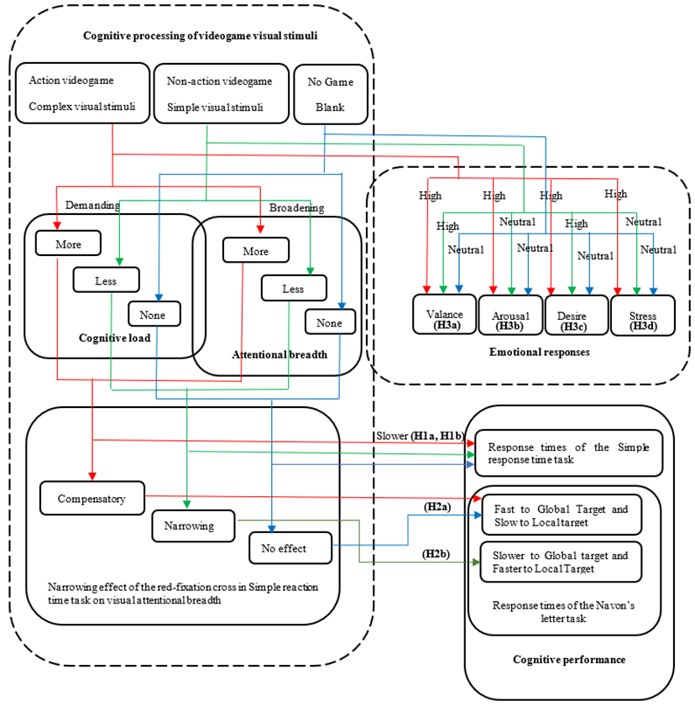Figure 1. The conceptual framework: Effects of viewing videogame visual stimuli on cognitive load, attentional breadth and emotional responses.

Moreover, action videogame stimuli differ from other games in that they are designed with an emphasis on peripheral visual field processing and divided attention (Bediou et al., 2023; Green and Bavelier, 2012); and playing this type of game can improve visual attentional breadth throughout the entire visual field (both central and peripheral visual processing). Thus, in addition, in the simple reaction time task, the red-fixation cross is likely to tune participants’ visual attention to the centre, causing a narrowing effect on visual attentional breadth. Interactions among these two cognitive processes of attentional breadth in the current study may imply that the demand of the ongoing cognitive processes caused by viewing the action videogame visual stimuli (cf. cognitive load theory, Chandler & Sweller, 1991; Sweller, 1988) may override the narrowing effect of the red-fixation cross in the simple reaction time task, affecting participants’ mechanisms of attentional breadth at different levels (e.g., measured in the visual and perceptual levels, but affected at the cognitive level). Therefore, it was assumed that such lingering cognitive effects on subsequent attentional breadth would be greater after viewing the action videogame stimuli hence producing a compensatory effect on the narrowing visual attentional breadth. Whereas, the other two conditions (NAG and NoG) would not have such compensatory effect, hence, NAG may show a narrowing effect on attentional breadth; whereas NoG may show no effect.
Attentional breadth can be measured by Navon’s paradigm (Navon, 1977), which present large letters (global level) composed of small letters (local level) in Navon letter task. Within this task, participants are instructed to respond to a composition stimulus at either the large letter or small letter as fast as possible. Typical results are consistently reliable that more interference derived from the global information with local processing than vice versa, indicating the global precedence effect (c.f., Navon, 1981). Dale and Arnell (2013) found the global precedence effect measured using Navon letter tasks were highly reliable (the test–retest reliabilities for global and local letters were r = .66 and .73, respectively), although this test may only measure a distinct aspect of global-local processing associated with attentional breadth (for more details see Dale & Arnell (2013) and section 3.2.3 of the present paper), and in doing so it was hypothesized:
H2a: Viewing action videogame visual stimuli will not reduce attentional breadth, resulting in no differences in reaction times for global targets between the action game condition and the no-game condition, and no differences in reaction times for local targets between the actiongame condition and the no-game condition.
H2b: Viewing non-action videogame visual stimuli will reduce attentional breadth, resulting in slower response times to global targets, and faster response times to local targets in comparison with action videogame condition and no-game condition.
Finally, in terms of investigating the effects of videogame stimuli on affective processes, following from Yeh (2015), it is assumed that viewing action videogame stimuli will also active positive emotions (i.e., pleasantness and desire), coupled with a high level of arousal and stress, compared to the non-action and no-game condition. Therefore, it was hypothesized that:
H3a: Viewing both the action videogame and the non-action videogame visual stimuli will evoke similar degrees of pleasant emotions (i.e., valence) which are higher than the no game condition.
H3b: Viewing the action videogame visual stimuli will evoke greater arousal than viewing the non-action videogame visual stimuli and the no game condition.
H3c: Viewing both action and non-action videogame visual stimuli will evoke similar levels of desire which are higher than the no game condition.
H3d: Viewing action videogame visual stimuli will evoke more stress than viewing non-action videogame visual stimuli and the no game condition.

Methodology

3.1 Participants

Twenty-four undergraduate psychology students took part in the current study (Mean age = 21.63; SD = 3.94; Range 18 - 32 years; 10 males, 14 females). A formal a priori power analysis was not conducted and the sample size of 24 was chosen prior to data collection, based on the sample sizes of similar studies on the psychological effects of action videogames (e.g., Libertus et al., 2017) and studies using global/local processing tasks (e.g., Gerlach & Krumborg, 2014; Helton, 2008). To avoid discrepancy in previous gaming experience, the criterion for inclusion was being a nonvideo game player (Green & Bavelier, 2006), with no more than 5-hours game experience a week in the past 6 months (M_{hours} = 1.96 hrs, SD = 1.58 hrs). All participants reported normal or corrected-to-normal vision. Course credits were awarded for participation. The study was fully approved by the Ethics Committee of Liverpool Hope University.

3.2 Materials

3.2.1 Snapshots of videogames
A greater variety of visual objects are presented in Light Heroes (see A, B, C in Figure 2, e.g., heroes, enemies, etc) compared to Clusterz (see D, E, F in Figure 2), in which only bubbles and several black circles are displayed. In Light Heroes, the “cognitive contents” of visual objects are also richer than that in Clusterz (for more details of the games, please see Yeh, 2015). Strictly speaking, Light Heroes is an “action-like” (point-and-click, shooter, and role-playing) videogame; which can be differentiated from other first-person and third-person shooting games that have recently been defined as the two main types of action videogames (Bediou et al., 2023; Parong et al., 2021). We chose this 2D simple action-like videogame for the same reason to reduce the complexity of cognitive load and to make better comparison for another 2D non-action videogame, Clusterz.
Forty snapshots of two online videogames were obtained. Snapshots were equated on low-level stimulus properties (size & luminance; Harrison & McCann, 2014). Another 40 black blank screens were created for the no-game condition.

 | D.  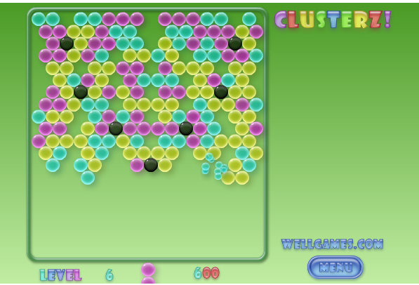
B   | E.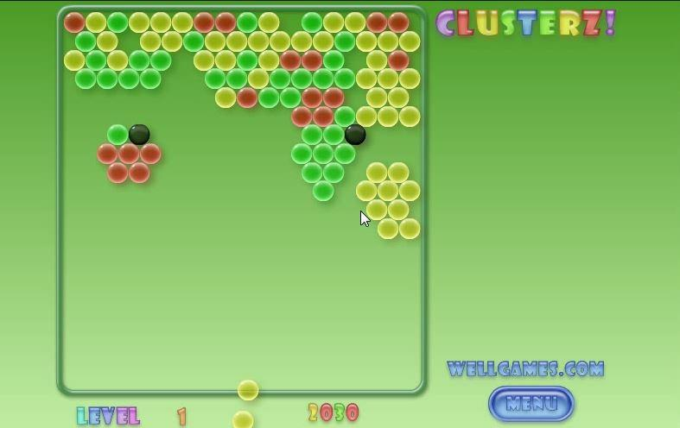
C. | F.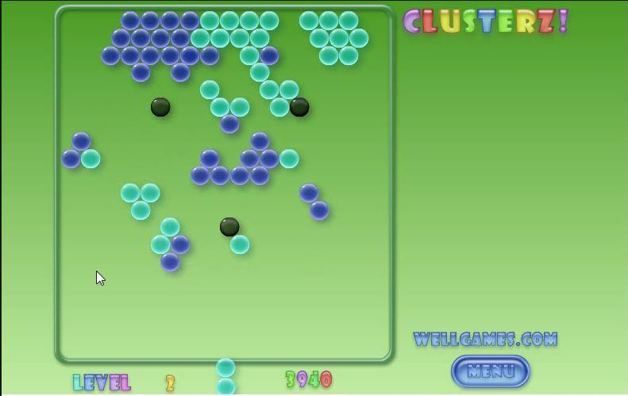
Figure 2. Screenshot of the videogame play: Light Heroes (A, B, C,) and Clusterz (D, E, F)

3.2.2 Simple reaction time task
A simple reaction time task ensured that participants’ visual attention was focused on the centre of the videogame snapshots throughout the videogame images exposure. This task also provides a measure of cognitive load (Brunken et al., 2003). There were 32 trials of the simple reaction time task per condition. Each trial (see Figure 3) started with a blank screen presented for 3000 ms, followed by a central fixation point displayed for 2000 ms, followed by a snapshot of the game image (either a snapshot of Light Heroes in AG condition, or of Clusters in NAG condition or a black blank screen in NoG condition) which appeared in the centre of the screen for a duration of at least 3000 ms. During this period, a red fixation-cross appeared at a random time between 1000 – 2000 ms at the centre of each game image. Participants were required to press the spacebar on detection of the red-fixation cross and ignore the game image. After a response, both the game image and the red-fixation cross disappeared, followed by a blank screen for 2000 ms. Response times (RTs) to the red fixation-cross were collected, as a measure of the cognitive load demanded in each condition (Brunken et al., 2003).

3.2.3 Navon’s letter task
Previous studies have used Navon’s letter task (1977) to measure attentional breadth (Förster & Higgins, 2005; Gable & Harmon-Jones, 2008). Following the design of the letter stimuli in the Navon’s task used by Förster and Higgins (2005), there were eight letter stimuli in the form of global composite letters, including large letters composed of small letters. As shown in Table 1, there were four global targets (Ts made of small Ls and Fs, and Hs made of small Ls and Fs), and four local targets (Ls made of Ts and Hs, and Fs made of Ts and Hs).
 | Target letters
 | T | H
Global  Target | L L L L L  L  L  L  L  F F F F F  F  F  F  F | L L  L L  L L L L L  L L  L L  H H  H H  H H H H H  H H  H H
Local  Target | T  T  T  T  T T T T T  H  H  H  H  H H H H H | T T T T T  T  T T T T T  T  T  H H H H H  H  H H H H H  H  H
Table 1. Letter Stimuli in the Navon’s Letter Task

There were 32 trials of the Navon’s letter task in each game condition, with each of the 8 global/local target stimuli presented 4 times in random order. Following completion of each trial in the simple reaction time task, and after a blank screen shown for 2000 ms, in each trial of the Navon’s letter task (see Figure 3) there appeared a 500 ms fixation point in the centre of the screen. Subsequently a global/local letter stimulus appeared and remained visible in the centre of the screen until participants responded by pressing either the target “T” or target “H” as rapidly and accurately as possible on a response pad.
Only correct RTs were analysed. Faster responses to the global targets than to the local targets represent a global (broader) attentional breadth, whereas faster responses to the local letters represent a local (narrower) attentional breadth (Gable & Harmon-Jones, 2008; Förster & Higgins, 2005). To analyse this we calculated a Global-Local Precedence index (Gerlach & Poirel, 2018) by calculating the difference in mean RTs to global and local judgements for each game type (i.e., mean RTs for local condition minus mean RTs for global condition).

3.2.4 Self-rating emotion scale
Emotional responses were measured using a self-report scale (Gable & Harmon-Jones, 2008; Yeh, 2015), after the completion of measuring cognitive performance at the end of each block. At the end of each block, 8 randomly chosen snapshots in each condition were presented to remind participants of the images of the games. They were then asked to indicate how they were feeling while seeing these images on a 9-point rating scale: valence (1: very unpleasant; 9: very pleasant), arousal (1: calm; 9: exciting), desire (1: did not desire; 9: really desired; “While viewing the picture how much desire did you feel?”), and stress (1: not stressed; 9: really stressed). For example, participants were asked to “indicate to what extent you felt this way while viewing the picture taken from the videogame/blank screen by circling the number from 1 (very unpleasant) to 9 (very pleasant). Valence and arousal were measured by adapting the Self-Assessment Manikin (Bradley & Lang, 1994) which is often used to assess affective reaction in various contexts and emotion studies.

3.2.5 Apparatus
All the above materials including images of videogames, simple reaction time task, Navon’s letter task, and self-rating emotional scale were presented on a 17-inch monitor. The viewing distance was approximately 60 cm. The experiment was controlled using E-prime 2.0.

3.3 Procedure
The experiment took place in a quiet room. On arrival, each participant was introduced with a brief description of this study, and provided their consent to partake in this study, following completion of a basic demographic form. Eight practice trials, each including a trial of the simple reaction time task and of the Navon’s letter task, were presented for practice. Each participant then moved on to complete all three game conditions respectively (AG, NAG, and NoG) in a randomised order. To ensure an equal number of participants took part in each possible set of game orders, 6 different versions of the study were created in which each version had one of the 6 possible game orders, and each game order was completed by an equal number of participants – ensuring that the number of participants in each version was balanced.
Each game condition included 32 trials which were counterbalanced. Each trial was composed of a trial of the simple reaction time task followed by a trial of the Navon’s letter task (See Figure 3). There was an inter-trial interval of 3000 ms before the next trial started. To measure participants’ emotional responses, after the completion of all 32 trials in each condition, 8 corresponding game/no game images were presented in a random order to participants to recall their emotional responses and then they indicated their emotional reaction during viewing these images on the self-rating emotional scale before they moved on to the next condition. After they completed all three conditions, participants were debriefed. The total duration of the experiment was approximately 30 minutes.
Data from this study is available on the Open Science Framework (https://osf.io/x258y/).
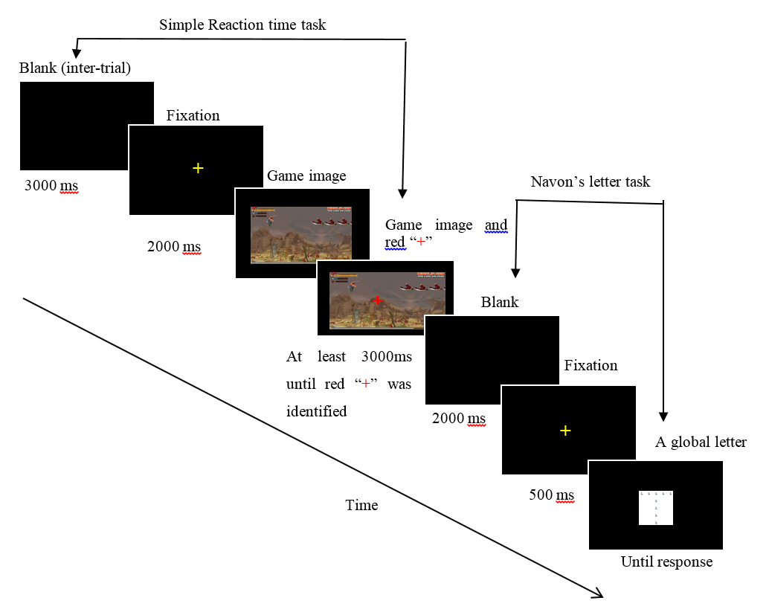
Figure 3. A trial of a simple reaction time task and a Navon’s letter task

Results

4.1 Simple reaction time task
To examine the differences in cognitive load demanded by different types of visual stimuli in videogames, a one-way repeated measures ANOVA was conducted with the within-subject factor of Game Type (AG, NAG and NoG) with the mean RT across all 32 trials for each condition as the dependent variable. Means and standard deviations of the response times are presented in Table 2. There was a marginally significant main effect of Game Type (F (2, 46) = 3.10, p = .055). Planned contrasts revealed no difference between AG and NAG conditions (t(23) = .82, p = .42), and no difference between NAG and NoG conditions (t(23) = 1.464, p = .157). However, RTs in the AG condition were significantly slower than RTs in the NoG condition (t(23) = 3.0, p = .007). Therefore, Hypothesis 1a was not accepted, however Hypothesis 1b was accepted.

 | Game Type
 | AG | NAG | NoG
 | M (SD) | M (SD) | M (SD)
 | 421.40 (115.20) | 410.44 (132.34) | 390.23 (108.37)
Table 2. Means and Standard Deviations of Response Times (ms) by condition in the simple reaction time task. Note: AG: Actiongame; NAG: Non-action game; NoG: No game

4.2 Navon’s letter task
To test the effects of videogame stimuli on attentional breadth, responses times (RTs) on Navon’s letter task were analysed (means and standard deviations are presented in Table 3). Accuracy rates were high (between 96.13% and 98.94%) and did not differ between conditions (F(3.72, 85.59) = 1.95, p = .114). We performed a two-way repeated measures ANOVA with the factors Game Type (AG, NAG and NoG) and Navon Condition (global, local). There was no main effect of Game Type (F(2,46) = 1.58, p = .218) and no main effect of Navon Condition (F(1,23) = 2.62, p = .119). There was a significant interaction between Game Type and Navon Condition (F(2, 46) = 6.20, p = .004). To investigate Hypothesis 2a, RTs in response to the global targets were compared between the action game condition and the no-game condition. A paired t-test found no significant difference (t(23) = 1.66, p = .11). We then compared RTs in response to local targets between the action game condition and the no-game condition. A paired t-test found no significant difference (t(23) = 0.95, p = .93). Hypothesis 2a was therefore accepted.
To examine hypothesis H2b, we computed a Global-Local Precedence index (Gerlach & Poirel, 2018), by calculating the difference in mean RTs to global and local judgements for each game type. This is equivalent to the interaction effect reported in the ANOVA above. Positive values on this index indicate faster processing of global compared with local shape information. A one-way within-subjects ANOVA was performed on the Global-Local Precedence index with the factor Game Type (AG, NAG, and NoG). We found a significant main effect of Game Type (F(2,46) = 6.20, p = .004). Planned contrasts revealed that the Global-Local Processing index was lower in the NAG condition (M = -30.3, SD = 143.2) compared to the AG condition (M = 37.8, SD = 126.5) (t(23) = 2.69, p = .013). The Global-Local Processing index was also lower for the NAG condition compared to the No game condition (M = 96.7, SD = 167.0) (t(23) = 3.02, p = .006). These results indicate a narrowed attentional focus in the non-action game, therefore Hypothesis 2b was accepted.

 | Game Type
 | AG | NAG | NoG
Target type | M (SD) | M (SD) | M (SD)
Global | 951.82 (370.61) | 927.43 (364.34) | 888.04 (328.60)
Local | 989.64 (319.21) | 897.13 (299.41) | 984.73 (384.48)
GLP | 37.82 (126.47) | -30.30 (143.23) | 96.69 (166.99)

Table 3. Means and Standard Deviations of Response Times (ms) by target type and condition (N=24). GLP = Global-Local Precedence Index

Figure 4. Results from Navon’s letter task: Mean responses times of interaction by condition and target type

4.3 Emotional responses
To explore emotional responses elicited by visual stimuli in different types of videogame, a within-subject MANOVA was performed (Pillai’s trace, V = .49) with game type (AG, NAG, NoG) as the within-subject factor and the self-reported emotional responses (valence, arousal, desire, stress) as the dependant variables. Table 4 shows descriptive statistics of the rating scale responses. There was a significant multivariate effect of game type on the four emotional responses F(8, 88) = 3.60, p = .001, $η_{p}^{2}$ = .25. Univariate analyses showed there were significant univariate effect among pleasantness: F(2, 46) = 6.20, p = .004, $η_{p}^{2}$ = .21, arousal: F(2, 46) = 4.22, p = .02, $η_{p}^{2}$ = .16 and stress: F(2, 46) = 3.90, p = .03, $η_{p}^{2}$ = .15. However, the levels of desire elicited among three conditions were not significantly different; F(2, 46) = 2.12, p = .13, $η_{p}^{2}$ = .08. Furthermore, pairwise comparisons showed that, 1) AG stimuli elicited significantly less pleasantness than NAG visual stimuli (p = .003); 2) AG visual stimuli significantly elicited stronger arousal than NoG stimuli (p = .04), but no difference to NAG stimuli (p = 1.00); and 3) stress elicited in AG condition was significantly stronger than in NAG condition (p = .03). H3a (Valence) and H3c (Desire) were not verified, and H3b (Arousal) and H3d (Stress) were partially verified.
Condition
 | AG | NAG | NoG
Emotional responses | M (SD) | M (SD) | M (SD)
Valence | 4.69ª (1.17) | 5.79^{b}(1.19) | 5.26 (1.23)
Arousal | 4.23ª (1.83) | 4.16 (1.94) | 3.40^{b} (1.64)
Desire | 2.40 (1.54) | 2.99 (1.86) | 2.70 (1.48)
Stress | 2.16ª(1.45) | 1.69^{b} (1.10) | 1.55(.77)

Table 4. Means and Standard Deviations of Emotional responses by conditions (n = 24). Note: Means with different superscripts in the same row differ significantly at the p < .05 level using pairwise comparisons (Bonferroni).

5. Discussion

5.1 Summary of findings
The goal of the present research was to investigate the effects of action and non-action videogame stimuli on cognitive load and attentional breadth, as well as to explore emotional responses to videogame stimuli. Results showed that, contrary to our prediction, the response times in the simple reaction time task after viewing action videogame stimuli were not significantly different to the non-action videogame, whereas, as we predicted, they were slower compared to the no game condition. Further, we showed that the response times in the simple reaction time task did not differ between non-action videogame condition and no game condition.
Results from the Navon’s letter task revealed that viewing the action videogame, Light Heroes, did not reduce attentional breadth after the exposure of red-fixation cross manipulated in the simple reaction time task, resulting in no significant differences in response times to global and local targets in comparison with no game condition. We found a greater global-local precedence effect in the action game compared to the non-action videogame, and a greater global-local precedence effect in the no-game condition compared to the non-action videogame. In terms of emotional responses, viewing Light Heroes visual stimuli were less pleasant than viewing Clusterz, more arousing than NoG condition, more stressful than NAG, and had no difference of desire in relation to viewing Clusterz and NoG conditions.

5.2 Viewing complex action videogame stimuli demanded higher cognitive load
Results in the simple RT task showed that viewing the action videogame, Light Heroes, did not slow responses to the red-fixation cross compared to viewing the non-action videogame, Clusterz. However, the action videogame did decrease RTs in comparison to the no game condition. Furthermore, there were no significant differences in the response times between non-action videogames (Clusterz) and no game condition either.
The above results can be explained by both the cognitive load theory (Chandler & Sweller, 1991; Sweller, 1988), and gameplay schema. In terms of gameplay schema, visual stimuli in different forms embedded in the videogames may involve different cognitive functions, hence influence subsequent information processing differently (Kalyuga & Plass, 2009; Lawrence, 2006). And, based on cognitive load theory, the only “task-relevant information” (i.e., intrinsic cognitive load) designed in the current study was “pressing the red-fixation cross when it appears” across all three conditions. However, in the Light Heroes visual stimuli there is much more task irrelevant information - the ‘extraneous cognitive load’ (e.g., the images of enemies and weapons signifying information about the task actions of destroying the enemy and avoiding attacks, the background of the battlefields etc), compared to the non-action videogame stimuli, Clusterz, where the different coloured round bubbles that form different geometric shapes of images are much simpler task irrelevant information.
As hypothesized, the results show that viewing action videogame stimuli was associated with a significantly greater cognitive load than the no game condition. This result supports the notion that the more complex the visual stimuli, the higher demand of cognitive load. Similarly, based on the gameplay schema theory (Lindley & Sennersten, 2008), visual stimuli in Light Heroes, such as a fuel or a weapon in a battlefield, may trigger other signals of related cognitive schemas and relevant conceptual information which help with comprehension of the game contexts, and interpretations of the themes. These gameplay schemas may carry different conceptual meanings for the higher order cognitive processes. Hence, more cognitive load was needed in the action game condition in relation to the no game condition.
However, our results showed no significant differences in the demand of cognitive load between viewing action and non-action videogame stimuli. This result does not support the notion that the more complex the visual stimuli, the more demand the cognitive load. Conceivably, this may be due to the following reasons. Firstly, the study was likely to have been may underpowered and therefore unable to detect small differences in response times between the action and non-action videogames. Alternatively, it is possible that the quantity of the visual stimuli might be an important factor which affects the overall cognitive load. Although it was assumed that images created in Light Heroes may be more complex and may possess more extraneous and germane cognitive load, it can be argued that the number of each type of visual stimuli between two types of games might be similar, resulting in no difference of overall cognitive load between action and non-action videogame condition. Future research might take the quantity of the visual stimuli as a variable into consideration as an important factor which may affect the overall cognitive load. Lastly, it is feasible that the simple reaction time task was not sensitive enough to reflect the cognitive load differences between the two different types of videogame images.
Failure to observe differences between the action and non-action videogame condition could also potentially be due to the fact that static pictures extracted from videogames do not fully reflect the actual cognitive demands imposed whilst gamers dynamically play the game. Unlike other video game research (Dale et al., 2020; Spencer & Feng, 2010), it could be that the static snapshots of visual stimuli in the current study had significantly removed some lingering effects caused by rapid movements and unexpected appearance of the visual stimuli as well as the interactivity between the players and cognitive demands triggered by different forms of visual stimuli in games. It could also be due to the choice of the action videogame (Light Heroes), which is a simple 2D “action-like” game. differing from other action video games that used first-person or third-person shooting games. The above reasons are feasible to explain why the result showed that there was no significant difference in cognitive load between the non-action videogame condition and the no-game condition – which is opposed to what is expected from the theoretical assumption. In future studies, other measures such as self-report scales, or psychophysiological measures, may be used to differentiate between cognitive load in these two conditions.

5.3 Effects of viewing videogame stimuli on attentional breadth
Results for the Navon’s letter task showed that the response times to global and local letters did not differ between the action game condition and the no-game condition. We also computed a Global-Local Precedence index, by calculating the difference in RTs to global and local judgements for each game type, where more positive values are indicative of faster processing of global compared with local shape information. Results found that the Global-Local precedence index was lower for the non-action videogame compared to the action videogame, and also lower for the non-action videogame compared to the no-game condition. These results indicate that the narrowing effect produced by the presentation of the red-fixation cross on the simple reaction time task in the NAG condition was extended to the subsequent attentional processing in the Navon’s letter task. This effect was not present in the action videogame condition. The red-fixation cross in the simple reaction time task is seen as a prime intended to narrow attentional breadth which can be reflected by a lower Global-Local Precedence effect in the NAG condition. These results suggest that the ineffectiveness of the narrowing effect due to the red-fixation cross in the AG condition may be due to the complexity of visual stimuli designed in Light Heroes, which appeared and was displayed in the entire visual field including the peripheral visual fields (e.g., different forms of enemies and weapons), in comparison with the simpler visual design (coloured bubbles) in Clusterz. In other words, the more complex forms of visual stimuli in action videogames may broaden ones’ attentional breadth, in comparison to simpler visual designs.
This provides further evidence to support the notion that the action videogame stimuli implicitly affected other internal higher order cognitive processes such as “cognitive” attentional breadth (Friedman et al., 2003), and that these continued to affect subsequent cognitive processes, i.e., attentional breadth as measured using Navon’s letter task. Such higher-order cognitive processes triggered by viewing visual stimuli in action videogames may have inhibited the lower order attentional processes, such as avoiding the narrowing effect of the red-fixation cross in the simple reaction time task and resulting in no subsequent differences in global and local response times in the Navon’s letter task. The greater demands of viewing complex action videogame stimuli in working memory capacity may have affected the subsequent attentional processes (Ahmed & de Fockert, 2012). The results of the current study provide further evidence that action videogame play may have a broadening effect on visual attentional breadth, in line with results from previous computer game studies (Bediou et al., 2023; Chisholm et al., 2010; Green & Bavelier, 2006; West et al., 2008).

5.4 Emotional responses of viewing videogame stimuli and potential effects on cognitive processes
The results regarding emotional responses elicited by viewing images of videogames are somewhat different from the emotional responses elicited by playing actual videogames in the study of Yeh (2015), even though the same action and non-action videogames were used in both studies. The results reported by Yeh (2015) supported the proposed three-dimension model of emotions elicited during videogame play, showing that both types of videogame play elicited similarly high levels of positive affect, coupled with high levels of approach motivation (i.e., desire, Gable & Harmon-Jones, 2008; 2010), yet emotional responses differed in the arousal dimension. However, the current study showed that viewing action videogame stimuli was less pleasant and more stressful than viewing non-action videogame stimuli, and both types of game stimuli did not differ at the level of desire.
To explain this apparent discrepancy, it can be suggested that the complex emotional experiences in all three dimensions elicited during videogame play in Yeh’s (2015) study make it difficult to systematically examine the effect of each emotion dimension on cognitive skills (e.g., attentional breadth). Such complexity of emotion may be caused by not only the cognitive mechanisms embedded within the game design (e.g., manipulations of visual attentional breadth, the design of gameplay schemas and goal setting), as well as the interactivity, competitions and the pleasure of control between the game design and the players associated with goal-setting nature of videogame play (Grodal, 2000; Vorderer et al., 2003).
Differently, in the current study, the interactivity between the game contexts and players was removed by only presenting snapshots of videogame images for viewing. This may be the reason for the reduced pleasantness level in the action videogame condition, for no significant differences in desire among all three conditions, and no difference in arousal between action and non-action videogame conditions. This echoes the concept of “interactivity” embedded within the nature of videogame play that makes videogame play pleasant, fun and desirable (Denis & Jouvelot, 2005; Ferguson, 2007; Vorderer et al., 2003). Therefore, the role of visual stimuli designed within games, although also eliciting various forms of emotional responses, may not play a significant role in eliciting pleasantness and desire during videogaming. In fact, by viewing the visual stimuli designed in Light Heroes, such as battlefields, enemies, weapons, fires and etc., actually elicited significantly more negative emotions than the viewing images of Clusterz.
The link between emotions elicited by videogame play and cognitive processing has been of growing interest, however, there is a lack of consistent findings on the effects of emotions on cognitive processing and attentional breadth. Research on emotion-cognition literature traditionally, using emotion-elicitation methods such as viewing emotionally-charged pictures or films, and recalling emotional memories, such as Fredrickson and Branigan (2005) and Gasper and Clore (2002) advocate the notion that positive emotions broaden attentional breadth due to a more global and heuristic attentional bias, whereas negative emotions narrow attentional breadth due to less global bias but more local bias.
Conversely, Gable and Harmon-Jones (2008) further differentiated that only those positive emotions which are “low” in approach motivation (e.g. amusement evoked by viewing a humorous film) would broaden attentional breadth, whereas, those positive emotions “high” in approach motivation actually narrowed the attentional breadth. Correspondingly, Gable and colleagues (Gable & Harmon-Jones, 2010a, 2010b; Harmon-Jones et al., 2013) also stated the same pattern of effects of negative emotions vary in the intensity of withdrawal motivation (high: disgust, stress; low: sad). Although the current study found that viewing non-action videogame stimuli elicited positive emotional states, and there was an interaction effect on attentional breadth in the same condition, the current study cannot make direct inference on the emotion-cognitive link.
The current results showing a higher arousal state after viewing the action videogame stimuli and the compensatory effect on the narrowing of attentional breadth may suggest that emotional arousal is a sign of higher cognitive load and cognitive processing. This view partially echoes Yeh’s (2015) notion that positive affect coupled with higher arousal may facilitate creative performance. However, viewing action videogame stimuli did not elicit positive affect, which is usually associated with a broadening of attentional/perceptual breadth (Fredrickson & Branigan, 2005; Gable & Haidt, 2005; Gasper & Clore, 2002). This implies that if there would be any effect of emotions elicited after viewing visual stimuli in videogames, then their effects may be overridden by the demands of other cognitive tasks. This notion is in line with results from a fMRI study by Van Dillen et al. (2009) which showed that the effects of cognitive load induced by another cognitive tasks (such as an arithmetic task) decreased the effects of emotions on the performances of subsequent cognitive tasks which required logical reasoning. However, the study of Van Dillen et al. (2009) did not consider the cognitive effect of the emotional content within the visual stimuli.
The emotions evoked by viewing videogame visual stimuli may be more complex than other traditional means of emotion elicitation techniques, such as viewing other forms of emotional visual stimuli, or recalling emotional memories. Thus, the result of this study can be better interpreted by the tri-dimensional model of emotions suggested by Yeh (2015), although the present study focusing viewing videogame stimuli rather than playing videogames. Together, it is emphasized that arousal should be an important emotional dimension to the effects on creative processes when investigating the emotional effects of different types of videogames on subsequent creative processes. In her study, in relation to the link between emotion, creativity and videogame play, Yeh (2015) also advocated that the emotional state of positive emotions coupled with high arousal after playing an action videogame may activate a broadened “cognitive” attentional breadth in comparison to a non-action videogame, however, there was no such evidence as a proof in her study. This may be due to several complex causes, such as the exposure of highly intense visual and audio stimuli, the demand of behavioural responses through eye-hand coordination during playing videogames. Therefore, the current research sort to reduce the complexity of such complex sensational experiences of videogame play in order to explore the link between emotions and attentional breadth by purely focusing on the emotional effect of visual stimuli of videogames on the cognitive processes and excluding other factors such as eye-hand coordination which may increase alertness, arousal and sometimes stress.

5.5 Limitations and Implications
The findings of this study imply that visual stimuli and the conceptual information attached to them varying in different types of videogames may trigger effects which affect other internal (top-town) and external (bottom-up) cognitive processes (such as cognitive attentional breadth and visual/perceptual attentional breadth). In affecting top-down cognitive processes, different forms of gameplay schemas related to the stimuli may be triggered. These different forms of cognitive representation may then trigger other cognitive materials and units and other higher cognitive processes; the effect of such can then be transferred and carried over to affect the subsequent cognitive processes (including visual attentional breadth) after the exposure of these visual stimuli designed in game contexts unconsciously without awareness (Shiffrin & Schneider, 1977).
A potential shortcoming of the current study was that the types and number of videogame displays were somewhat limited. The comparison between action and non-action videogame visual stimuli was only based on Light Heroes and Cluterz with a contrast that the former was designed with much more complex visual features than the latter. The implication of the result hence is limited to those games which are similar to the ones chosen by the current study. Therefore, future research could further explore effects of visual stimuli designed in other different types of videogames (such as role-playing games). Moreover, here we used a blank screen as the non-game condition, but a more complex type of non-game condition stimulus, such as an emotionally neutral image of nature, could provide a more useful comparison of cognitive load and attentional breadth in relation to the videogame stimuli conditions. Furthermore, it would also be interesting to see whether visual stimuli presented in videogames can achieve greater ecological validity similar to the real game play experiences, although, however, excluding the effect of interactivity. Such studies may help to provide new knowledge of the cognitive mechanisms and emotional responses, which may explain the reasons why that there are many people who like to spend a lot of time viewing others playing videogames (Kaytoue, Silva, Cerf, Meira, & Raïssi, 2012).
Many real-world videogames involve both images and sound, therefore future research could usefully investigate how the effects of videogame stimuli in other modalities (e.g., auditory stimuli) affect perceptual, cognitive, and affective processes. For example, it is known that visual attention is modulated by emotional sounds (Harrison & Davies, 2013), therefore the effects of videogames stimuli on visual attention would likely be influenced by accompanying affective auditory stimuli. Furthermore, visual cues can influence auditory attention (Harrison & Woodhouse, 2016), therefore future studies could investigate the extent to which different types of visual videogame stimuli influence players’ attention to sounds.
Lastly, two points should be noted in relation to the sample used in the study. Firstly, only young adults were recruited as participants, whereas age might be a further factor that could affect cognitive processing and performance during exposure to videogame stimuli. Hence, the interpretation and implication of the current study is limited to young adults, and future research may usefully investigate how age and cognitive development affect cognitive processing of videogames. Secondly, the sample size of 24 participants was relatively small. While the findings provide valuable insights, we cannot rule out that the limited number of participants may affect the generalizability of the results and that any null results were due to the study being underpowered. Future research should aim to replicate this study with a larger sample size to confirm the findings and ensure they are representative of a broader population. A larger sample size would enhance the statistical power of the study and provide more robust evidence for the observed effects.

6. Conclusion
Few research studies to date have sought to examine the effects of videogame play on creativity. Specifically, because creative thinking processes are very complex, to unpick our understanding of the processes, studies are required that focus on specific elements as highlighted in videogame-creativity relevant literature (i.e., cognitive load, attentional breadth and emotions), as well as examining the relationships amongst them.
The present research was original and interdisciplinary: In this study, a conceptual framework was created (see Figure 1) to examine the interplay between the effects of videogames on creativity-related cognitive processes (e.g., cognitive load and attentional breadth), and the role of emotions that are involved in this process. The current study explored the effects of an action videogame and a non-action videogame on cognitive load and attentional breadth which are closely related to creative cognitive processes, and how emotions evoked by the exposure of these different types of videogame stimuli may interfere with such effects. The first theoretical hypothesis on cognitive load was partially supported by the results, supporting the notion that the more complex the videogame visual stimuli the higher the demand for cognitive load. However, the quantity of the visual stimuli, different types of measurements of the cognitive load are worth taking into consideration in future studies to provide further evidence.
Results of the current study also support the second hypothesis that the exposure to the action videogame stimuli has the lingering broadening effect on viewers’ attentional breadth in comparison with the non-action videogame condition. The third hypothesis on emotional responses was not completely supported by the results, suggesting that without interactivity designed to cultivate pleasantness and desire during videogame play, viewing action videogame visual stimuli remain to elicit higher arousal and stress in relation to non-action and no game condition.
Overall, the current study showed that visual stimuli used in action and non-action videogames differentially affect creativity-related elements of cognition and emotions. The cognitive representations of the information carried within the visual display are likely to be processed continuously and their effects remain even when other subsequent cognitive tasks are performed, as the mere visual displays of the videogames are found to affect subsequent emotions and cognitive processes. That said, future research should aim to replicate this study with a larger sample size to confirm the findings and ensure they are representative of a broader population.

Conflict of Interest

We have no known conflict of interest to disclose.

References
Ahmed, L., & de Fockert, J. W. (2012). Working memory load can both improve and impair selective attention: Evidence from the Navon paradigm. Attention, Perception, and Psychophysics. http://doi.org/10.3758/s13414-012-0357-1
Anderson, R. C., Beghetto, R. A., Glăveanu, V., & Basu, M. (2023). Is Curiosity Killed by the CAT? A Divergent, Open-Ended, and Generative (DOG) Approach to Creativity Assessment. Creativity Research Journal, Advance online publication. https://doi.org/10.1080/10400419.2022.2157588
Angelelli, C. V., Ribeiro, G. M. de C., Severino, M. R., Johnstone, E., Borzenkova, G., & da Silva, D. C. O. (2023). Developing critical thinking skills through gamification. Thinking Skills and Creativity, 101354. https://doi.org/10.1016/j.tsc.2023.101354
Atkinson, A. P., & Adolphs, R. (2005). Visual emotion perception: Mechanisms and processes. In L. Feldman-Barrett, P.M. Niedenthal, and P. Winkielman (Eds.). Emotion and Consciousness, pp. 150-182. New York: Guilford Press.
Ashby, F. G., & Isen, A. M. (1999). A neuropsychological theory of positive affect and its influence on cognition. Psychological Review, 106(3), 529. https://doi.org/10.1037/0033-295X.106.3.529
Baddeley, A. (1992). Working memory - the interface between memory and cognition. Journal of Cognitive Neuroscience, 4(3), 281–288. http://doi.org/DOI 10.1162/jocn.1992.4.3.281
Baddeley, A. (2012). Working memory: theories, models, and controversies. Annual Review of Psychology, 63, 1–29. http://doi.org/10.1146/annurev-psych-120710-100422
Ball, K. K., Beard, B. L., Roenker, D. L., Miller, R. L., & Griggs, D. S. (1988). Age and visual search: Expanding the useful field of view. JOSA A, 5(12), 2210-2219. http://doi.org/10.1364/josaa.5.002210
Beaty, R. E., Silvia, P. J., Nusbaum, E. C., Jauk, E., & Benedek, M. (2014). The roles of associative and executive processes in creative cognition. Memory & cognition, 42, 1186-1197. https://doi.org/10.3758/s13421-014-0428-8
Bediou, B., Rodgers, M. A., Tipton, E., Mayer, R. E., Green, C. S., & Bavelier, D. (2023). Effects of Action Video Game Play on Cognitive Skills: A Meta-Analysis. Technology, Mind, and Behavior, 4(1: Spring 2023). https://doi.org/10.1037/TMB0000102
Bennett, S., Maton, K., & Kervin, L. (2008). The “digital natives” debate: A critical review of the evidence. British Journal of Educational Technology, 39, 775–786. http://doi.org/10.1111/j.1467-8535.2007.00793.x
Blanco-Herrera, J. A., Gentile, D. A., & Rokkum, J. N. (2019). Video games can increase creativity, but with caveats. Creativity Research Journal, 31(2), 119-131. ICS
Boot, W. R., Kramer, A. F., Simons, D. J., Fabiani, M., & Gratton, G. (2008). The effects of video game playing on attention, memory, and executive control. Acta Psychologica, 129(3), 387–398. http://doi.org/10.1016/j.actpsy.2008.09.005
Bowman, N. D. (2018). The demanding nature of video game play. In N. D. Bowman (Ed) Video Games: A Medium That Demands Our Attention (pp. 1-24). New York: Routledge.
Bradley, M., & Lang, P. J. (1994). Measuring emotion: The self-assessment manikin and the semantic differential. Journal of Bahavioral Therapy & Experimental Psychiatry, 25, 49–59.
Brunken, R., Plass, J. J. L., Leutner, D., Brünken, R., & Plass, J. J. L. (2003). Direct measurement of cognitive load in multimedia learning. Educational Psychologist, 38(1), 53–61. http://doi.org/10.1207/S15326985EP3801_7
Chandler, P., & Sweller, J. (1991). Cognitive Load Theory and the Format of Instruction. Cognition and Instruction, 8(4), 293–332. http://doi.org/10.1207/s1532690xci0804_2
Chisholm, J. D., Hickey, C., Theeuwes, J., & Kingstone, A. (2010). Reduced attentional capture in action video game players. Attention, Perception & Psychophysics, 72, 667–671. http://doi.org/10.3758/APP.72.3.667
Chung, A., Busseri, M.A. & Arnell, K.M. (2022). Individual differences in naturally occurring affect predict conceptual breadth: evidence for the importance of arousal by valence interactions. Cognitive Research: Principles and Implications, 7(98), 1-12. https://doi.org/10.1186/s41235-022-00447-w
Dale, G., & Arnell, K. M. (2013). Investigating the stability of and relationships among global/local processing measures. Attention, Perception, & Psychophysics, 75, 394-406. https://doi.org/10.3758/s13414-012-0416-7
Dale, G., Joessel, A., Bavelier, D., & Green, C. S. (2020). A new look at the cognitive neuroscience of video game play. Annals of the New York Academy of Sciences, 1464(1), 192-203. https://doi.org/10.1111/nyas.14295
Denis, G., & Jouvelot, P. (2005). Motivation-driven educational game design: applying best practices to music education. In Proceedings of the 2005 ACM SIGCHI International Conference on Advances in computer entertainment technology (pp. 462–465). http://doi.org/10.1145/1178477.1178581
Eldar, E., Niv, Y., & Cohen, J. D. (2016). Do you see the forest or the tree? Neural gain and breadth versus focus in perceptual processing. Psychological Science, 27(12), 1632-1643. https://doi.org/10.1177/0956797616665578
Ferguson, C. J. (2007). The good, the bad and the ugly: a meta-analytic review of positive and negative effects of violent video games. Psychiatric Quarterly, 78, 309–316. http://doi.org/10.1007/s11126-007-9056-9
Förster, J., & Higgins, E. T. (2005). How global versus local perception fits regulatory focus. Psychological Science, 16(8), 631–636. http://doi.org/10.1111/j.1467-9280.2005.01586.x
Fredrickson, B. L., & Branigan, C. (2005). Positive emotions broaden the scope of attention and thought-action repertoires. Cognition & Emotion, 19, 313–332. http://doi.org/10.1080/02699930441000238
Friedman, R. S., Fishbach, A., Forster, J., & Werth, L. (2003). Attentional priming effects on creativity. Creativity Research Journal, 15(2&3), 277–286. http://doi.org/10.1207/S15326934CRJ152&3_18
Gable, P. A., & Harmon-Jones, E. (2008). Approach-motivated positive affect reduces breadth of attention. Psychological Science, 19(5), 476–483.https://doi.org/10.1111/j.1467-9280.2008.0211
Gable, P. A., & Harmon-Jones, E. (2010a). The blues broaden, but the nasty narrows: attentional consequences of negative affects low and high in motivational intensity. Psychological Science, 21(2), 211–5. http://doi.org/10.1177/0956797609359622
Gable, P. A., & Harmon-Jones, E. (2010b). The motivational dimensional model of affect: Implications for breadth of attention, memory, and cognitive categorisation. Cognition & Emotion, 24(2), 322–337. http://doi.org/10.1080/02699930903378305
Gable, S. L., & Haidt, J. (2005). What (and Why) Is Positive Psychology? Review of General Psychology, 9(2), 103–110. http://doi.org/10.1037/1089-2680.9.2.103
Gasper, K., & Clore, G. L. (2002). Attending to the big picture: mood and global versus local processing of visual information. Psychological Science : A Journal of the American Psychological Society / APS, 13, 34–40. http://doi.org/10.1111/1467-9280.00406
Gerlach, C., & Krumborg, J. R. (2014). Same, same — but different: On the use of Navon derived measures of global/local processing in studies of face processing. Acta Psychologica, 153, 28–38. https://doi.org/10.1016/j.actpsy.2014.09.004
Goldschmidt, G. (2015). Ubiquitous serendipity: Potential visual design stimuli are everywhere. In J. S. Gero (Ed.), Studying Visual and Spatial Reasoning for Design Creativity (pp. 205–214). Netherlands: Springer. http://doi.org/10.1007/978-94-017-9297-4_12
Goldschmidt, G., & Smolkov, M. (2006). Variances in the impact of visual stimuli on design problem solving performance. Design Studies, 27, 549–569. http://doi.org/10.1016/j.destud.2006.01.002
Granic, I., Lobel, A., & Engels, R. C. M. E. (2014). The benefits of playing video games. The American Psychologist, 69(1), 66–78. http://doi.org/10.1037/a0034857
Green, C. S., & Bavelier, D. (2006). Effect of action video games on the spatial distribution of visuospatial attention. Journal of Experimental Psychology. Human Perception and Performance, 32(6), 1465–78. http://doi.org/10.1037/0096-1523.32.6.1465
Green, C. S., & Bavelier, D. (2012). Learning, attentional control, and action video games. Current Biology : CB, 22(6), R197-206. http://doi.org/10.1016/j.cub.2012.02.012
Grodal, T. (2000). Video games and the pleasures of control. In D. Vorderer & Zillmann P. (Eds.), Media Entertainment: The Psychology of its Appeal (pp. 197–212). Mahwah, NJ: Lawrence Erlbaum Associates.
Harmon-Jones, E., Gable, P. a., & Price, T. F. (2013). Does negative affect always narrow and positive affect always broaden the mind? Considering the influence of motivational intensity on cognitive scope. Current Directions in Psychological Science, 22(4), 301–307. http://doi.org/10.1177/0963721413481353
Harrison, N. R., & McCann, A. (2014). The effect of colour and size on attentional bias to alcohol-related pictures. Psicológica, 35(1), 39-48.
Harrison, N. R., & Davies, S. J. (2013). Modulation of spatial attention to visual targets by emotional environmental sounds. Psychology & Neuroscience, 6, 247-251. https://doi.org/10.3922/j.psns.2013.3.02
Harrison, N. R., & Woodhouse, R. (2016). Modulation of auditory spatial attention by visual emotional cues: differential effects of attentional engagement and disengagement for pleasant and unpleasant cues. Cognitive processing, 17, 205-211. https://doi.org/10.1007/s10339-016-0749-6
Hegarty, M. (2011). The cognitive science of visual-spatial displays: Implications for design. Topics in Cognitive Science, 3(3), 446–474. http://doi.org/10.1111/j.1756-8765.2011.01150.x
Hegarty, M., Canham, M. S., & Fabrikant, S. I. (2010). Thinking about the weather: How display salience and knowledge affect performance in a graphic inference task. Journal of Experimental Psychology. Learning, Memory, and Cognition, 36(1), 37–53. http://doi.org/10.1037/a0017683
Helton, W. S. (2008). Impulsive responding and the sustained attention to response task. Neuropsychology, Development, and Cognition. Section a, Journal of Clinical and Experimental Neuropsychology/Journal of Clinical and Experimental Neuropsychology, 31(1), 39–47. https://doi.org/10.1080/13803390801978856
Hollender, N., Hofmann, C., Deneke, M., & Schmitz, B. (2010). Integrating cognitive load theory and concepts of human-computer interaction. Computers in Human Behavior, 26(6), 1278–1288. http://doi.org/10.1016/j.chb.2010.05.031
Hou, S., Chen, S., Huang, Z., Yin, X., Zhao, K., & Zou, J. (2023). Mapping the neural mechanisms of creativity by convergent and divergent thinking in school-aged children: A functional near-infrared spectroscopy study. Thinking Skills and Creativity, 49, 101300. https://doi.org/10.1016/j.tsc.2023.101300
Howard-Jones, P. A. (2002). A dual-state model of creative cognition for supporting strategies that foster creativity in the classroom. International Journal of Technology and Design Education, 12, 215–226. http://doi.org/10.1023/A:1020243429353
Howard-Jones, P. A., & Murray, S. (2003). Ideational productivity, focus of attention, and context. Creativity research journal, 15(2-3), 153-166. https://doi.org/10.1080/10400419.2003.9651409
Isen, A. M., Daubman, K. A., & Nowicki, G. P. (1987). Positive affect facilitates creative problem solving. Journal of Personality and Social Psychology, 52(6), 1122.
Ivarsson, M., Anderson, M., Akerstedt, T., & Lindblad, F. (2013). The effect of violent and nonviolent video games on heart rate variability, sleep, and emotions in adolescents with different violent gaming habits. Psychosomatic Medicine, 75(4), 390–396. http://doi.org/10.1097/PSY.0b013e3182906a4c
Jackson, L. A., Witt, E. A., Games, A. I., Fitzgerald, H. E., Von Eye, A., & Zhao, Y. (2012). Information technology use and creativity: Findings from the Children and Technology Project. Computers in Human Behavior, 28(2), 370-376. https://doi.org/10.1016/j.chb.2011.10.006
Kasof, J. (1997). Creativity and breadth of attention. Creativity Research Journal, 10(4), 303–315. http://doi.org/10.1207/s15326934crj1004_2
Kaytoue, M., Silva, A., Cerf, L., Meira, W., & Raïssi, C. (2012). Watch me playing, i am a professional: a first study on video game live streaming. In Proceedings of the 21st international conference companion on World Wide Web (pp. 1181–1188). http://doi.org/10.1145/2187980.2188259
Kenett, Y. N. (2019). What can quantitative measures of semantic distance tell us about creativity?. Current Opinion in Behavioral Sciences, 27, 11-16. https://doi.org/10.1016/j.cobeha.2018.08.010
Kounios, J., Fleck, J. I., Green, D. L., Payne, L., Stevenson, J. L., Bowden, E. M., & Jung-Beeman, M. (2008). The origins of insight in resting-state brain activity. Neuropsychologia, 46, 281–291. http://doi.org/10.1016/j.neuropsychologia.2007.07.013
Lane, R. D., Chua, P. M. L., & Dolan, R. J. (1999). Common effects of emotional valence, arousal and attention on neural activation during visual processing of pictures. Neuropsychologia, 37(9), 989–997. http://doi.org/10.1016/S0028-3932(99)00017-2
Libertus, M. E., Liu, A., Pikul, O., Jacques, T., Cardoso-Leite, P., Halberda, J., & Bavelier, D. (2017). The Impact of Action Video Game Training on Mathematical Abilities in Adults. AERA Open, 3(4). https://doi.org/10.1177/2332858417740857
Lindley, C. A., Nacke, L., & Sennersten, C. C. (2008). Dissecting play – Investigating the cognitive and emotional motivations. In Proceedings of Cgames’ 2008: 13th International Conference on Computer Games: AI, Animation, Mobile, Educational and Serious Games (pp. 9–16). Wolverhampton, UK.
Lindley, C. A., & Sennersten, C. C. (2006). A cognitive framework for the analysis of game play : Tasks, schemas and attention theory. In the Workshop on the Cognitive Science of Games and Game Play, CogSci 2006, the 28th Annual Conference of the Cognitive Science Society, 26-29 July. Vancouver, Canada.
Lindley, C. A., & Sennersten, C. C. (2008). Game play schemas: From player analysis to adaptive game mechanics. International Journal of Computer Games Technology, 1(1), 1–7. http://doi.org/10.1155/2008/216784
Mandler, J. (1984). Stories, Scripts, and Scenes: Aspects of Schema Theory. Hillsdale, NJ: Lawrence Erlbaum.
Mednick, S. (1962). The associative basis of the creative process. Psychological Review, 69(3), 220-232. https://doi.org/10.1037/h0048850
Mercier, M., & Lubart, T. (2023). Video games and creativity: The mediating role of psychological capital. Journal of Creativity, 33(2), 100050. https://doi.org/10.1016/j.yjoc.2023.100050
McGonigal, J. (2011). Reality is broken: Why Games Make Us Better and How They Can Change the World JANE. New York. http://doi.org/10.1075/ni.10.1.03bro
Mendelsohn, G. (1976). Associative and attentional processes in creative performance. Journal of Personality, 44, 341–369.
Morris, T. H. (2020). Creativity through self-directed learning: Three distinct dimensions of teacher support. International Journal of Lifelong Education, 39(2), 168-178. https://doi.org/10.1080/02601370.2020.1727577
Navon, D. (1977). Forest before trees: The precedence of global features in visual perception. Cognitive Psychology, 9, 353–383. http://doi.org/10.1016/0010-0285(77)90012-3
Navon, D. (1981). The forest revisited: More on global precedence. Psychological Research, 43, 1–32. http://doi.org/10.1007/BF00309635
Oei, A. C., & Patterson, M. D. (2013). Enhancing cognition with video games: A multiple game training study. PLoS ONE, 8(3), e58546. http://doi.org/10.1371/journal.pone.0058546
O'Neil, H. F., Baker, E. L., Perez, R. S., & Watson, S. E. (Eds.). (2021). Using cognitive and affective metrics in educational simulations and games: Applications in school and workplace contexts. London & New York: Routledge.
Pallavicini, F., Pepe, A., & Mantovani, F. (2021). Commercial off-the-shelf video games for reducing stress and anxiety: systematic review. JMIR mental health, 8(8), e28150. http://doi.org/10.2196/28150
Parnandi, A., Ahmed, B., Shipp, E., & Gutierrez-Osuna, R. (2014). Chill-Out: Relaxation training through respiratory biofeedback in a mobile casual game. In G. Memmi & U. Blanke (Eds.), Mobile Computing, Applications, and Services. MobiCASE 2013. Lecture Notes of the Institute for Computer Sciences, Social Informatics and Telecommunications Engineering, vol 130. (pp. 252–260). Springer, Cham. http://doi.org/10.1007/978-3-319-05452-0_18
Parong, J., Holman, C., Cunningham, E., Green, C. S., & Bavelier, D. (2021). Video games and higher cognition. In H. F. O’Neil, E. L. Baker, R. S. Perez, and S. E. Watson (Eds), Using cognitive and affective metrics in educational simulations and games (pp. 3-30). New York Routledge.Russell, J. A. (1980). A circumplex model of affect. Journal of Personality and Social Psychology, 39, 1161–1178. http://doi.org/10.1037/h0077714
Russoniello, C. V., O’Brien, K., & Parks, J. M. (2009). The effectiveness of casual video games in improving mood and decreasing stress. Journal of Cyber Therapy and Rehabilitation, 2(1), 53–66.
Schnotz, W., & Kürschner, C. (2007). A reconsideration of cognitive load theory. Educational Psychology Review, 19, 469-508. https://doi.org/10.1007/s10648-007-9053-4
Shiffrin, R. M., & Schneider, W. (1977). Controlled and automatic human information processing: II. Perceptual learning, automatic attending, and a general theory. Psychological Review, 84(2), 127–190.
Spence, I., & Feng, J. (2010). Video games and spatial cognition. Review of General Psychology, 14(2), 92. http://doi.org/10.1037/a0019491
Sternberg, R. J., & Lubart, T. I. (1999). The concept of creativity: Prospects and paradigms. In R. J. Sternberg (Ed.), Handbook of Creativity (pp. 3–16). London/Cambrige: University Press.
Sweller, J. (1988). Cognitive load during problem solving: Effects on learning. Cognitive Science, 12(2), 257–285. http://doi.org/10.1016/0364-0213(88)90023-7
Sweller, J., Chandler, P., Tierney, P., & Cooper, M. (1990). Cognitive load as a factor in the structuring of technical material. Journal of Experimental Psychology: General, 119(2), 176–192. http://doi.org/10.1037/0096-3445.119.2.176
Torrance, E. P. (1966). The Torrance tests of creative thinking. Princeton, NJ: Personnel Press.
Van Dillen, L. F., Heslenfeld, D. J., & Koole, S. L. (2009). Tuning down the emotional brain: An fMRI study of the effects of cognitive load on the processing of affective images. NeuroImage, 45(4), 1212–1219. http://doi.org/10.1016/j.neuroimage.2009.01.016
Vorderer, P., Klimmt, C., & Hartmann, T. (2003). Explaining the enjoyment of playing video games: the role of competition. In Proceedings of the second international conference on Entertainment computing (pp. 1–9).
West, G. L., Stevens, S. A., Pun, C., & Pratt, J. (2008). Visuospatial experience modulates attentional capture: evidence from action video game players. Journal of Vision, 8(16), 13.1-9. http://doi.org/10.1167/8.16.13
Yeh, C. S-H. (2015). Exploring the effects of videogame play on creativity performance and emotional responses. Computers in Human Behavior, 53, 396-407. https://doi.org/10.1016/j.chb.2015.07.024

