Little Worlds of Food Control

Eccles Fellowship Blog, Professor Bryce Evans, Liverpool Hope University

My principal research interest is the global history of food, and much of my research has focused on the Americas and the Americanisation of food in the twentieth century. I have pursued this theme through the lens of airline food and – more specifically to a Caribbean context - how US public health and environmental policies relating to food developed in its empire in the first half of the twentieth century.
The expanding US early-century presence in territories such as Panama, Phillipines, Puerto Rico and Hawaii has come under pronounced academic scrutiny in recent years, encapsulated in Daniel Immerwahr’s provocatively titled How to Hide an Empire. More recently, and more broadly, Tao Leigh Goffe’s Dark Laboratory argues that these processes turned the Caribbean into a “dark laboratory of colonial desires and experiments” and laid the foundation for the current climate crisis.
In undertaking my Eccles Visiting Fellowship, my central research question concerned how US scientific understanding dovetailing environment, public health, and food played out in its imperial periphery in the early twentieth century. For example, in Panama, US-wrought environmental transformation through the world’s largest man-made reservoir, Gatun Lake, would become a brand new space for US Government ecologists and agronomists to control: in the words of Megan Raby, a “little world in itself” or, more insidiously, a “test tube republic”.
The Eccles Visiting Fellowship enabled me ready access to contemporary official and semi-official publications, books and periodicals outlining similar processes in the Phillipines, Puerto Rico, and Hawaii circa 1910-1940.
When it came to food and local environment, the US presence brought, on the one hand, progress but, on the other, prejudice.
On the one hand, better scientific understanding of the link between environment and food led to progressive public health measures regulating the consumption and preservation of food in the nascent empire. US scientists, civil servants and military personnel brought with them advanced nutritional understanding and technologies such as refrigeration, as well as measures to combat disease. As US Secretary of Agriculture Henry A. Wallace contended in a 1934 pamphlet, “science has given us control over nature far beyond the wildest imaginings of our grandfathers”. Such horticultural experimentation and innovation would culminate in the hybridisation of seed corn and the dawn of the so-called ‘Green Revolution’ of disease-resistant crops. In the longer-term, US presence led to the growth of hyphenated (fusion) cuisines such as Filipino-American food, the roots of which were observed in the early twentieth century by American visitors.
On the other hand, these transitions were marked by the racial ordering of food and the use of food science as an instrument of soft power, with the expanding US imperium controlling the environment in its newly acquired territories to the detriment of native peoples.
A good example of this process is to be found in Daisy Reck’s 1932 travelogue on Puerto Rico, which typifies white saviour narratives where grateful natives look to the United States as “a great and enlightened nation”. The various US organisations impacting the food system were lauded. US capitalists were praised for modernising sugar production by introducing the factory system; American Presbyterians running dormitory schools and institutes had brought with them (thank Goodness) “American style food”; and the Federal Reconstruction Administration had put the locals to work on large market gardening projects to wean them off their traditional diet of rice and beans (see image below). All observed from afar by Reck - coffee and cigarette in hand - and all, unquestioningly, in the name of progress.
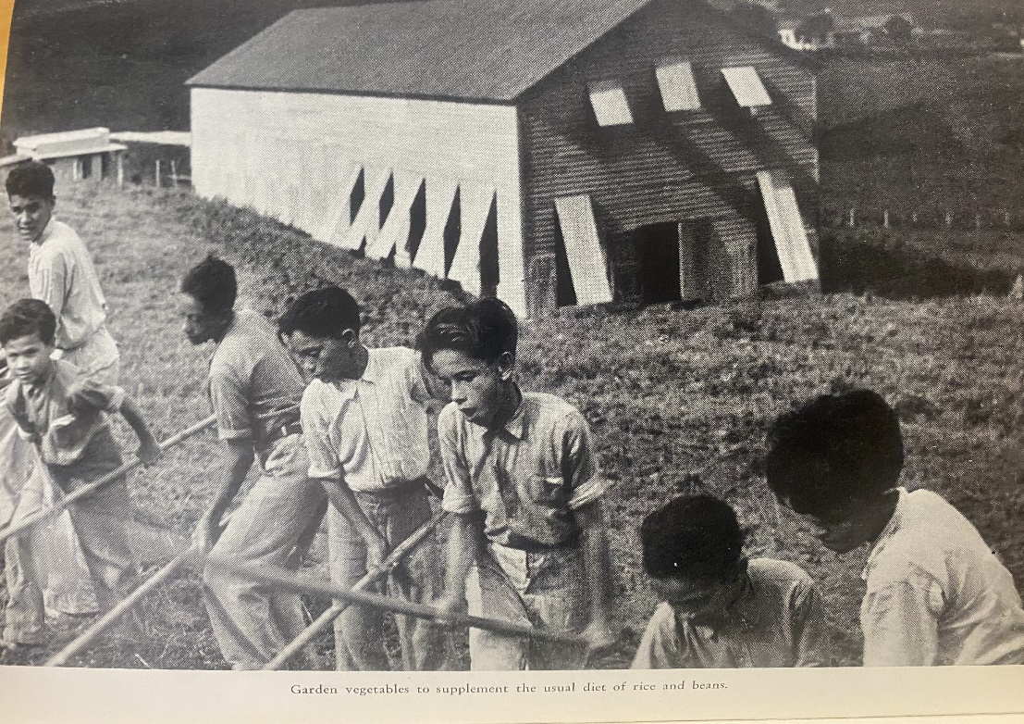
In places such as Hawaii, nutritious local food cultures were shunned in favour of the high-fat, high-sodium SPAM. While food trends like SPAM tend to be trivialised today, contemporary publications make clear that the coming of SPAM to Hawaii was symbolic of the intersected penetration of US military and capital – notably the sugar and pineapple industries – at a time when war with Japan loomed.
In the early US empire, food and diet was conceived in specifically racial terms. The situation in Hawaii echoed experiences in other parts of the Caribbean, where measures to coerce migrant workers into greater productivity led to the militarised enforcement of a ‘white’ diet high in protein and low in carbohydrates. In summary, in these little worlds of food control, racist assumptions underpinned narratives of progress.
The British Library’s collections contain much food-related material (collated in a guide by Ruby Tandoh and introduced by Polly Russell) and the Library’s Food Season is ever-popular. My Eccles fellowship enabled me to explore further the racialised ordering of food in the Caribbean in the early twentieth century: a topic which resonates with broader food themes accessible at the Library.

Bryce Evans, Food and Aviation in the Twentieth Century: the Pan American Ideal (London: Bloomsbury, 2022).
'Bryce Evans, “They have undertaken to regulate our palate”: Racism and the Spatial Authoritarianism of Food Consumption during the construction of the Panama Canal, 1904-1914', Journal of Caribbean History 58:2 (December 2024).
Daniel Immerwahr, How to Hide an Empire: A Short History of the Greater United States (New York: Penguin, 2019).
Tao Leigh Goffe, Dark Laboratory: On Columbus, the Caribbean, and the Origins of the Climate Crisis (New York: Penguin, 2025).
Megan Raby, American Tropics: The Caribbean Roots of Biodiversity Science (Chapel Hill: University of North Carolina Press, 2017).
J.R. McNeill, Mosquito Empires: ecology and war in the Greater Caribbean, 1620-1914 (Cambridge: CUP, 2010).
Henry A. Wallace, America Must Choose (New York: Foreign Policy Association, 1934).
George A. Malcolm, The Commonwealth of the Phillipines (New York: Appleton-Century, 1936).
Daisy Reck, Puerto Rico and the Virgin Islands (New York: Farrar and Rinehart, 1939).
Joseph Barber, Hawaii: Our Restless Rampart (Indianapolis: Bobbs-Merrill, 1941).
See, for example, H.L. Shapiro’s Migration and Environment: a study of the physical characteristics of the Japanese immigrants to Hawaii and the effects of environment on their descendants (Oxford: OUP, 1939) in which body measurements and physical characteristics across generations are extrapolated against occupational status on plantation and farms.
John Stephens, A Sketch of the Panama Canal: its past, present and possible future (Washington: Government Printing Office, 1908); Walter Stevens, A Trip to Panama (St Louis: Lesan-Gould, 1907).
Ruby Tandoh, Guide to English language food collections (London: British Library, 2025).

