How bringing back Churchill's wartime canteen culture could help tackle food poverty
During World War II, the public canteens set up by Winston Churchill became an integral part of British life. Now, in our modern age of social disconnection, it could be time to bring them back
Dr Marsha Smith and Professor Bryce Evans
8 May 2025
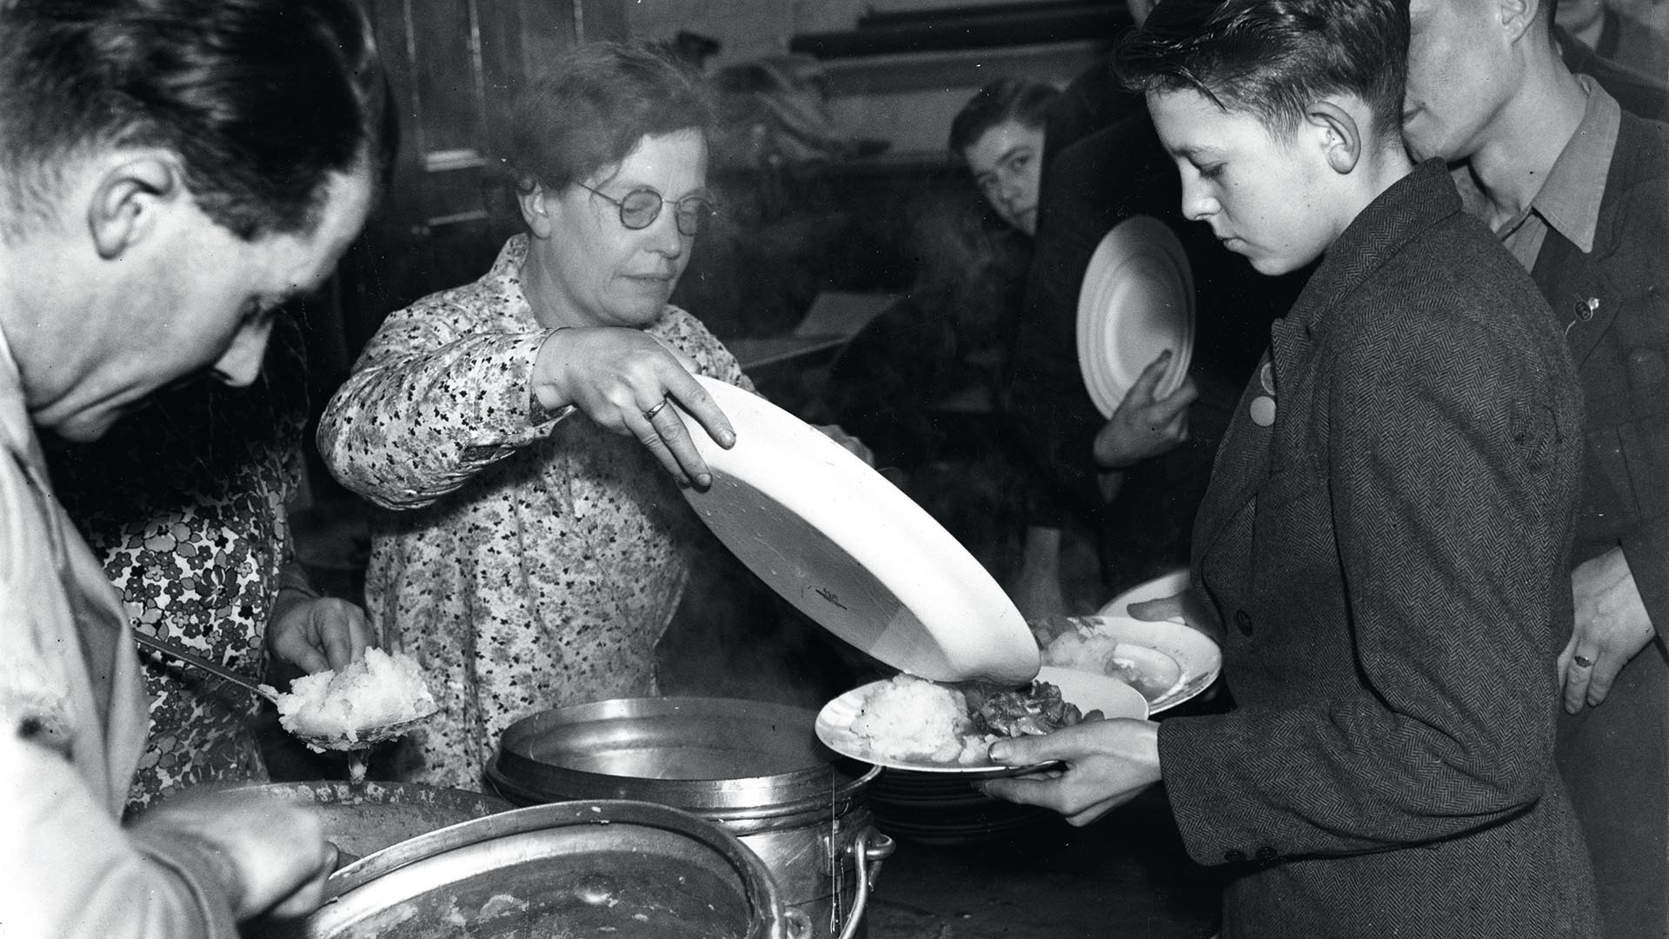
Canteen during WWII. Image: Picture Kitchen / Alamy
Share
Mealtimes might seem like a mundane activity; something we do to fulfil our biological needs. Yet eating in groups is one of the most fundamentally human activities that we undertake. Sociologists and historians agree that the more everyday something seems, the more powerful it is. We need that activity so much that it becomes completely normalised. Eating together at mealtimes transmits our culture and values. It reflects social status and social connections, and demonstrates nurturing, care and community. Eating dinner together is like a social glue holding us together.
But there is growing evidence to suggest that we are experiencing a disconnect from the deeper benefits of the mealtime. Food insecurity and challenges in accessing affordable, suitable food is reinforced by rising costs and record levels of fast, ready and takeaway meal consumption, which contributes to the blight of poor health.
- ‘Food is expensive’: How free community meals have become lifelines for people struggling to survive
- Community meals and workers’ rights: What happens if councils seize Deliveroo and Uber Eats’ ‘ghost kitchens’?
- ‘This is the dream’: These Londoners built their own homes to beat sky-high house prices
Mealtimes are becoming a challenge. Food is often eaten at a desk, alone, or in the street instead of being eaten together at a table as part of dinner. The seeming decline of this social phenomenon signifies the loss of opportunities for bonding and social connection and the diminishment of shared values and conventions – a manifestation of a social system that seems to be coming apart at the seams.
Still, we have evolved to eat together. Put food on the table and people will gather around. When times are difficult, we return to what matters. During the recent pandemic, aside from the more obvious focus on health, research revealed that the two ‘currencies’ which became socially valuable were food and social contact. We all have our stories of our favourite meal, a memory of a get-together around food, and a mealtime can be an easy way of kickstarting conversations and common ground. The significance of the mealtime should not be underestimated.
One response to our current malaise then, might be the reintroduction of public canteens and communal dining in the UK, a call that’s gaining traction across the academic, charitable and public sectors. Traditionally, public canteens were places – whether in the workplace or in public spaces – where low-cost meals would be served in a communal setting.
Variously referred to as cafeterias, diners, public restaurants or social eating spaces – these models of large-scale mealtime provisioning all point to a time when the opportunity to eat together was seen as important.

Subscribe
Advertising helps fund Big Issue’s mission to end poverty
In the UK we have a rich, but largely forgotten, history of public canteens instigated by Churchill himself. During World War II, the government staged an epic public health intervention designed to both sustain the populace nutritionally, and enrich the national spirit.
The government made start-up grants available to set up public meal services, called British Restaurants. These were designed to provide a wholesome, delicious, price-capped meal to the masses under a progressive ethos which commanded well-designed spaces as coterminous to good health.
This model enabled the provision of low-cost meals en masse but it also, implicitly, drew upon the everyday act of meal sharing as a means of upholding norms and values, and of infusing familiarity and comfort to create a convivial experience.
At their peak in 1943, there were more than 2,000 British restaurants serving millions of meals each week. They occupied prime retail spaces on the high street and were decorated with commissioned murals and artworks, and were frequented by a diverse mix of diners, forgoing social class and status for the act of meal sharing.
In Nottingham alone, for example, there were nine British Restaurants, with the largest serving 15,000 meals a week.

Although pressure from the burgeoning for-profit restaurant sector saw public eating spaces’ funding being withdrawn, prompting their subsequent decline, the significance of their purposeful design is as apt now as it was then. Badged as ‘centres of civilisation’, British Restaurants were hugely popular, instigating the shift from domestic to the now ubiquitous ‘eating out’ culture.
Public canteens can still facilitate shared mealtimes, bringing diverse people together to break bread. And they encourage face-to-face relations, forging conversations and connections in a way that Deliveroo cannot. They represent togetherness, social renewal, and sharing and caring at a time when competing crises leave us feeling overwhelmed. Public canteens can ensure that everyone has the opportunity to eat, eat well and eat together.
Careful stewardship of resources, food and water is vital for our planetary survival, so models that deliver meals en masse respond to this need for efficiencies and the pooling of resources. This can build food security by making affordable meals available through a number of high street and neighbourhood providers. They could be a pragmatic model of delivering nutritious meals made from sustainably sourced UK produce to the masses, via their at-scale procurement processes.
The word ‘canteen’ conjures for most of us memories of school dinner, or hospital or prison canteens – and visions of unappetising food and a lack of choice, served in austere conditions. But can public canteens be reimagined for the modern day? Can public canteen become synonymous with fresh, delicious, affordable and social meals, eaten in well-designed public places?
Practically, some aspects of canteen cultures can be identified here in the UK, from the IKEA canteen where thousands of people get their tray and queue up for meatballs, to Wetherspoons and McDonalds who bring an offer of unpretentious food to the masses. While these for-profit businesses dominate the market, their products don’t have that social sustenance. Instead, we have a system of overproduction, profit-extraction, food wastage, and the hyper-individualisation of mealtimes where choice is promoted over connection.

A recent blog post by Nourish Scotland likened public diners to other familiar infrastructures such as libraries, leisure centres and parks: places that deliver social value as well as a designated social ‘service’. Sociologist Eric Klinenberg, in his appraisal of how social infrastructures save lives in times of crisis, termed these phenomena ‘palaces for the people’.
These approaches, which seek to encourage social interactions through shared food consumption, consider the deeper gift of the group mealtime as extending and strengthening social bonds, and the social contract itself. Building on these projects and drawing together a mix of sociologists, historians, restaurateurs and social enterprise experts, the work of the newly established Canteen Culture Coalition is to convene experts, enthusiasts and customers alike to contribute to the story of how public canteens can and should be brought back into use.
They are also piloting the development of a canteen culture in two English cities, by inviting commercial hospitality, schools and civic providers to take turns offering monthly price-capped meals. The Canteen Culture Coalition will attract signatories to build the case for investment into new, purpose-built canteens, increase the use of sustainably produced food into the canteen network, and build evidence about the benefits of bringing back the nation’s dinner time.
Dr Marsha Smith is a research fellow at the Centre for Business in Society at Coventry University. Professor Bryce Evans is chair in modern world history at Liverpool Hope University
Do you have a story to tell or opinions to share about this? Get in touch and tell us more. Big Issue exists to give homeless and marginalised people the opportunity to earn an income. To support our work buy a copy of the magazine or get the app from the App Store or Google Play.

