Patterns and controls of topographic change within the deflation basins of a trough and bowl coastal blowout
Thomas Smyth*¹, Beth Fox¹, Paul Rooney², Brian Bodenbender³, Suzanne De Vries-Zimmerman³ and Nicholas O’Keeffe⁴.
¹ Division of Geography, Department of Physical and Life Sciences, School of Applied Sciences, University of Huddersfield, HD1 3DH, UK
² Department of Geography and Environmental Science, Liverpool Hope University, Liverpool, UK

³ Department of Geological and Environmental Sciences, Hope College, P. O. Box 9000, Holland, MI 49422-9000, USA

⁴ Natural England, Wayfaring House, Murley Moss Business Park, Oxenholme Road, Kendal, Cumbria, LA9 7RL

*Address for correspondence t.ag.smyth@hud.ac.uk

Acknowledgements
We wish to thank Dave Mercer and Natural England for generously facilitating access to the field site. This work was supported by a British Society for Geomorphology research grant awarded to Dr Thomas Smyth. The real-time kinematic global navigation satellite system (RTK-GNSS) used in the study was funded by the Royal Society grant RG170467.

Conflict of interest statement
The authors declare that they have no known competing financial interests or personal relationships that could have appeared to influence the work reported in this manuscript.

Patterns and controls of topographic change within the deflation basins of a trough and bowl coastal blowout
Abstract
In North-West Europe and throughout the world, dune systems are increasingly stabilised by vegetation, due to both human intervention and changes in climate. Blowouts are erosional hollows produced by wind erosion in vegetated or semi-vegetated dune systems. Where active blowouts are present in vegetated dunes, they provide a source of dynamism and sediment in an otherwise fixed environment. The transition from a fixed vegetated dune to an active blowout is poorly understood, however, and anthropogenic attempts to reactivate areas of bare sand in dunes are often unsuccessful. In this study we measured topographic change at a monthly resolution in the deflation basins of one bowl and one trough blowout over a 23-month period in Ainsdale Sand Dunes National Nature Reserve, North-West England. Our results show that monthly surface change in the blowouts did not correlate strongly with the transport capacity of winds measured at a meteorological station 10 km south of the site. Precipitation was found to have a moderate negative correlation with all indices of surface change, i.e., the more it rained the less the surface changed. Interannual (23 months) patterns of topographic change in the bowl and trough blowouts were distinctly different. In the deflation basin of the bowl blowout erosion predominantly took place on the erosional walls facing into the prevailing winds, while minimal change occurred on the erosional walls facing away from the prevailing wind direction. This produced a moderate negative correlation between surface change and slope, i.e., the steeper the slope, the more erosion occurred. In the trough blowout, erosion took place in the centre of the deflation basin and minimal change was measured on the easternmost erosional wall, which faced the prevailing winds. Patterns of monthly topographic change were highly variable and demonstrated that changes in the direction of above-threshold winds can cause blowout walls and floors to ‘flip’ from erosional to depositional surfaces. These findings highlight the variability and complexity of surface change in blowouts and demonstrate that patterns vary due to landform morphology and climatic conditions.
Keywords: aeolian; blowouts; sediment transport; climate; landform development; dunes; coasts.

- Introduction
Coastal dune systems range from dynamic environments of shifting sand and rapid geomorphological change to fully vegetated, stabilised dune fields that may support farmland or forestry. Due to the higher economic value of stabilised, vegetated dunes and damage caused to infrastructure and property by blowing sand, past management interventions in dune systems have focused on attempts at stabilisation (van der Meulen and Salman, 1996; Provoost et al., 2011). However, more recently land managers have recognised the environmental and ecological value of dynamic dune systems for coastal dune biodiversity (Pye et al., 2014). In North-West Europe and throughout the world, dune systems are being increasingly stabilised by vegetation (Goa et al., 2020). These changes have been primarily attributed to increases in human interventions e.g. land use change and dune stabilisation (Goa et al., 2020; 2023; Petrova et al., 2023) and climate change (Jackson et al., 2019).
Blowouts are erosional hollows produced by wind erosion in vegetated or semi-vegetated dune systems or other environments with poorly consolidated soils and relatively high wind speeds (Hesp, 2002). They are typically described as saucer, bowl, and trough in form (Hesp and Smyth, 2019). Generally, saucer blowouts are described as shallow and circular, trough blowouts as long and narrow, and bowl blowouts as deep and circular. They can occur in a range of settings, such as deserts, glacial outwash plains, and sandy coasts. At the coast, a blowout may breach the foredune, forming a corridor between the beach and the hinterdune, a landform referred to as a foredune blowout (Gares and Nordstrom, 1995; Schwarz et al., 2018). Where active blowouts are present in vegetated dunes, they provide a source of dynamism and sediment in an otherwise fixed environment. The transition from a fixed vegetated dune to an active one is relatively poorly understood however (Abhar et al., 2015; Smyth et al., 2020), and where managers have attempted to reactivate dunes by producing areas of bare sand, these often become vegetated within two to eight years after intervention (Arens and Geelen, 2006; Arens et al., 2013; Bar, 2013; Barchyn and Hugenholtz, 2013).
Morphological change in blowouts has been analysed using a range of methods, including erosion pins (Harris, 1974; Jungerius et al., 1981; Gares, 1992; Bitton and Byrne, 2002; Hugenholtz et al., 2009), Ground Penetrating Radar (GPR) ( Neal and Roberts, 2001; Girardi and Davis, 2010; González-Villanueva et al., 2013 and Warner et al., 2022), LiDAR (Jewel et al., 2014; Smyth et al., 2020), terrestrial laser surveys (TLS) (Smith et al., 2017; Smyth et al., 2019), real-time kinematic global navigation system surveys (RTK-GNSS) (Zhou et al., 2022a), photographic measurements (Bodenbender et al., 2021), structure from motion photogrammetry (Baird et al., 2021) and aerial imagery (Jungerius et al., 1992; Abhar et al., 2015). These studies have demonstrated that blowout evolution varies due to landform morphology and environmental conditions. For example, although blowout orientation has been reported to align with wind direction, blowouts may expand in either an upwind (Jungerius et al., 1981; Jungerius et al., 1992; Zhou et al., 2022b) or downwind direction (Smith et al., 2017; Luo et al., 2019; Smyth et al., 2019) in relation to the prevailing wind. Within saucer blowouts, Jungerius et al. (1981) and Jungerius et al. (1992) reported that blowout expansion occurred in an upwind direction, i.e., opposite to or ‘against’ the prevailing wind direction, because of a decrease in the erosive power of near-surface wind within the deflation basin of the blowout as it became “loaded” with sediment (pg. 135, Jungerius et al., 1992). Jungerius et al. (1992). Zhou et al. (2022b) attributed upwind erosion in trough shaped blowouts to turbulent vortices created by a “steep step” (pg. 135, Jungerius et al., 1992) as wind entered the deflation basin. These turbulent vortices were proposed as the cause of observed soil collapse (slumping) and sand avalanching. In contrast, deeper bowl blowouts have been reported to expand in a predominantly downwind direction in relation to the prevailing wind direction (Smith et al., 2017; Smyth et al., 2019). This downwind expansion and movement of sediment is commonly attributed to the reattachment and topographic acceleration of wind flow as it exits the steep erosional walls of the landform (Smyth et al., 2012; Smith et al., 2017; Smyth et al., 2019).
Carter et al. (1990) proposed that blowouts generally expand due to the erosion of sediment on steep erosional walls and the removal of sediment from the deflation basin by above-threshold, near-surface winds. Smyth et al. (2020a), studying saucer, bowl, and trough blowouts at Ainsdale Sand Dunes National Nature Reserve, England, noted that the patterns of surface change on both the erosional walls and deflation basins of all three blowout morphologies could vary dramatically and switch between net accretion or net erosion on an annual scale. These findings contrast with the consistent patterns of surface change on an annual scale measured by Hugenholtz and Wolfe (2006) in two blowouts on the northern Great Plains, Canada. As a blowout becomes deeper and wider, several studies have suggested that the deflation basin may become a net depositional surface as a) the zone of wind flow separation increases where wind flow enters over steep erosional walls (Smyth et al., 2012) and b) the wind is no longer ‘funnelled’ between the steep erosional walls to form a ‘jet’ or undergo topographic acceleration and, thus, transport sediment (Hesp, 2002; Hesp and Walker, 2012; Hesp et al., 2017). Hugenholtz and Wolfe (2006) documented this phenomenon occurring once a bowl blowout in the Northern Great Plains of Canada reached a critical size of 60 m × 36 m × 8·1 m (length × width × height). Gares and Nordstrom (1995) reported that a similar widening process within a foredune blowout in New Jersey, USA, resulted in a decrease in wind speed of up to 50% compared to wind speeds on the beach. At high wind speeds, saucer and bowl blowouts have also been documented to fill with sediment from upwind sources (Jungerius et al., 1981; Smyth et al., 2019). These findings indicate that surface lowering of blowout deflation basins does not necessarily linearly or positively increase with wind speed.
Seasonal differences in blowout activity have been reported in the literature and demonstrate a high degree of variation. In a trough blowout in Ontario, Canada, Byrne (1997) reported that the deflation basin generally accreted in summer and eroded in winter. In contrast, when investigating the relationship between deflation and wind speed in a coastal dune blowout in Meijendel, The Netherlands, Pluis (1992) found that winter, although the windiest season, was the least effective season for geomorphic change due to the high moisture content of the sand. Similarly, Jungerius et al. (1981) reported that although winter had the highest wind speeds in ‘De Blink’ coastal dune area in the Netherlands, it was during autumn and spring that the most substantive changes in surface elevation occurred. Defining an ‘active’ season of blowout activity in any location is further complicated by the potentially substantial geomorphic impact of intense storms that may occur at any time of year, e.g., ‘dry’ winter storms in the Netherlands (Jungerius et al., 1992) and hurricanes in the USA (Abhar et al., 2015; Bodenbender et al., 2021).

It is clear from the above discussion that, despite the importance of blowouts for the initiation and maintenance of bare sand habitats, our understanding of erosional and depositional processes in these landforms is still limited. In particular, observations in previous studies have tended to have relatively low temporal resolution (seasonal to annual), resulting in a poor understanding of the relationship between short-term weather events and morphological change, which is particularly important for changeable climates such as those in North-West Europe. To improve our understanding of patterns and drivers of shorter-term morphological change, we measured topographic change at a monthly resolution in the deflation basins of a bowl and trough blowout over a 23-month period using 59 erosion pins. Changes in surface elevation were statistically tested for relationships with slope at each pin location and with monthly wind and precipitation records from a meteorological station 10 km south of the blowouts.

- Study Site
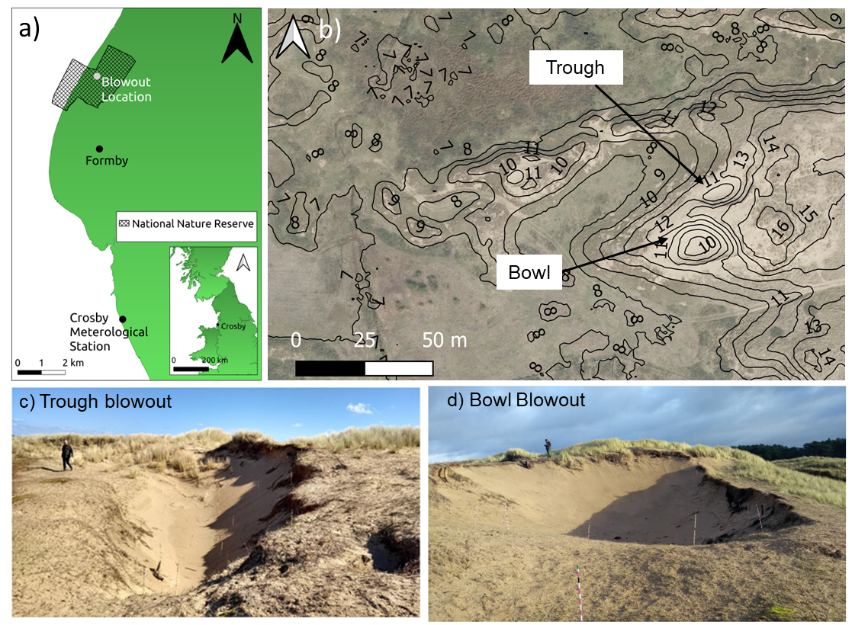
Figure 1. (a) Location of the blowouts investigated within Ainsdale Sand Dunes National Nature Reserve (NNR) (53° 35' 17.772'' N 3° 4' 30.252'' W) and of Crosby meteorological station, located 10 km to the south of the blowouts (53° 29' 49.2'' N 3° 3' 21.6'' W). (b) May 2019 aerial image of blowouts in the context of surrounding topography. 1 m contour lines calculated from September 2018 LiDAR survey (Appendix 1). (c) Photograph of the trough blowout taken on 5th April 2018 from the west of the landform, facing northeast. (d) Photograph of the bowl blowout taken on 5th April 2018 from the west of the landform, facing east.

The Sefton Coast in North-West England is the largest dune system in England, covering an area of 21.5 km², although approximately half of its original extent has been lost due to development (Smith, 2009). The dunes on the Sefton Coast have developed gradually over the last 5,600 years (Pye and Neal, 1993), with human interventions increasing from the medieval period in the form of grazing and sand winning (sand mining). Substantial areas of the dunes on the Sefton Coast were extensively planted with pine in the early twentieth century, some of which were partially removed from areas on the Ainsdale Sand Dunes National Nature Reserve in the 1990s (Sturgess and Atkinson, 1993). The pine plantations were limited to the relatively drier dune ridges, avoiding the wet dune slacks.

This study focused on two adjacent blowouts, one trough and one bowl, located in the Ainsdale Sand Dunes National Nature Reserve, 10 km north of Crosby meteorological station (Figure 1a). The blowouts are located 400 m inland from the foredune in an area of former pine plantation (Figure 1a). Within the study area the dune ridges are predominantly fixed and stable in nature (Figure 1b), with a mostly continuous vegetation cover of grasses, herbaceous perennials and annuals with lower plants. Between these ridges are extensive humid dune slacks with their associated wetland calcareous vegetation. These areas are of high conservation value in terms of biodiversity. Due to a lack of grazing pressure and the consequent threat of scrub invasion that reduces conservation value, some of these dune slacks have been mown for around the last 50 years. The product of this management intervention is a low and mostly continuous vegetation cover in the slacks with the aim of benefiting specialist species of plants and animals, especially the rare Natterjack Toad Epidalea calamita. Before the pine plantation was removed from this study area in the early / mid 1990s, there were large areas of invasive scrub dominated by the non-native (to this site) Sea Buckthorn Hippohae rhamnoides. These areas of scrub were concentrated on the fringes of the former pine plantation and within the dune slack areas. Since the removal of the pine plantations, all the dune habitats in this study area have been grazed by sheep and more recently by both sheep and cattle. The action of these grazing animals creates a short, closed turf with only occasional small areas of bare sand through ‘scrapes’ created by the domestic stock. Grazing pressure by rabbits remains at a relatively low and fluctuating level due to the persistence of the diseases myxomatosis (Myxoma virus MV) and rabbit viral haemorrhagic disease (RVHD1).

Topographic profiles of the bowl and trough blowout between 1999 and 2014 (Smyth et al., 2020a) demonstrate that both blowouts are erosional landforms that formed during a period of increased dune activity between 2000 – 2005. Both blowouts are located on a topographic high point relative to the surrounding topography. This dune ‘ridge’ was likely formed as the trailing arm of a now vegetated parabolic dune (Figure 1b). The relict parabolic dune deflation basin, a humid dune slack, located to the west of the blowouts (Figure 1b) has been periodically mown. The dune area immediately to the west of the blowouts comprises a mosaic of patches of bare sand (Figure 1b), sand sedge (Carex arenaria) and rosebay willowherb (Chamaenerion angustifolium). In April 2017, 11 months before the start of data collection for this study, the deflation basin and erosional walls of the trough blowout (Figure 1c) covered an area of 135 m² and measured 18 m along a southwest – northeast axis. The trough blowout was 5 m at its widest point and 3 m at its deepest. A clear depositional lobe colonised by marram grass (Ammophila arenaria) was present immediately northeast of the trough blowout. In April 2017 the bowl blowout was located 3.5 m south of the trough blowout and had an aerial extent of 380 m², more than three times larger than the trough (Figure 1d). The longest axis of the bowl blowout was orientated west – east and measured 32 m. The widest point of the bowl was 17 m and it had a maximum depth of 6 m from the deflation basin to the erosional wall rim. Unlike the trough blowout, a clear depositional lobe could not be observed in association with the landform.

- Methods
Vertical change in this study was measured using 59 erosion pins positioned in the deflation basin and erosional walls of the trough and bowl blowouts (Figure 2). The erosion pins were constructed by epoxying cylindrical jump rope beads to a 1.2 m fibreglass rod (Bodenbender et al., 2021). All pins were initially placed with 0.82 m of the beaded rod above the surface. If surface change was large enough that an erosion pin was close to being buried due to deposition or falling over due to erosion, it was ‘reset’ back to 0.82 m. Topographic change was recorded monthly over a 23-month period between March 2018 and February 2020 by measuring the distance between a washer at the top of the erosion pin and the sand surface. Measurements were taken using a metal tape measure with a precision of 0.001 m. All measurements were made along the western side of the erosion pin. All changes in height were measured relative to the previous survey. The location of each pin and the edge of each blowout were also surveyed twice during the study period, in August 2018 and August 2019, using a real-time kinematic global navigation satellite system (RTK-GNSS). Geomorphic activity at each erosion pin was analysed using three indices of surface change: (1) activity index (AI), (2) erosion index (EI) and (3) deposition index (DI) (cf. Hugenholtz and Wolfe (2006)):
$AI= \frac{Σ deposition+ |Σ erosion |}{\frac{n pins}{n period}}$ (1)

$EI= \frac{ |Σ erosion |}{\frac{n pins}{n period}}$ (2)

$DI= \frac{Σ deposition}{\frac{n pins}{n period}}$ (3)
Note that for the erosion index and deposition index, n pins refers to the number of pins where erosion or deposition took place rather than the total number of pins. For all indices n period is measured in days.
Hourly meteorological data for the study period were retrieved from Crosby meteorological station, located 10 km south of the blowouts (Figure 1a). Average hourly precipitation, wind speed and maximum gust per hour were recorded and compared to monthly surface change. From the average hourly wind data, drift potential (DP) and resultant drift potential (RDP) were calculated in m s⁻¹ using a modified version of the procedure given in Fryberger and Dean (1979), as outlined in Pye et al. (2017). For drift potential, the rates of sand drift for each 1-hour meteorological record were calculated using Equation 4, where Q is the rate of sand drift, $V$ is the wind velocity and $V_{t}$ is threshold velocity. $V_{t}$ was defined as 6.25 m s⁻¹, consistent with previous studies of dune mobility and change on the Sefton Coast (Delgado-Fernandez et al., 2019) and measurements of mean sediment size at Ainsdale by Pye and Blott (2010). To create a monthly value of drift potential (DP), each hourly record was summed into a monthly total which was then divided by the number of hourly records in that month. Drift potential was also calculated from 8 compass directions (N, NE, E, SE, S, SW, W, NW) to better understand any potential relationships between the direction of wind and topographic change instead of resultant drift direction (RDD) which only provides a net directional trend of sand drift. To calculate resultant drift potential (RDP), values of hourly drift potential were split into east-west and north-south vector components and converted into a resultant using Equation 5. Monthly values of resultant drift potential were calculated by summing each hourly record into a monthly total and dividing by the number of hourly records in that month.
$Q= V^{2}(V-V_{t})$ (4)
RDP = √(DP_{east}²+DP_{north}²), (5)
Surface slope throughout the study site and at each pin location was calculated from airborne LiDAR collected in September 2018 (see Appendix 1).
- Results

  - Topographic change
The trough and bowl blowouts exhibited distinctly different spatial patterns of surface change between the first and final surveys (Figure 2a). Generally, within the western hemisphere of the bowl blowout, minimal surface change (+/- 5 cm) occurred on the erosional walls and sediment deposition (5 – 14 cm) took place within the deflation basin (Figure 2a). In contrast, in the eastern hemisphere of the bowl blowout, the surface generally lowered in elevation, both in the relatively flat deflation basin and on the steep erosional walls. On the erosional walls the depth of erosion increased toward the rim of the blowout, with a maximum depth of 70 cm of erosion near the rim of the eastern erosional wall (Figure 2a).
The pattern of surface change in the trough blowout between the first and final surveys exhibited a substantially different pattern from the bowl blowout. In the trough blowout, the relatively flat deflation basin was dominated by erosion, rather than accretion as in the bowl blowout. Also, in contrast to the bowl blowout, the eastern erosional wall in the trough blowout was characterised by minimal change (+/- 5 cm) or an increase in elevation up to 13 cm over the study period, whereas in the bowl blowout the eastern erosional wall was dominated by erosion (Figure 2a).
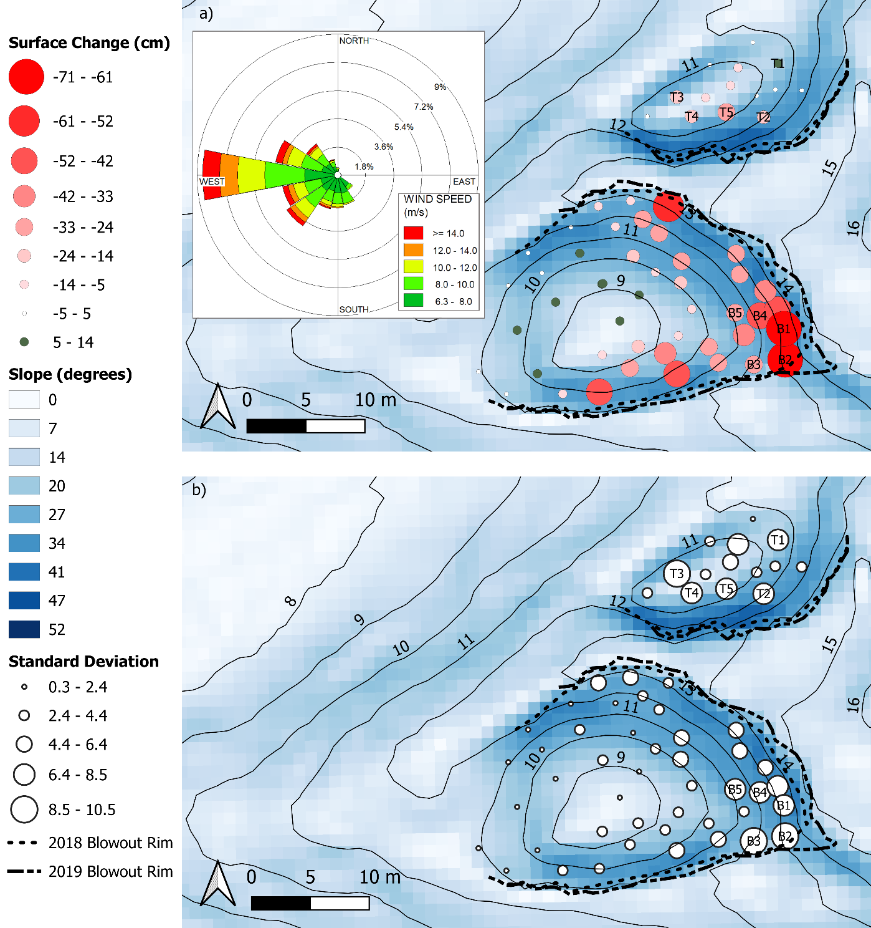
Figure 2. (a) Net surface change from March 2018 to February 2020. (b) Standard deviation of topographic change at each point between March 2018 to February 2020. B1 – B5 represent the 5 locations with the greatest topographic change in the bowl and T1 – T5 represent the 5 locations with greatest topographic change in the trough. The wind rose in Figure 2a represents above sediment threshold velocity winds measured at Crosby meteorological station as a percentage of all measured wind during the study period. 1 m contour lines and slope were calculated from a September 2018 LiDAR survey (Appendix 1). Blowouts are located at 53° 35' 17.772'' N 3° 4' 30.252'' W.
Table 1. Correlation of overall surface change (Figure 2a) and standard deviation (Figure 2b) with slope (slope data calculated from an airborne LiDAR survey flown in September 2018). Underlined and bold values are significant at the 90 percent confidence level and n refers to the number of pins in each blowout.
Location | n | Overall surface change | Standard Deviation
Bowl | 45 | -0.54 | 0.50
Trough | 14 | 0.27 | -0.06

To gain further insight into the patterns of topographic change within the blowouts, the overall surface change for each landform was tested for correlations with surface slope. A Spearman’s rank correlation test of the total surface change over the survey period and the topographic slope as measured in September 2018 shows that surface change in the bowl blowout had a moderate negative relationship with the surface slope (Figure 2a and Table 1), i.e., the steeper the slope, the greater the erosion. No statistically significant correlation was found between surface change and slope within the trough blowout; however, it must be considered that the trough blowout contained 14 pins, compared to 45 erosion pins in the bowl blowout.
RTK-GNSS measurements of the rim of each blowout show that each rim migrated between August 2018 and August 2019 at all locations where a distinct topographic ‘edge’ could be measured (Figure 2). In the bowl blowout the greatest advance of the rim (3.2 m) was measured in the eastern portion of the landform, directly opposite to the prevailing wind direction of above threshold velocity winds. In the trough blowout the greatest change in the position of the rim occurred along the southernmost extent of the landform, where a maximum change of 0.75 m was measured (Figure 2).
To gain insight into the monthly variations of topographic change, the standard deviation at each erosion pin was calculated and visualised (Figure 2b). Within the bowl blowout, the greatest variability of monthly topographic change generally occurred on the erosional walls. The five erosion pins with the greatest standard deviation (B1 – B5, Figure 2b) were clustered on the eastern erosional wall. The pin locations in the trough blowout with the greatest monthly topographic variability (T1 – T5, Figure 2b) were distributed across the bottom of the deflation basin (T3 – T5), the steep southern erosional wall (T2) and the western erosional wall/depositional lobe (T1). A Spearman’s rank correlation test of the standard deviation of surface change and topographic slope at each pin location in September 2018 shows that the standard deviation of topographic change in the bowl blowout had a moderate positive relationship with the surface slope (Figure 2b and Table 1), i.e., the steeper the slope the greater the standard deviation. No statistically significant correlation was calculated between the standard deviation of surface change and slope within the trough blowout.
With regards to the relationship between standard deviation and absolute surface change. Spearman’s rank correlation tests showed that standard deviation had a strong, negative correlation with absolute overall surface change in the bowl (r_{s} = 0.779, p = <0.001) and trough blowouts (r_{s} = 0.661, p = <0.005). i.e., the greater the standard deviation, the greater the surface change (either erosion or deposition).

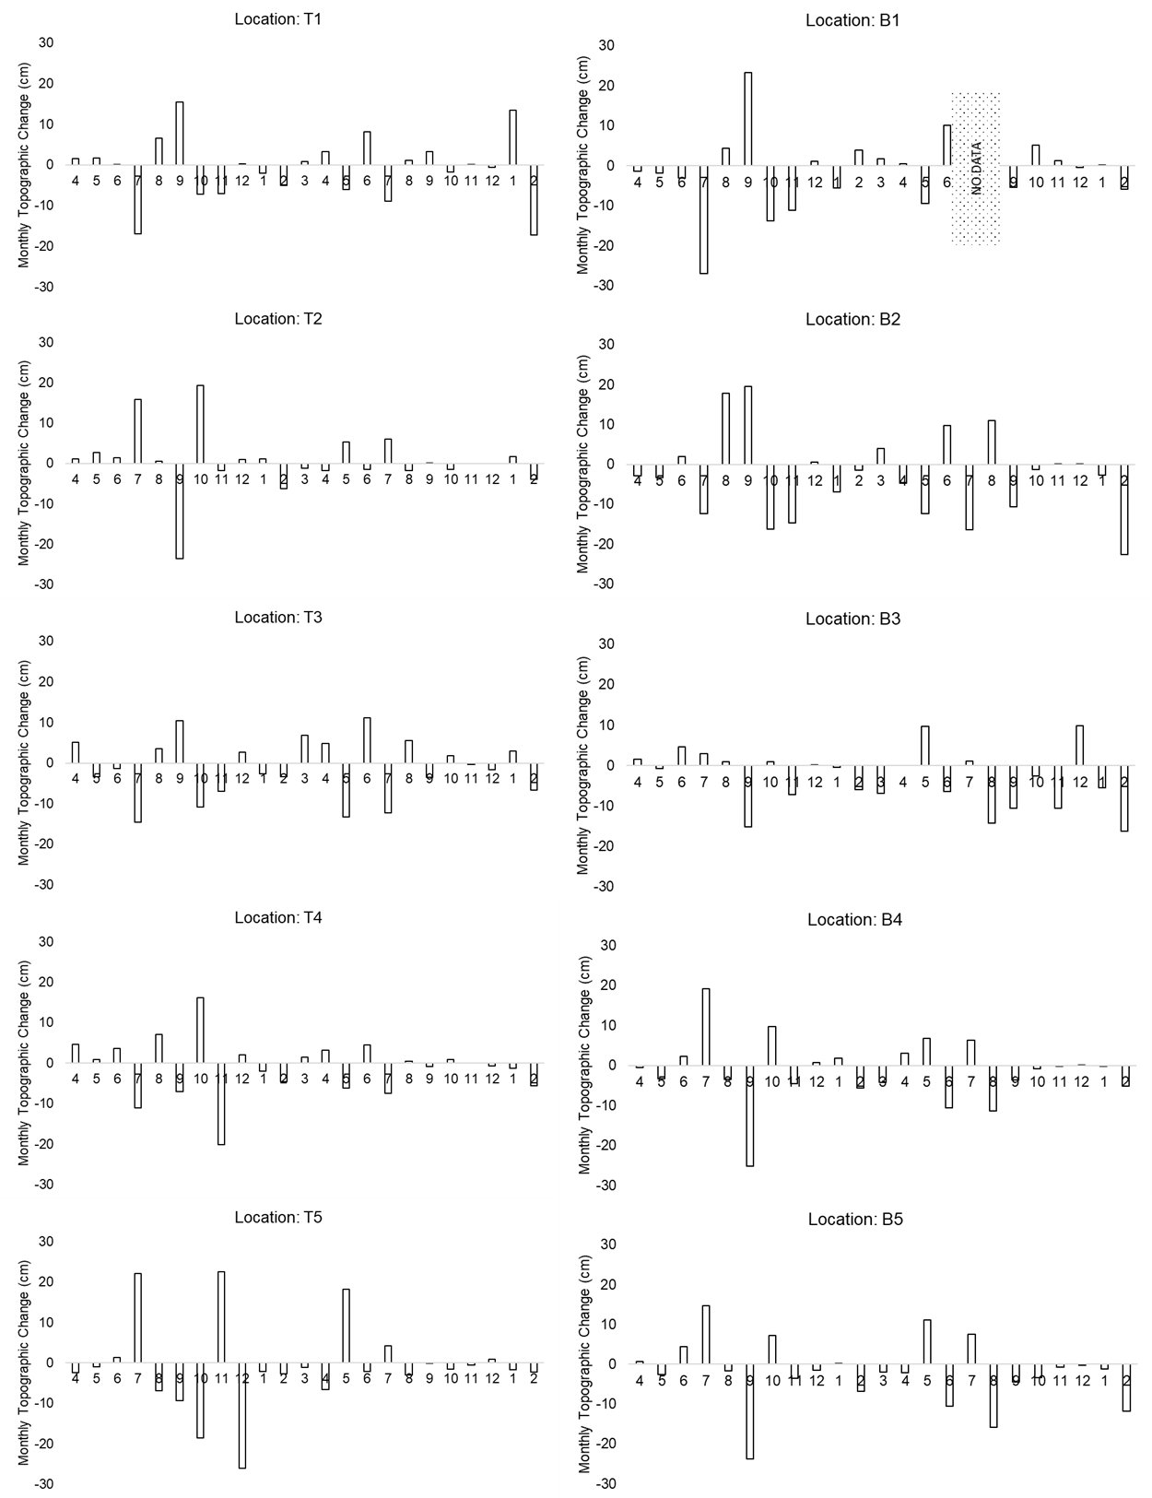
Figure 3. Monthly values of topographic change at the 10 pins with the highest values of standard deviation from April 2018 through to February 2020. Locations B1 – B5 refer to pins in the bowl and T1 – T5 refer to pins in the trough (see Figure 2 for locations). Numbers 1 - 12 on the x-axis refer to months of the year (e.g. 4 = April).
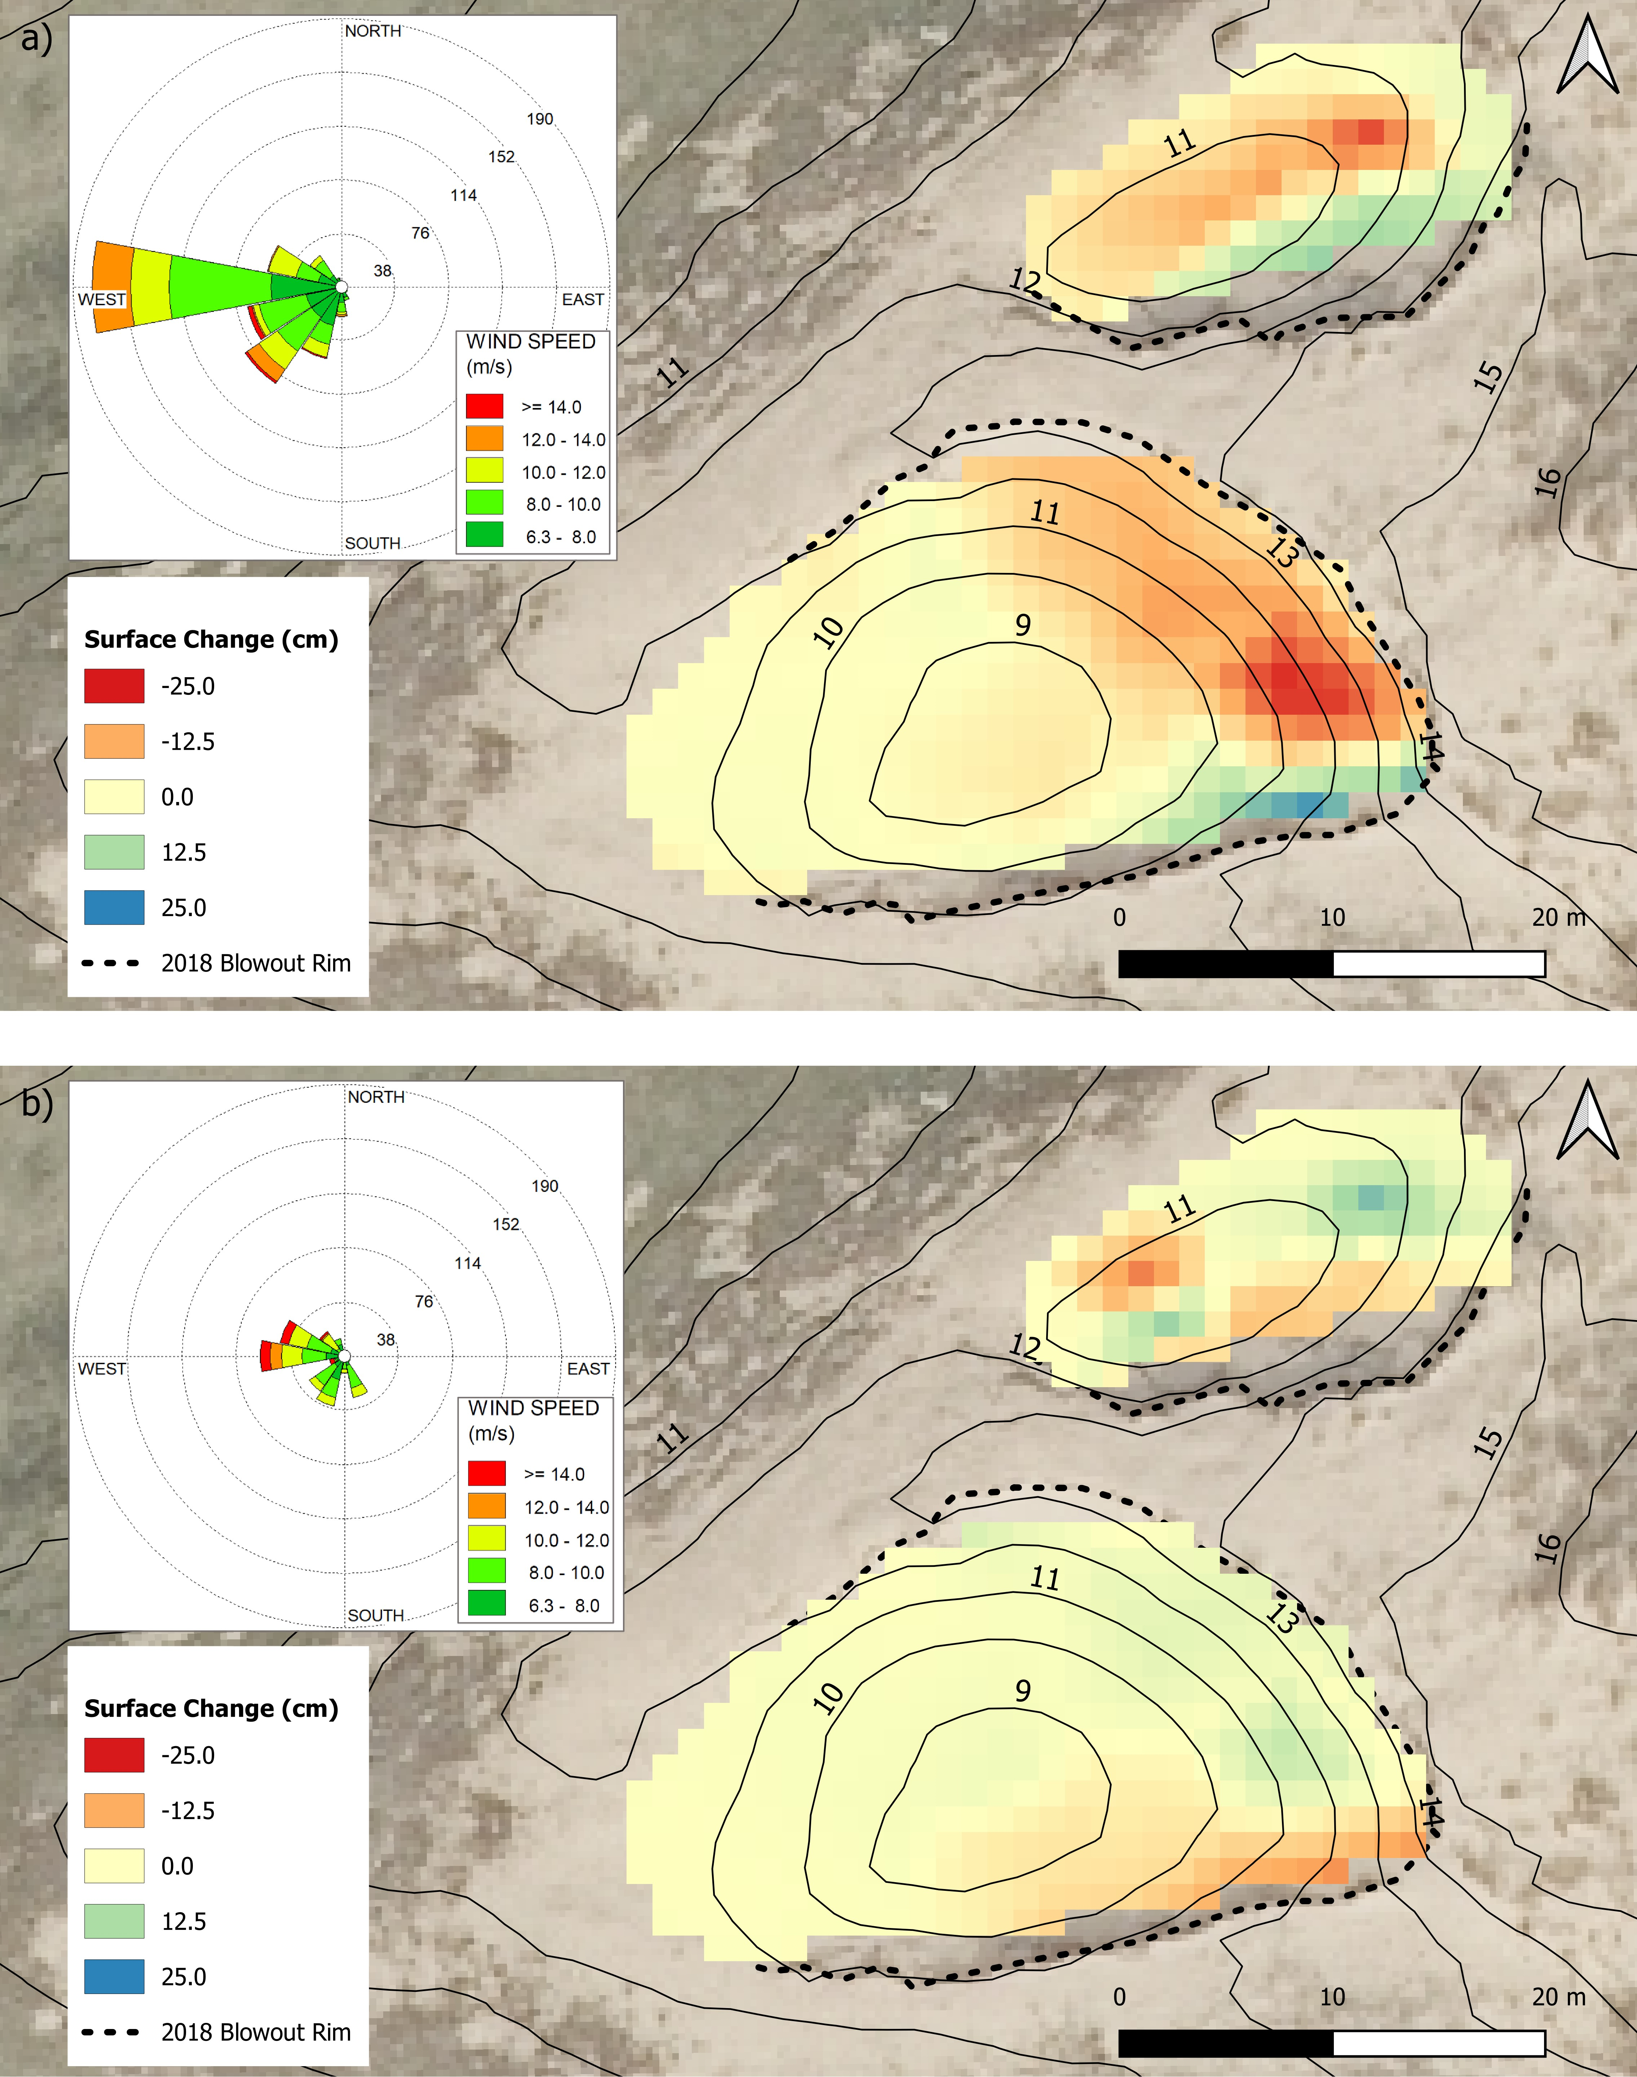
Figure 4. (a) Interpolated topographic change between the August 2018 and September 2018 surveys (b) Interpolated topographic change between the September 2018 and October 2018 surveys. 1 m contour lines and slope calculated from September 2018 LiDAR survey. Aerial imagery from May 2019 (Appendix 1). Blowouts are located at 53° 35' 17.772'' N 3° 4' 30.252'' W.

Although there was net erosion during the study at 9 of the 10 pin locations with the highest variability in monthly surface change (Figure 2), Figure 3 demonstrates that erosion at these locations was not a consistent monthly trend. Instead Figure 3 shows how the surface at the most variable pin locations within each blowout frequently ‘flipped’ between erosion and accretion. One major ‘flipping point’ is from September to October 2018. Overall surface change was generally high in both these months, but the direction of change was reversed at all the most variable locations in the bowl and four of the five most variable locations in the trough (Figure 3). Comparison of the above-threshold incident wind conditions and topographic change for September 2018 (Figure 4a) demonstrates that when the highest wind speeds were from the west (12 – 14 m s⁻¹) and southwest (>14 m s⁻¹), erosion generally took place in the northern hemisphere of each blowout and deposition in the southern hemisphere. Conversely, the pattern of erosion and deposition is largely the opposite during the October survey, with deposition mostly occurring in northern hemispheres of the blowouts and erosion in the southern hemispheres, although this pattern is more complex in the trough blowout with some erosion occurring in the northwest of the deflation basin (Figure 4b). The wind rose in Figure 4b indicates that in the month before the October survey, highest speed winds were from the west and northwest.
4.2 Climate and Topographic change
    - Meteorological conditions
Between the first (7th March 2018) and final survey (13th February 2020), 5509 hours of above sediment threshold velocity winds (33% of the total study period) were measured at Crosby meteorological station. The greatest directional components of above threshold winds were from the west (26%), west northwest (12%) and west southwest (11%). Almost no above sediment threshold velocity winds were measured from the east and northeast (Figure 2). On average 117 mm of precipitation per month were recorded at Crosby, with a maximum monthly total of 300 mm in October 2019 and a minimum monthly total of 12 mm recorded in July 2018. In total 11 named storms impacted the blowouts over the study period. These were clustered in three periods, between July 2018 and September 2018 (three storms), January 2019 and April 2019 (five storms) and December 2019 to February 2020 (three storms) (Table 2).
The windiest month of the study period was February 2020, during which storm Ciara impacted the site, with maximum wind gusts up to 28.05 m s⁻¹. This produced a drift potential of 617 and a resultant drift potential of 202 for the month, the highest erosion index (0.29 m pin⁻¹ month⁻¹) and the second highest activity index for the study period (0.23 m pin⁻¹ month⁻¹), but below average precipitation (98 mm). In contrast, March 2019, which contained two named storms (Table 2) and had the second highest values of drift potential (482) and resultant drift potential (157), had the 16th highest value erosion index (0.07 m pin⁻¹ month⁻¹, Table 2), the 18th highest value activity index (0.05 m pin⁻¹ month⁻¹, Table 2) and above average precipitation (204 mm). The least windy month of the survey period was June 2018, with a drift potential of 5, a resultant drift potential of 0, the 11th highest erosion index (0.07 m pin⁻¹ month⁻¹, Table 2), the 10th highest activity index (0.08 m pin⁻¹ month⁻¹, Table 2) and 20 mm of precipitation. The highest deposition index (0.28 m pin⁻¹ month⁻¹) was observed in July 2018 when storm Hector affected the site with a maximum wind speed of 24.28 m s⁻¹ but only 12 mm of precipitation.
Table 2. Precipitation (mm), drift potential (DP, dimensionless), resultant drift potential (RDP, dimensionless) and the activity index (AI), erosion index (EI) and deposition index (DI) for all 53 erosion pins (m pin⁻¹ month⁻¹) over the survey period. Named storms refer to low pressure systems that are expected to cause ‘severe weather’. Storms are named by the Met Office (UK), Met Éireann (Republic of Ireland) and The Royal Netherlands Meteorological Institute (KNMI). In this study seasons are defined as four periods that consist of a three-month period. Spring (March, April, May), summer (June, July, August), autumn (September, October, November) and winter (December, January, February). Shading denotes the autumn and winter periods.
Month of survey | Precipitation (mm) | DP | RDP | AI | EI | DI | Named storms with gusts over 20 m s⁻¹ at Crosby
April 2018 | 98 | 38 | 8 | 0.07 | 0.07 | 0.07
May 2018 | 59 | 59 | 17 | 0.07 | 0.08 | 0.05
June 2018 | 20 | 5 | 0 | 0.08 | 0.11 | 0.07
July 2018 | 12 | 82 | 39 | 0.25 | 0.28 | 0.25 | Hector. Max gust 24.28 m s⁻¹ from WSW
Aug 2018 | 57 | 29 | 12 | 0.07 | 0.06 | 0.08 | Ali. Max gust 28.05 m s⁻¹ from SW
Sept 2018 | 81 | 158 | 51 | 0.19 | 0.20 | 0.15 | Bronagh. Max gust 26.01 m s⁻¹ from WNW
Oct 2018 | 90 | 190 | 57 | 0.15 | 0.23 | 0.11
Nov 2018 | 25 | 101 | 34 | 0.16 | 0.19 | 0.12
Dec 2018 | 86 | 193 | 74 | 0.04 | 0.06 | 0.03
Jan 2019 | 65 | 131 | 61 | 0.05 | 0.06 | 0.06 | Deirdre. Max gust 26.52 m s⁻¹ from WSW
Feb 2019 | 148 | 293 | 148 | 0.11 | 0.13 | 0.07 | Erik. Max gust 29.07 m s⁻¹ from WSW
March 2019 | 204 | 482 | 157 | 0.05 | 0.07 | 0.03 | Freya. Max gust 23.46 m s⁻¹ from W  Gareth. Max gust 27.54 m s⁻¹ from WSW
April 2019 | 103 | 89 | 23 | 0.03 | 0.04 | 0.04 | Hannah. Max gust 23.46 m s⁻¹ from W
May 2019 | 45 | 16 | 5 | 0.17 | 0.19 | 0.17
June 2019 | 253 | 93 | 26 | 0.13 | 0.12 | 0.13
July 2019 | 216 | 55 | 20 | 0.05 | 0.09 | 0.07
Aug 2019 | 163 | 182 | 67 | 0.10 | 0.18 | 0.09
Sept 2019 | 69 | 190 | 59 | 0.08 | 0.12 | 0.04
Oct 2019 | 300 | 126 | 71 | 0.04 | 0.06 | 0.04
Nov 2019 | 247 | 120 | 27 | 0.03 | 0.03 | 0.04
Dec 2019 | 165 | 203 | 77 | 0.02 | 0.02 | 0.02 | Atiyah. Max Gust 22.95 m s⁻¹ from W
Jan 2020 | 98 | 108 | 34 | 0.06 | 0.07 | 0.05 | Brendan. Max Gust 23.94 m s⁻¹ from WSW
Feb 2020 | 98 | 617 | 202 | 0.23 | 0.29 | 0.11 | Ciara. Max Gust 28.05 m s⁻¹ from W

Table 3. Descriptive statistics of surface activity indices (AI, activity index; EI, erosion index; DI, deposition index). The sediment transport indices are measured in m pin⁻¹ month⁻¹.
 | Trough |  |  | Bowl
 | AI | EI | DI | AI | EI | DI
Mean | 0.13 | 0.13 | 0.13 | 0.09 | 0.12 | 0.07
Std | 0.10 | 0.10 | 0.12 | 0.06 | 0.08 | 0.05
Max. | 0.35 | 0.33 | 0.45 | 0.23 | 0.30 | 0.21
Min. | 0.01 | 0.01 | 0.01 | 0.02 | 0.03 | 0.02

On average the activity index within the trough blowout was greater than the bowl blowout (0.13 m pin⁻¹ month⁻¹ and 0.09 m pin⁻¹ month⁻¹, Table 2). The single highest monthly activity index (0.35 m pin⁻¹ month⁻¹ in the trough blowout, 0.23 m pin⁻¹ month⁻¹ in the bowl blowout, Table 3), was measured in July 2018, during which time storm Hector affected the site. The smallest activity values were measured in December 2019 (activity index 0.01 m pin⁻¹ month⁻¹ in the bowl, 0.02 m pin⁻¹ month⁻¹ in the trough, Table 3) during which time storm Atiya impacted the site.
The greatest difference in the means of activity indices between the trough and bowl blowouts is for the deposition index. On average the trough had a deposition index of 0.13 m pin⁻¹ month⁻¹ compared to the bowl with a deposition index of 0.07 m pin⁻¹ month⁻¹ (Table 3). This difference in deposition is also reflected in the 0.24 m pin⁻¹ month⁻¹ difference in the maximum deposition index for the two landforms (Table 3).
At a monthly and seasonal scale, Table 2 shows that no clear seasonal trend in overall activity index across the two sites was detectable. When analysed as an average activity index value per season, the greatest activity value was measured in autumn 2018 (September, October, November; average AI: 0.17 m pin⁻¹ month⁻¹) and the lowest in autumn 2019 (0.05 m pin⁻¹ month⁻¹). The average activity index for the study period was 0.10 m pin⁻¹ month⁻¹.

    - Temporal statistical analysis of activity indexes
Monthly activity index statistics (activity, deposition, and erosion) for the trough and bowl (Table 3) were not significantly different for any of the activity indices (tested via. a Student’s t test) and were, thus, statistically analysed together to increase statistical power (Table 4). For activity index, the only significant correlations were negative relationships with precipitation (r = -0.52), drift potential from the northeast (r = -0.49) and drift potential from the east (r = -0.36). Negative correlations were also calculated for the monthly erosion index with precipitation (r = -0.42), drift potential from the northeast (r = -0.50) and drift potential from the east (r=-0.37). Positive correlations were found between erosion index and the percentage of winds above 6 m s⁻¹ (r = 0.37) and 7 m s⁻¹ (r=0.37). The deposition index also had a negative correlation with precipitation (r=-0.45), the percentage of hourly wind averages above 11 m s⁻¹ (r = -0.38) and the percentage of records with gusts above 14 m s⁻¹ (r = -0.43) and 15 m s⁻¹ (r = -0.42). Negative correlations were also found between the deposition index and drift potential from the northeast (r=-0.40) and the west (r=-0.48).
Table 4. Correlation coefficients between blowout surface activity indices (AI, activity index; EI, erosion index; DI, deposition index) and meteorological variables. Bold underlined values are significant at the 90 percent confidence level. Wind % refers to the percentage of one-hour averages greater than the stated speed. Gust % refers to the percentage of one-hour records with a gust greater than the stated speed.
 | AI | EI | DI
Precipitation (mm) | -0.52 | -0.42 | -0.45
DP | -0.08 | 0.02 | -0.35
RDP | -0.07 | 0.02 | -0.32
Wind % >6 m s⁻¹ | 0.24 | 0.37 | 0.05
Wind % >7 m s⁻¹ | 0.24 | 0.37 | 0.02
Wind % >8 m s⁻¹ | 0.20 | 0.34 | -0.04
Wind % >9 m s⁻¹ | 0.05 | 0.18 | -0.17
Wind % >10 m s⁻¹ | -0.04 | 0.09 | -0.28
Wind % >11 m s⁻¹ | -0.18 | -0.08 | -0.38
Gust% >10 m s⁻¹ | 0.13 | 0.24 | -0.16
Gust% >11 m s⁻¹ | 0.06 | 0.17 | -0.20
Gust% >12 m s⁻¹ | -0.02 | 0.10 | -0.28
Gust% >13 m s⁻¹ | -0.08 | 0.03 | -0.34
Gust% >14 m s⁻¹ | -0.17 | -0.08 | -0.43
Gust% >15 m s⁻¹ | -0.20 | -0.13 | -0.42
DP (N) | -0.17 | -0.21 | -0.31
DP (NE) | -0.49 | -0.50 | -0.40
DP (E) | -0.36 | -0.37 | -0.23
DP (SE) | -0.09 | -0.05 | -0.07
DP (S) | 0.16 | 0.24 | 0.000
DP (SW) | 0.16 | 0.23 | -0.06
DP (W) | -0.29 | -0.18 | -0.48
DP (NW) | -0.05 | 0.02 | -0.19

- Discussion

  - Meteorological wind data was not a good predictor of deflation basin activity.
In this study, the only positive correlations between erosion and wind activity were for the percentage of winds above 6 m s⁻¹ and 7 m s⁻¹ (Table 4). This positive correlation between erosion index and marginally above-threshold winds was also found by Hugenholtz and Wolfe (2006) in blowouts in the Canadian Great Plains. Similarly, Jungerius et al. (1981) found that net lowering of six blowouts measured weekly over a two-year period in the Netherlands best correlated with relative low speed winds between 8.75 m s⁻¹ and 10 m s⁻¹. These findings highlight the role that relatively light, above-threshold winds have as an erosive geomorphic agent in blowouts.
Regarding statistical correlations with higher wind speeds, this study revealed a negative correlation between high wind speeds and deposition index, i.e., the stronger the wind the less deposition recorded at each pin. The same correlation was reported by Hugenholtz and Wolfe (2006), who found a negative correlation between all indices of transport capacity (wind %, drift potential and resultant drift potential) and the deposition index. These correlations indicate that ‘infilling’ of the blowout deflation basins during stronger winds, as reported by Jungerius et al. (1981), is not occurring at this location, most likely because of the lack of upwind sediment supply (Section 2 in this study). Negative correlations were also recorded between surface change and winds from the northeast and east, i.e., from the ‘opposite’ side of the blowout compared to the prevailing winds which likely formed the blowouts (Table 4). This negative correlation is likely because during winds from the northeast and east, both blowouts are sheltered from high wind speeds by a relatively tall dune ridge situated to the west of the blowouts. These findings further emphasise the role that local topography and wind direction has on blowout morphology and evolution, as reported in previous research (González-Villanueva et al. 2013; Pease and Gares, 2013). Precipitation was also found to have a moderate negative correlation with all indices of surface change, i.e., the more it rained, the less the surface changed. Hugenholtz and Wolfe (2006) also reported a moderate negative relationship between precipitation and the activity index and erosion index in two blowouts over a longer 10-year period. This decrease in surface activity is likely due to the increased wind velocity required to transport moist sand (Pluis, 1992). This binding of sediment by precipitation may explain why months such as March 2019 (204 mm precipitation, 74% above average) have large values of drift potential (482, second highest recorded) but low values of surface change (0.05 m pin⁻¹ month⁻¹, 18th highest recorded activity index).

  - Surface slope correlates with surface change.
In the bowl blowout in this study, a moderate negative correlation was found between surface change and slope, i.e., the steeper the slope, the more erosion that occurred. At a landscape scale, Smyth et al. (2023) found that dune slope, not wind speed, best predicted bare sand in vegetated coastal dunes. Smyth et al. (2023) hypothesised that this was due to three key phenomena: 1) wind erosion caused by topographic acceleration, 2) granular avalanching of unconsolidated sediment, and 3) rotational slumping of unstable slopes. Mass movement processes, such as granular avalanching and slumping, have also been reported to cause elevation change in blowouts (Jungerius and van der Meulen, 1997; Luo et al., 2019) and may explain how relatively high values of activity index were measured during dry summer months with no wind, e.g., June 2018 (Table 2) in this study. Evidence of dry, unconsolidated sediment being transported by slumping and avalanching, rather than aeolian sediment transport, was also observed in the field on steep erosional walls during months with low precipitation (Figure 5). Evidence from this study endorses Smyth et al.’s (2023) recommendation that slope steepness should be considered where land managers wish to ‘rejuvenate’ areas of bare sand in vegetated dunes that are understood as being over-stable for nature conservation purposes.
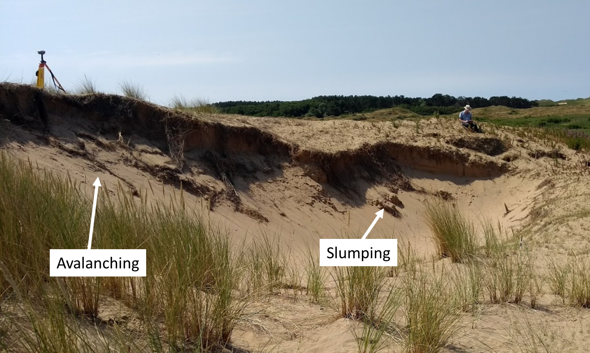
Figure 5. Evidence of granular avalanching and rotational slumping in the trough blowout. Image from July 2018.

  - Spatial patterns of topographic change are different in trough and bowl blowouts.
This study offered a rare opportunity to study interannual patterns of topographic change in a bowl and trough blowout experiencing the same environmental conditions in close proximity to each other (2 m at closest point). The results demonstrate that the patterns of topographic change in each blowout were distinctly different (Figure 2a). Inside the bowl blowout, erosion predominantly took place on the erosional walls facing the prevailing winds, while minimal change or deposition occurred on the floor of the deflation basin and on the erosional wall that was oriented opposite the prevailing wind direction (Figure 2a) similar to the findings of Smyth et al. (2019) in a bowl blowout. This pattern differs to the trough blowout, in which erosion took place in the centre of the deflation basin and minimal erosion or deposition was measured on the easternmost erosional wall which faced the prevailing winds. Comparable patterns of erosion have been measured during the formation and evolution of a foredune trough blowouts (Hesp and Hyde, 1996; Laporte-Fauret et al., 2022)
These differences in surface activity patterns are likely the result of different geomorphological processes in each landform. In bowl blowouts, sediment is eroded from steep erosional walls and transported onto the floor of the deflation basin, from where it is eroded if winds are sufficiently high (Carter et al., 1990). Alternatively, sediment may accumulate on the floor of the deflation basin as the landform increases in width and depth, becoming an area of wind flow retardation rather than acceleration (Gares et al., 1995; Hugenholtz and Wolfe, 2006; Smyth et al., 2020a). In contrast to bowl blowouts, wind flow in trough shaped erosional hollows is funnelled between the erosional walls into the relatively narrow deflation basin, even for incident winds that are highly oblique to the landform’s orientation (Hesp and Pringle, 2001; Yurk et al., 2013). Near-surface wind flow in trough blowouts may also form ‘jets’ (a localised area of high wind speed (Hesp and Smyth, 2016)) above the deflation basin that aid erosion (Hesp and Hyde, 1996; Smyth and Hesp, 2016). Another consequence of wind-flow steering in trough blowouts is that wind flow from a wide range of incident angles exits the trough at the same location (Smyth et al., 2020b). As wind flow exits the blowout and reduces in speed, sediment may accumulate in a very constrained area, resulting in the formation of a well-defined depositional lobe in comparison to a saucer or bowl blowout, as is found in lee of the trough blowout investigated in this study.
  - Monthly patterns of surface change are strongly influenced by preceding wind conditions.
Analysis of the monthly topographic surveys in this study (Figure 3) suggests that changes in direction of above-threshold winds can cause surfaces in both trough and bowl blowouts to ‘flip’ from erosional to depositional activity. Similar findings have also been reported by Jungerius and van der Meulen (1997), who found that “periods of erosion alternate with periods of accumulation” in a Dutch blowout complex (Jungerius and van der Meulen, 1997, p.63). Smith et al. (2017) also presented evidence of alternating periods of erosion and deposition in a bowl blowout. Evidence from this study suggests that this pattern may be particularly pronounced in bowl blowouts, due to the formation of a large zone of wind flow separation immediately downwind of where wind flow enters the deflation basin (Smyth et al., 2019). This zone of complex secondary wind flow is more likely to rework and transport sediment within the deflation basin than expel it, and contrasts with flow dynamics in the deflation basin of trough blowouts, where incoming wind flow is channelised and often undergoes acceleration along the deflation basin (Smyth and Hesp, 2016). The high degree of monthly variability exhibited by our monthly topographic surveys should encourage analysts to use caution when comparing topographic surveys as a proxy for interannual evolutionary patterns, as changes in blowout topography may only be representative of contemporary conditions, rather than any longer-term trend of deposition or erosion. A more accurate measure for interannual or decadal change may be mapping of the blowout edge/rim (see Luo et al., 2019 and Zhou et al., 2022b), as this is an erosive feature that is much less likely to be rebuilt or reformed, unlike the deflation basin of blowouts, which may undergo both erosion and deposition at the same location.

- Conclusion
This study highlights that although coastal dunes have become increasingly vegetated since at least the mid-twentieth century (Jackson et al., 2019; Goa et al., 2020), where conditions are favourable, they can continue to naturally evolve as dynamic landforms with minimal anthropogenic influence. Our results demonstrate that, despite being aeolian landforms, surface change within the deflation basin does not correlate well with the transport capacity of regional winds, thus making prediction of topographic change difficult, findings shared by previous studies in blowouts on the northern Great Plains, Canada (Hugenholtz and Wolfe, 2006) and coastal dunes in the Netherlands (Jungerius et al., 1981). Instead, we find that surface change is controlled by a combination of climate more broadly (e.g., precipitation) and landform morphology (e.g., slope), factors that should be considered when constructing anthropogenic dune landforms such as artificial foredune trough blowouts (notches) and restoring dynamism to vegetated parabolic dunes (Ruessink et al., 2024). Our research further highlights the complex spatial and temporal variability in surface change in blowouts, as surfaces frequently ‘flip’ between erosion and deposition, and vice-versa. Similar behaviour had previously been reported by Jungerius and van der Meulen (1997) inside a former saucer blowout. To build on the findings in this study and others, we suggest that future research could survey topography and vegetation simultaneously at a monthly scale over several years. Research of this nature would help further quantify relationships between landform morphology and vegetation in otherwise fixed vegetated dunes.

REFERENCES
Abhar, K. C., Walker, I. J., Hesp, P. A., & Gares, P. A. (2015). Spatial–temporal evolution of aeolian blowout dunes at Cape Cod. Geomorphology, 236, 148-162.
Arens, S. M., & Geelen, L. H. W. T. (2006). Dune landscape rejuvenation by intended destabilisation in the Amsterdam water supply dunes. Journal of coastal research, 22(5), 1094-1107.
Arens, S. M., Mulder, J. P., Slings, Q. L., Geelen, L. H., & Damsma, P. (2013). Dynamic dune management, integrating objectives of nature development and coastal safety: Examples from the Netherlands. Geomorphology, 199, 205-213.
Baird, T. R., Bristow, C. S., Luo, W., Du, E., Bryant, R. G., Mitchell, T. M., & Vermeesch, P. (2021). Blowout Morphometrics and Mass Balances. Frontiers in Earth Science, 9, 669440.
Bar, P. (2013). Restoration of coastal sand dunes for conservation of biodiversity: The Israeli experience. In Restoration of coastal dunes (pp. 173-185). Berlin, Heidelberg: Springer Berlin Heidelberg.
Barchyn, T. E., & Hugenholtz, C. H. (2013). Reactivation of supply-limited dune fields from blowouts: A conceptual framework for state characterization. Geomorphology, 201, 172-182.
Bitton, M. C., & Byrne, M. L. (2002). A volumetric analysis of coastal dune blowout morphology change, Pinery Provincial Park. In Proceedings of the Parks Research Forum of Ontario (PRFO) Annual Meeting (pp. 221-230).
Bodenbender, B. E., Hunter, J. P., & Yurk, B. P. (2021). Using photographic measurement and gigapixel panoramas to study changes in a Lake Michigan sand dune. Journal of Great Lakes Research, 47(6), 1495-1503.
Byrne, M. L. (1997). Seasonal sand transport through a trough blowout at Pinery Provincial Park, Ontario. Canadian Journal of Earth Sciences, 34(11), 1460-1466.
Carter, R. W. G., Hesp, P. A., & Nordstrom, K. F. (1990). Erosional landforms in coastal dunes. In Coastal dunes. Form and process (pp. 217-250).
Delgado-Fernandez, I., O'Keeffe, N., & Davidson-Arnott, R. G. (2019). Natural and human controls on dune vegetation cover and disturbance. Science of the Total Environment, 672, 643-656.
Fryberger, S. G., Dean, G., & McKee, E. D. (1979). Dune forms and wind regime. A study of global sand seas, 1052, 137-170.
Gao, J., Kennedy, D. M., & Konlechner, T. M. (2020). Coastal dune mobility over the past century: A global review. Progress in Physical Geography: Earth and Environment, 44(6), 814-836.
Gao, J., Kennedy, D. M., & McSweeney, S. (2023). Patterns of vegetation expansion during dune stabilization at the decadal scale. Earth Surface Processes and Landforms, 48(15), 3059-3073.
Gares, P. A. (1992). Topographic changes associated with coastal dune blowouts at Island Beach State Park, New Jersey. Earth Surface Processes and Landforms, 17(6), 589-604.
Gares, P. A., & Nordstrom, K. F. (1995). A cyclic model of foredune blowout evolution for a leeward coast: Island Beach, New Jersey. Annals of the Association of American Geographers, 85(1), 1-20.
Girardi, J.D., & Davis, D.M. (2010). Parabolic dune reactivation and migration at Napeague, NY, USA: insights from aerial and GPR imagery. Geomorphology, 114, 530-541.
González-Villanueva, R., Costas, S., Pérez-Arlucea, M., Jerez, S., & Trigo, R. M. (2013). Impact of atmospheric circulation patterns on coastal dune dynamics, NW Spain. Geomorphology, 185, 96-109.
González-Villanueva, R., et al. (2013). Impact of atmospheric circulation patterns on coastal dune dynamics, NW Spain. Geomorphology, 185, 96-109.
Harris, C. (1974). Wind speed and sand movement in a coastal dune environment. Area, 243-249.
Hesp, P. (2002). Foredunes and blowouts: initiation, geomorphology and dynamics. Geomorphology, 48(1-3), 245-268.
Hesp, P. A., & Hyde, R. (1996). Flow dynamics and geomorphology of a trough blowout. Sedimentology, 43(3), 505-525.
Hesp, P. A., & Smyth, T. A. (2016). Jet flow over foredunes. Earth Surface Processes and Landforms, 41(12), 1727-1735.
Hesp, P. A., & Pringle, A. (2001). Wind flow and topographic steering within a trough blowout. Journal of Coastal Research, 597-601.
Hesp, P. A., & Walker, I. J. (2012). Three-dimensional aeolian dynamics within a bowl blowout during offshore winds: Greenwich Dunes, Prince Edward Island, Canada. Aeolian Research, 3(4), 389-399.
Hesp, P. A., Hilton, M., & Konlecher, T. (2017). Flow and sediment transport dynamics in a slot and cauldron blowout and over a foredune, Mason Bay, Stewart Island (Rakiura), NZ. Geomorphology, 295, 598-610.
Hugenholtz, C. H., & Wolfe, S. A. (2006). Morphodynamics and climate controls of two aeolian blowouts on the northern Great Plains, Canada. Earth Surface Processes and Landforms: The Journal of the British Geomorphological Research Group, 31(12), 1540-1557.
Hugenholtz, C. H., Wolfe, S. A., Walker, I. J., & Moorman, B. J. (2009). Spatial and temporal patterns of aeolian sediment transport on an inland parabolic dune, Bigstick Sand Hills, Saskatchewan, Canada. Geomorphology, 105(1-2), 158-170.
Jackson, D. W., Costas, S., González-Villanueva, R., & Cooper, A. (2019). A global ‘greening’of coastal dunes: An integrated consequence of climate change?. Global and Planetary Change, 182, 103026.
Jewell, M., Houser, C., & Trimble, S. (2014). Initiation and evolution of blowouts within Padre Island National Seashore, Texas. Ocean & coastal management, 95, 156-164.
Jungerius, P. D., & Van der Meulen, F. (1989). The development of dune blowouts, as measured with erosion pins and sequential air photos. Catena, 16(4-5), 369-376.
Jungerius, P. D., Van Der Meulen, F., Loedeman, J. H., & Stuiver, J. (1992). A geometrical approach to monitoring blowout development from aerial photographs using a Geographical Information System (GIS). In Coastal dunes (pp. 129-138). Balkema.
Jungerius, P. D., Verheggen, A. J. T., & Wiggers, A. J. (1981). The development of blowouts in ‘De Blink’, a coastal dune area near Noordwijkerhout, The Netherlands. Earth surface processes and landforms, 6(3‐4), 375-396.
Laporte-Fauret, Q., Castelle, B., Marieu, V., Nicolae-Lerma, A., & Rosebery, D. (2022). Foredune blowout formation and subsequent evolution along a chronically eroding high-energy coast. Geomorphology, 414, 108398.
Luo, W., Wang, Z., Shao, M., Lu, J., Qian, G., Dong, Z., ... & Bateman, M. D. (2019). Historical evolution and controls on mega-blowouts in northeastern Qinghai-Tibetan Plateau, China. Geomorphology, 329, 17-31.
Neal, A., & Roberts, C.L. (2001). Internal structure of a trough blowout, determined from migrated ground-penetrating radar profiles. Sedimentology, 48, 791-810.
Pease, P., & Gares, P. (2013). The influence of topography and approach angles on local deflections of airflow within a coastal blowout. Earth Surface Processes and Landforms, 38(10), 1160-1169.
Petrova, P. G., de Jong, S. M., & Ruessink, G. (2023). A global remote-sensing assessment of the intersite variability in the greening of coastal dunes. Remote Sensing, 15(6), 1491.
Pluis, J. L. A. (1992). Relationships between deflation and near surface wind velocity in a coastal dune blowout. Earth surface processes and landforms, 17(7), 663-673.
Provoost, S., Jones, M. L. M., & Edmondson, S. E. (2011). Changes in landscape and vegetation of coastal dunes in northwest Europe: a review. Journal of Coastal Conservation, 15(1), 207-226.
Pye, K., & Blott, S. J. (2010). Geomorphology of the Sefton coast sand dunes. Sefton’s Dynamic Coast, 131.
Pye, K., & Neal, A. (1993). Late Holocene dune formation on the Sefton coast, northwest England. Geological Society, London, Special Publications, 72(1), 201-217.
Pye, K., Blott, S. J., & Guthrie, G. (2017). Advice on options for sand dune management for flood and coastal defence. Volume 2: Site Summaries, Report (No. 207). NRW Evidence Report.
Pye, K., Blott, S. J., & Howe, M. A. (2014). Coastal dune stabilization in Wales and requirements for rejuvenation. Journal of coastal conservation, 18, 27-54.
Ruessink, G., Groenendijk, D., & Arens, B. (2024). Digital Elevation Models and Orthomosaics of the Dutch Noordwest Natuurkern Foredune Restoration Project.
Schwarz, C., Brinkkemper, J., & Ruessink, G. (2018). Feedbacks between biotic and abiotic processes governing the development of foredune blowouts: a review. Journal of Marine Science and Engineering, 7(1), 2.
Smith, A., Gares, P. A., Wasklewicz, T., Hesp, P. A., & Walker, I. J. (2017). Three years of morphologic changes at a bowl blowout, Cape Cod, USA. Geomorphology, 295, 452-466.
Smith, P. H. (2009). The Sands of Time Revisited: An Introduction to the Sand Dunes of the Sefton Coast. Amberley Publishing Limited.
Smyth, T. A., Delgado-Fernandez, I., Jackson, D. W., Yurk, B., & Rooney, P. (2020b). Greedy parabolics: Wind flow direction within the deflation basin of parabolic dunes is governed by deflation basin width and depth. Progress in Physical Geography: Earth and Environment, 44(5), 643-660.
Smyth, T. A., Hesp, P. A., Walker, I. J., Wasklewicz, T., Gares, P. A., & Smith, A. B. (2019). Topographic change and numerically modelled near surface wind flow in a bowl blowout. Earth Surface Processes and Landforms, 44(10), 1988-1999.
Smyth, T. A., Jackson, D. W., & Cooper, J. A. G. (2012). High resolution measured and modelled three-dimensional airflow over a coastal bowl blowout. Geomorphology, 177, 62-73.
Smyth, T. A., Rooney, P., & Yates, K. L. (2023). Dune slope, not wind speed, best predicts bare sand in vegetated coastal dunes. Journal of Coastal Conservation, 27(4), 27.
Smyth, T., Thorpe, E., & Rooney, P. (2020a). Blowout Evolution Between 1999 and 2015 in Ainsdale Sand Dunes National Nature Reserve, England. North West Geography, 20(1).
Sturgess, P., & Atkinson, D. (1993). The clear-felling of sand-dune plantations: soil and vegetational processes in habitat restoration. Biological Conservation, 66(3), 171-183.
Van der Meulen, F., & Salman, A. H. P. M. (1996). Management of Mediterranean coastal dunes. Ocean & Coastal Management, 30(2-3), 177-195.
Warner, A.L., et al. (2022). Ground Penetrating Radar of Paleoblowouts and Transgressive Dunes, Younghusband Peninsula, South Australia. Journal of Coastal Research, 38(5), 885-895.
Yurk, B. P., De Vries-Zimmerman, S., Hansen, E., Bodenbender, B. E., Kilibarda, Z., Fisher, T. G., & van Dijk, D. (2013). Dune complexes along the southeastern shore of Lake Michigan: Geomorphic history and contemporary processes.
Zhou, Y., Hasi, E., Wang, Z., Qing, D., Han, X., Yin, J., & Wu, Z. (2022a). Dynamics of blowouts indicating the process of grassland desertification. Land Degradation & Development, 33(15), 2885-2897.
Zhou, Y., Hasi, E., Yin, J., Wang, Z., Qing, D., Hu, R., & Wu, Z. (2022b). Morphological dynamics of a trough-shaped blowout on a fixed dune in China. Aeolian Research, 59, 100830.

Appendix 1
Source of aerial imagery and digital terrain models:
2017 digital terrain model
England Lidar Digital Terrain Model England (2017) [ASC geospatial data], Scale 1:4000, Tiles: D0201630,D0202270, Updated: 2 September 2017, Open Government Licence, Using: EDINA LIDAR Digimap Service, <https://digimap.edina.ac.uk>, Downloaded: 2020-07-02 10:57:51.318

2018 digital terrain mode
England Lidar Digital Terrain Model England (2018) [TIFF geospatial data], Scale 1:4000, Tiles: F0210169,F0210264, Updated: 10 December 2018, Open Government Licence, Using: EDINA LIDAR Digimap Service, <https://digimap.edina.ac.uk>, Downloaded: 2022-09-09 05:59:37.717

2019 aerial imagery
High Resolution (25cm) Vertical Aerial Imagery (2019) [JPG geospatial data], Scale 1:500, Tiles: sd2810,sd2910, Updated: 29 October 2019, Getmapping, Using: EDINA Aerial Digimap Service, <https://digimap.edina.ac.uk>, Downloaded: 2022-09-09 10:43:54.541

