**Is there a place for young children in the modern-day UK church? Investigating approaches to faith nurture in the Early Year**[**s**](https://www.sciencedirect.com/journal/early-childhood-research-quarterly)

Sarah E. Holmes, Lecturer - Early Childhood, School of Education, Liverpool Hope University, Hope Park, Liverpool, L16 9JD, UK. Email: holmess1@hope.ac.uk

Emma Olorenshaw, Research Assistant - School of Education, Liverpool Hope University, Hope Park, Liverpool, L16 9JD, UK.

Ann Casson, Senior Research Fellow - National Institute for Christian Education Research (NICER) at Canterbury Christ Church University.

**Abstract**

This phenomenological study examined lived experiences and perceptions of Christian parents of young children to investigate their approaches to faith nurture and the extent to which this includes authenticity of welcome for young children in the modern-day church. Online survey data was analysed thematically through the lens of established theories regarding the nature of faith in the early years. Findings revealed that families with young children *do* wish to engage with their local church and wider Christian community, but often find existing approaches unsupportive and unhelpful. Significant adjustments are therefore required to church-led ethos and approaches to faith nurture to better serve the needs of young children. Recommendations are made for more flexibility and inclusivity within the church environment, enhanced partnership with parents, and greater church focus on co-constructing faith nurturing pathways within the home and church context to align more with relationships within the child’s microsystem.

**Keywords:** young child, faith nurture, spiritual wellbeing, church, UK Christian community.

**Compliance with Ethical Standards**

* This paper has no potential conflicts of interest  
* We can confirm that the human participants provided informed consent and the university ethics committee approved this project.

**Introduction**

There has been a trend of falling church attendance in the UK, dropping from 12% in 1980 to 5% in 2015,[1] which Hayward (2022) calculated could lead to extinction of many churches.[2] This seems particularly marked in families with young children, with reports of significantly declining numbers of children engaging with church in 2022.[3] Yet research has shown that under five years old is a key time for faith to develop.[4] This seems particularly pertinent in the early years because work with the preschool age group is often hidden, and seen as a fringe activity to the main activities in churches that focus on adults (Hope Together, 2020). Yet there are many benefits to faith nurture of young children within the Christian community (Souza, 2009; Rottman, 2012; Miller, 2016; Hyde, 2017) and there is considerable long-term impact upon those who attend church as a child (Barna, 2001; Bartkowski, Xu & Levin, 2008; Hope Together, 2020). Many have expounded the need to welcome children of all ages into churches (Berryman, 2003; Csinos, 2007; Grobbelaar, 2022), and prioritise children’s spiritual wellbeing (Nye, 2009; Mountain, 2011; Casson et al., 2021). Yet Bunge (2006) highlighted that there has been a lack of robust thinking and reflection regarding the role of children within religious communities. Indeed, Mercer (2005) observed ambivalence of churches towards children, whereby families are welcome but are also expected to ‘control’ their children so that they are not unruly, which is counter to the prevailing attitudes of early years practitioners who have an holistic understanding of a child’s development (Mercer, 2018), are concerned with providing enabling environments which are child-centred (Johnston, 2013), operate through the means of play (Owen, 2021), and co-construct learning opportunities with children (Thompson and Spenceley, 2020). Similarly, Csinos and Beckwith (2013) observed that church preschool programs may be primarily intended to eliminate noisy children from church services. This paper therefore seeks to investigate whether there is a place for young children in the modern-day church, and the authenticity of welcome for them. The potential situation outlined above contrasts greatly with other sectors which have recognised the need to intentionally welcome, include and value all children during the early years (Mainstone-Cotton, 2019; Bove and Sharmahd, 2020; Clark and Flewitt, 2020). This paper asks whether the UK church places a similar value on young children as do broader early years contexts. Kingston and MacDougall (2011) called for the church to create an environment which takes proper account of the way young children learn and perceive. In light of this call, this study examines the extent to which such an environment has been achieved and the practical implications of this; investigating faith nurture approaches amongst families of young children (under five years old) in the UK Christian community.

The findings are from research undertaken during later stages of the Covid-19 pandemic because that era provided opportunities to explore the experiences of individuals including their reflections on their pre-Covid practices (Steed et al., 2022), and was also a key time of reflection and heightened awareness for many families. The empirical research took place in the UK, although it is suspected that there may be similar findings in other contexts, because the Covid-19 pandemic illuminated similar patterns of exclusion of children, particularly the youngest, across a range of countries (Holmes, Sonnenberg, Weber, and Sandsmark, 2021). It is therefore proposed that the findings of this UK research may be applicable further afield also, emphasising the need for the global church to investigate and address the place of young children within the church and wider Christian community. This research project therefore asks the question: Is there a place for young children in the church in contemporary times?

**Background**

**The place of religious faith in the early years**

Tamminen (1991) asserted that religion is indisputably an important component of childhood. Many have shown the capacity of children to be spiritually engaged during the early childhood years (Berryman, 2003; Csinos, 2007; Nye, 2009) and children as young as six have been found to form social preferences based on religious identity (Heiphetz, Spelke, & Banaji, 2013). Rottman and Kelemen (2012) argued that evolved components of the human mind tend to lead people toward religiosity early in life as a result of the environments a child grows up in, setting their trajectory and making them prone to acquire religious beliefs. Kirkpatrick and Shaver (1990) similarly revealed that aspects of adult religiosity derive from early child attachment classification and religiousness of parents. Berne (1972) expressed one's life script being formed due to early childhood experiences and subsequently influencing the individual in their onward life, whilst Gurian (2002) preferred the term ‘soul markings;’ namely the marks on an individual’s soul that guide them from infancy, and throughout their life. Indeed, Bartkowski, Xu and Levin (2008) found that religion can serve as a bridge that links generations and yields pro-social outcomes, but conversely can function as a wedge which fosters division and conflict, thereby undermining children’s development. These ideas all exhibit the value and importance of engaging further enquiry into this field, hence this project focussed on approaches to Christian faith formation in early childhood.

Bunge (2006) argued that theological discourse has been dominated by simplistic and ambivalent views of children which diminishes understanding of their complexity, reinforcing narrow mindsets about adult-child interactions. Indeed, Fowler’s faith development model indicates that faith grows and expands with age, implying that young children exhibit a faith that is a reduced version of adult faith (Fowler, 1989). Similarly, Goldman (1965) limited children to a ‘pre-religious’ state due to cognitive and language restrictions. Fowler (1981) also labelled faith in early childhood as ‘pre-stage’, implying that it is not an entity in its own right, but a preparation stage for when an individual is sufficiently developed. These models insinuate a deficit notion of faith in young children (Dillen, 2007; Grobbelaar, 2022). In contrast, Westerhoff (1976) viewed faith development as similar to a tree’s growth, whereby a young tree with few tree rings is a valid and complete tree in its own right, and then continues to develop with age. He argued that in the same way, a young child’s faith is a viable and true entity, which can merely grow with time. Indeed, Berryman (2003) argued that young children have an “owned faith” from the beginning, and this is part of a life-long journey toward greater maturity. This understanding depicts children as being of positive worth and high potential, rather than requiring judgement and adjustment (Mountain 2011). Conversely, Nye (2009) proposed that that there is no inevitable course of spiritual development, but it can in fact be quite erratic. Similarly, Wangerin (1986) described a child’s early encounters with God as a dance; depicting creativity, play and imagination which appear to be implicit in childhood faith. Research would support this, showing that young children are certainly capable of significant spiritual experiences and expression (Coles, 1990; Hart, 2003; Heller 1986; Hay and Nye, 2006). Indeed, Mercer (2005) cited that Jesus Christ placed the child in the centre, pointing to them as a model for faith, and therefore an example and active agent rather than being deficient. Csinos (2007) demarks this as a great reversal of the norms and expectations of the day, aligning with the removal of invisibility championed by Bove and Sharmahd (2020).

To this end, Ratcliff and May (2004) expressed that children have a dual function: ‘to be’ and ‘to become,’ and hence faith nurture in the early years should both value and affirm what is present whilst also scaffolding and supporting onward development. This indicates that the role of the church is to encourage a young child’s natural desire to be continually expanding their naturally occurring spiritual experiences (Ratcliff and May, 2004), aligning with Vygotsky’s concept of the zone of proximal development, whereby the child naturally seeks new experiences and advancement of their own understanding of the world with the adult’s role being to scaffold this advancement (Vygotsky, 1987). Aligning with this, Cavalleti (1983) highlighted that a young child’s faith journey contains a series of ephemeral moments which continually reshape and redefine their faith, although these ephemeral moments cannot be engineered or coerced, but merely emerge from the child’s daily experiences. The reality of these moments is that they will be both inward and outward in nature (Yust, 2004), and hence more challenging to observe in younger children but nonetheless genuine. The role of the church and wider Christian community in scaffolding these experiences therefore requires further exploration. Bunge (2006) argued that the lack of complex thinking about children in the church and wider culture has undermined the church’s commitment to them and had serious consequences for the children themselves. This extent of the contemporary church’s commitment to children and how they are viewed will now be explored further, from the perspective of parents and church leaders.

**Aspects of the Christian church which cater for young children**

Churches address the needs of young children by supporting parents as primary educators in the faith (Catechism of the Catholic Church, p. 2226[5]), welcoming children into the Christian community through the sacraments of Baptism and Holy Communion and provision of child-friendly worship and activities. First, church support for parents in their faith nurturing role is found formally in offerings of baptismal courses, more informally in providing parental space and time. For example, church toddler groups, informal support, both pastoral and spiritual are offered (Talking Toddlers, 2020 Hewitt, 2016). Often parachurch organisations provide invaluable support to help parents nurture faith (Care for the family[6], Celebrate[7], Parenting for Faith[8]).

Second, the formal recognition of the child as an integral member of the Christian community is made visible in the rite of Baptism and Eucharist participation. A child is welcomed into the church community in the rite of infant Baptism. However, in line with the decline in church attendance, decreasing numbers of children are being baptised for example in the Church of England, less than 50,000 children under the age of 10 were baptised in 2021 (Statistics for Mission, 2021[9]). The extent to which children are viewed as an integral part of the worshipping community is visible in the church's differing attitudes to children's participation in the Eucharist. Catholic children are prepared and admitted to the Eucharist from the age of seven, following the decree of Pius X (Pius, 1910[10]). Within the Church of England, dioceses that view the Eucharist as 'the meal of the whole body of the local church' (Nichol, 2022, p.90) have welcomed children to receive Holy Communion as an integral part of the worshipping community through Baptism. However, in both Catholic and Anglican Eucharistic liturgy children are expected to participate in the ordinary liturgy. A Catholic children's liturgy[11] is primarily used for specific children's services, and Nichol (2022) argues within the Anglican context it is not enough to welcome children as communicants, attention needs to be paid to the extent to which children can understand and be active participants in the Eucharistic liturgy rather than just communicants.

Third, churches seek to offer child-friendly approaches to worship and faith nurture by prioritising children's needs according to age. This can involve providing age-specific activities within Sunday worship, offering various group activities during the week, or adopting a more intergenerational approach to children's ministry. In recent years there has been greater recognition that children are beings, not just becoming (Ratcliffe and May, 2004), that a child's relationship with God begins before they can comprehend or verbalise it (Wangarin, 1986) and that there is a need to engage more closely with the perspective of the child (Mercer, 2004). Many churches look to provide age-appropriate worship or faith education such as Godly Play (Berryman, 1991), which seeks to provide a way for the children to 'experience the presence of God through play an "in-between place" and provides infinite opportunities for the child to encounter and explore spiritual experiences (Hyde, 2021). However, a significant drawback of age-segregated activities is that many do not have theologically robust curricula (Bunge, 2006). When churches do not recognise children as active agents, able to engage in and take responsibility for their spiritual nurture, age-specific approaches often result in the exclusion of the children from the wider church and a usurping of parental spiritual responsibility for their child (Csinos and Beckwith, 2013). In the last twenty years, the focus has been on adopting a more intergenerational approach, bringing families together and nurturing faith through activity-based events, such as Messy Church, Muddy Church and Lego church (Williams, 2019; Given, 2014). Research has shown the value of this approach, which acknowledges the importance of viewing a child in terms of their interconnectedness with others (Grobbelaar, 2022). Indeed, a welcoming and supportive church community is vital in the spiritual growth of children (Bartkowski, et al., 2008). In summary, the church has opportunities to connect with children through family support, in key events, such as rites of initiation, and in activities within and without Sunday worship.

**Methodology**

Since this project sought to understand the experiences of faith nurture amongst families with young children, a phenomenological approach was adopted similar to Steed et al. (2022). This paper is part of a broader project in which exploratory data was collected through an online survey of parents of under 5 year olds (n=71), parents of children aged 6-16 (n=138) and church leaders (n=175) encompassing both closed and open-ended questions, interviews with parents (n=18) and interviews of children aged 7 to 11 years old (n=36). This paper draws from the data collected in the online survey of parents of children under five years old (n=71). Given the nature of the topic, rather than asking young children themselves, the project sought to capture data about faith nurture in the early years from the perspectives of parents.

The online survey was carried out between February and April 2022. Survey invitations were distributed by mailing lists and social media channels or denominational networks and para-church organisations. The implication of this was that those already in contact with church organisations were targeted, hence skewing the sample slightly as those who were disconnected from church may not have been aware of the invitation. Nevertheless, this was consistent with the aims of the project which sought to explore the approaches and experiences of faith nurture, hence it was a requirement that the participants did have recent lived experience of engagement with the church. Responses were obtained from fifteen different denomination descriptions, and from churches of a range of sizes (from less than 50 to over 500 attendees). The responses were analysed thematically to examine the nature of faith nurture occurring within the child’s microsystem and underlying discourses, assumptions and curricula related to these approaches. Open-ended and closed questions asked about their family’s attendance and engagement with church, religious activities in the home and perceptions and lived experiences regarding what is supportive to faith nurture during the early years. The responses were analysed using thematic analysis (Braun and Clark, 2006), so that initial coding of open-ended responses occurred initially. These codes were then clustered into sub-codes and then themes. These themes are shown in the figures included in this paper, and the fuller responses are expounded in the findings section. The project was subject to ethical scrutiny of Liverpool Hope University, encompassing assurances of informed consent, anonymity, confidentiality and awareness to avoid power relations.

**Findings**

**Engagement of young families with church**

Figure 1 shows that of the participating families, the majority (68%) stated that they attended church on a weekly basis, with 15% expressing that they attended on a fortnightly basis, with 16% less often. As explained above, this sample of respondents is skewed since they were recruited through UK church networks, but nevertheless these responses show that these families with young children are very regular attenders of church.

Figure 2 depicts the range of faith practices detailed by respondents regarding how their family had engaged in faith together during the pandemic. Despite church attendance being challenging at the time due to changeable lockdown restrictions, it is clear that these families engaged in church-based activity (online or in person) the most so as to support their family’s faith. This shows the value that these families place on the church. The remaining responses show that these families also partook in many other faith activities together. This included traditional activities such as Bible reading (76%), using Christian books and resources (69%), singing (59%) and reflective time (28%), in addition to utilising activities and resources outside of the home, such as craft or worksheets from church (65%), watching online Christian content (such as YouTube) (61%), and outdoor activities with a faith element (32%). Further to this, many included interactive and relational activities such as spending time with other Christians (59%), faith discussions (55%), serving others (44%) and helping others in the community (35%). One parent said ‘other’, which they described as creating online content for others, in the form of Lego bible story animations.

Figures 3a and 3b show how the parents described their changed involvement with church and faith due to the pandemic. In figure 3a, 45% stated that their engagement with church had reduced, and 18% said that it had increased, with 37% reporting that it had stayed similar. In contrast to this, figure 3b shows that 58% reported that their family faith practices at home had increased, 33% said that it had maintained the same and 9% stated that it had reduced. These figures demonstrate that for these families with young children, the pandemic situation resulted in less engagement with church but simultaneously more at home. This indicates that the family’s faith was not restricted to only practising in the church context, but that they were able to continue with their faith activity independently of the church. However, figure 2 does show that 65% of the families were using resources provided by their church in the home (craft and activity sheets), suggesting that the church still had a role to play even when family’s engagement with it physically was reduced.

An open-ended question aided further exploration of this, whereby participants were asked what activities or practices they had found to be beneficial to their family’s faith during the pandemic. Only 17% described church, as others listed worship, music, prayer, Bible reading, connection or conversation with others; all of which were described as independent from church activities. Of the 17% who detailed church as beneficial, they all described church services or events, such as Messy Church or holiday clubs, indicating that they appreciate the provision of services or activities by the church rather than the broader concept of relational connection amongst the church community.

The parent participants were asked an open-ended question regarding how the pandemic situation had changed how their family approached faith. Of the responses, 24% conveyed changed attitudes to church. Seven of these responses entailed less attendance or less desire to attend church physically, and the likeable possibility of doing something different on a Sunday rather than attending church. Three respondents explained that they had become ‘lazy with church’ or ‘less focused on church,’ whilst three asserted that they were ‘less reliant on Sunday services’ or ‘less dependent on church for my faith,’ intimating a realisation that their faith was broader and could exist independently from church attendance. One stated that they were very happy to worship online, indicating a preference for that option, whilst another described that they had been more intentional about guiding their children through Sunday Worship experience, suggesting a slight shift in focus for the parent. Four explained that they were relieved or glad to be able to return to church attendance, with one of these stating that they valued ‘in-person’ worship. Two respondents said that they had become more involved with church than they were previously and one said that they were now more intentional about going to church.

**Young families’ perceptions and experiences of church**

Figures 4a, 4b and 4c show the perceptions of respondents about the support received from their local church. Over half (55%) of the respondents expressed that they felt supported by their local church in their task of nurturing their child's faith (figure 4a), although 34% disagreed that they felt supported in this way and 11% were not sure. Figure 4b shows that 57% of the respondents agreed that the local church provided them with resources to support the child’s faith at home. This is negligibly higher than figure 4a. However, a higher number than the first question (37%) stated that they were not resourced by their local church in this way. The statistics were similar when participants were asked about the extent to which relationships with people at church had been a support for their family’s faith (figure 4c). Fifty percent of the respondents agreed that they had been but 37% stated that they had not been, with 13% unsure.

When asked for their views about their role of the church in nurturing children’s faith, 100% of the parent respondents agreed that the role of the church was to work in partnership with families to nurture children’s faith together, and 92% agreed that the church’s role is to provide activities and resources to equip families for their own spiritual growth. In contrast, only 3% agreed that the church should be the sole provider of spiritual support for their child. This clearly depicts that these parents respondents view the church as a support for the family in nurturing the child’s faith.

**Young families’ desires regarding church**

Open-ended questions were employed to gather participant opinions regarding what they would find beneficial from the Christian community and how the local church could provide improved support in the seasons ahead. The coded and collated responses are shown in figures 5a and 5b. The needs and desires described by these young families were split into three broad themes:

Firstly, provision of resources (24% desired these from the broader Christian community) and services (mentioned in 8% of the responses in figure 5a) were mentioned frequently. This was a strong theme of responses relating to desires from the local church, with 14% explaining that they would appreciate more events for families, and 13% conveying that increased provision of events for parents would be beneficial. These included midweek activities, parenting support groups and whole family activities rather than separating into different age groups. There were comments about the need to equip, empower and encourage parents more to boost their confidence in discussing their faith with the child, and to share ideas and teaching themes with parents so that this discussion can be continued at home. Furthermore, 6% of the responses expressed that they would like improved support through the Sunday services, with many calling for them to be accessible to all, particularly with shorter and more engaging services. This included greater flexibility around service times and consideration of nap times, more flexible opportunities for fellowship, including online groups. Some asserted that more provision was needed within their local church for under 5 year olds. More specifically, help for sharing faith at home was mentioned in 17% of the responses regarding provision from the local church and 7% of the responses regarding the Christian community. Suggestions for this included training for parents regarding how to disciple children at home, and regular ideas for this such as resources to encourage conversations amongst the family, particularly specific resources and ideas for families containing young children.

Secondly, relationships and connections with the broader Christian community were mentioned by 23% of the respondents, and support and care was mentioned by 14% of respondents relating to their local church. There were a lot of comments about fostering peer support amongst parents and a sense of ‘journeying together.’ Some also expressed desire for more emphasis on intergenerational connections being enabled, such as discipleship opportunities between older and younger families. Many simply wanted more possibilities created for community building and fostering genuine relationships amongst parents and families. Within the local churches, there was a great desire from many of the parent participants for children to be truly seen, valued and included in their local church, and for people on the margins to be recognised and welcomed.

Thirdly, improvement in the culture of the Christian community was expressed in 20% of the responses, whilst 6% of the responses conveyed a desire for enhanced discipleship culture to support their family’s faith nurture of their children. Respondents stated that improved culture would be more empathy, honesty, more in depth conversation and sharing stories about life’s challenges, and increased modelling of faith. Others wrote of the need to listen to families rather than guess what they need, and to truly love and accept children within the faith community, embracing differences rather than expecting them to fit into stereotypes. Some also asserted that there is a need for greater expectation within the culture of their local church for more discipleship to occur at home.

Some lesser-mentioned concepts of how the local church (figure 5b) could be more supportive were prayer (6% of responses), timings and childcare (4%) and improved communication and listening to families (3%). Relating to the wider Christian community, 2% of responses would find prayer supportive and 3% said that they would appreciate the community to be more community focused.

**Discussion**

The responses from parent participants regarding their family’s faith activity demonstrates that for these families, their faith is broader than mere church attendance. Hence, they reported a range of faith activities outside of church attendance, indicating a commitment and significant underlying family ethos of religious faith involvement. Even though this sample is skewed, since respondents were recruited via existing church and para-church networks, it is clear that these parents of young children do wish to engage with their local church and wider Christian community since they report attending very regularly. Against the backdrop of reducing church attendance, this suggests that families with young children are gaining something from attending church. This concurs with previous findings regarding the benefits of families being part of a church community (Holmes, 2021). However, in a separate question, only 17% of the parents expressed that church services and events were beneficial to their family’s faith. Rather, personalised activity in the form of prayer, worship, Bible reading and faith conversations were deemed to be more beneficial by parents. It is evident from the responses that much of what the parents reported as faith activity was beyond the scope of the local church and was fostered through relational connections with other Christian adults within the broader Christian community. The insinuation of this is that young children and their families do have a place within the contemporary UK church, but their place in the local church is very much supported and enabled by their sense of belonging to the broader Christian community. It is key that the local church is aware of this dynamic as they seek to engage with young children and their families, particularly concerning how adults view children as this will inform their practice of faith nurture (Bunge, 2006).

Despite the positivity of their reported engagement with church, almost half of the respondents stated that their involvement with church had reduced, even though their faith practices at home had increased in almost two thirds of cases. This reveals that their family’s spiritual focus and activity had been maintained, but it had in fact been channelled within their home context rather than the church, aligning with the findings of Höllinger and Makula (2021). This concurs with the notion of the microsystem being most influential on a child (Bronfenbrenner, 1979), and hence indicates that participant parents are aware of this and the need to foster faith within this relational space. Furthermore, some of the parents reported a more flexible understanding of church attendance, with some realising due to the pandemic restrictions that they are able to have an active faith despite reduced physical attendance of church since many expressed appreciation for time and space for alternative activities than Sunday church attendance, although some did express great appreciation for being able to attend church. Even amongst those who were focussing their faith more at home than church, they reported that they were in part reliant on the church for their faith activity at home, since they used resources provided by the church. Awareness of this changed so that a more flexible mindset regarding church attendance is important for local churches and the wider Christian community to comprehend. Indeed, this avenue of churches contributing to a family’s faith at home could be bolstered through further resource provision, support and guidance. Such support may be beneficial for families whose preference is to operate their faith activity more privately in their home context rather than by attending church services and activities. This would also be more accessible for families with young children who expressed the need to fit their church activity around their child’s nap times or other family requirements and timetables. This approach would align more closely with the prevailing attitudes of early years practice whereby practitioners are acutely aware of and attentive to the holistic development of a child (Mercer, 2018), and concurs with the call of Kingston and MacDougall (2011) for churches to be more accommodating of the needs of the young child. Churches should therefore be more focussed on supporting the holistic development of children within the Christian community, rather than requiring young families to fit into the church-shaped space and timetable. This requires evaluation of provision of services and activities for young families and expectations of them.

This need for increased support from churches for faith nurture in families of young children is very important to address since all of the participants wanted the church to be a partner with them in nurturing their child’s faith, and the majority wanted the church to provide activities and resources to help in this way. This echoes the fundamental EYFS notion of partnership with parents (Department for Education, 2021), and the observations of Nye (2009) and Wangarin (1986) that faith in the early years does not follow a universal pathway or prescribed route or model. Rather, having the young child as the starting point for church activity model’s Jesus’ valuing of the child as an example of faith (Mercer, 2005). In reality, a third of our research participants reported that they did not feel supported or resourced by their local church in nurturing their child’s faith. Significant numbers expressed that they would appreciate specific and targeted advice, guidance and equipped so that they as parents are better enabled to nurture their child’s faith, in partnership with the church. Alongside this, more targeted events for parents or families were requested, rather than only catering for children in isolation. This seemed particularly true for families with children under five years old, which is most likely due to the unsuitable expectations and demands put upon parents of young children by churches (Mercer, 2005) as well as an understanding that many parents desire to take spiritual responsibility for their child (Csinos and Beckwith, 2013). Furthermore, the parents expressed clearly that the Sunday services currently provided by the church were often challenging to access and navigate with young children, so they called for more awareness, acceptance and support in this regard to better enable young families to access regular services. Taking steps to create and foster enabling environments which are child-centred (Johnston, 2013) and operate through the means of play (Owen, 2021) would enhance the experience and effectiveness of this faith nurture considerably.

Further to the resourcing and training support, the vast majority of responses conveyed desires for the church to provide opportunities to develop relationships amongst the faith community. This contained connotations of enhanced inclusivity, acceptance and involvement for all, as well as notions of mentoring and coaching. This concurs with Mercer’s assertion (2005) that many churches are ambivalent towards children, whereby the welcome of children can often seem tokenistic rather than truly accepting children, even if they are noisy and disruptive. Adjusting the ethos and practice to be more intentionally welcoming, inclusive and genuinely value all children during the early years would make a marked improvement on the experience for families with young children (Mainstone-Cotton, 2019; Bove and Sharmahd, 2020; Clark and Flewitt, 2020). This suggests a need for churches to be more attentive to this area of developing relational connections amongst the congregation, as emphasised by Holmes (2021), rather than focussing mainly on provision of services or resources.

More broadly than this, many participants were calling for a change in culture within the Christian community whereby this notion of a partnership between parents and the church was expected and developed to better support the child’s faith nurture overall. This appeared to serve two purposes. Firstly, the partnership would enhance listening to the needs of families and responding accordingly, and this would foster enhanced inclusivity of those on the margin and a more authentic welcome for young families. This reflects the notion of co-constructing learning opportunities, which has been shown to be highly effective in early years practice (Thompson and Spenceley, 2020).  Secondly, it would create an atmosphere whereby parents were more open with one another and with the church which would in turn enable more in-depth conversations and collaboration for faith nurture.

**Conclusion**

This paper asks whether there is a place for young children in the modern-day UK church. Examination of perspectives of parents of young children reveals that they strongly value the local church and wider Christian community and desire to work collaboratively to nurture their child’s faith. However, the existing structures and provision of support and services require adjustment so that they better meet the needs of these families with young children for faith nurture. Firstly, there is a need for improved partnership with parents, and greater support from churches for faith nurture and spiritual activity of young families in the home context, leading to improved co-construction of faith nurturing pathways. Secondly, greater flexibility regarding church attendance and engagement is required to be more inclusive and accepting of families with young children, and to provide environments which truly enable them to encounter faith in child-centred and playful ways.

**References**

Ainsworth, M.D.S. and Bowlby, J. (1991). ‘An ethological approach to personality development. *American Psychologist, 46,* pp.333-341.

Barna (2001). *Adults Who Attended Church As Children Show Lifelong Effects*, <https://www.barna.com/research/adults-who-attended-church-as-children-show-lifelong-effects/>

Bartkowski, J.P., Xu, X. and Levin, M.L., (2008). Religion and child development: Evidence from the early childhood longitudinal study. *Social science research*, *37*(1), pp.18-36.

Berne, E. (1972). *What Do You Say After You Say Hello? The Psychology of Human Destiny.* New York: Grove Press.

Berryman, J.W. (1991). *Godly Play: A Way of Religious Education.* London: Harper Collins.

Bove, C. and Sharmahd, N., (2020). Beyond invisibility. Welcoming children and families with migrant and refugee background in ECEC settings. *European Early Childhood Education Research Journal*, *28*(1), pp.1-9.

Bowen, M. (1966). The use of family theory in clinical practice. *Comprehensive*

*Psychiatry, 7*, 345–374.

Bronfenbrenner, U. (1979) *The Ecology of Human Development*. London: Harvard University Press.

Bunge, M.J., (2006). The Dignity and Complexity of. *Nurturing Child and Adolescent Spirituality: Perspectives from the World's Religious Traditions*.

Casson, A., Hulbert, S., Pittaway, A., Woolley, M. and Bowie, R.A., (2021). Faith in the Nexus: spiritual wellbeing and the implications for spiritual leadership.

Cavalletti, S. (1983) *Religious Potential of the Child.* Ramsey: Paulist Press. – translated by Coulter, P.M. & Coulter, J.M.

Clark, A. and Flewitt, R., (2020). The Competent Child: valuing all young children as knowledgeable commentators on their own lives. *Review of Science, Mathematics and ICT Education*, *14*(2), pp.9-24.

Coles, R. (1990) *The Spiritual Life of Children.* London: Harper Collins.

Csinos, D., (2007). The biblical theme of welcoming children. McMaster Journal of Theology and Ministry, 8, pp.97-117.

Csinos, D.M. and Beckwith, I., (2013). *Children's ministry in the way of Jesus*. InterVarsity Press.

De Roos, S.A., Miedema, S. and Iedema, J., (2001). Attachment, working models of self and others, and God concept in kindergarten. *Journal for the Scientific Study of Religion*, *40*(4), pp.607-618.

Dillen, A. (2007). ’Religious participation of children as active subjects: toward a hermeneutical communicative model of religious education in families with young children’. International Journal of Children’s Spirituality, 12(1), pp. 37–49.

Fowler, J.W. (1987) *Faith Development and Pastoral Care.* Minneapolis:Fortress Press.

Given, E. S. (2014). *Building Faith Brick by Brick.* Fayetteville, NC: Moorhouse Education Resources.

Goldman, R.D. (1965) *Readiness for Religion*. London: Routledge & Kegan Paul.

Grobbelaar, J. (2022), ‘Getting to the root of the problem,’ in Tan, R., Patellar, N.A. & Hefford, L.A. (eds.) *Gods heart for children: Practical theology from global perspectives*, Carlisle: Langham Publishing, pp.3-12.

Gurian, M. (2002) *The Soul of the Child: Nurturing the Divine Identity of Our Children*. New York: Atria Books.

Harlow, H., Dodsworth, R.O., and Harlow, M.K., (1965). ‘Total isolation in monkeys, in *Proceedings of the National Academy of Sciences, 54,* pp. 90-96.

Harris, J.R. (1998). *The Nurture Assumption*, New York: The Free Press.

Hart, T. (2003) *The Secret Spiritual World of Children.* California: New World Library.

Hay, D. & Nye, R. (2006) *The Spirit of the Child*. London: Jessica Kingsley Publishers.

Heller, D. (1986). *The Children’s God*. Chicago: University of Chicago Press.

Heiphetz, L., Spelke, E.S. and Banaji, M.R., (2013). Patterns of implicit and explicit attitudes in children and adults: tests in the domain of religion. *Journal of Experimental Psychology: General*, *142*(3), p.864.

Hewitt, B., (2016) Research conducted for Church of England with Church in Wales Report available from <http://www.going4growth.com/growth_in_faith_and_worship/early_years/church-based-> toddler-groups

Höllinger, F. and Makula, L., (2021). Religiosity in the major religious cultures of the world. International Journal of Sociology, 51(5), pp.345-359.

Holmes, S., Sandsmark, A., Sonnenberg, R. and Weber, S., (2021). Reflections on ministry amongst children during the covid-19 pandemic. *Journal of Youth and Theology*, *20* (1), pp.82-106.

Holmes, S.E. (2021): Do contemporary Christian families need the church? Examining the benefits of faith communities from parent and child perspectives, Practical Theology, DOI: 10.1080/1756073X.2021.1930698

Hope Together, 2020, *Talking Toddlers Research Report*, <https://www.hopetogether.org.uk/Groups/343164/Talking_Toddlers.aspx>

Hyde, B., (2017). Nurturing the spiritual child: Recognising, addressing and nurturing spirituality in early years’ classrooms through a dispositional framework. In *Re-Enchanting Education and Spiritual Wellbeing* (pp. 201-214). Routledge.

Hyde, B. (2021). Kairos moments and serendipitous insights: lived experiences of children as a means of grace in the Godly Play room. Journal of Beliefs & Values, 42(2), 235-246.

Johnston, J., (2013). ‘Enabling Environments’, in Beckley, P. (ed) *Learning in Early Childhood,* London: Sage, pp.137-149.

Kingston, C. and MacDougall, I., (2011). *Children in the way? Creating opportunities for churches with young children,* Oxford: Monarch Books.

Kirkpatrick, Lee A., and Phillip R. Shaver. (1990). “Attachment Theory and Religion: Childhood Attachments, Religious Beliefs, and Conversion.” *Journal for the Scientific Study of Religion* 29, no. 3, pp.315–34. <https://doi.org/10.2307/1386461>.

Mainstone-Cotton, S., (2019). Make it a warm welcome. *Early Years Educator*, *21*(5), pp.18-20.

Mercer, J.A., Matthews, D.L. and Walz, S., (2004). Children in congregations: Congregations as contexts for children’s spiritual growth. Children’s spirituality: Christian perspectives, research, and applications, pp.249-265.

Mercer, J.A., (2005). *Welcoming children: A practical theology of childhood*. Chalice Press.

Mercer, J., (2018). *Child Development: Concepts and theories.*  London: Sage.

Miller, L., (2016). *The spiritual child: The new science on parenting for health and lifelong thriving*. Macmillan.

Mountain, V. (2011). ‘Four links between Child Theology and children’s spirituality’. International Journal of Children’s Spirituality, 16(3), pp. 261–269.

Nichols, B., (2022). The Admission of Baptized Children to Holy Communion before Confirmation Anglican Approaches. *Review of Ecumenical Studies Sibiu*, *14*(1), pp.87-99.

Nye, R. (2009) *Children’s Spirituality: What it is and why it matters*. London: Church House Publishing.

Owen, K., (2021). *Play in the Early Years,* London: Sage.

Ratcliff, D. & May, S. (2004). Identifying Children’s Spirituality. In: Ratcliff, D. ed. *Children’s Spirituality: Christian Perspectives, Research and Applications*. Eugene: Cascade Books, pp.7-21.

Robinson, E. (1977) *The Original Vision: Studies in Religious Experience*. Oxford: Religious Experience Research Unit.

Robinson, C., (2020). To be ‘formed’and ‘informed’: early years’ educators’ perspectives of spirituality and its affordance in faith-based early learning centres. *International Journal of Children's Spirituality*, *25*(3-4), pp.254-271.

Rottman, J. and Kelemen, D., (2012). Is there such a thing as a Christian child? Evidence of religious beliefs in early childhood. *Science and the World’s Religions*, *1*, pp.205-238.

Shepherd, N. and Nash, S., (2014). Solid steps on shifting sand: Theological education for work with children, young people and young adults. *Journal of adult theological education*, *11*(1), pp.5-19.

Souza, M.D., (2009). Promoting wholeness and wellbeing in education: Exploring aspects of the spiritual dimension. In *International handbook of education for spirituality, care and wellbeing* (pp. 677-692). Springer, Dordrecht.

Steed, E.A., Leech, N., Phan, N. and Benzel, E., (2022). Early childhood educators’ provision of remote learning during COVID-19. *Early childhood research quarterly*, *60*, pp.307-318.

Talking Toddlers (18th May 2020) available at https://[www.hopetogether.org.uk/Groups/343164/Talking_Toddlers.aspx](http://www.hopetogether.org.uk/Groups/343164/Talking_Toddlers.aspx)

Tamminen, K. (1991). Religious development in childhood and youth: An empirical study. Helsinki, Finland: Suomalainen Tiedeakatemia.

Thompson, C. and Spenceley, L., (2020). *Learning theories for everyday teaching*, London: Sage.

Timo, E.I.N., (2021). Church Tradition and Culture: No Admission of Children to the Holy Communion. *EDULEAD: Journal of Christian Education and Leadership*, *2*(1), pp.36-52.

Vygotsky, L. (1987). Zone of proximal development. In: *Mind in society: The development of higher psychological processes.* 5291.

Wangerin, W. (1986) *The Orphean Passages.* Grand Rapids: Zondervan.

Williams, Cate. (2019). *Forest Church: Earth Perspective on the Gospel*. Grove Mission and Evangelism. Cambridge: Grove Books Limited.

Watson, J.B. (1930). *Behaviourism,* New York: Norton.

**Figures**

|  |  |
| --- | --- |
| Weekly | 68% |
| Fortnightly | 15% |
| Once a month | 6% |
| Once every two to three months | 4% |
| Less than once a month | 6% |
| Don't Know | 1% |

**Figure 1: Responses to question: Generally, how often has your family attended church (either online or in person) during the past year?**

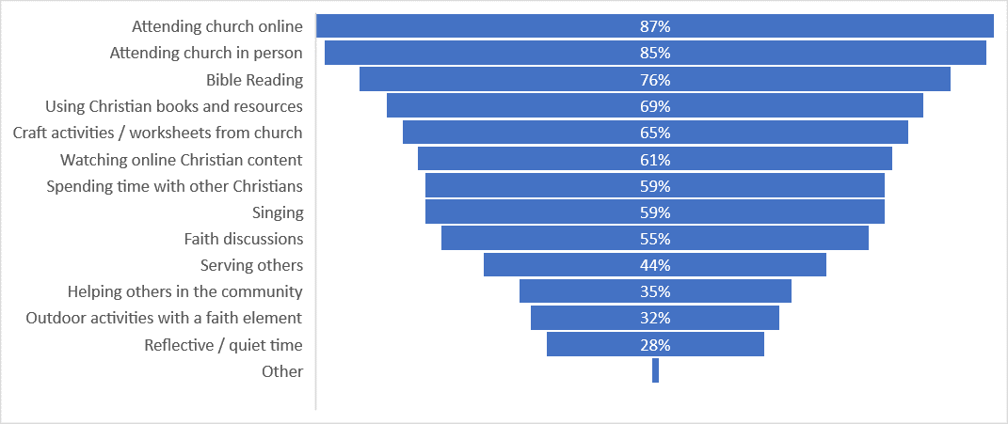

**Figure 2: Responses to question: What sort of faith practices (if any) has your family engaged in together during the pandemic?**

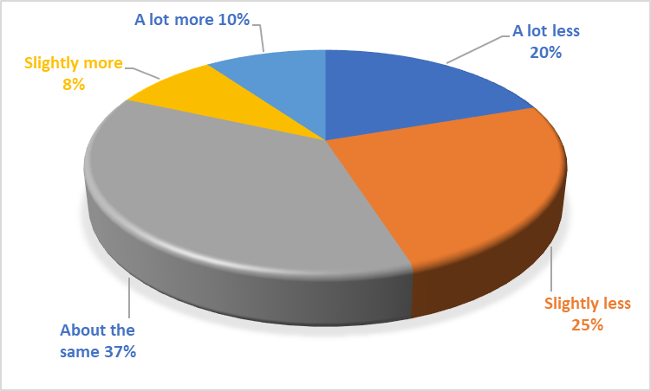

**Figure 3a: Responses to question: Compared with pre-pandemic, has your family engaged more or less with your local church?**

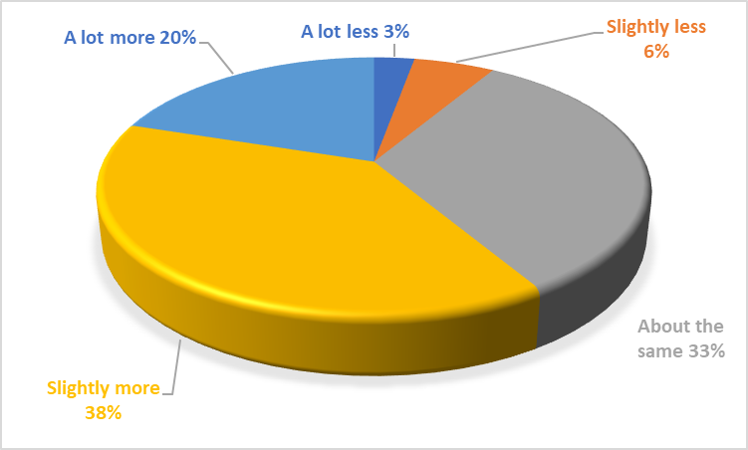

**Figure 3b: Responses to question: Compared with pre-pandemic, has your family engaged more or less in faith practices at home?**

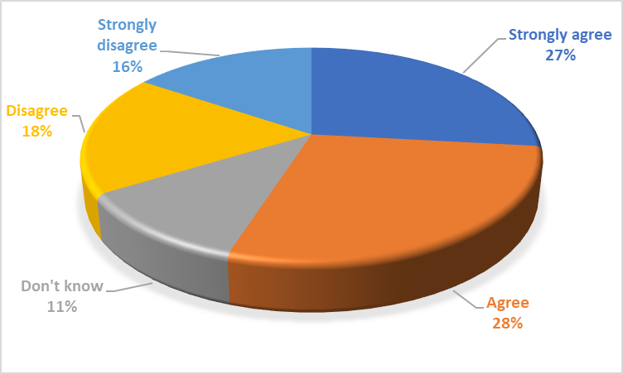

**Figure 4a: Responses to statement: As a Christian parent, I have felt supported by my local church as I seek to nurture my child’s faith at home**

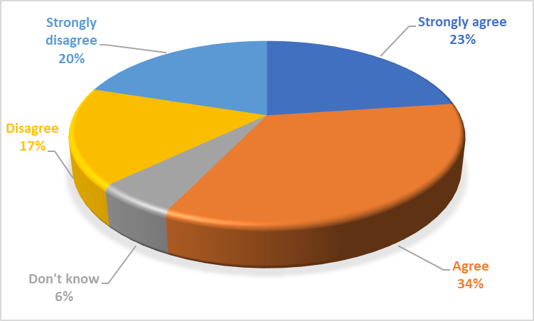

**Figure 4b: Responses to statement: My local church provides resources to use at home to grow and develop my child’s faith.**

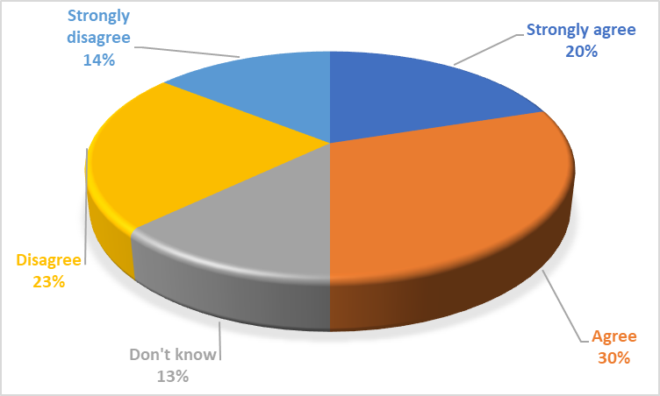

**Figure 4c: Response to statement: Relationships with people at church have been a support for our family’s faith**

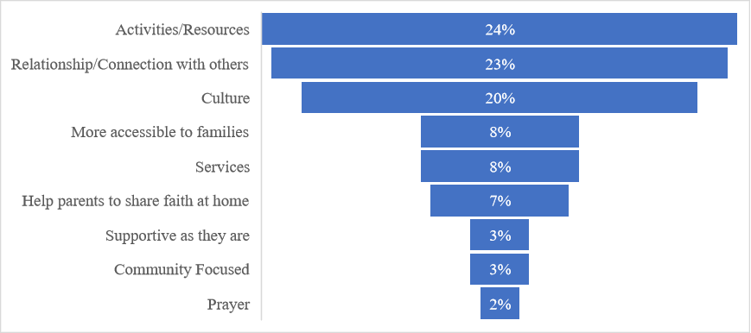

**Figure 5a: Response to question: How could the Christian community better support Christian families on their faith journeys? .**

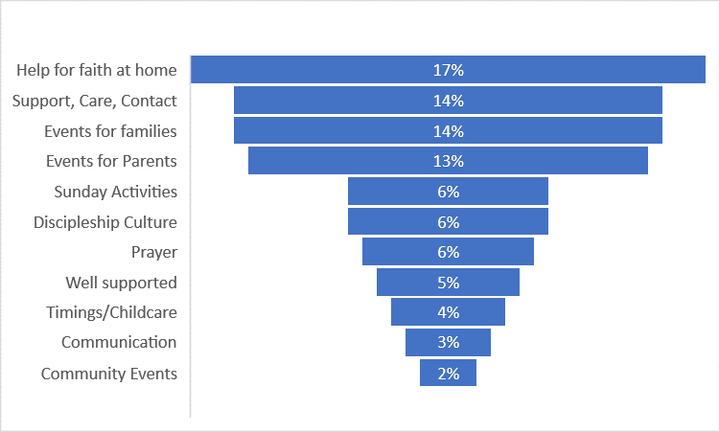**Figure 5b: Responses to the question: What would you like your local church to provide for your family in the year ahead, to support your family faith?**

1. [Faith Survey | Christianity in the UK](https://faithsurvey.co.uk/uk-christianity.html)
2. [Growth, Decline and Extinction of UK Churches - Church Growth Modelling (churchmodel.org.uk)](https://churchmodel.org.uk/2022/05/15/growth-decline-and-extinction-of-uk-churches/)
3. Youth and Children's Growth research, <https://www.churchofengland.org/sites/default/files/2022-07/Youth%20and%20Childrens%20Growth%20-%20research%20paper.pdf>
4. <https://www.churchofengland.org/sites/default/files/2019-01/GS%202121.pdf>
5. https://www.vatican.va/archive/ENG0015/_INDEX.HTM
6. [Home - Care for the Family](https://www.careforthefamily.org.uk/)
7. [Celebrate Trust](https://www.celebratetrust.org/)
8. [Parenting for Faith | Equipping parents to raise God-connected children and teens (brf.org.uk)](https://www.parentingforfaith.brf.org.uk/)
9. Church of England, Statistics for Mission, 2021. Available at <https://www.churchofengland.org/sites/default/files/2023-01/2021%20Statistics%20For%20Mission.pdf>. (accessed 10th May 2023)
10. <https://www.papalencyclicals.net/pius10/p10quam.htm>
11. <https://jesuitinstitute.org/Resources/Directory%20for%20Masses%20With%20Children.pdf>