Bioenergetic mechanisms linking V̇O2 kinetics and exercise tolerance

Richie P. Goulding1, Harry B. Rossiter2,3, Simon Marwood4, Carrie Ferguson2

1 Applied Physiology Laboratory, Kobe Design University, Kobe, Japan

2 School of Biomedical Sciences, Faculty of Biological Sciences & Multidisciplinary Cardiovascular Research Centre, University of Leeds, Leeds, LS 2 9JT, UK

3 Rehabilitation Clinical Trials Center, Division of Respiratory & Critical Care Physiology & Medicine, The Lundquist Institute for Biomedical Innovation at Harbor-UCLA Medical Center, Torrance CA, 90254, USA

4 School of Health Sciences, Liverpool Hope University, Liverpool, L16 9JD, UK

Running Title: V̇O2 kinetics and exercise intolerance

**CORRESPONDING AUTHOR:** Carrie Ferguson, School of Biomedical Sciences, University of Leeds, Woodhouse Lane, Leeds, LS 2 9JT, UK. Email: c.ferguson@leeds.ac.uk

**SUPPORT**:RPGis supported by anInternational Research Fellowship, Japan Society for Promotion of Sciences, Tokyo, Japan.

**ABSTRACT**

We present contemporary evidence that the V̇O2 time constant (τV̇O2) determines exercise tolerance by defining the power output associated with a “critical threshold” of intramuscular metabolite accumulation (e.g. inorganic phosphate), above which muscle fatigue and work inefficiency are progressive. Thereafter, the “slow component” of intramuscular metabolism and its systemic consequences (increased pulmonary, circulatory and neuromuscular demands) determine performance limits.

**SUMMARY**

V̇O2 kinetics determine exercise tolerance by mediating the power output at which muscle metabolite accumulation exceeds a “critical threshold”.

**KEY POINTS**

* Understanding the physiological determinants of exercise tolerance remains an important goal for exercise physiologists, however, these determinants remain unclear
* Here, we present contemporary quantitative evidence that exercise intolerance is mediated via a “critical threshold” and “positive feedback” mechanism, which links V̇O2 kinetics to the ability to sustain exercise
* Specifically, the fundamental phase of V̇O2 kinetics determines the power output at which O2-deficit-related metabolite accumulation (e.g. [inorganic phosphate]) exceeds critical limits
* Exceeding this "critical threshold” causes muscle fatigue and initiates a positive feedback loop - a self-driving, reciprocal mechanism of diminishing return - which causes the loss of work efficiency, increased ATP demand, further fatigue, and so on
* Once the critical threshold is exceeded, the tolerable duration of exercise is a function of the propagation rate of this positive feedback loop, with intolerance reached once peak pulmonary, circulatory or neuromuscular limits, or associated symptoms, are reached

**KEY WORDS**

Muscle fatigue; work efficiency; power-duration relationship; mitochondria; inorganic phosphate; oxidative capacity.

**INTRODUCTION**

Understanding the physiological determinants of whole-body exercise tolerance remains one of the ultimate targets in exercise physiology. These determinants are particularly pertinent when considered in the context of the continuum of physiological function; underpinning elite sporting performance at one extreme, and predictive of morbidity, mortality and quality of life in chronic disease patients at the other. Identification of parameters of aerobic function, such as the maximum rate of pulmonary oxygen uptake (V̇O2max), lactate threshold (LT) and critical power (CP), have advanced our understanding of the role of O2 transport and utilization in endurance exercise performance (1) and are strong prognostic biomarkers. V̇O2 kinetics, however, have received less attention as an index of exercise tolerance or prognosis. V̇O2 kinetics confer the ability to meet physical tasks in a physiologic steady-state by reducing the intramuscular metabolism disturbance for any given power output (termed “metabolic stability”; 2), and are therefore a crucial mediator of fitness and survival. V̇O2 kinetics shares mechanisms with V̇O2max, CP and LT, such as mitochondrial volume-density, the capacities for intramuscular oxidative phosphorylation and convective and diffusive O2 delivery. However, as V̇O2 kinetics is operant during any increase in energy demand, it is more relevant than traditional parameters of aerobic function to the ability to meet activities of daily living in a steady-state. The aim of this review is to demonstrate that V̇O2 kinetics is central in defining exercise intolerance, by determining the external power available before reaching a “critical threshold” of intramuscular metabolite accumulation, which in turn initiates a “positive feedback loop” of muscle fatigue and inefficiency that presage exercise performance limitations (3–6).

**V̇O2 KINETICS AND THE O2 DEFICIT**

Adenosine triphosphate (ATP) fuels skeletal muscle contraction. However, muscle ATP concentration alone is too low to sustain contractions for more than a few seconds. Therefore, substrate-level and oxidative phosphorylation bioenergetic pathways are recruited at the onset of contractions to supply ATP at rates commensurate with demands. The relative contribution to the rate of ATP turnover (AṪP) from substrate-level or oxidative phosphorylation is determined by the speed with which V̇O2 responds – the V̇O2 kinetics – and is fundamental in determining both the metabolic stress (exercise intensity) and tolerability associated with any particular power output.

At the onset of constant power exercise, necessitating an instantaneous increase in AṪP, the V̇O2 response is finite. Following a short phase I V̇O2 increase, reflecting the limb-lung vascular transit delay, there is a phase II V̇O2 increase that follows an exponential-like profile closely related to the rate of muscle oxygen consumption (7), and is typically characterized by an exponential time-constant (τV̇O2; Figure 1A). This finite pulmonary V̇O2 response leaves a substantial deficit of energy provision, which is provided by a reduction in oxygen stores used for oxidative phosphorylation and substrate-level phosphorylation (phosphocreatine (PCr) breakdown and glycolysis/glycogenolysis forming lactate): a phenomenon termed “the O2 deficit” by Krogh and Lindhard (8).

The magnitude of the O2 deficit at exercise onset is critical since: (1) capacitances of phosphocreatine (PCr), glycolysis/glycogenolysis and O2 stores (dissolved or associated with hemoglobin or myoglobin) are each limited, and small relative to the demands of continuing exercise for more than a few minutes; (2) it determines the extent of the muscular metabolic disturbance for a given power output e.g. accumulation of hydrogen ions [H+], inorganic phosphate [Pi], adenosine diphosphate [ADP], extracellular [K+], and loss of sarcoplasmic Ca2+ release and sensitivity; (3) loss of muscle metabolic stability is associated with muscle fatigue and reduced work efficiency.

At the onset of constant power output exercise, power output determines the AṪP requirement and the steady-state increment in V̇O2 (∆V̇O2) through ratios mediated by watts/AṪP and ATP/molecular oxygen (P/O). For power outputs that reach a steady-state, the O2 deficit can be reasonably estimated by the product of ∆V̇O2 and τV̇O2 (Figure 1, Equation 1), where τV̇O2 is the exponential time constant of the overallV̇O2 response (also termed the mean response time):

O2 deficit = V̇O2 * τV̇O2 (Equation 1)

During steady-state cycle ergometry, ∆V̇O2 is related to power by a functional gain of 10 ml·min-1·W-1 (ranging ~9-11 ml·min-1·W-1) (9). This functional gain is highly invariant, being similar across sex, age, or state of training. On the other hand, τV̇O2 is stronglyaffected by state of training, age, or chronic disease, and can vary ~10-fold from the fastest (elite endurance athletes τV̇O2 = 12 s) to the slowest (elderly patients with chronic obstructive pulmonary disease τV̇O2 = 120 s) (10,11). Therefore, the size of the O2 deficit for any given power output is mainly determined by τV̇O2; those with the fastest V̇O2 kinetics will achieve power outputs in a steady-state with a smaller O2 deficit than those with slow V̇O2 kinetics (Figure 1B).

The variables that contribute to setting individual V̇O2 kinetics are the subject of comprehensive review elsewhere (10,11) and are not the intended focus of this review. Broadly, the primary site of flux control for muscle oxygen consumption kinetics resides with the rate of ADP feedback to the mitochondrion, the mitochondrial volume-density, the relative activation state of a wide array of enzymes involved in oxidative phosphorylation, and spatial and temporal buffering by PCr (10–13). In canine muscle, acute creatine kinase (CK) inhibition speeds muscle oxygen consumption kinetics (14), suggesting a central role for CK activity in limiting V̇O2 kinetics. More recent evidence indicates that the parallel activation of ATP consumption and processes related to mitochondrial and glycolytic enzyme activity, perhaps via Ca2+ accumulation, is likely to exert a major controlling influence on the rate of oxidative phosphorylation induced by [ADP] at the inner-mitochondrial membrane (12,13). Hence, rapid muscle oxygen consumption kinetics require strong parallel activation of ATP-consuming and producing pathways (12,13), high oxidative enzyme activity and sufficient mitochondrial ADP delivery regulated by the CK kinase reaction (14). Pharmacological activation of pyruvate dehydrogenase did not speed muscle oxygen uptake kinetics in most experimental preparations (for discussion see 15), suggesting that reducing equivalent delivery to the electron transport chain is not a limiting factor. There may, however, be a role for mitochondrial enzyme activity to speed V̇O2 kinetics in aged muscles (16). Naturally, O2 is required for oxidative phosphorylation, and therefore mitochondrial O2 delivery has the potential to limit muscle oxygen consumption kinetics. Most evidence suggests that increasing muscle O2 delivery does not speed muscle oxygen consumption or V̇O2 kinetics in young, healthy individuals (10). However, the potential for O2 delivery limitations to V̇O2 kinetics increases in the elderly and chronic disease (10,11).

**THE O2 DEFICIT AND EXERCISE INTENSITY**

For over 100 years, exercise physiology pioneers such as August Krogh, Archibald Hill, Rodolfo Margaria, David Dill, Bengt Saltin, Brian Whipp and a great many others, focused research efforts on identifying the relationships among the O2 deficit, lactate production and accumulation, and mechanisms of exercise intolerance. It is intuitive that the bioenergetics comprising the O2 deficit play a role in limiting exercise tolerance, but attempts to establish a quantitative link have proven divisive (17,18). Overall, the O2 deficit is unable to explain exercise performance limitations (19). This is in no small part because quantitation of the O2 deficit is prone to extreme artifact: it is only reliably calculated for power outputs that attain a steady-state or very rapidly achieve V̇O2max (20). However, exercise limitation mainly occurs in non-steady-state physiology. Therefore, attempts to accurately predict exercise tolerance during non-steady-state tasks using the O2 deficit (and by inference V̇O2 kinetics) were destined for failure.

During constant power outputs that result in a progressive metabolic acidosis (very heavy intensity), watts/AṪP decreases (21). This means that there is no single V̇O2 associated with the exercise task performed, and therefore the assumptions inherent in equation 1 (that V̇O2 reaches a state-state) are no longer valid. The progressive increase in V̇O2 during very-heavy intensity exercise is termed the V̇O2 “slow component” (V̇O2SC). This means that for power outputs which exceed some “critical threshold” (see below), the O2 deficit cannot be reliably calculated and instead ranges between plausible limits, set largely by the lower (~9 ml·min-1·W-1) and upper observed limits for V̇O2 gain (up to ~15 ml·min-1·W-1 in very-heavy intensity exercise) (Figure 1B). Without a simple means to measure the O2 deficit, it becomes complex to study its effects on exercise tolerance.

**THE ‘CRITICAL THRESHOLD AND POSITIVE FEEDBACK’ MODEL THAT LINKS V̇O2 KINETICS TO EXERCISE LIMITATION**

Two consequences of exceeding the aforementioned “critical threshold” are peripheral fatigue (22,23) and an increase in AṪP that reduces exercise efficiency (21). These are reflected in the slow components of intramuscular metabolism (progressive rise in [Pi] and progressive fall in [PCr] and pH) and V̇O2 (V̇O2SC) (24–27). The link with muscle fatigue is the essential clue to development of the hypothesis outlined below. Classical views of the O2 deficit reflect either an exercise limitation caused by “depletion” of stored energy equivalents during exercise (PCr, glycogen, stored O2) or an “accumulation” of one or more metabolic products (e.g. [ADP], [Pi], [H+]) to some peak level that prevents continued exercise. For example, depleting a muscle of PCr or glycogen would cause intolerance due to lack of substrates to support ATP production, or increasing [ADP] or [Pi] to some high level would inhibit the power stroke and/or slow cross-bridge cycling to a degree that prevented contractions to continue at the force and/or velocity required.

A vital question in the search to understand whether depletion or accumulation mechanisms are better associated with the characteristics of exercise intolerance during large muscle mass exercise, such as cycling, is, how does the muscle “sense” whether it is above or below the “critical threshold” that signals the loss of metabolic stability and precipitates exercise limitation? There is no PCr or glycogen receptor in muscle that can facilitate such signaling. Equally, there is no sensor for power output, AṪP or metabolic rate (muscle oxygen consumption) that, once exceeded, causes a loss of work efficiency. Muscle fatigue, on the other hand, can act in a “sensor-like” role by causing increased AṪP for a given power output.

There is a strong association between muscle fatigue (loss of force and/or velocity) and the loss of work efficiency (decreased watts/AṪP causing the V̇O2SC) (28). The mechanism is not well understood, but may result from loss of efficiency in type 1 muscle fibers during high force or velocity contractions, where type 1 fibers must be shortened actively by the contractile activity of type 2 fibers (29) i.e. the muscle begins to “work against itself” during fatigue where shortening velocities are reduced. Thus, the onset of muscle fatigue can signal the onset of increased AṪP demand i.e., fatigue is the sensor identifying whether or not a “critical threshold” is reached at a particular power output.

Of the O2-deficit-related metabolites proposed, [Pi] is a prime candidate due to its central role in muscle fatigue (30). Pi inhibits the power stroke of the cross-bridge cycle, i.e. the transition to high-force cross-bridge states. It also decreases myofibrillar Ca2+ sensitivity and can co-precipitate with Ca2+ ions in the sarcoplasmic reticulum (SR), lowering Ca2+ release following excitation (30). Towards the limit of sustained muscle contractions, only a small increase in Pi may be needed to result in a significant depletion of free Ca2+ which interferes with excitation–contraction coupling and thus contributes to limiting muscular work (30).

The potential role of [Pi] in mediating the “critical threshold” was recently provided by studies *in silico* using a validated model of myocellular bioenergetics (5,31). By defining a “critical” (i.e. threshold) and a “peak” (i.e. limiting) [Pi], Korzeniewski & Rossiter (5) demonstrated that exceeding the critical [Pi] during an exercise transition can cause reciprocal increases in the requirements for AṪP, i.e. reducing watts/AṪP. This additional AṪP results in a self-propagating positive feedback loop where additional AṪP turnover results in increased [Pi], which causes fatigue and additional AṪP turnover, and so on. This continues until a peak [Pi] is reached and exercise intolerance ensues.

Simulations using a “critical [Pi]” to trigger a reduction in work efficiency revealed a hyperbolic relationship between ATP usage activity (AUT; analogous to external power output) and the tolerable duration of exercise (Figure 2). This hyperbolic behavior is consistent with experimental data across a wide array of exercise modes or species (reviewed by 32), with an asymptote termed critical power (CP), reflecting the highest power output at which a steady-state can be attained, and a curvature constant (W'), reflecting a finite volume of work that can be performed above CP. Additional simulations to limit or enhance myocellular O2 availability resulted in the changes in V̇O2 kinetics, CP and exercise tolerance that were anticipated based on human experimental data (5).

These data provide theoretical support for the “critical threshold and positive feedback loop” hypothesis, placing [Pi] as the central mediator, responsible for both the threshold, and initiation of the positive feedback loop that ultimately results in termination of exercise when [Pi] reached some predetermined peak [Pi] beyond which the task is limited. The concept of a critical [Pi], proposed by Korzeniewski & Rossiter (5), thus provides a plausible candidate mechanism linking the traditional “accumulation” hypothesis of the O2 deficit to our current understanding of the power-tolerable duration relationship and exercise performance.

As the authors point out, the notion that a single variable i.e., [Pi] or other mechanisms based on actions of a single metabolite (33) is responsible for the complex integrative physiology of exercise limitation is clearly an oversimplification. Rather, these simulations demonstrate that for a single metabolite, with known fatigue-inducing ability, exceeding a “critical threshold” can set in motion a wide array of muscle and systemic bioenergetic behaviors that are consistent with directly measured experimental observations (5).

This model of exercise intolerance results in (at least) two inferences. Firstly, since faster V̇O2 kinetics at exercise onset (i.e. lower τV̇O2) reduce the O2 deficit, and therefore the rate of metabolite accumulation for a given power output, a greater power output would be achieved before the critical threshold is exceeded (i.e. greater CP), compared with when V̇O2 kinetics are slower (i.e. lower CP). Hence, τV̇O2 is a primary mediator of CP through its relationship with the O2 deficit, the rate of metabolite accumulation and the value of the critical threshold inducing fatigue and inefficiency. It is worth noting here that this hypothesis means that that CP does not represent a unique power output, nor does it represent a unique metabolic rate or V̇O2 (c.f. 34), but rather a critical level of muscle metabolite accumulation that is associated with fatigue induction and results in work inefficiency. This is consistent with findings that CP delineates power outputs that result in progressive muscle fatigue from those that do not (22,23).

The second inference from this is hypothesis is that the work available above CP (i.e. W') is a function of the rate of accumulation of fatigue-related metabolites and loss of efficiency that drives a “positive feedback loop” and determines how quickly peak [Pi] is attained. It is worth noting here that in the model of Korzeniewski and Rossiter (5), increases in [Pi] have a diminishing return on propagation of inefficiency as exercise progresses, in much the same way that increases in [Pi] in isolated muscle preparations has a diminishing effect on force (35). In other words, watts/AṪP decreases more for a given increase in [Pi] just above the critical threshold, compared with when [Pi] approaches peak. It should also be noted that should the proximal cause of exercise limitation be located somewhere other than the active muscle (e.g. limitation due to dyspnea or pain), then the peak [Pi] (or peak combination of accumulating metabolites) will be a consequence rather than a cause of exercise termination.

Murgatroyd et al. (4) characterized relationships between τV̇O2 and CP by normalizing exercise intensity across individuals such that the tolerable duration of exercise was uniform (6 minutes). They demonstrated a strong, inverse correlation between τV̇O2 and CP (*R2* = 0.90) (and also a strong, positive association between the V̇O2SC and W'; *R2* = 0.76; see below), wholly consistent with the predictions of the critical threshold and positive feedback model of exercise intolerance. However, until recently, a quantitative mechanism to explain this link was lacking.

**EVIDENCE FOR THE CRITICAL THRESHOLD: τV̇O2 AND CRITICAL POWER**

A wealth of cross-sectional evidence exists to support an association between τV̇O2 and CP. Cross-sectional comparisons in endurance athletes, the elderly, and in patients with chronic diseases that affect the O2 transport and utilization pathways indicate that where τV̇O2 is small (i.e. V̇O2 kinetics are fast), CP is correspondingly large, and where τV̇O2 is large (i.e. V̇O2 kinetics are slow), CP is correspondingly small (Figure 2B) (11). Indeed, when this analysis is performed across populations, the relationship is strong, inverse, and appears linear (Figure 2B) (11). Furthermore, interventional studies also support a causative link: endurance training both reduce τV̇O2 (36) and increase CP (37), whereas in hypoxia τV̇O2 is increased (38) and CP is decreased (39), in agreement with *in silico* predictions(5). Increasing pedal cadence (thereby increasing type II muscle fiber activation) increases τV̇O2 (40) and reduces CP (34).

Thus, there is strong rationale and a large body of cross-sectional evidence in humans that supports the hypothesis that there is a mechanistic link between τV̇O2 and CP. This has then been further validated by studies with targeted experimental interventions to acutely speed or slow τV̇O2 within an individual and observe the effect on CP. Specifically, when τV̇O2 was increased, CP was concomitantly decreased (33,41), and when τV̇O2 was reduced, CP was concomitantly increased (42–44). The changes observed in CP following each intervention occurred both with (42–44) and without (33,41) concomitant changes in muscle O2 delivery, suggesting that τV̇O2 exerts a determining effect on CP that is independent of the already-established effect of muscle O2 delivery (26). Moreover, a priming-exercise-induced speeding of V̇O2 kinetics also increased CP in a group of patients with type 1 diabetes (44). Hence, there appears to be a consistency in the τV̇O2-CP relationship across both distinct human populations differing in aerobic function (11,44), as well as conditions of altered muscle O2 availability (33,41–43,45). Together these data support that τV̇O2-CP relationship is ubiquitous across both health and disease, and CP is mediated by τV̇O2 through its relationship to reach a critical threshold of intramuscular metabolite accumulation.

Stronger evidence for a determining effect of τV̇O2 on CP, however, would arguably come from demonstrating a relationship between changes in τV̇O2 (ΔτV̇O2) and CP (ΔCP) following an intervention. Evidence for this was provided by studies that determined τV̇O2 and CP during supine exercise in normoxic and hyperoxic conditions, and also used repeated bouts of moderate intensity exercise in both conditions to allow precise characterization of the relationship between ΔτV̇O2 and ΔCP (42). Consistent with previous data, the lower τV̇O2 in hyperoxia occurred concomitantly with an increase in CP; despite this, ΔCP and ΔτV̇O2 were not linearly related (*r* = -0.45). However, it was notable that in this (42) and previous studies utilizing the supine position (41,43) the linear relationship between τV̇O2 and CP was absent in normoxic conditions, unlike the linear relationship seen with exercise in the upright position (41–43). Whilst such findings may question the role of τV̇O2 in determining CP, it is likely that supine exercise introduces a kinetic dissociation between muscle oxygen consumption and pulmonary V̇O2 kinetics,due to the lower baseline perfusion and slower O2 delivery kinetics during exercise in this position (11). Such a dissociation would serve to obscure the relationship between ΔCP and ΔτV̇O2. With respect to this latter point, in hyperoxia, the relationship between τV̇O2 and CP in the supine position was restored (*r* = -0.89) (42).

In a further study, hyperoxia increased indices of muscle O2 availability assessed via NIRS (i.e. [oxyhaemoglobin + myoglobin]) and increased CP during upright cycle exercise, despite τV̇O2 being unchanged between normoxia and hyperoxia (45). This finding suggests that microvascular O2 availability, in addition to τV̇O2, is an independent determinant of CP. This finding is consistent with the predictions of the critical threshold and positive feedback model, when considering that the degradation of [PCr] and accumulation of [ADP] and [Pi] during constant-power exercise are inversely related to FiO2 (46). It is inferred that increased microvascular O2 availability in hyperoxia could allow a lesser degree of [Pi] accumulation for a given power output (2), thereby increasing the power output at which the critical [Pi] is attained independently of changes in τV̇O2. Taken together, across a series of studies (4,11,33,41–45) there is strong evidence that τV̇O2 is an independent mediator of CP.

**EVIDENCE FOR THE POSITIVE FEEDBACK LOOP: V̇O2SC AND W'**

The proposed model of exercise intolerance predicts that once the critical threshold of metabolite accumulation is exceeded, tolerable duration of exercise is a function of W'. This acts through the rate of “accumulation” of intramuscular metabolites to achieve peak, or limiting, values. Therefore, the rate at which work efficiency is lost (reflected in the speed/magnitude of the V̇O2SC) and the attainment of limiting conditions e.g., reflected in V̇O2max, would determine W'. Thus, evidence for a relationship between V̇O2SC and W', would further support this concept.

A large body of empirical evidence demonstrating a relationship between the amplitude of the V̇O2SC and W' exists. For example, the positive relationship noted between the amplitude of the V̇O2SC and W' for constant work rate exercise (4) is also present during all-out exercise (27). Endurance training reduces both the amplitude of the V̇O2SC at a fixed submaximal work rate (36,47), and also decreases W' (37,48). Glycogen depletion reduces W' (49) and also reduces the amplitude of the V̇O2SC at a fixed submaximal work rate(50). Also, prior exhaustive severe-intensity exercise reduces both the V̇O2SC and W' during subsequent exercise following a brief (i.e. 2 min) recovery period, without affecting either τV̇O2 or CP (51). However, when the performance of prior exercise is carefully selected to increase subsequent exercise performance, W' is increased in concert with a reduced V̇O2SC (52). Rather than argue against a mechanistic relationship between the V̇O2SC and W’, such observations instead highlight that quantification of the amplitude of the V̇O2SC *per se*, especially when it is incompletely evolved, is a simplistic metric that does not fully capture its role in reflecting the loss of muscle efficiency and thus W'. Interventions that alter the magnitude of W' therefore also impact the amplitude and/or rate of progression of the V̇O2SC, thereby influencing exercise tolerance.

On the other hand, Goulding et al. showed that initiating exercise from an elevated baseline work rate in the supine position (i.e. work-to-work exercise) reduced the amplitude of the V̇O2SC but increased W' (41). However, in these conditions, CP was reduced without a concomitant reduction in V̇O2max. The effects of this intervention include greater τV̇O2 and a greater potential to increase V̇O2 above the V̇O2 associated with CP, which together complicate quantification of the V̇O2SC amplitude. Hyperoxia reduces the rate of development of the V̇O2 (45) and intramuscular (26) slow components, but also decreases W'. In this latter scenario, both CP and the fundamental V̇O2 amplitude are raised in hyperoxia (26,45), which would reduce the potential for the V̇O2SC to develop. The extant literature is therefore largely consistent with the notion that the V̇O2SC and W' are mechanistically related.

**INTEGRATION: DIFFERENT MODALITIES**

At the core of the proposed model of exercise tolerance is the notion that CP is the external power output associated with a critical threshold of muscle metabolite accumulation and fatigue induction. If so, critical metabolite accumulation would remain constant even when the relationship between power output and metabolic rate was dissociated. This notion is supported by studies that alter both pedal cadence during cycle exercise and the work:recovery ratios during intermittent exercise. Barker et al. (34) demonstrated that CP was lower at 100 rpm when compared to 60 rpm, however, the V̇O2 measured at each pedal-rate specific CP did not differ between the two pedal rates. Thus, the critical threshold, within an individual, can be achieved at different external power output and pedal rate combinations.

Intermittent exercise, wherein periods of supra-CP work are interspersed with periods of recovery, dissociates the power output from the systemic (V̇O2, [L-]) and intramuscular ([PCr], [Pi], and pH) (53) responses. Hence, exercise tolerance at a given very-heavy or severe intensity power output is greater using intermittent compared to continuous work and is associated with a reduced intramuscular metabolic strain (53). Specifically, shortening the work:recovery durations at a high power output (corresponding to 110% V̇O2max) increased exercise tolerance from ~4 minutes to being reached in a steady-state (the experiment was stopped after ~30 minutes) (53). Indeed, with very short work:recovery durations, the peak of the V̇O2 fluctuation can be constrained below the LT and as such, the bioenergetic responses reflect those expected of moderate intensity exercise (53) (Figure 4). Thus, it is proposed that the time course of the V̇O2 response at exercise onset and the associated rate of metabolite accumulation determines exercise tolerance, even during intermittent exercise. During intermittent exercise, despite the high AṪP, the V̇O2 kinetics and limited work bout duration can constrain the V̇O2 below the rate required to reach the notional critical metabolite threshold, thereby increasing exercise tolerance. Hence, it is not a *fait accompli* at exercise onset that intolerance will eventually ensue. Rather, it is the temporal responses of V̇O2 (which in turn mediate the intramuscular bioenergetic responses) that determine whether or not intolerance occurs, depending on whether or not exercise is continued for long enough to allow the [Pi] (or some combination of muscle metabolites) to accumulate to critical limits.

**CONCLUSIONS**

Here we review the experimental evidence to support the concept that a critical threshold and positive feedback loop model of muscle metabolite accumulation determines supra-CP exercise tolerance by constraining it to the limits defined by the power-tolerable duration curve. We show that the classical view that the O2 deficit is associated with accumulation of fatigue-related metabolites, can qualitatively and quantitatively explain the shape of the power-tolerable duration relationship and therefore that V̇O2 kinetics are a central player in mediating exercise tolerance: fast V̇O2 kinetics allow improved metabolic stability, lesser metabolite accumulation and greater CP. There is a wide array of correlative evidence supporting a strong relationship between τV̇O2 and CP. Moreover, recent acute interventional studies also support that a change in τV̇O2 results in an appropriate change in CP. Exceeding CP is associated with the loss of metabolic stability, muscle fatigue and progressive reduction in work efficiency. Metabolite accumulation is proposed to act as a “sensor”, by causing fatigue and loss of efficiency, and which determines whether a particular power output is below or above CP. Exceeding this critical threshold would initiate a positive feedback loop that propagates (with diminishing return) the demand for ATP synthesis and therefore the rate or amplitude of the V̇O2SC.Interventions that modify either the rate or amplitude of the V̇O2SC are shown to also alter the capacity for supra-CP exercise (W'). *In silico* simulation studies of the human bioenergetic system offer a mechanism underpinning the proposed model through [Pi] accumulation (or some combination of fatigue-inducing metabolites). These simulations suggest that exceeding critical [Pi] causes fatigue and lowers work efficiency: implying that CP represents the external power associated with attainment of a critical threshold of fatigue-inducing metabolite accumulation. Future experiments are required to test this hypothesis *in vivo*.

**REFERENCES**

1. Joyner MJ, Coyle EF. Endurance exercise performance: the physiology of champions. J Physiol. 2008 Jan 1;586(Pt 1):35–44.

2. Grassi B, Porcelli S, Salvadego D, Zoladz JA. Slow VO₂ kinetics during moderate-intensity exercise as markers of lower metabolic stability and lower exercise tolerance. Eur J Appl Physiol. 2011 Mar;111(3):345–55.

3. Murgatroyd SR, Wylde LA. The power–duration relationship of high-intensity exercise: from mathematical parameters to physiological mechanisms. J Physiol. 2011 May 15;589(Pt 10):2443–5.

4. Murgatroyd SR, Ferguson C, Ward SA, Whipp BJ, Rossiter HB. Pulmonary O2 uptake kinetics as a determinant of high-intensity exercise tolerance in humans. Journal of Applied Physiology. 2011 Jun 1;110(6):1598–606.

5. Korzeniewski B, Rossiter HB. Exceeding a “critical” muscle Pi: implications for [Formula: see text] and metabolite slow components, muscle fatigue and the power-duration relationship. Eur J Appl Physiol. 2020 May 20;

6. Korzeniewski B, Zoladz JA. Possible factors determining the non-linearity in the VO2-power output relationship in humans: theoretical studies. Jpn J Physiol. 2003 Aug;53(4):271–80.

7. Grassi B, Poole DC, Richardson RS, Knight DR, Erickson BK, Wagner PD. Muscle O2 uptake kinetics in humans: implications for metabolic control. J Appl Physiol. 1996 Mar;80(3):988–98.

8. Krogh A, Lindhard J. The regulation of respiration and circulation during the initial stages of muscular work. J Physiol. 1913 Oct 17;47(1–2):112–36.

9. Wilkerson DP, Koppo K, Barstow TJ, Jones AM. Effect of work rate on the functional “gain” of Phase II pulmonary O2 uptake response to exercise. Respir Physiol Neurobiol. 2004 Sep 15;142(2–3):211–23.

10. Poole DC, Jones AM. Oxygen uptake kinetics. Compr Physiol. 2012 Apr;2(2):933–96.

11. Rossiter HB. Exercise: Kinetic Considerations for Gas Exchange. Compr Physiol. 2011 Jan;1(1):203-44.

12. Korzeniewski B, Rossiter HB. Each‐step activation of oxidative phosphorylation is necessary to explain muscle metabolic kinetic responses to exercise and recovery in humans. J Physiol. 2015 Dec 15;593(24):5255–68.

13. Glancy B, Willis WT, Chess DJ, Balaban RS. Effect of Calcium on the Oxidative Phosphorylation Cascade in Skeletal Muscle Mitochondria. Biochemistry. 2013 Apr 23;52(16):2793–809.

14. Grassi B, Rossiter HB, Hogan MC, Howlett RA, Harris JE, Goodwin ML, et al. Faster O₂ uptake kinetics in canine skeletal muscle in situ after acute creatine kinase inhibition. J Physiol (Lond). 2011 Jan 1;589(Pt 1):221–33.

15. Marwood S, Constantin-Teodosiu D, Casey E, Whyte M, Boobis L, Bowtell J. No acetyl group deficit is evident at the onset of exercise at 90% of maximal oxygen uptake in humans. J Sports Sci. 2010;28(3):267–79.

16. Gurd BJ, Peters SJ, Heigenhauser GJF, LeBlanc PJ, Doherty TJ, Paterson DH, et al. Prior heavy exercise elevates pyruvate dehydrogenase activity and muscle oxygenation and speeds O2 uptake kinetics during moderate exercise in older adults. American Journal of Physiology-Regulatory, Integrative and Comparative Physiology. 2009 Sep 1;297(3):R877–84.

17. Medbø JI, Tabata I. Anaerobic energy release in working muscle during 30 s to 3 min of exhausting bicycling. J Appl Physiol. 1993 Oct;75(4):1654–60.

18. Bangsbo J. Oxygen deficit: a measure of the anaerobic energy production during intense exercise? Can J Appl Physiol. 1996 Oct;21(5):350–63; discussion 364-369.

19. Billat VL, Hamard L, Koralsztein JP. The influence of exercise duration at VO2 max on the off-transient pulmonary oxygen uptake phase during high intensity running activity. Arch Physiol Biochem. 2002 Dec;110(5):383–92.

20. Ozyener F, Rossiter HB, Ward SA, Whipp BJ. Negative accumulated oxygen deficit during heavy and very heavy intensity cycle ergometry in humans. Eur J Appl Physiol. 2003 Sep;90(1–2):185–90.

21. Cannon DT, White AC, Andriano MF, Kolkhorst FW, Rossiter HB. Skeletal muscle fatigue precedes the slow component of oxygen uptake kinetics during exercise in humans. J Physiol (Lond). 2011 Feb 1;589(Pt 3):727–39.

22. Keir DA, Copithorne DB, Hodgson MD, Pogliaghi S, Rice CL, Kowalchuk JM. The slow component of pulmonary O2 uptake accompanies peripheral muscle fatigue during high-intensity exercise. Journal of Applied Physiology. 2016 Jun 23;121(2):493–502.

23. Burnley M. Estimation of critical torque using intermittent isometric maximal voluntary contractions of the quadriceps in humans. J Appl Physiol. 2009 Mar;106(3):975–83.

24. Jones AM, Wilkerson DP, DiMenna F, Fulford J, Poole DC. Muscle metabolic responses to exercise above and below the “critical power” assessed using 31P-MRS. Am J Physiol Regul Integr Comp Physiol. 2008 Feb;294(2):R585-593.

25. Poole DC, Ward SA, Gardner GW, Whipp BJ. Metabolic and respiratory profile of the upper limit for prolonged exercise in man. Ergonomics. 1988 Sep;31(9):1265–79.

26. Vanhatalo A, Fulford J, DiMenna FJ, Jones AM. Influence of hyperoxia on muscle metabolic responses and the power-duration relationship during severe-intensity exercise in humans: a 31P magnetic resonance spectroscopy study. Exp Physiol. 2010 Apr;95(4):528–40.

27. Vanhatalo A, Black MI, DiMenna FJ, Blackwell JR, Schmidt JF, Thompson C, et al. The mechanistic bases of the power-time relationship: muscle metabolic responses and relationships to muscle fibre type. J Physiol (Lond). 2016 Aug 1;594(15):4407–23.

28. Grassi B, Rossiter HB, Zoladz JA. Skeletal muscle fatigue and decreased efficiency: two sides of the same coin? Exerc Sport Sci Rev. 2015 Apr;43(2):75–83.

29. Barclay CJ. Mechanical efficiency and fatigue of fast and slow muscles of the mouse. J Physiol. 1996 Dec 15;497(Pt 3):781–94.

30. Allen DG, Lamb GD, Westerblad H. Skeletal muscle fatigue: cellular mechanisms. Physiol Rev. 2008 Jan;88(1):287–332.

31. Korzeniewski B. Pi-induced muscle fatigue leads to near-hyperbolic power-duration dependence. Eur J Appl Physiol. 2019 Oct;119(10):2201–13.

32. Jones AM, Vanhatalo A, Burnley M, Morton RH, Poole DC. Critical power: implications for determination of V˙O2max and exercise tolerance. Med Sci Sports Exerc. 2010 Oct;42(10):1876–90.

33. Goulding RP, Roche DM, Marwood S. Elevated baseline work rate slows pulmonary oxygen uptake kinetics and decreases critical power during upright cycle exercise. Physiol Rep. 2018 Jul; 6 (14):e13802. doi: 10.14814/phy2.13802.

34. Barker T, Poole DC, Noble ML, Barstow TJ. Human critical power–oxygen uptake relationship at different pedalling frequencies. Experimental Physiology. 2006 May 1;91(3):621–32.

35. Cooke R, Pate E. The effects of ADP and phosphate on the contraction of muscle fibers. Biophys J. 1985 Nov;48(5):789–98.

36. Demarle AP, Slawinski JJ, Laffite LP, Bocquet VG, Koralsztein JP, Billat VL. Decrease of O2 deficit is a potential factor in increased time to exhaustion after specific endurance training. Journal of Applied Physiology. 2001 Mar 1;90(3):947–53.

37. Gaesser GA, Wilson LA. Effects of continuous and interval training on the parameters of the power-endurance time relationship for high-intensity exercise. Int J Sports Med. 1988 Dec;9(6):417–21.

38. Hughson RL, Kowalchuk JM. Kinetics of oxygen uptake for submaximal exercise in hyperoxia, normoxia, and hypoxia. Can J Appl Physiol. 1995 Jun;20(2):198–210.

39. Simpson LP, Jones AM, Skiba PF, Vanhatalo A, Wilkerson D. Influence of hypoxia on the power-duration relationship during high-intensity exercise. Int J Sports Med. 2015 Feb;36(2):113–9.

40. Pringle JSM, Doust JH, Carter H, Tolfrey K, Jones AM. Effect of pedal rate on primary and slow-component oxygen uptake responses during heavy-cycle exercise. J Appl Physiol. 2003 Apr;94(4):1501–7.

41. Goulding RP, Roche DM, Marwood S. “Work-to-Work” exercise slows pulmonary oxygen uptake kinetics, decreases critical power, and increases W’ during supine cycling. Physiol Rep. 2018 Nov;6(21):e13916.

42. Goulding RP, Roche DM, Marwood S. Hyperoxia speeds pulmonary oxygen uptake kinetics and increases critical power during supine cycling. Exp Physiol. 2019 May 4;

43. Goulding RP, Roche DM, Marwood S. Prior exercise speeds pulmonary oxygen uptake kinetics and increases critical power during supine but not upright cycling. Exp Physiol. 2017 Sep 1;102(9):1158–76.

44. Goulding RP, Roche DM, Scott SN, Koga S, Weston PJ, Marwood S. Limitations to exercise tolerance in type 1 diabetes: the role of pulmonary oxygen uptake kinetics and priming exercise. J Appl Physiol. 2020 May 1;128 (5):1299-1309.

45. Goulding RP, Roche DM, Marwood S. Effect of Hyperoxia on Critical Power and VO2 Kinetics during Upright Cycling. Med Sci Sports Exerc. 2020 May; 52 (5): 1041-1049.

46. Hogan MC, Richardson RS, Haseler LJ. Human muscle performance and PCr hydrolysis with varied inspired oxygen fractions: a 31P-MRS study. J Appl Physiol. 1999 Apr;86(4):1367–73.

47. Cleuziou C, Perrey S, Lecoq AM, Candau R, Courteix D, Obert P. Oxygen uptake kinetics during moderate and heavy intensity exercise in humans: the influence of hypoxia and training status. Int J Sports Med. 2005 Jun;26(5):356–62.

48. Jenkins DG, Quigley BM. Endurance training enhances critical power. Med Sci Sports Exerc. 1992 Nov;24(11):1283–9.

49. Miura A, Sato H, Sato H, Whipp BJ, Fukuba Y. The effect of glycogen depletion on the curvature constant parameter of the power-duration curve for cycle ergometry. Ergonomics. 2000 Jan;43(1):133–41.

50. Carter H, Pringle JSM, Boobis L, Jones AM, Doust JH. Muscle glycogen depletion alters oxygen uptake kinetics during heavy exercise. Med Sci Sports Exerc. 2004 Jun;36(6):965–72.

51. Ferguson C, Whipp BJ, Cathcart AJ, Rossiter HB, Turner AP, Ward SA. Effects of prior very-heavy intensity exercise on indices of aerobic function and high-intensity exercise tolerance. Journal of Applied Physiology. 2007 Sep 1;103(3):812–22.

52. Burnley M, Davison G, Baker JR. Effects of priming exercise on VO2 kinetics and the power-duration relationship. Med Sci Sports Exerc. 2011 Nov;43(11):2171–9.

53. Davies MJ, Benson AP, Cannon DT, Marwood S, Kemp GJ, Rossiter HB, et al. Dissociating external power from intramuscular exercise intensity during intermittent bilateral knee-extension in humans. J Physiol (Lond). 2017 01;595(21):6673–86.

**FIGURE LEGENDS**

**Figure 1**. Schematic representation of: (A) the kinetic V̇O2 response to a moderate-intensity constant-power output test with different values of τV̇O2; and (B) the corresponding interdependent relationship between ∆V̇O2 (AṪP) and τV̇O2 in determining the size of the O2 deficit below (solid line) and above (hatched area) a critical threshold of intramuscular metabolite accumulation. The hatched areas above represent the duration and amplitude dependent changes in ATP demand and V̇O2 for a given constant power exercise. Fast V̇O2 kinetics (τV̇O2 = 15 s) allow high ∆V̇O2 to be achieved in a steady state (below the O2 deficit associated with the critical threshold). Slower V̇O2 kinetics (τV̇O2 = 30 s or 60 s) will result in attaining the O2 deficit associated with the critical threshold at a lower ∆V̇O2 (or power output) (see text for additional details).

**Figure 2. A:** Simulated relationship between ATP usage activity (AUT) (herein termed AṪP) and the tolerable duration of exercise. One AUT unit corresponds roughly to 3 watts of power output. A hyperbolic fit of the simulated AUT–duration relationship is also shown. The asymptote of this hyperbola is (Parameter B = 75; the critical ATP usage activity) corresponds approximately to critical power (CP) of 222 W of total mechanical power or 210 W of external power. The curvature constant (Parameter A = 50) corresponds to the total work available above CP before intolerance, i.e. W'. Reproduced with permission from (5). **B:** Critical power (CP) as a function of the fundamental phase pulmonary oxygen uptake kinetics time constant (τV̇O2p) during cycle ergometry across populations differing in aerobic function. The figure is derived from 35 reports published between 1982 and 2008. Reproduced with permission from (11).

**Figure 3**. A schematic of the AṪP (A), V̇O2 (B), PCr (C) and [Pi] responses for participants with fast (τV̇O2 = 15 s; solid line) and slow V̇O2 kinetics (τV̇O2 = 60 s; dashed line). For a given AṪP, a steady-state is achieved rapidly in all variables with a small τV̇O2. The greater rate of O2 deficit accumulation associated with a large τV̇O2 leads to increased PCr depletion and Pi accumulation, to the extent that Pi accumulation (and other muscle metabolites, not shown) exceeds a critical threshold. Exceeding the critical threshold induces fatigue, which generates inefficiency and increases AṪP for a given power output. This initiates a positive feedback loop where increased AṪP, causes increased metabolite accumulation, which causes increased fatigue, which causes further increased AṪP, and so on until peak limits are reached (indicated by X). Stimulation of oxidative phosphorylation by metabolite accumulation above the critical threshold results in an increase in the O2 cost of the exercise, development of the V̇O2SC, and eventual attainment of V̇O2max.

**Figure 4**. V̇O2 (filled circles, top row), PCr (clear circles, top row) and intramuscular pH(pHi; bottom row) responses to work:recovery durations of 16:32 s (first column), 32:64 s (second column), 64:128 s (third column) or continuous exercise (fourth column) at an external work rate corresponding to 110% peak incremental test power. Lactate threshold (LT) from the ramp incremental test is shown by the dotted line (top row), as is V̇O2 max (top row, dashed line) and pHi at task failure from the continuous exercise protocol (bottom row, dashed line). Note that during the 16:32 s protocol, V̇O2 never exceeds the LT and the fluctuations in pHi and PCr are small, i.e. consistent with moderate intensity exercise. The peak V̇O2 amplitude exceeds the LT in the 32:64 and 64:128 s intermittent protocols and during continuous exercise, and this is accompanied by a metabolic acidosis (decline in pHi), consistent with a greater metabolic strain in these protocols. Reproduced with permission from (53).



**Figure 1.**

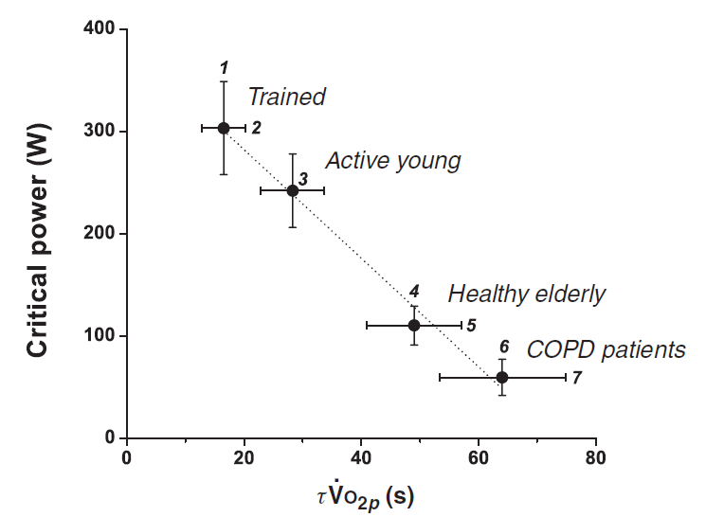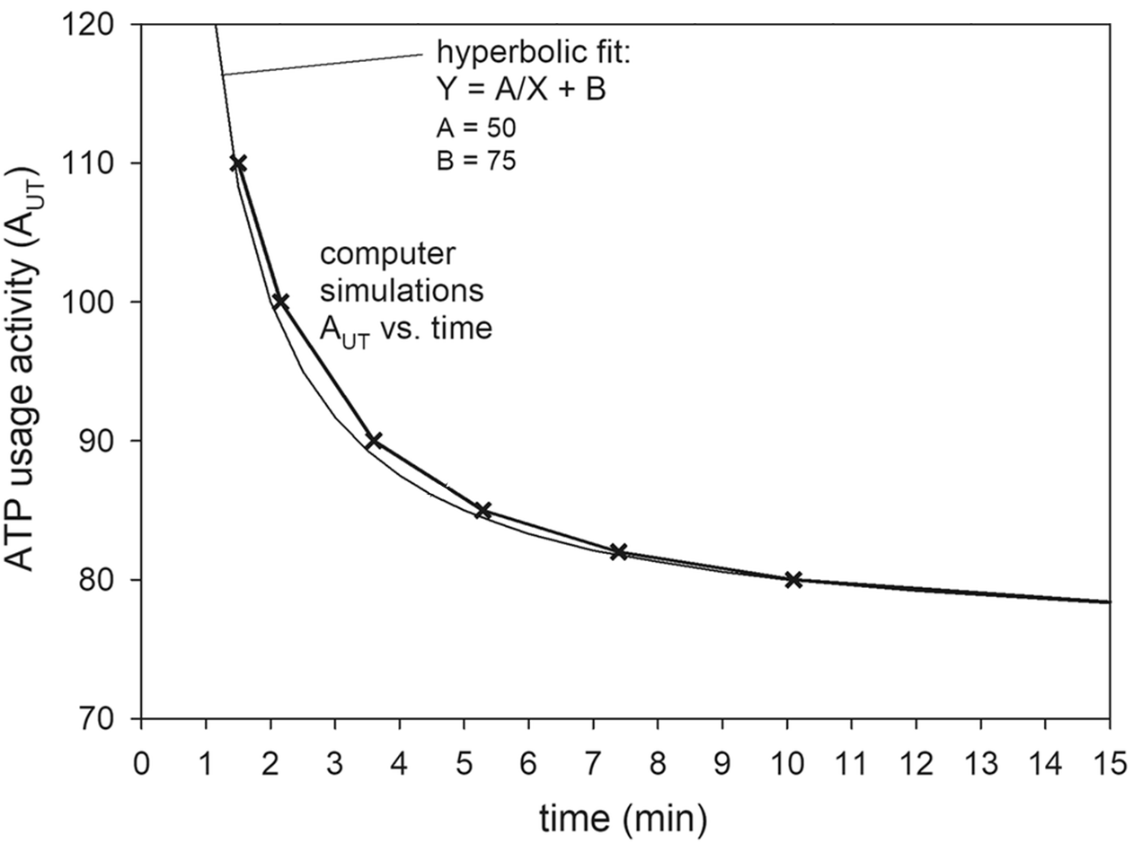

**A**

**B**

**Figure 2.**

**Figure 4**.

**Figure 2.**

C:\Users\Shunsaku Koga\Downloads\ESSR Figure 3.tif

**Figure 3.**

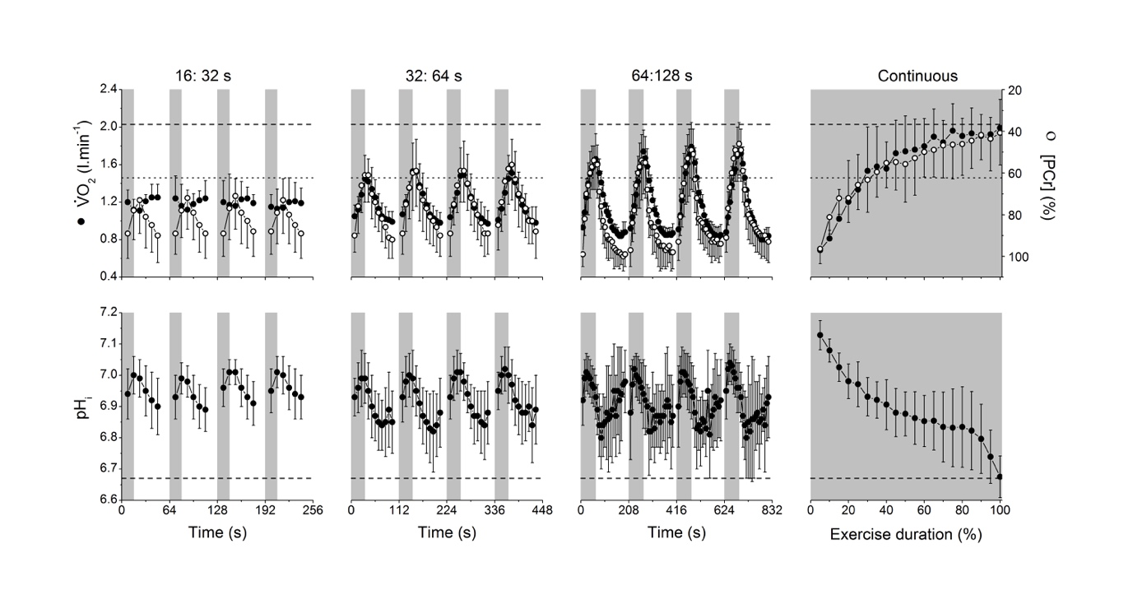

**Figure 4.**