Symmetry Detection in Autistic Adults Benefits from Local Processing in a Contour Integration Task
Abstract
Symmetry studies in autism are inconclusive possibly due to different types of stimuli used which depend on either local or global cues. Therefore, this study compared symmetry detection between 20 autistic and 18 non-autistic adults matched on age, IQ, gender and handedness, using contour integration tasks containing open and closed contours that rely more on local or global processing respectively. Results showed that the autistic group performed equally well with both stimuli and outperformed the non-autistic group only for the open contours, possibly due to a different strategy used in detecting symmetry. However, there were no group differences for the closed contour. Results explain discrepant findings in previous symmetry studies suggesting that symmetry tasks that favour a local strategy may be advantageous for autistic individuals. Implications of the findings towards understanding visual sensory issues in this group are discussed.
Introduction
Altered sensory experiences are common in autistic individuals, forming part of the diagnostic criteria for autism (American Psychiatric Association, 2013) and influencing how they respond to stimuli surrounding them (Crane et al., 2009; Leekam et al., 2007). Some autistic individuals are hyposensitive to stimulation, causing them to be under-responsive to their surroundings, while some are hypersensitive and tend to be over-responsive to their surroundings (Bogdashina & Casanova, 2016; Thye et al., 2018) or feel discomfort to the stimulation (Parmar et al., 2021) leading to sensory overload. Alongside these sensory issues, many autistic individuals also show perceptual differences where global processing, the integration of information to perceive objects and shapes as a whole, is thought to be less dominant, causing preference towards local details over global, contextual cues (Happé & Frith, 2006; Koldewyn et al., 2013).
This was evidenced in several perceptual studies where autistic individuals outperformed non-autistic individuals in visual search tasks (Rinehart et al., 2000; Shah & Frith, 1993). In such tasks, it has been proposed that reduced global mechanisms present in autistic individuals make it easier for them to segregate the stimuli in order to find the hidden target within a complex stimulus. In this study, two perceptual grouping cues that require global processing termed symmetry and closure were investigated to further understand visual perception in autism.
Perceptual grouping is a visual phenomenon that is applied to all incoming visual stimuli to simplify the information received by the brain. This phenomenon groups the incoming information that likely belong to the same object together, hence speeding up cortical processing of the information. Symmetry is one example of a grouping cue in a visual scene where elements that contribute to a regular pattern tend to be grouped together (Wagemans et al., 2012). For example, a symmetrical configuration, which by definition entails a regular structure (Lockwood & Macmillan, 1978) enhances the organization of elements into a coherent group within a stimulus (e.g. a dot-pattern) (Locher & Wagemans, 1993), or the integration of separate elements such as Gabor patches in a contour line to form an object (Machilsen et al., 2009). Symmetry detection involves global processing of the whole configuration (Baylis & Driver, 1995) and contributes to perceptual organization and object identification, for example in figure-ground segregation (Driver et al., 1992). Superior performance with symmetrical stimuli can be explained by the efficiency of the visual system in detecting symmetry, even with brief presentations between 50ms and 100ms (Barlow & Reeves, 1979; Tyler et al., 1995; Wagemans, 1993). Furthermore, the ability to process symmetry has been found for a variety of visual stimuli, including abstract shapes, dot patterns and faces (Barlow & Reeves, 1979; Chen et al., 2007; Palmer, 1985; Wagemans, 2003). Reflectional (mirror) symmetry, especially with a vertically oriented axis (Baylis & Driver, 1995; Friedenberg & Bertamini, 2000; Locher & Wagemans, 1993) is processed faster compared to asymmetrical shapes and other types of symmetries, such as translational and rotational (Julesz, 1971; Palmer & Hemenway, 1978; Royer, 1981). This is explained by the visual system being tuned to this regular configuration (Bertamini & Makin, 2014) and the involvement of lateral occipital complex (LOC) in processing images with mirror symmetry (Cattaneo et al., 2011; Sasaki et al., 2005).
To date, little work has examined symmetry perception in autism and those studies have provided mixed findings possibly due to different stimuli used. Perreault et al. (2011), the first to study mirror symmetry in autism asked adult participants to decide which one of the two successive random-dot patterns presented for 250ms was symmetrical. They reported that the autistic group had a significantly better performance than the non-autistic group when detecting symmetry suggesting a higher sensitivity to symmetry in this group. This finding, however, seemed to contradict with the assumption of weaker global perception in autism which predicts reduced perception of symmetry in this group. Falter (2013) suggested that one possible reason for this finding is the enhanced ability of autistic individuals to attend to local information. Instead of perceiving the patterns globally (as a whole), Falter suggested that the autistic group could possibly use a point-wise comparison by comparing the locations of individual dots of the mirrored images to complete the task, resulting in a higher sensitivity to symmetry in this group.
Another study examining the benefit of mirror symmetry in autism (Falter & Bailey, 2011) used the Picture Symmetry Test, a test adapted from a game about mirror symmetry called the Mirror Puzzles game (Walter, 1988). In this study, young adult participants were asked to place a transparent sheet containing a straight line to act as an imaginary mirror (symmetry line) on a target picture, which was a closed figure. They reported that the autistic group performed significantly slower than the control group matched for age and IQ, suggesting reduced perception of mirror symmetry in the former. Nevertheless, the task used in this study may require more cognitive load in working memory and motor planning as well as execution skills that can be altered in autism (Gowen & Hamilton, 2013; Kercood et al, 2014), contributing to the slower performance times. On the other hand, Evers et al. (2013) used an implicit test of symmetry detection by asking autistic and non-autistic children to identify symmetrical versus asymmetrical silhouettes of everyday objects made of Gabor patches (contour detection). They reported a main effect of symmetry, where symmetrical contours were detected quicker than asymmetrical, but no group difference was observed suggesting that the two groups processed symmetry for closed shapes equally well.
With the exception of the Picture Symmetry test that has additional cognitive and motor demands involved in task performance, it is possible that the type of stimuli may have contributed to the mixed findings reported above as the task with local cues found better performance for the autistic group (Perreault et al, 2011), whereas the task using closed (more global) stimuli found similar performance (Evers et al, 2013); although it is also possible that it is the developmental process in children which has yet to reach maturity that causes the absence of group difference in the later study (Hadad et al, 2010). Enhanced perceptual function (EPF) suggests that local low-level sensory information is given more priority over global high-level information, resulting in the enhanced perception of local details in autism, therefore predicting superior performance in this group when local cues are available (Mottron et al., 2006). Furthermore, in light of the predictive coding framework (Rao & Ballard, 1999; Clark 2013), Van de Cruys et al (2014) suggested that low-level sensory prediction errors in autistic people are often too precise and take less consideration from its context, resulting in increased reliance on sensory input. This too will benefit the detection of stimuli that contain local cues, underpinning the difference in performance in autism observed between studies using local versus global cues.
Therefore, in the current work, we explored how symmetry detection may be influenced by open or closed shapes that respectively rely on local or global cues in autistic and non-autistic individuals using a contour integration task; a low-level perceptual task that requires integration of local elements such as Gabor patches to see patterns or shapes (Field et al., 1993). In such tasks, global perception is measured based on the ability to integrate the local elements forming a shape that are aligned at a varying angle (jitter) or are separated by a varying distance. Global perception is deemed to be stronger if participants can tolerate more jitter (misalignment of local elements) or a larger separation of local elements to detect the shape. In contour integration tasks, the detection of closed shapes (e.g. a square) has been consistently found to be faster than detection of open shapes (e.g. a square with missing segments), termed “the closure effect” (Kovács & Julesz, 1993; Mathes & Fahle, 2007). The closure effect is another example of a visual grouping cue that helps to facilitate perception by filtering out irrelevant information and creating a ‘pop-out’ effect (Wagemans et al., 2012). In addition, previous studies have shown that participants can tolerate more jitter (better performance) with closed shapes compared to open shapes indicating a stronger influence of global perception on detection of the closed shapes (Gowen et al., 2020; Jachim et al., 2015).
Existing evidence supports the idea that perception of closed shapes entails relatively more global and higher-level processing than open shapes. While detection of both closed and open contours involves activation of neurons at the lower level of visual processing, when this is disrupted, detection of open contours is more affected than closed contours. In contrast, detection of closed contours has been shown to be more affected by the interference of higher-level processing. For example, Sweeny et al. (2011) compared open versus closed curvatures using monoptic and dichoptic masking that reduce neural activity in early visual areas (e.g. V1) or higher visual areas respectively (Macknik & Martinez-conde, 2004). They observed that the aftereffect of the closed curvature was affected by dichoptic while the open curvature was affected by monoptic masking suggesting differences in neural coding between the two. Moreover, detection of closed contours involves more global mechanisms in addition to processing of the contour integration per se (Gerhardstein et al., 2012), including feedback from higher visual areas such as V4 (Pasupathy & Connor, 2001) and LOC (Shpaner et al., 2013; Volberg & Greenlee, 2014) that facilitates rapid detection of closed contour.
Returning to global processing in autism, a second aim of our study was to investigate the effect of the visual grouping cue of closure on symmetry detection in autistic and non-autistic individuals. While one study reported reduced contour integration in autistic children (Mihaylova et al., 2021), the majority of earlier studies found no group differences between non-autistic and autistic children (Blake et al., 2003; Del Viva et al., 2006; Kemner et al., 2007; Evers et al., 2013) and adults (Hadad & Ziv, 2015) in the detection of closed objects, arguing against altered global perception in autism on these tasks. Absent group differences were also observed in a more recent contour integration study, comparing open and closed shapes in autistic and non-autistic adults (Jachim et al., 2015). However, there was a reduced closure effect in the autistic compared to non-autistic group, which was replicated in a later study with a different sample of participants (Gowen et al. 2020). While perception of simple, closed shapes appears similar between autistic and non-autistic individuals, the relative difference between open and closed shapes is less apparent in autistic groups, suggesting less benefit of closure. Therefore, the reduced closure effect in the autistic group suggests reduced reliance on global mechanisms when processing visual stimuli (Jachim et al, 2015; Gowen et al, 2020).
As both closure and symmetry involve higher visual areas such as the LOC and both contribute to object identification, it is plausible that these two aspects of perception may interact, where one would benefit the other (Schmidt & Schmidt, 2014). Previous studies have shown that symmetry detection is faster with the presence of additional grouping cues such as parallelism in the stimuli (Labonté et al., 1995; Locher & Wagemans, 1993) and symmetry can in turn facilitate perception of closed shapes (Ballesteros et al., 1998) and contours (Machilsen et al., 2009). Considering possible interactions between closure and symmetry and that grouping cues may have an additive effect on each other, the reduced closure effect in the autistic group reported in recent works (Jachim et al, 2015; Gowen et al, 2020) may have potential consequences for symmetry detection. As autistic individuals have reduced closure, and detection of mirror symmetry depends on the processing of the global shape, it is possible that there will be less influence and possibly less additive effect of closed shapes on symmetry detection in autistic compared to non-autistic people.
In summary, considering the influence of stimulus type on the inconclusive findings in symmetry perception in autism and the possible impact of reduced closure on symmetry perception, the current study had two aims. First, we aimed to reconcile previous symmetry studies in autism by examining symmetry perception using closed and open shapes which rely more on global and local processing respectively. If group differences in symmetry detection depend on the stimuli type, we expected better symmetry detection with the open shapes for the autistic compared to non-autistic individuals but equivalent performance for the closed shapes. Second, we aimed to investigate if the reduced closure effect in autism reported earlier may impact symmetry perception in this group by comparing symmetry detection between closed and open shapes. We hypothesised that (a) symmetry detection would be better with closed compared to open shapes in the non-autistic group indicating a benefit of closure in symmetry detection (b) symmetry detection would be comparable for closed and open shapes (i.e. no benefit of closure) in the autistic group due to reduced closure.

Methodology
This experiment was completed as part of a longer session published elsewhere (Gowen et al. 2020). Therefore, all autistic participants and 16 non-autistic participants were the same as those in the sample reported in Gowen et al (2020). Data and analysis scripts are openly available on OSF (Gowen et al, 2022).

Participants
20 (8 females) autistic and 18 (7 females) non-autistic participants matched for age, gender, full IQ scale (measured using Wechsler Abbreviated Scale of Intelligence (Wechsler, 1999) and handedness were tested (Table 1). The sample size was based on our previous studies that observed an interaction effect between groups for open and closed contours with a total of 13 participants in each group (Jachim et al, 2015). We also conducted a pilot study in non-autistic individuals that showed a significant effect of closure on symmetry detection (better symmetry detection for closed compared to open shapes) in five non-autistic individuals (see supplementary materials). However, since a similar design has not been used to investigate symmetry in autism, a larger sample was aimed for in this study.
(Insert Table 1 here)
Participants were recruited via posters and adverts posted around the university and to autism support groups around Manchester. All participants had normal or corrected-to-normal vision of a minimum of 6/6 with reduced Snellen, and stereopsis of a minimum of 60” as tested with TNO test. All non-autistic participants in the control group reported no autism diagnosis and first-degree relative with autism. While for the autistic group, all participants had been clinically diagnosed with either autism or Asperger’s Syndrome by external assessment centers, which was also confirmed using module 4 of Autism Diagnostic Observation Schedule (ADOS) (Lord et al., 2000) by a qualified researcher. The average ADOS score for autistic group was 9.06 (SD: 3.30). No group differences were observed for age (t(36) = 0.38, p = 0.70) and FIQ (t(36) = 2.04, p = 0.50). 2 out of 20 autistic participants and 1 out of 18 non-autistic participants were left-handed.
The Autism Spectrum Quotient (AQ) score for the non-autistic group ranged from 7 to 30 (M=16, SD=7.2). Other demographic characteristics of the participants are presented in Table 1. Information on socioeconomic status and educational background of the participants were not recorded in the study as these were not expected to affect the results. Written consent was obtained from all participants prior to the experiment and all data collected were pseudo anonymised. The study was conducted in accordance with the Declaration of Helsinki and was approved by the university research ethics committee where the study was carried out (UREC1 number: 12013).

Apparatus
The stimuli were displayed on Iiyama MA203DT CRT monitor with 1600x1200 resolution, 85Hz vertical refresh rate and 42 cd/m² average luminance in a darkened room. Participants were positioned 70cm away from the monitor, which was fixed using a chinrest. Color-coded keys on a keyboard were used for participants to give their response during the experiment. Additionally, their eye movements were monitored throughout the experiment using a remotely located eye tracker with 0.5º - 1º of visual angle accuracy and 60Hz sampling rate (Gazepoint eye tracker, Gazepoint).

Stimuli
The stimuli were generated using The Grouping Elements Rendering Toolbox v1.30 (GERT) (Demeyer & Machilsen, 2012) and displayed using Matlab (R2015b) Psychophysics Toolbox extension (Brainard & Vision, 1997). The contours of the stimuli were created as a vector image using Inkscape 0.1 before imported to GERT. Using GERT, Gabor patches were arranged along the contour followed by a random placement of Gabors in the background. Each stimulus contained a total of 330 Gabors, with 44 min of arc average centre-to-centre distance between elements. Each Gabor had bandwidth of 1.2octaves, standard deviation of 0.1⁰, and spatial frequency of 4.6cpd presented at 100% Michelson contrast. These parameters were similar to that used by Jachim et al (2015). After placement of the Gabors, a central fixation cross subtending 0.12 degree was positioned within each stimulus.
There were two types of contours used in this experiment; a square (closed) and an incomplete square (open) (Figure 1). Both contours were presented at 30º jitter value and tested at six levels of asymmetry which was selected from a pilot study (see supplementary materials). This jitter value was selected as it has moderate level of difficulty that yields good psychometric function for threshold determination. The symmetry level of the contour in the target slide was varied by changing the angle of all four sides of the square to form an asymmetrical square, at six levels of asymmetry (Fig. 1). The six levels of asymmetry were specified as percentage (%), where the percentage of asymmetry reflects how much adjustment was made from the original angle, and how irregular the shape was; the higher the percentage, the more irregular the shape was.
The original angle for each side of a perfect square was 90º, and the changes made to each angle were therefore given by: adjustment made (χ_{n}) = 90º - new angle (y_{n}), where n refers to each side of the square. The total adjustments made (χ_{T}) represents the total amount of angle changed (χ₁+ χ₂+ χ₃+ χ₄) and the % of asymmetry level can be calculated as level of asymmetry (%) = (χ_{T} /90⁰) x 100. The six levels of asymmetry used in this experiment were 0% (perfectly symmetric square), 5%(χ_{T}=4.5º), 10%(χ_{T}=9º), 15%(χ_{T}=13.5º), 20%(χ_{T}=18º) and 25%(χ_{T}=22.5º). The sample stimuli are shown in Fig. 1.
(insert Fig. 1 here)

For the five levels of asymmetry except 0%, the angle of each side was adjusted in a way that none of them had the same angle ƴ to avoid creating a symmetric trapezium. All closed stimuli for the six levels had approximately the same perimeter (length of contour: 1920±12pixels), number of Gabors forming the contour (40 elements) and inter-element distance (44 minute of arc). After the sides of the closed shape had been manipulated to create the six levels of asymmetry, open shapes were created by cutting out a small portion (5 Gabors) of the closed shapes at each level of asymmetry to make a gap (a cut out of 240pixels long). Therefore, both closed and open contours at each level of asymmetry have the same angle, with the only difference between the two was the gap that has been cut-out. This gave all open stimuli a perimeter of approximately 1680±12pixels long with 35 elements.
The orientation of the stimuli in the target slide was rotated and could appear at four different orientations throughout the experiment to avoid participants anticipating the position of the irregular sides of the square. A perfect square of similar jitter value was used as the comparison slide.

Procedure
In the experiment, participants were instructed to look at the fixation cross binocularly and decide which one of the two stimuli slides (slide 1 or slide 2) contained the most symmetric contour. The two-interval forced choice design (2IFC) was employed, where the two stimuli were presented sequentially. The trial sequence is illustrated in Fig. 2. Each trial began with a blank screen containing a fixation cross at the center, which was presented for 1010ms, followed by the two stimulus presentations (250ms each) separated by a blank screen containing the fixation cross for 505ms. For each trial, the two stimuli were presented in a random order so that either the target or comparison slide was shown first. Each trial ended with a blank screen that appeared until a response was received, or for the maximum of 3000ms (whichever earlier).
(Insert Figure 2 here)
The closed and open contours were tested in different blocks and were counterbalanced among participants. Each of the six levels of asymmetry for each closed and open contour was presented forty times in random order, giving a total of 240 trials per contour. These were presented across 4 blocks with sixty trials per block. The method of constant stimuli was used where the order of the asymmetry levels in one block was predetermined and randomized by the system independent of participants’ performance.
A practice session of ten trials was conducted prior to the actual experiment to make sure participants understood the instructions. After that, they began the actual experiment voluntarily by pressing the ‘spacebar’ key on a keyboard; provided that they achieved satisfactory performance of at least 90% correct for the practice trials. Participants were reminded to fixate on the central cross and offered more frequent breaks (between blocks) if they showed signs of losing concentration.

Analysis
Trials with eye movements greater than 2.5º visual degrees from the central cross were excluded from the analysis (< 1%; 9 trials across 3 autistic participants and 5 trials across 2 non-autistic participants). Psignifit Matlab toolbox (version 2.5.6) was used to fit logistic functions to the data obtained using maximum-likelihood (ML) criterion. The estimation of α and β for the psychometric function fitting were done using bootstrap analysis, the computer randomly generated values.
The psychometric function illustrated the proportion of correct detection as a function of the level of asymmetry. From the function, the threshold representing the level at which the participants were able to discriminate the symmetrical from asymmetrical stimulus with 75% accuracy (symmetry detection threshold) was estimated. There was a removal of 1 participant per group following outlier removal at the group level based on the non-recursive procedure recommended by Van Selst and Jolicoeur (1994). A mixed ANOVA with repeated measures of stimulus (open and closed) and a between factor of group (non-autistic and autistic) was used to compare the thresholds between stimuli and groups. Bonferroni correction was made for multiple comparisons.

Results
The effect of closure on symmetry detection was examined by comparing the symmetry detection thresholds between closed and open contours in both groups; a lower value indicates better performance. Levene’s test of homogeneity indicated the data had equality of variance (F=1.18; p=0.28), but the Shapiro-wilks test indicated that the data was not normally distributed (w=0.96, p=0.02). As non-parametric and parametric tests indicated similar findings, only parametric tests are reported, while the non-parametric results can be found online as supplementary material.
A mixed ANOVA with repeated measures of stimulus and between-group measures of group showed that there was a main effect of stimulus [F(1,34) = 11.7; p =0.002; ges = .0.09; BFinc = 3.28] indicating that symmetry detection was better for closed (mean=5.94, SD= 1.81) compared to open (mean=7.87, SD= 4.67) stimuli across groups. In addition, there was a main effect of group ([F(1,34) =4.82; p = 0.04; ges = .0.09; BFinc = 4.65], indicating that the autistic group (mean=5.91, SD= 3.48) were better than the non-autistic group (mean=8.01, SD= 3.57) at detecting symmetry.
However, the interaction between group and stimulus was also significant [F(1,34) =5.72; p =0.02; ges = 0.04; BFinc = 2.49]. Further investigation of the interaction showed that the non-autistic group could detect symmetry better for the closed stimulus (M=6.3, SD=2.0) compared to the open stimulus (M=9.7, SD=4.0) (t(34)=4, p=0.003; d=0.5). However, there was no significant difference between open and closed stimuli for the autistic group (open: M=6.22, SD=4.41; closed: M=5.61, SD=1.57; t(34)=0.75; p=0.46; d=0.13)). Simple main effects comparisons indicated that the autistic group had lower symmetry detection thresholds than the non-autistic group for the open stimulus (t(34)= 2.39, p=0.02, d=0.4) but there were no group differences for the closed stimulus t(34)=-1.14, p= 0.26, d=-0.20) (Fig. 3). (Fig. 3)

Discussion
The main aim of this study was to investigate symmetry perception for open and closed shapes in autistic adults using contour integration, a low-level perceptual task in an attempt to reconcile previous findings and examine the impact of reduced closure on symmetry detection. Findings revealed a main effect of stimulus and groups implying that symmetry detection was better with closed compared to open shapes across groups and that the autistic group was generally better at detecting symmetry. Most importantly, a significant group x stimulus interaction was found indicating that while symmetry detection was poorer with open compared to closed shapes in the non-autistic group, symmetry detection was statistically equivalent for open and closed shapes in the autistic group. This interaction appeared to be driven by better symmetry detection for the open shapes in the autistic group as compared to the non-autistic group.
Using a perceptual task that has less cognitive demand than previous symmetry tasks (Falter and Bailey, 2011) and with two types of stimuli that contain local or global cues, our findings provide a better insight into symmetry perception in autism. Our finding demonstrating the influence of stimulus type (containing local or global cues) on symmetry detection reconciles previous symmetry findings in autism. Considering symmetry detection thresholds between groups, we did not find evidence of reduced sensitivity to symmetry in the autistic group which is inconsistent with poorer symmetry detection in autism reported by Falter and Bailey (2011). A possible reason for this was the complexity of their task, which involved greater cognitive and motor planning, and execution demands which are known to be altered in autistic individuals (Fournier et al., 2010; Gowen & Hamilton, 2013) and would have impacted on their outcome measure of performance time. Instead, the group difference in symmetry detection in our study was driven by poorer performance in the non-autistic group at detecting symmetry with open shapes despite comparable performance for closed shapes. These findings are in line with both, increased sensitivity to symmetry in the autistic group with random dots stimuli (Perreault et al., 2011) and equivalent performance found in detection of closed symmetrical objects (Evers et al., 2013) reported in earlier studies. The task employed by Perreault et al (2011) using random dot stimuli favours a local (pointwise) strategy over a global strategy which may be an advantage for the autistic group. Therefore, using two different types of stimuli in a symmetry detection task, our results suggest that when symmetry detection incorporates fewer global cues, autistic individuals may show an advantage over non-autistic individuals.
Symmetry detection of different stimuli in the autistic group can be explained in the context of existing theories on perceptual differences in autism, particularly EPF (Mottron et al., 2006) and predictive coding (Van de Cruys et al., 2014). Superior performance in the autistic compared to non-autistic group with open shapes suggests that they might be using a different strategy to complete the task, in keeping with theories of EPF. This finding also fits with superior contour detection with open shapes in the same autistic participants reported earlier (Gowen et al., 2020) which might have contributed to superior symmetry detection due to better detection of the target. In contrast, the non-autistic group who rely more on global mechanisms might be more distracted by background Gabors which possibly decelerate the processing of the open shapes. Therefore, while a strong global percept in the non-autistic group has cost them at detecting symmetry with the open stimuli, a strong reliance on low-level processing in the autistic group has preserved their sensitivity at detecting symmetry with open stimuli suggestive of EPF. It could be inferred that while global processing may be the default mechanism to process symmetry regardless of the type of stimuli (open or closed) in the non-autistic group, local strategies supported by EPF may be predominant in the autistic group causing them to remain sensitive to symmetry with stimuli that benefit from this mechanism such as open shapes or random dots. The equivalent performance for the closed shape for both groups might suggest intact global mechanisms in the autistic individuals or that they might be using EPF rather than global mechanisms to complete the task. We are unable to rule out whether the autistic group were still receiving a closure benefit on symmetry detection with closed contours which was somewhat masked by EPF.
According to the predictive coding framework, higher-level processing continuously generates predictions about the incoming stimuli to be matched with incoming sensory information (Rao & Ballard, 1999; Clark et al, 2013). Any mismatch between the two will be regarded as prediction errors, which can either be ignored or considered in making perceptual inferences about the stimuli. Van de Cruys et al (2014) suggested that autistic individuals are less flexible in weighting these prediction errors when processing sensory input, which is also referred to as high, inflexible precision of sensory prediction errors. As a result, they will be less efficient in deciding when a signal is important and relevant, and when it is not (merely noise) which consequently results in their perception being less modulated by contextual information and more affected by noise than the actual stimuli (Lawson et al., 2014). This results in increased reliance on sensory input which benefits the processing of shapes that favour low-level processing such as open shapes. Therefore, this would also predict increased sensitivity to symmetry detection with open shapes due to a lower probability for irrelevant background information to impair perception of the shapes. Additionally, if a similar approach is employed to perceive closed shapes, no enhancement of perception is expected due to reduced learning of higher and more abstract representations of the stimuli such as shapes, which is consistent with findings reported in our study.
It was also predicted that the reduced closure effect previously reported in autistic participants (Jachim et al., 2015) may reduce the chance for closure to benefit symmetry detection in this group. The interaction between group and stimuli found in the study reveals that the benefit of closure in symmetry detection is present in the non-autistic group (better performance with closed compared to open shapes) but is absent in the autistic group who showed equivalent performance between open and closed shapes. Importantly, the lack of a closure effect in autistic individuals is driven by better performance for the open stimuli. The advantage of closure in non-autistic individuals for symmetry detection in a contour detection task is new but not surprising considering the benefit of other grouping cues on symmetry detection in previous studies (Locher and Wagemans, 1993; Labonte et al, 1995). Closed shapes and symmetry are two visual properties that contribute to the perception of a figure against the background leading to object identification (Kovács & Julesz, 1993; Machilsen et al., 2009; Schmidt & Schmidt, 2014). In support of this, there is evidence that both closure and symmetry are processed in the LOC (Cattaneo et al., 2011; Sasaki et al., 2005; Shpaner et al., 2013; Volberg & Greenlee, 2014). Therefore, strong reliance on global processing in the non-autistic group may hinder processing of the open shapes that relies on local processing, therefore maximising the benefit offered by these grouping cues with closed shapes (larger closure effect as a result of poorer performance with open shapes).
Investigating symmetry and closure in autism may have implications towards understanding sensory issues in this group. When viewing a visual scene, the brain is bombarded with lots of visual input despite its limited resources to process all sensory inputs. To work efficiently, it has to select the most relevant and important information to attend to and filter out less important ones to get the gist of it. To facilitate this, gestalt grouping cues such as symmetry and closure that rely on global cues help to give that ‘pop-out’ effect which speeds up the detection process (Xu & Chun, 2007) and improves filtration of visual information by visual working memory (Allon et al., 2019). With less dominant or efficient local processing, the effect of the grouping cues in non-autistic individuals would be more pronounced therefore enhancing the ‘pop-out’ effects. In contrast, while strong local processing in autism may benefit some situations (such as enhanced perception of open shapes in our task, and other visual search tasks such as Navon Figures (Iarocci et al., 2006) and Embedded Figures Test (Jolliffe & Baron-Cohen, 1997)), it can diminish the ‘pop-out’ effects which can be seen as a reduced closure effect. It is true that strong local processing may facilitate perception of certain types of stimuli, but this may only be when there is a predictable environment or stimulus. On the contrary, in accordance with predictive coding theory, a strong influence of local processing may result in more uncertainties and overweighting of irrelevant features due to a higher number of stimuli and less predictable environment characteristic of real-life situations, leading to increased visual clutter when viewing a visual scene. With reduced pop-out effects, incoming stimuli may all seem to be equally visible, competing for attention from the brain, leading to sensory overloads as it demands larger processing capacity of the brain. This may eventually lead to sensory symptoms that are commonly reported in autism (Crane et al, 2009; Parmar et al. 2021).
There are two limitations to the study in light of the findings reported. Firstly, contrast sensitivity test was not tested at baseline. However, research has shown that contrast sensitivity is comparable between autistic and non-autistic groups, and therefore is not expected to cause the group difference found in this study (Behrmann et al. 2006; Bertone et al. 2005; Koh et al. 2010; de Jonge et al. 2007; Jachim et al, 2015; Gowen et al, 2020). In addition, the use of Gabor patches as the stimulus is useful in minimising the potential contribution of these simple local mechanisms in such a task (Dakin & Frith, 2005). Secondly, there was quite a variation in performance for open shapes and may to some extent influence direct comparison between the shapes. However, the significant group differences for the open shape condition observed despite high variability, and the significant interaction found with ANOVA test do indicate that the pattern of performance was different between the groups.
In summary, by mixing closure and symmetry, our results have highlighted that differences in symmetry perception between autistic and non-autistic groups is likely to be stimulus-dependent: sensitivity to symmetry for closed shapes is comparable between groups, but poorer symmetry detection for open shapes can be observed in the non-autistic group which perhaps explains the conflicting findings reported in previous symmetry studies. These findings are in support of the existing theories of perceptual difference in autism such as EPF and predictive coding. Future work is required to disentangle whether the autistic group uses a different strategy to detect symmetry in closed shapes such as enhanced low-level filtering and a higher precision of sensory prediction errors in processing visual stimuli.

REFERENCES:
Allon, A. S., Vixman, G., & Luria, R. (2019). Gestalt grouping cues can improve filtering performance in visual working memory. Psychological Research, 83(8), 1656–1672. https://doi.org/10.1007/s00426-018-1032-5
American Psychiatric Association. (2013). Diagnostic and statistical manual of mental disorders (5th ed). American Psychiatric Association.
Ballesteros, S., Millar, S., & Reales, J. M. (1998). Symmetry in haptic and in visual shape perception. Perception & Psychophysics, 60(3), 389–404. https://doi.org/10.3758/BF03206862
Barlow, H. B., & Reeves, B. C. (1979). The versatility and absolute efficiency of detecting mirror symmetry in random dot displays. Vision Research, 19(7), 783–793. https://doi.org/https://doi.org/10.1016/0042-6989(79)90154-8
Baylis, G. C., & Driver, J. (1995). Obligatory edge assignment in vision: The role of figure and part segmentation in symmetry detection. Journal of Experimental Psychology: Human Perception and Performance, 21(6), 1323–1342. https://doi.org/10.1037/0096-1523.21.6.1323
Behrmann, M., Thomas, C., & Humphreys, K. (2006). Seeing it differently: visual processing in autism. Trends in Cognitive Sciences, 10(6), 258–264. https://doi.org/10.1016/j.tics.2006.05.001
Bertamini, M., & Makin, A. D. J. (2014). Brain activity in response to visual symmetry. Symmetry, 6(4), 975–996.
Bertone, A., Mottron, L., Jelenic, P., & Faubert, J. (2005). Enhanced and diminished visuo-spatial information processing in autism depends on stimulus complexity. Brain, 128(10), 2430–2441. https://doi.org/10.1093/brain/awh561
Blake, R., Turner, L. M., Smoski, M. J., Pozdol, S. L., & Stone, W. L. (2003). Visual recognition of biological motion is impaired in children with autism. Psychological Science : A Journal of the American Psychological Society / APS, 14(2), 151–157. https://doi.org/10.1111/1467-9280.01434
Bogdashina, O., & Casanova, M. (2016). Sensory Perceptual Issues in Autism and Asperger Syndrome, Second Edition: Different Sensory Experiences - Different Perceptual Worlds (2nd ed.). Jessica Kingsley Publishers. https://books.google.com.my/books?id=1tR1CwAAQBAJ
Brainard, D. H., & Vision, S. (1997). The psychophysics toolbox. Spatial Vision, 10(4), 433–436.
Cattaneo, Z., Mattavelli, G., Papagno, C., Herbert, A., & Silvanto, J. (2011). The role of the human extrastriate visual cortex in mirror symmetry discrimination: a TMS-adaptation study. Brain and Cognition, 77(1), 120–127. https://doi.org/10.1016/j.bandc.2011.04.007
Chen, C.-C., Kao, K.-L. C., & Tyler, C. W. (2007). Face Configuration Processing in the Human Brain: The Role of Symmetry. Cerebral Cortex, 17(6), 1423–1432. https://doi.org/10.1093/cercor/bhl054
Clark, A. (2013). Whatever next? Predictive brains, situated agents, and the future of cognitive science. Behavioral and Brain Sciences, 36(3), 181-204. doi:10.1017/S0140525X12000477
Crane, L., Goddard, L., & Pring, L. (2009). Sensory processing in adults with autism spectrum disorders. Autism, 13(3), 215–228. https://doi.org/10.1177/1362361309103794
Dakin, S., & Frith, U. (2005). Vagaries of visual perception in autism. Neuron, 48(3), 497–507. https://doi.org/10.1016/j.neuron.2005.10.018
de Jonge, M. V, Kemner, C., de Haan, E. H., Coppens, J. E., van den Berg, T. J. T. P., & van Engeland, H. (2007). Visual information processing in high-functioning individuals with autism spectrum disorders and their parents. Neuropsychology, 21, 65–73. https://doi.org/10.1037/0894-4105.21.1.65
Del Viva, M. M., Igliozzi, R., Tancredi, R., & Brizzolara, D. (2006). Spatial and motion integration in children with autism. Vision Research, 46, 1242–1252. https://doi.org/10.1016/j.visres.2005.10.018
Demeyer, M., & Machilsen, B. (2012). The construction of perceptual grouping displays using GERT. Behavior Research Methods, 44(2), 439–446. https://doi.org/10.3758/s13428-011-0167-8
Driver, J., Baylis, G. C., & Rafal, R. D. (1992). Preserved figure-ground segregation and symmetry perception in visual neglect. Nature, 360(6399), 73–75. https://doi.org/10.1038/360073a0
Evers, K., Panis, S., Torfs, K., Steyaert, J., Noens, I., & Wagemans, J. (2013). Disturbed interplay between mid- and high-level vision in ASD? evidence from a contour identification task with everyday objects. Journal of Autism and Developmental Disorders, 44, 801–815. https://doi.org/10.1007/s10803-013-1931-7
Falter, C. M. (2013). Impaired and superior mirror symmetry perception in autism. Autism, 17(1), 117–118. https://doi.org/10.1177/1362361312438618
Falter, Christine M, & Bailey, A. J. (2011). Perception of mirror symmetry in autism spectrum disorders. Autism, 16(6), 622–626. https://doi.org/10.1177/1362361311407353
Field, D. J., Field, D. J., Hayes, A., Hayes, A., Hess, R. F., & Hess, R. F. (1993). Contour integration by the human visual system: Evidence for a local ‘association field’. Vision Res, 33(2), 173–193.
Fournier, K. A., Hass, C. J., Naik, S. K., Lodha, N., & Cauraugh, J. H. (2010). Motor coordination in autism spectrum disorders: A synthesis and meta-analysis. Journal of Autism and Developmental Disorders, 40(10), 1227–1240. https://doi.org/10.1007/s10803-010-0981-3
Friedenberg, J., & Bertamini, M. (2000). Contour symmetry detection: the influence of axis orientation and number of objects. Acta Psychologica, 105(1), 107–118. https://doi.org/10.1016/S0001-6918(00)00051-2
Gerhardstein, P., Tse, J., Dickerson, K., Hipp, D., & Moser, A. (2012). The human visual system uses a global closure mechanism. Vision Research, 71, 18–27. https://doi.org/10.1016/j.visres.2012.08.011
Goldstein, E. B., & Cacciamani, L. (2021). Sensation and perception (11th ed.). Cengage Learning.
Gowen, E., & Hamilton, A. (2013). Motor abilities in autism: A review using a computational context. Journal of Autism and Developmental Disorders, 43(2), 323–344. https://doi.org/10.1007/s10803-012-1574-0
Gowen, E., Jachim, S., Subri, S., Dickinson, C., Hamblin-Pyke, B., & Warren, P. A. (2020). Collinear facilitation and contour integration in autistic adults: Examining lateral and feedback connectivity. Vision Research, 177, 56–67. https://doi.org/https://doi.org/10.1016/j.visres.2020.08.004
Gowen, E., Subri.S, & Palumbo, L. (2022, June 29). Symmetry detection in autistic adults benefits from local processing in a contour integration task. Retrieved from osf.io/xeuhg
Hadad, B., Maurer, D., & Lewis, T. L. (2010). The effects of spatial proximity and collinearity on contour integration in adults and children. Vision Research, 50(8), 772–778. https://doi.org/10.1016/j.visres.2010.01.021
Hadad, B. S., & Ziv, Y. (2015). Strong Bias Towards Analytic Perception in ASD Does not Necessarily Come at the Price of Impaired Integration Skills. Journal of Autism and Developmental Disorders, 45(6), 1499–1512. https://doi.org/10.1007/s10803-014-2293-5
Happé, F., & Frith, U. (2006). The weak coherence account: Detail-focused cognitive style in autism spectrum disorders. Journal of Autism and Developmental Disorders, 36(1), 5–25. https://doi.org/10.1007/s10803-005-0039-0
Iarocci, G., Burack, J. A., Shore, D. I., Mottron, L., & Enns, J. T. (2006). Global–Local Visual Processing in High Functioning Children with Autism: Structural vs. Implicit Task Biases. Journal of Autism and Developmental Disorders, 36(1), 117–129. https://doi.org/10.1007/s10803-005-0045-2
Jachim, S., Warren, P. a., McLoughlin, N., & Gowen, E. (2015). Collinear facilitation and contour integration in autism: evidence for atypical visual integration. Frontiers in Human Neuroscience, 9(March), 1–12. https://doi.org/10.3389/fnhum.2015.00115
Jolliffe, T., & Baron-Cohen, S. (1997). Are people with autism or Asperger`s syndrome faster than normal in Embedded Figure Task? Journal of Child Psychology and Psychiatry, 38(5), 527–534.
Julesz, B. (1971). Foundations of cyclopean perception.
Kemner, C., Lamme, V. a F., Kovacs, I., & van Engeland, H. (2007). Integrity of lateral and feedbackward connections in visual processing in children with pervasive developmental disorder. Neuropsychologia, 45, 1293–1298. https://doi.org/10.1016/j.neuropsychologia.2006.09.016
Kercood, S., Grskovic, J. A., Banda, D., & Begeske, J. (2014). Working memory and autism: A review of literature. Research in autism spectrum disorders, 8(10), 1316-1332.
Koh, H. C., Milne, E., & Dobkins, K. (2010). Spatial contrast sensitivity in adolescents with autism spectrum disorders. Journal of Autism and Developmental Disorders, 40, 978–987. https://doi.org/10.1007/s10803-010-0953-7
Koldewyn, K., Jiang, Y. V, Weigelt, S., & Kanwisher, N. (2013). Global/local processing in autism: not a disability, but a disinclination. Journal of Autism and Developmental Disorders, 43(10), 2329–2340. https://doi.org/10.1007/s10803-013-1777-z
Kovács, I., & Julesz, B. (1993). A closed curve is much more than an incomplete one: effect of closure in figure-ground segmentation. Proceedings of the National Academy of Sciences of the United States of America, 90(August), 7495–7497. https://doi.org/10.1073/pnas.90.16.7495
Labonté, F., Shapira, Y., Cohen, P., & Faubert, J. (1995). A model for global symmetry detection in dense images. Spatial Vision, 9(1), 33–55. https://doi.org/10.1017/CBO9781107415324.004
Lawson, R. P., Rees, G., & Friston, K. J. (2014). An aberrant precision account of autism. Frontiers in Human Neuroscience, 8. https://doi.org/10.3389/fnhum.2014.00302
Leekam, S. R., Nieto, C., Libby, S. J., Wing, L., & Gould, J. (2007). Describing the sensory abnormalities of children and adults with autism. Journal of Autism and Developmental Disorders, 37(5), 894–910. https://doi.org/10.1007/s10803-006-0218-7
Locher, P. J., & Wagemans, J. (1993). Effects of element type and spatial grouping on symmetry detection. In Perception (Vol. 22, Issue 5, pp. 565–587). https://doi.org/10.1068/p220565
Lockwood, E. H., & Macmillan, R. H. (1978). Geometric symmetry. London Cambridge Press.
Lord, C., Risi, S., Lambrecht, L., Cook, E. H., Leventhal, B. L., DiLavore, P. C., Pickles, a, & Rutter, M. (2000). Autism Diagnostic Observation Schedule (ADOS). In Journal of Autism and Developmental Disorders (Vol. 30, Issue 3, pp. 205–223). https://doi.org/10.1007/BF02211841.
Machilsen, B., Pauwels, M., & Wagemans, J. (2009). The role of vertical mirror symmetry in visual shape detection. Journal of Vision, 9(12), 1–11. https://doi.org/10.1167/9.12.11.Introduction
Macknik, S. L., & Martinez-conde, S. (2004). Dichoptic Visual Masking Reveals that Early Binocular Neurons Exhibit Weak Interocular Suppression: Implications for Binocular Vision and Visual Awareness. Journal of Cognitive Neuroscience, 16(6), 1049–1059.
Mathes, B., & Fahle, M. (2007). Closure facilitates contour integration. Vision Research, 47, 818–827. https://doi.org/10.1016/j.visres.2006.11.014
Mihaylova, M. S., Bocheva, N. B., Totev, T. T., & Staykova, S. N. (2021). Visual Noise Effect on Contour Integration and Gaze Allocation in Autism Spectrum Disorder. Frontiers in Neuroscience, 15(February), 1–18. https://doi.org/10.3389/fnins.2021.623663
Mottron, L., Dawson, M., Soulières, I., Hubert, B., & Burack, J. (2006). Enhanced perceptual functioning in autism: An update, and eight principles of autistic perception. In Journal of Autism and Developmental Disorders (Vol. 36, pp. 27–43). https://doi.org/10.1007/s10803-005-0040-7
Palmer, S. E. (1985). The role of symmetry in shape perception. In Acta Psychologica (Vol. 59, Issue 1, pp. 67–90). Elsevier Science. https://doi.org/10.1016/0001-6918(85)90042-3
Palmer, S. E., & Hemenway, K. (1978). Orientation and symmetry: effects of multiple, rotational, and near symmetries. Journal of Experimental Psychology: Human Perception and Performance, 4(4), 691.
Parmar, K. R., Porter, C. S., Dickinson, C. M., Pelham, J., Baimbridge, P., & Gowen, E. (2021). Visual Sensory Experiences From the Viewpoint of Autistic Adults. Frontiers in Psychology, 12(June), 1–13. https://doi.org/10.3389/fpsyg.2021.633037
Pasupathy, A., & Connor, C. E. (2001). Shape representation in area V4: position-specific tuning for boundary conformation. Journal of Neurophysiology, 86(5), 2505–2519. https://doi.org/10.1152/jn.2001.86.5.2505
Perreault, A., Gurnsey, R., Dawson, M., Mottron, L., & Bertone, A. (2011). Increased sensitivity to mirror symmetry in autism. PLoS ONE, 6(4), 4–8. https://doi.org/10.1371/journal.pone.0019519
Rao, R. P. N., & Ballard, D. H. (1999). Predictive coding in the visual cortex: a functional interpretation of some extra-classical receptive-field effects. Nature Neuroscience, 2, 79–87.
Rinehart, N. J., Bradshaw, J. L., Moss, S. A., Brereton, A. V, & Tonge, B. J. (2000). Atypical Interference of Local Detail on Global Processing in High-functioning Autism and Asperger’s Disorder. Journal of Child Psychology and Psychiatry, 41(6), 769–778.
Royer, F. L. (1981). Detection of symmetry. Journal of Experimental Psychology: Human Perception and Performance, 7(6), 1186.
Sasaki, Y., Vanduffel, W., Knutsen, T., Tyler, C., & Tootell, R. (2005). Symmetry activates extrastriate visual cortex in human and nonhuman primates. Proceedings of the National Academy of Sciences of the United States of America, 102(8), 3159–3163. https://doi.org/10.1073/pnas.0500319102
Schmidt, F., & Schmidt, T. (2014). Rapid processing of closure and viewpoint-invariant symmetry: Behavioral criteria for feedforward processing. Psychological Research, 78(1), 37–54. https://doi.org/10.1007/s00426-013-0478-8
Shah, A., & Frith, U. (1993). Why do autistic individual show superior performance on the block design task? J Child Psychol Psychiat, 34(8), 1351–1364.
Shpaner, M., Molholm, S., Forde, E., & Foxe, J. J. (2013). Disambiguating the roles of area V1 and the lateral occipital complex (LOC) in contour integration. NeuroImage, 69, 146–156. https://doi.org/10.1016/j.neuroimage.2012.11.023
Sweeny, T. D., Grabowecky, M., & Suzuki, S. (2011). Awareness becomes necessary between adaptive pattern coding of open and closed curvatures. Psychological Science, 22(7), 943–950. https://doi.org/10.1177/0956797611413292
Thye, M. D., Bednarz, H. M., Herringshaw, A. J., Sartin, E. B., & Kana, R. K. (2018). The impact of atypical sensory processing on social impairments in autism spectrum disorder. Developmental Cognitive Neuroscience, April, 0–1. https://doi.org/10.1016/j.dcn.2017.04.010
Tyler, C. W., Hardage, L., & Miller, R. T. (1995). Multiple mechanisms for the detection of mirror symmetry. In Spatial Vision (Vol. 9, Issue 1, pp. 79–100). VSP. https://doi.org/10.1163/156856895X00124
Van de Cruys, S., Evers, K., Hallen, R. Van Der, Eylen, L. Van, Boets, B., & Wagemans, J. (2014). Precise Minds in Uncertain Worlds : Predictive Coding in Autism. Psychological Review, 121(4), 649–675. https://doi.org/10.1037/a0037665
Van Selst, M., & Jolicoeur, P. (1994). A Solution to the Effect of Sample Size on Outlier Elimination. The Quarterly Journal of Experimental Psychology Section A, 47(3), 631–650. https://doi.org/10.1080/14640749408401131
Volberg, G., & Greenlee, M. W. (2014). Brain networks supporting perceptual grouping and contour selection. Frontiers in Psychology, 5(APR), 1–17. https://doi.org/10.3389/fpsyg.2014.00264
Wagemans, J. (1993). Skewed symmetry: A nonaccidental property used to perceive visual forms. In Journal of Experimental Psychology: Human Perception and Performance (Vol. 19, Issue 2, pp. 364–380). American Psychological Association. https://doi.org/10.1037/0096-1523.19.2.364
Wagemans, J. (2003). Detection of visual symmetries. Human Symmetry Perception and Its Computational Analysis, 31–54.
Wagemans, J., Elder, J. H., Kubovy, M., Palmer, S. E., Peterson, M. a, Singh, M., & von der Heydt, R. (2012). A century of Gestalt psychology in visual perception: I. Perceptual grouping and figure-ground organization. Psychological Bulletin, 138(6), 1172–1217. https://doi.org/10.1037/a0029333
Walter, M. (1988). The Mirror Puzzle Book. Tarquin Publications.
Wechsler, D. (1999). Wechsler abbreviated scale of intelligence. The Psychological Corporation: Harcourt Brace & Company. New York, NY.
Xu, Y., & Chun, M. M. (2007). Visual grouping in human parietal cortex. Proceedings of the National Academy of Sciences of the United States of America, 104(47), 18766–18771. https://doi.org/10.1073/pnas.0705618104

Figure Captions

Figure 1. Examples of stimuli used
Figure 2. The sequence of stimuli presentation
Figure 3. Symmetry detection threshold for both groups by stimuli

Fig. 1
Examples of Stimuli Used
[Figure 1 top]
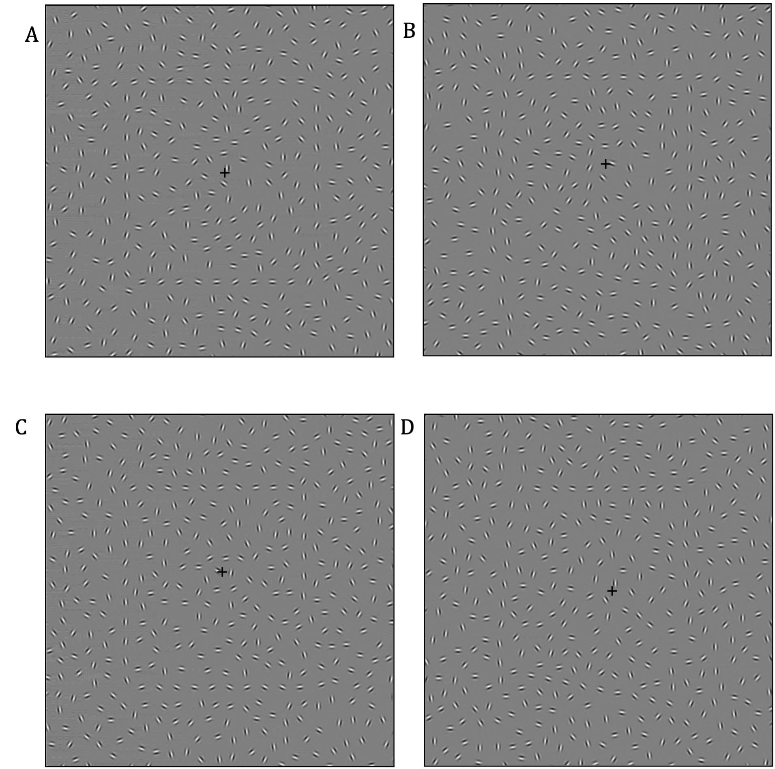
Note. Sample stimuli used at jitter = 30º (the Gabors along the contour were not perfectly aligned). A: Square at 0% irregularity (symmetry-closed); B: Irregular square at 25% irregularity (asymmetric-closed); C: Incomplete square at 0% irregularity (symmetry-open); D: Irregular incomplete square at 25% irregularity (asymmetric-open). For the irregular targets (B and D) and open target (C), the position of the irregular sides and/or the gap of the square may appear at four different positions during the trials.

Fig. 2
The Sequence of Stimuli Presentation
[Figure 2 top]
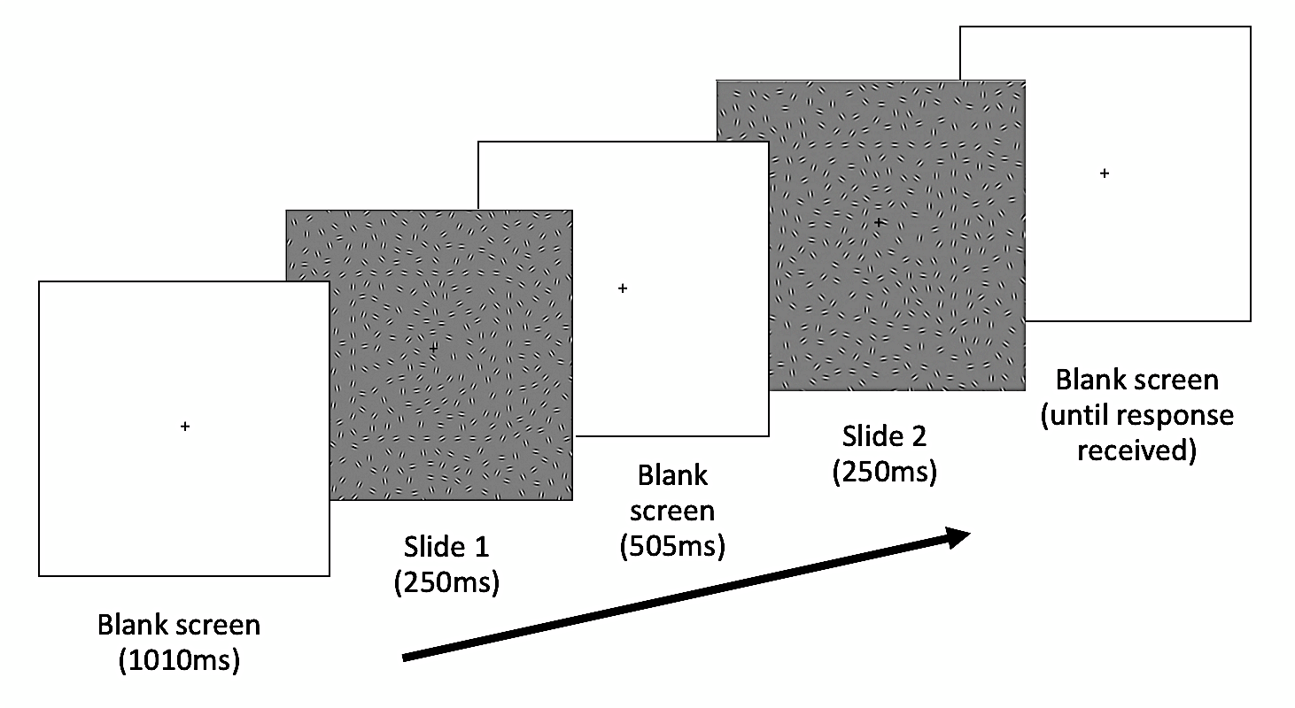
Note. Two stimuli were presented, the target stimulus (of varying level of asymmetry) and the comparison stimulus (a perfect square). These two stimuli were presented in a random order, in which either stimulus may appear in Slide 1 or Slide 2. In this example, comparison stimulus is presented in Slide 1, while the target stimulus in Slide 2.
Fig. 3
Symmetry Detection Threshold for Both Groups by Stimuli
[Figure 3 top]
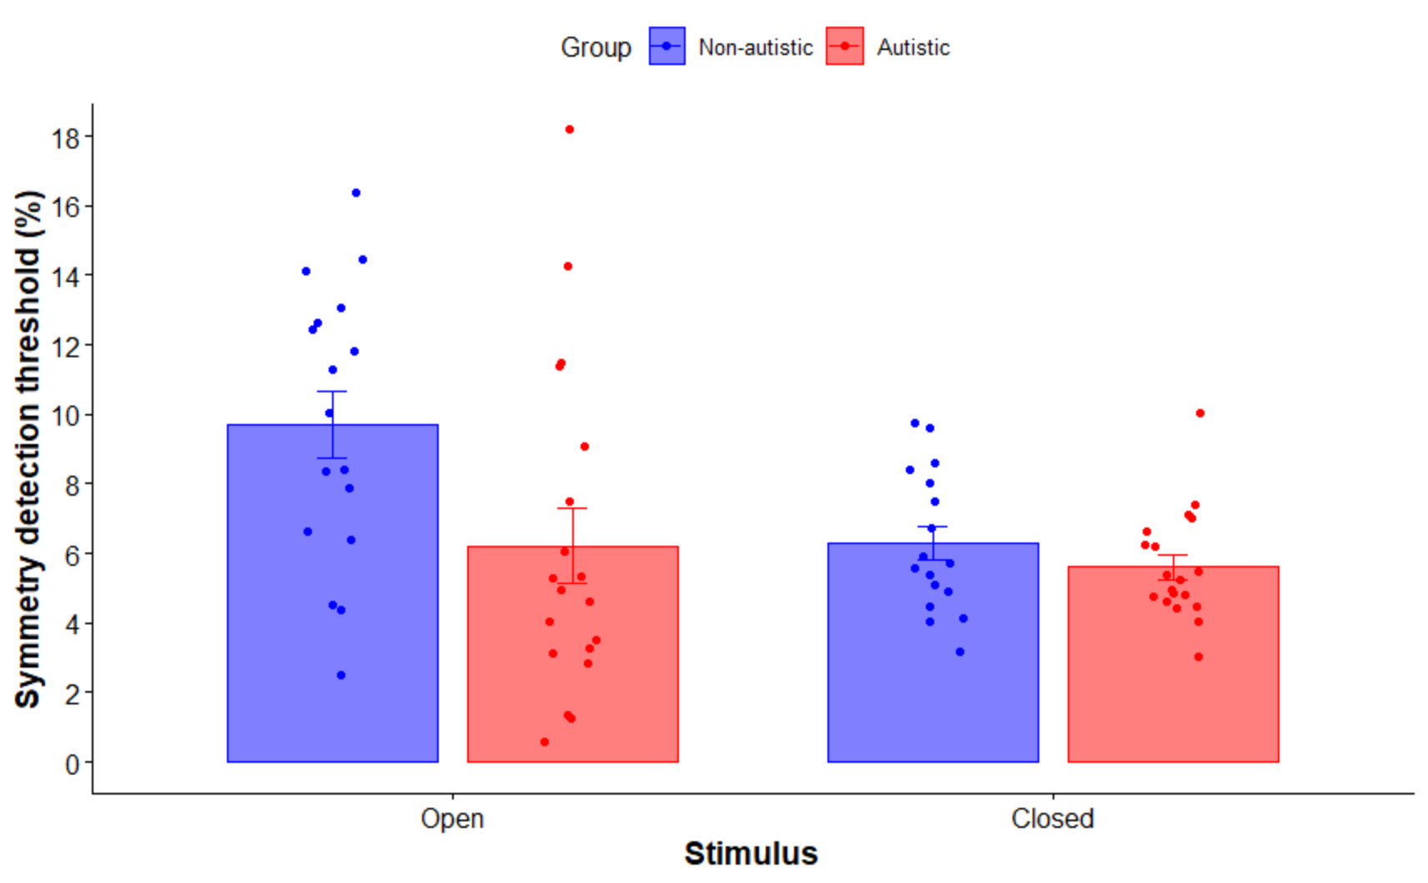

*
Note. Symmetry detection thresholds for non-autistic (blue) and autistic (red) groups for open and closed stimuli. Standard error bars are shown. Dots are individual participants. Lower values mean better performance. Group difference was significant for open shapes only, which is indicated by an asterisk (*).

Table 1
Demographic Characteristics of The Participants in Each Group
Autistic Group (N = 20) |  |  |  |  |  | Non-autistic Group (N = 18)
P | Ethnic | Age | Sex | Hand | FIQ |  |  | Ethnic | Age | Sex | Hand | FIQ
1 | White British | 22 | F | R | 134 |  |  | White British | 33 | F | L | 99
2 | White British | 28 | F | R | 132 |  |  | White British | 33 | M | R | 133
3 | White British | 34 | F | R | 128 |  |  | White British | 35 | F | R | 136
4 | White British | 34 | F | L | 128 |  |  | White British | 26 | M | R | 130
5 | White British | 22 | F | R | 124 |  |  | White-Carribean | 29 | M | R | 88
6 | White British | 24 | M | R | 109 |  |  | White British | 39 | M | R | 127
7 | White British | 27 | M | R | 144 |  |  | White British | 45 | M | R | 127
8 | White British | 38 | M | R | 126 |  |  | White British | 45 | M | R | 127
9 | White British | 39 | M | L | 125 |  |  | White British | 45 | M | R | 115
10 | White American | 43 | M | R | 140 |  |  | White British | 22 | F | R | 127
11 | White British | 44 | M | R | 118 |  |  | White British | 27 | F | R | 118
12 | White British | 44 | M | R | 108 |  |  | Asian British | 35 | F | R | 118
13 | White British | 31 | M | R | 101 |  |  | White British | 28 | F | R | 132
14 | White British | 32 | F | R | 121 |  |  | White British | 22 | F | R | 113
15 | White British | 32 | F | R | 131 |  |  | White British | 22 | M | R | 124
16 | White British | 28 | F | R | 109 |  |  | White British | 30 | M | R | 116
17 | White British | 24 | M | R | 111 |  |  | White British | 37 | M | R | 95
18 | White British | 38 | M | R | 108 |  |  | White British | 25 | M | R | 137
19 | White British | 28 | M | R | 134
20 | White British | 44 | M | R | 132
Mean (SD) |  | 32.80 (7.51) |  |  | 122.06 (12.23) |  |  |  | 32.1 (7.82) |  |  | 120.1 (14.05)

Note. P = The individual participant. Hand = Handedness. Full IQ score (FIQ) was measured using Wechsler Abbreviated Scale of Intelligence (Wechsler, 1999). SD = standard deviation.

Gabor patches are 2-D images produced by multiplying sinusoidal grating (sine-wave) with a Gaussian function resulting in stimuli with alternating black and white stripes that are best to stimulate orientation-selective cells in visual cortex (Field et al., 1993).

