**Testate amoebae response and vegetation composition after plantation removal on a former raised bog**

Angela L. Creevy a*, David M. Wilkinson b, Roxane Andersen c and Richard J. Payne (deceased) de

a Liverpool Hope University, Department of Geography and Environmental Science, Hope Park, Liverpool, L16 9JD, UK

b School of Life and Environmental Sciences, University of Lincoln, Brayford Pool, Lincoln LN6 7NS, UK

c Environmental Research Institute, University of the Highlands and Islands, Castle Street, Thurso KW14 7JD, UK

d University of York, Environment Department, Heslington, York, YO10 5DD, UK

e Department of Zoology and Ecology, Penza State University, Krasnaya str. 40, 440026 Penza, Russia

*Corresponding author: [creevya@hope.ac.uk](mailto:creevya@hope.ac.uk)

**Abstract**

Extensive drainage of peatlands in north-west Europe for afforestation for timber production and harvesting has altered the carbon balance and biodiversity value. Large-scale restoration projects aim to reinstate hydrological conditions to keep carbon locked up in the peat and to restart active peat growth. Testate amoebae are an informal grouping of well-studied protists in peatland environments and as microbial consumers play an important role in nutrient and carbon cycling. Using a space for time substitution approach, this study investigated the response of testate amoebae assemblages and vegetation composition after tree removal on a drained raised bog. There was a clear difference in microbial assemblages between open and a chronosequence of restoration areas. Results suggest microbial recovery after rewetting is a slow process with plant composition showing a faster response than the microbial assemblage. Mixotrophic testate amoebae had not recovered seventeen years following plantation removal and the establishment of *Sphagnum* mosses in the wetter microforms. These results suggest that vegetation composition and Testate amoeba assemblages respond differently to environmental drivers at forest-to-bog restoration areas. Local physicochemical peat properties were a stronger driver of the testate assemblage compared with vegetation. Complete recovery of microbial assemblages may take place over decadal timescales.

**Keywords:** Peatland, Raised Bog, Restoration, Testate amoebae, Vegetation, Mixotroph

**Acknowledgements**

We greatly appreciate Dr Joan Daniels M.B.E. and Peter Bowyer from Natural England also Mr. Edward Wardle for providing access to the study areas and for sharing local knowledge of the study site. Thank you to Dr Anne Oxbrough at Edge Hill University for providing helpful comments on the draft manuscript and Chris Marsden for help with satellite imagery. This work was funded by a Graduate Teaching/PhD Scholarship to A.L.C from Edge Hill University, UK. This paper is dedicated to the memory of our co-author the late Dr Richard Payne.

**Introduction**

Northern peatlands have accumulated a large soil carbon (C) pool over the Holocene (Yu et al., 2010; Davies et al., 2022) with a cooling influence on earth’s climate (Frolking and Roulet, 2007). They are estimated to cover 3.7 ± 0.5 million km2 and store 415 ± 150 Pg C (Hugelius et al., 2019). This century however, peatlands may shift from a carbon C sink to a C source (Loisel et al., 2021). The fate of the C sink potential depends on the balance between C uptake by plants and C release through microbial decomposition (Clymo 1978; Gallego-Sala et al., 2018). It has recently been shown that plant composition is an important factor controlling C emissions from peatlands undergoing restoration management (Creevy et al., 2020).

Climate change and large-scale rapid land use change of peatlands create uncertainty for the future fate of the terrestrial C store (Leifield et al., 2019; Lenton and Huntingford, 2003; Billet et al., 2010). For example, increased drought and drying in peatlands may favour microbial decomposition of peat by lowering the water table and introducing oxygen into previously anaerobic soil (Bardgett et al., 2008), which will potentially shift these ecosystems from being stores of C in their intact form, to accelerating climate change by releasing more C into the atmosphere (Dise 2009).

Heathy intact peatlands play a non-trivial role in nature-based climate mitigation (Beaulne et al., 2021). Large scale degradation of peatlands, coupled with appreciation of the climate and biodiversity benefits healthy intact peatlands can provide, has created a substantial interest in the restoration of such sites. The aim of restoration is to keep C locked up in the peat and restart active peat growth again after peatland drainage for agriculture and forestry (Gewin 2020). Studies in Scotland have shown that the process of forest-to-bog restoration and raising the water table creates a shift in vegetation communities which are slow to recover and resemble nearby reference sites, especially on ridges where conditions are dry (Hancock et al., 2018). Given that microorganisms control the decomposition and release of peatland C under drier conditions, understanding microbial community structure in peatlands can provide fundamental knowledge for assessing peatland quality and the peatland C cycle (Li et al., 2022; Perryman et al., 2022). Indeed, there is a growing interest in the idea of microbial inoculation as part of ecological restoration, including in peatland habitats (Shepherd et al, 2023).

Testate amoebae (TA) are an informal grouping of well-studied protists in peatland environments (Mitchell et al., 2003; Jassey et al., 2013; Marcisz et al., 2014; Lamentowicz et al., 2020). They possess several functional traits (Fournier et al., 2015; Marcisz et al., 2020) making them suitable candidates for bioindicators (Payne 2013; Swindles et al., 2016; Creevy et al., 2018; Gomes da Silva et al., 2022) and potentially as a monitoring tool in bog restoration (Wilkinson 2022). As heterotrophic/mixotrophic microbial consumers - sitting at the top of the microbial food web in peatlands (Mitchell el al., 2003; Payne 2013), they are important for nutrient and C cycling in organic-rich soils (Wilkinson and Mitchell, 2010), and have been shown to be sensitive to changes in elevated CO2 in peatlands (Mitchell et al., 2003; Jassey et al., 2013). Using traditional microscopy techniques, populations can be enumerated by direct counting of individuals in a sample – like data collected in the study of the ecology of macroscopic organisms such as plants (Wilkinson et al., 2012). In addition, living individuals can be quantified seasonally (Marcisz et al., 2014).

Using the Indicator Species Approach, several studies have shown TA to be useful indicators in blanket peatlands undergoing restoration management (Swindles et al., 2016), and especially mixotrophic testate amoebae (MTA) at blanket peat sites where conifer plantations are removed (often referred to as forest-to-bog restoration) (Creevy et al., 2018). MTA are increasingly recognised for their dual role in peatland C cycling at different trophic levels (Jassey et al., 2015; Payne et al., 2016; Hamard et al., 2021). MTA contribute to C fixation (primary production) through photosynthesis (phototrophy) and obtain energy though organic compounds (heterotrophy). As such, they could be potential contenders as bioindicators at peatland restoration sites on raised as well as blanket bog (Creevy et al., 2018).

Using a space-for-time substitution approach (Picket 1989) the aims of this study were to evaluate how TA and MTA respond to forest-to-bog restoration and to assess whether they could be used as microbial indicators of disturbance and recovery of restoration of a raised bog. Water table depth and vegetation are key controls of C emissions from peatlands (Creevy et al., 2020; Li et al., 2022; Perryman et al., 2022) and microtopography integrates these factors into features called microforms (Creevy et al., 2018; Perryman et al., 2022). To encompass small-scale variability, the objective of this study was to sample representative microforms and consider whether TA and vegetation respond similarly to the same edaphic and environmental drivers. The following hypotheses were tested: [H1] Seventeen years after plantation removal, TA assemblages will be more similar to areas of undisturbed open raised bog. [H2] MTA will recover ten years after forest-to-bog restoration. [H3] TA and vegetation respond similarly to environmental drivers at forest-to-bog restoration sites.

**Methods**

*Field site and experimental design*

The experimental site Fenns, Whixall and Bettisfield Mosses National Nature Reserve (52°92’24’’N, 2°76’94’’W) is a former raised mire situated on the border between England and Wales (Leah et al., 1998). Monthly average air temperature in this region ranges from 0.6OC (min) to 21.0OC (max) and mean annual rainfall is 659.9 mm (1981 – 2010 average at Shawbury Meteorological Station, 22 km from the study site).

Since peat extraction ended here in 1991, the site has been managed for nature conservation. One aspect of the nature conservation management involves the removal of marginal forestry plantings. Trees (Lodgepole pine *Pinus contorta*, Norway spruce *Picea abies* and Scots pine *Pinus sylvestris)* were planted at 2 metre spacings at the study areas ~ 1960, however, since the late 1990’s management efforts have focused on removing existing plantations to reduce interception, evapotranspiration, shading and tree seed sources combined with damming ditches to raise the water table (Joan Daniels, pers comm). Because trees were removed at different timescales, this study site provided the opportunity to investigate changes over a restoration chronosequence (Fig 1). Although chronosequences have to be interpreted with some care (Johnson and Miyanishi 2008), their utility is that they can be studied now rather than having to wait several decades for the results from a more conventional experimental approach.

Samples for quantification of TA assemblages were collected in August 2015, November 2015, February 2016 and May 2016 across three study areas. Above-ground vegetation (vascular plants, mosses) were quantified in August 2015 and 2016. The three study areas consisted of an area with trees removed in 1998 (referred to as RES17YRS i.e. 17 years post-restoration) (52°93’49’’ N, 02°76’00’’ W), trees removed in 2009 (RES6YRS) (52°93’52’’ N, 02°75’86’’ W) and these areas were compared to a reference ‘control’ area not planted with trees (OPEN) (52°91’44’’ N, 02°77’23’’ W).

Reference areas were characterised by hummock-hollow microtopography and supported typical peatland plant species such as: *Sphagnum* spp*.*, *Aulacomnium palustre*, *Vaccinium oxycoccos, Erica tetralix* and *Eriophorum vaginatum.* Restoration areas were characterised by ridge-furrow microtopography. Vegetation/cover in RES17YRS was dominated by ericaceous species such as: *Calluna vulgaris,* *Vaccinium oxycoccos* and *Erica tetralix* on the drier ridges with *Eriophorum vaginatum* and *Sphagnum* spp., colonising the wetter furrows. At RES6YRS ridges consisted of bare peat and brash (e.g. conifer needle litter and woody debris) with *Calluna vulgaris* and furrows were colonised by *Eriophorum angustifolium* on bare peat and brash.

*Edaphic and environmental variables*

At each sampling point, dipwells were permanently installed to allow for repeated water table measurements. Samples for the measurement of pH, conductivity, moisture content, bulk organic matter content and bulk density were collected in December 2015. Three replicate sub-samples were collected from each sampling point (n = 63). Samples for measurement of micro-environmental variables were prepared according to standard methods (Chambers et al., 2010). Bulk density samples were carefully extracted by cutting into the surface vegetation/peat using an open cylinder of known volume (400 ml). Samples were weighed, oven-dried at 105°C and reweighed to determine bulk density and moisture content. Organic matter content was determined by loss on ignition at a temperature of 550°C (Chambers et al., 2010). Samples for measurements of pH and conductivity were prepared by mixing 20 ml surface sample with 25 ml de-ionised water. Samples were shaken at 400 rpm for 30 minutes and centrifuged at 3000 rpm for 5 minutes. Measurements were obtained using a Hanna HI 98128 multiparameter probe for pH and conductivity was measured using a Hanna HI 98311 probe. Water table position was measured at the same time as TA sampling using dipwells located within one metre of the TA sampling points.

*Vegetation composition*

Vegetation surveys were carried out at the peak biomass period in August 2015 and August 2016 using the line point-intercept (LPI) method (Rochefort et al., 2013). This involved carefully placing a 50 x 50 cm frame over each sampling area and taking 25 measurements at equal 5 cm intervals based on the number of species touches with a vertically placed pin (1 mm diameter). Plant species composition for both surveys was averaged and the and moss and vascular plant abundances were expressed as percentage of mean number of hits (%). The relative proportion (%) of key plant groups was calculated. Cover of aerenchymas plants (AERENCOV) included *Eriophorum angustifolium* and *Eriophorum vaginatum*, *Sphagnum* moss cover (SPHCOV) included *Sphagnum angustifolium* and *Sphagnum capillifolium* and shrub cover (SHRUBCOV) included *Calluna vulgaris*, *Empetrum nigrum*, *Erica tetralix*, *Vaccinium oxycoccos* and *Vaccinium myrtillus*. The nomenclature followed Atherton et al. (2010) for mosses and Stace (2019) for vascular plants.

*Testate amoebae sampling, preparation and quantification*

Within each of the three study areas seven sampling points (n = 7) were located at the interface of micro-topographic features, these were ridges and furrows at the restoration areas and hummocks and hollows were the equivalent microforms at the reference ‘OPEN’ area. At RES17YRS three ridges and four furrows were sampled, at RES6YRS four ridges and three furrows and at the OPEN areas three hummocks and four hollows. For the analysis of TA assemblages, surface vegetation/peat samples of approximately 5 × 5 x 10 cm3 were collected every three months (August 2015, November 2015, February 2016 and May 2016) from three permanently marked plots giving a total of 84 samples. This experimental field design allowed for multiple sampling over time and collection of a composite sample from each plot to encompass small-scale variation. The composite sample was combined of three individual samples per plot. All samples were frozen in the laboratory prior to preparation.

TA samples were prepared using a modified version of the method of Booth et al. (2010). Assemblages were enumerated by direct counts using light microscopy at x 400 magnification (Prior Scientific Advanced Laboratory Microscope). Search effort was restricted to 100 individuals per sample following Payne and Mitchell (2009). Morphological identification of testate amoebae was based on the guides of Charman et al., (2000), Ogden and Hedley, (1980) and Mazei and Tsyganov, (2006).

*Statistical analyses*

Statistical analyses were performed with R (R Core Team, 2013) and IBM SPSS statistics (version 25).

Multivariate techniques were used to analyse influences on TA assemblages and vegetation and to investigate differences between study areas. Species data were Hellinger transformed prior to all multivariate analyses to give low weights to rare species (Legendre and Gallagher, 2001). Principal components analysis was used to investigate the structure of the full TA dataset between restoration areas, sampling month and microtopography. Nested Permutational Multivariate Analysis of Variance (PERMANOVA, function ‘*adonis’*) was used to test the effects of restoration area, microtopography and sampling month on TA assemblages.

To detect functional response, two functional indices were calculated: mixotrophy ratio and aperture size. Mixotrophic taxa included: *Archerella flavum*, *Heleopera* *sphagni*, *Hyalosphenia* *papilio* and *Placocista* *spinosa* (Gomaa et al., 2017) and mixotrophy was determined as the proportion of mixotrophic taxa within an assemblage. Aperture sizes were classified into three size categories: 1 = < 20 µm, 2 = < 40 µm and 3 = > 41 µm following Payne et al. (2016).

The IndVal approach (Dufrene and Legendre, 1997) was adopted to identify indicator species of forest-to-bog and open (unafforested) study areas on the full TA dataset. The clusters were categorised by study areas (RES6YRS, RES17YRS and OPEN). Indicator species for each cluster were identiﬁed using the ‘indval’ function in the package ‘labdsv’ (Roberts, 2010). For each assemblage, taxa with a p-value = <0.01 and IndVal >0.30 were selected as potential indicator species.

Redundancy analysis (RDA) (function “RDA”, package “vegan”) was used to identify whether vegetation and TA respond similarly to edaphic and environmental drivers. To reduce the influence of rare species on the RDA, taxa present in less than ten samples were eliminated, except for *Hyalosphenia papilio* which was included because of its high abundance at certain sampling points.

Variation partitioning (function “varpart”, package “vegan” (Peres-Neto et al. 2006)) was used to test the proportion of variation in TA and vegetation explained by edaphic and environmental variables. Analysis of variance (ANOVA) was used to test for differences. The non-parametric Kruskal–Wallis (KW) test was used for continuous data which did not satisfy the assumptions of normality and homogeneity of variance after data transformation.

**Results**

*Edaphic and environmental variables*

Edaphic and environmental factors were variable between the three study areas (Fig 2). Mean water table depth was siginificantly higher at RES17YRS (12.59 ± 2.14 SE) compared to RES6YRS (28.32 ± 2.68) and OPEN (17.08 ± 1.58) areas (F 2,81 = 15.319, *p* = <0.001). Mean percentage moisture content was significantly greater in OPEN areas (88.61 ±1.08) compared with RES6YRS (75.06 ± 0.85) and RES17YRS (85.42 ± 1.98) (F 2,57 = 24.902, *p* = <0.001). Conductivity followed a similar trend and was significantly higher in OPEN areas (18.40 ± 1.25) compared with RES6YRS (14.64 ± 1.19) and RES17YRS (13.48 ± 0.80) (F 2,60 = 5.449, *p* = <0.007). Bulk organic matter content was significantly higher at RES17YRS (93.31 ± 1.61) than RES6YRS (77.41 ± 2.22) and OPEN (89.88 ± 2.39) areas (F 2,60 = 15.876, *p* = <0.001). RES6YRS had significantly higher bulk density (0.10 ± 0.005) than RES17YRS (0.06 ± 0.004) and OPEN (0.05 ± 0.003) areas (F 2,60 = 48.957, *p* = <0.001) and was least acidic (F 2,60 = 28.889, *p* = <0.001).

*Vegetation composition*

Vegetation cover of plant groups differed between study areas (Fig 3). *Sphagnum* cover was significantly greater in OPEN areas and at RES17YRS compared with RES6YRS (F2,77 = 17.403, *p* = <0.001) where *Sphagnum* had not recovered on ridges nor in furrows. In general, coverage of plant species was significantly higher in hollows and furrows compared with hummocks and ridges (F1,78 = 89.175, *p* = <0.001) where shrubs tended to be the dominant vegetation type.

*Testate amoeba assemblages*

TA assemblages displayed relatively high diversity with 54 taxa identified from 8495 individuals in the 84 samples. The most abundant taxa in decreasing order of abundance were: *Nebela tincta* (15.7 % of all tests), *Corythion dubium* (12.2 %), *Assulina muscorum* (10.0 %), *Archerella flavum* (8.5 %), *Trinema lineare* (7.8 %), *Trigonopyxis arcula* (5.9 %), *Galeripora discoides* - formerly *Arcella discoides* - (5.5 %), *Nebela collaris* (4.5 %), *Hyalosphenia subflava* (4.0 %) and *Cryptodifflugia oviformis* (3.7 %). These taxa accounted for a relatively high proportion (>77 %) of the overall assemblage (Fig 4). There were significant differences (Kruskal-Wallis test, *p* = <0.05) in relative abundance (%) between restoration areas and OPEN areas for all taxa except for: *N. tincta, C. dubium* and *A. muscorum*. Large variations were observed between certain taxa and microtopography, for instance*, G. discoides* was present only in furrows at RES17YRS in contrast with *A. flavum* whose presence was largely observed in OPEN areas. Mean species richness was significantly lower in OPEN areas (8.75 ± 0.539 SE) compared with RES17YRS (12.14 ± 0.462 SE) and RES6YRS (12.11 ± 0.403 SE) (F2,81 = 17.109, *p* = <0.001).

TA assemblages were distinctive between the three study areas (Fig 5). The first two PCA axes explained 41 % of the variability in the unconstrained species data and cumulatively PCA axes 1-4 accounted for 62 % of the variability in the unconstrained species data. Assemblages in RES6YRS were quite distinct compared with assemblages observed at RES17YRS and OPEN areas, which displayed some overlap between microtopography. For instance, hummocks in RES17YRS clustered closer to OPEN hummocks with some overlap displayed. In contrast, assemblages in the OPEN hollows appeared distinct compared with hollows in both restoration areas, primarily because of the high abundance of *A. flavum* which was largely absent in restoration areas. PERMANOVA showed that TA composition was significantly different between study area (F = 21.010, *p* = 0.001). The TA assemblage also differed significantly with microtopography (F = 9.180, *p =* 0.001) but not with sampling month (F = 1.328, *p* = 0.067).

*Testate amoebae Indicator species analysis*

Indicator species analysis showed fourteen significant indicator species (Table 1). The highest indicator values (IndVal) were found for *T. arcula* (0.87), *H. subflava* (0.76) and *T. lineare* (0.70). At RES17YRS the strongest indicators were *G. discoides* (0.62), *Euglypha compressa* (0.45) and *C. oviformis* (0.43). RES6YRS contained the largest proportion of indicator species (43%) with *T. arcula*, *H. subflava*, *T. lineare*, *N. militaris, E. tuberculata* type and *E. rotunda/laevis* identified as significant indicators. The strongest indicator of OPEN areas was *A. flavum*. Although not significant indicators at the defined cut-off point (IndVal > 0.30), *H. elegans* and *H. papilio* were shown to be significant indicators of OPEN areas (IndVal 0.18) respectively.

*Testate amoebae functional trait analysis*

The functional trait analysis showed the effects of restoration on certain functional traits within the TA assemblages. Notably, mixotrophs (*A. flavum* and *H. papilio*) made up a significantly larger proportion of the assemblage in OPEN areas (χ2 (2) = 26.429, *p* = < 0.001), compared with forest-to-bog restoration areas where mixotrophs were largely absent. In contrast, there was no difference in the proportion of mixotrophs between sampling months (χ2 (3) = 1.632, *p* = 0.652). Sampling months also had no effect on aperture size (F = 0.977, *p* = 0.408), and aperture sizes were not significantly different between the three study areas (F = 2.734, *p* = 0.071).

*Vegetation and Testate amoebae response to environmental drivers*

In the RDA (Fig 6b), edaphic (OM, BD, pH, EC and moisture) and environmental (WTD and temperature) variables accounted for 60 % variation in vegetation (percentage cover of AERENCOV, SPHCOV and SHRUBCOV). The first axis explained 40 % of the variation and indicated a bulk density - moisture – acidity gradient. The second axis explained 20 % of the variation in the vegetation dataset and indicated an organic matter – moisture gradient. Edaphic factors and environmental variables measured were found to be significant controls on vegetation compsition (*p* = 0.001).

The results of the RDA for TA assemblages (Fig 6a) (which also included vegetation cover as a covariate) explained a smaller proportion (47 %) of the variation. The first axis explained 23 % variation and the contribution of RDA axis one to the variation in the model was significant (*p* = 0.001) and indicated strong influences of moisture, *Sphagnum* cover and organic matter content on TA assemblages. The contribution of the second axis to the variation in the model was also significant and explained 11 % variation indicating pH, BD and WTD were stronger drivers. *Sphagnum* cover was shown to have a greater influence on TA assemblages compared with shrub and aerenchymas cover.

Analysis to determine the proportion of the variation in TA assemblages that is explained by environmental factors demonstrated that edaphic variables were stronger drivers than vegetation shaping the TA assemblages (Fig 7). Overall, the model explained about 40% of the variation in the TA assemblages, edaphic and environmental variables explained a larger proportion (16 %) compared with vegetation (13 %) and the remaining 11 % was explained by the interaction between edaphic/environmental factors and vegetation composition.

**Discussion**

*The impact of restoration on Testate amoeba assemblages*

These results demonstrate significant effects of restoration on TA assemblages in a raised bog. The first hypothesis that restoration recovers the TA assemblage to reference conditions was rejected because, as with studies in blanket peatland (Creevy et al., 2018), whilst there was some overlap between individual sampling points at RES17YRS and OPEN, there was a clear distinction in TA assemblages between the three study areas. Lower TA species richness was observed in reference OPEN areas compared with restoration areas, however, the TA composition in the reference areas comprised of taxa, such as *A. flavum* and *H. papilio* which are more indicative of a healthy raised bog and good indicators of a well-functioning *Sphagnum* peatland (Łucow et al., 2022). This pattern mirrors many other habitats where often disturbed sites contain more species – for example an influx of ‘weedy’ early successional species – but lack the specialist species characteristic of relatively undisturbed habitats (Hambler and Canney, 2013).

These trends reflect the slow recovery of microbial assemblages and absence of MTA after plantation removal on a raised bog. Other studies investigating the restoration of microbial processes following restoration of raised bog suggests timescales in excess of ten years for microbial processes to be fully-re-established and resemble near-natural conditions (Andersen et al., 2010). In the present study, cover of *Sphagnum* mosses were not significantly different to the reference area seventeen years post restoration, supporting the idea that recovery of mosses and shrubs in peatlands under restoration controls the structure of the microbial assemblage. *Sphagnum* mosses showed no recovery six years following plantation removal and vegetation composition of key plant groups was highly variable between microforms.

There has been a longstanding interest in the importance of hummock and hollow microtopography in peatland ecology (Moore and Bellamy, 1974; Godwin, 1981; Łucow et al., 2022). In addition to restoration age, microtopography was also shown to be an important factor for the recovery of TA assemblages. For example, assemblages found in ridges at RES17YRS clustered closer to hummocks in OPEN areas whereas assemblages observed in ridges at RES6YRS were still quite distinct and supported taxa indicative of a dry bog surface such as *Hyalosphenia subflava* (Valentine et al., 2013) and *Trigonopyxis arcula* (Gauthier et al., 2019).

Taxa typifying furrows at RES6YRS were smaller and bacterivorous (e.g. *Trinema lineare*) whereas the open bog hollows supported MTA, specifically, a high abundance of *A. flavum* and wet-related taxon *H. papilio* (*sensu lato*) (Heger et al., 2013). *Nebela collaris* (*sensu lato*) (Kosakyan et al., 2015) was comparably abundant in furrows at RES17YRS and OPEN bog hollows and the recovery of this taxon in hollows at RES17YRS is perhaps best explained by the feeding habits. *N. collaris* is a heterotroph and has been shown to feed on a wide variety of material including diatoms, fungal spores, rotifers, ciliates and smaller TA (Gilbert et al., 2003). In contrast with RES6YRS, *Sphagnum* mosses were established in furrows at RES17YRS. In these areas, the water content of *Sphagnum* mosses plays an important role in determining the ability of predators to catch their prey (Gilbert et al., 2003), and could further explain the comparable abundance of *N. collaris*. The high abundance of *G. discoides* in the present study agreed with other findings (Davis and Wilkinson, 2004; Lamentowicz et al.,2008; Łuców et al., 2022) indicating hydrological instability at RES17YRS.

*Testate amoebae functional traits and mixotroph recovery after restoration*

The recovery of MTA at these restoration sites is more complex. Results here demonstrate a lack of recovery of MTA seventeen years after plantation removal of a raised bog, despite having a higher water table than the OPEN reference area. Furthermore, these results demonstrate that recovery of light conditions (i.e. removal of trees) is not enough to recover the MTA over decadal timescales. There is growing evidence of an absence of MTA at forested peatlands (Payne et al., 2016; Creevy et al., 2018; Lamentowicz et al., 2020), with potential consequences for the global carbon cycle (Jassey et al., 2015; Lara and Gomaa, 2017; Hamard et al., 2021). Mixotrophy is both a trait of prokaryotes and eukaryotes. Eukaryotic microorganisms - including TA – form symbiotic relationships between heterotrophic and/or photosynthetic organisms (Lara and Gomaa, 2017). However, most studies investigating such relationships has mainly taken place for prokaryotes, notably bacteria (e.g. O’Brien et al., 1984).

This is an important finding because it has been shown that decreasing MTA abundance may affect bryosphere photosynthesis and/or respiration (Jassey et al., 2015). Green algal symbionts contained within MTA may be responsible for the fixation of a significant part of global atmospheric C in ombrotrophic northern peatlands (Lara and Gomaa, 2017; Hamard et al., 2021). Recent research (Hamard et al., 2021) suggests species-specific *Sphagnum* leachate may be an important factor influencing the survival and/or reproduction of MTA, which could explain why they are poorly represented in certain *Sphagnum* biomes. Further, MTA are dependent on their green algal symbionts (Lara and Gomaa, 2017) and cannot survive solely by means of heterotrophy (Jassey et al., 2015). It is also likely that the fluctuating water table at RES17YRS may not favour mixotrophs such as *A. flavum* as decreases in MTA abundance has been linked to prolonged periods of drought (Jassey et al., 2015 and references therein).

Results here agree with recent findings and the suggestions made by Lamentowicz et al, (2020), that mixotrophic species not only need light, but they also require stable conditions and wet *Sphagnum* to survive and reproduce. Importantly, the slow recovery of MTA at forest-to-bog sites is an important area for future research, as despite over five decades of research investigating mixotrophic protists (e.g. Schönborn 1965), we are only beginning to understand the energetic benefits of endosymbiotic algae of mixotrophs and their potential role in the global carbon cycle (Jassey et al., 2015; Hamard et al., 2019). MTA possibly occurred simultaneously with the first establishment of Northern oligotrophic *Sphagnum* dominated peatlands (Lara and Gomaa, 2017), it is therefore important to quantify how much atmospheric carbon has been fixed by green, algal symbionts of MTA.

In contrast with other studies (e.g. Marcisz et al., 2014), sampling month was not found to be a significant control on TA assemblages, including MTA. These findings could support the suggestion made by Mazei and Tsyganov, (2007), that seasonal trends in TA dynamics are probably variable in different biotopes. Marcisz et al. (2014), using different sampling methodologies from those employed in the present study, found the relative abundance of mixotrophic taxa increased between spring and summer and linked this to light intensity changes over the season. The cranked wire method (Clymo 1970) which distinguishes the new growth of *Sphagnum* mosses is a better approach if the aim of the study is to analyse the living testate assemblages, however, this methodology maybe problematic in our younger restoration areas, for example RES6YRS, where *Sphagnum* had not established.

Other observational studies have shown mixotroph abundance higher on the upper portions of *Sphagnum* stems (Mitchell and Gilbert, 2004) and higher in open as opposed to forested peatlands (Payne et al., 2016), providing some evidence of light dependence in mixotrophs. Although, using stable isotopes Herbert et al. (2019) show that mixotroph abundance increased in shaded plots, highlighting the need for further research to assess the impacts of light variability on peatland mixotrophs. As with mixotrophs, sampling month was not shown to have a significant control on aperture size. Aperture size is an effect trait (Fournier et al., 2015) and can be used as an indicator of the trophic position in the microbial food web i.e. taxa with smaller apertures feed on smaller prey and vice-versa (Jassey et al., 2013). For future trait-based studies, shell type could be useful at forest-to-bog restoration sites as it has been reported to show a clear response to light availability (Lamentowicz et al., 2020).

*Testate amoebae and vegetation response to environmental and edaphic drivers and their roles in monitoring restoration*

TA and vegetation are key biotic components of C cycling in peatlands, contributing to both photosynthesis and respiration. In terms of temporal dynamics, vegetation in furrows has been shown to respond faster at forest-to-bog sites compared with drier ridges (Hancock et al., 2018), with vegetation cover composed of *Sphagnum* and *E. vaginatum* which has been shown to have a more positive influence on the peatland carbon balance (Creevy et al., 2020). Given that vegetation and microbial communities operate at completely different spatial and temporal scales, an important question in the present study is whether they respond similarly to the same environmental drivers. These results suggest that vegetation composition and TA assemblages show different trends in their response to environmental drivers at forest-to-bog restoration areas. The third hypothesis that testate amoebae and vegetation respond similarly to the same environmental drivers was therefore rejected. Edaphic variables were a stronger driver than vegetation shaping testate assemblages, suggesting the physiochemical environment might be the main driver of microbial recovery. Other studies (Li et al., 2022) have reported succession pattern of ground vegetation as the main driver of the soil bacterial community. As eukaryotic bacterial consumers, it is likely that TA assemblages will respond at a slower rate than prokaryotic microorganisms.

Results here demonstrate that afforestation of previously open bog and subsequent restoration to open conditions has altered edaphic factors. These results agree with other findings (Anderson and Peace, 2017), that forest-to-bog restoration treatments resulted in a decrease in bulk density and an increase in water content. These directional changes could indicate that forest-to-bog restoration can be successful in returning physical peat properties to pre-disturbance conditions, but this study suggests timescales in excess of ten years may be required.

Six years post restoration surface ridge/furrow microtopography was evidently remnant of forestry practices. *Trigonopyxis arcula* was a strong indicator of these conditions and restoration stage. *T. arcula* is a relatively large testate which appears to be a fungal specialist, either directly consuming hyphae or possibly feeding on exudates from the hyphae (Wilkinson and Mitchell, 2010). In this study this taxon was largely confined to RES6YRS and was more abundant in ridges as opposed to hollows. Six years post-restoration, these ridges had barely been colonised by plants other than a patchy cover of *Calluna vulgaris*. A possible explanation for the dominance of *T. arcula* is that the dry bare peat is being decomposed by fungi providing an important food source for *T. arcula*. Seventeen years post-restoration ridges generally consisted of shrubs *Vaccinium oxycoccos* and *V. myrtillus* with a ground cover of *Pleurozium schreberi* and were associated with typical peatland testates such as *Nebela tincta* and *Assulina muscorum*. In many blanket bogs impacted by afforestation, a technique known as ground smoothing, where plough ridges are flattened, furrows are blocked and brash is buried in the peat, is being trialled and may provide opportunities for future research.

Drainage and compaction at RES6YRS increased bulk density by about fifty percent therefore reducing the diffusion of gaseous C and oxygen (Ball et al., 1997). Bulk density of approximately 0.2 g cm-3 was recently reported as the critical threshold for maintaining hydraulic properties of peat soils, with higher values tending to behave more like mineral soils with respect to hydraulic parameters (Liu and Lennartz, 2019), although, perhaps important to note are differences in hydraulic parameters between temperate and tropical peatlands. Higher bulk density estimates, as found at RES6YRS, can be attributed to greater microbial decomposition and lower porosity and could partly explain why edaphic variables were shown to be stronger drivers than vegetation shaping the TA assemblages. Higher bulk density may similarly increase the micropores potentially resulting in an increase in moisture retention but this trend was not observed in the present study.

Decomposition is impeded by saturated conditions owing to the high-water table leading to greater organic matter content (Moore 1987). Results here provide evidence for this as RES17YRS was shown to have highest OM content and water table position. Andersen et al (2013) found the capacity of microorganisms in using different C sources (microbial functional diversity) highest at restoration sites and lowest at the reference site, suggesting that vegetation may override peat properties (e.g. bulk density, moisture, degree of decomposition), regulating belowground processes through changes in microbial community structure. Future studies should quantify microbial functional diversity alongside taking detailed measurements of the chemical and physical environment.

Overall, these findings suggest vegetation is perhaps a better tool for monitoring peatland restoration compared with TA, which are perhaps better used as bio-indicator species for assessing the trajectory of fine-scale edaphic conditions and peatland quality after restoration management. From a management perspective, it is certainly easier and less time consuming for land managers to quantify the surface vegetation composition than TA assemblages (Wilkinson 2022).

**Conclusion**

This study demonstrated some recovery of TA assemblages at forest-to-bog restoration sites of a raised bog seventeen years after tree removal and restoration management. Recovery was more evident in wetter hollow microforms compared with drier ridge microtopography. The recovery of MTA at such restoration sites is more complex with results here showing light dependence and the establishment of *Sphagnum* mosses in wetter hollows do not appear to be the main factors in the recovery of MTA and hence their ability as phototrophic microorganisms to fix atmospheric C. In the early stages of restoration (< 20 years), results here suggest local edaphic factors are more important than vegetation for the recovery of the TA assemblage, including MTA. We conclude that TA and MTA are useful bioindicators of the fine-scale progress of forest-to-bog restoration. From a monitoring perspective though, vegetation composition may be quicker and less time-consuming.

**References**

Andersen, R., Grasset, L., Thormann, M.N., Rochefort, L. and Francez, A.J. (2010). Changes in microbial community structure and function following Sphagnum peatland restoration. *Soil Biology and Biochemistry,* **42**, 291-301.

Andersen, R., Chapman, S.J., Artz, R.R.E., 2013. Microbial communities in natural and disturbed peatlands: A review. *Soil Biol. Biochem*. **57**, 979–994.

Anderson, R., Peace, A., 2017. Ten-year results of a comparison of methods for restoring afforested blanket bogs. Mires. Peat. 19, 1–23. Article 06.

Atherton, I., Bosanquet, S., Lawley, M., 2010. Mosses and Liverworts of Brian and Ireland: A Field Guide. British Bryological Society, Plymouth, UK

Ball, B.C., Dobbie, K.E., Parker, J.P. and Smith, K.A., 1997. The influence of gas transport and porosity on methane oxidation in soils. Journal of Geophysical Research 102, 23301–23308

Bardgett, R.D., Freeman, C. and Ostle, N.J. (2008) Microbial contributions to climate change through carbon cycle feedbacks. The IMSE Journal, 2, 805-814.

Beaulne, J., Garneau, M., Magnan, G., & Boucher, É. (2021). Peat deposits store more carbon than trees in forested peatlands of the boreal biome. Scientific Reports, 11(1), 2657. https://doi.org/10.1038/ s41598-021-82004-x

Billet, M.F., Charman, D.J., Clark, J.M., Evans, C.D., Evans, M.G., Ostle, N.J., Worral, F., Burden, A., Dinsmore, K.J., Jones, T., McNamara, N.P., Parry, L., Rowson, J.G. and Rose, R. (2010) Carbon balance of UK peatlands: current state of knowledge and future research challenges. Climate Research, 45, 13-29.

Booth, R.K., Lamentowicz, M. and Charman, D.J. (2010). Preparation and analysis of testate amoebae in peatland palaeoenvironmental studies. Mires and Peat. 7, 1–7.

Chambers, F.M., Beilman, D.W. and Yu, Z. (2010). Methods for determining peat humification and for quantifying peat bulk density, organic matter and carbon content for palaeostudies of climate and peatland carbon dynamics. Mires and Peat, 7, 1-10.

Charman, D.J., Hendon D. and Woodland, W.A. (2000). The identification of Testate amoebae in Peats. Quaternary Research Association Technical Guide No 9. London.

Clymo, R.S. (1970). The growth of Sphagnum: methods of measurement, Journal of Ecology, 58, 13-49.

Clymo, R.S. (1978). A Model of Peat Bog Growth. In: Heal, O.W., Perkins, D.F. (eds) Production Ecology of British Moors and Montane Grasslands. Ecological Studies, vol 27. Springer, Berlin, Heidelberg. https://doi.org/10.1007/978-3-642-66760-2_9

Creevy, A.L., Andersen, R., Rowson, J.G. and Payne, R.J. (2018) Testate amoebae as functionally significant bioindicators in forest-to-bog restoration. Ecological Indicators, 84, 274-282.

Creevy, A.L., Payne, R.J., Andersen, R. and Rowson, J.G. (2020) Annual gaseous carbon budgets of forest-to-bog restoration sites are strongly determined by vegetation composition. Science of the Total Environment, 705, 135863.

Davies, M.A., McLaughlin, J.W., Packalen, M.S. and Finkelstein, S.A. (2022). Holocene carbon storage and testate amoeba community structure in treed peatlands of the western Hudson Bay Lowlands margin, Canada. *Journal of Quaternary Science*, 38, 92-106 1-15.

Davis, S.R. and Wilkinson, D.M. (2004). The conservation management value of testate amoebae as restoration indicators: speculations based on two damaged raised mires in northwest England. The Holocene. 14, 135-143

Dise, N. (2009) Peatland response to global change, Science, 326, 810-811.

Dufrene, M. and Legendre, P (1997). Species assemblages and indicator species: the need for a flexible asymmetrical approach. Ecological Monographs, 67, 345-366.

Fournier, B., Lara, E., Jassey, V.E.J. and Mitchell, E.A.D. (2015). Functional traits as a new approach for interpreting testate amoeba palaeo-records in peatlands and assessing the causes and consequences of past changes in species composition. The Holocene, 25, 1375-1383.

Frolking, S. and Roulet, N. T. (2007) ‘Holocene radiative forcing impact of northern peatland carbon accumulation and methane emissions’, Global Change Biology, 13(5), pp. 1079–1088. doi: 10.1111/j.1365-2486.2007.01339.x

Gallego-Sala AV et al (2018) Latitudinal limits to the predicted increase of the peatland carbon sink with warming. Nature Climate Change, doi:10.1038/s41558-018-0271-1.

Gauthier, E., Jassey, V.E.J., Mitchell, E.A.D., Lamentowicz, M., Payne, R., Delarue, F., Laggoun-Defarge, F., Gilbert, D. and Richard, H. (2019) From Climatic to Anthropogenic Drivers: A Multi-Proxy Reconstruction of Vegetation and Peatland Development in the French Jura Mountains. Quaternary, 2, 1-13.

Gewin, V. (2020) Bringing back the bogs. Nature, 578, 204-208.

Gilbert D, Mitchell EAD, Amblard C, Bourdier G, Francez A-J (2003) Population dynamics and food preferences of the testate amoeba Nebela tincta major-bohemica-collaris complex (Protozoa) in a Sphagnum peatland. Acta Protozool 42:99–104

Gilbert D, Mitchell EAD, Amblard C, Bourdier G, Francez A-J (2003) Population dynamics and food preferences of the testate amoeba Nebela tincta major-bohemica-collaris complex (Protozoa) in a Sphagnum peatland. Acta Protozool 42:99–104

Godwin, H. (1981) The archives of the peat bogs. Cambridge University Press, Cambridge.

Silva, Y.G.D., Sampaio, G.S.,Ramos, B.R.D.O., Freitas, Y.D.G.C., Nascimento, L., Branco, C.W.C. and Miranda, V.B.D.S. (2022) Testate amoebae (Amorphea, Amoebozoa, Cercozoa) as bioindicators: a scientometric review. *Acta Limnologica Brasiliensia*, 34

Hamard, S., Céréghino, R., Barret, M., Sytiuk, A., Lara, E., Dorrepaal, E., Kardol, P., Küttim, M., Lamentowicz, M., Leflaive, J., Le Roux, G., Tuittila, E.S., Jassey, V.E.J., 2021. Contribution of microbial photosynthesis to peatland carbon uptake along a latitudinal gradient. *J. Ecol*., 1–18 <https://doi.org/10.1111/1365-2745.13732>

Hambler, C. and Canney, S.M. (2013*) Conservation* 2nd ed. Cambridge University Press, Cambridge.

Hancock, M.H., Klein, D., Andersen, R. and Cowie, N.R. (2018) Vegetation response to restoration management of a blanket bog damaged by drainage and afforestation. Applied Vegetation Science, 21, 167-178.

Heger, T.J., Mitchell, E.A.D. and Leander, B. (2013) Holarctic pylogeography of the testate amoeba Hyalosphenia papilio (Amoebozoa: Arcellinida) reveals extensive genetic diversity explained more by environment than dispersal limitation. Molecular Ecology, 22, 5172 – 5184.

Herbert RP, Peters SC, Nelson DM, Booth RK. 2019. Light variability and mixotrophy: Responses of testate amoeba communities and shell δ13C values to a peatland shading experiment. European Journal of Protistology 67: 15–26. https://doi.org/10.1016/j.ejop. 2018.10.005

Hugelius G., Loisel J., Chadburn S., Jackson R., MacDonald G., Marushchak M., Packalen M., Siewert M., Treat C., Turetsky M., Voigt C., Yu Z. 2020. Northern peatlands and permafrost thaw: effects on carbon and nitrogen stocks and fluxes. Proceedings of the National Academy of Sciences, doi:10.1073/pnas.1916387117

Jassey, V.E.J., Shimano, S., Dupuy, C., Toussaint, M. and Gilbert, D. (2013). Characterizing the Feeding Habits of the Testate Amoebae Hyalosphenia papilio and Nebela tincta along a Narrow “Fen-Bog” Gradient Using Digestive Vacuole Content and 13C and15N Isotopic Analyses. Protist, 163, 451-464.

Jassey, V.E.J., Signarbieux, C., Hättenschwiler, S., Bragazza, L., Buttler, A., Delarue, F., Fournier, B., Gilbert, d., Laggoun-Défarge, f., Lara, E., Mills, R.T.E., Mitchell, E.A.D., Payne, R.J. and Robroek, B.J.M. (2015d). An unexpected role for mixotrophs in the response of peatland carbon cycling to climate warming. Scientific Reports, 5

Johnson, E.A. and Miyanishi, K. (2008). Testing the assumptions of chronosequences in succession. Ecology Letters, 11, 419-431.

Kosakyan, A., Gomaa, F., Lara, E. and Lahr, D.J.G. (2016). Current and future perspectives on the systematics, taxonomy and nomenclature of testate amoebae. European Journal of Protistology, 55, 105-117.

Lamentowicz, M., Milecka, K., Galka, M., Cedro, A., Pawlyta, J., Piotrowska, N., Lamentowicz, L. and Van der Knapp, W. (2008). Climate and human induced hydrological change since AD800 in an ombrotrophic mire in Pomerania (N Poland) tracked by testate amoebae, macro-fossils, pollen and tree rings of pine. Boreas, 38, 214-229

Lamentowicz et al., (2020) Testate amoebae taxonomy and trait diversity are coupled along an openness and wetness gradient in pine-dominated Baltic bogs. European Journal of Protistology, doi.org/10.1016/j.ejop.2020.12567

Lara, E. and Gomaa, F. (2017) Symbiosis between Testate amoebae and Photosynthetic Organisms. In M. Grube, J. Seckbach, & L. Muggia (Eds.) Algal and Cyanobacteria Symbioses. London, UK, 399-419.

Leah, M.D., Wells, C.E., Huckerby, E. and Stamper, P. (1998) The Wetlands of Shropshire and Staffordshire. Lancashire Imprints, Lancaster

Legendre, P. and Gallagher, E.D. (2001). Ecologically meaningful transformations for ordination of species data. Oecologia, 129, 271-280

Leifeld, J., Wüst-Galley, C. and Page, S., 2019. Intact and managed peatland soils as a source and sink of GHGs from 1850 to 2100. Nature Climate Change, 9(12), pp.945-947.

Lenton, T.M. & Huntingford, C. (2003) Global terrestrial carbon storage and uncertainties in its temperature sensitivity examined with a simple model. Global Change Biology, 9, 1333- 1352.

Li, J., Li, M., Zhao, L., Sun, X., Gao, M., Sheng, L. and Bian, H. (2022). Characteristics of soil carbon emissions and bacterial community composition in peatlands at different stages of vegetation succession. Science of the Total Environment, 839, 156242

Liu, H. and Lennartz, B. (2019) Hydraulic properties of peat soils along a bulk density gradient – A meta study. Hydrological Processes, 33, 101-114

Loisel, J., Gallego-Sala, A. V., Amesbury, M. J., Magnan, G., Anshari, G., Beilman, D. W., Benavides, J. C., Blewett, J., Camill, P., Charman, D. J., Chawchai, S., Hedgpeth, A., Kleinen, T., Korhola, A., Large, D., Mansilla, C. A., Müller, J., van Bellen, S., West, J. B., … Wu, J. (2021). Expert assessment of future vulnerability of the global peatland carbon sink. *Nature Climate Change*, **11**, 70–77. https://doi.org/10.1038/ s41558-020-00944-0

Łucow, D., Küttim, M., Słowinski, M., Kołaczek, P., Karpinska-Kołaczek, M., Küttim, L., Salme, M. and Lamentowicz, M. (2022) Searching for an ecological baseline: Long-term ecology of a post-extraction restored bog in Northern Estonia. *Quaternary International*, 607, 65-78

Marcisz, K., Lamentowicz, L., Słowińska, S., Słowiński, M., Muszak, W. and Lamentowicz, M. (2014). Seasonal changes in Sphagnum peatland testate amoeba communities along a hydrological gradient. European Journal of Protistology, 50, 445-455.

Marcisz, K., Jassey, V.E.J., Kosakyan, A., Krashevska, V., Lahr, D.J.G., Lara, E., Lamentowicz, Ł., Lamentowicz, M., Macumber, A., Mazei, Y., Mitchell, E.A.D., Nasser, N.A., Patterson, R.T., Roe, H.M., Singer, D., Tsyganov, A.N. and Fournier, B. (2020) Testate amoeba functional traits and their use in paleoecology. Front Ecol Evo 8:575966

Mazei, Y.A. & Tsyganov, A.N. (2006). Freshwater Testate Amoebae. KMK Publisher, Moscow [in Russian]

Mitchell EAD, Gilbert D, Buttler A, Amblard C, Grosvernier P, Gobat JM (2003) Structure of microbial communities in Sphagnum peatlands and effect of atmospheric carbon dioxide enrichment. Microbial Ecology, 46, 187-199.

Mitchell, E.A.D. and Gilbert, D. (2004). Vertical Micro-Distribution and Response to Nitrogen Deposition of Testate amoebae in Sphagnum. Journal of Eukaryotic Microbiology, 51, 480-490.

Moore, P.D. and Bellamy, D.J. (1974) Peatlands. Elek Science, London.

Moore, P.D. (1987) Ecological and hydrological aspects of peat formation. Geological Society, London, Special Publications, 32(1), 7–15.

Ogden, C.G. and Headley, R.H. (1980). An atlas of freshwater testate amoebae. Oxford University Press, Oxford.

Payne, R.J. and Mitchell, E.A.D. (2009). How many is enough? Determining optimal count totals for ecological and palaeoecological studies of testate amoebae. Journal of Palaeolimnology. 42, 483-4

Payne, R.J. (2013). Seven reasons why protists make useful bioindicators. Acta Protozoologica, 52, 105-113.

Payne, R.J., Creevy, A., Malysheva, E., Ratcliffe, J., Andersen, R., Tsyganov, A.N., Rowson, J.G., Marcisz, K., Zielińska, M., Lamentowicz, M., Lapshina, E.D. and Mazei, Y. (2016). Tree encroachment may lead to functionally significant changes in peatland testate amoebae communities. Soil Biology and Biochemistry, 98, 18-21.

Peres-Neto, P.R. et al. (2006) Variation Partitioning of species data matrices: Estimation and comparison of fractions. Ecology, 87, 2614-2625.

Perryman, C.R., McCalley, C.K., Ernakovich, J.G., Lamit, L.J., Shorter, J.H., Lilleskov, E. and Varner, R.K. (2022). Microtopography Matters: Belowground CH4 Cycling Regulated by Differing Microbial Processes in Peatland Hummocks and Lawns. *Journal of Geophysical Research: Biogeosciences*, **127**, 1-18. https://doi. org/10.1029/2022JG006948

Pickett, S.T.A. (1989) Space-for-Time Substitution as an Alternative to Long-Term Studies. In: Likens GE (ed) Longterm studies in ecology. Springer, New York, pp 110–135.

R Core Team (2013). R: A Language and Environment for Statistical Computing. RDevelopment Core Team http://www.r-project.org/. [accessed July 2016]

Roberts, D.W. (2010). labdsv: Ordination and Multivariate Analysis for Ecology.

Rochefort, L., Isselin-Nondedeu, F., Boudreau, S., Poulin, M., 2013. Comparing survey methods for monitoring vegetation change through time in a restored peatland. Wetlands Ecol. Manage 21, 71–85

Schönborn, W. (1965). Untersuchungen über die Zoochlorellen- Symbiose der HochmoorTestaceen. Limnologica, 3, 173–176.

Shepherd, H.E.R., Martin, I., Marin, A., Cruijsen, P.M.J.M., Temmink, R.J.M., and Robroek, B.J.M. (2023) Post-fire peatland recovery by peat moss inoculation depends on water table depth. Journal of Applied Ecology. doi.org/10.1111/1365-2664.14360

Stace, C., 2019. New Flora of the British Isles. C & M Floristics, UK.

Swindles, G.T., Green, S.M., Brown, L., Holden, J., Raby, C.L., Turner, T.E., Smart, R., Peacock, M. and Baird, A.J. (2016). Evaluating the use of dominant microbial consumers (testate amoebae) as indicators of blanket peatland restoration. Ecological Indicators, 69, 318- 330.

Valentine, J., Davis, S.R., Kirby, J.R. and Wilkinson, D.M. (2012). The use of Testate amoebae in Monitoring peatland restoration management: Case studies from North-West England and Ireland. Acta Protozoologica, 52, 129-145.

Wilkinson, D.M. and Mitchell, E.A.D. (2010). Testate amoebae and Nutrient Cycling with Particular Reference to Soils. Geomicrobiology, 27, 520-533.

Wilkinson, D.M., Creevy, A.L. & Valentine, J. (2012) The past, present and future of soil protist ecology. Acta Protozoologica, 51, 189-199

Wilkinson (2022) Testate amoebae – a beginner’s guide to a fascinating microworld. British Wildlife 34, 96-104.

Yu, Z., Loisel, J., Brosseau, D.P., Beilman, D.W. and Hunt, S.J. (2010) ‘Global peatland dynamics since the Last Glacial Maximum’, Geophysical Research Letters, 37(13), pp. 1–5. doi: 10.1029/2010GL043584.

**Statements and Declarations**

This work was funded by a Graduate Teaching/PhD Scholarship to A.L.C from Edge Hill University, UK.

The authors have no relevant financial or non-financial interests to disclose.

All authors contributed to the study conception and design. AC and RP carried out the fieldwork and AC carried out the laboratory work and data collection. AC and RA analysed the data. The first draft of the manuscript was written by AC. RA and DW commented on previous versions of the manuscript. All authors (except the late RP) read and approved the final manuscript.

The datasets generated during and/or analysed during the current study are available from the corresponding author on reasonable request.

Edge Hill University confirmed that no ethical approval is required.

|  |  |  |  |  |  |  |  |  |
| --- | --- | --- | --- | --- | --- | --- | --- | --- |
|  | | | | |  | |  | |
|  | |
|  |  | | |  | |  | |  | |  |  |
|  | | | | |  | |  | |
|  | | | | |  | |  | |
|  | | |
|  | | | | |  | |  | |
|  | | | | |  | |  | |
|  | | | | |  | |  | |

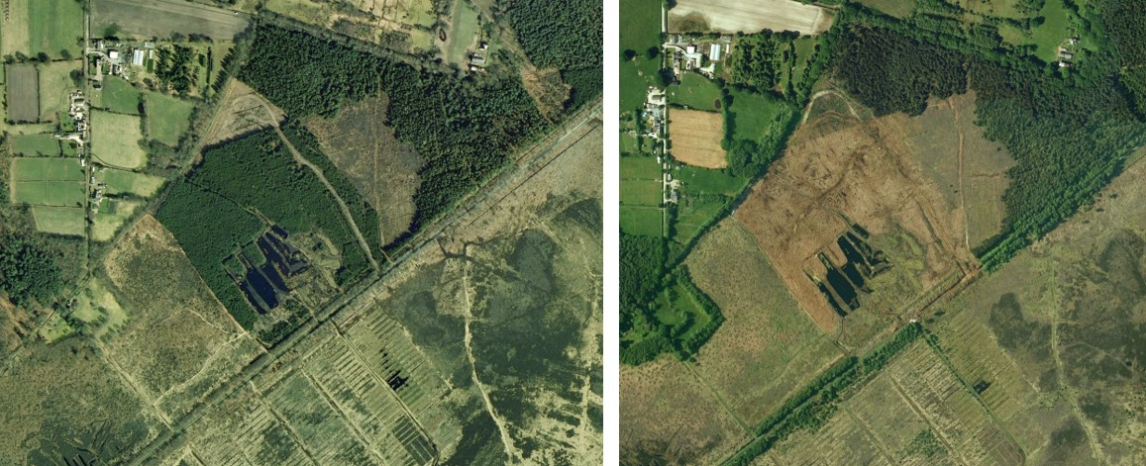

Fig 1. Satellite photographs (Google Earth) of the study sites in 2006 (left) and 2009 (right) showing plantation removal.

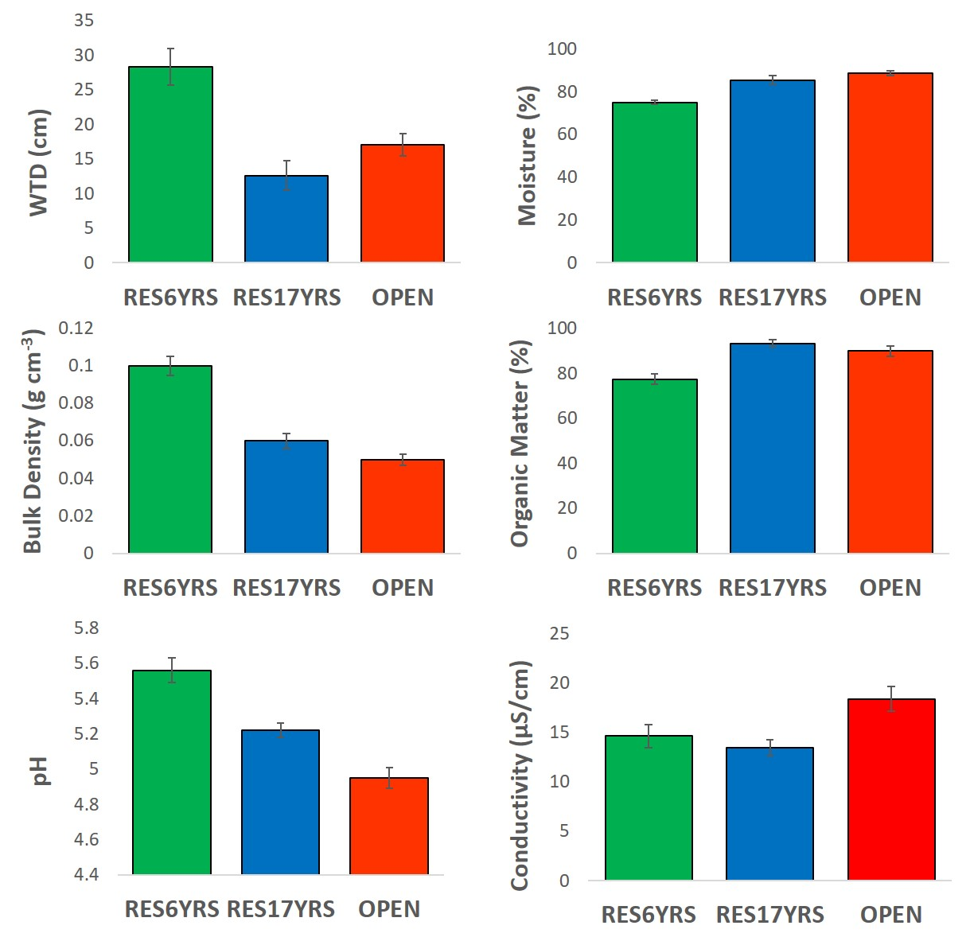

Fig 2. Environmental characteristics of the three study areas. Given are means and standard errors (SE).

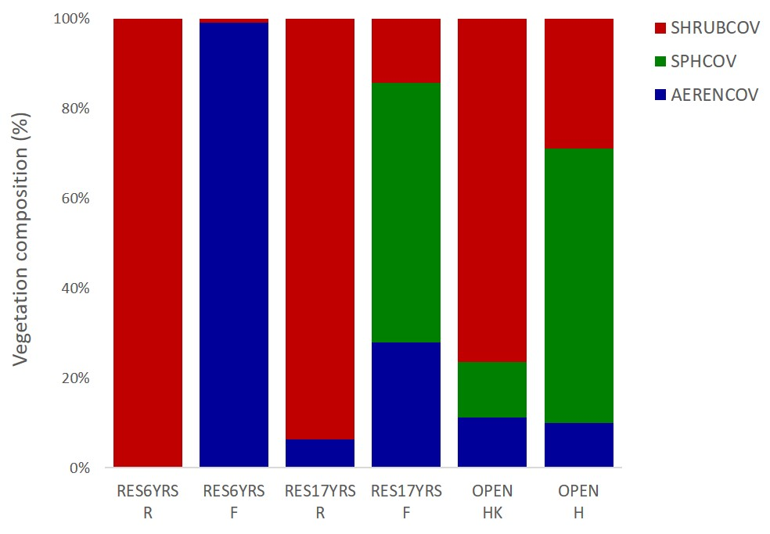

Fig 3. Relative proportion (%) of plant groups (shrubs, *Sphagnum* mosses and aerenchymas plants) from ridges (R) and furrows (F) in restoration areas (RES6YRS and RES17YRS) and hummocks (HK) and hollows (H) in the OPEN reference areas.

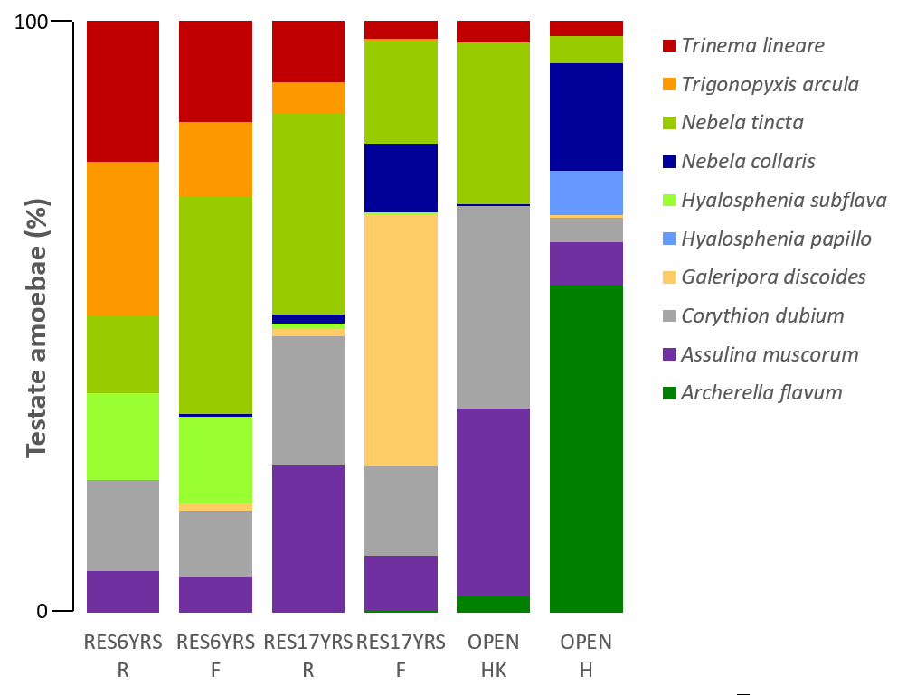

Fig 4. Relative proportion (%) of Testate amoebae assemblages determined in samples from ridges (R) and furrows (F) in restoration areas and hummocks (HK) and hollows (H) at the OPEN study areas. Mixotrophic taxa included are *Archerella flavum* and *Hyalosphenia papilio*.

Fig 5. Principal Components Analysis on full testate amoeba dataset showing the effect of restoration age and microtopography on testate amoeba assemblages. Dominant taxa are displayed.

Figs 6 a and b. RDA biplots of Hellinger transformed (a) testate and (b) vegetation to address the hypothesis whether TA and vegetation respond similarly to the same edaphic and environmental drivers.

**Fig 7**. Variation partitioning Venn diagram showing the percentages of individual contributions of vegetation cover (AERENCOV, SPHCOV and SHRUBCOV) and abiotic (WTD and Temperature) and edaphic (BD, OM, pH, EC, moisture) factors to testate amoeba assemblages.

|  |  |  |
| --- | --- | --- |
| **Table 1.** Indicator species identified in the three study areas (RES6YRS, RES17YRS and OPEN) showing taxa with Indval > 0.30 (except for *H. elegans* and *H. papilio*), significant at p < 0.01. | | |
| **RES6YRS** | **RES17YRS** | **OPEN** |
| *Trigonopyxis arcula* (0.87) | *Galeripora discoide*s (0.62) | *Archerella flavum* (0.53) |
| *Hyalosphenia subflava* (0.76) | *Euglypha compressa* (0.45) | *Hyalosphenia elegans* (0.18) |
| *Trinema lineare* (0.70) | *Cryptodifflugia oviformis* (0.43) | *Hyalosphenia papilio* (0.18) |
| *Nebela militaris* (0.57) | *Euglypha strigosa* (0.38) |  |
| *Euglypha tuberculata* type (0.53) | *Assulina seminulum* (0.32) |  |
| *Euglypha rotunda/laevis* (0.41) |  |  |