The time-course of fixations in representational paintings: a cross-cultural study.

Tobiasz Trawiński¹, Chuanli Zang^{2, 3}, Simon P. Liversedge³, Yao Ge², & Nick Donnelly¹

¹ Department of Psychology, Liverpool Hope University, United Kingdom
² Key Research Base of Humanities and Social Sciences of the Ministry of Education, Faculty of Psychology, Tianjin Normal University, Tianjin, China

³ School of Psychology and Computer Science, University of Central Lancashire, United Kingdom

Contact details:
Tobiasz Trawiński
Liverpool Hope University,
Hope Park, Liverpool L16 9JD,
United Kingdom
trawint@hope.ac.uk

Abstract
British and Chinese participants viewed a set of Western representational paintings (henceforth paintings) for later identification in a yes/no discrimination task. Eye movements were recorded while participants viewed the paintings with each painting split into face, theme of the painting and its context regions of interest (ROIs). British participants performed the discrimination task more accurately than Chinese participants. Eye movement data were first analyzed to confirm reliable individual differences in the proportion of fixations made to ROIs, and second, for evidence of a cross-cultural influence in focus on ROIs over the time-course of viewing. The results confirmed that individual differences in the proportion of fixations made to ROIs were reliable across a subset of paintings for both British and Chinese. In the context of the present study, this finding was a precondition to explore the time-course of fixations across ROIs. With respect to the time-course of fixations across ROIs, Chinese participants focused more on the theme, and less on faces (and vice-versa for British participants), in a period starting around 2 seconds after the onset of viewing. Earlier in viewing there was evidence that Chinese participants had an increased focus on the context. The results (1) extend the findings reported by Trawiński et al. (2021) on the impact of the Other Race Effect on the viewing of paintings; (2) show the time course associated with a more general cross-cultural influence on scene perception (Masuda & Nisbett, 2001).

Keywords: cross-cultural differences, eye-movements, other race effect, viewing of paintings

The time-course of fixations to faces, theme and context in representational paintings: a cross-cultural study.
Previous studies have explored whether an individual’s cultural background influences how they view scenes (Ji et al., 2000; Kitayama et al., 2003; Ko et al., 2011; Masuda, Gonzalez, et al., 2008; Mickley Steinmetz et al., 2018; Miyamoto et al., 2006; Yang et al., 2013). The dominant hypothesis that has been tested is that individuals from collectivist cultures (e.g., Japanese or Chinese observers) attend more to the context of a scene than do those from more individualistic cultures (e.g., American or British observers). The first studies that explored this hypothesis asked participants from collectivist and individualistic culture to encode animals presented as the focal object in the context of a scene (Masuda & Nisbett, 2001; Nisbett & Masuda, 2003). Participants were then asked to discriminate those animals from foils (i.e., animals not shown in the encoding phase). The critical manipulation in these experiments was that the background context on which the animals were presented was either the same or different across encoding and discrimination phases. Discrimination accuracy for participants drawn from collectivist culture was reduced more by changes to the background context than were those from individualistic culture.
Other studies have tested the same hypothesis of a cultural difference in the viewing of scenes by the recording of eye movements. For example, Chua et al. (2005) recorded eye movements from European, American and Chinese participants as they rated their liking of scenes. Chua et al. reported that European and American participants fixated the focal objects presented in these scenes sooner and for longer than did Chinese participants. In addition, they reported that Chinese participants made more, and shorter fixations to the background than did European and American participants. Chua et al. suggested that their results showed participants from individualistic cultures prioritize attention to focal objects, and pay less attention to the background context, than do those from collectivist cultures.
Trawiński et al. (2021) have recently reported a different cross-cultural influence on the viewing of scenes. Trawiński et al., recorded eye movements as Chinese and British participants encoded Western and East Asian representational paintings (henceforth paintings) for recall in a yes/no discrimination task. The manipulation of participant culture and painting tradition in Trawiński et al.’s study allowed them to explore the influence of a match (or mismatch) between a participant’s culture (i.e., British versus Chinese) and the tradition from which a painting was drawn (i.e., Western versus East Asian) on fixations made to the paintings.
Trawiński et al. (2021) were particularly interested in the fixations made to faces (see also Di Dio et al., 2020; Massaro et al., 2012; Savazzi et al., 2014; Trawiński et al., 2019). Studies in the face perception literature have shown that a mismatch in race between participant and the stimulus being viewed can markedly affect face processing and recognition – a finding known as the Other Race Effect (ORE; in eye movements: Blais et al., 2008; Fu et al., 2012; Goldinger et al., 2009; in role of the social context in recognition of face expression: Ko et al., 2011; Masuda, Ellsworth, et al., 2008; in recognition of face identity: Meissner & Brigham, 2001). The specific question explored by Trawiński et al. was whether the ORE influenced the eye movements made to faces and to those made elsewhere in the paintings? Their findings showed that a mismatch between the race of a participant and the tradition of a stimulus resulted in faces being looked at less (as measured by total fixation duration) than when there was a match between participant race and painting tradition (see also Goldinger et al., 2009). Moreover, a mismatch between participant culture and painting tradition was associated with increased fixations to the area around faces relative to when there was a match. Their findings, therefore, are consistent with the hypothesis that differences in the ease of face processing influence eye movements to paintings.
Although they showed significant differences in processing time, Trawiński et al., did not explore the time course and nature of processing faces and the areas beyond faces. The effort to encode paintings into memory does not necessarily require faces to be fixated first. Nevertheless, faces are known to attract attention (Fletcher-Watson et al., 2008; Langton et al., 2008) and Trawiński et al. suggested that the increased fixations to the areas beyond faces that occurred when viewing paintings from a different tradition may have been a response to difficulty experienced when encoding faces. Trawiński et al.’s logic was that difficulty in encoding faces might lead participants to scan elsewhere in the paintings for information helpful to discrimination. If this interpretation that difficulty encoding other race faces leads to more fixations being made beyond faces is correct, then in the present experiment, we should again see this cross-cultural influence affect patterns of fixations to faces and the areas beyond faces reported by Trawiński et al. Moreover, we should expect to see increased fixations to areas beyond faces occurring soon after faces in a picture are first fixated. Trawiński et al. did not investigate this second question and answering it is central to the present study.
To test the hypothesis that there is a cross-cultural influence on the time-course of visual encoding of paintings, paintings must first be split into at least two regions of interest (ROIs): faces and areas beyond faces. Paintings can be split into regions of theme and context (e.g., Locher et al., 1996, 2015; Nodine et al., 1993). The theme defines content that is central to the narrative of the painting (Locher et al., 2007). In Western paintings the theme is typically painted around the center of the painting (Arnheim, 1982; Berlyne, 1971; Gombrich, 1992). The context, in contrast, locates the theme in a specific setting but is not open to change while not affecting the theme. The context is generally more peripheral to the center of the painting than the theme. The area beyond faces was, therefore, sub-divided into areas of theme and context in the present study. This approach allowed for fixations made during the encoding of paintings to be classified as falling within face, theme, or context ROIs. Faces are reasonably easy to define as an ROI but the area beyond faces is more complex. While precise definition of the spatial boundary between theme and context in any painting may be open to question, in practice there is strong agreement between art experts of what areas constitute theme and context (Arnheim, 1982; Gombrich, 1992). Here we follow the same procedure as used in Trawiński et al., (2021; see also Trawiński et al., 2019 for similar approaches) which was underpinned by seeking agreement across experts for the paintings shown in that study. The present study, therefore, tested whether viewing paintings from a different tradition increases probability of fixating areas beyond faces, once the initial fixations to faces have been made. We do so by exploring eye movements to the face, theme and context ROIs of Western paintings by British and Chinese participants. Critically, we test the hypothesis that participant groups will differ in their time-course of fixations to ROIs.
In the present study, participants were shown the same set of Western paintings as used by Trawiński et al., (2021). While able to discriminate targets from foils reasonably accurately, Chinese participants performed less accurately than British participants. Here, we explore if discrimination accuracy for Chinese participants might be improved by making the narrative of the paintings explicit. As such, participants viewed paintings either in randomized sequences (random condition) or organized into five groups based on motif categories (blocked condition) or blocked and presented with the name of each motif prior to painting exposition (named condition).
Method
Participants
Participants were 45 Chinese (21 males and 24 females; M = 22.13, SD = 2.35) and 39 British (5 males and 34 females; M = 19.72, SD = 2.20) undergraduate students from Tianjin Normal University (PRC) and University of Southampton (UK), respectively. An opportunity sample was recruited through an online system advertising the studies. The Chinese participants were born and completed their pre-university education in China. The British participants were born and completed their pre-university education in the UK. Participants received course credits or, in the case of the Chinese participants, payment (£12) to compensate for their time.
The groups of Chinese and British participants were each pseudo-randomly allocated to one of three conditions: random (13 British and 15 Chinese participants), blocked (13 British and 15 Chinese participants) and named (13 British and 15 Chinese participants). The sample size within each subgroup was determined a priori based on that used by Trawiński et al. (2021). If it transpires that presentation condition has no influence on task accuracy, then these subgroups can be safely collapsed in the knowledge that there is unlikely to be a differential influence of the learning of motifs across British and Chinese participants. If this condition is satisfied, and the groups collapsed over presentation order, then the sample size will be three times larger than that used in Trawiński et al. (2021).
All participants reported having little knowledge of art. To confirm this self-report, participants completed a test of art knowledge. The questionnaire was translated to English and Chinese from the original German version of an art knowledge questionnaire (Jakesch & Leder, 2009; Trawiński et al., 2021). The questionnaire focused on knowledge about Western art. As expected, British participants had a higher score on the art knowledge questionnaire than Chinese participants (t(81) = 6.00, p <.001, d = 1.32). However, the level of art knowledge was rather low in both groups (Chinese: M = 2.98 [out of 48]; SD = 2.65; Mdn = 2; range = 0 - 16; British: M = 7.42; SD = 4.05; Mdn = 7; range = 1 - 18). The participants were, therefore, classified as naïve to art.
A potential risk in interpreting the results of cross-cultural perceptual/attentional studies is a failure to match groups on basic perceptual and cognitive attributes. To guard against this risk, we asked participant to complete a standard battery of visual-cognitive measures and compared the groups on these measures (see the Procedure section for details in relation to the collection of these data). British and Chinese participant groups were matched on executive attention and attentional orienting (as measured in the Attention Network Task (ANT), t(81) = -1.69, p = .094, d = -0.37; t(81) = -0.39, p = .697, d = -0.09, respectively: see Table 1), inhibitory attention (as indexed by saccadic latency in an anti-saccade task where fixations are held at a centrally presented arrow for either 1s or 3s before making a saccadic eye movement in the opposite direction to the visual cue, t(81) = -1.77, p = .081, d = -0.39; t(81) = -1.61, p = .111, d = -0.35; 1s and 3s delayed conditions, respectively) and verbal working memory (as measured in the n-back task, t(81) = 1.03, p = .304, d = .23). British participants had higher alerting attention scores on the ANT than Chinese participants (t(81) = -2.29, p = .025, d = -0.50). In contrast, Chinese participants had a higher capacity on visuospatial working memory task (as measured in the n-back task), both forward and backward version of digit span test, and performed better on the mental rotation task (t(81) = 3.03, p = .003, d = .67: t(81) = 9.05, p < .001, d = 1.99; t(81) = 8.35, p < .001, d = 1.84; t(81) = 2.21, p = .030, d = 0.49; respectively). We return to consider the potential impact of the group difference on visuospatial working memory, digit span, and mental rotation tasks in the Results and Discussion sections.

Table 1
The results of the battery of cognitive tests used to estimate the individual differences between British and Chinese participants.
 | Chinese |  |  | British
 | M | SD |  | M | SD
N-Back: Spatial | 63.44 | 13.74 |  | 52.53 | 18.96
N-Back: Verbal | 65.29 | 14.61 |  | 61.18 | 21.37
Mental Rotation | .92 | .05 |  | .90 | .05
Digits Span: Forward | 9.43 | 1.32 |  | 6.82 | 1.30
Digits Span: Backward | 8.68 | 1.35 |  | 6.23 | 1.31
ANT: EXEC | 68.27 | 23.13 |  | 80.00 | 39.15
ANT: ORIENT | 33.85 | 22.95 |  | 36.92 | 43.46
ANT: ALERT | 19.21 | 22.62 |  | 33.18 | 32.78
A-S: Saccade Latency [1s] | 63.60 | 15.96 |  | 71.25 | 25.65
A-S: Saccade Latency [3s] | 70.59 | 25.58 |  | 81.62 | 36.58
Note. ANT = Attention Network Test; EXEC = executive; ORIENT = orienting; ALERT = alerting; A-S = Anti-Saccade task.
Apparatus
Stimuli were presented on a View-Sonic graphics Series G225f CRT monitor with screen size 40 cm x 30 cm in a darkened room. Participants were seated at a distance of 70 cm giving a visual angle of 30.11° by 23.75 ° for the screen. Screen resolution was 1024 x 768 with a refresh rate of 120 Hz. Viewing was binocular, though only the movements of the right eye were recorded using an SR Research Limited Eye-Link 1000 eye tracker operating at 1000Hz. Head movement was stabilized using a chin and headrest. Participants terminated each presentation by pressing one button on a five-button response box.
Stimuli
The set of 150 high-resolution images of Western paintings used in Trawiński et al. (2021) were used. Paintings were drawn from five motif categories: Three Graces, Judith, Bathers, Odalisque, and Venus. Motifs can be thought of as any visual category. Paintings within each motif category share similar semantic and structural features (Panofsky, 1987, p. 40 - 41). In the present study, we used paintings drawn from five motif categories. The set of paintings used in the present study consisted of paintings taken from five motifs categories: Three Graces, Judith, Bathers, Odalisque, and Venus. For example, paintings representing the mythological motif of Venus show the nude woman across a variety of contexts that differ in place and time (for example, Botticelli, The Birth of Venus, 1486; Cranach the Elder, Cupid Complaining to Venus, 1525; Titian, Venus of Urbino, 1534).
Thirty paintings were gathered, in total, for each of the five motif categories (see Appendix A). All signatures and descriptions were removed using Adobe Photoshop CS6. The height varied between 7.81 and 27.09 cm on the screen resulting in visual angles between 6.35° and 21.79°. Widths varied between 11.38 and 20.32 cm, that is, visual angles from 16.17° to 28.48°. Paintings were always presented centrally on the screen against a grey background.
Three ROIs were defined in each painting. Specifically, each painting was split into face, theme, and context ROIs. Faces ROIs are reasonably simple to define. Face ROIs were defined irrespective of their position within the painting. The theme ROI was defined as the area of the painting critical to the motif (minus the area covered by face(s) that sit within the region of the motif). The area of a painting beyond the theme (minus any areas covered by a face(s)) was defined as the context. The definitions for the regions of theme and context in each painting were agreed by two art experts familiar with the motifs of Western art. The face, theme and context ROIs covered, on average, 3%, 55%, and 42% of the area of paintings (Figure 1A).
The face and theme ROIs were operationalised as the smallest possible rectangle including the whole face or theme. Rectangular ROIs provide a pragmatic solution to a complex problem of analysing eye movements across multiple images. With respect to faces, eye movements within the rectangle will be heavily influenced by the position of the eyes. With respect to themes, the rectangular ROI was a simple instantiation of the agreement between experts about painting’s motif. It is important to note that the consensus across experts is not subject to change by a difference in the interpretation of an individual mark on the canvas. ROIs were defined manually. In sum, the ROIs were defined as in Trawiński et al. (2021).

Figure 1. A Cupid complaining to Venus (Lucas Cranach the Elder, 1526-7).

Note. A In this example, the motif is Venus and so the theme ROI includes her alone (dashed line). The face (solid line) and context (remaining area of the painting) ROIs are also shown. B, C the heat maps illustrate the location and duration (from shorter in green through to longer in red) of fixations made by grouped Chinese (B) and British (C) participants. Copyright by Bridgeman Images. Reproduced with permission.

Design and Procedure
The experiment had five stages and all participants completed all stages. In the first stage, participants completed the art knowledge questionnaire. In the second stage (encoding session), participants were asked to try to memorise each of one hundred paintings (for recall in a later discrimination session). The second stage began with participants completing a nine-point calibration procedure for accurate eye movement recording. The eye tracker was calibrated to less than 0.5⁰ error. Once calibration was complete, the presentation of paintings began.
The presentation of each painting was preceded by a fixation cross presented central to the screen. Once this point was fixated, a grey screen (randomized condition), or block number (blocked condition), or motif name (named condition) was presented for 1000 ms. The paintings were presented in random order within each motif category in the blocked and named condition, but block order was fixed. In contrast, paintings presentation was fully randomized in the randomized condition. Each painting was presented individually and remained on the screen until participants made a key press on a response box to indicate that they had finished viewing. The inter-trial interval was set to 500 ms.
During the third stage participants performed an Anti-Saccade Task (Hepsomali et al., 2017). After either a short (1 second) or long (3 seconds) delay, participants had to supress a saccade to a peripheral stimulus (prosaccade condition), or generate a saccade to the mirror position (antisaccade condition), depending on the identity of a visual cue shown at the centre of the screen. Here we used the saccade latency in the antisaccade condition for correct responses, as a measure of attentional control (Reinholdt-Dunne et al., 2012). The task was run with a delay of 1 or 3 seconds to give increased uncertainty as to the time point when the eye movement was required. This approach allows for a measure of inhibitory control under easy and difficult conditions respectively.
In the fourth stage (the discrimination session), participants were shown 100 paintings and asked to discriminate paintings shown at encoding (50% of trials) from foils (50% of trials). The 100 paintings included twenty paintings from each motif category of which ten had been shown during the encoding phase. All participants saw the same set of paintings during the discrimination session. Responses were made by pressing one of two buttons on a response box. Eye movements were recorded, and participants’ eye movements were re-calibrated at the beginning of the session.
In the fifth stage, participants completed the remaining battery of visual-cognitive measures: N-Back Task (Shackman et al., 2006), Digit Span Test (Conway et al., 2005), Attention Network Task (ANT; Fan et al., 2002), and Mental Rotation Test (Cooper & Shepard, 1973). Together these tests measure visuospatial and verbal working memory, attentional orienting, alerting, and executive components, and mental imagery.

Results
The results are structured to consider four issues. First, the impact of the three encoding conditions on discrimination was explored. Hit rate was calculated from correct positive identifications in the discrimination task of paintings shown during the encoding phase. The false alarm rate was calculated by dividing correct rejections by the number of foil paintings and subtracted this figure from one. Together the hit and false alarm rate were then analysed using Signal Detection Theory (Macmillan & Creelman, 2004) to create measures of sensitivity (ď) and bias (c).
In this initial set of analyses, we also explored the consistency of eye movement data to ROIs across trials. The goal of both analyses was to determine whether either sensitivity and bias, or individual differences in the pattern of visual inspection, were influenced by presentation condition. Second, we sought to replicate the findings of Trawiński et al. (2021). In particular, the existence of both an ORE and increased fixations to the theme and context when participants viewed paintings from a different tradition. Third, we sought evidence in support of the hypothesis that the raised probability of fixations to the theme and context occur after fixations are made to faces for Chinese relative to British participants. Finally, we explored whether individual differences in fixations to faces were associated with any of the set of basic visual-cognitive factors used to assess the comparability of participant groups.
Data analyses were conducted in R version 3.5.0 (Team R Core, 2016). Eye movement data were fitted in Linear Mixed-effects Models (LMMs) using the lmer4-package (Bates et al., 2014) and MASS-package (Venables & Ripley, 2002). The random effects were structured for items and participants including slopes for meaningful fixed effects and correlations. The full random structure was trimmed down for those models that did not converge or had a correlation equal to zero or one. The t-values equal to 1.96 or higher were interpreted as significant because the t-statistic in LMMs approximates the z-statistic for high degrees of freedom (Baayen et al., 2008).
Discrimination Accuracy
Sensitivity and bias data were analyzed in two between-subjects ANOVAs with the factors of Condition (3: random versus blocked versus named) and Culture (2: Chinese versus British). With respect to sensitivity, the main effect of Culture was significant with sensitivity being higher for British than Chinese participants (F(1,79) = 24.65, p < 0.001, η_{p}² = 0.238, Figure 2). Neither the main effect of Condition, nor the interaction between Condition and Culture reached significance (Fs < 1.02). With respect to bias, no main effects, nor the interaction reached significance (Fs < 1.67). While Culture influenced sensitivity, the different encoding conditions did not influence either sensitivity or bias. We conclude that there is no evidence that presentation condition influenced sensitivity or bias. Consequently, all the remaining analyses were collapsed over encoding condition.

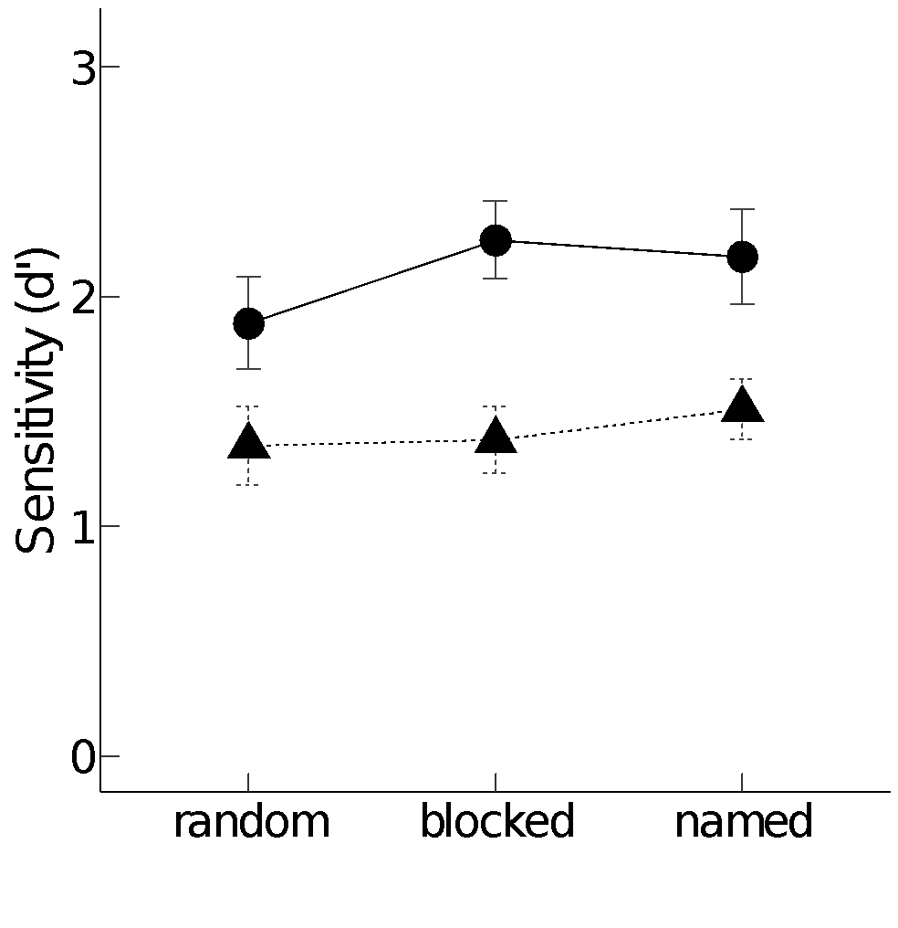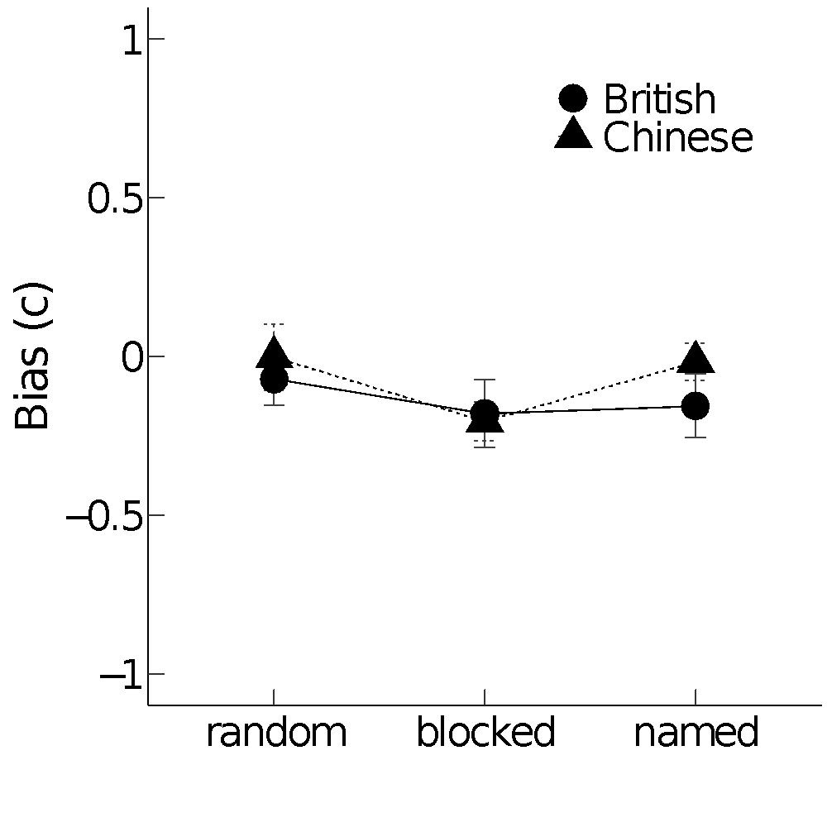
Figure 2. Mean (SE) sensitivity and bias as a function of Condition, and Culture group.

Eye Movements
Outliers and exclusion. The data from one participant were removed due to errors in the eye movement reports. Fixations shorter than 60 ms or longer than 1200 ms were removed. Fixations that coincided with the display onset or the response were also removed. This led to 4% of the data being excluded. The final data set consisted of 334846 fixations in the encoding session.
Consistency in individual differences in total time spent fixating ROIs. Two indices of reliability across the dataset were examined (de Haas et al., 2019). First, the internal consistency of the proportion of total fixation duration made to each ROI by participants was calculated using a permutation-based split-half approach with 5000 random splits across all trials (Parsons, 2021). The bootstrapped split-half correlations for proportion of viewing time of each ROI were high for both British and Chinese participants (estimated r(splits)’s >.83; see Figure 3).
The correlation between odd and even trials for the proportion of total fixation duration made to each ROI was also calculated. The analyses revealed highly reliable (p’s <.001) individual differences in the split of fixation durations across context, face, and theme ROI by British (r = .692; .795; .782; respectively) and Chinese participants (r = .783; .881; .812; respectively) across odd and even trials. The reliability of the proportion of the total fixation duration associated with each ROI suggests general performance and the proportion of overall time spent processing each ROI were unlikely to be affected by the order in which paintings were presented to participants.

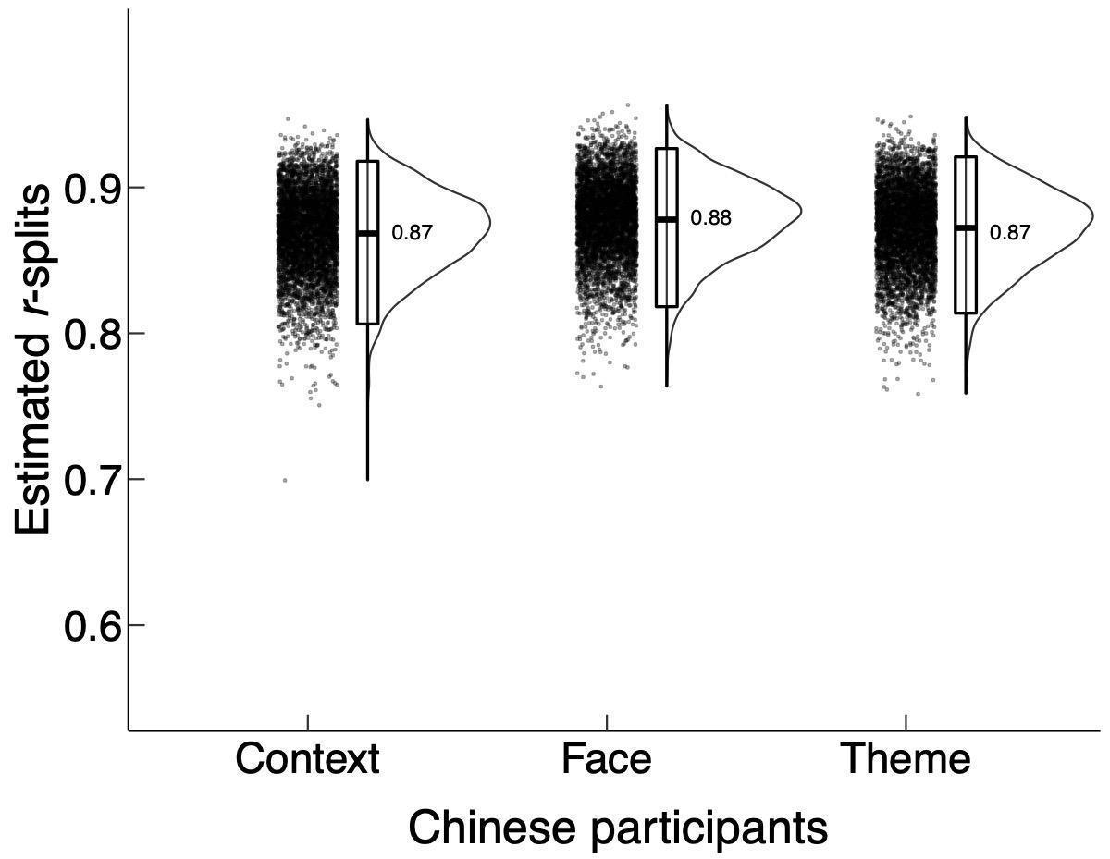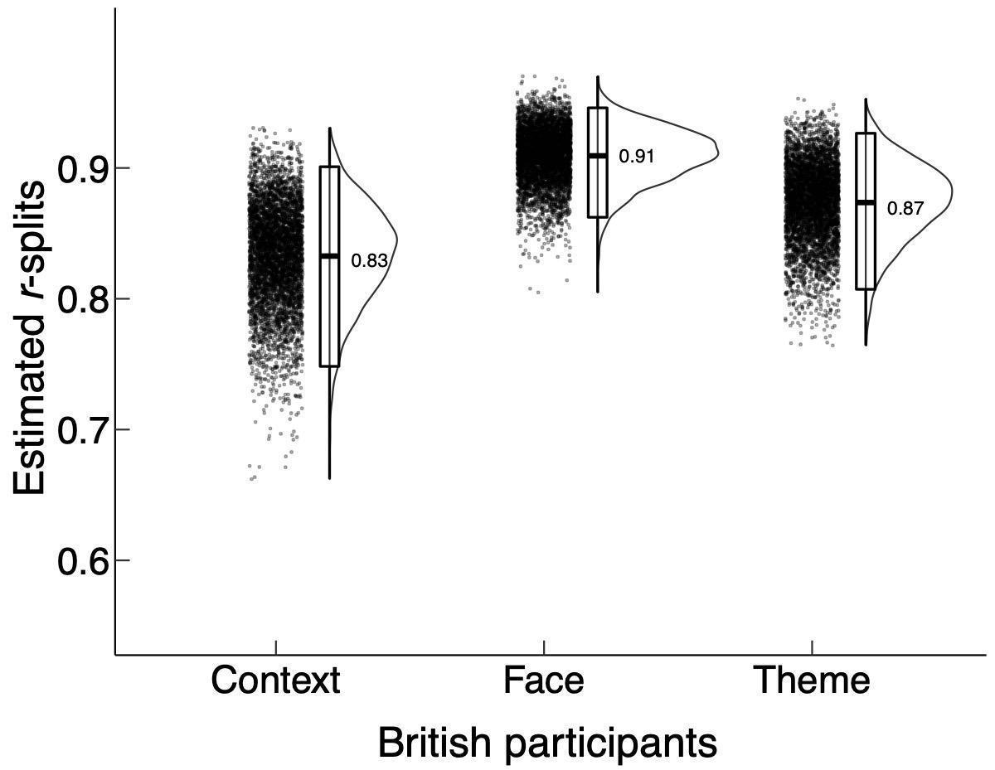
Figure 3. The bootstrapped split-half correlations for proportion of viewing time of each ROI as a function of participants’ cultural background.

Fixations to ROIs. We now turn to explore whether the current data confirm the influence of culture on eye movements to ROIs reported by Trawiński et al. (2021). Eye movement data recorded during the encoding session were analysed with respect to two fixed factors: Culture (2: Chinese versus British) and ROI (3: context versus theme versus face). The reference levels were Chinese for Culture, context for ROI. Analyses of eye movement data were conducted for the number of fixations, mean fixation duration, and total fixation duration (the sum of all fixation durations in each ROI). To control for differences in the spatial extent of regions across stimuli, the number of fixations was normalised by dividing the number of fixations made within a ROI by the number of pixels within it. The full LMM results are presented in the Table 2.
The analyses show that Chinese participants made fewer fixations to faces, but more to the context and the theme, than did British participants. Chinese participants made longer fixations to each ROI than did British participants but especially so for faces. The overall effect of the differences in number and duration of fixation leads to a net effect on viewing time. Specifically, Chinese participants looked longer than British participants at the context and theme but there was no difference in the extent of looking at faces (Figure 4).
While specific details of the results of the present study differ from those reported in Trawiński et al (2021), the overall effect on total fixation durations to ROIs were similar: Chinese participants looked longer at the context and theme than did British participants but there was no difference in total fixation duration to faces. As a proportion of their overall viewing times, Chinese participants looked less at faces than British participants (see Figure 1B and C).
Table 2
Fixed effect estimates from the Linear Mixed Models for log-transformed normalized number of fixations, log-transformed mean fixation durations, and log-transformed total fixation duration on type of ROIs and Culture at encoding session.
 | Number of fixations |  |  | Mean fixation duration |  |  |  | Total fixation duration
Predictors | b | SE | t |  | b | SE | t |  | b | SE | t
Intercept | -11.00 | 0.08 | -145.67 |  | 5.54 | 0.02 | 291.64 |  | 6.88 | 0.07 | 99.79
ROI[context vs faces] | 3.02 | 0.02 | 188.51 |  | 0.13 | 0.01 | 21.47 |  | 0.35 | 0.02 | 18.79
ROI[context vs theme] | 1.23 | 0.02 | 77.42 |  | 0.09 | 0.01 | 14.75 |  | 1.52 | 0.02 | 81.34
Culture | -0.08 | 0.10 | -0.79 |  | -0.03 | 0.03 | -1.09 |  | -0.09 | 0.10 | -0.94
ROI[context vs faces]: Culture | 0.18 | 0.02 | 7.61 |  | -0.02 | 0.01 | -2.34 |  | 0.14 | 0.03 | 5.22
ROI[context vs theme]: Culture | 0.09 | 0.02 | 4.01 |  | -0.02 | 0.01 | -2.51 |  | 0.06 | 0.03 | 2.05
Note. Significant results are in bold.

Figure 4. Mean (SE) number of fixations, mean fixation duration, and total fixation duration as a function of ROI and of participants’ cultural background in the encoding session.

Time-course of cultural differences. We now explore the time-course of the probability of making fixations to each ROI (context, face, and theme) over the first four seconds of encoding. Eye movement data were aggregated across all participants in order to calculate the probability of fixating the face in each of sixteen 250 ms time bins (Dink & Ferguson, 2015).
The time course of the influence of culture on fixations to specific ROIs was explored using growth curve analysis (Figure 5). The curves are shown separately for each ROI. A series of the t-tests was performed at each 250 ms time bin. Relative to British participants, Chinese participants showed evidence of an increased probability of fixating the context and theme relatively early in viewing (below 1500 ms). In contrast, relative to Chinese participants, British participants showed evidence of increased fixations to the theme and faces somewhat later in viewing (1750 ms - 2750 ms.).
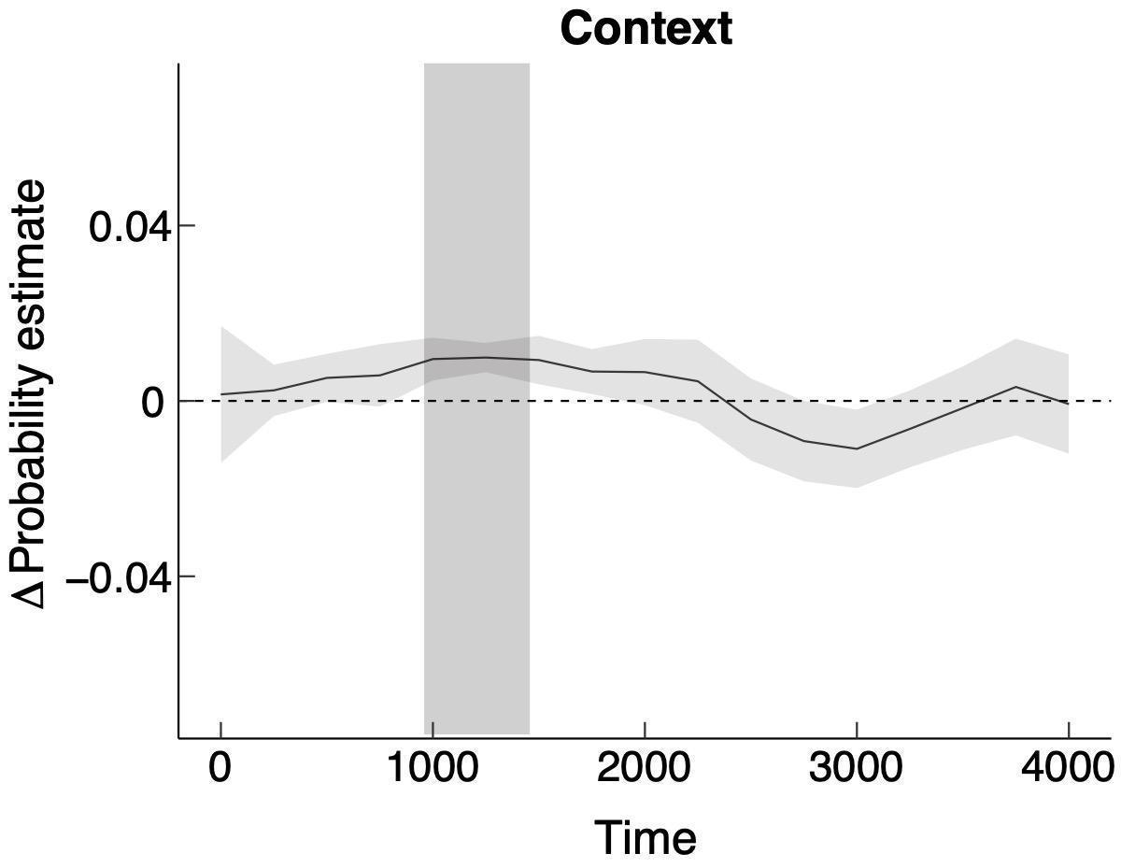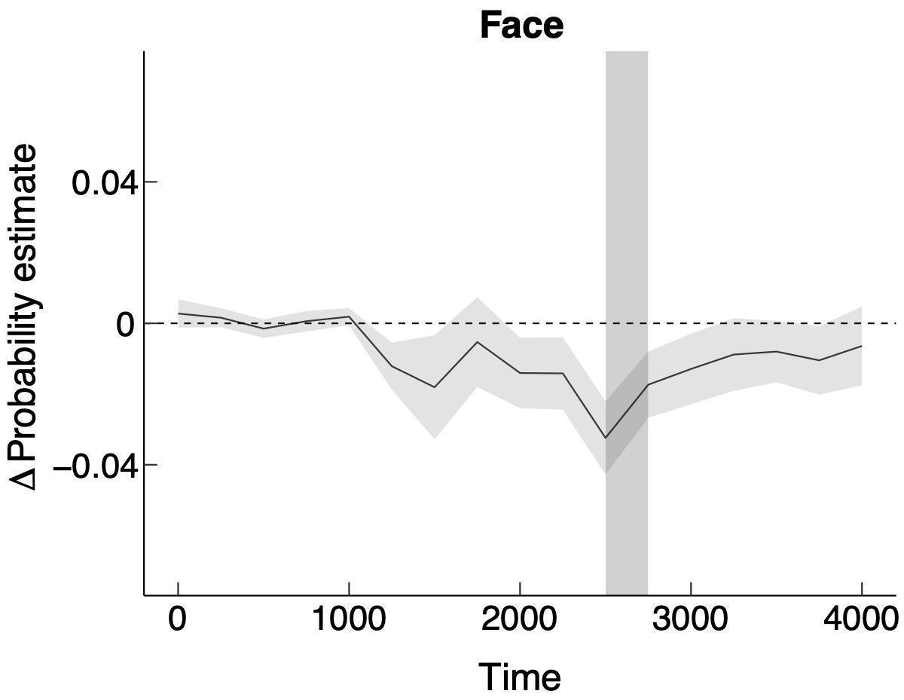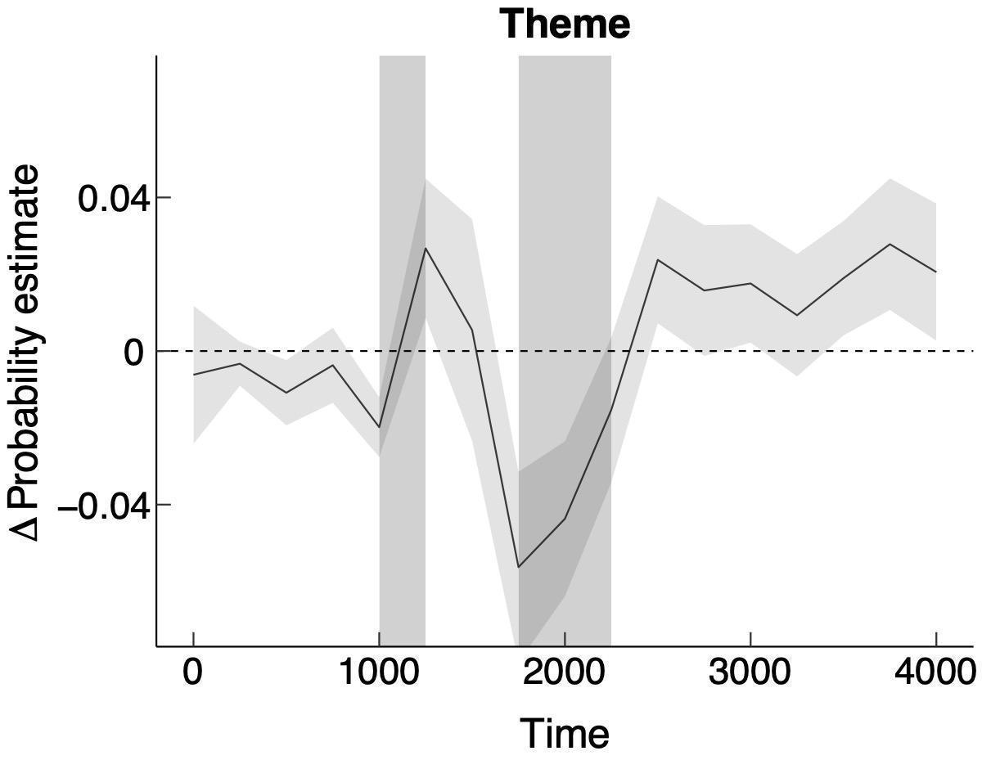
Note. Shaded vertical area indicates significantly different time bins.

Figure 5. ∆ Probability estimate functions (SE) for fixating paintings context, face, and theme during the first four seconds of encoding. The ∆ probability estimate was indexed by the difference between Chinese and British participants in fixating context, face, and theme. Positive scores indicate higher probability of looking to the specific ROIs by Chinese relative to British participants, while negative scores indicate higher probability of looking by British relative to Chinese participants.

Individual differences in the proportion fixations to faces. Finally, we now turn to explore whether individual differences in fixations to faces were associated with any of the set of basic visuo-cognitive tests taken to establish the comparability of the participant groups. The motivation for these analyses follows from de Haas et al.’s (2019) exploration of the hypothesis that individual differences in fixation to faces may be associated with set of cognitive (indexed as the performance on the Cambridge Face Memory Test; CFMT) and personality factors (including Big Five, Sensation Seeking, and High Sensitivity). De Haas et al. found evidence of an association between first fixations to faces and performance on the CFMT in a free-viewing scene perception task. We did not measure performance on the CFMT, but we did take multiple other measures that may reflect processes used in the encoding of paintings into memory. While exploratory, it is possible that individual differences in visual-cognitive abilities may influence the proportion of time spent viewing faces in paintings. In particular, we were interested in exploring the role of attentional orienting in determining fixations to faces given that Trawinski et al. (2019) had shown it leading to increased fixations to salient features in the context of paintings. If so, then attentional orienting may be negatively associated with fixations to faces. We provide the full set of correlations for the basket of visual-cognitive tests measures and the proportion of total fixations focused on faces for sake of completeness.
To explore potential associations between performance on visual-cognitive tests and the proportion of time fixating faces, we conducted a set of pairwise correlations for British and Chinese participants, separately and applying family-wise error correction for multiple comparison (see Table 3, Figure 6). The results confirm that orienting is more strongly associated with proportion of total fixations to faces in British than Chinese participants. Other significant findings were between total fixations to faces and mental rotation for British participants, and a negative correlation between proportion of total fixations to faces and Art Knowledge for Chinese participants.

Table 3

Correlations (with 95% confidence interval) between proportion of total fixations to faces and cognitive tests for Chinees and British participants (above and below diagonal, respectively).

Variable | 1 | 2 | 3 | 4 | 5 | 6 | 7 | 8 | 9 | 10 | 11 | 12
1. P-TFD |  | .17  [-.19, .48] | .18  [-.18, .49] | .01  [-.34, .35] | -.39*  [-.65, -.06] | .08  [-.27, .41] | .22  [-.13, .53] | -.43*  [-.67, -.10] | -.31  [-.59, .04] | -.16  [-.48, .20] | -.12  [-.44, .24] | .07  [-.28, .41]
2. Art Knowledge | -.30* |  | .15 | .16 | -.22 | -.03 | .02 | .09 | -.13 | .16 | -.24 | -.23
 | [-.55, -.00] |  | [-.21, .47] | [-.20, .47] | [-.52, .13] | [-.37, .32] | [-.33, .36] | [-.26, .42] | [-.45, .23] | [-.19, .48] | [-.54, .11] | [-.53, .12]
3. 3-Back: Spatial | -.15 | .07 |  | .80** | -.12 | .12 | .35* | -.19 | -.19 | .18 | -.32 | -.14
 | [-.43, .16] | [-.23, .36] |  | [.63, .90] | [-.45, .23] | [-.23, .45] | [.01, .62] | [-.50, .17] | [-.50, .17] | [-.18, .49] | [-.60, .02] | [-.46, .21]
4. 3-Back: Verbal | -.07 | .00 | .70** |  | -.16 | .15 | .34 | -.06 | -.10 | .26 | -.32 | -.28
 | [-.37, .23] | [-.30, .30] | [.51, .83] |  | [-.48, .20] | [-.20, .47] | [-.00, .61] | [-.40, .29] | [-.43, .25] | [-.10, .55] | [-.60, .03] | [-.57, .07]
5. Mental Rotation | .17 | .09 | -.15 | -.11 |  | -.21 | -.28 | .31 | .25 | -.03 | .28 | .19
 | [-.14, .45] | [-.21, .38] | [-.43, .16] | [-.39, .20] |  | [-.52, .14] | [-.57, .07] | [-.04, .59] | [-.10, .55] | [-.37, .31] | [-.07, .57] | [-.17, .50]
6. Digits Span: Forward | -.04 | .15 | -.11 | -.13 | -.36* |  | .67** | -.27 | -.08 | -.33 | -.14 | -.23
 | [-.34, .26] | [-.16, .43] | [-.39, .20] | [-.42, .17] | [-.60, -.07] |  | [.43, .82] | [-.56, .08] | [-.41, .27] | [-.61, .01] | [-.46, .22] | [-.53, .13]
7. Digits Span: Backward | .02 | .17 | .07 | .02 | -.16 | .50** |  | -.20 | -.21 | -.18 | -.26 | -.27
 | [-.28, .32] | [-.13, .45] | [-.23, .36] | [-.28, .32] | [-.44, .15] | [.23, .69] |  | [-.51, .15] | [-.52, .14] | [-.49, .18] | [-.55, .10] | [-.56, .08]
8. ANT: ORIENT | -.09 | -.07 | -.14 | -.28 | .07 | .14 | .17 |  | .21 | .28 | .27 | .11
 | [-.38, .21] | [-.36, .24] | [-.42, .17] | [-.53, .02] | [-.23, .37] | [-.16, .43] | [-.13, .45] |  | [-.14, .52] | [-.07, .57] | [-.08, .56] | [-.25, .43]
9. ANT: ALERT | -.13 | .03 | .04 | .01 | .00 | .00 | -.17 | .25 |  | .12 | .31 | .30
 | [-.41, .18] | [-.27, .33] | [-.26, .34] | [-.29, .31] | [-.30, .30] | [-.30, .30] | [-.44, .14] | [-.05, .51] |  | [-.23, .45] | [-.04, .59] | [-.05, .59]
10. ANT: EXEC | .15 | -.06 | .05 | .08 | .11 | -.13 | .00 | .00 | -.08 |  | .09 | .08
 | [-.16, .43] | [-.35, .25] | [-.26, .34] | [-.23, .37] | [-.20, .39] | [-.41, .18] | [-.30, .30] | [-.30, .30] | [-.37, .23] |  | [-.26, .42] | [-.27, .41]
11. A-S: Saccade Latency [1s] | -.15 | -.18 | .02 | .06 | -.02 | .03 | .22 | .15 | -.04 | -.03 |  | .73**
 | [-.43, .16] | [-.45, .13] | [-.28, .32] | [-.24, .36] | [-.32, .28] | [-.28, .33] | [-.09, .49] | [-.16, .43] | [-.34, .26] | [-.33, .27] |  | [.52, .86]
12. A-S: Saccade Latency [3s] | -.28 | -.12 | .03 | .07 | -.02 | .15 | .22 | .20 | .02 | .15 | .81**
 | [-.54, .02] | [-.40, .19] | [-.27, .33] | [-.23, .37] | [-.32, .28] | [-.16, .43] | [-.09, .49] | [-.11, .47] | [-.28, .32] | [-.15, .43] | [.67, .89]

Note. P-TFD = proportion of time fixating faces; ANT = Attention Network Test; EXEC = executive; ORIENT = orienting; ALERT = alerting; A-S = Anti-Saccade task. * indicates p < .05. ** indicates p < .01.

.

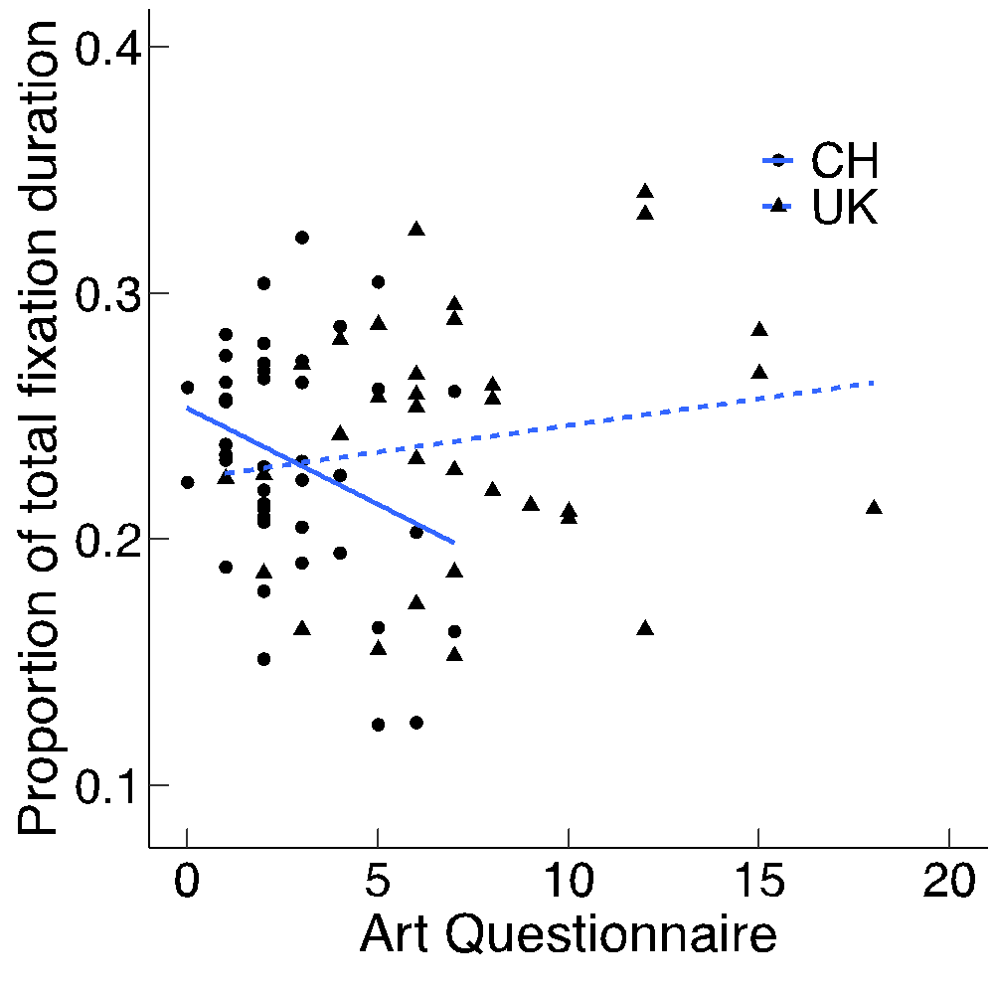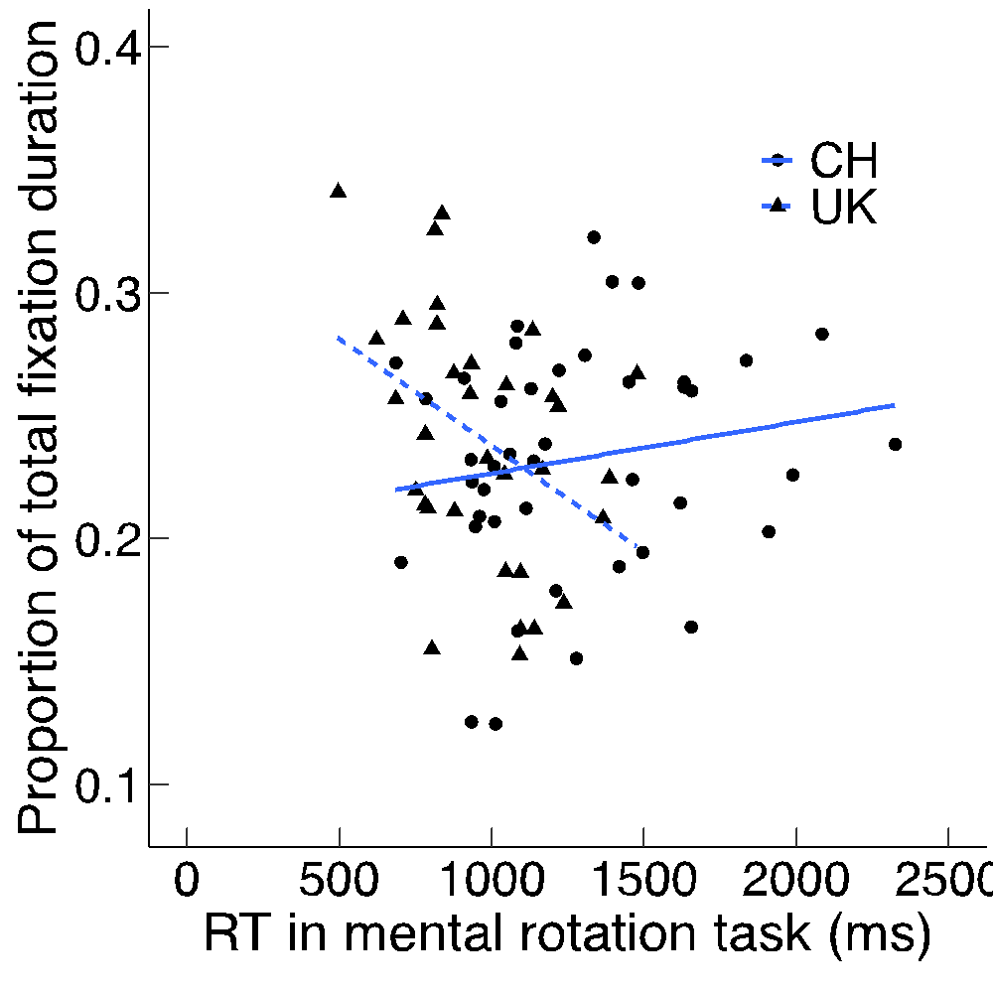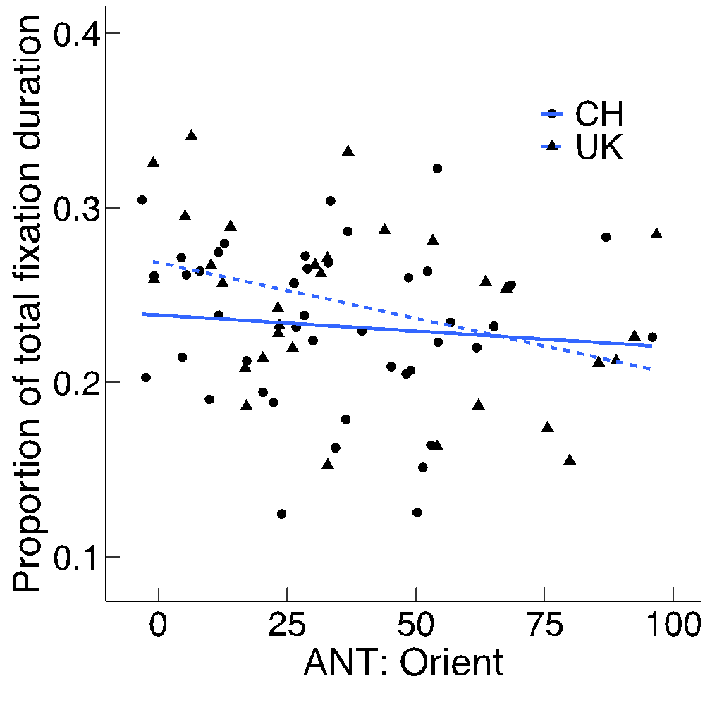

Figure 6. Scatter plots (with best fitting regression line) showing correlations between results of the art questionnaire, reaction time in mental rotation task, orienting function of attention (x-axis) and proportion of time fixating faces (y-axis) for Chinese [indexed by circle and solid line] and British [indexed by triangles and dashed line] participants.

Discussion
We hypothesized that Chinese participants would attend more to the theme and context ROIs than the face ROI in response to a difficulty encoding faces in Western paintings. The results of the study support the conclusion that Chinese participants do focus more on the theme and context than do British participants. However, while evidence of increased focus on the theme by Chinese participants tends to parallel (but be offset from) a reduced focus on faces, increased focus on the context precedes any evidence of reduced focus on faces. Crucially, there was no difference in the overall viewing time for the paintings across Chinese and British participants. In sum, the results are consistent with a cross-cultural influence on viewing across faces, theme and context ROIs when encoding paintings into memory.
The findings led us to revisit the data first published in Trawiński et al. (2021) in order to perform the growth curve analysis on the comparable data originally presented in that paper (see Figure 7). The data are noisier than those reported in the present study, but this is to be expected given that the sample size was much smaller (30 versus 84 respectively). Nevertheless, the findings of the growth curve analyses are remarkably consistent across the two studies. When viewing paintings to encode them into memory, Chinese participants attend more to the context early in viewing than do British participants. Around 2 seconds into viewing, British participants begin to attend more to faces than do Chinese participants. Around 2.5 seconds into viewing, Chinese participants attend more to the theme than British participants. More generally, the shape of the curves in the three graphs are quite similar across the two experiments.
The definition of context and theme ROIs makes sense with respect to art theory (Arnheim, 1982; Berlyne, 1971; Gombrich, 1992), however, the participants in the present study were (largely) naïve to art. This point is important as considering theme and context as being discrete might obfuscate a simple account of the present results. Another way of describing the findings from the growth curve analyses is in terms of what both participant groups focus on over time. While eye fixations imply focus on specific spatial locations, the relative distribution of those spatial locations is consistent with the view that Chinese participants start with, and maintain, a broader focus of looking than the British participants. British participants tend to begin inspection by looking at the theme and progress their inspection towards focusing on faces. By comparison, Chinese participants begin by tending to focus on the picture context and progress their inspection in order to attend to the theme. In sum, the fixation data are consistent with an account whereby Chinese participants maintain a broader focus of attention than do British participants. It seems to us very likely that the adoption of a broad focus occurs to compensate for the relative paucity of information garnered when looking at faces. This suggestion is consistent with that put forward by Trawiński et al. (2021).

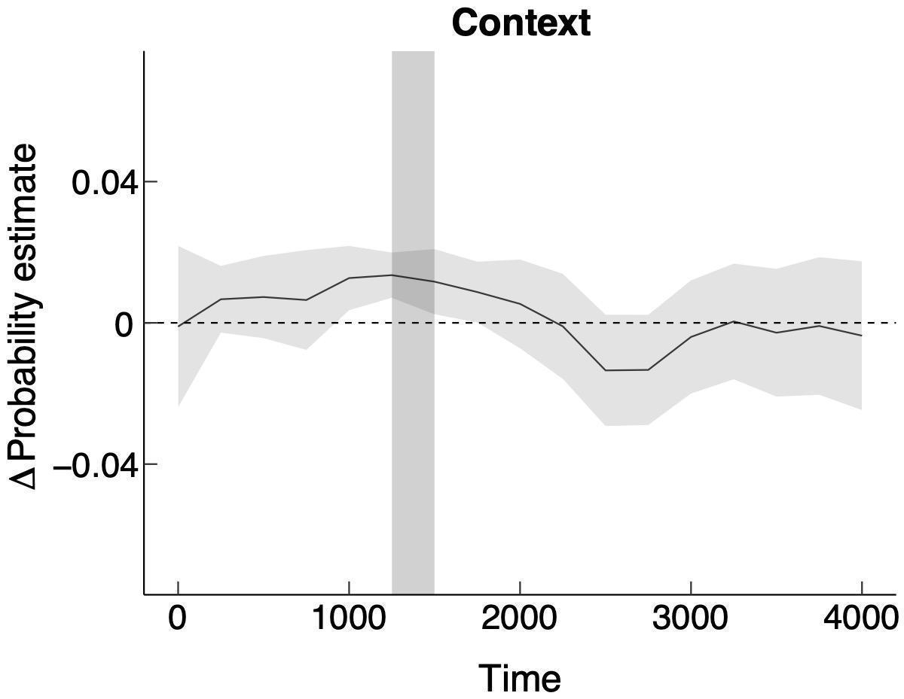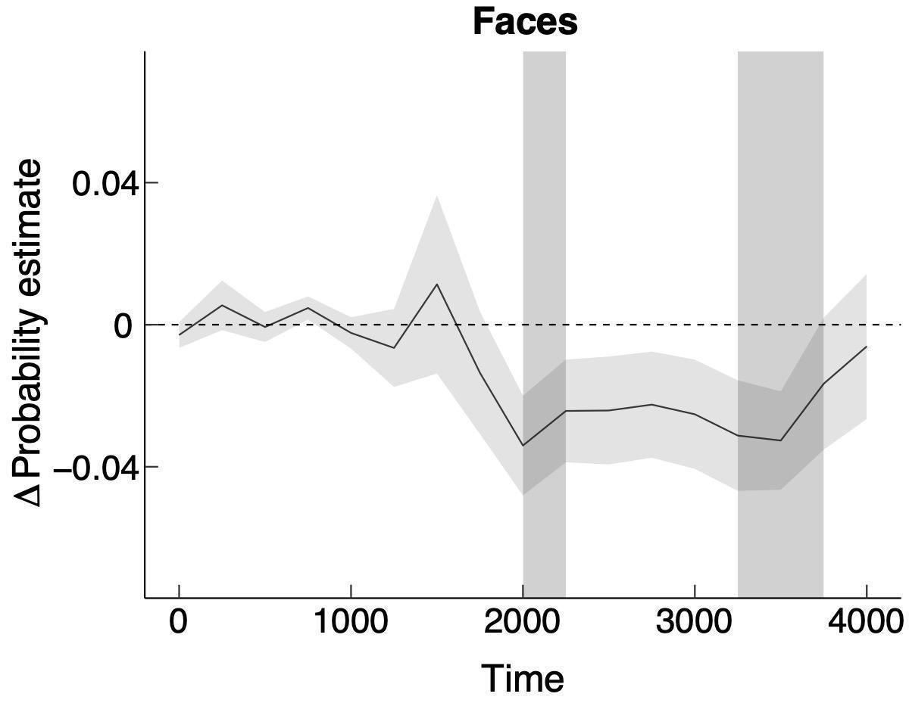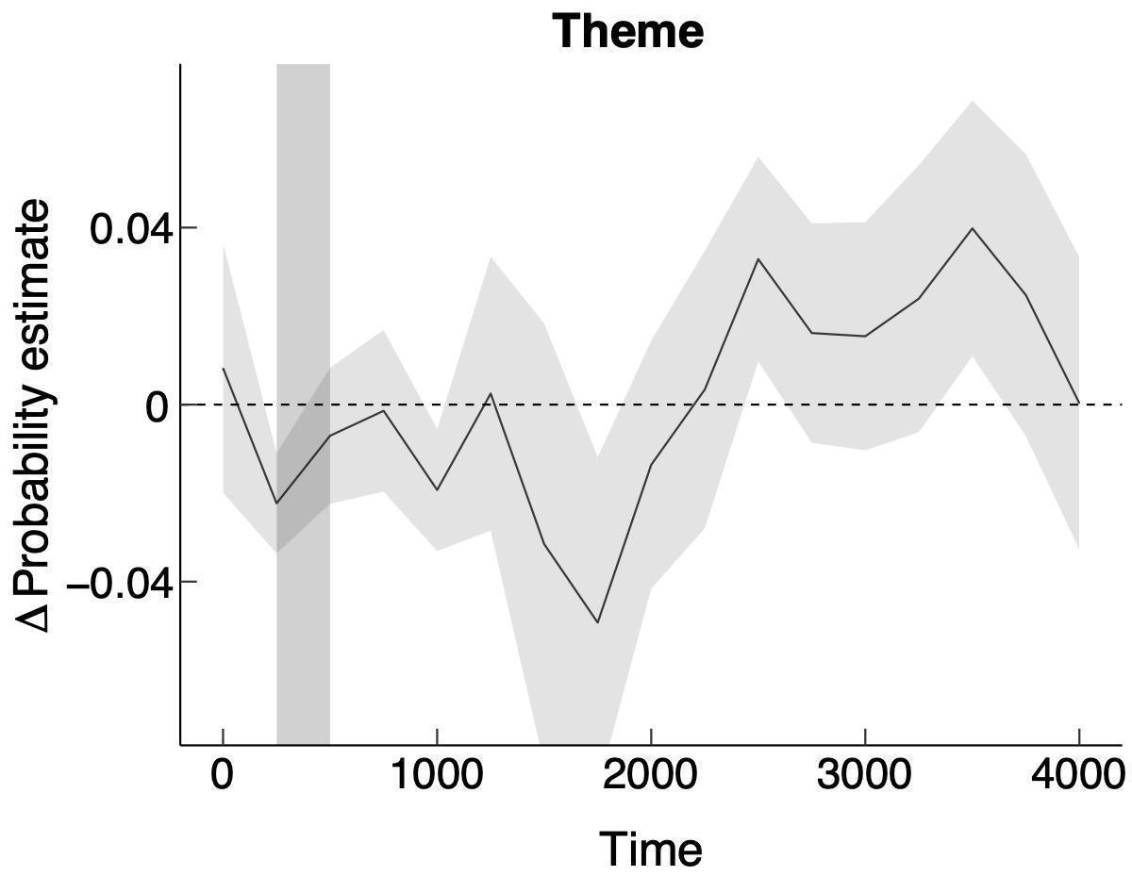
Note. Shaded vertical area indicates significantly different time bins.

Figure 7. ∆ Probability estimate functions (SE) for fixating painting context, face, and theme during the first four seconds of encoding Western paintings (source Trawiński et al., 2021). The ∆ probability estimate was indexed by the difference between Chinese and British participants in fixating context, face, and theme. Positive scores indicate higher probability of looking to the specific ROIs by Chinese relative to British participants, while negative scores indicate higher probability of looking by British relative to Chinese participants.
Given that the paintings form a diverse set of stimuli, it was important to first establish reliability in patterns of fixations to ROIs across individuals. This was done using techniques described by de Haas et al. (2019). De Haas et al. (2019) reported bootstrapped reliability for fixations to faces that were very high, and similar in magnitude to those we report in the present study. The present data provide independent confirmation of De Haas et al.’s findings with respect to the consistency of individual differences in the proportion of total viewing time spent in different ROIs.
We think this finding of consistency in the individual differences in looking to ROIs has theoretical importance quite apart from our primary concern with respect to a cultural influence on the viewing of Western paintings. While it is beyond the scope of this study, it is important for future studies to consider what underpins individual differences in the manner of visual inspection of scenes (Castelhano & Henderson, 2008; Hayes & Henderson, 2017; Henderson & Luke, 2014; Risko et al., 2012).
As we had gathered information from participants on a range of visual-cognitive tests (in order to ensure the comparability of the participants group), we were also able to explore whether these impacted on the proportion of total fixations to faces. While exploratory, the data show that, at least for British participants, increased attentional orienting tends to reduce total fixations to faces. This result is consistent with a finding previously reported by Trawiński et al. (2019). We hypothesize that the failure to find a similar result in the Chinese participants may be a function of them looking more to the context than British participants such that the subtle influence of attentional orienting on reducing fixations to faces is lost.
We do not wish to speculate too much about the other associations between the proportion of total fixations to faces and speeded mental rotation (for British participants) and art knowledge (for Chinese participants). It may be that the ability to mentally rotate the image is crucial for faces depicted on the paintings (which are unlikely to be presented in canonical position; Costa & Corazza, 2006; Graham et al., 2014; Schirillo, 2007) and that increased knowledge of Western art in Chinese participants is a proxy measure for greater familiarity with Western faces rather than reflecting a specific role for art knowledge. In support of this idea, there is some evidence that a lack of contact experience with individuals of other race is likely to increase the difficulty of encoding other race faces for later discrimination tasks (Allport, 1954; Chiroro & Valentine, 1995; Valentine et al., 2016; Williams, 1947), and may contribute to longer fixations made to other race faces (Goldinger et al., 2009).
Of more importance is to draw the limited conclusion that there is some evidence of fixations to faces being associated with different factors across British and Chinese participants. It may be that the spectatorship of paintings is subject to influence of broad individual differences which are not limited to level of art expertise (e.g., Francuz et al., 2018; Harland et al., 2014; Pihko et al., 2011). It is for future work to explore this issue more systematically.
It is possible that the broader focus of attention maintained by Chinese participants is contributed to by factors in addition to the other race effect. It may be that Chinese participants are attracted to the context because variants of objects typically represented in traditional Chinese art (e.g., trees, hills, or waterfall) may appear in the context of Western paintings. Moreover, it may be that Chinese participants found it difficult to understand the narrative of paintings from the theme and so looked for cues in the context.
Is it possible that these alternative factors that might influence fixations do so without reference to the influence of the ORE. It seems to us to be unlikely. The eye movement data with respect to fixations to faces reported in this study and reported by Trawiński et al. (2021; see also Goldinger et al., 2009 for similar findings in face memory task), are consistent with a cultural difference in the processing of faces. If the alternative factors we have outlined above do exert an influence on looking, they do so in addition to the existence of an ORE. In contrast, and while possible, there is no actual evidence to support the possibility that variants of objects typically represented in traditional Chinese art (e.g., trees, hills, or waterfall) appear in the context of Western paintings or that Chinese participants found it difficult to understand the narrative of paintings from the theme and so looked for cues in the context. Moreover, if these additional factors do exert an influence on looking then it must be a coincidence that it occurs just at the time when the growth-curve analysis shows Chinese participants to begin to look away from faces.
What we can say is that the results show culture influences the viewing of paintings being encoded into memory. Chinese participants maintained a broader focus of attention than British participants when viewing Western paintings, perhaps because of a difference in the value of information extracted from faces. En route to this finding, the present study also showed the existence of reliable individual differences in total time spent differentially processing faces, theme, and context for both British and Chinese participants.

References
Allport, G. W. (1954). The nature of prejudice. Addison-Wesley.
Arnheim, R. (1982). The power of the center: A study of composition in the visual arts. University of California Press.
Baayen, R. H., Davidson, D. J., & Bates, D. M. (2008). Mixed-effects modeling with crossed random effects for subjects and items. Journal of Memory and Language, 59(4), 390–412. https://doi.org/10.1016/j.jml.2007.12.005
Bates, D., Mächler, M., Bolker, B., & Walker, S. (2014). Fitting Linear Mixed-Effects Models using lme4. Journal of Statistical Software, 67(1), 1–48. https://doi.org/10.18637/jss.v067.i01
Berlyne, D. E. (1971). Aesthetics and Psychobiology. Appleton-Century-Crofts.
Blais, C., Jack, R. E., Scheepers, C., Fiset, D., & Caldara, R. (2008). Culture Shapes How We Look at Faces. PLoS ONE, 3(8), 1–8. https://doi.org/10.1371/journal.pone.0003022
Castelhano, M. S., & Henderson, J. M. (2008). Stable individual differences across images in human saccadic eye movements. Canadian Journal of Experimental Psychology/Revue Canadienne de Psychologie Expérimentale, 62(1), 1–14. https://doi.org/10.1037/1196-1961.62.1.1
Chiroro, P., & Valentine, T. (1995). An Investigation of the Contact Hypothesis of the Own-race Bias in Face Recognition. Quarterly Journal of Experimental Psychology, 48(4), 879–894.
Chua, H. F., Boland, J. E., & Nisbett, R. E. (2005). Cultural variation in eye movements during scene perception. Proceedings of the National Academy of Sciences of the United States of America, 102(35), 12629–12633. https://doi.org/10.1073/pnas.0506162102
Conway, A. R. A. , Kane, M. J. , Bunting, M. F. , Hambrick, D. Z. , Wilhelm, O. , & Engle, R. W. (2005). Working memory span tasks: A methodologicalreview and user’s guide. Psychonomic Bulletin & Review, 12(5), 769–786.
Cooper, L. A., & Shepard, R. N. (1973). The time required to prepare for a rotated stimulus. Memory & Cognition, 1(3), 246–250. https://doi.org/10.3758/BF03198104
Costa, M., & Corazza, L. (2006). Aesthetic phenomena as supernormal stimuli: The case of eye, lip, and lower-face size and roundness in artistic portraits. Perception, 35(2), 229–246. https://doi.org/10.1068/p3449
de Haas, B., Iakovidis, A. L., Schwarzkopf, D. S., & Gegenfurtner, K. R. (2019). Individual differences in visual salience vary along semantic dimensions. Proceedings of the National Academy of Sciences, 201820553. https://doi.org/10.1073/pnas.1820553116
Di Dio, C., Massaro, D., Savazzi, F. A., Gallese, V., Garau, T., Gilli, G., & Marchetti, A. (2020). Beauty in life: An eye-tracking study on young adults’ aesthetic evaluation and vitality judgment of pictorial representations of sleeping and dead subjects. PsyCh Journal, 9(4), 458–471. https://doi.org/10.1002/pchj.285
Dink, J. W., & Ferguson, B. (2015). EyetrackingR: An R library for eye-tracking data analysis. www.eyetracking-r.com
Evans, K., Rotello, C. M., Li, X., & Rayner, K. (2009). Scene perception and memory revealed by eye movements and receiver-operating characteristic analyses: Does a cultural difference truly exist? Quarterly Journal of Experimental Psychology, 62(2), 276–285. https://doi.org/10.1080/17470210802373720
Fan, J., Mccandliss, B. D., Sommer, T., Raz, A., & Posner, M. I. (2002). Testing the Efficiency and Independence of Attentional Networks. Journal of Cognitive Neuroscience, 14(3), 340–347. https://doi.org/10.1162/089892902317361886
Fletcher-Watson, S., Findlay, J. M., Leekam, S. R., & Benson, V. (2008). Rapid detection of person information in a naturalistic scene. Perception, 37(4), 571–583. https://doi.org/10.1068/p5705
Francuz, P., Zaniewski, I., Augustynowicz, P., Kopiś, N., & Jankowski, T. (2018). Eye Movement Correlates of Expertise in Visual Arts. Frontiers in Human Neuroscience, 12(87), 1–13. https://doi.org/10.3389/fnhum.2018.00087
Fu, G., Hu, C. S., Wang, Q., Quinn, P. C., & Lee, K. (2012). Adults scan own- and other-race faces differently. PLoS ONE, 7(6). https://doi.org/10.1371/journal.pone.0037688
Goldinger, S. D., He, Y., & Papesh, M. H. (2009). Deficits in Cross-Race Face Learning: Insights From Eye Movements and Pupillometry. Journal of Experimental Psychology: Learning Memory and Cognition, 35(5), 1105–1122. https://doi.org/10.1037/a0016548
Gombrich, E. (1992). Art and Illusion. A study in the psychology of pictorial representation. Phaidon Press Limited.
Graham, D., Pallett, P. M., Meng, M., & Leder, H. (2014). Representation and Aesthetics of the Human Face in Portraiture. Art and Perception, 2(1–2), 75–98. https://doi.org/10.1163/22134913-00002026
Harland, B., Gillett, J., Mann, C. M., Kass, J., Godwin, H. J., Liversedge, S. P., & Donnelly, N. (2014). Modes of Address in Pictorial Art: An Eye Movement Study of Manet’s Bar at the Folies-Bergère. Leonardo, 47(3), 241–247. https://doi.org/10.1162/LEON_a_00676
Hayes, T. R., & Henderson, J. M. (2017). Scan patterns during real-world scene viewing predict individual differences in cognitive capacity. Journal of Vision, 17(5), 23. https://doi.org/10.1167/17.5.23
Henderson, J. M., & Luke, S. G. (2014). Stable individual differences in saccadic eye movements during reading, pseudoreading, scene viewing, and scene search. Journal of Experimental Psychology: Human Perception and Performance, 40(4), 1390–1400. https://doi.org/10.1037/a0036330
Hepsomali, P., Hadwin, J. A., Liversedge, S. P., & Garner, M. (2017). Pupillometric and saccadic measures of affective and executive processing in anxiety. Biological Psychology, 127, 173–179. https://doi.org/10.1016/j.biopsycho.2017.05.013
Jakesch, M., & Leder, H. (2009). Finding meaning in art: Preferred levels of ambiguity in art appreciation. Quarterly Journal of Experimental Psychology, 62(11), 2105–2112. https://doi.org/10.1080/17470210903038974
Ji, L. J., Peng, K., & Nisbett, R. E. (2000). Culture, control, and perception of relationships in the environment. Journal of Personality and Social Psychology, 78(5), 943–955. https://doi.org/10.1037/0022-3514.78.5.943
Kitayama, S., Duffy, S., Kawamura, T., & Larsen, J. T. (2003). Perceiving and object and its context in different cultures: A Culture Look at New Look. Psychological Science, 14(3), 201–206. https://doi.org/10.1111/1467-9280.02432
Ko, S. G., Lee, T. H., Yoon, H. Y., Kwon, J. H., & Mather, M. (2011). How Does Context Affect Assessments of Facial Emotion? The Role of Culture and Age. Psychology and Aging, 26(1), 48–59. https://doi.org/10.1037/a0020222
Langton, S. R. H., Law, A. S., Burton, A. M., & Schweinberger, S. R. (2008). Attention capture by faces. Cognition, 107(1), 330–342. https://doi.org/10.1016/j.cognition.2007.07.012
Locher, P., Gray, S., & Nodine, C. (1996). The structural framework of pictorial balance. Perception, 25(12), 1419–1436. https://doi.org/10.1068/p251419
Locher, P., Krupinski, E. a, Mello-Thoms, C., & Nodine, C. F. (2007). Visual interest in pictorial art during an aesthetic experience. Spatial Vision, 21(1–2), 55–77. https://doi.org/10.1163/156856807782753868
Locher, P., Krupinski, E., & Schaefer, A. (2015). Art and authenticity: Behavioral and eye-movement analyses. Psychology of Aesthetics, Creativity, and the Arts, 9(4), 356–367. https://doi.org/10.1037/aca0000026
Macmillan, N. A., & Creelman, C. D. (2004). Detection theory: A user’s guide (2nd ed.). NJ: Erlbaum.
Massaro, D., Savazzi, F., Di Dio, C., Freedberg, D., Gallese, V., Gilli, G., & Marchetti, A. (2012). When art moves the eyes: A behavioral and eye-tracking study. PLoS ONE, 7(5), 1–16. https://doi.org/10.1371/journal.pone.0037285
Masuda, T., Ellsworth, P. C., Mesquita, B., Leu, J., Tanida, S., & Van de Veerdonk, E. (2008). Placing the Face in Context: Cultural Differences in the Perception of Facial Emotion. Journal of Personality and Social Psychology, 94(3), 365–381. https://doi.org/10.1037/0022-3514.94.3.365
Masuda, T., Gonzalez, R., Kwan, L., & Nisbett, R. E. (2008). Culture and aesthetic preference: Comparing the attention to context of East Asians and Americans. Personality and Social Psychology Bulletin, 34(9), 1260–1275. https://doi.org/10.1177/0146167208320555
Masuda, T., & Nisbett, R. E. (2001). Attending holistically vs. Analytically: Comparing the context sensibility of Japanese and American. Journal of Personality and Social Psychology, 81(5), 922–934. https://doi.org/10.1037//0022-35I4.81.5.922
Meissner, C. A., & Brigham, J. C. (2001). Thirty Years of Investigating the Own-Race Bias in Memory for Faces: A Meta-Analytic Review. Psychology, Public Policy, and Law, 7(1), 3–35. https://doi.org/10.1037/1076-8971.7.1.3
Mickley Steinmetz, K. R., Sturkie, C. M., Rochester, N. M., Liu, X., & Gutchess, A. H. (2018). Cross-cultural differences in item and background memory: Examining the influence of emotional intensity and scene congruency. Memory, 26(6), 751–758. https://doi.org/10.1080/09658211.2017.1406119
Miyamoto, Y., Nisbett, R. E., & Masuda, T. (2006). Culture and the Physical Environment. Psychological Science, 17(2), 113–119. https://doi.org/10.1111/j.1467-9280.2006.01673.x
Nisbett, R. E., & Masuda, T. (2003). Culture and point of view. Proceedings of the National Academy of Sciences, 100(19), 11163–11170. https://doi.org/10.1073/pnas.1934527100
Nodine, C. F., Locher, P., & Krupinski, E. A. (1993). The Role of Formal Art Training on Perception and Aesthetic Judgment of Art Compositions. Leonardo, 26(3), 219–227. https://doi.org/10.2307/1575815
Panofsky, E. (1987). Meaning in Visual Art. Penguin Books.
Parsons, S. (2021). splithalf: Robust estimates of split half reliability. Journal of Open Source Software, 6(60), 3041. https://doi.org/10.21105/joss.03041
Pihko, E., Virtanen, A., Saarinen, V.-M., Pannasch, S., Hirvenkari, L., Tossavainen, T., Haapala, A., & Hari, R. (2011). Experiencing Art: The Influence of Expertise and Painting Abstraction Level. Frontiers in Human Neuroscience, 5(94), 1–10. https://doi.org/10.3389/fnhum.2011.00094
Rayner, K., Li, X., Williams, C. C., Cave, K. R., & Well, A. D. (2007). Eye movements during information processing tasks: Individual differences and cultural effects. Vision Research, 47(21), 2714–2726. https://doi.org/10.1016/j.visres.2007.05.007
Reinholdt-Dunne, M. L., Mogg, K., Benson, V., Bradley, B. P., Hardin, M. G., Liversedge, S. P., Pine, D. S., & Ernst, M. (2012). Anxiety and selective attention to angry faces: An antisaccade study. Journal of Cognitive Psychology, 24(1), 54–65. https://doi.org/10.1080/20445911.2011.560111
Risko, E. F., Anderson, N. C., Lanthier, S., & Kingstone, A. (2012). Curious eyes: Individual differences in personality predict eye movement behavior in scene-viewing. Cognition, 122(1), 86–90. https://doi.org/10.1016/j.cognition.2011.08.014
Savazzi, F., Massaro, D., Dio, C. D., Gallese, V., Gilli, G., & Marchetti, A. (2014). Exploring Responses to Art in Adolescence: A Behavioral and Eye-Tracking Study. PLoS ONE, 9(7), 1–12. https://doi.org/10.1371/journal.pone.0102888
Schirillo, J. A. (2007). Gender’s effect on the hemispheric laterality of Rembrandt’s portraits. Spatial Vision, 21(1–2), 19–26. https://doi.org/10.1163/156856808782713753
Shackman, A. J., Sarinopoulos, I., Maxwell, J. S., Pizzagalli, D. A., Lavric, A., & Davidson, R. J. (2006). Anxiety selectively disrupts visuospatial working memory. Emotion, 6(1), 40–61. https://doi.org/10.1037/1528-3542.6.1.40
Stanley, J. T., Zhang, X., Fung, H. H., & Isaacowitz, D. M. (2013). Cultural differences in gaze and emotion recognition: Americans contrast more than chinese. Emotion, 13(1), 36–46. https://doi.org/10.1037/a0029209
Team R Core. (2016). R: A Language and Environment for Statistical Computing. R Foundation for Statistical Computing.
Trawinski, T., Mestry, N., Harland, B., Liversedge, S., Godwin, H., & Donnelly, N. (2019). The Spectatorship of Portraits by Naïve Beholders. Psychology of Aesthetics, Creativity, and the Arts.
Trawiński, T., Zang, C., Liversedge, S. P., Ge, Y., Fu, Y., & Donnelly, N. (2021). The influence of culture on the viewing of Western and East Asian paintings Psychology of Aesthetics, Creativity, and the Arts. https://doi.org/10.1037/aca0000411
Valentine, T., Lewis, M. B., & Hills, P. J. (2016). Face-space: A unifying concept in face recognition research. Quarterly Journal of Experimental Psychology, 69(10), 1996–2019. https://doi.org/10.1080/17470218.2014.990392
Venables, W. N., & Ripley, B. D. (2002). Modern Applied Statistics with S. Fourth Edition. Springer.
Williams, R. M., Jr. (1947). The reduction of intergroup tensions: A survey of research on problems of ethnic, racial, and religious group relations. Social Science Research Council Bulletin, 57.
Yang, L., Li, J., Spaniol, J., Hasher, L., Wilkinson, A. J., Yu, J., & Niu, Y. (2013). Aging, Culture, and Memory for Socially Meaningful Item-Context Associations: An East-West Cross-Cultural Comparison Study. PLoS ONE, 8(4), 1–7. https://doi.org/10.1371/journal.pone.0060703

Appendix A: List of Western paintings used at Encoding and Discrimination session collapsed by authors and motifs.

Author | Title | Year |  |  | Motif
Encoding Session
Baldung Grien, Hans | The Three Graces | c. 1540 |  |  | 1
Canova, Antonio | The Three Graces Dancing | c. 1799 |  |  | 1
Cranach, Lucas the Elder | The Three Graces | 1535 |  |  | 1
Furini, Francesco | The Three Graces | c. 1633 |  |  | 1
Rubens, Peter Paul | The Three Graces | 1639 |  |  | 1
Rafaello Sanzio | The Three Graces | 1504 |  |  | 1
Rubens, Peter Paul | Nature Adoring the Three Graces | c. 1615 |  |  | 1
Botticelli, Sandro | Primavera | c. 1482 |  |  | 1
Tintoretto | Mercury and the Graces | c. 1576 |  |  | 1
Bronkhorst, Jan Gerritsz | The Three Graces | c. 1645 |  |  | 1
Moser, Koloman | The Three Graces | 1905 |  |  | 1
Carle van Loo | The Three Graces | 1763 |  |  | 1
Mathews, Arthur Frank | Song of the Sea (Three Graces) | c. 1909 |  |  | 1
Dali, Salvador | Enchanted Beach With Three Fluid Graces | 1938 |  |  | 1
Delaunay, Robert | La Ville de Paris | 1912 |  |  | 1
Scalbert, Jules | The Three Graces dancing with Faun | c. 1877 |  |  | 1
Janco, Marcel | The Three Women in Malta | 1930 |  |  | 1
Fragonard, Jean_Honore | The Three Graces | 1756 |  |  | 1
Etty, Wiliam | Venus and Her Satellites | 1835 |  |  | 1
Picasso, Pablo | Three woman | 1908 |  |  | 1
Botticelli, Sandro | Judith Leaving the Tent of Holofernes | c. 1495 |  |  | 2
Cairo, Francesco del | Judith with Head of Holofernes | c. 1645 |  |  | 2
Catena, Vincenzo | Judith | 1520 |  |  | 2
Elsheimer, Adam | Judith Beheading Holofernes | 1601 |  |  | 2
Gentileschi, Artemisia | Judith and Her Maidservant | c. 1614 |  |  | 2
Allori, Cristofano | Judith with Head of Holofernes | 1613 |  |  | 2
Giorgione | Judith | c.1504 |  |  | 2
Riedel, August | Judith | 1840 |  |  | 2
Rubens, Peter Paul | Judith with Head of Holofernes | c.1616 |  |  | 2
Tintoretto | Judith and Holofernes | c.1579 |  |  | 2
Tiziano | Judith | c. 1515 |  |  | 2
Klimt, Gustav | Judith I | 1901 |  |  | 2
Valentin de Boulogne | Judith | c. 1626 |  |  | 2
Corot, Jean_Baptiste-Camille | Judith | c. 1872 |  |  | 2
Moser, Koloman | Judith and Holofernes | 1916 |  |  | 2
Mellin, Charles | Judith with Head of Holofernes | 1630 |  |  | 2
Piazzetta, Giovanni Battista | Judith and Holofernes | c. 1745 |  |  | 2
Cranach, Lucas the Elder | Judith Victorious over Holofernes | c. 1520 |  |  | 2
Carrachi, Agostino | Juditt | c.1590 |  |  | 2
Stuck, Franz | Judith | 1928 |  |  | 2
Renoir, Pierre-Auguste | Large Bathers | c. 1884 |  |  | 3
Seurant, Georges | Bathers at Asnieres | c. 1883 |  |  | 3
Bazille, Jean-Frederic | Bathers (summer Scene) | 1869 |  |  | 3
Vernet, Claude-Joseph | Landscape with Bathers | 1783 |  |  | 3
Cezanne, Paul | Bathers Beneath a Bridge | c. 1895 |  |  | 3
Coubert, Gustave | The Bathers | 1853 |  |  | 3
Gaugini, Paul | The Baters | 1897 |  |  | 3
Fragonard, Jean-Honore | The Baters | c. 1772 |  |  | 3
Carracci | Landscape with Bathers | 1616 |  |  | 3
Cezanne, Paul | The Large Bathers | c. 1900 |  |  | 3
Kirchner, Ernst Ludwig | Bathers at Mortizburg | c. 1909 |  |  | 3
Cezanne, Paul | Bathers | c. 1872 |  |  | 3
Cezanne, Paul | Bathers | c. 1890 |  |  | 3
Andre Derain | Bathers | 1907 |  |  | 3
Picasso, Pablo | Bathers with Toy Boat | 1937 |  |  | 3
Picasso, Pablo | Bathers | 1918 |  |  | 3
Picasso, Pablo | Les Demoiselles d’Avignon | 1907 |  |  | 3
Walker, Frederick | The Bathers | c. 1866 |  |  | 3
Matisse, Henri | Joy of Life | c. 1905 |  |  | 3
Matisse, Henri | Bathers with turtle | 1908 |  |  | 3
Leighton, Frederic | Odalisque | 1862 |  |  | 4
Boucher, Francois | Brown Odalisque | 1745 |  |  | 4
Delacroix, Eugene | Odalisque | 1857 |  |  | 4
Ingres, Jean-Auguste-Dominique | The Grand Odalisque | 1814 |  |  | 4
Renoir, Pierre-Auguste | Odalisque | 1870 |  |  | 4
Matisse, Henri | Odalisque, Harmony in Red | c. 1926 |  |  | 4
Tanoux, Adrien Henri | Odalisque | 1913 |  |  | 4
Schiovoni, Natale | Odalisque | 1845 |  |  | 4
Matisse, Henri | Odalisque | 1926 |  |  | 4
Picasso, Pablo | The Great Odalisque (after Ingres) | 1907 |  |  | 4
Picou, Henri Pierre | Odalisque | 1858 |  |  | 4
Picasso, Pablo | Woman of Algier (Version N) | 1955 |  |  | 4
Picasso, Pablo | Jacqueline in Turkish Dress | 1955 |  |  | 4
Corot, Jean_Baptiste-Camille | The Roman Odalisque | 1843 |  |  | 4
Fabbi, Fabio | Girls of the Harem | c. 1906 |  |  | 4
Delacroix, Eugene | The Women of Algiers in Their | 1834 |  |  | 4
Jonghe, Gustave Leonard | A reclining Odalisque | c. 1870 |  |  | 4
Fortuny, Maria | The Odalisque | 1861 |  |  | 4
Lefebvre, Jules Joseph | Odalisque | 1874 |  |  | 4
Bukovac, Vlaho | Odalisque | 1882 |  |  | 4
Botticelli, Sandro | The Birth of Venus | 1486 |  |  | 5
Cabanel | The Birth of Venus | 1683 |  |  | 5
Fauconnet, Guy Pierre | Venus | 1919 |  |  | 5
Titian | The Venus of Urbino | 1538 |  |  | 5
Picasso, Pablo | Nude woman with Necklece | 1968 |  |  | 5
Cranach, Lucas the Elder | Cupid Complaining to Venus | 1525 |  |  | 5
Sustris, Lambert | Venus and Love | 1550 |  |  | 5
Matisse, Henri | Venus | 1952 |  |  | 5
Rosetti, D. G. | Venus | c. 1863- |  |  | 5
Velazques, Diego | Venus at her Mirror | 1601 |  |  | 5
Gossart, Jan | Venus | c. 1521 |  |  | 5
Rubens, Peter Paul | Venus at a Mirror | c. 1615 |  |  | 5
Modigliani, Amadeo | Venus-Maja | 1917 |  |  | 5
Rembrandt van Rijni | Hendrickje Stoffels as Venus | 1662 |  |  | 5
Albani, Francesco | Venus Attended by Nymphs and Cupids | 1633 |  |  | 5
Bollandt, Heinrich | Venus and Amor | c. 1520 |  |  | 5
Lambert, Sustris | Venus and Love | 1550 |  |  | 5
Boucher, Francois | The Triumph of Venus | 1740 |  |  | 5
Ingres, Jean-Auguste-Dominique | Venus Anadyamene | c. 1825 |  |  | 5
Dali, Salvador | Venus Binding Cupids | 1925 |  |  | 5
Discrimination Session
Aachen, Hans von | The three Graces |  | 1604 | 1
Bisson, Eduard | The Three Graces |  | 1899 | 1
Bouvier, Jules Augustus | The Three Graces |  | 1975 | 1
Cranach, Lucas the Elder | The Three Graces |  | 1531 | 1
Delaunay, Robert | The Three Graces |  | 1912 | 1
Frost, William | The Three Graces |  | c. 1854 | 1
Picasso, Pablo | The Three Graces |  | 1908 | 1
Picasso, Pablo | The Three dancers |  | 1925 | 1
Vernon, Emile | The Three Graces |  | 1917 | 1
Rubens, Peter Paul | The Three Graces |  | 1620 | 1
Botticelli, Sandro | Primavera |  | c. 1482 | 1
Bronchorst, Jan Gerritsz | The Three Graces |  | c. 1645 | 1
Dali, Salvador | Enchanted Beach With Three Fluid Graces |  | 1938 | 1
Etty, Wiliam | Venus and Her Satellites |  | 1835 | 1
Furini, Francesco | The Three Graces |  | c. 1633 | 1
Janco, Marcel | The Three Women in Malta |  | 1930 | 1
Mathews, Arthur Frank | Song of the Sea (Three Graces) |  | c. 1909 | 1
Picasso, Pablo | Three woman |  | 1908 | 1
Rubens, Peter Paul | The Three Graces |  | c. 1615 | 1
Tintoretto | Mercury and the Graces |  | c. 1576 | 1
Botticelli, Sandro | The return Judith to Bethulia |  | 1427 | 2
Carravagio | Judith Beheadinng Holofernes |  | c.1598 | 2
Cranach, Lucas the Elder | Judith Victorious |  | c.1530 | 2
Gentileschi, Artemisia | Judith and Holofernes |  | 1620 | 2
Goya, Francisco | Judith and Holofernes |  | 1819 | 2
Klimt, Gustav | Judith II |  | 1909 | 2
Lama, Gulia | Judith and Holofernes |  | 1730 | 2
Vasari, Giorgio | Judith and Holofernes |  | c. 1554 | 2
Bray, Salomon de | Judith Delivering the Head of Holofernes |  | 1636 | 2
Vermeyen, Jan Cornelisz | Judith with Head of Holofernes |  | c. 1525 | 2
Botticelli, Sandro | Judith Leaving the Tent of Holofernes |  | c. 1495 | 2
Cairo, Francesco del | Judith with Head of Holofernes |  | c. 1645 | 2
Corot, Jean_Baptiste-Camille | Judith |  | c. 1872 | 2
Giorgione | Judith |  | c.1504 | 2
Moser, Koloman | Judith and Holofernes |  | 1916 | 2
Mellin, Charles | Judith with Head of Holofernes |  | 1630 | 2
Riedel, August | Judith |  | 1840 | 2
Piazzetta, Giovanni Battista | Judith and Holofernes |  | c. 1745 | 2
Stuck, Franz | Judith |  | 1928 | 2
Valentin de Boulogne | Judith |  | c. 1626 | 2
Picasso, Pablo | Bathers in Forest |  | 1908 | 3
Wouwerman, Philips | Landscape with Bathers |  | c.1660 | 3
Cezanne, Paul | Bathers |  | 1892 | 3
Gaugini, Paul | Bathers at Tahiti |  | 1897 | 3
Kirchner, Ernst Ludwig | Three Bathers |  | 1913 | 3
Peter, Jean Baptiste Joseph | The Bathers |  | c. 1721 | 3
Preisler, Jan | Bathers |  | 1912 | 3
Renoir, Pierre-Auguste | The Bathers |  | 1918 | 3
Seurat, Georges | Study for Bathers at Asnieres |  | 1883 | 3
Cezanne, Paul | Bathers |  | c. 1900 | 3
Bazille, Jean-Frederic | Bathers (Summer Scene) |  | 1869 | 3
Carracci | Landscape with Bathers |  | 1616 | 3
Cezanne, Paul | The Large Bathers |  | c. 1900 | 3
Fragonard, Jean-Honore | The Bathers |  | c. 1772 | 3
Walker, Frederick | The Bathers |  | c. 1866 | 3
Gaugini, Paul | The Bathers |  | 1897 | 3
Matisse, Henri | Joy of Life |  | c. 1905 | 3
Picasso, Pablo | Bathers with Toy Boat |  | 1937 | 3
Picasso, Pablo | Bathers |  | 1918 | 3
Courbet, Gustave | The Bathers |  | 1853 | 3
Boucher, Francois | Blond Odalisque |  | 1752 | 4
Ingres, Jean-Auguste-Dominique | Odalisque with slave |  | 1842 | 4
Matisse, Henri | Odalisque with a Green Plant and Screen |  | 1923 | 4
Matisse, Henri | Reclining Odalisque |  | 1926 | 4
Picasso, Pablo | Femmes d'Alger |  | 1955 | 4
Renoir, Pierre-Auguste | Parisian Women in Agerian Costume |  | 1872 | 4
Tanoux, Adrien Henri | Odalisque |  | 1904 | 4
Weisz, Adolphe | Odalisque |  | 1884 | 4
Gervex, Henri | Odalisque |  | 1882 | 4
Renoir, Auguste | Reclining Odalisque |  | c. 1917 | 4
Bukovac, Vlaho | Odalisque |  | 1882 | 4
Corot, Jean_Baptiste-Camille | The Roman Odalisque |  | 1843 | 4
Delacroix, Eugene | The Women of Algiers in Their |  | 1834 | 4
Ingres, Jean-Auguste-Dominique | The Grand Odalisque |  | 1814 | 4
Lefebvre, Jules Joseph | Odalisque |  | 1874 | 4
Leighton, Frederic | Odalisque |  | 1862 | 4
Picasso, Pablo | Jacqueline in Turkish Dress |  | 1955 | 4
Picasso, Pablo | The Great Odalisque (after Ingres) |  | 1907 | 4
Picou, Henri Pierre | Odalisque |  | 1858 | 4
Schiovoni, Natale | Odalisque |  | 1845 | 4
Amaury, Duval | La Naissance de Venus |  | 1862 | 5
Bouguereau, A. | The Birth of Venus |  | 1879 | 5
Picasso, Pablo | Venus et L'Amour |  | 1957 | 5
Giorgione | Sleeping Venus |  | c. 1510 | 5
Titian | Venus and Music |  | 1547 | 5
Rubens, Peter Paul | Venus Frigda |  | 1614 | 5
Girodet de Roucy-Trison, Louis | Mademoiselle Lange as Venus |  | 1798 | 5
Tintoretto | Venus, Mars and Vulcan |  | c. 1551 | 5
Carracci | Sleeping Venus |  | c. 1602 | 5
Poussin, Nicholas | Venus and Satyr |  | 1626 | 5
Boucher, Francois | The Triumph of Venus |  | 1740 | 5
Dali, Salvador | Venus Binding Cupids |  | 1925 | 5
Fauconnet, Guy Pierre | Venus |  | 1919 | 5
Gossart, Jan | Venus |  | c. 1521 | 5
Matisse, Henri | Venus |  | 1952 | 5
Modigliani, Amadeo | Venus-Maja |  | 1917 | 5
Picasso, Pablo | Nude woman with Necklace |  | 1968 | 5
Rembrandt van Rijni | Hendrickje Stoffels as Venus |  | 1662 | 5
Rubens, Peter Paul | Venus at a Mirror |  | c. 1615 | 5
Sustris, Lambert | Venus and Love |  | 1550 | 5
Note. In fourth column is shown motif categories (1 = Three Graces, 2 = Judith, 3 = Bathers, 4 = Odalisque, 5 = Venus).

While the finding of a cross-cultural influence on attention to scenes has received significant experimental support, it is important to note that other studies have failed to find a difference in attention to focal objects and their context. In particular, studies where multiple objects may be present in the foreground of scenes have failed to find evidence of a cross-cultural influence on eye-movements to scenes (Evans et al., 2009; Rayner et al., 2007; Stanley et al., 2013).
For the eye movement measures the random structure for the LMM was (1| Subject) + (1| Stimuli), in the encoding session.
The four second window for exploring the probability of fixating ROIs was chosen to allow inclusion of all data from the majority of trials (the median time spent encoding paintings was 4372 ms; range: 597 ms – 10448 ms).
Zou’s (2007) method for comparing correlation coefficients revealed these differed across Chinese and British participants in relation to the proportion of time fixating faces and art knowledge and RT in the mental rotation task (95% CI[-0.89, -0.04]; 95% CI[0.05, 0.89]; respectively). The correlation coefficients for Chinese and British participants between proportion of time fixating faces and orienting function of attention (95% CI[-0.05, 0.75]) were not significantly different. The results of the analyses mirror the results of the test of differences reported in the Participants section.

