Enterprise’s strategic management under COVID-19: Evidence from South Africa

Fakhrul Hasan*
Lecturer in Accounting and Finance
Liverpool Hope Business School,
Liverpool Hope University,
Liverpool, UK
Email: hasanf@hope.ac.uk
ORCID-0000-0002-5406-9906

Mohammad Raijul Islam
MSc Management and International Business
Nottingham Business School,
Nottingham Trent University,
Nottingham, UK
Email: mohammad.islam2020@my.ntu.ac.uk
samiulraijul234@gmail.com
ORCID-0000-0002-5392-9759

Salma Akter
Assistant Professor in Finance,
Feni University Business School,
Feni University, Feni, Bangladesh
Email: salma@feniuniversity.edu.bd

*Corresponding Author

Biographical notes: Fakhrul Hasan is a Lecturer in Accounting and Finance at the Liverpool Hope University. Prior to that, he worked at the De Montfort University, Leicester, UK as Lecturer in Accounting and Finance and University of Cumbria as Lecturer in Finance. He obtained his PhD in Economics from the Keele University in 2018. His main research interests include behavioural finance, dividend policy, capitalism, sustainability reporting, corporate governance and stock markets. All of his papers published in ABS high ranking journals.

Mohammad Raijul Islam received his MSc Management and International Business from Nottingham Trent University, UK. Prior to that, he completed his Bachelor’s degree in Business Administration (International Business) from North South University, Bangladesh. His research front includes – management, international business, global trade policy, sustainable business operations and sustainability.
Salma Akter is an assistant profession in Finance at the Feni University, Bangladesh. She obtained her MBA from Jahangir Nagor University (IBA). Her research interests include corporate finance, stock market, banking and corporate governance.

Enterprise’s strategic management under COVID-19: Evidence from South Africa

Abstract

In our research, we mainly looked at the questions on how enterprise strategic management is affected during COVID-19 period in South Africa, from the context of stakeholder theory, legitimacy theory, and based on organisational culture. For both stakeholder theory and legitimacy theory, as the pandemic continues to unfold, palpable social pressure has pointed to both a shift from short-term to long-term outcome, and renewed importance of CSR. This is due to the short-term impact of this very special pandemic, prior to which, the term ‘social distancing’ was unheard of. On top of that short-term impacts, was also identified in this research that enterprise strategic management that gives focus to stakeholder management are also more resilient to major external shocks like COVID-19 pandemic.

Key words: COVID-19, Strategic management, enterprise, organisational culture, CSR

JEL classifications: M10, M14, M19
1. Introduction

The severe acute respiratory syndrome coronavirus 2 (SARS-CoV-2) is the causative agent for coronavirus disease 2019 (COVID-19). As of time of this paper, COVID-19 has caused over 219 million cases worldwide, of which, more than four and a half million deaths are attributed to infection of this disease (Ingravallo, 2020). This makes COVID-19 one of the greatest challenges that we have ever faced.

Due to its rapid spread, governments in many countries have taken measures to slow down the spread of the disease. Business is one of the sectors which is severely affected by the pandemic. As a part of business, enterprises are impacted as well. Due to the impact of the pandemic, many countries such as South Africa have adopted comprehensive lockdown measures to deal with the epidemic, which has greatly affected some companies (Hasan and Shahbaz, 2021). Some enterprises went bankrupt because of the high operating costs, some companies change their strategic management to adapt to the impact of the COVID-19. Many countries went through multiple lockdowns, internally and externally, as well as implemented pharmacological interventions, in hope of curbing the pandemic. Vaccination efforts vary by country due to a plethora of reasons. Cultural differences have seen varied level of acceptance and up-take for vaccines. Disparities in economic and political power lead to inequitable distribution of vaccine stocks globally, which in turn have led to fast mutations of the virus at unprecedented rate. Specifically looking at businesses, global mobility both in terms of human traffic and supply chain traffic were under significant restrictions. This directly disrupted normal operations of many industries and businesses (Hasan et al. 2022a and Hasan et al. 2022b). The macro-level of impact has seen cultural shifts similar to the response of an economic shock where noticeable conservative tendencies are present. On an individual level, Schaller (2011) reported that conditions like these where the population is under constant information overload of the infectious disease are likely to make us more discriminatory, hierarchical, and xenophobic. The implications for the global economic and political climate are multi-dimensional and unanticipated.

Of the impacted industries, S&P Global has compiled data on company financials and socio-economic factors to create a probability of defaults (PD) index. The top 5 industries in terms of PD as per late 2020 data were, airlines, leisure facilities, oil & gas drilling, auto parts and equipment, and restaurants (S&P Global Market Intelligence, 2021).

How will businesses respond to challenges like these? Specifically, how would the strategic management for enterprises realign compositions and priorities of entities who are directly or indirectly associated with everyday activities of a company as a response to COVID-19 for better survival in an environment that is not only harsher, but is also irreversibly altered? What factors influence and mediate these realignments? Are there pressures to change organisational culture because of the pandemic as well as how various stakeholders have responded to the pandemic? If so, what are they, and what factors determine the resilience of specific components of organisational culture? Finally, how well do these relate to the long-term survival of companies? These questions motivate this study. The focus is on companies that have changed their strategic management due to the impact of the COVID-19, and to compare the differences in the factors that lead to such changes in their strategic management. The purpose of our research is to explore the different factors that will affect the strategic management of enterprises under the background of COVID-19, and compare differences between different factors in different enterprises, and then classify these factors for analysis to draw a conclusion. our main research questions include:

- What are the possible factors affecting enterprise strategic management?

- Does the decline of guest count a factor that affecting the strategic management of the enterprise?

Due to the influence of COVID-19, social distancing has become one of the rules we need to abide by, which will affect the business of many companies and may lead to the decline of guest count. Therefore, one of the questions in our research is to explore whether the decline of guest count is a factor to change the strategic management of the enterprise. This research topic is relatively noble because the COVID-19 outbreak is a major public health event and may affect our society for a long time as well as will be a long-term effect on
global business, including a company's normal operation and business conduct. Therefore, it is crucial for companies to change their strategic management to adapt to the impact of COVID-19. By studying the different factors that affect the company's strategic management, sorting out and analysing these factors, it may guide companies’ business development. These factors may positively influence corporate strategy management, they may also negatively influence them. By identifying the internal and external factors, we formulated a plan around better future strategy formulation and management, which could help the company improve the performance in business in the context of COVID-19. In addition, the study also provides a basis and reference for companies to formulate or change their strategic management in the face of possible new similar epidemics in the future.
And to the understanding and unpacking of these questions, theories, and theoretical frameworks such as the stakeholder theory, the legitimacy theory, and organisation culture will be examined. The change of strategic management of enterprises may be related to meeting the interests of stakeholders and pursuing social legitimacy. In addition, the theory of organizational culture will also be used. The change of corporate strategy is usually related to the change of corporate culture. In the case of COVID-19, the corporate culture may also change thus changing its strategic management.
Rest of the paper is organised as follows. In the following section we critically analysed previous literature and theoretical framework. We explained our methodology, methos and model specifications in section. We shoed our findings in section 4 and finally in section 5 we discussed our paper and conclude the paper.

2. Literature review

2.1. Challenges of COVID-19 pandemic to the businesses

If the COVID-19 pandemic could be considered as a shock to business (and the world at large), there is something unique about this shock, making it different from shocks like the global financial crisis in 2007 or the European debt crisis in 2011. These shocks are a direct result of corporate issues in terms of management and control (Zattoni and Pugliese, 2021), whereas the COVID-19 pandemic is both an inevitability in terms of how novel communicable respiratory diseases have been emerging, and in terms of the unpreparedness of national and international level of prompt actions to both halt the transmission and to mitigate the impact from it towards industries.
Lockdown, social distancing measures and travel restrictions from the government will impact greatly industries that rely on foot traffic, or any sort of supply chain mechanisms. While for certain industries, demand would be delayed until more consumer confidence is restored as the pandemic unfolds, for business like restaurants, unconsumed goods and services will not be delayed until later, but simply lost. Governments have to function under expanded fiscal pressure in order to cover furlough schemes and relief programmes to help with the resilience of businesses. And businesses have to rethink its strategic management priorities.
Shareholder versus stakeholder governance, as well as for profit corporations whose objective lies solely with profitability versus those which also incorporates positive social and environmental impact, which will fare better in the long struggle with COVID-19, and which will have better resilience towards the storms this pandemic brings about?

2.2. Stakeholder theory

The stakeholder theory is often understood to be founded by Edward Freeman in his book Strategic Management: A Stakeholder Approach (Freeman, 2010), which expanded groups of interest of a corporation well beyond that of its owners and stakeholders in a traditional sense (i.e. those on the board of a company for whom financial performances matter, shareholder), to include further internal stakeholders such as employees, and external stakeholders such as consumers, entities from within the supply chain, government agencies and trade unions, as well as the community within which the corporation functions in. It is a very important theory in organisational management as it enables an updated and more inclusive view of entities that (a) have the capacity to exert influence on the company, and (b) for whom the company also has the capacity to influence, and subsequently, offers management implications on how the varying and sometimes competing interests of stakeholders could be balanced or compromised. Since the stakeholder theory has been founded, it has become more apparent that the traditional approach of looking only at the fiduciary interest of the shareholders not only is more subject to business ethics problems but is also highly unsustainable for often ignoring the societal role of the company (Hasan, 2021). Conversely, successful application of the stakeholder theory is believed to be able to, albeit subject to some criticism, better position the company for success through better understanding of the opinion and interests of the expanded pool of stakeholders, as well as creating better public perception of the company (Obrenovic et al., 2020).

SARS-CoV-2 is highly contagious and has to date seen numerous mutations, making it a disease hard to exterminate. On a national government level, competing interests of slowing down the transmission in order to not overflood the healthcare system, and easing restrictions such that businesses have a chance at surviving, makes the choices of lockdown quite difficult. When looking at an international level, travel bans, cross-country trade, and vaccine procurement also see conflicting interests at stake depending on the perspective taken. For managers of an enterprise, the unprecedented scope of the COVID-19 pandemic’s impact will mean that it is necessary to engage in an even broader scope of stakeholders, beyond those of immediate financial interest to the firm. Not only will the type of stakeholders be different, but managers also need to redefine stakeholder management to engage with priorities and considerations of stakeholders differently while incorporating these in decision makings. This pandemic is both a crisis and an opportunity. And companies who adapted to better stakeholder management will be the ones to survive and build up long-term resilience over similar future crisis.
The COVID-19 pandemic has presented unprecedented level of complexity and heterogeneity when it comes to involving stakeholders on a corporation level. In a recent paper published by Robert et al (Hill et al., 2021), the Cynefin taxonomy has been proposed to be applied to stakeholder analysis to help with disordered domains, which was argued to be more relevant the case for the COVID-19 pandemic. Hitt et al. (2020) have reported that organisations during COVID-19 have to work with more prominent social pressure and stakeholder demands, which also pushes focus from short-term outcomes to long-term ones.
Ding et al. (2020) discussed about the impact of COVID-19 on shareholder and ownership structures (Ding et al., 2020). In their research, firms which have a more centralised shareholder structure (hence stronger control) seemed to have performed better in the short run during the pandemic, having had much lower stock price decline compared to companies with otherwise more sparsely distributed shareholder structures. But it is uncertain if this difference may be sustained. Zattoni and Pugliese (2021) in their research have also pointed out potential disproportional impact from such ownership structural implications over minority shareholders.
Another interesting research from Paine (2020) in the Harvard Business Review see the norm of executive remuneration tied with corporation performances brought under the focus. This is largely related to the unavoidable negative impact on the profitability of firms during the pandemic. In this research, the idea of executive remuneration being shifted from pure financial performances to having more of a societal and environmental performance has been brought up, as COVID-19 has been seen to have further strengthened the stakeholder theory version of looking at a firm’s responsibility, through more apparent and stringent societal scrutiny.
Crane and Matten (2020) in their recent publication have emphasised that these non-economic outcomes are likely to be more integrated in a firm’s objectives as focus shifts from short- to long-term as pushed by the pandemic

2.3. Legitimacy theory

Legitimacy theory suggests that a firm’s healthiness, short-term, or perhaps more importantly long-term, is contingent on it having a value system ‘congruent with the value system of the larger social system of which the entity is part’ (Zelditch, 2020). In other words, the former is to conform, or manifest the latter, in terms of the actions and decision making the firm engages itself with. ‘Legitimacy’ in the sense that a contract with the society is getting fulfilled with the firm’s operations. It is related to the stakeholder theory in that they are both theories nested under the societal paradigm, acting almost complimentary to each other.
A society’s goal is multifaceted as it has numerous stakeholders. How an enterprise legitimises itself is therefore merely the enterprise articulating and externalising its interpretation of the socially constructed system of norms (Archel, 2009). Prior research has demonstrated that this process - the presence of it as well as the choices it’s made – is highly related to the perception of the company by entities of interest, which range from potential regulatory bodies, investors, government agencies, down to end consumers, and the employees of the very company (Guthrie and Parker, 1989).
More favourable legitimacy has become more and more important to the survival of a company nowadays where ‘cancel culture’ has claimed countless casualties. Gone are the days where financial and/or political rigor themselves transpire infallibleness. In some sense, the legitimacy theory can be seen as an extension to the stakeholder theory in that efforts spent on these value manifesting legitimisations is ultimately demonstrating care and value of the broader society which are often non-shareholding stakeholders. A commonly used term for these activities which function to establish and preserve the value and / or ethos of the firm is corporate social responsibility (CSR) activities or initiatives (Jones, 2016).

CSR have been studied extensively particularly on its financial impact on a firm, and these impacts do vary based on the industry the firm is in, the size of the firm, etc. The financial impact is often rationalised to be coming from employees, clients, and communities.

For employees, CSR examples include promoting equitable fair employment and human resources practices, holding workshops and dedicating resources in ensuring employee mental wellbeing, and so on. These are shown to be useful practices in keeping employees loyal and motivated, as well as enhancing productivity and ensuring resilience (Qiu et al., 2021).
For clients and customers, proper disclosure of decisions of societal significance in CSR have been shown to articulate genuine respect and care towards consumer’s welfare and benefits and conveys a confident and healthy image of the firm among current and future customers while at the same time build up trust capital to help counter negative impacts on a brand’s image during a possible scandal (Agrawal and Kamakura, 1995). When looking at CSR at a community level, disaster relief and philanthropical actions are common examples. Previous literature has found quality evidence that these CSR conducted during a crisis offer more effects than otherwise (Madsen and Rodgers, 2015).

However, as existing literature pointed out, the level of returns for CSR in terms of financial rigor, are both hard to quantify, and subject to varied efficacy (Franco et al., 2020). The uniqueness of the COVID-19 pandemic makes it further complicated, as most industries are hit hard by the pandemic, and have to function with more resource constraints, and will naturally have to reduce CSR spending. The fact that the pandemic is very much still happening with a lack of reliable extrapolation over the efficacy of the vaccination efforts between various countries, as well as the seasonality of the protective effect of the vaccination efforts, makes it unknown territory due to the unprecedentedness of the COVID-19 storm (Wang et al., 2020).

Research by Perez et al. (2020) has pointed out that a major determining factor on CSR success during a pandemic, is industry type, where more prominent categories receive disproportionally more benefit from CSR engagements through media coverage (Pérez et al., 2020). Firm size also intrinsically provides more power to CSR returns during these difficult times owing to more often higher CSR profiles from larger firms (Lins et al., 2017).
Emerging evidence are also suggesting that during the COVID-19 pandemic, CSR has successfully, in some industries, increased stakeholder attention and stock returns, with a community level focus garnering the most prompt and prominent effect (Qiu et al., 2021).

2.4. Organisational culture

There are many different interpretations of organisational culture. Existing theoretical framework tend to provide a two-dimensional cartesian coordinate system approach in understanding organisational culture, with a binary vertical axis of flexibility versus control, and a perpendicular horizontal axis of external versus internal focus, i.e. differentiation versus integration (Goodman et al., 2001). This creates four quadrants, corresponding to four distinct culture type: clan culture, adhocracy culture, hierarchical culture, and market culture.


-
Flexibility
-
Sense
of
belonging
-
Teamwork
-
Innovation
-
Creativity
-
Risk-taking
-
Rules
and
objectives
-
Align
task
with
objectives
-
Unity
of
command
-
Promotes
innovation
-
Adapt
to
changes
-
Goal
achievement
Internal
focus
vs.
External
focus
F
l
e
x
i
b
i
l
i
t
y
a
n
d
d
i
s
c
r
e
t
i
o
n
S
t
a
b
i
l
i
t
y
a
n
d
c
o
n
t
r
o
l
Figure
1
The
Competing
Value
Framework
(
CVF
)
of
Organisational
Culture

- Promotes in
The four distinct culture type engender due to the competing nature of the opposing forces as shown in the figure above. Together, this creates what is referenced a Competing Value Framework (CVF) (Cameron 2009).
Quadrant one of the cartesian coordinate system refers to adhocracy culture, which has an emphasis of creativity. It represents more flexibility and more external focus of the two axes. Companies with a dominant adhocracy culture tends to value innovation and the tendency to take risks, and the agility in adapting to various changes (Cameron et al., 2011). Employees tend to be more resilient and are more ready to take on brand new challenges.
Quadrant two of the system refers to the clan culture, or sometimes called group culture. It takes on also more flexible approach in terms of goal achieving but vary from adhocracy culture in that there is more of an internal focus. Employees of a firm of a dominant group culture tend to characterise it as “a family”, with very strong team affiliation. There is an inherent sense of a unified image and ideology of the teams, and the culture is fairly geared towards collaborative efforts (Joseph et al., 2019). Previous research has demonstrated significant association of better customer satisfaction for industries which are more consumer facing, when the dominant culture type is clan culture (Davies et al., 2000).
Quadrant three of the cartesian coordinate system looks at hierarchical culture, which is the exact opposite of the adhocracy culture. It has an internal focus, and values stability and control way more over flexibility and discretion. Following rules is a prominent theme in firms with strong hierarchical culture.
The clear company structures call for clear pipeline of responsibility, and accountability. The evidence of performance metrics because of a dominant hierarchical culture remains inconclusive as different industries seem to vary. In a healthcare setting, hierarchical culture has been reported to be negatively associated with clinical outcomes and patient satisfaction (Tzeng et al., 2002), whereas in larger high-profile industries, this culture type has been reported to be positively associated with performance metrics (Khan et al., 2019).
Finally, quadrant four represents the market culture, which values stability and control, and has an external rather than internal focus of the firm. Because of such nature, competition is a strong theme in companies with a dominant market culture. In an increasingly competitive global market, having a competitive nature helps with innovation and survivability of the firm. The interesting thing about organisational culture is that it takes relatively long exposure and time to develop and are not as easily susceptible as other features of a firm, to individual manager’s control.
Questionnaires that solicit the organisational culture in a quantitative way are usually done via assigning weights to descriptions of various types of work environment, or company ethos. These types would correspond to the four culture types. And a spider web figure could then be generated to reflect the organisational culture profile of the company. This is then usually studied across different companies, or for the same company, but across a longitudinal data, to look at changes in culture profile and establish possible causal inference with company performance indicators.
More often though, rather than quantitative look at culture types, focus group or personal interviews are conducted to generate qualitative evidence on a company’s core culture. Unfortunately, while organisational culture is very important and relevant in how different industries are tackling the unprecedented COVID-19 pandemic, very little evidence has been found in literature that specifically looks at culture change following the CVF, quantitative or qualitative. In one of the recent publications looking at employee performance during the COVID-19 pandemic, author Sapta et al. (2021) proposed the pathway where organisational culture could exert influence both on employee self-motivation, and on employee performance directly. In their quantitative analysis, the first pathway (organisational culture to employee motivation) is statistically significant when looking at 350 employees of rural banks in Denpasar, Bali during the COVID-19 pandemic, with a coefficient of 0.155 and a p-value of 0.031, below the 5% conventional threshold. However, the pathway from organisational culture directly to employee performance was not statistically significant, with a p-value of 0.593 and a much smaller coefficient (0.030), indicating this relationship to be both less likely and less powerful (Sapta et al., 2021). This, however, is not consistent with previous literature conducted not under the COVID-19 pandemic, where this pathway sees positive relationship between organisational culture and employee performance (Staempfli et al., 2020). It will be difficult to say if this one case could present enough evidence to suggest that the extended pandemic somehow sees different interaction of organisational culture and certain performance metrics. Company output level of result is also noticeably missing with the end point defined as employee performance.

3. Methodology

3.1. The Business Impact of COVID-19 Survey (BICS)

The Business Impact of COVID-19 Survey (BICS) was used in this analysis to understand whether decline of guest count a factor that affecting the strategic management of the enterprise. This survey has 17 waves covering the period from 9 March 2020 to 1 November 2020. Businesses reported status about their workforce price, turnover, and resilience status voluntary fortnightly. In wave 17 (the last wave), around 39,000 businesses in South Africa have received the survey but only 10,377 businesses respond, which means that the return rate of the survey is about 26.8%. In other waves, the return rate is about 20%-25%.

3.2. Weighting

From wave 7, the dataset reported weighted and unweighted results after more small-sized businesses was included in the survey. Weighted results have better generalisability as they considered business size, turnover, and employment while the unweighted data can only represent business who respond the survey.

Weighting by business size. Businesses with 0 to 9, 10 to 49, 50 to 99 and 100 to 249 employees are categorised as four smallest business sizes. The survey weighted different business size using following equation to calculate the weighting factor.

$W_{i}=\frac{N_{i}}{n_{i}}$ (1)

Where $W_{i}$ is the weighting factor in stratum i, Ni is the population size in stratum i, and n_{i} is the responding sample size in stratum i.
Weighting by turnover. A ratio calculated as below is used for responses from the four smallest business sizes. It means that the population’s registered turnover and the turnover form responded business is weighted by the factor.

$W_{i}=\frac{\sum_{N}{{IDBR}_{turnover}}}{\sum_{n}{{IDBR}_{turnover}}}$ (2)

Where $\sum_{N}{{IDBR}_{turnover}}$ means the turnover record on the Inter-Departmental

Business Register (IDBR) for all businesses in the stratum, $\sum_{n}{{IDBR}_{turnover}}$ means the turnover for the responding sample.

Weighting by employment. Similar with the weighting method for turnover, employment is weighted using factor calculated below.

$W_{i}=\frac{\sum_{N}{{IDBR}_{employment}}}{\sum_{n}{{IDBR}_{employment}}}$ (3)

Where $\sum_{N}{{IDBR}_{employment}}$ means the employment record registered on IDBR for all businesses in the stratum, $\sum_{n}{{IDBR}_{employment}}$ means the employment record for the responding sample.

3.3. Methods and model specifications

All 17 waves data were downloaded from the BICS dataset available from Eikon software. Data were reorganised by 13 industry and 17 time point to build a panel dataset. Four variables are defined as key variables to understand the relationship between guest count and strategic management, Footfall, Profit, Stock and Confidence.
Footfall_{i,t} represents the change of guest count for businesses in industry i at timepoint t. The values of Footfall came from the question of “Overall, how has the change in operating hours affected footfall?”. There are five answers for this question, which are “increased”, “stay the same”, “decreased”, “not sure” and “not applicable”. The percentage of response for each option is reported in the raw dataset. To calculate the footfall level for each industry, we assumed that the footfall level for a business as “1” at the beginning. If its response is “increased”, a scale of 1.5 will be multiplied to the value. For the response of “stay the same” the scale is “1”; for the response of “decreased” the scale is “0.5”; scale of “not sure” is “0”; scale of “not applicable” is “1”. A footfall index will be calculated under this strategy, which is as follows:

${Footfall}_{it}=1.5×{Footfall_increased}_{it}+1×{Footfall_staysame}_{it}+0.5×{Footfall_decreased}_{it}+0×{Footfall_notsure}_{it}+1×{Footfall_notapplicable}_{it}$ (4)

Profit_{i,t} represents the profit changes impacted by the pandemic. The values came from the question of “In the last two weeks, how has the coronavirus (COVID-19) pandemic affected profits, compared with normal expectations for this time of year?” The profit change can reflect potential strategy change as businesses may choose different marketing, employment, and management strategy as their profit changes. This question has similar structure with Footfall and a similar method was applied to calculate a profit index for each industry at each time point.

${Profit}_{it}=1.5×{Profir_{increased}>50\%}_{it}+1.35×{Profir_{increased}20\%-50\%}_{it}+1.2×{Profir_{increased}<20\%}_{it}+1×{Profit_staysame}_{it}+0.8×{Profir_{decreased}<20\%}_{it}+0.65×{Profir_{decreased}20\%-50\%}_{it}+0.5×{Profir_{decreased}>50\%}_{it}+0×{Profit_notsure}_{it}+1×{Profit_notapplicable}_{it}$ (5)
Stock_{i,t} represents the changes of stock levels due to the pandemic. The values came from the question of “How has the coronavirus (COVID-19) pandemic affected your business’s stock levels in the last two weeks?” The stock level is an important aspect to reflect management strategies for a business as it directly linked to its cost of logistic, operation and its potential profit. Business holders may choose different management strategies as the stock level changes. The stock index was calculated as below.

${Stock}_{it}=1.5×{Stock_increased}_{it}+1×{Stock_staysame}_{it}+0.5×{Stock_decreased}_{it}+0×{Stock_notsure}_{it}+1×{Stock_notapplicable}_{it}$ (6)

Confidence_{i,t} represents the confidence of resilience for the business. The values came from the question of “How much confidence does your business have that it will survive the next three months?” This variable can reflect the motivation and willingness of a business to act differently in the management strategy. If a business loses its confidence of survival, the management strategy might be different from the otherwise. The confidence index was calculated as below.

${Confidence}_{it}=1.5×{Confidence_high}_{it}+1×{Confidence_moderate}_{it}+0.5×{Confidence_low}_{it}+0×{Confidence_no}_{it}+0×{Confidence_notsure}_{it}$ (7)

To summary, Footfall_{i,t} represents the level of guest count. Profit_{i,t} , Stock_{i,t} and Confidence_{i,t} represent the strategic management of the enterprise. The key model for this study can be written as below:

$Y_{it}=β_{0}+β_{1}{Footfall}_{it}+α_{i}+μ_{it}$ (8)
Where i = 1,2,3,…………...,13 is the 13 industries include | in the analysis. t =
1,2,3,……..…,17 is the 17 time points covered by the dataset. | Footfall_{i,t} | represent
the level of guest count. Y_{i,t} can be Profit_{i,t}, Stock_{i,t} or | Confidence_{i,t} | to reflect

management strategy. α_{i} is the characteristics of each industry that are not change with time. $μ_{it}$is the error term.

Hausman test was conducted to decide whether random or fixed effect is suitable for the panel regression. The null hypothesis of the Hausman test is that the random effect model is appropriate. However, as the data point is very limited the Hausman test cannot decide which effect model should be used.

4. Findings

4.1. Descriptive statistics

13 industries were included in the analysis. For Footfall_{i,t} , data for 6 time points are available. For Profit_{i,t} data for 3 time points are available. For Stock_{i,t} , data for 8 time points are available. For Confidence_{i,t} , data for 2 time points are available. The basic descriptive analysis results showed as below.

Table 1 Descriptive statistics for all industries and time points

Variable | Obs | Mean | Std. Dev. | Min | Max
Profit | 39 | 0.641 | 0.113 | 0.341 | 0.793
Stock | 143 | 0.928 | 0.065 | 0.723 | 1.044
Confidence | 26 | 1.041 | 0.156 | 0.716 | 1.405
Footfall | 65 | 0.820 | 0.104 | 0.558 | 0.997

Table 2 Descriptive statistics for all time points by industry

Industry | Variable | Obs | Mean | Std. Dev. | Min | Max
1. Manufacturing | Profit | 3 | 0.711 | 0.025 | 0.693 | 0.738
 | Stock | 11 | 0.934 | 0.016 | 00.911 | 0.955
 | Confidence | 2 | 1.024 | 0.042 | 0.995 | 1.054
 | Footfall | 5 | 0.868 | 0.065 | 0.752 | 0.906
2. Water Supply, | Profit | 3 | 0.740 | 0.046 | 0.688 | 0.777
Sewerage, Waste | Stock | 11 | 0.965 | 0.042 | 0.922 | 1.044
Management and | Confidence | 2 | 0.994 | 0.144 | 0.893 | 1.096
Remediation Activities | Footfall | 5 | 0.907 | 0.156 | 0.629 | 0.997
3. Construction | Profit | 3 | 0.726 | 0.007 | 0.721 | 0.735
 | Stock | 11 | 0.945 | 0.013 | 0.914 | 0.963
 | Confidence | 2 | 1.095 | 0.027 | 1.077 | 1.114
 | Footfall | 5 | 0.898 | 0.026 | 0.861 | 0.931
4. Wholesale and | Profit | 3 | 0.718 | 0.033 | 0.688 | 0.747
Retail Trade; Repair | Stock | 11 | 0.877 | 0.013 | 0.849 | 0.901
of Motor Vehicles | Confidence | 2 | 1.050 | 0.067 | 1.003 | 1.098
and Motorcycles | Footfall | 5 | 0.761 | 0.031 | 0.714 | 0.787
5. Transportation | Profit | 3 | 0.633 | 0.032 | 0.598 | 0.662
and Storage | Stock | 11 | 0.957 | 0.014 | 0.933 | 0.977
 | Confidence | 2 | 0.930 | 0.065 | 0.884 | 0.976
 | Footfall | 5 | 0.855 | 0.034 | 0.813 | 0.903
6. Accommodation | Profit | 3 | 0.482 | 0.064 | 0.412 | 0.539
and Food Service | Stock | 11 | 0.767 | 0.028 | 0.723 | 0.817
Activities | Confidence | 2 | 0.873 | 0.007 | 0.868 | 0.878
 | Footfall | 5 | 0.637 | 0.061 | 0.558 | 0.698
7. Information and | Profit | 3 | 0.723 | 0.037 | 0.683 | 0.757
Communication | Stock | 11 | 0.945 | 0.012 | 0.923 | 0.963
 | Confidence | 2 | 1.046 | 0.091 | 0.983 | 1.109
 | Footfall | 5 | 0.905 | 0.007 | 0.898 | 0.915
8. Real Estate | Profit | 3 | 0.702 | 0.079 | 0.653 | 0.793
Activities | Stock | 11 | 0.977 | 0.022 | 0.949 | 1.01
 | Confidence | 2 | 1.345 | 0.086 | 1.284 | 1.405
 | Footfall | 5 | 0.786 | 0.088 | 0.642 | 0.873
9. Professional, | Profit | 3 | 0.701 | 0.034 | 0.674 | 0.739
Scientific and | Stock | 11 | 0.967 | 0.006 | 0.956 | 0.975
Technical Activities | Confidence | 2 | 1.155 | 0.028 | 1.135 | 1.175
 | Footfall | 5 | 0.890 | 0.015 | 0.869 | 0.911
10. Administrative | Profit | 3 | 0.612 | 0.008 | 0.593 | 0.609
and Support Service | Stock | 11 | 0.962 | 0.014 | 0.947 | 0.981
Activities | Confidence | 2 | 1.036 | 0.023 | 1.020 | 1.052
 | Footfall | 5 | 0.842 | 0.039 | 0.793 | 0.901
11. Education | Profit | 3 | 0.586 | 0.023 | 0.563 | 0.609
 | Stock | 11 | 0.923 | 0.021 | 0.879 | 0.957
 | Confidence | 2 | 1.183 | 0.005 | 1.179 | 1.186
 | Footfall | 5 | 0.816 | 0.072 | 0.760 | 0.912
12. Human Health | Profit | 3 | 0.651 | 0.053 | 0.595 | 0.736
and Social Work | Stock | 11 | 1.004 | 0.032 | 0.94 | 1.037
Activities | Confidence | 2 | 1.081 | 0.074 | 1.029 | 1.134
 | Footfall | 5 | 0.818 | 0.014 | 0.807 | 0.832
13. Arts, | Profit | 3 | 0.368 | 0.038 | 0.341 | 0.413
Entertainment and | Stock | 11 | 0.852 | 0.033 | 0.794 | 0.888
Recreation | Confidence | 2 | 0.718 | 0.003 | 0.716 | 0.720
 | Footfall | 5 | 0.674 | 0.112 | 0.588 | 0.865

From the results of data analysis, the correlation between footfall and confidence index is not statistically significant at 5% level and the correlation between footfall and profit is also not statistically significant at 5% level. Only stock level and footfall showed strong correlation with each other (p<0.01). After that we found the association between stock level and footfall in correlation analysis, we can do regression analysis for stock level and footfall.

Table 3 Pairwise correlations

Variables | Profit | Stock | Confidence | Footfall
Profit | 1.000
Stock | 0.593* | 1.000
Confidence | 0.636* | 0.587* | 1.000
Footfall | 0.300 | 0.635* | 0.085 | 1.000

Note: *** p<0.01, ** p<0.05, * p<0.10

4.2. Regression analysis for Stock Level

As the data have two dimensions which are industry type and time point of data collection, panel data regression methods were used to understand the relationship between stock level and footfall. After doing panel regression using both fixed effect and random effect estimation, we found that footfall is statistically positively related to stock level under both type of estimation. The coefficient is 0.076 and the p-value is 0.046 under fixed effect estimation, which means that if the footfall index increased by one unit, the stock level index will increase by 0.076 unit and this result is statistically significant at 5% level. The coefficient is 0.107 and the p-value is 0.005 under random effect estimation, which means that if the footfall index increased by one unit, the stock level index will increase by 0.107 unit and this result is statistically significant at 5% level. The results showed that footfall can be a factor having impact on stock level. Characteristics of industry can be added as control variables if more data are available in future studies.

Table 4 Regression results for stock level

Variable | Fixed Effect model | Random effect model
Football | 0.076** | 0.107***
 | (0.037) | (0.039)
Constant | 0.875*** | 0.851***
 | (0.031) | (0.034)
N | 65 | 65
R² | 7.65% | 7.60%
F-test | 4.195***
Chi² |  | 7.708***
Note: *** p<0.01, ** p<0.05, * p<0.10

4.3. Impact of Industry Type

To analyse the impact of industry type, graphs of each variables changing overtime were drew separately and combined to understand the relationship. Following graphs showed that for different industry type how their footfall, profit, stock level and confidence change over time. Horizontal axis showed the time point representing 1-17 waves of data collection. Exact date of 17 data collection waves were shown in the following table. The vertical axis showed the index value of each variable, which are defined in section 6.3 Methods.
Footfall index increased slightly for most of the industries, e.g. constructions, retail & trade, transportation and administrative & supportive activities. The footfall index of real estate and food & accommodation industry decreased from wave 10 to wave 15. Water & waste management and arts & entertainment’s footfall index had sharply increase after wave 15.
Stock level index is stable for most of the industry excluding water & waste management, arts & entertainment, and accommodation & food. Stock levels for accommodation & food and arts & entertainment were lower than other industries and with fluctuation.
Regarding profit index, only two waves of data were available. Profit index of water & waste management, retail & trade, food & accommodation, real estate, arts & entertainment decreased over wave 14 to 16. Other industries remain stable across time, e.g. construction, administrative & support and education. Most industries have increasing business confidence excluding real estate and human health.
From the graphs, we found that for water & waste management, construction, education, and human health industries the impact of footfall is not as significant as food & accommodation, retail & trade, transportation and real estate industries. The reason of why real estate is sensitive with footfall, but art & entertainment is not may be that the revenue of real estate directly depends on how many customers want to buy or rent a house, but the market of arts & entertainment may change slower than the footfall level.

Table 5 Details about data


Date for each wave of data collection

Wave No. |  |  |  | Date
 |  | From |  |  | To
1 |  | 9th Mar 2020 |  |  | 22nd Mar 2020
2 |  | 23rd Mar 2020 |  |  | 5th Apr 2020
3 |  | 6th Apr 2020 |  |  | 19th Apr 2020
4 |  | 20th Apr 2020 |  |  | 3rd May 2020
5 |  | 4th May 2020 |  |  | 17th May 2020
6 |  | 18th May 2020 |  |  | 31st May 2020
7 |  | 1st June 2020 |  |  | 14th June 2020
8 |  | 15th June 2020 |  |  | 28th June 2020
9 |  | 29th June 2020 |  |  | 12th July 2020
 | 10 |  | 13th July 2020 |  |  | 26th July 2020
 | 11 |  | 27th July 2020 |  |  | 9th Aug 2020
 | 12 |  | 10th Aug 2020 |  |  | 23rd Aug 2020
 | 13 |  | 24th Aug 2020 |  |  | 6th Sept 2020
 | 14 |  | 7th Sept 2020 |  |  | 20th Sept 2020
 | 15 |  | 21st Sept 2020 |  |  | 4th Oct 2020
 | 16 |  | 5th Oct 2020 |  |  | 18th Oct 2020
 | 17 |  | 19th Oct 2020 |  |  | 1st Nov 2020

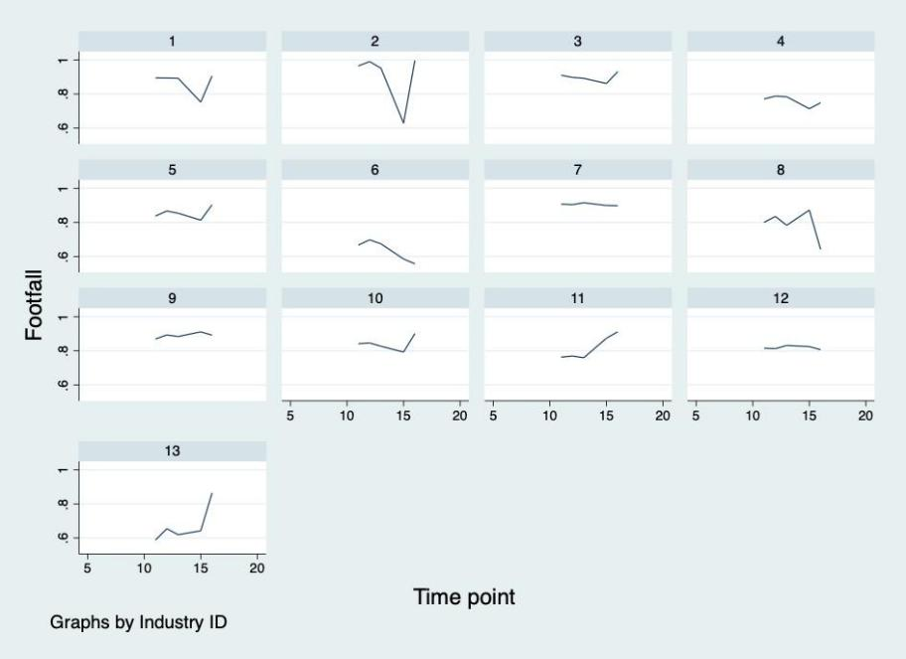

Figure 2 Footfall and industry type

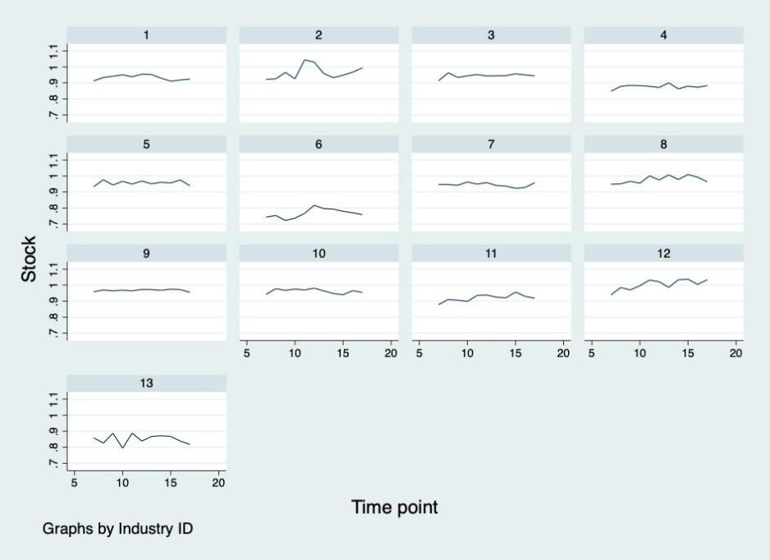

Figure 3 Stock and industry type

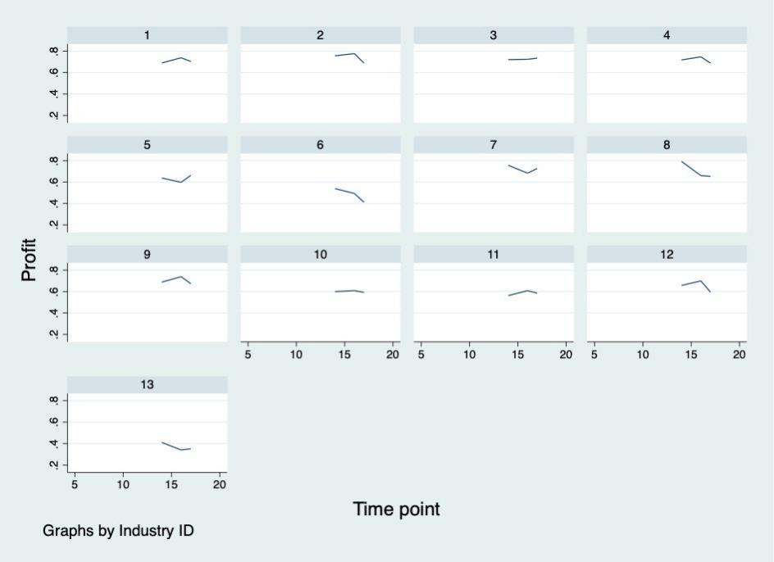

Figure 4 Profit and industry type

Figure 5 Confidence and industry type
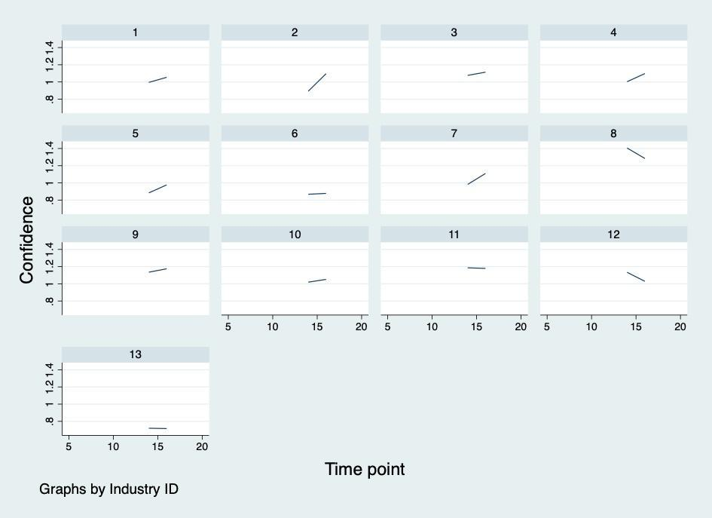

The results of correlation analysis and panel regressions showed that footfall can be a factor that related to stock level and have impact on strategic management for businesses. However, the results did not show statistically significant relationship neither between footfall and profit nor footfall and confidence. The reason might be the limitation of data available for this study. To evaluate the influence on profits and businesses confidence, we may need a longer period of observation.
From the graphs of footfall, profit, stock level and business confidence, the impact of different type of industry can be evaluated. The footfall changes in manufacturing, water & waste management, administrative & support, and education did not have strong impact on their stock level, profit, and confidence. The footfall levels in retail & trade, transportation, food & accommodation, and real estate have impact on their stock level, profit, and business confidence.

5. Discussion and Conclusion

Different researchers have different understandings of the factors that influence the change of strategic management of enterprises. From the perspective of external factors, there are some relevant discussions in the literature. COVID-19 has affected the business of enterprises, due to the quarantine requirements of various governments, social production and import and export trade have been blocked. In addition, due to lockdown factors, domestic markets such as France and the United States have been slow to recover. With the recovery of some foreign markets and the re-operation of commercial enterprises, Song et al. (2021) believes that for some enterprises which are more dependent on domestic market, it is necessary to change strategic management and follow the pace of internationalization. For these enterprises paying more attention to foreign markets is a good choice (Amankwah-Amoah et al., 2021). During COVID-19, due to lockdown measures and some people's fears about COVID-19, it is of great significance for some companies to change their strategic management and develop online business for consumers to change their buying habits and for their survival (Wang et al.,2020; Sheth, 2020; Hassen et al., 2020).

Similarly, Amankwah-Amoah et al.(2021) also believe that there is an inseparable relationship between the decline of consumer demand and the change of strategic management by enterprises. Companies in different industries react differently to the impact of COVID-19, and for companies like airlines, due to the decrease in customer demand, airlines have to change their strategic management to mitigate the impact of the epidemic by taking measures such as telecommuting, shortened working hours, vacation plans, office closures and layoffs (Amankwah-Amoah et al., 2021; Albers and Rundshagen, 2020). In addition, due to the impact of COVID19, lockdown measures are widely used, affecting social production and parts of the supply chain, while how enterprises respond to the crisis becomes a matter of concern. One possible solution is for enterprises to shift to servitization and digitalization when facing customers (Rapaccini et al.,2020; Sheth, 2020).

From the perspective of internal factors, some literature also has relevant discussions. The COVID-19 affects the existing business environment and makes it more complex and diversified. The COVID-19 affects the operation of the company and makes the mismatch between the internal resources and capabilities of the enterprise and the complex business environment, which may make the enterprise appear very vulnerable in the competition. It becomes necessary to upgrade and update resources to match internal resources and the new environment (Amankwah-Amoah et al., 2021; Lee and Trimi, 2021). Supply chain and customer location are related to the performance of enterprises in the case of COVID-19. Enterprises with a high degree of customer dependence have poor performance in the case of COVID-19, which is also related to the research of Albers and Rundshagen (2020) on airlines. For airlines, changing strategic management to improve their performance in COVID-19 situations can help them better survive (Amankwah-Amoah et al., 2021).

In addition, some literature also gives relevant discussions and studies on the epidemiological studies like COVID-19. SARS is one of the greatest challenges facing humanity, and it has had a huge impact on the service industry. According to some studies (Tse and Sin, 2006), it will lead to the decline of the company's turnover, the increase of operating costs, and other problems. Some companies are forced to change their strategic management to adapt to this situation, and layoffs and forced vacations become mitigation means. This is similar to the research of Albers and Rundshagen (2020) and Kim et al. (2005) that the decline of business volume/customer demand becomes one of the factors for enterprises to change their strategic management. The disorder of supply and demand is also one of the most serious influences brought by the large-scale epidemic to most enterprises. The study of Ivanov (2020) also shows this point. Due to the similarity of the impact brought by SARS and COVID-19, the imbalance of supply and demand makes companies change their strategic management to pursue the balance of supply and demand.

With the question about the possible factors affecting enterprise strategic management, from the qualitative research, we can see there are many factors can affect enterprise strategic management.

- One factor could be the lockdown caused by government quarantine restrictions, which hit companies that were heavily dependent on local markets. As a result, some companies have changed their strategic management to focus more on countries and regions with faster economic recovery to make more profits.

- In the context of COVID-19, due to the fear of this unprecedented pandemic, people are more willing to choose online shopping instead of going out shopping. It is more common for people to order supermarket daily necessities online than before. Therefore, some companies may change their strategic management to develop online businesses.

- The passenger flow is obviously also a factor affecting enterprises to change their strategic management, which is reflected in different industries. This is also reflected in quantitative research. The most obvious example comes from the airline industry. Due to the strict immigration policies of various governments, the flow of people between countries has slowed down and the passenger flow has declined significantly, which also forces airlines to change their strategic management. Measures to change strategic management include the following: (a) Lay off staff to reduce salary expenses; (b) Ground some planes to reduce unnecessary expenses; (c) The unpaid leave plan in rotation enables employees to have more choices and reduce salary expenditure without leaving the company; (d) post-employment reemployment plan. Through these changes in strategic management, airlines are seeking to reduce losses, which is also in line with the content of stakeholder theory to reduce losses of stakeholders. At the same time, it is consistent with the Legitimacy Theory. Under the condition that the quality of service is not reduced, the company is socially responsible to reduce unemployment by retaining the job but suspend the salary and rehiring after quitting.

- The imbalance between internal resources and the capabilities of the enterprise can be another factor. Social environment is changing all the time, the enterprise internal resources are difficult to match the changing social environment which makes the enterprise become quite vulnerable when they face the situation like COVID-19. The most typical example is the collapse of some old department store, this pushes some surviving companies to change the strategic management to update their internal resources, also better match the company’s internal resources and external environment to make the company more in line with the interests of stakeholders.

- Another factor that influences enterprises to change strategic management is the imbalance between supply and demand. In the context of COVID-19, due to social distancing and government requirements such as remote working, production in some manufacturing enterprises has stalled, resulting in a serious mismatch between supply and demand. During the lockdown, the production capacity of businesses such as luxury goods companies has been greatly reduced. Globally, the demand is far greater than the supply, resulting in a situation of short supply, which forces these enterprises to change their strategic management, through price increases, purchase limits, global deployment of products and other measures to reduce the gap between supply and demand.

So, for question 1, it can be clearly seen that the possible factors that affecting enterprise strategic management. However, the lockdown can be considered one of the most severe impacts of COVID-19, limiting the movement of citizens, limiting production, and finally causing a whole host of problems. For customer-oriented companies, the impact of the lockdown seems to be more severe, and changes in strategic management seem more urgent. For service enterprises like catering enterprises, when they meet a similar pandemic, they should change their strategic management and actively develop online business. This change in strategic management also has meaning for companies preparing for the next pandemic. In the face of such a similar pandemic, enterprises can better make changes, which has certain benefits for stakeholders. At the same time, customers and employees seem to have higher recognition of their organizational culture, which is because enterprises that seem to be more stable will have a more stable organizational culture.

Whether the customer flow is one of the factors affecting the strategic management of the enterprise? From the correlation analysis, the stock level has a strong connection with footfall, and the stock level is closely related to the interests of stakeholders. Under normal circumstances, when an enterprise cannot meet the interests of stakeholders, managers may change the strategic management to better meet the interests of stakeholders and become more socially responsible. According to the results of regression analysis, footfall can be used as a factor affecting the stock level and is positively correlated with the stock level, which means that when footfall decreases, the stock level of the company will also decline, which may be a factor for managers to change strategic management to drive the interests of stakeholders. Footfall also has different impacts on different industries. For enterprises in the retail and catering industries, which are more dependent on customers' consumption, as mentioned before, Footfall has a greater impact on them. For these enterprises to survive or even develop better in the context of COVID-19, We need to change and develop new business models to adapt to the impact of COVID-19 and other pandemics. From the qualitative analysis of the data, passenger flow is also obviously a factor that affects the enterprise to change strategic management. In the data of qualitative analysis, the aviation industry is more mentioned. Aviation is a very important part of the service and transportation industry, which affects many people around the world. In quantitative analysis, the transportation industry is also affected by passenger flow to a greater extent than construction, education and other industries. Look from these two aspects, airline companies have very special reason make then different from education, and other enterprises, this is because these companies are more dependent on customer flow, compared with the education industry, the education industry has greater flexibility, the teacher can choose the way they teach by face to face on the Internet or recorded in advance, this is no way on the aviation industry. Therefore, airlines are destined to be very vulnerable in the context of COVID-19, and it is particularly necessary for managers to change strategic management to reduce losses. Therefore, passenger flow as a factor affecting enterprises to change strategic management should be undoubted, but it will affect some kinds of companies more severe.

In our research, we mainly looked at the questions on how enterprise strategic management is affected in the COVID-19 context from the lenses of stakeholder theory, legitimacy theory, and that of organisational culture. For both stakeholder theory and legitimacy theory, as the pandemic continues to unfold, palpable social pressure has pointed to both a shift from short-term to long-term outcome, and renewed importance of CSR, especially in the engagement of activities that is of public health significance. This is due to the short-term impact of this very special pandemic, prior to which, the term ‘social distancing’ was unheard of. Existing emerging literature that looks at these was able to demonstrate positive impact from these types of CSR on both brand recognition and value (mainly in terms of stock price stabilisation). On top short-term impacts, it was also identified in this research that enterprise strategic management that gives focus to stakeholder management are also more resilient to major external shocks like that of the COVID-19 pandemic. This highlights the long-term benefits from targeted CSR in boosting confidence both in investors and in consumers. While limited evidence was available on the association in industry type and how effective these measures are, I anticipate more literature, both qualitative and quantitative, to surface soon which addresses that question. This point, however, is quite relevant in answering the question regarding factors impacting strategic management, as in the COVID-19 context, the level of economic / financial stress would vary across industries, which has direct implication on both how well stakeholder involvement which boosts brand confidence and image could be funded, as well as how effective the CSR investment can be.
From the perspective of organisational culture, the theory seems to point towards it being at the top of specific management decisions / tendencies. However, very few research was identified that specifically tried to solicit a culture profile using established organisational culture questionnaires. This points at a significant and relevant research gap in the sense that the COVID-19 pandemic introduced major shifts of mode of work in many industries where work is seen shifted to be conducted remotely. Businesses which were reliant on foot traffic are striving to seek ways to implement new service deliveries that are not in accordance with government lock-down measures, but also promotes public health concerns in the pandemic. Relevant examples include the shifting to online platforms of the education industry, and the shifting to delivery services for restaurant and supermarkets alike. This ensured the survival of businesses which heavily relied on footfall and in-person contact and is theoretically tightly connected to the two dimensions and four quadrants of organisational culture. Another point that speaks of the relevance of organisational culture would be employee confidence. Amidst financial crises, many employees are fearful of job stability implications. Zoom meetings and home-office also come with impacts on how productivity is assessed. These presents fascinating research ideas for studies to look at how they interact with organisational culture, if specific culture types would provide more resilience to the COVID-19 shock and see enterprises more readily adapted to these new sets of challenges, as well as if otherwise gradual and slow changes in organisational culture in companies, could be impacted differently by the COVID-19 pandemic.
With regret, this research did not and could not go beyond looking at the theoretical framework of organisational culture, and limited qualitative evidence of and related to the COVID-19 pandemic. Most of the research was conducted during the lock-down and initial reopening, making field trips and or interviews difficult. It would have been helpful if financial reports of enterprises are made more readily available electronically, to serve as a proxy to look at organisational culture, but this has been difficult too. While the BICS dataset provided by the ONS has domains that are somewhat relevant to organisational culture, the weak linkage is rendered next to superficial as the data has been aggregated without individualised responses accessible to researchers. Nevertheless, the quantitative component clarified the impact of footfall in industries in England during the COVID-19 pandemic.
Future research could look at better conceptually divide the short- and long-term effects of CSR, and possibly the relationship between CSR and organisational culture. While the recovery trajectory of the COVID-19 pandemic is still unclear with us being in the middle of it, as more data become available and the world hopefully resuming to some extent its pre-pandemic norms, with regard to work, travel, commercial life, many of the questions that are crucial to enterprise strategic management could be better studied and reported. In addition, future studies should pay more attention to companies in other industries other than airlines, the impact of passenger flow on their change of strategic management, and the relationship between organizational culture and enterprise change of strategic management. At the same time, future studies can combine field visits and interviews, and the data obtained are more inclined to individualized responses, to investigate the real connection between organizational culture and change of enterprise strategic management. In this way, the future research can make up for the shortcomings of this research to a large extent and make the future research more meaningful.

References

Agrawal, J. and Kamakura, W.A., 1995. The economic worth of celebrity endorsers: An event study analysis. Journal of marketing, 59(3), pp.56-62.

Alan, C.B., So, S. and Sin, L., 2006. Crisis management and recovery: how restaurants in Hong Kong responded to SARS. International Journal of Hospitality Management, 25(1), pp.3-11.

Albers, S. and Rundshagen, V., 2020. European airlines′ strategic responses to the COVID-19 pandemic (January-May, 2020). Journal of air transport management, 87, p.101863.

Amankwah-Amoah, J., Khan, Z. and Wood, G., 2021. COVID-19 and business failures: The paradoxes of experience, scale, and scope for theory and practice. European Management Journal, 39(2), pp.179-184.

Archel, P., Husillos, J., Larrinaga, C. and Spence, C., 2009. Social disclosure, legitimacy theory and the role of the state. Accounting, auditing & accountability journal, 22(8), pp. 1284-1307.

Cameron, K., 2009. An introduction to the competing values framework. Organizational culture white paper. Haworth.

Cameron, K.S. and Quinn, R.E., 2011. Diagnosing and changing organizational culture: Based on the competing values framework. John Wiley & Sons.

Crane, A. and Matten, D., 2020. COVID‐19 and the future of CSR research. Journal of Management Studies, 58(1), pp.280-284.

Davies, H.T., Nutley, S.M. and Mannion, R., 2000. Organisational culture and quality of health care. BMJ Quality & Safety, 9(2), pp.111-119.

Ding, W., Levine, R., Lin, C. and Xie, W., 2020. Corporate immunity to the COVID-19 pandemic (No. w27055). National Bureau of Economic Research.

Franco, S., Caroli, M.G., Cappa, F. and Del Chiappa, G., 2020. Are you good enough? CSR, quality management and corporate financial performance in the hospitality industry. International Journal of Hospitality Management, 88(2020), p.102395.

Freeman, R.E., 2010. Strategic management: A stakeholder approach.

Cambridge university press.

Goodman, E.A., Zammuto, R.F. and Gifford, B.D., 2001. The competing values framework: Understanding the impact of organizational culture on the quality of work life. Organization Development Journal, 19(3), pp.58-68.

Guthrie, J. and Parker, L.D., 1989. Corporate social reporting: a rebuttal of legitimacy theory. Accounting and business research, 19(76), pp.343-352.

Hasan, F. 2021. Corporate social responsibility and agency cost: Evidence from the UK retail industry. International Journal of Research in Finance and Management, 4(2), pp.105-115.
Hasan, F., and Shahabaz, A.A. 2021. COVID-19 and Two different Stock Markets: An Event Study Analysis. The Journal of Prediction Markets, 15(2), pp. 3-18.

Hasan, F., Hasan, Md. Z., and Islam, M. R. 2022a. COVID-19 movement control effect on the socio-economy: evidence from Bangladesh manufacture industry. International Journal of Critical Accounting. 12(6), pp. 531-553.

Hasan, F., Islam, M. R., and Siddique, M. 2022b. Management challenges analyses and information system redevelopment in SMEs due to Covid 19 fallout: Prescriptive case study. International Journal of Critical Accounting. (In Press).

Hassen, T.B., El Bilali, H. and Allahyari, M.S., 2020. Impact of Covid-19 on Food Behavior and Consumption in Qatar. Sustainability, 12(17), pp.1-18.

Hill, R., Sarkani, S. and Mazzuchi, T.A., 2021. Managing in a Post-COVID-19 World: A Stakeholder Network Perspective. IEEE Engineering Management Review, 49(1), pp.63-71.

Hitt, M.A., Arregle, J.L. and Holmes Jr, R.M., 2020. Strategic management theory in a post‐pandemic and non‐ergodic world. Journal of Management Studies, 58(1), pp. 259-264.

Ingravallo, F., 2020. Death in the era of the COVID-19 pandemic. The Lancet Public Health, 5(5), p.e258.

Ivanov, D., 2020. Predicting the impacts of epidemic outbreaks on global supply chains: A simulation-based analysis on the coronavirus outbreak (COVID-19/SARS-CoV-2) case. Transportation Research Part E: Logistics and Transportation Review, 136(2), p.101922.

Jones, T.M., 2016. Instrumental stakeholder theory: A synthesis of ethics and economics. The Corporation and Its Stakeholders,20(2), pp.205-242.

Joseph, O.O. and Kibera, F., 2019. Organizational culture and performance: Evidence from microfinance institutions in Kenya. Sage Open, 9(1), p.2158244019835934.

Khan, C.B.A. and Ahmed, R., 2019. Organizational Culture and Entrepreneurial Orientation: Mediating Role of Entrepreneurial Leadership. Business & Economic Review, 11(4), pp.149-178.

Kim, S.S., Chun, H. and Lee, H., 2005. The effects of SARS on the Korean hotel industry and measures to overcome the crisis: A case study of six Korean five-star hotels. Asia Pacific journal of tourism research, 10(4), pp.369-377.

Lee, S.M. and Trimi, S., 2021. Convergence innovation in the digital age and in the COVID-19 pandemic crisis. Journal of Business Research, 123(2021), pp.14-22.

Lins, K.V., Servaes, H. and Tamayo, A., 2017. Social capital, trust, and firm performance: The value of corporate social responsibility during the financial crisis. the Journal of Finance, 72(4), pp.1785-1824.

Madsen, P.M. and Rodgers, Z.J., 2015. Looking good by doing good: The antecedents and consequences of stakeholder attention to corporate disaster relief. Strategic Management Journal, 36(5), pp.776-794.

Obrenovic, B., Du, J., Godinic, D., Tsoy, D., Khan, M.A.S. and Jakhongirov, I., 2020. Sustaining enterprise operations and productivity during the COVID-19

pandemic:“Enterprise Effectiveness and Sustainability Model”. Sustainability, 12(15), p.5981.

Paine, Lynn S. "Covid-19 is rewriting the rules of corporate governance." Harvard Business Review 6 (2020).

Pérez, A. and López-Gutiérrez, C., 2020. Market reactions to CSR news in different industries. Corporate Communications: An International Journal, 25(2), pp. 243-261.

Qiu, S.C., Jiang, J., Liu, X., Chen, M.H. and Yuan, X., 2021. Can corporate social responsibility protect firm value during the COVID-19 pandemic?. International Journal of Hospitality Management, 93(2021), pp.1-12.

Rapaccini, M., Saccani, N., Kowalkowski, C., Paiola, M. and Adrodegari, F., 2020. Navigating disruptive crises through service-led growth: The impact of COVID-19 on Italian manufacturing firms. Industrial Marketing Management, 88(2020), pp.225-237.

S&P Global Market Intelligence, 2021. Industries Most and Least Impacted by COVID-19 from a Probability of Default Perspective – September 2020 Update. https://www.spglobal.com/marketintelligence/en/news-insights/blog/industries-

most-and-least-impacted-by-covid19-from-a-probability-of-default-perspective-

september-2020-update. Accessed in August 2021

Sapta, I., MUAFI, M. and SETINI, N.M., 2021. The role of technology, organizational culture, and job satisfaction in improving employee performance during the Covid-19 pandemic. The Journal of Asian Finance, Economics, and Business, 8(1), pp.495-505.

Schaller, M., 2011. The behavioural immune system and the psychology of human sociality. Philosophical Transactions of the Royal Society B: Biological Sciences, 366(1583), pp.3418-3426.

Sheth, J., 2020. Impact of Covid-19 on consumer behavior: Will the old habits return or die?. Journal of business research, 117(2020), pp.280-283.

Song, H.J., Yeon, J. and Lee, S., 2021. Impact of the COVID-19 pandemic: Evidence from the US restaurant industry. International Journal of Hospitality Management, 92(2021), p.102702.

Staempfli, S. and Lamarche, K., 2020. Top ten: A model of dominating factors influencing job satisfaction of emergency nurses. International emergency nursing, 49(2020), p.100814.

Tzeng, H.M., Ketefian, S. and Redman, R.W., 2002. Relationship of nurses’ assessment of organizational culture, job satisfaction, and patient satisfaction with nursing care. International journal of nursing studies, 39(1), pp.79-84.

Wang, K., Wong, E.L.Y., Ho, K.F., Cheung, A.W.L., Chan, E.Y.Y., Yeoh, E.K. and Wong, S.Y.S., 2020. Intention of nurses to accept coronavirus disease 2019 vaccination and change of intention to accept seasonal influenza vaccination during the coronavirus disease 2019 pandemic: A cross-sectional survey. Vaccine, 38(45), pp.7049-7056.

Wang, Y., Hong, A., Li, X. and Gao, J., 2020. Marketing innovations during a global crisis: A study of China firms’ response to COVID-19. Journal of Business Research, 116(2020), pp.214-220.

Zattoni, A. and Pugliese, A., 2021. Corporate Governance Research in the Wake of a Systemic Crisis: Lessons and Opportunities from the COVID‐19 Pandemic. Journal of Management Studies, 58(5), pp.1405-1410.

Zelditch Jr, M., 2020. Legitimacy theory (pp. 340-371). Stanford University Press.

