**New energy vehicles from the perspective of market and environment**

**Fakhrul Hasan**

Lecturer in Accounting and Finance

Liverpool Hope Business School,

Liverpool Hope University,

Liverpool, UK

Email: [hasanf@hope.ac.uk](mailto:hasanf@hope.ac.uk)

ORCID-0000-0002-5406-9906

**Mohammad** **Raijul Islam**

MSc Management and International Business

Nottingham Business School

Nottingham Trent University

Nottingham, UK

Email: [mohammad.islam2020@my.ntu.ac.uk](mailto:mohammad.islam2020@my.ntu.ac.uk) ,

[samiulraijul234@gmail.com](mailto:samiulraijul234@gmail.com)

ORCID-0000-0002-5392-9759

**Corresponding Author:**

**Fakhrul Hasan**

Lecturer in Accounting and Finance

Liverpool Hope Business School,

Liverpool Hope University,

Liverpool, UK

Email: [hasanf@hope.ac.uk](mailto:hasanf@hope.ac.uk)

Conflict of interest: Authors do not have any conflict of interest.

Funding: Authors did not receive any fundings to conduct this research paper.

Acknowledgement: Both authors want to thank journal reviewers and editor in chief.

**Abstract**

New energy vehicles have received extensive attention from consumers in today's society. In recent years, the strong rise of pure electric vehicles and hybrid vehicles has brought considerable changes to the entire automotive market. This research mainly focuses on the theme of new energy vehicles and explores the competitive advantages and challenges of new energy vehicles for traditional vehicles from both market and environmental perspectives. This research adopts the method of secondary research, collects data and information from websites, books, journals and academic papers, uses quantitative analysis to analyze the sales and share of new energy vehicles in the global and Chinese markets, and explores the impact of new energy vehicles on the traditional Challenges and impacts of automotive-related industries, exploring the impact of new energy vehicles on the environment and energy, and our results shows that the competitive advantages of new energy vehicles mainly lie in: energy saving and environmental protection, government policy support, and future trends.

**Key words:** new energy vehicles, Market share, Environment, Secondary research, Quantitative analysis

1. **Introduction**

In 2014, Chinese President Xi Jinping emphasized during an inspection tour in Shanghai that the development of energy vehicles is the only way to become a powerful automobile nation. (People's Daily Online, 2014) But for the masses of the Chinese people, the terms ‘new energy vehicles’ and ‘new energy technologies’ were very unfamiliar a few years ago. At that time, these two terms seemed to represent not only the reform of an industry, but also a technological breakthrough. Therefore, from the time when the American Tesla Company entered China in 2012 until 2014, the sales of the company's first electric car in China have been much lower than expected (Tesla Financial Report, 2014). However, as of the end of May 2021, China's new energy vehicle ownership has reached approximately 5.8 million, accounting for about 50% of the global total of new energy vehicles (China Automobile Industry Association, 2021). Moreover, in addition to the sales proportion of imported new energy vehicles such as Tesla, these data also include many new energy vehicle brands independently developed in China. Therefore, based on this premise, the purpose of this study is to explore the impact of the continuous increase in sales of new energy vehicles on the Chinese market and the environment. The ultimate goal of this research is to find out which aspects of the competitiveness of new energy vehicles are reflected in the analysis of these two factors, and what challenges still exist.

The research questions raised in this paper also revolve around research purposes. First, ask the question from the perspective of the market: What is the impact of new energy vehicles on the market? Through the analysis of market share, it is found that although the overall sales of new energy vehicles have been on the rise from 2016 to the present, there have been some twists and turns. The second market question is: What impact will new energy vehicles have on traditional auto-related companies after entering the market? The development of new energy vehicles will inevitably affect some traditional auto companies, such as traditional auto parts production plants. Through research on this issue, it is found that the extent of the possible impact of new energy vehicles has a certain relationship with sales. And the study of this issue will play a role in the final goal of this report.

Secondly, this research will also raise questions from an environmental perspective. As environmental issues have always been a concern for China and the world, while the Chinese government advocates energy conservation and emission reduction, new energy vehicles have become the focus of attention. Therefore, the exploration of new energy vehicles is inseparable from environmental factors. The first question in the environmental category: What are the impacts of the promotion of new energy vehicles on energy? Through research, it is found that the most important type of new energy vehicles is electric vehicles, which can replace traditional fuel supply with electricity to achieve the effect of environmental protection. However, the survey found that battery technology is always the worthiest of research in the development. The second question involves environmental pollution, because the battery of an electric car is a good substitute for the fuel of a traditional car, so ‘how much is the difference between the emissions of a traditional car and an electric car? 'Has also become the focus of this research. Through research, it is found that the pollutants in the exhaust gas are not only carbon monoxide, but also other harmful substances. Experiments are the most intuitive way of comparison, so this study quoted previous experimental data for research and analysis.

This research paper is organised in the following way: in the following section we explain the literature review in detail. In our section 3 we discuss our methodology. In section 4 we provide our data analysis and finally in section 5 we conclude this research.

1. **Literature review and developing research questions**

Transportation is an indispensable part of modern life. With the changes of the times and the advancement of science and technology, there are more and more transportation vehicles around the people, which brings great convenience to everyone's life.

New energy vehicles have become a development trend. In 2020, 33.28 million new motor vehicles were registered nationwide, and automobiles accounted for 24.24 million of them. As of the end of 2020, China’s total motor vehicle ownership has reached 372 million, of which cars accounted for 281 million (Ministry of Public Security of the People's Republic of China,2021).For the Chinese government, although the continuous increase in the number of cars has certain benefits to the economy, it has also caused considerable impact in many other aspects. For example, China's demand for oil has increased significantly (China Energy Development Report, 2020), and the total emissions of four pollutants from motor vehicles nationwide have reached 16.038 million tons in 2019 (China Mobile Source Environmental Management Annual Report, 2020) and so on. Therefore, in the face of various problems and challenges, the Chinese government has also begun to formulate corresponding countermeasures in recent years. For the automotive industry, the government has successively issued policies and benefits to help companies develop new energy technologies and encourage consumers to purchase new energy vehicles. In this context, new energy vehicles have only gradually begun to enter the sight of consumers in recent years.

* 1. *The impact of new energy vehicles on China's auto market share*

From 2016 to 2019, the global sales of new energy vehicles are gradually increasing (EV Sales Blog, 2019). Although as of 2019, the global market share of new energy vehicles is only 2.5%, but from a statistical point of view, the overall trend is showing an upward trend.

Tesla is an American electric vehicle and energy company that produces and sells electric vehicles, solar panels, and energy storage equipment. Although Tesla was founded in 2003, it released its first car product ‘Roadster’ in 2008. Later, from 2012 to 2015, three models of different price points were launched. One of Tesla’s successful vehicles is the Model 3, and Tesla sold approximately 140,000 Model 3 electric vehicles in the U.S. in 2018(Phil,2019). So far, Tesla has also begun to enter the Chinese market, impacting the traditional car market with pure electric vehicle technology and products, and gaining consumers' awareness. After Tesla's pure electric vehicles began to gradually rise in the global automotive market, many large auto brands have also spent a lot of energy researching new energy vehicles (including pure electric vehicles and hybrid vehicles). Among them are the 'Beiqi EU-Series' series produced by the Chinese car brand 'BAIC', the 'Yuan EV' series of the Chinese car brand 'BYD', the ‘Nissan LEAF' series of the Japanese car brand, and the 'BMW' series of the German car brand. 530e' series, etc. But according to the global car sales data in 2019, Tesla set two records: one is monthly sales of 63,148 units and annual sales of 367,820 units.

According to the "Analysis Report of China's New Energy Automobile Industry Market Outlook and Investment Strategy Planning for 2020-2025" released by the Foresight Industry Research Institute, from the perspective of regional distribution, China is the world's largest new energy vehicle market. From 2015 to 2019, the sales of new energy vehicles in China showed an overall upward trend, reaching a peak during this period in 2018, with 1.25 million new energy vehicles sold throughout the year. Although sales declined in 2019, it also reached 1.206 million vehicles, accounting for 4.68% of total car sales.

Whether it is from actual sales data or market share, new energy vehicles are gradually developing. In line with the supportive policies of the Chinese government, new energy vehicles are bound to continue to be popular in the future. But there are also many factors that will affect the sales of new energy vehicles. In my opinion, there are two main aspects: one is technical issues, and the other is price issues. In recent years, there have been reports that negative situations such as spontaneous combustion of electric vehicles and electric vehicle brake failure have occurred. These problems fully reflect the technical problems that still exist in the manufacture of electric vehicles. When the potential risks of technical problems can threaten consumers When it comes to personal safety, consumers will have concerns when they choose to buy new energy vehicles, which will affect overall sales. Also, under the high-cost technology investment, the price of the car will also be higher. Judging from the several models released by Tesla, Tesla Model 3 has always been the lowest-priced model of all models, but at the same time it is also the highest-selling model of all electric vehicles. It can also be seen from this that what is the level of the overall consumption power of this part of consumers who are willing to buy new energy vehicles. If the positioning of new energy vehicles is too high, it is also an insurmountable threshold for most consumers.

* 1. *Challenges brought by the development of new energy vehicles to traditional automobile-related companies*

The government's vigorous promotion and encouragement of the development of pure electric vehicles will undoubtedly give the automotive industry a future research and development direction. However, whether there are any challenges or drawbacks in the development process has always been a topic that most people are concerned about. In 2014, the famous American electric vehicle Tesla entered the Chinese market at a price lower than the market expectation. This news not only hit the traditional fuel automobile industry, but also brought crisis and thinking to many other industries.

The high operation of crude oil prices provides a cost advantage for the development of pure electric vehicles. When Tesla first entered the Chinese market in that year, the price of no.93 gasoline in China has been around 7. 5 yuan per liter Development and Reform Commission, 2014. At that time, the cost of electricity energy was only about 0.5 yuan. According to relevant statistics, the 100-kilometer consumption cost of a pure electric vehicle is only about one-tenth that of a traditional fuel-powered vehicle.

But due to the high cost of batteries, the price of pure electric vehicles is also very high. In 14 years, Tesla's first car, Model-S, entered China with a price of more than 700,000 yuan. This undoubtedly deterred many consumers. Taking Tesla as an example, the mileage after a single charge is only 350 kilometers, while a traditional fuel car can travel at least 500 kilometers with a tank of fuel (Shang,2014). Although it is just discussing Tesla, it is also a common problem in the current pure electric vehicle market.

In addition to pure electric cars, hybrid cars similar to the BMW i3 have been born on the market. Hybrid cars are a mixture of oil and electricity. For now, hybrid cars are also a dark horse in the automotive market. But there is also a problem, the maintenance cost is too high after the failure. So, whether it is hybrid or pure electric, there is still a long way to go in terms of technology.

The rapid development of new energy vehicles, it has also brought a huge impact on traditional automobile-related industries, and even the huge changes in the entire automobile industry have caused a particularly cruel impact on some traditional industries and enterprises. The first to be affected is the traditional automobile engine and gearbox manufacturing industry. The body structure of a traditional fuel car is more complicated than that of a pure electric car because it has an engine. Pure electric vehicles rely on batteries to generate power. This change makes the engine and engine-related systems unnecessary (Auto Technician, 2018). So, for traditional cars, manufacturers of engines, clutches, and transmissions will face huge challenges. With the popularization of new energy vehicles in the future, these manufacturers will face transformation, while those unable to transform will directly face bankruptcy.

Aside from the auto manufacturing industry, related auto service industries will also be affected. For example, the after-sales maintenance services for engines and transmissions mentioned above will also be directly hit by the gradual elimination of their original parts (Fang, 2019). However, compared with the manufacturing industry, it is easier for service-type industries and enterprises to achieve transformation.

However, it is not that the development of new energy technologies and the promotion of new energy vehicles will only have a negative impact on the traditional automobile industry. It also brings more hope to the development of the traditional automobile industry, and at the same time brings more possibilities, but the popularization of new energy vehicles will certainly bring many other developments and opportunities to the automobile industry (People’s Daily, 2020).

* 1. *Government measures to promote the use of new energy and its significance*

The government's economic and policy support for the new energy industry is one of the most critical reasons to help the new energy industry get through the early stage of development. In order to more directly reflect the impact of government support on the development of new energy industry, SVAR model was established (Xiaohan,2017). The utilization and development of new energy has been a topic of common concern in the world for many years. For China, low-carbon living, energy conservation and emission reduction are also major concepts of environmental protection. For example, this slogan is familiar to all Chinese people, because the theme of the *2010 Shanghai world expo* is "better city, better life". In this context, the new energy reflects its value and the importance of the government to it (Liu,2010).

In addition, the government's support for the new energy industry is also very necessary. Although it takes a lot of financial resources to develop and invest in the early stage of new energy technology, it is an inevitable requirement for realizing low-carbon economy in the long run (Weixia,2010; Hasan,2020 and 2021a). The scholar said that the phenomenon has seriously threatened China's energy security as the oil price rises triggered by the oil shortage. Although China's oil resources are not small, but because of the huge demand for oil, so the domestic production of oil is far from enough to meet the demand. This leads to having to import oil from other countries. In March 2017, China became the world's largest crude oil importer, importing 9.2 million b/d of crude oil (GACC,2017). Therefore, to solve the oil crisis, guarantee energy security and enhance competitiveness in the future international market, our government must also develop new energy.

However, the financial support of energy conservation and new energy industry in China is still a big problem. Although the state has introduced a lot of energy support policies, the development of China's new energy industry has been gradually accelerated. But there are still many constraints, the lack of capital being the most fundamental (Liu Songwan,2009). Based on the analysis of financing factors forming the capital gap, and combined with foreign experience, China's incentive policy is still not complete. Energy conservation and new energy enterprises are in their infancy, and most of them are small and medium-sized enterprises. Therefore, many enterprises also lack the ability of financing and the financing method is very single. Another point is that many new energy enterprises are worried about investment because of the lack of risk guarantee mechanism (Liang,2009 and Hasan et al., 2021b).

In general, the impact and significance of the government's measures and the final impact on the development have been shown in the above paragraphs. No matter how far the new energy develops in the future, the development of any technology enterprise project cannot be achieved without the government.

* 1. *The impact of new energy use on the environment*

The development of new energy is the most intuitive solution and reaction of the problem is the environmental problem. The development of new energy is the most intuitive solution and reaction of the problem is the environmental problem. China’s top leaders raised the theme of developing clean energy and improving the quality of the environment at the first meeting of the national energy commission (Li Keqiang,2014). From the macro point of view, it is because of the need to improve the environment that new energy is vigorously developed and promoted. So, the use of new energy is to make the environment better and better. The development of new energy technology can partly reduce the consumption of non-renewable resources (Wang & Gao,2009). For example, a new environmentally friendly gasoline developed by a Chinese company was in a trial phase in 2009, and it can be seen from the trial that various indicators have exceeded the sales of gasoline and diesel on the market. This also indicates that the development of new energy technology to a stable, is able to replace part of the traditional resources.

It's always abstracted to talk about theory. Focusing on specific things, pure electric vehicles can be said to be the closest product to our lives after the development of new energy technology. The pure electric vehicle and the traditional automobile from the thermal efficiency and energy consumption comparison, the pure electric vehicle has a great advantage (Sheng et al.,2014). From the emission point of view of traditional fuel car and electric car, pure electric car does not need to emit exhaust gas is almost a clear winner. Therefore, it can be known that new energy technology plays a huge role in environmental protection.

Or take the case of the electric car Tesla. Tesla's achievements in the electric car market have an important impact on the environment, and electric cars have a role to play in reducing pollution. For example, as mentioned in the article “Reducing Pollution with Electric Vehicles,” from the Department of Energy, the concept of direct emissions with regards to vehicles is explained. “Direct emissions are emitted through the tailpipe, through evaporation from the fuel system, and during the fuelling process. Direct emissions include smog-forming pollutants (such as nitrogen oxides), other pollutants harmful to human health, and greenhouse gases (GHGs), primarily carbon dioxide. All-electric vehicles produce zero direct emissions, which specifically helps improve air quality in urban areas.” (Department of Energy) As a result of Tesla producing large numbers of electric vehicles, middle- and upper-class consumers who live in cities, where pollution is already rampant, can help in creating a cleaner environment by using electric vehicles.

1. **Methodology**

In this research paper we used quantitative research method. The research approach is a plan and procedure that consists of the steps of broad assumptions to detailed methods of data collection, analysis, and interpretation. Ttherefore, based on the nature of the research problem being addressed. In addition to the two methods of qualitative and quantitative analysis mentioned above, the analysis and reasoning of data is also divided into two types: deductive method and inductive method.

The main difference between inductive reasoning and deductive reasoning is that inductive reasoning aims to develop theories, while deductive reasoning aims to test existing theories. Inductive reasoning shifts from specific observations to broad generalizations, while deductive reasoning is the opposite. When there is little or no existing literature on a topic, inductive research is usually carried out because there is no theory to test. But the limitation of the inductive method is that the conclusion drawn by the inductive method can never be proved, but it can be proved invalid. The deductive research method always starts with a theory when conducting deductive research. Deductive reasoning means testing these theories. If there is no theory, deductive research cannot be conducted. Its limitation is that the conclusion of deductive reasoning can be true only when all the premises set in inductive research are true and the conditions are clear.

This study will use a deductive approach to help achieve the research objectives in order to explore the competitiveness and challenges of new energy vehicles. Because deductive reasoning is reasoning from the general to the particular, it requires a sufficient or sufficient necessary condition link between the premises and the conclusion. The analysis of market data and environmental data collected in this paper will allow conclusions to be drawn from it to effectively respond to the purpose of the study.

1. **Data collection and analysis**

Nowadays, more and more new energy vehicles begin to enter our lives. In order to analyse and discuss the impact of new energy vehicles on the Chinese market and environment more intuitively. This chapter will be divided into three parts to provide data, tables, and graphics to support the questions raised in the literature review. The first part will provide data on the global and Chinese markets of new energy vehicles in recent years and explain and analyse the data. The second part will analyse the impact of new energy vehicles on energy. The third part will Comparative analysis of the data from the pollution emission experiment of electric vehicles and traditional fuel vehicles.

As this study uses secondary research for data collection, all data in this section is sourced from journals, company annual reports, government documents, and academic literature. The data collected in the market section in this section will be collected using word and Excel tools. The authoritative data will be first categorised and recorded through excel, and then the data from excel will be imported directly into word through the functions of the office software to produce graphs and tables. The purpose of this is to visualise the data and to see the relevant trends more visually in a graphical way. In the environmental research section, this study takes the form of collecting data from previous experiments, in addition to using the same data processing methods as the market analysis. Because of the limitations of experimental data, it was difficult to obtain data relevant to the purpose of the study by means of primary research. Therefore, the literature on the relevant experiments was found through academic websites. In this section, the collected experimental data will be analysed and summarised using mainly comparative analysis and graphical description.

* 1. *Market share of new energy vehicles*

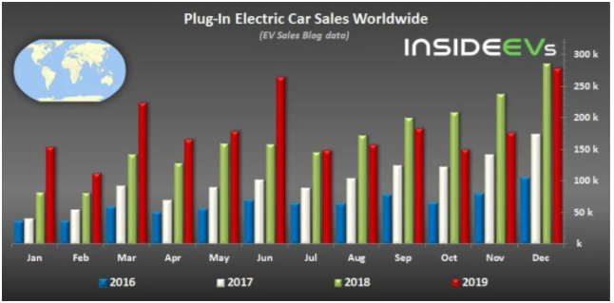

Figure 1: Global sales of plug-in hybrid vehicles (including pure electric vehicles) from 2016 to 2019

According to the above chart, the most intuitive feeling is that from 2016 to 2019, the total sales of global plug-in hybrids have increased significantly. Generally speaking, the increase in sales is considerable, and it can also show that the global new energy vehicles are in a stage of rapid development. However, a particularly important problem can be found from the table is that in the comparison of sales in 2018 and the second half of 2019, there was a negative sales growth for the first time. As a big country in the sales of new energy vehicles, China also encounters the problem of negative sales growth. Through the understanding of a number of new energy vehicle markets and listed companies in 2019, it was found that the biggest external reason for the decline in sales in 2019 was the decline in government subsidies. In 2019, new energy vehicle subsidies continued to decline by more than 50%, and two decline nodes were introduced at the end of March and the end of June, and the sales fluctuations of new energy vehicles throughout the year also increased significantly (China Automobile Association, 2019).It can be seen from this that in the early stage of the development of new energy vehicles, government support had a significant impact on sales.

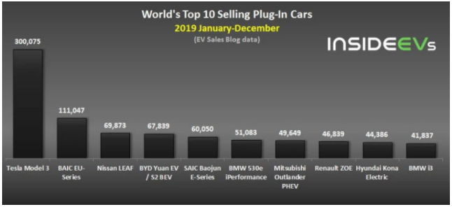

Figure 2: The top ten best-selling plug-in hybrid vehicles in the world (including pure electric vehicles)

From Figure 2 we can see the top ten best-selling new energy vehicles in 2019. There is no doubt that the Model 3 of Tesla Inc. is the best-selling in the world. First of all, as the sales champion of the electric car industry, Tesla's reputation, technology, and quality have been recognized by the public after its advent, but the biggest problem is that it is expensive. After the Model 3 was launched in mainland China, the pricing fell to a range acceptable to the public after government subsidies. Therefore, the increase in sales is likely to be due to the price. Putting aside Tesla, Chinese auto brands BAIC and BYD's models are also on the list, which shows the continuous rise of China's new energy technology. The increase in local sales will also greatly affect the total global sales of new energy vehicles.

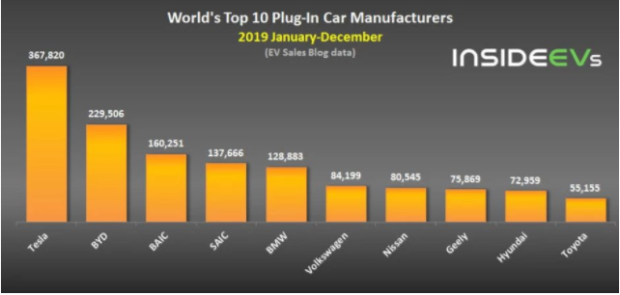

Figure 3: The world's top ten plug-in hybrid vehicles (including pure electric vehicles)

The manufacturer Tesla easily won the manufacturer's ranking and set two records: monthly sales of 63,148 units and annual sales of 367,820 units! It is 140,000 higher than BYD's sales. Despite the recent poor performance of BYD, its overall sales performance (229,506 units) is still higher than that of BAIC, SAIC and BMW, and the sales of these three manufacturers are all higher than 100,000 units.

At a time when new energy vehicles are in dispute, the sales of BAIC and BYD in the world's top three new energy vehicles are a big pride of China's independent brands. According to data, my country occupies a large part of the foreign market in commercial new energy vehicles. BYD's new energy buses have been exported to dozens of countries around the world, and the United Kingdom has ordered many double-decker buses from BYD. And BAIC has also exported a large number of new energy vehicles to Mexico and other countries as taxis.

Figure 4: 2015-2018 China's new energy vehicle sales and proportion statistics

According to data from the China Association of Automobile Manufacturers, the sales volume and proportion of new energy vehicles in China have shown an upward trend from 2015 to 2018. Until 2018, sales reached 1.25 million, the highest peak in recent years. According to data in 2019, China's new energy vehicle sales were 1.206 million units, a decrease compared to 2018. However, the overall market share accounted for 4.68%, which was a slight increase from 4,47% in 2018. This means that the trend of new energy vehicles in China in recent years has been on an upward trend.

Figure 5: 2015-2018 China's pure electric vehicle and plug-in hybrid vehicle sales statistics

According to the data in the table, it can be found that among the new energy vehicles, the proportion of pure electric vehicles is still much larger than that of plug-in hybrid vehicles. Tesla, as the leader of the pure electric vehicle brand, naturally contributed most of the sales. However, as Tesla's second largest consumer market, China's sales revenue in 2018 decreased compared with 2017. In 2018, China's revenue was US$1.757 billion, a year-on-year decrease of 15.4%. In 2017, its sales in China were US$2.027 billion. . Among them, some analysis said that part of the reason for Tesla's 2018 sales revenue decline was affected by tariffs. Also due to the rise of many domestic new energy automobile brands, Tesla has gradually lost some of its monopoly position in China.

* 1. *The impact of new energy vehicles on energy*

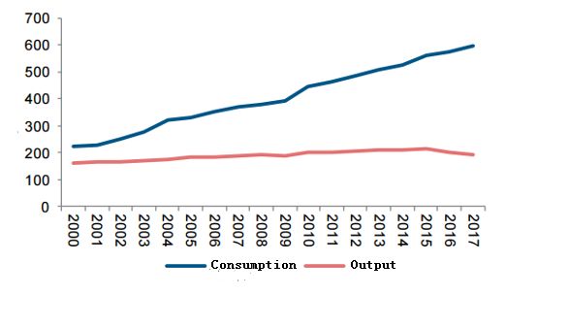

Figure 6: China's crude oil production and consumption from 2000 to 2017

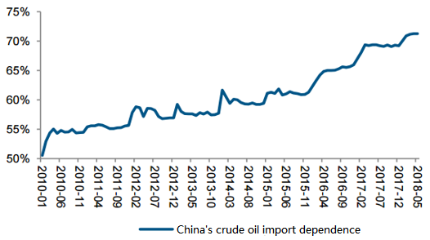

Figure 7: China's crude oil import dependence from 2000 to 2018

In recent years, crude oil production has continued to be lower than crude oil consumption, and the consumption gap has been expanding. The gap can only be made up through crude oil imports: China's crude oil import growth rate has remained high for many years, and import dependence has reached more than 70%. Moreover, with the diversification of crude oil import sources, more and more imports are turned to the United States, South America and other regions, and the shipping distance of China's crude oil imports has gradually increased. Although my country is the world's sixth largest oil producer, China's oil imports surpassed the United States in 2018, becoming the world's largest oil importer. In 2019, my country's oil imports amounted to 506 million tons, an increase of 9.55% year-on-year, and the degree of dependence on foreign oil was as high as 72%.

According to the latest issue of the World Energy Outlook published by the International Energy Agency (IEA), studies have shown that after 2025, global oil consumption by passenger cars will reach a peak of about 23 million barrels per day, but by 2040, Even if the global car volume grows by 80%, oil consumption will drop back to current levels. Although the current number of electric vehicles is limited, the energy-saving effects produced are expanding. By the end of this year, global electric buses will replace 233,000 barrels of crude oil consumption. Coupled with the energy consumption saved by electric vehicles, it will replace 279,000 barrels of oil per day, which is roughly equivalent to the amount of oil consumed by Greece every day. It is estimated that by 2040, as many as 300 million electric vehicles will be put into use, which will replace 3 million barrels of oil consumption every day.

* 1. **Comparison of pollutant emissions and consumption between traditional cars and pure electric vehicles**

|  |  |  |
| --- | --- | --- |
| Basic parameters | Pure electric vehicle | Traditional car |
| Dimensions (L×W×H)/mm | 4155×1650×1445 | 4155×1650×1445 |
| Wheelbase/mm | 2400 | 2400 |
| Curb weight/kg | 1260 | 1100 |
| Fuel type | Electricity | Gasoline (93#) |
| Engine displacement/L | - | 1.3 |
| Maximum speed/(km/h) | 100 | 170 |

Table 1 Basic parameters (Guo&Shi&Li&Guo,2014)

Taking a gasoline car produced by a domestic automobile plant and a pure electric car produced by the plant as an example for comparative analysis, the pure electric car is improved and manufactured on the basis of the same gasoline car. The relevant basic parameters of the two cars See Table 1.

It can be seen from the table that the curb weight of the pure electric vehicle is 160 kg heavier than the traditional car, mainly because the pure electric car and the traditional car are only different in power system (the other is basically unchanged), and the power system of the pure electric car is mainly Consists of motor, controller and battery. The traditional car is the traditional way of engine construction.

|  |  |  |
| --- | --- | --- |
| Project | Traditional car | Pure electric vehicle |
| Energy consumption per 100 kilometers/KJ | 250 119 | 155 136 |
| Fold standard coal/kg | 8.5 | 5.3 |
| Comprehensive efficiency/% | 18 | 22 |
| Specific energy consumption (/KJ/(t·km)) | 2 274 | 1 231 |

Table 2 Comparison of energy consumption and comprehensive efficiency(Guo,et al.2014)

By comparison, pure electric cars are superior to traditional cars in terms of energy consumption per hundred kilometers, overall efficiency, and specific energy consumption. In terms of energy consumption per 100 kilometers, traditional cars are nearly 38% higher. This is because the traditional cars will cause the engine to idle or be in a low-efficiency zone under idle, low-speed and other operating conditions. Specific energy consumption is the energy consumption per unit of car driving per unit distance. The energy consumption of two cars of different qualities can be compared. From the comparison of data, pure electric vehicles have obvious advantages in specific energy consumption.

|  |  |  |
| --- | --- | --- |
| Pollutant | Traditional car emissions（kg/100km） | Electric vehicle emissions（kg/100km） |
| CO | 0.0394 | 0 |
| HC | 0.0046 | 0 |
| NOx | 0.0022 | 0.041 |
| CO2 | 16.85 | 11.6358 |
| SO2 | 0.0022 | 0.02838 |

Table 3 Comparison of emissions from traditional cars and electric cars(Zhang,et al.2012)

In Table 3, the emissions of traditional vehicles are direct emissions; while electric vehicles basically have no exhaust, their emissions are mainly reflected in the atmospheric emissions from coal-fired thermal power plants. It can be seen from Table 3 that compared with traditional cars, electric vehicles have reduced the types of harmful gases emitted into the atmosphere, and it can also be said that they are basically free of CO and HC (hydrocarbon). However, CO and HC are the most harmful gas components in atmospheric pollution. For both NOx and SO2, direct emissions are still relatively small, and power plants have taken a series of positive measures to reduce NOx and SO2 emissions. For the majority of the CO2 emitted by both, the emissions of electric vehicles have been reduced by about 31%, which has a greater effect on mitigating global warming and climate anomalies caused by the greenhouse effect.

* 1. *Prospects for electrification in transport in the coming decade*

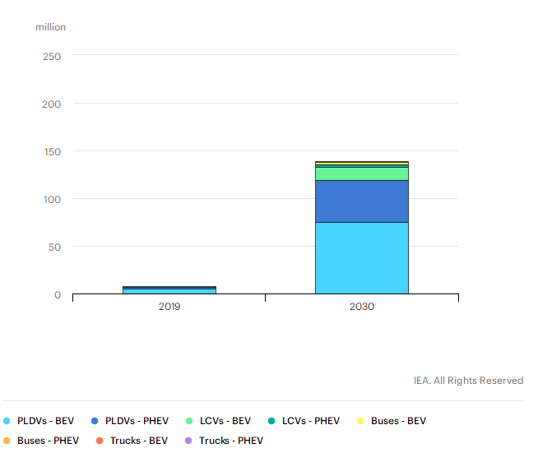

### Chart1 Global electric vehicle stock in the Stated Policies Scenario, 2019 and 2030

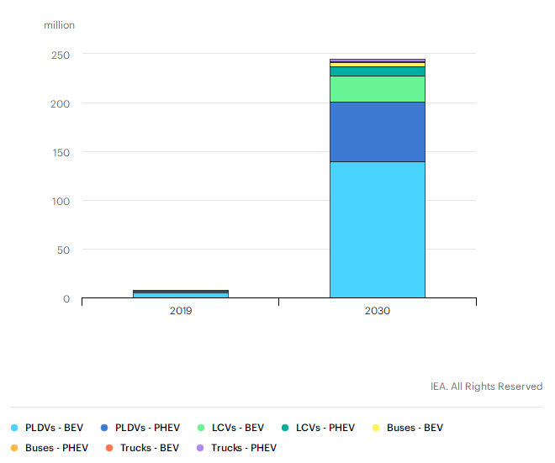

Chart2 Global electric vehicle stock in the Sustainable Development Scenario, 2019 and 2030

Through the two scenarios proposed by the IEA, there are two prospects for electric transportation by 2030: one is an established policy scenario that includes existing government policies, and the other is a sustainable development scenario that fully complies with the climate goals of the Paris Agreement.

The sustainable development plan includes the goal of the EV30@30 movement, which means that by 2030, with the exception of two-wheelers, the market share of all models of electric vehicles will reach 30%.

Electric vehicles play a key role in achieving the environmental goals envisaged for sustainable development, reducing local air pollution, and responding to climate change.

Under this circumstance, the global electric vehicle inventory (excluding two/three-wheelers) will increase by 36% every year, and will reach 245 million by 2030, which is more than 30 times the current level.

In addition to two- and three-wheeled vehicles, the strongest growth is in the field of light vehicles, where electric powertrain technology is most readily available.

Under the above policy scenario, it is assumed that the global electric vehicle inventory (excluding two- and three-wheeled vehicles) is close to 140 million vehicles, accounting for 7% of the total global vehicle fleet.(IEA (2020))

Therefore, it is not difficult to see that new energy vehicles will continue to be popularized globally after breakthroughs in technology in the future and standardization of the overall market. Although it is not known whether new energy vehicles can completely replace fuel vehicles in the future, the prospects for the next ten years are still quite impressive.

1. **Discussion and Conclusion**

In general, through research on new energy technologies, this report makes some comparisons and analyses between new energy vehicles and traditional vehicles. Starting from the environment and the market, using experimental data and other methods to compare and draw. In 2019, the global sales of plug-in hybrid vehicles (including pure electric vehicles) were approximately 2.2 million, with a market share of 2.5%. Among them, Tesla's sales of new energy vehicles in the United States ranks first in sales of new energy vehicles. As far as the current Chinese market is concerned, gasoline vehicles still dominate. In this study, we also compared the differences in energy consumption and pollutant emissions between new energy vehicles and traditional vehicles through the analysis of experimental data. It can be clearly compared through a series of experimental data that the pollutant emissions and energy consumption of traditional cars far exceed those of electric cars. In addition, this study also conducted a brief analysis of China's oil consumption and predicted the energy savings that electric vehicles can save globally after reaching a certain base. In the last part of the data collection, the project also evaluated and predicted the prospects of new energy technologies and pure electric vehicles. Thanks to the support of government policies and the prominent role of new energy vehicles in environmental protection, the prospects of new energy vehicles in the next ten years are rising. Although in the analysis process, some companies have a certain understanding of the challenges faced by new energy vehicles, but in the end these companies are destined to innovate and transform in the climax of new energy vehicles.

Suggestions for the above test results: The development of new energy vehicles still faces many challenges and unresolved problems. It takes a long process to completely replace traditional fuel vehicles, but the government and consumers are aware of the importance of environmental protection, and the test data also confirms that the impact of new energy vehicles on the environment is indeed much smaller than that of traditional vehicles. I hope that the technology will mature as soon as possible, and the development of new energy is worthier of everyone's expectation.

Finally, the purpose of this study is to analyse the competitiveness of new energy vehicles and the challenges they face. Through the above analysis, it can be concluded that the competitive advantages of new energy vehicles mainly lie in: energy saving and environmental protection, government policy support, and future trends. The main challenge is that the technology is not mature enough and the market price is relatively high.

In future researches can do more research based on how cheap is to use electrical car and whether it will be cost effective for emerging or developing countries to use electrical car.

**Reference**

Bing,L.,2010. "low-carbon expo" future new energy starts from 2010 Shanghai Expo. HARDWARE.

China Association of Automobile Manufacturers, 2021. Economic performance of automobile industry in May 2021 [WWW Document]. CAA. URL http://www.caam.org.cn/chn/4/cate_30/con_5234082.html (accessed 9.5.21).

China Association of Automobile Manufacturers, 2021. May 2021 new energy vehicles continue to set historical production and sales records for the month [WWW Document]. CAA. URL http://www.caam.org.cn/chn/4/cate_32/con_5234079.html (accessed 9.5.21).

Fang, Q., 2019. The impact of new energy vehicle technology development trend on the traditional automobile industry. *Consume Guide*, (51) (1672-5719), pp.25-36.

Hasan, F. 2020. How sustainability reporting has changed over the years for companies listed in oil and gas sector*. International Journal of Critical Accounting*. 11 (6), pp.520-557.

Hasan, F. 2021a. Corporate social responsibility and agency cost: Evidence from the UK retail industry.  *International Journal of Research in Finance and Management*. 4(2), pp.105-115.

Hasan, F., Hossen, R. and Shahbaz, A.A. 2021b. How Steel Industry has been Affected Due to Trade War Between the USA and China. *International Journal of Critical Accounting*. 12(4), pp.348-368.

Ministry of Ecology and Environment of the People’s Republic of China, 2020. China Mobile Source Environmental Management Annual Report. [online] Available at: <http://www.mee.gov.cn/hjzl/sthjzk/ydyhjgl/202008/P020200810554506003762.pdf> [Accessed 5 September 2021].

LeBeau, P., 2019. Tesla CEO Elon Musk’s influence grows as automakers roll out electric-vehicle plans at Detroit auto show. CNBC.

Liang,Z., 2009. Financial support for China's energy conservation and new energy industry, institute of linguistics, Chinese academy of social sciences (Beijing).

Phil, L., 2019. “Elon Musk’s Tesla Model Y Best Electric SUV In The Market?”. [online] Available at: <https://www.cnbc.com/2019/01/15/teslas-influence-grows-as-automakers-charge-up-electric-vehicle-plans.html> [Accessed 5 September 2021].

“Reducing Pollution with Electric Vehicles.” Office of Energy Efficiency and Renewable Energy. Department of Energy. <https://www.energy.gov/eere/electricvehicles/reducing-pollutionelectric-vehicles>

Sheng,G., Qin,S., Yanbao,L., and Ning,G.,2014.A comparative analysis of energy consumption and emissions of pure electric vehicles and traditional vehicles. Anhui: Hefei University of Technology.

Songwan,L.,2009. Development of new energy industry of fiscal policies and measures. *Shandong social science*, 11, pp118-120.

The People’s Daily, 2015. Xi Jinping: Developing new energy vehicles is the only way to become an automobile power [WWW Document]. People’s Daily online. URL http://auto.people.com.cn/n/2014/0526/c1005-25066662.html (accessed 9.5.21).

Transport Authority, 2021. In 2020, 33.28 million new energy vehicles were registered nationwide, reaching 4.92 million [WWW Document]. Ministry of Public Security of the People’s Republic of China. URL https://app.mps.gov.cn/gdnps/pc/content.jsp?id=7647257 (accessed 9.5.21).

Weixia,H., 2010. Analysis on the necessity of developing new energy. *Science and technology and life*, 22, pp 210-218.

Xu, X., 2017. Research on the impact of government support on the development of new energy industry. China University of Petroleum (Beijing).

Yongheng ,Z., Penghui,L., Jinbo,C., Hong,J. 2011. The new energy from the current situation of the study of scientific and technological achievements and the future development of our country. *The Chinese and foreign energy,* 12, pp 33-38.

Yunling,W. and Cun,G.2009.Take the road of new energy to replace traditional energy. *China economic and trade guide*, 14 (22), pp 215-280.