# Sub-fossil bark beetles as indicators of past disturbance events in temperate *Picea abies* mountain forests

Nick Schafstall1*, Niina Kuosmanen1,2, Petr Kuneš3, Helena Svitavská Svobodová3,4, Marek Svitok5,6, Richard C. Chiverrell7, Karen Halsall7, Peter Fleischer8,9, Miloš Knížek10, Jennifer L. Clear11

*1. Department of Forest Ecology, Faculty of Forest and Wood Sciences, Czech University of Life Sciences, Kamycka 129, 165 00 Praha-Suchdol, Czechia; nick.schafstall@gmail.com; kuosmanen.niina@gmail.com*

*2. Department of Geosciences and Geography, Faculty of Science, P.O. Box 64 (Gustaf Hällströmin katu 2)*

*FI-00014 University of Helsinki, Finland*

*3. Department of Botany, Faculty of Science, Charles University, Benátská 433/2, 128 01 Praha 2, Czechia; petr.kunes@natur.cuni.cz*

*4. Departmernt of Paleoecology, Institute of Botany v.v.i., Czech Academy of Sciences, Zámek 1, 252 43 Průhonice, Czechia;* [*helena.svitavskasvobodova@ibot.cas.cz*](mailto:helena.svitavskasvobodova@ibot.cas.cz)

*5. Department of Biology and General Ecology, Faculty of Ecology and Environmental Science, Technical University in Zvolen, T. G. Masaryka 24, 960 01 Zvolen, Slovakia; svitok@tuzvo.sk*

*6. Department of Ecosystem Biology, Faculty of Science, University of South Bohemia in České Budějovice, Branišovská 1760, 370 05 České Budějovice*

*7. Department of Geography and Planning, University of Liverpool, Roxby Building, Liverpool, L69 7ZT, United Kingdom; R.C.Chiverrell@liverpool.ac.uk; karen.halsall@gmail.com*

*8. Faculty of Forestry, Technical University in Zvolen, Ul. T. G. Masaryka 24, 960 01 Zvolen, Slovakia*

*p.fleischersr@gmail.com*

*9. State Forest of TANAP, Tatranská Lomnica 64, 059 60 Vysoké Tatry-Tatranská Lomnica, Slovakia*

*10. Forestry and Game Management Research Institute, Jı́loviště-Strnady, Czechia; knizek@vulhm.cz*

*11. Department of Geography and Environmental Science, Liverpool Hope University, Hope Park, Liverpool L16 9JD, United Kingdom; clearj@hope.ac.uk*

* Corresponding author: nick.schafstall@gmail.com

Keywords: Disturbance history; Bark beetle outbreaks; Fire; Fossil proxies; Ecosystem services; Central Europe; High Tatra Mountains

**Abstract**

Temperate mountain forests have experienced an increase in frequency and severity of natural disturbances (e.g., droughts, fires, windstorms and insect outbreaks) in recent decades due to climate and environmental change. Outbreaks of bark beetles have caused significant dieback of conifer forests in Central Europe and it is essential to model and predict the potential severity of future bark beetle outbreaks. However, to predict future bark beetle activity, historical baseline information is required to contextualize the magnitude of current and potential future outbreaks. A fossil beetle record from a forest hollow in the Tatra Mountains, Slovakia; one of the best-preserved national parks in Central Europe, was produced to identify insect outbreaks during the last millennia. Sub-fossil bark beetle remains were compared with parallel pollen and charcoal to assess whether peaks in conifer bark beetle remains correspond with indications of disturbance documented in historical or sedimentary fossil records. Three peaks in bark beetle remains were detected (1) post-2004, (2) AD 1140 – 1440, and (3) AD 930 – 1030. The abundance of species *Pityogenes chalcographus* and *Pityophthorus pityographus* in the two top samples can be linked directly to large bark beetle outbreaks in the High Tatra Mountains after 2004. *P. chalcographus* and *P. pityographus* are also the abundant species in the second peak (AD 1140 – 1440) while the third peak (AD 930 – 1030) consists of the species *Polygraphus poligraphus*. The most prominent conifer bark beetle in Central Europe, *Ips typographus*, was found to be present in most of the samples but always at very low numbers. It is plausible that *P. chalcographus* and *P. pityographus* fossils might be useful proxies for past conifer bark beetle outbreaks in Central Europe, as they occur together with fossils of *I. typographus* but appear to be well-preserved. A significant correlation was found between primary bark beetles and macroscopic charcoal densities in the sediment, highlighting the complex interactions between disturbance agents, bark beetles and fire, in this long-term regime of natural disturbances. Our 1400-year disturbance record shows how bark beetle outbreaks have been an important component of the regional natural disturbance regime for over a millennium and have intensified with increasing anthropogenic activity. Bark beetle outbreaks are likely one of the drivers promoting the future ecological stability of the temperate conifer ecosystem over decades to centuries.

**1. Introduction**

Temperate conifer forests cover large parts of the northern hemisphere, often in montane areas, and are typically occupied by endemic flora and fauna communities (Jeník, 1998; Amori et al., 2019). During recent decades, these forests have experienced significant environmental changes. Climate change has increased the frequency and severity of droughts, fires, windstorms and insect outbreaks; of which conifer bark beetles are a large component (e.g., Schelhaas et al., 2003; Seidl et al., 2017). Bark beetles can be categorized as either primary or secondary bark beetles: primary bark beetles are species which successfully invade and kill healthy trees while secondary bark beetles only colonize dead or dying trees (e.g., Martikainen et al., 1999). Primary bark beetle outbreaks have increased in both severity and scale across Europe and North America in the recent decades (Hicke et al., 2016; Thorn et al., 2017). Large quantities of trees are currently killed by bark beetle attacks annually, and these events are often triggered after other disturbance events such as fires and droughts (Geiszler et al., 1984; Kolb et al., 2016). Recurring bark beetle outbreaks have changed the forest structure in regions throughout Europe and North America, creating extensive areas of dead standing trees (Müller, 2011, Bentz et al., 2009).

Studies have been conducted with the aim of mitigating bark beetle outbreaks to prevent large-scale conifer tree mortality in the future (e.g., Fettig et al. 2007; Seidl et al., 2017). These studies vary from developing and improving methods to negate en masse colonization of trees by bark beetles (e.g., Jakuš and Šimko, 2000), to modelling approaches to predict the conditions under which future bark beetle outbreaks are more likely to happen (e.g., Hicke et al., 2006; Stadelmann et al., 2013). However, bark beetle outbreaks are a natural component of forest dynamics and it is possible that increases in outbreak frequency and/or severity may reflect the human manipulation of these natural forest systems into managed plantations (e.g., Zemek & Herman, 2001; Nagel et al., 2017).

The current bark beetle outbreaks in the Northern Hemisphere are unprecedented compared to the existing historical records (Schelhaas et al., 2003; Raffa et al., 2008), but these historical records date back only a few hundred years. Few paleoecological studies have been conducted to provide longer-term perspectives on the history of outbreaks (>200 years) of tree-killing bark beetle species in their primary habitats (Zhang et al., 1999; Morris et al., 2015; Jarvis and Kulakowski, 2015). Such paleoecological studies have great potential to provide important information on the current and future outbreaks by providing a historical baseline for the frequency and magnitude of past outbreaks and identify the conditions under which past outbreaks occurred (Froyd and Willis, 2008; Schafstall et al., 2020a). Natural forest disturbances over these longer (millennial) time scales have primarily been linked to fires identified from sedimentary charcoal (Kilgore and Taylor, 1979; Anderson et al., 2008; Carter et al., 2018). Fossil beetles have potential to be used as a proxy for paleo-reconstructions on various spatial and temporal scales, yielding proxy data for changes in vegetation composition, landscape structure and insect outbreaks (Olsson and Lemdahl, 2009; Smith et al., 2010; Whitehouse and Smith, 2010; Lindbladh et al., 2013). That said, to date there have been few attempts to reconstruct bark beetle outbreaks from sediment records (e.g., Schafstall et al. 2020a and citations therein). Reconstructing conifer bark beetle outbreaks requires large quantities of sediment to yield an abundance of fossil remains (Schafstall et al., 2020a). Previously, beetle remains from typically low volume lake sediment cores have been limited to qualitative reconstructions owing to the paucity of the fossil record recovered (Brunelle et al., 2008; Morris et al., 2015).

To reconstruct insect outbreaks during the last millennia, this study presents a local record of fossil bark beetle remains from a small forest hollow peat sequence in the High Tatra Mountains, Slovakia. This National Park is the largest non-intervention zone in Central Europe (European Union, 2013) and is currently under pressure by human activities and climate change (Fleischer et al., 2005; Rączkowska, 2019). Several large windstorms were documented in this region over the last century and a large area of Tatra National Park was affected by a severe windstorm in 2004, and consecutive outbreaks of *Ips typographus* have occurred since 2007 (Nikolov et al., 2014). Parallel analysis of fossil pollen was used to detect changes in vegetation, and sedimentary charcoal was used to reconstruct past fire events, facilitating the comparison of proxies to identify past forest disturbances. Disentangling these disturbance events within the High Tatra Mountains could reveal past bark beetle outbreaks and their relation to other disturbance evidence in the region. This multi-proxy assessment of paleo-disturbance could contribute to improving the understanding of the mechanisms behind current bark beetle outbreaks in Central Europe. We aim to explore the following hypotheses:

1. Conifer bark beetle remains from small forest hollow records provide a robust local indicator record for past outbreaks.
2. Correspondence of conifer bark beetle remains with other disturbance indicators (pollen and charcoal) highlights complex interactions between the drivers of forest disturbance.

**2. Material and methods**

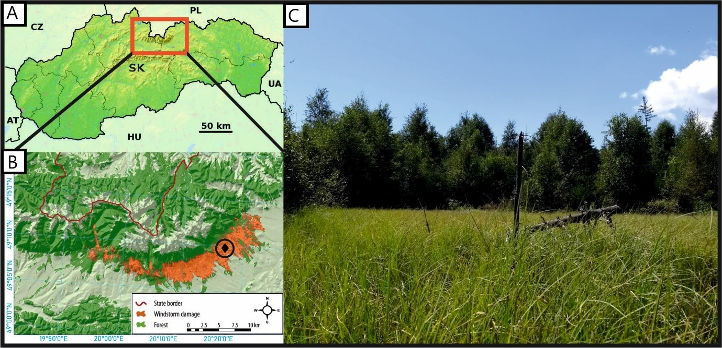

**Figure 1 The High Tatra Mountains in Slovakia (A), with the study site Diera Hollow (B; black diamond) located near the Slovak-Polish border. Map B after Nikolov et al. (2014) highlighting the area damaged by the 2004 windstorm Alžbeta. Photo of the sample site in 2017 (C).**

2.1 Site area

Tatra National Park is situated in the High Tatra Mountains and forms a large transboundary UNESCO biosphere reserve between Poland and Slovakia ([unesco.org](http://www.unesco.org/new/en/natural-sciences/environment/ecological-sciences/biosphere-reserves/europe-north-america/polandslovakia/tatra/)). The Tatra National park was established in Slovakia in 1949. Since the end of the 19th century the region has gradually developed from a cultural landscape into a popular tourist destination (Chrenka and Ira, 2011). The eastern part of the Tatra Mountains has a sub-continental climate with average monthly temperatures between -5.3 °C – 15.4 °C (Tatranská Lomnica weather station, 830 m a.s.l). The region is densely forested with *Picea abies* as the predominant tree species, together with *Pinus sylvestris, P. cembra*, *Larix decidua*, *Abies alba* and *Betula* sp. (Fleischer and Homolová, 2011). Two windstorms, in 2004 and 2014, damaged thousands of hectares of trees across a large area of the Tatra National Park (Nikolov et al., 2014). A series of bark beetle outbreaks have occurred since 2004 due to an abundance of deadwood and damaged trees. Outbreaks of *I. typographus* were ongoing in this region at the time of sampling in 2017 and have continued to damage a significant area of (mostly) large spruce trees between 2004 and 2017. This bark beetle outbreak and subsequent damage has expanded far beyond the area which was initially affected by the windstorms (Potterf et al., 2019).

A forest hollow located on the southern slope of the High Tatra Mountains was selected for paleoecological studies to reconstruct changes in forest composition, fire events and the associated changes in abundance of primary bark beetle species over the last 1000 years. Forest hollows are waterlogged anoxic peat depressions within a forest canopy. Due to their small to moderate size (~100 – 2000 m2) the fossil remains from these sites reflect a local signal of past disturbances, ideal for local studies of vegetation dynamics (Overballe-Petersen and Bradshaw, 2011). The source area for beetle remains is estimated to be up to 400 m from the sample site (Smith et al. 2010), which is similar to the source area of 200 – 400 m for pollen and charcoal particles in forest hollows (Sugita, 2007; Bradshaw, 2013). Diera Hollow is a small forest hollow of 30 x 80 m in size and located at 982 m a.s.l., near the village Tatranská Lomnica (49.1593° N, 20.26357° E; Fig. 1). The site was heavily affected by the autumnal storm Alžbeta in 2004 and is currently surrounded by *Pinus* sp., *Picea abies*, *Larix decidua*, *Betula* sp. and *Vaccinium myrtillus*. Seedlings of *Betula* sp., *Galium* sp., *Epilobium angustifolium* and Cyperaceae were found growing on the site during fieldwork.

2.2 Field methods

A master sediment core was extracted from Diera Hollow in 2016, with a 5 x 50 cm D-section corer (Jowsey 1965; Aaby & Digerfeldt 1986). To provide the volumes of material required for quantitative analysis of fossil beetles, a further 12 proximal sediment cores were sampled in 2017 using a gridded system (50 cm between cores), with a 10 x 50 cm D-section corer. Cores measured between 50 cm and 78 cm in total length due to variability of peat accumulation on top of the underlying bedrock. The master core (88 cm in length) was radiocarbon dated and analyzed for geochemistry (Energy-Dispersive X-Ray Fluorescence: ED-XRF), fossil beetles, fossil pollen and charcoal particles, while the additional cores were analyzed for geochemistry and fossil beetles. The master core and additional cores showed that the profile consisted completely of *Carex* peat, with some larger clasts from the underlying bedrock and wood fragments at the bottom of the profile. No hiatuses were registered. For further information on core correlation see Figure S2 and Schafstall et al. (2020b).

2.3 Chronology, geochemistry and subsampling

Four botanical macrofossil samples from the 2016 master core were dated in the Poznan radiocarbon laboratory and were used to establish a site chronology (Supplementary material). The absolute chronology was retrieved from the Bayesian age-depth model calculated in ‘BACON’ software (Blaauw & Christen, 2011) using the IntCal13 calibration curve (Reimer et al., 2013). All 13 cores, including the master profile, were analyzed for geochemistry on a wet-sediment basis using an Olympus Delta Professional ED-XRF mounted on the University of Liverpool Geotek Multi-Sensor Core Logger (MSCL). XRF is a common method in limnology (Davies et al., 2015) and, to lesser extent, in studies on peat profiles (e.g., Longman et al., 2019). Patterns in concentration of the atmospheric fallout pollutant Pb (Renberg et al., 2000) displayed a strongly repeatable signal. Profiles for conservative lithogenic elements (e.g., Rb) also showed strongly repeatable stratigraphic records, which facilitated cross-correlation of the cores. The master core was subsampled in 1-cm resolution, while the other 12 cores for beetle remains were subsampled according to their geochemical signals, resulting in 18 pooled samples of varying volume and temporal duration (see Figure S2).

2.4 Fossil beetle analysis

Fossil beetle preparation followed the methods described in detail by Elias (2010). Samples were wet sieved over 200 μm mesh size and the organic remains were soaked in paraffin oil and floated in water. Isolated flots were sieved at 200 μm and rinsed before being stored in ethanol (C2H5OH). Beetle remains were picked under a binocular light microscope with 10x magnification and were identified to family, genus and species level with the use of online databases (Kerbtier.de, Cassidae.uni.wroc.pl) and museum collections in United Kingdom (Plymouth City Museum and Oxford Museum of Natural History) and Czechia (Czech National Museum in Prague, the Central Bohemian Museum in Roztoky u Prahy and the Moravian Museum in Brno). A description of the complete beetle assemblage can be found in Schafstall et al. (2020b). Bark beetle (Scolytinae) remains consist of sub-fossil elytra, pronota, heads and legs. Species were classified as either primary or secondary bark beetle species, according to their ability to successfully attack and invade healthy trees (e.g., Martikainen et al., 1999). For each bark beetle taxon, the number of individuals per 100 ml of sediment sample was calculated to account for difference in sample sizes.

2.5 Pollen analysis

Pollen analysis of the 2016 master core was performed in continuous 1 cm resolution between 1-70 cm and in 2 cm intervals for the rest of the core, amounting to a total of 78 samples. Subsamples of 0.5 cm3 were prepared with standard procedures of KOH-, acetolysis- and HF-treatment (Fægri and Iversen 1989). The samples were mounted in glycerin and a minimum of 500 terrestrial pollen grains were identified under a light microscope using a 400x magnification. Pollen identification was based on standard pollen keys (Punt 1976–2003; Beug 2004, photographic atlases (Reille 1992–1998), and the reference collection of the Institute of Botany, CAS, in Průhonice. Pollen data were plotted using the program Tilia (Grimm, 1990).

2.6 Macroscopic charcoal analysis

Macroscopic charcoal (> 180 µm) analysis was performed in continuous 1 cm resolution on the 2016 master core to identify local fire events in the vicinity of the study site (Peters and Higuera, 2007; Higuera et al., 2007, 2010). Macroscopic charcoal was analyzed following a method adapted from Mooney and Tinner (2011). A known volume of sediment (0.5-1 cm3) was disaggregated using 20 ml sodium hexametaphosphate (Calgon™) with 10 ml potassium hydroxide (KOH) and left for a few hours. The sediment was washed gently through a 250 µm sieve, then either 1 or 2 ml of sodium hypochlorite was added to the sediment in water and left for the minimum time necessary to achieve a consistent bleaching effect up to a maximum time of overnight. The sediment was then washed gently through a 125 µm sieve to retain any fragmented particles. A light microscope and pipette were used to sort and remove any dark non-charcoal material, after which the Petri dishes were photographed using a 12-megapixel digital camera and light table. The total concentrations and influx of macroscopic charcoal counts were calculated for each sample.

CharAnalysis software was used to detect the peaks in macroscopic charcoal records indicating local fire events (Higuera, 2009, 2010; Kelly et al., 2011). First, macroscopic concentrations (particles / cm3) were interpolated to mean temporal sample resolution. Charcoal records were separated into low-frequency background component (BCHAR) and peak component using the CharAnalysis software (Higuera, 2009). To determine the background component, smoothing with LOWESS regression within a 200-year moving-window was employed. The peak component was then calculated as residuals between interpolated charcoal records and BCHAR (Cpeak = CHAR-BCHAR) and evaluated using the 99th percentile of a Gaussian mixture model in order to separate fire events reflected by charcoal peaks from the background noise. The detected peaks were screened using a minimum-count peak (p = 0.05) test in CharAnalysis.

2.7 Data analysis

The pollen record from Diera Hollow was used to calculate a Disturbance Frequency (DF) Index (after Kuneš et al., 2019). First, pollen identified in each sample were assigned to a plant species following Beug (2004) and associated with a disturbance indicator value of that species based on the Whole‐Community DF available for Central European flora (Herben et al., 2016). The DF is expressed as mean disturbance return time based on disturbance processes including logging, cutting, mowing, herbivory, trampling, herbicide, burning, wind‐throws, soil erosion, ploughing, hoeing or burrowing. If the given pollen taxon covers several species, one species was assigned at random (weighted by the present‐day frequencies of these species). This process was repeated 100 times to provide the mean disturbance indicator value represented by the given pollen grain. The mean DF of the pollen sample was calculated as a mean of estimated disturbance frequency indicator values of all pollen grains in the sample. DF is expressed on a common logarithm scale and ranges from −2 (once in 100 years) to 0.78 (six times per year).

Since a certain degree of correspondence among the disturbance indicators was expected, we assessed the relationships between the density of bark beetle remains, macroscopic charcoal influx and disturbance frequency index using cross-correlation functions (CCF). However, asynchronous unevenly spaced paleoecological time series, such as those analyzed here, make direct use of standard association measures impossible, as they rely on regular observations at identical time points (Chatfield & Xing, 2019). To overcome this limitation, we adopted binned correlation approach that allows to correlate irregular time series (Mudelsee, 2014). The binned correlation was performed by resampling the data into time bins on a regular grid that are assigned the mean values of the observations within these bins. To quantify the bin-widths, persistence time (memory) of the irregular series is calculated (Mudelsee, 2002) and the values are combined to an estimate of bin-width common to both compared time series. There are several rules for the calculation of bin-width from persistence times, but we used the rule based on average spacing as it showed superior performance in Monte Carlo simulations (Mudelsee, 2014). Since the bark beetle densities and charcoal fluxes showed heterogeneous variances and significant long-term trends (Mann-Kendall test; bark beetles: z = -2.01, p = 0.045 and charcoal: z = -6.65, p < 0.0001), we log-transformed and detrended linearly the variables to enhance stationarity. The analyses were performed in R (R Development Core Team, 2019) using the libraries bincor (Polanco-Martinez, 2018), ggplot2 (Wickham, 2016) and trend (Pohlert, 2018).

**3. Results**

3.1 Primary bark beetles

A total of 302 individuals from 22 taxa of the subfamily of Scolytinae, all conifer bark beetles, were identified from the beetle assemblages from Diera Hollow (Table 1). Primary bark beetle remains (see Table S2 for a summary of the ecology of these species) were found in higher numbers than secondary bark beetle remains; secondary bark beetles reached maximum values of 1.5 individuals per 100 ml sample but were completely absent in some of the samples. The amount of primary bark beetles per 100 ml sediment ranged between 0.3 and 5.9, depending on the sample. Primary bark beetles were more numerous around AD 900 – 1000, 1300 – 1500 and in the top sample which has a basal age of ~ AD 2000. Three taxa of primary bark beetles; *Polygraphus poligraphus* (L.), *Pityogenes chalcographus* (L.) and *Pityophthorus pityographus* (Ratz.) appeared in numbers of five individuals or more in at least one of the 18 samples, while all other taxa have occurrences in low numbers of less than five individuals per sample (Table 1). The pollen and charcoal records from the 2016 master core extend from AD 590 until present, while the bark beetle record extends from AD 930 until present. For the bark beetle samples, the median between the minimum and maximum age of each sample (see Table 1) was taken to create single data points in order to compare the bark beetle record with the other proxy records.

The first distinctive peak in bark beetle remains (see Table S2; Figure 2) was found in samples 17 and 18 (AD 930 – 1030), with high numbers of *P. poligraphus*. Starting from sample 14 (AD 1140), but most prominently in sample 12 (AD 1390), a distinctive peak in the numbers of *P. chalcographus* and *P. pityographus* was found, although these values only exceed the standard deviation (SD) for *P*. *pityographus* in sample 12 (AD 1390). Finally, samples 1 and 2 contain high amounts of *P. chalcographus* and *P. pityographus*, with numbers several times exceeding the SD of *P. chalcographus* in sample 1 (AD 2000 – present).

**Table 1 Counts of primary (P) and secondary (S) bark beetles (Scolytinae) from the samples of Diera Hollow. The preferred host per taxon is displayed as Pinus (Pin), Picea (Pic), Abies (Ab) or Larix (Lar). The number of P and S bark beetles per 100 ml sediment of each sample is displayed at the bottom of the table. The bottom row shows the total number of identified individuals from all Coleoptera families, per sample.**

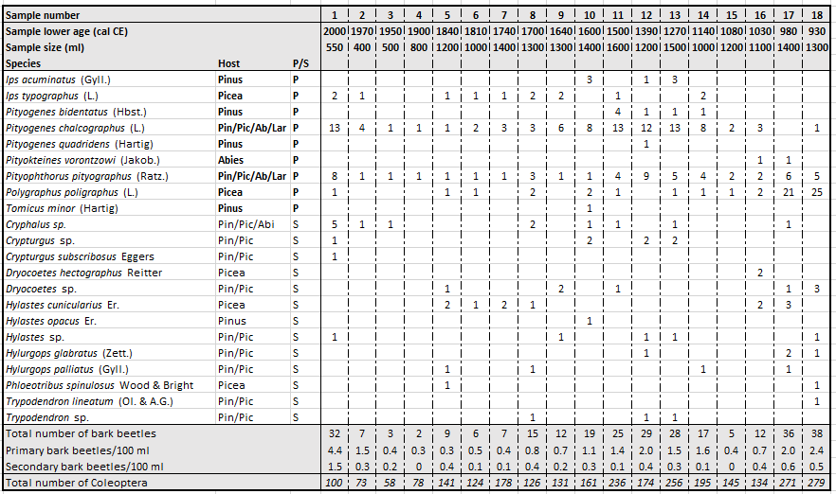

**Fig 2 Summary figure showing fossil records from Diera Hollow. A disturbance frequency index based on the composition of different plant taxa in the pollen record (log-transformed), displayed with its standard deviation; a macroscopic charcoal influx (particles cm-2 year-1), with fire events marked as pluses calculated from offsets from the background signal BCHAR (red line); forestry historical records starting from AD 1800, showing documented wind throws and bark beetle outbreaks (106m3 loss of wood); primary bark beetle remains (individuals per 100 ml; single occurrences) obtained from the same locality. For a description of the ecology of identified bark beetle species, see table S2. Zones highlighted in grey correspond to the samples where high abundances of primary bark beetles were found. Pollen abundances (% terrestrial pollen sum) of the conifer host tree taxa *Picea abies, Pinus* spp.and *Abies alba*, as well as *Fagus sylvatica* to show changes in the broadleaved tree community. The pollen and macroscopic charcoal record extend from AD 590 until present, while the bark beetle record extends from AD 930 until present. Depth and correlated ages are displayed on the left.**

3.2 Changes in dominant tree taxa

Notable changes occur in the pollen record of main conifer tree taxa, namely *Picea abies, Pinus* spp. and *Abies alba*. *Fagus sylvatica* was abundant in the lower part of the pollen record (AD 590 – 1300). A peak in *A. alba* pollen occurs around AD 1000, with pollen values otherwise remaining relatively constant between AD 590 – 1250. *F. sylvatica* values gradually increased until ca. AD 1300. Between AD 1300 – 1400, pollen values of *A.* *alba*, *P.* *abies* and *F. sylvatica* decreased significantly. Around AD 1400 a peak in the *Pinus* pollen curve occurs, which subsides ca. AD 1550. *F. sylvatica* pollen increased slightly between ca. AD 1600 – 1800 but remained at lower values. *P. abies* pollen increased around AD 1600 while *A. alba* pollen continued to decrease; *Pinus* pollen gradually started to increase from AD 1750. At AD 1850, *P. abies* pollen values reached their second maximum while *Pinus* pollen simultaneously showed a brief decrease. From AD 1950, *Pinus* pollen values were as high as around AD 1500. *A. alba* pollen are almost absent at this time. More detailed data from the pollen record have been published in Schafstall et al. (2020b).

3.3 Disturbance events detected by Disturbance Frequency Index

The disturbance index (DI) shows continuously lower values before AD 1250 (Figure 2). Between AD 1250 – 1400, high values of the DI indicate an increased disturbance of the vegetation surrounding Diera Hollow. A second, more moderate period of increased vegetation disturbances occurs between AD 1550 – 1850. Between AD 1900 – 1950, a short disturbance event of similar magnitude as AD 1550 – 1850 is recorded.

3.4 Past fire events

Macroscopic charcoal influx values (particles cm-2 year-1) are higher in the oldest part of the core (AD 560 – 1450) and drop notably after AD 1450 (Figure 2). Between AD 560 – 870 values remain constantly above 4 particles cm-2 year-1 on average, after which values remain lower except for short peaks at AD 950 and AD 1220. Notable increases in macroscopic charcoal record occur between AD 1260 – 1360 with the highest amount of macro-charcoal (18 particles cm-2 year-1) around AD 1320. There is a decline in charcoal concentrations between AD 1370 – 1420, followed by another short peak around AD 1430. After this, the macroscopic charcoal concentrations decline below 2 particles cm-2 year-1 until ~ AD 1970, when there is a moderate peak in the macroscopic charcoal record. CharAnalysis detected possible nearby (<400 m) fire events between AD 600 – 1040 as well as fire events before and after the high increase in charcoal between AD 1250 – 1400. Further possible fire events were detected between AD 1600 and present, even though the amounts of macroscopic charcoal were much lower.

3.5 Correspondence of disturbance indicators

The cross-correlation analysis revealed significant relationships between the binned time series of primary bark beetles and charcoal at lags 1 and -2 (Figure 3a). The positive correlation at lag 1 (rxy = 0.67, p = 0.021) suggests that higher macroscopic charcoal fluxes are followed by the increase of bark beetle densities. The high negative correlation at lag -2 (rxy = -0.68, p = 0.019) may reflect a low frequency of fire events over a horizon of ~170 years after the bark beetle outbreak. However, considering the precision in the age estimates of these records (Table S2), the lagged relationships may stem also from the chronological uncertainties and we cannot rule out that dating uncertainties, rather than a real long-lasting effect, caused the lagged response.

No significant relationship was found between the binned time series of bark beetles and disturbance frequency index (Figure 3b).

In contrast, the CCF analysis showed significant positive correlations between DI and charcoal at time lag 0 (rxy = 0.35, p = 0.008) and lag 1 (rxy = 0.36, p = 0.007) and lag 2 (rxy = 0.30, p = 0.027) (Figure 3c). These results indicate the immediate positive response of DI to fire events that lasts up to ~18 years (lag 1). Also, modelled lagged correlations between DI-charcoal should be considered with caution due to the precision in the age estimates of these records.

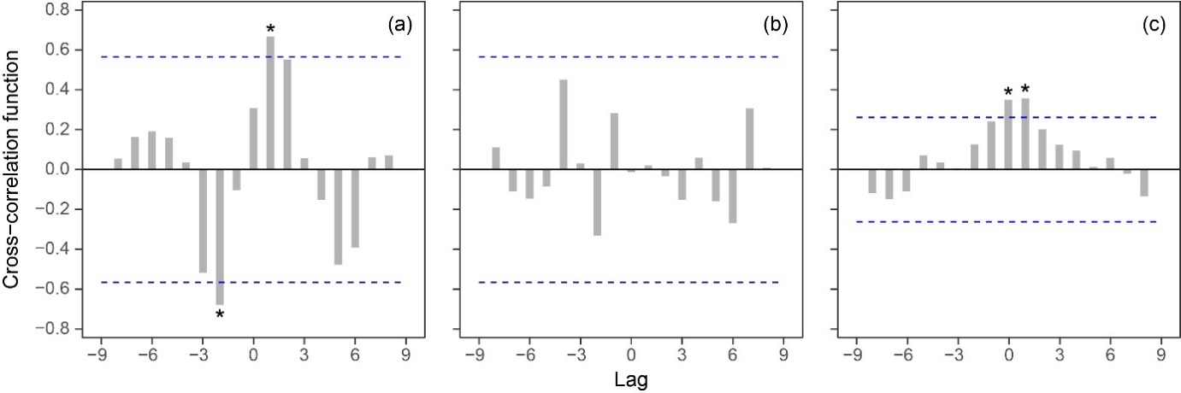

**Figure 3 Cross-correlation function of the binned time series of primary bark beetles and macroscopic charcoal influx (a), bark beetles and disturbance index (b), and disturbance index and charcoal (c). The estimated persistence times are 71 years for bark beetles, 31 years for charcoal and 39 years for disturbance index series. The lags are equivalent to 83 years (a, b) and 18 years (c). Dashed lines represent 95% confidence bands. Cross-correlations significant at α = 0.05 are marked with asterisks.**

**4. Discussion**

Here we present the first fossil beetle record from Central Europe which demonstrates that conifer bark beetles, when analyzed in large quantities, can be used as a reliable proxy to reconstruct past insect outbreaks. Previously, only one fossil site from North America recorded similar amounts of primary conifer bark beetle species (Elias et al., 1991; documented in Schafstall et al., 2020a). The well-documented large bark beetle outbreak in the High Tatras after AD 2004 was clearly recorded in the sediment record, providing means to assess bark beetle remains from older samples as an indication of past bark beetle outbreaks. Therefore, within the 1400-year limit of this record, our data suggestthreebark beetle outbreaks on a 400 – 500-year frequency in the area around Diera Hollow.

4.1 The fossil bark beetle record and other records of past disturbance

Peaks in the numbers of bark beetle fossils as well as pollen and charcoal show a 1400-year long disturbance record for the High Tatra Mountains. The modern bark beetle outbreak which started after AD 2004 is apparent in the fossil bark beetle record, with a distinctive peak in numbers of *P. chalcographus* and *P. pityographus*. The post-2004 outbreaks of *I. typographus* affected a large area between ca. 2007 and 2017 (Potterf et al., 2019), including the area around Diera Hollow. Almost every year during this period, more than 1000 hectares of forest loss in the total area was contributed to bark beetle attacks (Havašová et al., 2017). *P. chalcographus* and *P. pityographus* appear in the same area and attack the same individual trees as *I. typographus*, whereas *P. chalcographus* maintains populations in much higher numbers than *I. typographus* (Jurc et al., 2006; Zubrik et al., 2008). Here, the peaks in fossil remains of *P. chalcographus* and *P. pityographus* clearly indicate the post-2004 outbreak in the area around Diera Hollow.

Based on the proxy data for disturbance events, there appears to be a relationship between other disturbances such as fire between AD 1250 – 1400 and the higher numbers of *P. chalcographu*s and *P. pityographus* fossils around the same time, although only the number of *P. pityographus* remains exceeds their SD (see table S2). The disturbance index (DI) is extremely high during this time (up to -1.0, indicating a disturbance event approx. every ten years), and higher values of macrofossil charcoal (8 – 16 particles cm-2 year-1) suggest that forest fires occurred in the area between AD 1250 – 1400. The increase in macrofossil charcoal and DI coincides with the first evidence of human disturbances in the region, according to the presence of human-indicator pollen (e.g, Cerealia-type; Gaillard, 2013) as presented in Schafstall et al. (2020b). Even though no settlements have been recorded in the vicinity of the sample site, this period of increased disturbances might be linked to the Wallachian expansion (Kołaczek et al., 2020) due to the timing of these events. Directly after the period of high disturbance, several bark beetle species feeding on *Pinus* spp. were identified in the fossil record. As *P. chalcographu*s and *P. pityographus* colonize not only *P. abies* but also other conifer taxa (for an overview of the ecology of the Scolytinae found in this study, see Table S3), it is likely that the peak in remains of this species is related to an increase of pine trees around Diera Hollow following the major disturbance event(s) between AD 1250 – 1400. The bark beetles, charcoal and pollen data suggest that over the past 1400 years, a significant relationship occured between bark beetle population densities and forest fires. The nature of the relationship that exists between bark beetle outbreaks and fires (charcoal), remains however elusive. Although the atmospheric Pb signal provides accurate correlation in the upper parts of the multiple cores from Diera Hollow (Le Roux et al., 2005). variation in sample sizes and resolution (see figure S2) may have caused bias to the statistical analyses, e.g., regression.

In parts of North America, where forest fires are a common disturbance agent, relationships between forest fires and bark beetle outbreaks have been described and modelled (e.g., Jenkins et al., 2014; Sieg et al, 2017). These studies suggest that bark beetle outbreaks increase the amount of available deadwood which has been argued to increase the frequency and severity of wildfires (Page and Jenkins, 2007; Sieg et al, 2017). The peak in remains of the primary bark beetle *P. poligraphus* at Diera Hollow around AD 930 – 1030 exceeded its SD significantly, although no increased DI was found during this period. *P. poligraphus*, however, has been recorded to only cause major dieback of its host, *P. abies*, when the trees are severely weakened (Kraemer, 1953). There is also a possible relationship between the outbreak of *P. poligraphus* and forest fires. The macrofossil charcoal record suggests that several fire events took place prior to the peaks in remains of *P. poligraphus* but as the beetle record only starts at AD 930, it remains uncertain if the increase in *P. poligraphus* remains occurred before, during or after the occurrence of local fires. A profound increase in macroscopic charcoal suggests a change in fire regime between AD 1250 – 1400, alongside notable disturbances in the vegetation composition. The correspondence of these changes in fire events with greater human activity in the region is highly suggestive of human interference with or manipulation of the fire regime, either direct by controlled burning or indirect by making changes to the vegetation structure (Figure 4).The complete beetle record does not indicate human occupation in the vicinity of Diera Hollow (e.g. synanthropic species, dung beetles; Schafstall et al., 2020b) and historical records of human activity in the region (Gladkiewicz and Homza, 2003; Rączkowska, 2019) do not recount any centres of occupation in the vicinity of Diera Hollow, Still, the pollen record (Schafstall et al., 2020b; Kuosmanen et al., under review) indicates clear human impact in the surrounding area, suggesting that changes in forest composition around Diera Hollow have been under the influence of increasing levels of human activity since AD 1250.

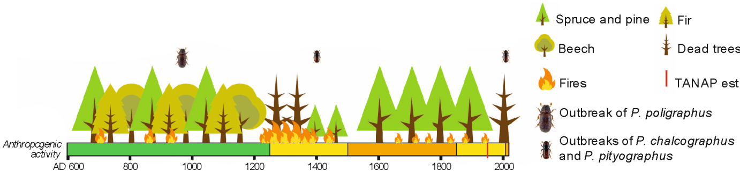

**Figure 4 An overview of the development of forest structure, fire events and bark beetle outbreaks around Diera Hollow at the foothills of the High Tatra Mountains in Slovakia, compared to a simplified estimation of regional anthropogenic activity (such as clearcutting, logging and grazing) in the region based on human-indicator pollen and historical records. Green colour equals ‘absent’, yellow equals ‘present’ and orange equals ‘increasingly’ Displayed tree taxa are *Picea abies* (spruce) and *Pinus* spp. (pine), *Abies alba* (fir) and *Fagus sylvatica* (beech). Tatra National Park (TANAP) was established in 1949.**

Between AD 1500 and 2000, the DI and charcoal records suggest multiple disturbance events, however peaks in primary bark beetle remains are absent. The amount of bark beetle fossils remains low despite several reconstructed fire events and an increased DI of the vegetation between AD 1550 – 1800 and around AD 1930 (Figure 2). The area was under moderate anthropogenic pressure between AD 1500 ~ 1800, primarily under the Walachian colonization of the Slovakian uplands which led to herding intensification above the timberline and in forest glades (Gladkiewicz and Homza, 2003; Rączkowska, 2019 and references therein). Mining activities might have influenced the landscape since the 11th century and mining activity continued until the 20th century, but sources are mostly absent on the Slovak side of the mountains and Polish references show activity >10 km from Diera Hollow (Rączkowska, 2019). Forest inventory historical records are sparsely recorded since AD 1800 but more precisely recorded after AD 1900 (Figure 2; Koreň, 2006) and describe several additional windstorm disturbances in the High Tatra Mountains. These include a large windstorm in AD 1925, which also affected the area around Diera Hollow (Koreň, 2006) and could be related to the peak in the DI around AD 1930. The largest windstorms occurred in 1915, 1941, 1981 and 2004, but not all affected the area around Diera Hollow. Although the bark beetle outbreaks after the windstorm of 2004 are by far the largest recorded for this area, three previous bark beetle outbreaks are described in the historical records (Koreň, 2006). Substantial bark beetle damage was reported 30 km away to the west of Diera Hollow after the 1925 windstorm. Koreň (2006) reports two other large-scale bark beetle outbreaks before 2004 from a location approximately 10 km north of Diera Hollow, on the other side of the eastern mountain range in 1968 and the more recent one between 1993 – 1998 (Grodzki et al., 2010). Even this distance appears to have been large enough for the bark beetle outbreak to be absent in our fossil record.

4.2 Quantifying bark beetle fossil remains to reconstruct past outbreaks

These results of a first quantitative bark beetle record for Central Europe show that the use of large amounts of sediment (~2 liters per 10 cm profile) can lead to quantitative reconstructions from forest beetle remains (e.g., Whitehouse, 2004; Olsson and Lemdahl, 2009; Zhang and Elias, 2019). Conifer bark beetles seem to preserve very well in acid peat bogs, which are in general good sites to identify fossil beetle remains (e.g., Ellias, 2010). The distinctive peak in numbers of *P. chalcographus* and *P. pityographus* around AD 2004 shows that it is possible to correlate peaks in numbers of bark beetle remains to historical outbreaks. Low numbers of *I. typographus* do not indicate any outbreak around AD 2004. An increase in the occurrences of *I. typographus* fossils from AD 1550 onward might suggest an increase in this conifer pest around the sample site, but due to low occurrences in the fossil record of 1 or 2 individuals per sample no correlation could be made. Although the absence of a species in the fossil record does not necessarily mean the absence of the species during that time, which is likely also the case for *I. typographus*, remains of *P. chalcographus* and *P. pityographus* are continuously present at Diera Hollow and show clear fluctuations throughout the record. Both *I. typographus* and *P. chalcographus* have been recorded in high numbers from pheromone traps during outbreaks in various locations in Central Europe; tens of thousands of specimens of *I. typographus* and hundreds of thousands of specimens of *P. chalcographus* are mentioned from different sources, with exact numbers depending on the region (Niemeyer, 1992; Jurc et al., 2006; Zubrik et al., 2008). Although *P. chalcographus* generally exceeds *I. typographus* in numbers eight- to tenfold during outbreaks, it is remarkable that no peak in *I. typographus* remains was recorded around AD 2004. There are, however, indications that not only high densities of its primary host *Picea abies* but also several other factors such as crown closure and stand age determine local concentrations of *I. typographus* populations (Schroeder, 2012; Økland et al., 2016; Stereńczak et al., 2020), which would complicate any quantitative fossil signal. *P. chalcographus* (and the less intensively studied *P. pityographus*) densities are primarily linked to Norway spruce stand density (Schroeder, 2012) and therefore, together with their apparent abundance in the fossil record, peaks in the fossil remains of these two species might be a more suitable proxy for conifer bark beetle outbreaks in Central Europe.

The three reconstructed bark beetle outbreaks appear to have occurred under different relationships to other agents of disturbance. Changes in the landscape from AD 1250 onward possibly caused a change of bark beetle regimes from a closed spruce forest with *P. poligraphus* as dominant bark beetle species to a semi-open forest landscape dominated by *I. typographus,* *P. chalcographus* and *P. pityographus*. The high abundances of several tree-killing bark beetle species at Diera Hollow show that it is beneficial to consider multiple beetle species in addition to the main disturbance agent *I. typographus* to understand the disturbance conditions. As multiple species of primary bark beetle can increase in population size during an outbreak of the main bark beetle (Schroeder, 2012), several species could be targeted in the search for past bark beetle outbreaks.

Just like other studies based on fossil beetle remains, bark beetle fossil remains provide a highly detailed but strictly local signal of past outbreaks and for more regional reconstructions several sites would need to be studied. Historically documented outbreaks that occurred around 10 km away from the sample site (Grodzki et al., 2010) were not captured in the sediment record at Diera hollow, confirming that those outbreaks were too far away to generate a noticeable peak in the bark beetle record. For regional studies on the frequency and magnitude of bark beetle outbreaks, multiple records from areas where recent bark beetle outbreaks took place should be considered.

4.3 Bark beetle outbreaks and ecosystem services in temperate mountain forests

The 1000-year bark beetle record from this study is an important step in the development of new proxy records for long-term forest dynamics in Central Europe, adding to recent studies on vegetation development and fire events in this region (e.g., Jamrichová et al., 2017; Feurdean et al., 2017; Carter et al., 2018). Bark beetle remains were found in Late Glacial sediments (Schafstall et al., 2020a and references therein) and have likely been part of forest ecosystems for millions of years (Kirejtshuk et al., 2009). Yet, recent bark beetle outbreaks have been perceived as intensive and beyond the natural background signal by local authorities. The Slovakian government supported a large-scale salvage logging project to mitigate bark beetle outbreaks in the High Tatra Mountains after 2005 (Nikolov et al., 2014; Havašová et al., 2017). Controversy remains about the long-term effects of these management actions (Vanička et al., 2020) such as the delay of natural regeneration on the affected plots (Michalová et al., 2017) and the effects on water circulation by an increase in forest infrastructure (Fidelus-Orzechowska et al., 2018). There is currently an increase in studies that argue for the positive role of primary bark beetles as keystone species in forest dynamics in Central Europe, as they create new gaps in the vegetation which support biodiversity (e.g., Müller et al., 2008; Horák et al., 2016; Kameniar et al., 2021). Additionally, a range of recent studies highlights the negative effects of salvage logging on forest biodiversity, such as bird species (Mikoláš et al. 2017), saproxylic insects (Kozák et al., 2021), fungi and other specialist species that require a diverse forest structure with high amounts of deadwood (e.g., Zemanová, 2017; Thorn et al., 2018). The relevance of suppressing bark beetle outbreaks in commercial forests is foremost understandable (e.g., Toth et al., 2020), but bark beetle attacks do not necessarily have a negative impact on the forest ecosystem, as was found in particular in studies on the long-term effect of large disturbances on forest biomass (Trotsiuk et al., 2016; Seedre et al., 2020), forest hydrology (Kopáček et al., 2020) and water quality (Beudert et al., 2014). While most arguments about bark beetle attacks as a negative effect on ecosystem services are currently contradicted by other studies, the perception of the public and of policy makers on bark beetle outbreaks generally remains negative (Werner et al., 2006; Müller, 2011; Mikusiński and Niedziałkowski, 2020). It has become increasingly important to educate the general public as well as policy makers about the social-ecological implications of bark beetle outbreaks (e.g., Morris et al., 2017). Recent dendroecological studies on European primary *Picea* forests show that increasingly common high-severity disturbances are not only a result of climate change and should be reinterpreted considering legacy effects (resulting in increased susceptibility e.g., Schurman et al. 2018). In contrast with the literature on stand scale natural disturbance reconstructions (e.g., Szewczyk et al., 2011), recent landscape level studies show that large scale natural disturbances historically occurred in primary (unmanaged) forest landscapes (Svoboda et al., 2014; Janda et al., 2017). This study contributes to the conception that bark beetle outbreaks, even in their unprecedented magnitude, are acting as a natural disturbance agent in temperate conifer mountain forest (e.g., Kulakowski, 2016). On a longer time scale, such bark beetle outbreaks would likely be one of the drivers to promote a dynamic ecological system typical for temperate conifer ecosystems, with higher tolerance to our current climate (Kulakowski et al., 2017). Therefore, the stakeholders of Tatra National Park and any other national park in Central Europe would be advised to adopt other management practices than salvage logging as reactions to bark beetle outbreaks.

**5 Conclusions**

This study presents the first sub-fossil record with high numbers of conifer bark beetle remains in mountain spruce forests of Central Europe. Large amounts of sub-fossil conifer bark beetles from a 1000-year long peat record from a forest hollow in the High Tatra Mountains, Slovakia were compared with indications of disturbance derived from pollen and charcoal records. High numbers of the primary bark beetles *P. chalcographus* and *P. pityographus* were found in the top samples of the sediment core and correlated to the large bark beetle outbreak which started in this region after a windstorm in 2004. Between AD 1140 – 1500 elevated numbers of *P. chalcographus* and *P. pityographus* likely indicate outbreaks on *Pinus* spp. trees during the ecological succession that occurred after a large disturbance around the sample site. High occurrences of *P. poligraphus* around AD 930 are likely indicators of an outbreak of this species, although no changes to the vegetation structure were recorded during this period. The main disturbance agent *I*. *typographus* was only found in very low numbers (1 or 2 individuals per sample) and no increases in numbers were found in the top samples. Although outbreaks of *P. chalcographus* and *P. pityographus* do not cause major mortality of mature *P. abies* trees, their high abundance and direct relation to densities of the host tree species, potential render these species a more accessible proxy record for bark beetle outbreaks than the remains of *I. typographus*. A significant correlation between bark beetle and macroscopic charcoal densities highlights the role of bark beetles in the natural disturbance regime of this region. Comparison with historical records of outbreaks in the region during the last 100 years suggests that only nearby outbreaks (<10 km) were recorded in our record, however additional studies would be required to confirm this. Our study shows that in the High Tatra Mountains, bark beetle outbreaks were a natural part of the forest dynamics that developed with the increase in anthropogenic activity. Over a timescale of decades to centuries, bark beetle outbreaks are likely to be one of the key drivers that promote ecological stability and higher resilience of these temperate conifer ecosystems.

**6 Acknowledgements**

We thank Daniel Vondrák and Jana Beranová, who assisted with the fieldwork in Slovakia. Martin Mikoláš provided valuable advice about the role of primary bark beetles in Central European forests. Icons for trees and fire, used in Figure 4, were freely downloaded from https://www.vecteezy.com/free-vector/autumn and <https://www.vecteezy.com/free-vector/fire>

**7 Funding**

NS, HSS, KH, NK, PK, RCC and JLC (PI) were supported by the PEDECO project, by the Czech Science Foundation (16-23183Y). NS, NK and PK were also supported by the BESTFORCE -project (20-13368S) by the Czech Science foundation. NS was also supported by the Czech University of Life Sciences (IGA A_19_04). NK was further supported from project 323065 by the Academy of Finland. HSS was further supported by the Czech Academy of Science (RVO 67985939). MK was supported by the Ministry of Agriculture of the Czech Republic, institutional support MZE-RO0118. MS was supported by the Operational Programme Integrated Infrastructure (OPII), funded by the ERDF (ITMS 313011T721).

**8 References**

Aaby, B., Digerfeldt, G., 1986. Sampling techniques for lakes and bogs, in: Berglund, B.E., (Ed.), Handbook of Holocene Palaeoecology and Palaeohydrology. Wiley, N.Y., pp. 181 – 194.

Amori, G., Boitani, L., Milana, G., et al., 2019. Endemism and diversity in European montane mammals: macro-ecological patterns. Biological Journal of the Linnean Society, 128(1), 225 – 237. https://doi.org/10.1093/biolinnean/blz081

Anderson, R.S., Allen, C.D., Toney, J.L. et al., 2008. Holocene vegetation and fire regimes in subalpine and mixed conifer forests, southern Rocky Mountains, USA. International Journal of Wildland Fire 17(1), 96 – 114. DOI: 10.1071/WF07028

Bentz, B., Logan, J., MacMahon, J. et al., 2009. Bark Beetle Outbreaks in Western North America: Causes and Consequences. Salt Lake City, UT: The University of Utah Press,

42 pp. https://www.fs.usda.gov/treesearch/pubs/43479

Beudert, B., Bässler, C., Thorn, S. et al., 2014. Bark beetles increase biodiversity while maintaining drinking water quality. Conservation Letters 8(4), 272 - 281. DOI: 10.1111/conl.12153

Beug, H.J., 2004. Leitfaden der Pollenbestimmung für Mitteleuropa und angrenzende Gebiete(Guide to the Pollen Analysis for Central Europe and the adjacent Areas). Pfeil, München.

Blaauw, M. and Christen, J.A., 2011. Flexible paleoclimate age-depth models using an autoregressive gamma process. Bayesian Anal. 6, 457 – 474. DOI: 10.1214/ba/1339616472

Bradshaw, R.H.W., 2013. *Stand-scale palynology*. In: Elias SA (ed.) Encyclopedia of Quaternary Science, vol. 3. Amsterdam: Elsevier, pp. 846–853.

Brunelle, A., Rehfeldt, G.E., Bentz, B. et al., 2008. Holocene records of Dendroctonus bark beetles in high elevation pine forests of Idaho and Montana, USA. Forest ecology and Management 255, 836 – 846. DOI: 10.1016/j.foreco.2007.10.008

Čada, V., Morrissey, R.C., Michalová, Z. et al., 2016. Frequent severe natural disturbances and non-equilibrium landscape dynamics shaped the mountain spruce forest in central Europe. Forest Ecology and Management 363, 169 – 178. DOI: 10.1016/j.foreco.2015.12.023

Carter, V.A., Moravcová, A., Chiverrell, R.C et al., 2018. Holocene-scale fire dynamics of central European temperate spruce-beech forests. Quaternary Science Reviews 191, 15 – 30. DOI: 10.1016/j.quascirev.2018.05.001

Chatfield, C., Xing, H., 2019. *The analysis of time series: an introduction with R*, 7th edition CRC press, Boca Raton.

Chrenka, B. and Ira, V., 2011. Transformation of tourist landscapes in mountain areas: case studies from Slovakia. Human Geographies 5(2), 13 – 20. http://humangeographies.org.ro/articles/52/5_2_11_2_chrenka.pdf

Clark, S.H.E. and Edwards, K.J., 2004. Elm bark beetle in Holocene peat deposits and the northwest European elm decline. Journal of Quaternary Science 19(6), 525 – 528. DOI: 10.1002/jqs.863

Davies, S., Lamb, H. and Roberts, S., 2015. Micro-XRF Core Scanning in Palaeolimnology: Recent Developments. In: Croudace, I., Rothwell, R. (eds) Micro-XRF Studies of Sediment Cores. Developments in Paleoenvironmental Research, vol 17. Springer, Dordrecht.

Elias, S.A.,Carrara, P.E., Tollin, L.J., et al., 1991. Revised age of deglaciation of Lake Emma based on new radiocarbon and macrofossil analyses. Quaternary Research 36, 307 – 321. https://doi.org/10.1016/0033-5894(91)90005-P

Elias, S.A., 2010. *Advances in Quaternary Entomology*. Elsevier, Amsterdam.

European Union, 2013. Guidelines on Wilderness in Natura 2000. ISBN 978-92-79-31157-4

Fægri, K., Iversen, J., 1989. Textbook of pollen analysis. Wiley and Sons, Chichester.

Fettig, C.J., Klepzig, K.D., Billings, R.F. et al., 2007. The effectiveness of vegetation management practices for prevention and control of bark beetle infestations in coniferous forests of the western and southern United States. Forest Ecology and Management 238, 24 – 53. DOI: 10.1016/j.foreco.2006.10.011

Feurdean, A., Florescu, G., Vannière, B. et al., 2017. Fire has been an important driver of forest dynamics in the Carpathian Mountains during the Holocene. Forest Ecology and Management 389, 15 – 26. DOI: 10.1016/j.foreco.2016.11.046

Fidelus-Orzechowska, J., Strzyżowski, D. and Żelazny, M., 2018. The geomorphic activity of forest roads and its dependencies in the Tatra Mountains. Geografiska Annaler: Series A, Physical Geography 100(1), 59 – 74. https://doi.org/10.1080/04353676.2017.1376585

Fleischer, P., Godzik, B., Bicarova, S. et al., 2005. Effects of air pollution and climate change on forests of the Tatra Mountains, Central Europe. In: Omasa, K., Nouchi, I., de Kok, L.J. (Eds.), Plant Responses to Air Pollution and Global Change. Springer, Tokyo.

Fleischer, P. and Homolová, Z., 2011. Long-term research on ecological condition in the larch-spruce forests in High Tatras after natural disturbances. Lesn. Čas. – Forestry Journal 57(4), 237 – 250. [In Slovak, abstract in English].

Froyd, C.A. and Willis, K.J., 2008. Emerging issues in biodiversity & conservation management: The need for a palaeoecological perspective. Quaternary Science Reviews 27, 1723 – 1732. DOI: 10.1016/j.quascirev.2008.06.006

Geiszler, D.R, Gara, R.I. and Littke, W.R., 1984. Bark beetle infestations of Lodgepole pine following a fire in South Central Oregon. Journal of Applied Entomology 98 (1-5), 389 – 394.

Gladkiewicz, R. and Homza, M. (Eds.), Terra Scepusiensis, 2003, Lewoca-Wroclaw, 987 pp.

Grimm, E.C., 1990. TILIA and TILIA*GRAPH. PC spreadsheet and graphics software for pollen data. INQUA Working Group on Data-Handling Methods Newsletter 4, 5e7.

Grodzki, W., Turčani, M., Jakuš, R. et al., 2010. Bark beetles in the Tatra Mountains.

International research 1998– 2005 – an overview. Folia Forestalia Polonica (series A) 52(2), 114 – 130. http://agro.icm.edu.pl/agro/element/bwmeta1.element.agro-f0333049-12b4-4502-99d8-79bba5838eb8

Grosvenor, M.J., Jones, R.T., Turney, C.S.M et al., 2017. Human activity was a major driver of the mid-Holocene vegetation change in southern Cumbria: implications for the elm decline in the British Isles. Journal of Quaternary Science 32(7), 934 – 945. DOI: 10.1002/jqs.2967

Havašová, M, Ferenčík, J. and Jakuš, R., 2017. Interactions between windthrow, bark beetles and forest management in the Tatra national parks. Forest Ecology and Management 391, 349 – 361. DOI: 10.1016/j.foreco.2017.01.009

Herben, T., Chytrý, M. and Klimešová, J., 2016. A quest for species‐level indicator values for disturbance. Journal of Vegetation Science 27(3), 628 – 636. DOI: 10.1111/jvs.12384

Hicke, J.A., Logan, J.A., Powell, J. et al., 2006. Changing temperatures influence suitability for modelled mountain pine beetle (Dendroctonus ponderosae) outbreaks in the western United States. Journal of Geophysical Research: Biogeosciences 111(G2), 1 – 12. DOI: 10.1029/2005JG000101

Hicke, J.A., Meddens, A.J.H. and Kolden, C.A., 2016. Recent tree mortality in the western United States from bark beetles and forest fires. Forest Science 62, 141 – 153. DOI: 10.5849/forsci.15-086

Higuera, P.E., Peters, M.E., Brubaker, L.B. et al., 2007. Understanding the origin and analysis of sediment-charcoal records with a simulation model. Quaternary Science Reviews 26 (13-14), 1790 – 1809. DOI: 10.1016/j.quascirev.2007.03.010

Higuera, P.E., Brubaker, L.B., Anderson, P.M. et al, 2009. Vegetation mediated the impacts of postglacial climate change on fire regimes in the south-central Brooks Range, Alaska. Ecological Monographs 79(2), 201 – 219. DOI: 10.1890/07-2019.1

Higuera, P.E., Gavin, D.G., Bartlein, P.J. et al., 2010. Peak detection in sediment-charcoal

records: impacts of alternative data analysis methods on fire-history interpretations.

International Journal of Wildland Fire 19**,** 996 – 1014. DOI: 10.1071/WF09134

Horák, J., Kout, J., Vodka, S. et al., 2016. Dead wood dependent organisms in one of the oldest protected forests of Europe: Investigating the contrasting effects of within-stand variation in a highly diversified environment. Forest Ecology and Management 363, 229 – 236. DOI: 10.1016/j.foreco.2015.12.041

Jakuš, R. and Šimko, J., 2000. The use of dispensers with different release rates at pheromone trap barriers for *Ips typographus*. Anzeiger für Schädlingskunde 73(2), 33 – 36. https://doi.org/10.1046/j.1439-0280.2000.00033.x

Janda, P., Trotsiuk, V., Mikoláš, M. Et al., 2017. The historical disturbance regime of mountain Norway spruce forests in the Western Carpathians and its influence on current forest structure and composition. Forest Ecology and Management 388, 67– 78. DOI: 10.1016/j.foreco.2016.08.014

Jamrichová, E., Libor, P., Jimenez-Alfaro, B. et al., 2017. Pollen-inferred millennial changes in landscape patterns at a major biogeographical interface within Europe. Journal of Biogeography 44(10), 2386 – 2397. DOI: 10.1111/jbi.13038

Jarvis, D.S. and Kulakowski, D., 2015. Long-term history and synchrony of mountain pine beetle outbreaks in lodgepole pine forests. Journal of Biogeography 42, 1029 – 1039. DOI: 10.1111/jbi.12489

Jenik, J., 1998. Biodiversity of the Hercynian mountains of central Europe. Pirineos 151 – 152, 83 – 99. http://pirineos.revistas.csic.es/index.php/pirineos/article/view/120/120

Jenkins. M.J., Runyon, J.B., Fettig, C.J. et al., 2014. Interactions among the mountain pine beetle, fires, and fuels. Forest Science 60(3), 489 – 501. DOI: 10.5849/forsci.13-017

Jowsey, P.C., 1965. An improved peat sampler. New Phytologist 65, 245 – 248. https://doi.org/10.1111/j.1469-8137.1966.tb06356.x

Jurc, M., Perko, M., Džeroski, S. et al., 2006. Spruce bark beetles (*Ips typographus*, *Pityogenes chalcographus*, Col.: Scolytidae) in the Dinaric mountain forests of Slovenia: Monitoring and modeling. Ecological Modeling 194, 219 – 226. DOI: 10.1016/j.ecolmodel.2005.10.014

Kameniar, O., Balaz, M., Svitok, M. et al., 2021. Historical natural disturbances shape spruce primary forest structure and indirectly influence bird assemblage composition. Forest Ecology and Management 481: 118647. DOI: 10.1016/j.foreco.2020.118647

Kelly, R.F., Higuera, P.E., Barrett, C.M. et al., 2011. A signal-to-noise index to quantify the potential for peak detection in sediment–charcoal records. Quaternary Research 75, 11 – 17. DOI: 10.1016/j.yqres.2010.07.011

Kilgore, B.M. and Taylor, D., 1979. Fire history of a sequoia-mixed conifer forest. Ecology 60(1), 129 – 142. DOI: 10.2307/1936475

Kirejtshuk, A.G., Azar, D., Beaver, R.A. et al., 2009. The most ancient bark beetle known: a new tribe, genus and species from Lebanese amber (Coleoptera, Curculionidae, Scolytinae). Systematic Entomology 34, 101 – 112. DOI: 10.1111/j.1365-3113.2008.00442.x

Kołaczek, P., Margielewski, W., Gałka, M. et al., 2020. Towards the understanding the impact of fire on the lower montane forest in the Polish Western Carpathians during the Holocene. Quaternary Science Reviews 229:106137. DOI: 10.1016/j.quascirev.2019.106137

Kolb, T.E., Fettig, C.J., Ayres, M.P. et al., 2016. Observed and anticipated impacts of drought on forest insects and diseases in the United States. Forest Ecology and Management 380, 321 – 334. DOI: 10.1016/j.foreco.2016.04.051

Kopáček, J., Radek Bače, R., Hejzlar, J. et al., 2020. Changes in microclimate and hydrology in an unmanaged mountain forest catchment after insect-induced tree dieback. Science of The Total Environment 720: 137518. DOI: 10.1016/j.scitotenv.2020.137518

Koreň, M., 2006. Vetrová kalamita 19. novembra 2004: nové pohľady a konsekvencie (Wind calamity 2004 new insights and consequences). Tatry, 44, mimoriadne vydanie, 6 – 28 [In Slovak]. (www.lesytanap.sk/sk/vetrova-kalamita)

Kozák, D., Svitok, M., Wiezik, M. et al., 2021. Historical disturbances determine current taxonomic, functional and phylogenetic diversity of saproxylic beetle communities in temperate primary forests. Ecosystems 24(10), DOI: 10.1007/s10021-020-00502-x

Kraemer, G-D, 1953. Die kritischen Grenzen der Brutbaumdisposition für Borkenkäferbefall an Fichte (*Picea excelsa* L.). Journal for Applied Entomology 34(4), 463 – 512.

Kulakowski, D., 2016. Managing bark beetle outbreaks (*Ips typographus*, *Dendroctonus* spp.) in conservation areas in the 21st century. Forest Research Papers 77(4), 352 – 357. https://sciendo.com/article/10.1515/frp-2016-0036

Kulakowski, D., Seidl, R., Holeksa, J. et al., 2017. A walk on the wild side: Disturbance dynamics and the conservation and management of European mountain forest ecosystems. Forest Ecology and Management 388, 120 – 131. DOI: 10.1016/j.foreco.2016.07.037

Kuneš, P., Abraham, V. and Herben, T., 2019. Changing disturbance-diversity relationships in temperate ecosystems over the past 12000 years.Journal of Ecology 107(4), 1678 – 1688. DOI: 10.1111/1365-2745.13136

Kuosmanen, N., Čada, V., Halsall, K. et al., 2020. Integration of dendrochronological and palaeoecological disturbance reconstructions in temperate mountain forests. Forest Ecology and Management 475: 118413. DOI: 10.1016/j.foreco.2020.118413

Le Roux, G., Aubert, D., Stille, P. et al., 2005. Recent atmospheric Pb deposition at a rural site in southern Germany assessed using a peat core and snowpack, and comparison with other archives. Atmospheric Environment 39(36), 6790 – 6801. DOI: 10.1016/j.atmosenv.2005.07.026

Lindbladh, M., Fraver, S., Edvardsson, J. et al., 2013. Past forest composition, structures and processes – How paleoecology can contribute to forest conservation. Biological conservation 168, 116 – 127. DOI: 10.1016/j.biocon.2013.09.021

Longman, J., Veres, D. and Wennrich, V., 2019. Utilisation of XRF core scanning on peat and other highly organic sediments. Quaternary International 514 (SI), 85 – 96. DOI: 10.1016/j.quaint.2018.10.015

Martikainen, P., Siitonen, J., Kaila, L. et al., 1999. Bark beetles (Coleoptera, Scolytidae) and associated beetle species in mature managed and old-growth boreal forests in southern Finland. Forest Ecology and Management 116 (1-3): 233 – 245. DOI: 10.1016/S0378-1127(98)00462-9

Michalová, Z., Morissey, R.C., Wohlgemuth, T. et al., 2017. Salvage-logging after windstorm leads to structural and functional homogenization of understory layer and delayed spruce tree recovery in Tatra Mts., Slovakia. Forests 8(3): 88. DOI: 10.3390/f8030088

Mikoláš, M., Tejkal, M., Kuemmerle, T. et al., 2017. Forest management impacts on capercaillie (*Tetrao urogallus*) habitat distribution and connectivity in the Carpathians. Landscape Ecology 32(1), 163 – 179. DOI: 10.1007/s10980-016-0433-3

Mikusiński, G. and Niedziałkowski, K., 2020. Perceived importance of ecosystem services in the Białowieża Forest for local communities–Does proximity matter? Land Use Policy 97: 104667. https://doi.org/10.1016/j.landusepol.2020.104667

Mooney, S.D. and Tinner, W., 2011. The analysis of charcoal in peat and organic sediments. Mires and Peat 7(9), 1 – 18. http://mires-and-peat.net/pages/volumes/map07/map0709.php

Morris, J.L., Courtney Mustaphi, C.J., Carter, V.A. et al., 2015. Do bark beetle remains in lake sediments correspond to severe outbreaks? A review of published and ongoing research. Quaternary International 387, 72 – 86. DOI: 10.1016/j.quaint.2014.03.022

Morris, J.L., Cottrell, S., Fettig, C.J. et al., 2017. Managing bark beetle impacts on ecosystems and society: priority questions to motivate future research. Journal of Applied Ecology 54, 750 – 760. DOI: 10.1111/1365-2664.12782

Mudelsee, M., 2002. TAUEST: A computer program for estimating persistence in unevenly spaced weather/climate time series. Computers & Geosciences, 28: 69 – 72. DOI: 10.1016/S0098-3004(01)00041-3

Mudelsee, M., 2014. *Climate time series analysis, Classical Statistical and Bootstrap Methods*, 2nd edition. Springer, Cham.

Müller, M., 2011. How natural disturbance triggers political conflict: Bark beetles and the meaning of landscape in the Bavarian Forest. Global Environmental Change 21(3), 935 – 946. DOI: 10.1016/j.gloenvcha.2011.05.004

Müller, J., Bußler, H., Goßner, M. et al., 2008. The European spruce bark beetle *Ips typographus* in a national park: from pest to keystone species. Biodivers Conserv 17, 2979. DOI: 10.1007/s10531-008-9409-1

Nagel, T.A., Mikac, S., Dolinar, M. et al., 2017. The natural disturbance regime in forests of the Dinaric Mountains: A synthesis of evidence. Forest Ecology and Management 388, 29 – 42. DOI: 10.1016/j.foreco.2016.07.047

Niemeyer, H., 1992. Monitoring *Ips typographus* and *Pityogenes chalcographus* (Col., Scolytidae) in Lower Saxony and Schleswig-Holstein. Journal of Applied Entomology 114, 98 – 102. DOI: 10.1111/j.1439-0418.1992.tb01101.x

Nikolov, C., Konôpka, B., Kajba, M. et al., 2014. Post-disaster Forest Management and Bark Beetle Outbreak in Tatra National Park, Slovakia. Mountain Research and Development 34(4), 326 – 335. DOI: 10.1659/MRD-JOURNAL-D-13-00017.1

Økland B., Nikolov, C., Krokene, P. et al., 2016. Transition from windfall- to patch-driven outbreak dynamics of the spruce bark beetle *Ips typographus*. Forest Ecology and Management 363: 63 – 73. DOI: 10.1016/j.foreco.2015.12.007

Olsson, F. and Lemdahl, G., 2009. A continuous Holocene beetle record from the site Stavsåkra, southern Sweden: Implications for the last 10 600 years of forest and land use history. Journal of Quaternary Science 24(6), 612 – 626. DOI: 10.1002/jqs.1242

Overballe-Petersen, M.V., Bradshaw, R.H.W., 2011. The selection of small forest hollows for pollen analysis in boreal and temperate forest regions. Palynology35, 146 – 153. DOI: 10.1080/01916122.2011.558173

Page, W.G. and Jenkins, M.J., 2007. Mountain pine beetle-induced changes to selected lodgepole pine fuel complexes within the Intermountain Region. Forestry Science 53, 507 –518. https://doi.org/10.1093/forestscience/53.4.507

Peters, M.E. and Higuera, P.E., 2007. Quantifying the source area of macroscopic charcoal with a particle dispersal model. Quaternary Research 67, 304 – 310. DOI: 10.1016/j.yqres.2006.10.004

Pfeffer, A., 1989. *Kůrovcovití Scolytidae a jádrohlodovití Platypodidae*. Academia, Praha [in

Czech]. ISBN 80-200-0089-5.

Pohlert, T., 2018. trend: Non-parametric trend tests and change-point detection. R package version 1.1.1.

Polanco-Martinez, J.M., 2018. BINCOR: Estimate the correlation between two irregular time series. R package version 0.2.0.

Potterf, M., Nikolov, C., Kočičká, E. et al., 2019. Landscape-level spread of beetle infestations from windthrown- and beetle-killed trees in the non-intervention zone of the Tatra National Park, Slovakia (Central Europe). Forest Ecology and Management 432, 489 – 500. DOI: 10.1016/j.foreco.2018.09.050

Punt, W. (Ed.) (1976-2003) *The Northwest European Pollen Flora I-VII*. Elsevier, Amsterdam.

R Core Team, 2019. R: A language and environment for statistical computing. R Foundation for Statistical Computing, Vienna, Austria.

Rączkowska, Z., 2019. Human impact in the Tatra Mountains. Cuadernos de Investigacion Geografica 45, No 1 https://publicaciones.unirioja.es/ojs/index.php/cig/article/view/3661

Raffa, K.F., Aukema, B.H., Bentz, B.J. et al., 2008. Cross-scale drivers of natural disturbances prone to anthropogenic amplification: the dynamics of bark beetle eruptions. BioScience 58(6), 501 – 517. DOI: 10.1641/B580607

Reille, M., 1992 – 1998. Pollen et spores d´Europe et d´Afrique du Nord. Lab Bot Hist Palynol, Marseille.

Reimer, P.J., Bard, E., Bayliss, A. et al., 2013. IntCal13 and Marine13 Radiocarbon Age Calibration Curves 0–50,000 Years cal BP. Radiocarbon 55(4), 1869 – 1887. DOI: 10.2458/azu_js_rc.55.16947

Renberg, I., Brännvall, M-L., Bindler, R. et al., 2000. Atmospheric Lead Pollution History during Four Millennia (2000 BC to 2000 AD) in Sweden. AMBIO 29(3), 150 – 156. DOI: 10.1639/0044-7447(2000)029[0150:ALPHDF]2.0.CO;2

Schafstall, N., Kuosmanen, N., Fettig, C.J. et al., 2020a. Late Glacial and Holocene records of tree-killing conifer bark beetles in Europe and North America: Implications for forest disturbance dynamics. The Holocene 30(6), 847 – 857. DOI: 10.1177/0959683620902214

Schafstall, N., Whitehouse, N.J., Kuosmanen, N. et al., 2020b. Changes in species composition and diversity of a montane beetle community over the last millennium in the High Tatras, Slovakia: implications for forest conservation and management. Palaeogeography Palaeoclimatology Palaeoecology 555: 109834. DOI: 10.1016/j.palaeo.2020.109834

Schelhaas M-J, Nabuurs G-J and Schuck A (2003) Natural disturbances in the European forests in the 19th and 20th centuries. Global Change Biology 9, 1620 – 1633. DOI: 10.1046/j.1365-2486.2003.00684.x

Schroeder, L.M., 2012. Monitoring of *Ips typographus* and *Pityogenes chalcographus*: influence of trapping site and surrounding landscape on catches. Agricultural and Forest Entomology 15(2), 113 – 119. DOI: 10.1111/afe.12002

Schurman, J.S., Trotsiuk, V., Bače, R. et al., 2018. Large‐scale disturbance legacies and the climate sensitivity of primary *Picea abies* forests. Global Change Biology 24(5), 2169 – 2181. DOI: 10.1111/gcb.14041

Seedre, M., Janda, P., Trotsiuk, V. et al., 2020. Biomass carbon accumulation patterns throughout stand development in primary uneven-aged forest driven by mixed-severity natural disturbances. Forest Ecology and Management 455: 117676. DOI: 10.1016/j.foreco.2019.117676

Seidl, R., Thom, D., Kautz, M. et al., 2017. Forest disturbances under climate change. Nature Climate Change 7(6), 395 – 402. DOI: 10.1038/NCLIMATE3303

Sieg, C.H., Linn, R.R., Pimont, F. et al., 2017. Fires following bark Beetles: factors controlling severity and disturbance interactions in ponderosa pine. Fire Ecology 13, 1 – 23. DOI: 10.4996/fireecology.130300123

Smith. D., Whitehouse, N., Bunting, J.M., et al., 2010. Can we characterise ‘openness’ in the Holocene palaeoenvironmental record? Modern analogue studies of insect faunas and pollen spectra from Dunham Massey deer park and Epping Forest, England. The Holocene 20(2), 215 – 229. DOI: 10.1177/0959683609350392

Stadelmann, G., Bugmann, H., Wermelinger, B. et al., 2013. A predictive framework to assess spatio-temporal variability of infestations by the European spruce bark beetle. Ecography 36(11), 1208 – 1217. DOI: 10.1111/j.1600-0587.2013.00177.x

Stereńczak, K., Mielcarek, M., Kamińska, A. et al., 2020. Influence of selected habitat and stand factors on bark beetle *Ips typographus* (L.) outbreak in the Białowieża Forest. Forest Ecology and Management 459, 117826. DOI: 10.1016/j.foreco.2019.117826

Sugita, S., 2007. Theory of quantitative reconstruction of vegetation II: All you need is LOVE. The Holocene 17(2): 243–257. DOI: 10.1177/0959683607075838

Svoboda, M., Janda, P., Bače, R. et al., 2014. Landscape-level variability in historical disturbance in primary *Picea abies* mountain forests of the Eastern Carpathians, Romania. Journal of Vegetation Science 25, 386 – 401. DOI: 10.1111/jvs.12109

Szewczyk, J., Szwagrzyk, J and Mutter, E., 2011. Tree growth and disturbance dynamics in old-growth subalpine spruce forests of the Western Carpathians. Canadian Journal of Forest Research 41(5), 938 – 944. DOI: 10.1139/X11-029

Thorn, S., Baessler, C., Svoboda, M. et al., 2017. Effects of natural disturbances and salvage logging on biodiversity – Lessons from the Bohemian Forest. Forest Ecology and Management 388, 113 – 119. DOI: 10.1016/j.foreco.2016.06.006

Thorn, S., Förster, B., Heible, C. et al., 2018. Influence of macroclimate and local conservation measures on taxonomic, functional, and phylogenetic diversities

of saproxylic beetles and wood‐inhabiting fungi. Biodiversity and Conservation 27, 3119 – 3135. DOI: 10.1007/s10531-018-1592-0

Toth, D., Maitah, M., Maitah, K. et al., 2020. The impacts of calamity logging on the development of spruce wood prices in Czech forestry. FORESTS 11(3): 283. DOI: 10.3390/f11030283

Trotsiuk, V., Svoboda, M., Weber, P. et al., 2016. The legacy of disturbance on individual tree and stand-level aboveground biomass accumulation and stocks in primary mountain *Picea abies* forests. Forest Ecology and Management 373, 108 – 115. DOI: 10.1016/j.foreco.2016.04.038

UNESCO biosphere reserves: Tatra (<http://www.unesco.org/new/en/natural-sciences/environment/ecological-sciences/biosphere-reserves/europe-north-america/polandslovakia/tatra/>)

Vanická, H., Holuša, J., Resnerová, K. et al., 2020. Interventions have limited effects on the population dynamics of *Ips typographus* and its natural enemies in the Western Carpathians (Central Europe). Forest Ecology and Management 470 – 471: 118209. DOI: 10.1016/j.foreco.2020.118209

Werner, R.A., Holsten, E.A., Matsuoka, S.M. et al., 2006. Spruce beetles and forest ecosystems in south-central Alaska: a review of 30 years of research. Forest Ecology and Management 227,195 – 206. DOI: 10.1016/j.foreco.2006.02.050

Whitehouse, N.J., 2004. Mire ontogeny, environmental and climatic change inferred from fossil beetle successions from Hatfield Moors, eastern England. The Holocene 14, 79 – 93. DOI: 10.1191/0959683604hl691rp

Whitehouse, N.J. and Smith, D., 2010. How fragmented was the British Holocene wildwood? Perspectives on the ‘Vera’ grazing debate from the fossil beetle record. Quaternary Science

Reviews 29, 539 – 553. DOI: 10.1016/j.quascirev.2009.10.010

Wickham, H., 2019. ggplot2: Elegant Graphics for Data Analysis. Springer-Verlag New York.

Zemanová, L., Trotsiuk, V., Morissey, R. et al., 2017. Old trees as a key source of epiphytic lichen persistence and spatial distribution in mountain Norway spruce forests. Biodiversity and Conservation 26, 1943 – 1958. DOI: 10.1007/s10531-017-1338-4

Zemek, F. and Herman, M., 2001. Bark beetle - A stress factor of spruce forests in the Bohemian Forest. Ekológia-Bratislava 20(1), 95 - 107. https://www.researchgate.net/publication/289715925_Bark_beetle_-_A_stress_factor_of_spruce_forests_in_the_Bohemian_Forest

Zhang, Q., Alfar, R.I. and Hebd, R.J., 1999. Dendroecological studies of tree growth, climate and spruce beetle outbreaks in Central British Columbia, Canada. Forest Ecology and Management 121, 215 – 225. DOI: 10.1016/S0378-1127(98)00552-0

Zhang, T. and Elias, S.A., 2019. Holocene palaeoenvironmental reconstruction based on fossil beetle faunas from the Southern Altai region, north-west China. Journal of Quaternary Science 34(8), 593 – 602. DOI: 10.1002/jqs.3135

Zubrik, M., Raši, R., Vakula, J. et al., 2008. Bark beetle (*Ips typographus* L., *Pityogenes chalcographus* L., Col.: Scolytidae) pheromone traps spatial distribution optimization in Central Slovakian mountains. Forestry Journal 54(3), 235 – 248. ISSN 0323-10468

**Table S1 Radiocarbon dates from master core DIE-16, taken in 2016 from Diera Hollow, High Tatra Mountains, Slovakia. Results provided by Poznan radiocarbon laboratory. The 14C ages were calibrated with the IntCal13 curve (Reimer et al., 2013) within a Bayesian age-depth modelling routine ‘BACON’ (Blaauw and Christen, 2011), which modelled all age information, including the sediment surface, using a Student-t distribution that accounted for scatter and allowed statistical outliers.**

|  |  |  |  |  |  |
| --- | --- | --- | --- | --- | --- |
| **Laboratory ID** | **Dated material** | **Sample depth (cm)** | **Measured C14 age (yr BP)** | **IntCal13 curve; 95.4 % confidence interval; cal. AD** | **Median cal yr** (AD) |
| Poz-91232 | Carex seeds | 22-23 | 230 ± 30 | 1530-1539 (0.9 %)  1635-1684 (44.7 %)  1736-1805 (39.2 %)  1935-... (10.6 %) | 1786 AD |
| Poz-91233 | Carex seeds | 43-44 | 335 ± 30 | 1475-1641 (95.4%) | 1558 AD |
| Poz-91235 | Carex seeds | 65-66 | 830 ± 30 | 1160-1264 (95.4%) | 1212 AD |
| Poz-91236 | Carex seeds | 87-88 | 1470 ± 30 | 545-645 (95,4%) | 595 AD |

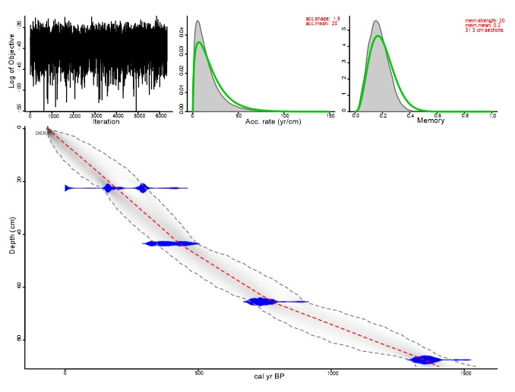

**Figure S1 Age-depth model based on four radiocarbon dates (Table S1) of master core DIE-16. Calibrated with the IntCal13 curve (Reimer et al., 2013) within a Bayesian age-depth modelling routine ‘BACON’ (Blaauw and Christen, 2011), which modelled all age information, including the sediment surface, using a Student-t distribution that accounted for scatter and allowed statistical outliers. The Bayesian analysis (Christen and Perez, 2009) partitioned the core into three sections (31.3 cm thick) estimating the accumulation rate for each segment using a Markov Chain Monte Carlo (MCMC) approach. The modelling was constrained by a prior model of sediment accumulation rate (a gamma distribution with mean 20-year cm-1 and shape 1.5) and its variability (memory, a beta distribution with mean 0.2 and shape 20).**

**Table S2 Values for the three primary conifer bark beetle species *Polygraphus poligraphus*, *Pityogenes chalcographus* and *Pityophthorus pityographus* (individuals/100 ml) which occurred in numbers of five or more in at least one of the samples in the fossil beetle record of Diera Hollow. The medians of sample ages are shown. The Z-score is a measure for the number of standard deviations above or below the mean. Z-scores higher than 1 are displayed in bold.**

|  |  |  |  |  |  |  |  |
| --- | --- | --- | --- | --- | --- | --- | --- |
| Sample | Age (AD) | *P. Poligraphus* | | *P. chalcographus* | | *P. pityographus* | |
|  |  | #/100 ml | Z-score | #/100 ml | Z-score | #/100 ml | Z-score |
| 1 | 2009 | 0.181818 | -0.1386 | 2.363636 | **3.3174** | 1.454545 | **3.5337** |
| 2 | 1985 | 0 | -0.4858 | 1 | 0.8574 | 0.25 | -0.1814 |
| 3 | 1960 | 0 | -0.4858 | 0.2 | -0.5858 | 0.2 | -0.3356 |
| 4 | 1925 | 0 | -0.4858 | 0.125 | -0.7211 | 0.125 | -0.5669 |
| 5 | 1870 | 0.083333 | -0.3267 | 0.083333 | -0.7963 | 0.083333 | -0.6954 |
| 6 | 1825 | 0.1 | -0.2949 | 0.2 | -0.5858 | 0.1 | -0.644 |
| 7 | 1775 | 0 | -0.4858 | 0.214286 | -0.5601 | 0.071429 | -0.7321 |
| 8 | 1720 | 0.153846 | -0.192 | 0.230769 | -0.5303 | 0.230769 | -0.2407 |
| 9 | 1670 | 0 | -0.4858 | 0.461538 | -0.114 | 0.076923 | -0.7152 |
| 10 | 1620 | 0.142857 | -0.213 | 0.571429 | 0.0842 | 0.071429 | -0.7321 |
| 11 | 1550 | 0.0625 | -0.3665 | 0.8125 | 0.5191 | 0.25 | -0.1814 |
| 12 | 1445 | 0 | -0.4858 | 1 | 0.8574 | 0.75 | **1.3608** |
| 13 | 1330 | 0.066667 | -0.3585 | 0.866667 | 0.6168 | 0.333333 | 0.0757 |
| 14 | 1205 | 0.1 | -0.2949 | 0.8 | 0.4966 | 0.4 | 0.2813 |
| 15 | 1095 | 0.083333 | -0.3267 | 0.166667 | -0.646 | 0.166667 | -0.4384 |
| 16 | 1055 | 0.181818 | -0.1386 | 0.272727 | -0.4546 | 0.181818 | -0.3916 |
| 17 | 1005 | 1.5 | **2.3787** | 0 | -0.9467 | 0.428571 | 0.3694 |
| 18 | 955 | 1.923077 | **3.1866** | 0.076923 | -0.8079 | 0.384615 | 0.2338 |
| *Mean* |  | *0.254403* |  | *0.524749* |  | *0.308802* |  |
| *SD* |  | *0.523646* |  | *0.554322* |  | *0.324229* |  |

**Table S3 Description of the ecology of primary bark beetle species (invading healthy trees), identified at Diera Hollow.** **Bark beetle ecology after Pfeffer (1989).**

|  |  |
| --- | --- |
| **Bark beetle species** | **Ecology** |
| *Ips typographus* (L.) | Feeds mainly on *Picea abies*; can form outbreaks when large amounts of weakened wood (wind, snow, draught etc.) are available. Large outbreaks have occurred throughout Europe in the last decades. |
| *Polygraphus poligraphus (L.)* | Feeds mainly on *P. abies*; attacks dense, depressed stands of trees. No severe outbreaks have been recorded, but it can be an important disturbance agent locally. |
| *Pityogenes chalcographus* (L.) | Feeds on *P. abies*, as well as on other coniferous tree species (*Pinus, Abies, Larix*). Infestation of crown or branches is preferred but it also infests trunk parts. Outbreaks have been recorded, killing young trees at plantations and young stands. |
| *Pityophthorus pityographus* (Ratz.) | Feeds mainly on *P. abies*, but also on other coniferous tree species (*Pinus, Abies, Larix*); only in the crown or branches. No severe outbreaks were recorded in any historical records. |
| *Tomicus minor* (Hartig) | Feeds on *Pinus* spp., attacking upper trunk part of weakened trees. Damaging mature trees by maturation feeding in fresh shoots. |
| *Pityogenes bidentatus* (Hbst.) | Feeds mainly on *Pinus* spp., attacking crowns and branches. Frequent species, but no significant damage to forest stands was recorded in any historical records. |
| *Pityogenes quadridens* (Hartig) | Feeds on *Pinus* spp., attacking crowns and branches. No significant damage to forest stands was ever recorded. |
| *Ips acuminatus* (Gyll.) | Feeds on *Pinus* spp.*,*attacking upper trunk part of weakened trees, with severe outbreaks in dry periods.  Large outbreaks have occurred in the last years. |
| *Pityokteines vorontzowi* (Jakob.) | Feeds on *Abies alba*. Responsible for fir dieback in southern and Central Europe, together with other *Pityokteines* species. |

**Figure S2a Comparison of the atmospheric lead (Pb) signals of core Die11 with the master core Die2016 which was radiocarbon dated at four different depths (three radiocarbon dates visible as stars in this figure: see Table S1; Figure S1; Schafstall et al. 2020b). The cores were divided into five zones (red lines) according to the atmospheric lead signal (Pb; Fig. S2b) and, primarily for the lower part of the cores, according to iron (Fe; Fig S2c) and rubidium (Rb; fig S2d) concentrations. Cores Die1-Die10 and Die12 were correlated to Die11 in a similar way by wiggle-matching. Zones were divided in three or four samples, where possible in accordance with their geochemical signals. The lowest two zones were often less straightforward to distinguish and evenly divided in four samples. This resulted in 18 samples of unequal size. Depths of the upper and lower boundaries of each sample (red and grey bars in core Die11) were extrapolated to the depths of the master core and then compared to the age-depth model from the master core (See figure S1) in order to determine the upper and lower age boundary of each sample.**

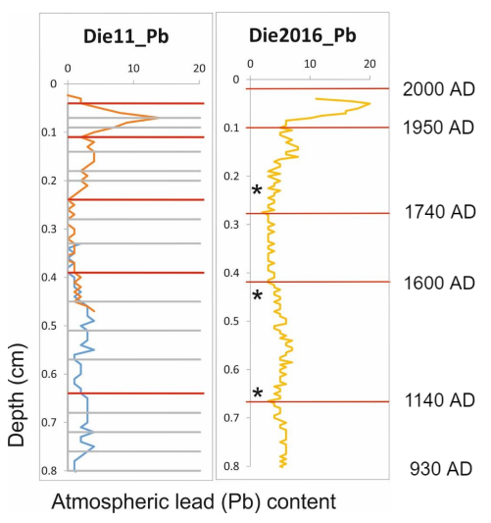

**Figure S2b Atmospheric lead (Pb) curves (ppm) of the master core Die16 and the additional 12 cores, which were wiggle-matched to allow for subsampling and pooling of samples of the 12 additional cores. The y-axis represents the length of each peat core.**

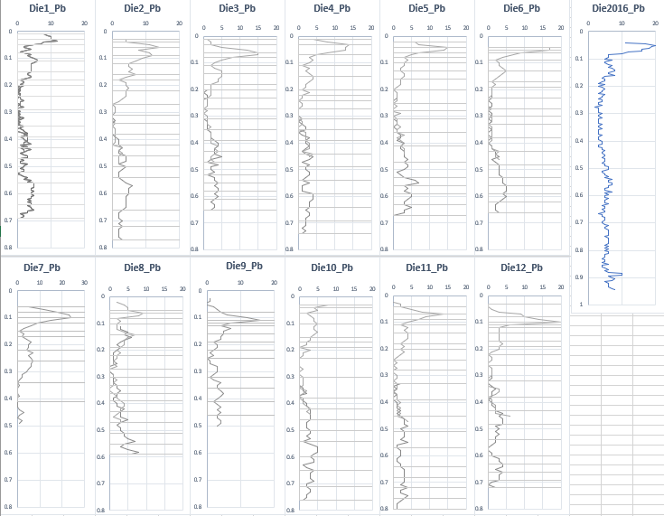

**Figure S2c Iron (Fe) curves (ppm) of the additional 12 cores, which were wiggle-matched to allow for subsampling and pooling of samples of the 12 additional cores. The y-axis represents the length of each peat core.**

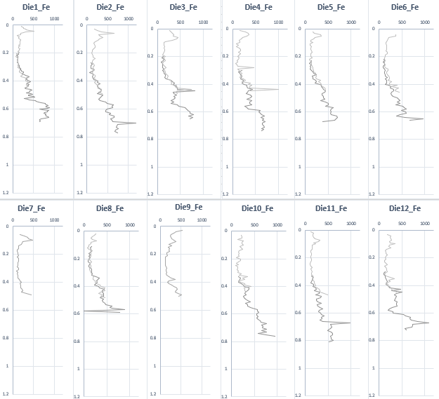

**Figure S2d Rubidium (Rb) curves (ppm) of the master core Die16 and the additional 12 cores, which were wiggle-matched to allow for subsampling and pooling of samples of the 12 additional cores. The y-axis represents the length of each peat core.**

