The use of realistic and mechanical hands in the rubber hand illusion, and the relationship to hemispheric differences

Marco Bertamini
Noreen O'Sullivan

Department of Psychological Sciences
University of Liverpool

Keywords: embodiment, laterality, rubber hand illusion, multi-sensory integration

Abstract

Embodiment, as measured through the rubber-hand illusion (RHI), depends on the similarity between object to be embodied and part of the body it replaces. We compared a fake hand similar to a real hand, and one matched in size but made of wires (mechanical). Left and right versions were tested to investigate whether the effect of appearance was stronger in the left hand. We found that the mechanical hand induced embodiment, though to a reduced degree relative to the realistic hand (N=120). Left and right versions of the mechanical hand did not differ in strength of the illusion. However, with the left realistic hand there was a stronger relationship between drift (an objective measure of the illusion) and agreement on the questionnaire (subjective experience). With the mechanical hand, objective and subjective measures were unrelated. We discuss the results in relation to factors that influence the RHI and hemispheric differences.

The rubber hand illusion (RHI) plays a key role in the study of how the inner representation of one's body changes over time based on experience. In the standard procedure, one’s hand is hidden, and a fake hand is visible. When both hands are stimulated at the same time, for instance by a paintbrush, the visual experience of seeing the fake hand touched is combined with the corresponding tactual sensation. After less than a minute, most participants experience a sense of ownership of the fake hand, including a sense that the fake hand feels the touch (Botvinick & Cohen, 1998, for a review see Serino & Haggard, 2010). The illusion is strongest following synchronous stroking, weaker with asynchronous stroking, and weaker with only visual exposure to the fake hand and no stimulation (e.g. Longo, Cardozo, & Haggard, 2008, Rohde, Di Luca, & Ernst, 2011).
The conditions necessary for the illusion have been debated in the literature. Some authors have suggested that the correlation between vision and touch is sufficient for inducing the experience of ownership of objects totally different from a hand, for instance a table (Armel & Ramachandran, 2003). Other authors, however, have concluded that the fake hand has to have a plausible appearance, and be placed in a plausible relationship to the body. We review this literature below, and next we consider reasons to predict a difference in the strength of the illusion when the left hand or the right hand is stimulated (Ocklenburg, Rüther, Peterburs, Pinnow, & Güntürkün, 2011), and how this might relate to the appearance of the fake hand. Our study addresses both the role of appearance, by using two types of hands, and the role of laterality, by testing both left and right hands of each participant.

The appearance of the fake hand

In our study, we revisited the role of the appearance of the hand. In particular, we compared hands that looked like human hands, and hands that had the size and shape of a hand, including the presence of fingers, but were clearly non-biological. There is empirical evidence that the plausibility of the hand determines the strength of the illusion. Tsakiris and Haggard (2005) compared fake hands with wooden sticks, and the latter failed to elicit the illusion. A rectangular wooden block has been used as a control condition and it does not elicit an illusion (Bertamini, Berselli, Bode, Lawson, & Wong, 2011, but see Hohwy & Paton, 2010, for a discussion of the role of previous experience). Even when cuts of wood have been made to look hand-like, they fail to elicit the illusion (Tsakiris, Carpenter, James & Fotopoulou, 2010). In contrast, gloves that can be worn on real hands do not interfere with the illusion (Haans, Ijsselsteijn & de Kort, 2008). Similarly the illusion can be produced with a left fake hand placed on the right when the right biological hand is stimulated (Petkova & Ehrsson, 2009).
A different but related phenomenon provides some indication that appearance of the hand may be less important for some measures of the illusion. It is known that observers mislocalise a tactile stimulus delivered to an unseen hand if lights near a fake hand are perceived to flash in synchrony with the tactile stimulus (Pavani, Spence & Driver, 2000). This effect survived when there was no match in the texture, or the visual material of the fake and the real hands, and even when a green alien hand was used (Austen, Soto-Faraco, Enns, & Kingstone, 2004). More salient contextual cues may therefore bias perception in favor of accepting a fake hand.
Other cues that influence the induction of the illusion include the degree to which the fake hand fits a biologically plausible orientation relative to the body (Costantini & Haggard, 2007; Ehrsson, Spence & Passingham, 2004; Tsakiris & Haggard, 2005), and the distance between the fake and hidden hands (Lloyd, 2007). There is conflicting evidence as to how much the relative size of the fake hand matters in the strength of the illusion produced. There is some suggestion that larger, but not smaller, fake hands, relative to average, will illicit an illusion of ownership (Pavani & Zampini, 2007), but other evidence that the size does not matter to the strength of the illusion (Bruno & Bertamini, 2010), but size of the fake hand influences subsequent haptic perception of size.
In our study the fake hands matched the size of the average hand, and were placed in a biologically plausible orientation. Hands appeared to exit the sleeve of a shirt that the participant was wearing. We tried to optimize conditions that would be conducive to the illusion and focused the analysis on comparing two specific types of hands (realistic and mechanical). The mechanical hand is different from other non-hand objects that have been tested before. For instance placing a glove on a fake hand may change the texture of a hand (Haans et al., 2008) but it may still be seen as a biological hand. A mechanical hand has the shape of a hand but because it is made of wires it has no biological plausibility.

Hemispheric differences and body representation

The right hemisphere has been connected to a stronger awareness of the physical and mental self, with evidence coming from neurological patients and neurophysiological techniques (Feinberg & Keenan, 2005; Karnath & Baier, 2010; Keenan, Nelson, O'Connor, & Pascual-Leone, 2001). Recently, differences in representations related to self have been addressed through the RHI. There is evidence that the right hemisphere accepts a fake hand more easily than the left hemisphere. Skin conductance response to the fake hand being threatened with a syringe is stronger when the RHI is induced through the left hand relative to the right (Ocklenburg et al., 2011), suggesting that the representation of the left hand was updated more fully. In addition to a stronger skin conductance response, the same participants reported a stronger feeling of ownership when the illusion was induced through the left hand (Ocklenburg et al., 2011; Reinersmann, Landwehrt, Krumova et al., 2013).
Other evidence suggests that one’s subjective perception of the body may draw on inter-hemispheric cross talk. Increased mixed handedness, reflective of the strength of influence of the right hemisphere over the left, is positively related to a stronger perception of the illusion when induced through the left hand, suggesting that, while the right hemisphere can facilitate the updating of the representation of the illuded hand more easily, inter-hemispheric cross talk influences subjective perception (Niebauer, Aselage, & Schutte, 2002).
Consistent with the potential for inter-hemispheric cross talk to influence embodiment, the illusion can be induced in the right hand when it is illuded, but the unhidden left hand is being stroked along with the rubber hand mimicking the right hand (Petkova & Ehrsson, 2009; objective and subjective measures were included). Moreover, fMRI data of the illusion being induced in the left hand show bilateral activity in premotor cortex that correlates with the subjective perception of the illusion (Ehrsson, Spence, & Passingham, 2004). However, both hemispheres may be making separable contributions, as an objective measure of the illusion was shown to correlate more with the right posterior insula and the right frontal operculum, even though the illusion was induced through the right hand (Tsakiris et al., 2007). The posterior insula is related to interoceptive awareness; thus the right hemisphere may have a stronger awareness of self. Additionally, TMS induced disruption of the right temporo-parietal junction reduced subjective measures of the illusion (Tsakiris, Constantini, and Haggard, 2008), consistent with the right hemisphere making a unique contribution.
Alternatively, a laterality effect in the RHI may relate to other differences across the hemispheres that are not specifically related to representing the self. Both cerebral hemispheres make unique contributions in multiple domains of cognition, including memory, decision-making, and attention. With regard to memory, priming experiments have shown that primes activate specific associates in the left hemisphere, and a more dense quantity of semantic associates on the basis of feature overlap in the right hemisphere (e.g. Deacon, Grose-Fifer, Yang et al., 2004). With regard to decision-making, the left hemisphere supports decisions that fit better with objectivity, whereas the right hemisphere supports decisions that take emotions into account (Gallagher & Dagenbach, 2007; McElroy & Seta, 2004). With regard to attention, the left hemisphere is thought to direct attention towards less salient, but task-relevant aspects of content, whereas the right hemisphere is thought to direct attention towards salient information (Mevorach, Humphreys, & Shalev, 2006).
In addition, the right hemisphere is specialized for fine spatial representations (Jager & Postma, 2003). This is believed to account for the well-known line bisection bias (for a review see Jewell & McCourt, 2000). Inducing the rubber hand illusion in the left hand leads to a correction in the spatial attention bias, and to more accurate line bisection (Kitadono & Humphreys, 2007; Ocklenburg, Peterburs, Rüther, & Güntürkün, 2012).
There are some physiological differences between the hemispheres; spacing between columns of pyramidal cells is greater in the left hemisphere relative to the right, and there are sparser connections between columns in the left hemisphere relative to the right (Hutsler & Galuske, 2003). This difference implies sparser signaling in the left hemisphere, and more diffuse signaling between columns in the right hemisphere, and has been hypothesized to underlie laterality differences in language (Hutsler & Galuske, 2003), in addition to perceptual and attentional differences (Cipollini, Hsiao, & Cottrell, 2012; Hsiao, Shahbazi, & Cottrell, 2008; Kosslyn, Chabris, Marsolek, & Koenig, 1992).
Denser signaling within the right hemisphere may facilitate updating of online representations, based on the ease with which alternatives are analysed, and this may contribute to the ease with which a fake left hand can replace the real hand. To explore hemispheric differences in embodiment, we compared the illusion when induced in the left and right hands. If the right hemisphere facilitates the illusion through a greater awareness of the self, then inducing the illusion in the left hand should be strongly affected by the characteristics of the fake hand. If, on the other hand, the right hemisphere facilitates the illusion through the ease with which it updates online representations, then it should not be differentially affected, relative to the left hemisphere, by the difference in appearance of the hands.

Different measures of the strength of the illusion

Two measures of the illusion were taken. The objective measure required participants to close their eyes, and point towards the middle finger of the illuded hand with the index finger of the non-illuded hand. Proprioceptive drift towards the fake hand, and away from the real hand, measures the degree of change in the representation of the position of the real hand. The subjective measure included three questions selected and adapted from Botvinick and Cohen (1998). Drift and subjective experience of the illusion have been shown to be linked but dissociable (Rohde, Luca, and Ernst, 2011; Tsakiris & Haggard, 2005). It is possible that objective measures tap on exteroceptive representations of the body, and subjective measures tap on interoceptive awareness of the body (Suzuki, Garfinkel, Critchley, & Seth, 2013).
There is evidence for embodiment of non-body objects, particularly those mirroring the real hand in terms of global (shape) and local (presence of fingers) characteristics (e.g. Haans et al., 2008). Therefore, we expected that proprioceptive drift towards the mechanical hand would still be generated, and that participants would subjectively experience the illusion, even if to a reduced degree. However, given that the mechanical hand was less realistic, we hypothesized that this difference in appearance would affect the relationship between objective and subjective measures of the illusion. Specifically, the discrepancy in appearance might reduce the degree to which interoceptive awareness of the illusion draws from exteroceptive representations, thus leading to a decoupling in the relationship between objective and subjective measures of the illusion.
Above, we contrasted two possibilities for how the mechanical hands might affect the illusion. If the right hemisphere facilitates the illusion through a greater awareness of the self, then inducing the illusion in the left hand should be affected by the characteristics of the fake hand used. If, on the other hand, the right hemisphere facilitates the illusion through the ease with which it can update inner representations, then it should not be differentially affected, relative to the left hemisphere, by the difference in appearance. Our final hypothesis related to the relationship between objective and subjective measures of the illusion. If the right hemisphere updates the proprioceptive position of the hand more easily than the left in the direction of the fake hand, then subjective awareness of the illusion when generated through the left hand will be more strongly related to this exteroceptive update.

Experiment

As mentioned in the introduction we conducted an experiment that compared two types of hands. One type was realistic and was created from casting a real pair of male hands. The other hand matched the realistic hand in size but was made of metallic wires (see Figure 1). We manipulated appearance and tested both left and right hands for each participant in a large sample (N=120) of young adults. A subset of the same data, excluding the mechanical hand and combined with measures of depersonalisation, has been analyzed and reported in another study (O'Sullivan et al., 2014).

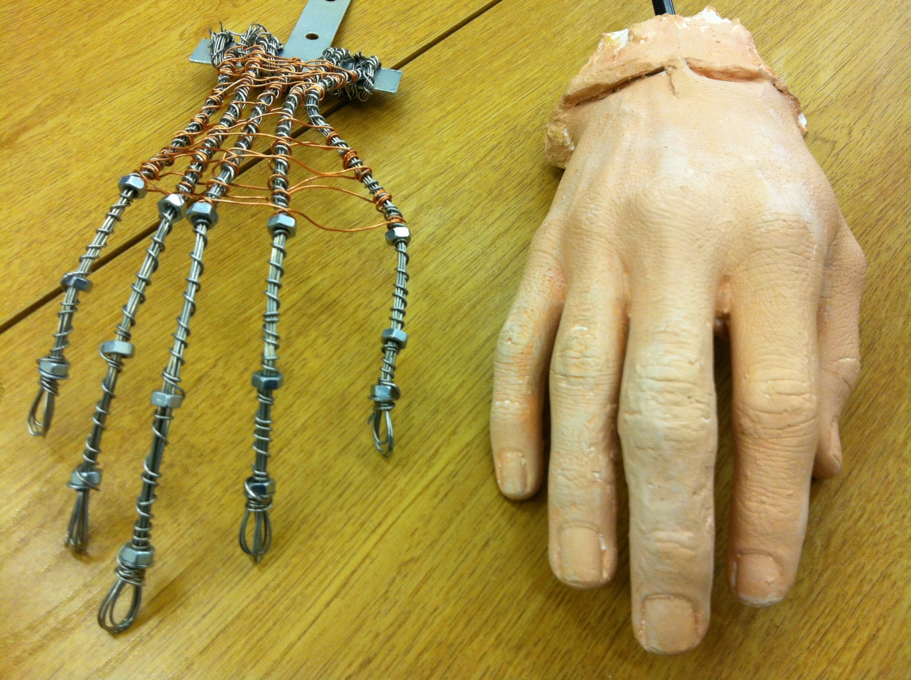
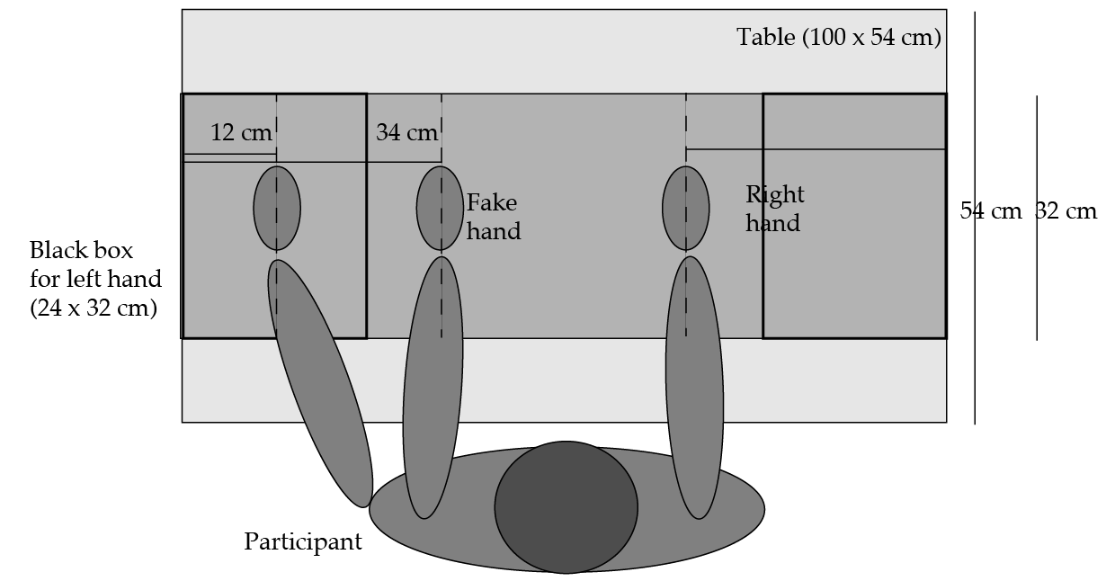
Figure 1. (a) The cast of the right hand is shown next to the mechanical version of the right hand. Note that the lengths of the hands, and of each finger, were matched. In the experiment, the hands protruded from a sleeve. (b) A diagram showing the dimension of the table and the location of the hands. There were two boxes on the left and right side (24 x 32 cm) in which one of the hands was hidden. Over these boxes, during the proprioceptive drift measure, the experimenter placed a rectangular board (100 x 32 cm).

Participants.
One hundred and twenty students at the University of Liverpool took part in the study (mean age 21 years, 88 females). All participants were right-handed based on self-report. Sixty were assigned to the realistic hand condition and sixty to the non-biological, or mechanical, hand condition. For sixty the left hand was tested before the right hand, and the other sixty were tested in the opposite order. Participants were unaware of the hypothesis under investigation.

Materials and procedure.
Two fake hands were cast from an alginate mould of real hands, selected to be of average size (165 mm from the base of the palm to the tip of the middle finger) for the general population. The hands were painted with a realistic skin colour. Mechanical hands were created using wire. The length of the hand and of each finger was matched to that of the realistic hand.
Participants wore a black shirt on one arm and torso. The other arm was outside the shirt, thanks to a large hole. After sitting in front of a small table (100 x 54 cm), one hand was placed out of sight behind the screen (labeled black box in Figure 1), parallel to the fake hand. The empty sleeve was arranged with the fake hand jutting out. The middle fingers of the fake and real hands were placed on top of markers 22 cm apart.
The experimenter provided the stimulation using two long-handle paintbrushes. Frequency was 1Hz and a metronome provided help with the timing. The experimenter stroked the hand only along the fingers, from the knuckle to the fingertip, for two minutes.
Half of the participants were tested with the realistic hand, whereas the other half was tested with the mechanical hand. Moreover, for half of the participants the left hand was tested before the right hand and for the other half the order was the opposite. The visual condition was followed by the asynchronous condition, which was followed by the synchronous condition.
An estimate of finger position was obtained. Prior to stimulation with brush strokes, participants closed their eyes and pointed with their hand to the horizontal position of the middle finger of the other hand. To make recording of the position easier, we placed a horizontal flat cardboard on top of vertical supports, above the hands. The same procedure after stimulation provided the posttest measures.
To assess the extent to which participants experienced the illusion, we used a three-item questionnaire. For each statement, participants responded by choosing a value on a 10-point Likert scale from "strongly agree" to "strongly disagree". The questions were: Q1) it seemed as if I were feeling the touch of the paintbrush in the location where I saw the fake hand touched; Q2) it seemed as though the touch I felt was caused by the paintbrush touching the fake hand; Q3) I felt as if the fake hand were my hand. These questions were selected because have been found to elicit strong agreement when the illusion is experienced (Botvinick & Cohen, 1998).

Analysis
The first set of analyses focused on drift and subjective experience of the illusion in relation to the variables Hand-type, mechanical versus realistic, and Hand, left versus right. The second set of analyses focused on the relationship between objective and subjective measures of the illusion. To that end, a factor analysis first tested whether objective and subjective measures of the illusion were independent of one another. Next, we analysed the correlations between objective and subjective measures. Lastly, regressions tested whether proprioceptive drift uniquely influenced subjective experience of the illusion when the illusion was induced through the left hand. The final analysis availed of the sample size, and tested for gender differences.
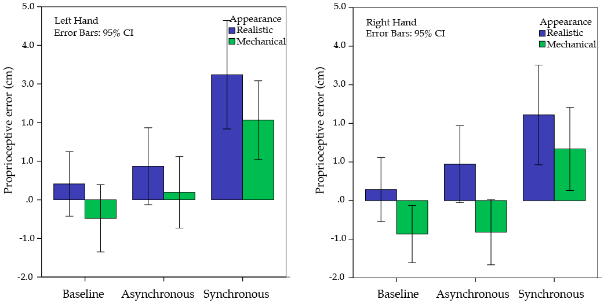
Figure 2. Data for the cross-manual pointing task. Proprioceptive error is the distance from the position of the real hand, which we also refer to as drift. The blue bars show the data for the realistic fake hand and the green bars for the mechanical data.

Results

Cross-manual pointing.
The distance between the position of the middle finger of the real hand and the pointed location is plotted in Figure 2. The larger the error the greater the drift towards the fake hand.
Drift was normally distributed; thus parametric analyses were run. Two repeated factors, Hand (left, right) and Brushing (visual, asynchronous, synchronous), were placed in an ANOVA with Appearance as a between-subject factors. The dependent variable was the proprioceptive error in pointing to the real hand. Replicating the illusion, there was a main effect of Brushing, F(2,236)=37.70, p<.001, with synchronous brushing leading to the most drift, followed by asychronous brushing (p<.001), followed by the visual condition (p=.038). The effect of Appearance was significant F(1,118)=4.64, p=.033, with the realistic hand generating more drift than the mechanical hand (realistic, M = 1.33; SD = 3.01; mechanical, M = .24; SD = 2.51); however, Appearance failed to interact with any of the remaining variables (ps>.24). An effect of Hand was marginal, F(1,118)=3.59, p=.061. The trend was in the direction of the left hand generating more drift than the right (left: M = 1.05; SD = 3.38; right: M = .52; SD = 3.03).
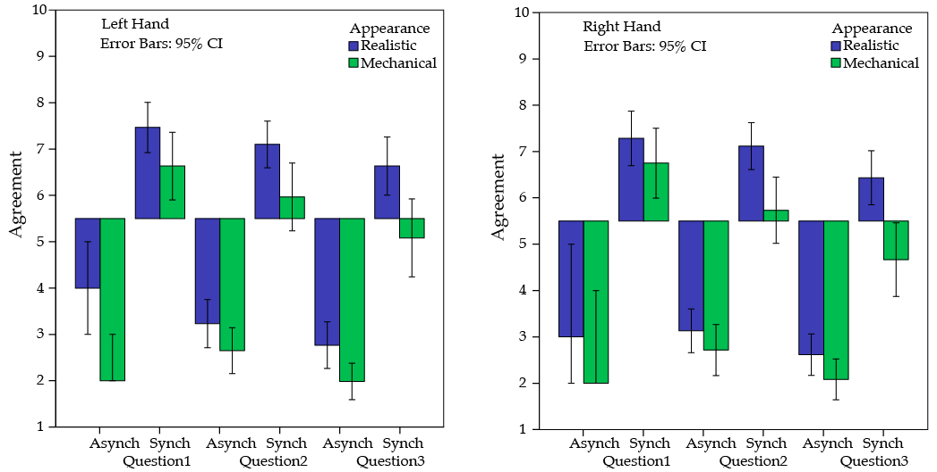
Figure 3. Median agreement on the three questions: Q1) it seemed as if I were feeling the touch of the paintbrush in the location where I saw the fake hand touched; Q2) it seemed as though the touch I felt was caused by the paintbrush touching the fake hand; Q3) I felt as if the fake hand were my hand. The blue bars show the data for the realistic fake hand and the green bars for the mechanical data.

Agreement with the questions.
Agreement with the three questions as measured by the scale (1-10) is shown in Figure 3 as a function of type of stimulation and appearance of the hand. Question data were not normally distributed. Log transformations failed to correct the degree of positive skew in asynchronous questions and negative skew in synchronous questions, and the residuals of the ANOVA were not normally distributed; therefore, non-parametric comparisons were made. Figure 3 shows the medians for each condition.
Wilcoxon signed-ranks tests showed effects of Brushing in both the realistic and mechanical hands [realistic, Z (59) = 6.68, p < .001; mechanical, Z (59) = 6.62, p < .001]. Effects of Hand were absent (realistic, p = .337; mechanical, p = .866). A Mann-Whitney test confirmed an overall effect of Appearance, U (59) = 3.08, p = .002. Correcting for multiple comparisons, Appearance affected responses the most for question 3, the ownership question, with synchronous brushing, Z (59) = 3.17, p < .001 (asynchronous: Q1, p = .022; Q2, p = .057; Q3, p = .010; synchronous: Q1, p = .271; Q2, p = .009).

The relationship between objective and subjective measures of the illusion
Factor analysis
Factor analysis was used to demonstrate that the objective and subjective measures of the illusion were dissociable. A principal component analysis with a varimax rotation and Kaiser normalization dissolved the 4 conditions for each measure into two factors: the questions loaded on one factor (eigen value = 3.27; % of variance accounted for = 34.71); proprioceptive drift loaded on another (eigen value = 2.07; % of variance accounted for = 31.98). Loadings on each factor were distinctive, Table 1.

Table 1: Outcome of the factor analysis including the 4 measures of proprioceptive drift, and the 4 measures of subjective experience.

The effect of appearance
Each non-parametric correlation in Table 2 corresponds to the strength of the relationship between drift, the objective measure, and average question score, the subjective measure, stratified by whether the hand was realistic or mechanical, and whether brushing was asynchronous or synchronous. The mechanical appearance of the fake hand had an effect on the relationship between drift and subjective experience of the illusion: drift and subjective experience were unrelated for the mechanical hand relative to the realistic hand, z(59) = 1.90, p=.057, see Figure 4.

Figure 4. The correlation between proprioceptive drift and question score, averaged across left and right hands, and asynchronous and synchronous brushing.

Table 2: Each non-parametric correlation corresponds to the strength of the relationship between drift and subjective experience of the illusion as a function of the characteristics of the fake hand, and the stimulation applied.

The effect of laterality.
As the mechanical hand eliminated the relationship between objective and subjective measures of the illusion, the relationship between both measures as a function of left and right hand was addressed in the realistic hand data. The aim was to test whether subjective experience was more affected by the internal body update when the left hand was stimulated. Four regressions were run, one for each condition, predicting average question score from proprioceptive drift. The factor analysis had confirmed that subjective and objective measures of the illusion are separate factors; therefore in each regression we controlled for subjective experience by including the average question score of the corresponding hand. If a relationship between proprioceptive drift and question score for a specific condition survived this correction, then the relationship is likely to relate to the influence of proprioception on subjective experience.
The models were first run on the raw question data; however, the residual distributions of all models were not normally distributed. Instead, log-transforming the question data led to normal distributions of the residuals in each regression (Shapiro-Wilk, ps>.38); therefore the primary assumption for regression models, that the residuals are normally distributed, was upheld. Table 3 shows the t-statistics and proportion of variance explained in each model. Each model was significant: left asynchronous, F(2, 57)=34.11, p<.001; left synchronous, F(2, 57)=60.03, p<.001; right asynchronous, F(2, 57)=31.42, p<.001; right synchronous, F(2, 57)=51.39, p<.001. Only in the left synchronous model did proprioceptive account for a significant proportion of the variance in subjective experience of the illusion—see Figure 5.

Table 3: Regression models in which subjective experience of the illusion in each of the conditions was predicted from proprioceptive drift, and subjective experience of the illusion for the alternate hand (p-values corresponding to t-stats are in brackets; cells in grey correspond to variables that were not added in the given model)

Figure 5. The correlation between proprioceptive drift and question score in the synchronous conditions of the left and right hands.

Gender differences
The sample size provided the opportunity to look at gender differences. In the drift analysis, Appearance interacted with Gender, F(1,116)=5.31, p=.023, and the 3-way interaction between Appearance, Gender, and Brushing was significant, F(2,232)=3.55, p=.041. A significant interaction between Gender and Appearance was specific to synchronous drift, F(1,116)=7.62, p=.007. The mechanical hand reduced proprioceptive drift in males more than in females: males, mechanical versus normal, t(30)=2.61, p=.014. A similar trend was present in the asynchronous data (Appearance x Gender, p=.092).
In the question data, the mechanical hand reduced subjective perception of the illusion more in males than in females, and to a similar degree with both asynchronous and synchronous brushing: male asynchronous, U(59)=3.05, p=.002; male synchronous U(59)=3.40, p<.001; female asynchronous p=.334; female synchronous p=.220.
The mechanical hand reduced the correlation between proprioceptive drift and the question data to a similar degree across both genders (correlations ps>.8). In the realistic hand data, including gender as a predictor, and as an interaction term with drift in each regression, did not lead to any gender-related effects (ps>.13).

Discussion

We explored the role of the appearance of the fake hand on the strength of the RHI, and whether effects of appearance were lateralized. We contrasted hands that shared many of the characteristics of real hands; however, one was mechanical, and therefore less plausible in contrast to a more realistic one. We tested both a left and right version of each hand. We expected that the mechanical hand would lead to a reduced strength in the illusion, and that this reduction would be greater when the left hand was stimulated. We collected objective (proprioceptive drift) and subjective measures of the illusion. In addition to looking at these measures in relation to our manipulated variables, we also tested whether the relationship between objective and subjective measures of the illusion became decoupled as the object to be embodied became less real (the mechanical hand), relative to a part of the self (the realistic hand).

The effect of the mechanical nature of the hand on the illusion
In a large sample, we found that the illusion was present for both the realistic and mechanical hands; however, the illusion was weaker for the mechanical hand. Drift towards the mechanical hand was reduced relative to the realistic hand. Moreover, the manipulation had the greatest impact on subjective experience of ownership, and perception of the cause of perceived touch, consistent with the manipulation tapping into high-level subjective awareness of the self. Therefore, the hand-like characteristics of the mechanical hand were enough to generate an illusion, but the mechanical nature of the hand did interfere with the process of updating the representation of the hand. The mechanical hand in this study can be likened to the glove in the study of Haans et al. (2008): both objects have a more real association to actual hands in comparison to wooden-made alternatives with less of an overlap in terms of local and global properties of hands (Tsakiris & Haggard, 2005; Tsakiris, Longo, & Haggard, 2010). Embodiment of these objects is facilitated, though to a reduced degree relative to more realistic hands.
In addition to the mechanical hand becoming embodied to a reduced degree, the correlation between drift and subjective experience became decoupled, in contrast to the embodiment of the realistic hand. A strong relation between these two types of measures suggests greater interoceptive awareness of the current exteroceptive state of the body (Suzuki, et al. 2013). Given the visual appearance of the mechanical hand, participants felt less of a connection with the mechanical hand. Despite this, common characteristics facilitated some degree of embodiment, but the awareness that this hand was less like the real hand drove the decoupling between drift and subjective awareness. The finding bares resemblance to circumstances in which it is clear that an object has been embodied, for example, a tool (e.g. Cardinali, Frassinetti, Brozzoli et al., 2009), but one’s interoceptive connection to the embodied object is weak. Looking at the coupling of objective and subjective measures of embodiment is a means to gauge the precision with which interoceptive awareness is tracking exteroceptive representations.
Although gender was not the focus of our study we discovered some gender differences in the strength of the illusion with the mechanical hand. The mechanical hand lead to a weaker illusion in males, measured in both proprioceptive drift and subjective experience. A more accurate representation of the body should preclude integration of the mechanical hand into one’s representation of self. A biased representation of the body, measured through body image-related measures, has been related to increased susceptibility to the rubber hand illusion (Mussap & Salton, 2006). A biased representation of the body, specifically related to a negative body image, is a criterion of eating disorders, which have a higher prevalence in females (Cash & Deagle, 1998). Perhaps the greater rejection of the fake hand in males is related to a stronger body image.
Variability in the degree to which the mechanical hand was embodied is also of interest in relation to embodiment of prosthetic limbs. There is some evidence that females have a poorer outcome relative to males in the integration of prosthetic limbs (Singh, Hunter, Philip, & Tyson, 2008). It could be that differential embodiment of realistic body parts relative to less realistic body parts could act as a predictor of how individuals who gain a prosthetic limb will adjust to its use.

Laterality effects.
We expected the illusion to be stronger when the left hand was stimulated. This effect for drift was reduced relative to that of Ocklenburg et al. (2011), in which skin conductance responses functioned as the objective measure. The proprioceptive drift measure requires participants to use the non-illuded hand to point to the illuded hand; thus, the added noise of communicating the updated coordinates for the representation of the illuded hand to the contralateral hand may impact on the effect. In agreement with arguments that subjective and objective measures of the illusion are picking up on different underlying sources of variability (e.g. Rohde et al., 2011), subjective and objective measures of the illusion did not load on the same factor.
The absence of an effect of laterality in the subjective data is consistent with some fMRI evidence for the combined role of both hemispheres in influencing one’s subjective perception of having embodied the fake hand. For example, bilateral activity in premotor cortex has been shown to correlate with subjective data (Ehrsson et al., 2004). In addition to that, Niebauer et al. (2002) found that it was mixed handedness that correlated with an increased subjective experience of the illusion, consistent with inter-hemispheric cross-talk facilitating subjective experience of the update. Finally, recent data from split-brain patients suggest that feelings of ownership and agency are more dependent on inter-hemispheric cross talk, as opposed to right hemisphere output alone (Uddin, 2011). Effects of variables on the extrinsic representation of the body need not translate into interoceptive differences in how the body is subjectively experienced.
The overall effect of laterality in the drift data was reduced relative to that demonstrated previously by skin conductance responses. However, drift and subjective experience of the illusion were more strongly related for the left realistic hand relative to the right realistic hand. A stronger relation between these two measures on the left is consistent with an advantage for the right hemisphere in embodying the fake hand, and interoceptive awareness benefiting as a consequence. An objective measure of the illusion was shown to correlate more with the right posterior insula, an area recognized as playing a key role in interoceptive awareness (Tsakiris et al., 2007). Thus, although interoceptive awareness may act from information provided by both hemispheres, exteroceptive updates to regions involved in interoceptive awareness in the right hemisphere may have an advantage.
Based on evidence that the right hemisphere has prioritized access to detailed representations of self (Feinberg & Keenan, 2005; Karnath & Baier, 2010), we hypothesized that the mechanical hand would have a greater impact on measures of the illusion taken when the left hand was stimulated. This was not the case. Inducing the illusion requires an update to the online representation of the real hand. That the mechanical hand did not differentially influence the updating process as a function of whether it was the left or right hand, suggests that the updating does not require access to those details of the self that the right hemisphere have prioritized access to. Therefore, in relation to the RHI, is seems more likely that lower level differences (as opposed to awareness of self) in the hemispheres drive these higher-level differences. For example, realistic hands are more saliently related to online representations of self; there is more featural overlap between realistic hands and real hands in contrast to mechanical; and there may be a stronger emotional connection to realistic fake hands as opposed to mechanical. Any one of these accounts, already connected with other domains in cognition (Deacon et al., 2004; Gallagher & Dagenbach, 2007; Kosslyn et al., 1998; McElroy & Seta, 2004; Mevorach et al., 2006), might explain a stronger connection between the right hemisphere and embodiment, and none of them imply a unique role of the self (Gillihan & Farah, 2005). Perhaps also connected, biological differences that allow for increased communication between columns of pyramidal cells in the right hemisphere may facilitate easier updating of exteroceptive representations (Cipollinil et al., 2012; Hsiao et al., 2008; Hutsler & Galuske, 2003).
In conclusion, the findings show that embodiment of fake body parts intended to mimic real body parts is dependent on the similarity between the two. With increasing dissimilarity, there is still the potential to embody a fake object; however, awareness in feeling a sense of ownership over the object, will become decoupled from the degree to which the object becomes part of an exteroceptive representation of the body. The right hemisphere facilitates updating of online exteroceptive representations of self to a stronger degree than the left, and this could potentially be accounted for through characteristics of the right hemisphere that are unrelated to accessing higher-level representations of self.

Acknowledgements

We would like to thank Carole Bode for designing and building the fake and mechanical hands used in the study.

References

Armel, K. C. & Ramachandran, V. (2003). Projecting sensations to external objects: evidence from skin conductance response. Proceedings of the Royal Society of London. B: Biological Sciences, 270(1523), 1499-1506. doi:10.1098/rspb.2003.2364
Austen, E.L., Soto-Faraco, S., Enns, J.T., & Kingstone, A. (2004). Mislocalizations of touch to a fake hand. Cognitive, Affective, & Behavioral Neuroscience, 4 (2), 170-181. doi:10.3758/CABN.4.2.170
Bertamini, M., Berselli, N., Bode, C., Lawson, R., & Wong, L. T. (2011). The rubber hand illusion in a mirror. Consciousness and Cognition, 20(4), 1108-1119. doi:10.1016/j.concog.2011.04.006
Botvinick, M. & Cohen, J. (1998). Rubber hands 'feel' touch that eyes see. Nature, 391, 756. doi:10.1038/35784
Bruno, N. & Bertamini, M. (2010). Haptic perception after a change in hand size. Neuropsychologia, 48(6), 1853-1856. doi:10.1016/j.neuropsychologia.2010.01.006
Cardinali, L., Frassinetti, F., Brozzoli, C., Urquizar, C., Roy, A. C., & Farne, A. (2009). Tool-use induces morphological updating of the body schema. Current Biology, 19(12), R478-479. doi: 10.1016/j.cub.2009.05.009
Cash, T.F. & Deagle, E.A. (1998). The nature and extent of body-image disturbances in anorexia nervosa and bulimia nervosa: a meta-analysis. International Journal of Eating Disorder, 22(2), 107-126.
Cipollini, B., Hsiao, J., & Cottrell, G. (2012). Connectivity asymmetry can explain visual hemispheric asymmetries in local/global, face, and spatial frequency processing. Cognitive Science Society
Costantini, M. & Haggard, P. (2007). The rubber hand illusion: sensitivity and reference frame for body ownership. Consciousness and cognition, 16(2), 229-40. doi: 10.1016/j.concog.2007.01.001
Deacon, D., Grose-Fifer, J., Yang, C., Stanick, V., Hewitt, S., & Dynowska, A. (2004). Evidence for a new conceptualization of semantic representation in the left and right cerebral hemispheres. Cortex, 40, 467-478. doi:10.1016/S0010-9452(08)70140-0
Ehrsson, H. H., Spence, C., & Passingham, R. E. (2004). That's my hand! Activity in premotor cortex reflects feeling of ownership of a limb. Science, 305(5685), 875. doi: 10.1126/science.1097011
Feinberg, T. E., & Keenan, J. P. (2005). Where in the brain is the self ? Consciousness and Cognition, 14, 661􏰃678. doi:10.1016/j.concog.2005.01.002
Gallagher, P., & Dagenbach, D. (2007). Manipulating noise frequencies alters hemispheric contribution to decision making. Brain and Cognition, 64, 42–49. doi:10.1016/j.bandc.2006. 10.004
Gillihan, S.J., & Farah, M.J. (2005). Is self special? A critical review of evidence from experimental psychology and cognitive neuroscience. Psychological Bulletin, 131(1), 76-97. doi:10.1037/0033-2909.131.1.76
Haans, A., Ijsselsteijn, W. A., & de Kort, I. A. (2008). The effect of similarities in skin texture and hand shape on perceived ownership of a fake limb. Body Image, 5(4), 389-394. doi:10.1016/j.bodyim.2008.04.003
Hohwy, J. & Paton, B. (2010). Explaining away the body: experiences of supernaturally caused touch and touch on non-hand objects within the rubber hand illusion. PLoS ONE, 5(2), e9416. doi:10.1371/journal.pone.0009416
Hsiao, J., Shahbazi, R., & Cottrell, G. (2008). Hemispheric asymmetry in visual perception arises from differential encoding beyond the sensory level. Proceedings of the 30th Annual Meeting of the Cognitive Science Society
Hutsler, J., Galuske, R.A.W. (2003). Hemispheric asymmetries in cerebral cortical networks. Trends in Neurosciences, 26(8), 429-435. doi:10.1016/S0166-2236(03)00198-X
Jager, G. & Postma, A. (2003). On the hemispheric specialization for categorical and coordinate spatial relations: a review of the current evidence. Neuropsychologica, 41, 504-515. doi:10.1016/S0028-3932(02)00086-6
Jewell, G. & McCourt, M.E. (2000). Pseudoneglect: a review and meta-analysis of performance factors in line bisection tasks. Neuropsychologia, 38, 93-110. doi:10.1016/S0028-3932(99)00045-7
Karnath, H.O., Baier, B. (2010). Right insula for our sense of limb ownership and self-awareness of actions. Brain Structure and Function, 214, 411-417. doi:10.1007/ s00429-010-0250-4
Keenan, J. P., Nelson, A., O'Connor, M., & Pascual-Leone, A. (2001). Self-recognition and the right hemisphere. Nature, 409, 305.
Kitadono, K. & Humphreys (2007). Short-term effects of the rubber hand illusion on aspects of visual neglect. Neurocase: The Neural Basis of Cognition, 13, 260-271. doi:10.1080/13554790701625815
Kosslyn, S.M., Chabris, C.F., Marsolek, C.J., & Koenig, O. (1992). Categorical versus coordinate spatial relations: computational analyses and computer simulations. Journal of Experimental Psychology: Human Perception & Performance, 18, 562-577. doi: 10.1037//0096-1523.18.2.562
Lloyd, D. M. (2007). Spatial limits on referred touch to an alien limb may reflect boundaries of visuo-tactile peripersonal space surrounding the hand. Brain and Cognition, 64(1), 104-109. doi:10.1016/j.bandc.2006.09.013
Longo, M. R., Cardozo, S., & Haggard, P. (2008). Visual enhancement of touch and the bodily self. Consciousness and Cognition, 17, 1181-1191. doi:10.1016/ j.concog.2008.01.001
McElroy, T., & Seta, J. J. (2004). On the other hand am I rational? Hemispheric activation and the framing effect. Brain and Cognition, 55, 572–580. doi:10.1016/ j.bandc.2004.04.002
Mevorach, C., Humphreys, G.W., & Shalev, L. (2006). Opposite biases in salience-based selection for the left and right posterior parietal cortex. Nature Neuroscience, 9(6), 740-742. doi:10.1038/nn1709
Mussap, A.J. & Salton, N. (2006). A rubber-hand illusion reveals a relationship between perceptual body image and unhealthy body change. Journal of Health Psychology, 11(4), 627-639. doi: 10.1177/1359105306065022
Niebauer, C. L., Aselage, J., & Schutte, C. (2002). Hemispheric interaction and consciousness: Degree of handedness predicts the intensity of a sensory illusion. Laterality: Asymmetries of Body, Brain and Cognition, 7, 85-96. doi:10.1080/13576500143000159
Ocklenburg, S., Peterburs, J., Rüther, N., & Güntürkün, O. (2012). The rubber hand illusion modulates pseudoneglect. Neuroscience Letters, 523, 158-161. doi: 10.1016/j.neulet.2012.06.068
Ocklenburg, S., Rüther, N., Peterburs, J., Pinnow, M., & Güntürkün, O. (2011). Laterality in the rubber hand illusion. Laterality: Asymmetries of Body, Brain and Cognition, 16, 174-187. doi:10.1080/13576500903483515
O'Sullivan, N. Braithwaite, J. Medford, N. Donnellan-Smith, W. Sharp, H. Bolda, R. Millward, A. Bentall, R, & Bertamini, M. (2014). Variability in embodiment, and its relationship to depersonalization and voice hearing. Manuscript submitted.
Pavani, F., Spence, C., & Driver, J. (2000). Visual capture of touch: Out of the body experiences with rubber gloves. Psychological Science, 11, 353-9. doi:10.1111/1467-9280.00270
Pavani, F. & Zampini, M. (2007). The role of hand size in the fake-hand illusion paradigm. Perception, 36, 1547-1554. doi:10.1068/p5853
Petkova, V.I. & Ehrsson, H.H. (2009). When right feels left: referral of touch and ownership between the hands, PLoS One, 4(9), 1-8. doi:10.1371/ journal.pone.0006933
Reinersmann, A., Landwehrt, J., Krumova, E.K., Peterburs, J., Ocklenburg, S., Güntürkün, O. & Maier, C. (2013). The rubber hand illusion in complex regional pain syndrome: preserved ability to integrate a rubber hand indicates intact multisensory integration. Pain, 154, 1519-1527. doi:10.1016/j.pain.2013.03.039
Rohde, M., Di Luca, M., Ernst, M.O. (2011). The Rubber Hand Illusion: Feeling of Ownership and Proprioceptive Drift Do Not Go Hand in Hand. PLoS ONE, 6(6), e21659. doi:10.1371/journal.pone.0021659
Serino, A. & Haggard, P. (2010). Touch and the body. Neuroscience and Biobehavioral Reviews, 34(2), 224-236. doi:10.1016/j.neubiorev.2009.04.004
Singh, R., Hunter, J., Philip, A., & Tyson, S. (2008). Gender differences in amputation outcome. Disability and Rehabilitation, 30(2), 122-125. doi: 10.1080/09638280701254095
Suzuki, K., Garfinkel, S.N., Critchley, H.D., & Seth, A.K. (2013). Multisensory integration across exteroceptive and interoceptive domains modulates self-experience in the rubber-hand illusion. Neuropsychologica, in press, doi: 10.1016/j.neuropsychologia.2013.08.014
Tsakiris, M., Carpenter, L., James, D., & Fotopoulou, A. (2010). Hands only illusion: multisensory integration elicits sense of ownership for body parts but not for non-corporeal objects. Experimental Brain Research, 204(3), 343-352. doi:10.1007/s00221-009-2039-3
Tsakiris M, Costantini M & Haggard P (2008). The role of the right temporoparietal junction in maintaining a coherent sense of one's body. Neuropsychologia, 46(12) 3014-3018. doi:10.1016/j.neuropsychologia.2008.06.004
Tsakiris, M., Hesse, M. D., Boy, C., Haggard, P., & Fink, G. R. (2007). Neural signatures of body ownership: a sensory network for bodily self-consciousness. Cerebral cortex, 17(10), 2235-2244. doi:10.1093/cercor/bhl131
Tsakiris, M., Longo, M. R., & Haggard, P. (2010). Having a body versus moving your body: Neural signatures of agency and body-ownership. Neuropsychologia, 48, 2740--2749. doi:10.1016/j.neuropsychologia.2010.05.021
Tsakiris, M. & Haggard, P. (2005). The rubber hand illusion revisited: visuotactile integration and self-attribution. Journal of Experimental Psychology: Human Perception & Performance, 31, 80-91. doi:10.1037/0096-1523.31.1.80
Uddin, L.Q. (2011). Brain connectivity and the self: the case of cerebral disconnection. Consciousness and Cognition, 20(1), 94-98. doi:10.1016/j.concog.2010.09.009

Left asynchronous, skewness = .272 (SE = .309), kurtosis = .581 (SE = .608); left synchronous, skewness = .077 (SE = .309), kurtosis = .800 (SE = .608); right asynchronous, skewness = .278 (SE = .309), kurtosis = .408 (SE = .608); right synchronous, skewness = .172 (SE = .309), kurtosis = .246 (SE = .608).
Note, we have since replicated the differential relationship between left-sided proprioceptive drift and subjective experience of the illusion relative to the relationship between right-sided drift and subjective experience in the same models as above in an independent sample of 64 participants with realistic fake hands: left synchronous drift predicting subjective experience, t=2.36, p=.022; right synchronous drift predicting subjective experience, p=.164.

