**Level of uncertainty about the affective nature of a pictorial stimulus influences anticipatory neural processes: An event-related potential (ERP) study**

Johnen, A-K., & Harrison, N.R.

Department of Psychology, Liverpool Hope University, Liverpool, UK

**Corresponding Author:**

Dr Neil Harrison

Department of Psychology

Liverpool Hope University

Liverpool

UK

L16 9JD

Email address: [harrisn@hope.ac.uk](mailto:harrisn@hope.ac.uk)

**Abstract**

Uncertainty about the emotional impact of future events is a common part of everyday life. However, relatively little is known about whether the level of uncertainty about the affective nature of an upcoming visual image influences anticipatory neurocognitive processes. To investigate this, participants viewed a series of negative and neutral pictures, which were preceded by abstract anticipatory cues. Neural activity was measured using event-related potentials (ERPs). In the ‘uncertain’ cue condition, the cue could be followed by either a negative or a neutral picture with equal probability; in the ‘fairly uncertain’ condition the cue was followed by a negative picture on 70% of trials, and by a neutral picture on 30% of trials. In the ‘certain’ condition, the cue was always followed by a negative picture. For the P200 component, reflecting early stages of selective attention, there was no amplitude difference between cue conditions. At later stages of processing, the early posterior negativity (EPN) amplitude was enhanced for cues indicating a greater level of certainty, and the late positive potential (LPP) amplitude was greater for certain, compared to fairly uncertain and uncertain cues. The stimulus preceding negativity (SPN), an index of anticipatory processing, was more negative for certain cues compared to fairly uncertain and uncertain cues. For the SPN there was no difference between fairly uncertain and uncertain cues. These results provide evidence that the level of uncertainty regarding the affective nature of an upcoming picture influenced several stages of processing during the anticipation of the stimulus.

Keywords: Uncertainty; Emotions; Anticipations; ERPs

**Introduction**

In everyday life we may experience emotions that we had anticipated in advance, for example joy at the birth of a baby, or grief at losing a friend or relative. Sometimes we experience emotions that could not be anticipated beforehand, for example the sudden feeling of fear due to unexpectedly encountering a fierce dog. At other times we may have some expectation that an upcoming event may be emotional (e.g., giving a public speech), but there is a degree of uncertainty about whether the event will evoke an affective response. Understanding how expectation uncertainty affects neurocognitive processes related to emotions is important, as anticipatory processes can assist an organism to adaptively prepare for the occurrence of an upcoming event (for reviews, see Morriss, Gell, & van Reekum, 2019; Peters, McEwen, & Friston, 2017). In addition, the anticipation of uncertain events has been associated with negative responses such as apprehension and anxiety (Grupe & Nitschke, 2013), in particular in individuals with anxiety disorders (Grillon, 2008), therefore increased knowledge of the neural mechanisms of uncertain anticipation may enhance our understanding of these psychological symptoms.

To empirically investigate the effects of uncertainty about the emotional content of an upcoming stimulus, an affective cueing paradigm (also known as a cue-picture paradigm) has commonly been employed. In this paradigm an abstract cue (‘S1’) is followed, after an interval, by a target stimulus (‘S2’). The cue typically contains information about the emotional content of the target stimulus. A large number of studies has now established that expectations set up by the cue (i.e., by S1) about the affective content of a target picture (i.e., S2) affects neural and behavioural responses to the target picture (Dieterich, Endrass, Kathmann, 2016; Gole, Schäfer, & Schienle, 2012; Johnen & Harrison, 2019; Lin et al., 2015). However, as well as understanding the effects of emotion expectations on the responses to the target stimulus (S2), it is vital to understand the processes that occur *prior* to the appearance of the target stimulus, i.e., the anticipatory processes occurring in the interval between S1 and S2.

Event-related potentials (ERPs), with their high temporal resolution, are ideally suited to examine the time-course of anticipatory brain processes. To measure the effects of uncertainty on attention allocation to cues conveying information about the affective content of an upcoming picture, we investigated three ERP components time-locked to the anticipatory cue (S1), namely the P200, the early posterior negativity (EPN) and the late positive potential (LPP).

The P200 is an early positive deflection occurring between 180 – 250 ms after onset of a visual stimulus, and is an indicator of selective attention following early perceptual processing (Hajcak, Weinberg, MacNamara, & Foti, 2012), and is modulated by affectively relevant images (Carretié, Martín-Loeches, Hinojosa, & Mercado, 2001). Prior research, using a threat-of-shock paradigm, has shown that the P200 was increased during the certain, compared to more uncertain, anticipation of threat (Tanovic, Pruessner, Joormann, 2018). This finding is in line with the models proposing that uncertain cues carry less information than certain cues, therefore they are allocated less attention (Mackintosh, 1975). On the other hand, several studies have found that the picture-locked P200 was enhanced by uncertainty (Dieterich et al., 2016), and that the P200 was increased during the uncertain, compared to the certain, anticipation of a painful stimulus (Huang, Shang, Dai, & Ma, 2017). These latter results are in line with models arguing that uncertain cues are allocated more attention than certain cues, in order to attempt to resolve the uncertainty (Pearce & Hall, 1980). More recent models have attempted to reconcile these opposing viewpoints, arguing that aspects of both models may be applicable in different contexts (Pearce & Mackintosh, 2010). Nevertheless, it is currently unclear how uncertainty about the emotional nature of an upcoming picture affects early electrophysiological indices of attention.

The EPN is a well-studied ERP component indexing reflexive visual attention to an emotionally arousing stimulus, which may facilitate more in-depth processing of the stimulus at later stages. The EPN is typically observed as a relative negativity between around 200 – 400 ms following affective compared to neutral pictures, over temporo-occipital sites (Harrison & Chassy, 2019; Van Strien, Langeslag, Strekalova, Gootjes, & Franken, 2009; Van Strien, Eijlers, Franken, & Huijding, 2014). An enhanced EPN has been observed in response to arbitrary symbolic cues which signalled the future presence of an emotionally arousing or painful stimulus, compared to the future presence of an emotionally neutral, or painless, stimulus (Michalowski, Pané-Farré, Löw, & Hamm, 2015; Wu et al., 2017). Using an affective cuing design, Michalowski and colleagues (2015) found that the EPN was more negative during the encoding of cues indicating spider pictures, and cues indicating unpleasant pictures, compared to cues indicating a neutral picture. The enhanced EPN likely reflected enhanced attention to cues that signalled an upcoming negative event. Further, Wu et al. (2017) found an enhanced EPN following arbitrary cues indicating the future delivery of a painful electric stimulus, compared to cues indicating a non-painful stimulus. Together, these two studies show that the EPN is sensitive to differences in the informational content of cues signalling the arousal value of an upcoming event. However, a currently unexplored question is whether the EPN indexes the degree of certainty regarding the affective nature of the upcoming stimulus.

The late positive potential (LPP) is a sustained positive-going deflection in the ERP wave over centro-parietal cortex, with a peak latency occurring around 500 - 600 ms after the presentation of an emotionally arousing stimulus. A wealth of studies indicates that it typically reflects enhanced attention to motivationally relevant stimuli (for reviews, see Hajcak, MacNamara, & Olvet, 2010; Hajcak, Weinberg, MacNamara, & Foti, 2012). While typically studied in response to stimuli that contain affectively arousing content, an enhanced LPP may also be evoked by purely abstract, symbolic cues, that provide information about an upcoming affective event, compared to an upcoming non-affective event (Michalowski et al., 2015; Poli et al., 2007; Wu et al., 2017). The increase in LPP amplitude evoked by symbolic cues signalling an upcoming affective event suggests an enhanced encoding of these cues due to their informative nature, on the basis of which adaptive preparatory responses can be planned (Michalowski et al., 2015; Poli et al., 2007; Wu et al., 2017). Here we aimed to examine whether the LPP amplitude evoked by a symbolic cue is modulated by the level of certainty provided by the cue about the affective nature of an upcoming picture.

It is known that the anticipation of motivationally relevant stimuli typically evokes a negative slow cortical potential (SCP) in the ERP waveform, reflecting preparation to process the stimulus (Brunia, van Boxtel, & Böcker, 2012; Van Boxtel & Böcker, 2004). Of particular relevance here is one variety of SCP referred to as the stimulus preceding negativity (SPN). The SPN is a fronto-centrally distributed component that has been linked to anticipatory emotional reactivity, i.e., the anticipation of upcoming emotional pictures in the absence of a motor response (Brunia et al., 2012). The amplitude of the SPN has been reliably associated with the intensity of motivational engagement to the upcoming stimulus, as well as the anticipation of the stimulus (Moser, Krompinger, Dietz, & Simons, 2009; Poli, Sarlo, Bortoletto, Buodo, & Palomba, 2007; Takeuchi, Mochizuki, Masaki, Takasawa, & Yamazaki, 2005). Results from studies using visual stimulation in general demonstrated an increased SPN under the condition where the occurrence of unpleasant stimuli is certain (Michalowski et al., 2015; Poli et al., 2007; Tekeuchi, Mochizuki, Masaki, Takasawa, & Yamazi, 2005), whereas other studies reported an increased SPN during the uncertain, compared to more certain, anticipation of an electric shock (Tanovic et al., 2018).

Previous investigations into the effects of uncertainty on the anticipation of pictorial emotional stimuli have, to our knowledge, compared only uncertain (50%) versus certain (100%) conditions. Here we extend previous work firstly by providing a more nuanced investigation of the effects of different levels of uncertainty about the emotional nature of an upcoming picture. We compared the temporal dynamics of brain activity elicited by cues signalling different degrees of uncertainty about whether a forthcoming picture would be emotionally neutral or negative. We chose three levels of uncertainty: very uncertain (50% chance of negative picture), fairly uncertain (70% chance of negative picture), and certain (100% chance of negative picture). Secondly, we extended previous research by investigating the influence of uncertain anticipation on the EPN and LPP, which are well-studied components reflecting visual attention processes. Based on the literature reviewed above, we predicted that more certain cues, compared to more uncertain cues, would be associated with increased attentional processing (reflected by enhanced amplitude of the P200, EPN and LPP components), and with enhanced anticipatory processing (i.e., more negative SPN).

**Method**

*Participants*

Twenty-six female right-handed participants (age: *M* = 24.4, *SD* = 7.5 years) with no history of psychological or neurological illness took part in the study. One participant was excluded from the analysis due to a later-disclosed ADHD diagnosis. The sample size was based on the sample sizes of previous research using affective cueing paradigms (e.g. Gole et al., 2012; Huang et al., 2017; Johnen & Harrison, 2019; Lin et al., 2012). The study was conducted in accordance with the standard ethical guidelines as defined in the Declaration of Helsinki and written informed consent was obtained prior the testing. The study was approved by the Ethics Committee of Liverpool Hope University.

*Stimuli*

Three hundred and thirty pictures from the International Affective Pictures System (IAPS; Lang, Bradley, & Cuthbert, 2008) were selected. Of these pictures, 103 were of neutral valence and 227 of negative valence. Pictures in the negative valence category had an average valence rating norm of less than 4 (valence: *M* = 2.60, *SD* = 0.78; arousal: *M* = 5.73, *SD* = 0.90), and neutral pictures had an average valence rating norm between 4 and 6.5 (valence: *M* = 5.26, *SD* = 0.65; arousal: *M* = 4.03, *SD* = 0.97). The pictures in the negative and neutral categories differed significantly in valence (*t*(221.80) = 32.73, *p* < .001) and arousal (*t*(358) = 15.81, *p* < .001). The number of pictures displaying faces was the same for the negative and neutral categories. All pictures were matched in terms of luminance and size (on-screen display size: 512×384 pixels). Eight neutral and 22 negative pictures were included in the practice block, and the remaining pictures were included in the main experiment.

*Procedure*

Participants were seated in a dimly lit room approximately 80 cm from a monitor. After giving informed consent, participants were informed that they would be presented with emotional pictures that were always preceded by a cue. An up and down pointing arrow (↕) could be followed by either a negative or neutral picture with equal likelihood, whereas a 45° angle arrow (↗) would be followed by a negative picture 70% of the time and by a neutral picture 30% of the time. The right pointing arrow (→) was always followed by a negative picture. Participants were informed of the predictive values of the cues at the beginning of the experiment. They were instructed to rate the pleasantness of each image at the end of each trial. Prior to the start of the experiment, participants undertook a practice block to familiarise themselves with the cues, consisting of 30 trials (10 per cue condition).

Each trial started with a fixation cross presented for 500 ms (see Figure 1). After a blank screen was presented for between 600 to 1000 ms (*M* = 800 ms), the anticipatory cue was presented for 200 ms. After another blank screen was presented for between 1600 to 2000 ms (*M* = 1800 ms), a picture was displayed for 1000 ms. Following a blank screen, presented for 200 ms, a rating scale was presented until the participant responded, where participants rated the pleasantness[1] of the image on a 9-point Likert-type scale (1 = extremely unpleasant; 9 = extremely pleasant). Each trial ended with a blank screen presented for 1000 ms. The experiment consisted of 300 trials in total. In the uncertain cue condition there were 100 trials (the uncertain cue was followed by a negative picture in 50 trials, and by a neutral picture in 50 trials); in the fairly uncertain condition there were 150 trials (the fairly uncertain cue was followed by a negative picture in 105 trials, and by a neutral picture in 45 trials); in the certain condition there were 50 trials (always followed by a negative picture). Trials were presented in a pseudo-randomised order. The study took approximately 30 minutes, divided into five 6-minute blocks of 60 trials. E-Prime 2.0 (Psychology Software Tools, Pittsburgh, PA) was used to display the stimuli and collect behavioural responses.

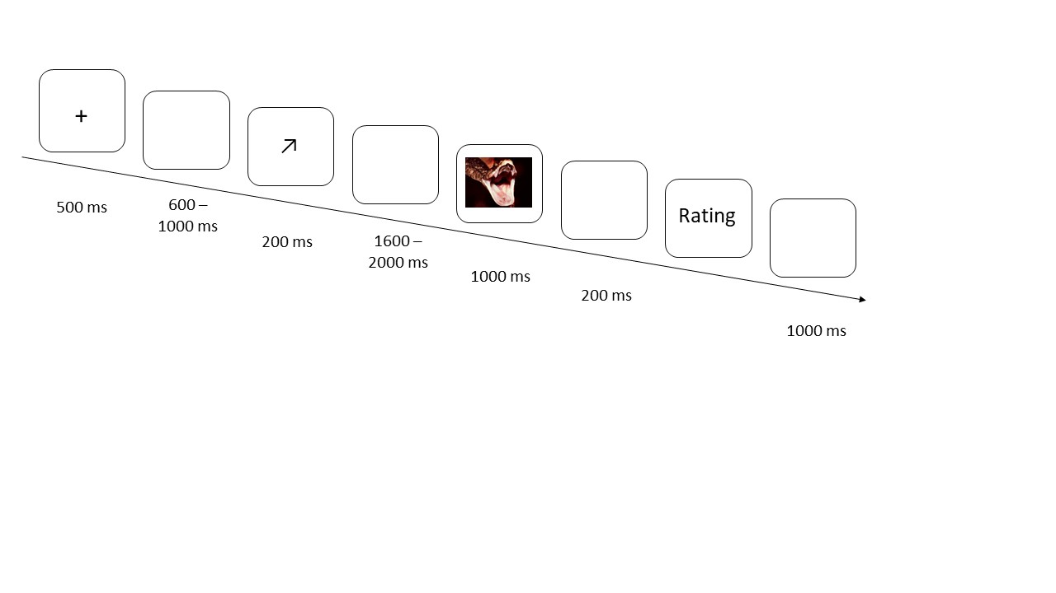

*Figure 1. Schematic illustration of the trial procedure. The on-screen duration of each stimulus is displayed in milliseconds.*

EEG data acquisition

EEG data were recorded from 32 scalp electrodes using an Active Two amplifier system (BioSemi, Amsterdam, Netherlands). Electrodes were placed according to the extended 10–20 system (Nuwer et al., 1998). Four further electrodes were positioned above and below the left eye and on the outer canthi of the left and right eyes, to record the vertical and horizontal electrooculogram (VEOG and HEOG, respectively). EEG signals from all channels were acquired with respect to the common mode sense (CMS) electrode with a sampling rate of 512Hz.

*ERP data analysis*

The continuous EEG was divided into epochs offline, beginning 200 ms prior to cue onset and ending 1800 ms after cue onset, and the epochs were digitally filtered (second-order zero-phase-lag bandpass filter, 0.01 – 25 Hz). The 200 ms pre-cue period was used for baseline correction. Artifact rejection was performed using the Statistical Control of Artifacts in Dense Arrays Studies (SCADS) method using standard parameters (Junghöfer, Bradley, Elbert, & Lang, 2001). Across all participants and all conditions, the procedure rejected an average of 19.9% of epochs as artefacts. ERPs were averaged separately for the three cue conditions (certain, fairly uncertain, and uncertain), resulting in three ERPs per channel for each participant.

Time windows and electrode clusters for statistical analysis were chosen based on visual inspection of the grand average waveforms and previous studies. The P200 component was maximal at around 190 ms, with a midline fronto-central scalp distribution, in line with previous studies (e.g., Harrison & Ziessler, 2016; Tanovic et al., 2018). The P200 was analysed between 170 – 210 ms at fronto-central electrode locations (Fz, FC1, FC2, Cz), in close agreement with previous studies (Harrison & Ziessler, 2016; Tanovic et al., 2018).

The early posterior negativity (EPN) was maximal at around 290 ms over occipito-temporal scalp, in agreement with previous studies (Schupp, Flaisch, Stockburger, & Junghöfer, 2006; Van Strien et al., 2014). The EPN was analysed at parieto-occipital locations (O1, O2, Oz, PO3, PO4, P7, and P8), in close alignment with other studies (Harrison & Chassy, 2019). Visual inspection of the grand-average waveforms suggested a time window of interest for analysis of between 260 – 340 ms, in close agreement with previous studies (e.g., Wierzchoń, Wronka, Paulewicz, & Szczepanowski, 2016). The late positive potential (LPP) was largest at around 600 ms following cue onset over parietal cortex, in agreement with previous studies (Hajcak et al., 2010; Hajcak et al., 2012). Mean activity at electrode Pz was analysed between 400 to 800 ms in close alignment with other studies (e.g., Lu et al., 2011; Moser et al., 2009; Wu et al., 2017).

For the SPN, the processing was the same, except for the following details. The continuous EEG was divided into epochs beginning 1000 ms prior to picture onset and ending 200 ms after picture onset. The epochs were digitally filtered (second-order zero-phase-lag bandpass filter, 0.01 – 10 Hz). The period from 1000 to 900 ms prior to picture onset was used as the baseline. The SPN was analysed at fronto-central electrodes (Fz, FC1, FC2, Cz, CP1, CP2), in close agreement with previous studies (e.g., Tanovic et al., 2018; Tanovic & Joormann, 2019), in the 500 ms prior to picture onset. Mean amplitudes for each electrode cluster within each time window were submitted to a one-way repeated-measures ANOVA with the factor Cue Condition (certain, fairly uncertain, uncertain).

**Results**

Picture Ratings

To check that the pictures evoked typical ratings of pleasantness, participants’ valence ratings for negative and neutral pictures were compared. Negative pictures were rated as more negative (*M* = 2.77, *SD* = 0.55) compared to neutral pictures (*M* = 5.53, *SD* = 0.70) (*t*(24) = 22.82, *p* < .001).

P200

The cue-locked P200 component was largest over fronto-central scalp at around 190 ms (see Figure 2). Mean amplitudes within a fronto-central electrode cluster (Fz, FC1, FC2, Cz) were analyzed in a 170 – 210 ms time window. A one-way repeated measures ANOVA with the factor Cue Condition (certain, fairly uncertain, uncertain) revealed no significant difference between conditions (*F*(2,48) = 0.412, *p* = .665).

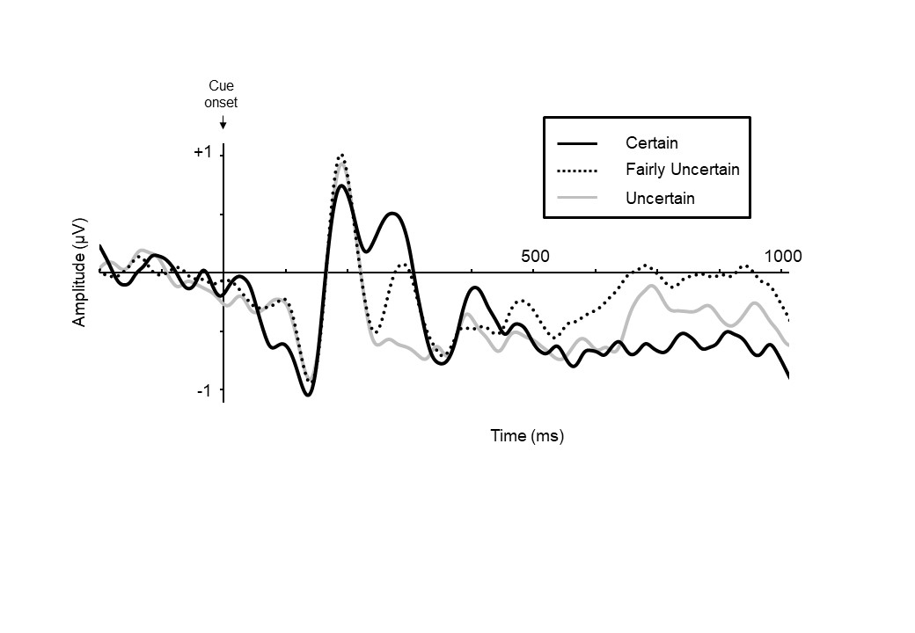

*Figure 2. Grand-averaged waveform following certain, fairly uncertain and uncertain cues, at the fronto-central electrode cluster. ERPs are time-locked to the onset of the cue. The P200 component can be seen at around 200 ms after cue onset.*

EPN

Between 250 – 350 ms after cue onset, ERPs evoked by the cues showed a relative negativity over occipito-temporal electrodes (see Figure 3), characteristic of the EPN component (Van Strien et al., 2014; Van Strien et al., 2009). The EPN was measured between 260 – 340 ms post-cue onset, over occipito-temporal scalp. A one-way ANOVA revealed a main effect of Cue Condition (*F*(2,48) = 11.10, *p* < .001). Planned contrasts revealed that the EPN was enhanced in the certain compared to the uncertain condition (*t*(24) = 3.725, *p* = .001). The EPN was enhanced in the certain compared to the fairly uncertain condition (*t*(24) = 2.839, *p* = .009). The EPN was enhanced in the fairly uncertain condition, compared to the uncertain condition (*t*(24) = 2.840, *p* = .009).

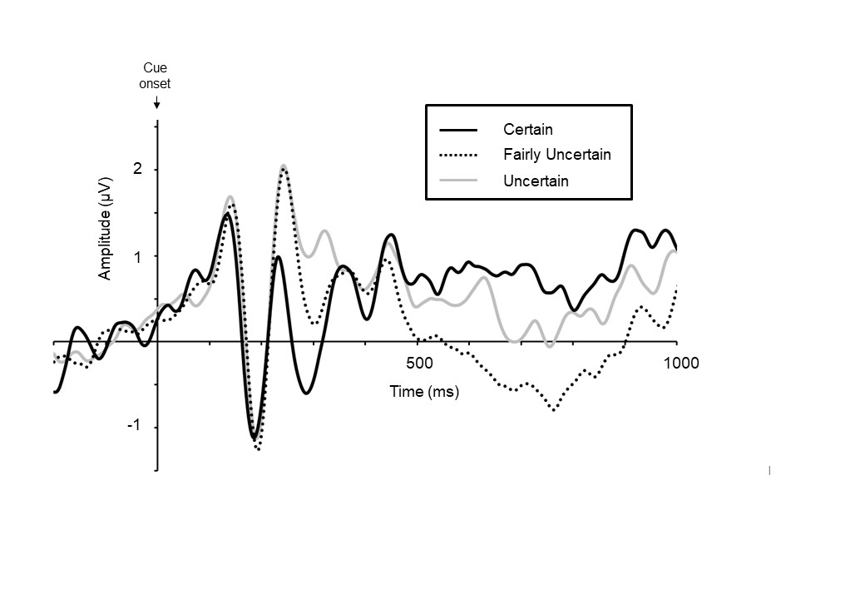

*Figure 3. Grand-averaged waveform following certain, fairly uncertain and uncertain cues, for the occipito-temporal electrode cluster. ERPs are time-locked to cue onset. The EPN can be observed as a relative negativity at around 290 ms after cue onset.*

LPP

The late positive potential (LPP) component, consisting of a sustained positive waveform with a maximum amplitude at around 600 ms, was observed at parietal electrode Pz (see Figure 4), in particular for the certain cue condition. A one-way ANOVA showed a main effect of Cue Condition (*F*(2,48) = 6.15, *p* = .004). Planned contrasts revealed that the LPP amplitude was more positive in the certain compared to the uncertain condition (*t*(24) = 2.421, *p* = .023), and in the certain compared to the fairly uncertain condition (*t*(24) = 3.777, *p* = .001). There was no difference between the fairly uncertain condition and the uncertain condition (*p* = .823).

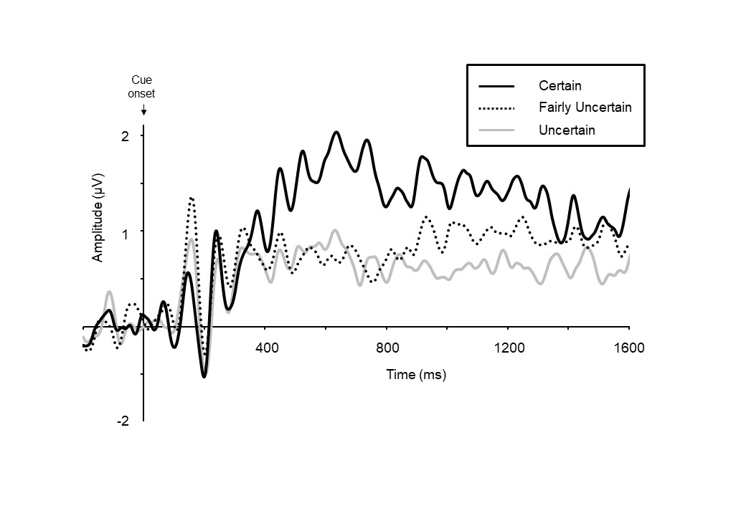

*Figure 4. Grand-averaged ERP waveform at electrode Pz, showing the late positive potential. ERPs are time-locked to the cue onset. The LPP was most prominent in the certain cue condition, around 600 ms following cue onset.*

SPN

The SPN was measured in the 500 ms interval prior to picture onset, over fronto-central scalp (see Figure 5). A one-way ANOVA revealed a main effect of expectation (*F*(2,48) = 5.90, *p* = .005). Planned contrasts revealed that the SPN was more negative in the certain compared to the uncertain condition (*t*(24) = 2.793, *p* = .010) There was no difference between the certain and fairly uncertain conditions, and no difference between the uncertain and fairly uncertain conditions (*p*s > .1).

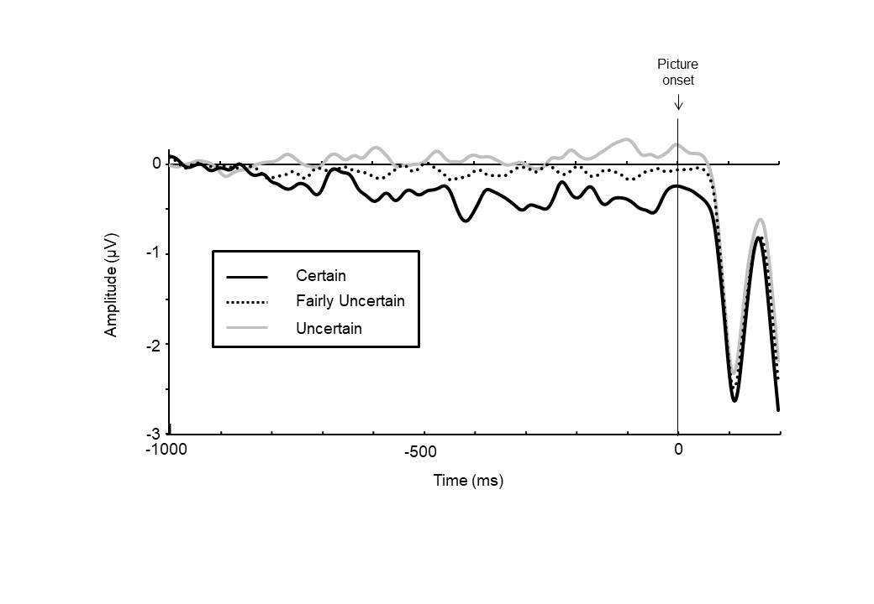

*Figure 5. Grand-averaged ERP waveform over fronto-central electrodes prior to picture onset. ERPs are time-locked to picture onset. The SPN can be seen as a slow negative wave prior to picture onset.*

**Discussion**

In daily life, some emotional events are highly certain to occur, for others there is some uncertainty about whether they will happen, while for others still there is a high level of uncertainty about whether they will occur. Here we extended previous work by examining how the degree of uncertainty about the affective nature of an upcoming picture influenced electrophysiological indices of attention and anticipatory emotional reactivity. Anticipatory cues varied in terms of their predictive value with regards to the emotional content of a following picture. For the cue-locked P200, an indicator of early selective attention, we found no differences between the anticipatory cue conditions (i.e., between certain, fairly uncertain, and uncertain cues). The EPN, which indexes somewhat later stages of attentional processing, was most pronounced for the certain cue condition, but was also sensitive to the degree of uncertainty of the anticipatory cues, as it was more pronounced in the fairly uncertain condition compared to the uncertain condition. The LPP amplitude was greater for certain, compared to fairly uncertain and uncertain cues, reflecting enhanced encoding of cues that signalled the certain presence of an unpleasant picture. We observed an enhanced SPN in the certain cue condition, compared to both the fairly uncertain and uncertain cue conditions. These data show that the level of uncertainty regarding the affective nature of an upcoming pictorial stimulus modulated several different stages of processing during the anticipation of the image.

Contrary to our predictions, for the cue-locked frontal P200 component we observed no amplitude differences between the certain, fairly uncertain, and uncertain conditions. This suggests that there was no difference in attentional allocation as a function of cue certainty at this early processing stage. In contrast, a prior study, which used a threat of shock paradigm, reported that the P200 was increased during certain, compared to more uncertain, anticipation of threat (Tanovic et al., 2018). This apparent discrepancy may be due to the salience of the stimuli (electric shocks) that were used in their study, which may have captured attention soon after cue onset due to their high motivational relevance. In contrast, the pictorial stimuli in our study may have been less motivationally salient, thus capturing less attention at this early stage of anticipation.

The EPN, the second electrophysiological index of anticipatory attention, differed depending on the level of uncertainty provided by the cue about the emotional nature of the forthcoming picture. In the certain condition, the EPN was more strongly enhanced compared to the fairly uncertain and uncertain conditions, suggesting that attention was most strongly increased when the emotional outcome was certain. Additionally, the EPN was enhanced in the fairly uncertain, compared to the uncertain condition. In other words, if the emotion of the upcoming picture was less certainly predicted by the cue, there was a concomitant decrease in attention, compared to the case when the emotion of the picture was predicted with certainty. Larger EPN amplitudes have previously been reported following the presentation of cues indicating the upcoming appearance of an emotionally arousing or painful stimulus, compared to the upcoming presence of an emotionally neutral, or painless, stimulus (Michalowski et al., 2015; Wu et al., 2017). However, here we go beyond previous findings, by showing that the EPN differed depending on the degree of certainty about the emotional nature of the upcoming stimulus. The EPN is generally regarded as reflecting early involuntary visual attention toward a stimulus that may facilitate more in-depth processing at later stages (Schupp, Junghöfer, Weike, & Hamm, 2003). The current results suggest that arbitrary symbolic cues, without any a-priori emotional relevance, can modulate the EPN response depending on the information they contain about the degree of likelihood of a future emotional event.

Regarding the LPP, we observed an increased amplitude in response to certain cues i.e., to cues that signalled without doubt an upcoming unpleasant picture, compared to those cues that contained some uncertainty regarding whether the picture would be unpleasant or neutral. These findings are in agreement with results showing an enhanced LPP to cues indicating an upcoming affective (versus neutral) picture (Michalowski et al., 2015; Poli et al., 2007), and to cues indicating an upcoming painful (versus non-painful) stimulus (Wu et al., 2017). The current results extend these previous findings by showing that, during anticipation, the LPP amplitude is sensitive to levels of uncertainty about the affective nature of the upcoming stimulus, as the amplitude was higher for certain compared to fairly uncertain and uncertain cue conditions. A number of studies have reported modulations of the LPP by uncertainty during exposure to a picture in an affective cueing design (Dieterich et al., 2016; Gole et al., 2012; Lin, Liang, Jin, & Zhao, 2018), but the current study is the first, to our knowledge, that examines the effects of uncertainty on the LPP evoked by perceptually simple cues signalling the affective nature of an upcoming picture. Compared to the cues that contained uncertainty about whether an unpleasant picture would be presented, our LPP results indicated more in-depth processing of the certain cues, presumably as these were highly informative for planning adaptive preparatory responses.

The current experiment showed clear evidence of enhanced EPN and increased LPP amplitudes during the encoding of cues signalling the certain occurrence of an unpleasant emotional picture. The notion that the EPN and LPP reflect the allocation of attentional resources suggests that the more certain cues about future emotional events captured greater attentional resources, compared to the less certain cues. These data are in agreement with findings from fear conditioning studies, showing that cues indicating greater certainty of aversive electric shocks elicit greater LPP amplitudes (Bublatzky & Schupp, 2012) and enhanced startle and skin conductance responses (Grillon, 2008; Weike, Schupp, & Hamm, 2008). The enhanced encoding of stimuli signalling the certain occurrence of an unpleasant stimulus is consistent with models proposing that certain cues are allocated more attention due to their increased informational content compared to more uncertain cues (e.g., Mackintosh, 1975). In terms of underlying neural mechanisms, increased brain activity in emotion-related (i.e. anterior cingulate cortex, insula and amygdala) brain regions, prefrontal and occipital cortices has been observed during the certain anticipation of negative images (Nitschke, Sarinopoulos, Mackiewicz, Schaefer, & Davidson; Onoda et al., 2008). Onoda and colleagues (2008) speculated that emotional warning signals generated by the limbic system may be communicated to prefrontal regions, which in turn regulate the state of the visual system to receive the affective stimulus. It is therefore plausible that the increased LPP amplitude, which is known to correspond to activity in visual cortical areas (Keil et al., 2002; for review, see Hajcak et al., 2010), reflects the up-regulation of the visual system by prefrontal areas, during the certain anticipation of an unpleasant emotional event.

Regarding later stages of anticipatory processing, we found a larger (i.e., more negative) SPN amplitude following certain compared to both fairly uncertain and uncertain cues, in line with our predictions. An increase in SPN amplitude has been associated with enhanced cortical anticipation and preparation processes (Poli et al., 2007; van Boxtel & Böcker, 2004). The observation that the amplitude of the SPN was enhanced for certain compared to uncertain cues is in broad agreement with results by Lin et al. (2014) and Poli et al. (2007), who found an increased negative slow cortical potential, reflecting anticipatory processing, following certain compared to uncertain negative cues. Together, these findings suggest that when cues provide certainty about the emotional nature of the upcoming event (in this case, an unpleasant picture), anticipatory processes are initiated to adaptively prepare for the outcome.

The increased SPN amplitude for certain compared to uncertain cues in the current study is in contrast to several results from threat of shock paradigms (Tanovic et al., 2018; Tanovic & Joormann, 2019), where an enhanced SPN was observed for more uncertain compared to certain cues. This apparent discrepancy is likely due to differences between emotions evoked by a symbolic source (i.e., an unpleasant picture) versus by actual pain (i.e., an electric shock), as there is evidence of a dissociation between the neural mechanisms of emotional responses to unpleasant pictures and threat of shock (Funayama, Grillon, Davis, & Phelps, 2001). Furthermore, threat of shock has been shown to elicit higher levels of emotional arousal compared to unpleasant pictures, as indexed by increased self-reported state anxiety and greater startle potentiation (Lissek et al., 2007). The nature (symbolic versus actual) of the outcome event, and its degree of arousal, may interact with the uncertainty of the event’s occurrence, to determine its influence on neural markers of anticipation such as the SPN. It would be worthwhile for future studies to systematically examine the effects of uncertainty associated with different types of outcome events.

We found no SPN amplitude differences between fairly uncertain and uncertain cues, indicating that the SPN did not appear to distinguish between levels of uncertainty. Instead, the SPN was largest for when the expectation of a future negative stimulus was certain, compared to if there was any level of uncertainty involved in the outcome. This finding is in agreement with the results obtained by Tanovic et al. (2018), who similarly found that the SPN did not reflect different degrees of threat uncertainty. Rather, it appears that the SPN may index anticipatory processes that are based on a coarser appraisal of whether an upcoming affective event is either certain or uncertain to occur.

Several potential limitations of the current study should be noted. Firstly, the different number of cues per condition could have impacted the ERPs, making it difficult to separate certainty/uncertainty effects from effects related to cue frequency. Generally, stimuli occurring with a lower frequency (e.g., oddballs) elicit a positive amplitude over posterior scalp with a peak between 300 – 500 ms after stimulus onset, referred to as the P300 or P3 component (Polich, 2007; Pritchard, 1981). Therefore, cue frequency may have influenced our results concerning the EPN and LPP components. Although we cannot rule out this possibility, several considerations lead us to suspect that cue frequency did not significantly influence the current findings. Regarding our analysis of the EPN, which took place between 260 – 340 ms, we would have expected to see a more positive ERP wave for the certain cue condition if cue frequency had influenced the waveforms. However, on the contrary, the ERP for the certain condition was more negative between 250 – 400 ms, compared to the other two conditions (see Figure 3). Regarding the LPP (see Figure 4), the peak of the posterior positivity occurred at around 600 ms, which is much later than the time at which the P300 generally occurs (Hajcak et al., 2012). Given that our time-window of analysis for the LPP was 400 – 800 ms, it is unlikely that the results for the LPP were significantly influenced by the frequency of presentation of the cues.

A second limitation was that the exclusion of a certain neutral cue condition precluded investigation into the separate effects of valence and arousal on uncertain anticipation of emotional pictures. Future studies should therefore include positive and negative pictures that do not differ in arousal, in addition to neutral images. Thirdly, the sample was composed solely of females, to ensure more homogeneity, as females may be more sensitive to negative stimuli (Groen, Wijers, Tucha, & Althaus, 2013). This of course necessarily limits the generalizability of the findings. Furthermore, individual differences in intolerance of uncertainty (IU) were not assessed in this experiment. It has been established that IU influences psychophysiological indices of uncertain anticipation, therefore future studies should incorporate this measure when investigating how uncertainty influences anticipatory processes (Gole, et al., 2012; Morriss, 2019; Tanovic et al., 2018). Lastly, here we did not examine the effects of levels of uncertainty on neural processes following picture presentation. Future studies should investigate the effects of different degrees of uncertainty on the perceptual and affective responses to the pictures.

**Conclusion**

In this study, we extended previous research on uncertain anticipation by investigating the effects of the level of uncertainty about the affective nature of an upcoming pictorial stimulus on electrophysiological indices of attention and anticipatory emotional reactivity. At very early stages of processing (P200), there was no difference in attentional allocation depending on the level of uncertainty of the cues. At somewhat later stages of attentional processing (between 260 – 340 ms), we found that the EPN was sensitive to the level of uncertainty contained in the cues, with more certain cues leading to an enhanced EPN. This provided evidence that more attention was allocated to cues that more certainly predicted the occurrence of a negative picture. From 400 – 800 ms after cue onset, the LPP was larger for certain, compared to fairly uncertain and uncertain cues, reflecting increased encoding of cues that provided certain information that an unpleasant picture would be presented. Regarding anticipatory emotional reactivity, the amplitude of the SPN was enhanced when the cues were certain, compared to when they contained uncertainty; the SPN did not distinguish between degrees of uncertainty. Together, the results showed that the level of uncertainty provided by an abstract cue about the emotional nature of a pictorial stimulus differentially influenced a number of anticipatory neural processing stages.

**References**

Bublatzky, F., & Schupp, H.T. (2012). Pictures cueing threat: brain dynamics in viewing

explicitly instructed danger cues*. Social, Cognitive and Affective Neuroscience, 7*(6),

611–22.

Brunia, C. H. M., van Boxtel, G. J. M., & Böcker, K. B. E. (2012). Negative Slow Waves as Indices of Anticipation: The Bereitschaftspotential, the Contingent Negative Variation, and the Stimulus-Preceding Negativity. In E. S. Kappenman & S. J. Luck (Eds.), *The Oxford Handbook of Event-Related Potential Components* (pp. 189–207). New York: Oxford University Press.

Carretié, L., Martín-Loeches, M., Hinojosa, J. A., & Mercado, F. (2001). Emotion and attention interaction studied through event-related potentials. *Journal of Cognitive Neuroscience, 13*(8), 1109–1128. https://doi.org/10.1162/089892901753294400

Dieterich, R., Endrass, T., & Kathmann, N. (2016). Uncertainty is associated with increased selective attention and sustained stimulus processing. *Cognitive, Affective, & Behavioral Neuroscience, 16*(3), 447–456. <https://doi.org/10.3758/s13415-016-0405-8>

Funayama, E.S., Grillon, C., Davis, M., Phelps, E.A. (2001). A double dissociation in the affective modulation of startle in humans: Effects of unilateral temporal lobectomy. *Journal of Cognitive Neuroscience, 13*(6), 721–729.

Gole, M., Schäfer, A., & Schienle, A. (2012). Event-related potentials during exposure to aversion and its anticipation: The moderating effect of intolerance of uncertainty. *Neuroscience Letters, 507*(2), 112–117. <https://doi.org/10.1016/j.neulet.2011.11.054>

Groen, Y., Wijers, A.A., Tucha, O., & Althaus, M. (2013). Are there sex differences in ERPs

related to processing empathy-evoking pictures? *Neuropsychologia, 51*(1), 142–155.

Grillon, C. (2008). Models and mechanisms of anxiety: Evidence from startle studies. *Psychopharmacology, 199*, 421–437.

Grupe, D. W., & Nitschke, J. B. (2013). Uncertainty and anticipation in anxiety: An integrated neurobiological and psychological perspective. *Nature Reviews Neuroscience, 14*(7), 488–501.

Hajcak, G., MacNamara, A., & Olvet, D. M. (2010). Event-Related Potentials, Emotion, and Emotion Regulation: An Integrative Review. *Developmental Neuropsychology, 35*(2), 129–155. <https://doi.org/10.1080/87565640903526504>

Hajcak, G., Weinberg, A., MacNamara, A., & Foti, D. (2012). ERPs and the study of emotion. In E. Kappenman & S. Luck (Eds.), *The Oxford Handbook of Event-Related Potential Components* (pp. 441– 472). New York, NY: Oxford University Press.

Harrison, N., & Chassy, P. (2019). Habitual use of reappraisal to regulate emotions is associated with decreased amplitude of the late positive potential (LPP) elicited by threatening pictures. *Journal of Psychophysiology, 33*, 22–31.

Harrison, N.R., & Ziessler, M. (2016). Effect anticipation affects perceptual, cognitive, and motor phases of response preparation: evidence from an event-related potential (ERP) study. *Frontiers in Human Neuroscience, 10*:5. doi:10.3389/fnhum.2016.00005

Huang, Y., Shang, Q., Dai, S., & Ma, Q. (2017). Dread of uncertain pain: An event-related potential study. *PLOS ONE, 12*(8). doi.org/10.1371/journal.pone.0182489

Johnen, A-K., & Harrison, N.R. (2019). The effects of valid and invalid expectations about stimulus valence on behavioural and electrophysiological responses to emotional pictures. *International Journal of Psychophysiology, 144*, 47-55.

Junghöfer, M., Bradley, M. M., Elbert, T. R., & Lang, P. J. (2001). Fleeting images: a new look at early emotion discrimination. *Psychophysiology, 38*(2), 175–178.

Keil, A., Bradley, M., Hauk, 0., Rockstroh, B., Elbert, T, & Lang, P. (2002). Large-scale neural correlates of affective picture processing. *Psychophysiology, 39*(5), 641-649.

Lang, P. J., Bradley, M. M., & Cuthbert, B. N. (2008). *International affective picture system (IAPS): Affective ratings of pictures and instruction manual. Technical Report A-8.* University of Florida, Gainesville, FL.

Lin, H., Gao, H., You, J., Liang, J., Ma, J., Yang, N., Xu, H., & Jin, H. (2014). Larger N2 and smaller early contingent negative variation during the processing of uncertainty about future emotional events. *International Journal of Psychophysiology, 94*(3), 292–297. https://doi.org/10.1016/j.ijpsycho.2014.10.004

Lin, H., Jin, H., Liang, J., Yin, R., Liu, T., & Wang, Y. (2015). Effects of Uncertainty on ERPs to Emotional Pictures Depend on Emotional Valence. *Frontiers in Psychology*, *6* :1927 <https://doi.org/10.3389/fpsyg.2015.01927>

Lin, H., Liang, J., Jin, H., & Zhao, D. (2018). Differential effects of uncertainty on LPP responses to emotional events during explicit and implicit anticipation. *International Journal of Psychophysiology, 129*, 41-51.

Lissek, S., Orme, K., McDowell, D. J., Johnson, L. L., Luckenbaugh, D. A., Baas, J. M., Cornwell, B.R., & Grillon, C. (2007). Emotion regulation and potentiated startle across affective picture and threat-of- shock paradigms. *Biological Psychology, 76*, 124–133

Mackintosh, N. J. (1975). A theory of attention: Variations in the associability of stimuli with reinforcement. *Psychological Review, 82*(4), 276–298.

Michalowski, J. M., Pané-Farré, C. A., Löw, A., & Hamm, A. O. (2015). Brain dynamics of visual attention during anticipation and encoding of threat- and safe-cues in spider-phobic individuals. *Social Cognitive and Affective Neuroscience, 10*(9), 1177–1186. <https://doi.org/10.1093/scan/nsv002>

Morriss, J. (2019). What do I do now? Intolerance of uncertainty is associated with discrete patterns of anticipatory physiological responding to different contexts. *Psychophysiology, 56*(9), e13396.

Morriss, J., Gell, M., & van Reekum, C. M. (2019). The uncertain brain: A co-ordinate based meta-analysis of the neural signatures supporting uncertainty during different contexts. *Neuroscience & Biobehavioral Reviews, 96*, 241-249.

Moser, J. S., Krompinger, J. W., Dietz, J., & Simons, R. F. (2009). Electrophysiological correlates of decreasing and increasing emotional responses to unpleasant pictures. *Psychophysiology, 46*(1), 17–27. <https://doi.org/10.1111/j.1469-8986.2008.00721.x>

Nitschke, J. B., Sarinopoulos, I., Mackiewicz, K. L., Schaefer, H. S., & Davidson,

R. J. (2006). Functional neuroanatomy of aversion and its anticipation.

*Neuroimage, 29*, 106–116.

Nuwer, M. R., Comi, G., Emerson, R., Fuglsang-Frederiksen, A., Guérit, J. M., Hinrichs, H., … Rappelsburger, P. (1998). IFCN standards for digital recording of clinical EEG. International Federation of Clinical Neurophysiology. *Electroencephalography and Clinical Neurophysiology, 106*(3), 259–261.

Onoda, K., Okamoto, Y., Toki, S., Ueda, K., Shishida, K., Kinoshita, A.,…, Yamawaki, S. (2008). Anterior cingulate cortex modulates preparatory activation during certain anticipation of negative picture. *Neuropsychologia, 46*(1), 102–110.

Pearce, J. M., & Hall, G. (1980). A model for Pavlovian learning: Variations in the effectiveness of conditioned but not of unconditioned stimuli. *Psychological Review, 87*, 532–552.

Pearce, J. M., & Mackintosh, N. J. (2010). Two theories of attention: A review and a possible integration. In C. Mitchell & M. E. LePelley (Eds.), *Attention and Learning* (pp. 11–39). New York, NY: Oxford University Press.

Peters, A., McEwen, B. S., & Friston, K. (2017). Uncertainty and stress: Why it causes diseases and how it is mastered by the brain. *Progress in Neurobiology, 156*, 164-188.

Poli, S., Sarlo, M., Bortoletto, M., Buodo, G., & Palomba, D. (2007). Stimulus-Preceding Negativity and heart rate changes in anticipation of affective pictures. *International Journal of Psychophysiology, 65*(1), 32–39.

Polich, J. (2007). Updating P300: An integrative theory of P3a and P3b. *Clinical Neurophysiology, 18*(10), 2128-2148.

Pritchard, W.S. (1981). Psychophysiology of P300. *Psychological Bulletin, 89*, 506–540.

Schupp, H. T., Flaisch, T., Stockburger, J., & Junghöfer, M. (2006). Emotion and attention: event-related brain potential studies. *Progress in Brain Research, 156*, 31–51.

Schupp, H. T., Junghöfer, M., Weike, A. I., & Hamm, A. O. (2003). Attention and emotion: an ERP analysis of facilitated emotional stimulus processing. *Neuroreport, 14*(8), 1107–1110.

Takeuchi, S., Mochizuki, Y., Masaki, H., Takasawa, N., & Yamazaki, K. (2005). Stimulus preceding negativity represents arousal induced by affective picture. *International Congress Series, 1278*, 385–388. <https://doi.org/10.1016/j.ics.2004.11.135>

Tanovic, E., & Joormann, J. (2019). Anticipating the unknown: The stimulus-preceding negativity is enhanced by uncertain threat. *International Journal of Psychophysiology, 139*, 68–73.

Tanovic, E., Pruessner, L., & Joormann, J. (2018). Attention and anticipation in response to varying levels of uncertain threat: An ERP study. *Cognitive Affective and Behavioral Neuroscience, 18*, 1207–1220.

Van Boxtel, G.J.M., & Böcker, K.B.E. (2004). Cortical measures of anticipation. *Journal of Psychophysiology, 18*, 61–76.

Van Strien, J. W., Langeslag, S. J. E., Strekalova, N. J., Gootjes, L., & Franken, I. H. A. (2009). Valence interacts with the early ERP old/new effect and arousal with the sustained ERP old/new effect for affective pictures. *Brain Research, 1251*, 223–235.

Van Strien, J. W., Eijlers, R., Franken, I. H. A., & Huijding, J. (2014). Snake pictures draw more early attention than spider pictures in non-phobic women: Evidence from event-related brain potentials. *Biological Psychology, 96*, 150–157.

Weike, A.I., Schupp, H.T., Hamm, A.O. (2008). In dubio pro defensio: initial activation of

conditioned fear is not cue specific. *Behavioral Neuroscience, 122*(3), 685–96.

Wierzchoń, M., Wronka, E., Paulewicz, B., & Szczepanowski, R. (2016). Post-decision wagering affects metacognitive awareness of emotional stimuli: an event related potential study. *PLOS One, 11*(8): e0159516. doi:10.1371/journal.pone.015951.

Wu, L., Kirmse, U., Flaisch, T., Boiandina, G., Kenter, A., & Schupp, H. T. (2017). Empathy, Pain and Attention: Cues that Predict Pain Stimulation to the Partner and the Self Capture Visual Attention. *Frontiers in Human Neuroscience, 11*. <https://doi.org/10.3389/fnhum.2017.00465>

1. Ratings data was not analysed in the current study, as here we were interested only in the anticipatory processes occurring prior to picture onset.