**Scaling of the extrastriate neural response to symmetry**

Letizia Palumbo12, Marco Bertamini2 & Alexis Makin2

*1Department of Psychology, Liverpool Hope University, UK*

*2Department of Psychological Sciences, University of Liverpool, UK*

palumbl@hope.ac.uk

m.bertamini@liverpool.ac.uk

alexis.makin@liverpool.ac.uk

Correspondence:

Letizia Palumbo

Department of Psychology

Liverpool Hope University

Hope Park

L16 9JD

Liverpool

UK

**Abstract**

Neuroimaging work has shown that visual symmetry activates extrastriate brain areas, most consistently the Lateral Occipital Complex (LOC). LOC activation increases with proportion of symmetrical dots (pSymm) in a degraded display. In the current work, we recorded a posterior ERP called the Sustained Posterior Negativity (SPN), which is relatively negative for symmetrical compared to random patterns. We predicted that SPN would also scale with pSymm, because it is probably generated by the LOC. Twenty-four participants viewed dot patterns with different levels of regularity: 0% regularity (full random configuration) 20%, 40% 60%, 80%, 100% (full reflection symmetry). Participants judged if the pattern contained “some regularity” or “no regularity”. As expected, the SPN amplitude increased with pSymm, while the latency and duration was the same in all conditions. The SPN was independent of the participant’s decision, and it was present on some trials where people reported ‘no-regularity’. We conclude that the SPN is generated at an intermediate stage of visual processing, probably in the LOC, where perceptual goodness is represented. This comes after initial visual analysis, but before subsequent decision stages, which apply a threshold to the analogue LOC response.

**Keywords**

Symmetry, EEG, ERPs, Sustained Posterior Negativity, Perceptual Goodness

**1. Introduction**

Symmetry is relevant for a variety of visual processes, such as for perceptual grouping and pattern recognition (Machilsen, Pauwels & Wagemans, 2009), face recognition and for discriminating living organisms from non-living objects (Tyler, 1995). Psychophysical work has shown that reflection on the vertical axis is more salient than when the axis is horizontal or oblique (Bertamini, Friedenberg & Kubovy, 1997) and that reflection detection is superior to translation and rotation (Royer, 1981). Symmetry discrimination is not an all or nothing affair: people can discriminate regularity in noisy displays (Barlow & Reeves, 1979). It is also well known that humans and animals like symmetry, whether it is a property of abstract patterns (Eysenk, 1941; Jacobsen & Höfel, 2002; Makin, Pecchinenda & Bertamini, 2012) or potential mates (Bertamini, Byrne & Bennett, 2013; Grammer, Fink, Møller & Thornhill, 2003; Rhodes, Proffitt, Grady & Sumich, 1998). Despite the perceptual and emotional relevance of symmetry, its neural basis is still under investigation.

There are many ways of classifying regular patterns, including Euclidian plane isometries, the 7 frieze groups and the 17 wallpaper groups (Grunbaum & Shephard, 1987). Here we focus on the neural response to reflectional symmetry. The extent to which these results generalize is a topic for future work.

**1.1 Brain responses for symmetry**

The existing neuroimaging work symmetry perception was reviewed by Bertamini and Makin (2014). Functional Magnetic Resonance (fMRI) and Trans-cranial Magnetic Stimulation (TMS) studies have revealed that the lateral occipital complex (LOC) is causally involved in symmetry detection (Bona, Herbert, Toneatto, Silvanto & Cattaneo, 2014; Cattaneo, Mattavelli, Papagno, Herbert & Silvanto, 2011; Sasaki, Vanduffel, Knutsen, Tyler & Tootell, 2005). Sasaki et al. (2005) recorded cerebral blood flow with fMRI while participants viewed reflection or random dot configurations. The authors found that V3A, V4, V7 and the LOC were more activated for reflection. There was no response to reflection in V1 and V2. Importantly, the activity within this extrastriate network was positively correlated with subjective perception of symmetry: the more the stimuli were perceived as symmetrical, the more they evoked neural activity. Furthermore, the proportion of symmetrical and random dots in the displays was varied, both the probability of reporting symmetry and size of the neural response increases with this variable. We refer the proportion of symmetrically positioned dots in a pattern as ‘pSymm’.

There have also been several ERP studies on symmetry perception. First, Norcia, Candy, Pettet, Vildavski and Tyler (2002) found that amplitude was reduced for symmetrical compared random pattern in posterior electrodes from around 220 ms onwards. Jacobsen and Höfel (2003) reported a similar sustained posterior negativity (SPN) beginning after the P1 and N1 components of the visual evoked potential at posterior channels. The SPN is a *difference wave*- the term ‘negative’ refers to the fact that the amplitude was more negative for the symmetrical than random patterns. The SPN is partially independent of task, it can be recorded when participants are not explicitly classifying patterns as symmetrical or random (Höfel & Jacobsen, 2007a) or when people deliberately misreport their responses (Höfel & Jacobsen, 2007b) but can be reduced if people are attending to superimposed words instead of the symmetry of the patterns (Rampone, Makin & Bertamini, 2014).

Makin, Rampone, Pecchinenda, & Bertamini (2013) showed that the SPN is larger for reflection than translation and rotation symmetry, and concluded that reflection is the optimal stimulus for a more general regularity-sensitive network in the extrastriate visual cortex. Other experiments have found that the SPN is similar for symmetrical objects and gaps between objects (Makin, Rampone, Wright, Martinovic & Bertamini, 2014) and that the SPN is a view-invariant response to symmetry when participants are attending to regularity (Makin, Rampone & Bertamini, 2014). The SPN is similar for horizontal and vertically oriented patterns (Wright, Makin & Bertamini, 2015).

These studies tell us much about symmetry networks in the brain, but they do not clarify whether the SPN wave is generated by the LOC, identified as the major ‘symmetry region’ by Sasaki et al. (2005), Tyler et al. (2005), Cattaneo et al., (2011) and Bona et al. (2014). Makin et al., (2012) did perform a preliminary source localization analysis that identified SPN generators in lateralized posterior brain regions. However, this was not precise enough to warrant a strong conclusion.

**1.2 Current work**

We presented abstract patterns while recording EEG. The patterns varied in terms of the proportion of reflection over random elements. There were 300 random trials, and 60 trials with 20%, 40% 60% and 80% and 100% symmetry (Figures 1 and 2). We refer to this factor as ‘pSymm’. On every trial, participants were forced to choose a response, either “some regularity” or “no regularity”. For all 5 levels of pSymm, the SPN was calculated as the difference from the random wave.

Sasaki et al. (2005) found that the BOLD response in LOC and V4 parametrically increased with the proportion of reflected dots. If they SPN is generated by symmetry related activity in these areas, it will also scale with pSymm. This is important purely in terms of understanding the nature of the SPN signal. However, a positive result would also tell us something about the nature of symmetry processing in the extrastriate visual cortex. A parametric increase in the BOLD response is not conclusive: Increased BOLD could be produced by a longer-lasting period of symmetry related activity or by an earlier onset of the symmetry response. Alternatively, the temporal characteristics of the response could be the same for all levels of pSymm, but the amplitude response could increase with pSymm. The SPN has the temporal resolution to distinguish between these distinct ‘amplitude’ and ‘duration’ possibilities.

The second aim of the current study was to characterize the relationship between the neural response to symmetry in the extrastriate cortex and higher decision-making processes in the brain. Consider the trials with a medium pSymm, say 60% and 40%. Participants sometimes correctly reported ‘some regularity’ (a hit) and sometimes erroneously reported ‘no regularity’ (a miss). If the SPN is generated by the decision stage, there should be no SPN whatsoever on the miss trials, and a large, similar SPN on all the hit trials. Conversely, it could be that the SPN reflects an analogue response to symmetry, at an intermediate level of the processing hierarchy. A subsequent decision stage applies a threshold to this signal. In this case, we will still record an SPN, albeit at a lower amplitude, on the miss trials.

These two questions represent a major step forward in understanding the neural basis of symmetry perception. The current work tests whether pSymm alters the amplitude or duration of the neural response in extrastriate symmetry networks, and also how these networks fit in to the rest of cognitive processing. More generally, this is an important topic for understanding mid level vision, where consciously experienced visual structure emerges (Peirce, 2014).

**2. Method**

**2.1 Participants**

Twenty-four participants took part in the experiment (age range: 19 – 46, average age 21.5 years, 9 males, 5 left handed). All participants had normal or corrected to normal vision. They provided a written consent for taking part and received course credits. The experiment was approved by the Ethics Committee of the University of Liverpool and was conducted in accordance with the Declaration of Helsinki (2008).

**2.2 Apparatus**

Apparatus was identical to that used in previous SPN studies (e.g. Makin et al., 2012). Participants sat 140 cm from a 40x30 cm CRT monitor and entered their responses pressing the A and L buttons of a computer keyboard. Stimuli were generated and presented using the PsychoPy software (Peirce, 2007). Electroencephalographic (EEG) activity was recorded using a BioSemi Active-Two amplifier in an electrically shielded and darkened room. EEG was sampled continuously at 512 Hz from 64 AgCl scalp electrodes arranged according to the International 10-20 system. Two additional electrodes, called common mode sense (CMS) and driven right leg (DRL), were used as reference and ground. Biopolar vertical (VEOG) and horizontal (HEOG) electrooculogram electrodes were positioned above and below the right eye, and on the outer canthi of both eyes, respectively. The EOG signals were recorded from four external channels of the same BioSemi amplifier and were used for on-line monitoring of eye movements.

**2.3 Stimuli**

The Experiment was programmed in Python using open source Psychopy software (Peirce, 2007). The dot patterns were all within a circular frame approximately 5 degrees in diameter. Stimuli were constructed on every trial according an algorithm with randomized parameters. This meant that no two patterns were ever identical, either within or between subjects. The two basic steps for stimulus generation of a 100% reflection are shown in Figure 1. First a single pie-slice like segment was generated, with a single axis of symmetry. This was tiled with a regular grid of cells some of which are occupied with a small black dot. If a cell is placed in the dot on the left of the axes, another will automatically be placed in the cell on the right of the axis. In the second step, the segment was then rotated and replicated in the other three positions. For intermediate levels of regularity, a certain proportion in segment first were set to be reflected, and these positions were memorized, and repeated in the other three segments. The randomly position dots were chosen independently in each segment. Four examples of each kind of regularity are shown in Figure 2.

On average, 40% of all grid positions were occupied: There were 1328 cells, and on average 531.2 of these will be filled with a dot. The average number of dots was the same at all stimuli. However, there was variability around this mean, and this variability increased with pSymm. The approximate Standard Deviation (SD) values were 16, 26, 31, 39, 45 and 57 dots for random, 20%, 40%, 60%, 80% and 100% patterns. SD thus ranged between 11% and 3% of the mean number of dots. This low magnitude confound is highly *unlikely* to explain the ERP differences. There were always hundreds of dots in every pattern, and salience of visual reflectional symmetry is thought to be independent of number of dots (van der Helm & Leeuwenberg, 1996).

There is also an issue of accidental pairing in the randomly positioned dots. These dots were not actively de-coupled, and dots could form accidental pairs across the axes. This can be illustrated by first considering the random patterns with 0% deliberate symmetry. With average density of 40%, independent random positioning on either side of an axis produces an average accidental dot pairing rate of 0.42 = 0.16. However, there were 4 folds, so the average accidental pairing rate was 0.42 + 0.43 + 0.44 + 0.45 = 0.26. As pSymm increased, the accidental pairing rate reduced to 0.21, 0.16, 0.10, 0.05 and 0, because more of the dots were incorporated into deliberate pairs instead. This makes it sound like our advertised pSymm values are a gross underestimate. However the deliberate symmetry was across four axes, while most of the accidental symmetry was across just one axis. Accidental pairing only made a minor contribution to the perceived regularity of the patterns. We also note that active de-coupling of random dots would introduce anti-symmetry, where black and white regions alternate across the axis.

**2.4 Experimental Design and Procedure**

First participants were fitted with an appropriate electrode cap, and sigma gel was applied to each electrode site. Two strands of active electrodes were plugged in, along with four external electrodes. The important indicator of electrode-scalp contact quality in the Biosemi system is *DC offset* (not impedance), and this was kept below 40 for all electrodes before the experiment began, and typically below 25. During the experiment, data recording quality was checked intermittently, and sub-optimal electrodes improved.

The experiment had a within-subjects design. There were 300 random trials, and 60 trials at each level of pSymm (20%, 40%, 60%, 80% and 100%). Participants sat in a darkened and electrically shielded room in front of the stimulus monitor. The baseline lasted 1.5 s, followed by the pattern that was displayed for 1.5 s. At the end of each stimulus presentation, participants were prompted with a response screen to indicate whether they have seen “some regularity” or “no regularity” in the pattern. The left and right keyboard keys for reporting “some regularity” and “no regularity” were counterbalanced across participants. Participants were instructed to fixate on the central red dot during baseline and presentation periods. The experiment was divided into 20 blocks of 30 trials. The experiment started with a 10 trial practice block of that presented the same design as the experimental block.

**2.5 EEG data pre-processing**

EEG data were processed using the EEGLAB toolbox in MATLAB (Delorme & Makeig, 2004). Raw signals from 64 scalp electrodes were referenced to an average reference, and low-pass filtered at 25 Hz. For filtering, we used the elliptical, non-causal iirfilt function in the eeglab toolbox. This was chosen for consistency with previous SPN work (e.g. Makin et al., 2012). Data were re-sampled at 128 Hz to reduce file size, and segmented into −1 to +1.5 s epochs, with −200 to 0 ms baseline. After this, independent components analysis (ICA; Jung et al., 2000) was used to remove gross artefacts produced by blinks and eye movements. Data were reformed as 64 components, and an average of 9.79 components were removed from each participant (min = 2, max = 22). After ICA, trials with amplitude beyond +/- 100 μV at any electrode were excluded. The average proportion of excluded trials did not differ significantly between the six conditions (approximately 7% in all cases).

**2.6 Data Analysis**

First behavioural data was explored. The proportion of trials where participants reported ‘some regularity’ was calculated for each level of pSymm, and for the random trials. This was analyzed with 6 level repeated measures ANOVA (Random, 20, 40, 60, 80, and 100%).

To quantify the SPN for each participant and condition, average amplitude in the PO7-PO8 electrodes from 300 to 1000 ms was obtained. The difference between each level of pSymm and the random trials was then measured. SPN was analysed as a function of pSymm with a one-factor, 5 level repeated measures ANOVA (20, 40, 60, 80, and 100%).

Participants were nearly always correct in classifying 80 and 100% symmetry trials as having ‘some regularity’, and hardly ever reported regularity in the 20% symmetry or random trials. The second part of the analysis therefore focused on 40% and 60% symmetry trials, where there were a reasonable number of both hit trials (where people claimed some regularity was present), and miss trials, (where they erroneously reported no regularity). The hit rate on 60% symmetry trials was 69%, the hit rate on 40% symmetry trials 35%. The SPN was obtained for the hit and miss trials separately, using the same parameters as above. The absolute number of trials averaged to make these waves ranged from 3 to 53, and the average number of trials in the four conditions used in this analysis was 38.92, 16.75, 19.38 and 36.21 (for 60% hit, 60% miss, 40% hit and 40% miss conditions respectively).

We also considered Random trials. These can be sub divided into correct rejections (average number of trials = 242.29, min 155, max = 286) and false alarms (average = 36.38, min 3, max = 99). ERPs on the hit, miss, correct rejection and false alarm trials are thus potentially noisy, given the very low numbers of trials in some conditions.

**3. Results**

**3.1 Behavioural results**

In Figure 3A the proportion of ‘some regularity’ responses is plotted against pSymm. Unsurprisingly, affirmative responses increased with pSymm. Repeated measures ANOVA found a main effect of pSymm (F (2.206, 50.742) = 437.123, p < 0.001, *ηp2* = .950). Paired t-tests showed that for every level of pSymm from 20% up to 100%, participants were more likely to report some regularity than in the random condition (p < 0.001).

**[Figure 3 about here]**

**3.2 EEG results**

SPN amplitude for each pSymm condition was defined as the difference from random wave, in the PO7 and PO8 electrodes, from 300 to 1000 ms. Figure 4A shows the topographic difference map of the SPN for each pSymm condition. Clearly the SPN scaled parametrically with pSymm. This can also be seen in the ERP plots in Figure 4B, and the difference waves in Figure 4C. There was some symmetry related activity at the N1 latency; however, the response has reached approximately maximum amplitude by 300 ms (See vertical dashed lines in Figure 4B and C).

A one factor repeated measures ANOVA with 5 levels was used to explore the effect of pSymm on SPN amplitude. The increase in SPN amplitude with pSymm was significant (F (2.394, 55.057) = 37.669, p < 0.001, *ηp2* = .621). Next, SPN Amplitude in each level of pSymm was compared against zero with one-sample t tests. There was significant response to symmetry in the 40% 60%, 80% and 100% conditions (p < 0.04), but there was no SPN for 20% symmetry (t (23) = -0.222, p = 0.826). Paired t-tests found that every successive pSymm increment produced a significant increase in SPN amplitude (p < 0.005) except 40%, which was only marginally greater than 20% (t (23) -1.927, p = 0.066).

**[Figure 4 about here]**

Next we consider the relationship between SPN and the participant’s decisions. First, we note that participants *could* discriminate 20% symmetry from random, although there was *no* SPN for 20% symmetry. Second, SPN was significantly larger for 100% than 80% symmetry, but participants were reported virtually all these trials as ‘some regularity’. These differences are illustrated in Figure 3B. Here behavioural and brain data were normalized to facilitate comparison of the shape of the functions (the highest and lowest values are yoked to the top and bottom of the respective axes). The important point is that the shapes of the functions are different. This ‘decoupling’ is not entirely conclusive on its own, because ERPs and behavioural reports are subject to independent source of noise.

We next focused on the 60% and 40% symmetry trials in detail. These were classified into cases where participants correctly reported symmetry (hits) and cases where they did not (misses). Did the SPN differ on hits and miss trials? Results for the 60% symmetry condition are shown in Figure 5A and C. The SPN for hits was significantly different from zero (t (23) = -5.067, p < 0.001). Interestingly, the SPN for misses was also significantly different from zero (t (23) = -2.618, p = 0.015), even though participants classified these trials as having no symmetry. However, the hit and miss SPNs were not significantly different from each other (t (23) = -0.709, p = 0.486).

For 40% symmetry (Figure 5B and D) the SPN for hits was substantial (t (23) = -4.659, p <0.001) while there was no significant SPN for misses (t (23) = -0.080, p = 0.937). Moreover, the hit SPN was significantly larger that the miss SPN (t (23) = 4.439, p < 0.001).

**[Figure 5 about here]**

There were rare random trials where participants erroneously reported ‘some regularity’ (false alarms), and many were they correctly reported ‘no regularity’ (correct rejections). The ERPs in PO7/8 electrodes from these trials were very similar, as shown in Figure 6. There was no evidence for a ‘false SPN’ in the ‘false alarm’ trials compared to the ‘correct rejection’ trials (t (23) = 0.562, p = 0.579).

**[Figure 6 about here]**

**4. Discussion**

In the last 15 years the neuroscience of symmetry perception has flourished, but it is still at an early stage (Bertamini & Makin, 2014). In one influential study Sasaki et al. (2005) showed that LOC activation increased with the proportion of symmetrical dots (pSymm). Tyler et al. (2005) also found a symmetry-related response in LOC, and Chen, Kao and Tyler (2007) found a LOC response to symmetrical faces. TMS studies have suggested that the LOC has a causal role in symmetry perception (Cattaneo et al., 2011, Bona et al., 2014). Meanwhile, ERP studies have reliably reported Sustained Posterior Negativity (SPN) component, where amplitude is lower for regular than random patterns (Jacobsen & Höfel, 2003; Makin, Wilton, et al., 2012). Here we found that the SPN, like the LOC activation, scales with pSymm. Furthermore, both SPN and fMRI responses have a comparable non-linearity – there is no response at 20% symmetry, but then linear increase from around 40% up to 100% (Compare our Figure 3B with Figure 3 in Sasaki et al., 2005). These similarities increase confidence that the LOC generates the SPN. Put another way, the SPN can be taken as a measure of the symmetry response in the LOC.

The current work also adds to the fMRI findings. Because of the poor temporal resolution of the BOLD response, it is uncertain whether a larger LOC activation reflects an earlier onset, or a more prolonged response, or a higher amplitude response of the same duration. Our SPN results clearly supports the latter interpretation. The temporal characteristics of the SPN were similar at all levels of pSymm, while SPN amplitude increased with pSymm. This is a step forward in understanding the nature of symmetry coding in LOC.

Related theoretical work has attempted to quantify the perceptual ‘goodness’ of different regularities (goodness is a concept from Gestalt psychology, which approximately means ‘salience’ or ‘detectability’). For example, van der Helm and Leewenberg (1996) introduced their *Holographic Weight of Evidence* model, which quantifies the goodness of reflection, translation, rotation and glass patterns under various conditions. The central idea is that the goodness = the number of ‘holographic identities’ in a pattern, normalized by the total amount of information in the pattern. For reflectional symmetry, goodness is simply the number of pairs/ the number of dots. Goodness therefore increases with pSymm. It could be that the SPN is a neural signature of perceptual goodness, as determined by the Holographic model. The Holographic model also predicts that reflectional symmetry should be more salient than translation or rotation. This fits well with the findings of Makin et al., (2013), Makin et al., (2014) and Wright et al. (2015), who all showed a larger SPN for reflection than these alternative regularities. This again highlights the similarities between the SPN and Goodness values attributed by the holographic model. This is likely to be a fruitful topic for future research.

Based on the current recordings alone, one might conclude that SPN amplitude is confounded with detection probability, and that this is problematic. Could the SPN be generic ‘hit’ response in the visual cortex, not related to stimulus features, rather than a response to symmetry? This alternative account is not plausible. In the current data, we found a substantial SPN on 60% miss trials where people ultimately reported ‘no regularity’. Moreover, other work has shown the type of regularity modulates SPN amplitude, even when all are correctly reported (e.g. Makin et al., 2014). We do not interpret the current results in a vacuum, but in the context of other SPN recordings.

Given past and current results, we believe that the SPN is generated by an intermediate stage of visual processing, probably in the LOC, where the goodness of symmetry representations linked to the amplitude of the neural response. This stage comes after the initial visual response in V1 and V2, but before voluntary decisions are made about the presence or absence of regularity. In fact, this LOC symmetry response can occur without the decision stage, which is essentially an ‘optional add on’. After all, we get a similar LOC activation when people are classifying regularity, or when they are judging the colour of the patterns (Makin et al., 2014, Sasaki et al, 2005). Jacobsen and Höfel (2003) also found the SPN when participants were not classifying patterns in terms of regularity, but evaluating patterns as beautiful or not beautiful. Meanwhile, Höfel and Jacobsen (2007a) found an SPN during passive viewing conditions, and Höfel and Jacobsen (2007b) found a similar SPN when people misreported their repsonses.

Clearly the LOC response and consequent SPN are largely task independent. However, when people are making judgments about symmetry, the LOC response must be coupled to these judgements in some way. The current work thus characterized the relationship between the SPN and subsequent decision-making in more detail. We propose that people apply a threshold to the analogue response to symmetry in the LOC: if the threshold is exceeded, then participants always report ‘some regularity’. Supporting evidence comes from the 80% symmetry trials, where the LOC response was *large enough* for participants to report ‘some regularity’ nearly every time, even though it was not the maximum possible LOC response (which happened on the 100% symmetry trials). Furthermore, analysis of the 60% symmetry trials clearly shows that a substantial neural response to regularity can occur even on trials where participants report ‘no regularity’. Presumably on these ‘miss’ trials, the LOC activation was not large enough to warrant an affirmative response. Finally, in the small number of 40% symmetry trials where participants reported ‘some regularity, the SPN was as larger or larger than 60% trials where people reported ‘no regularity’. This again supports the notion of a threshold applied to a continuous symmetry response in the LOC.

This account perhaps suggests that there should be notable ‘false SPN’ on when people erroneously reported ‘some regularity’ on the random trials. This was not found. However false alarm rate on random trials was only around 13%, and many of these responses would have been miss-presses, or cases where people did not remember the pattern they had just seen when the judgement was made.

**“Relationship between the SPN and other ERPs**

Our interpretation of the SPN as a neural response to symmetry generated in extrastriate visual cortex requires critical examination. Other ERPs resemble the SPN in some way, so it is reasonable to query whether the SPN is just a new name for an existing ERP. Perhaps the SPN can be reduced to another well-studied component, generated by a much broader range of stimuli? These are legitimate concerns, which we must consider carefully.

First, a difference wave called the Selection Negativity (SN) has a similar posterior topography to the SPN. The SN is measured by subtracting the posterior ERP produced by a stimulus with an unattended feature from that produced by a stimulus with an attended feature (Hillyard & Anllo-Vento, 1996). In contrast, the SPN is measured by subtracting regular from random waves, and crucially, it is independent of participants task. For instance, we get similar SPN waves when people are classifying patterns in terms of regularity, or in terms of something else, be it aesthetic appeal (Jacobsen and Hofel, 2003) the presence of rare oddballs (Hofel and Jacobsen, 2007, Makin et al., 2013) the number of objects (Makin et al., 2014) or the colour of the elements (Makin et al., 2015). We have also found that the SPN is similar irrespective of whether symmetry is a ‘target’, requiring a ‘yes’ response, or a distractor, requiring a ‘no’ response (Makin et al., 2012). Finally, the SN also has a different latency to the SPN, and a shorter duration.

The Sustain Posterior Contralateral Negativity (SPCN) is also similar to the SPN (as the names imply). The SPCN is generated when people shift spatial attention to the left or right visual hemifield. There is a relative negativity contralateral to the focus of spatial attention (Lefebvre, Dell'acqua, Roelfsema, & Jolicoeur, 2011). Conversely, the SPN is bilateral, driven by stimulus characteristics and is independent of task.

We think the SPN is distinct from attention related ERPs. However, it could be linked to object and shape related components. Others have recorded a comparable late component, more negative for whole objects than scrambled objects (Gruber & Muller, 2005, Martinovic, Wuerger & Mordal, 2011). The overlap between SPN and the late component has not been established in a within-subjects experiment. This remains an important topic for future work.

Finally we note that there are deep questions about how far we can generalize conclusions from a single data set. All ERP experiments assume the stimuli presented to participants are representative examples from some wider class. But how wide is the class? How far can we generalize? Most properly, we could refuse to generalize at all. But we could also go to the other extreme. In our case, the stimuli could be interpreted as examples of structure, organization or non-accidentalness in a general sense. By interpreting the SPN as a response to symmetry (including reflection, rotation and translation, rendered in any number of ways) we hope to adopt a reasonable middle ground, somewhere between under-generalization and over-generalization. We also think this interpretation is most consistent with the empirical work in this area.“

**4.2 Conclusions**

To conclude, we suggest that the SPN is probably generated by the LOC, and is another measure of the symmetry related LOC activity found with fMRI and TMS (Sasaki et al., 2004; Cattaneo et al., 2011; and Bona et al., 2014). Further studies might assess a more direct link between these two signals by using the fMRI in combination with the EEG technique. The LOC-symmetry response, that generates the SPN, is an intermediate stage of visual processing, where perceptual goodness is represented. This comes after the initial visual analysis by small receptive fields in V1 and V2, but before subsequent, and optional, decision stages, which apply a threshold to the analogue LOC response.

**Acknowledgements**

This work was supported by the Economic and Social Research Council (ESRC, Ref. ES/K000187/1). Alexis Makin is sponsored by a Leverhulme Trust Early Career Fellowship (ECF – 2012 – 721)

**References**

Barlow, H. B., & Reeves, B. C. (1979). Versatility and absolute efficiency of detecting mirror symmetry in random dot displays. *Vision Research, 19*, 783-793.

Bertamini, M., Byrne, C., & Bennett, K. M. (2013). Attractiveness is influenced by the relationship between postures of the viewer and the viewed person. *i-Perception, 4*, 170-179.

Bertamini, M., Friedenberg, J. D., & Kubovy, M. (1997). Detection of symmetry and perceptual organization: The way a lock-and-key process works. *Acta Psychologica, 95*, 119-140.

Bertamini, M., & Makin, A. D. J. (2014). Brain Activity in Response to Visual Symmetry. *Symmetry, 6*, 975-996.

Bona, S., Herbert, A., Toneatto, C., Silvanto, J., & Cattaneo, Z. (2014). The causal role of the lateral occipital complex in visual mirror symmetry detection and grouping: an fMRI-guided TMS study. *Cortex, 51*, 46-55.

Cattaneo, Z., Mattavelli, G., Papagno, C., Herbert, A., & Silvanto, J. (2011). The role of the human extrastriate visual cortex in mirror symmetry discrimination: A TMS-adaptation study. *Brain and Cognition, 77*, 120-127.

Chen, C. C., Kao, K. L. C., & Tyler, C. W. (2007). Face configuration processing in the human brain: The role of symmetry. *Cerebral Cortex, 17*, 1423-1432.

Delorme, A., & Makeig, S. (2004). EEGLAB: an open source toolbox for analysis of single-trial EEG dynamics including independent component analysis. *Journal of Neuroscience Methods, 134*, 9-21.

Eysenk, H. (1941). The empirical determination of an aesthetic formula. *Psychological Review, 48*, 83-92.

Grammer, K., Fink, B., Møller, A. P., & Thornhill, R. (2003). Darwinian aesthetics: sexual selection and the biology of beauty. *Biological Reviews, 78*, 385-407.

Gruber, T. and Muller M. M. (2005). Oscillatory brain activity dissociates between associative stimulus content in a repetition priming task in the human EEG. *Cerebral Cortex*, *15*, 109-116.

Grunbaum, B. and Shephard, G. C. *Tilings and Patterns*. W.H. Freeman and Company, New

York, 1987.

Höfel, L., & Jacobsen, T. (2007a). Electrophysiological indices of processing aesthetics: Spontaneous or intentional processes? *International Journal of Psychophysiology, 65*, 20-31.

Höfel, L., & Jacobsen, T. (2007b). Electrophysiological indices of processing symmetry and aesthetics: A result of judgment categorization or judgment report? *Journal of Psychophysiology, 21*, 9-21.

Hillyard, S. A. and Anllo-Vento, L. (1998). Event-related brain potentials in the study of visual selective attention. *Proceedings of the National Academy of Sciences of the United States of America*. *95*, 781-787.

Jacobsen, T., & Höfel, L. (2002). Aesthetic judgments of novel graphic patterns: Analyses of individual judgments. *Perceptual and Motor Skills, 95*, 755-766.

Jacobsen, T., & Höfel, L. (2003). Descriptive and evaluative judgment processes: Behavioral and electrophysiological indices of processing symmetry and aesthetics. *Cognitive Affective & Behavioral Neuroscience, 3*, 289-299.

Lefebvre, C., et al. (2011). Surfing the attentional waves during visual curve tracing: Evidence from the sustained posterior contralateral negativity. *Psychophysiology*, *48*, 1509-1515.

Machilsen, B., Pauwels, M., & Wagemans, J. (2009). The role of vertical mirror symmetry in visual shape detection. *Journal of Vision*, 9(12):11.1-11. doi: 10.1167/9.12.11.

Makin, A. D. J., Pecchinenda, A., & Bertamini, M. (2012). Implicit affective evaluation of visual symmetry. *Emotion, 12*, 1021-1030.

Makin, A. D. J., Rampone, G., & Bertamini, M. (2014). Conditions for view invariance in the neural response to symmetry. *Psychophysiology,* DOI: 10.1111/psyp.12365.

Makin, A. D. J., Rampone, G., Pecchinenda, A., & Bertamini, M. (2013). Electrophysiological responses to visuospatial regularity. *Psychophysiology, 50*, 1045-1056.

Makin, A. D. J., Rampone, G., Wright, A., Martinovic, J., & Bertamini, M. (2014). Visual symmetry in objects and gaps. *Journal of Vision, 14*, 1-12.

Makin, A. D. J., Wilton, M. M., Pecchinenda, A., & Bertamini, M. (2012). Symmetry perception and affective responses: A combined EEG/EMG study. *Neuropsychologia, 50*, 3250-3261.

Martinovic, J., Mordal, J., and Wuerger, S. M. (2011). Event-related potentials reveal an early advantage for luminance contours in the processing of objects. *Journal of Vision*, 11 doi: 10.1167/11.7.1.

Norcia, A. M., Candy, T. R., Pettet, M. W., Vildavski, V. Y., & Tyler, C. W. (2002). Temporal dynamics of the human response to symmetry. *Journal of Vision, 2*, 132-139.

Peirce, J. W. (2007). PsychoPy - Psychophysics software in Python. *Journal of Neuroscience Methods, 162*, 8-13.

Peirce, J. W., Compound feature detectors in mid-level vision. Journal of Vision, 2014. 14(10): p. 1455-1455.

Rampone, G., Makin, A. D. J., & Bertamini, M. (2014). Electrophysiological analysis of the affective congruence between pattern regularity and word valence. *Neuropsychologia, 58*, 107-117.

Rhodes, G., Proffitt, F., Grady, J. M., & Sumich, A. (1998). Facial symmetry and the perception of beauty. *Psychonomic Bulletin & Review, 5*, 659-669.

Royer, F. L. (1981). Detection of symmetry. *Journal of Experimental Psychology-Human Perception and Performance, 7*, 1186-1210.

Sasaki, Y., Vanduffel, W., Knutsen, T., Tyler, C., & Tootell, R. (2005). Symmetry activates extrastriate visual cortex in human and nonhuman primates. *Proceedings of the National Academy of Sciences of the United States of America, 102*, 3159-3163.

Tyler, C. W. (1995). Empirical aspects of symmetry perception. *Spatial Vision, 9*, 1-7.

Tyler, C. W., Baseler, H. A., Kontsevich, L. L., Likova, L. T., Wade, A. R., & Wandell, B. A. (2005). Predominantly extra-retinotopic cortical response to pattern symmetry. *Neuroimage, 24*, 306-314.

van der Helm, P. A. (2014). Symmetry perception. In J. Wagemans (Ed.), *Oxford Handbook of Perceptual Organization*. Oxford: Oxford University Press.

van der Helm, P. A., & Leeuwenberg, E. L. J. (1996). Goodness of visual regularities: A nontransformational approach. *Psychological Review, 103*, 429-456.

Wagemans, J. (1995). Detection of visual symmetries. *Spatial Vision, 9*, 9-32.

Wright, D., Makin, A. D. J., & Bertamini, M. (2015). Right-lateralized alpha desynchronization during regularity discrimination: Hemispheric specialization or directed spatial attention? Psychophysiology. DOI: 10.1111/psyp.12399.

Figure 1

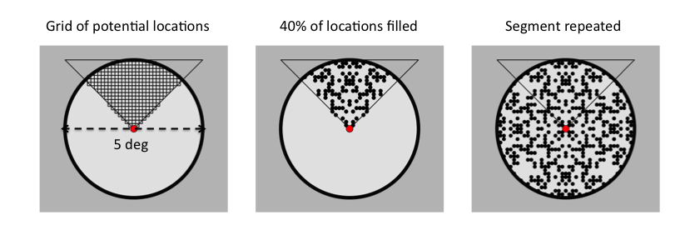

Figure 2

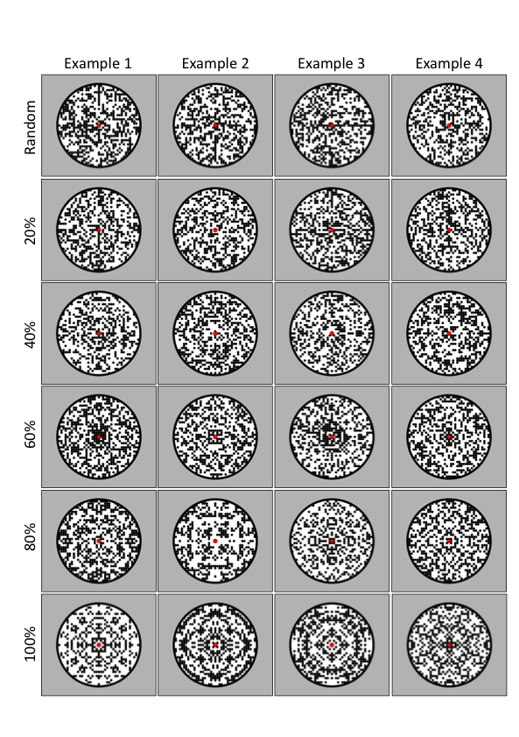

Figure 3

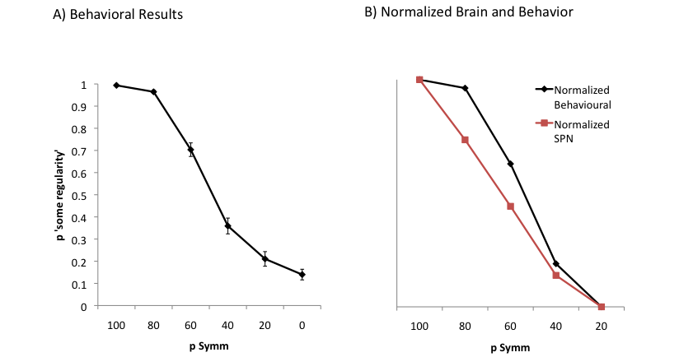

Figure 4

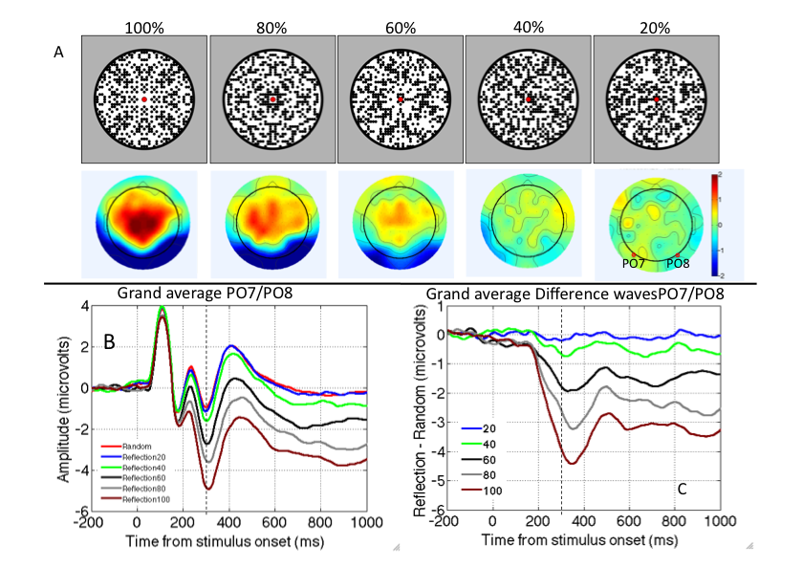

Figure 5

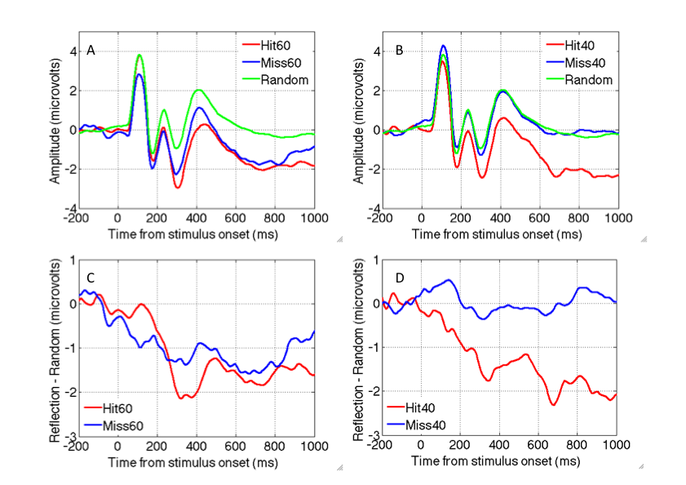

Figure 6

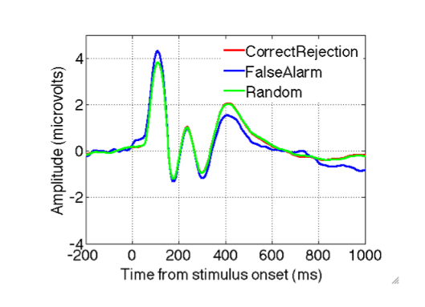

**Figure Legends**

**Figure 1 – Stages in construction of 100% symmetry.** This does not show the stimuli as seen by the participants, but illustrates the steps involved in construction. First a single tiled segment was produced, then 40% of the cells were occupied with a dot in a reflectional configuration. This segment was replicated in the other three orientations, giving four-fold symmetry. For random trials, there was no reflection and each segment was generated independently. For trials with an intermediate level of symmetry, the symmetrical dots were repeated in each segment, but the randomly positioned dots were generated afresh each segment.

**Figure 2 – Example stimuli.** Each row shows four examples from each condition. The top row shows four random patterns, then moving down the rows, 20% 40% 60% 80% and 100% symmetry.

**Figure 3 – Behavioural performance.** A) The Proportion of trials in which the participants reported ‘some regularity’ plotted against pSymm. B). Normalized behavioural and brain responses. Maximum and minimum values from each measure are yoked to the top and bottom of the axes. Note the differences in the shape of these functions.

**Figure 4 – The SPN scales with proportion of symmetrical dots.** A) Topographic difference maps (reflection – random) from the 300 to 1000 ms window. B) Grand-average ERP waves in each condition, from PO7 and PO8 electrodes. C) Difference waves in each of the pSymm conditions.

**Figure 5) SPN and decisions.** A) Grand-average ERP waves in 60% symmetry hit, 60% symmetry miss and random conditions, from PO7 and PO8 electrodes. B) Same data for 40% symmetry. C) SPN as a difference wave in the 60% hit and 60% miss conditions. D) Same data for 40% symmetry.

**Figure 6. Random ERPs and decisions.** The Posterior ERPs from PO7 and PO8 electrodes are shown from the random trials. Different waves show all random trials, those where people correctly reported ‘no regularity’ and those where people erroneously reported ‘some regularity’.