Development and spatial distribution of soils
on an active volcano: Mt Etna, Sicily

Peter James^{a,}, David K. Chester^{b}, Angus M. Duncanª

ª Department of Geography and Planning, School of Environmental Sciences, University of Liverpool, Liverpool, L69 3BX, UK.
^{b} Department of Geography and Environmental Studies, Liverpool Hope University, Hope Park,
Liverpool, L16 9JD, UK and Department of Geography and Planning, School of Environmental Sciences, University of Liverpool.

Abstract
As a large, active volcano, Mt Etna presents a complex soil-forming environment, with a spatial diversity of lava-flow age, tephra deposition, local climate and land use. Following a review of previous published research on Etna's soils, this paper analyses physical and chemical data for 23 profiles between 120 m and 1030 m elevation, on all flanks of the volcano, with the aim of characterising the soils and determining the extent to which the chief controls on their nature and geography may be identified. Soils are sampled across a chronosequence of lava flows, dating from 72 yr to between 28 ka and 42 ka BP, which occur in conditions of diverse land use and local climate. Ages of flows >1,000 yr are only broadly constrained. The majority of soils comprise mostly tephra. Chief soil processes inferred have been identified in previous published research on Mt Etna: accumulation of soil organic matter, rapid loss of Na and production of fine-grained materials, particularly those inferred to be of short-range order. Other developments are soil structural formation and evidence of increasing soil mesofaunal activity. Despite the complexity of environmental diversity and spatial variation in tephra deposition, a number of soil properties (including: material <.020 mm; organic C; organic N; C/N; pH; total Na; extractable phases of Fe and Al) are statistically related to age of lava flow, most of these also related to annual rainfall. That a number of statistically significant relationships with age of flow also hold for near ground-surface samples is unexpected and unexplained. Two areas which require further research are the precise impacts of tephra deposition on development of Etnaean soils, and processes of weathering and related pedogenesis at the soil - lava bedrock interface.

Key words
Mt Etna; soils; lava; tephra; chronosequence

1. Introduction and aims
This paper reviews previous research into the soils of the largest terrestrial volcano on the European mainland, the active Mt Etna, and analyses new data. Because of their global distribution, the human settlements and economies they support, their distinctive properties and significance as an element of the volcanic environment, volcanic soils have attracted much attention from specialists in pedology, ecology, hydrology, environmental chemistry, horticulture and archaeology. Soils may also contribute to the impact of volcanoes on the atmosphere: rapid weathering of volcanic materials, a part of pedogenesis, may constitute an important sink in the global CO₂ cycle (Vitousec et al., 1997). Distinguishing between release of soil-derived CO₂ and the higher degassing rates of magma-derived CO₂ is an important aid in predicting volcanic activity (Liuzzo et al., 2013). Soil reactive processes moderate storage and release to groundwater of volcanigenic elements potentially harmful to humans (Bellomo et al., 2007; Floor et al., 2011).
The genesis of volcanic soils is reasonably well understood. Specific process pathways, development rates and geography of soils on a particular volcano, however, are not readily predicted. Large, active volcanoes, especially those of predominantly hawaiian/strombolian eruptive style such as Mt Etna, present some of the most complex soil-forming environments on Earth. Historic activity on Mt Etna has been predominantly Strombolian in style, but periodic phases of lava fountaining of Hawaiian style generate considerable lapilli fall on the flanks. Diversity in age and character of volcanic materials, land surface morphology, local climate, vegetation and land use history translates into complex soil spatial patterns determined by controls operating at scales of differing spatial order, e.g. local climate, age and morphology of lava flow, and even individual plants (Certini et al., 2001). In the vertical dimension (i.e. profile), complex soils result from intermittent tephra deposition, anthropogenic disturbance, erosion and subsequent deposition. Soil profiles may reflect the amount and frequency of tephra deposition as much as 'normal' profile-forming soil processes operating on stable surfaces. The building-up of soil by the addition of tephra may have either a 'retardant' or 'developmental' effect on pedogenesis (Johnson, 1985). In the former case existing soil is effectively sealed by burial, and pedogenesis begins anew in fresh material; in the latter, pedogenesis keeps pace with a lesser amount of added tephra, absorbing the new material, the soil nevertheless being altered and made more difficult to interpret. A problem in dealing with the impact of tephra deposition is its considerable spatial variation, because the history of deposition at a particular location is unlikely to be known. Furthermore, units of tephra in soil are not everywhere easily differentiated in the field.
Many analyses of soil spatial variation on volcanoes relate soil properties to environmental gradients which represent important state factors in pedogenesis. The gradients are sequences of age, climate (as it varies with elevation and slope orientation), vegetation or topography. Many volcanic environments are well suited to chronosequence studies because of the age-range of lava surfaces. Examples abound. Vitousec et al. (1997) applied the chronosequence approach to the study of soil and ecosystem development across a well-defined 1.4 m yr sequence in Hawaii. Shorter age-ranges have been examined in Italy: e.g. on Mt Amiata by Lulli (2007), and in three studies comprising the most comprehensive published analyses of soil profiles on Mt Etna to date, by Egli et al. (2007; 2008; 2012). Drawbacks of soil chronosequence modelling include the role of factors other than time and the problem of climate change over longer timescales (Huggett, 1998). There is also the problem of determining age of landforms or sediments. Age estimates for some of Mt Etna's flows are only very broadly constrained. Where appropriate, and with careful interpretation, however, chronosequence studies provide at least a good basis to begin analysis of processes and patterns of soil development across an area.
Pedological research on Mt Etna has tended to concentrate either on selected soil properties or processes, or on relationships between soils and certain vegetation types or plant species, and deals in most cases with comprehensive analyses of a small number of soil profiles. This approach is essential to understanding the soils and the environmental controls upon them. Of equal importance, however, are the soils' spatial relationships with environmental controls as they vary across the volcano. There are two small-scale soil maps of Mt Etna (Comitato per la Carta dei Suoli, 1966; Fierotti et al., 1988), but without accompanying published details on the soils. Egli et al. (2007; 2008; 2012) find that a number of soil properties are related to age of the substrate lava and to elevation (and therefore precipitation, temperature and vegetation). In the present study we cast the spatial net more widely, examining a sample of soils on all flanks of the volcano, and across a range of environments, including those disturbed by agriculture, and across a range of local climates. The soil attributes selected for analysis are fundamental to soils generally and to volcanic soils particularly. Our aim is to determine whether, and to what extent, environmental controls on pedogenesis and soil spatial distribution are identifiable from the complex of influences affecting the soils sampled. This is attempted using statistical tests and by considering spatial variation in soil characteristics. Soil variables are first plotted against age of lava flow. The flows comprise a chronosequence. The soils in a strict sense do not: they have developed through a range of past and present environmental conditions. Age of flow is, nevertheless, a sound basis for soil sampling, and the question of the extent to which soil properties reflect flow-age remains a question to be addressed.
Soils are described using terminology of Soil Survey Division Staff (1993). They are classified only tentatively, and as far as the derived data permit, according to the Soil Taxonomy system (Soil Survey Staff, 1999). Most Soil Taxonomy terms used in the text are defined in the glossary, Appendix 1. For further details and for terms not included in the glossary, the reader is referred to Soil Survey Staff (1999; 2014).

2. Mt Etna
Mt Etna spans 3,350 m in elevation and 40 km in basal diameter; tephra fall has been frequent. Below 1,100 m above sea level (asl), the sampling zone (i.e. 120-1030 m), lava varies in age from the 2014/15 flow which is ongoing in January 2015 to the ca 500,000 yr-old tholeitic basalts of a small area on the lower part of the southern flank (Guillot et al., 1994). Flows of the last millennium (Fig. 1a), referred to below as 'historical', are dated using written records; older ('prehistoric') flows by archaeomagnetic and radiometric, particularly U series, dating (Condomines et al., 1982; Tanguy et al., 2007; 2012). Terrain of historical and of some prehistoric flows is dominated by rugged aa lava (with surfaces comprising blocks in an openwork structure), pahoehoe (with smooth, undulating surface) and toothpaste morphology (Kilburn and Guest, 1993; Polacci and Papale, 1997; Guest et al., 2012). The mineralogy and geochemistry of historical and young prehistoric Mt Etna lavas vary little (Romano and Guest, 1979: see Table 1; Tanguy et al., 1997; Corsaro and Pompilio, 2004). The hawaiite lavas are porphyritic with up to 45% phenocrysts comprising plagioglase, clinopyroxene and olivine (typically in that order of abundance) set in a matrix of microlites and glass with scattered titanomagnetite granules (Chester et al., 1985). Explosive activity from summit craters is frequent. Less frequent eruptions, often with higher effusion rates, occur from flank vents, with strombolian activity from vents high on the volcano (Chester et al., 1985). The geochemistry of the tephra, emitted from summit craters and lateral vents, is similar to that of the lava (Coltelli et al., 2000). The tephra (which consists of phenocrysts set in a glassy matrix) varies in deposition rate and particle-size with distance and direction from source, and accumulates unevenly on rugged lava surfaces. The detailed tephra chronostratigraphy at any location is thus unique and unknown. Heiken and Wohletz (1985) reported the median particle-size of tephra samples from a 1971 eruption to vary between .001 and 1 mm. There are few tephra deposits comprising extensive stratigraphic markers (Del Carlo and Branca, 1998). In the soils we examine, only one buried tephra layer is identified, that of the 1669 eruption of the Monti Rossi cinder cones (Fig. 1a). Tephra at our site ES19, on the 1792 flow, is probably from the 1998 or another recent eruption.
A Mediterranean climate of marked seasonality is recorded at a number of stations on Mt Etna (Carpenter, 2004). Mean annual rainfall (m.a.r.) increases with elevation and is significantly greater on the E than the W flank (Fig. 1b):
Adrano, west flank, 589 m. asl: m.a.r. 497 mm; January means: 69 mm, 9.8º C; July means: 14.3 mm, 26 ºC.
Zafferana, E flank, 574 m asl: m.a.r. 1353 mm; January means: 227 mm, 9.2º C; July means: 17 mm (June: 12.7 mm), 24.8º C.
A strong prevalence of westerly to northwesterly winds (Fig. 1b; Durbin and Henderson-Sellers, 1981) is significant for the distribution of airborne volcanic emissions.
Judging from the meteorological data and high permeability of many soils, soil moisture regimes for the study area are xeric and ustic; and temperature regimes predominantly thermic, with mesic at the higher elevations (see Appendix B for definitions). Fernández-Sanjurjo et al. (2003) judge the regimes at Monti Rossi (850m asl, Fig. 1a) to be ustic and mesic. Geobotanical regions of Mt Etna range with elevation through thermo, meso, supra and oromediterranean (Poli Marchese, 2000), the sampling area for the present study lying within the first two.
Below 900 m elevation the more productive soils are terraced for a wide range of tree crops, vines and to a more limited extent for arable crops (Dazzi, 2007). Some terraces, especially at higher elevations, have not been cultivated for a number of years, though these are still grazed. Woodland is common on older flows between 900 and 2000 m asl, a climate control evident in a preference of evergreen oak (Q. ilex) for the W side and deciduous oak (Q. pubescens; Q. cerris) and economically important chestnut (Castanea sativa) woods for the E side of the mountain (Poli Marchese, 2000; Puzzolo and Folving, 2001). The Etna broom (Genista aetnensis), a common colonizer of open areas, is found up to 1800 m asl. Major ash fall may cause significant damage to fruit and vegetable crops (Dazzi, 2007). Within our sampling zone, relationships between vegetation on the one hand and age, morphology and slope aspect of lava flow on the other, are visible in the landscape (as reflected in the site data in Table 3). At the sites examined, the Etna broom occurs on flows older than that of 1923; 3 m-high deciduous oak ( sp.)on the 1865 flow; 3.5 m evergreen oak (Q. sp.)on the 1792 flow; mature deciduous oak woodland on the 1408, and mixed deciduous woodland on prehistoric flows. Agricultural terraces or walled enclosures occur at five of the sites (≥ 671 years-old), and intense grazing at two (Table 3).
Using palynological data from Lago di Pergusa in central Sicily (667 m asl, 70 km to the west of Mt Etna), Sadori and Narcisi (2001) infer that the transition from dry Pleistocene to more moist Holocene climate started at about 10,700 years BP. The wettest conditions of the Postglacial occurred between ̴9,000 - ̴7,200 yr BP, followed by a trend towards desiccation at about 3,000 yr BP. Significant human impact upon vegetation and soils of Mt Etna is likely to have begun early, during the Bronze Age, if not in Neolithic times (Leighton, 1999; Chester et al., 2010).
In a few of the many papers published on the chemistry of gas and particle emissions, rainwater and groundwater, implications are considered for rock weathering but not for pedogenesis. Degassing from the summit craters continuously releases volatiles into the atmosphere, with high enrichment of at least 13 trace metals together with Al, Fe, CO₂ and SO₂ in the volcanic plume (Buat-Ménard and Arnold, 1978; Varekamp et al., 1986; Francis et al., 1998; Gauthier and le Cloarec, 1998; Varrica et al., 2000; Aiuppa et al., 2003). Mt Etna is the world’s greatest point source of F, SO₂ and HCl (Allard, 1997; Francis et al., 1998), <1% being deposited around the volcano during eruptions (Aiuppa et al., 2006). Rapid downward mixing of the plume on to the lower flanks of the volcano, however, occurs under certain meteorological conditions (Allen et al., 2006). Particulate emissions also contribute significantly to rainwater chemistry (Cimino and Toscano, 1998), deposition rates of major ions being controlled mainly by rainfall (Aiuppa et al., 2006). Na, K, Ca and Mg have varied sources, including volcanic ash and aerosols. Volcanic emissions comprise a significant addition to dust sources of many chemical elements in lichens on Mt Etna (Varrica et al., 2000). Vacca et al (2003) and Egli et al. (2008) conclude, however, that an allochthonous loessic component is of minor importance in volcanic soils of southern Italy. Passive degassing on Mt Etna's flanks results in intense leaching of basalt by phreatic groundwaters rich in CO₂ (Giammanco et al., 1996; Aiuppa et al., 2000; 2004). The residence time of any gas-charged waters in permeable soil is short, but the effect of magma-derived CO₂ on Mt Etna soils has not to our knowledge been researched.

3. The nature of volcanic soils and a model for Mt Etna
A distinctive feature of young volcanic soils is the abundance of the neoformed, metastable, short-range order materials (SROMs), allophane, imogolite (which tend to occur together: Nanzyo, 2002) and ferrihydrite (Lowe, 1986) (i and ii, Fig. 2). Their formation is favoured by oversaturation of the soil solution with elements released by rapid weathering of volcanic glass and the rapid precipitation kinetics of the materials compared with those of crystalline products (Dahlgren and Ugolini, 1989). Both allophane and imogolite occur in the soils of Mt Etna (see section 4), the latter having the same chemical composition as Al-rich allophanes (Dahlgren et al., 1993). Formation of allophane and imogolite (in allophanic soils) on the one hand, and Al-humus complexes (iii, Fig.2) with layer silicate clays (iv, Fig. 2) (in non-allophanic soils: Ugolini and Dahlgren, 2003) on the other, is favoured by contrasting conditions; the first by pH 5 to 7, low concentrations of complexing organic compounds, basic parent materials such as basalt, and precipitation of <1,000 mm per annum (Shoji et al., 1982; Shoji and Fujiwara, 1984). These are conditions which obtain at lower elevations, particularly on the drier west flank of Mt Etna. Non-allophanic soils are associated with acid (pH <5.5) and organic-rich conditions, in which Al-humus complexes and 2:1 layer silicates dominate (Shoji and Fujiwara, 1984). Al-humus complexes may also occur in A horizons of allophanic Andisols with an excess of Al relative to the complexing capacity of the humic substances (Dahlgren et al., 2004). Ferrihydrite persists because its affinity for humic substances impedes crystallisation of iron oxides (Schwertmann, 1988).
The SROMs impart significant properties to volcanic soils, including low bulk density, high water-holding capacity, high organic matter accumulation, phosphate fixation and variable charge (Shoji et al., 1993). SROM concentration, bulk density and phosphate retention are the principal criteria for Andisols in Soil Taxonomy (Soil Survey Staff, 1999; 2014) (see under 'andic property' in appendix) and Andosols in the World Reference Base scheme (IUSS Working Group WRB, 2006). Andisols, however, are not confined to soils in volcanic materials (Imarino and Terribile, 2008), nor are they the only soils on volcanic materials. Relatively stable Entisols may persist where intermittent tephra deposition rejuvenates processes of soil development. In hot, dry conditions and with soil-ageing, formation of crystalline Fe oxyhydroxides (v Fig. 2) and layer silicate minerals (iv, Fig. 2) is favoured in volcanic materials, determining characteristics of Inceptisols and Alfisols (Southard and Southard, 1989; Takahashi et al., 1993; Dahlgren et al., 2004). A distinction of Mediterranean volcanic soils is a reported paucity of 2:1-type pedogenic clay minerals, attributed to dry climate in Lipari, Italy (Mirabella et al., 2005), and to climate and the addition of tephra on Mt Etna by Egli et al. (2008). Where clay exists in significant amounts, its eluviation results in the argillic B horizons of Alfisols, a process favoured by a strongly seasonal climate and one characteristic of Mediterranean soils (Yaalon 1997). The process has been effective in older volcanic soils of southern Italy (Lulli, 2007), including those of Mt Etna (Fierotti et al., 1988). Loss by leaching of soluble bases and Si during initial stages of glass alteration, and relative concentration of Fe and Al (vi, Fig. 2), are other characteristics of young volcanic soils (Busà et al., 1998; Egli et al., 2008).
The amount and distribution of soil organic matter (viii, Fig. 2) reflect: input and processing by flora and fauna; micro- and local climate; lava morphology; soil erosion and deposition; burial of organic-rich horizons, or of surface vegetation by intermittent tephra additions and human activity. Volcanic soils are noted for their accumulation and stabilization of organic matter, as metal-humus complexes (Shoji and Fujiwara, 1984; Dahlgren et al., 1993) (iii Fig. 2) and in stable association with SROMS (Torn et al., 1997; Nanzyo, 2002; Broquen et al., 2005; van Breeman and Buurman, 2002). Formation of soil structure (aggregation of soil materials into distinct 'lumps' of varying size and shape) is favoured by well decomposed organic matter and non-crystalline inorganic materials (Nanzyo et al., 1993). Dark colours are common in surface horizons, where melanic epipedons form (Nanzyo, 2002). In Mediterranean environments where settlement and land use are intensive, frequent fires are a major determinant of vegetation type and therefore indirectly a significant factor in the nature and amounts of soil organic matter. Charcoal may also be of sufficient concentration to affect soil colour (Agnelli et al., 2007).
Complex soil profiles result from intermittent tephra deposition and from agricultural and other human disturbance (commonly the building of agricultural terraces on Mt Etna), and erosion and deposition of soil by water and wind. Erosion occurs by rain-triggered lahars, and there is risk of gullying (Pierson et al., 2013) and wind erosion in mantles of fine tephra. Where vegetation is disturbed by human activity on steep slopes, soil erosion occurs above 900 m asl (Poli Marchese et al., 2000). Erosion may not occur, however, where high saturated hydraulic conductivity results in low runoff amounts, as in coarse-textured soils or where soil structure is well developed.

4. The soils of Mt Etna: review of research
Part of Fierotti et al.'s (1988) map is reproduced in Fig 1c. In this, soils are classified according to Soil Survey Staff (1975). Associations 1 and 10, largely at higher elevations, were classed as Lithic, Typic and Andic Xerorthents, and Andic Xerochrepts; Association 15 at lower elevations, and extensive on E, S and SW flanks, included Typic Xerorthents, Andic Xerochrepts and Ultic Haploxeralfs. In the scheme of Soil Survey Staff (1975) a separate Andisol Order had not been introduced (they were in 1978); the soils classed by Fierotti et al. as 'andic' would probably include soils now classed as Andisols. The Ultic Haploxeralfs, the most fully developed of the soils mapped, are referred to as clayey and as having A-Bt-C profile which includes well structured, organic-rich, dark brown or black A horizon and blocky, more often prismatic, argillic B horizon. Dazzi (2007) and Lo Papa et al. (2003) (both referred to by Lulli, 2007), encountered only young, vitric soils on Mt Etna, Lo Papa finding Typic Vitrixerands, Typic Udivitrands and Vitric Hapludands, all under forest (and all Andisols). Published papers analyse pedological aspects (Bellanca et al., 1996; Buemi et al., 1998; Busà et al., 1998; Certini et al., 2001 and Parisi et al., 2003); effects of plants on soils (Certini et al., 2001; Fernández-Sanjurjo et al., 2003) and biogeochemical cycling (Leonardi and Rapp, 1981; Leonardi et al., 1992; Leonardi et al., 1996; Santa Regina et al., 2001). Mineralization of carbon in soils of Mt Etna was analysed by Hopkins and Bartoli (2004), and soil microbial activity by Hopkins et al. (2007) and Shillam et al. (2008). Plant colonisation and lichen-weathering of lavas have been examined by Carpenter (2004).
In recent studies on or near the cinder cones on the south flank of the volcano, soils classified by various authors include: sand-skeletal, mixed, mesic, aridic Ustipsamment (beneath broom on tephra of Mts Rossi, 850 m asl, Fig. 1a); sand-skeletal, mixed, frigid Vitrandic Udorthent (under broom and pine - Pinus nigra - on Mt Vetore, 1820 m asl, Fig. 1a) and Vitric Hapludands (elevation not given; precipitation, 1130 mm yr⁻¹) (Bellanca et al., 1996; Busà et al., 1998; Del Carlo and Branca, 1998; Palumbo et al., 2000; Certini et al., 2001; Fernández-Sanjurjo et al., 2003). The weakly weathered Vitric Hapludand reported by Palumbo et al. (2000) contains allophane, imogolite and halloysite. Andic properties do not occur in the Monti Rossi and Mt Vetore soils described by Fernández-Sanjurjo et al., (2003), but were confirmed by Bellanca et al. (1996) in a soil in which allophane, imogolite, halloysite and a small amount of goethite were evident in the B horizon. The former authors describe different characteristics between soil under the canopy of broom and that outside the canopy on Monti Rossi. The sand fraction of these soils is largely vesiculated glass, with plagioclase, augite, magnetite and apatite. Organic matter and NH₄ oxalate-extractable Al, Si and Fe increased, and Ca, Mg, K and Si decreased down-profile, reflecting greater alteration of tephra in the B than in the A horizon formed in overlying younger tephra. Busà et al., (1998) also describe a reduction in Ca, Mg and K, and relative enrichment in Al, Fe and Ti concentrations at 1372 m asl near Monte Salto de Cane cone (Fig. 1a). Contrasts between soil profiles on Mt Vetore (1800 m asl) and Monti Rossi (850 m asl) are attributed by Fernández-Sanjurjo et al. (2003) to differences in climate and more intense pedogenesis associated with plant roots at the lower site. Certini et al. (2001) consider the greater acid weathering under pine than under Etna broom on Mt Vetore to be a cause for concern regarding loss of soil fertility, as the Corsican pine (Pinus nigra) has been widely planted on Mt Etna in recent decades. Those authors attribute low amounts of N in the Vitrandic Udorthent of Mt Vetore in part to coarse mineral texture and continual soil rejuvenation by fresh cinder. Total C, microbial biomass and microbial respiration were analysed by Hopkins et al. (2007) in eight soils under trees between 850 m and 1450 m asl. Carbon content and microbial biomass were greater in more developed soils, but ability to analyse trends with soil development was limited by differences in management and tephra addition. Shillam et al. (2008) compared the structural and functional properties of the microbial communities in two soils of different age on Mt Etna. The microbial community in the older soil was structurally more diverse than that of the younger soil but proved in experiments not to be more resistant to environmental disturbance simulated by experimental heating.
The important role of reactive surfaces of fine materials of Mt Etna soils on the storage and release of volcanigenic pollutants to groundwater has been demonstrated. Bellomo et al. (2007) estimate that soils absorb ̴ 60% of atmospheric F depositions, maintaining F within the safe drinking-water limit; the active soil constituents being SROMs, particularly allophane. Both SROMs and soil organic matter are implicated by Floor et al. (2011) for Se immobilization, but with competition by sulphate for adsorption sites and mineral dissolution by acid rainwater (on the E flank) accounting for release of adsorbed Se to groundwater (with less Se mobilized in organic-rich soils).
Egli et al. (2008) examined eight soils (6 on the N, 2 on the SE flank) between 780 and 1090 m asl, on lavas 125 to 115,000 years old and with estimated mean annual rainfalls ranging between 1100 and 1200 mm. Only soils on non-agricultural land were sampled. The soils, classified using IUSS Working Group WRB (2006), were equivalent to Entisol on the 125-year old lava, Inceptisols on 358 and 438 yr BP lavas and Andisols on 115,000-yr lavas. The main mineral transformations were inferred to be volcanic glass ➔ imogolite-type minerals ➔ kaolinite. Textures were predominantly sand and loamy sand. These authors found the chief pedogenic processes to be leaching of base cations and passive enrichment of Al and Fe, and that these were pronounced in the early stages of pedogenesis, with much reduced rate of change between 15,000 and 115,000 yrs. In contrast, the rate of formation of imogolite-type minerals and particularly of ferrihydrite was more linear through the chronosequence. Imogolite was transformed to kaolinite, amounts of 2:1-type clay minerals being very small even on the oldest flows, and inferred to have been released from glass by weathering rather than resulting from pedogenic transformation. The scarcity of 2:1 type clay minerals was attributed to addition of ash and low rainfall. The accumulation rate of soil organic matter was most rapid in flows up to 2,000 yr old, tending to zero after 15,000 yr. Stabilisation of organic matter was related to pyrophosphate-extractable Al and Fe phases, kaolinite and clay content, rather than to imogolite-type material. Baglieri et al. (2010) find, however, that glycerol-extractable soil organic fractions were closely bound to SROMS, particularly in older (>9,000 yr) soils (Udivitrands), and consequently less subject to biodegradation. From their first analysis of five Vitric Andosols (IUSS Working Group WRB, 2006) in an elevation sequence (551 to 1772 m) on 10,000 to 15,000 yr bp lava, on the north-east flank of Mt Etna, Egli et al. (2007) conclude that organic C stocks, imogolite-type minerals and crystalline Fe-oxyhydroxides decreased with elevation; C/N ratio being related to vegetation type.
In a subsequent study of their elevation sequence of soils, Egli et al. (2012) address the complex and important issue of fire impacts on the soils. The stable soil organic fraction at higher elevations survived from >8,000 yr, dating close to the onset of pedogenesis, whereas with decreasing elevation soil charcoal analysis indicates a history of increased fire frequency causing vegetation change and rejuvenation of soil organic matter. The authors conclude, however, that fire frequency on Mt Etna is not such as to deplete a large pool of soil organic matter.
Bellanca et al. (1996) account for differences between A and B horizons in one soil to an age-difference of tephra between the horizons. In the present study we find boundaries between buried tephra units difficult or impossible to identify, and no morphologically distinct buried soil was found. Buried units of tephra may be defined by detailed grain size and chemical analyses of soil profiles (Taboada et al., 2007), but there are few data on buried soils in tephra sequences of Mt Etna (Zehetner et al., 2003). Superimposed buried soils (classified as Typic Hapludands) in two deep exposures of radiocarbon-dated tephra sequences are described by Agnelli et al. (2007). These, at 1350 m asl (on the south flank) and 1550 m asl (E flank), are now under chestnut (Castanea sativa) and pine forest (Pinus laricio), respectively. The base of the oldest sequence sampled dates from ̴7,000 yr bp, the timescales for development of the buried soils being much shorter than this, <800 yr in one case. Neoformed 'amorphous' and crystalline mineralogical phases were absent, a feature attributed to insufficiently intense, or too short a period, of pedogenesis (despite the presence of a number of Bw horizons and weak subangular blocky structure).
From this and the previous section it is clear that, given time and with stable site conditions, the sequence of soil development at the low to middle elevations on Mt Etna is likely to be as shown in Fig. 3, rejuvenation of soil by tephra deposition capable of halting the sequence at any stage.

5. Materials and methods
Sampling sites (Fig. 1a) cover a range in age of subjacent lava flow (72 yr to ̴ 35,000 yr), elevation, and agriculture. The soils examined occur in tephra (of varying particle-size) overlying lava, though in two soils alluvial deposition of local soil material was evident. Below, soils are referred to by site number with age of flow in brackets. The ages of lava flows (Table 3) are based on the Geological Map of Etna Volcano (Branca et al., 2011). The dating of lavas older than reliable historic records (> ̴ 400 years BP) is tentative and where possible based on archaeomagnetic and radiometric dating (Tanguy et al., 2012), though dates for some older flows are constrained only by stratigraphical relationships. For the statistical analysis of the soils the age of flow for each site is recalibrated against a baseline of 2000 AD. For those lavas constrained only by a range of age (in some cases, very broad), a date at the mid-point of the range is used (Table 3). Archaeological evidence (Drs Gianna Ayala and Francesco Privitera, pers. comm.) was used in the field where possible. Where surface and margins of older flows are concealed by well developed plant cover and where agricultural use is intensive it may be difficult to identify flows in the field, or to know the age of the underlying lava. ES23 posed a particular problem, this being a dagala of unknown age (Table 3). Samples from this site are therefore excluded from all statistical analyses which involve the age of a flow.
Annual rainfall for study sites (Table 3) is estimated by interpolation from data quoted by Durbin and Henderson-Sellers (1981) (Fig. 1b). Sites and soils were described in the field, following Soil Survey Division Staff (1993). Where feasible, soil pits were dug to bedrock or to clast-supported lava blocks (horizons denoted by 'R' in Table 3). As tephra stratification was impossible to define in most cases (c.f. Buurman et al., 2004), the horizon notation used in Table 3 gives the pedological character of each horizon but does not define sequences of buried layers, which inevitably occur (Agnelli et al., 2007). As we do not have all data required for full classification following Soil Taxonomy (Soil Survey Staff, 1999), we name soils tentatively at the Order or Suborder level only. Three criteria for Andisol classification not determined are P adsorption, bulk density and volume proportion of volcanic glass (Soil Survey Staff, 1999). The high glass content observed in many relatively young soils on Mt Etna (which we classify as Entisols) will reduce the threshold amounts of SROMs required to qualify a soil as Andisol (Soil Survey Staff 2014), but on this criterion alone, ES1(1928), ES2(1928), ES3(1928), ES9(1809), ES12(1651) and ES22(1843) would fail to qualify as Andisols (year of emplacement of lava flow in parentheses after site number).
Prior to laboratory analysis, samples were air-dried, disaggregated and passed through a 2mm sieve. Sub-samples for particle-size analysis were not dried further in order to avoid irreversible aggregation on drying where amorphous materials are present (Nanzyo et al., 1993). Laser diffraction was used for particle-size determination of <1 mm material in preference to the sieve and pipette method as it was considered prudent to keep samples in suspension for as short a time as possible. Textural classes named in Table 3 are based on estimation in the field (following Mizota and van Reeuwijk, 1989). We infer the nature of neoformed materials from chemical data rather than from direct physical examination. For phases of Al, Fe and Si conventional subscripts are used, as shown in Table 2. The conventional procedures for extraction of: 1. organic-bound (by pyrophosphate), denoted below as e.g. Fe_{p}; 2. inorganic non-crystalline (by NH₄ oxalate), denoted as e.g., Fe_{o-p}, and 3. crystalline phases of Fe and Al (by dithionite), denoted as e.g. Fe_{d-o}. These data are to be treated with caution as, for example, oxalate may dissolve a portion of the crystalline phase (García-Rodeja et al., 2007; Agnelli et al., 2007; Algoe et al., 2012).
In the following sections, after discussion of profile morphology, the analytical variables are examined in relation to age of flow and location in terms of flank of the volcano, the latter varying significantly in rainfall amount and tephra fallout from summit eruptions. For brevity, the moister flanks of the volcano (i.e. NE, E, SE and S) are referred to as E flank, other sectors as W flank. Spearman correlation (ρ = coefficient; p = probability of null hypothesis) and the Mann-Whitney U test are used. For parametric statistical analyses non-normal variables are transformed using log₁₀, square root, and in one case (Fe_{d-o}) an inverse transformation. Of the functions tested for regression models relating transformed soil variables to age of flow (Figs 4 and 18a) the quadratic proved efficient in terms of significance level in the great majority of cases. Multivariate analyses used are principal components analysis (pca) and cluster analysis. In the former, orthogonal components are rotated using Varimax. The unsupervised, agglomerative, hierarchical cluster analysis using the first four components of the pca is based on Euclidean distance as the dissimilarity measure and Ward’s grouping method, with all variables standardized to mean of zero and variance of 1.

6. Results
6.1 Profile morphology
Details of profile morphology and site conditions are given in Table 3. Table 4 groups soils according to extent of development expressed in profile morphology. There is a clear trend of increasing pedogenesis with age of flow between the groups, I to IV (Table 4). Only in the two soils of group IV, ES6 (15- 3.9 ka) and ES13 (450 AD), was there a clear B horizon and a colour other than black (with colour value ≥3). Very shallow soils, Psamments (I, Table 4), occur in rock-dominant areas of (mostly young) lava flows with very thin (commonly <5cm) accumulations of tephra and other allochthonous mineral and organic material in depressions in bedrock surfaces or between blocks in aa lava. Vegetation is limited to lichens or mosses, or may also include a narrow range of vascular plants. Examples are ES1, ES2 and ES3 on the 1928 Mascali flow. Organic matter content may be relatively high under a more developed plant cover (Table 3). The soils are black (2.5Y 2.5/1), sandy, cindery or ashy, vitric, and occur in pockets (typically <30 cm in diameter) in exposed lava where organic debris and small amounts of tephra collect. Commonly, ash and lapilli are trapped within the plant cover. On aa flows, mosses bridge narrow interstices between the lava clinker. Smooth, little weathered surfaces of pahoehoe lava on a 1991 flow collect mineral and plant detritus, moisture and rabbit dung in depressions, and support a number of plant species and larvae. The lava surfaces beneath these soils had no sign of weathering visible in the field. Vingiani et al. (2013) report that mineral fragments which have been transported to accumulate in cavities and depressions on young lava flows of Mt Etna are little altered chemically beneath a cover of lichens.
Developed in thicker tephra than those soils described above, are coarse-textured Entisols (or Andisols) with limited visible evidence of pedogenesis (II in Table 4). Sufficient amounts of glass, value of (Al_{o}+½Fe_{o})% and horizon thickness (≥18 cm) would qualify some of these soils as Vitrandic Xeropsamments or Vitrandic Ustipsamments (depending on moisture regime). Tephra is of highly variable thickness (7 cm to >120cm), depending in part on underlying lava morphology. With the exception of reddish brown Monti Rossi tephra in ES20 (1329) the soils are black (predominantly 2.5Y 2.5/1 and 10YR 2/1), ashy, cindery or pumiceous, sandy, occasionally skeletal, loose, stony or very stony, non-sticky and non-plastic. Such soils are very common in the study area on flows of all morphologies, dating from 1923 to 1329 in the cases we sampled. They have Oe, A or Ap horizons between 3 and 15 cm thick over little altered ash, lapilli, cinder, clinker, pumice or scoria. The soils vary in texture, horizon thickness and depth to lithic contact. Otherwise, variation in profile morphology is limited to very weak, barely perceptible structure in some A horizons. Organisms observed in these soils in February were larvae, millipedes and ants. Roots commonly extend to bedrock. Vegetation includes herbs and grasses, often with mosses and, in some cases, lichens. Broom is common (to 4 m in height); deciduous oaks are 3 m high near ES14 (1865), 8 m near ES15 (1689) and mature near ES21 (1444); evergreen oak grows to 6 m at ES12 (1651) and ES20 (1329). Land has been organized for terraced agriculture only at ES20 (1329). Here, dark reddish-brown (2.5YR 3/4) cinder from the 1669 Monti Rossi flank eruption at the base of the soil appears to have been used to level the lava surface for terrace construction. There was evidence of grazing by sheep at ES9 (1809) and by rabbits at other sites.
Other soils developed in tephra and lacking a B horizon are Entisols or Andisols (III in Table 4) of finer texture than in groups I and II (Table 4, containing loamy sand or sandy loam. Age of flow varies from the 1180±30 (ES7) to 42-28 ka (ES17 and ES18). Where exposed, lava morphology includes slabby aa, pahoehoe, levée and tumulus. The soils are black, with A or Ap and C horizons. The finer texture of these soils results from either a finer parent tephra (ES4 15-3.9 ka) or from more advanced weathering than in those soils described above. In the silty clay loam of ES17 and ES18 (both in the range, 42 to 28 ka), no material coarser than sand-size was observed. Related to the finer texture is a weak granular or blocky structure in A horizons of some soils and the presence of earthworms (Table 3), which, where more common, cause marked bioturbation: in ES17, earthworm burrows, extending to the base of the soil, are a striking feature. Consistence varies from non- to moderately sticky, but slightly friable in ES8 (15- 3.9 ka). All sites have a mixed herb and grass flora; a number have been terraced for agriculture, recent cultivation having been abandoned in several cases. Trees are deciduous oak: 3m high at ES7 (1180±30) and 6m at ES8 (15-3.9 ka); olives (Olea europaea) at ES10 (15-3.9 ka) and olives and prickly pear (Opuntia ficus-indica) in a walled enclosure at ES4 (15-3.9 ka). In all cases where lava surfaces were examined beneath soils they were ‘clean’, irrespective of age of flow. Red tephra of the Monti Rossi 1669 eruption occurred in ES24 (1000±50) (Table 3).
The most fully developed soils examined have a Bw horizon (IV, Table 4). These are either Inceptisols or Andisols, are very dark grayish brown (10YR 3/2) to brown (10YR 4/3), silt loam over clay loam (ES6 15-3.9 ka) and loam (ES13 1651). There is no evidence of recent tephra fall at these sites, both of which occur on the W flank of the volcano. A horizons are blocky; the Bw in ES13 being blocky and in ES6, prismatic. ES6 is distinct in most respects from other soils examined. Unusually for Etnaean soils, the lower part of the profile is not free-draining, slight gleying occurring on the ped faces of the lower part of the Bw horizon. The soil, at least in part, appears to have been washed into the depression where the soil occurs, which may account for the presence of pottery fragments at 33 - 34 cm depth. ES6 and ES13 are in enclosed fields and are the most intensively farmed soils examined, ES6 being grazed by cattle and ES13 cultivated. Trees are 4m-high deciduous oak, almond (Prunus dulcis) and prickly pear at ES6, and pistachio (Pistacia vera) at ES13.

6.2 Soil physical and chemical properties
Values for selected variables (for each soil sample) are plotted against age of flow in Fig. 4, in which E and W flanks (as defined in section 5) are differentiated. Where available estimates give a broad range of age, the mid-point of the range is used (section 5). In Table 5 are shown correlations for variables with age and rainfall, respectively; also listed are variables which differ significantly (using the Mann-Whitney U test) between W and E flanks of the volcano, with the flank noted on which the median of the variable is greater.

6.2.1 Particle-size
Soil texture, as estimated in the field, ranges from coarse sand to clay loam. The size distribution and proportion of particles >2mm varies appreciably (Table 3), tending to be of high concentration. Fine particle-size fractions correlate strongly with age of flow, as illustrated for <.002 mm ('clay') in Fig. 4a and by the envelopes of particle-size curves in Fig. 5. Silt, .002-<.02 mm, also correlates strongly with age (Table 5a). The <.002 mm fraction correlates negatively with rainfall (Table 5a), there being a significant difference in <.002 mm material between E and W flanks (Table 5a), lowest concentrations occurring across the SE and S flanks (Fig. 6). Despite intermittent addition of tephra to many of the soils, for near-surface samples only, the correlation between <.002 mm and age of flow is higher (ρ = .868; p <.001) than that for all samples (Table 5a). For deepest samples taken in each soil, the correlation with age of flow is ρ = .781, p <.001. The significant correlation with age of flow for near-surface samples obtains for those variables listed in Table 5A, the degree of correlation being high in a number of cases.
As allochthonous particles have been discounted as a significant component of the soils of Mt Etna (section 2), we attribute the increase in the finer fractions to pedogenesis. The map of clay profile for each soil (Fig. 6) reflects age-dependency and factors related to location on the volcano. Intense weathering in organic-rich, near-surface horizons is a likely cause of an up-profile increase in <.002 mm material (Fig. 6) in a number of flows up to 1050 y bp (ES5 950±50; ES9 1809; ES15 1689; ES21 1408; ES22 1843 and ES24 1000±50), but more marked is a down-profile increase in older flows (particularly in ES6 15-3.9 ka; ES13 1651, ES17 42-28 ka; ES18 42-28 ka) resulting from either of, or both, weathering of older tephra at depth and weathering of lava at the lithic contact.

6.2.2 Organic carbon
The marked near-surface enhancement of organic matter in many of the soils (Fig. 7) is the most visible morphological effect of pedogenesis across the full age-range of flows sampled, and on all flanks of the volcano. Organic C concentration is nowhere of sufficient depth to form a melanic epipedon. Charcoal may be a cause of black coloration in volcanic soils, but in the soils we examine the colour is determined by little-weathered, basaltic parent material. Owing to the sensitivity of soil organic matter concentration to plant cover, 'dilution' by tephra and other disturbance, amounts of organic C vary widely. High concentrations (>8.0%) occur in surface horizons beneath a range of vegetation types: cultivated fruit trees (ES4 15-3.9 ka: 8.96 %); mature deciduous oak (ES21 1408: 9.8 %); discontinuous herb and grass cover in a lava levée (ES5 950±50: 8.3 %), and beneath the lichen of ES2 (1928: 8.8 %). There is no distinct regional pattern in organic C profiles (Fig 7), and organic C does not correlate with rainfall (Table 5a). There is, however, a weak but significant correlation between organic C and age of flow (ρ = .263, p = .016; Fig. 4b). In their sample of soils Egli et al. (2008) find a steady increase of soil organic C stock to an age of about 15,000 years. Hopkins et al. (2007) also find that more developed soils have higher concentrations of organic C (and N) on Mt Etna.
Fluctuations in organic matter content with depth would be expected in soils which have received intermittent tephra deposits or have been disturbed in some other way. In the great majority of soils sampled there is, however, a progressive decline in organic matter content with depth (Fig 7). In the moderate concentrations of organic C at depth in the agricultural terrace soil, ES8 (15-3.9 ka) (4.47% at 23 cm depth, and 5.59% at 53 cm), there is a suggestion of soil burial resulting from terrace construction.
The quality of organic matter in terms of organic N and the ratio, C/N, is more closely related to age of flow than is organic C (evident in the correlations, Table 5a). The possible influence of rainfall amounts on organic matter quality, though not organic C, is also evident in correlations with organic N and C/N (Table 5a), and also in the significant E-W flank differences in C/N but not in organic C (Table 5b). Organic N just fails the 95% level for significance of this difference. Lower C/N ratios in Andisols of drier xeric as compared with udic moisture regimes may be attributed to a higher rate of mineralization in the former (cf Broquen et al., 2005).

6.2.3 pH
pH varies between 4.8 and 7.7, many values being higher than those reported by Shoji et al. (1993) for volcanic soils in other climatic regions, but comparable with values found by Vacca et al., (2003) on Roccamonfina and by Egli et al. (2008) on Mt Etna (5.1 to 6.25). Most of the values <5.5 occur on the E flank (Fig. 8), presumably reflecting acid deposition from the plume and higher rainfall. There is an increase in pH with age (ρ .307, p .004) (Fig. 4c; Table 5a), which is more marked with ES17 and ES18 samples omitted for this correlation: ρ = .610 and p = <.001. It is not clear why this increase occurs. The correlation between pH and rainfall is negative, and there is a significant pH difference between E and W flanks (Table 5b). There are, however, variations on each flank, with for example, anomalously low values which are difficult to explain in ES17 and ES18 (42-28 ka) (Fig. 4c), samples ES17/1 to 3 yielding the only values <5.0.

6.2.4 Bases
In common with findings of Egli, et al. (2008), Na is the most responsive of the bases to weathering and leaching. In the present study, of all those measured, this property shows one of the most marked changes with age of flow (correlation: ρ -.850, p <.001), the rate of loss showing no sign of abating over the ̴ 35,000-yr range (Fig. 4d). Highest values for Na (reaching 7.27 g kg⁻¹) occur in the Psamments, ES11(1923) and ES22(1843) (Fig. 9). The significant correlation with age for near-surface samples only is very high and positive for Na ( Table 5a). At variance with the Na trend is the lack of correlation between age of flow and Ca and Mg, and lack of at least linear correlation with age for K (Figs 4e-g; Table 5a). This contrasts with findings of Egli et al. (2008), that base cation leaching is a dominant process in their sample of Mt Etna soils, and of Martínez Cortizas et al. (2007), who report a reduction in K and Ca (as well as in Na), with increasing degree of weathering in a wide range of European volcanic soils. Such element depletion they attribute to the diluting effect of organic matter on element concentration, and the mobility of certain elements. Nevertheless, Martínez Cortizas et al. (2003) find that, despite significant depletion of Ca and K in soils of Gauro (Campi Flegrei) and Vico volcanoes, in organic-rich horizons an enhancement of Ca occurs, which they attribute to biocycling of the element. In soils we anlayse, Ca and more especially K show an up-profile increase (Figs 10, 11), these cations correlating negatively with depth in the soil (Ca: ρ -.364, p .001; K: ρ -.312, p .004). Ca correlates positively with organic C (ρ .396, p <.001). Quality of organic matter (and therefore possibly its age) appears, however, to have greater control on base distribution than organic C concentration: K correlates negatively with C/N. Ca, Mg and Na (in contrast to its negative correlation with organic C) correlate positively with C/N (correlation details not shown). A factor in greater near-surface Ca, Mg and Na concentrations in a number of soils we sample may be soil-rejuvenation by tephra. A significant distinction of Mt Etna among most of its European volcanic peers is that it is continually active.
Na, Mg, Ca and K all correlate with rainfall (K negatively: Table 5a), and all show significant differences between E and W flanks, the first three tending to occur in greater amount on the E flank (Table 5b). The E-W contrast may reflect greater tephra fall on the E flank. This, however, would not appear to be a major factor in K distribution.

6.2.5 Extractable Fe
Concentrations of extractable Fe phases - organic-bound (Fe_{p}), non-crystalline (Fe_{o}-Fe_{p}) and crystalline (Fe_{d}-Fe_{o}) - are plotted for each sample in Fig 13. For the majority of samples, the relative abundance of the three phases is in the order, Fe_{o-p}>Fe_{d}-Fe_{o}>Fe_{p}, a feature of the Etnaean soils reported by Fernández-Sanjurjo et al. (2003), and one reflecting both the status of the SROM, ferrihydrite, and the limited pedogenesis in much of the study area. The stronger correlations with age of flow, however, are for the crystalline (Fe_{d-o}: ρ .719, p <.001) and organic-complexed (Fe_{p:} ρ .711, p <.001) phases, both showing a steepening increase on flows of >200 yr (Fig. 4 h-j). The ratio, Fe_{o}/Fe_{d}, related to the crystallinity of the Fe oxides (Schwertmann, 1985), has been found to reflect degree of pedogenesis in volcanic soils, the ratio value decreasing with age (Malucelli et al., 1999). This trend is indicated in our samples by a weak but significant negative correlation between Fe_{o-p}/Fe_{d-o} and age of flow (Table 5a). In contrast, on volcanic materials of Roccamonfina Volcano (older than those we analyse) Vacca et al. (2003) find Fe_{o}/Fe_{d} not to be age-dependent. In our Mt Etna samples, Fe crystallisation is favoured by seasonal dehydration in the Mediterranean climate (Schwertmann, 1985), which is drier on the W flank, where mean Fe_{d-o} is significantly greater than on the E (Table 5b). The correlation between Fe_{o-p}/Fe_{d-o} and rainfall is quite strong, and there is a marked, significant difference between E and W flanks (Table 5b; Fig. 14). Fe_{o-p}/Fe_{d-o} shows no consistent depth pattern between soils (Fig. 14), but a marked down-profile increase in several of the soils (Fig. 14: ES7 1180±30; ES19 1792; ES23 age unknown; ES21 1444 on the E flank and ES13 1651 on the W), the proportion of crystalline secondary Fe reflecting more advanced transformation in layers of older tephra, and/or less crystallinity in organic-rich horizons.

6.2.6 Extractable Al and Si
The presence of Al and Si in the form of SROMS is inferred from the range of Al_{o-p} (.26% to 2.44%) and Si_{o-p} (.064% to 1.36%), the first correlating with age of flow, but not the latter (Table 5a, Figs 4l and n). Lack of correlation between each of these phases and organic C is not consistent with the protection of organic matter by SROMS, commonly inferred for volcanic soils, though degree of humification may be a factor: Al_{o-p} correlates negatively with C/N (ρ -.315, p .004). As Fe_{p}, the organic-bound Al_{p} increases with age, the Al and Fe organic phases being quite strongly inter-correlated (ρ .787, p <.001). In most samples, pH (>5.0) is favourable to allophane and imogolite formation, and although Al_{p} increases with age, Al_{p}/Al_{o-p} is <0.5 (a condition associated with the presence of allophane and imogolite: Legros, 2013) in all samples except ES6/2 to 4 (15-3.9 ka) and 13/3 (450 AD). Al_{p} and Al_{p}/Al_{o-p} correlate with organic C (Al_{p}: ρ .449, p <.001; Al_{p}/Al_{o-p}: ρ .447, p <.001), but both have negative correlations with C/N (Al_{p:} ρ -.432, p <.001; Al_{p}/Al_{o-p}: ρ -.315 p.004), reflecting the ability of the humified fraction to compete for Al, thereby reducing Al availability for the formation of allophane.
The value of the qualifying criterion for Andisols, (Al_{o}+½Fe_{o})%, increases with age of flow (Fig. 4o), a number of samples in soils on >9000-yr flows having values >2.0 (samples ES6/4 15-3.9 ka; ES8/2 and 3 15-3.9 ka; ES17/1, 2 and 3 42-28 ka), but also the much younger ES14 (1865) (samples 3 and 4). However, high glass content increases the potential for qualifying as Andisols on this criterion, a value of (Al_{o}+½Fe_{o})% = 0.4% being the minimum required. This value is exceeded in all samples analysed, though in many, other qualifying criteria for Andisols which are not measured are unlikely to be met.
Bellanca et al. (1996) found that NH₄ oxalate-extractable Al, Fe and Si concentrations all increase down-profile in soils to the north of Nicolosi. In our greater range of soils, there is no consistent down-profile trend in Al_{o-p} or Si_{o-p} (Figs 16 and 17). The reason for higher amounts of Si_{o-p} occurring on the N side of the volcano (Fig 17) is not clear.

7. Principal components analysis
The variables selected for the pca and the rotated component matrix are shown in Table 6. The first four components (pcs) with initial eigenvalues >1 account for only 70% of the variance but give a meaningful insight into combinations of soil variables reflecting key dimensions of pedogenesis on the volcano. Pc1 includes those properties shown to be related to age of flow and which reflect, and may be used as one indicator of, the extent of pedogenesis related to processes modelled in Fig. 2. High loadings obtain for measures of fine particle-size, Na (negative), Fe_{d-o} (inverse positive) and organic C. The highest negative loading for C/N in the matrix signals the degree of humification. The high loading for Al_{p} relative to the negative loading of Si_{o} gives a non-allophanic signal in the component, and reflects the increase of Al_{p} with age of flow.
Sample scores on pc1 correlate with age of flow (Fig. 18a) and negatively with rainfall, there being a significant difference in scores between the volcano's E and W flanks (Table 5), giving a marked regionalization to scores; negative scores occurring on the SE and S sides of the volcano (Fig. 18b), possibly reflecting greater tephra addition on these slopes. An up-profile increase in scores occurs in ES5 (950±50), ES12 (1651), ES22 (1843), ES4 (15-3.9 ka), ES9 (1809), ES11 (1923), ES7 (1180±30), ES15 (1689), ES23 (age unknown), ES20 (1329), ES21 (1408) and ES24 (1,000±50) (Fig. 18B), indicating greater alteration, as defined by this component, in near-surface horizons. This is contrary to the findings of Bellanca et al. (1996) regarding more intensive alteration in B than in A horizons, referred to in section 4. A down-profile increase in scores occurs, however, in four of the most developed soils (ES18 35 ka; ES13 450AD; ES6 15-3.9 ka; ES8 15-3.9 ka).
In pc2, the two phases, Si_{o-p} and Al_{o-p}, are isolated with their high scores consistent with an allophanic effect. The component lacks indicators of advanced pedogenesis with loadings low for fine particle-sizes and positive for Na. With Al_{p}/Al_{o-p} inserted into the analysis in lieu of Al_{p} and Al_{o-p} (result not shown), the structure of components 1 and 2 is little changed, but the loading of Al_{p}/Al_{o-p} is high positive in pc1 and moderate negative in pc2, reinforcing the distinction between conditions associated with an allophanic versus a non-allophanic effect. Pc2 correlates significantly with neither age of flow nor rainfall, nor is there a significant difference in scores between E and W flanks. There is no clear regionalization in pc2 scores. A down-profile increase in scores occurs (not shown) in eleven soils: ES18 (42-28 ka), ES4 (15-3.9 ka), ES6 (15-3.9 ka), ES8 (15-3.9 ka), ES22 (1843), ES14 (1865), ES19 (1792), ES20 (1329), ES21 (1408), ES23 (age unknown) and ES24 (1,000±50 AD), which may relate to decreasing organic matter content with depth.
Pc3 is a moderate Fe_{o-p} and positive (inverse) Fe_{d-o} component, the resulting ratio between these phases suggesting the role of ferrihydrite. The component does not correlate with age, but positively with rainfall (ρ .523, p <.001), and there are significantly greater scores on the E flank, consistent with conditions favouring persistence of a high Fe_{o-p}/Fe_{d-o} ratio. The less organic-rich soil at depth may explain a predominant down-profile decrease in scores (not shown), occurring in all soils except ES6 (15-3.9 ka), ES12 (1651), and ES22 (1843). A feature of pc3 scores not shared by pc1 or pc2 is a reduction in rate of decrease down-profile, or a reversal in trend, in the lowest parts of the sampled profiles at twelve locations, ES4 (15-3.9 ka), ES5 (950±50), ES6 (15-3.9 ka), ES8 (15-3.9 ka), ES9 (1809), ES12 (1651), ES14 (1865), ES19 (1792), ES20 (1329), ES21 (1408), ES23 (age unknown) and ES24 (1,000±50), though scores remain negative.
Pc4, a 'C/N - organic C - base cation' component, is the only component with positive loadings for all four bases, Ca, Mg, Na and K. These are not associated in this component with signals of much advanced pedogenesis in terms of particle-size, Fe_{o-p}/Fe_{d-o} and C/N. Across the matrix, loadings differ between the bases, presumably reflecting the interplay between parent material, loss from the soil during pedogenesis and retention by plants, the most salient features being the marked loss of Na and a putative retention of at least K by plants. Pc4 scores do not correlate with age; they are generally higher on the E flank (Table 5b), but there is no distinct regional pattern in scores (not shown). A down-profile decrease occurs in scores of all soils except ES11 (1828), reflecting the distribution of organic matter. The reduction in rate of decrease, or reversal of trend, at depth in the profile found in pc3 scores occurs also in scores on pc4, with the exception of ES10 (15-3.9 ka), ES11 (1923), ES12 (1651), ES15 (1689) and ES17 (42-28 ka). There is insufficient evidence to speculate on the reason for this common, if subtle, change in conditions at depth in the profile.
In pc5 a high positive loading for pH contrasts with much lower loadings for other variables. The low % variance explained by this component suggests a limited impact of pH in distinguishing between the soils analysed, a reflection possibly of a narrow range of pH across most of the samples. The low but positive loading for pH in pc1 reflects the (unexplained) statistically significant increase of pH with age of flow described above.

8. Cluster analysis
Five clusters of samples are chosen from the analysis based on the first four pcs (Fig. 19), clusters 1 and 2 being a division of a group of thirty-nine samples. The distribution of scores on the first four pcs is shown for each cluster in Fig. 20. The spatial distribution of sample members in the five clusters (Fig. 21) comprises a form of soil map for the sites sampled. In cluster 1 both median and lower quartile are positive on all five pcs, providing a pedogenic 'mixed message' in which signals of relatively advanced formation occur with expressions of a strong presence of Al, Si and Fe SROMS (with highest mean of the clusters for Al_{o-p}, Si_{o-p} and Fe_{o-p}: 10.8, 5.3 and 12.3 mg kg⁻¹, respectively), and high amounts of organic matter characterised by high C/N. Cluster 1 members occur on all flanks, especially in the NE, and in soils ranging from 135 yr to ̴ 9500 in age (Fig. 21). In this cluster, the range in age and climate of sites, and the positive median score for all four pcs, give an impression of a complex of controls on pedogenesis leading to relatively similar outcome for all samples.
Cluster 2 (19 samples) is distinguished by the highest pc3 scores (the 'high Fe_{o-p}/Fe_{d-o} - high Mg' pc) of all clusters. Sample scores on the remaining pcs are largely negative. With the exception of ES5(950±50 AD), this cluster does not occur on the west flank (Fig. 21), cluster members occurring at sites with highest rainfall (i.e. 750 to 1250 mm).
In Cluster 3 (20 samples), scores on pc1 and pc2 are largely negative. The cluster is distinguished by the highest median on pc4 (the 'high organic matter - high C/N - high base pc'). Samples occur on the E, SE and S flanks and in the younger soils of the W flank (ES22-1843 and ES12-1651).
Cluster 4 (9 samples) has the lowest scores of all clusters on pc1, and mainly positive scores on the 'allophanic' pc2. The cluster has the lowest distribution of scores on pc3, (the 'ferrihydrite' pc). The weakly developed samples, which occur in ES 11(1923), ES22(1843) and ES9(1809), comprise the coarsest tephra (highest .02-1.0 mm %; lowest <.002 mm %) and the highest Na amount (mean: 5.2 mg kg⁻¹) of all clusters.
Cluster 5 (19 samples) is distinguished by its high positive median on pc1 and its largely negative scores on other pcs. Unlike other samples in this cluster, those in the upper 45 cm of ES17 (42-28 ka) have high positive score on the 'high Si_{o-p} - Al_{o-p}' component, pc2. Samples in this cluster, which express a relatively well developed character, occur on the oldest flows, with least rainfall, on the W flank, though single samples occur anomalously near the surface of ES4 (15-3.9 ka), ES5 (950±50 AD) and ES9 (1809).

9. Conclusions
9.1 Soil processes and profiles
The chief processes inferred from our data are largely those inferred in a number of previous studies of Mt Etna, particularly that of Egli et al. (2008). However, although loss of Na is one of the most marked features of our sequence of soils, we do not, in contrast to Egli et al. (2008) and Busà et al. (1998), have evidence of loss of Ca or K. Ca and K are associated with surface, organic-rich horizons and retained in the soil, a feature reflected in pc4, which subsumes high amounts of organic matter and C/N together with positive loadings for all bases. Other chief processes we infer are: production of clay- and silt-size material; incorporation of organic matter and its modification in terms of decreasing C/N ratio; the formation of SROMS (indicated by NH₄-extraction); development of soil structure, and a tendency for vigorous bioturbation in finer grained, older soils. We do not identify allophane directly, but the pca clearly distinguishes conditions favouring allophane formation. A protective mechanism relating amounts of organic C to NH₄-extractable phases is not borne out in the data. The degree of humification (C/N ratio) of organic matter, in addition to its concentration, emerges as a significant influence on soil chemistry. An up-profile increase in pc1 scores in many soils indicates greater near-surface intensity in certain major processes.
Soils of limited development, generally with distinct organic-rich surface horizon but lacking B horizon, occur on flows dating up to 42-28 ka. The most marked pedogenic effects are an organic-rich surface horizon and weak structure in A horizons. With increasing age of flow, a finer texture occurs and bioturbation is more in evidence. Ony two soils have Bw horizons, one (ES6 15-3.9 ka) formed in fluvially deposited sediment, the other (ES13 450 AD), a rich soil in a mature agricultural landscape. We do not verify the presence of illuviated clay using micromorphological techniques, but we find no suggestion of illuviation having taken place. Nor are we able to quantify secondary crystalline clay minerals in the soils.
In one agricultural terrace there is a buried soil (ES8 15-3.9 ka), and two profiles (ES6 15-3.9 ka and ES17 15-3.9 ka) contain inwashed sediment, but there is no clear evidence of major disruption of profile development in other soils, despite the identification of buried tephra units in two of the profiles. The properties measured tend not to have very irregular depth functions (with the exception of Mg, which we are not able to explain). The near-surface enhancement of organic matter, which occurs in all but one soil, is typical of profiles which have developed on quite stable surfaces.

9.2 Environmental factors
Although the soils do not form a true chronosequence, their relationship with age will be formed in part by the oldest material in each soil, regardless of addition of fresh tephra. At least as important as flow-age in determining soil character and distribution on the volcano are rainfall and other, unmeasured, environmental contrasts between windward and lee sides of the volcano. The size of Mt Etna and direction of prevailing wind have major implications for the volcano's soil geography. Mt Etna is unique in its combination of volcanic activity and local climates. On the E and SE flanks, rainfall amounts should favour pedogenesis, yet this appears to be restrained (as reflected in low pc1 scores), possibly by tephra deposition.
Lulli (2007) concludes that the Mediterranean climate of volcanic regions of Italy does not favour allophane genesis and the full development of Andosols, but conditions favourable to allophane formation on Mt Etna are inferred from our analyses, and Andisols are classified in a number of studies referred to in section 4. Soils with illuviated clays were mapped on Mt Etna by Fierotti et al. (1988), and a reddened B horizon was reported in a Typic Hapludand in late Pleistocene pyroclastic material at 838 m asl on Vico Volcano, Italy (Quantin et al., 1985), but in the soils we examine, even on the drier, more 'Mediterranean' W flank, and on the 42-28 ka flow, neither reddening nor evidence of clay illuviation was found. This contrasts with Pleistocene volcanic soils elsewhere in the Mediterranean region: reddened soils with pedogenic calcite and illuviated clay in Pleistocene andesites of Methana, Greece, (m.a.r. <400 mm; James et al., 1997) and on Quaternary basalts of Morocco (Hamidi et al., 1999; Dekayir and El Maâtaoui, 2000); and reddened soils in Pleistocene scoria of the Golan Heights, Israel (m.a.r. 850-950 mm: Singer et al., 2004).

9.3. A note on the economy and settlement
Despite the activity of Mt Etna, the volcano's lower slopes have attracted settlement for millennia (Chester et al., 2010). An assymetry exists between flanks of the volcano in climate and in aspects of the soils, but also in the lower elevation and greater distances to which lava flows have extended on the S and SE flanks: here, physical benefits and proximity to the sea have resulted in a greater extent of cultivable land than occurs on the W flank, and in greater urban development, including Catania, the second largest city of Sicily. Economic geographic (as opposed to purely physical) factors may determine land use for all but the poorest soils, but, apart from ES1, ES2 and ES3 on the 1928 flow, the vegetation of all sites we sample has potential for at least extensive grazing. This use is more intensive at ES9 (1809), and quite heavy on relatively large flat areas of ES6 (15-3.9 ka) and ES17 (15-3.9 ka). Terraces occur at sites on flows dating from 671 BP and older.

9.4. Research design and known unknowns
We demonstrate the difficulties which may face the application of chronosequence models to soil studies in complex volcanic environments. Our sample of soils is spread across a range of ecological, climatic and agricultural environments. Ages of prehistoric lava flows are only broadly constrained. For all flows, known or estimated age gives only the date of onset of lava-weathering and related pedogenesis. At unkown intervals, tephra has contributed soil parent material, this forming the bulk of most soils we examine. Two of the soils contain material inferred to be washed from surrounding flows. The sample of soils therefore comprises only an approximate chronosequence. We infer certain mineralogical properties from chemical analyses, themselves arguably approximate. The classification of soils is only partial, and, owing to the exactitude of modern soil classification schemes, would require determination of further soil properties to complete. Whatever the finer classes to which Mt Etna's soils may be allocated, however, the majority of those we sample are entirely, and inevitably, 'volcanic' in their appearance and major properties.
The heuristic approach we take is chiefly statistical, with subjective interpretation of spatial patterns of selected properties. Our sample of soils is small, in view of Mt Etna's diverse environments. Nevertheless, the number of significant correlations, corroborated in many cases by geographical distribution, appears to indicate a causal relationship between a number of soil properties and, respectively, age of lava flow and rainfall (and presumably other important environmental contrasts between the volcano's flanks). This finding echoes the conclusion of Colombo et al. (2007) with respect to volcanic soils of south-central Italy, that such factors as duration of pedogenesis, human impact and soil climate appear to play more important roles than effects of stratified pyroclastic materials. Patterns we are not able to explain include the increase of pH with age of flow and the higher Si_{o-p} concentrations on the N slope.
That age of flow emerges as a chief soil-forming factor in the complexity of the Etnaean environment may be remarkable. Puzzling, however, is the correlation between age of flow and a number of soil properties for near-surface samples only. This fits easily with neither 'retardant' nor 'developmental' effects (sensu Johnson, 1985) of intermittent tephra deposition on soil profile development. The complexity of the effects of tephra addition remains a challenge for research into the soils of Mt Etna. So too do processes at the base of soils and the contribution of lava-bedrock weathering to soil profiles. The soil-rock interface remains a largely unexplored soil environment on the volcano.

Acknowledgements

The authors are grateful to the HSBC for a grant to cover part of the fieldwork; to the Universities of Liverpool and Bedfordshire; to Sandra Mather for producing the illustrations; to Alan Henderson, Irene Cooper and Bob Jude for the laboratory analyses, and to Drs Gianna Ayala and Francesco Privitera for archaeological data.

References

Agnelli, A.E, Corti, G., Agnelli, A., Del Carlo, P., Coltelli, M. and Ugolini, F.C., 2007. Features of some paleosols on the flanks of Etna volcano (Italy) and their origin. Geoderma 142, 112–126. doi: 10.1016/j.geoderma.2007.08.003

Aiuppa, A., Allard, P., D'Alessandro, W., Giammanco, S., Parello, F. and Valenza, M., 2004. Magmatic gas leakage at Mount Etna (Sicily, Italy): Relationships with the volcano-tectonic structures, the hydrological pattern and the eruptive activity. In: Bonaccorso, A., Calvari, S., Coltelli, M., Del Negro, C. and Falsaperla, S. (eds), Mount Etna: Volcano Laboratory. Geophysical Monograph Series 143, pp. 129-145. AGU, Washington. doi:10.1029/143GM09

Aiuppa, A., Allard, P., d’Alessandro, W., Michel, A., Parello, F., Treuil, M. and Valenza, M., 2000. Mobility and flux of major, minor and trace metals during basalt weathering and groundwater transport at Mt Etna volcano (Sicily). Geochimica et Cosmochimica Acta 64, 1827-1841. doi: 10.1016/S0016-7037(00)00345-8

Aiuppa, A., Bellomo, S., Brusca, L., d'Alessandro, W. and Fedrico, C., 2003. Natural and anthropogenic factors affecting groundwater quality of an active volcano (Mt. Etna, Italy). Applied Geochemistry 18, 863-882. doi: 10.1016/S0883-2927(02)00182-8

Aiuppa, A., Bellomo, S., Brusca, L., d’Alessandro, W., di Paola and Longo, M., 2006. Major-ion bulk deposition around an active volcano (Mt. Etna, Italy). Bulletin of Volcanology 68, 255-265. doi: 10.1007/s00445-005-0005-x

Aiuppa A., Bonfanti, P., d'Alessandro, W., 2003. Rainwater chemistry at Mt. Etna (Italy): natural and anthropogenic sources of major ions. Journal of Atmospheric Chemistry 46, 89-102. doi: 10.1023/A:1024878323823

Algoe, C., Stoops, G., Vandenberghe, R.E. and Van Ranst, E, 2012. Selective dissolution of Fe–Ti oxides - extractable iron as a criterion for andic properties revisited. Catena 92, 49-54. doi: 10.1016/j.catena.2011.11.016

Allard, P., 1997. Endogenous magma degassing and storage at Mount Etna. Geophysical Research Letters 24, 2219-2222. doi: 10.1029/97GL02101

Allen, S.E., 1989. Chemical Analysis of Ecological Materials. Blackwell Scientific, Oxford.

Allen, A.G., Mather, T.A., McGonigle, A.J.S., Aiuppa, A., Delmelle, P., Davison, B., Bobrowski, N., Oppenheimer, C., Pyle, D.M. and Inguaggiato, S., 2006. Sources, size distribution, and downwind grounding of aerosols from Mount Etna. Journal of Geophysical Research - Atmospheres, 111, 10 pp. doi: 10.1029/2005JD006015

Baglieri, A., Ioppolo, A., Nègre, M., Abbate, C. and Gennari, M., 2010. Characterization of Glycerol-extractable organic matter from Etna soils of different ages. Pedosphere 20, 120–128. doi: 10.1016/S1002-0160(09)60291-5

Bellanca, A., Hauser, S., Neri, R. and Palumbo, B., 1996. Mineralogy and geochemistry of soils related to Etna Volcano: heavy metal distribution as a result of soil-forming processes and inherited features. Mineralogica et Petrographica Acta 39, 95–107.

Bellomo, S., Aiuppa, A., D’Alessandro, W., Parello, F., 2007. Environmental impact of magmatic fluorine emission in the Mt. Etna area. Journal of Volcanology and Geothermal Research 165, 87-101. doi: 10.1016/j.jvolgeores.2007.04.013
Branca, S., Coltelli, M., Groppelli, G. and Lentini, F., 2011. Geological map of Etna volcano, 1;50,000 scale. Bollettino Società Geologica Italiana 130, 265-291.

Broquen, P., Lobartini, J.C., Candan, F., Falbo, G., 2005. Allophane, aluminium and organic matter accumulation across a bioclimatic sequence of volcanic ash soils of Argentina. Geoderma 129, 167–177. doi: 10.1016/j.geoderma.2004.12.041

Buat-Ménard, P. and Arnold, M., 1978. The Heavy metal chemistry of atmospheric particulate matter emitted by Mount Etna volcano. Geophysical Research Letters 5, 245-248. doi: 10.1029/GL005i004p00245
Buemi, A., Cimino, G., Strazzulla, G., 1998. Characterization of Etnean soils and application to Mars. Journal of Geophysical Research - Planets 103, 13,667-13,674. doi: 10.1029/98JE00816

Busà, T., Cirrincione, R., Cristofolini, R., Pezzino, A., 1998. Caratterizzazione petrologico-tessiturale di una successione piroclastica in prossimita di Monte Salto del Cane (versante meridionale dell'Etna): implicazioni sui processi di alterazione e di pedogenesi. Mineralogica et Petrographica 41, 61-78.

Buurman. P., Rodeja, E.G., Cortizas, A.M. and van Doesburg, J.D.J., 2004. Stratification of parent material in European volcanic and related soils studied by laser-diffraction grain-sizing and chemical analysis. Catena 56, 127-144. doi: 10.1016/j.catena.2003.10.007

Carpenter, M.P., 2004. Early successional processes of basaltic lava ecosystems on Mt. Etna (Sicily) with additional comparative studies of Mauna Loa (Hawaii). Ph.D. thesis, Unversity of Luton.

Certini, G., Fernández-Sanjurjo, M.J., Corti, G. and Ugolini, F.C., 2001. The contrasting effect of broom and pine on pedogenic processes in volcanic soils (Mt Etna, Italy). Geoderma, 102: 239-254. doi: 10.1016/S0016-7061(01)00017-9

Chester, D. K., Duncan. A. M., Guest. J. E. and Kilburn. C. R. J., 1985. Mount Etna: The Anatomy of a Volcano. Chapman and Hall, London.

Chester, D.K., Duncan, A. and James, P.A., 2010. Mount Etna, Sicily: Landscape evolution and hazard responses in the pre-industrial era. In: Martini, P. and Chesworth, W. ed(s). Landscapes and Societies. Dordrecht, Springer.

Cimino, G. and Toscano, G., 1998. Dissolution of trace metals from lava ash: influence on the composition of rainwater in the Mount Etna volcanic area. Environmental Pollution, 99: 389-393.
doi: 10.1016/S0269-7491(98)00004-9

Colombo, C., Sellitto, M.V., Palumbo,G., Terribile, F. and Stoops, G. 2007. Characteristics and genesis of volcanic soils from south central Italy: Mt Gauro (Phlegraean Fields, Campania) and Vico Lake (Latium). In: Arnalds, O., Bartoli, F., Buurman, P., Oskarsson, H., Stoops, G. and García-Rodeja, E. (eds), Soils of Volcanic Regions in Europe. Springer: Berlin, pp. 197-229.

Coltelli, M., Del Carlo, P. and Vezzoli, L., 2000. Stratigraphic constraints for explosive activity in the past 100 ka at Etna volcano, Italy. International Journal of Earth Science, 89: 665-677. doi: 10.1007/s005310000117

Comitato per la Carta dei Suoli, 1966. Carta dei Suoli D’Italia, A. and R. Senatori, Firenze.

Condomines, M., Tanguy, J. C., Kieffer, G. and Allegre, J. C., 1982. Magmatic evolution of a volcano studied by 230Th-238U disequilibrium and trace element systematics: the Etna case. Geochimica et Cosmochimica Acta, 46: 1397-1416. doi: 10.1016/0016-7037(82)90275-7

Corsaro, R.A. and Pompilio, M., 2004. Dynamics of magma at Mount Etna. In: Mt Etna: volcano Laboratory. In Bonaccorso, A., Calvari, S., Coltelli, M, del Negro, C. and Falsaperla, S. (eds), Mt Etna: Volcano Laboratory. AGU Geophysical Monograph Series 143, 91-110. doi: 10.1029/143GM07

Dahlgren, R., Shoji, S. and Nanzyo, M., 1993. Mineralogical characteristics of volcanic ash soils. In: Shoji, S., Nanzyo, M. and Dahlgren, R. (eds), Volcanic Ash Soils. Genesis, Properties and Utilization. Elsevier, Amsterdam, pp. 101-143.

Dahlgren, R.A., Saigusa, M. and Ugolini, F. C., 2004. The nature, properties and management of volcanic soils. Advances in Agronomy, 82: 113-182. doi: 10.1016/S0065-2113(03)82003-5

Dahlgren, R.A. and Ugolini, F.C., 1989. Effects of tephra addition on soil processes in Spodosols in the Cascade Range, Washington, U.S.A. Geoderma 45, 331-355. doi: 10.1016/0016-7061(89)90015-3

Dazzi, C., 2007. Environmental features and land use of Etna (Sicily, Italy). In: Arnalds, O., Bartoli, F., Buurman, P., Oskarsson, H., Stoops, G. and García-Rodeja, E. (eds), Soils of Volcanic Regions in Europe. Springer: Berlin, pp.629-644.

Dekayir, A. and El Maâtaoui, M., 2000. Apport de l’analyse d’images dans l’étude de l’altération d’un basalte alcalin (Moyen Atlas, Maroc). Engineering Geology 56, 325-334. doi: 10.1016/S0013-7952(99)00099-X

del Carlo, P. and Branca, S., 1998. Tephrostratigraphic dating of the pre-1300 AD SE flank eruption of Mt Etna. Acta Vulcanologica 10, 33-37.

Durbin, C. S. and Henderson-Sellars, A., 1981. Meteorological importance of the volcanic activity of Mount Etna. Weather 36, 284-291. doi: 10.1002/j.1477-8696.1981.tb05343.x

Egli, M., Mastrolonardo, G., Seiler, R., Raimondi, S., Favilli, F., Crimi, V., Krebs, R., Cherubini, P. and Certini, G. 2012. Charcoal and stable soil organic matter as indicators of fire frequency, climate and past vegetation in volcanic soils of Mt. Etna, Sicily. Catena 88, 14-26. doi: 10.1016/j.catena.2011.08.006

Egli, M., Mirabella, A., Alioth, L., Nater, M. and Raimondi, S., 2007. Effect of climate and vegetation on soil organic carbon, humus fractions, allophane, imogolite, kaolinite and oxyhydroxides in volcanic soils of Etna (Sicily). Soil Science 172, 673-691. doi: 10.1097/ss.0b013e31809eda23
Egli, M., Mirabella, A., Nater, M., Alioth, L. and Raimondi, S. 2008. Clay minerals, oxyhydroxide
formation element leaching and humus development in volcanic soils. Geoderma 143, 101-114. doi: 10.1016/j.geoderma.2007.10.020

Fernández-Sanjurjo, M., Corti, G., Certini, G., Ugolini, F. 2003. Pedogenesis induced by Genista aetnensis (Biv.) DC on basaltic pyroclastic deposits at different altitudes, Mt Etna, Italy. Geoderma 115, 223-243. doi: 10.1016/S0016-7061(03)00013-2

Fierotti, G. F., Dazzi, C. and Raimondi, S., 1988. Carta dei Suoli della Sicilia, 1:250,000 (with Report). Regione Siciliana Assessorato Territorio ed Ambiente and Universita degli Studi di Palermo, Facoltà di Agraria, Istituto di Agronomia Generale, Cattedra di Pedologia, Palermo.

Floor, G.H., Calabrese, S., Román-Ross, G., D´Alessandro, W., Aiuppa, A., 2011. Selenium mobilization in soils due to volcanic derived acid rain: An example from Mt Etna volcano, Sicily. Chemical Geology 289, 235–244. doi:10.1016/j.chemgeo.2011.08.004

Francis P., Burton, M.R. and Oppenheimer C., 1998. Remote measurements of volcanic gas compositions by solar occultation spectroscopy. Nature 396, 567-570. doi: 10.1038/25115

García-Rodeja, E., Nóvoa, J.C., Pontevedra, X., Martínez-Cortizas, A. and Buurman, P. 2007. Aluminium and iron fractionation of European volcanic soils by selective dissolution techniques. In: Arnalds, O., Bartoli, F., Buurman, P., Oskarsson, H., Stoops, G. and García-Rodeja, E. (eds), Soils of Volcanic Regions in Europe. Springer: Berlin, pp. 325-351.

Gauthier, P.J. and Le Cloarec, M.F., 1998. Variability of alkali and heavy metal fluxes released by Mt. Etna volcano, Sicily, between 1991 and 1995. Journal of Volcanological and Geothermal Research 81, 311-326. doi: 10.1016/S0377-0273(98)00002-X

Giammanco, S., Gurrieri, S., Principio, E. and Valenza, M., 1996. CO₂ fluxes from Mt. Etna soils. Acta Vulcanologica 8, 220-221.

Guest, J.E., Duncan., A.M, Stofan, E.R. and Anderson, S.W. 2012. Effect of slope on development of pahoehoe flow fields: Evidence from Mount Etna. Journal of Volcanological and Geothermal Research 219-220, 52-62. doi: 10.1016/j.jvolgeores.2012.01.006

Guillot, P. Y., Kieffer, G. and Romano, R., 1994. The evolution of Mount Etna in the light of potassium-argon dating. Acta Volcanologica 5, 81-87.

Hamidi, E.M., Nahon, D., McKenzie, J.A., Micard, A., Colin, F. and Kamel, S., 1999. Marine Sr (Ca) input in Quaternary volcanic rock weathering profiles from the Mediterranean coast of Morocco: Sr isotopic approach. Terra Nova 11, 157-161. doi: 10.1046/j.1365-3121.1999.00239.x

Heiken G. and Wohletz, K., 1985. Volcanic Ash. University of California Press, Berkeley.

Hesse, P. R., 1971. A Textbook of Soil Chemical Analysis. Murray, London.

Hopkins, D.W. and Bartoli, F., 2004. Size and activity of the soil microbial community from a range of European volcanic soils. In: H. Oskarsson and Arnalds, O. (eds), Volcanic Resources in Europe. Cost Action 622 final meeting. Abstracts. Agricultural Research Institute, Rejkyavic, 35-36. http://www.rala.is/Andosol/Fjolrit214.pdf Accessed 09 Feb, 2015.

Hopkins, D.W., Badalucco, L., English, L.C., Meli, S.M., Chudek, J.A. and Ioppolo, A., 2007.
Plant litter decomposition and microbial characteristics in volcanic soils (Mt Etna, Sicily) at different stages of development. Biology and Fertility of Soils 43, 461–469. doi: 10.1007/s00374-006-0124-3

Huggett, R J., 1998. Soil chronosequences, soil development, and soil evolution: a critical review. Catena 32, 152 - 172. doi: 10.1016/S0341-8162(98)00053-8

Imarino, M. and Terribile, F.T., 2008. The importance of andic soils in mountain ecosystems: a pedological investigation in Italy. European Journal of Soil Science 59, 1284-1292. doi: 10.1111/j.1365-2389.2008.01075.x

IUSS Working Group WRB, 2006. World Reference Base for Soil Resources 2006. World Soil Resources Reports No. 103. FAO, Rome. ftp://ftp.fao.org/agl/agll/docs/wsrr103e.pdf Acessed 09 Feb, 2015.

James, P.A., Atherton, M.A., Harvey, A.M., Firmin, A. and Morrow, A., 1997. The physical environment of Methana: formation, exploitation and change. In: C.B. Mee and H.A. Forbes (eds), 'A Rough and Rocky Place': the Landscape and Settlement History of the Methana Peninsula, Greece’. University of Liverpool Press, Liverpool, pp. 5-32.

Johnson, D.L., 1985. Soil thickness processes. Catena Supplement 6, 29-40.

Legros, J-P., 2013. Major Soil Groups of the World. Ecology,Genesis, Properties and Classification. CRC Press, Taylor and Francis. Boca Raton, Florida.

Kilburn C.R.J. and Guest J.E., 1993. Aa lavas of Mount Etna. In Kilburn C.R.J and Luongo, G. (eds), Active lavas: monitoring and modelling. UCL Press: London, 73-103.

Leighton, R., 1999. Sicily before history: an archaeological survey from the Palaeolithic to the Iron Age. Duckworth, London.

Leonardi, S. and Rapp, M., 1981. Return of mineral elements and nitrogen to the soil through leaves in an ecosystem of Quercus-ilex L on Mount-Minardo (Etna). Flora 171, 329-337.

Leonardi, S., Rapp, M. and Denes, A., 1992. Organic-matter distribution and fluxes within a holm oak (Quercus-ilex l) stand in the Etna Volcano - a synthesis. Vegetatio 100, 219-224. doi: 10.1007/BF00118228

Leonardi, S., Rapp, M., Failla, M. and Guarnaccia, D., 1996. Annales des Science Forestieres 53, 1031-1048. doi: 10.1051/forest:19960510

Liuzzo, M., Gurrieri, S., Giudice, G. and Giuffrida, G., 2013. Ten years of soil CO₂ continuous monitoring on Mt. Etna; exploring the relationship between processes of soil degassing and volcanic activity. Geochemistry, Geophysics, Geosystems - G (super 3) 14, 2886-2899. doi: 10.1002/ggge.20196

Lo Papa, G., Palermo, V., Parisi, S., Laudacina, V.A., Tusa, D. and Scalenghe, R., 2003. Caratteristiche di una sequenza di suoli forestali nel versante Nord-occidentale dell’Etna. Bollettino della Società Italiana Scienza Suolo 52, 513-522.

Lowe, D.J., 1986. Controls in the rates of weathering and clay mineral genesis in air fall tephra: a review and New Zealand case study. In: S.M. Coleman and D.P. Dethier (eds), Rates of Chemical Weathering of Rocks and Minerals. Academic Press, Orlando, pp. 265-330.

Lulli, L. 2007. Italian volcanic soils. In: Arnalds, O., Bartoli, F., Buurman, P., Oskarsson, H., Stoops, G. and García-Rodeja, E. (eds), Soils of Volcanic Regions in Europe. Springer: Berlin, pp. 51-67.

Malucelli, F., Terribile, F. and Colombo, C., 1999. Mineralogy, micromorphology and chemical analysis of andosols on the Island of Sao Miguel (Azores). Geoderma 88, 73-98. doi: 10.1016/S0016-7061(98)00081-0

Martínez Cortizas, A. García-Rodeja, E, Gayosoa E., Nóvoa Muñoz, J.C., Pontevedra Pombal, X., Buurman, P. and Terribile F., 2003. Distribution of some selected major and trace elements
in four Italian soils developed from the deposits of the Gauro and Vico volcanoes. Geoderma 117, 215–224. doi: 10.1016/S0016-7061(03)00124-1

Martínez Cortizas, A., Nóvoa, J.C. , Pontevedra, X, Taboada, T., García-Rodreja, E. and Chesworth, W., 2007. Elemental composition of reference European volcanic soils. In: Arnalds, O., Bartoli, F., Buurman, P., Oskarsson, H., Stoops, G. and García-Rodeja, E. (eds), Soils of Volcanic Regions in Europe. Springer, Berlin, pp. 289-306.

McKeague, J.A., 1967. An evaluation of 0.1 M pyrophosphate and pyrophosphate-dithionite in comparison with oxalate as extractants of the accumulation products in podzols and some other soils. Canadian Journal of Soil Science 47, 95-99. doi: 10.4141/cjss67-017

McKeague, J.A. and Day J.H., 1966. Dithionite- and oxalate-extractable Fe and Al as aids in differentiating various classes of soils. Canadian Journal of Soil Science, 46, 13-22. doi: 10.4141/cjss66-003

Mirabella, A., Egli, M., Raimondi, S. and Giaccai, D., 2005. Origin of clay minerals in soils on pyroclastic deposits in the island of Lipari (Italy). Clays and Clay Minerals 53, 409-421. doi: 10.1346/CCMN.2005.0530409

Mizota, C. and van Reeuwijk, L.P. 1989. Clay mineralogy and chemistry of soils formed in volcanic material in diverse climatic regions. Soil Monograph 2, International Soil Reference and Information Centre, Wageningen, 185pp.

Nanzyo, M., 2002. Unique properties of volcanic ash soils. Global Environmental Research 6, 99-112.

Nanzyo, M., Shoji, S. and Dahlgren, R., 1993. Pysical characteristics of volcanic ash soils. In: Shoji, S., Nanzyo, M. and Dahlgren, R.A. (eds), Volcanic Ash Soils: Genesis, Properties and Utilization. Elsevier, Amsterdam, pp. 189-207.

Palumbo, B., Angelone, M., Bellanca, A., Dazzi, C., Hauser, S., Neri, R. and Wilson, J., 2000. Influence of inheritance and pedogenesis on heavy metal distribution in soils of Sicily, Italy. Geoderma 95, 247-266. doi: 10.1016/S0016-7061(99)00090-7

Parisi, S., Meijer, E., Dazzi, C. and Buurman, P., 2003. Una metodologia auto validante per la quantificazione della frazione amorfa inorganica in suoli dell’Etna. Paper presented at the Annual Convention of the Società Italiana della Scienza del Suolo, ‘Qualità del Suolo, Impatto Antropico e Qualità dei Prodotti Agricoli’, Siena, June 2003. Istituto Sperimentale per lo Studio e la Difesa del Suolo and the Amministrazione Provinciale di Siena.

Pierson, T.C., Major, J.J., Amigo, A. and Moreno, H., 2013. Acute sedimentation response to rainfall following the explosive phase of the 2008–2009 eruption of Chaitén volcano, Chile. Bulletin of Volcanology, 75, 17 Pages. doi: 10.1007/s00445-013-0723-4

Polacci, M. and Papale, P., 1999. The development of compound lava fields at Mount Etna. Physics and Chemistry of the Earth: Solid Earth and Geodesy 24, 949-952. doi: 10.1016/S1464-1895(99)00140-4

Poli Marchese, E. and Patti, G., 2000. Carta della vegetazione dell’ Etna a scala
1:50,000. Unversità di Catania, Selca, Firenze.

Poli Marchese, E., Grillo, M., Di Benedetto, L., Patte, G. and Caruso, F. 2000. Vegetazione ed erosione del suolo in aree del parco naturale dell'Etna (Italia meridionale). Archivio Geobotanico 6, 113-132.

Puzzolo, V. and Folving, S., 2001. A GIS integration of topographic, geological and climatic data for the analysis of the Mt Etna forests distribution (Sicily, Italy). http://www.ec-gis.org/Workshops/7ec-gis/papers/html/puzzolo/virginia.htm (accessed 09 Feb, 2015).

Quantin, P., Lulli, L., Dabin, B., Bidini, D. and Bouleau, A., 1985. Characteristics and genesis of two Andosols in Central Italy. Catena Supplement 7, 107–117.

Romano. R. and Guest J. E., 1979. Volcanic geology of the summit and northern flank of Mount Etna, Sicily. Bollettino della Società Geologica Italiana 98, 189-215.

Sadori, L. and Narcisi, B., 2001. The Postglacial record of environmental history from Lago di Pergusa, Sicily. Holocene 11, 655-671. doi: 10.1191/09596830195681

Santa Regina, I., Leonardi, S. and Rapp, M., 2001. Foliar nutrient dynamics and nutrient-use efficiency in Castanea sativa coppice stands of southern Europe. Forestry 74, 1-10. doi: 10.1093/forestry/74.1.1

Schwertmann, U., 1985. The effect of pedogenic environments on iron oxide minerals. In: B.A. Stewart (Editor), Advances in Soil Science. 1. Springer Verlag, New York, pp. 171-200. doi.org/10.1007/978-1-4612-5046-3_5

Schwertmann, U., 1988. Occurrence and formation of iron oxides in various pedoenvironments. In: J. W., Stucki, B.A. Goodman and U. Schwertmann (eds), Iron in Soils and Clay Minerals, pp. 267-308. Reidel Publishing, Dordrecht, pp. 276-308.

Shillam, L., Hopkins, D.W., Badalucco, L. and Laudicina, V.A., 2008. Structural diversity and enzyme activity of volcanic soils at different stages of development and response to experimental disturbance. Soil Biology and Biochemistry 40, 2182–2185. doi: 10.1016/j.soilbio.2008.04.006

Shoji, S and Fujiwara, T., 1984. Active aluminium and iron in the humus horizons of Andosols from northeastern Japan: their forms, properties and significance in clay weathering. Soil Science 137, 216-226. doi: 10.1097/00010694-198404000-00002

Shoji, S., Fujiwara, Y., Yamada, I., Saigusa, M., 1982. Chemistry and clay mineralogy of Ando soils, Brown forest soils, and Podzolic soils formed from recent Towada ashes, Northeastern Japan. Soil Science 133, 69–86. doi: 10.1097/00010694-198202000-00001

Shoji, S., Nanzyo, M. and Dahlgren, R., 1993. Volcanic Ash Soils: Genesis, Properties and Utilization. Elsevier Science, Amsterdam.

Singer, A., Zarei, M., Lange, F.M. and Stahr, K., 2004. Halloysite characteristics and formation in the northern Golan Heights. Geoderma 123, 279–295. doi: 10.1016/j.geoderma.2004.02.012

Soil Survey Staff, 1975. Soil Taxonomy. U.S.D.A., Soil Conservation Service, Agriculture Handbook, 436, U.S. Government Printing Office, Washington, D.C.

Soil Survey Division Staff, 1993. Soil Survey Manual, U.S.D.A., Soil Conservation Service, Agricultural Handbook, 18. U.S. Government Printing Office, Washington, D.C. http://www.nrcs.usda.gov/wps/portal/nrcs/detail/national/home/?cid=nrcs142p2_054254 Accessed 09 Feb, 2015.

Soil Survey Staff, 1999. Soil taxonomy: A basic system of soil classification for making and interpreting soil surveys. 2nd edition. Natural Resources Conservation Service. U.S. Department of Agriculture Handbook 436. http://www.nrcs.usda.gov/wps/portal/nrcs/main/soils/survey/class/taxonomy/ Accessed 09 Feb 2015.

Soil Survey Staff, 2014. Keys to Soil Taxonomy. 12th Edition. United States Department of Agriculture, Natural Resources Conservation Service, Washington, DC. http://www.nrcs.usda.gov/wps/portal/nrcs/detail/soils/survey/class/?cid=nrcs142p2_053580 Accessed 09 Feb 2015

Southard, S.B. and Southard, R.J., 1989. Mineralogy and classification of andic soils in northeastern California. Soil Science Society of America Journal 53, 1784-1791. doi: 10.2136/sssaj1989.03615995005300060029x

Taboada, T., García, C., Martínez-Cortizas, A., Nóvoa, J. C., Pontevedra, X. and García-Rodeja, E. 2007. Chemical weathering of Reference European Volcanic Soils. In: Arnalds, O., Bartoli, F., Buurman, P., Oskarsson, H., Stoops, G. and García-Rodeja, E. (eds), Soils of Volcanic Regions in Europe. Springer: Berlin, pp. 307-323.

Takahashi, T., Dahlgren, R. and van Susteren, P., 1993. Clay mineralogy and chemistry of soils formed in volcanic materials in the xeric moisture regime of northern California. Geoderma 59, 131-150. doi: 10.1016/0016-7061(93)90066-T

Tanguy, J.C., Condomines, M. and Kieffer, G., 1997. Evolution of the Mount Etna magma: constraints on the present feeding system and eruptive mechanism. Journal of Volcanology and Geothermal Research 75, 221-250. doi: 10.1016/S0377-0273(96)00065-0

Tanguy, J.C., Condomines, M., Le Goff, M., Chillemi, V., La Delfa, S. and Patanè, G. 2007. Mount Etna eruptions of the last 2,750 years: revised chronology and location through archeomagnetic and ²²⁶Ra²³⁰Th dating. Bulletin of Volcanology 70, 55-83. doi: 10.1007/s00445-007-0121-x

Tanguy, J.C., Condomines, M., Branca, S., La Delfa, S., and Coltelli, M., 2012. New archeomagnetic and ²²⁶Ra- ²³⁰Th dating of recent lavas for the Geological map of Etna volcano. Italian Journal of Geoscience 131 (2), 241-257. doi: 10.3301/IJG.2012.01

Torn, M.S., Trumbore, S.E., Chadwich, O.A., Vitousek, P.M. and Hendricks, D.M., 1997. Mineral control of soil organic carbon storage and turnover. Nature 389, 170-3. doi: 10.1038/38260

Ugolini, F.C. and Dahlgren, R.A., 2003. Soil development in volcanic ash. Global Environmental Research 6, 69-81.

Vacca, A., Adamo, P., Pigna, M. and Violante, P., 2003. Genesis of tephra-derived soils from the Roccamonfina Volcano, south central Italy. Soil Science Society of America Journal 67, 198-207.
doi: 10.2136/sssaj2003.0198

van Breeman, N. and Buurman, P. 2002. Soil Formation. 2nd ed. Kluwer Academic Publishers. New York

Varekamp, J.C., Thomas, E., Germani, M. and Buseck, P.R., 1986. Particle geochemistry of volcanic plumes of Etna and Mount St Helens. Journal of Geophysical Research: Solid Earth
91, 12223-12248. Doi: 10.1029/JB091iB12p1223

Varrica, D., Aiuppa, A. and Dongarra, G., 2000. Volcanic and anthropogenic contribution to heavy metal content in lichens from Mt. Etna and Vulcano island (Sicily). Environmental Pollution 108, 153-162. doi: 10.1016/S0269-7491(99)00246-8

Vingiani, S., Terribile, F. and Adamo, P., 2013. Weathering and particle entrapment at the rock-lichen interface in Italian volcanic environments. Geoderma 207, 244-255.
doi: 10.1016/j.geoderma.2013.05.015

Vitousek, P.M., Chadwick, O.A., Crews, T., Fownes, J., Hendricks, D., and Herbert, D., 1997. Soil and Ecosystem Development Across the Hawaiian Islands. GSA Today 7, 1–8. ftp://rock.geosociety.org/pub/GSAToday/gt9709.pdf Accessed Feb 09, 2015

Yaalon, D.H., 1997. Soils in the Mediterranean region: what makes them different? Catena 28, 157-169. doi: 10.1016/S0341-8162(96)00035-5

Zehetner, F., Miller,W.P. and West, L.T., 2003. Pedogenesis of volcanic ash soils in Andean Ecuador. Soil Science Society of America Journal 67, 1797-1809. doi: 10.2136/sssaj2003.1797

APPENDIX

NOTE ON SOIL TAXONOMY NOMENCLATURE AND GLOSSARY OF TERMS USED IN THE TEXT

Soil Taxonomy nomenclature comprises a shorthand notation in which formative elements indicate the soil Orders and subclasses, which are based on their chief defining properties. E.g. Vitrixerand = soil of Andisol Order with vitric property in xeric soil environment. Other elements of soil names include: Hapl (implying minimum horizon); orth (common); psamm (sandy); ud (udic soil moisture regime), ust (ustic soil moisture regime). For details and definitions not included below see Soil Survey Staf (1999), in which most properties are defined quantitatively.

Alfisol (element 'alf'). The chief defining characteristic is the presence of down-washed silicate clays (producing an argillic horizon - see Bt horizon, below) without excessive depletion of bases. They have sufficient water to support crop growth and tend therefore to be intensively used. They are particularly important in Mediterranean environments where their formation is favoured by the markedly seasonal climate. Subclass names are identifiable as belonging to the order of Alfisols by presence of formative element 'alf' in the nomenclature. These soils have been reported from Mt Etna, but were not encountered in the present study.

Andic soil property. Requirements relate to measures of: 1. NH₄ oxalate-extractable Al and Fe (Al+½Fe (%) ≥ 2.0); 2. volcanic glass content; 3. bulk density at 33 kPa water retention and 4. phosphate retention.

Andisol (element 'and'). Soil with the unique property of a dominance of SROMs or Al-humus complexes resulting from weathering and mineral transformation with a minimum of down-washed particles. Common to most Andisols are high phosphorus retention, available water capacity and cation-exchange capacity. Qualifying criteria, apart from quantities of SROMS and glass, relate to soil bulk density, P retention and organic C content. Most Andisols occur in volcanic materials, but they may occur in other materials. In addition to strongly weathered soils rich in SROMS, Andisols may include weakly weathered soils with a greater content of volcanic glass. Must have andic soil properties in 60% or more in the soil thickness.

Ap horizon. Surface layer disturbed by cultivation, pasturing or similar uses.

Argillic horizon. Subsurface horizon with significantly more phyllosilicate clay than the overlying soil material. It shows evidence of clay illuviation.

Aridic soil moisture regime. Normally occurs in arid climates, and a few in semi-arid climates, where properties of the parent material result in a dry soil (e.g. on Monti Rossi, Mt Etna). There is therefore little or no leaching.

Bt horizon. Argillic horizon. Normally a subsurface horizon with a significantly higher percentage of phyllosilicate clay than the overlying soil material. It shows evidence of clay illuviation.

Bw horizon. Cambic horizon. A subsurface horizon with development of colour or structure with little if any illuvial material. It is differentiated from subsurface horizons which result from distinct processes, e.g. clay illuviation or accumulation of carbonates. In the context of Mt Etna it comprises a degree of pedogenesis presented in Inceptisols or, if the surface horizon qualifies, in Andisols.

Entisol (element 'ent'). These are the most rudimentary soils. They are mineral soils which lack distinct pedogenic horizons. On Mt Etna they are associated with lava flows and tephra which are of insufficient age for pedogenesis to have had much effect. Entisols must not have andic soil properties in 60 percent or more of the soil thickness.

Epipedon. Surface or near-surface horizon in which most of the rock structure has been destroyed. It is darkened by organic matter or shows evidence of eluviation, or both.

Frigid. Soil temperature regime with mean annual temperature between 0 and 8 ºC.

Hapl. Formative element denoting minimum horizonation: a simple profile.

Inceptisol (element 'ept'). Soils of this order range widely in character. Their unique properties include combination of water available to plants for more than half the year or more than 3 consecutive months during a warm season. They contain one or more horizons which are altered pedogenically but which do not qualify the soil for another order (e.g. Alfisol).

Lithic. Important in the context of Mt Etna where many soils are shallow. The term refers to a contact (boundary) between soil and a consolidated material (commonly but not always rock). In most soil groups a lithic contact is diagnostic at the subgroup level if it is within 50 cm of the mineral soil surface.

Melanic epipedon. A thick, dark coloured (commonly black) horizon at or near the soil surface with high concentrations of organic carbon, generally associated with SROMS or aluminium-humus complexes. One requirement is 6 % or more organic carbon.

Mesic soil temperature regime. Mean annual soil temperature 8 ºC - <15 ºC and difference between mean summer and mean winter soil temperatures >6 ºC.

Mixed. Of mixed mineralogy.

Ochric epipedon (element 'ochr'). Failing to qualify for any of the other seven epipedons because it is too thin, too dry, too high in colour value and chroma, or it contains too little organic matter, or is massive and hard when dry.

Oe horizon. One dominated by organic matter.

Orthic (element 'orth'). Common type of soil for an Order.

Psammic (element 'psamm'). Sandy

Soil moisture regime. Defined in terms of the level of ground water and the seasonal presence of water held at <1500 kPa tension in that part of a soil tending to correspond to the rooting depth of most crops. See aridic, udic, ustic and xeric.

Soil temperature regime: mean annual soil temperature, intended to apply to the main rooting zone. It may be close to ambient mean annual temperature. See frigid, mesic, thermic.

Thermic soil temperature regime. Mean annual soil temperature 15 ºC to <22 ºC, and the difference between mean summer and mean winter soil temperatures of >6 ºC.

Typic. Commonly applies to soils which do not have properties of other subgroups. Does not necessarily refer to soils which are 'ideal' representatives of the Great Group or are the most extensive subgroups of an Order.

Udic soil moisture regime (element 'ud'/'udi'). Common to the soils of humid climates that have well distributed rainfall; the soil is moist but not wet.

Ustic soil moisture regime (element 'ust). Intermediate between very dry (aridic) and very moist (udic) regimes. The implication is that moisture is limited, but present when conditions are suitable for plant growth.

Vitric (element 'vitr'). Refers to presence of glass. Formative element, 'vitr', present in nomenclature of soil classes.

Xeric soil moisture regime (element 'xer'). The moisture regime typical of areas of lowland Mediterranean climate, with dry soil conditions in summer and moist in winter.

Acknowledgements

The authors are grateful to the HSBC for a grant to cover part of the fieldwork; to the Universities of Liverpool and Bedfordshire; to Sandra Mather for producing the illustrations; to Alan Henderson, Irene Cooper and Bob Jude for the laboratory analyses, and to Drs Gianna Ayala and Francesco Privitera for archaeological data.

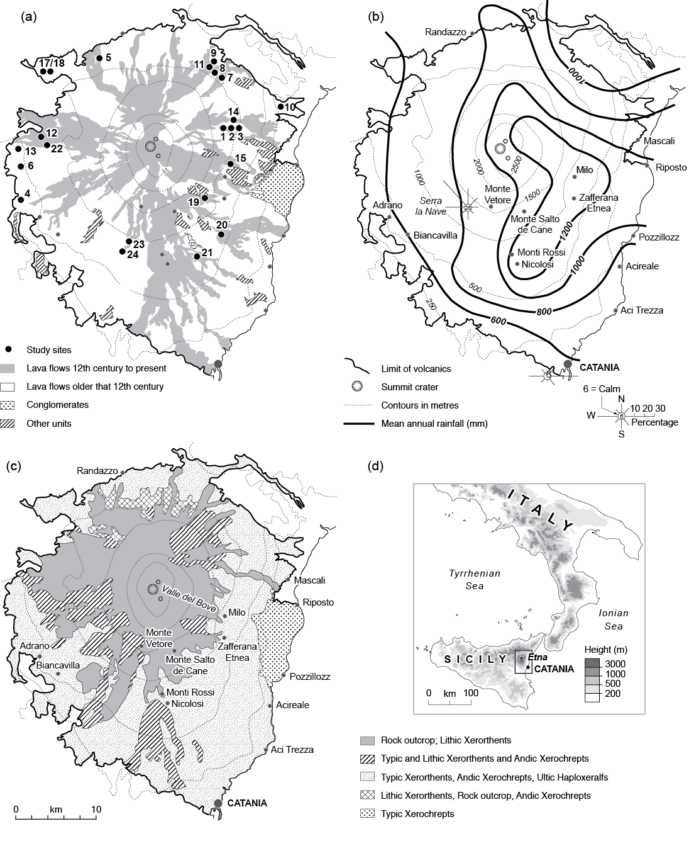

Fig. 1. Mt Etna.
a. Relief, geology and location of sampling sites.
b. Mean annual rainfall and wind direction (after Durbin and Henderson-Sellars, 1981); chief settlements and place-names referred to in text.
c. Map of Fierroti et al’s (1988) soil associations.
d. Location of Mt Etna and study area.

(DOUBLE COLUMN)
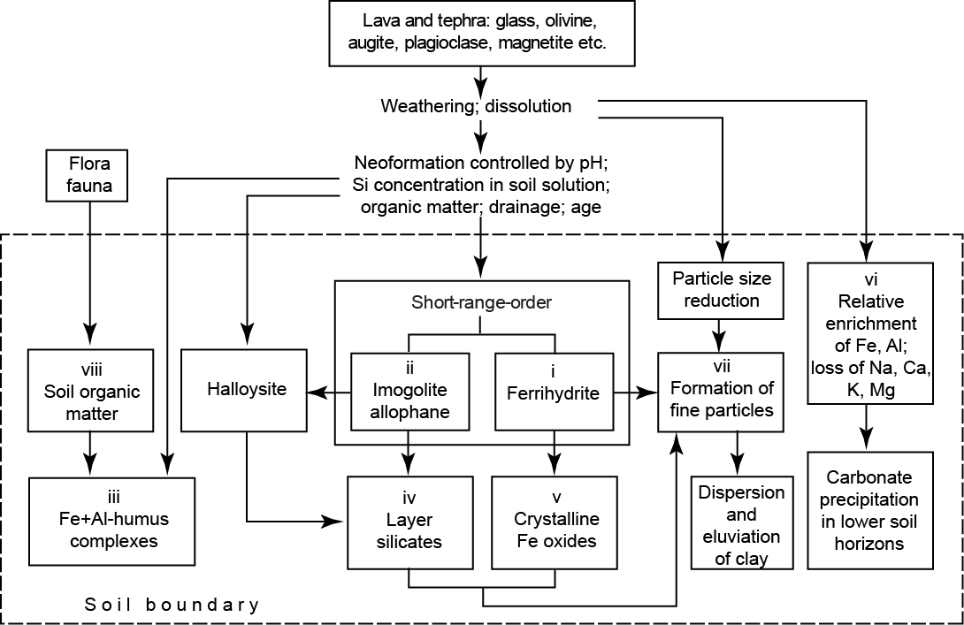

Fig. 2. Model of chief pedogenic processes in volcanic materials.

(DOUBLE COLUMN)

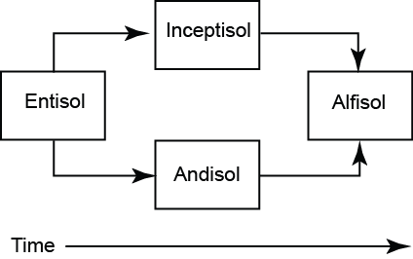

Fig. 3. Soil evolution on Mt Etna as inferred from previous research.

(SINGLE COLUMN)
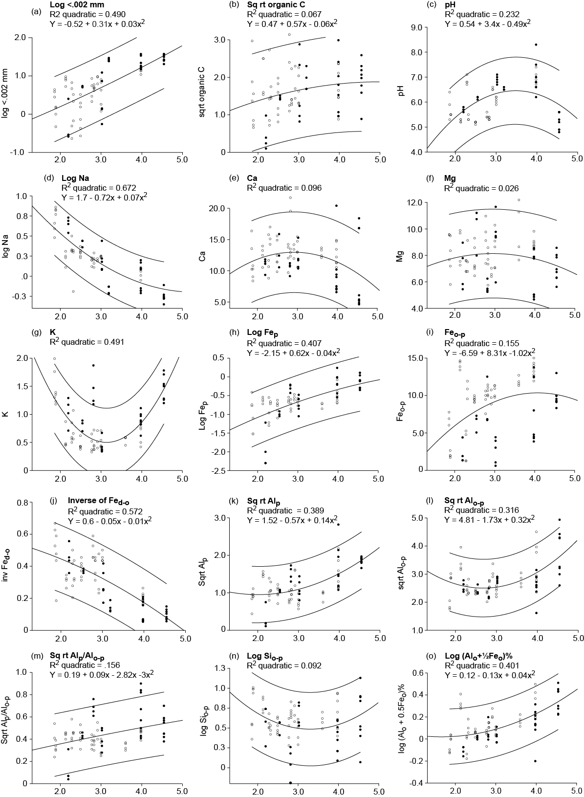

Fig. 4. Soil variables plotted against age of lava flow for all samples. Black circles: W flank sites; open circles: E flank. Curves for quadratic (or linear) function and 95% limits shown in each case. R² = coefficient of determination. For samples with equal or very nearly equal values, symbols are over-written (e.g. samples in ES17 and ES18 in several cases).

(DOUBLE COLUMN)

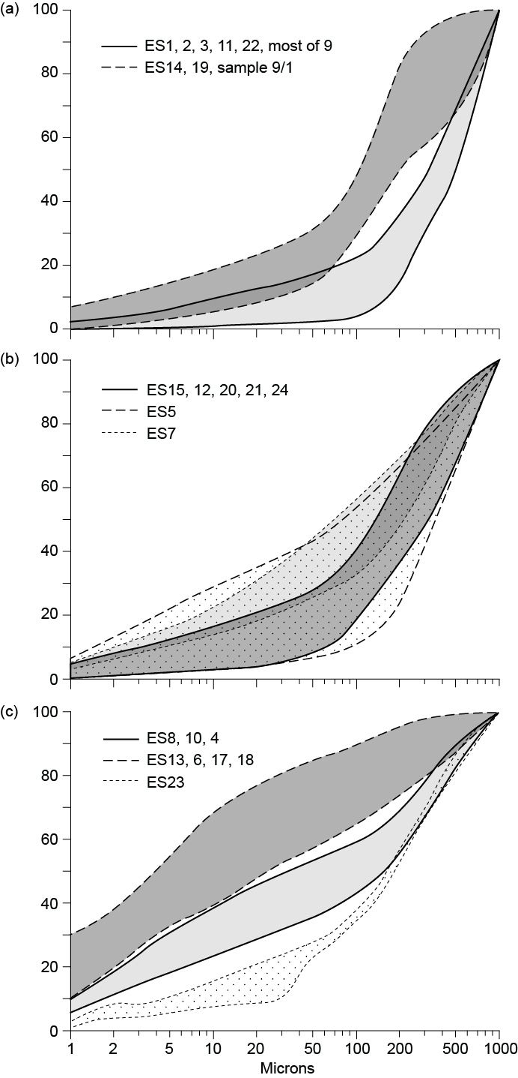

Fig. 5. Envelopes of cumulative particle-size curves (.001 - 1 mm) for soils on flows grouped by age:
a. 72 to 208 yr BP: ES1, ES2, ES3, ES11, ES14, ES22, ES9, ES19.
b. 311 to 1050 yr BP: ES15, ES12, ES21, ES20, ES7, ES24, ES5.
c. ~9,000 to ~35,000 yr BP: ES4, ES6, ES8, ES10, ES13, ES17, ES18. ES23 - age unknown.

(SINGLE COLUMN)
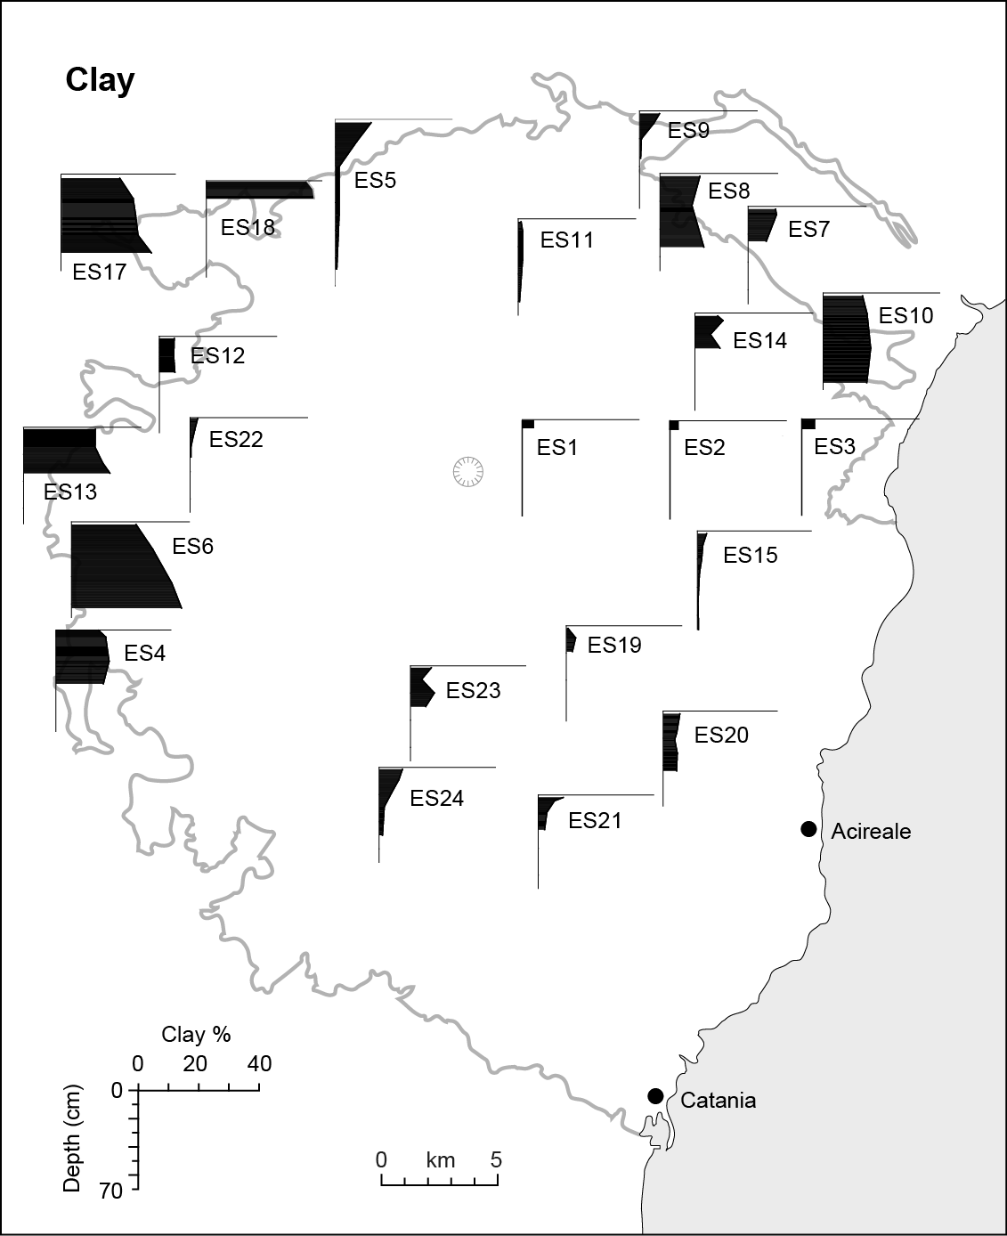

Fig. 6. Schematic map of clay: <.002 mm % against depth for each soil. Exact location of sample sites shown in Fig. 1a.

(SINGLE COLUMN)

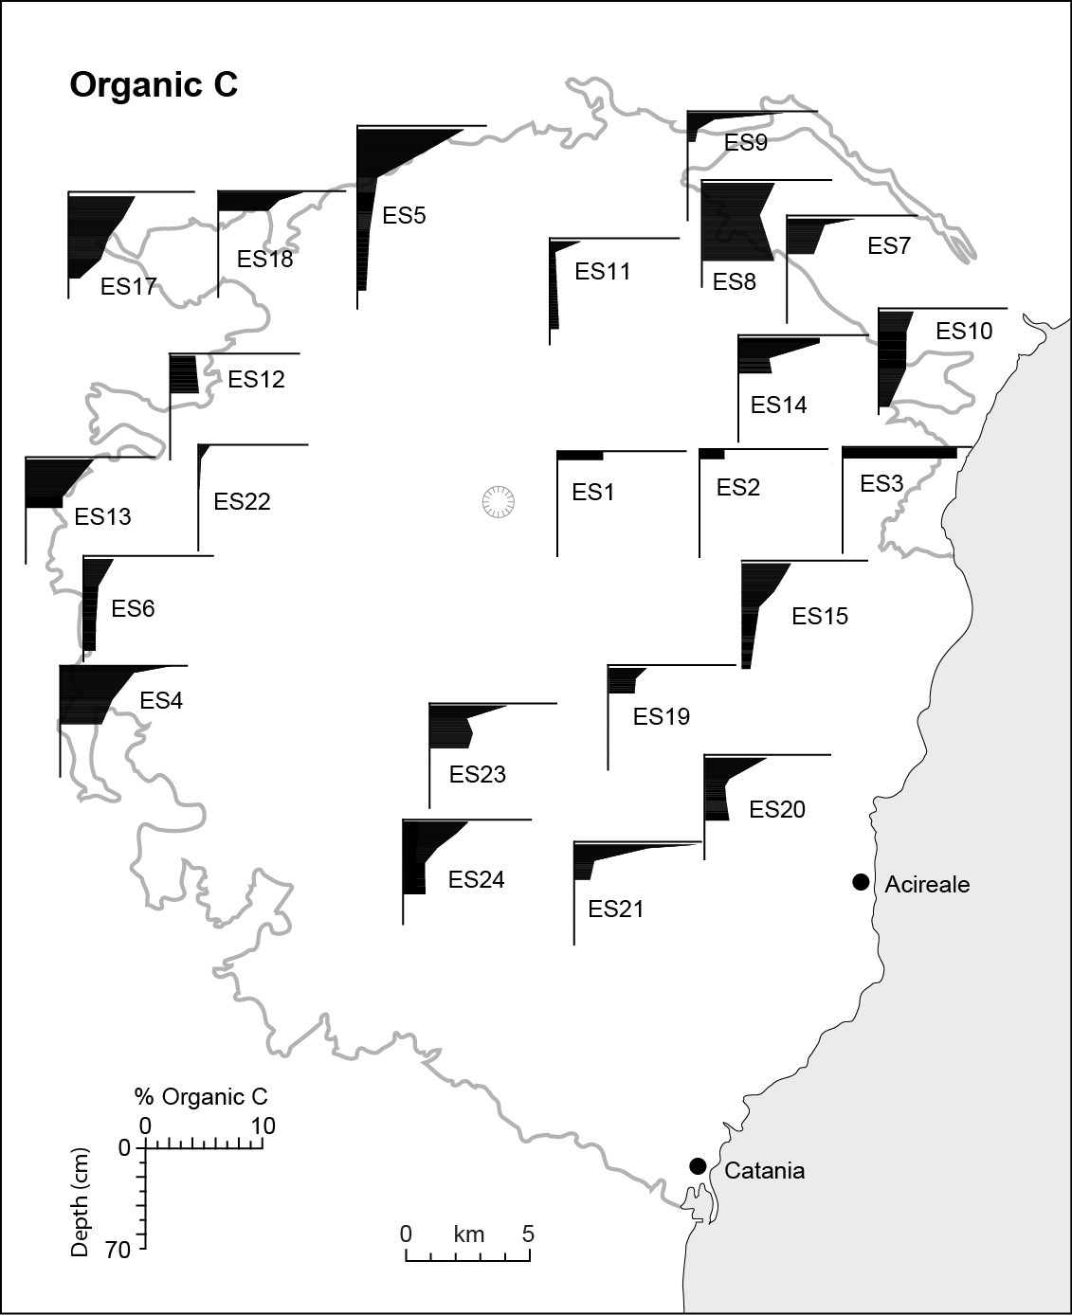

Fig. 7. Schematic map of % Organic Carbon against depth for each soil. Exact location of sample sites shown in Fig. 1a.

(SINGLE COLUMN)

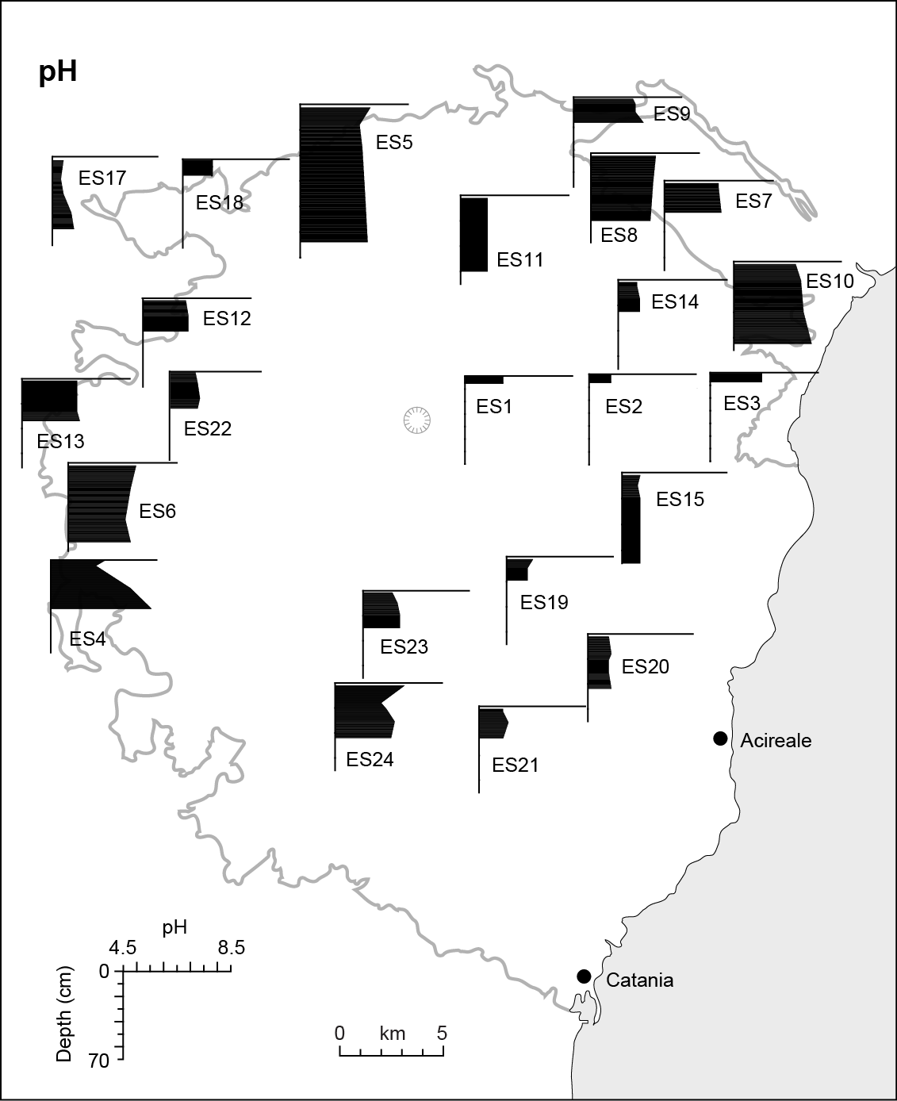

Fig. 8. Schematic map of pH against depth for each soil. Exact location of sample sites shown in Fig. 1a.

(SINGLE COLUMN)

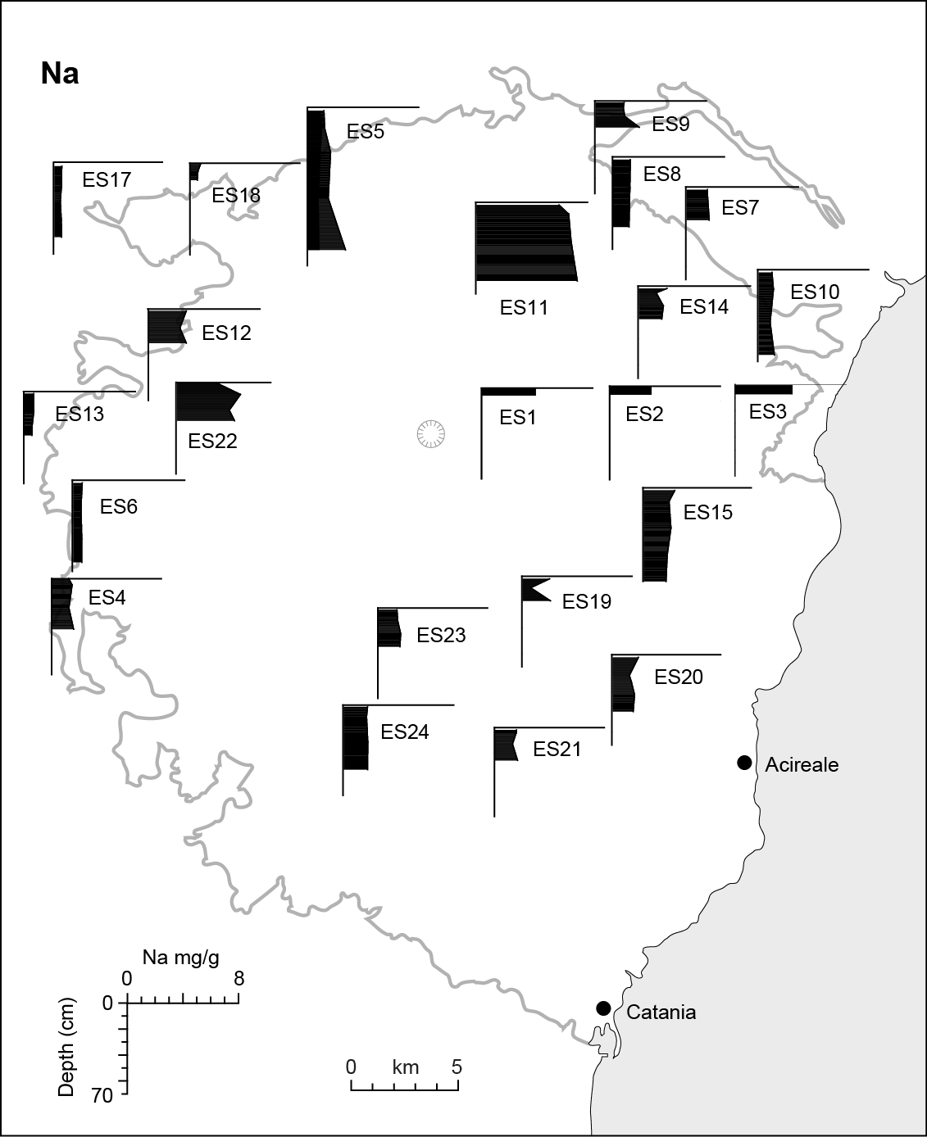

Fig 9. Schematic map of Na: mg g⁻¹ against depth for each soil. Exact location of sample sites shown in Fig. 1a.

(SINGLE COLUMN)

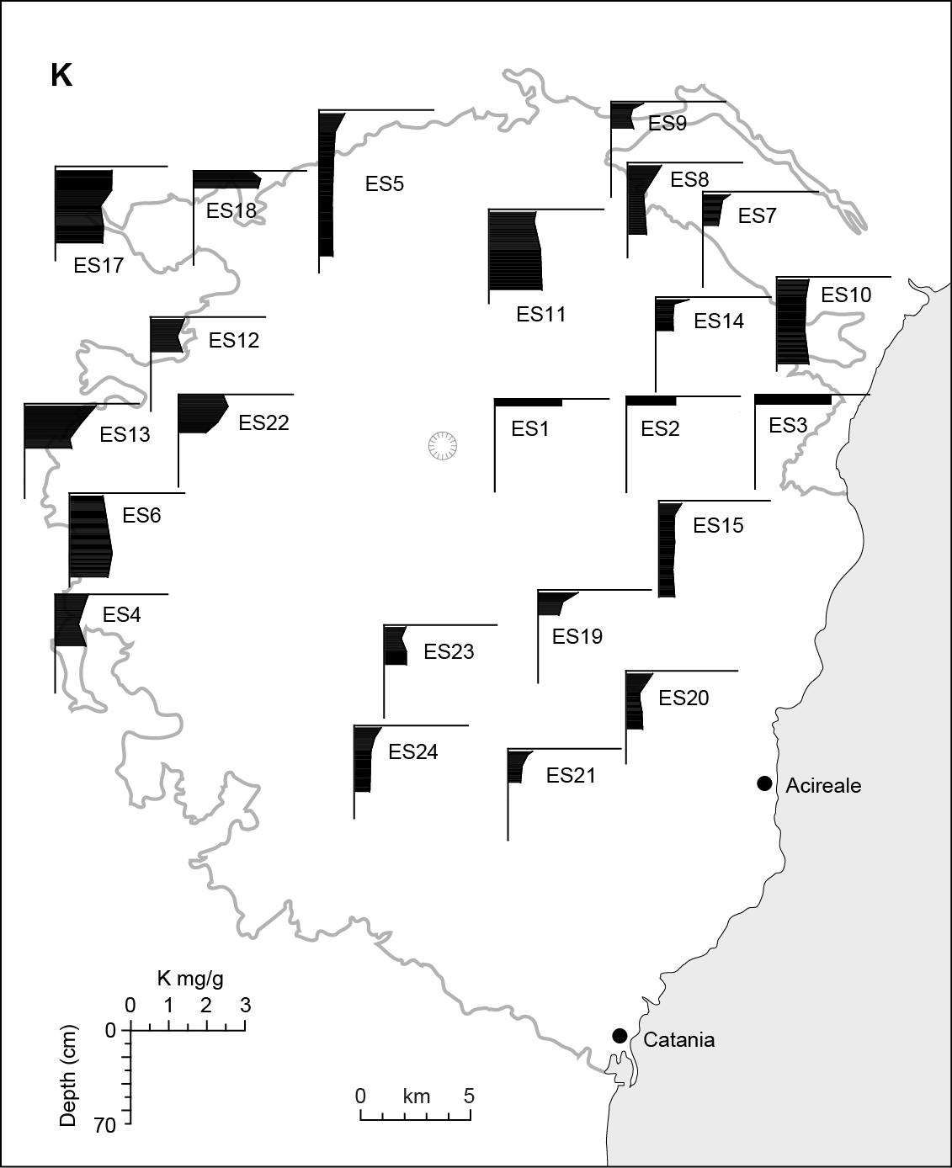

Fig 10. Schematic map of K: mg g⁻¹ against depth for each soil. Exact location of sample sites shown in Fig. 1a.

(SINGLE COLUMN)

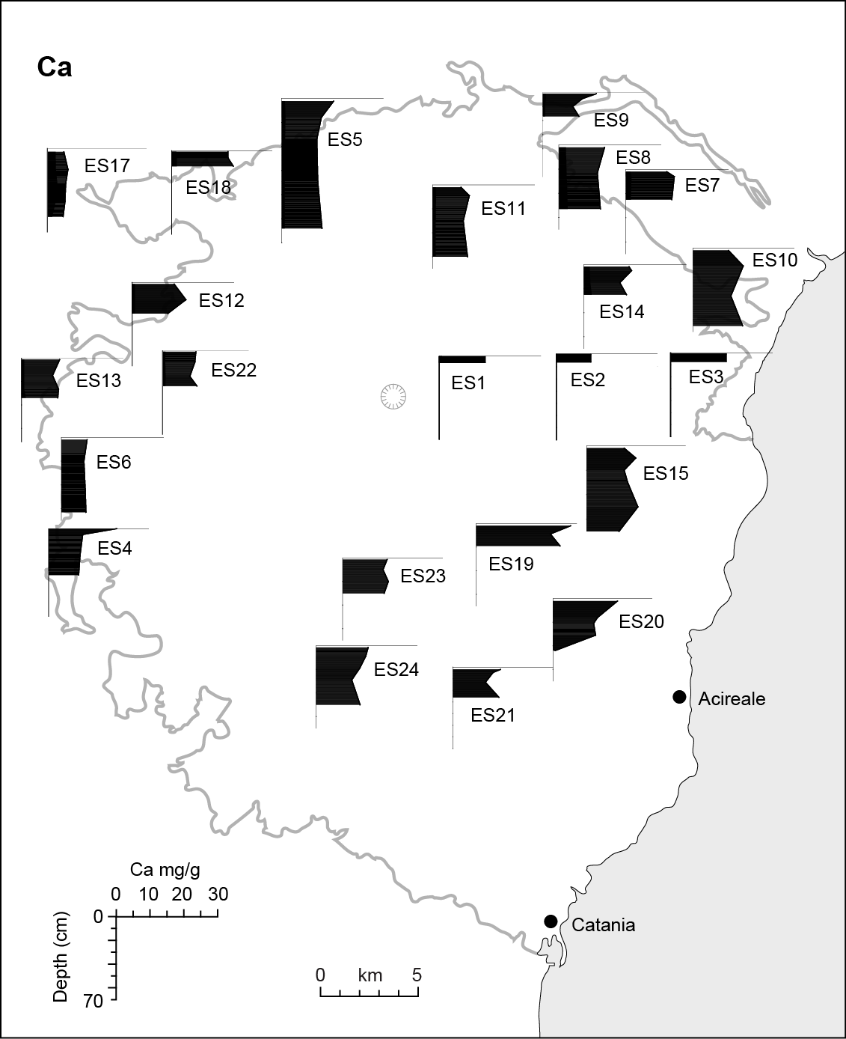

Fig 11. Schematic map of Ca: mg g⁻¹ against depth for each soil. Exact location of sample sites shown in Fig. 1a.

(SINGLE COLUMN)

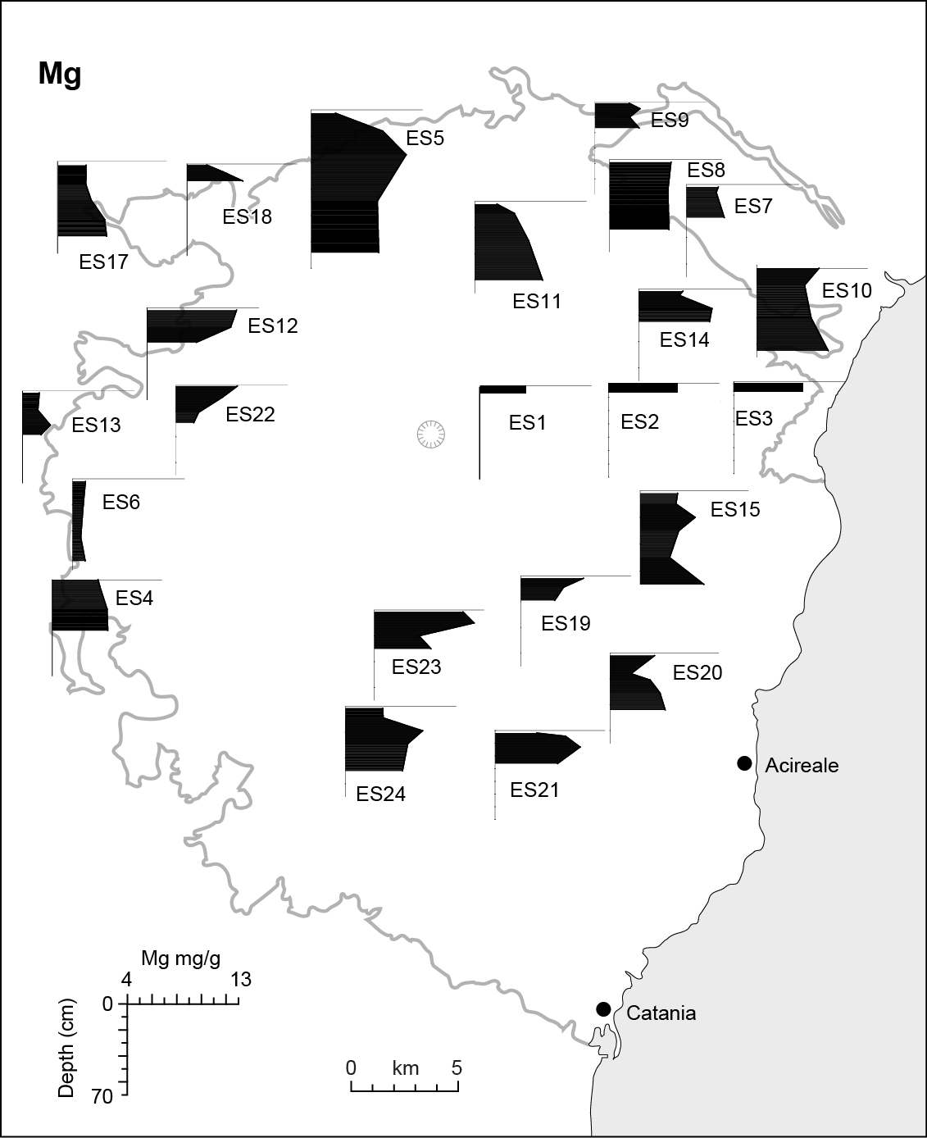

Fig 12. Schematic map of Mg: mg g⁻¹ against depth for each soil. Exact location of sample sites shown in Fig. 1a.

(SINGLE COLUMN)

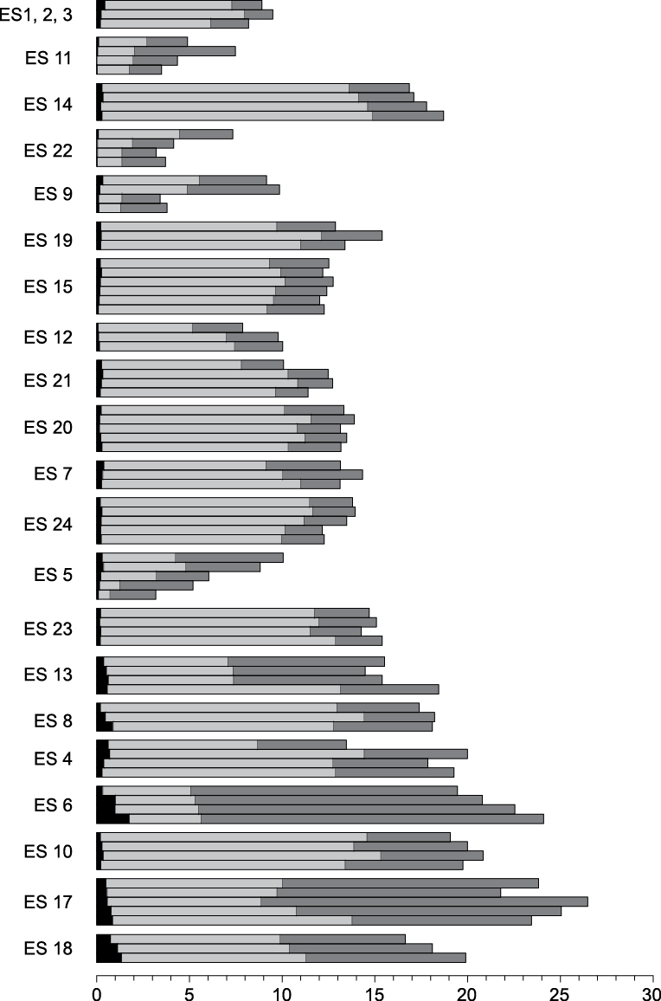

Fig. 13. Three Fe phases (Fe_{p}, Fe_{o-p} and Fe_{d-o}, mg^{-g}) for each soil sample. Soils in order of increasing age of flow. Position of ES23 - age unknown - is arbitrary).

(SINGLE COLUMN)

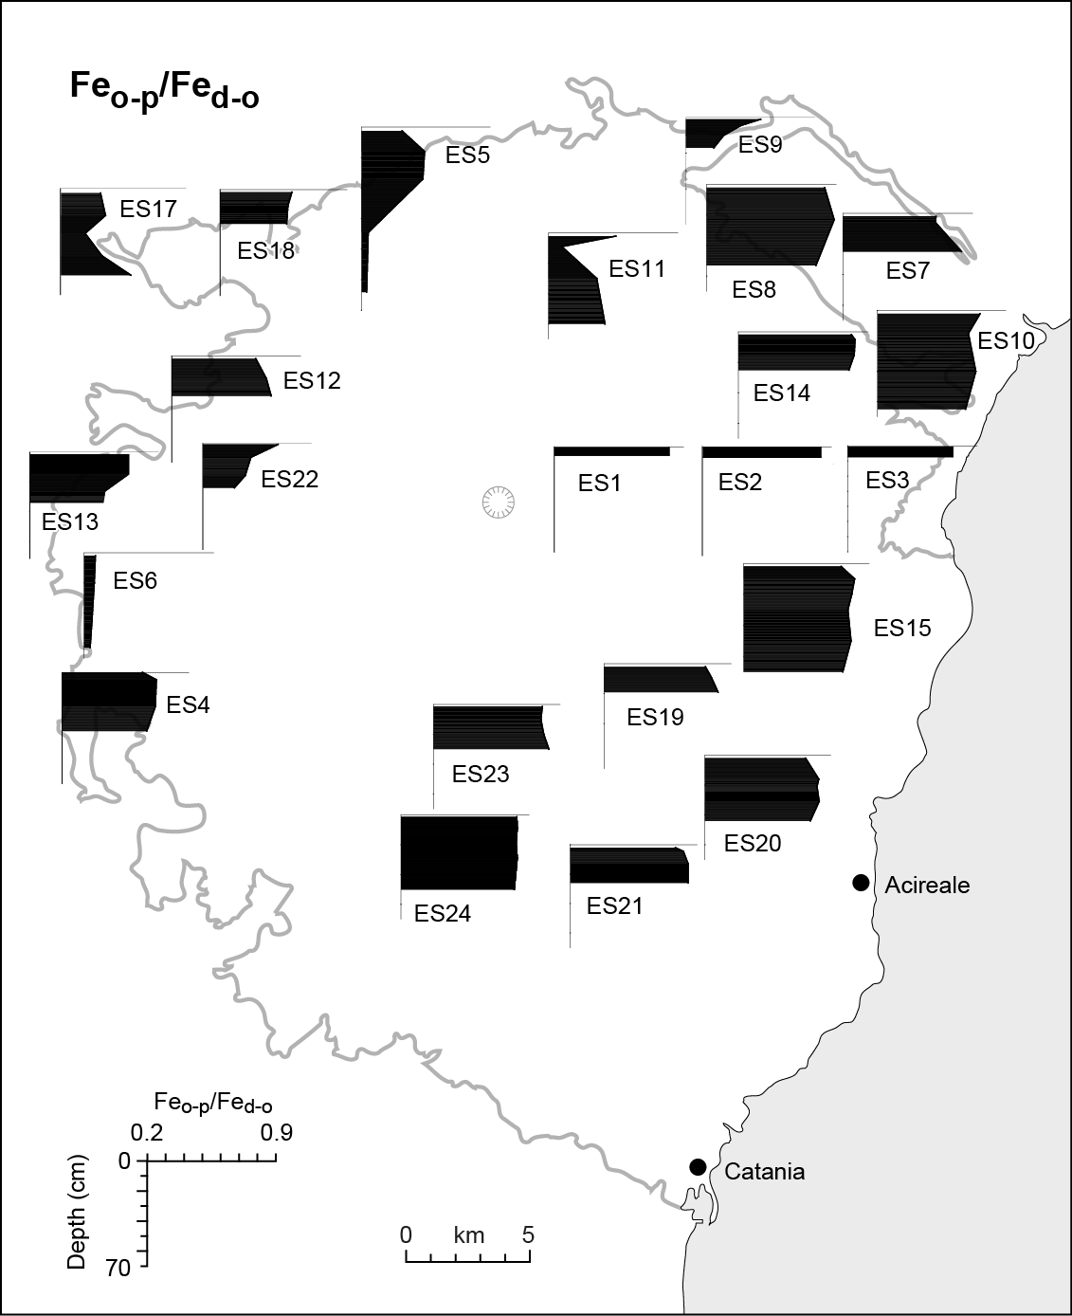

Fig . 14. Schematic map of Fe_{o-p}/Fe_{d-o} against depth for each soil. Exact location of sample sites shown in Fig. 1a.

(SINGLE COLUMN)

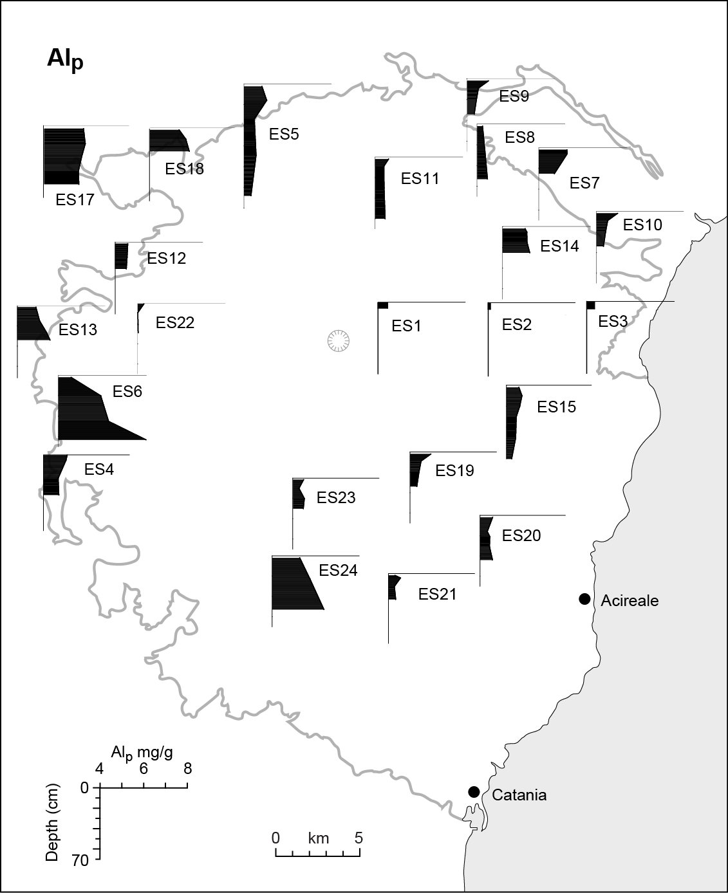

Fig. 15. Schematic map of Al_{p}: mg g⁻¹ against depth for each soil. Exact location of sample sites shown in Fig. 1a.

(SINGLE COLUMN)

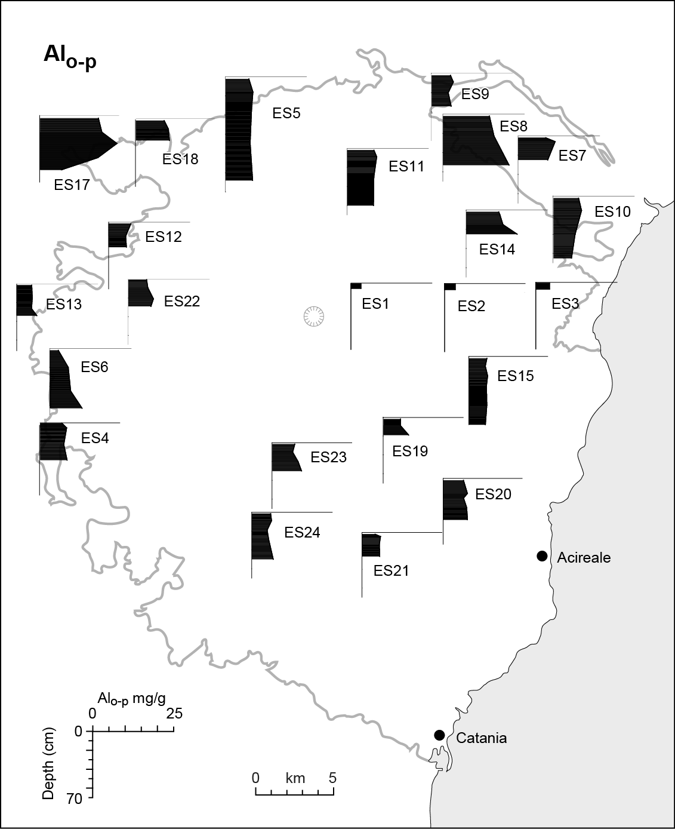

Fig. 16. Schematic map of Al_{o-p}: mg g⁻¹ against depth for each soil. Exact location of sample sites shown in Fig. 1a.

(SINGLE COLUMN)

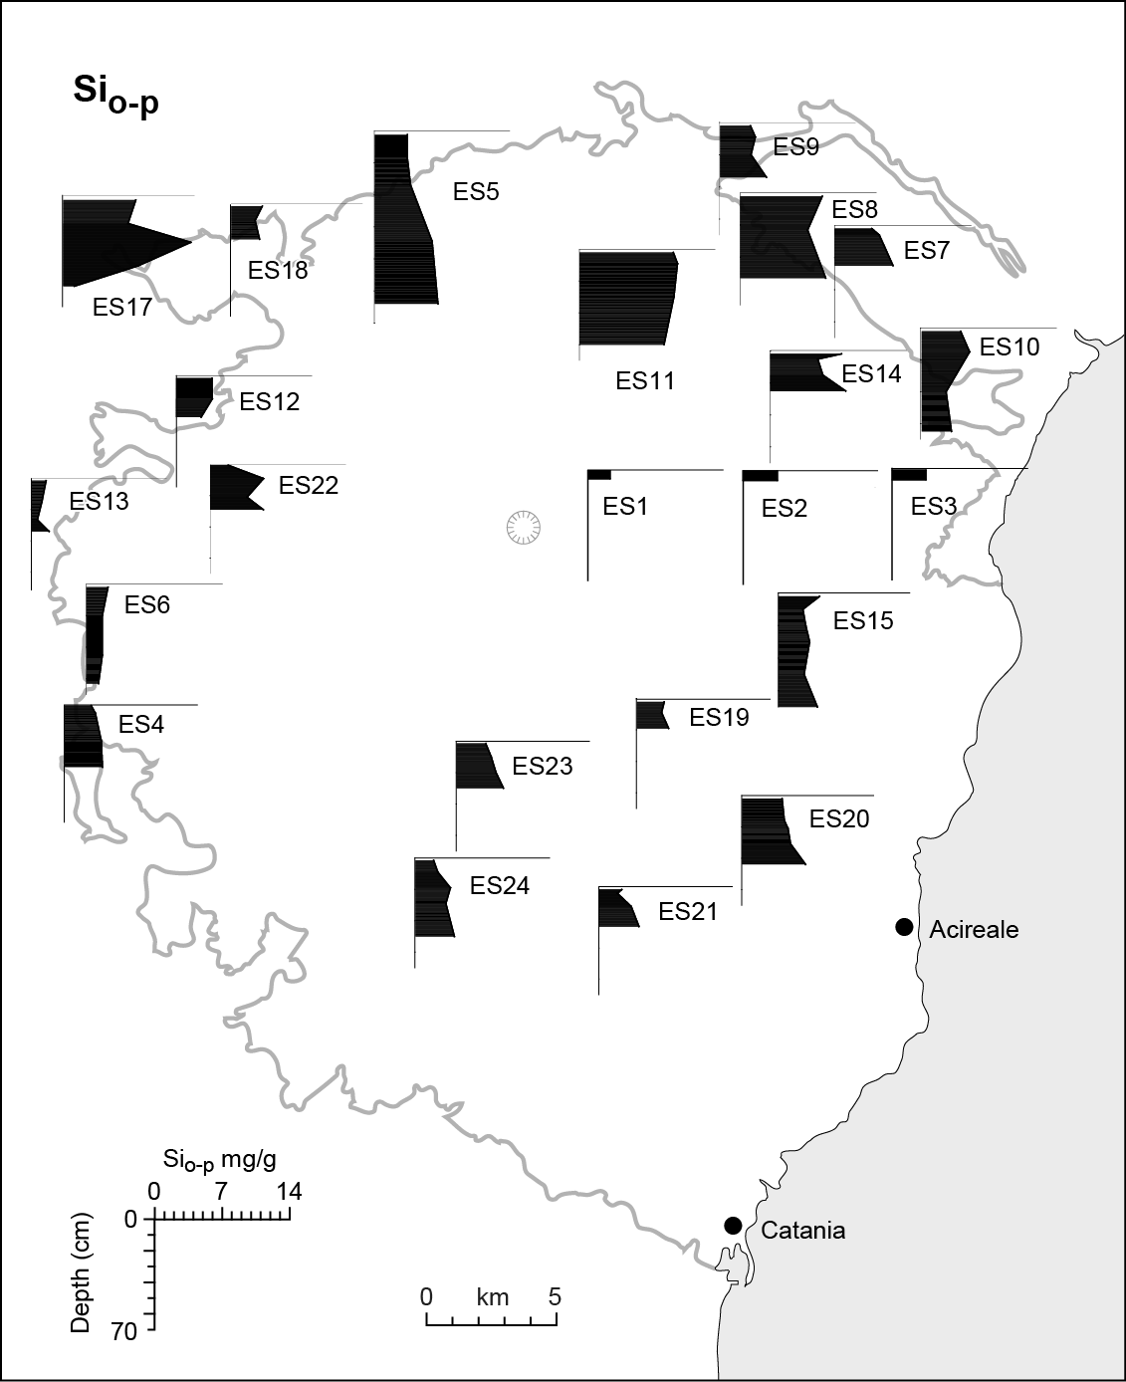

Fig. 17. Schematic map of Si_{o-p}: mg g⁻¹ against depth for each soil. Exact location of sample sites shown in Fig. 1a.

(SINGLE COLUMN)

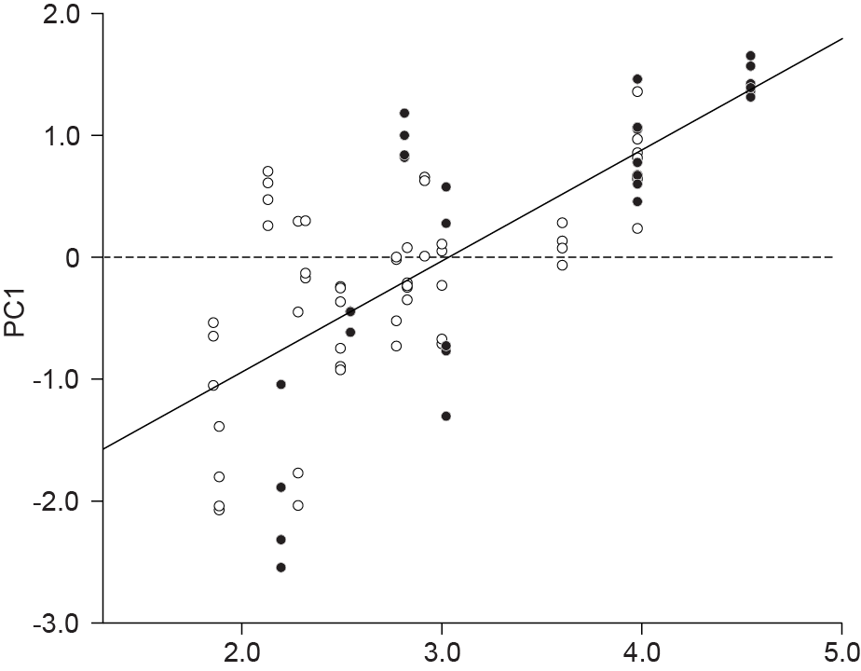
a.

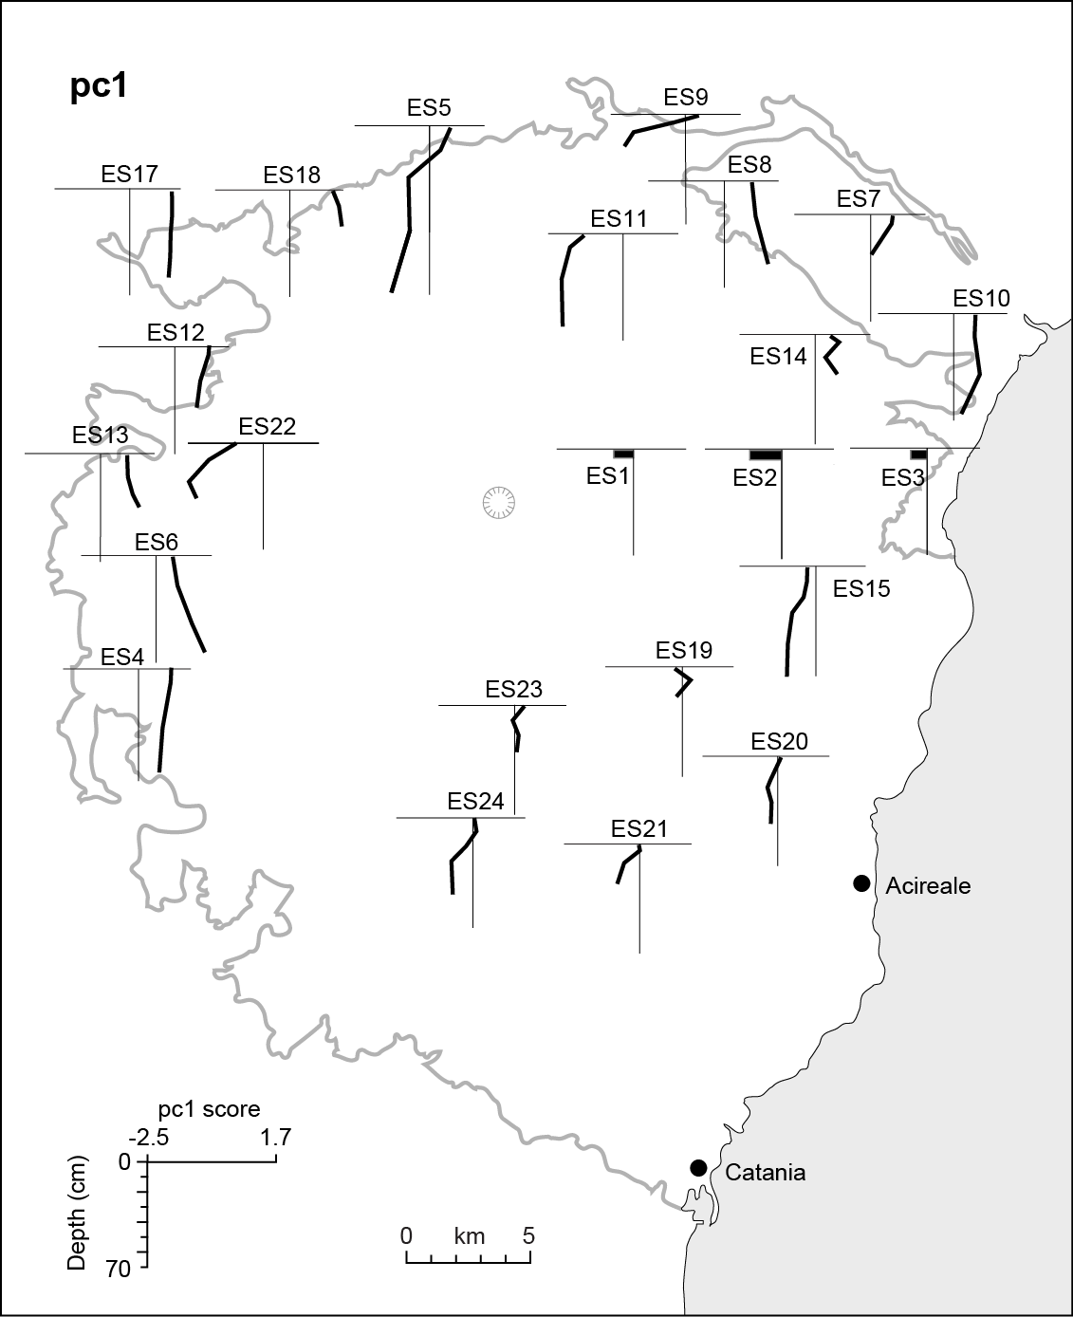
b.
Fig. 18.
a. Pc1 scores plotted against log of age of lava flow for all samples. Black circles: west flank sites; open circles: east flank. Linear best-fit and 95% limits shown. R² = coefficient of determination. For samples which have equal or near-equal values, symbols are over-written (e.g. in ES17 and ES18). Exact location of sample sites shown in Fig. 1a.
b. Schematic map of Pc1 scores against depth for each soil. Vertical line = score of 0 in each case. Exact location of sample sites shown in Fig. 1a.
(SINGLE COLUMN)

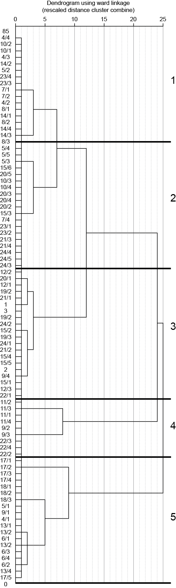

Fig. 19. Dendrogram from cluster analysis using sample scores on four principal components. Cluster numbers 1 to 5 as in Figs 20 and 21.

(SINGLE COLUMN)

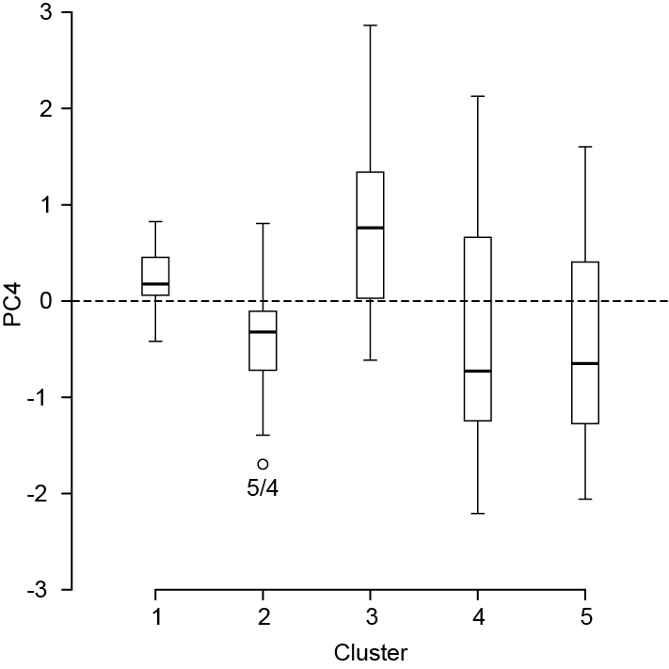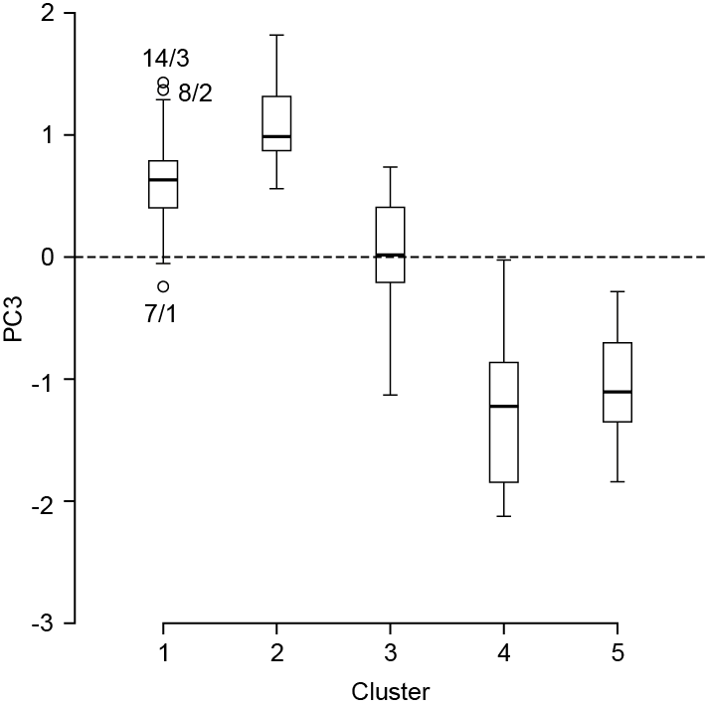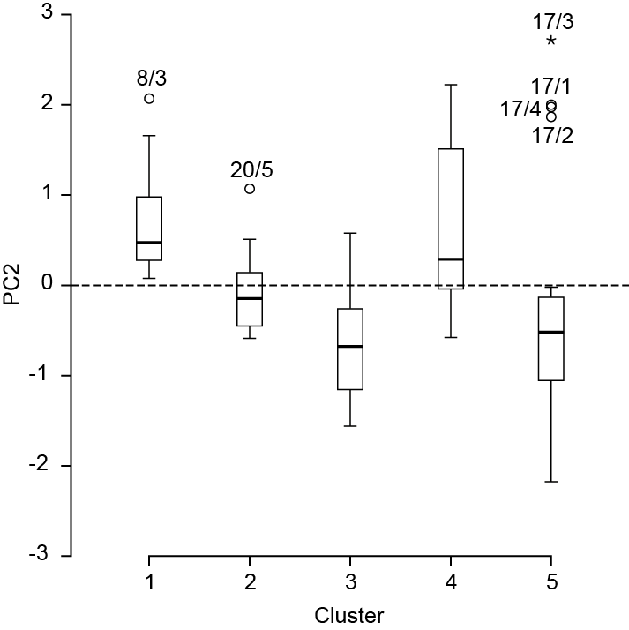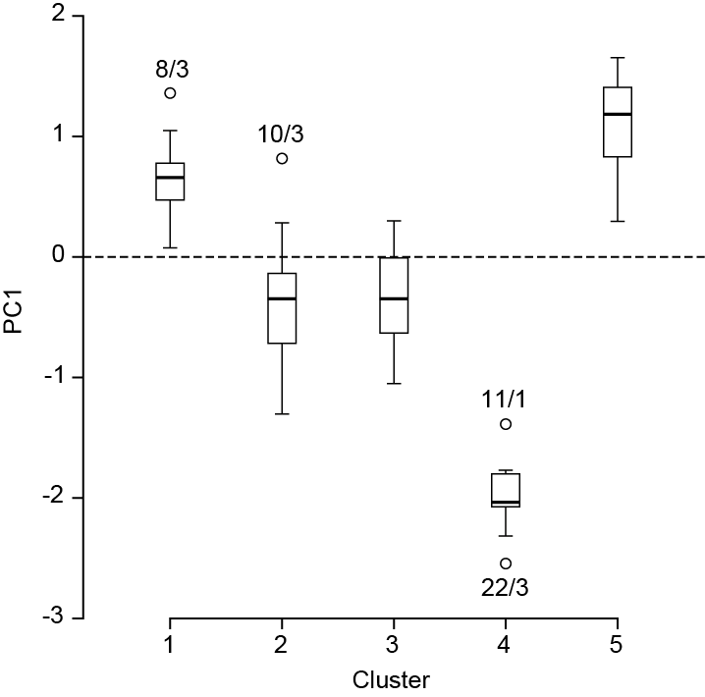

Fig. 20. Box plots showing median and upper and lower quartiles of scores on each four pcs for each cluster.

(SET OF FOUR IN DOUBLE COLUMN)

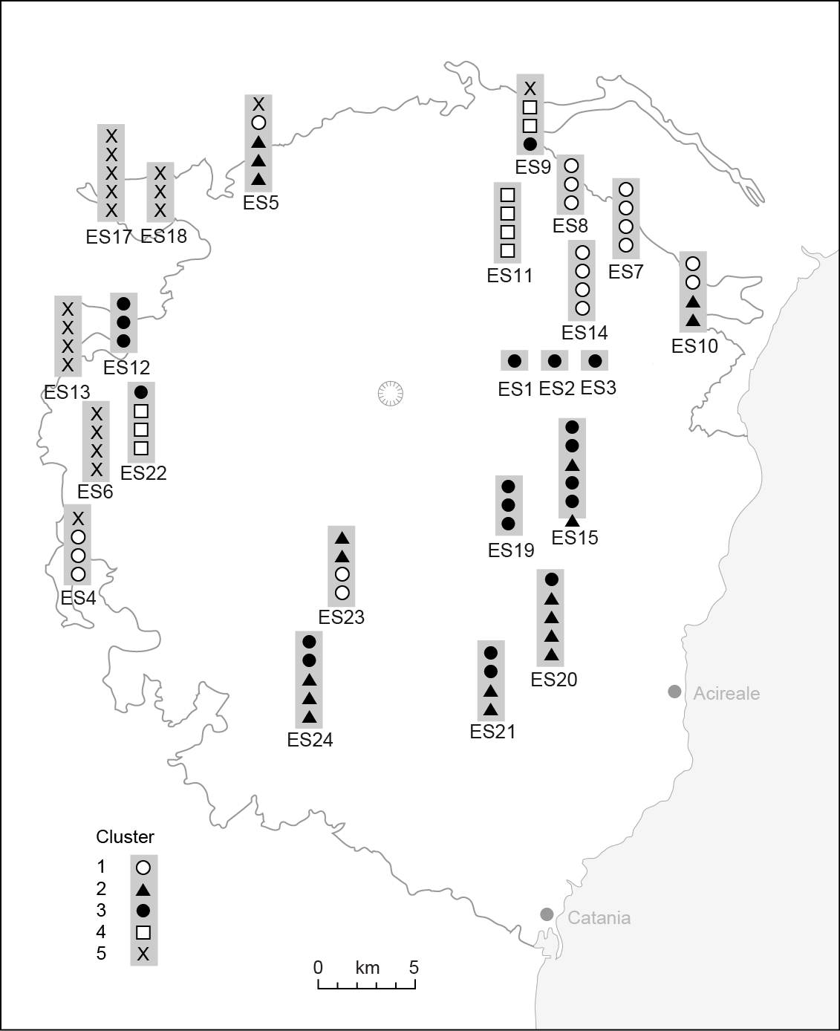

Fig. 21. Schematic map showing cluster membership of samples in each soil. Depth in each profile not to scale. Clusters as defined in Fig. 19. Exact location of sample sites shown in Fig. 1a.

(SINGLE COLUMN)

 | Min | Max
SiO₂ | 46.33 | 48.86
Al₂O₃ | 17.35 | 18.94
Fe₂O₃ | 5.48 | 7.06
FeO | 3.01 | 5.82
MgO | 4.44 | 5.85
CaO | 9.53 | 10.37
Na₂O | 3.32 | 4.40
K₂O | 1.50 | 1.76

Table 1. Selected oxides (percent weight) for Etna lavas, dating from 1923, 1947, 1809 and 1614-24 (Romano and Guest, 1979).

Soil properties | Unit | Method and description
Total Ca, Mg, K,  Na | mg g⁻¹ | Digestion in nitric and perchloric acids (Hesse, 1971); determination of Ca and Mg by atomic absorption spectrometer; of Na and K by colorimeter using molybdenum blue method (Allen, 1989).
Particle size fractions (in <1mm material) | % vol | Coulter laser diffractometer, following pretreatment with H₂O₂, and dispersion with 'Calgon'. Textural terms based on field estimation because of the unreliability of particle-size analysis of Andisols (Nanzyo et al., 1993).
Pyrophosphate-extractable Fe and Al (Fe_{p}, Al_{p}) | mg g⁻¹ | Extracted with potassium pyrophosphate (McKeague, 1967). For Fe and Al present in metal-organic complexes.
Oxalate-extractable Fe, Al and Si (Fe_{o-p}, Al_{o-p}, Si_{o-p}) | mg g⁻¹ | Extracted in darkness with acid NH₄-oxalate (McKeague and Day, 1966). Inorganic, non-crystalline: Fe_{o-p}, Al_{o-p}, Si_{o-p}.
DCB-extractable Fe (Fe_{d-o}) | mg g⁻¹ | Extracted with dithionite-citrate-bicarbonate (Mehra & Jackson, 1960). Fe_{d-o} as crystalline Fe oxyhydroxides (goethite, magnetite etc.)
pH in water | -log [H+] | Electrometrically in water (2.5:1 volume water: soil)
Organic carbon | % weight | Potassium dichromate digestion by Walkley-Black method (Hesse, 1971)
Organic nitrogen | % weight | Kjeldhal procedure (Allen, 1989)

Table 2.
Soil properties determined, techniques used, and units expressed.

Site (ES prefix omitted)ª | Grid reference^{b} | date and age of flow | elevation (m) | Site details^{c} | Vegetation (max ht shrubs/trees); land use^{d} | Layer^{e} | Depth (cm) | Lower boundary^{f} | Moist colour | Field Texture^{g} | rock fragments:  % volume + size^{h} | Consistence^{i} | Structure^{j} | Roots: abundance and size^{k} | Fauna^{l} | Remarks
1 | 103  812  Acir | 1928  72 | 970 | Aa (Mascali flow): lava blocks maximum length, 60 cm. Strong slope on flow-edge. Soil scraped from beneath moss in depressions in, and bridging spaces between, lava blocks. Lapilli on moss surface. | m in depressions; l covers 40% rock surfaces. | A  R | 0-2  2+ |  | 2.5Y2.5/1  black | S | 10% fp | l ns np | 0 | 0 | l
2 | 103  812Acir | 1928  72 | 970 | Aa (Mascali flow) 1m from site 1M. Soil scraped from beneath lichen on lava. | l covers 40% rock surfaces. | A  R | 0-0.2  0.2+ |  | 2.5Y2.5/1  black | S | 0 | l ns np | 0 | 0
3 | 102  808  Acir | 1928  72 | 960 | Aa (Mascali flow), 150 m to south of ES1 and ES2. On level floor of 8m-wide depression in flow. | cont h, g, l, small shr. | A  R | 0-5  5+ |  | 2.5Y2.5/1  black | S | 10% p (max 5) | l ns np | 0 | m vf
11 | 083  887  Tao | 1923  77 | 700 | Aa flow. Nearly level floor of 13m deep x 8m wide linear depression containing tephra and scoria. | cont under canopy of br (1.5m): h, g, shr. Signs of rabbits-grazing. | A  C  C | 0-6  6-25  25-65+ | a  c  bns | 10YR2/1  10YR2/1  10YR2/1 | coS  coS  coS | 15% p+c (max 10)  20% p (max 3)  85% p+c (max 3) | l ns np  l ns np  l ns np | 0  0  0 | m f+ vf  m f  m f | a
14 | 112  819  Acir | 1865  135 | 850 | Aa lava. Nearly level floor of 3m-wide depression; many lapilli on surface. Sides of depression: class 5 cover of lava boulders and stones. | cont h, g, m, br (2.5m), do (3m). Signs of rabbits-grazing. | A  C  C  R | 0-8  8-20  20-32/35  35+  32/35+ | a  g  g | 2.5Y2.5/1  2.5Y2.5/1  2.5Y2.5/1 | SL  SL  SL | 5% fp  10% fp  35% p+c | l ns np  l ns np  vf ns np | 0  0  0 | m f, med + co  c f , med + co  mod few f, med + co
22 | 871  795  Mt  E | 1843  157 | 700 | Aa flow. Sparse pockets of soil in strongly sloping lava surface. Clinker, lapilli and recent ash on surface, comprising >90% cover of p + c; possibly from 1974 flank eruption | discont m, h, g,  low shr; l on rock  surfaces. | A  C  C | 0-3  3-15  30+ | A  C  bns | 2.5Y2.5/1  2.5Y2.5/1  2.5Y2.5/1 | m +  co S  m+  coS | 10% fp  10% p+c  35% p+c | l np ns  l np ns  l np ns | 0  0  0 | m f  c f  few med
9 | 084  895  Tao | 1809  191 | 725 | Aa flow. Nearly level 3m x  1.5m surface between lava stones + boulders. | discont m, h, g,  low shr; l on rock  surfaces. | A  C  C | 0-3  3-15  30+ | A  C  bns | 2.5Y2.5/1  2.5Y2.5/1  2.5Y2.5/1 | m +  co S  m+  coS | 10% fp  10% p+c  35% p+c | l np ns  l np ns  l np ns | 0  0  0 | m f  c f  few med
19 | 072  722  Acir | 1792  208 | 1030 | Slabby pah with spreads of aa, clinker and young (1998?) lapilli. Nearly level floor of 17m-long depression. Site has 10% cover of ash and lapilli. | cont h, g, ho (3.5m), br (3.5m). Signs of rabbit-grazing. | A  C  R | 0-3  3-7/25  7/25+ | a | 2.5Y2.5/1  2.5Y2.5/1 | S  LS | 0  60% p | l ns np  l ns np | 0  0 | m v f  c v f | l
15 | 097  769  Acir | 1689  311 | 875 | Aa flow. Nearly level surface in small valley. | cont h, g, m, br,  bramble, do (8m). Signs of rabbit-grazing. | Oe  A  C  C  R | 0-0.5  0.5-15  15-50  50-75  75+ | a  a  g | 2.5Y2.5/1  2.5Y2.5/1  2.5Y2.5/1 | LS  S  coS | <5% f+mp  <5% p (max 4)  5% f+mp | f ns np  l ns np  l ns np | vw f b  0  0 | m v f  m v f  c v f  few v f | L  l | between  20-30cm:  charcoal,  fragments,  coke and  rusty iron nail
12 | 863  806  Mt  E | 1651  349 | 925 | nearly level surface, ~100m-wide, between pah ridges. 65% of surface covered with  c, b. | cont l, m with  isolated low sh,  bramble, ho (6m) | A  C  C | 0-15  15-45  45+ | C  G  bns | 10YR3/1.  5  10YR3/1  10YR3/1 | LcoS  coS  coS | 50% p  60% p+c  90% p+c | l np ns  l np ns  l np ns | 0  0  0 | m v f  m v f + f  f v f
7 | 094  877  Cast | 1180±30 AD  820 | 820 | slabby aa. Moist depression | cont h, g, m, bramble, br (3m), do (3m) near site; cattle; Signs of rabbit-grazing. | A  C  R | 0-5  5-35  35+ | a  c | 2.5Y2.5/1  2.5Y2.5/1 | SL  SL | <5% fp  1-% fp | f ss np  f ss np | mod c g  0 | m v f  c v f | w  w | layer of lapilli (max 0.5cm) between 7-8cm and ash lenses in top 12cm
21 | 048  653  Acir | 1408  592 | 720 | level site on slabby aa flow | cont under mature do woodland; h, g, shr, including br | Oe  A  C  R | 0-0.25  0.25-5/8  5/8-8/45+  8/45+ | a  a  c | 2.5Y2.5/1  2.5Y2.5/1 | S  LS | 5% fp  10% p+c (max 15) | l ns np  l ns np | 0  0 | c v f  c v f  c v f; few med |  | bedrock surface sloping across pit from 8cm to pit-base at 45cm
20 | 092  674  Acir | 1329  671 | 500 | lava morphology concealed by agricultural terraces; lava outcrops 3m from pit. Scoriaceous clinker has been piled up. Reddish-brown scoria in pit is from Monti Rossi cinder cone and may have been carried in to level the ground | abandoned walled fields and terraces. Pit on terrace, 3m from front; 2m from back. cont h, g, ho (6m), br.(4m), bramble. Signs of rabbit-grazing. | A  C  C  R | 0-12  12-40  40-45  45+ | c  a | 2.5Y2.5/1  2.5Y2.5/1  2.5Y2.5/1 | LcoS  coS  coS | 10% f+mp  10% p  95% p | l ns np  l ns np  l ns np | 0  0  0 | m f  c f  few f | l | 5cm-thick layer of scoria (2.5YR3/4) from Monti Rossi lies over bedrock.
5 | 934  903  Ran | 950  ±50  1000 | 880 | exposure cleaned in 1m-wide  levée on aa flow | discont h, g | A  C  C | 0-15  15-55  55-127+ | c  g  bns | 10YR2/1  10YR2/1  10YR2/1 | SL  LS  LS | 10% f+mp  15% p+c  80% p+c+ s | l ns np  l ns np  l ns np | 0  0  0 | m v f  c v f  c v f |  | below 55cm,  soil  penetrates  fissures in  bedrock
23 | 793  668  Mt E | dagala within 1780 AD flow. Age not known. | 975 | Flow morphology concealed.  Site on level surface of  dagala. | cont h, g,  bramble, do (8m),o, chestnut and other deciduoustree species (7m) | A  C  C | 0-5  5-30  30-40+ | a  c  bns | 2.5Y2.5/1  2.5Y2.5/1  2.5Y2.5/1 | LS  SL  LS | <5% fp  40% p+c  90% p+c+s | vf ss  np  l ns np  l ns np | w m b  0  0 | m f  few f + m  few f
24 | 963  653  Mt  E | 1000 ±50 AD  1000 | 790 | slabby pah with large tumuli. Pit in 1m-deep, 2m-wide axial crack of tumulus with level floor | cont h, g, m shr, do (4m), br (3m) | A  C  C | 0-5  5-20  20-61+ | a  a  bns | 2.5Y2.5/1  2.5Y2.5/1  2.5Y2.5/1 | SL  LcoS  S | 5% fp  20% p (max 3)  90% p (max 3) | vf ns np  l ns np  l | w f to m b  0  0 | m f  c f  few f + med |  | below 20cm are lapilli from 1669 Monti Rossi eruption: 95% volume of gravel
13 | 851  087  Mt  E | 450  1550 | 800 | flow concealed by terraces + walls. Pit on level, walled, 25m-wide terrace. | cont h, g, o, pistachios, pp. Used for grain | A_{p}  Bw/C  C | 0-15  15-35  35-40+ | a  c  bns | 10YR4/3  10YR4/3  10YR4/3 | L  L  L | 20% f+mp  20% f+mp  60% f+mp | f ss np  f ms np  f ms np | w f-m b  w m b  0 | m v f  c v f  c v f | w  w
17 | 854  892  Ran | 42-28 ka  35000 | 625 | Level depression in pah flow field. Very little fragmental material on surface. Possible that soil has been washed into this depression from surrounding flows. | cont h, g, bramble. Horses, goats, Signs of rabbit-grazing. | A  C  C  R | 0-25  25-45  45-55/65  55/65 | c  g | 10YR2/1.5  10YR2/1.5  10YR2/1.5 | SiL  SiCL  SiCL | <5% p+c (max 10)  0  0 | fr ss sp  fr ms mp  fr ms mp | w m b  0  0 | c v f + f  few f  few f | a l w  w  w | faunal channels running through whole profile. One 1cm-wide, to base of soil.
18 | 855  892  Ran | 42-28 ka  35000 | 627 | Fissure in tumulus summit, 100 m from ES17. Depression is 58cm wide, 20 deep; floor is level. | cont h on level floor of  depression | A  C  R | 0-10  10-40  40+ | c | 10YR2/2.5  10YR2/2.5 | SiCL  SiCL | 0  0 | f ms  mp  f ms mp | wmb  0 | m f  few f |  | Soil continues down fissure in bedrock
6 | 821  764  Mt  E | 15- 3.9 ka  9500 | 435 | Level floor of 40m-wide depression in pah lava pond. Ground surface is very moist. | 95% cover of g, h, do (4.5m) almond, pp, mature o. Cattle.  Trampled. | A  Bw  Bw/C | 0-12  12-40  40-66+ bns | g  g | 10YR3/2  10YR3/2  10YR3/2; ped faces: 7.5YR2.5/1 | SiL  CL  CL | 5% fg (m)  5% fg (few)  0 | f ms mp  firm vs mp  v firm vs vp | wmb  wmp  wmp | c f+med,  c f + med  few f | w  w  w | 33-34cm: 2 pot sherds and one flake of worked stone
4 | 836  724  Mt  E | 15- 3.9  ka  9500 | 390 | Flow morphology concealed.  15m-wide walled enclosure. | 80% cover of o  litter and gravel.  O, pp. Citrus in  Adjacent terraces | A  C | 0-5  5-  30/70+ | a  bns | 2.5Y3/1  10YR2/1  10YR2/2 | SL  SL | 75% p+c  75% p+c; one  stone >40cm  long | l ns np  l ns np | 0  0 | few f
8 | 088  884  Tao | 15- 3.9 ka  9500 | 870 | Flow morphology concealed by agricultural terraces. Pit on level surface of 7m long x 3m wide terrace. | cont h, g, shr,  bramble, do (6m) | A  C  C  C | 0-3  3-35  35-45  45-55+ | a  c  c  bns | 10YR2/1  10YR2/1  10YR2/1  10YR2/1 | SL  SL  L  L | 15% p  20% p  20% p  85% p+c | vf ns  np  vf ns  np  f ns np  vf ns  np | 0  0  0  0 | m f  m f  m f  m f |  | Buried soil?
10 | 177  844  Tao | 15- 3.9 ka  9500 | 120 | Lava morphology concealed. Section through old agricultural terrace on strong slope. | cont h, g, o | A_{p}  C | 0-12  12-80+ | a  bns | 10YR2/1  10YR2/1 over  10YR2/2 | SL  SL | 35% p  40% p | f ns np  f ns np | wmb  0 | m f  m f | w m | pot sherd or tile fragment at 25cm depth
ª Soil group, as defined in Table 4 shown, in brackets
^{b} 1:50000 map sheets: Acir = Acireale Mt E = Monte Etna Ran = Randazzo Tao = Taormina
^{c} pah = pahoehoe; b = boulders; c = cobbles; p = pebbles; s = stones
^{d} con = continuous plant cover; disc = discontinuous cover; br = broom; do = deciduous oak; g = grasses; h = herbs; ho = holm oak; l = lichens; m = moss; o = olive; pp = prickly pear; shr = shrubs; (3.5) = maximum height of species in m. Animals are those grazing site
e tentative genetic designation
f bns = lower boundary not seen; a = abrupt; c = clear; g= gradual
^{g} C = clay; Si = silt; S = sand; L = loam or loamy; co = coarse; m = medium
^{h} p = pebbles; c = cobbles; s = stones; b = boulders; f = fine; m = medium; co = coarse
^{i} l = loose; ns = non-sticky; np = non-plastic; ss = slightly sticky; sp = slightly plastic; f = friable; m = moderately
^{j} f = fine; m = medium; bl = blocky; p = prismatic; w = weak; 0 = structureless
^{k} f = fine; vf = very fine; med = medium, c = common; m = many; mod = moderately; f = fine; med = medium, co = coarse
^{l} a = ants; ch = faunal channels; l = larva; m = millipede; w = earthworms

Table 3.
Site characteristics and selected morphological properties of soils. Terms are those of Soil Survey Division Staff, 1993.
Soil | Age of flow, yr |  | Broad soil characteristics
ES1 | 72 | I | Very shallow, black Psamment or Orthents in pockets in lava. Plant cover predominantly mosses and lichens; few vascular plants.
ES2 | 72 | I
ES3 | 72 | I
ES11 | 77 | II | Black soils Including Entisols, Psamments (possibly Andisols) in little-altered tephra. Soil depth and range of soil mesofauna are greater than in group I, though no evidence of earthworms was found. Occasionally very weak structure in A horizons. Highly variable vegetation from bryophytes and grasses to mature trees. Some agricultural terracing.
ES14 | 135 | II
ES22 | 157 | II
ES9 | 191 | II
ES19 | 208 | II
ES15 | 311 | II
ES12 | 349 | II
ES21 | 592 | II
ES20 | 671 | II
ES7 | 820 | III | Black loamy Entisols, possibly Andisols; occasional weak granular or blocky structure; earthworms. Vegetation includes mature cropped trees associated with terraced agriculture.
ES24 | 1000 | III
ES5 | 1050 | III
ES23 | unknown | III
ES8 | ~9500 | III
ES4 | ~9500 | III
ES10 | ~9500 | III
ES17 | ~35000 | III
ES18 | ~35000 | III
ES13 | 1550 | IV | Grayish-brown to brown, loamy and fine loamy Inceptisols; possibly Andisols: blocky A (over prismatic Bw horizon in ES6). ES6 is pasture; ES13 pistachio orchard.
ES6 | ~9500 | IV

Table 4.
Summary of general soil and site characteristics grouped into (tentative) soil Orders (I to IV). There is a trend of increasing pedogenesis with age of lava flow (with the exception of ES6 and ES13), from I to IV. Soils are listed by age but within each group it is not possible to separate soils on the basis of extent of development.

 |  |  | All samples |  | Near-surface samples only
 |  |  | Age | Rain | Age
 | <.002 mm | ρ | .760 | -.591 | .868
 | <.002 mm | p | <.001 | .000 | .000
 | .002 - <.02 mm | ρ | .748 | -.561 | .871
 | .002 - <.02 mm | p | <.001 | .000 | <.000
 | Organic C | ρ | .272 | -.017
 | Organic C | p | .015 | .879
 | Organic N | ρ | .445 | -.271
 |  | p | <.001 | .012
 | C/N | ρ | -.455 | .593 | -.422
 | C/N | p | <.001 | .000 | .050
 | pH | ρ | .324 | -.320
 | pH | p | .003 | .003
 | Ca | ρ | -.156 | .388
 | Ca | p | .166 | .000
 | Mg | ρ | -.165 | .258 | -.424
 | Mg | p | .143 | .018 | .049
 | Na | ρ | -.850 | .379 | -.929
 | Na | p | <.001 | .000 | <.000
 | K | ρ | .135 | -.601
 | K | p | 232 | .000
 | Fe_{p} | ρ | .711 | -.404 | .531
 | Fe_{p} | p | <.001 | .000 | .011
 | Fe_{o-p} | ρ | .275 | .256
 | Fe_{o-p} | p | .013 | .019
 | Fe_{d-o} | ρ | .719 | -.607 | .853
 | Fe_{d-o} | p | <.001 | .000 | <.000
 | Fe_{o-p}/Fe_{d-o} | ρ | -.286 | .675 | -.509
 | Fe_{o-p}/Fe_{d-o} | p | .010 | .000 | .016
 | Al_{p} | ρ | .607 | -.489 | .598
 | Al_{p} | p | <.001 | .000 | .003
 | Al_{o-p} | ρ | .314 | -.272 | .449
 | Al_{o-p} | p | .005 | .012 | .036
 | Si_{o-p} | ρ | -.170 | .107
 | Si_{o-p} | p | .131 | .331
 | Pc1 | ρ | .766 | -.449 | .862
 | Pc1 | p | <.001 | <.001 | <.000
 | Pc4 | ρ | -247
 | Pc4 | p | .027
 | Pc5 | ρ | .256
 | Pc5 | p | .022
Table 5a. Spearman correlations with age of flow and rainfall for all samples and near-surface samples only (only significant correlations shown in third column). Correlations significant at ≥95% in bold. Pc = principal component score (Table 6). ES23 (dagala within 1780 AD flow) is omitted from analyses involving age of flow.

Significant differences

 | U | Flank with greater median
Fe_{d-o} | 1354.5 | W
Fe_{o-p}/Fe_{d-o} | 169 | E
Fe_{o-p} | 456 | E
Fe_{p} | 1157.5 | W
Al_{p} | 1171 | W
Si_{o-p} | 600.5 | E
C/N | 328 | E
.02-1000 mm | 339 | E
.002-<20 mm | 1185 | W
<.002 mm | 1256 | W
<.001 mm | 1241 | W
K | 1249 | W
Ca | 503 | E
Na | 461 | E
Mg | 576 | E
pH | 1065.5 | W
Pc1 | 1162 | W
Pc3 | 386 | E
Pc4 | 521 | E
Not significant
Organic C
Organic N | ( p = .53)
Al_{o-p}
Pc2

Table 5b. Significant differences (.95% level) between W and E flanks, using Mann-Whitney U.

Rotated Component Matrix
 | Component
 | 1 | 2 | 3 | 4 | 5
Log Fe_{p} | .907 | -.124 | -.014 | .116 | .007
Log .002-.<02 mm | .904 | .069 | -.226 | .062 | -.010
Log Na | -.896 | .131 | -.018 | .243 | .043
Log <.002 mm | .895 | .004 | -.225 | .149 | .105
Sqrt Al_{p} | .805 | .274 | -.274 | -.098 | .072
Inverse Fe_{d-o} | -.752 | -.184 | .332 | .197 | -.258
Fe_{o-p} | .591 | .042 | .481 | .249 | -.359
Log Si_{o-p} | -.247 | .891 | .146 | .019 | -.095
Sq rt Al_{o-p} | .398 | .850 | .020 | -.170 | -.065
K | .202 | -.005 | -.853 | .094 | -.021
Mg | -.203 | .190 | .626 | .268 | .082
Ca | -.051 | -.189 | .226 | .724 | -.052
Sqrt org. C | .553 | -.005 | -.053 | .679 | .046
C/N | -.472 | .146 | -.121 | .492 | -.072
pH | .114 | -.123 | .066 | -.026 | .955
% variance explained | 37.7 | 11.8 | 11.6 | 10.34 | 7.70

Table 6. Principal components analysis: loadings of variables and % of variance explained.

Sample | Date of flow | Age used in analyses | Elelvation (m) | Rainfall (mm) | Sample depth (cm) | pH | Organic C % | Organic N % | Ca mg g₋₁ | Mg mg g₋₁ | K mg g₋₁ | Na mg g₋₁ | Fe_{p} mg g₋₁ | Fe_{o-p} mg g₋₁ | Fe_{d-o} mg g₋₁ | Al_{p} mg g⁻¹ | Al_{o-p} mg g₋₁ | Si_{o-p} mg g₋₁ | <.002 mm | .002-<.02 mm | .02-1 mm
1/1 | 1928 | 72 | 970 | 900 | 0.5 | 5.9 | 3.52 | 0.25 | 13.55 | 7.67 | 1.76 | 3.88 | 0.39 | 7.29 | 8.89 | .90 | 3.07 | 2.31 | 13.3 | 3.8 | 82.9
2/1 | 1928 | 72 | 970 | 900 | 0.5 | 5.3 | 1.89 | 0.54 | 10.26 | 9.58 | 1.3 | 2.99 | 0.17 | 7.94 | 9.44 | .19 | 3.3 | 3.56 | 9.8 | 2.8 | 87.4
3/1 | 1928 | 72 | 960 | 900 | 1 | 6.4 | 8.81 | 0.41 | 16.38 | 9.54 | 1.99 | 4.6 | 0.18 | 6.21 | 8.11 | .71 | 4.21 | 3.48 | 13.8 | 4.4 | 81.8
4/1 | 15-3.9 ka | 9500 | 390 | 700 | 0.5 | 6.6 | 8.96 | 0.72 | 20.42 | 7.76 | 0.89 | 1.24 | 0.62 | 8.63 | 13.43 | 2.21 | 6.81 | 2.83 | 39.7 | 14.9 | 45.5
4/2 | 15-3.9 ka | 9500 | 390 | 700 | 9 | 6.2 | 5.79 | 0.38 | 10.2 | 7.89 | 0.82 | 1.49 | 0.64 | 14.4 | 20 | 2.10 | 8.29 | 3.26 | 36.5 | 17.3 | 46.2
4/3 | 15-3.9 ka | 9500 | 390 | 700 | 39 | 7.5 | 4.11 | 0.31 | 9.4 | 8.49 | 0.62 | 1.25 | 0.36 | 12.78 | 17.88 | 1.37 | 7.4 | 3.89 | 36.2 | 18.4 | 45.4
4/4 | 15-3.9 ka | 9500 | 390 | 700 | 67 | 8.3 | 3.25 | 0.25 | 9 | 8.56 | 0.82 | 1.6 | 0.29 | 12.83 | 19.23 | 1.43 | 8.43 | 4.01 | 34.0 | 16.5 | 49.5
5/1 | 950±50 AD | 1050 | 880 | 750 | 2.5 | 7.1 | 8.28 | 0.58 | 15.3 | 5.96 | 0.67 | 1.19 | 0.26 | 4.21 | 10.01 | 1.65 | 7.19 | 3.41 | 32.0 | 12.3 | 55.7
5/2 | 950±50 AD | 1050 | 880 | 750 | 16 | 6.7 | 5.45 | 0.26 | 11.69 | 9.78 | 0.42 | 1.24 | 0.33 | 4.76 | 8.76 | 2.08 | 8.44 | 3.38 | 17.8 | 7.3 | 74.9
5/3 | 950±50 AD | 1050 | 880 | 750 | 34 | 6.8 | 1.55 | 0.31 | 10.37 | 11.67 | 0.38 | 1.67 | 0.17 | 3.21 | 6.01 | .95 | 8.03 | 3.74 | 5.6 | 1.4 | 93.0
5/4 | 950±50 AD | 1050 | 880 | 750 | 69 | 6.9 | 0.95 | 0.36 | 10.62 | 9.36 | 0.34 | 1.5 | 0.14 | 1.21 | 5.11 | 1.11 | 7.58 | 5.96 | 10.3 | 1.4 | 88.3
5/5 | 950±50 AD | 1050 | 880 | 750 | 108 | 7 | 0.67 | 0.21 | 11.9 | 9.46 | 0.36 | 2.74 | 0.09 | 0.71 | 3.11 | .64 | 8.36 | 6.57 | 9.2 | 0.6 | 90.2
6/1 | 15-3.9 ka | 9500 | 435 | 600 | 2 | 7 | 2.33 | 0.21 | 7.53 | 5.04 | 0.87 | 0.7 | 0.28 | 5.06 | 19.46 | 1.16 | 2.61 | 2.22 | 48.9 | 21.9 | 29.2
6/2 | 15-3.9 ka | 9500 | 435 | 600 | 20 | 6.8 | 1.14 | 0.14 | 6.59 | 4.86 | 0.97 | 0.61 | 0.97 | 5.28 | 20.78 | 3.85 | 5.66 | 1.64 | 28.58 | 53.10 | 18.32
6/3 | 15-3.9 ka | 6000 | 435 | 600 | 45 | 6.6 | 0.95 | 0.1 | 7.01 | 4.67 | 1.11 | 0.66 | 0.96 | 5.46 | 22.56 | 4.56 | 6.41 | 1.64 | 49.2 | 34.0 | 16.8
6/4 | 15-3.9 ka | 9500 | 435 | 600 | 63 | 6.8 | 0.92 | 0.13 | 7.18 | 5.02 | 1 | 0.66 | 1.72 | 5.58 | 24.08 | 7.96 | 9.89 | 1.24 | 48.7 | 37.3 | 14.0
7/1 | 1180±30 AD | 820 | 730 | 1000 | 2 | 6.5 | 5.3 | 0.53 | 11.97 | 6.56 | 0.71 | 1.55 | 0.34 | 9.18 | 13.08 | 2.56 | 8.44 | 3.82 | 35.5 | 9.3 | 55.2
7/2 | 1180±30 AD | 820 | 730 | 1000 | 6 | 6.5 | 2.9 | 0.32 | 14.19 | 6.39 | 0.51 | 1.55 | 0.28 | 10 | 14.3 | 2.58 | 11.34 | 4.59 | 37.4 | 9.7 | 53.0
7/4 | 1180±30 AD | 820 | 730 | 1000 | 25 | 6.6 | 2.07 | 0.17 | 13.44 | 7.03 | 0.4 | 1.67 | 0.24 | 10.98 | 13.08 | 1.42 | 9.09 | 6.01 | 19.8 | 6.2 | 74.0
8/1 | 15-3.9 ka | 9500 | 870 | 1000 | 2 | 6.9 | 5.63 | 0.45 | 13.44 | 8.94 | 0.89 | 1.29 | 0.2 | 12.97 | 17.37 | 2.54 | 14.26 | 8.45 | 32.0 | 13.6 | 54.4
8/2 | 15-3.9 ka | 9500 | 870 | 1000 | 23 | 6.8 | 4.47 | 0.32 | 11.33 | 8.69 | 0.42 | 1.25 | 0.41 | 14.42 | 18.22 | 3.48 | 15.7 | 6.95 | 25.7 | 10.9 | 63.4
8/3 | 15-3.9 ka | 9500 | 870 | 1000 | 53 | 6.7 | 5.59 | 0.45 | 12.2 | 8.77 | 0.5 | 1.19 | 0.84 | 12.77 | 18.07 | 4.76 | 20.29 | 8.81 | 35.7 | 14.9 | 49.4
9/1 | 1809 | 191 | 725 | 1000 | 2 | 6.7 | 7.46 | 0.55 | 15.78 | 6.77 | 0.85 | 2.11 | 0.28 | 5.54 | 9.14 | 1.94 | 5.8 | 3.15 | 27.4 | 6.7 | 66.0
9/4 | 1809 | 191 | 725 | 1000 | 9 | 6.8 | 2.02 | 0.11 | 11.67 | 7.63 | 0.56 | 2.04 | 0.11 | 4.89 | 9.79 | 1.03 | 6.7 | 3.66 | 13.4 | 4.7 | 81.9
9/2 | 1809 | 191 | 725 | 1000 | 20 | 6.8 | 0.72 | 0.04 | 8.81 | 6.8 | 0.5 | 2.16 | 0.06 | 1.36 | 3.36 | .84 | 5.11 | 3.2 | 2.5 | 0.5 | 97.0
9/3 | 1809 | 191 | 725 | 1000 | 34 | 7.1 | 0.52 | 0.03 | 10.65 | 7.57 | 0.59 | 3.19 | 0.05 | 1.3 | 3.7 | .64 | 6.02 | 4.8 | 2.1 | 0.2 | 97.7
10/1 | 15-3.9 ka | 9500 | 120 | 900 | 2 | 6.8 | 2.73 | 0.2 | 10.55 | 9.07 | 0.85 | 1.03 | 0.21 | 14.52 | 19.12 | 1.69 | 7.73 | 4.03 | 30.0 | 13.5 | 56.4
10/2 | 15-3.9 ka | 9500 | 120 | 900 | 15 | 7 | 2.17 | 0.16 | 14.9 | 7.9 | 0.77 | 1.14 | 0.24 | 13.87 | 19.97 | 1.28 | 8.65 | 4.96 | 30.5 | 15.1 | 54.5
10/3 | 15-3.9 ka | 9500 | 120 | 900 | 40 | 7.1 | 2.13 | 0.15 | 11.24 | 8.43 | 0.74 | 0.9 | 0.31 | 15.31 | 20.81 | 1.39 | 6.65 | 2.53 | 33.6 | 16.3 | 50.1
11/1 | 1923 | 77 | 700 | 1000 | 2 | 5.5 | 2.42 | 0.11 | 8.38 | 5.8 | 1.23 | 5.96 | 0.08 | 2.73 | 4.83 | 1.23 | 8.24 | 9.69 | 10.2 | 1.0 | 88.9
11/2 | 1923 | 77 | 700 | 1000 | 9 | 5.5 | 0.44 | 0.01 | 10.81 | 7.19 | 1.18 | 6.66 | 0.03 | 2.01 | 7.41 | .81 | 9.1 | 10.12 | 6.6 | 1.5 | 91.8
11/3 | 1923 | 77 | 700 | 1000 | 30 | 5.5 | 0.54 | 0.01 | 9.05 | 8.35 | 1.35 | 6.83 | 0.03 | 1.97 | 4.27 | .82 | 8.23 | 9.75 | 6.5 | 1.5 | 92.1
11/4 | 1923 | 77 | 700 | 1000 | 60 | 5.5 | 0.72 | 0.03 | 10.28 | 9.48 | 1.39 | 7.27 | 0.03 | 1.74 | 3.44 | .92 | 8.12 | 8.74 | 7.6 | 0.5 | 91.9
12/1 | 1651 | 349 | 925 | 650 | 2.5 | 6.1 | 1.98 | 0.07 | 12.44 | 11.21 | 0.89 | 2.75 | 0.09 | 5.15 | 7.85 | 1.17 | 6.92 | 3.71 | 19.5 | 5.2 | 75.3
12/2 | 1651 | 349 | 925 | 650 | 25 | 6.2 | 2.11 | 0.08 | 15.88 | 10.74 | 0.7 | 2.29 | 0.1 | 6.97 | 9.77 | 1.11 | 5.32 | 3.75 | 21.3 | 5.1 | 73.6
12/3 | 1651 | 349 | 925 | 650 | 45 | 6.2 | 2.27 | 0.09 | 10.56 | 7.99 | 0.84 | 2.75 | 0.12 | 7.41 | 10.01 | 1.04 | 5.54 | 2.59 | 24.3 | 5.5 | 70.3
13/1 | 450 AD | 1550 | 800 | 700 | 1.5 | 6.5 | 5.27 | 0.4 | 11.23 | 5.35 | 1.87 | 0.74 | 0.37 | 7.09 | 15.49 | 1.70 | 4.64 | 1.53 | 34.3 | 24.5 | 41.2
13/2 | 450 AD | 1550 | 800 | 700 | 15 | 6.5 | 3.96 | 0.31 | 9.15 | 5.24 | 1.47 | 0.74 | 0.49 | 7.33 | 14.43 | 2.03 | 4.81 | 1.1 | 34.6 | 24.4 | 41.0
13/3 | 450 AD | 1550 | 800 | 700 | 26.5 | 6.5 | 2.85 | 0.24 | 10.89 | 6.24 | 1.18 | 0.61 | 0.59 | 7.35 | 15.35 | 2.67 | 4.58 | 0.64 | 35.8 | 27.0 | 37.2
13/4 | 450 AD | 1550 | 800 | 700 | 34 | 6.6 | 2.85 | 0.24 | 10.7 | 5.48 | 1.24 | 0.6 | 0.61 | 13.12 | 18.42 | 2.99 | 6.22 | 1.84 | 33.2 | 29.4 | 37.3
14/1 | 1865 | 135 | 850 | 850 | 1.75 | 5.2 | 6.25 | 0.49 | 13.25 | 7.55 | 0.87 | 2.06 | 0.23 | 13.62 | 16.82 | 2.05 | 9.99 | 7.32 | 21.3 | 7.8 | 71.0
14/2 | 1865 | 135 | 850 | 850 | 5 | 5.2 | 6.27 | 0.42 | 13.97 | 7.26 | 0.48 | 1.29 | 0.29 | 14.14 | 17.04 | 2.21 | 10.37 | 4.87 | 22.1 | 9.6 | 68.4
14/3 | 1865 | 135 | 850 | 850 | 15 | 5.3 | 2.36 | 0.21 | 10.53 | 9.88 | 0.45 | 1.8 | 0.19 | 14.65 | 17.75 | 2.22 | 11.29 | 5.4 | 15.4 | 5.3 | 79.3
14/4 | 1865 | 135 | 850 | 850 | 25 | 5.3 | 2.57 | 0.2 | 12.49 | 9.68 | 0.46 | 1.69 | 0.25 | 14.88 | 18.68 | 2.47 | 15.65 | 7.74 | 27.2 | 8.5 | 64.3
15/1 | 1689 | 311 | 875 | 1250 | 2 | 5.2 | 3.91 | 0.24 | 11.42 | 7.12 | 0.62 | 2.36 | 0.19 | 9.28 | 12.48 | 1.19 | 5.74 | 4.41 | 15.1 | 3.3 | 81.7
15/2 | 1689 | 311 | 875 | 1250 | 10 | 5.1 | 3.34 | 0.2 | 14.91 | 6.99 | 0.43 | 1.94 | 0.24 | 9.95 | 12.15 | 1.48 | 5.23 | 2.64 | 13.8 | 2.0 | 84.3
15/3 | 1689 | 311 | 875 | 1250 | 20 | 5.2 | 2.56 | 0.14 | 11.4 | 8.58 | 0.41 | 2 | 0.2 | 10.18 | 12.68 | 1.27 | 5.97 | 2.93 | 13.5 | 1.5 | 85.0
15/4 | 1689 | 311 | 875 | 1250 | 30 | 5.2 | 1.37 | 0.05 | 12.47 | 7.22 | 0.43 | 2.08 | 0.17 | 9.67 | 12.37 | .94 | 5.6 | 3.35 | 11.4 | 0.7 | 87.8
15/5 | 1689 | 311 | 875 | 1250 | 50 | 5.2 | 1.01 | 0.05 | 15.57 | 6.46 | 0.38 | 1.8 | 0.13 | 9.54 | 11.94 | .89 | 5.72 | 2.76 | 9.8 | 0.3 | 89.9
15/6 | 1689 | 311 | 875 | 1250 | 70 | 5.2 | 0.66 | 0.04 | 9.85 | 9.3 | 0.43 | 1.71 | 0.08 | 9.17 | 12.17 | .50 | 5.26 | 4.18 | 15.6 | 0.4 | 84.0
17/1 | 42-28 ka | 35 ka | 808 | 625 | 3 | 4.9 | 5.27 | 0.67 | 4.87 | 6.32 | 1.51 | 0.56 | 0.45 | 9.99 | 23.79 | 3.72 | 18.48 | 7.73 | 67.9 | 20.4 | 11.7
17/2 | 42-28 ka | 35 ka | 808 | 625 | 18 | 4.8 | 4.27 | 0.59 | 6.08 | 6.3 | 1.5 | 0.54 | 0.51 | 9.74 | 21.74 | 3.88 | 19.58 | 6.9 | 60.1 | 25.1 | 14.8
17/3 | 42-28 ka | 35 ka | 808 | 625 | 30 | 4.9 | 3.16 | 0.53 | 5.41 | 6.74 | 1.2 | 0.45 | 0.5 | 8.82 | 26.42 | 3.56 | 24.35 | 13.59 | 64.9 | 26.0 | 15.8
17/4 | 42-28 ka | 35 ka | 808 | 625 | 45 | 5.2 | 2.52 | 0.31 | 5.21 | 7.85 | 1.28 | 0.52 | 0.77 | 10.72 | 25.02 | 3.24 | 18.29 | 7.95 | 56.4 | 26.8 | 16.8
17/5 | 42-28 ka | 35 ka | 808 | 625 | 58 | 5.3 | 0.8 | 0.12 | 4.64 | 8.03 | 1.26 | 0.54 | 0.81 | 13.8 | 23.4 | 3.28 | 6.75 | 1.18 | 51.2 | 31.5 | 17.3
18/1 | 42-28 ka | 35 ka | 809 | 625 | 2 | 5.6 | 6.71 | 0.74 | 16.82 | 5.62 | 1.54 | 0.77 | 0.77 | 9.89 | 16.59 | 2.74 | 8.97 | 3.3 | 48.1 | 35.0 | 16.9
18/2 | 42-28 ka | 35 ka | 809 | 625 | 11 | 5.6 | 4.79 | 0.56 | 16.83 | 6.95 | 1.78 | 0.59 | 1.1 | 10.39 | 18.09 | 3.37 | 10.32 | 2.54 | 48.7 | 37.0 | 14.4
18/3 | 42-28 ka | 35 ka | 809 | 625 | 23 | 5.6 | 3.92 | 0.51 | 18.41 | 8.57 | 1.71 | 0.54 | 1.29 | 11.26 | 19.86 | 3.70 | 10.62 | 3.02 | 48.3 | 37.4 | 14.3
19/1 | 1792 | 208 | 1030 | 1250 | 2 | 5.5 | 3.05 | 0.23 | 17.01 | 9.13 | 1.07 | 2.02 | 0.21 | 9.75 | 12.85 | 1.10 | 5.45 | 2.92 | 18.7 | 0.7 | 80.6
19/2 | 1792 | 208 | 1030 | 1250 | 9 | 5.3 | 2.18 | 0.14 | 14.24 | 7.5 | 0.66 | 0.64 | 0.22 | 12.13 | 15.33 | 1.14 | 5.37 | 2.64 | 19.7 | 3.3 | 77.0
19/3 | 1792 | 208 | 1030 | 1250 | 19 | 5.3 | 2.07 | 0.11 | 15.11 | 6.78 | 0.56 | 2.08 | 0.19 | 11.05 | 13.35 | 1.66 | 7.96 | 3.38 | 16.9 | 2.2 | 80.9
20/1 | 1329 | 671 | 500 | 1200 | 2 | 5.3 | 4.97 | 0.25 | 19.56 | 7.7 | 0.72 | 1.95 | 0.19 | 10.12 | 13.32 | 1.19 | 6.43 | 4.3 | 18.1 | 5.9 | 75.9
20/2 | 1329 | 671 | 500 | 1200 | 16 | 5.4 | 1.98 | 0.11 | 13.49 | 5.75 | 0.38 | 1.29 | 0.12 | 11.54 | 13.84 | .69 | 7.69 | 4.55 | 15.9 | 4.8 | 79.3
20/3 | 1329 | 671 | 500 | 1200 | 21 | 5.3 | 1.62 | 0.09 | 12.34 | 7.34 | 0.37 | 1.44 | 0.14 | 10.8 | 13.1 | .93 | 6.46 | 4.93 | 14.4 | 4.1 | 81.5
20/4 | 1329 | 671 | 500 | 1200 | 31 | 5.3 | 1.73 | 0.12 | 12.93 | 8.15 | 0.43 | 1.67 | 0.19 | 11.25 | 13.45 | .90 | 7.46 | 5.21 | 17.3 | 5.0 | 77.7
20/5 | 1329 | 671 | 500 | 1200 | 44 | 5.4 | 1.96 | 0.11 | 0.71 | 8.58 | 0.45 | 1.57 | 0.25 | 10.33 | 13.13 | 1.18 | 7.71 | 6.79 | 16.0 | 4.8 | 79.2
21/1 | 1408 | 592 | 720 | 1250 | 2 | 5.4 | 9.83 | 0.43 | 14.24 | 7.4 | 0.65 | 1.6 | 0.24 | 7.8 | 10 | .61 | 4.06 | 2.39 | 14.8 | 8.6 | 76.7
21/2 | 1408 | 592 | 720 | 1250 | 4.5 | 5.4 | 5.76 | 0.23 | 12.04 | 9.77 | 0.52 | 1.57 | 0.29 | 10.3 | 12.5 | 1.11 | 5.78 | 1.92 | 13.0 | 5.5 | 81.4
21/3 | 1408 | 592 | 720 | 1250 | 13 | 5.6 | 1.57 | 0.08 | 9.72 | 10.97 | 0.37 | 1.31 | 0.22 | 10.81 | 12.71 | .54 | 5.42 | 3.37 | 10.0 | 2.9 | 87.1
21/4 | 1408 | 592 | 720 | 1250 | 26 | 5.4 | 1.22 | 0.08 | 13.77 | 9.12 | 0.33 | 1.68 | 0.21 | 9.67 | 11.37 | .67 | 5.56 | 4.19 | 8.1 | 2.1 | 89.8
22/1 | 1843 | 157 | 930 | 700 | 0.5 | 5.6 | 0.97 | 0.06 | 11.49 | 8.96 | 1.17 | 3.43 | 0.06 | 4.46 | 7.26 | .56 | 5.63 | 1.86 | 13.6 | 2.5 | 83.9
22/2 | 1843 | 157 | 930 | 700 | 9 | 5.7 | 0.15 | 0.03 | 11.13 | 7.79 | 1.29 | 5.41 | 0.01 | 1.91 | 4.12 | .01 | 6 | 5.5 | .75 | 10.71 | 88.54
22/3 | 1843 | 157 | 930 | 700 | 21 | 5.8 | 0.06 | 0.02 | 9.35 | 5.83 | 1.02 | 4.45 | 0.01 | 1.37 | 3.17 | .03 | 7.72 | 3.81 | 4.8 | 0.3 | 94.9
22/4 | 1843 | 157 | 930 | 700 | 29 | 5.7 | 0.01 | 0.09 | 11.83 | 5.44 | 0.71 | 4.9 | 0.01 | 1.36 | 3.66 | .04 | 6.96 | 5.49 | 7.3 | 0.3 | 92.5
23/1 | unknown |  | 975 | 1100 | 1.5 | 5.6 | 6.16 | 0.48 | 13.31 | 11.28 | 0.58 | 1.4 | 0.19 | 11.74 | 14.64 | 1.00 | 7.14 | 3.11 | 15.9 | 7.2 | 76.9
23/2 | unknown |  | 975 | 1100 | 10 | 5.8 | 2.94 | 0.13 | 12.11 | 12.19 | 0.45 | 1.45 | 0.14 | 11.98 | 15.08 | .57 | 6.47 | 3.68 | 23.0 | 3.9 | 73.2
23/3 | unknown |  | 975 | 1100 | 20 | 5.9 | 3.41 | 0.21 | 13.68 | 7.65 | 0.59 | 1.67 | 0.19 | 11.51 | 14.21 | 1.07 | 8.16 | 4.19 | 21.6 | 8.2 | 70.2
23/4 | unknown |  | 975 | 1100 | 30 | 5.9 | 3.05 | 0.17 | 12.43 | 8.65 | 0.59 | 1.61 | 0.2 | 12.89 | 15.39 | .97 | 9.25 | 4.97 | 20.2 | 5.3 | 74.5
24/1 | 1000±50 AD | 1000 | 790 | 1050 | 1.5 | 6.2 | 5.1 | 0.32 | 15.45 | 7.05 | 0.71 | 1.77 | 0.17 | 11.47 | 13.77 | .44 | 5.88 | 1.93 | 21.0 | 8.0 | 70.9
24/2 | 1000±50 AD | 1000 | 790 | 1050 | 9 | 6 | 4.18 | 0.24 | 14.73 | 7.08 | 0.54 | 1.7 | 0.27 | 11.6 | 13.9 | .97 | 6.15 | 2.38 | 18.2 | 6.8 | 75.0
24/3 | 1000±50 AD | 1000 | 790 | 1050 | 19 | 5.9 | 2.67 | 0.15 | 12.96 | 10.28 | 0.44 | 1.75 | 0.24 | 11.16 | 13.46 | .67 | 4.8 | 3.68 | 15.4 | 4.3 | 80.4
24/4 | 100 ±50 AD | 1000 | 790 | 1050 | 29 | 6.1 | 1.7 | 0.08 | 10.57 | 9.08 | 0.43 | 1.79 | 0.21 | 10.15 | 12.15 | .33 | 5.27 | 3.21 | 10.0 | 1.8 | 88.2
24/5 | 1000±50 AD | 1000 | 790 | 1050 | 50 | 6.2 | 1.74 | 0.07 | 13.04 | 8.64 | 0.41 | 1.77 | 0.23 | 9.98 | 12.18 | .51 | 6.69 | 4.1 | 9.2 | 1.2 | 89.6

Appendix
Selected site and analytical data for each soil sample.

Corresponding author. Tel: +44 151 722 3178 E-mail addresses: jg04@liv.ac.uk (P.A. James); jg54@liv.ac.uk (D.K. Chester), aduncan@liverpool.ac.uk (A.M. Duncan)

