**The Reflection, Objective, Movement and Action (ROMA) Model©: A new paradigm for anti-racist social work practice**

Dan Allen and Allison Hulmes

T**he Gypsy, Roma and Traveller Social Work Association**

Romani and Traveller people have been saying for many years that they want social workers to promote their human rights and social intercultural inclusion. To do this, social workers must be better equipped with the knowledge, values and skills needed to recognise and challenge racism and to build opportunities for restorative practices.

In 2020, The Gypsy, Roma and Traveller Social Work Association was established to develop world-leading knowledge and support for social workers and allied professionals working to engage Romani and Traveller people. We develop restorative practices that help build and maintain positive healthy relationships, resolve difficulties, and repair the harm caused by centuries of racism.

**Antigypsyism and aversive racism**

Within this chapter, the term 'Romani' includes 'Roma' and 'Romani Gypsies'. The term 'Traveller' specifically refers to 'Irish Travellers'. For readers seeking a more comprehensive introduction, Allen and Adam’s (2013) foundation text provides insights into the unique cultures and challenges faced by 'Roma,' 'Romani Gypsies,' and 'Irish Travellers' within the British context.

Our Association has sought to understand and theorise the relationship between Romani and Traveller communities and social work (Allen, Dove, Hulmes and Moloney-Neachtain, 2021; Unwin *et al.,* 2023; Marsh, Hulmes and Peacock, 2024). Much of this research recognises that social workers tend to place Romani and Traveller people as 'outsiders' who challenge the dominant ideologies of child welfare (Allen and Hulmes, 2021). Often associated with the notion of ‘The Stranger’ (Simmel, 1950), (Powell 2016) contends that Romani and Traveller families are continually ‘Othered’ and stigmatised by social workers as part of an ‘established-outsider figuration’ that maintains a ‘sizeable power imbalance’ between Romani and Traveller people and social work practice.

Research also shows that inequalities in social work can be reproduced through the perpetuation of racist stereotypes about Romani and Traveller cultures. This is recognised in the literature as ‘antigypsyism’ and described by the European Commission against Racism and Intolerance (2015):

‘...a specific form of racism, an ideology founded on racial superiority, a form of dehumanization and institutional racism nurtured by historical discrimination, which is expressed, among others, by violence, hate speech, exploitation, stigmatization and the most blatant kind of discrimination’.

Antigypsyism exists when social workers behave in a way that’s openly hostile toward or critical of Romani and Traveller people. When a social worker uses negative stereotypical views to talk about or represent a ‘Gypsy’ culture, they can also normalise antigypsyism as they dehumanise Romani and Traveller people. One other possible explanation for sizeable power imbalance between Romani and Traveller people and social work is aversive racism.

The phenomenon of aversive racism has been derived from Kovel (1970), who distinguished implicit racism from the traditional form of explicit racism, which he called ‘dominative racism’. According to Kovel (Ibid: 54), the dominative racist ‘acts out bigoted beliefs [as the] the open flame of racial hatred’. Aversive racists, in comparison, might sympathise with victims of injustice, support the principle of equality, and regard themselves as non-prejudiced; but, at the same time, possess negative feelings, views and beliefs about others. Gaertner and Dovidio (2005: 618) explain:

‘The fundamental premise of aversive racism is that many Whites who consciously, explicitly, and sincerely support egalitarian principles and believe themselves to be non-prejudiced also harbor negative feelings and beliefs about Black and other historically disadvantaged groups. These unconscious negative feelings and beliefs develop as a consequence of normal, almost unavoidable and frequently functional, cognitive, motivational, and social-cultural processes.’

In contrast to antigypsyism, aversive racism is a subtle form of prejudice that can alter the attitudes of social workers. As shown by Allen and Hulmes (2021) aversive racism can be identified when a social worker, genuinely believes themselves to uphold the principles of anti-oppressive practice but feels fearful and helpless when interacting with members of the Romani and Traveller community. An example of aversive racism and antigypsyism and is presented in the following case study taken from Allen and Riding’s (2018) research:

**Case Study: Róisín’s application for Special Guardianship**

|  |
| --- |
| My name is Róisín. I am an Irish Traveller and I am 56 years year old. I am looking after my grandson under a Special Guardianship Order because his mother can no longer care for him. Getting the Special Guardianship Order was a terrible experience for me. I have buried three of my children, experienced domestic abuse and now live in brick-and-mortar housing, away from my family and community, because that is what the social worker said I had to do if I wanted to be considered a suitable carer for my grandson. Despite these challenges, when I applied for Special Guardianship the Local Authority initially refused.  There were lots of reasons why the Local Authority refused my application at first, but the most upsetting reason was because I am an Irish Traveller. During our meetings, the social worker told me that my grandson was not meeting his cognitive abilities because he was living in an Irish Traveller culture. She also said that my grandson suffered harm because of my aggressive behaviour and the lack of emotion I give to him. In another report, an expert witness psychologist wrote "I was oppositional and unable to be emotional because I was an Irish Traveller and because I lack cognitive development as seen in Travellers". In the report, the psychologist wrote that the "Irish Traveller culture influenced my Grandson's development adversely". To my knowledge, there is no research to prove the claim that Irish Travellers lack cognitive development. But, based on these words, the Local Authority refused my application for Special Guardianship because they believed that my grandson needed to be saved from the ‘Irish Traveller culture’.  Eventually, and after a week-long court hearing, my barrister managed to challenge all the negative reports about me. I was awarded the Special Guardianship Order, but nothing has ever been done about the racist things that were said about me. This was all just brushed under the carpet. I suppose that the social worker and psychologist who tried to remove my grandson are still out there writing racist things about Travellers. |

The examples of antigypsyism and aversive racism presented in the case study represent the legacy of a social work system constructed by non-Romani and Traveller people for non-Romani and Traveller people. Although the case study presents a range of concerning practices, we don’t think social work needs reform. But we do think practices need to be reframed. Within this context, restorative supervision, rather than a well-rehearsed recommendation for cultural competence, emerges as the potential solution to overcome antigypsyism and aversive racism.

**Restorative Supervision**

In social work, restorative supervision is the process used to support good practice and take account of professional values, codes of conduct and continuing professional development. Unlike traditional models of supervision, which tend to focus on monitoring and evaluation, restorative supervision emphasises the importance of building relationships, fostering learning environments, and addressing the well-being of social workers and the communities they serve. A crucial component in the provision of restorative practice emerges as supervisors enable social workers to identify oppression within the existing socio-political order of public protection and child welfare services. Although restorative supervision can be conducted in more than one format, we believe it should consist of four stages. Facilitated by a skilled supervisor, each stage should focus on the need to address conflict, repair harm, and promote opportunities to heal the social divisions caused by centuries of racial inequity (see Figure 1).

**Figure 1: The Reflection, Objective, Movement and Action (ROMA) Model©: A Framework for Restorative Supervision**

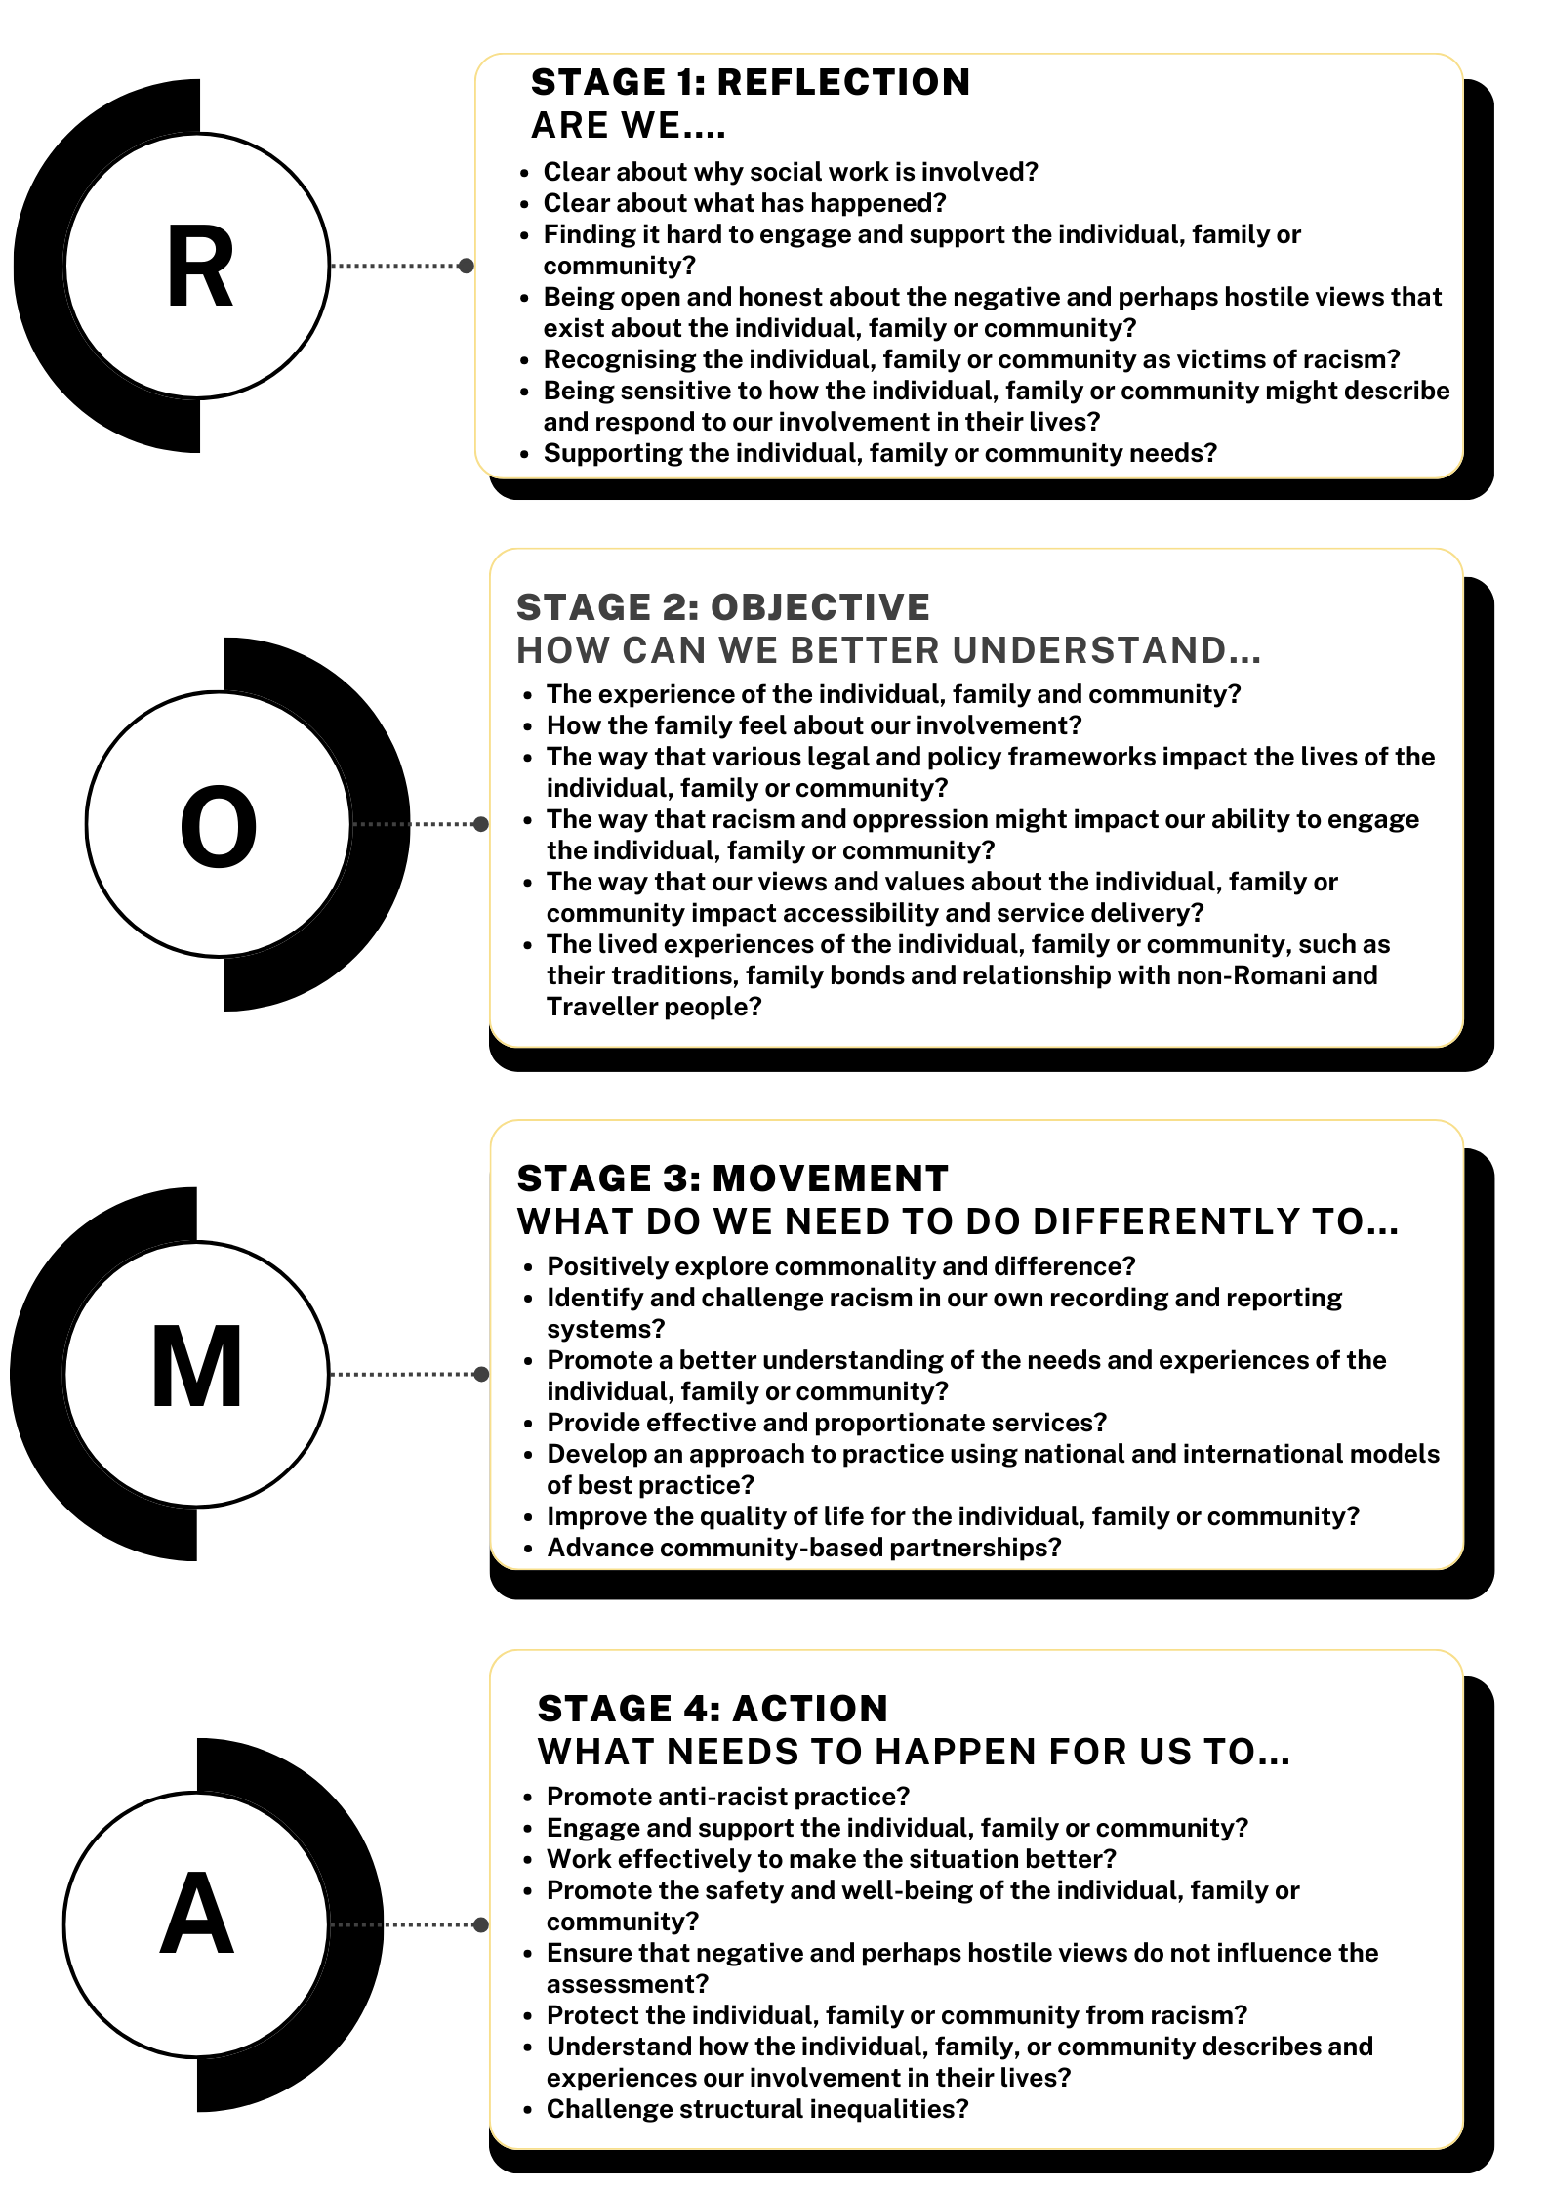

Adapted from Allen *et al*., (In Press)

**Stage 1: Reflection**

Applied to the case study above, ‘Stage 1, Reflection’ offers critical reflection to identify and analyse social inequities and the power structures that maintain them. Reflection encourages discussion about antigypsyism and more critical thought about the impact of assumptions, values, and actions. To support anti-racist practice in the first stages of the conversation, attention is given to the reason for social work involvement with Róisín and her family and the presence of interlocking structural inequalities. This would include the intersectional impact of antigypsyism, ecological and social injustice, poverty, sexism and gender-based violence.

**Stage 2: Objectives**

Stage 1 emphasises the importance of understanding the hidden presuppositions that can shape the relationship between Róisín and social work. But stage 2, the identification of ‘Objectives’, supports conversations about social work involvement and how to tackle antigypsyism. During Stage 2, the supervisor facilitates opportunities for the social worker to articulate and gain some control over inequalities and uncertainty. This creates the chance for positive engagement, clear explanation, and clarity of both expectation and momentum for change.

If social workers realise that actions used to exclude and marginalise Róisín can create a fearful response toward intervention, Stage 2 offers a closer analysis of the differences created and maintained by hierarchies of oppression. Objectives can then be set to effect social change and justice through individual and/or collective activism. The inclusion of the ‘Objective’ stage is, therefore, an important precursor to ‘Movement’, allowing individuals to locate and scaffold their ability to affect change, both at an individual and collective level.

**Stage 3: Movement**

Stage 3 advances a framework for accepting antigypsyism and the views, options and experiences of Róisín whilst building momentum for movement and transformational change in line with legislation and core professional values.

To promote conversations that are cooperative and productive, Stage 3 encourages the social worker to think about ways to develop community, manage conflict and repair relationships that have been damaged by centuries of racism. Throughout stage 3, the conversation focuses on the importance of confronting racism through the recognition that Róisín and her grandson must have access to the resources they need to live healthy, happy, and fulfilling lives.

**Stage 4: Action**

The ‘Action’ stage requires a great deal of courage as social workers try to engage the struggle for racial justice while concurrently understanding racism, discrimination and antigypsyism. Although social workers might struggle to repair relationships that have been damaged by prolonged oppression and racism on their own, it’s hoped that by moving through Stages 1, 2 and 3, the ‘Action’ agreed at Stage 4 will enable social workers to stand together in solidarity with Róisín in the evolution of a pro-Romani and Traveller rights-based approaches to social protection and child welfare.

To facilitate opportunities for all involved to be positively motivated, Stage 4 offers sufficient time to discuss the reasons for social work interventions and decide on a fair and proportionate solution. At all times, the conversation centres on the principles of participation, collaboration and restorative justice. Once the actions have been identified and agreed upon, the conversation can move on to review and evaluate the ‘action plan’ with respect to safety, legal concerns, and associated resources, moving back to Stage 1, as and when required.

**Conclusion**

The conversations facilitated using the ROMA Model© are unlikely to eliminate antigypsyism on their own. Most Romani and Traveller people experience extreme socio-economic deprivation and inequality and need additional support to develop positive relationships with social work and social workers. As such, the model may be best used to complement rather than replace current structures and systems of supervision, casework management, and review. Used alongside formal methods of supervision, models of case discussion, team meetings and direct work with Romani and Traveller individuals, families, and communities, we believe that the ROMA Model© can be used to address conflicts, repair harm, and promote opportunities to heal the social divisions caused by centuries of racial inequity.

Critical Reflections to Move us Forward

1. **What is antigypsyism and how does it impact on social work with Romani and Traveller people?**
2. **What examples of antigypsyism and aversive racism can you identify in Róisín’s case study?**
3. **How can you use the ROMA Model© to practice in a way that is rights-based, anti-racist and congruent with international social work ethics and values?**

**References**

Allen, D., Bolton, J., Dove, J., Hulmes, A., Kidd, C., Moloney-Neachtain, M., Rees, I., Rogers, M., Smith, A., & Unwin, P. (In Press) A scoping review of social work with Romani and Traveller communities: introducing the ROMA Model©. *European Journal of Social Work*

Allen, D., & Hulmes, A. (2021). Aversive Racism and Child Protection Practice with Gypsy, Roma and Traveller Children and Families. *Seen and Heard*, 31(2) 44-67.

Allen. D., Dove, D., Hulmes, A., & Moloney-Neachtain, M. (2021) The Romani and Traveller perspective. In Tanya Moore and Glory Simango (Eds) *The Anti-Racist Social Worker: stories of activism in social care and allied health professionals*. St Albans: Critical Publishing, pp 61-75.

Allen, D., & Riding, S. (2018). *The Fragility of Professional Competence: A Preliminary Account of Child Protection Practice with Romani and Traveller Children*. Budapest: European Roma Rights Centre.

Allen, D., Adams, P. (2013). *Social Work with Gypsy, Roma and Traveller Children*. London: CoramBAAF.

European Commission against Racism and Intolerance. (2015). *ECRI General Policy Recommendation No. 15: On combating hate speech.* Strasbourg: European Council.

Gaertner, S. L., & Dovidio, J. F. (2005). Understanding and addressing contemporary racism: from aversive racism to the common ingroup identity model. *The Journal of Social Issues*, 61(3), 615–639.

Kovel, J. (1988).*White racism: a psychohistory.* Free Association Books: London.

Marsh, H., Hulmes, A., & Peacock, J. (2024). Inclusive Curriculum Design, Anti-Oppressive Pedagogy and Gypsy, Traveller, Roma, Showmen and Boater Communities. In *Supporting Gypsy, Traveller, Roma, Showmen and Boaters (GTRSB) in Higher Education: A Handbook for University Staff in the United Kingdom on Developing Good Practice*(pp. 54-68). Work and Employment Research Unit, University of Greenwich.

Powell, R. (2016). Gypsy-Travellers/Roma and Social Integration: Childhood, Habitus and the We-I Balance. *Historical Social Research,* 41(3), 134–156.

Simmel, G. (1950). *The Sociology of Georg Simmel* (Translated & Edited by Kurt H. Wolff). Glencoe, Illinois: The Free Press.

Unwin, P., *et al.,* (2023). *Inequalities in Mental Health Care for Gypsy, Roma, and Traveller Communities, Identifying Best Practice Inequalities in Mental Health Care for Gypsy, Roma, and Traveller Communities, Identifying Best Practice*. NHS: Race and Health Observatory.