Multi-HAPS Network Implementation within 3GPP’s NTN Framework for 5G and beyond

Ogbonnaya Anicho
Liverpool Hope University
anichoo@hope.ac.uk
Philip B Charlesworth
Liverpool Hope University
charlep@hope.ac.uk
Gurvinder S Baicher
Liverpool Hope University
baicheg@hope.ac.uk
Atulya K Nagar
Liverpool Hope University
nagara@hope.ac.uk

Abstract:
High Altitude Platform Station (HAPS) is part of the 3GPP defined non-terrestrial network (NTN) infrastructure for 5G networks. Various technical studies by 3GPP have addressed NTN-based implementations and have significantly studied satellite-based scenarios. However, the study does not sufficiently address HAPS or multi-HAPS based scenarios specifically. Though HAPS, is captured under Unmanned Aerial Systems (UAS), it has unique operational realities that set it apart from other NTN platforms. For instance, HAPS come in different variants of fixed-wing, balloons and airships. This paper highlights the need for expanded studies specifically aimed at HAPS for more seamless integration. The work also analyses the Doppler effect associated with fixed-wing HAPS systems to further demonstrate how operational scenarios may differ for these platforms and the need for targeted studies. HAPS is expected to contribute significantly to the NTN-based implementations and may require more specialised considerations within the 3GPP NTN technical specification process, especially for 5G and beyond 5G (B5G) networks.
Keywords: HAPS, NTN, 5G, Multi-HAPS, UAS

Introduction
This paper examines the implementation of multi-HAPS networks within 3GPP’s non-terrestrial network (NTN) framework for 5G networks and beyond. It considers how far the 3GPP standardisation efforts address the requirements for integrating multi-HAPS systems. 3GPP in Release 16 (Rel-16) addressed the requirements for integrating NTN within the 5G framework (3GPP, 2021). NTN by definition refers to a “network or segment of networks using RF resources onboard a satellite (or UAS platform)” (3GPP, 2021); essentially covering all types of Satellites and UAS based networks. This development has significant technical and commercial ramifications and demands careful analysis. It is important to understand how NTN infrastructure will fulfil the demands of stringent 5G and beyond 5G (B5G) targets.
Satellite operators are upgrading and deploying new infrastructure to meet these expectations and investing in new technologies and techniques to further assure service reliability for 5G networks. The different satellite implementations have their unique strengths and challenges which either improves its integration into 5G as an NTN infrastructure or introduce issues for further consideration (Rinaldi, 2020). As a practical matter, GEO satellites have excellent global coverage capabilities but significant latency challenges due to their altitude of operation at about 36000 km. In contrast, at 300-1200km altitude, LEO satellites have a better latency profile (Hatt, 2021), but complex and costly coverage dynamics since a constellation of these satellites are required for any meaningful global coverage(Mukherjee, 2020). Technologies and techniques have been constantly developed to address some of these challenges e.g. High Throughput Satellites (HTS), improved antenna systems and so on.
Another equally important NTN infrastructure are HAPS, whose key technical advantage is its terrestrial-class latency deriving from its implementation altitude of 17-25 km (Anicho et., 2021, Hatt, 2021). From this altitude of operation, HAPS can deliver excellent LOS propagation characteristic that is beneficial to the 5G service model, with a coverage area of about 200-400 km radius. It is within these implementation contexts that satellites & UAS systems are being proposed as part of the NTN framework for 5G. However, a key observation here is that Satellite systems to a large extent have established technical and operational frameworks that provide 3GPP better understanding and guidance for its NTN-5G NR study. This is, however, not the case for UAS systems in general and multi-HAPS networks in particular. It may be beneficial to 3GPP study groups and HAPS system designers if the study on HAPS and other UAS systems is expanded as part of the standardisation process.
The main contribution of this paper is to highlight or elevate the need for a more targeted study of the HAPS/multi-HAPS use cases and operational scenarios for seamless integration into the 5G NR access network. Multi-HAPS networks, in particular, may significantly contribute to realising the full potentials of NTN-based access infrastructure for 5G & B5G.
This paper is organised as follows; the introduction covers the general concept of NTN and multi-HAPS systems. Section 1, examines the key considerations for HAPS within the 3GPP NTN framework, while Sections II & III address the main issues of multi-HAPS implementation as an NTN-based infrastructure within the 5G framework. It also highlights issues like Doppler effects as it relates to HAPS implementation specifically, and its impact on the fixed-wing variant of HAPS. The final section concludes the work and lays out the future direction of the research.

3GPP NTN Framework – Key Considerations for HAPS
HAPS deployment is expected to be in the form of multi-HAPS networks or a constellation of HAPS with inter-HAPS links (IHLs) and service links. The platforms will also have varying levels of mobility as they station-keep to maintain a quasi-stationary position. It is important to understand more concretely how these and other dynamics will impact the access network layer of any network that integrates NTN and more specifically HAPS.
The 3GPP study typically highlighted transparent and regenerative payload based scenarios as the key methods for providing access to user equipment (see figures 1 and 2). In the transparent payload scenario, the satellite (or UAS platform) will perform Radio Frequency Filtering, Frequency conversion and amplification, while in the regenerative mode it performs additional tasks like modulation/demodulation, coding, switching, routing and essentially acts as an aerial gNB.
Figure 1 - Transparent Payload based Scenario (3GPP, 2021)
Satellite implementation in either the transparent or regenerative scenario is well understood and 3GPP has reflected this in the analysis of NTN as an access network layer for 5G (3GPP, 2021). This consideration is also being extended to HAPS or more generally UAS systems. The study seems to have approximated more generally the satellite framework to cover HAPS or UAS systems in general as reflected in figures 1 & 2. The technical and operational environment for HAPS systems for instance has some uniqueness which neither GEO, MEO nor LEO systems can accurately approximate. The transparent or regenerative deployment scenarios can be extended to HAPS, but the operational context for HAPS may be different and requires careful consideration. In the next section, this phenomenon will be illustrated by analysing one of the technical issues which approximations may not accurately reflect in practice.
Figure 2 - Regenerative Payload based Scenario (3GPP, 20201)

Multi-HAPS Network – Considerations for 5G & B5G Implementation
The potentials for HAPS within the NTN framework can be better realised through multi-HAPS implementations which have Inter-HAPS Links (IHL) as a standard feature. IHL interfaces are equivalent to ISLs in satellite implementations and will perform similar functions but within a different radio or optical environment. 3GPP has not exclusively defined the multi-HAPS scenario and this is one of the key considerations of this paper. The mobility and stability dynamics of HAPS in a multi-platform environment is very different to that of a LEO or GEO network. In the 3GPP technical study, the assumption was made that the same enhancements for LEO may be applicable for UAS (3GPP, 2021), however, this may not be the case. However, it may be beneficial to carry out specific studies for HAPS to further understand if these assumptions are tenable for HAPS/multi-HAPS deployments. For instance, HAPS has three distinct platform variants namely fixed-wings, balloons and airships with different station-keeping dynamics that will impact IHLs and service links differently. As a result, each variant of HAPS implementation may have varying levels of issues.
For instance, how will Doppler shift profiles vary among the different variants of HAPS due to station-keeping or platform induced noise due to mobility? HAPS designers will need to understand the expected variation of platform induced noise and its impact on the IHLs and the service links. The implementation of orthogonal frequency division multiplexing (OFDM) waveform in 5G New Radio (NR) and the orthogonal frequency division multiple access (OFDMA) in the uplink (UL) multi-access scheme is significant as Doppler shift can impact the orthogonality of OFDMA (Lin et al., 2021, Roudsari & Bousquet, 2018). In this work, Doppler shift due to HAPS platform mobility will be analysed to further establish the main point of the paper. A more simplistic approach is used to demonstrate the concept but more complex modelling can be used. For example, the fixed-wing variant of HAPS must account for variations occasioned by the need to balance the forces of flight to remain airborne.

Doppler Shifts for Fixed-Wing HAPS Platforms
The Doppler shift profile of fixed-wing HAPS is analysed below and will provide some insight into the operational scenario for these types of platforms. HAPs as earlier mentioned has three main variants, fixed-wing, balloon and airship. This analysis considers the fixed-wing variant (an HTA platform), future work will examine LTA platforms, which may likely have a different Doppler shift profile. The analysis involved computing Doppler shift at frequencies allocated for HAPS, using platform velocities consistent with current industry-based HAPS cruise speed capabilities.
Recall that the Doppler effect is dependent on the relative velocity of the platform with respect to the receiver terminal (e.g. user equipment), and the nominal carrier frequency $F_{O}$, on which the signal is transmitted (Mukherjee, 2020).
The Dopper shift $ΔF$ for a receiving or transmitting terminal velocity V is given by (Mukherjee, 2020., Mountaciri, 2021);

$ΔF= (F_{O}VCos(θ)/C)$ (1)

where $θ$ is the angle between the velocity vector $V$ of the mobile (transmitter or receiver) and the direction of propagation of the signal between the UE and the HAPS platform. This can be represented by the minimum elevation angle, while $C$ is the speed of light.
From equation 1, the Doppler shift for a fixed-wing HAPS can be calculated for different frequencies and velocities. By design, a fixed-wing HAPS remains airborne and within the service area (station-keep) by loitering with a fixed pattern. This is different from how a HAPS balloon or airship will station-keep to remain within the service area. In the next section, the result of the doppler computation for a fixed-wing HAPS is shown and the likely implications for its deployment as part of the 5G access network.

HAPS Doppler Shift Computation Analysis
The fixed-wing HAPS Doppler computation was based on the following parameters derived from industry data and is representative of the state-of-the-art in terms of fixed-wing HAPS capabilities and application scenarios. For instance, the cruise speed of one of the most advanced fixed-wing HAPS – Haps Mobile’s Sunglider is about 110km/hr (about 30m/s) and gives a general idea of a practical platform velocity (Haps Mobile n.d.).
- HAPS Platform Velocity – 15m/s, 24m/s & 30m/s
- Frequency – 6GHz, 21GHz, 31GHz & 48GHz (sampled from allocated HAPS Frequencies) (ITU, 2019).
- Elevation Angle – 5 degrees (Corresponds to the minimum elevation possible) (Mukherjee, 2020).
Figure 3, shows the Doppler shift profile at these different velocities and frequencies and provides a clear picture of the magnitude of frequency errors that are possible with fixed-wing HAPS. The 6GHz frequency provided the lowest Doppler shift variation over all the considered velocities. As expected the slower the velocity the lower the value of Doppler shift experienced in this frequency band (never exceeded 500 Hz). This was not the case for the 31GHz and 48GHz frequency bands with almost 4500Hz Doppler shift at 30m/s velocity. This is consistent with the theoretical position on the problematic nature of the higher frequencies and is certainly the case for the Doppler effect. The point here is that the analysis for HAPS as part of the NTN framework has to capture this analysis in detail. For context, a terrestrial system operating at 6GHz will have a Doppler shift less than 1KHz, even for a UE moving at 30m/s (about 105km/hr). In contrast, LEOs can have as high as 48KHz Doppler shift in the downlink for S-band (Mukherjee, 2020), or more than 20 parts per million (ppm)(about 40KHz) for 2GHz carrier frequency (Qi, 2019). 5G NR uplink channel will struggle with 48KHz Doppler shift as it is not designed for such values (Thales Alenia Space, 2019). The Doppler shift experienced with fixed-wing HAPS though significantly lower than LEOs, is still far from the performance of terrestrial systems. It is expected that 5G should have UE transmit frequency accuracy that is better than ±0.1 ppm over 1 ms which translates to 3KHz doppler shift at 30GHz and 2KHz at 20GHz (Thales Alenia Space, 2019). From the results in figure 3, HAPS platforms moving at 30m/s and above may require specialised techniques and equipment to address carrier frequency offsets (CFO) beyond specified thresholds or limits.
Doppler shift is known to contribute to signal degradation by affecting the BER performance of the system due to interference connected to the frequency shift and offsets (Bazin, 2018). Various mitigation techniques can be deployed all designed to compensate for the frequency shift and the associated impact on the system both in the uplink and downlink directions. The point of this paper is not to analyse these techniques but to highlight the importance of studying how Doppler effects may impact HAPS-based NTN implementations for all the variants of the platform (fixed-wing, balloon and airship). The current 3GPP technical study on NTN may not have addressed the HAPS platform deployment, especially in a multi-HAPS network scenario within the NTN framework. The computation is not entirely theoretical, as it uses practical operational parameters and may help in the study and characterisation of this phenomenon. It may not be as consequential but at this stage requires further investigation beyond the assumptions currently held.

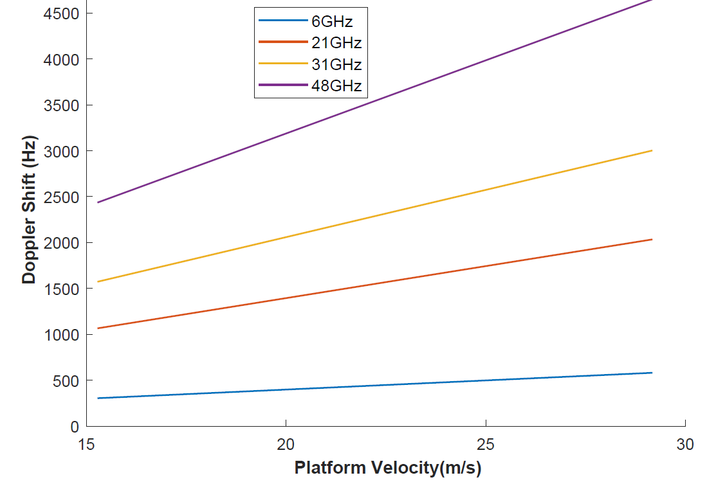
Figure 3 - Fixed-Wing HAPS Doppler Profile

Conclusions and Future Work
Multi-HAPS network implementation is a key infrastructure option within the current 3GPP NTN framework for 5G networks and beyond. The 3GPP study has focused more on Satellite systems which is a key part of NTN. However, in this work, the need to expand the study for UAS systems and multi-HAPS platforms, in particular, was highlighted. This is particularly needed to facilitate the seamless integration of multi-HAPS systems as part of the NTN-based 5G NR access network. In the work, the unique characteristics of the HAPS and the fixed-wing variant were demonstrated using the doppler shift analysis. It was shown that the doppler phenomenon of fixed-wing HAPS requires further study and should be expanded in the 3GPP documentations.
Future work will consider the same analysis for other variants of HAPS (balloon and airship) to further understand how these platforms may operate with the 5G-NTN framework. This is an ongoing inquiry that aims at contributing to current efforts to seamlessly integrate NTN-based infrastructure to 5G networks and beyond.

References
3GPP (2021). 3rd Generation Partnership Project; Technical Specification Group Radio Access Network; Solutions for NR to support non-terrestrial networks (NTN)(Release 16)

Rinaldi, F., Määttänen, H., Torsner, J., Pizzi, S., Andreev, S., Iera, A., Koucheryavy, Y., Araniti, G. (2020). Non-Terrestrial Networks in 5G & Beyond: A Survey. IEEE Access. 8. 165178 - 165200. 10.1109/ACCESS.2020.3022981.

Mukherjee, A. (2020). 5G New Radio: Beyond Mobile Broadband. London: Artech House

Anicho, O., Charlesworth, B.P., Baicher, G., & Nagar, K.A. (2021). Reinforcement learning versus swarm intelligence for autonomous multi‑HAPS coordination. Springer Nature (SN) Applied Sciences https://doi.org/10.1007/s42452-021-04658-6

Hatt, T. (2021). Radar: Connectivity from the Sky. GSMA Intelligence

Lin, X., Lin, Z., Löwenmark, S.E., Rune, J., & Karlsson, R. S. (2021). Doppler Shift Estimation in 5G New Radio Non-Terrestrial Networks. ArXiv, abs/2108.07757.

Roudsari, M. H., & Bousquet, J. F. (2018). A Time-Varying Filter for Doppler Compensation Applied to Underwater Acoustic OFDM. Sensors (Basel, Switzerland), 19(1), 105. https://doi.org/10.3390/s19010105

Mountaciri, A., Makroum, E. M., & Youssefi, M. A. (2021). MATLAB Simulation of IEEE 802.11p Technology on High User’s Mobility. Ademović, N., Mujčić, E., Akšamija, Z., Kevrić, J., Avdaković, S., & Volić I. (Eds.). Advanced Technologies, Systems, and Applications VI: Proceedings of the International Symposium on Innovative and Interdisciplinary Applications of Advanced Technologies (IAT) 2021 (pp 3-14).

Bazin, A., Jahan, B., & Hélard, M. (2018). Doppler Effect Reduction in an OFDM System Thanks to Massive MIMO. IEEE Access, IEEE, 2018, 6, pp.38498-38511. ff10.1109/ACCESS.2018.2854001ff. ffhal-01852601f

Haps Mobile (n.d). Technology: Specifications. https://www.hapsmobile.com/en/technology/

International Telecommunications Union (ITU). (2019). HAPS – High-Altitude Platform Systems. https://www.itu.int/en/mediacentre/backgrounders/Pages/High-altitude-platform-systems.aspx

Qi, Y. (2019). Non-terrestrial Networks: Standardization in 5G NR. https://www.cambridgewireless.co.uk/media/uploads/files/CWTEC19-Yinan_Qi-Samsung.pdf

Thales Alenia Space (TAS). (ed.) (2019). Satellite and Terrestrial Network for 5G. https://www.sat5g-project.eu/wp-content/uploads/2019/04/761413_Deliverable_16_Satcom-5G-ControlUser-Plane-Harmonisation-%E2%80%93-Mid-and-Long-Term-Approach.pdf

