Transforming the Resourcing of Christenings in the Anglican Diocese of Liverpool
Author: Dr Sarah Holmes, Liverpool Hope University, UK.
Email: holmess1@hope.ac.uk

Abstract
In order to improve engagement and retention of families in Anglican churches nationally, the Church of England sought to improve support and resourcing of ministries amongst baptism families. Sharing this vision, the Liverpool Diocese partnered with the National Church in order to explore the issues, needs and opportunities within the Liverpool Diocese. This project became known locally as the “Three Steps to Christening” initiative. Participatory action research was adopted, enabling the core team to continually and simultaneously research and equip the 14 participant parish churches over a three-year period. The approach generated a rich data set, facilitating development and trialling of a wide range of resource materials and training opportunities. This paper describes the key findings and reflections, including summaries of the macro scale data and abstracts from the in-depth qualitative data pool. The continual cycle of research and resourcing has resulted in transformation of the Christening ministry within many of the participant churches. Furthermore, a plethora of resources and materials have been generated, which could be utilised further afield.

Key words
Christening, Liverpool Diocese, Resource, Training, Action Research

Background and Rationale
During 2017 there were 102,000 baptisms and 4,000 thanksgivings of a child in the Church of England, demonstrating the high significance of this ministry nationally. There was however a marked decrease of 22% in baptisms and thanksgivings from 142,000 in 2007 to 106,000 in 2017. This translated to a baptism occurring for 14% of live births in 2007, compared with 10% in 2017. Within the Liverpool Diocese baptisms had followed a similar trend to nationally by reducing from 4,280 in 2012 to 3,370 in 2017. This equated to a baptism occurring for 11% of births in 2017, which is marginally above the national figure. Graff‐Kallevåg (2017, p.251) interpreted the decrease in baptism rates within Western society as a sign that baptism is no longer necessarily considered to be important or even relevant. This decline is undoubtedly connected to the decline of church attendance and involvement nationally. Yet the arrival of a new child has a significant impact upon family life, and is seen as a significant ministry opportunity for parishes (Millar, 2017). Indeed, Jenson (2001, p.187) argued that during a time when belief in God is no longer obvious, baptism can be an entry into the church, and ultimately a way for families to connect with God. Within this context the “Three Steps to Christenings” Project was launched in the Liverpool Diocese during Spring 2017. It sought to investigate three ministry phases of: before the service, the service itself and after the service, removing speculation regarding resource needs, in order that relevant and effective strategies may be embedded across the Diocese. Ultimately the project aimed to retain more baptism families within the parish congregations, through encouraging both good practice and providing appropriate resources and activities within the Diocese.

Methodology
Action research was adopted due to being flexible and allowing inquiry to be guided by the context, rather than speculation (Winter, 2006, p.59). It also permitted consideration of the associated social, cultural, and emotional factors (Conde-Frazier, 2006, p.325). This holistic mindset was crucial in more fully understanding the context of the parishes and associated ministries, so that positive change could be encouraged in participating churches (Winter, 2006, p.59). Ensuring that the methodology was participant-led was also key. Conde-Frazier (2006, p.325) observed that through this methodology, the community’s interests are defined rather than the researchers. Hence the project aligned with the needs of the participant parishes throughout the three years. Furthermore, this methodology supported empowerment of participants in their roles (Martin, 2006, p.263), resonating with the National and Liverpool Diocesan strategies. The participant-led cyclical process therefore allowed for simultaneous implementation of resourcing and analysis of strategies and practices (Conde-Frazier, 2006, p.325). Figure 1 depicts the three-year process, whereby the first column describes the training and resourcing to the participant parishes; and the second column details the associated research elements. These occurred simultaneously.

Action research also permits collaboration of the participants (Martin, 2001, p.262), which was an essential aspect of this project. Indeed, Conde-Frazier (2006, p.325) remarked that this method results in the development of relationships between persons for group participation, aligning with the project aims. Collaboration and negation with participants underpinned the whole process, so that relationships were built at both parish and diocesan levels. However, care was required to ensure that respondents did not feel obligated to participate, due to the potential of power relations given the Diocesan involvement. This, alongside all aspects of the research were compliant with the ethical standards and scrutiny of Liverpool Hope University.
The data was collected using online surveys, interviews, and focus groups, alongside observations and field notes by the core team. Participants primarily comprised congregation members, Baptism team members and clergy. Secondary data was incorporated from baptism families, in the form of verbal feedback, written feedback and some surveys administered by churches. In the initial stages of the project, there was nervousness from churches about the baptism families being contacted directly for research purposes, and the potential conflict and confusion with the pastoral role of the church, so many church leaders preferred to ask families for feedback themselves. This did create some bias since baptism families are less likely to provide negative feedback to the church directly, although some did so. Later stages of the project obtained more first-hand experience from baptism families, once churches gained more confidence. Thematic analysis was carried out on the qualitative data in order that a broad view was possible to gain insights into key ideas and experiences within the Diocese as a whole. However, this equated to the data being decontextualized (Grbich, 2013, p.259), so individual narrative analysis was also carried out on the data so that individual church experiences could be captured and understood. This combination increased perspective and ensured a fuller understanding and interpretation of the data collected. An inductive approach was adopted, so that the themes and patterns were enabled to emerge from the data rather than utilising a theoretical framework as the starting point.

The Three-Year Research Process
Early research identified that families often received a poor welcome to church. Consequently, initial resources included a children’s book, christening service ideas (including science experiments, video clips, puppets, music and visual aids), welcome baskets (see photo 1) for use during a family’s first church visit, training events, and signposting of wider relevant resources. Initial emerging themes and needs were: baptism preparation, the baptism service, welcoming baptism families, encouraging faith in the home and the congregation culture surrounding Christenings.
During the second year, in response to ongoing research, the focus areas were refined to: baptism preparation, faith in the home and changing the church culture surrounding baptism. Focus groups were held on each of these themes (figures 5,6 and 7), prompting the planning and development of further resources, which were utilised and tested within the second year. This included ideas for baptism preparation and use during the service, such as illustrated wallpaper rolls (photo 2) and baptism boxes (photo 3). Alongside a story was written, entitled “welcome to the journey little one”, for use in services and as a gift possibility. Diocesan-wide training events occurred, focussing on welcoming families and effective church communication.
The third stage encouraged mutual support of participants across the Diocese, alongside further training and resourcing opportunities, including ‘faith in the home’ themed leaflets for the churches to distribute as part of baptism preparation, post Christening and for the Godparents, discussion packs for the PCC (‘parochial church council’, the executive committee of a parish; consisting of clergy, churchwardens and representatives of the laity), and preaching and teaching resources. Groups for parents of young babies were formulated to augment toddler groups in providing connection opportunities with church.

Results
Figure 2 shows the baptism numbers at each of the churches over the three years. The third year numbers were affected by the Covid-19 pandemic, resulting in no baptisms occurring in any of the churches during the spring and summer of year three. Baptism numbers range from five to seventy-eight across the participant churches, demonstrating the range of contexts across the Diocese, and those included in the project. In the first year there was a total of 249 baptisms in ten of the churches, and eight of these were non-white ethnicities. In year two there were 347 baptisms in twelve of the churches. Of these seven were non-white ethnicities. Year three totalled 388 baptisms over the 14 participating churches. These figures are generally higher than the National Church of England figures, of seven baptisms in the average sized (average weekly attendance of 62) church, 28 baptisms in the largest churches (with average weekly attendance of 190), and significantly less in smaller parishes. Within the participant churches of this project, the average number in the first year was 24.9 per church, and 27.7 in the third year. This shows a slight increase in baptism numbers within the total of participant churches, although there are some increases and some decreases individually across the three years.

Reasons for Baptism
Participants were asked to document the frequency of reasons given for families opting for their child to be baptised (figure 3). The most frequently reported reason was “family tradition”. Other reasons that were often the most frequently given were “to be part of the church family”, and “personal choice”. This concurs with Lawrence (2019), observing that many families seeking a christening for their child did so in order that their child may be part of the church, yet in their understanding this did not equate to church-going. Awareness that families sought a moral compass for their children was not mentioned as a primary reason for baptism, but did seem to be a supplementary reason (Hill, 2006, p.288). The least frequently reported reason for baptism in these parishes was school admission. Indeed, in only three of the ten churches there was the requirement for families to attend church in connection with school admission. One church reported that they often lose families to other churches since they need to attend there in order to qualify for admission to other schools. The nationally commissioned research (carried out by 9DOT research) revealed that many residents of the Liverpool area (particularly poorer or more traditional demographics) exhibit the desire for their child to be baptised as young as possible or risk going to hell or purgatory if they die. This aligns with the national statistics that in 2017, 59% of baptisms were of children under the age of one.

Connections with Baptism Families
Hewitt (2019) observed that the majority of families having their children baptised are ‘positive about baptism but have no current relationship with the church’, although remarked that it would be ideal for baptism families to have both ‘positive thoughts about baptism and a current relationship with the church’. The Three Steps project confirmed this, finding that the majority of baptisms in the participating churches were classified as visiting families, although three of the churches in year one observed that they were predominantly nominal attenders. In the majority of cases this remained unchanged over the three-year period. Yet, two of the churches reported a change from mainly visitors to mainly nominal attenders, indicating success of these churches in relationship building. Both of these churches were particularly committed and passionate about developing their family ministry, emphasising that a more holistic vision of family ministry is required rather than solely baptism ministry. This distinction reflects the concepts of ‘wide contacts’ and ‘warm contacts’ (Millar, 2018, p.13). A wider vision to increase ministry amongst families will result in more families having a relationship with the church, other than purely through baptism events. This wider ministry amongst families was evidenced in some of the parishes, mainly through midweek toddler groups, but also Messy Church, schools work, all-age services and community events.

The Church’s Aims
In year one, the most reported aims (figure 4a) were to enable baptism families to have a positive experience and to feel welcomed. Other frequently reported aims were providing support at the start of the faith journey, enabling baptism families to feel part of the wider church family, relationship building, and to ensure an enjoyable experience. Other aims were: to remove fear, demystify myths, be relevant and meaningful, provide a comfortable atmosphere, plant seeds, ensure that everyone knows that they are loved and valued by God, and that all felt included. At the close of the project, churches reported slightly different aims going forward (figure 4b). Many stated that this was because they felt that their welcome had considerably improved so they wanted to build on this and tended to be more specific in their strategy going forward. Whilst two churches still wanted to focus on developing their welcome, the most commonly stated aims in year three were relationship building and developing their post baptism follow-up. Other aims were: to encourage the Christening families to worship more regularly as part of the church family, to walk alongside families in their every-day lives, to ask the community for their needs so that the church can respond accordingly, and to set up a new congregation for the Christening families. These changes over the three-year period demonstrate a considerable shift in the position of the churches, from a situation of recognising that they were largely unwelcoming which hampered the effectiveness of their Christening ministries; to a place where the welcome was considerably improved and relationships with the families were becoming established.

Discussion – Practicalities of Baptism Ministry
Baptism Preparation
When asked about their baptism policy, only 30% had a policy, and one of these respondents stated that it needed updating. All of the churches with no policy gave the caveat that they were happy to baptise any child. Many communicated that a baptism policy was rigid and prevented openness, inclusivity and flexibility. Without exception, the participating churches all wished to be inclusive and welcome those wishing for their child to be baptised. Hill (2006) revealed that the attitudes towards young parents regarding baptism requests can often lead to bewilderment, upset and disengagement. This connected with Millar’s (2017) observation that despite not necessarily having the spiritual language to explain their motivation for having their child baptised, parents come with serious motivations, ultimately wanting the best start for their child. However, in the final year two churches reported that they had changed their policy to only baptise children of families who intended to maintain contact with the church. In both cases, the clergy reported that this resulted in slightly lower baptism numbers but the baptisms which did occur were much more meaningful as a result of the relationships formed. This approach reflects the notion that baptism should be the start on ongoing relationships with families (Lawrence, 2019), and is natural since it connects with the human need for loving relationships and a sense of belonging (Mountain, 2011). Indeed, this aligns with the corporate meaning of baptism (Pence, 1998). Yet it would be interesting to explore further the depth of these relationships and how they develop over time, since religious belonging should be more than simply being together; but rather an active state of being connected together, towards God (Godin, 1964).
The churches reported a range of baptism preparation. One of the churches utilised informal preparation. Four parishes used a home visit to explain the service and its meaning. Another church provided explanation of the service at the time the booking form was returned, whilst another setting asked the family to come to church a month before for a tour and explanation of the service. In one case, this occurred at a “baptism tea” event. In contrast, two of the churches gathered numerous baptism families together for a session of preparation, where they met the baptism team to facilitate relationship building. None of the participating parishes actively sought to involve godparents in the baptism preparation. In all of these parishes, the baptism preparation was used to explain the baptism service, rather than to address faith more broadly. There did not seem to be an exploration with the baptism families of their “household god”, or their own religious beliefs and experiences (Hill, 2006). Indeed, only 30% of the churches considered how to encourage faith in the home context, and this merely was a gift of a Bible, godparent fridge magnets or a leaflet stating that the church was praying for their child. In one of these cases, the church loaned Christmas and Easter ‘faith in the home’ baskets to families. It may be beneficial to explore how churches could connect into individual family rituals, in order to incorporate faith formation (Pence, 2008). The majority of participants stated that they are very keen to develop this aspect but were unsure how, which reveals the need for greater signposting of resources by providers (Hill and Frost, 2018; Paddison, 2015; Turner, 2014). During the focus group (figure 5), participants questioned the desire and willingness of families for baptism preparation. Furthermore, one clergyman felt strongly that baptism preparation should not equate to tricks and bribery to result in families attending church services. They believed that families would “jump through hoops”, but would hate the church for it, having a detrimental impact on the longer-term relationship. This concurs with a strong desire observed in clergy to build relationships rather than alienate (Millar, 2018). Consequently, the over-riding feeling within the focus group was that improved and more flexible resources were required for use in carrying out baptism preparation. During the end of project interviews, many of the churches reported that their baptism preparation had been developed and improved due to their involvement on the project, and whilst they felt that it was now much more effective, they were seeking to improve it further still.
The existence of baptism teams was limited within participating parishes. At the beginning of the project, there was little investment into baptism teams, in terms of recruiting and supporting them. Where baptism teams did exist, they were long-established and appeared resistant to any change. There was no training provided within the local church context, and participants expressed that they were unaware of the availability of resources to meet this need. Four of the participant churches had a baptism team at the beginning of the initiative, and eight did by the end of the three years. Three more were in the process of developing baptism teams. Many of these churches reported increased welcome and integration of baptism families as a result. One of the parish churches was very intentionally and actively involving significant portions of the congregation, through knitting gifts for the baptised child. Participants described the ideal being a team approach to a child’s baptism because families often desired someone familiar to perform the baptism, and baptism teams were able to support with familiarity in this way. Such pastoral connections with team members could be established and incorporated into various stages of the pregnancy, birth and early years in order to more fully walk alongside families (Pence, 2008).

These observations all highlight one clear theme emerging from this research, namely the need for greater relationship building. It is suggested that a broader church approach to family ministry could result in more connections with families in the wider community, which may in turn result in nominal attenders, rather than visitors requesting baptism for their child. This resonates with Barna (2019). A broader vision would replace the tendency to divide church ministries into distinct entities, such as Baptism ministry which would be much more all-encompassing if described as parenting ministry. It is suggested that the language adopted is key in being more inclusive, which may indeed result in more volunteers to facilitate this ministry. There has been evidence within this project that the existence of baptism teams can be highly effective in such relationship building. It is therefore proposed that investing more into creating and developing baptism teams may be key to embedding effective relationship building amongst families. These teams could also be integral in supporting and improving baptism preparation and follow-up (both short and long-term), which would further develop relationships with these families. Indeed, the experience of being part of a church family is invaluable in supporting the child’s onward faith formation (McKnight, 2018). However, it is clear from this research that this area needs considerably increased resourcing and there is a distinct lack of training materials.

The Baptism Service
In terms of welcoming families, the most frequently reported approaches were a friendly welcome at the church door (70% of participant churches) and a dedicated children's area somewhere in church (60%). However, one of these churches reported that the children's area wasn't used much by families. All, except two, of the churches reported that they had obtained the Child Friendly award, confirming that they have met the diocesan requirements encouraging them to be more child focused, and demonstrating the pre-existing commitment to welcome children and families. Two of the churches stated that they distribute welcome packs or leaflets. Where baptism teams existed, they were clearly beneficial in providing designated people to welcome the baptism families. At the end of the project, one participant observed that the whole ethos of the church has become welcoming, including sides-people, clergy and the entire congregation.
In 70% of the churches, baptisms were held on a monthly basis, and in one case twice monthly if required. The remaining churches booked baptisms as requested. Only four of the parishes reported that they hold baptisms within the main service, with much discussion surrounding this issue. The churches which held baptisms during the main service felt strongly that this was important. However, many churches stated that they would prefer to hold them within the main service but it is not possible due to building size restrictions, the desires of the regular congregation, and preference of the baptism families themselves. Two of the churches reported that they hold it within the main service for regular attenders, and outside of this time for non-church families. Five of the churches explained that they limit the number of baptism families per service to two, and in one church the limit is three families. This was in part due to church capacity, but also in order that the service may be personalised more effectively.
In the majority of cases, the service content was traditional and formal, although two of the churches reported that they tailored content such as prayers to the participating families. One church stated that they ensure all of their baptism services are non eucharistic. Many of the churches stated that they wished to improve the baptism service, so that it is more creative, interactive, relevant and personalised to the baptism families. Such personalising was encouraged by Millar (2017), although during the first year it appeared that the majority of churches lacked the confidence to do this in practice. Whilst at the end of the project, there were still some cases of churches finding difficulty with this, the majority of participants appeared to be more confident in their approach, with them all having made changes to their practice and processes. Each setting had made different changes, according to the needs that they had identified in their particular setting. They cited that involvement in the Three Steps Project had equipped and empowered them to this end.

Follow-Up
When asked what churches do to follow-up with families after a baptism, three churches sent out birthday cards, and one sent baptism anniversary cards. In addition, one of these churches distributed knitted angels to families at Christmas time, and one invited families back the week following the baptism to collect their certificate and a small gift. The majority of the churches (70%) send out invitations to subsequent services or events, a practice which was encouraged by Millar (2017). However, three stated that they wanted to improve their follow-up with baptism families. All of the churches reported that families return to them for subsequent baptisms, which demonstrates that families feel that they have some form of connection with the church following their child’s baptism. Two of the participating churches stated that they would consider holding a “godparents Sunday” in the future. However, the remainder of the sample explained that they thought it would be of limited success due to many godparents not being local to the church and/or baptism family. Nevertheless, all of the churches asserted that they would like to provide more resources to support godparents in their role.
In terms of supporting families to nurture faith in the home, very little intentional activity was reported by the participant churches. However, one of the churches encouraged this by giving families a Bible, godparents cards and leaflets and by suggesting lighting of the baptism candle on the baptism anniversary. In a focus group, participants asserted that personalising the baptism preparation, service and follow-up would result in more “buy in” from families in an ongoing way. It was suggested that communicating with and offering to pray for children and family’s post-baptism, would be beneficial to support faith in the home. Furthermore, home visits were perceived to be helpful follow-up, in order that relationships could be built with church members, and questions answered. A strongly recurring theme was the importance of inviting baptism families to a variety of events and services post-baptism. However, participants reported limited uptake from baptism families in this way. An online forum for families to share experiences and distribution of family faith ideas were suggested as potential ways to support nurture of faith in the home context. One thing that all participants agreed upon was that courses for parents or families did not work, due to the time commitment required and the stigma which is often attached. During focus group discussions, it emerged that re-education was necessary to communicate that baptism is not a single event, but is indeed part of a lifelong process and faith journey. In conjunction with this, during the first-year interviews, nine of the churches discussed the need to support families in sharing faith in the home context, since this was not currently viewed as part of the church’s agenda but was an aspect that families seemed to lack confidence with. Furthermore, during the discussion, church representatives asserted that family’s non-attendance at church post-baptism does not equate to a lack of desire to develop their child’s faith. Therefore, providing families with resources for nurturing faith in the home context was viewed as highly beneficial.

Resources
A key aspect of the intended strategy was to support the National church’s approach to baptism and utilise the National materials. Once again, it was critical to listen to the responses of the parish churches regarding this. The online resources were considered by participant churches to be good quality, highly beneficial, and relevant to their needs. However there seemed to be issues of publicity and sign-posting, since there was limited awareness of these resources and how exactly churches could access them. Unfortunately, the majority of the parishes involved stated that they did not have the financial budgets to allow them to purchase the other National resources and generally they were not seen as adding value to their baptism ministries. Consequently, the majority of the purchasable National resources were not adopted or tested by many of the participant churches.

Discussion – Research Reflections
Reflecting on the Three Steps Project, this process has been far from straight forward. It became obvious very quickly that one of the key aims of the project (to create one or two working models focussing on baptism as a missional activity of the church) was drastically over-ambitious and an over-simplification. Through detailed discussion with the participant churches, it was clear that there could be no “set model”, but instead each church was unique so therefore required support to develop their own unique approach to their baptism ministry. This applied equally to the macro and micro levels of the project. Regarding the macro scale, for example the choice of focus area was individual, so that some churches opted to focus on the refining and resourcing of the baptism service itself, whereas some opted to focus more on improving the follow up of the service. Others chose different focuses. This desire for context-specific approaches also applied to the micro level, in terms of how individual resources were adopted and adapted. For example, the baptism basket was used in a variety of ways including baptism preparation, at baby showers, during the baptism service, as follow-up to support faith in the home. Key to the methodology of this project was that at no point did it dictate the approach that parishes should adopt, but rather listened to and supported churches in tailoring their own approach specific to their context.
It quickly became clear to the team that developing relevant training and resources was fundamental to the needs of the parishes and therefore became a high priority. Consequently, this aspect consumed significant time and expertise, in dialogue with participant churches and formulating resources in response. These resources were then trialled by the churches and further dialogue ensued to reflect upon their effectiveness and suitability, leading to further refining. There was a suggestion within the original project design to develop ministry activities for both pre-baptism and post-baptism. These were included as part of the development, although it became clear to the team that the general atmosphere and ethos of the church towards baptisms and baptism families was equally important.
It is difficult to fully isolate the significance of elements of this project on the participant church’s growth and development because other factors have undoubtedly occurred simultaneously to the Three Steps Project. For example, during this timeframe, three clergy moved to different parishes and five clergy were very unwell. It was evident through both formal conversations and informal observations that these factors impacted the church’s formation and identity over this time. In some settings this had a detrimental effect, whereby the congregation faltered, but in others the congregations stepped up and took on additional responsibilities for a season. Nevertheless, this project has made a significant contribution to support the ongoing and developing ministry of these churches throughout these seasons. Indeed, many of the participating churches expressed that the Three Steps project had enabled them to navigate through challenging times. This is a significant credit to the expertise, energy and compassion of the Three Steps team.
There was an overriding sense from all of the participating parishes that they did wish to improve their baptism ministry, but they wanted or needed to do that in their own way, so that the improvements would be appropriate to meet the specific needs and preferences of their parish. When compared across the three years it was interesting to observe that many participants seemed to move from being unsure and lacking confidence in considering improvements at the beginning of the project, to confidently reporting positive changes that had occurred within their Christening ministry, and there was a strong sense communicated that there was a newly acquired ethos and acceptance within their congregations that changes were both required and inevitable.

The Cultures of the Church Family and Baptism Families
Within one focus group (figure 7), the consensus was that there was a simultaneous problem. Firstly, some congregation members express that they do not wish to be part of or attend baptism services. Conversely, some baptism families communicate that they do not desire to be part of or have any contact with the wider church following the baptism. Participants in the focus group agreed unanimously that both of these contrasting cultures and attitudes needed to be addressed and changed, since they are very prevalent within their parishes. This concurs with the observations of Lawrence (2019), whereby clergy and parishioners often misunderstood each other when discussing expectations and desires surrounding baptism. It is equally true that whilst baptism families may use conventional ‘God-language’ to describe their beliefs and experiences, they may also demonstrate and exhibit non-conventional beliefs and practices (Hill, 2006, p.287). Congregations frequently express frustration at observing such contradictions, and it may be that this requires discussion at local level in order to support churches in understanding this further and how best to tackle it. Indeed, awareness of this is therefore key amidst churches in order that ‘performative belonging’ is not all that occurs within baptism families (Fenton, 2017), but also so that congregations comprehend more fully their role in supporting faith formation of children who are baptised within their parish. This would reinforce the notion of welcoming the individual into communion with God and the eternal family of God, rather than faith in solitude (Graff‐Kallevåg (2017). The role of godparents within these contrasting cultures is also worthy of further investigation, since they epitomise spiritual kinship for the family along their faith journey (Alfani, Gourdon & Vitali, 2012). It is possible that constructive godparent relationships could form a bridge across these contrasting ideas.
In connection with this, when asked about the extent to which the wider church was aware of the parish involvement in the Three Steps project, 57% said that the congregation was slightly aware, whilst 14% reported that they were very aware, but 29% stated that the congregation was unaware. A small number of the parishes had opted to intentionally seek to engage the wider congregation in baptism ministry. This occurred through encouraging the congregation to smile and warmly welcome baptism groups, and chat to them if they feel able. More broadly, some congregation members were making blankets, teddies, knitted caterpillars and other items to be gifted to baptism families. For one church in particular, this notion of involving the wider congregation was very prevalent and appeared to have resulted in very positive feedback from baptism families and a general feeling of warmth towards baptism ministry amongst the congregation. Another setting emphasised the importance of promoting wider awareness and engagement with the ministry. This approach seems to have appropriately tackled the significant mismatch in cultures between the congregation and the Baptism families in their context. However, in the end of project interviews other churches reported a less positive situation. One stated that whilst their congregation is welcoming, they are disappointed by the lack of repeat attendance of baptism families after the event. Another participant expressed frustration that whilst the congregation were aware of baptisms, they did not embrace the ministry. In another setting, it was reported that the PCC agree to all baptism discussions but do not engage in robust conversation, and in fact conceded that the majority of the PCC would probably never witness baptisms or encounter baptism families. Hill (2006, p.293) expounded the tensions that clergy often feel as a result of these contrasting ideas.
Regarding the level of discussion at PCC meetings, in the first year six of the churches reported that it had been discussed briefly and four of the churches reported that it had been discussed in detail. At the close of the three years, nine churches reported that it was discussed briefly at PCC and only three reported that it was discussed in detail. All participants stated that they thought it should be included much more fully in PCC conversations. It was noticeable that the churches who reported higher levels of change and improvement in their baptism ministry were those who had discussed it in detail at the PCC meetings.

The Vision of Baptism Ministry
A further observation from this project is regarding the place of baptism within churches. This reflects the notion that for there to be growth, the existing congregation must be willing to change. However, it is suggested that this notion needs developing further, so that the congregation is not only willing to change, but also to allow the function of baptism to be transformed. This may include more awareness by congregations of the spiritual experiences and needs of baptism families (Hill, 2006), and also a desire of churches to facilitate baptism families in embedding and strengthening their identity and belonging to the church and Christ (Fenton, 2017). Over the three-year period, the majority of the participating parishes moved from an ad hoc and passive attitude and approach to baptisms, to a more thoughtful, deliberate and comprehensive experience. This was demonstrated through increased discussions at PCC and involvement of the congregation, and evidence of a wide variety of baptism related initiatives. It is therefore proposed that the place and vision of baptism ministry within the parish church is of key importance in shaping the attitude of the congregation towards it, the attitude of baptism families to the church family and the role of PCC including budgetary implications. Indeed, adaptation and evolution is necessary in order to continue to meet individual’s needs in changing circumstances (Lawrence, 2019). Further work is required in establishing how this fundamental transformation can occur, since this needs to be done on an individual basis to meet the needs of the specific parish context.

Conclusion
There is clearly further work to be done within the Liverpool Diocese to support parishes in transforming their ministries amongst baptism families. Key aspects of future work are: Firstly, developing relationships with families long-term; secondly, addressing the mismatch of cultures and attitudes between the regular congregations and baptism families; and thirdly, transforming the vision of baptism ministry within the parish church in order to increase and embed the effectiveness of this ministry. Despite theological understandings regarding the place and role of baptism, those seeking to minister within this sector must be mindful of the free will and choice of baptism families regarding their engagement level post-baptism. Nevertheless, as one participant stated: “my role is to point them to Jesus….it’s up to them to do the rest….if they choose not to engage with church or God after their child’s baptism, that’s up to them.” This reflects the missiological implications of the parable of the sower (Millar, 2018). Furthermore, all missional work is dependent on God’s kairos and the movement of the spirit (Conde-Frazier, 2006, p.328). Equally, churches must be aware of the missio Dei, in that God’s mission to humankind is broad and occurs irrespective of organised institutions (Bosch, 1991).

Acknowledgements
The Three Steps Team: Mrs Sue Mitchell (Diocesan Children and Families Missioner), Mrs Caroline Collins (Deanery Children and Families resourcing officer) & Rev Dr Chris Stafford (Team Rector and Schools Minister in the Winwick Deanery). Their commitment to supporting and resourcing the Liverpool churches is inspirational and has been deeply appreciated amongst many churches across the Liverpool Diocese.
The partnership with the National church was invaluable, including Rev Dr Sandra Millar (Head of Life Events) and Benita Hewitt of 9DOT Research.

Funding Details
The project was funded through the National Church and Liverpool Diocese.

Biographical Note: Dr Sarah Holmes has lectured in Early Childhood at Liverpool Hope University since 2015. Her key research interest is children’s faith, particularly nurturing of faith within the family context. More broadly her research interests are: children’s spirituality, Religious Education, dynamics of extended family, post-partum support for mothers, and child and family well-being.

Disclosure Statement: The author reports no conflict of interests.

Word count: 6564

References
Alfani, G., Gourdon, V. and Vitali, A. (2012). ‘Social Customs and Demographic Change: The Case of Godparenthood in Catholic Europe’, Journal for the Scientific Study of Religion, 51:3, pp.484-504.
Barna Group. (2019). Households of Faith. Ventura: Barna Group.
Conde-Frazier, E. (2006). Participatory Action Research: Practical Theology for Social Justice, Religious Education, 101:3, pp.321-329.
Fenton, A. (2017). Meaning-Making for Mothers in the North East of England: An Ethnography of Baptism. Doctoral thesis, Durham University.
Godin, A. (1964). ‘Belonging to a church: What does it mean psychologically?’, in Journal for the Scientific Study of Religion, 3:2, pp.204-215.
Graff‐Kallevåg, K. (2017). Baptism in a Secular Age, Dialog: A Journal of Theology, 56: 3, pp.251-259.
Grbich, C. (2013). Qualitative Data Analysis, London: Sage.
Harding, J. (2019). Qualitative Data Analysis, London: Sage.
Hewitt, B. (2018). Christenings Research: Liverpool Diocese, Kettering: 9DOT Research.
Hill, G. (2006). Birthright or Misconception? An Investigation of the Pastoral Care of Parents in Relation to Baptismal Enquiries in the Church of England. Doctoral Thesis. University of Portsmouth.
Hill. K. and Frost, A. (2018). Raising Faith: Helping our children find a faith that lasts, Cardiff: Care for the Family.
Jenson, R.W. (2001). Systematic Theology: The Works of God, Oxford: Oxford University Press.
Lawrence, S. (2019). A Rite on the Edge: The Language of Baptism and Christening in the Church of England. London, SCM Press.
Martin, B. (2001). Transforming a local church congregation through action research, Educational Action Research, 9:2, 261-278.
McKnight, S. (2018). It takes a church to baptize, Grand Rapids: Brazos Press.
Millar, S. (2017). Threes for the Three, unpublished document.
Millar, S. (2018). Life events: Mission and Ministry at Baptisms, Weddings and Funerals. London, Church House Publishing.
Miller, J. & Glassner, B. (2011). ‘The “insider” and the “outsider”: Finding reality in interviews’, in Silverman, D. (ed.), Doing Qualitative Research. London: Sage, pp.
Mountain, V. (2011). ‘Four links between Child Theology and children’s spirituality’, International Journal of Children’s Spirituality, 16(3), pp.261-269.
Paddison, J. (2015). Starting Rite: Spiritual nurture for babies and their parents, London: Church House Publishing.
Pence, G. (1998). ‘Infant Baptism as a Family Rite of Passage’, Pastoral Psychology, 46:3, pp.185-206.

Roach, J.C (2011). Talking about God in practice: Theological action research and practical theology, in Journal of Multidisciplinary Research, 3:2, pp.

Taylor, C. (2007). A Secular Age, Cambridge: The Belknap Press of Harvard University Press.

Turner, R. (2010). Parenting children for a life of faith, Abingdon: Bible Reading Fellowship.

Winter, R. (1998). Finding a voice – thinking with others: a conception of action research, Educational Action Research, 6:1, pp.53-68.

Figure 1: The Cycles of Action Research

Figure 2: Number of baptisms (of all ages) at each church during years 1, 2 and 3. The letters each represent a parish.
(NB Year 3 baptism numbers were impacted due to the covid-19 pandemic)
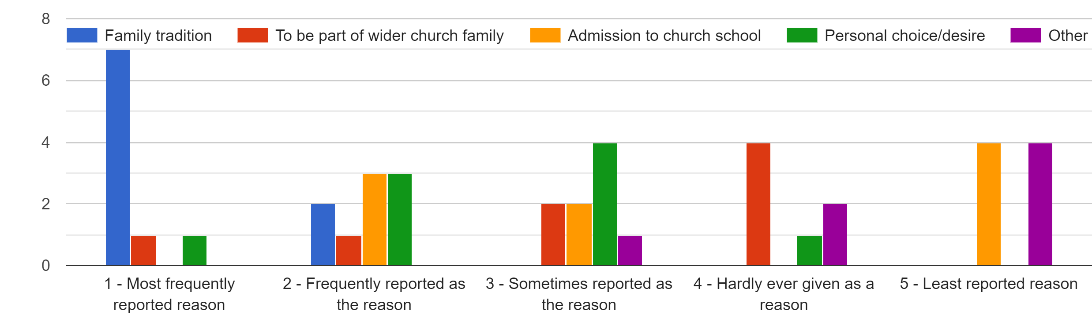 Figure 3: Reasons churches stated in year one for children being baptised

Figure 4a: Aims of Parishes at commencement of Three Steps Project

Figure 4b: Aims of Parishes at end of Three Steps Project

- Choices and flexibility about the baptism process (allowing the preparation, service and follow-up to be personalised and tailored would potentially get more “buy in” from families)
- Asking families to attend church for a few weeks prior to Baptism to become more familiar
- Church offering to pray for children and families post-baptism. Also for church to text families at key times, for example “We are praying for your family this week as schools start back.”
- Home visits to build up relationships, provide information and answer questions.
- A pack to be given to parents at baptism, including church information, upcoming events and family faith activities and ideas.
- Events and services at different times, including midweek (such as Messy Church)
- Events and activities in the school holidays
- Monthly mums groups
- Hearing experience of other parents in a variety of forums.
Figure 5: Ideas that emerged from a focus group regarding “faith nurture in the family context”

- Baptism prep should not equate to tricks and bribery of the parents to attend church activities. The families will jump through hoops but hate it. Instead, we want the process to be positive.
- We need to be aware that some families don’t want anything other than the baptism.
- The resources available are inadequate. Many churches find them too long, since they often deliver Baptism preparation in a single event, but most resources are written for a series of events.
- One church has developed their own approach, using picture prompts and conversation.
- The new liturgy is too long – we need a bespoke liturgy for baptism.
- We need to be aware of literacy level – not all visitors can read. They are isolated by the need to read liturgy.
- Baptism preparation needs to explain God’s grace and the parents promises, rather than talk through the liturgy.
- Things that have worked well: flexibility in defining belonging, informal initial contact (for example a lunch after toddler group for those interested in christening, a baby shower type celebration to start sharing info about christenings), baptism buddies, bespoke liturgy, a personal touch (for example home visits), continuity of person throughout process to enable relationship building.
Figure 6: Key Ideas from discussion of “baptism preparation” focus group

- Problem: Some congregation members find the baptism service long and said “I won’t be going to a Baptism service again”
- Conversely: Some Baptism families say “We’ve been through the motions now. It’s done and complete”.
…BOTH OF THE ABOVE CULTURES NEED ADDRESSING.
- Communion in the service can be hard for baptism families to access/relate to/engage with….Need to create a balance between a service tailored to Baptism families and the needs of the regular congregation.
- Often the missional element of this ministry is not recognised.
- Things that have worked well: Moving christenings to within established service, using Church magazine to profile the baptism ministry, Charlie Caterpillar on leaflets and around church to maintain congregation’s awareness, encouraging whole church family to welcome Baptism families and remain inclusive, sending invitations to events afterwards – families can then choose whether to engage or not, appropriate readings, prayers and sermon themes for baptism, flexible use of the lectionary.
Figure 7: Outcomes of “changing the culture” focus group
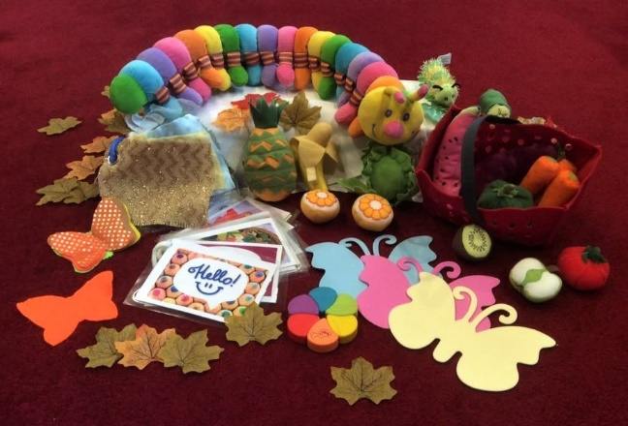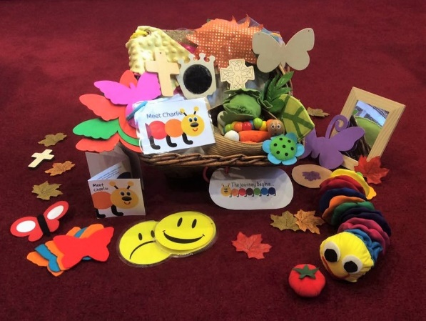
Photo 1: Examples of the welcome baskets

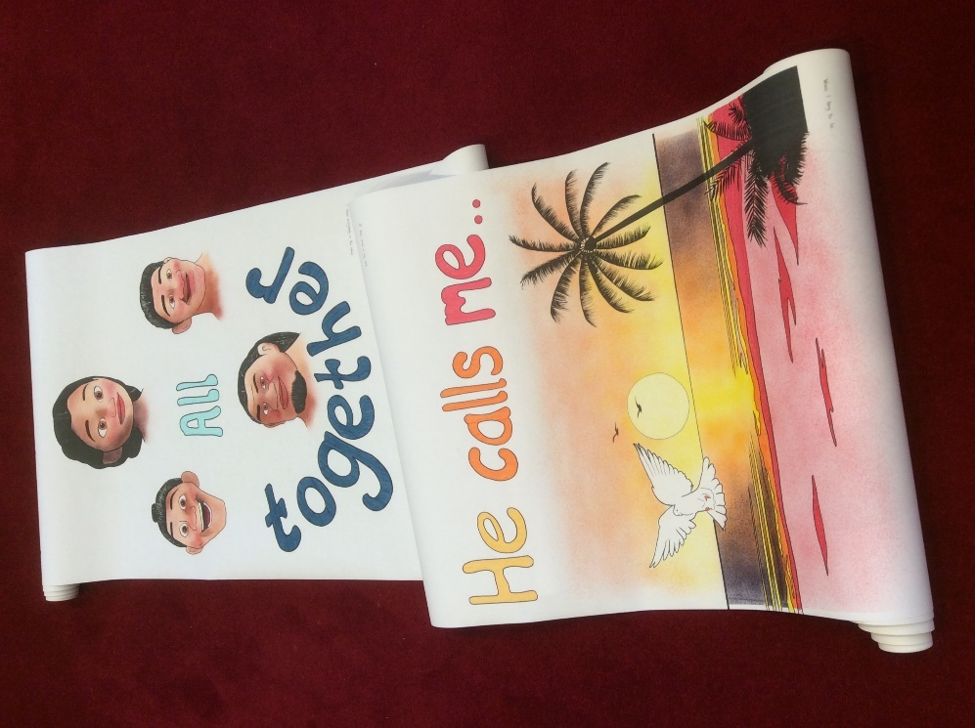
Photo 2: Wallpaper illustrations, which were set to music
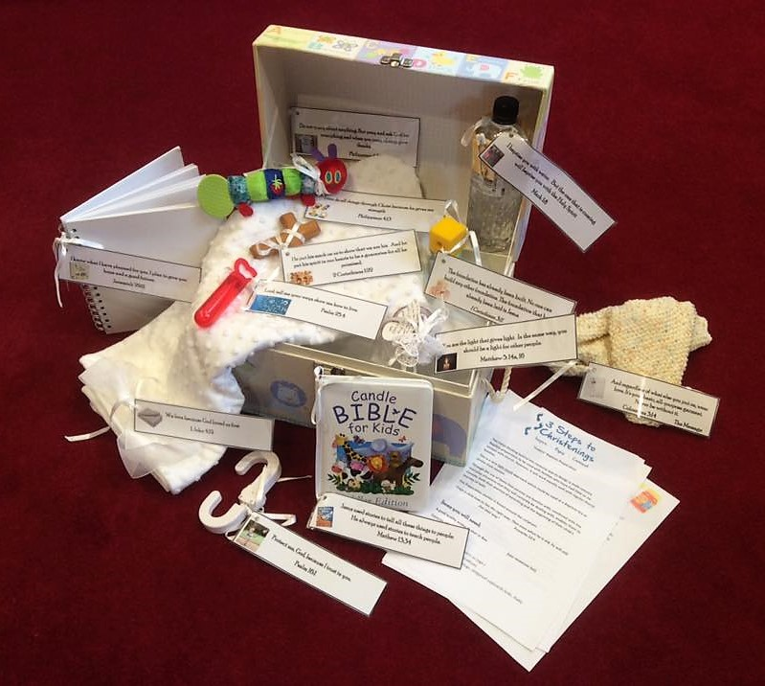
Photo 3: Baptism boxes, used for baptism preparation and during baptism services

Research & Statistics (2018), Statistics for Mission 2017, London: Church House, p.8
Research & Statistics (2018), Statistics for Mission 2017, London: Church House, p.14
Research & Statistics (2018), Statistics for Mission 2017, London: Church House, p.15
Research & Statistics (2018), Statistics for Mission 2017, London: Church House, p.34
https://liverpool.anglican.org/BiggerChurchBiggerDifference, https://liverpool.anglican.org/RuleOfLife
Story author Bob Hartman, as yet unpublished.
https://liverpool.anglican.org/index.php?p=3286
Author Bob Hartman, as yet unpublished.
Research & Statistics (2018), Statistics for Mission 2017, London: Church House, p.9
Hewitt, B. (2018), Christenings Research: Liverpool Diocese, Kettering: 9DOT RESEARCH, P.7
Research & Statistics (2018), Statistics for Mission 2017, London: Church House, p.8
https://liverpool.anglican.org/CFCA
Church of England (2014). From Anecdote to Evidence: Findings from the Church Growth Research Programme 2011-2013, p.11

