**Mother as Curator – Ethical Encounters in Art Making with Children**

**Dr Sarah Black (Liverpool Hope University)**

***Conversation with Oliver and Isabel about family - February 2017***

***Mum - Isabel, what is family?***

***Isabel - I don’t know***

***Mum - Who is in your family?***

***Isabel - Betty (dog) Auntie Esther …I forgot…. Emma, Nanny, I forgot all the other ones…. Oh You Oliver and Daddy in the house.***

***Can I play the rest of my game now?***

***Mum - Oliver, what is family?***

***Oliver - I don’t know…..Mum Daddy Isabel. I don’t know.***

***Mum - Ok. Do you think family is about people or a feeling?***

***Oliver - I think it is love.***

This article and the research practice, ‘*Mother as Curator’,* that I discuss, speaks directly to the mother developing art with her family, and addresses the ethical implications which arise in this kind of performance making. I will discuss two pieces of work I have developed with my children*, Oliver’s World* (2014) and *Isabel’s Shoes* (2017), and will evoke particular encounters with my children and a moment of interruption by Oliver during a live performance in the family home. These performance works and encounters highlight and encourage performance making from different angles, acknowledging the ways in which art making as part of family life shifts perspectives on, and understandings of, what we mean by art practice and the ways it might be experienced.

I come to this work as a mother and as a site-specific artist and choreographer who is continuously juggling the roles of mother/artist/researcher. And, while I question the extent to which ‘mother’ is the primary identity, in the end I place mother first as it defines the lens through which the practice is developed and located. Positioning myself as the instigator, facilitator and curator of a practice that equally honours my own voice and the voices of family that contribute to a shared knowledge of family and art making, leads to a multifaceted practice. Thereby, I argue for a kind of art making which prioritizes collective experience of art making and viewing, over singluarised or highly aesthetised outcomes. Embracing art making across a range of modes, and from people with a range of artistic abilities, I attend to facilitating and working with family and children to develop ‘personalized’ and collaborative art works with them. This is a ‘family art practice’, and as such, it deliberately does not attempt to conform to ‘normative’ modes of live art or performance art; however, it might carry some characteristics of these practices.

The focus of my work, as the mother-artist, is found in the title of my practice *Mother as Curator*, wherein a play on words encourages me to *curate* and *take care* of practice. One of my main concerns is to bring forward the challenge of mothering and curating, practically and philosophically, whilst at the same time addressing the ethical issues that come forward. The ethical issues discussed in this article, are framed by maternal approaches to ethics which foreground the particularities of the relationship between mother and child, positioning this as the paradigm for moral interaction. The particular act of curation described guides, supports and activates interdisciplinary performance work, sharing it with the attention of a mother who then makes it available to guests in the home – the very place it was made. While I shall not be exploring curation directly, this lens pulls together different domains of knowledge disciplines and artistic works to establish a framework where dialogues can happen. It offers a frame of care, through which to negotiate the ethical and moral questions that rise through the performance practice discussed and relationships within the family unit.

Informed by debates in Maternal Studies, I refer to feminist scholar Sara Ruddick (1989) as well as feminist psychoanalyst Lisa Baraitser (2008). I deploy an understanding of mothering as a threefold task: (1) the preservation of the life of the child, (2) fostering the growth of the child, and (3) the nurture of a socially acceptable child (Ruddick, 1994). I thus understand mothering as a particular practice that gives rise to the ways I approach the daily tasks of mothering, attitudes to care giving and consequently art making.

Baraitser’s approach to identifying and addressing pressing ethical relations involved in the mother and child dyad is of particular importance. She discusses (her own) maternal experience as a series of interruptions, and suggests that whilst this can reveal the mother as exposed, or feeling that she is falling short of the expectation of mother, also asks that we see vulnerability as a key characteristic of humankind (2009). Adopting the term ‘interruption’ to speak of a field of experience, I explore my own perspective on mothering, and develop creative methods in my own practice.

Whilst this text is written predominantly in a scholarly style, there are anecdotal diary sections dispersed throughout the article, written from the position of the mother and deliberately integrated into the text and echo the act of interruption. This follows Baraitser’s (2009) own use of anecdotal writing of which she asks; ‘What is it like to stay alongside a child?’ (Baraitser, 2009: 11). Writing through a succession of subjective positions she encounters herself through a series of unexceptional incidents which reveal maternal subjectivity to be defined not by ‘[…] fluidity, hybridity or flow, but of physical viscosity, […] and a renewed sense of oneself as a speaking subject’ (Baraitser, 2009: 4).[1] Similarly,Suzanne Juahsz (2003) in *Mother-Writing* explains,

bringing together in the same textual space the aggregate of identities that mothers’ possess and establishing a viable relationship, or “grammar,” among them. Though frequently difficult to achieve in lived experience, this process is enabled by locating a connecting point in the woman herself, for all these identities are hers.

(Juhasz, 2003: 400)

I position these interruptions as repositories of information and understanding of personal reflections, where the layers of maternal subject positions unveil an intimate, corporeal, textual exploration of mothering and family life - through self and others. Through these interruptions I reveal becoming a mother, my ever-changing and sometimes failing body, conversations with my children, the ebbs and flows of frustration, guilt, boredom and the complete and wholesale messiness of motherhood and of family life.

***Diary Excerpt – 19th December 2012***

***Naomi Klein says in* Misconceptions *‘that new mothers are not born but through a great effort made. Bonding fiercely with your baby may be natural, but good day-to-day mothering, as few seem publicly to acknowledge, is no more ‘natural’ than is any painstaking, exhaustive, difficult work that is both biologically driven and deeply willed’ (2003: 5). I feel like I am in mourning for an old self. It feels more acute this time during the second birth with Isabel… I have found it hard to lose a part of myself-again, a part of myself to motherhood, when I feel like there is no patience or acknowledgement for the labour of mothering. The opening of one world, and the closing of another. I am fascinated with my child, and yet I resent giving over the absolute self, my body, my time and my mind in-between constant anguish and love.***

**Creative Methodologies**

Investigating art making with my children is an ongoing process in which art making becomes an extension of the caring labour of mothering. This is explicitly linked to the curatorial practice of the *Mother as Curator* role, where, as part of the continuum between mother and curator, I approach art making with a particularized sensibility. The pieces discussed here, reveal creative processes with children and subtleties in the mother and child relationship. *Oliver’s World* (2104) a photographic exploration and *Isabel’s Shoes* (2015) a play encounter involving all of her shoes since birth, and an interruption which further highlights the mother-child dyad.

My *Mother as Curator* practice, entails heightened state where I orchestrate a dialogical process in the complexities and interconnectedness/blurriness of mothering/research/art. As a result my performance work responds to, and is shaped by, what I shall describe as, the ‘messiness’ of daily life. This entails acknowledging that the research practice is an iterative one, which has to be malleable enough to accommodate and adapt to the identifiable needs and demands of my family structure, accommodating transient states, such as are evidently necessary when working with growing children and shifting family relations.

When working with my children the main aim is to recognise them as subjects, rather than objects of the research, and I am guided by their imaginative, educational and emotional worlds, acknowledging them as people who can speak in their own right. I ask as a mother/artist/researcher what is my duty of care to my children and who is represented in my artworks? (Ryan, 2017). As such, an overriding premise when researching with my children is attended to their consent, and willingness, to be involved in creative work.

My approach to consent is seen through the establish parameters of consent between the mother and child as an extension of my own mothering practice. This approach to consent and power emphasises my duty of care and what I believe to be in the best interests of the child (Alderson, 2001). For example, in both *Oliver’s World* and *Isabel’s Shoes* the works are *ours*; jointly made through play and negotiation between adult and child. When working on such jointly made work, as I elaborate in what follows, the children have a voice in forming my view of their best interests.

***Diary Excerpt – 12th September 2012***

***I am not sure where the time has gone***

***I don’t sleep much; I always have my beautiful baby with me in bed, nursing, she sleeps. I surface read to keep me in touch with the outside world.***

***I read the pro-woman, pro-life sisterhood campaign, the New Feminism is telling American Women they are capable and strong, and if keeping an unintended pregnancy is not possible, adoption is a beautiful option, and you can still follow your dreams. This is floating around my head as I think of Sarah Palin, the pro-life campaigner who dragged her children around with her on political campaigns.***

***My thoughts are interrupted, pulled back to the present, by the stirring child.***

***My head swims, I hold you, and I turn off the computer.***

***Still I don’t feel rested, my thoughts are not clear.***

***I hope I am doing ok, in the micro moments of this new life I find complete solace***

***and clarity. Those moments are fleeting, but the whole picture looks different. It’s blurred, the boundaries are blurred.***

***This feels isolating, isolated.***

***I live in the bedroom; I live in-between time. The now is difficult to define. I have***

***arrived at a new place, but I can’t find a name for it. Maybe I could feel better if I could name it. Like the naming ceremony of a child. This place is consumed with cooking, feeding, holding, dressing, cleaning, cooking, dressing, holding, cleaning, dressing, holding, dressing, feeding.***

***The ground, the bed, the surfaces of life feel like sand, they move.***

***I am bed bound***

**With Children**

*Oliver’s World* (2014) is a mother and son photographic collaboration through which family life was documented and presented. The origins of this collaboration arose due to Oliver’s decision to not have his photograph taken. I had to tussle with my desire to document the family and fulfil Oliver’s wishes for privacy. I stopped documenting the family. Sometime later I approached Oliver with a proposition; I would buy him a camera and he would take up the activity of documenting for himself/me. He gave his consent and embraced the idea, photographing his world, his sister, his toys, his parents, some trips out of the house. As this process continued we developed a method together – Oliver would photograph, we – mother and son – would view the images on a computer screen, Oliver would describe the pictures, and select the images to put into a curated book. This process was not without its complications; Oliver enjoyed the photographing but not always the archiving of them. He would come in and out of this process, therefore there are a lot of images that will never be seen, and are still stored away on a computer.

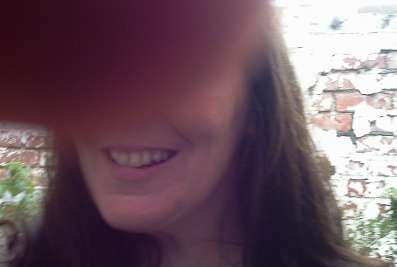 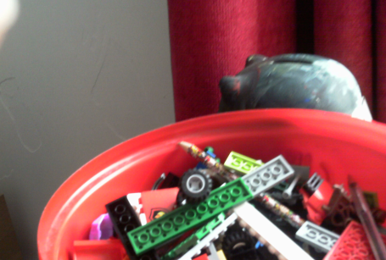

*Oliver’s World* 2014.

The context of *Oliver’s World* can be helpfully understood by Ruddick’s notion of attentive love (1989). Ruddick defines this as an act of maternal thinking, which is conceptualised as a form of responsive care. She articulates that the mother’s role is to love a child without seizing him, seeing a child with a patient eye. Attentive love itself is a discipline, but does not optimize maternal work (1989). Mothers can train themselves in the task of maternal attention, which is prompted by the responsibility to act and, when successful, gives way to the action it informs (Ruddick, 1989). Such loving attention can describe the separation of mother and child from the mother’s point of view (Ruddick, 1989). This kept my attention fixed on the wider situation of how Oliver did not want his photograph taken and, more generally, on the ethical implications of documentation and the position of the children within the research. By turning this into a collaborative project, Oliver and I had the opportunity to develop a practice which located him as artist. Attentive love is a hard, uncertain, exhaustive and exhilarating work of conscience (Ruddick, 1989).

During this project I explicitly explored Oliver’s agency and active role in performance making. Children and young people have often been placed passively in research and maybe have not had the chance to analyse and represent their own position (Alderson, 2001). *Oliver’s World* positions him as photographic documenter who comments on his subjective view of the world through the power of the image. This positioning of my son as co-creator in my art making poses particular questions for me, as adult, as to how the material chosen by Oliver is integrated and/or informs my own creative decisions, and how I document such contributions. This is a negotiated relationship between adult and child, rather than one in which I, the adult, decides on Oliver’s interests.

***Diary Excerpt – 7th October 2015***

***All motherhood is based around time. Time. Stealing time for oneself without interruption. Interruptions such as love and crying and maternal stuff.***

***Time away from the children, finding enough time to work, but it drips through my fingers.***

***I cannot hold onto my maternal time, watching my children grow in front of me. Their youth so physical in form, I love watching them, they grow so fast.***

*Isabel’s Shoes* (a short film, 2015) presents a different encounter between mother and child. For this piece, I invited Isabel to line up her shoes in size order and the work reveals an unfolding and playful space between the mother and daughter. Isabel happily embraces the activity, playing with her shoes, trying them on, noting her growth and begins to slip into and out of spontaneous moments of play. The exchange opens a space where mother situates the child in a task and lets the dynamic of the relationship develop between us. While I establish the focus of this activity and it was filmed from my perspective, it is something that we do together and Isabel has the freedom to come and go, engaging freely with the activity, making this *our* work. A work made with, and revealing, caring labour and which employs a child centred approach to documentation / art making processes.

The work of mother-artist Lenka Clayton (2012) demonstrates similar ways of developing documentation and installation projects which house artifacts related to her children. Clayton collects objects she has taken out of her son’s mouth and presents them in a glass case in a gallery context. In this piece there is evidence of the son; he is located in the engagement of the work, but we do not see him. Similarly mother-artist Lena Simic’s *Contemplation Time* (2008) presents the mother’s perspective, but she locates both mother and child in the work by visually documenting their time together. We see the son, the location, and we hear and read the mother’s thoughts. These mother-artists construct discourse and art in response to their immediacy of being/living with (young) children. They, embrace and react, as I do, to the maternal role as one who cares for small children.

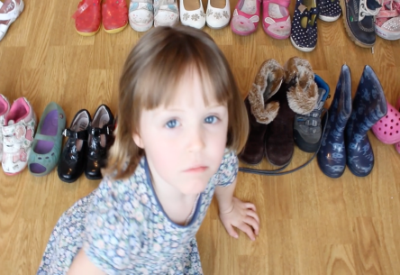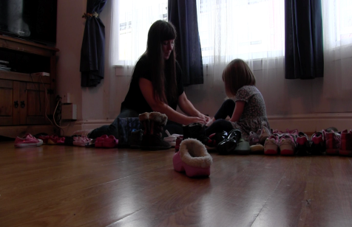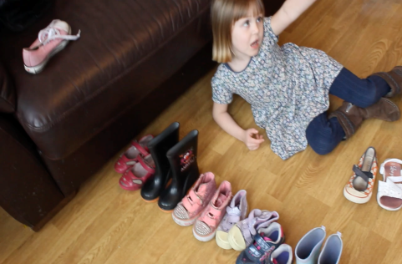

Untitled Screen shots from *Isabel’s Shoes* (2015)

**Interruptions**

When working with my children the approaches and ideological position I have taken to document the interactions between mother and child can be carefully situated by the ways Ruddick defines the child as open structure, whose acts can be unpredictable and mysterious (1989). In my own experience of combining everyday life and art making practices, the mother’s relation to maternal practice is something that can fall short of her demands (Ruddick, 1989). Therefore, I have developed a considered approach to working with my children, which exists within a responsive framework. This documentation records and invokes an open and safe space where the status of the task and the art making does not outweigh the interaction between the mother and child. In daily life the demands of the child can be contradictory, and challenging; therefore, through this process I have attempted to find ways to develop creative expression and stimulation with my child alongside my parental obligations. Ruddick states the judgements we make, the metaphysical attitude a mother adopts, assigns maternal labour as a discipline, where specific social and relational practices give rise to an ethical maternal thinking (1989).

***Diary Excerpt - 21st February 2016***

***The children are fighting, constantly. I can’t seem to make the peace. Part of my mothering role is peace-maker. Finding ways to compensate for moody, unhappy children, distracting them.***

***We are trying to go out, a cold and wet day, a day on the beach with the Iron Men. The day seems doomed from an early start. The voices shouting over each other, Oliver formed words, Isabel still forming hers, but the intention is clear. It is over a toy, I try to find another. The fighting continues, escalating to crying and screaming. I reach over and turn the TV on. Distraction.***

Working in similar ways with children, Simic and collaborator Miffy Ryan, in their event *Motherhood and Live Art 2: Are we screwing the kids up?* **(**April 29th 2017), open a platform for mother-artists to share their experiences of working with their children in performance. Simic shares her ideas and approaches, where she sets the premise to let her children come and go, in and out of performance. Simic performs live with her children predominantly in a theatrical setting. In a conversation at the event, she states – ‘*some things work and some things don’t, the key point is not to be too attached and put too much emphasis on the work, it is part of their journey and not just mine so there is no pressure to complete’* (L. Simic, 2017, Personal Communication 29th April).

Like Simic, I have developed arts-based methods that accommodate our lives, and therefore reveal something about our world. These methods encompass and respond to the practicalities of life, working to a mother’s timetable which integrates interruptions such as feeding times, bed times, tantrums, my energy levels, and frustrations. Such interruptions and practical issues have impacted upon my performance research in interesting ways. For example, my children’s daily activity would move me from room to room, from emotional state to emotional state, which ultimately shaped my thinking and artistic methods. The constant state of flux between the everyday activity and my intention of recording the moment for performance making purposes recognises the multi-tasking that is required not just of mother, but especially of mother as researcher,

As a mother turns herself towards a child mid-sentence, mid-mouthful, mid-thought, or in the middle of the night, she often makes herself available without finishing the things that replenish her.

(Baraitser, 2009: 67)

Baraitser (2009) refers to this multi-tasking as relentless, experienced perhaps as a series of blows that brings the mother back into the here and now, ‘drawing the attention to the immediacy of the child, which wrenches the mother from the world of thought or action’ (Baraitser, 2009: 68). These interruptions, Baraitser argues, is the given maternal experience and she questions whether this fundamentally changes the mother’s experience of being (2009). On the one hand, Baraitser explains, interruption makes it impossible to exist in the realm of reflective thought or one’s own reflective maternal space of experience. On the other hand, this opens an opportunity so that something new can be created.

While the act of interruption acts as a reminder to me as performance-researcher that I am working with an element of unpredictability, it enhances my sense of agency in selecting and curating material for performance. Interruption highlights the ethical relationship between me, mother, and child, and reminds me of the challenge and opportunity in these moments, and how they can be expedited in other ways.

***Diary Excerpt – August 13th 2014***

***The children are playing and occupied in their imaginary world.***

***I lie back on the sofa and choose to write in my diary,***

***Oliver sees my total absorption in own activity, this is an invitation for him to bring his pen and join in with my writing. He begins to scribble all over my book.***

***I am no longer a writing subject I am an object that plays and writes.***

Exploring this further, the encounter I describe in what follows led me to an alternative, contemplative space – a place of differentiated attention, a place between separation and immersion at the same time, or perhaps, a new way of being with my son. The brief encounter I describe took place during the live performance event presented in our family home. [2] As part of this event I was performing a solo dance work in my bedroom and I invited people to watch from the bed. The performance of the solo demands a particular attention as I move across the furniture to get from one side of the room to another. During the solo performance, Oliver entered the room and sat on the bed to watch; he had seen the piece in rehearsal. He extends his hand to me as I am moving, and I see he is holding a DVD: ‘Mummy can you put this on please?’. I take the DVD, and pass it back to him, and continue until the end of the performance, and then I take the DVD and put it in the player, responding to his interruption.

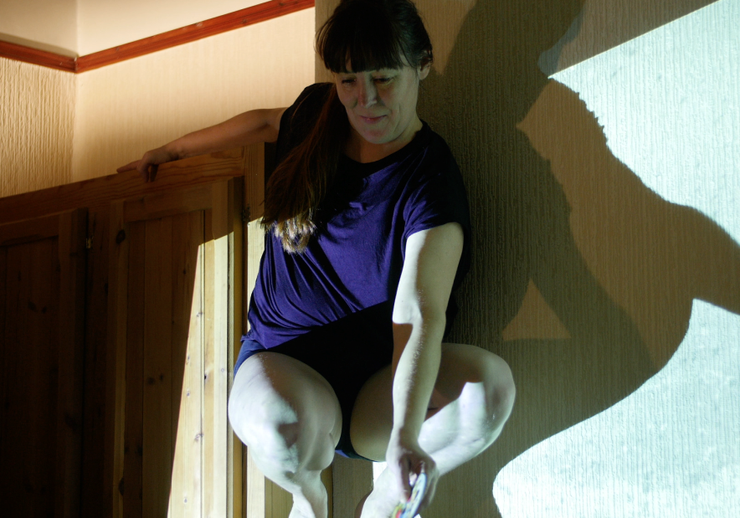

Untitled screen shot *31 Days Old* (2016). January 2016. Oliver passes the DVD during the performance.

I look down at Oliver in that moment, and see him looking at me, needing my attention. He had created the opportunity and found another way of our being together. In that moment, I experienced the conflation of being the mother and performing subject. Baraitser explains: ‘She who is subjected to relentless interruption, and she whom interruption enunciates; a subject, that is, who emerges from the experience of interruption itself’ (2006: 66). This experience of, and emerging from, interruption presents a temporality to motherhood, which is elongated, so that reflexive thought must be abandoned, presenting a more immediate form of thinking – not a thinking from or towards elsewhere (Baraitser, 2006). I held the DVD – my intention was to reassure him – and returned to the dance. Mother-artist, Emily Underwood-Lee explains that in performance where the mother is foregrounded, the construction of a maternal identity is happening before our very eyes (2016). In this instance, both Oliver and I negotiate our identity in relation to each other in real time. As Imogen Tyler (2008) describes that motherhood, is not a property, but a series of relations between subjects (2008). There is a triangular relation established between mother/performer, son and action. It is in the moment of performance, when the mother is joyfully/innocently disrupted, even usurped, by the immediate need of the child in his moment of livedness/being, that Tyler’s idea of the mother’s positionality and multiple forms of being is played out.

***Diary Excerpt - 18th December 2012***

***I found myself day dreaming of work today. I pictured what people were doing – drinking coffee, grabbing conversation before they head off to teach. I day dream about moving, moving freely through the space, moving to music, rolling on the floor, pausing, breathing, (re)connecting with my body. I long for a dancer’s touch, the weight of the hand, guiding me through space.***

***I come back into the room, I put music on and pick up Oliver, I swirl him around he laughs and giggles. Follow mummy, I roll on the floor and stretch out, he jumps on me, his weight, his touch. We roll together.***

**Conclusion**

The importance of ethics in my role as mother-artist is articulated through the ways I define maternal-art as a projection of care and labour. I primarily draw upon the written works of Ruddick (1989) and Baraitser (2009) to develop and apply my ethical approaches and maternal thinking when exploring work with children. Ruddick argues:

I was- and still am-interested in maternal thinking because of what maternal concepts might introduce into political and philosophic discussions. But maternal concepts can be reflective of mothers, and a help to them, only if they are anchored in thinking about children.

(Ruddick, 1994: 30)

Ruddick notes the possibility of the wider impacts of maternal thinking across the fields of politics and philosophy. In my own work, I consider maternal thinking a core feature of the ways I interact and approach art making practices with my children.

More broadly I suggest that the performance practice and artistic processes of the mother-artist are not ‘distinct for the work of the artist, but are on the contrary enabling life and art’ (Tyler and Baraitser, 2013: 3). In other words, the mother-artist role reaches beyond practical considerations such as: How do I feel about mothering and art making? How do I, as a mother, attempt to strike a balance between my own personally driven needs and desires within motherhood? How can I deliver upon the needs of my children as they change, grow and develop, whilst I too mature and change? The ideological dimension of these questions illuminate tensions and borders between mothering and creating art which are fundamental to my practice.

The ways I work with children in my *Mother as Curator* practice reveals certain ethical issues, such as the relations between mother and child, and child and the performance work. This art making reveals the ways I challenge the context of the art making by clinging onto my parental duty, where my duty to the child and the act of mothering and daily-ness occupy the encounter and the frame. I have found inventive ways of responding to the voices, privacy and agency of my children. The significance of this practice presents how as a mother I worked with my children and their needs through an artistic process. In *Oliver’s World*, Oliver is positioned as artist, and his photography as art work. There isn’t a precedence for a hierarchy or aesthetic value imprinted *Oliver’s World* rather, I refer to the importance of the intention and artistic process of the work. Similarly, *Isabel’s Shoes* meaningfully encourages a dynamic to unfold between mother and daughter. This practice explores the notion of consent and presents the opportunity for Isabel to come in and out of the encounter. I identify this work as a way to document these encounters and it is evidently presented from the mother’s perspective of the encounter.

***Bibliography***

Adams, T.E., Jones, S.H., Ellis, C. (2014) *Autoethnography (Understanding Qualitative Research).* Oxford: Oxford University Press.

Alderson, P. (2001) Research by Children: Rights and Methods. *International Journal of Social Research Methodology: Theory and Practice* 4(2), 139-153.

Allegue, J., Kershaw, B., Jones, S. and Puccini A. (eds.). (2009) *Practice-as-Research in Performance and Screen*. Basingstoke: Palgrave.

Allegue, L., Jones, S. and Kershaw, B. (2010) *Practice-As-Research: In Performance and Screen [With DVD]*. New York, NY: Palgrave Macmillan.

Allen, K. R., and Farnsworth, E. B. (1993) Reflexivity in Teaching about Families *Family Relations* 42(3), 351-356.

Allen, K. A. Few, A. L. and Lloyd, S. A. (eds.). (2009) *Handbook of Feminist Family Studies* Thousand Oaks, CA: Sage Publications.

Anderson, B.J. (2000) *Doing the Dirty Work? The Global Politics of Domestic Labour*. London: Zed Books.

Arendell, T. (2000) Conceiving and Investigating Motherhood: The Decade’s Scholarship*,* *Journal of Marriage and Family* 62(4), 1192–1207.

Arendell, T. and Brody, L. (2001) Gender, Emotion, and the Family. *Contemporary Sociology* 30(1), 48-50.

Ashton, E. (2012) ‘Transforming’ Women’s Lives: Bobby Baker Performances of ‘Daily Life’. *New Theatre Quarterly* 16, 17-25.

Bannon,F. (2018) *Considering Ethics In Dance, Theatre and Performance.* Palgrave Macillan.

Baraitser, L. (2006) Oi Mother, Keep Ye’ Hair On! Impossible Transformations of Maternal Subjectivity. *Studies in Gender and Sexuality* 7(3), 217–238.

Baraitser, L. (2008*)* Mum’s the Word: Intersubjectivity, Alterity, and the Maternal Subject. *Studies in Gender and Sexuality* 9(1), 86–110.

Baraitser, L. (2009) *Maternal Encounters: The Ethics of Interruption*. London: Taylor & Francis.

Baraitser, L. (2014) Duration, Skin, and the Ageing Subject. *Studies in Gender and Sexuality* 15(3), 228–234.

Baraitser, L. and Frosh, S. (2008) Psychoanalysis and Psychosocial Studies. *Psychoanalysis*, *Culture & Society* 13(4), 346–365.

Baraitser, L. and Segal, L. (2009) Lynne Segal in Conversation with Lisa Baraitser. *Studies in the Maternal* 1(1), 1-19.

Baraitser, L. and Spigel, S. (2009) Editorial: Mapping Maternal Subjectivities, Identities and Ethics. *Studies in the Maternal* 1(1), pp 1.

Bar-On, D. (1996) Ethical Issues in Biographical Interviews and Analysis. In Ruthellen Josselson (ed.), *Ethics and Process in the Narrative Study of Lives, Vol.4*. Thousand Oaks, CA: Sage Publications.

De Beauvoir, S. (1997) *The Second Sex*. Translated by H.M. Parshley. London: Vintage Books

Cixous, H. and Galle-Gruber, M. (1997) *Rootprints Memory and Life Writing*. Abingdon: Routledge.

Chodorow, N.J. (1999) *The Reproduction of Mothering: Psychoanalysis and the Sociology of Gender.* Updated edition. Berkeley, CA: University of California Press.

Clayton, L. (2012) [online] Available from: <http://www.lenkaclayton.com/> [Accessed 23rd March 2014].

Conly, S. (2001) Why Feminists Should Oppose Feminist Virtue Ethics [online]. *Philosophy Now* 33. Available from: <https://philosophynow.org/issues/33/Why_Feminists_Should_Oppose_Feminist_Virtue_Ethics> [Accessed: 23 July 2016].

Copp, D. (2006) Introduction: Metaethics and Normative Ethics. In David Copp (ed.), *The Oxford Handbook of Ethical Theory*. Oxford: Oxford University Press, 3-39.

Family Activist Network (2015) [Online} Available from <http://www.twoaddthree.org/fan-family-activist-network/> [Accessed 20th August 2016].

Family Ties Network (2012) *Family Ties Network* [online]. Available at: <https://familytiesnetwork.wordpress.com/>. [Accessed: 10th June 2015 - 4th March 2017].

*The Institute for the Art and Practice of Dissent at Home* (2008-present) [online]. Available from: [http://www.twoaddthree.org](http://www.twoaddthree.org/) [Accessed: 10th July 2015].

Irigaray, Luce. (1985) *Speculum of the Other Woman*. Translated by Gill, C,G. Ithaca, NY: Cornell University Press.

Iversen, M. (1997) *Mary Kelly* (Contemporary Artists). London: Phaidon Press.

Jack, I. (2005) *Granta: The Magazine of New Writing 88. Mothers.* London: Granta Books.

Jaggar, A.M. (2000) Ethics Naturalized: Feminism’s Contribution to Moral Epistemology. *Metaphilosophy* 31(5), 452–468.

Jeremiah, E. (2002)Troublesome Practices. Mothering, Literature and Ethics. *Journal of the Motherhood Initiative for Research and Community Involvement* 4(2), 7–16.

Kelly, M. (1999) *Post-Partum Document*. Berkeley, CA: University of California Press.

Kershaw, B. (2010) Practice as Research: Transdisciplinary Innovation in Action. In

Baz Kershaw and Helen Nicholson (eds.). *Research Methods in Theatre and Performance* (Research Methods for the Arts and Humanities). Edinburgh: Edinburgh University Press. 63-86.

Kelly, M. (1999) *Post-Partum Document*. Berkeley, CA: University of California Press.

Kershaw, B. (2010) Practice as Research: Transdisciplinary Innovation in Action. In

Baz Kershaw and Helen Nicholson (eds.). *Research Methods in Theatre and Performance* (Research Methods for the Arts and Humanities). Edinburgh: Edinburgh University Press. 63-86.

Liss, A. (2009) *Feminist Art and the Maternal*. Minneapolis, MN: Minnesota Press.

Liss, A. (2013) Maternal Aesthetics: The Surprise of the Real. *Studies in the Maternal* 5(1), 1.

Loveless, N.S. (2016) Contemporary Mamactivist Artists: A Forum on Maternal Activist Art for the Studies in the Maternal Special Issue on The Everyday Maternal Practice: Activist Structures in Creative Work, Summer 2016. *Studies in the Maternal* 8(2),15.

Obrist, H.U., Hulte., P. and Bovier, L. (2008) *Hans Ulrich Obrist: A Brief History of Curating*. Zurich: JRP Ringier.

Okin, S.M. (1989) *Justice, Gender, and the Family*. New York, NY: Basic Books.

O’Neil, P. (2007) The Curatorial Turn: From Practice to Discourse. In Judith Rigg, Michle Sedgewick (eds.), *Issues in Curating Contemporary Art and Performance*. Bristol: Intellect, 13-28.

O’Reilly, A. (2007) *Maternal Theory Essential Readings*. Toronto: Demeter Press.

O’Reilly, A. (2010a) *Encyclopedia of Motherhood.* (Vol 1) Thousand Oaks, CA : Sage Publications.

O’Reilly, A. (2010b) Outlaw(ing) Motherhood: A Theory and Politic of Maternal Empowerment for the Twenty First Century. *Hecate* 36(1/2), 17-29.

O’Reilly, A. and Ruddick, S. (eds.). (2009) *Maternal Thinking Philosophy, Politics, Practice*. Toronto: Demeter.

Oxford Dictionary (2018) [Online]. Available: <https://en.oxforddictionaries.com/definition/curator>

[Accessed 2nd April 2017].

Pollock, G. and Mulvey, L. (2010) Laura Mulvey in Conversation with Griselda Pollock. *Studies in the Maternal* 2 (1), 1-13.

Rich, A. (1986) *Of Woman Born, Motherhood as Experience and Institution*. New York, NY. W.W. Norton & Company.

Ruddick, S. (1989) *Maternal Thinking: Towards a Politics of Peace*. New York, NY: Ballantine Books.

Ruddick, S. (1994) Thinking Mothers/Conceiving Birth*.* In DonnaBassin and Margaret Honey, Meryle Mahrer Kaplan(eds.), *Representations of Motherhood*. New Haven, CT: Yale, Univesity Press, 29-46.

Ruddick, S. (1997) The Idea of Fatherhood. In Hilde LindemannNelson (ed.*), Feminism and Families.* New York, NY: Routledge.

Ruddick, S. (2010) On Maternal Thinking*.* *WSQ: Women’s Studies Quarterly* 37(2), 305–308.

Ryan, M. and Simic, L. (2017) Motherhood and Live Art 2.

Available from: <http://www.twoaddthree.org/motherhood-and-live-art-2/>

[Accessed 4th May 2017].

Siegel, S. Silagi, L. Krall, D. (2011) MotherArt: A Collection of Women Artists. Los Angeles: Otis.

Simic. L. (2009) Maternal Matters [online] Available from https://www.academia.edu/1414963/Maternal Matters and Other Sisters Artist Catalogue Lena Simic The Institute for the Art and Practice of Dissent at Home [Accessed 12th May 2015].

Simic, L. (2016) *Performing Everyday Maternal Practice: Activist Structures in Creative Work* [online]. Available from: <https://www.mamsie.bbk.ac.uk/articles/10.16995/sim.235>[Accessed: 24th April 2017]

Simic, L. and Underwood-Lee, E. (2017) Editorial. On the Maternal. *Performance Research Journal* 22 (4), 1-4.

Surman, G. (date) [Online] Available from: <https://gracesurman.wordpress.com/> [Accessed on 13th February 2016].

Surman, G. (2017) *Performance with Hope* [Bluecoat Chambers Liverpool 25/02/2018].

Tong, R. (1998) Feminist Ethics [online]. In *Routledge Encyclopedia of Philosophy*. London: Taylor and Francis. Available from: <https://www.rep.routledge.com/articles/thematic/feminist-ethics/v-1>. [Accessed: 4th November 2016].

Townley & Bradby, (2007) [Online] Available from <https://www.axisweb.org/p/townleyandbradby/> [Accessed: 25th March 2017]

Tyler, I (2009) Maternal Matters: The Political Aesthetic of Lena Simic. In Lena Simic (ed.), *Maternal Matters and Other Sisters: Artist Catalogue.* Liverpool: The Institute for the Art and Practice of Dissent at Home, 14-16.

Tyler, I. and Baraitser, L. (2013) Private View, Public Birth: Making Feminist Sense of the New Visual Culture of Childbirth. *Studies in the Maternal* 5(2), 1-27.

Ukeles, M.L. (1992) A Journey: Earth/City/Flow. *Art Journal* 51(2), 12.

Veale, A. (2005) Creative Methodologies in Participatory Research with Children. In Sheila Greene and Diane Hogan (eds.), *Researching Children’s Experiences*. London: Sage, 253-273.

Vygotsky, L. (1933) *Play and its Role in the Mental Development of the Child* [online]. Available from: <http://www.mathcs.duq.edu/~packer/Courses/Psy225/Classic%203%20Vygotsky.pdf> [Accessed: 21st May 2017].

Woolf, V. and Barrett, M. (2003) *Women and Writing*. Orlando, FL: Mariner Books.

Young, I, M. (1997) Asymmetrical Reciprocity: On Moral Respect, Wonder, and Enlarged Thought. *Feminism and The Public Sphere* 3(3), 340-363.

Young, I.M. (2005) *On Female Body Experience: Throwing Like a Girl.* Oxford: Oxford University Press.

1. Baraitser performs an approximation of anecdotal theory offered by Jane Galllop (2002). Gallop blurs distinctions between the ‘reality and text; she approaches reading the account for the theoretical insights that it offers, ‘a short account of some interesting or humorous incident’ (Gallop, 2002: 2). Baraitser approaches Gallop’s anecdotes as ‘textual fragments that can be unravelled to find within them theoretical insights, while at the same time using them to evoke a relation with what she refers to lived experience’ (2009: 12).
2. In 2016 I created a large installation in my family home called 31 Days Old. I worked with my mother, my auntie, my daughter. This installation contained a range of film work and interviews installed into rooms across the house and live performance.