Changing aesthetics and the affluent elite in urban tourism place making

Janet Speake*

Department of Geography and Environmental Science, Liverpool Hope University, UK [speakej@hope.ac.uk](mailto:speakej@hope.ac.uk)

Victoria Kennedy

Department of Geography and Environmental Science, Liverpool Hope University, UK [kennedv@hope.ac.uk](mailto:kennedv@hope.ac.uk)

*\* Denotes corresponding author*

ABSTRACT

At the nexi between urban aesthetics, power of the affluent elite, property and tourism destinations are complex intersections. These are explored utilising a critical theory approach within the context of neoliberalism and the concept of ‘aesthetic common sense’ is introduced. New conceptualisations of the ways in which tourists and others are influenced, demonstrate how they, through the processes of commodification and mediatisation, adopt the preferred aesthetics of the affluent elite. Cityscape aesthetics, incorporating both structural, top-down aspects (placemaking) and human agency (place-making) as co-performers in place making, impact on and influence, tourism destinations. An outcome is styled-for-status built environments and streetscapes. This is illustrated through the lens of Malta and its capital city Valletta, which presents a contemporary and dynamic exemplar.

KEYWORDS

Aesthetics, aesthetic common sense, affluent elite, neoliberalism, cityscape, place making, destinations, Valletta, Malta,

# INTRODUCTION

This study conceptualises the hitherto currently underexplored intersections between the aesthetics of the affluent elite, property-led development, and contemporary tourist consumer behaviours and expectations in the setting of urban environments within the context of the financialisation phase of neoliberal capitalism. There is currently a substantial gap in the literature at the nexus of aesthetics, power, property and tourism. It is the void at their intersection which this paper aims to fill. In doing so, we explore the contributions of aesthetics, power, property and tourism to the place making literature. We introduce the concept of ‘aesthetic common sense’, informed by Gramsci’s ‘common sense’ (Gramsci, 1971), whereby the less wealthy adopt the preferred aesthetics of the affluent elite.

This research draws on the extant literature in each of these themes and extends them to create a distinctive exploration of what creates the aesthetic ‘look’ of contemporary cities and how this influences the expectations of tourists who consume them. In particular, it builds on the work in the field of urban aesthetics and cityscape scripting (Alaily-Mattar & Thierstein, 2018; Ghertner, 2015; Speake, 2017; Kennedy & Speake, 2018; Speake & Kennedy, 2019), transnational building styles (Ponzini & Manfredino, 2017), in the realm of aesthetics, beauty and tourist destinations (Baggio & Moretti, 2018) and luxury (Yeoman & McMahon-Beattie, 2006; Yeoman & McMahon-Beattie, 2017). Bianchi (2018) reports on the current dominance of transnationals and calls on scholars to recognise the capitalist nature of tourism. Therefore, the capitalist context drives the property market and urban development in which tourism operates. Within the setting of cities as destinations for tourists, aesthetics are a facet of placemaking and gives a destination its character which may be of interest and/or attractive to visitors and contribute to their experience.

There is an extensive literature on ‘placemaking’ (e.g. Wyckoff, 2014; Mansilla & Milano, 2019) and ‘place-making’ (e.g. Hultman & Hall, 2012; Kolås, 2004; Lew, 2017; Sofield, Guia & Specht, 2017). We understand ‘placemaking’ to be “a deliberate and purposeful approach to place creation” (Lew, 2017: p.450) exemplified by top-down structural approaches (e.g. planning and urban design), and ‘place-making’ created by bottom-up human agency initiatives in which tourists as consumers of place become co-performers in place-making (Everett, 2012). ‘Place making’ is the overarching umbrella concept encompassing both placemaking and place-making (for further delineation of the terms see Lew, 2017).

A distinctive contribution of this paper is the addition of a different dimension to the place making literature, in that this study does not give precedence to either placemaking or place-making, but suggests a duality approach. Although other recent literature has attempted to examine the intersecting character of these terms and processes (Mansilla & Milano, 2019), the role of *aesthetic* change in cityscape transformation has not been considered. Moreover, associated elements of commodification and mediatisation, which extend the preferences of the affluent elite to Others (including tourists), warrant examination. Placemaking is currently inextricably linked to the creation and materialisation of the preferred dominant aesthetics of the affluent elite within contemporary cityscape, though tourist expectations play only a marginal role within this process and are more closely evidenced in place-making.

Within the placemaking literature there is little recognition of how preferred gazes, such as the future gaze (Jansson & Lagerkvist, 2009) (beyond the historic and romantic tourist gaze), inform and are used in cityscape transformation. It is important for this to be explored from the perspectives of urban users including tourists, as identified by Speake and Kennedy (2019). Given the nature of changing tourist behaviour associated with post-mass tourism (Speake & Kennedy, 2019), issues relating to notions of place-making are emerging. This is exemplified in how the style status seeking of tourists influences place making and how this adds to their expectation of what the contemporary ‘face’ of cities ‘should’ look like.

Thus, this study asserts that cityscapes are (re)scripted according to the aesthetics and preferred gaze of the affluent elite. All aspects of cityscape are impacted including administrative, commercial and residential functions. Urban status symbolism is often created by signature architects and presented in styled-for-status built environments and streetscapes. This offer is then marketable and attractive to both affluent and less affluent tourists and other users. Figure 1 presents a diagrammatic representation of key features of the conceptual framing. It highlights the interplay between aesthetics, place making, the wealthy and powerful affluent elite, creators and (re)scriptors of upscale urban change such as architects and tourists/others. It is not intended to be exhaustive but indicative of the influence of ‘aesthetic common sense’. It provides a frame for the ideas we develop in detail throughout this thought piece.

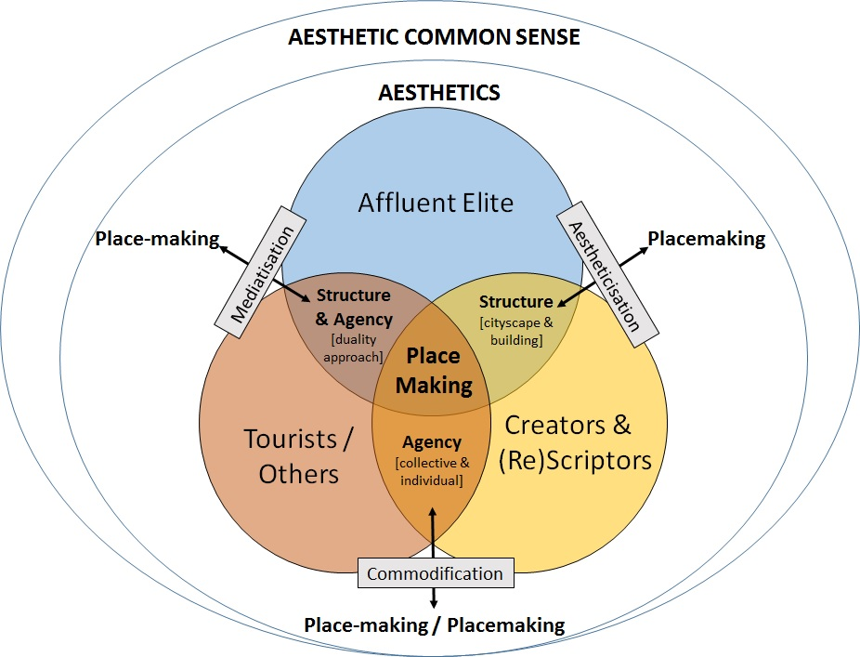

**Figure 1: Place Making - Aesthetics Dynamics**

In presenting our overarching conceptualisation, we also include here an exemplifying lens through which to explore our framing. The chosen lens through which to view and reflect on these conceptualisations of aesthetics, power, place making and tourism is Malta and more specifically its capital city, Valletta. As a tourist destination, it presents an excellent, multi-faceted microcosm of the dynamics of contemporary urban kaleidoscopic change. Valletta is a capital city, a historic city which has UNESCO World Heritage Status (Malta Government, 2016), and also has a polarised and juxtaposed socio-economic and demographic profile (Valletta Local Council, 2010; Malta Government, 2016). This creates challenges for current and future (re)development and place making. Its cityscape has been and continues to be transformed by large injections of transnational capital into development initiatives and projects. Many of these projects exemplify the current aesthetic preferences of the affluent elite and those, such as the mobile middle class, who seek to emulate them. As a city attractive to tourists, Valletta presents a distinctive offer, which reflects the current high-end aspirations and expectations of post-mass tourists (Speake & Kennedy, 2019).

The paper first presents the methodological approach adopted, before synthesising the underpinning interdisciplinary theoretical constructs and then exploring these through the case study setting of Valletta, Malta.

**Methodological approach**

This paper is a thought piece in which the authors’ conceptualisation of the interlinkages between aesthetics, power of the affluent elite and tourism are articulated. Through the utilisation of a critical theory approach (e.g. Kincheloe & McLaren, 2002; Mostafanezhad, 2018), we explore these nexi by integrating the qualitative case study of Valletta, Malta as a lens through which key processes of urban transformation are examined. The work draws on the authors’ combined expertise in tourism destinations, urban development and visual culture (Chapman & Speake, 2011; Kennedy & Augustyn, 2014; Speake, 2017; Speake & Kennedy, 2019).

The study has been developed through dialogue and discourse, synthesising the largely compartmentalised literature strands and has been inspired by our shared interdisciplinary field-based research in many urban settings over time. Various information-gathering techniques were used, including primary research such as field observations and interpretation, as well as secondary research in the form of a synthesis of interdisciplinary literature sources and ‘grey’ literature (e.g. government reports). In choosing to use a case study (Stake, 2005), detail and depth were achieved in a way which revealed the benefits of employing an inductive approach (Teddlie & Tashakkori, 2009; Wilson & Hollinshead, 2015). In Valletta, observation of the city’s rapid transformation and visual change, particularly over the last five years (since 2014), has provided the impetus to develop deeper understanding of the drivers for, and outcomes of, processes of cityscape change and place making. Before starting the research, ethical clearance was approved by Liverpool Hope University, according to usual practice.

The next section draws on the underpinning interdisciplinary conceptual and theoretical literature to explore key elements of the relationship between urban aesthetics and the affluent elite, place making and tourism that provide the basis for our conceptualisations presented in this study.

# Urban aesthetics and the affluent elite

## Aesthetics

In this study, aesthetic is taken to be visual appearance and attractiveness applied specifically in the context of the ‘look’ of cityscapes. It aligns closely with Maitland and Smith’s (2006) and Berleant’s (2004, 2005) framing of visual merit and beauty. Here the aesthetics of objects and individual’s aesthetic experiences of them in space are required. As Dewey (1932) and others (e.g. Berleant, 2005) have asserted, aesthetic experience grounds itself in the everyday and ordinary experience of life and how individuals engage with visual style and taste in a cultural and social context. Such an approach is distinctive from interpretations that draw on conventional understandings of aesthetics as artistic merit and value accompanied by associated senses of awe and spiritual transcendence (Berleant, 2005). This study, akin to others (notably, Jansson & Lagerqvist, 2009; Maitland & Smith, 2006; Pow, 2009; Sklair, 2017), is also underpinned by the conceptualisation that what is understood as being ‘attractive’, through processes of aesthetisation, is intrinsically entwined with political structure and motive. It is also associated with ‘internalised repression’ (after Horkheimer and Adorno, 1947), in which the power of dominant elites is asserted through visual artefacts including buildings and other cityscape features.

Although perceiving that they have their own aesthetic perspectives, individuals are shaped within their contextual hegemonic structures (Ghertner, 2015). Within this, people are influenced by political, societal and mediatising forces and reproduce aesthetic values of the dominant elite, which are adapted as their own. This reflects what Harvey (1989, p. 6) called “a certain ‘imperialism of taste’ that stood to recreate in new ways the very hierarchy of values…”.

The affluent elite demand top specification property, living and working environments that conform to mediatised expectations of luxury living and luxury lifestyle. Some exist, as they have in different politico-socio-economic contexts over time (see Sklair, 2017; Sudjic, 2005), in the form of expressions of dominant concepts of ‘beauty’ explored by Baggio and Moretti (2018). To this may be added the allure of pleasure and freedom (Postrel, 2003). Tourists’ destination and holiday choices reflect this aspirational quest for style status. In “a world of hyper-consumerism” (Lew, 2008: 412) and the creation of niche tourism offers, there is a move towards post-mass tourism, which encapsulates changed choices and behaviour influenced by socio-political, and economic factors (Kennedy & Speake, 2018; Speake & Kennedy, 2019).

## Neoliberalism

This prevailing dominant aesthetic ‘look’ of much up-market transnational urban development is not spontaneous, but created, (re)scripted, commodified and sold in the name of capital accumulation. The socio-political and economic context for this study lies at the nexus of aesthetics, power, property and financial dominance of the affluent elite (individuals and corporations) in the current financialisation phase of neoliberal capitalism. Emerging in the 1980s, neoliberalism was the response of the socio-economic and political elites to falling levels of capital accumulation (Brenner, Peck & Theodore, 2010; Harvey, 2005). Since then, using land and property has been a key mechanism of profit generation (Lees, 2008; Weber, 2002, 2010) by the elite, as emphasis has switched from capital accumulation through production to consumption of assets, including property and land.

Within the financialisation phase of neoliberal capitalism (see Christophers, 2016; Weber, 2010) there is an increased drive towards monetary acquisition through investment in property. At its core is speculative profit making through private real estate and the property market. The role of the state is minimal. In combination with the ubiquity of aesthetic ‘common sense’ (Gramsci, 1971), current urban (re)development approaches under neoliberal capitalism are driven and the pervasive dominant power of the affluent elite is maintained and extended. Its reach spreads geographically and socially within the context of globalisation and as mobile capital trawls and is trawled around the world for the next speculative money-making opportunity. At the heart of these processes are the variously titled super-rich (Forrest Koh & Wissink, 2017)/transnational capitalist class (Sklair, 2002, 2016), in whose hands more and more global wealth is being concentrated (Dorling, 2014, 2015).

It is perhaps unsurprising that this entrenchment of capital, in which 99% of the world’s wealth is owned by 1% of the population (Dorling, 2014), is mirrored in the entrenchment and uniformity of the aesthetics and ‘appearance’ of places, especially cities, in which this particular form of power, based on the acquisition of capital through property speculation, is (in)vested. The cities targeted by the investors of mobile capital as potential ‘gold mines’ may change but the processes by which capital is generated through property development remain broadly the same (Speake, 2017). Cityscapes transformed by these injections of capital tend to display the emblematic ‘preferred’ and generally unmistakable ‘look’ of the transnational architectural style (Ponzini and Manfredini, 2017). Much inspired by the Le Corbusier influenced International Modernism of the early part of the twentieth century and its contemporary successors (see Relph, 2016; Wharton, 2002), the transnational architectural style imposes its standardised presence globally (Aalbers, 2019). This is reflected in tourism standardisation and uniformity of product in terms of supply and demand (hotels and global chains) and the creation of symbolic capital. These contribute to creating standardised expectations of what ‘quality’/’up-market’ cities should look like and how they are benchmarked and branded as a product (Bramwell & Rawding, 1996) as a contributor to tourism place-making.

## Aesthetic ‘common sense’ and cities

In this section we introduce the novel concept of ‘aesthetic common sense’, informed by Gramsci’s ‘common sense’ (Gramsci, 1971), whereby the working class adopts the ideas of the ruling elite as their own, as self-evident truth. In this paper it is argued that the aesthetic preferences of the affluent elite are adopted, largely without being questioned. They are becoming the ‘aesthetic norm’ and ‘usualised’, as the less affluent ‘viewing public/subject’ (Ghertner, 2015; Speake, 2017) are being conditioned to this particular way of seeing, ascribing to it, partaking in it and ‘making it their own’ (e.g. Eagleton, 1990; Pow, 2009). This is what we call ‘aesthetic common sense’.

City authorities are also drawn in and utilise this preferred ‘gaze’ in order to project and ‘sell’ their city as successful and forward-looking with clear, aspirant ‘future gaze’ (Jansson and Lagerqvist, 2009), sometimes to the extent of using the preferred ‘affluent’ gaze of developers, urban designers and planners to drive economic growth and image making. In many cities, their projected and notional ‘preferred’ urban ‘beauty’ and ‘good looks’ clearly reflect the aesthetic preferences of the affluent elite, past and present (see Baggio and Moretti, 2018; Maitland and Smith, 2006; Sklair, 2017).

Moreover, such ‘good looks’ become ‘normalised’ as they are scripted into cityscapes in a variety of contexts and scales by architects, planners and other agents of urban change, who are instrumental in their visioning, creation and construction. Pow (2009) refers to this as strategic beautification. Through mediatisation, in different guises, the viewing public assesses and places these aesthetic values on what cityscape spaces look like and ‘should’ look like, creating a normative expectation. As Barretto (2013) asserts within the context of tourist expectations, they have a pre-formed idea of what they want to see and what it will look like. Thus, the aesthetics and aesthetic gaze of the affluent elite permeate a wider socio-economic cadre.

## Visualisation, creation and commodification

So how is it then that ‘we know it when we see it’? For many of the viewing public the preferred ‘affluent gaze’ is absorbed consciously and subconsciously through incessant media projections of luxury lifestyles, top-end property and urban environments with a wow factor. Social media, TV and movies all project wall-to wall images and imaginaries of high end (and world class) urbanism and their associated style statements (Barretto, 2013). The repeated reporting and images of media ascribed ‘aspirational’ urban settings create knowledge and understanding of the ‘best’. The style icons of the architectural world (both buildings and architects) bear testimony to the work of starchitects (Ponzini and Nastasi, 2011; Sklair, 2017) and their and others’ signature and star buildings. Much has been written about the impacts of a handful of ‘stellar’ celebrity architects, whose work is sought after the world over (especially Gehry, Foster, Hadid, Piano) by aspiring wannabe bigger and better global/national/regional cities and destinations (e.g. as narrated by Alaily-Mattar, Dreher & Thierstein, 2018; Sklair, 2017).

## Mediatisation

Given the setting of uniform standards of what is expected to be present in a ‘successful’, ‘great’ or ‘global’ city within the context of the dominant aesthetic, it is therefore no surprise that people feel that they are familiar with well-known and publicised cities and their built environments without ever having visited them (Bramwell & Rawding, 1996). There is a construction of expectations about what cities *should* look like which can then be transferred to cities when people *do* visit.

Mediatised imageries of cities are not confined to the ubiquitous transnational architectural style but extend to projections of other ‘expected’ city forms - for example, what a ‘historic’ city looks like at the start of the 21st century. This is especially pertinent in the case of the viewing public’s perspective on the historic cityscape as experienced within the contemporary urban, economic and cultural setting. Cityscapes of traditional spaces with contemporary twists of ‘the here and now’ created within the setting of the streetscapes are being transformed by the creators and (re)scriptors of up-scale urban change. It is a widespread occurrence as seen in new buildings like Zaha Hadid’s MAXXI building in the Flaminio quarter of Rome, Renzo Piano’s Parliament Building, City Gate, Valletta, and also through revitalisation of existing structures such as I M Pei’s extension to the Altes Museum in Berlin. The intention is to ‘enhance’ and ‘improve’ the historic and traditional. Thus, the aesthetics of the rich are presented to the viewing public, tourists and others, in grandiose monumental statements and power iconography as symbolic capital. This is exemplified by high-rise developments in the City of London (Kaika, 2010) and in Helsinki (Ponzini and Ruppoila, 2018). It is particularly marked in cases where the assumed, associated capital gains for individuals and the city’s revenue and tax base, are encouraged and promoted (e.g. Kaika, 2010; Martin & Beck, 2018).

Furthermore, other facets of the visual presence of high-end lifestyles are signified through upmarket and ‘style’ visualisations of ‘good taste’, materialised in streetscapes as playgrounds for the rich. The ABC (art galleries, boutiques and cafes) of ‘gentrified’ street life (Zukin, Kasinitz & Chen, 2015) reinforce a city’s style status. As Zukin (2010 p. 3) perceptively observed, “… through technology, imitation of novelty, and the normal hype of consumer culture, experience is increasingly seduced by appearances.” When the aesthetic preferences of the wealthy elide with the life-style accoutrements they enact, their visual signifiers assert authority and superiority. As they become the ‘preferred’ gaze of agents of urban change and (some of) those who live and/or work in, and those who visit, the city, the imposed ‘look(s)’ become the ‘norm’.

## ‘Collideoscapes’

Juxtaposed with, and polarised from, often dissimilar adjacent uses, style status signifiers create a complex combanitorial cultural and social landscape which impact on the spatial trajectories of cityscape transformation. The visible outcomes in the built environment of these changes pin-point indicators of diverse and contrasting socio-economic lived experiences and imaginaries. Like a kaleidoscope, these different aesthetics and life-style statements converge, merge and collide. They present ‘collideoscapes’ (e.g. Merrifield, 2013) of conflicting and contested aesthetics, uses and meanings. For some these multiple looks and meanings affirm the rise of ‘the good life’, for others they confuse, and for many more they provide evidence of social inequality (Bramwell & Rawding, 1996; Zukin, 2010; Berglund & Gregory, 2019). It is not at all surprising that such cityscape ‘make-overs’, ‘take-overs’ and placemaking are frequently interpreted as the latest manifestations of cultural colonialism and postcolonial imperialism (see Ghertner, 2015; Sklair, 2017).

In this paper so far, we have established the conceptual framing and revealed the complexity of the nexi between aesthetics, power of the affluent elite and tourism. In the next section, we explore these key ideas within the context of Malta, specifically its capital city, Valletta.

# MALTA

Malta is situated in the southern Mediterranean, 80 km south of Sicily, covering an area of 316 km2 with a population of 416,055 in 2011 (NSO, 2012). Tourism contributes 29% to the GDP (Jones, 2018) and many of the 2.6 million tourists (Malta Tourism Authority, 2019) choose to visit Valletta.

From a tourist perspective, up to date statistics on the Maltese islands suggest movement upmarket and targeting of niche tourists and new forms of tourism (for younger people). New source markets in central and northern Europe have been sought, facilitated by the rapid recent growth of low cost carrier routes to Malta, accounting for 51.1% of all flights (Malta Tourism Authority, 2018). Although collective accommodation remains the most popular (66.8%), there has been steady growth in private accommodation accounting for 33.2% of all inbound tourists in 2017 (Malta Tourism Authority, 2018). In line with a move upmarket, 4- and 5-star accommodation is becoming more prevalent, representing 65.3% of collective accommodation in Malta (Malta Tourism Authority, 2018), much of which is evidenced in the increase of boutique hotels in Valletta (Markwick, 2018a).

The transnational affluent elite search for places in which to invest across the world and Malta currently offers such spaces and opportunities. The Maltese Government and major development companies rely heavily on the anchoring of mobile global capital and the attraction of high-end prestige residential and commercial developments (Kennedy & Speake, 2018). Special Development Areas (SDAs) [of which there were 11 in 2017] (Speake & Kennedy, 2019) have been created to encourage overseas investment. Moreover, wealthy Maltese are also buying into prestige developments, e.g. 90% of properties in up-market Fort Cambridge, Sliema, and in Valletta are Maltese owned (Anonymous, personal communication, March 1, 2017). This suggests the allure of wealth creation through property investment, although the reality is increasing dependence on the vagaries of the global stock market. Malta is still in the process of establishing its identity post-independence (Malta has been independent since 1964) (Smith, 2007). Yet, it is intrinsically adopting and espousing the style values and underpinning power ideologies dictated by the dominant transnational capitalist class.

There is a tradition of property ownership among the Maltese (Bianco, 2006), akin to the UK-North American model, where ‘property is king’. Already high prices continue to increase, especially in high-end luxury waterfront developments (Kennedy & Speake, 2018). Aspirant middle-class purchasers are also buying and renting to tourists via sharing platforms like Airbnb (e.g. Camilleri & Neuhofer, 2017). These practices have become part of the current revitalisation/renewal processes in Valletta (e.g. Malta Government, 2016).

Landscape aesthetics in parts of Malta are changing rapidly as the standardised transnational architectural style is being adopted more extensively. There is a proclivity for luxury. Skylines and streetscapes are changing as high-rise, upmarket developments are becoming visually pre-eminent. Famous ‘starchitects’ and their global design companies, notably Renzo Piano (Parliament Building, Valletta) and Zaha Hadid (Telemalta Building, on the Mercury House site, Paceville), have been b(r)ought in to provide aesthetic standing and status through the construction of signature buildings. Prestige waterfront developments such as Portomaso and Vittoriosa Marina, and the styled-for-status regeneration taking place in Valletta, all reinforce the increased pervasiveness of the aesthetic of the affluent elite and the ‘future’ gaze.

In essence, Malta attracts a wide range of tourists (Malta Tourism Authority, 2018). The transnational capital class - the super-rich – are drawn by investment opportunities, luxury waterfront developments and marinas in which super yachts can be moored and style status displayed. The affluent middle class seek to experience the cultures and heritage of Malta. These tourists are attracted by the islands’ ‘heritage’ *and* quality modern amenities. Relationships between these expectations can be uneasy (Billiard, 2014), segregated, enclaved and yet they can ‘interact’ with each other as in Valletta. Diverse tourist gazes (Urry, 2005), typically the traditional ‘romantic’ *and* current ‘preferred’ gaze, co-exist and simultaneously challenge the viewing public. Old built environments seem to be accepted where heritage is sanitised and modernised in the form of the ‘preferred’ dominant aesthetics of the affluent elite. However, there are also the harsh realities of rundown neighbourhoods that challenge the observer. Aesthetically driven perspectives and potentially ‘loaded’ values may be generated individually, by collective understandings and also by ‘authorised’ expressions of relative aesthetic values. For example, when describing vacant property in Valletta, the Valletta Action Plan states that “There is a myriad of buildings built in different epochs. Some are part of a palace. Others are substandard *with no aesthetic value whatsoever*.”[authors’ italicisation] (Malta Government, 2016, p. 23).

## Valletta Urban Aesthetics

Much has been written about Valletta’s history, cultural heritage and tourism (e.g. Ashworth & Tunbridge 2017; Ebejer, 2018; Smith, 2007) and culture-led regeneration, associated with Valletta’s role as European Capital of Culture, 2018 (e.g. Markwick, 2018 a and b; Sacco & Vella, 2017). However, there is a major gap in terms of exploring contemporary aesthetics, power of the affluent elite, property development and tourism in the city. This study’s specific and critical approach fills the gap. Through placing emphasis on the drivers and processes of the rapidly changing aesthetics and new ‘look’ of Valletta’s contemporary cityscape, the following section explores the influence of contemporary dominant lifestyle values and status symbolism of the rich and its consequences for the city.

Valletta (*Il-Belt* [city] in Maltese) with its population of 5,784 (2011) and area of just 0.84 km2 (Office of National Statistics, 2012) is the capital city of Malta. Located on a peninsula between two imposing harbours (Grand Harbour to the south and Marsamxett Harbour to the north), Valletta is a city with a distinctive urban fabric comprising both the iconic and the everyday. It presents a complex palimpsest (see Marvell & Simm, 2015) of layers of imprinted historical identifiers of successive waves of colonialism, each with their distinctive character and symbolic meanings (Ashworth & Tunbridge, 2017; Smith, 2007). Current architectural imperialism is present in the visual symbolic signifiers, not of colonising nation states but of the globally mobile affluent, their capital and ubiquitous transnational architectural styles. This is superimposed on a historic, unique cityscape which was awarded UNESCO World Heritage status in 1980 and designated as an Urban Conservation Area in 1995 (Malta Government, 2016), adding the latest layer to an already complex structure and aesthetic (see Figure 2).

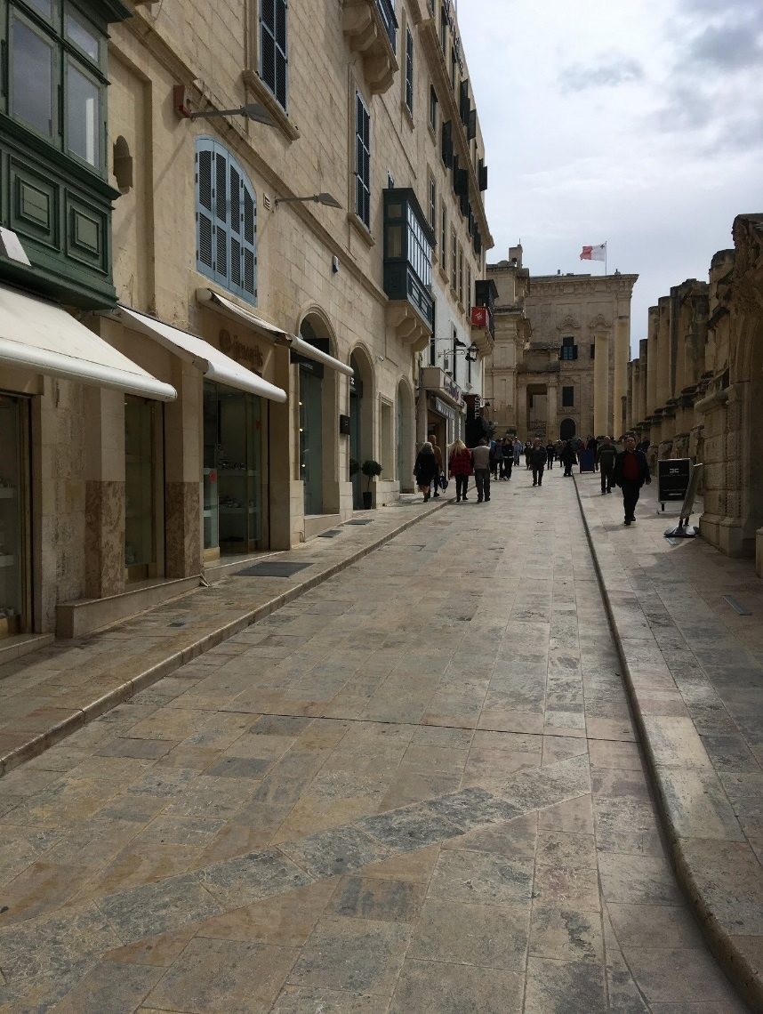

**Figure 2: Valletta, showing the upmarket ‘face’ of a refurbished streetscape**

The dominant historic cityscape dates from the 16th century with its rectilinear, grid-iron master plan, commissioned by the ruling Knights of St John, framing honey coloured cathedrals, domes, auberges, palaces and street canyons of high density residences and commercial spaces surrounded by extensive fortifications. Subsequent architecture styles reflect the imposition of the architecture of successive ‘Others’ and colonial influences, especially French and British and the devastating impacts of the two World Wars. Since independence in 1964, signifiers of Maltese identity such as the new Parliament Building, reinforce the city as Malta’s capital (for further detail on Valletta’s architectural history see e.g. Chapman & Cassar, 2004; Ebejer, 2018; Malta Government, 2016). However, despite its unique historic cityscape and role as the dominant city in Malta and a popular destination for tourists, Valletta has experienced extensive challenges. Notably, these have included an outmigration of population, poverty, high levels of property vacancy and declining commercial viability, as wealthier residents and businesses have relocated to more spacious and appropriate accommodation away from the city centre (Malta Government, 2016; Valletta Local Council, 2010).

It is argued that the preferred aesthetic of the wealthy elite is manifested in many facets of the cityscape *beyond* large scale iconic/signature design. Moreover, unlike many studies that focus on the predominant role of the iconic/monumental large-scale buildings (e.g. Ashworth & Tunbridge, 2017; Bianco, 2018; Smith, 2007), this study also includes the impact of this preferred aesthetic on the streetscapes of everyday living.

In the Valletta cityscape there are clear signs of the widespread adoption of the aesthetics of the elite. Radical transformation of parts of the city, particularly around the main entrance - City Gate (*Bieb il-Belt*), assert this dominance. The construction of Renzo Piano’s Parliament Building (*Il-Parlament il-Ġdid*) (completed 2014), brought an imposing addition to Freedom Square along with the remodelled City Gate itself and adjacent bastion walls. Immediately outside City Gate, a large new piazza (*pjazza*), Triton Place, with the restored Triton Fountain (*Il-Funtana tat-Tritoni*), at its centre, has created a grand entrance to the city, opened up new vistas of the city and neighbouring Floriana (*Il-Furjana*) and provided space for art installations and performance. In providing this new space, the bus station has been relocated to the south side of the piazza.

Accompanying these large scale, prestige developments are new streetscapes which also assert the uniform aesthetic characteristics of the elite’s ‘pattern book’ of development – modernist contemporary urban design, muted colour palette, quality building materials, decorative floorscapes, landscaping and subtle signage and overall appearing clean, even sanitised. Nevertheless, there is a vibrancy and distinctive patina to the city comprising common elements in its appearance, patterns, shapes and colour which contribute to its unique look. As an example, the decorative external features of the Parliament Building are mimicked in the new cladding on the façade of a shopping arcade across the road. The trend towards greater conformity and uniformity of style and diminished distinctiveness is visible in much of the central city (especially in the vicinity of the revitalised covered market *Is-Suq tal-Belt*), where changing retailing units are progressively becoming more high-end.

The major transformations of the city are taking place concurrently and within a short space of time. There is a sense of the wakening of a new aesthetic and awareness of a different look to parts of the city. Even though starting at different times, both planned and organic/ad hoc developments were completed just in time for 2018 and Valletta’s status as European Capital of Culture (ECoC) (Times of Malta, 2017). This occurrence has happened elsewhere, e.g. particularly in Rotterdam (Richards & Wilson, 2004) and Liverpool, in the run-up to their own hosting of ECoC, but has been particularly marked in Valletta.

At a time of post-mass tourism (Speake & Kennedy, 2019) and the experience economy (Benur & Bramwell, 2015; Pine & Gilmore, 1999), there are expected levels of comfort and familiarity (i.e. some homogeneity of offer and experience that aligns with that elsewhere). Boutique hotels may be classified as 3* (e.g. because they have no elevators) but have luxury attributes and are of the highest standard. This can also be seen giving traditional space contemporary twists, to create a mix of unfamiliar and familiar (heterogeneity and homogeneity), which are simultaneously different, other, exciting but at the same time familiar and safe. Floorspace levels for commercial and tourism accommodation doubled between 2011 and 2014, indicating the increasing popularity of Valletta for tourism largely due to the conversion of palaces (*palazzini*) and larger town houses into boutique hotels (Malta Government, 2016).

However, this aestheticisation occurs in pockets, it is fragmented, interdispersed with the ‘traditional cityscape’ attributes that are relatively untouched by elite aestheticisation, equivalent to the ‘back regions’ (Goffman, 1959), characterised by retailers selling domestic goods to local residents. This leads to both polarisation and juxtaposition of authenticity and staged authenticity and to a reduction in visual coherence that can contribute to a sense of place (Berleant, 2005; MacCannell, 1999). As Barretto (2013, p. 18) asks “why should back regions need decoration?”. Her response is that aesthetics provide the obvious answer.

There are growing concerns about the fate of heterogeneity in the face of increasing homogeneity (e.g. Zukin et al., 2015). This is particularly associated with the decline in visual and other ‘tradition’ which is resulting in the contestation by the less affluent of the imposition of the aesthetic and other values of the affluent elite. Much resistance is associated with the loss of [visual] identity that gives Valletta its unique character (Figure 3). As reported in other gentrifying cities and neighbourhoods (Zukin, 2010), there are concerns about the contraction of traditional retailing in Valletta and its impacts on the everyday ‘lived experience’ of the city (for those who visit and those who live and work in the city centre). Affordable prices have largely gone (Times of Malta, 2016). Two examples clearly demonstrate these changes, the regeneration of the *Is-Suq tal-Belt* (covered market) and the loss of *pastizzerias* (kiosks and small shops selling local pastries ‘*pastizzis’*).

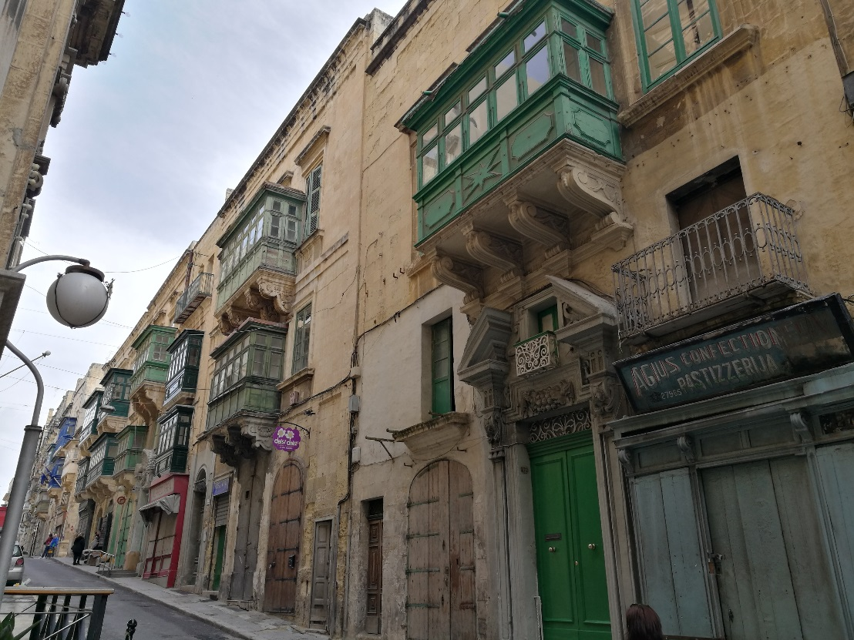

**Figure 3: Valletta, showing traditional cityscape, little touched by contemporary aestheticisation**

The 19th century *Is-Suq tal-Belt* originally sold local produce and was a hub of retail activity in the city centre. For many years it was in decline but its €14 m regeneration (2016-17), led by architect Marco Casamonti (Malta Independent, 2018) has reorientated its retailing upmarket. It is now an international food court with the UK based top-end supermarket Waitrose in the basement. In many ways it conforms to the expectations of wealthy residents and visitors and of those who aspire to the trappings of ‘luxury’ living. However, in doing so it outprices many residents and city workers. Although recent estimates (Anonymous, personal communication, March 2, 2018) suggest that 90% of people purchasing property in Valletta are Maltese, they do not have high disposable incomes.

Similar repositioning of the pastizzeria is happening, both spatially and symbolically. The traditional kiosks selling pastizzis challenge the emerging dominant aesthetic and concomitant streetscape experience. In areas which have recently experienced redevelopment, e.g. at City Gate, many traditional pastizzerias have closed or relocated. The new pastizzerias are repositioned up-market with commensurate price hikes – again pricing out many. There has been vociferous response and reaction to this as consternation and anger of local residents and others about the loss of cultural and visual identity, distinctiveness and authenticity (Zammit, 2018). As a consequence of public resistance, there are now traditional pastizzeria kiosks back in the Triton Place and City Gate area.

Thus currently, the juxtaposition of new build, up-market cityscape with lower cost, largely social housing is creating marked visual differences as well as reflecting serious underlying social and economic disparity (Government of Malta, 2016; Valletta Local Council, 2010). Underpinned by the legacy of ‘peppercorn’ (very low) rents in the 1960s, combined with passive land ownership (where owners keep property for speculative gain but with little or no obligation to maintain property), such areas are next in line to be gentrified. For the viewing public/tourist the atmosphere of the city as a transitioning city is unmistakeable. This is in marked contrast to viewing from a distance, with a dominant focus on the preferred historic gaze of the Valletta skyline when the poverty at street level is not ‘seen’, unless the viewer is particularly so informed. This poverty, evidenced in harsh living conditions and dilapidated buildings (Barretto, 2013), challenges expectations of the knowledge economy, changes the tourist experience of Valletta, impacts on the visitors ‘romantic, historic gaze’ and the commodified, mediatised preferred gaze. This adds another dimension to the process of place-making (Berglund & Gregory, 2019). The presence of stark poverty in the streets, such as a soup kitchen on a main route to the Sliema Ferry terminal, challenges the visitor to engage with, respond to and contest these conditions of urban life.

In the case of Valletta, there are clear visual signifiers of structural placemaking through standardised aesthetics, urban design elements and the erosion of local traditional cityscape. The adoption of the aesthetic values and luxury style statements of the affluent elite is having consequences on both the look and the identity of the city and its people. Local residents and businesses are already challenging, contesting and resisting the processes of intensive gentrification, massive increases in property prices, widespread adoption of elite aesthetics and a loss of Valletta traditions (Malta Independent, 2016; Malta Today, 2017; Markwick, 2018b). This is in keeping with similar experiences elsewhere (e.g. Berglund & Gregory, 2019; Novy & Colomb, 2019; Sequera & Nofre (2018). In common with other cities, such as Palma, Majorca (González-Pérez, 2019) and Barcelona (Cocola Grant, 2018), there is resistance too to the accompanying widespread displacement of lower income groups. In the case of Valletta, this movement has been from the old city to adjacent neighbourhoods such as Floriana. Concerns have been expressed about the well-being of vulnerable people who remain in the city centre (Malta Government, 2016; Valletta Local Council, 2010). However, the challenges of resistance are intense due to the large scale and great speed of the investment of mobile capital in the city’s property and pace of current urban change.

For the tourist, Valletta presents a challenge too, from the perspective of the city’s ‘face’ of upscale style symbolism combined with a unique World Heritage cityscape *and* displaying many of the standardised aesthetics characterising the investment of mobile capital. For many visitors this may be attractive, meeting their expectations of what a contemporary historic city should look like, whilst providing aesthetically ‘conforming’ standardised accommodation etc. For others, perhaps drawn from the increasing numbers of ‘niche tourists’ and cultural tourists seeking a more authentic experience, it may be too homogenised, familiar and superficial. Future research may consider these issues along with addressing questions such as: Do the changing aesthetics of Malta meet their ‘demands’/expectations? Might they seek even more of the up-market offer and international modern look? What might be the implications of this, for example is there an overdependence on it? How compatible is the traditional sun, sea and sand tourist offer with the new aesthetic?

Despite its current aura of conspicuous consumption, style status signifiers and affluence, alongside increasing visitor numbers, we assert that Valletta is a city potentially at risk. Primarily, this is due to a lack of diversified tourism product in a scenario in which the luxury, upmarket and expensive increasingly dominate. Secondly, the completion of major projects at the same time can lead to vulnerability in the future, for, although it might seem a positive mechanism of future proofing, obsolescence and decline will probably also happen at the same time, as experienced in many post-industrial cities worldwide. There are already examples of this in Malta, most notably happening with the decline of mass tourism resorts exemplified by Bugibba (Chapman & Speake, 2011) and more recently, Sliema. Responses to Sliema’s need for update to meet contemporary expectations are reflected in the up-market developments proposed for the emerging ‘Golden Mile’ northwards from Sliema to Paceville (Malta Today, 2016), which could present a major challenge to Valletta in terms of the provision of luxury life-style opportunities.

The economies of Valletta and Malta, as elsewhere, are vulnerable to the machinations and vagaries of the present phase of neoliberal capitalism, urban development and tourism trends. The nature of trajectories of change lie largely outside the hands of city or state, in the hands of the affluent elite, their mobile capital and the search for new, lucrative locations for its investment. With it comes a distinctive aesthetic ‘look’, one which through place making can change the ‘face’ of cities, reflect changing urban functions and also create up-market style statements in the cityscape which tourists experience, engage with, respond to and influence.

# CONCLUSION

This paper presents new insights into the nexi between aesthetics, power, property and tourism, within the context of the financialisation phase of neoliberal capitalism. It offers a conceptualisation of the ways in which tourists and others are adopting the preferred aesthetics of the affluent elite. By placing emphasis on the politico-economic contexts and by utilising a critical theory approach, the paper contributes to the current re-politicising and political turn within academic tourism research (e.g. Bianchi, 2018; Uitermark, Nicholls & Loopmans, 2012). The paper provides an analysis of the capitalist nature of property and development as the setting in which tourism operates. It does so specifically through the lens of cityscape aesthetics and place making and the ways in which these, as the product of the dominant aesthetics of the wealthy elite, impact on and influence, the tourist gaze and experience.

In order to attain this perspective and conceptualisation, the study synthesises material from a range of cognate discipline literature contexts (aesthetics and the affluent elite, property-led development and changing contemporary tourist destinations). We demonstrate the benefits of adopting a multidisciplinary approach (see also Alialy-Mattar & Thierstein, 2018). We show how essential multidisciplinarity and the analysis and synthesis of diverse, often compartmentalised, literature is to creating a more rounded and incisive understanding of the inherently complex processes at work in transforming cityscape, place making and the tourist experience.

Akin to other recent studies situated at the intersections of ‘placemaking’ and ‘place-making’ (for example, Mansilla & Milano, 2019), this study does not fit tidily into either of the classic binaries of ‘placemaking’ and ‘place-making’ (see Lew, 2017). It recognises both the ‘placemaking’, structural, top-down contributions of architects, planners and others *and* the role of the human agency of consumers and co-performers of place-making. Our research adds a different dimension to the place making literature in its exploration of the under researched role of aesthetic change and cityscape transformation, commodification and mediatisation, which extend the aesthetic to tourists and other urban users (see Figure 1). Our study shows how placemaking is associated with the materialisation (i.e. buildings and urban environment) of the preferred dominant aesthetics of the affluent elite, which generate a distinctive character within contemporary cityscapes. This is taking place with little emphasis given to, or focus on, tourist expectations.

This study also extends knowledge and understanding of how preferred gazes such as the future gaze (Jansson & Lagerkvist, 2009; Speake, 2017), are integrated into urban (re)development cityscape change and place making. It is also important for this to be explored within the context of the perspectives of urban users including tourists, in the light of changing tourist behaviour associated with post-mass tourism (see also Speake & Kennedy, 2019). We assert that this is demonstrated through the style seeking of tourists influencing the creation of places and how this contributes to their expectation of what contemporary cities ‘should’ look like.

A key facet of this study is to show how cityscapes are (re)scripted according to the preferred gaze of the wealthy elite. All aspects of cityscape are involved, including residential, commercial and administrative functions. The status symbolism of the rich is thus (re)scripted into cities by architects, designers and planners. The outcome is styled-for-status built environments and streetscapes. These cityscape products are attractive and marketable to the wealthy whose capital fuels their creation. In addition, through astute mediatisation and place/destination promotion by city and tourist authorities, these style-status leading cityscapes are then presented to less affluent users (including tourists) as aspirational places and destinations in which to live, work or visit (Speake & Kennedy, 2019). At this point, the human agency of tourists and other urban users invoke processes of place-making and engage with, influence and ultimately shape the evolving city. The degree to which these developments may attempt to mimic the initial aesthetic drivers of the wealthy elite is impacted on by the availability of capital and creative scripting, planning contexts among other generators of change. This is a potentially fruitful area for future research.

In our application of a critical theory approach, the Gramscian context of ‘common sense’ (Gramsci, 1971), provides a revealing lens through which to conceptualise how the wealthy elite exert and maintain power as the less affluent, aspire to and accept the values of the affluent elite. The mediatisation of these values through popular and social media reinforce the ‘value’ of luxury living, celebrity lifestyles and the aesthetic preferences of the affluent elite that are presented and projected to tourists and others as the values of contemporary culture. The adoption of these values within urban settings, asserts the power and influence of the affluent elite and provides the framework for much contemporary urban (re)development and place making. In turn, the transformed city is commodified and mediatised to project the aesthetic (and other) values of the affluent elite and influence others, including mobile middle class tourists to succumb to them and buy into them. However, an unplanned outcome of this, as evidenced through tourist-led place-making, is that it presents a challenge to the hegemonic, structural, top-down placemaking of the elite (Kennedy & Speake, 2018).

In our interpretation of ‘aesthetic common sense’, tourists and others consume the (re)scripted, mediatised cityscapes presented to them. Our study demonstrates how “… all experience, including aesthetic, is never entirely personal but is always part of a situational process” (Berleant, 2005, p. 107). It is situational in the sense that while each city has a unique urban environment, it reflects wider trends and socio-political and economic contexts of neoliberalism and the power-broking of the affluent elite. For many cities, including Valletta, the challenge is to maintain individual distinctiveness and their unique selling point at a time in which the forces within the financialisation phase of neoliberal capitalism are intensifying. Moreover, urban transformations are not always planned and place-making can occur organically and swiftly (Sofield et al., 2017; Zukin, 2010; Zukin et al. 2015). Neither are these changes solely associated with the construction of iconic and signature buildings, despite the perspective generated within the extensive literature on monumentality and planned grand iconic cityscape change (e.g. Sklair, 2017; Smith, 2007; Alaily-Mattar et al., 2018).

We have identified that in comparison to the dominant, important, focus on iconicity and cityscape there is, and has been, far less focus on very recent piecemeal, organic *aesthetic* transformation of cities and the longer-term implications for the maintenance of distinctive cityscape aesthetics and identity. Thus, this paper has moved beyond the focus on iconic buildings and spaces to explore everyday streetscapes from the aesthetic perspective. Our emphasis has been to reflect on the *aesthetic* dimension, rather than take the wider view of social and cultural change associated with processes of gentrification, such as those reported for example by Zukin (2010) in her exploration of the demise and rebirth of authentic urban places in *Naked City* and by Zukin et al. (2015) and Philips (2018). Our study has focused on myriad, entangled components of streetscape aesthetics, particularly those generated by the adoption of standardised, international aesthetics. As in other cities elsewhere (for example New York (Zukin, 2010) and Shanghai (Zukin et al. 2015)), the changing visual appearance of Valletta is happening by design, (re)scripting (planned) and stealth – it creeps in little by little in a piecemeal way. Subtle, sometimes small-scale change in visual artefacts and function occur and, before long, the historic, traditional vernacular is subverted, irrevocably changed or has ‘vanished’. All too often recognition of this comes as a “momentary awareness or shocking realization” (Berleant, 2005, pp. 156), too late for effective response, and despite warnings by scholars (e.g. Battaglia, 1998) of the dangers of adopting internationalised design that contrasts sharply with local urban settings.

We maintain that aesthetic situations (including architecture) are essentially social (Berleant, 2005) and that politico-economic, cultural and social contextualisation is vital to the understanding of tourists’ and others’ reactions and responses to changing cityscapes and place making. Cityscape change represents the evolution of the city itself and the city as a tourist destination. From the tourist perspective, the reduction in actual or perceived place authenticity and the creation of unmemorable, dull spaces creates standardisation, familiarity and ‘ordinaryness’. While on the one hand the latter may make the tourist more ‘at home’ and ‘comfortable’, on the other hand these evocations of mundane and banal aesthetics may deflect from the sense of distinctiveness, sense of place and unique selling point. It is an area of study ripe for further research.

# Notes on contributors

*Dr Janet Speake* is Associate Professor in Geography and Associate Dean Postgraduate Research at Liverpool Hope University. Her research interests centre on the contemporary transformation of urban areas, spaces of affectivity and the impacts of satellite navigation technologies on spatial awareness. ([speakej@hope.ac.uk](mailto:speakej@hope.ac.uk))

*Dr Victoria Kennedy* is Lecturer in Tourism at Liverpool Hope University. Her research interests include stakeholder theory and engagement, tourism policy, power, destination management and seaside tourism. ([kennedv@hope.ac.uk](mailto:kennedv@hope.ac.uk))

# REFERENCES

Aalbers, M.B. (2019). Financial geography III: The financialization of the city. Progress in Human Geography. Advance online publication. <https://doi.org/10.1177%2F0309132519853922>

Alaily-Mattar, N. & Thierstein, A. (2018). Urban transformations through exceptional architecture: Introduction to the special issue. *Journal of Urban Design, 23*(2), 165-168.

Alaily-Mattar, N., Dreher, J. & Thierstein, A. (2018). Repositioning cities through star architecture: How does it work? *Journal of Urban Design, 23*(2), 169-192.

Ashworth, G. J. & Tunbridge, J. E. (2017). Multiple approaches to heritage in urban regeneration: The case of City Gate, Valletta. *Journal of Urban Design, 22*(4), 494-501.

Baggio, R. & Moretti, V. (2018). Beauty as a factor of economic and social development. *Tourism Review, 73*(1), 68-81.

Barretto, M. (2013). Aesthetics and tourism. *Pasos, 11*(3), 79-81.

Battaglia, R. (1998). Shame in Spain. *Architecture, 87*(2), 19.

Benur, A.M. & Bramwell, B. (2015). Tourism product development and product diversification in destinations. *Tourism Management, 50,* 213-224.

Berglund, L. & Gregory, S. (2019). Introduction: the aesthetics of neighborhood change. *Journal of Cultural Geography*. Advance online publication. DOI: [10.1080/08873631.2019.1595915](https://doi.org/10.1080/08873631.2019.1595915)

Berleant. A. (2004). The aesthetics in place. In S. Menin. (Ed.), *Constructing place: Mind and the matter of place-making* (pp. 41-54). London: Routledge.

Berleant, A. (2005). *Aesthetics and the environment. Variations on a theme*. Aldershot: Ashgate.

Bianchi, R. (2018). The political economy of tourism development: A critical review*. Annals of Tourism Research, 70*, 88-102.

Bianco, L. (2006). Malta: Housing and real estate, 1980-2005. *Architectural Design, 76*(3), 76-81.

Bianco, L. (2018). Architecture, values and perception: Between rhetoric and reality. *Frontiers of Architectural Research, 7*, 92-99.

Billiard, E. (2014). La moralité des espaces publics dans le quartier des plaisirs maltais. *Urbanites # 3*. April 2014.

Bramwell, B., & Rawding, L. (1996). Tourism marketing images of industrial cities. *Annals of Tourism Research, 23*(1), 201-221.

Brenner, N., Peck, J. & Theodore, N. (2010). After neoliberalization? *Globalizations, 7*(3), 327-379.

Camilleri, J., & Neuhofer, B. (2017). Value co-creation and co-destruction in the airbnb sharing economy. *International Journal of Contemporary Hospitality Management, 29*(9), 2322-2340.

Chapman, D. & Cassar, G. (2004). City profile: Valletta. *Cities, 21*(5), 451-463.

Chapman, A. & Speake, J. (2011). Regeneration in a mass-tourism resort: The changing fortunes of Bugibba, Malta. *Tourism Management, 32*(3), 482-491.

Christophers, B. (2016). For real: Land as capital and commodity*. Transactions of the Institute of British Geographers,* 41, 134-148.

Cocola Gant, A. (2018). *Struggling with the leisure class: Tourism, gentrification and displacement* (Doctoral dissertation, Cardiff University).

Dewey, J. (1932). *Art as experience*. New York: McMillan, Balch & Co.

Dorling, D. (2014). *Inequality and the 1%.* London: Verso.

Ebejer, J. (2018). Urban heritage and cultural tourism development: A case study of Valletta’s role in Malta’s tourism. *Journal of Tourism and Cultural Change.* DOI: [10.1080/14766825.2018.1447950](https://doi.org/10.1080/14766825.2018.1447950)

Everett, S. (2012). Production places or consumption spaces? The place-making agency of food tourism in Ireland and Scotland. *Tourism Geographies, 14*(4), 535-554.

Forrest, R., Koh, S.Y. & Wissink, B. (2017). In search of the super-rich: Who are they? Where are they? In: R. Forest, S. Y. Koh & B. Wissink, (Eds.), *Cities and the super-rich,* (pp. 1-18). New York: Palgrave-McMillan.

Ghertner, D. A. (2015). *Rule by aesthetics: World-class city making in Delhi*. Oxford: Oxford University Press.

Goffman, E. (1959). *The presentation of self in everyday life*. Garden City, New York: Doubleday.

González-Pérez, J. M. (2019). The dispute over tourist cities. Tourism gentrification in the historic Centre of Palma (Majorca, Spain). *Tourism Geographies*, 1-21.

Gramsci, A. (1971). *Selections from the prison notebooks*. London: Lawrence and Wishart.

Horkheimer, M., Adorno, T. W., & Noeri, G. (2002 [1947]). *Dialectic of enlightenment*. Stanford: Stanford University Press.

Hultman, J. & Hall, C.M. (2012). Tourism place-making: Governance of locality in Sweden. *Annals of Tourism Research, 39*(2), 547-570.

Jansson, A., & Lagerkvist, A. (2009). The future gaze: City panoramas as politico-emotive geographies. *Journal of Visual Culture, 8*(1), 25-53.

Jones, A. (2018). Case Study Malta: Climate change and tourism: Risks, hazards and resilience – An island perspective. In: A. Jones & M. Phillips (Eds.), *Global climate change and coastal tourism* (pp. 138-146), Wallingford: CABI.

Kaika, M. (2010). Architecture and crisis: Re‐inventing the icon, re‐imag (in) ing London and re‐branding the City. *Transactions of the Institute of British Geographers, 35*(4), 453-474.

Kennedy, V. & Augustyn, M. (2014). Stakeholder power and engagement in an English seaside context: Implications for destination leadership. *Tourism Review, 69*(3), 187-201.

Kennedy, V. & Speake, J. (2018, July). *Waterfront property-led development in Malta under neo-liberal capitalism: Changing tourist behaviour and the appeal of luxury borrowed spaces.* Paper presented at the Fifth Global Conference on Economic Geography, Cologne, Germany.

Kincheloe, J.L. & McLaren, P. (2002). Rethinking critical theory and qualitative research. *Ethnography and schools: Qualitative approaches to the study of education*, 87-138.

Kolås, Å. (2004). Tourism and the making of place in Shangri-La. *Tourism Geographies*, 6(3), 262–278.

Lees, L. (2008). Gentrification and social mixing: Towards an inclusive urban renaissance? *Urban Studies, 45*(12), 2449-2470.

Lew, A.A. (2008). Long tail tourism: new geographies for marketing niche tourism products. *Journal of Travel & Tourism Marketing, 25*(3-4), 409-419.

Lew, A.A. (2012). Tourism planning and place making: Place-making or placemaking? *Tourism Geographies, 19* (3), 448-466.

MacCannell, D. (1999). *The tourist: A new theory of the leisure class.* Berkeley: University of California Press.

Maitland, R. & Smith, A. (2009). Tourism and the aesthetics of the built environment. In: J. Tribe (ed). *Philosophical issues in tourism* (pp.171-190), Bristol: Channel View Publications.

Malta Independent (2016, April 18). The changing face of Valletta. *Malta Independent.* Retrieved from: <http://www.independent.com.mt/articles/2016-04-18/newspaper-lifestyleculture/The-changing-face-of-Valletta-6736156489>

Malta Independent (2018, January 6). Is-Suq tal-Belt (Valletta market): Doors open, public pours in. *Malta Independent*. Retrieved from: <http://www.independent.com.mt/articles/2018-01-06/local-news/Is-Suq-tal-Belt-Valletta-market-Doors-open-public-pours-in-6736183261>

Malta Government (2016). A strategy for Valletta. *Planning Authority and Office of the Principal Permanent Secretary, Malta Government, Valletta*. Retrieved from: <http://www.independent.com.mt/filebank/Valletta_Strategy_June_2016.pdf>

Malta Today (2016, September 26). The golden mile: Bold planning for the elite. *Malta Today.* Retrieved from: <https://www.maltatoday.com.mt/news/national/69929/the_golden_mile_bold_planning_for_the_elites#.Wuw5g5ch1PY>

Malta Today (2017, November 13). Cities of justice: Reclaiming Valletta from the market forces of gentrification. *Malta Today.* Retrieved from: <https://www.maltatoday.com.mt/arts/valletta_2018/82118/cities_of_justice_Valletta#.WvHsv4gvzIU>

Malta Tourism Authority [MTA] (2018). *Tourism in Malta*. Presentation by the Malta Tourism Authority at the University of Malta, 1st March, 2018.

Malta Tourism Authority [MTA] (2019). *Tourism in the Maltese Islands.* Presentation by the Malta Tourism Authority at the University of Malta, 25th February 2019.

Mansilla, J.A. & Milano, C. (2019): Becoming centre: tourism placemaking and space production in two neighborhoods in Barcelona. *Tourism Geographies*, DOI: 10.1080/14616688.2019.1571097

Markwick, M. (2018a). Creative clusters in the regeneration of Valletta and the cultural politics of Strait Street. *Urban Research & Practice, 11*(2), 87-110.

Markwick, M. (2018b). Valletta ECoC 2018 and cultural tourism development. *Journal of Tourism and Cultural Change, 16*(3), 286-308.

Martin, I. W., & Beck, K. (2018). Gentrification, property tax limitation, and displacement. *Urban Affairs Review, 54*(1), 33-73.

Marvell, A. D. & Simm, D. (2016). Unravelling the geographical palimpsest through fieldwork: Discovering a sense of place. *Geography, 101*(3), 125-136.

Merrifield, A. (2013). *The politics of the encounter: Urban theory and protest under planetary urbanism*. University of Georgia Press.

Mostafanezhad, M. (2018). The geopolitical turn in tourism geographies. *Tourism Geographies, 20*(2), 343-346.

Novy, J., & Colomb, C. (2019). Urban tourism as a source of contention and social

mobilisations: a critical review. *Tourism Planning & Development*, *16*(4), 358-375.

NSO (2012). *Census of population and housing*. Valletta: National Statistics Office.

Philips, M. (2018). Gentrification and landscape change. In: L. Lees, L. & M. Philips (Eds.), *Handbook of gentrification studies,* pp. 81-100. Cheltenham, UK: Edward Elgar Publishing

Pine, J. & Gilmore, J.H. (1999). *The experience economy: Work is theatre & every business a stage.* Boston: Harvard Business School Press.

Ponzini, D. & Manfredini, F. (2017). New methods for studying transnational architecture and urbanism: A primer. *Territorio.* May 2017.

Ponzini, D. & Nastasi, M. (2011). *Starchitecture: Scenes, actors and spectacles in contemporary cities.* New York: The Monacelli Press.

Ponzini, D. & Ruoppila, S. (2018). Local politics and planning over transnational initiatives: The case of Guggenheim Helsinki. *Journal of Urban Design, 23*(2), 223-238.

Postrel, V. (2003). *The substance of style: How the rise of aesthetic value is remaking commerce, culture and consciousness*. New York, Harper Collins.

Pow, C.P. (2009). Neoliberalism and the aestheticisation of new middle-class landscapes. *Antipode. 41*(2), pp. 371-390.

Relph, E. (2016). *The modern urban landscape (Routledge Revivals).* Abingdon: Routledge.

Richards, G., & Wilson, J. (2004). The impact of cultural events on city image: Rotterdam, cultural capital of Europe 2001. *Urban Studies, 41*(10), 1931-1951.

Sacco, P. L., & Vella, G. (2017). Introduction to Valletta2018 cultural mapping: Debating space and place. *City, Culture and Society, 11*, 1-3.

Sequera, J., & Nofre, J. (2018). Shaken, not stirred: New debates on touristification and the

limits of gentrification. *City*, *22*(5-6), 843-855.

Sklair, L. (2002). The transnational capitalist class and global politics: Deconstructing the corporate-state connection. *International political science review, 23*(2), 159-174.

Sklair, L. (2016). The transnational capitalist class, social movements, and alternatives to capitalist globalization. *International Critical Thought, 6*(3), 329-341.

Sklair, L. (2017). *The icon project: Architecture, cities, and capitalist globalization*. Oxford: Oxford University Press.

Smith, A. (2007). Monumentality in ‘capital’ cities and its implications for tourism marketing: The case of Barcelona*. Journal of Travel and Tourism Marketing, 22*(3-4), 79-93.

Sofield, T., Guia, J. & Specht, J. (2017). Organic ‘folkloric’ community driven place-making and tourism. *Tourism Management, 61*, 1-22.

Speake, J. (2017). Urban development and visual culture: Commodifying the gaze in the regeneration of Tigné Point, Malta. *Urban Studies, 54*(13), 2919-2934.

Speake, J. & Kennedy, V. (2019). ‘Buying’ into the waterfront dream? Trajectories of luxury property-led developments in Malta. *Tourism Management, 71*, 246-258.

Stake, R. E. (2005) Qualitative case studies. In Denzin, N. K. & Lincoln, Y. S. (Eds.) *The Sage handbook of qualitative research* (pp. 443-466).London: Sage.

Sudjic, D. (2005). *The edifice complex: How the rich and powerful shape the world*. Allen Lane: London.

Teddlie, C. & Tashakkori, A. (2009). *Foundations of mixed methods research: Integrating quantitative and qualitative approaches in the social and behavioural sciences,* Thousand Oaks, CA: Sage Publications.

Times of Malta (2016, August 24). Trying to make rent in a booming Valletta market. *Times of Malta.* Retrieved from: <https://www.timesofmalta.com/articles/view/20160824/local/trying-to-make-rent-in-a-booming-valletta-market.622891>

Times of Malta (2017, December 3). Triton Place and Is-Suq tal-Belt to be ready ‘just in time’. *Times of Malta*. Retrieved from: <https://www.timesofmalta.com/articles/view/20171203/local/triton-place-and-is-suq-tal-belt-to-be-ready-just-in-time.664696>

Urry, J. (1990). *The tourist gaze: Leisure and travel in contemporary societies.* London: Sage.

Uitermark, J., Nicholls, W., & Loopmans, M. (2012). Cities and social movements: theorizing beyond the right to the city. *Environment and Planning A 2012, 44*, 2546 – 2554.

Valletta Local Council (2010). *Valletta action plan: Integrated cultural heritage management plan.* Retrieved from Valletta Local Council website: <http://www.cityofvalletta.org/common/file_provider.aspx?id=634612821044531250>

Weber, R. (2010). Selling city futures: The financialization of urban redevelopment policy. *Economic Geography, 86*(3), 251-274.

Weber, R. (2002). Extracting value from the city: Neoliberalism and urban redevelopment. *Antipode, 34*(3), 519-540.

Wharton, A.J. (2001). *Building the cold war: Hilton international hotels and modern architecture.* Chicago: University of Chicago Press.

Wilson, E. and Hollinshead, K. (2015). Qualitative tourism research: Opportunities in the emergent soft sciences. *Annals of Tourism Research, 54*, 30-47.

Wyckoff, M. A. (2014). Definition of placemaking: Four different types. *Planning & Zoning News, 32*(3). Retrieved from http://www.canr.msu.edu/news/lpis_mark_wyckoff_authors_article_on_ four_different_types_of_placemaking.

Yeoman, I., & McMahon-Beattie, U. (2006). Luxury markets and premium pricing. *Journal of Revenue and Pricing Management, 4*(4), 319-328.

Yeoman, I., & McMahon-Beattie, U. (2018). The future of luxury: mega drivers, new faces and scenarios. *Journal of Revenue and Pricing Management*, *17*(4), 204-217.

Zammit, P. (2018). *Valletta’s renaissance: A quick fix or evolving growth?* Retrieved from: <http://www.vida.com.mt/vallettas-renaissance-quick-fix-evolving-growth/>

Zukin, S. (2010). *Naked city: The life and death of authentic urban places*. New York: Oxford.

Zukin, S., Kasinitz, P. & Chen, X. (2015). *Global cities, local streets: Everyday diversity from New York to Shanghai.* London: Routledge.