Geographical Considerations for Implementing Autonomous Unmanned Solar-HAPS for Communications Area Coverage

Ogbonnaya Anicho, Philip B Charlesworth, Gurvinder Baicher, and Atulya Nagar

**Abstract**—The impact and requirements for implementing stratospheric or high altitude vehicles for communications coverage may vary from one geographical location to another. These variations may impose significant constraints on energy and various key parameters of the vehicle’s operation and performance.This paper therefore, examines the potential for autonomous fixed-wing unmanned (Pilot-less) solar-powered High Altitude Platform Station or Pseudo-Satellite (HAPS) to provide persistent communications coverage. As a solar dependent platform, the potential for harnessing green energy and long platform endurance makes it an attractive communications coverage option. However, the variation of latitude and seasons across the globe presents an implementation constraint and challenges power availability and coverage capability. This paper investigates how the services of a typical

solar-powered HAPS are affected by latitude and season. It shows that the degree of insolation directly affects the unmanned aircraft’s altitude, hence, its footprint diameter and power available to the communications payload. The paper highlights effective energy management algorithms as key to successful implementation of solar-powered unmanned HAPS especially at challenging latitudes and seasons.

**Index Terms**—Solar-Powered HAPS, Communications, UAV.

✦

1. **INTRODUCTION**

HAPS is considered a platform for providing persis- tent communications coverage to mobile and fixed users, with inherent technical strengths of terrestrial and satellite communications systems combined [1], [2], [3]. Specifically, HAPS offer large footprints with signal latency similar to terrestrial systems. Furthermore, they can be easily recov- ered and redeployed to meet changes in demand, a new capability that neither satellite nor terrestrial systems can offer effectively.

Providing communications coverage and services from unmanned HAPS platforms has been proposed in literature and treated in varying depths by Grace et al and others, for example [4]. The application of HAPS for broadband im- plementation specifically has also been widely investigated and cited as a potentially viable technology for providing wide area broadband coverage [3], [2]. However, until spe- cific technical challenges are resolved, HAPS may not be integrated fully both as a communications infrastructure and an aviation vehicle [5]. Early studies were based on lighter-than-air (LTA) craft [1], [2], but recent developments by Airbus (Zephyr-S) and others have shown that heavier- than-air (HTA) craft offer a feasible alternative [6].

This paper considers how a particular type of HAPS, based on solar-electric aircraft, can be used to provide area communications coverage from altitudes up to 25km. Area coverage in this context refers to a form of blanket coverage

* *O. Anicho is a Ph.D., candidate with Liverpool Hope University, United Kingdom.*

*E-mail:* [*anichoo@hope.ac.uk*](mailto:anichoo@hope.ac.uk)

* *P. Charlesworth, G. Baicher and A. Nagar are with Liverpool Hope University.*

*Manuscript sent December 12, 2018; revised December , 2018.*

as defined by Gage and Howard et al [7], [8], to provide communications services over an area of interest. A HAPS operating at such altitudes has a usable communications footprint of approximately 130 km diameter or up to 14000 sq km circular area depending on considered elevation angle [9]. The choice of platform and its characteristics strongly influence the service that can be delivered to sub- scribers [10], [11]. Futhermore, the design and construction of solar-powered fixed-wing aircraft demands very light aircraft with large wing area [12]. Making the craft light- weight makes it susceptible to adverse winds and turbu- lence, particularly when climbing to or descending from its operating altitude. The current generation of fixed-wing HAPS can typically carry payloads of a few tens of kg and support them with a few hundred watts placing limits on the complexity and functionality of the payloads. Airbus and few other players have HAPS platforms at varying levels of development [6].

Although, Solar-electric aircrafts may enable signifi- cantly increased flight endurance they present power man- agement challenges [13]. During the day the solar panels need to generate a surplus of energy that can be stored for overnight use. Most of this energy is stored electrically in batteries, but some is stored as potential energy by using propulsive power to increase altitude. The stored electrical energy can be released overnight to power onboard sys- tems, including the communications payload. Any remain- ing electrical energy can be used to maintain altitude until safety margins are reached. After this the aircraft glides to a lower altitude until the sun illuminates the solar panels after dawn.

# 1.1 Geographical Considerations

On key area of consideration which underpins this work is the impact of geography on the operations of the solar HAPS. During winter at higher latitudes the short days and low elevation angle of the sun provide a worst-case scenario for solar HAPS. The long night deeply discharges the batteries, and the low insolation barely replenishes the batteries before sunset. Increasing the battery capacity is not always possible, the additional weight can result in steeper glides and lower final altitudes, requiring increased propulsive energy to climb back to the operating altitude. There is thus a limit to the highest latitude at which any solar-electric aircraft can operate continuously. Therefore, geography may be a major consideration in the implemen- tation of this technology globally and forms a key aspect of this work.

The geographical factor introduces a complex energy management dynamics and has two main effects on the communications payload. Firstly, the stored electrical en- ergy must be rationed to ensure that the aircraft systems operate. This may involve reducing power to the payload during the night, hence reducing the services available to subscribers. Secondly, the reduction in altitude during the night reduces the diameter of the communications footprint. This directly affects the service to subscribers at the edge of the footprint. Implementing HAPS in the described manner may have significant impact as terrestrial systems are essen- tially fixed infrastructure while satellite constellations have limitations of cost and complex operational requirements [14], [3]. This work describes how this problem is being addressed through current research efforts in this field. To realise the full potential of HAPS and to position it as a viable solution for providing communication services, extensive research has to address the complexity and chal- lenges of seamless solar power collection and management. In this paper, section 1 introduces unmanned fixed wing solar-powered HAPS and its unique capabilities and limi- tations. In section 2 the scenario and problem formulation details are introduced. Section 3 describes the model of the simulated HAPS highlighting its aeronautical, power and communications payload configurations. Section 5 details the simulation scenario and presents simulation results of power and coverage performance of the solar HAPS plat- form at different latitudes and seasons. The result analysis provides insight into the unique challenges of power on system availability and coverage capability. Finally, section 6 draws conclusions on the work and considers future work.

1. **SCENARIO AND PROBLEM FORMULATION**

The application of solar-HAPS stretches technical capability as it demands significant improvement in size, weight and power (SWaP) dimensions. However, energy profile of solar dependent HAPS systems will have considerable impact on available power for flight control, propulsion and payloads and therefore, demands further research. Solar irradiance theoretically varies globally depending on latitude and sea- son. This research paper investigates how much impact latitude and season variation will have on the performance of a solar-powered HAPS platform. Since, footprint changes with altitude and altitude is a function of available power

required to maintain the HAPS at such altitudes [5]. It follows therefore, that coverage may be impacted if solar irradiance varies significantly and affects available energy storage. The work studies various geographical latitudes to establish a variation curve that may provide tighter perfor- mance measurements for HAPS design and implementation consideration. This work therefore lays a foundation and provides a basis to investigate performance of solar HAPS in different latitudes and how coverage and energy chal- lenges vary from latitude to latitude. The HAPS was later simulated to operate specifically at 6 degrees latitude due to proximity to the equator and assumed higher irradiance throughout the year, and at higher latitude of 53 degrees. By comparing the performance of the HAPS in these latitudes, the problem could be investigated within two distinct geo- graphical scenarios (these latitudes were chosen arbitrarily), to move from generalisations to specifics.

1. **MODELING AND SIMULATION BACKGROUND**

This section describes the modeling principles and simula- tion method implemented to address the research problem. Modeling and simulation fidelity is critical to the validity of results and this chapter details the research methodology applied. A model is a representation or approximation of a real system or phenomena and can be physical, mathe- matical or a logical representation [15]. It is a purposeful abstraction of a real system which aids the approximation of the system to a set of meaningful attributes [16]. The level of abstraction and underlying assumptions may affect the validity and fidelity of the model and simulation output. Understanding what attributes of the modeled system to ab- stract is one of the main challenges in modeling any system. Simulation, however, involves the execution of the model over time. To investigate this problem, a software model of key system segments were developed using Matlab and simulated to investigate different aspects of the research problem. The models were based on standard aerodynamic and communication link equations. The system models are designed to be modular in nature for smoother implementa- tion and debugging. Each system abstraction was developed as a software model. For instance, the HAPS aircraft model is based on established aerodynamic equations for lift, drag, thrust and weight (model and system specifications are shown in the next section).

# HAPS Model and System Specifications

The chosen HAPS platform for this research is a solar- powered unmanned aerial vehicle with characteristics typ- ical of emerging HAPS platforms. The model used in these simulations includes the kinematic model of the aircraft in 6 degrees of freedom (3 translational and 3 rotational), a solar model supported by an energy management algorithm and a communications model. To successfully model the HAPS system as conceived for this project the following models and concepts were applied;

* + - Reference Frame Transformation.
    - HAPS Flight Dynamics Model.
    - HAPS Navigation Model.
    - HAPS Solar Energy Model.

The above concepts and models are further described in some details in the sections below.

# Reference Frame Transformation

HAPS as an aerial vehicle has kinematic attributes and re- quires precise resolution of reference frames and coordinate systems for accurate analysis of its motion in space. Refer- ence frames are mathematical constructs or systems that are used to specify or establish distances and direction [17], [18] and could be inertial or non-inertial. Coordinate systems, however, are measurement systems for locating points in space [17], [18] in a given reference frame, with coordinates and an origin. In essence, reference frames are quantified by coordinate systems [19], these terms should not be used in- terchangeably. The modeled HAPS vehicle is defined by its orientation in 3-dimensional space and with its orientation parameters, the angle of incidence of solar radiation on the HAPS solar panels can be calculated. Accurately tracking the Sun’s elevation angle and the local HAPS orientation involves complex coordinate system transformations. The model was relied on for the transformation of reference frames and coordinate systems which is central to achieving accurate simulation results. The model adopted the World Geodetic System 1984 standard (WGS-84), which specifies the shape of the earth as oblate spheroid with circular cross section at any given latitude, and an ellipse through a meridian, with identical axes lengths for all longitudes [20] i.e.

1) Semi-major: a = 6,378,137 m

2) Semi-minor: b = 6,356,752.3142 m.

# Flight Kinematics and HAPS Flight Dynamics Model

The kinematics of mechanical systems or objects gener- ally, describes their motion without considering the forces or mechanisms that produce these motions [17], [21]. All aircraft are governed by the laws of physics, however, their specific motion profiles are different depending on shape, weight, propulsion systems and atmospheric en- vironment. The HAPS vehicle is treated as a body with a three-dimensional configuration, with position defined by the coordinates of a specific reference point on or in the body; while the velocity is defined by the velocity of this reference point [21]. The HAPS heading and bearing defines its navigation and orientation vectors with respect to the specific reference frame under consideration. The model is further simplified to address the restrictions of 6 degrees of freedom (6DOF) by decoupling the kinematics to consider only simple turns for both the horizontal and vertical components of motion of the HAPS platform [22], [23]. In this research work, the solar-powered HAPS is mod- eled as a parameterised aircraft model in three-dimensional space [22]. This simplified model is derived from reasonable abstractions and assumptions valid within the context of the research problem. Aerospace simulations require mod- eling of essential aspects of the vehicle and its kinematic attributes. The model considers aerodynamic forces acting on the platform, these forces such as lift, drag and thrust are computed based on established flight dynamics model.

The air density which changes with altitude has significant impact on the kinematic model of the vehicle, as the thinner the air, the lesser the thrust developed by the propellers for any given propeller speed (in revolutions per second). The main aerodynamic forces acting on the HAPS such as lift, drag and thrust are dependent on the density of the atmosphere which varies with altitude [22], [21]. By specifying relevant parameters the aerodynamic profile of the HAPS can be modeled using the standard atmospheric model to derive the density at any given altitude. The model equations were coded in MATLAB as functions and integrated into the model and simulation platform.

# HAPS Navigation Model

The navigation model of the HAPS aircraft defines its move- ment from one location to another within the simulation scenario. In any navigational system the vehicle position given in geographic coordinates ( geodetic latitude, geodetic longitude and altitude) is the key parameter. The model is simplified to use basic dead reckoning principles for HAPS navigation. Navigation is achieved by extrapolation of the current(known) latitude and longitude of the HAPS to obtain the ’next’ latitude and longitude using the aircraft speed and heading vectors. The simulation applies spheri- cal earth model unless for very short distances where flat earth implementations can be used with negligible error. By employing this navigational principle the HAPS movement is modeled to approximate real aircraft systems within abstractions relevant for the problem. The effect of wind turbulence or wind induced course errors are assumed to be negligible due to stratospheric wind profile which is relatively mild [24].

# HAPS Solar Energy Model

This sub-section describes how the solar energy profile of the HAPS system is modeled. The accuracy and validity of the model is of critical importance to the simulation output and analysis. The model is based on standard insolation parameters and Sun ephemeris data. The reference frame transformation model is also very important in modeling accurate insolation profiles at any geographical latitude. The derivation of the angle of elevation of the Sun on the HAPS solar panels cannot be derived directly as both objects exist in different reference frames. To obtain the Sun’s elevation angle in HAPS Aircraft Body Frame (ABF), a standard pro- cess of transformation is required as described earlier. The simulation process executes the matrix transformation and determines the Sun elevation angle in the right reference frame and outputs value for computing the instantaneous Solar output power. The HAPS solar modules are modeled as a single module defined by the surface area of the wing with dimensions as reflected in table 1. The attitude of the HAPS with respect to wing orientation is assumed aligned along the direction of flight. This model provides valid solar model outputs comparable for instance to lower altitude simulation model output as given by Oettershagen et al [13]. However, future models will explore incorporating attitude adjustment manoeuvres to expose the wing area to more sunlight while the gimbal assembly focuses the antenna for consistent ground coverage. Another essential aspect

of the solar model is the battery storage module which is modeled with the energy density (400W-hr/Kg is assumed for this model) and battery weight parameters also captured in figure 2. The key elements for the solar energy model applied within the work are [22];

* + - Area of HAPS Solar Panel (*HP* )
    - Efficiency of Panel (*ηP* )
    - Insolation of the Sun (*Is*)
    - Obscuration of the Panel (O*P* )*,* 0 *≤ OP ≤* 1, (where, 0 = Total Obstruction and 1 = Unobstructed)
    - Sun elevation angle (*εS* )

HAPS solar power (*HSP* ), is derived from the solar model equation expressed as;

|  |  |  |  |
| --- | --- | --- | --- |
| S/N | Item | Specification | Justification |
| 1 | Half Power Beam  Width (HPBW) | 145 degrees | Specific to  Model |
| 2 | Normalised Signal to  Noise Ratio (Eb/No) | 10 dB | Assumed for  Link |
| 3 | EIRP | Depends on Slant Range | Power to  support 1 subscriber at edge of cover |
| 4 | Data Rate | 0.5 Mbit/s | Desired Link  Data Rate |
| 5 | HAPS Transmitter  Antenna Efficiency | 0.75 | Assumed for  Model |
| 6 | Ground Receiver  Antenna Gain | 1 | Assumed for  Model |
| 7 | Signal Frequency | 7 GHz | Assumed for  Model |
| 8 | System Noise  Temperature | 350K | Standard |

*HSP* = *Is HP ηP OP Cos*(*εS* ) (1)

The values of the parameterized model used for this simulation are shown in the tables 1, 2 and 3.

TABLE 1

HAPS Physical and Aerodynamic Specifications

TABLE 2

HAPS Electrical and Power System Parameters

|  |  |  |  |
| --- | --- | --- | --- |
| S/N | Item | Specification | Justification |
| 1 | Area of Solar Panel | 37m2 | Specific to Model |
| 2 | Solar Panel  Efficiency | 0.25 | Assumed |
| 3 | Obscuration | 0.95 | Typical value |
| 4 | Energy Density | 400W-  hr/Kg | Specific to Model |
| 5 | Payload Power | 80Watts | Specific to Model |
| 6 | FCS Power | 20 Watts | Specific to Model |

TABLE 3

HAPS System Communications and Link Budget Parameters

The parameters in table 1 describe the model of the HAPS simulated in this work. Similarly, the specifications of the solar model and related power parameters are shown in table 2 below. While, table 3 describes the HAPS system communications and link budget parameters which ulti- mately defines the profile of the service segment e.g. HAPS communications payload power and link data rates. The link budget is based on a payload power of 80 Watts, with the simulated HAPS able to support about 100 subscribers with each downlink connection consuming about 0.83Watts of power.

|  |  |  |  |
| --- | --- | --- | --- |
| S/N | Item | Specification | Justification |
| 1 | Aircraft Mass | 100kg | Zephyr-S Class |
| 2 | Payload Mass | 20kg | Experimentally  Derived |
| 3 | Main Battery  Mass | 25.5kg | Specific to Model |
| 4 | Flight Control  System (FCS) Battery Mass | 3.5kg | Specific to Model |
| 5 | Area of Wing | 50m2 | 32m span, 2m chord,  tapered tip |
| 6 | Area of Drag | 0.5m | Effective Drag Area |
| 7 | Coefficient of  Drag | 1.5 | Generic for Slow  Aircraft |
| 8 | Coefficient of  Lift | 0.90 | Generic for Slow  Aircraft |
| 9 | Propeller Pitch | 1 | Assumed |
| 10 | Propeller  Diameter | 2m | Assumed |
| 11 | Propeller  Efficiency | 0.8 | Assumed |
| 12 | Propeller Motor  Efficiency | 0.8 | Assumed |

# Model Validation and Assumptions

The HAPS aircraft and communication models are based on standard models for flight performance and commu- nications link budgets and can be validated against these standard models. However, validation of the simulation output which is essentially an integration of all models into

a system is more challenging. Therefore, various validation procedures are being developed for this work and will continue to be improved over time. Every simulation output is tested for statistical significance and to isolate noise due to errors or bugs. Model and simulation validation and verification is a critical aspect of all research based on computer modeling and simulation methodology.

Below are some assumptions made on the simulated models;

* + - The HAPS platform does not accelerate (Velocity is constant).
    - Effect of wind turbulence is negligible.

# Validation Analysis and Generalisation

In order to verify and validate the model and to further provide some generalisation of the methodology applied to the work, a series of simulation was carried out on major latitudes of the earth. These latitudes were selected based on a 30 degree spacing starting from the equator northwards an southwards. This approach provided a universal picture and an easier analytical framework to base the validation. It is also makes verification of the model by third party much easier as these locations may have existing mappings of irradiation. The latitudes investigated are; 30, 60, 90 degrees (North and South) including the equator which is 0 degrees. Figure 1, shows the solar power profile over the selected latitudes and provides an irradiation distribution over the geographical regions during a specific time and season of the year (mid-winter). It can be deduced from the graph

as expected that implementing HAPS in some latitudes will present significant challenges as solar energy will be inadequate. For instance operating HAPS at 60 degrees north and below may be infeasible during this period and therefore, requires critical considerations. The solar irradia- tion at below 4000 watts for a limited time of the day will not able to sustain flight, propulsion and payload requirements of any active HAPS platform.

**12000**

**10000**

**8000**

**Mid-Summer Solar Power Profile**

**12000**

**Mid-Winter Solar Power Profile**

**6000**

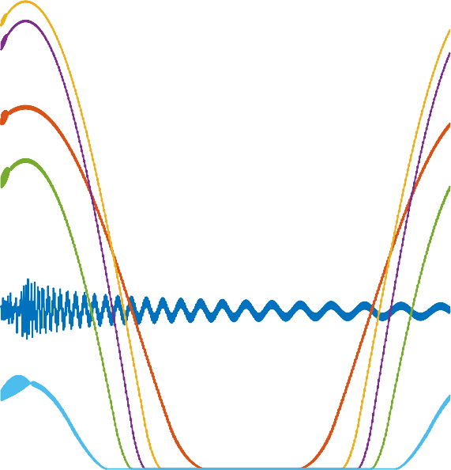

**90Deg North**

**60Deg North**

**30Deg North**

**0Deg Equator**

**60Deg South 90Deg South**

**30Deg South**

**Power (Watts)**

**10000**

**4000**

**8000**

**90Deg North**

**60Deg North 30Deg North 0Deg Equator 30Deg South 60Deg South 90Deg South**

**2000**

**Power (Watts)**

**6000**

**4000**

**0**

**9AM 12PM 3PM 6PM 9PM 12AM 3AM 6AM 9AM 12PM**

**Time**

**2000**

Fig. 2. Mid-Summer Solar Profile

**104 Mid-Winter Altitude Profile**

**2.5**

**0**

**9AM 12PM 3PM 6PM 9PM 12AM 3AM 6AM 9AM 12PM**

**Time**

Fig. 1. Mid-Winter Solar Profile

The mid-summer implementation is almost a reverse of the winter scenario. Figure 2, shows the solar profile over the latitudes and clearly provides insight on where operational challenges of implementing HAPS will be most significant. Impelementing HAPS anywhere around 60 de- grees south of the equator will be problematic with below 4000 watts and no chance at all at the poles.

Figures 3 and 4, describe the altitude profile of the HAPS over different geographical locations. The altitude of the HAPS which is a function of available power directly affects the area coverage or its footprint. The HAPS will be forced to descend to lower altitudes if there are challenges with solar energy. This phenomenon will be demonstrated further in the section where specific cities where considered. However, the graph demonstrates that the poles (90 degrees North and South) are off-limits to implementing HAPS at least with this model of HAPS. Any implementation of HAPS at the poles will have to deal with enormous energy issues irrespective of season or time of the year.

1. **UNMANNED HAPS AND AUTONOMOUS CAPA-**

**BILITY**

The simulated HAPS is designed to be unmanned (i.e. pilot- less) and is expected to be operated with minimal human intervention. The essence of developing pilot-less HAPS addresses the fundamental question of risk and cost, which further impacts the commercial viability of the technology. HAPS by definition can be manned or unmanned but in this

**2**

**1.5**

**Altitude (Metre)**

|  |  |
| --- | --- |
| **90Deg North**    **60Deg North** | |
|  | **30Deg North** |
| **0Deg Equator**  **30Deg South** | |
| **60Deg South**  **90Deg South** | |

**1**

**0.5**

**0**

**9AM 12PM 3PM 6PM 9PM 12AM 3AM 6AM 9AM 12PM**

**Time**

Fig. 3. Mid-Winter Altitude Profile

work, the unmanned version is considered for the already stated reasons.

However, implementing unmanned HAPS creates an opportunity to extend its capability such that the HAPS can operate with minimal human intervention. In this work, autonomy is defined within the context of the capability of the HAPS for decision making or self governance, however, levels of autonomy exist and may depend on design, func- tions and specifics of the mission [25]. Expectation is that the movement of HAPS platforms will be managed by fully autonomous algorithms maintaining network connectivity, data rate and coverage as mission objectives [26]. Current

**2.5**

**2**

**1.5**

**Altitude (Metre)**

**1**

**0.5**

**104 Mid-Summer Altitude Profile**

diagram in figure 5, below and forms a core aspect of this research project. The successful performance of the energy management algorithm is central to the case of deploying solar-powered HAPS platforms.

1. **SIMULATION AND ANALYSIS OF RESULTS**

A series of simulations was run to compare how the HAPS system performed in providing coverage of some subscribers or subscribers. The energy management system which is the key system on a solar-powered HAPS, was tested in two different regions of the world. Two scenarios and locations were considered; one at midsummer at low latitude (close to the equator), while the other was midwin- ter at a higher latitude (around Europe), equivalent to flying missions in Africa and Europe.

**0**

**9AM 12PM 3PM 6PM 9PM 12AM 3AM 6AM 9AM 12PM**

**Time**

Fig. 4. Mid-Summer Altitude Profile

HAPS concepts have adopted the *many-to-one operating* op- erating paradigm where many operators manage one HAPS platform [27]. This approach is not sustainable due to cost and will need autonomous capability to resolve. In this work, one aspect of autonomy considered is the manage- ment of energy by the HAPS. The energy management algorithm provides some level of autonomous operation, whereby the HAPS manages its energy to ensure high availability; this is elaborated on in the next sub-section.

# 4.1 Energy Management Algorithm

A rules-based energy management algorithm was designed for this simulation and manages the HAPS power and energy consumption profile. It manages decisions on how to dimension power resources to all units of the system with the objective of pioritising and switching between primary and secondary energy sources for successful missions. The energy management logic achieves the mentioned objec- tives by tracking solar power availability and switching to back-up batteries when inevitable and triggers gliding manoeuvre when energy resources reach critical minimum thresholds. Under such critical conditions the logic shuts off power for propulsion and payload while the HAPS glides freely subject to glide dynamics consistent with the vehicles configuration. However, the logic keeps monitoring relevant indicators and triggers ascent when appropriate. Another layer of redundancy is added to the system by separating the secondary power source into main and flight control system (FCS) back-up battery units. The main battery unit supplies the propulsion and payload units while the flight control system battery supplies only the avionics unit. This extra layer of redundancy is also managed by the logic and ensures that both batteries are adequately charged during solar powered operational phase of the mission. This algorithm manages one of the critical decision layers that define the autonomous attribute of the HAPS modeled in this work. The details of the logic are further captured in the

# Operation of HAPS at High and Low Latitudes

Changes in latitude, seasons and times-of-day affect the power available for HAPS propulsion and communications payload. In any practical HAPS implementation it is critical to understand how latitudinal variations will affect com- munications payload availability to subscribers and service users. The impact of latitude on HAPS altitude profile directly affects coverage or service footprint. HAPS should be able to attain and maintain altitudes of above 17km, well above the cruising altitude of airlines, for flight safety reasons.



**90Deg North**

**60Deg North 30Deg North 0Deg Equator 30Deg South 60Deg South 90Deg South**

The HAPS platform was simulated in selected low and high latitudes to test impact of latitudinal and seasonal vari- ations on communications payload power and by extension availability of service to potential subscribers.

Figures 6 and 7 clearly show the impact of latitudes on altitude attainable during different seasons and times of the day. It can be seen that, during summer, the HAPS can climb to altitudes over 25Km which translates to larger footprints. This trend was sustainable for all of the day into the night season for the higher altitude see Figure 6, with the back-up battery to support. It demonstrates that mid- summer implementation for solar HAPS will not be very challenging for this latitude if flight and power parameters are well dimensioned. However, in contrast mid-summer night operations in the lower latitude (see Figure 7) did not fare as well since the HAPS needed to drop altitude at some point during the night/dawn phase of the mission. The cause for this drop in altitude will be examined further when the insolation intensity and duration is analysed.

The worst case scenario from the simulations carried out is the mid-winter, high latitude operation as shown in Figure 8 below. Due to extremely short day, the HAPS insolation could not provide enough energy to complete the mission and hence the extreme altitude loss leading to a crash of the platform. This demonstrates how latitude impacts and places limitations on the altitude profile of the solar-HAPS. In this case the HAPS could not maintain altitude at 20- 25Km or glide within acceptable thresholds of 17-10Km as seen in other cases.

Therefore, from subscribers point of view there may be service interruptions at low latitudes at some point in the non-daylight times. This will particularly affect the subscribers at the edge of the footprint as they will be the first ones to be dropped and the last ones to be restored.

**HAPS ENERGY MANAGEMENT LOGIC**

**Start**

**Compute Sun Angle**



**Compute PropPower, PayloadPower, TimetoSunrise**

**Compute Solar Power Output**

**Turn-off Propulsion and Reduce Payload- Worst Glide Profile**

**a**

**No (Night Time)**

**Is Sun**

**Angle>0?**

**Yes (Day Time)**

**b**

No

Yes

**c**

**Is Solar**

**Power>0?**

No

**Is**

**CurrentBattEnergy>(Pa yload*TimetoSunrise)?**

**This is a critical**

**scenario that should only be experienced in extreme Seasons or Regions.**

**d**

**Night Operations with**

**HAPS is very Sensitive and Climbing at Night is still under consideration. The designer strongly considers eliminating night climbs but prefers designing for longer night Level flights with minimal Glides at critical power thresholds.**

**Is Solar**

**Power>Payloa dPower?**

No

**This is a critical scenario that should only**

**be experienced in extreme Seasons or**

Yes

**i**

Yes

No

**Is**

**CurrentBattEnergy>(Pr opulsion Power*TimetoSunrise)?**

**e**

No

**Is Solar**

**Power>MainPower**

Yes

**f**

**J**

Yes

**Is Req.**

**RPS<Max RPS?**

No

Turn-

Off Propuls ion Power (Prop)

**Can Batt Support**

**MainPower &&**

**< Max RPS?**

No

**g**

No

**Is ClimbTable**

**Populated?**

**Turn-**

**Off Propuls ion Power (Prop)**

**Turn-Off**

**Propulsion Power (Prop)**

**h**

Yes

Yes

**Can Batt**

**Support Prop && < Max RPS?**

Turn-Off

Propulsi on Power (Prop)

No

Yes

Excess Power

is Calculated at this Step and Batteries Charged.

Yes

**Compute Payload Power**

**Compute Required Prop, Rev for Level Flight**

**Compute MainPower=(Payload+Prop)**

**Compute Best Climb Conditions from Climb**

**Glider**

**Battery-Powered Level Flight**

**Glider**

**Glider**

**Glider**

**Battery-Powered Level Flight**

**Solar-Powered Climb at MaxClimb Angle**

**Battery-Powered Level Flight**

**Glider**

Fig. 5. HAPS Energy Management Decision Tree

**2.6 10**

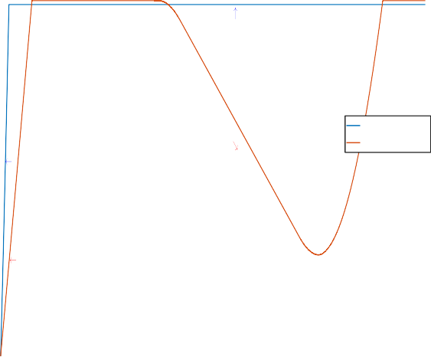

**4**

**2.5**

**2.4**

**Altitude (m)**

**2.3**

**Altitude Gain (Day Time)**

**Level Flight (Sufficient Power)**

**Altitude**

**Main Battery Capacity**

**107**

**4**

**3.5**

**3**

**Main Battery Capacity(J)**

**2.5**

**2**

**2.6 10**

**2.5**

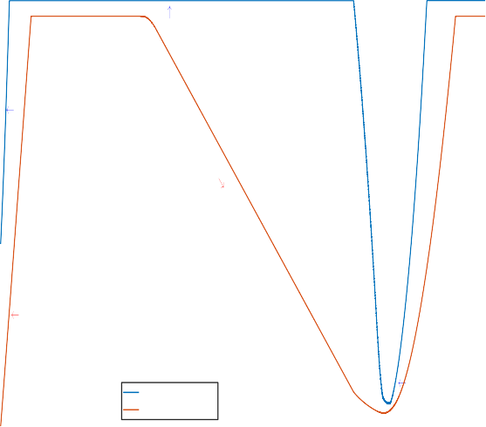

**4**

**2.4**

**2.3**

**2.2**

**Altitude (m)**

**2.1**

**Altitude Gain (Day Time)**

**Level Flight (Sufficient Power)**

**107**

**4**

**3.5**

**3**

**Main Battery Capacity(J)**

**2.5**

**2**

**2.2**

**2.1**

**2**

**Battery Charging(Day Time)**

**1.5**

**1**

**0.5**

**0**

**2**

**1.9**

**1.8**

**1.7**

**1.6**

**Battery Charging(Day Time)**

**Altitude**

**Main Battery Capacity**

**Altitude Loss**

**1.5**

**1**

**0.5**

**0**

**9AM 12PM 3PM 6PM 9PM 12AM 3AM 6AM 9AM 12PM**

**Time of Day**

**9AM 12PM 3PM 6PM 9PM 12AM 3AM 6AM 9AM 12PM**

**Time of Day**

Fig. 6. HAPS Altitude Profile - High Latitude & Mid-Summer

# Available Payload Power

The previous section showed that latitude and season in- fluence the flight profile and hence the footprint size. This section examines the payload power based on 24-hour mis- sions at different latitudes and seasons (mid-summer and winter). The HAPS circled at selected low and high latitudes providing communications service to subscribers.

In the case of low latitudes (see figure 10) it is observed that, even though insolation intensity is higher, during mid-summer the night time is longer. This places higher demands on the battery, resulting in deeper discharge. In order to conserve power the energy management system

Fig. 7. HAPS Altitude Profile - Low Latitude & Mid-Summer

shuts down the communications payload.

This shut-down occurs in the overnight period when there are few subscribers active. As the requirements for current internet and communication services races towards ubiquitous and ’always-on’ connected service, outages due to power will be a key challenge in HAPS implementation.

After running simulations in high and low latitudes for various seasons, Figures 9, 10 and 11 show solar power, communications payload power and propulsion power pro- files for the 24-hour duration of the test. Further explana- tions and analysis on the dynamics of the result is given in the next sub-section.

**7 150**

**104**

**10**

**4**

**.5**

**Level Flight**

**3.5**

**2**

**3**

**2.5**

**.5**

**2**

**1**

**1.5**

**Battery Charging(Short Duration)**

**1**

**.5**

**0.5**

**Altitude**

**Main Battery Capacity**

**2**

**12000**

**10000**

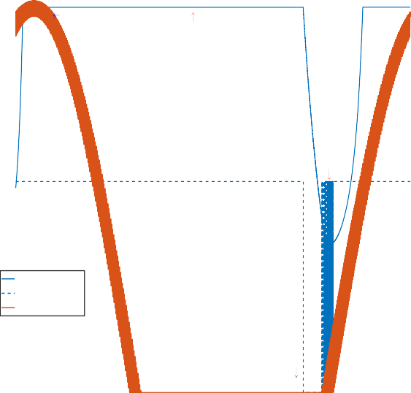

**Peak Solar Power (Midday)**

**Propulsion Power**

**Propulsion Power**

**Comms Payload Power Solar Power**

**100 8000**

**Main Battery Capacity(J)**

**1**

**Altitude (m)**

**Power (W)**

**Solar Power(W)**

**6000**

**50 4000**

**Comms Payload (Drop)**

**0 2000**

**0 0 0 0**

**12PM 3PM 6PM 9PM 12AM 3AM 6AM**

**Time of Day**

**9AM 12PM 3PM 6PM 9PM 12AM 3AM 6AM 9AM 12PM**

**Time of Day**

Fig. 8. HAPS Altitude Profile - High Latitude & Midwinter Fig. 10. HAPS Operations Profile - Low Latitude & Mid-Summer

**150**

**140**

**12000**

**10000**

**Propulsion Power (Stable)**

**Peak Solar Power (Midday)**

**Propulsion Power**

**Comms Payload Power Solar Power**

**Increasing Propulsion**

**Comms Payload (Stable)**

**150**

**6000**

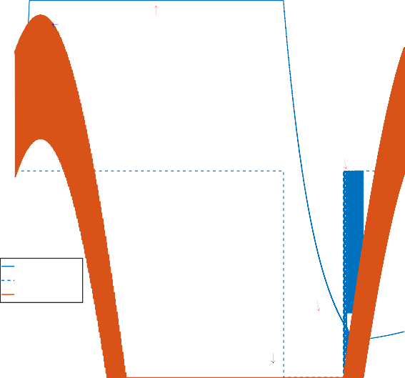

**Propulsion Power**

**Peak Solar Power (Midday)**

**Propulsion Power**

**Comms Payload Power Solar Power**

**5000**

**130**

**8000**

**120**

**100**

**4000**

**110 6000**

**Power (W)**

**3000**

**Comms Payload (Drop)**

**Solar Power(W)**

**100**

**Power (W)**

**90**

**80**

**4000 50**

**Solar Power(W)**

**2000**

**2000**

**1000**

**70 0 0 0**

**9AM 12PM 3PM 6PM 9PM 12AM 3AM 6AM 9AM 12PM**

**Time of Day**

**9AM 12PM 3PM 6PM 9PM 12AM 3AM 6AM 9AM 12PM**

**Time of Day**

Fig. 9. HAPS Operations Profile - High Latitude & Mid-Summer

# Service Availability and Coverage Profile

The service availability and coverage profile of the simu- lated system is a function of available payload power. The power management algorithm implemented on the simu- lated platform dynamically manages available power and rations power distribution based on high level decision logic which determines distribution priority. Therefore, available power for running the communications payload determines how much subscribers will be covered and hence HAPS availability and coverage performance.

From the simulation results the service profile of solar HAPS platforms is affected by the latitude of operation and the season of the year including daily variations of day and night durations. HAPS implementation in high latitudes

Fig. 11. HAPS Operations Profile - High Latitude & Mid-Winter

demonstrate significant difference in service profiles in mid- summer and mid-winter. In mid-summer service availabil- ity remained constant with the system supplying the needed communications payload power. In this scenario service availability and coverage will attain consistent positive per- formance as power availability is maintained. However, in mid-winter the service profile changed significantly, with more than 4 hours continuous outage of service due to drain on main battery and no solar power. In this case, coverage will be affected during the period and hence sys- tem availability performance will be adversely affected. This service profile is not sustainable and will need technological innovation to mitigate this problem. Another significant service profile impact is seen from the low latitude imple-

mentation where service was continuously interrupted for about 1 hour which is still a challenge. From the result the propulsion power and communications payload was adequately managed to optimise energy resources and push the HAPS through the critical phase of the night mission. By rationing supply to the payload and trading coverage for power the HAPS prioritizes persistence over service gains.

The solar power profile on closer observation indicates some noise introduced by the variation of sun angle at dawn, amplified by the circular movement of the HAPS. This motion keeps altering the solar panel exposure to the rising solar rays, and causing the algorithm to sense varying sun angle measurements, switching back and forth between battery and solar sources. This phenomenon is clearly shown in figures 10 and 11 above. This problem may be resolved by defining a threshold value before the system is completely switched to solar power below which it remains on battery.

**6 CONCLUSION AND FUTURE WORK**

The geographical impact of implementing HAPS involves understanding how latitude and seasons will affect its op- erations and performance. A careful analysis of this phe- nomenon as it affects HAPS operation specifically has been attempted in this work. From a design and development perspective this understanding may direct how hardware (platform etc) and software(algorithms) can be designed to aid HAPS performance in challenging locations of the world, where HAPS services may be required for normal or emergency applications.

The provision of persistent communications services from a solar-powered HTA HAPS will be highly reliant on the energy management system. Overnight the energy man- agement system needs to balance the demands of allocating power to propulsion, keeping the altitude constant and maintaining a constant footprint, and providing power to the payload to maintain continuous support for subscribers. Some payload downtime might be possible for voice ser- vices where demand is often low overnight. The growth of ’always on’ data services means that the option of turning off the payload is not permissible.

The problems of energy management become more acute at higher latitudes. The longer nights, correspondingly shorter days, and lower solar elevation in winter can result in complete battery discharge and possible loss of the air- craft. Increasing battery capacity merely adds weight and places more load on the propulsion system and wings. This indicates that, for any platform, there is a maximum latitude at which it can be expected to operate.

This leads to some interesting challenges for future re- search. Simulations are ongoing to explore improving per- formance at the highest latitude at which the current HAPS model can operate. This will lead to ideas for optimising the aircraft model to permit operation at the highest possible latitude. The design of the energy management system could also be improved, in particular the power supply to the payload, could be made dynamic so that power is reduced in steps overnight. This paper proposes that suc- cessful performance of energy management algorithms will be central to the case for deploying solar-powered HAPS platforms for communications or other purposes.

**ACKNOWLEDGMENTS**

The authors would like to thank Liverpool Hope University for supporting the Solar-HAPS project.

**REFERENCES**

[1] David Grace and Mihael Mohorcic. *Broadband Communications via High Altitude Platforms*. Wiley, 2011.

[2] B.I Wicaksono and Iskandar. On The Evaluation of Techno- Economic High Altitude Platforms Communication. In *2012 7th International Conference on Telecommunication Systems, Services, and Applications (TSSA)*, 2012.

[3] Working Group on Technologies in Space and the Upper- Atmosphere. Identifying the Potential of New Communications Technologies for Sustainable Development. Technical report, Broadband Commission For Sustainable Development, 2017.

[4] Z. Yang and A. Mohammed. Wireless Communications from High Altitude Platforms: Applications, Deployment and Development,, 2010.

[5] Ogbonnaya Anicho, Philip B Charlesworth, Gurvinder S Baicher, and Atulya Nagar. Autonomous Unmanned Solar Powered HAPS:Impact of Latitudes and Seasons on Power and Commu- nications Coverage. In *COMNETSAT*. COMNETSAT, IEEE, 2018.

[6] Airbus Defence and Space. Zephyr, the High Altitude Pseudo-Satellite, 2017. [online]. available: [http://www.defence.airbus.com/portfolio/uav/zephyr/.](http://www.defence.airbus.com/portfolio/uav/zephyr/) [accessed: 23- jun- 2017]. Online, 2017.

[7] Douglas W. Gage. Command and Control of Many-Robot Systems.

*Unmanned Systems*, 1992.

[8] Andrew Howard, Maja Mataric, and Gaurav Sukhatme. Mobile sensor network deployment using potential fields: A distributed, scalable solution to the area coverage problem. International Symposium on Distributed Autonomous Robotic Systems, June 2002.

[9] Feihong Dong, Han Han, Xiangwu Gong, Jingchao Wang, and Hongjun Li. A Constellation Design Methodology Based on Qos and User Demand in High Altitude Platform Broadband Networks. *IEE Transactions on MultiMedia*, 2016.

[10] S. Hayat and et al. Survey on Unmanned Aerial Vehicle Networks for Civil Applications: A Communications Viewpoint,. *IEEE Communications Surveys & Tutorials*, 18(4):2624–2661, 2016.

[11] S. Chandrasekharan and et al. Designing and Implementing Future Aerial Communication Networks. *IEEE Communications*, 2016.

[12] J. J. Kiam and A. Schulte. Multilateral Quality Mission Planning for Solar-Powered Long-Endurance UAV. pages 1–10. Aerospace Conference, IEEE, March 2017.

[13] Philipp Oettershagen, Amir Melzer, Thomas Mantel, Konrad Rudin, Thomas Stastny, Bartosz Wawrz, Timo Hinzmann, Kostas Alexis, and Roland Siegwart. Perpetual Flight with a Small Solar- Powered UAV: Flight Results, Performance Analysis and Model Validation. Number 2016. IEEE Aerospace Conference, 2016.

[14] Jonathan Bonnet, Marie-Pierre Gleizes, Elsy Kaddoum, Serge Rainjonneau, and Gregory Flandin. Multi-Satellite Mission Plan- ning Using a Self-Adaptive Multi-Agent System. *IEEE 9th Interna- tional Conference on Self-Adaptive and Self-Organising Systems,*, 2015.

[15] Mikel D. Petty. Model verification and validation methods. IIT- SEC, 2013.

[16] Jose Amaral, M. Buro, R. Elio, J. Hoover, I. Nikolaidis,

M. Salavatipour, L. Stewart, and K. Wong. About Computing Science Research Methodology. *Available at* [*http://webdocs.cs.ualberta.ca/*](http://webdocs.cs.ualberta.ca/) *c603/readings/research-methods.pdf*, 2011.

[17] Brian L. Stevens, Frank L. Lewis, and Eric N. Johnson. *The Kinematics and Dynamics of Aircraft Motion*. Wiley, 2015.

[18] Sunil Kumar Singh. *Kinematics Fundamentals*. Connexions, 2008. [19] Don Koks. Changing coordinates in the context of orbital me-

chanics. Technical report, Australian Government DOD - Defence Science and Technology Organisation, 2017.

[20] Don Koks. Using rotations to build aerospace coordinate systems. Technical report, Australian Government DOD - Defence Science and Technology Organisation, 2008.

[21] Robert Stengel. *Flight Dynamics*. Princeton University Press, 2004. [22] Philip Charlesworth. A solar aircraft model for simulations.

*Internal Publication : Liverpool Hope University*, 2015.

[23] Alexandros Giagkos, Elio Tuci, Myra S. Wilson, and Philip B. Charlesworth. Evolutionary coordination system for fixed- wing communications unmanned aerial vehicles. *In: Mistry M., Leonardis A., Witkowski M., Melhuish C. (eds) Advances in Au- tonomous Robotics Systems. TAROS 2014. Lecture Notes in Computer Science, vol 8717. Springer, Cham*, 2014.

[24] Jacob Gavan, Saad Tapuchi, and David Grace. Concepts and main applications of high altitude platform radio relays. *The Radio Science Bulletin*, 2009.

[25] Hai Chen, Xin min Wang, and Yan Li. A survey of autonomous control for uav. *IEEE Computer Society*, 2009.

[26] Zhongliang Zhao and Torsten Braun. Topology control and mo- bility strategy for uav ad-hoc networks: A survey. *Joint ERCIM eMobility and MobiSense Workshop*, 2012.

[27] V. Hehtke, J.J. Kiam, and A. Schulte. An autonomous mission management system to assist decision making for a hale operator. *Deutscher Luft-und RaumfahrtKongress*, 2017.