Title: Towards A Vital Pedagogy: Learning from Anti-ableist Practice in Art Education
Keywords: art education, disability studies, crip theory, ableism, special educational needs

Abstract:
Art education has the potential to promote inclusive education for all children and young people. However, the pervasive discourse of special education, with an emphasis on individual deficit, support and remediation, can dominate our thinking about the relationship between disability and art education. This paper reports on an attempt to resist the limitations of such discourses by introducing anti-ableist, crip theory to art educators (n=48). Visual and textual storyboards enabled practitioners to present, reflect and revise projects from a committed anti-ableist position. Modified projects reflected an awareness of the benefits of multi-sensory approaches, the advantages of interdependency and a greater resonance with contemporary arts practice. Acknowledging the challenges of taking theory to practice, the paper suggests that anti-ableist theory can promote a vital pedagogy in art education. It concludes that crip theory can provoke practice-based resistance to deficit-based models of disability.

Introducing Crip Theory to Art Education
Art education is acknowledged internationally as a significant, established element in school curricular, with a capacity for distinctive learning with, about and from materials (Atkinson 2017a). It is transformational in enabling children and young people to understand historic and contextual ideas about making, and as a means of knowing and being through creative connections. There is a strong international commitment to provide high quality art education for all children including those with so-called special educational needs and disabilities (Keifer-Boyd 2018). Contemporary art education is ocularcentric, remaining clearly aligned with its visual arts heritage and frequently encompasses art, craft, design and historical or contextual studies. Art education is acknowledged as a site of resistance to dominant neoliberal discourses of individualistic competition that frame compulsory education (Adams 2013). Although championed for its inclusive capacities, the value of art and design education has been significantly undermined in a number of international contexts, particularly in England, due to significant curricular change (Atkinson 2017b). At the heart of this project is an aim to recognize the importance of art education (and art educators) whilst extending possibilities for the future by drawing on progressive work in disability studies. This paper reports on an innovative application of crip theory in practice with beginning art educators in England who were prompted to challenge normative assumptions about ability and engage in curricular revision from a committed anti-ableist stance. As a scholar in disability studies, based in England, I seek to problematise the label of special educational needs and its implications for art education. The term ‘disabled people’ is used throughout the paper and aligns with the preferred language use associated with the radical British social model of disability. Whilst recognizing impairment, the social model acknowledges that people are disabled by barriers present in social structures and practices (Oliver 1990).

Developed by US scholar Robert McRuer, crip theory is provocative in drawing attention to the compulsory nature of ability (McRuer 2006). Emerging from contemporary crip/queer politics, crip theory questions the naturalized dominance of heterosexuality and ability in social and cultural practices, including education. In its critique of ableism, crip theory highlights ability as an invisible set of preferences that are produced, exhibited and reinforced throughout our social and cultural lives (Kumari-Campbell 2009). An attempt to ‘crip’ the curriculum in art education therefore means to draw attention to the taken for granted assumptions about ability that are reinforced through its systems and practices. Crip theory offers a theoretical framework for attending to the dominance of compulsory able-bodiedness as a non-identity; one that fails to be recognized by our usual cultural and educational practices. More recently McRuer has utilized this framework for examining a range of cultural forms of production and resistance in film, literature and the arts in the context of neoliberal austerity politics in the United States and England (McRuer 2018). Crip ways of knowing and being are identified as an overt form of resistance to taken-for-granted assumptions about ability that underpin how we think and act. This anti-ableist stance is embraced in the term ‘cripistemology’, a term which acknowledges the centrality of crip ways of knowing and being, informing who we are and what we might become (McRuer & Merri-Johnson 2014). This paper examines the application of crip theory in practice with art educators in order to promote an alternative discourse to the dominance of special educational needs.

Crip theory is provocative in proposing a radical revision of our thinking about ability and used here to inform a heuristic device for advancing pedagogic practice. Crip, in this instance, is not imposed as an identity, but operates instead as a transitive act (to crip) in order to decentre forms of compulsory able-bodied/mindedness inherent in contemporary models of art education (Price in McRuer & Johnson 2014). The term body/mind is essential here in recognising the relationship between mind and body as well as the influence of ableist practices on both. The argument here is that a curricular cripistemology, epistemology informed by crip ways of knowing and being (Mitchell, Snyder and Ware 2014), can stimulate new thinking about the relationship between disability and art education. Some may level criticisms at the employment of such neologisms yet the provocation offered by crip theory is essential in destabilising the relationship between art education and the limiting discourse of special educational needs. This application is intentionally disruptive in establishing new ideas about how we perceive art education for disabled children and young people and how we can remake art education for all. Neologisms are rarely just ‘spin’ since they emphasise the importance of language in enabling us to think differently. This project emerged from a desire to innovate whilst recognising the limitations of working with theoretical complexity in a brief workshop. It began with two questions:
- What does it mean to ‘crip’ art education?
- What happens when art educators apply this theory to their practice?
The following section outlines an argument for employing alternative modes of thinking about the relationship between art education and disability before moving into a more detailed explanation of crip theory and its proposed application.

Special Education as a Limiting Pedagogic Discourse
The removal of barriers in education for disabled children and young people is a significant concern shared across international contexts with a commitment to pursue inclusive practice in education and the arts across continents (See Antony and Ammon 2013 for an example of the Indian context for disability and inclusive education and Hakala et al 2018, for Nordic perspectives). The need to emphasise basic levels of access to education for disabled children and young people cannot be underestimated, particularly in countries where material resources cannot be taken for granted (see work by Kristensen et al 2006 for an examination of inclusive practice in Uganda). However, the education of disabled children and young people is problematic in being framed as special or additional to that usually provided. Support may be put in place to remove barriers to learning but there is less emphasis on making radical changes to teaching practice. The need to engage with special education as a social and political site for oppression and exclusion has been long established in writing in the UK and Australia (Tomlinson 1982; Barton 1986; and Slee 2011). Although the social model of disability is clear in drawing conceptual differences between impairment and disability, the policies and practices relating to the education of disabled children and young people remain dominated by individual, deficit-based language more clearly aligned with a medical model of disability. For example, the SEN Code of Practice in England, and equivalent legislation in Ireland (Mullaney 2017) and the US (Mitchell et al) emphasise individual limitations over capability. Such discourses can obfuscate and devalue the creative endeavours of disabled children and young people by positioning them as body/minds to be accommodated rather than actors who shape practice (Penketh 2017). Australian scholar, Roger Slee, is a clear proponent of the international project for inclusion in education and asserts that the reinforcement of technical discourses to ‘manage’ children with so-called special educational needs are likely to inhibit rather than extend the pursuit of inclusion and social justice in education (Slee 2001). Of further concern to this paper is the distance between policy and pedagogy in the education of disabled children and young people since statutory guidance governing the management and allocation of funding and resources appears detached from the material reality of pedagogic practice (Tomlinson 2017). Policies designed to manage resources have offered little for educators in terms of professional confidence in their pedagogic practice, particularly when encountering those labelled with a special educational need (Robinson 2017). More particularly such discourses in art education reinforce unhelpful conceptions of difference and limit our ability to imagine alternative futures. Work purporting to further the goals of inclusion in art education has conceptualised disabled children and young people as those to be ‘catered for’ or ‘dealt with’ above creative people who ‘make things’ (see Mullaney 2017 for example). Individual, deficit-based models result in exclusionary practices that limit our conceptualisations of what it is to be and what it is to learn. In its failure to acknowledge the generative capacity of disability, art education may be damaged or at least unable to flourish in new and exciting ways. Crip theory offers an important direction for challenging such discourses encouraging us to question deeply held beliefs about the relationship between ability and disability. Its position within the field of disability studies is explained more fully in this next section.

From a social theory of disablement to disability gains
This section of the paper acknowledges the move from Mike Oliver’s seminal work in disability studies on the social model of disability (Oliver & Barnes, 2012) to the position of crip theory in more recent writing that promotes the epistemic and ontological advantages of valuing diverse body/minds. Building on the affirmative model of disability, recent developments in disability studies seek to promote an appreciation of the contributions of diverse body/minds to our experiences of knowing and being in the world. For example, work by US scholar Georgina Kleege, explores the pedagogic gains brought by her embodied experience of visual impairment (Kleege and Wallin 2015) and Tobin Siebers’ development of disability aesthetics acknowledges the advantages of diverse experiences of embodiment (Siebers 2010). In the UK, David Bolt promotes an understanding of the complex experience of disability via a tripartite model that asks for equal consideration to be given to the gains brought by non-normative experiences (Bolt 2018). These developments are of particular importance in educational contexts in enabling us to contest a deficit discourse in special education and offer alternative framings for valuing the role of disabled children and young people in shaping creative arts practice.

A number of art educators and theorists have brought theoretical perspectives from disability studies into art education practice (Blandy 1991; Derby 2012; Penketh 2014; Wexler 2016). Recent writing in disability studies and art education acknowledges the potential for significant epistemic change in the way we conceptualise ability and disability in the art classroom. US scholar, Tobin Siebers (2010) recognises the relationship between disability and arts practice as generative, arguing that ‘the acceptance of disability enriches and complicates notions of the aesthetic, while the rejection of disability limits definitions of artistic ideas and objects’ (Siebers 2010:3). His appeal for this appreciation of a disability aesthetic creates an opening for arts practice to be extended, rather than reduced by interactions with disability. This work in disability studies resonates with that of the UK educationalist Dennis Atkinson who acknowledges the potential for art education to operate as an expansive space for a kind of ‘real learning’, defined as a space where learner and teacher can be open to alternative ways of knowing and being (Atkinson 2017). Atkinson questions ‘What is Art Education? What Might it Become?’. I argue here that our quest to understand the nature, importance and potential of art education can be enhanced if we take greater account of diverse body/minds. Both Siebers and Atkinson seek to challenge established practices that limit and are limited by prescribed ways of knowing and being. Their work exemplifies the potential for interdisciplinary perspectives to inform a pedagogic practice that challenges an assumed aesthetic and engages with art education as a form of critical social practice. Such challenges to fundamental assumptions regarding the nature art education and its purpose enables practitioners to re-imagine a relationship between art education and disability that moves beyond the limitations of special educational. For example, an adherence to particular forms of representation in observational drawing practice might be questioned when we encounter diverse body/minds for whom such practices might not work. Such encounters should not prompt us to reject such traditions but causes us to reflect on their purpose and relevance.

Robert McRuer’s work in crip theory is particularly significant to this study in that it offers an overtly anti-ableist stance, resisting the compulsory able-bodiedness promoted by late-capitalism (McRuer 2006). Mitchel et al (2014) extend this work by taking account of the influence of crip ways of knowing and being on curriculum and pedagogy in their development of curricular cripistemologies. Crip theory, and its extension to curricular cripistemology, is resistant to neat solutions to difference in education. Mitchell et al are particularly critical of forms of ‘inclusionism’ a term that describes surface responses to difference and attempts to include disabled people in educational contexts that remain fixed, inflexible and unlikely to be open to the value that disabled children and young people might bring (Mitchell, Snyder & Ware 2014). Crip approaches embrace the disruption and dislocations that emerge when ableist practices meet the lived reality of impairment. This is significant since inclusionism denies individual difference and fails to acknowledge the pedagogic benefits emerging from non-normative ways of knowing and being. Failure, the implications of what can happen when body/minds don’t work in typical ways, are acknowledged and worked with rather than resisted or avoided.

‘Crip’ is criticized as a populist, privileged and disrespectful term more readily associated with work in literary and cultural disability studies (Sherry 2013). However, I contend that such criticisms signify the need for a greater exemplification of the relevance of crip theory to practice. My argument here is that if the relationship between education and disability is dominated by the individualized deficit discourse of special education, then we require a proliferation of alternative examples in order to understand and promote pedagogic gain. Curricular cripistemologies are essential in advancing a position where pedagogic practice becomes open to the generative capacities of difference and the transformative dimension of crip ontology is therefore highly significant for art education. Art educators in England must develop an understanding of the relevant legislation underpinning provision for children with so-called special educational needs. However, they are not obliged to critique this designation or to engage with alternative models for understanding disability. This study aimed to offer alternative tools for educators to develop counter-cultural approaches in practice. The next section charts the introduction of these ideas in practice.

Methodological approach: storyboards as a graphic method for cripping the curriculum
The study draws on an action research framework for exploring my own practice as a guest lecturer at a university in the South of England, introducing art educators to theoretical work in disability studies (Mason 2005). Crip theory was initially introduced to a group of students enrolled on a postgraduate certificate in art education (PGCE) as part of their training in special educational needs. This took the form of a presentation and discussion with opportunities for group work to explore how these ideas might further practice. The challenges of introducing complex countercultural theory in a brief guest session was worth further exploration. I was keen to collect and analyse student responses in order to reflect on this aspect of my practice. The following discussion is based on work with a cohort of beginning art educators enrolled on a PGCE in art education (n=48). All participants gave informed consent for their contributions to be collected and analysed as research data and the project was subject to relevant university ethical approval processes.

An initial workshop, designed to generate insights into the relationship between art education, special education and disability studies encouraged art teachers to employ crip theory as a tool for developing overtly anti-ableist approaches. After an initial introduction to crip theory, participants were asked to investigate taken for granted notions regarding ability that might be implicit in projects they had witnessed, designed or delivered. They were asked to ‘crip’ these projects, meaning to actively interrogate and revise them from an anti-ableist position. Participants worked in groups of four or five, using a storyboard to identify and describe a current project, explore limitations and revise the project (see figure 1). This offered a graphic form for combining image and text in an attempt to identify barriers in practice and potential revisions. It operated as a tool for collaborative discussion and debate and a structure for reflecting on and revising practice.

(INSERT FIGURE 1: Outline for storyboard)
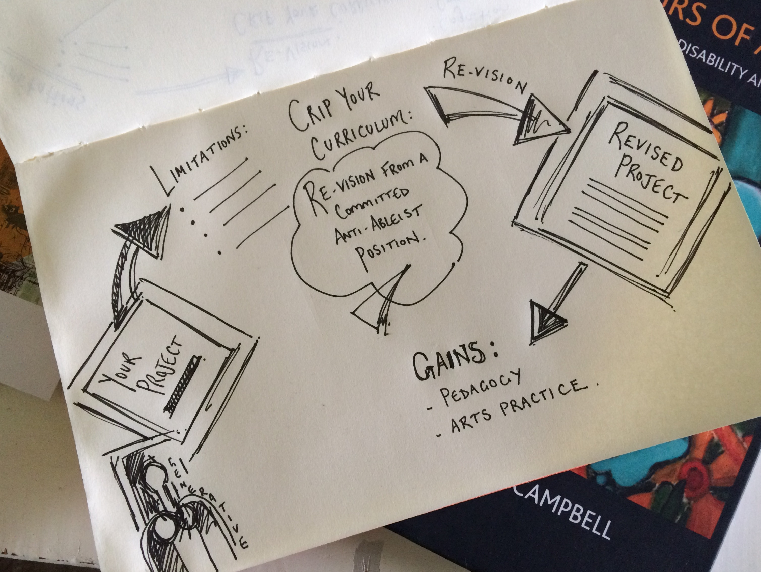

The storyboard created a structure for resisting compulsory able-bodied/mindedness with the underlying ‘crip’ framework, informed by curricular cripistemologies, designed to resist neat resolutions. It aimed instead to provoke a process for continuous questioning as part of a ‘productive’ inability to offer tidy solutions, recognising the creative im/possibilities of diverse body/minds making art. The application of crip theory provoked a rupture, resisting neat resolutions and opening new possibilities for pedagogy.

Although the storyboard, as a heuristic device, provided an initial framework for group reflection and discussion, participants were not limited to its structure. Some allowed their ideas to spill off the page with some making a larger, more elaborate responses. The methodology acknowledged the value of making and moved beyond the limits of language, bringing more embodied interactions into play. For example, one group, exploring representations of movement, produced a 2-metre outline of a traced body moving through space along with a number of traced, waving hands as their project shifted from copying Duchamps’ Nude Descending a Staircase to an activity that involved embodied experiences of movement.

(INSERT FIGURE 2: Crip as a ‘fix’)
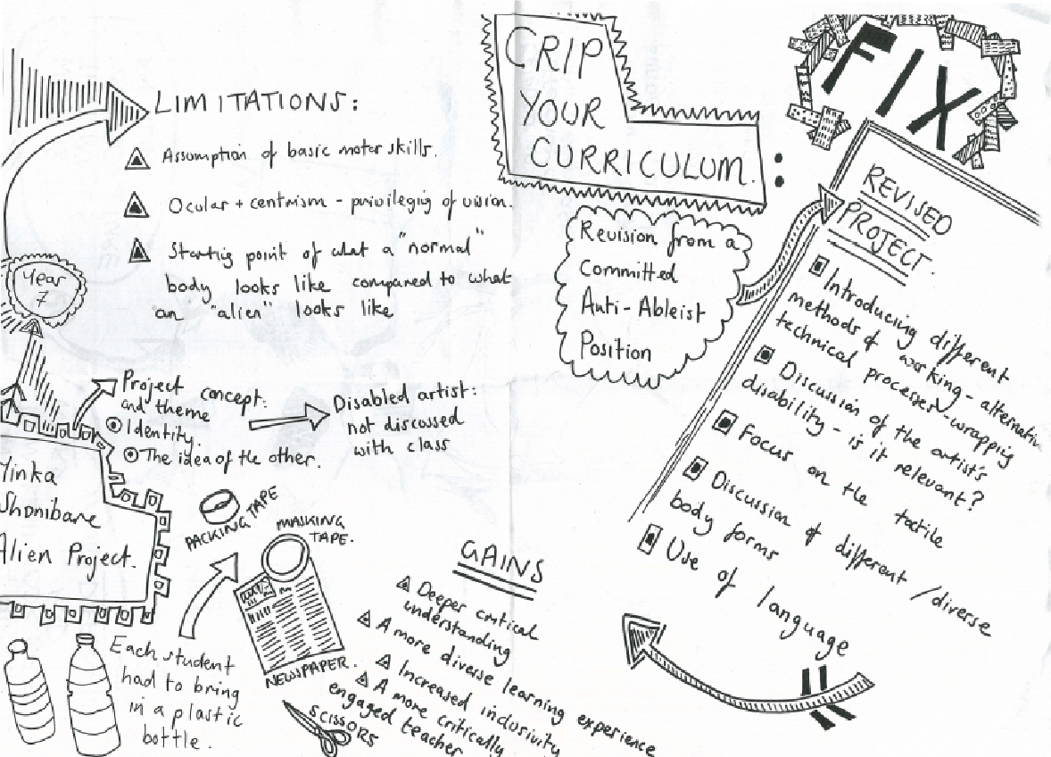

Crip Analysis of Art Education Practice
12 storyboards were photographed and written responses compiled in a tabular form for analysis noting the range of starting points for projects, limitations, revisions and pedagogic gains. The most significant elements emerging from the workshop are explained below prior to a more detailed exploration of the ideas generated along with implications for further iterations of this work. First, the storyboards appeared successful in prompting participants to acknowledge taken for granted assumptions regarding ability:

Ocularnormativity and Manual Dexterity
Most obviously participants identified an emphasis on vision as a major limitation in art projects they had observed or designed. A reliance on this single sense highlights the centrality of vision or ocularcentrism in art education, unsurprising given the historic emphasis on visual art education. Although predictable, participants recognised ocularnormativity within the context of art education as a key factor in exclusionary practices (Bolt 2016). To explain further, the emphasis on vision in art education reflects the centrality and prioritisation of sight in experiencing the world and making art. Ocularnormativity acknowledges that the experiences of some pupils’ might be rendered abnormal and therefore excluded not by sight ‘loss’ but by our inability to imagine art making that is not reliant purely on sight.

There was also an acknowledgement that an emphasis on fine motor skills, particularly in relation to drawing, presumed particular forms of dexterity. The emphasis on sight and on fine motor skills were highlighted as particularly problematic when projects relied on sight as the sole means of sensory perception and on detailed observational drawings when responding to and/or generating work. This is not to suggest that drawing from observation is undesirable but indicates that this becomes problematic when it is the only form of imagined engagement.

Orthodox Practice as a Normative Canopy
Participants identified an emphasis on a traditional curriculum as a limitation. This is described elsewhere as orthodox practice defined by an emphasis on individual rather than collaborative responses and aligned with the reproduction of existing and established imagery and ideas associated with a traditional Western art canon (Adams 2013). For example, a group identifying still-life and another noting landscape as starting points discussed the limitations associated with projects designed to generate similar and predictable responses. This resonates with Atkinson’s description of the ‘normative canopy’ generated by the dominance of preconceived ideas and approaches in art education (Atkinson 2017a: 7). Reduced opportunities for individualised creative practice were subject to criticism in generating unhelpful comparisons regarding the perception of ability. Atkinson’s work resonates strongly with an anti-ableist approach in drawing our attention to the limitations of an art education that presumes ‘a particular kind of life’ and reduces the social, and educational, imaginary (ibid). This normative canopy can be extended to include the importance of temporality. Participants drew attention to the sustained time dedicated to producing a piece of work, and the constraints that this might place on different bodies and minds making work.

Disability Gains for a Vital Pedagogy
The storyboards appeared successful in provoking revisions to projects. Participants offered revisions and reflected on the potential for pedagogic gain. A significant advantage of this anti-ableist methodology related to the development of a personalised curriculum that enabled teachers to promote and recognise individual capabilities. Participants noted that their revisions acknowledged a greater range of sensory experiences with ‘cripped’ projects becoming richer for this. For example, one project had initially described a lesson which involved making pencil drawings from photocopies of architectural forms (see Figure 3). This lesson was revised to include a performative dimension where pupils used their bodies to create a cityscape. Here it was acknowledged that the presence of different bodies was a distinct advantage. The revised lesson included a city soundscape, as well as an audio description of an imagined journey. There was an emphasis on collaboration as opposed to individualised outcomes as pupils worked together to construct a multisensory cityscape. The collaborative dimension of the project was in turn critiqued as potentially problematic for those who might want to work quietly on an individual piece of work and the project was redesigned for diverse responses. The group acknowledged the affective dimension of art making suggesting strategies for reducing pupil anxiety and this corresponded with a desire to create safe, non-competitive environments for pupils where assessment criteria acknowledged and valued individual experience over perceived quality judgments.
(INSERT FIGURE 3: Revised architecture project)
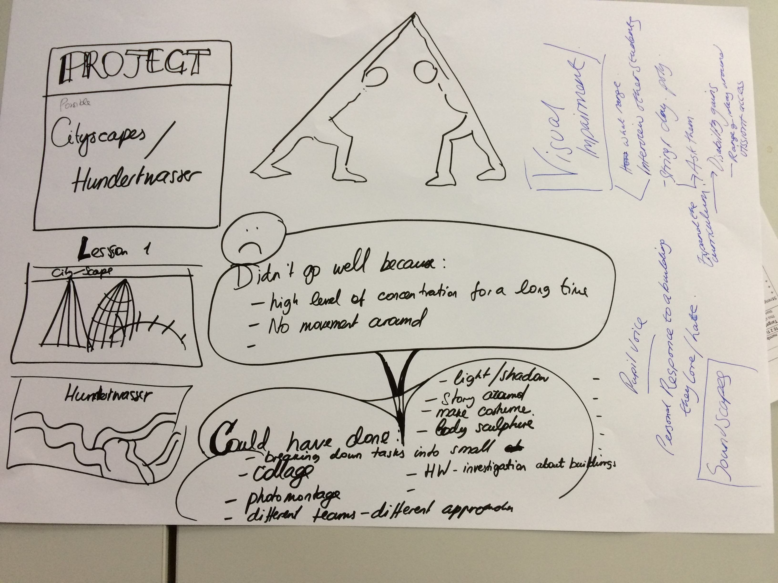
Two of the storyboards proposed a challenge to existing assessment practices in one case revising the self-assessment criteria from ‘How well have you represented what you have observed?’ to ‘How have you responded to your experience of landscape?’ This signalled a radical transformation in shifting assessment objectives from a subjective judgement of quality of what was seen and recorded to one that encouraged pupils to make a qualitative response to their aesthetic experience of landscape. Another group challenged an imagined examination board to revise and expand their definitions of observational drawing to include tactile representations of experience in clay.

Revised projects such as the cityscape described above resonated with contemporary art practice in being collaborative and open to exploration via a range of media or in some cases relating to dematerialised forms through language, sound and performance. The original project outlined above would have resulted in approximately 24 A3 pencil drawings based on a set stimulus of secondary sources selected by the teacher. The revised project presented opportunities for a multimedia representation of pupils personal and multisensory experiences of landscape. This example recognises the potentially symbiotic relationship between anti-ableist approaches and recent aims to reinvigorate ‘school art’ practices through engagement with contemporary art practice (Adams 2013). The orthodox practices in art education critiqued by Atkinson as removed from authentic art practice (2017a) are also limited in being open only to those with normative body/minds. Contemporary art practices, through multiple modes of representation might reflect and generate more inclusive practice although it would be simplistic to presume that contemporary art practices are automatically more inclusive.

In a final example from one of the storyboards, pupils developed three dimensional alien bodies from recycled materials. The initial project engaged with ideas about identity and ‘the other’ referencing the work of artist Yinka Shonibare. Pupils were asked to think about the properties of a ‘normal’ body compared to an alien being. Participants identified limitations with the project in that all pupils were expected to have good fine motor skills in order to construct the alien bodies and that vision was still privileged over the tactile dimensions of the work. Revisions to this project suggested alternative forms of making such as wrapping as well as cutting and taping. There was a greater emphasis on tactile properties in the revised project and an explicit discussion of diverse body forms. Here the project became open to new possibilities and directions. The image of the alien model included prompts about body forms, normal bodies, how bodies function and the types of environments that were needed for different types of bodies to evolve and thrive.

Participants began to acknowledge ideas about bodies and appearance making connections between disability, questioning what is normal, and thinking about the relationship between bodies and the environment. This prompted a discussion regarding the artist Yinka Shonibare and the relevance of his status as a disabled person. The group questioned whether it was appropriate to discuss disability in relation to this artist, acknowledging that they were uncomfortable and uncertain about the relevance of this for pupils. They concluded that this could in fact have been determined by the pupils yet in this example the opportunity had been closed down by the teacher who had felt uncertain about initiating a conversation about disability.

There was a clear limitation in use of the storyboards in that although they created a distilled summary of ideas, they did not provide a record of the linguistic richness of the group discussion for analysis. They did however enable participants to summarise their discussions and demonstrate the revision process effectively in a space that also created the structure for action. A further limitation was evident where a number of the storyboards promoted the application of crip theory as a ‘fixed’ or repaired curriculum. This highlights the difficulty in effectively articulating theoretical complexity within the time constraints of the workshops. The desire to use crip theory to ‘fix’ or repair presents tensions with the aim of curricular cripistemologies to resist easy surface level solutions. It also suggests stasis which works in direct conflict with an aim to promote fluid and creative responses (FIGURE 2). Participants were encouraged to recognise barriers in the curriculum and revise accordingly although many still framed responses in relation to individual deficit. This is an aspect that could have been more fully explored in a further session or a longer workshop. This is perhaps indicative of the difficulties of reducing complex theory within a relatively short session rather than working with ideas over a sustained period. An outcome of this cycle of the work has been to propose an extended workshop with art teachers in order to develop a more sustained approach for taking theory into practice.

Reflections on a Vital Pedagogy
Atkinson, jagodinski and Baldachinno (2017) and Biesta (2017) recognize the tensions inherent in the relationship between art practice and art education. Biesta emphasizes the need to ‘let art teach’ and indicates a crisis in an art education that has become divorced from both art practice and education. Similarly, Atkinson is adamant that art should not be viewed as an instrument for learning although ‘a kind of learning may emerge through the experience of art practice or engaging with art’. He goes on to acknowledge art as ‘an ontological force of becoming that often involves unlearning’ (Atkinson 2017: 7). This capacity for art to promote ‘unlearning’ resonates with the application of crip theory in this present paper which aimed to provoke a process of ‘unlearning’ about the relationship between special education, disability and art education. The question for art educators becomes then how they are able to negotiate the distinctive contribution of the arts to learning and how they might work within the constraints of special education policy, and curricular and assessment frameworks that shape the ways that learners and teachers think about disability.

The curricular revisions and discussions presented by participants suggest that a vital pedagogy can emerge when we imagine the productive presence of non-normative body/minds in the art classroom and when we more fully acknowledge exclusionary failures in orthodox approaches. This requires art educators to have the confidence and agency to design curricula directly with and in response to the diverse children and young people with whom they work. I describe this as a vital pedagogy, drawing on two key definitions of the word. The first as an essential approach in response to McRuer and Johnson’s appeal for all aspects of culture and life to take account of disability. They suggest that:
an understanding of virtually any aspect of contemporary Western culture must be not merely incomplete, but damaged in its central substance to the degree that it does not incorporate a critical analysis of able-bodied/disabled definition
(Johnson and McRuer 2014:131)

Of course, any academic wishing to promote their ideas would benefit from an argument that promotes it as universally essential to the survival of other disciplines. However, if we accept this argument then we must draw on anti-ableist approaches as a critical means for sustaining art education, equipping it with the tools to adapt and survive. A vital pedagogy is resistant to deficit definitions of pupils, and their regulation through assessment processes that can appear contrary to the very nature of art practice (Atkinson 2017).

The second application of the word vital refers to the vital sparks or life’s energy emanating from playing, imagining and valuing non-normative capacities for making art. The ability for crip theory to destabilize practice in art education, even in its provocative naming, promoted friction as participants questioned the existence of ableism and worked with transformative ideas generated by supposing and imagining non-normative practice. The vital pedagogy that emerges here is one that must remain in constant motion in responding to the uncertainty of minds/bodies that we do not yet know. A vital pedagogy recognizes the tremendous creative potential in recognizing our uncertainty in being able to predetermine the ability of others or to predict the range of ways that they may respond to the world around them. Again, I make very direct reference to Atkinson’s work on art education as a process of becoming, being open to ‘that which is not yet’ (2017a). An anti-ableist approach promotes a vital pedagogy that is open to and benefits from the presence of non-normative body/minds and questions the orthodoxy of ability.

Conclusion for the generation of vital sparks
Special education can operate as a limiting domain for the development of educational practice and by implication for the development of practices in art education (Slee 2011). The argument then is for direct action via local ruptures of professional practice, creating debates about disability and difference with artist/educators who are coming together to ‘make things’ with children and young people. There are observable gains for pedagogic practice in art when norms concerning the nature of educable bodies are questioned and used as a resource to inform and enhance curricular. This demands the development of counter narratives that can challenge typical expectations regarding the ways in which learning takes place in art. It is at the level of local and particular interventions, that such narratives might emerge, enabling the promotion of expansive definitions of pedagogic practice by promoting an overtly anti-ableist understanding of the pedagogic subject (and the term subject here applies to both discipline and pupil). A significant contribution of this project lies in the gains for art education where a vital pedagogy emerges from the generative potential of diverse body/minds, coming together to learn with and from others. Although reporting on a project with a relatively small group of 48 emerging art teachers, the research clearly demonstrates the potential for a wider application of crip theory via a tangible reflective tool. In terms of action research, the study reflects the importance of live work with theory in order to more fully appreciate its application.

I will conclude by acknowledging the limitations of taking theory to practice particularly where there are reduced opportunities for sustained engagement with new ideas. We are right to be attuned to a distance between theory and the lived experiences of disablement and of grafting reductionist forms of theory onto practice but we can strive for innovation. Testing ideas beyond the academy, making things with precious others, can sustain us and enable us to retain our own vitality. A vital pedagogy informed by crip theory demands that we remain open to the uncertainty of subjects in order to come to know them better.

References:
Adams. J. (2013). The Artful Dodger: Creative Resistance to Neoliberalism in Education. Review of Education, Pedagogy and Cultural Studies, 35(4), 242- 255.
Adams, J. (2010). Risky Choices Risky choices: the dilemmas of introducing contemporary art practices into schools. British Journal of Sociology of Education. 31(6), 683-701.
Antony, J.P. and Ammon, R. (2013). Special Education History, Current Status and Future: India. Journal of International Special Needs Education. 16(1), 5-16.
Atkinson, D. (2017a). Art, Disobedience and Ethics – The Adventure of Pedagogy Switzerland: Palgrave Macmillan.
Atkinson, D. (2017b). ‘What is Art Education? What Might it Become?’ in jagodzinski, j. (Ed), What is Art Education? After Deleuze and Guattari (pp. 143 – 160). New York: Palgrave Macmillan.
Barton, L. (1986). The Politics of Special Educational Needs. Disability, Handicap and Society. 9(3), 273 – 290.
Biesta, G. (2017). Letting Art Teach: Art Education ‘after’ Joseph Beuys, ArtEZ Press
Bolt, D. (2018). Cultural Disability Studies in Education, New York: Routledge.
Bolt, D. (2016). The Metanarrative of Blindness, Ann Arbour: University of Michigan Press.
Blandy, D. (1991). Conceptions of Disability: Toward a Sociopolitical Orientation to Disability for Art Education. Studies in Art Education. 32(3), 131 – 144.
Campbell, F.K. (2009). Contours of Ableism, UK: Palgrave Macmillan.
Derby, J. (2012). Art Education and Disability Studies. Disability Studies Quarterly 32(1) http://dsq-sds.org/article/view/3027/3054 [accessed 25.02.2019].
Hakala, K., Björnsdóttir, K., Lappalainen, S., Jóhannesson, I and Teittinen, A. (2018). Nordic perspectives on disability studies in education: a review of research in Finland and Iceland. Education Enquiry. 9(1), 78-96.
Keifer-Boyd, K. (2018). Creativity, disability and diversity, and inclusion. in Crockett, J.B. and Malley, (Eds.). Handbook of Arts Education and Special Education. (pp 45-55) London, ENG: Routledge.
Kleege, G. & Wallin, S. (2015). Verbal description as a pedagogical tool. Disability Studies Quarterly. 35(2). http://dsq-sds.org/article/view/4622/3945 [accessed 25.02.2019]
Kristensen, K., Omagor-Loican, M., Onen, N. and Okot, D. (2006). Opportunities for inclusion? The education of learners with special educational needs and disabilities in special schools in Uganda. British Journal of Special Education. 33(3), 139-147.
Mason, R. (2005). Art Teachers and Action Research. Educational Action Research 13(4), 563 – 579.
McRuer, R. (2018). Crip Times: Disability, Globalization and Resistance, New York: University Press.
McRuer, R. (2006). Crip Theory – Cultural Signs of Queerness and Disability, New York University Press.
McRuer, R. Johnson, M.L. (2014). Proliferating Cripistemologies – A Virtual Roundtable. Journal of Literary and Cultural Disability Studies 8(2), 149 – 169.
Mitchell, D., Snyder, S. & Ware, L. (2014). [Every] Child Left Behind Curricular Cripistemologies and the Crip/Queer Art of Failure. Journal of Literary and Cultural Disability Studies. 8 (3), 295 – 313.
Mullaney, M. (2017). Inclusivity through exclusivity: An evaluation of the provision of a special educational needs (SEN) placement within second level art and design education in the Republic of Ireland. Teaching and Teacher Education. (64), 139-149.
Oliver, M. (1990), The Politics of Disablement. London: MacMillan.
Oliver, M. & Barnes. C. (2012). A New Politics of Disablement, Hampshire: Palgrave MacMillan.
Penketh, C. (2017). ‘Children see before they speak’: Exploring ableism in art education. Disability & Society. 32(1), 110 – 127.
Robinson, D. (2017). Effective inclusive teacher education for special educational needs and disabilities: Some more thoughts on the way forward. Teaching and Teacher Education. 61(1), 164-178.
Sherry, M. (2013). Crip Politics? Just…no The Feminist Wire, http://www.thefeministwire.com/2013/11/crip-politics-just-no/ [accessed 25.02.2019]
Siebers, T. (2010). Disability Aesthetics, Ann Arbour: University of Michigan Press.
Slee, R. (2011). The Irregular School – Exclusion, Schooling and Inclusive Education, London: Routledge.
Tomlinson, S. (2017). A Sociology of Special and Inclusive Education, New York: Routledge.
Wexler, A. (2016). Re-imagining Inclusion/Exclusion: Unpacking Assumptions and Contradictions in Arts and Special Education from a Critical Disability Studies Perspective. Journal of Social Theory in Art Education. (36), 32 – 42.

