Figure 1: An image of Careportal®

Figure 2: Recruitment process for Phase 1 and Phase 2

Figure 3: Process of question set development

Figure 4: Distribution of high priority notifications

Figure 5: Proposed service configuration to be tested

Figure 1: An image of Careportal®

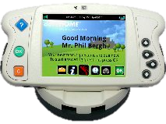

Figure 2: Recruitment process for Phase 1 and Phase 2

**Phase 2 completion**

**N=10**

**Phase 2 enrolment**

**N=13**

**Phase 1 enrolment**

**N=9**

**Approached for Phase 1**

**N=12**

**Assess for eligibility for Phase 1**

**N=40**

Declined from participation = 2

Died after consent = 1

9 more patients approached for Phase 2

Declined from participation = 4

Died after consent = 1

Withdrew from study = 1 (at Week 5)

Died = 2 (at Week 9 and Week 14)

**Expert Panel 1 (initial development)**

Panel consisted of: consultant respiratory physician (n=3); NIV nurse (n=2); MND nurse (n=1); NIV physiotherapist (n=3)

**DEVELOPMENT**

Figure 3: Process of question set development

21 questions

Morning: 10 items (1 nested)

Evening: 11 items (5 nested)

High priority: 10 items

Low priority: 5 items

**Face validity assessment (n=9):** 8-week trial; focus group; interview

Mean age=58y (range = 49-67y); limb onset (n=7); bulbar onset (n=1); respiratory onset (n=1); median illness duration=23m (range 4m-13y2m); median NIV usage=10m (range=1-4y9m)

20 questions

Morning: 9 items (1 nested)

Evening: 11 items (3 nested)

High priority: 9 items

Low priority: 5 items

**Expert Panel 2**

Panel consisted of: consultant respiratory physician (n=2); consultant neurologist (n=1); NIV nurse (n=2); NIV specialist physiotherapist (n=1); Neuro-physiotherapist (n=1); psychologist (n=2)

26 questions

Morning: 10 items (1 nested)

Evening: 16 items (4 nested)

High priority: 11 items

Low priority: 9 items

**VALIDATION**

**Face validity and feasibility assessment (n=13)**

24-week trial with the final question set

**31**

**13**

**3**

**1**

**40**

**12**

**36**

Figure 4: Distribution of high priority notifications during the trial

Figure 5: Proposed service configuration to be tested

1. **Data Entry**

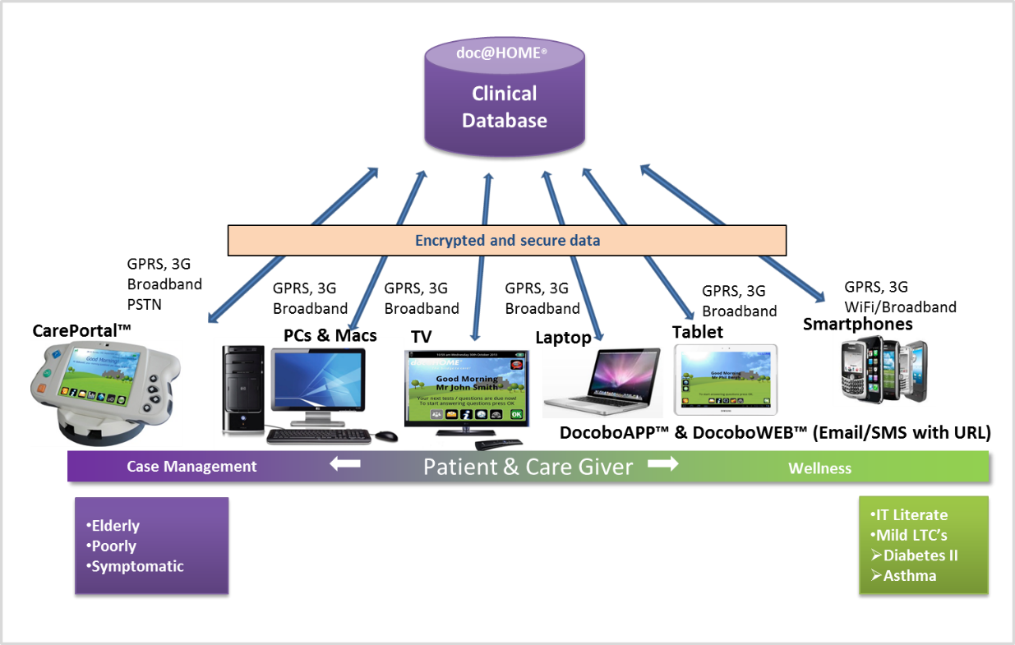  

Acknowledgement

Acknowledgement



Acknowledgement



- Chest infection

**OpNivent question set**

**Patient Ventilator interaction**

**Overnight oximetry data**

**Z`**



MND NURSE

- illness progression

- Swallowing

- Care / Enquiry / request

- Chest infection

z

PHYSIO ASSISTANT

-NIV problem /mask leak

-Enquiry / request

PHYSIOTHERAPIST

-Hypoventilation

-NIV use

-Clearing Chest

- Chest infection

**3. Intervention and Job Log**

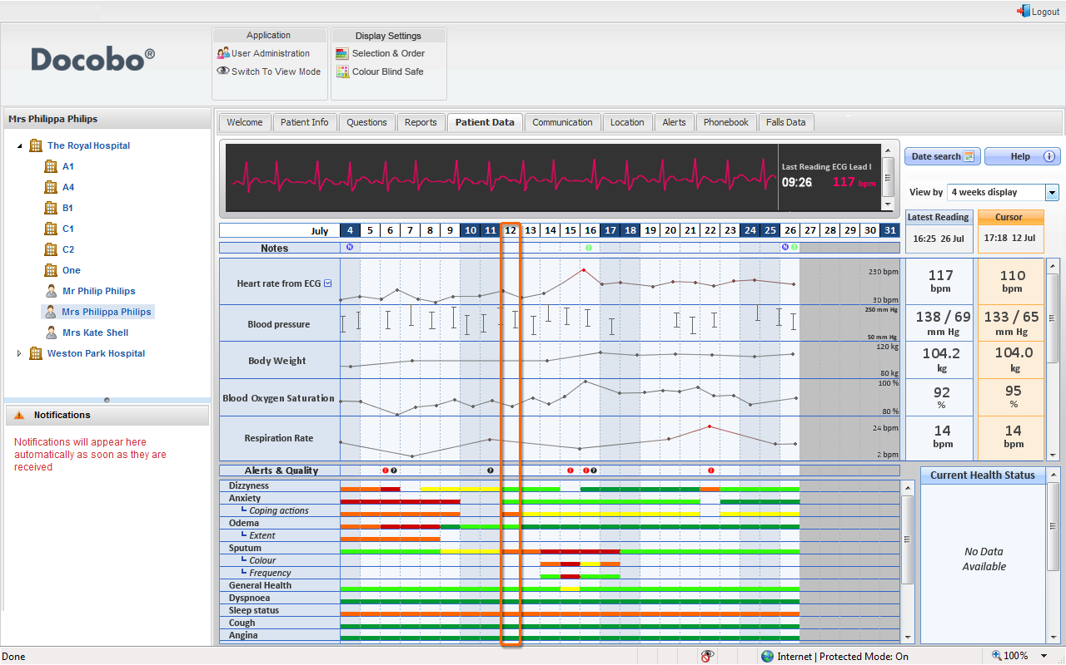

**Interventions**