**Reconstitution of W' in recovery slows with repeated bouts of maximal exercise**

***An Original Investigation***

Alan Chorleya orcid: 0000-0003-0000-3394

Richard P. Botta

Simon Marwoodb orcid:0000-0003-4668-1131

Kevin L. Lamba

a Department of Sport and Exercise Sciences, University of Chester, Chester, CH1 4BJ, UK

b School of Health Sciences, Liverpool Hope University, Liverpool, L16 9JD, UK

Corresponding Author

Alan Chorley

Dept. of sport & exercise sciences, University of Chester, Parkgate Road, Chester, Ch1 1BJ.

Email: a.chorley@chester.ac.uk

Tel: +44(0)1244 512058

Running head: Repeated bouts slow W' reconstitution

Abstract Word Count: 248

Text Only Word Count: 3484 (exc. Tables, figures)

No. of Figures: 4

No. of Tables: 2

**Abstract**

**Purpose** This study examined the partial reconstitution of the work capacity above critical power (W’) following successive bouts of maximal exercise using a new repeated ramp test (RRT), against which the fit of an existing W’ balance (W’bal) prediction model was tested. **Methods** Twenty active adults, consisting of trained cyclists (n = 9; age 43 ± 15 years; V̇O2max 61.9 ± 8.5 mL∙kg∙min-1) and untrained (n = 11; age 36 ± 15 years; V̇O2max 52.4 ± 5.8 mL∙kg∙min-1) performed two tests 2-4 days apart, consisting of three incremental ramps (20 W∙min-1) to exhaustion interspersed with 2-min recoveries. **Results** Intra-trial differences between recoveries demonstrated significant reductions in the amount of W’ reconstituted for the group and both sub-sets (*p* < 0.05). The observed minimal detectable changes of 475 J (first recovery) and 368 J (second recovery) can be used to monitor changes in the rate of W’ reconstitution in individual trained cyclists. Inter-trial relative reliability of W’ reconstitution was evaluated by intraclass correlation coefficients for the group (≥ 0.859); trained (≥ 0.940) and untrained (≥ 0.768) sub-sets. Absolute reliability was evaluated with typical error (TE) and coefficient of variation (CV) for the group (TE ≤ 559 J; CV ≤ 9.2%), trained (TE ≤ 301 J; CV ≤ 4.7%), and untrained (TE ≤ 720 J; CV ≤ 12.4%). **Conclusions** The reconstitution of W’ is subject to a fatiguing effect hitherto unaccounted for in W’bal prediction models. Furthermore, the W’bal model did not provide a good fit for the RRT, which itself proved to be a reliable test protocol.

**Keywords** Critical Power; Modelling; Testing; fatigue

**Introduction**

Cycle races are often characterised by the ability of competitors to perform repeated surges of severe intensity efforts (‘attacks’) interspersed with short recovery periods. The critical power (CP) model first introduced by Monod, Scherrer1 offers an objective physiological framework for the work performed during these surges, which could lead to a better understanding of how hard and how long a cyclist could attack for.

The intensity of exercise can be classified into discernible domains2, with CP marking the boundary between the *heavy* and *severe* exercise domains.3 Below CP energy is derived predominantly from sustainable aerobic pathways4,5, whilst work above CP requires a greater anaerobic contribution, drawing upon a finite capacity of work known as W’. The precise physiological underpinnings of W’ remain elusive; initially thought to be a finite amount of energy drawn from oxygen stores within the muscle, phosphates and anaerobic glycolysis,6 but later shown to be related to the accumulation of fatiguing metabolites such as adenosine diphosphate, inorganic phosphate and hydrogen ions within the muscle.7 The magnitude of W’ has also been shown to be affected by oxygen availability8 dispelling the notion of it solely reflecting anaerobic capacity. Furthermore, the magnitude of W’ has been correlated with muscle size9 and the development of the V̇O2 slow component in the ‘headroom’ between CP and maximal oxygen uptake (V̇O2max).10,11

Despite W’ appearing to be the product of a complex energetic system, the contribution of W’ in determining exercise performance above CP is highly predictable. W’ is expended at a rate proportional to the power output above CP. When CP and W’ are known, the limited duration of work (Tlim) at a power output (P) above CP can be predicted by the hyperbolic relationship described by equation 1.

$T_{lim}=W^{'}/(P-CP)$ (1)

Once depleted, W’ has been shown to begin reconstitution only when power output falls below CP,12 with recovery being curvilinear in its nature.7 The reconstitution of W’ has been shown to be slower than that of V̇O2 recovery and faster than that of blood lactate (BLa).7 Further investigations13 have linked the reconstitution of W’ with the recovery of muscle phosphocreatine concentration (PCr) establishing that like W’, recovery of these metabolic factors initiates at intensities below CP. However, the kinetics of PCr recovery differed from that of W’,14 indicating an associative link rather than a dependency, and that PCr recovery is only a part of a complex system of W’ reconstitution.

Skiba, Chidnok, Vanhatalo, Jones15 suggested an exponential W’ reconstitution model, based on an intermittent exercise protocol (equation 2) for the remaining balance of W’ (W’bal) during exercise and recovery, where t-u is the recovery duration.

${W'}_{bal}=W^{'}- \int_{0}^{t}{\left({W^{'}}_{exp}\right)(e^{-{(t-u)}/{τ_{w^{'}}}})}$ (2)

The authors15 evidenced that the rate of W’ reconstitution increased as the difference between recovery power output and CP increased, deriving an average value for the time constant of W’ reconstitution (τW’) based on the difference between recovery power output and CP (DCP) equation 3.

$τ_{W'}=546e^{(-0.01D_{CP})}+316$ (3)

Whilst the W’bal model has been validated in subsequent studies,16 faster recovery kinetics have been observed in elite cyclists resulting in the proposition of different relationship between DCP and the W’ reconstitution time constant (equation 4).17

(4)

The W’bal model13 was derived from regression analysis, the only individualized independent variable being CP, with τW’ assigned an average value based upon DCP. However, notable variations in τW’ between individuals with similar CP have been observed.18 Furthermore, the only known points are the initial W’ at the outset, and defining W’ = 0 J at the limit of tolerance of intermittent exercise. Hence an additional possible limitation of the W’bal model is that it assumes that the reconstitution of W’ will be constant following repeated bouts of >CP exercise. Therefore, the primary aim of the present study was to examine whether repeated bouts of maximal exercise, thus fully depleting W’, affect the rate of reconstitution of W’. A secondary aim of the present study was to assess the reliability of a repeated ramp test (RRT) to quantify an individual’s reconstitution of W', and to assess the validity of the W’bal model against this protocol.

**Methods**

***Subjects***

With institutional ethics approval, twenty healthy adults (male = 19; female = 1; age 39 ± 15 years; stature 177.6 ± 6.0 cm; body mass 74.3 ± 8.9 kg; V̇O2max 56.7 ± 8.5 mL∙kg∙min-1) volunteered to take part in the study after providing written informed consent. The subjects included active non-cyclists (untrained) (n = 11; age 36 ± 15 years; stature 178.8 ± 4.3 cm; body mass 77.8 ± 8.1 kg; V̇O2max 52.4 ± 5.8 mL∙kg∙min-1) and trained cyclists (n = 9; age 43 ± 15 years; stature 176.1 ± 7.6 cm; body mass 70.6 ± 8.8 kg; V̇O2max 61.9 ± 8.5 mL∙kg∙min-1).

***Design***

Following a repeated measures design subjects visited an air-conditioned laboratory on three occasions 2-4 days apart at similar times of day. Subjects were instructed to avoid strenuous exercise and alcohol in the previous 24 hours, and caffeine in the preceding 4 hours, and to have eaten similar meals at least 3 hours prior. The first visit included familiarisation and baseline testing, whilst subsequent visits comprised of the RRT. All testing was conducted on an electronically braked cycle ergometer (Lode Excalibur Sport, Lode BV, Groningen, Netherlands). Pulmonary gas exchange was measured breath-by-breath throughout each test using an online gas analysis system (Quark CPET, Cosmed, Rome, Italy), calibrated prior to each test with gases of known concentrations and volumes. BLa was measured via capillary fingertip samples with a portable analyser (Lactate Pro II, Arkay, Kyoto, Japan). All ramp phases increased at a rate of 20 W·min-1.

***Methodology***

*Baseline tests*

A single baseline test was used to establish parameters to be used in subsequent trials and act as a familiarisation. The ergometer was adjusted for individual comfort and pedal type, and replicated in later visits. For CP determination the ergometer was switched into ‘linear mode’ requiring the configuration of the ‘linear factor’ (LF; equation 5), and was based on a predicted CP and preferred cadence during this phase. These were established from subjects’ own training data (where available), else CP was predicted as 3x body mass (in kg)19 and defaulting to a cadence of 80 r·min-1.20

(5)

The protocol commenced with a 5-min warm up at 100 W at a self-selected cadence which then transitioned into a ramp until the limit of tolerance despite very strong verbal encouragement. Power output was then stepped down to a constant work rate 30 W above estimated CP to ensure full depletion of W’ as it has been shown that subjects can continue to cycle at a power output below their maximum power output but still above their CP for a short period13. When cadence dropped to 50 r·min-1 despite continued encouragement the subjects were encouraged to cycle all-out for 2 minutes to allow determination of CP from the final 30-s of this phase20. To avoid pacing, time to completion of this phase was withheld from subjects21. Then followed 2 minutes of recovery at 50 W22, before a further ramp commenced at 30 W above estimated CP, together with a step down following intolerance again at 30 W above CP until cadence dropped to 50 r·min-1. The protocol then ended with 5 minutes at 50 W (see Figure 1 for the power profile of the baseline test).

*<<< Figure 1 around here >>>*

*Experimental trials*

The RRT commenced with a 5-minute warm-up at 100 W which then transitioned into a ramp. Upon reaching the limit of tolerance power output was stepped down to a level 30 W above the CP determined during baseline testing, until the limit of tolerance, after which a 2-min recovery at 50 W allowed a partial reconstitution of W’. Two further ramps to assess the amount of W’ reconstituted then followed. The second and third ramps commenced at 30 W above measured CP, until the limit of tolerance before a step down to the power output at 30 W above CP. A further 2-min recovery period at 50 W preceded the final ramp (see Figure 2 for the power profile of the experimental trial). The protocol again finished with 5 min at 50 W. All reconstitution ramps commenced at 30 W above CP in order to minimise the impact of inter-day variability of CP on the measurement of W’. BLa were obtained at the start of each recovery phase and at the end of the cool down. Three subjects failed to complete the third ramp successfully and their data for this final ramp has been excluded from the results.

*<<< Figure 2 around here >>>*

*Data processing*

Breath-by-breath gas analysis was examined and errant breaths removed23. Data was reduced to second-by-second intervals by linear interpolation and time aligned to power output using Microsoft Excel 2016. V̇O2max was deemed to be the maximum mean V̇O2 recorded over a 30-s period across all tests24. Localised V̇O2peak measurements during each ramp were calculated as the mean V̇O2 over the last 10-s of each ramp phase. Power output during the all-out phase of the baseline test was split into 30-s time ‘bins’ and CP was recorded as the mean power output during the final 30-s time bin. W’ was calculated as the work done above CP during the initial ramp and step-down phases. Similarly, the amount of W’ reconstituted during each recovery was calculated as the amount of work done above CP during the subsequent ramp and step-down phase.

***Statistical Analysis***

Descriptive statistics (mean ± SD) were calculated for all the dependent variables and their distributions were confirmed as normal via the Shapiro-Wilk statistic. One-way repeated measures ANOVA was performed to identify within-test differences of power output in the 30-s time bins of the final 90-s of the baseline test all-out phase. Two-way repeated measures ANOVA were performed to assess the interaction between the repeated trials (x2) and the reconstitution ramp phases (x2) on the dependent variables (W’ reconstituted, V̇O2peak and BLa). Paired sample *t*-tests were used to compare mean W’ reconstitution between the repeated trials and between phases within tests. W’ reconstitution measurements (within-subject errors) were explored and found to be homoscedastic. Mixed model intraclass coefficients [ICC(3,1)], typical errors (TE; standard deviation of the differences ÷ √2) and co-efficient of variations (CV) together with 90% confidence limits were calculated to quantify the reproducibility of W’ and its reconstitution. To assist interpretation in the form of an analytical goal, the minimal detectable change (MDC) in performance required with 84% confidence25 is expressed in terms of additional work above CP and the difference in time to exhaustion it would equate to. The W’bal model was assessed by enumerating equations 2 and 3 on a per-second basis using the measurement of CP from the baseline tests and W’ and the power output profiles from the final test sessions. Paired sample t-tests were then used to assess the fit of the model against actual measurements of W’ at the points of exhaustion and after recovery periods. Analyses were also performed on the sub-sets of trained and untrained cyclists. Statistical significance was set at *p* < 0.05 throughout. Analysis was performed using SPSS v.23 (IBM Corp., Armonk, NY, US).

**Results**

*Baseline tests*

There was no difference between mean power outputs in the 30-s time bins covering the final 90-s of the all-out phase (*p* = 0.86), as such CP for each subject was determined as the mean power output during the final 30-s. Mean CP was 259.6 ± 45.9 W (whole group), 276.3 ± 46.8 W (trained sub-set), and 245.9 ± 42.4 W (untrained sub-set). Mean values of W’, peak ramp power and V̇Opeak respectively, were 9168 ± 3460 J, 334.7 ± 51.0 W and 55.1 ± 9.3 ml∙kg-1∙min-1 (group); 9813 ± 2278 J, 356 ± 51 W and 60.9 ± 9.2 ml∙kg-1∙min-1 (trained) and 8639 ± 4231 J, 317 ± 46 W and 50.4 ± 6.4 ml∙kg-1∙min-1 (untrained).

*Assessments of W’ reconstitution*

Intra-trial differences between the two reconstitution phases of the RRT are shown in Table 1. All groupings demonstrated a significantly reduced amount of W’ reconstituted in the final recovery period (*p* < 0.05). Figure 3 shows both the group and sub-set means and individual values of the intra-trial W’ reconstitution. Additionally, significant differences in W’ reconstitution between the two recovery phases for the whole group (*p* < 0.01); cyclists (*p* = 0.01) and non-cyclists (*p* = 0.04) during trial 1 were observed, and for the group (*p* < 0.01) and trained cyclists (*p* = 0.01) only during trial 2 also.

*<<< Table 1 around here >>>*

*<<< Figure 3 around here >>>*

*RRT reliability*

The initial ramp phase of the RRT to deplete W’ demonstrated excellent inter-trial reliability (ICC = 0.922) for the determination of W’ for the group. Furthermore, the reconstitution of W’ measured in the subsequent ramps had high inter-trial ICCs (see Table 2), with the greatest reliability being demonstrated by trained cyclists. This superior reliability is also reflected by the TE and CV values for the inter-trial phases; CV < 5% for both W’ reconstitution measurements. Paired sample *t*-tests revealed no systematic changes in W’ (*p* > 0.05) between the trials for the initial W’ depletion phase or the first W’ reconstitution for the group overall or sub-sets. When compared to the first trial, the second trial resulted in significant increases in the final W’ reconstitution for the group and both sub-sets (*p* < 0.05).

*<<< Table 2 around here >>>*

A significant trial x ramp interaction was observed for reconstituted W’ for the whole group (*p* = 0.019), corresponding to a smaller difference between the reconstitution ramps in the second trial. However, no such effect was evident within either of the two sub-sets, and no other significant interactions or main effects were found for the measures of V̇O2peak or BLa for the group or sub-sets (*p* > 0.05). Mean values of V̇O2peak and BLa at the end of the reconstitution ramp phases respectively, were 50.9 ± 8.0 ml∙kg-1∙min-1, 16.6 ± 3.0 mM∙L-1 (group); 55.0 ± 7.3 ml∙kg-1∙min-1, 16.8 ± 3.0 mM∙L-1 (trained) and 47.4 ± 6.9 ml∙kg-1∙min-1, 16.4 ± 3.1 mM∙L-1 (untrained).

*Accuracy of W’bal model*

The predicted values of remaining W’ from the W’bal model (equations 2 and 3) were compared to those of recorded measurements (trial 2) at the local maxima W’ reconstituted at the end of each recovery phase, and at subsequent full depletion at exhaustion (when W’ = 0). The predicted values significantly (*p* < 0.01) overestimated the measured values of remaining W’ after the initial W’ depletion and significantly underestimated the W’ reconstituted by the end of the both recovery periods (*p* < 0.01). Whilst the model also overestimated the balance of W’ at the end of the subsequent depletion phases by 605 ± 1170 J and 246 ± 2405 J, respectively, these converging differences were not significant. Figure 4 shows the recorded measurements of W’ for a typical subject in comparison to the predicted values of W’ using the W’bal model15.

*<<< Figure 4 around here >>>*

**Discussion**

The principal finding of the study was that the reconstitution of W’ slowed following the repeated maximal intensity bouts representing a fatiguing effect not accounted for in the current W’bal models. Intra-trial differences between successive ramps demonstrated a significant reduction in W’ reconstitution during the second recovery period. This reduction was attenuated slightly in the second trial although there were no accompanying physiological differences between any of the measurements of V̇O2peak or BLa.

The complete depletion of W’ results in the same intramuscular environment for each individual regardless of the preceding exercise,5,26 however, PCr reconstitution kinetics slow as intermittent exercise continues.26. Whilst it was suggested that the slowing PCr reconstitution could affect W’ reconstitution, this could not be confirmed due to the intermittent exercise protocol and the inability to measure intermediate values of W’.26 In contrast, the present study clearly shows a reduction in W’ reconstitution as exercise continued with repeated severe intensity bouts to the limit of tolerance and recovery periods, despite each 2-min recovery period starting with complete W’ depletion. Whilst W’ and its reconstitution are not dependent upon a single factor,15,26 this apparent fatiguing effect could be explained by the slowing of PCr reconstitution. Neither the W’bal model15, nor the modification,17 incorporate any variables which could account for the fatiguing effect evidenced in the present study. Enhancements to a W’bal model should therefore look to account for a fatiguing effect that slows W’ reconstitution with repeated bouts of severe intensity exercise, in order to extend its validity beyond intermittent exercise protocols.

The RRT demonstrated good relative reliability for the measurement of W’ reconstitution over both recovery periods with ICCs > 0.85 for the whole group. Further examination demonstrated excellent reliability for both reconstitution phases in the trained sub-set (ICCs > 0.94). These high values of relative reliability are comparable to those of current tests commonly used for assessing W’, such as the 3-min all-out test27 and the ramp-sprint test,20 demonstrating the suitability of the RRT for discriminating between individuals, both trained and untrained. The measures of absolute reliability (TE and CV) showed greater susceptibility to training status. The trained sub-set yielded CVs of < 5% in both W’ reconstitution measurements, whilst the untrained sub-set demonstrated greater variability between trials with a CV of 12.4% for the first W’ reconstitution, improving to 7.5% in the second. Therefore, intervention or longitudinal studies relying upon measures of absolute reliability should look to use trained cyclists. Again, there are notable differences between the MDC for the trained and untrained sub-sets, hence this protocol should only be used in this context for the assessment of trained individuals. The test sensitivity in the trained sample suggests a detectable change corresponding to an increased time to W’ exhaustion of approximate 4 s when riding at 100 W above CP.

W’ is a notoriously difficult parameter to measure, with TE and CV of measurement protocols based around the three-minute all-out test typically in the region of 1.81 – 1.90 kJ and 12.0 - 39.4% respectively.28,29 In the present study the reconstitution of W’ demonstrated greater inter-day reliability than that of W’ itself, (W’ group: TE = 1421 J; CV = 13.1%) with the final reconstitution having the smallest TE & CV for the group and both sub-sets. This improved reliability corresponded to a reduction in the duration of time spent working above CP during each of the ramp phases, suggesting that the variation in CP is compounded over time in the variability of the W’ measurements. Indeed, a mere ± 4 W inter-day variation in CP could account for all of the variation in W’ reconstitution observed in the trained cyclists in the present study. W’ reconstitution, and by extension W’ itself, could be a much more reliable physiological quantity than otherwise thought.

The application of the W’bal model15 was tested against measured values in the current study at each point of exhaustion (i.e. when W’ = 0 J) and at the end of each 2-min recovery period. To allow for a single equation the prediction model incorporates an element of W’ reconstitution whilst work is being performed above CP, contradicting the findings that W’ is only reconstituted when power output falls below CP.12 Consequently, the prediction model overestimated W’ at each point where the limit of tolerance was encountered by up to ≈ 1.8 kJ, yet underestimated the W’ reconstituted at the end of each recovery period by up to ≈ 2.0 kJ. There was also a wide degree of variation between subjects in the difference between W’ reconstitution and their predicted values, further suggesting that the generalised equation for τW’ requires individual adjustment. The differences between the predicted and measured values converged as exercise progressed, as might be expected from a model derived from a continuous intermittent exercise protocol and fitted to a single point of exhaustion. Similar results have been observed when fitting the W’bal model to a varied intensity intermittent exercise protocol18 whereby actual exhaustion occurred before the prediction model. Whilst the prediction model has been shown to be valid for some protocols with a single point of exhaustion,16,30 it would appear not to fit the protocol of the present study. A derivation of the W’bal model31 (Skiba2) separates the depletion and reconstitution phases of the W’bal model during intermittent exercise, thus modelling W’ reconstitution only when power output falls below CP. The Skiba2 model also allows 𝜏Wʹ to be modified continuously throughout a session potentially making it more applicable to a wider range of protocols than the W’bal model. However, like the W’bal model, the Skiba2 model in its current form still derives 𝜏Wʹ solely from the difference between an individual’s CP and their power output during recovery. Whilst the Skiba2 model was validated against intermittent single leg extension exercise, further validation of the model is required against sport specific exercise.

**Practical Applications**

Despite the importance of W’ reconstitution in athletic performance this is the first study to examine the reconstitution of W’ following repeated bouts of exercise that fully deplete W’. Hence, athletes and coaches should be aware that whilst useful, current W’bal models do not account for any progressive slowing of W’ reconstitution as exercise continues, which is a target for the improvement of present models of W’ reconstitution.

The RRT provides a reliable test protocol with which to investigate W’ reconstitution and practitioners can use utilise the MDC to determine real changes in athlete performance. However, future studies should ideally seek trained participants for longitudinal studies where measures of absolute reliability are appropriate such as training intervention studies.

**Conclusions**

This study evidenced that the rate of W’ reconstitution slowed in the second recovery period indicating that the reconstitution process is subject to fatigue, a factor not accounted for in the current W’bal prediction model. The RRT protocol provided reliable measures of W’ reconstitution, particularly in the trained population, providing a framework for further investigations.

**References**

1. Monod H, Scherrer J. The work capacity of a synergic muscular group. *Ergonomics.* 1965;8(3):329-338.

2. Wilkerson DP, Koppo K, Barstow TJ, Jones AM. Effect of prior multiple-sprint exercise on pulmonary o-2 uptake kinetics following the onset of perimaximal exercise. *J Appl Physiol.* 2004;97(4):1227-1236.

3. Keir DA, Fontana FY, Robertson TC, et al. Exercise intensity thresholds: Identifying the boundaries of sustainable performance. *Med Sci Sports Exerc.* 2015;47(9):1932-1940.

4. Poole DC, Ward SA, Gardner GW, Whipp BJ. Metabolic and respiratory profile of the upper limit for prolonged exercise in man. *Ergonomics.* 1988;31(9):1265-1279.

5. Jones AM, Wilkerson DP, DiMenna F, Fulford J, Poole DC. Muscle metabolic responses to exercise above and below the "critical power" assessed using 31p-mrs. *Am J Physiol Regul Integr Comp Physiol.* 2008;294(2):R585-593.

6. Moritani T, Nagata A, Devries HA, Muro M. Critical power as a measure of physical work capacity and anaerobic threshold. *Ergonomics.* 1981;24(5):339-350.

7. Ferguson C, Rossiter HB, Whipp BJ, Cathcart AJ, Murgatroyd SR, Ward SA. Effect of recovery duration from prior exhaustive exercise on the parameters of the power-duration relationship. *J Appl Physiol (1985).* 2010;108(4):866-874.

8. Vanhatalo A, Fulford J, DiMenna FJ, Jones AM. Influence of hyperoxia on muscle metabolic responses and the power-duration relationship during severe-intensity exercise in humans: A 31p magnetic resonance spectroscopy study. *Exp Physiol.* 2010;95(4):528-540.

9. Miura A, Endo M, Sato H, Sato H, Barstow TJ, Fukuba Y. Relationship between the curvature constant parameter of the power-duration curve and muscle cross-sectional area of the thigh for cycle ergometry in humans. *Eur J Appl Physiol.* 2002;87(3):238-244.

10. Simpson LP, Jones AM, Skiba PF, Vanhatalo A, Wilkerson D. Influence of hypoxia on the power-duration relationship during high-intensity exercise. *Int J Sports Med.* 2015;36(2):113-119.

11. Murgatroyd SR, Ferguson C, Ward SA, Whipp BJ, Rossiter HB. Pulmonary o-2 uptake kinetics as a determinant of high-intensity exercise tolerance in humans. *J Appl Physiol.* 2011;110(6):1598-1606.

12. Chidnok W, Dimenna FJ, Bailey SJ, et al. Exercise tolerance in intermittent cycling: Application of the critical power concept. *Med Sci Sports Exerc.* 2012;44(5):966-976.

13. Chidnok W, Fulford J, Bailey SJ, et al. Muscle metabolic determinants of exercise tolerance following exhaustion: Relationship to the "critical power". *J Appl Physiol (1985).* 2013;115(2):243-250.

14. Skiba PF, Jackman S, Clarke D, Vanhatalo A, Jones AM. Effect of work and recovery durations on w' reconstitution during intermittent exercise. *Med Sci Sports Exerc.* 2014;46(7):1433-1440.

15. Skiba PF, Chidnok W, Vanhatalo A, Jones AM. Modeling the expenditure and reconstitution of work capacity above critical power. *Med Sci Sports Exerc.* 2012;44(8):1526-1532.

16. Skiba PF, Clarke D, Vanhatalo A, Jones AM. Validation of a novel intermittent w' model for cycling using field data. *Int J Sports Physiol Perform.* 2014;9(6):900-904.

17. Bartram JC, Thewlis D, Martin DT, Norton KI. Accuracy of w' recovery kinetics in high performance cyclists - modelling intermittent work capacity. *Int J Sports Physiol Perform.* 2017:1-21.

18. Fitton B, Symons D, Caddy O. Exploring existing physiological models for short intermittent exercise. Paper presented at: International Conference on Sports Engineering; October, 2017; Jaipur, India.

19. van der Vaart H, Murgatroyd SR, Rossiter HB, Chen C, Casaburi R, Porszasz J. Selecting constant work rates for endurance testing in copd: The role of the power-duration relationship. *Copd.* 2014;11(3):267-276.

20. Murgatroyd SR, Wylde LA, Cannon DT, Ward SA, Rossiter HB. A 'ramp-sprint' protocol to characterise indices of aerobic function and exercise intensity domains in a single laboratory test. *Eur J Appl Physiol.* 2014;114(9):1863-1874.

21. Burnley M, Doust JH, Vanhatalo A. A 3-min all-out test to determine peak oxygen uptake and the maximal steady state. *Med Sci Sports Exerc.* 2006;38(11):1995-2003.

22. Boone J, Bourgois J. The oxygen uptake response to incremental ramp exercise methodogical and physiological issues. *Sports Med.* 2012;42(6):511-526.

23. Lamarra N, Whipp BJ, Ward SA, Wasserman K. Effect of interbreath fluctuations on characterizing exercise gas-exchange kinetics. *J Appl Physiol.* 1987;62(5):2003-2012.

24. Day JR, Rossiter HB, Coats EM, Skasick A, Whipp BJ. The maximally attainable vo(2) during exercise in humans: The peak vs. Maximum issue. *J Appl Physiol.* 2003;95(5):1901-1907.

25. Hopkins WG, Marshall SW, Batterham AM, Hanin J. Progressive statistics for studies in sports medicine and exercise science. *Med Sci Sports Exerc.* 2009;41(1):3-12.

26. Chidnok W, DiMenna FJ, Fulford J, et al. Muscle metabolic responses during high-intensity intermittent exercise measured by (31)p-mrs: Relationship to the critical power concept. *Am J Physiol Regul Integr Comp Physiol.* 2013;305(9):R1085-1092.

27. Dekerle J, Barstow TJ, Regan L, Carter H. The critical power concept in all-out isokinetic exercise. *J Sci Med Sport.* 2014;17(6):640-644.

28. Clark IE, Murray SR, Pettitt RW. Alternative procedures for the three-minute all-out exercise test. *J Strength Cond Res.* 2013;27(8):2104-2112.

29. Constantini K, Sabapathy S, Cross TJ. A single-session testing protocol to determine critical power and w'. *Eur J Appl Physiol.* 2014;114(6):1153-1161.

30. Broxterman RM, Skiba PF, Craig JC, Wilcox SL, Ade CJ, Barstow TJ. W' expenditure and reconstitution during severe intensity constant power exercise: Mechanistic insight into the determinants of w'. *Respir Physiol Neurobiol.* 2016;4(19).

31. Skiba PF, Fulford J, Clarke DC, Vanhatalo A, Jones AM. Intramuscular determinants of the ability to recover work capacity above critical power. *Eur J Appl Physiol.* 2015;115(4):703-713.

**Table 1** Intra-trial differences in the expenditure of W' following the reconstitution during the first and second 2-minute recovery periods

**Table 2** Reliability measures between trial 1 and trial 2 for the expenditure of W' following the reconstitution during the 2-minute recovery periods.

**Figure 1** A typical profile of power output during the baseline test protocol. The 100 W warm up was followed by the ramp at a rate of 20 W∙min-1, and the step down to 30 W above estimated CP. Actual CP was determined from the 2-minute all-out phase. The 2-minute recovery at 50 W, and second ramp, step down and final 5-minute recovery at 50 W served as a familiarisation for the subsequent test protocols*.*

**Figure 2** A typical profile of power output during the RRT protocol. The 5-minute 100 W warm-up was followed by the ramp to the limit of tolerance and step down to exhaust W'. All ramp rates were 20 W∙min-1. The W' reconstitution ramps started at 30 above CP, all step downs were also at 30 W above CP. Recovery periods between ramps were 2 minutes at 50 W, and the final cool down lasted 5 minutes at 50 W. W' and the amount of W' reconstituted comprised the area contained within each ramp and step down and CP*.*

**Figure 3** Within test differences in the amount of W' reconstituted following each 2-minute recovery period for each group. Mean differences in dark, individual changes shaded (trained cyclists open circles, untrained solid circles)*.*

**Figure 4** Comparison of predicted W'bal with the measured values of W' at limits of tolerance and at the end of the reconstitution periods for subject #12*.*

|  |  |  |  |  |  |  |  |
| --- | --- | --- | --- | --- | --- | --- | --- |
| **Table 1** Intra-trial differences in the expenditure of W' following the reconstitution during the first and second 2-minute recovery periods. | | | | | | | |
| Group | Recovery 1 - W' reconstituted (J) (mean ± SD) | Recovery 2 - W' reconstituted (J) (mean ± SD) | Difference (J) (mean ± SD) | ICC | TE (J) | CV % (90% CI [LL, UL]) |  |
| Trial 1 | | | | | | | |
| All | 5789 ± 934 | 5020 ± 919 | -769 ± 765 | 0.665 | 541 | 10 (7.8, 14.1) |  |
| Trained | 6061 ± 807 | 5081 ± 1040 | -980 ± 833 | 0.570 | 589 | 10.3 (7.5, 19.0) |  |
| Untrained | 5547 ± 1017 | 4965 ± 858 | -582 ± 692 | 0.772 | 489 | 9.3 (6.7, 15.9) |  |
| Trial 2 | | | | | | | |
| All | 5982 ± 1000 | 5527 ± 1036 | -455 ± 606 | 0.860 | 429 | 7.4 (5.8, 10.6) |  |
| Trained | 6193 ± 959 | 5543 ± 1172 | -650 ± 537 | 0.856 | 380 | 6.3 (4.6, 11.6) |  |
| Untrained | 5794 ± 1054 | 5513 ± 972 | -282 ± 641 | 0.881 | 453 | 8.0 (5.8, 13.8) |  |

Results include a reduced sample size where comparisons include the 2nd reconstitution due to three cases of unsuccessful completion.

|  |  |  |  |  |  |  |  |  |  |  |
| --- | --- | --- | --- | --- | --- | --- | --- | --- | --- | --- |
| **Table 2** Reliability measures between trial 1 and trial 2 for the expenditure of W' following the reconstitution during the 2-minute recovery periods. | | | | | | | | | |  |
| Group | Trial 1 - W' reconstituted (J) (mean ± SD) | Trial 2 - W' reconstituted (J) (mean ± SD) | Difference (J) (mean ± SD) | ICC | TE (J) | CV % (90% CI [LL, UL]) |  | | Minimal Detectable Change (J) | Detectable change as time difference @ 100 W above CP (s) |
| 1st Reconstitution | | | | | | | | | | |
| All | 6021 ± 1158 | 6079 ± 1051 | 58 ± 791 | 0.859 | 559 | 9.2 (7.3, 12.7) |  | | 732 | 7.3 |
| Trained | 6277 ± 994 | 6409 ± 1106 | 132 ± 426 | 0.958 | 301 | 4.7 (3.4, 8.1) |  | | 475 | 4.8 |
| Untrained | 5811 ± 1285 | 5809 ± 970 | -2 ± 1018 | 0.768 | 720 | 12.4 (9.2, 19.7) |  | | 1068 | 10.7 |
| 2nd Reconstitution | | | | | | | | | | |
| All | 5020 ± 919 | 5527 ± 1036 | 507 ± 447 | 0.885 | 316 | 6.0 (4.7, 8.5) |  | | 425 | 4.3 |
| Trained | 5081 ± 1040 | 5543 ± 1172 | 461 ± 317 | 0.940 | 224 | 4.2 (3.0, 7.6) |  | | 368 | 3.7 |
| Untrained | 4965 ± 858 | 5513 ± 972 | 548 ± 555 | 0.827 | 392 | 7.5 (5.4, 12.8) |  | | 618 | 6.2 |
| Results include a reduced sample size where comparisons include the 2nd reconstitution due to three cases of unsuccessful completion.  Detectable change is the change in the amount of W' reconstituted needed to be 84% confident that the test has detected a performance change between trials. | | | | | | | | | | |
| Detectable change is also expressed as the change in the time to exhaustion if the athlete were to cycle at 100 W above critical power. | | | | | | | |  | |  |

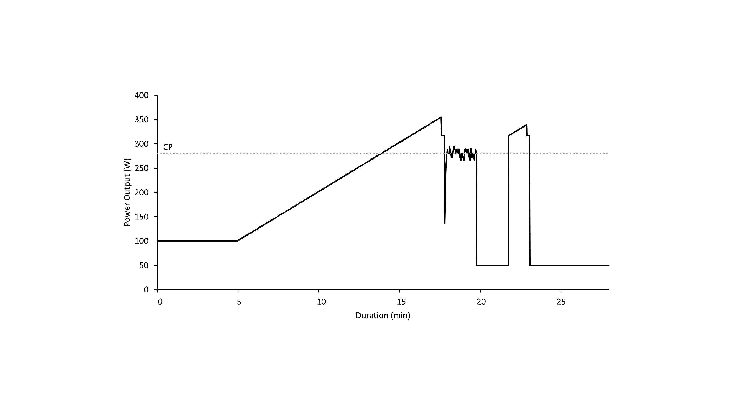

**Figure 1** A typical profile of power output during the baseline test protocol. The 100 W warm up was followed by the ramp at a rate of 20 W∙min-1, and the step down to 30 W above estimated CP. Actual CP was determined from the 2-minute all-out phase. The 2-minute recovery at 50 W, and second ramp, step down and final 5-minute recovery at 50 W served as a familiarisation for the subsequent test protocols*.*

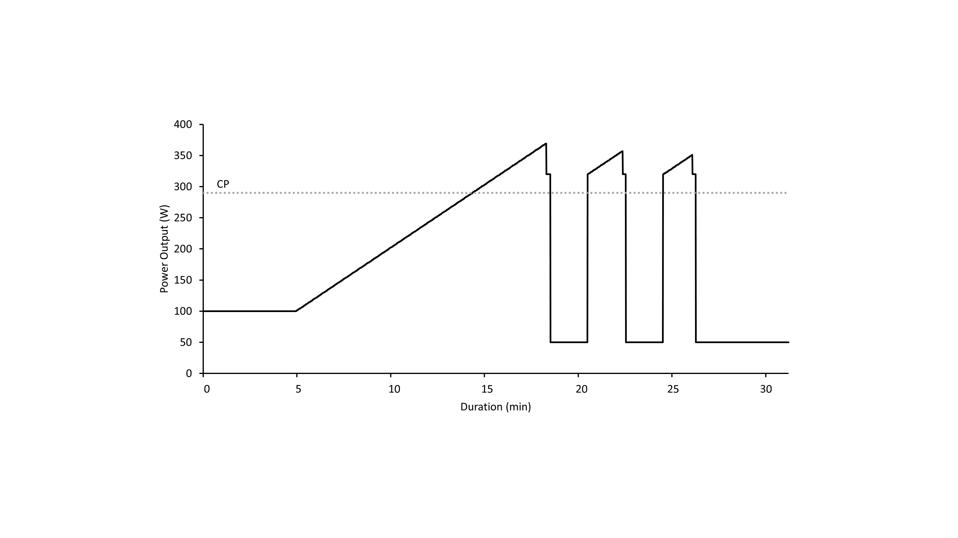

**Figure 2** A typical profile of power output during the RRT protocol. The 5-minute 100 W warm-up was followed by the ramp to the limit of tolerance and step down to exhaust W'. All ramp rates were 20 W∙min-1. The W' reconstitution ramps started at 30 above CP, all step downs were also at 30 W above CP. Recovery periods between ramps were 2 minutes at 50 W, and the final cool down lasted 5 minutes at 50 W. W' and the amount of W' reconstituted comprised the area contained within each ramp and step down and CP*.*

**Figure 3** Within test differences in the amount of W' reconstituted following each 2-minute recovery period for each group. Mean differences in dark, individual changes shaded (trained cyclists open circles, untrained solid circles)*.*

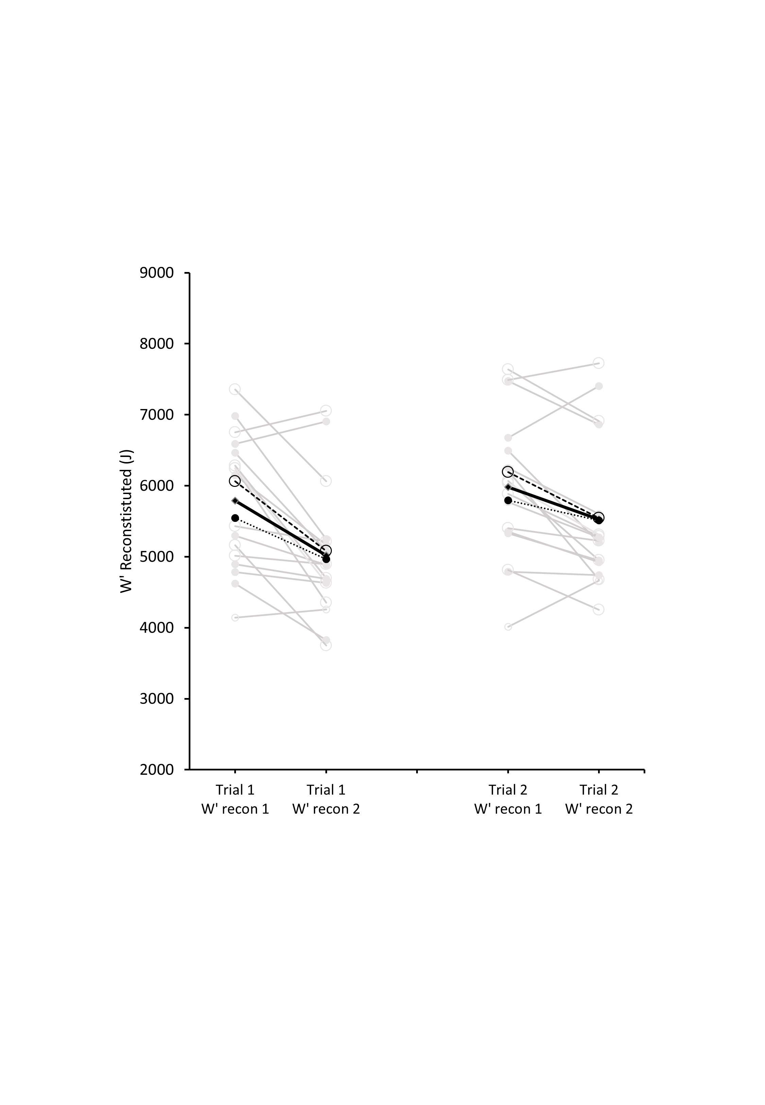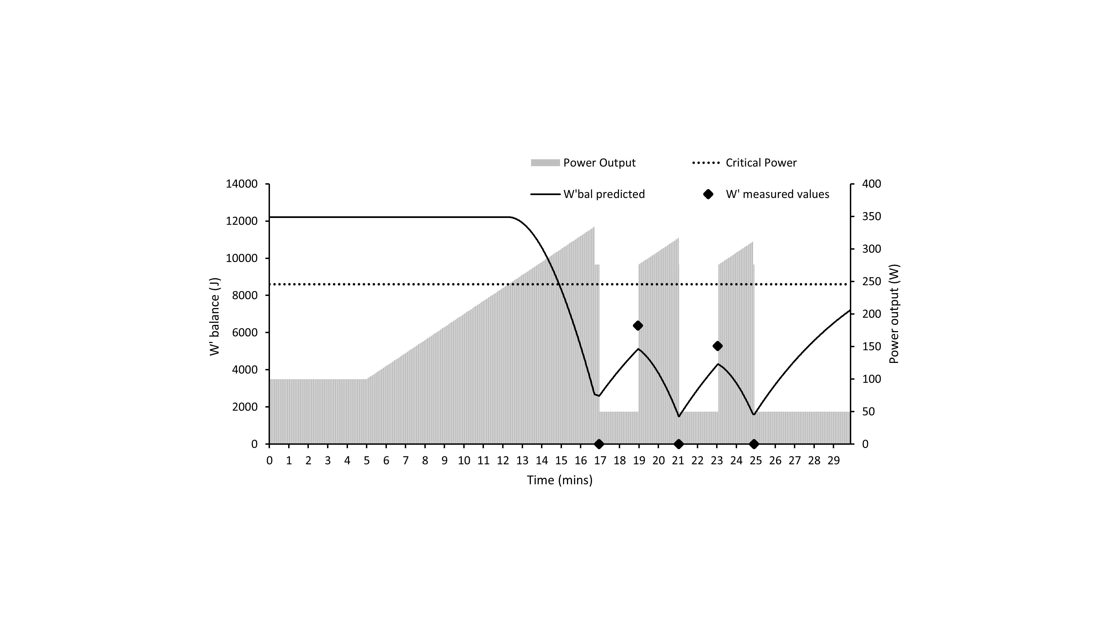

**Figure 4** Comparison of predicted W'bal with the measured values of W' at limits of tolerance and at the end of the reconstitution periods for subject #12*.*