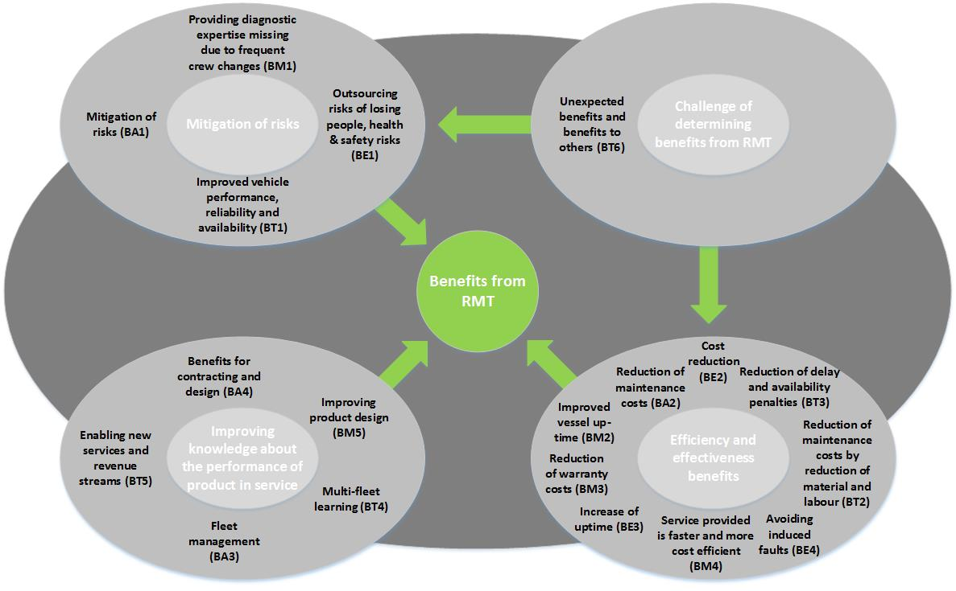
Figure 1. Overview of key findings from the case study research

System used to code a particular benefit (B) from the adoption of RMT in a particular case study (e.g. A-Aerospace Co.).

