***Upon Awakening*: Addiction, Performance, and Aesthetics of Authenticity**

***Zoe Zontou***

This chapter explores aspects of the complex relationship between addiction, performance, and aesthetics. In particular, it attempts to conceptualise what we might call “risky aesthetics” in participatory theatre practices by way of an exploration of particular facets of the philosophy of Deleuze and Guattari – namely, notions of “becoming” and practices of “experimentation” as set out on Mille Plateaux (1987). This will be developed in conjunction with addiction theories (Alexander 2008; Seddon 2010) and the aesthetics of autobiographical performance (Briginshaw 2001; Maguire 2015; White 2015). It explores the many and complex ways in which the identities of people in recovery from addiction are manifested through dance performance, not just as fixed identity markers (although these are also crucial), but also as engagements in becomings (in the Deleuzian sense). Risk is examined in relation to drug-taking behaviours in this instance, but also by drawing on Deleuzian notions of experimentation alongside neuroscientific research on cognitive experience and performance (Arnold 2014; Lewis 2015; Shaughnessy 2013). In other words, this chapter argues that there is a strong affiliation between risk taking in drug addiction and risk taking in performance making. To this end, it proposes that participation in performance can provide a platform from which to encourage an affirmative yet creatively challenging form of risk taking, and in so doing produce a generative aesthetic praxis for performers. In an endeavour to further deploy this argument, this chapter poses the following questions: What happens when drug addicts dance their stories on stage? Do we create a “politically risky metaphor”? Do their collective bodies have the power to make an affirmative political claim and create challenging juxtapositions between the stigmatised–artistic body dyad? For example, what happens when a professional dancer’s body performs next to an addicted/stigmatised body?

To evidence the arguments and relate them to applied performance, the work of Fallen Angels Dance Theatre Company is being examined as a case study. Fallen Angels is a professional dance theatre company working with addicts, people in recovery, and the wider community. In 2014, it received funding from Arts Council England to produce the performance *Upon Awakening*. The project brought together for the first time professional dancers and nonprofessional dancers, working together in a collaboration to choreograph personal stories of addiction and recovery. The performance was shown at the Royal Opera House in London, among other venues, and festivals. The methodological frameworks of this chapter are a synthesis of reflective ethnography, practice-led research, and quantitative modes of enquiry. I have worked with the group since 2012 as principal researcher and creative consultant. In addition, the arguments presented in this chapter are drawn from my body of research in the field of addiction and performance (Reynolds and Zontou 2014; Zontou 2012, 2013).

**Risky aesthetics in applied performance**

Frost and Yarrow state that “we are in an area when it has become fashionable to examine the ‘aesthetics of risk’” (Frost and Yarrow 2016, 242), but aesthetics in applied performance[1] have always been risky. Since the late 1980s and 1990s, applied performance (also known as socially engaged theatre, applied and social theatre, or community theatre) has been largely connected with discourses around impact and instrumentalism, where the ethics and impact or “usefulness” were prioritised over the aesthetic value of the work. Authors such as Claire Bishop (2011), Michael Balfour (2009), and James Thompson (2009), among others, have scrutinised this tendency, arguing that is contributing to what Eleonora Belfiore (2009) calls “bullshit rhetoric”. This is due to the fact that these practices have been mainly perceived to serve certain political agendas. Particularly in the UK, in the early 1990s the ideological and economic shifts in government policies introduced a neoliberal model of practice that fostered a new relationship between socially engaged arts and policymaking. Theatre as a social intervention was perceived as a powerful tool to promote personal or behavioural change (Balfour 2009; Thompson 2011) and education (Winston 2011). Funding from external or public bodies was widely available in support of these practices. Alongside this, there was a growing interest in measuring the social impact of arts, which resulted in a “donor agenda” (Balfour 2009) relationship between art organisations and funding bodies. Evaluating and monitoring the social and economic value of these practices was prioritised over their aesthetic value. As Shannon Jackson (2011) reminds us, the “social turn” of the arts to place stronger emphasis on social practice was a necessity for the development, validity, and security of funding of these practices. Despite this, it should not be dismissed that, at the same time, these practices generated a different form of aesthetic, a type of aesthetic that derives directly from vulnerable and disadvantaged communities and is opposed to any discourse on dominant understandings of institutionalised aesthetics. This “aesthetic heterogeneity” (Jackson 2011, 14) has been informed by the narratives and embodied experiences of individuals who engage in the creative process. The multiplicity and diversity of their life experiences are the basis of this type of aesthetic. It is grounded on stories of risk, vulnerability, memory, and resistance. Hence, it seems deeply problematic to examine aesthetics in isolation from the social context of the work, and without considering the specific risks that are associated with the artistic choices made in each case. Fundamental to our understanding of these aesthetics is a consideration of the backdrop of the social and political context that the artistic work takes place in. Working with vulnerable and marginalised communities requires a deeper understanding of the characteristics and social and cultural values that are specific to each social group. It therefore entails an awareness of the cultural or political constructions faced by certain social groups. Having a greater awareness of these issues prior to initiating the creative process is crucial in order to fully comprehend how to work artistically and socially with vulnerable groups. It is necessary for practitioners working in participatory arts to be clear about their own approach on the role of aesthetics in vulnerable contexts. In turn, this will determine which type of risky aesthetics is appropriate in each case.

In recent years, there has been a growing interest in bridging the gap between the social, instrumental, and aesthetic parameters of applied performance. James Thompson in his renowned book *Performance Affects: Applied Theatre and the End of Effect* (2009) reiterated the role of beauty in applied performance. After drawing on his experience of working in places of war, conflict, and environmental disaster, Thompson called for a turn to the notion of affective practice. He asserted that applied theatre should be better regarded for its ability to restore beauty to the lives of those affected by war and conflict. For Thompson, the notion of beauty in performance refers to and manifests the need to centralise an individual’s potential to create and enact moments and stories that they regard as beautiful. With this argument he attempted to change the direction of the debate regarding theatre’s efficacy to support behavioural or societal change (effect), advocating the need to place further emphasis on the importance of engaging participants and communities in the creation of moments that they regard as beautiful, and in doing so generate positive feelings (affect). He states:

The sheer physical enjoyment and energy that these projects can elicit, make them potential examples of the enactment of beauty – a performance of beauty – moments that make the heart beat faster, and people start a search for ‘something of the same scale’. (Thompson 2009, 56)

He connects affective practice with the aesthetics that emerge from moments that make the heart beat faster, in situations where the aftermath of war, the risk of national security, or environmental disaster are the only reality. The participants’ experiences of risky lives becomes the *modus operandi* of the creative practice and defines performance making in these contexts. Thompson’s emphasis on affective practice has been supported by other scholars such as Joe Winston (2011), who explores the role of beauty in educational theatre. Comparable to Thompson’s arguments, Winston concludes that awakening aesthetic value in educational settings is an essential part of developing cultural citizens. By exploring the role of aesthetics through the lenses of educational and developmental theories, he argues that learning how to relate to aesthetics is an important asset for developing learners’ cultural and social identity. More recently, Gareth White (2015) in his volume *Applied Theatre: Aesthetics* gathered academics and practitioners to respond to questions about the relevance of aesthetics in applied performance. Contributors to this volume addressed a number of issues relating to the complex relationships between applied theatre practice, aesthetic theory, and efficacy, uncovering further the complexities of participation and its relation to aesthetics. For instance, Kirsten Sadeghi-Yekta’s chapter (2015) discusses her experiences of conducting research about applied theatre’s international aesthetics in an arts centre in Cambodia. She draws our attention to the competing aesthetic criteria often shared by artists, participants, government bodies, and international non-governmental organisations involved in applied theatre projects. As she maintains, contesting understandings of aesthetics can lead to tensions, forcing artists to produce the same type of work, in order to match the aesthetics of the funding bodies or dominant Western understandings of art aesthetics, resulting in aesthetic homogeneity. Risky aesthetics, therefore, become a form of protection, ensuring the preservation of the unique work that is being produced by applied theatre practitioners. It is a way of maintaining aesthetic heterogeneity and adding value to the artistic work that has been produced through, or as a result of, the participants’ vulnerable and risky lives. Furthermore, risky aesthetics become a platform within which to pose crucial questions about artistic autonomy, inclusivity, and representation. Addressing these questions is important for the context of this chapter and more broadly for applied theatre practice as a whole as it brings to the surface the many and complex ways in which risky lives are negotiated to create an aesthetic but also introducing a radical understanding to our enquiry. It is important for artists working in participatory settings to embrace this aesthetic and situate it within the larger picture of performing arts. This is a radical approach as it sets out to contradict the dominant institutionalised aesthetics. Instead, it places the aesthetics that emerge from risky lives at the epicentre of the creative process. I return to this argument later in the chapter when I discuss in detail the work of Fallen Angels where I propose the genesis of a form of aesthetic that moves beyond dominant institutionalised aesthetics. This links with Augusto Boal’s notion that democratisation of the creative practice sits at the heart of applied theatre:

We seek the Beauty hidden in the heart of each and every citizen, since every citizen is an artist – each in his or her own way: even though some may not be capable of creating an *Aesthetic Product* which enlightens all of us, all are capable of developing an *Aesthetic Process* which enriches themselves. (2006, 39)

Boal’s remark regarding a participant’s incapacity to create aesthetic product can be misleading. In my view, his argument does not imply that they are unable to create an aesthetic product per se, but are unable to go against the accepted/dominant aesthetics as have been manifested in the art world. Hence, he turns our attention to aesthetics as a cognitive notion of self-expression, and identity formation, liberated from any pre-established conceptions of beauty in the arts. However, this is equally problematic as it enlarges the gap between participatory theatre and artistic excellence. It excludes the possibility of generating a different aesthetic capable of embracing artistic work that is generated by the experiences of every citizen, and is equally able to “enlighten all of us”.

Concerns about the aesthetics of applied performance practices have been raised throughout my research and my artistic work with people in recovery from addiction. Aside from the issues of stigmatisation and exclusion, the biggest challenges that I have to face are related to discovering means of representing personal experience in ways that go against sentimental aesthetics or promote the exploitation of human experience. In previous work I have problematised the complexity of working with personal stories of addiction recovery (Zontou 2014). While exploring examples of popular culture representations of addiction, I highlighted the limitations of language and text to challenge the stereotypes and stigmas of addiction. I argued that an additional emphasis on safeguarding the participants’ personal experiences is needed. For this I suggested a different form of representation is required, one that moves away from victimising the performers. I recommended that bringing the stigmatised body into performance, and engaging audiences with the performers’ personal journeys, is a potential powerful strategy to challenge social perceptions. It is my contention that any discussion about aesthetics in applied performance ultimately becomes a discussion about authenticity and ethics. For people in recovery from addiction, exposing their past experiences of vulnerability can be risky, unethical, and problematic yet equally beautiful and empowering. The dichotomy between vulnerable lives of addiction recovery and risky aesthetics produces a strong juxtaposition between the stigmatised/artistic dyad versus the ethics/politics of representation. Problematising the complex tension between vulnerable lives and risky aesthetics is fundamental, particularly when we work artistically with autobiographical experiences. My argument echoes Tom Maguire, who maintains,

offering one’s life story involves a risk to the teller in exposing herself to the judgments of other people; the teller makes herself vulnerable to their incomprehension, ridicule or rejection. The risk may be intensified where these is no pre-existing relationship and the teller can not rely on shared assumption and values. (Maguire 2015, 60)

To add to this argument, the risk of exposing vulnerabilities can be magnified when the performers are stigmatised through their past experiences of addiction dependency. As Clark Baim, in chapter four of this volume, points out, “staging pain and suffering is not an answer in itself and runs the serious risk of voyeurism, collusion with oppression, and even reabuse and retraumatisation of victims” (Baim 000). Hence, working towards an autobiographical performance requires a disintegration of previous conceptions about one’s self in order to allow space for the reshaping of identity, and subsequently generating an alternative aesthetic. This aesthetic derives from the process of recollection of past embodied experiences of shame, guilt, and trauma and is informed by the multiplicity of identities and conceptions of pre-stigma and post-stigma self. The role of vulnerability in autobiographical performance is to initiate the process of deconstructing personal experience. Vulnerability is not perceived as a weakness but rather as the starting point to understand one’s life narrative and by doing so to maintain worthiness and authenticity. Narratives of addiction and recovery are not always coherent and are difficult to pin down. This slipperiness is the result of addiction recovery being a circular ongoing process that is often slowly constructed through language and repetition in the privacy of counselling rooms and group therapy meetings. These stories are in flux and exist as unending performances of becoming and identity formation (Lewis 2015; White 1996). Working with personal narratives in dance theatre means that these stories, however incoherent, incomplete, or fractured, are finding a way to be constructed as meaning-making entities in front of an audience, who in turn acknowledges them as signs of identity formation. Paul Bayes Kitcher, artistic director of Fallen Angels, asserts:

When addicts come into group settings and recovery they become used to expressing themselves verbally so it becomes easier for them to articulate what they have been through and how they feel. This becomes very useful when we start to develop movement material through improvisational tasks as they have emotional intelligence. What I experience when I see this is something very transformative and powerful, as the movement they create becomes beautifully broken, but whole at the same time, making the quality authentic and honest. (Bayes Kitcher 2016,n.p)

Bayes Kitcher underlines the choreographer’s ability to incorporate and translate personal experience into an artistic product that should be equally regarded for its artistic excellence. By acknowledging the challenges presented when working with communities, in terms of balancing institutional aesthetics as well as encompassing the aesthetics of the experience, he calls for the aesthetics of authenticity. This echoes Christine Lomas who suggests that, “to empower implies a challenge to prevailing systems, with emphasis on the authentic, on non-traditional aesthetics, and on a way of working predominantly concerned with facilitation” (1998, 159). Applying this understanding to applied performance practice, and the context of this chapter, it could be argued it is crucial to move away from pre-established conceptions of aesthetics, so as to allow the aesthetics of authenticity to become equivalent to aesthetics of artistic excellence. The aesthetics of authenticity in turn produce moments of post-authenticity, when performing embodied experiences of addiction move beyond the truthful representation of “real” experiences and instead place emphasis on a phenomenological and semiotic understanding of bodies on stage. The authenticity of vulnerable narratives and the many ways that they are presented on the theatrical stage offer new possibilities for reimagining and conveying meaning to these experiences. These representations overreach “real” story representation to provide a deeper exploration of how personal experiences of risk can be manifested through movement. Rat Western’s (chapter eight, this volume) analysis of the connections between authenticity, sincerity, and risk are useful to my argument. Drawing on Benjamin Walter’s theories on authenticity, she suggests that risk is “contextual” and thus capable of challenging both the “real” and representations of the real. Western’s approach to risk as contextual, liberated from any preconceptions about real and its representation, illuminates my argument as it opens up new possibilities for exploring how personal stories can be presented on stage. To develop this, I assert that risky aesthetics is an invitation to renegotiate the different dynamics involved in making theatre in social contexts. The aesthetics that emerge directly from the personal experiences of marginalised communities and run contrary to institutionalised aesthetics that dominate cultural production are crucial here. Risky aesthetics as a concept provides an explanatory framework to reshape the way that institutionalised aesthetics inform the construction of our subjectivity in terms of what we perceive as artistic value. Hence, risky aesthetics is a platform for the critical vulnerabilities of the participants to be reconfigured into aesthetic products capable of enlightening all of us. The power of vulnerability opens up space for a post-authentic exploration of the multiple and risky dynamics of putting a group of recovering addicts on stage to dance their stories. To build on this argument I turn now to conceptualise the connection between risk, addiction, and performance.

**Connections between drugs, performance, and risk**

So far in this chapter I have broadly situated aesthetics within the field of applied performance. This section moves the discussion forward in order to draw connections between risky aesthetics in performance making and drug addiction. In doing so, I am going to draw evidence from my previous body of research in the field of addiction and performance (2007–2015) and from a series of practice-based projects, participant observations, and interviews that I conducted in the UK and Greece[2]. The participatory research methods of my research in conjunction with the artistry and improvisatory nature of the creative practices that I investigated provided successive points of encounter between autobiographical experience, performance, and risk. The research findings indicated that, regardless of the context of the project, participants, especially those who did not have any previous experience of participating in performing arts, draw connections between their experiences of drug taking and those of creating theatre and/or performing. They made references to feelings of the buzz or “high”, euphoria, and a sense of belonging. In a first attempt to theorise these responses I coined the term “alternative substance” (Zontou 2011, 304). This refers to the possibilities of using applied performance as a medium to make an affirmative impact on the participants’ lives and help them on their journeys to recovery. This echoes the work of Nicholas Arnold (2014), who has identified significant parallels between the effects of psychoactive chemicals and performance on the body. Drawing on neuroscientific studies, Arnold maintains that, similar to psychoactive drugs, performing can activate our reward system, also known as “dopamine system”. Dopamine is one of the many important neurotransmitters that are associated with the “pleasure system” of the brain. When released it provides pleasure and a sense of euphoria and belonging. Various triggers such as food, sex, and physical activities such as performing can activate it naturally, but drugs such as psychedelics, cocaine, and ecstasy[3] have been widely used to reinforce dopamine release. Shamanistic rituals of performing the body (Winkelman 2002, 2011), together with contemporary cultural trends such as rave and club dancing (Joe-Laidler and Hunt 2013; Papadimitropoulos 2009), have been considered as paradigmatic to the way performance, alerted states of consciousness[4], and cognition are interconnected. In recent years, neuroscientists and theatre scholars have begun to explore these connections (McConachie and Hart 2007; Blair and Cook 2016). For instance, contributors to the volume *Affective Performance and Cognitive Science: Body, Brain and Being* (Shaughnessy 2013) bring new insights to the way brains and bodies engage with performance, and the particular risks that are associated with this process. By bringing together cognitive science and performance studies, they explore new understandings on perception, emotion, imagination, and empathy. Drawing on cognitive sciences research on the embodiment of human perception and interaction created new possibilities for theatre scholars and artists alike to deepen their explorations on how embodied risky experiences can be presented on stage. Hood’s (2013) chapter on the representation of physical pain through performance is particularly relevant to my argument. She offers an in-depth account on how the representations of pain, as an objective embodied experience, can offer themselves as a vehicle to understand risky aesthetics. This relates directly to my analysis on how vulnerability in performance is a process within which to situate risk taking as form of aesthetic.

Notwithstanding these studies, historically, there has been a strong affiliation between alerted states of consciousness, performance, and drug taking, to the point that the cultural and social connotations between drug misuse and aesthetic experience have become a paradigm of cultural and social subcultures alike (Boothroyd 2006; Brodie and Redfield 2002). The representations of drugs in popular culture, or what Klein (1993) refers to as the “sublime” aesthetics of the drug experience, have been intertextually depicted in myriad examples of film, art, music, and theatre. In contemporary performance practice, drugs have been widely used as a way to stimulate the artist’s creative impulse or to enhance audiences’ aesthetic experiences and perceptions. Professional performance artists have experimented with extensive drug and alcohol use as a way to enhance their performance aesthetics. The Wooster Group, for example, in its piece *L.S.D. (... Just the high points ...)* (1985) tried to re-enact the first part of its performance after taking LSD. More recently Bryony Kimmings’ piece, *7 day drunk* (2011), was the result of a week of creative experimentation conducted at a medically maintained level of drunkenness. The outcomes of Kimming’s creative experiment were put together and performed by her sober. In both cases, the artists did not “act” being high or drunk; they actually experienced it. The audience bore witness to the performers’ highs and was also able to watch the creative product of the performers’ drunkenness. Aside from the drug or alcohol consumption, another commonality of the above examples is the level of risk that was taken by the performers’ excessive use of substances. Both examples pose important questions about creativity, drugs, and performance aesthetics. An important aspect of the above examples lies in the artists’ emphasis on the authentication of the experience. The “real” experience of intoxication operated as a signifier of the “real” experience of performing being high or drunk. Nevertheless, it should be acknowledged that the deliberate act of making themselves vulnerable risk takers is deeply problematic for two main reasons. First, the level of risk taking was maintained at a controlled level. For instance, Kimming’s alcohol consumption was monitored by a team of medical doctors, which minimised the risk of overdose or other health implications. Second, the social status of the performers as artists played a significant role on the way their performances were received by the audience. In contrast, when it comes to people in recovery from addiction, the level of risk involved in performing their vulnerability is significantly higher and complex. Their vulnerability is the result of stigma, discrimination, and prolonged feelings of social disconnection. In this regard, they are not deliberately *becoming* vulnerable; they *are* vulnerable. Risk taking in this instance is considerably intricate. It requires a deeper understanding of the affirmation between risk taking in performance making and risk taking in drug consumption.

Similarly to drug consumption, voluntary risk taking is another factor that has become normalised in contemporary cultural practice, particularly when it is being discussed in association with health and body and its implications to drug subcultures. A considerable amount of literature has been published on the connection between risk taking, club dancing, and drugs (Milhet, Bergeron, and Hunt 2011; Hunt and Evans 2003; Wibberley 2003). For instance, in a study entitled *Dancing on Drugs*, Fiona Measham, Judith Aldridge, and Howard Parker (2000) explore the complex relationship between drug misuse, risk taking, and club dancing. According to their findings, club goers, although they were aware of the health and legal risks associated with drug use, perceived drug consumption as an essential part of the dancing experience and therefore a risk worth taking. Despite the fact that the Measham et al. study involved informants who consider themselves recreational users, it is my contention that their findings are relevant to people in recovery from addiction. This is because, similarly to clubbers, for addicts, risk taking expresses a resistance to conform to the dominant risk culture. They prefer to consider themselves as “risk-takers instead of ‘at-risk’ victims” (Peretti-Watel and Moatti 2006, 678). The distinction between risk takers as opposed to at-risk victims is of paramount significance for my argument. It highlights an underlying complexity between risk and vulnerability that is relevant to addiction recovery and risky aesthetics in participatory arts. It converses the meaning of risk so that it becomes an empowering concept capable of challenging pre-established identities. Risk, in these instances, contributes to the proliferation of drug taking as an identity marker. It provides a platform to convey a sense of self-determination, individuality, and self discovery, a quest for meaning making and even freedom (Seddon, 2010). In a society where risk is something to be continuously avoided, from mainstream health promotion models of behaviour or anti-drug campaigns, risk has become an instrument of social control that reinforces the medicalisation of deviance and contributes to the stigmatisation of drug addiction. Therefore, voluntary risk taking can be read as a symbol of resistance and an attempt to contest the dominant risk culture. This resonates with the perspective of Bruce Alexander (2008), who has claimed drug addiction is a sign of social dislocation and meaninglessness. It is not just about the direct effects that drugs such as heroin have in the brain *per se*, but rather the whole risk-taking lifestyle of searching for the next fix, funding habits, deviancy, escaping police, and legislation. Hence, risk taking is an essential part of this process. Drug users become social actors as they have to lie/perform to social services, police, and family to decrease any level of suspicion over their habits. As their relationship with the drug changes and escalates, risk becomes a tool for survival. Both drugs and risk replace their sense of belonging and identity and become the vehicle to escape social reality. Aside from the legal, social, and psychological risks, the biggest implications of drug taking are connected with risking their bodies. Kemps illustrates that drug addicts “live a disturbed relationship to their bodies” (2009, 120), whether this is because of injecting, snorting, smoking, neglecting to eat or sleep, or the physical pain of withdrawal syndrome. As addiction escalates, the risks of withdrawal syndrome and extreme bodily pain overcome the risks of prosecution, overdose, or potential death. Addicts develop a cellular relationship with their drug and subsequently with their bodies. Hence, the process of recovery from addiction has been regarded as a reconfiguration of the complex relationship between the individual and their body. Recovery from addiction requires a complete restoration of the sense of self. To this end, many people in recovery from addiction refer to their journey as rebirth (McIntosh and McKeganey 2000; White 1996). The process of becoming recovered is a continuum that facilitates the process of framing and reframing past experiences as well as reconstructing a new sense of self. This is relevant to those in the passage of transition, like the bodies of people in recovery from addiction that are in transit through discontinuing drug misuse and reconstructing their identity. Therefore, past experiences and the many ways that those are remembered and revisited are an essential aspect of becoming recovered. As social psychologist Oksanen denotes, becoming is “a creative flow, that makes things change and opens up new ways of seeing, feeling and perceiving” (2013, 59). Oksanen is arguing this from the point of view of social psychology, in which creative flow is a developmental process. He utilises the Deleuzian concept of becoming as a conceptual framework to understand the relationship between recovery, the body, and the production of desire. Nevertheless, his definition of becoming is relevant here as it indicates that there is a strong connection between becoming, recovery from addiction, and the aesthetics of participatory arts. When working artistically with people in recovery from addiction, the creative process is an invitation to revisit their past experiences as a means of both reconciling their past with the present and finding ways to move forward. However, as Deleuze and Guattari (1987) point out,

Drug addicts continually fall back into what they wanted to escape: a segmentarity all the more rigid for being marginal, a territorialization all the more artificial for being based on chemical substances, hallucinatory forms, and fantasy subjectifications. Drug addicts may be considered as precursors or experimenters who tirelessly blaze new paths of life, but their cautiousness lacks the foundation for caution. (Deleuze and Guattari 1987, 285)

In order to explore further this concept of drug addicts “as precursors or experimenters who tirelessly blaze new paths of life” and to connect it with participatory theatre practices, I consider risk taking in the arts as a form of a creative experimentation that embraces embodied experience. The implementation of dance and movement can be an effective way to introduce participants to experimentation and positive risk taking, especially in terms of translating past embodied experiences of addiction, stigma, and deviancy into an aesthetically challenging dance theatre piece. However, the danger with addiction is that addicts “continually fall back into what they wanted to escape”. I see “alternative risky aesthetics” as the passage between and betwixt two cultures: the culture of addiction and the culture of recovery. Risky aesthetics in this context can be understood as a reconfiguration of past experience. It is a dynamic medium to help addicts get out of (Deleuze and Guattari 1987) the embodied, identitarian, and self-expressive personal performance making. Instead, it moves them into a mode of critical enquiry along the lines of Deleuze and Guattari’s notion of becoming. By the same token, this supports the development of a sense of critical agency by inviting the participant and audience alike to understand the performance piece as a becoming, not only a marker of identity. This is because the performance is presented as a process of becoming rather than of a final identity marker event. Achieving this is not always easy and presents some crucial challenges for practitioners. It requires a deeper understanding of the nexus between risky aesthetics and performing risk and vulnerability. In the next section, I shift my analysis in order to explore the possibilities and challenges of creating a dance theatre piece based on the participants’ risky lives of addiction and recovery.

**Fallen Angels Dance Theatre: In the making of *Upon Awakening***

*Upon Awakening* is the latest production by Fallen Angels. It premiered at the Lowry Theatre in Manchester and was then performed at the Royal Opera House in 2014. Since then it has been performed in different venues and at events such as the UK Recovery Walk[5]. This project was a particularly significant moment for the development of Fallen Angels as it was part of a series of events launching its charity status. The aim of the final performance was to enhance the organisation’s profile as a charity devoted to challenging stereotypes placed on people in recovery from addiction through live performance. This was an opportunity to demonstrate its vision of ensuring artistic excellence whilst raising awareness that art has the potential to change lives with its rehabilitative power. The performance at the Royal Opera House’s Clore Studio Upstairs was a particularly significant moment for achieving this goal. Aside from the performance, the project itself was a pivotal moment for Fallen Angels as it was the first time it brought together five community dancers who were in recovery from addiction and three professional dancers. In August 2014, the team engaged in a one-week intensive workshop. The creative process was framed around the participants’ personal experiences of recovering from addiction. It aimed to creatively reflect on and consider wider philosophical themes around the concept of “awakening” and its associations with recovery and dance theatre. By using the theme of awakening as a starting point participants were asked to offer their responses by sharing their personal experiences of moments of awakening or stepping stones. These responses were then transformed into an exchange of movements and sequences between community dancers and professionals. Throughout this process the participants were given an opportunity to revisit and reshape their stories using artistic forms. Using the concept of awakening as a metaphor for recovery allowed them to add a symbolic affirmative dimension to their life experiences.

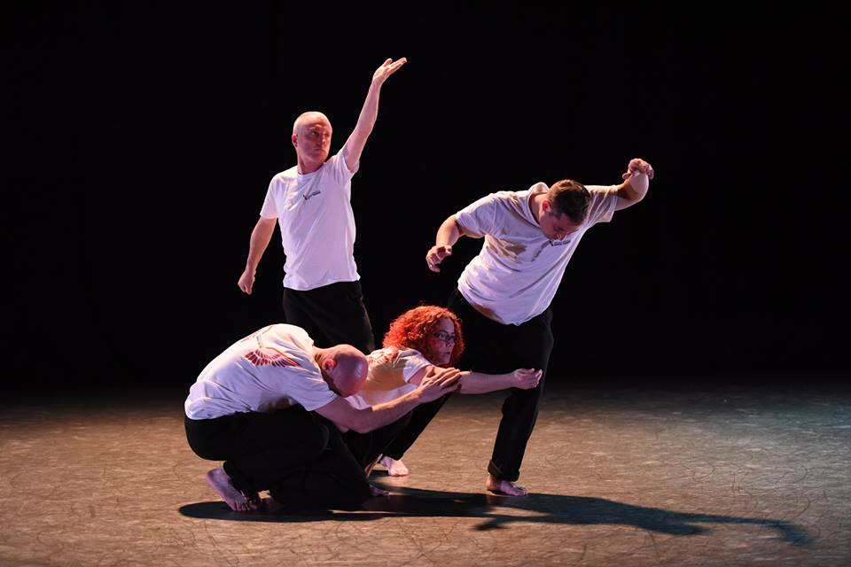Figure 9.1. *Letting Go*, Royal Opera House, 2014. Photo: Brian Slater.

In the secondary phase the professional dancers developed selected movements and routines that were further refined into exploratory sequences. This collaboration resulted in several benefits for both the professional and community dancers. The community dancers had an opportunity to reconsider their journeys by revisiting their personal experiences through artistic means and translating them into dance routines. The dancers were able to interpret these stories through movement and gain an insight into the complexities of addiction, understanding each individual member’s journey to recovery as different and diverse. In this way the community dancers became coperformers, leading the devising process and choreographing their own stories. Their verbal and embodied personal accounts operated as self-referential trajectories and formed a valuable part of the creative process. Furthermore, throughout these experimentations they were constantly engaging with “becomings” that allowed them to frame their embodied subjectivity and recognise their identity as an entity that is not fixed but inherently in flux. It provided an opportunity to create trajectories between their past, present, and future, and to see their own lives progressing, moving to meaningfulness, from painful past to viable future. By working with movement, symbolism, and personal storytelling the participants deepened into the physical and emotional aspects of addiction recovery. This echoes the views of Sonia[6], one of the community dancers, who said, “sometimes in addiction emotions are lost along the way, dancing brings it all back” (Sonia 2014). In this context aesthetics can be understood as a theory of experimentation with real experiences. This process facilitates the transformation of themselves but also the transformation of their understanding of the world**.** This process encouraged them to find creative ways to communicate their experiences to a wider audience and in so doing to explore where they positioned themselves socially, as citizens and members of the community. Moreover, the embodied encounters with the professional dancers opened up the possibility for a critical enquiry. It challenged the juxtaposition between the trained/stigmatised body versus the “real”/fictional experiences. These exchanges between the drug-using body and the trained body formulated a critical framework within which to consider questions about stigmatisation and exclusion.

This process is not simple. It can lead to complex dilemmas particularly when the experimentation needs to produce material for a public performance. Notwithstanding the mutual creative benefits for both groups, this process presented challenges relevant to the questions about aesthetic heterogeneity and risk that I discussed earlier. Specifically, it raised one significant question: How feasible is it to ensure artistic excellence and aesthetic quality when working with vulnerable communities? Throughout the evaluation process, the directors concluded that the intensity of the rehearsal process, combined with the lack of professional training for community dancers, created barriers for the true integration of both groups. They assert: “We felt that there was still development needed until we could integrate the professionals with community members to create a high quality artistic production, particularly in terms of improvisation and somatic frameworks” (Bayes Kitcher and Morris, 2014). Driven by their commitment to implement a person-centred approach, they made the decision to actively include everyone and to give to all the opportunity to tell their story and work alongside the professionals. Aside from the pressure to provide a participant-centred approach, I would argue that this ambivalence arose because of a higher demand to meet the pre-existing standards of the institutionalised aesthetics such as at the Royal Opera House. The tension between artistic excellence and the social values of participatory performance created a dichotomy and cast doubt on Bayes Kitcher’s artistic autonomy. This became apparent in an email correspondence between us in August 2014:

The project is going really well here […] My thoughts are being constantly evaluated as I sometimes struggle with decision making surrounding artistic excellence and the notion of integrating recovery dancers into this! Bringing vulnerable adults into a professional process can be problematic, in terms of discipline and ability to cope and sustain at such a high level. Retaining information, steps, choreography can be very challenging. There is always an issue when trying to firm down and retaining material […] Questions appearing […] Should they be put into this environment? How can this be a good experience for both recovery artists and professional dancers? Does our want to care, hinder the artistic process and the ability of the dancers? As a director how can I choose between a person’s innate and unique gift of performance verses their inability to retain direction. There can be beauty in the moment but can this be reliable? Or guaranteed in each performance? What is professionally acceptable? What are the expectations of the audience/programmers/funders? (Bayes Kitcher 2014)

It is evident that Bayes Kitcher is divided between the ethics of participation, as opposed to giving greater emphasis on achieving artistic excellence. Safeguarding the participants’ was prioritised over the aesthetic quality of the piece. In doing so, he questions the idea of participatory arts versus inclusivity versus artistic excellence and returns to the argument that I presented earlier on regarding risky aesthetics as a paradox that reveals the limitations of pre-established conceptions of aesthetics. For the final performance, he decided to divide the groups. In the first part community dancers performed their own introductory piece, *Letting Go*,followed by the professional dancers, who performed *Upon Awakening*. This decision to separate the performance created some interesting symbolical references that reveal further the dichotomy between the addicted/stigmatised bodies versus the trained bodies of the professional dancers. It raises questions about the politics of representing vulnerability on stage and the role of risky aesthetics in it. In the next section I discuss these issues in relation to the performance at the Royal Opera House. Drawing on the Deleuzian concept of “becoming”, I offer an account of how the dynamics between the vulnerable bodies as opposed to the trained bodies can be reversed through performance.

**Becomings at Royal Opera House**

The Royal Opera House is one of the world’s leading opera companies and also houses the Royal Opera Ballet. It is renowned both for its outstanding performances of traditional opera and for commissioning new works. On Tuesday 18 November 2014, while opera goers were arriving in the main auditorium to watch *L’Elisir d’Amore*, directed by Laurent Pelly, Fallen Angels’ audience were settling down at the Clore Studio Upstairs for a very different performance. The event was opened and introduced by Fallen Angels’ directors. Following this the community dancers had the opportunity to talk about their stories from addiction to recovery and their involvement with Fallen Angels. These introductory speeches achieved the goal of setting a personal and interactive tone for the two performances that were due to be presented, highlighting and enforcing the charity’s mission to play a role in promoting dance theatre and its transformative power. In the first performance, *Letting Go*, the community dancers offered an honest and emotional account of their stories of recovery. A synthesis of swaying movements of falling and getting up, accompanied by recorded voiceovers such as “are we dancing, dreaming, or awake?” and “our bodies are moving, our minds are open” and a blue wash stage lighting, all collided to create a dark, dream-like atmosphere. The authentication of their experiences was evidenced in their sharp, imperfect movements, and in the different shapes of their bodies, which signified their past experiences of years of substance misuse and living on the edge of addiction. This analogy was further enriched through dance phrases and isolated movements such as falls and tumbling, which were carefully shaped to symbolise the failures, despair, and complexities of addiction, as well as the merits of recovery. The finale of the first performance concluded with the five performers standing on stage with their arms wide open, in a symbolic gesture of embracing the audience and passing the message on that addicts do recover. Following this, the professional dancers who offered their own response to the issues of addiction with *Upon Awakening* developed the concepts that the first piece introduced. Their piece gave emphasis to the concept of awakening after the darkness of addiction. As Claire Cohen points out in her review in *London Dance*:

Filling the vast dark void of the Clore Studio with a handful of performers who were giving out a strong silent message: recovering from addiction propels you to the depths, but you can win through. After the raw authenticity of the first group it was evident [that the professional dancers] were *acting*. But they’d absorbed their lessons well, for their dancing was utterly compelling. (Cohen 2014, n.p., my emphasis)

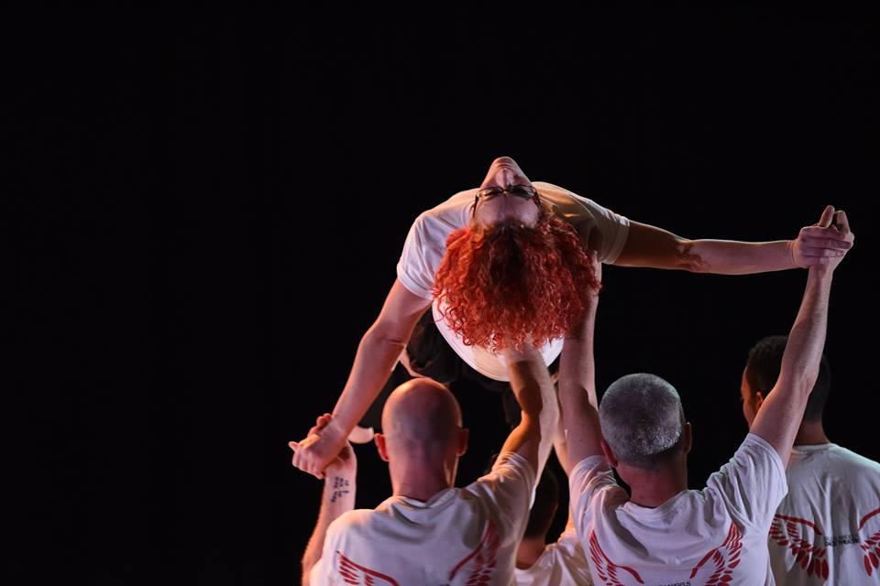

Figure 9.2. *Letting Go*, Royal Opera House, 2014. Photo: Brian Slater.

The juxtaposition between “a handful of performers who were giving out a strong silent message”, as opposed to the “obvious acting”, provides us with a useful framework to conceptualise the paradox of risky aesthetics. Risky aesthetics blur the boundaries between the subjectivity of the personal experience in antithesis to a trained body. It is precisely the subjectivity of the collective embodied experience of the community dancers that creates the basis for a generative form of aesthetics. A generative form of aesthetic means a type of aesthetic that derives directly from past embodied experiences of shame, guilt, and trauma and is informed by the multiplicity of the community dancers’ identities. This is a useful context to articulate how a dance theatre piece performed by a group of recovering addicts can draw attention to the dynamics of participatory theatre. The contrast between the recovering body and the trained body of the professional dancer creates a powerful dialogical interplay and raises questions about body politics and post-authenticity. At the basis of risky aesthetics is the invitation from performer to audience and fellow performer to move beyond the normative processes of judgement, both aesthetically and socially. This is possible by inviting performers and audiences to approach the performance as a becoming instead of a fixed identity marker. Risky aesthetics is the platform of this transition to become possible. Drawing on Antonin Artaud’s “To be done with the judgment of god”, Deleuzian becomings insinuate an end of judgement (Scheer 2009). Judgement in this instance relates to the societal stigmatisation and exclusion of people in recovery from addiction and, by the same token, judgement of their performance in terms of its aesthetic value. One way to decrypt society and its preconceptions about addicts and aesthetics is to start with the body. Aesthetics play a fundamental role in deconstructing the body in what Artaud refers to as “body without organs (BoW)” (Scheer 2009, 40-44), a concept that Deleuze and Guattari develop in *Anti-Oedipus* (1983) and *A Thousand Plateaus* (1987). Risky aesthetics depends upon a becoming vulnerable not only for the recovering-from-addiction performer but also in relation to the normative aesthetic values of, for example, the Royal Opera House. In an interesting analysis of Deleuzian ethico-aesthetics and drug addiction, Petra Malins maintains,

[A] body should, ultimately, be valued for what it can do (rather than what it essentially ‘is’), and that assemblages should be assessed in relation to their enabling, or blocking, of a body’s potential to become other. (2004, 84)

This was clearly evident in the case of the first piece for two main reasons: first, because for the first time in the history of the Royal Opera House a group of recovering addicts was given the opportunity to perform their stories. This has allowed them to transition from addicts to artists whose experiences are valued within the cultural canon and the setting of the Royal Opera House. Second, their embodied experience of addiction was immersive and gathered into a single context, an assemblage.

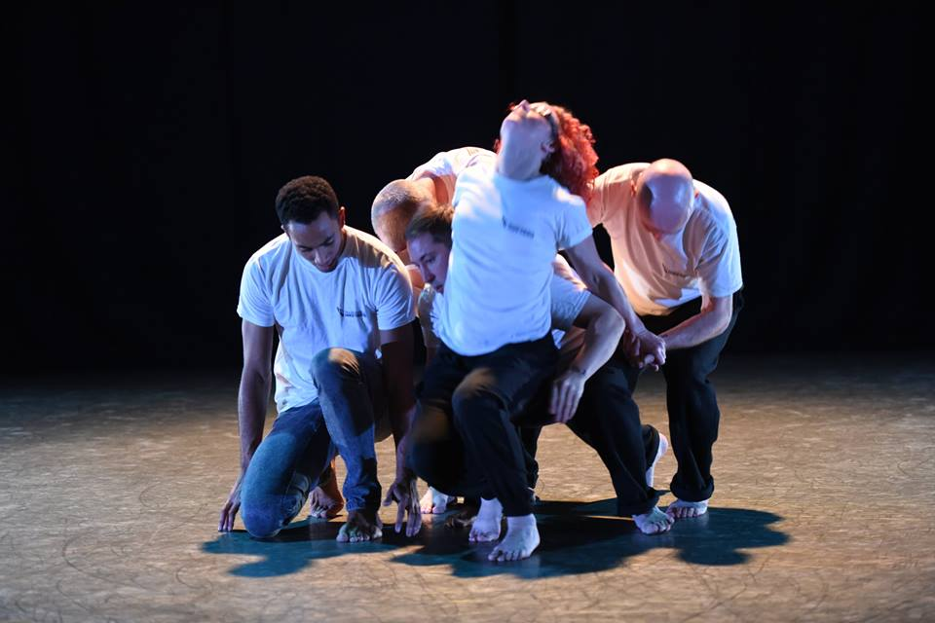

Figure 9.3. *Letting Go*, Royal Opera House, 2014. Photo: Brian Slater.

The aesthetics of their collective post-authenticity and the power of their bodies “to become other” in front of their audiences de-constructed the dominant, institutionalised aesthetics. This process of engaging in becomings constructs the genesis of risky aesthetics. This was made possible by the multiple symbolic exchanges between performers and audiences. The presence of a group of recovering addicts on stage runs contrary to institutionalised aesthetics that dominate cultural production. It reinforced a consideration of the role of vulnerability in performance making. The becoming of aesthetics emerges from participants’ experiences and is associated with the repositioning of the participants’ embodied subjectivity at the centre of the audience’s attention. Malins argues that

Bodies – even those which are as rigidly and abjectly stratified as the ‘junkie’ – can always change their territories and relations and form new assemblages. The idea of a stable identity (once a junkie, always a junkie) must be destabilized and abolished. (Malins 2004, 101)

The community dancers’ performance opened up the possibility for the creation of new becomings. Their narratives suggested that the performers’ identities are dependent upon their bodies; however, while they perform and reperform their vulnerabilities are constantly changing. This, in conjunction with the nonverbal semiotic positioning of their bodies on stage, allows them to overcome the limitations of language in order to create a direct metaphor, a political symbolism. The presence of their bodies on stage as vulnerable subjects recaptured the power of performance to create multiple transitions between stigmatised bodies and artistic bodies, which is a powerful metaphor. In particular, the anonymity of their body relates to the social anonymity and noiselessness of drug addicts (Alexander 2008). However, when their story is told through a body, it focuses the audience’s attention on that body and its ability to become other, co-constituting its identity. As Samantha, a community dancer, maintains, “the body has its own intelligence and wants to express that and sometimes where words won’t come, movement expresses what words can’t” (Samantha 2014).[7] The experience of performing vulnerability has the capacity to agitate and exceed the limitations of identity and representation. It brings attention to the complex possibilities that critical vulnerabilities are conceived on the theatrical stage. At the end of the performance at the Royal Opera House the vulnerable bodies of the recovering addicts become powerful engagements in becoming, which cast doubt on societal perceptions on stigma and exclusion.

**Conclusion**

In summary, this chapter argued that there is a strong affiliation between risk taking in drug addiction and performance. By exploring the connection between risk taking in drug consumption and its associations with performance making, it asserted that risk taking in arts is a form of creative experimentation. This experimentation places the vulnerable risky stories of addiction recovery at the centre of the creative process and in so doing facilitates the genesis of an alternative aesthetic. This type of aesthetic encompasses past and present experiences of vulnerability and risk. It is grounded on the authentic and real experiences of vulnerable lives and operates as an opposition to dominant institutionalised aesthetics that dominate the arts world. The work of Fallen Angels Dance Theatre was discussed as a case study, particularly in reference to how autobiographical experiences can be translated into a dance theatre piece. Vulnerability was presented as a process that opens up the space for a post-authentic exploration of the multiple and risky identities of the community dancers to be expressed. Drawing on the theories of Deleuze and Guattari (1987), this chapter claimed that throughout creative experimentations and engagements in becomings, the community dancers framed and reframed their embodied subjectivity. Risky aesthetics offered a platform for their critical vulnerabilities to be presented and reconfigured as an entity that is not fixed but inherently in transit. The process of becoming vulnerable on the theatrical stage created a political symbolism in ways that challenged the social stereotypes of addiction recovery and aesthetic excellence, respectively. Risk aesthetics was presented as a powerful concept within which to critically interrogate the many and complex possibilities of using socially engaged theatre with vulnerable adults.

**References**

Alexander, B. (2008) *The globalisation of addiction: A study in poverty of the spirit*. 1st edn. New York: Oxford University Press.

Arnold, N. (2014) ‘The Roar of the Grease-paint, the Smell of the Crowd’: Performance  as an Addictive Process’, in Reynolds, J. and Zontou, Z. (eds.) *Performance and Addiction*. Newcastle: Cambridge Scholars.

Balfour, M. (2009) ‘The politics of intention: Looking for a theatre of little changes’, *Research in Drama Education: The Journal of Applied Theatre and Performance*, 14(3), pp. 347–359. doi: 10.1080/13569780903072125.

Belfiore, E. (2009) ‘On bullshit in cultural policy practice and research: Notes from the British case’, *International Journal of Cultural Policy*, 15(3), pp. 343–359. doi: 10.1080/10286630902806080.

Bishop, C. (2011) *Artificial hells: Participatory art and the politics of spectatorship*. London: Verso Books.

Blair, R. and Cook, A. (eds.) (2016) *Theatre, performance and Cognition: Languages, bodies and Ecologies*. United Kingdom: Methuen Drama.

Boal, A. (2006) *The aesthetics of the oppressed*. United Kingdom: Routledge.

Boothroyd, D. (2006) *Culture on drugs: Narco-cultural studies of high modernity*. Manchester, UK ; Manchester University Press: Manchester University Press.

Briginshaw, V.A. (2001) *Dance, space and subjectivity*. Basingstoke: Palgrave Macmillan.

Brodie, J.F. and Redfield, M. (eds.) (2002) *High anxieties: Cultural studies in addiction*. Berkeley: University of California Press.

Cohen, C. (2014) ‘Review: Fallen Angels Dance Theatre –Letting Go/Upon Awakening- Clore studio, Royal Opera House’, *Londondance.com*.

Deleuze, G. and Guattari, F. (1983) *Anti-Oedipus: Capitalism and schizophrenia*. 6th edn. Minneapolis: University of Minnesota Press.

Deleuze, G., and Guattari, F. (1987) *A Thousand Plateaus: Capitalism and schizophrenia*. Minneapolis: University of Minnesota Press.

FRANK (2016) *Ecstasy*. Available at: http://www.talktofrank.com/drug/ecstasy (Accessed: 11 July 2016).

Frost, A. and Yarrow, R. (2016) *Improvisation in drama*. 3rd edn. Basingstoke: Palgrave Macmillan.

Hood, E. (2013) ‘Uncertain knowledge: representing physical pain through performance’, in Shaughnessy, N. (ed.) *Affective performance and cognitive science: Body, brain, and being*. London: Methuen Drama

Hughes, J. (1999) *Altered states*. Diane Pub Co.

Hunt, G. and Evans, K. (2003) ‘Dancing and drugs: A cross-national exploration’, *Journal of Contemporary Drug Problems*, 30(Winter), pp. 779–814.

Jackson, S. (2011) *Social works: Performing art, supporting Publics*. United Kingdom: Routledge.

Joe-Laidler, K. and Hunt, G. (2013) ‘Unlocking the spiritual with club drugs: A case study of Two youth cultures’, *Substance Use & Misuse*, 48(12), pp. 1099–1108. doi: 10.3109/10826084.2013.808067.

Kemp, R. (2009) ‘The Lived-Body of Drug Addiction’, *Existential Analysis*, 20(1), pp. 120–32.

Klein, R. (1993) *Cigarettes are sublime*. Durham, NC: Duke University Press Books.

Lewis, M. (2015) *The biology of desire: Why addiction is not a disease*. United States: Public Affairs, U.S.

Lomas, C., M. (1998) ‘Art and the Community: Breaking the Aesthetic of Disempowerment’, in Shapiro, S. (ed.) *Dance, Power, and Difference*. Champaign, IL: Human Kinetics, .

Maguire, T. (2015) *Performing story on the contemporary stage*. United Kingdom: Palgrave Macmillan.

Malins, P. (2004) ‘Machinic Assemblages: Deleuze, Guattari and an ethico-Aesthetics of drug use’, *Janus Head*, 7(1), pp. 84–104.

McConachie, B. and Hart, E.F. (eds.) (2007) *Performance and cognition: Theatre studies and the cognitive turn*. London: Routledge.

McIntosh, J. and McKeganey, N. (2000) ‘Addicts’ narratives of recovery from drug use: Constructing a non-addict identity’, *Social Science & Medicine*, 50(10), pp. 1501–1510. doi: 10.1016/s0277-9536(99)00409-8.

Measham, F., Aldridge, J. and Parker, H. (2000) *Dancing on drugs: Risk, health and hedonism in the British club scene*. London: Free Association Books.

Milhet, M., Bergeron, H. and Hunt, G. (eds.) (2011) *Drugs and culture: Knowledge, consumption and policy*. United Kingdom: Ashgate Publishing.

Oksanen, A. (2013) ‘Deleuze and the theory of addiction’, *Journal of Psychoactive Drugs*, 45(1), pp. 57–67. doi: 10.1080/02791072.2013.763563.

Papadimitropoulos, P. (2009) ‘Psychedelic Trance: Ritual, Belief and Transcendental Experience in Modern Raves’, *Durham Anthropology Journal*, 16(2), pp. 67–74.

Peretti-Watel, P. and Moatti, J.-P. (2006) ‘Understanding risk behaviours: How the sociology of deviance may contribute? The case of drug-taking’, *Social Science & Medicine*, 63(3), pp. 675–679. doi: 10.1016/j.socscimed.2006.01.029.

Reynolds, J. and Zontou, Z. (2014) *Addiction and performance*. Newcastle: Cambridge Scholars.

Sadeghi-Yekta, K. (2015) ‘Competing international players and their aesthetic imperatives’, in White, G. (ed.) *Applied theatre: Aesthetics*. United Kingdom: Methuen Drama.

Scheer, E. (2009) ‘I Artaud Bwo: The Uses of Artaud’s to Have Done with the Judgement of God’, in Cull, L. (ed.) *Deleuze and Performance*. Edinburgh University Press, pp. 37–53.

Seddon, T. (2010) *A history of drugs: Drugs and freedom in the liberal age*. New York, NY: Routledge Cavendish.

Shaughnessy, N. (2012) *Applying performance: Live art, socially engaged theatre and Affective practice*. New York: Palgrave Macmillan.

Shaughnessy, N. (ed.) (2013) *Affective performance and cognitive science: Body, brain and being*. United Kingdom: Methuen Drama.

Thompson, J. (2009) *Performance affects: Applied theatre and the end of effect*. Basingstoke: Palgrave Macmillan.

White, G. (2015) *Applied theatre: Aesthetics*. United Kingdom: Bloomsbury Academic.

White, W., L. (1996) *Pathways: From the culture of addiction to the culture of recovery*. Center City, MN: Hazelden Publishing.

Wibberley, D.C. (2003) ‘Drugs for dancing?’, *Addiction Research & Theory*, 11(3), pp. 207–208. doi: 10.1080/1606635031000123300.

Winkelman, M. (2002) ‘Shamanism, Neurotheology and contemporary healing’, *Anthropology News*, 43(4), pp. 18–19. doi: 10.1111/j.1556-3502.2002.tb00014.x.

Winkelman, M. (2011) ‘Shamanism and the evolutionary origins of spirituality and healing’, *NeuroQuantology*, 9(1). doi: 10.14704/nq.2011.9.1.390.

Winston, J. (2010) *Beauty and education,* New York: Routledge.

Zontou, Z. (2012) ‘Applied theatre as an “alternative substance”: Reflections from an applied theatre project with people in recovery from alcohol and drug dependency’, *journal of applied arts & health*, 2(3), pp. 303–315. doi: 10.1386/jaah.2.3.303_7.

Zontou, Z. (2013) ‘An allegory of addiction recovery: Exploring the performance of Eumenides by Aeschylus, as adapted by 18 ANO theatre group’, *Research in Drama Education: The Journal of Applied Theatre and Performance*, 18(3), pp. 261–275. doi: 10.1080/13569783.2013.810931.

Zontou, Z. (2014) ‘Staging Recovery from Addiction’, in Reynolds, J. and Zontou, Z. (eds.) *Addiction and Performance*. Newcastle: Cambridge Scholars.

1. Notes

   In order to avoid terminological confusion, I will use the term applied performance (as opposed to applied theatre), which reflects on the range of practices that Fallen Angels implements (dance, theatre, film, personal storytelling, and creative writing). In addition, I approach performance with its broader meaning.
2. Since 2007, I have conducted a series of projects and ethnographic research working in partnership with the following organisations and theatre companies: 18ANO (2007–2010), KETHEA (2008–2010) in Greece, and Addiction Dependency Solutions (2007–2011), Drug Advice and Sexual Health (2008–2009), Breaking Image (2007), Outside the Edge Theatre Company (2012), and Fallen Angels (2012–2016) in the UK.
3. Ecstasy, also known as MDMA or Molly, is a synthetic drug that affects mood and perception. It was particularly popular in the 1980s and early 1990s and is highly associated with the dance club culture (FRANK 2016).
4. Altered states of consciousness (ASCs) is a concept firstly introduced by Tart (1969) in order to describe the way in which mental states such as hypnosis, dreaming, meditation, and drug-induced condition revealed “a qualitative shift in the pattern of mental functioning” (Tart cited in Hughes 1999, 7).
5. The UK Recovery Walk takes place every year in a different city. For further information see <http://www.facesandvoicesofrecoveryuk.org>.
6. All participants’ names have been changed to protect their identities.
7. I thank Gary Anderson for helping me to work this out.