**Under the Influence of … Affective Performance**

**Zoe Zontou**

What is the relationship between applied performance and drug addiction? Can applied performance be addictive? And subsequently, what happens when the participants ‘need’ another fix, but performing is not an available option? This article aims to critically interrogate the possibilities and challenges of working artistically with people who have been ‘under the influence’ of alcohol and other drug dependencies and are now in ‘recovery’. It starts by exploring what addiction actually means in the context of our contemporary culture, and how these understandings can influence the complex ways that people in recovery from addiction are experiencing applied performance.

In order to avoid terminological confusion, I will use the term ‘applied performance’, as opposed to 'applied theatre', 'applied drama' or 'socially engaged theatre', to cover a range of performance practices such as dance, theatre, film and spoken word relevant to this study. The term ‘applied’ suggests that these practices were created and performed by non-professional artists. I have borrowed Nicola Shaughnessy’s emphasis on applied performance as a useful way to capture the shift from a 'theatre-dominated paradigm to a performance-centered one' (2012: 13). In addition, I approach performance within its broader sociological context as defined by Goffman (1959). Drawing on Braidotti’s (2013) formulation of *zoe* (or life force) as both affirmative and self-organising materiality, I propose a definition of addiction that helps us move beyond its pathologisation and towards its recognition as a critical ingredient in contemporary cultural production. Braidotti’s concept of zoe describes a vitalist and affirmative way of thinking about subjectivity, in contradiction to humanist and enlightenment modes of understanding of what a human subject is. Zoe, meaning life itself, is a more useful term in supporting the overturning of a reductive pathologisation of the human and their addiction. In other words, with zoe an addict is always-already a combination of human and nonhuman elements and enjoys a level of agency the pathologised addict does not.

The arguments presented here have been influenced by a continuous inquiry in the field of applied performance with people in recovery from alcohol and drug dependencies (Zontou 2012, 2014). My analyses evidenced a connection between drug taking and creativity. Regardless of the context of the project, participants, especially those who did not have any previous experience of participating in performing arts, drew connections between their experiences of drug taking and those of creating theatre and/or performing. They made references to the feelings of buzz, ‘high’ and euphoria, as well as a sense of belonging. Moreover, this research indicated that engaging in applied performance has the potential to have a positive impact on the participants’ journey to recovery from addiction, by enhancing their social and creative skills, as well as giving them access to particular forms of cultural production. Following the end of the projects, a number of respondents reported that they would be interested in pursuing further opportunities to create performance. In 2008, following a practice-led research project atAddiction Dependency Solutions (ADS) in Oldham, Greater Manchester, the participants requested the organization of another theatre project. The Royal Exchange Theatre was commissioned to run a series of theatre workshops that led to an on-going partnership with ADS. Additionally, in 2011 enJOY Arts, a Manchester based participatory arts organisation was commissioned to run a six-weeks project. In a similar vein, Paul Bayes Kitcher (2017) the artistic directors of Fallen Angels Dance Theatre, has confirmed this tendency as he frequently receives requests from individuals or drug services enquiring for more opportunities for arts projects.

Over the course of this inquiry in the field of addiction and performance, there have been a number of anecdotal stories of participants who claimed to want ‘more’ or to being ‘hooked’ by performance making. They continue to search for participation in arts activities and theatre groups, and even seek professional training or university degrees in performance studies. Drawing on my experience in conducting projects with people in different stages of recovery, in conjunction with investigating the work of Fallen Angels Dance Theatre, the leading company in performing arts and recovery, has led me to interrogate the role of performance and acknowledge some of the problematic notions of using it to overcome addiction.

In order to problematize notions of addiction in relation to applied performance’s apparent benevolence, I pose the following double question: Does the cycle of drug addiction become the cycle of performance addiction? If one accepts the argument that addiction is a compulsive and excessive behaviour, is there a purpose in diverting these experiences and behaviour patterns into what Kevin Murphy and Gary Becket (1988) call ‘beneficial addictions’– such as performance? In doing so, can an affirmative definition of addiction be created? By using conversation analysis and reflective ethnography as a mode of enquiry, I selected three individuals as case studies:

Paul Bayes Kitcher is the artistic director of Fallen Angels Dance Theatre, a professional dance theatre organisation working with addicts, people in recovery and the wider community. Paul was a former Scottish Ballet and Birmingham Royal Ballet soloist, whose personal experiences of recovering from addiction, alongside his previous work with various recovery groups in the northwest of England, inspired him to launch an organisation devoted to creating and performing work related to stories of addiction and recovery.

­Philip Ashby was in rehab when he first watched a performance by Fallen Angels Dance Theatre in 2012. Soon after, he attended their weekly workshops and started to perform nationally with Fallen Angels’ recovery programmes. This life-changing decision has led into a Higher National Certificate in Dance and Performing Arts and he has recently graduated with a first class degree in Dance, Drama and Theatre Studies from Liverpool Hope University. He believes that performance brings both happiness and challenges, and he envisions establishing a career as a performance artist helping others to overcome addictions and realise their potential.

Kirstie Burton has been in recovery for a year and has become an active member of Fallen Angels Liverpool performance group. Before that she was involved in other performing arts groups in Liverpool. She holds a BA (Hons) in Design for Performance from Edge Hill University. Kirstie has recently performed in Gary Clarke’s dance theatre piece *Coal* (2017) and is developing her own performance practice.

Over a period of six months, I conducted a series of interviews and observed workshops, rehearsals and performances in which the informants took part, either as directors (Paul) or performers (Phil and Kirstie). A case study approach was adopted to allow a deeper insight into the way people in recovery from addiction draw connections between drug addiction and performance. The informers were selected on the basis of the different stages of their recovery and involvement in the performing arts.

**Thoughts on addiction and applied performance**

There is no culture without drug culture.

– Avita Ronell (2004: 96)

In examining addiction as a contemporary and historical, cultural phenomenon, it needs to be acknowledged that addiction involves biological and psychological dimensions, but also broader social, political and cultural aspects. In order to construct a critical awareness of addiction as a concept deeply embedded in culture, researchers need to reconsider the notion of addiction as the byproduct of socio-political factors (The War on Drugs, prohibition laws, strict drug policies) and the beliefs, attitudes, morals and everyday practices of consumption and obsession. Indeed, it can be argued that addiction has become the synonym of extensive and compulsive behaviour, offering a paradigm through which to understand what Zygmunt Bauman calls ‘liquid’ modernity (2000)**.** Bauman coined the term liquid modernity to describe the fluidity of contemporary culture that encompasses the fragility of social bonds, precarity, the crisis of individualism, and the shift from citizen to consumer. Bauman writings on liquid modernity responded to the fast changing economic, political, social and ecological landscape, and the transition from modernity to postmodern ways of living. He examined the implications of the ‘consumerist syndrome’ (2005: 83), which refers to a compulsive and boneless way of living, driven by the apparatus of capitalism. Addiction, as a concept, influences so many aspects of our liquid lives, perhaps indiscriminately. It encapsulates the state of contemporary culture and the quest for escape and freedom from the constraints of modern, individualised, consumerist ways of living (Seddon 2010).

In light of Bauman’s concept of liquid modernity, the work of ‘posthuman’ theorists such as Karen Barad (2003) and Rosi Braidotti (2013) offer an analytical framework within which to understand and problematize the role of addiction in contemporary culture. The posthuman perspective invites us to consider the world around us in terms of ‘embodiment’, ‘connectivity’ and the complex relationship between human and non human, which includes animals, plants, and things, or in the case of this article, alcohol and drugs. Barad introduces the concept of a ‘posthumanist performativity’ (2003: 801) as a means of drawing attention to the materiality of the bodies as a way of reconfiguring the relationship between the human and the nonhuman. She proposes that posthumanism blurs the boundaries between what constitutes humans and non human, arguing that ‘the notion of discursivity cannot be founded on an inherent distinction between humans and nonhumans’ (Ibid: 821). She goes on to assert that, ‘humans’ are neither pure cause nor pure effect but part of the world in its open-ended becoming’(Ibid.). In relation to addiction and culture, Barad’s arguments on posthumanism force us to rethink the relationship between ourselves, and nonhumans (drugs), in terms of both the inter-subjectivity and affective relationships that are formulated as a result of this interaction. To this end, the relationship between humans (the addicts) and drugs (or other things) is constitutive and constantly stabilize and destastabilize the individuals’ subjectivity and agency. Braidotti’s (2013) formulation of *zoe* (or life force) as both affirmative and self-organising materiality encourages the human to redefine their attachment and connection, or perhaps addiction, to entities. In the process of becoming-posthuman ‘the subject is a transversal entity fully immersed in and immanent to a network of non humans (animal, vegetable, viral) relations’ (Ibid: 193). An analysis of the constellation of these interactions invites us to consider what a posthuman subject might be, but it also invites us to problematize such a subject particularly in relation to addiction and the human subjects of addiction. When humans undergo a period of addiction it could be argued that they are fully immersed in and immanent to the nonhuman (drugs). This is obviously problematic in the long term in relation to health and well being, but when an addict attempts to break from that relationship and become something other, the posthuman offers a suitable theoretical framework to understand the processes involved. In addition, thinking the posthuman can help support a further analysis of how performance (applied) can replace drugs and help produce affirmative, posthuman subjects. It is here that I would entertain the idea that applied performance encourages a zoe-centred embodied subjectivity.

In that sense, addiction, offers itself as a way of understanding the crisis of self and its position in contemporary culture. It challenges the premise that the consumption of materials, including art or drugs, can lead to ‘freedom from self’. As Charles Lee suggests, ‘Addiction is a paradoxical delusion that frees the individual from prescribed reality’. He furtheroffers a useful explanation of the connection between addiction and culture by stating that ‘etymologically and at its core addiction concerns devotion, worship and ritual’ (2012: 2). Similarly, applied performance engages those concerns too: devotion in terms of the commitment to the project in the form of active participation; worship and ritual in terms of practices grounded in ancient traditions of spirituality and storytelling. Hence, the relationship between addiction and cultural production might well be symbiotic.

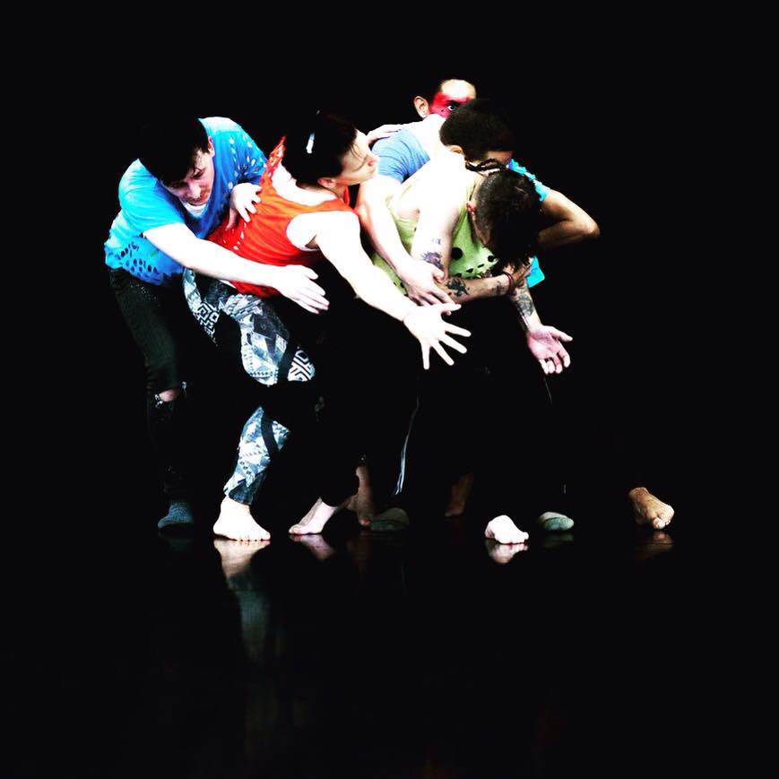

Figure 1. *Pinpricks of Light,* Liverpool Hope University, directed by Paul Bayes Kitcher 25 August 2016, Photo: Andrew Millar

If addiction to drugs is a paradoxical trap that leads to freedom, can addiction to performance lead to freedom too? In the same way as applied performance offers itself as an opportunity to escape from reality? To unpack these questions, Richard Schechner provides a useful distinction between ‘transformation’ in performance, as opposed to ‘transportation’:

I call performances where performers were changed ‘transformations’ and those that performers are returned to their starting places ‘transportations’ – ‘transportation’, because during the performance the performers are ‘taken somewhere’ but at the end, often assisted by others, they are ‘cooled down’ and re-enter ordinary life just about where they went in. (Schechner 1985: 125–26)

For Schechner, transformation is a permanent and unpredictable change in the life of the individual as might occur during a ritual like a wedding ceremony, as opposed to transportation, which only lasts for the duration of the performance and where performers are temporarily converted into someone or something else so as to facilitate their departure, only to return to the same subject position they started. Drawing connections between performance and addiction, then, it is precisely the idea of experiencing multiple moments of transportation that operates as a force to help recovering individuals retreat from their current experiences and encourage them to ‘depart’ into the sphere of fantasy. This moment of ‘disconnection’ from current realities (e.g. exclusion, prosecution, the threat of relapse) might allow addicts to reach a point at which to observe their lives from another perspective. Phil’s response confirms such a relevance:

Performing is the new high. It is the new drug. It is the new thing that makes me feel that there is a point to it. When I start going into rehearsals and start creating my own work, and each time I am going through an intense creative process at the end when it all comes together, and I am on the stage, my heart is beating fast and I perform in front of an audience. At the end, when I come off and there is clapping, I feel a big moment of, ‘Hah, that was amazing!’ It’s all about moments; it’s all about those small moments that you know that you’re never going to do that again – it’s never going to be like that again, but in that moment … that’s my high. (Ashby 2017)

Phil makes reference to the momentous, pleasurable and astonishing affects of a performance, which resonates with Schechner’s concept of transportation. Additionally, as Schechner explains, during transportation, participants exist in a flow situation and are taken on a journey to ‘somewhere’ that will ‘end about where it began’, until the next time that they participate in a new transportation (Schechner 1985: 125–26). Accordingly, repeatable experiences of transportation can potentially lead to a transformation, or as I would suggest, replace one addiction with another. To this end, do participatory art practices encourage a new form of addiction? However, a type of addiction that offers an alternative way of generating affective experience? Paul provides a useful explanation of the points of intersection between addiction and applied performance when he asserts,

What drugs do is fill an empty void, so if we can find a way to fill this void through creativity and performance making that talks to the soul, that’s a positive thing. However, this can equally lead to another form of obsession; in this way, we do replace one addiction with another. In our work in Fallen Angels, we get a lot of people who go through this transition. It’s almost like a love affair; when you use drugs, you are totally obsessed with that drug – that’s the passion there. But when you discontinue to use drugs, it’s almost like going through a ‘grieving’ period. It’s like finishing a relationship, but then you find another relationship which can be manifested in many different ways. In my personal life, this was manifested in various forms. For example, I can help others through my organisation to find a space [for people] to creatively express themselves. By creating work with them that is nurturing, authentic, creative and spiritual, this helps them to get in contact with themselves and others. This, I believe, fills that emptiness and turns it into a thirst for life (Bayes Kitcher 2017)

Paul's references to the positive affects of performance addiction describe it as an impulse to be creative and to reconnect with oneself and others. It provides opportunities to ‘fill the empty void’ and to replace the emptinesswith moments of connectivity and escapism that moves the participants beyond the sphere of everyday struggles and the harsh experiences of past drug addiction and stigmatisation. The affective outcomes of performance, then, generate an affirmative notion of how identities and subjectivities can be transformed and realised in a new context.

Braidotti’s work on the posthuman as an affirmative and political set of interdependent relations, are key to my argument that performance can revitalise affective experiences. As she suggests, ‘the selection of the affective forces that propel the process of becoming posthuman is regulated by an ethics of joy and affirmation that functions through the transformation of negative into positive passions’ (2013: 194). In the context of the creative process of performance making, as a material process in itself, the addict reconfigures their perhaps negative relationality with the drugs and transforms it into a positive passion.

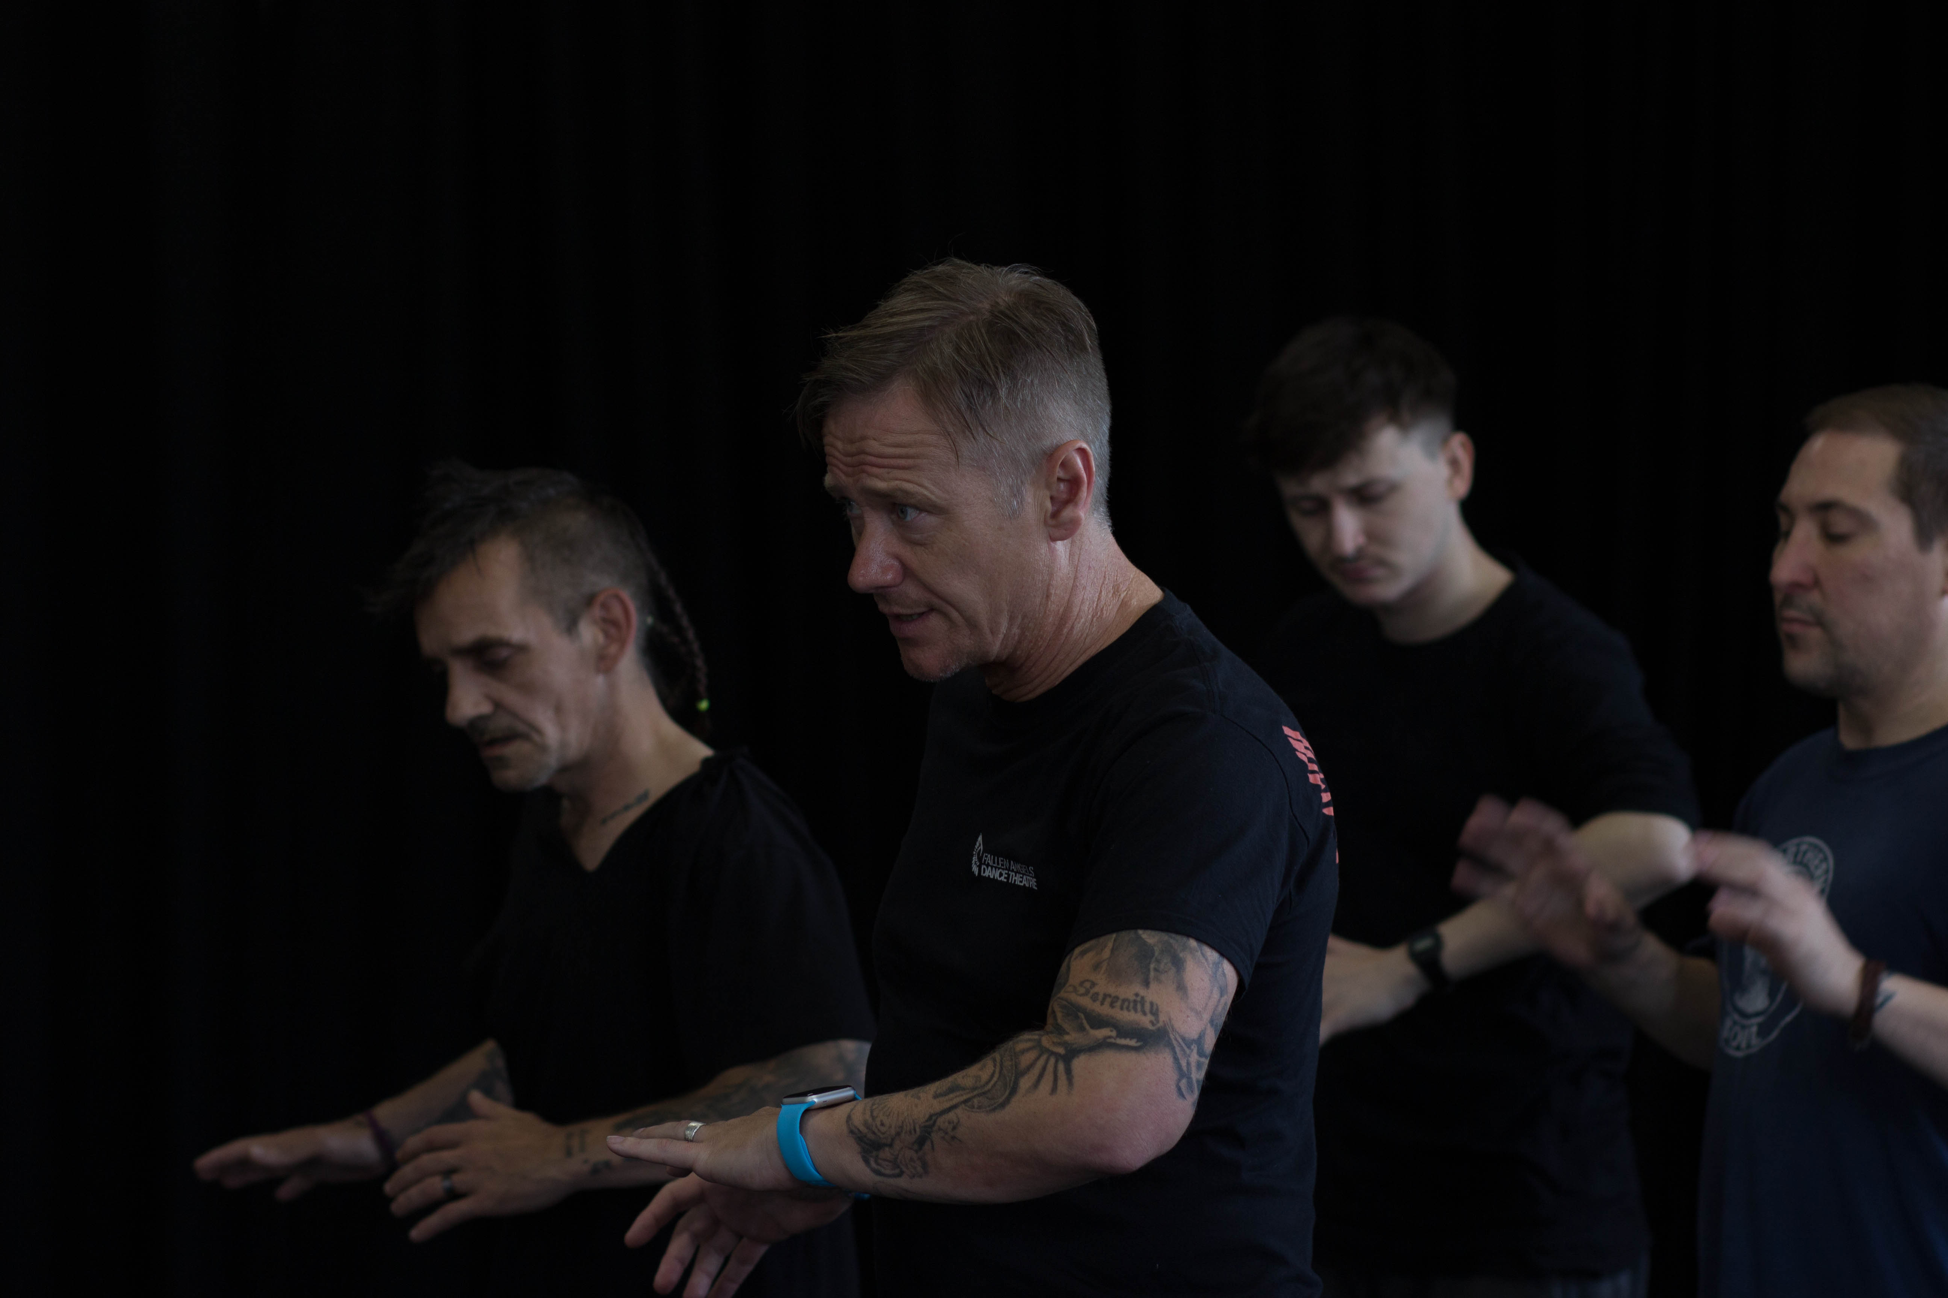

Figure 2. Paul Bayes Kitcher in rehearsals with dancers: Phil Kinsey, Joe Raey-Reid, Phil Ashby, Liverpool Hope University, 8 September 2016, Photo: Andrew Millar

Addicts necessarily complicate the limits of being a human and decentre what an affective relationship with the other (non human/drugs) might mean; performance proposes an ‘affective force’ that generates the transition of becoming addicted to performance instead of drugs. In other words the addict is quite usefully a posthuman figure, who has a sophisticated understanding of what it means to be in a co-dependent, co-existing, affective relationship with things (in this case drugs). They have been close to death, and have reconsidered what it means to be alive. Hence, when people in recovery from addiction engage fully in performance, they often describe it through the metaphor of rebirth and aliveness, and a ‘sense of zoe’ (Braidotti, 2013) as Kirstie maintains:

Performance makes me feel alive and full of life. Performance gives me life and energy. Drugs were taking away my life and energy – I was feeling tired all the time. Now, every time I participate in a workshop or perform, I feel full of drive, full of life. (Burton 2017)

The addict as posthuman is dynamically and diversely transformed through performance and through assuming different configurations and associations with others. Performance offers opportunities for an affective reconfiguration of personal subjectivity and agency and, therefore, can replace drug addiction not only in terms of the affective, sensational interactions with oneself and others, but also in terms of the sense of freedom and positive energy. Performance embodies what Braidotti calls an affirmative ‘act of unfolding the self onto the world, while enfolding the world within’ (2011: 193). The idea of ‘enfolding the world within’ connects with how James Thompson (2009) shifts the debate about applied performance towards a critical interrogation of its affective dimensions. The ‘turn to affect theory’ continues to influence current discourse on applied performance’s efficacy, specifically by drawing attention to the complex intersections between what we might understand by ‘affects’ and what we might understand by ‘performance’. Similarly to Braidotti, Thompson suggests that creating something beautiful can elicit joy and positive energy: ‘working with affect awakens individuals’ possibilities beyond themselves without an insistence on what the experience is – what meaning should be attached’ (2009: 111). It is precisely in the idea of awakening 'individuals' possibilities beyond themselves' that justifies the connection between addiction and performance. Performance provides addicts with opportunities to engage in an activity that rouses their desire to live, and provides moments of autonomy and personal freedom. These moments are capable of replacing their previous experiences of intoxication with something affirmative. Not only can they find a natural way of getting ‘high’, performance also supplies a platform to share these moments with a wider audience. Where perhaps drug use could be seen as a private, insular event for the user, performance is a more shared experience built on the multiple layers of interactions with the individual’s past and present experiences. The previous addiction to the effects of drugs becomes an addiction to the affects of performance.

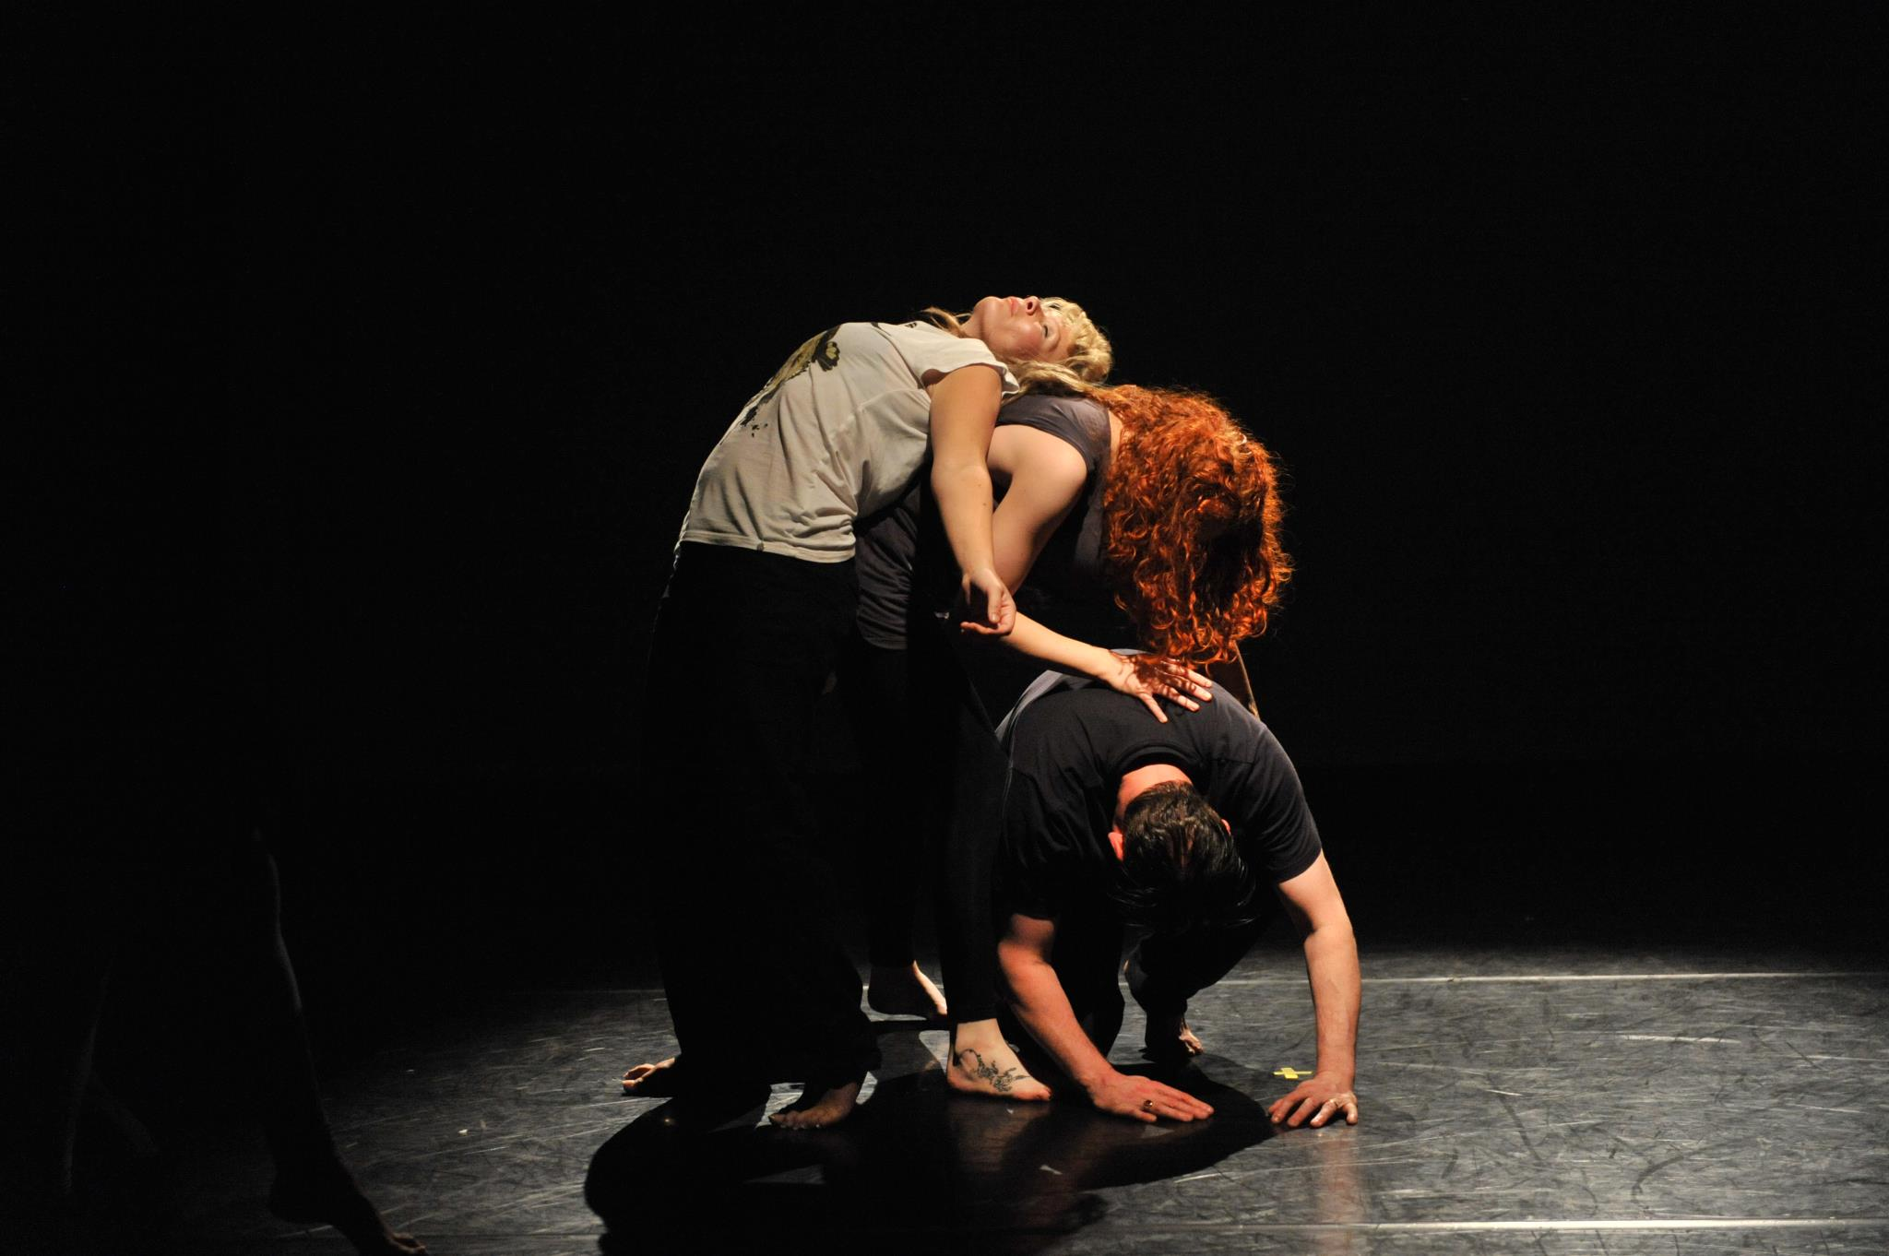

Figure 3. Kirstie Button performing in *Chapter 1. Battle of the Soul* directed by Paul Bayes Kitcher, The Lowry Salford Quays, 16 May 2012, Photo: Brian Slater

**Performance as an ‘affective addiction’**

In order to conceptualise the transition from drug addiction to affective performance addiction, I shall move to discuss how performance and affective theory offer a broad framework of analysis and a useful lens to explore these interconnections. The relationship between performance and affective theory has discussed widely by Thompson (2009), and Shaughnessy (2013). While Thompson discusses the relationship in reference to the aesthetics of applied performance, Shaughnessy focuses on affect as a cognitive process. Both authors, however, agree that performance can stimulate an affective sensation, whereby embodied knowledge is realised and translated into a positive and creative force. Engagements in creative moments that the participants regard as beautiful might generate an affirmative affective experience or to return to Braidoti’s quote an affirmative ‘act of unfolding the self onto the world’ (ibid). As Thompson maintains, the outcome of these engagements constitutes a degree of ‘goodness’ (2009: 153) or affirmative affect, suggesting that there is always something better than the current realities of the participants’ lives, or better ways of realizing their embodied subjectivity and individual autonomy. For instance, in reference to the subject of this article, goodness can constitute the realization that the individual can function without the drugs. As Thompson asserts ‘good’ as an affective sensation, […] can be a vital counterpoint to a situation of pain and suffering’ (ibid. 154). The concept of affective performance as a counterpoint to situations of pain and suffering, corresponds with the experiences of people in recovery from addiction, who often describe the process of ‘cutting off’ drugs as painful and traumatic. Thompson’s ideas echo Phil, who draws significant parallels between the effects of drugs and affective performance. He makes strong references to performance as a ‘good way’ of expressing his emotions:

Performance, especially for me, is [sic] been life changing. Coming from an addictive background [of] drugs and alcohol, performance ... in a sense replaced that but replaced it in a *good way*. In a way that I have completely done a full circle and changed from being quite horrible to myself to now using dance and performance to be able to express my views and how I feel about the world, how I feel about myself, and how I am able to use my body now to perform that – instead of smashing it up, which I did before. (Ashby 2017, my emphasis)

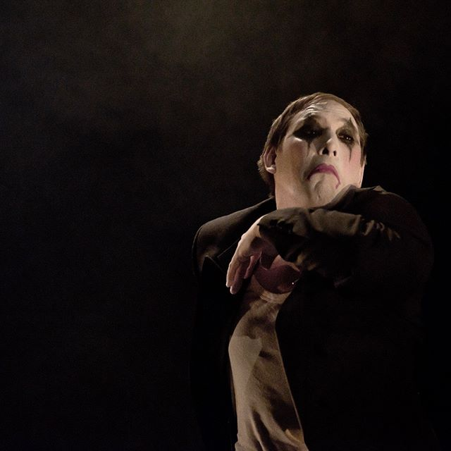

Figure 4. Phil Ashby performing in *Upon Awakening* directed by Paul Bayes Kitcher, The Lowry Salford Quays, 16 November 2016, Photo: Brian Slater

Phil refers to applied performance as a medium that made an affirmative impact on his life and helped his journey to recovery. He makes particular reference to the affect that performance has had on his body, in terms of finding ways to express his views and feelings, which all collectively contribute to a degree of goodness. This corresponds with the work of the cultural studies scholar Nicholas Arnold, who has identified resemblances between the bodily effects of psychoactive chemicals and performance. He suggests that both activate the body's reward system. By analyzing performance practices through the lens of neuroscience, he concludes that relating addiction to performance offers new possibilities of understanding the role of addiction in contemporary culture:’[S]ome people get the 'theatre bug'; there is also the 'drug bug'. To conceptualise addiction in such a way is not to trivialise it, but to place it in a subjective context in which we can more completely appreciate its nature and circumstances. (2014: 280)’

Similarly to Arnold’s analysis, in a study exploring attitudes to theatre attendance in Italy, Davide Infante and Concetta Castiglione (2016) identify theatre as an addictive good. Drawing upon rational addiction theory,[1] they maintain that theatre, like other cultural experiences, is affected by consumerist behavior. Rational addiction theory views addiction as merely a special case of consumerism, and provides a framework within which to understand how individuals make decisions about the consumption of ‘harmful’ or ‘beneficial’ addictive commodities. Accordingly, theatregoers are consumers and therefore attend as a beneficial addiction. What is interesting about this argument is the use of a market approach to make a distinction between harmful and beneficial addictions, both of which benefit the economy (either legal or illegal). Therefore, addiction is a useful consumerist tool.

However, using a socio-economic model to measure addictions is deeply problematic. Theorists disagreeing with this approach argue that addiction is not rational and there are other important factors that need to be considered when discussing addictive behaviours (see Tomer 2001; Henden et al. 2013). Nevertheless, I argue that Murphy and Becker's model is interesting because it moves away from the pathologisation of addiction and establishes a new direction in thinking about the role of addiction in contemporary culture. Art is a form of commodity and, similarly to other drugs, can lead to addiction. People can ‘get hooked’ on the arts the same way as they can get hooked to the Internet, sugar, or shopping. The concept of performance as a beneficial addiction corresponds to an idea presented in the sequel of *T2 Trainspotting* (2017): ‘You’re an addict, so be addicted. Just be addicted to something else’. Therefore, performance can be presented as ‘something else’ another form of addiction.

In a similar vein, Kirstie and Paul explained how performance functioned as any other drug and distracted their obsessive minds. The experience of addiction and being in recovery has helped them to find effective strategies to discover a positive way to address compulsive behaviours through creative practices. For instance, Kirstie constantly seeks opportunities to get involved and maintains that the energy she absorbs from Fallen Angels' weekly sessions operates as an encouraging force to inspire her to find other forms of participation or to create her own work. The proposition that performance can offer a positive strategy of managing compulsive behaviours reiterates what neuroscientist Marc Lewis argues about the disease model and the larger biomedical theory often used in the analysis of addictive behaviours. As he maintains, these theories fail to take into account the personal life experiences of those affected by addiction as well as the affect that it has on the brain. Lewis contends that addiction changes the plasticity of the brain. However, these changes are influenced by the way the brain develops, therefore ‘addiction can be seen as a developmental cascade’ often foreshadowed by difficulties in early development of the individual’s brain, and heightened by recurrent cycles of acquisition, isolation and loss (2015: xi). Because addiction is a developmental progression, people with an addictive background can be channelled towards things that are creative and healthy. The possibility of such channelling affirms the premise of applied performance helping addiction. Yet there are complex and ethical dilemmas that arise. For instance, how can one deal with the issue of ‘cooling down’ or ‘withdrawing’ from performance? What happens when the performance opportunities are not available? Is ‘relapse’ to performance a positive developmental progress?

Kirstie gives a poignant explanation when she reflects on her experience of undergoing a period of ‘abstinence’ from Fallen Angels' activities for two weeks over the Christmas period: ‘I felt loss. When the opportunity to create work and perform is missing, I found it very difficult and low, the same way I was feeling when I was using drugs’ (Burton 2016). The political overtones of addiction should be carefully considered in any attempt to move forward the argument that performance is an affective addiction, as all addictions (harmful or beneficial) can have negative affects that ought to be understood and managed. On the other hand, Paul is conscious of these challenges in relation to Fallen Angels’ work. He proposes that community art projects, such as those involving persons in recovery from addiction, should be used as ‘springboards’ and an opportunity for a natural progression (Kitcher 2017). It can help individuals to be part of a supportive network interested in seeing them succeed, and can convert an addictive past into an optimistic future.

**Performance as an addiction to life**

Ronell’s statement that ‘there is no culture without drug culture’ (2004: 96) situates drugs at the core of cultural production. In this article, I foregrounded this argument by suggesting that there is no culture without recovering addicts, addicted to affective performance. In understanding the process of becoming addicted to performance, it is necessary to undergo an intellectual shift in the dynamics between what constitutes the human and the nonhuman. Being addicted to drugs, means that the human is in a catastrophic relationship with the nonhuman as a result what occurs is a commensurate catastrophic loss of autonomy and agency. In other words they have become a particular set of affects of the drug. In the transition from being addicted to drugs, to becoming addicted to performance, our posthuman subjects are introduced to what is described by participants as a natural ‘high’.

Applied performance also supplies a platform to reclaim their subjectivity and autonomy. The implications and ultimate significance of applied performance for recovering addicts is the shift of focus onto the micropolitics of cultural production, in order to make sense of what addicts produce. Applied performance can then offer new ways of understanding the complex subjects that addicts are capable of becoming. In other words, understanding the recovering addict as a posthuman subject afford the addict more agency and autonomy than understanding them as the scapegoated and pathologised subject of contemporary culture.

Braidotti suggests that life 'is an acquired taste, an *addiction* like any other, an open-ended project. One has to work at it. Life is passing and we do not own it, we just inhabit it’ (2013: 133, my emphasis). Performance offers opportunities for an affective reconfiguration of our embodied subjectivity and agency and an opportunity to get addicted to *life*. This is a political act. Performance, like life, is a drug too.

**Acknowledgments**

I would like to thank Paul Bayes Kitcher, Phil Ashby and Kirstie Burton for inspiring the arguments presented in this article, and for agreeing to be interviewed. A special thank you to Gary Anderson for his helpful comments, encouragement and for the inspiration of his work, and Claire Morris for her ongoing support.

**Biography**

Zoe Zontou is Senior Lecturer in Drama and Theatre Studies at Liverpool Hope University. Her principal research interests lie in the field of applied performance with people in recovery from alcohol and drug dependency. Her research covers a wide range of topics, including autobiography in performance, addiction studies and cultural theory, which are examined through their relationship with applied performance. Zoe has worked as a practitioner and researcher in a number of organisations, and has published in the area of applied performance research and practice.

**References**

Arnold, Nicholas (2014) ‘In the Roar of the Grease-Paint, the Smell of the Crowd": Performance  as an Addictive Process’, in James Reynolds and Zoe Zontou, eds, *Addiction and Performance*, Newcastle: Cambridge Scholars, pp. 264-285.

Ashby, Philip (2017) interview with the author, Liverpool, 14 March 2017.

Barad, Karen (2003) ‘Posthumanist performativity: Toward an understanding of how matter comes to matter’. *Signs: Journal of Women in Culture and Society,* 28 (3), pp. 801–831.

Bauman, Zygmunt (2000) *Liquid Modernity*. Cambridge: Polity.

Bauman, Zygmunt (2005) *Liquid life*. Cambridge: Polity Press.

Bayes Kitcher, Paul (2017) interview with the author, Liverpool, 16 March 2017.

Braidotti, Rosi (2013) *The posthuman*, Cambridge: Polity Press.

Burton, Kirstie (2017) interview with the author, Liverpool, 16 March 201

enJOY Arts (2017) https://enjoy-arts.org.uk, accessed 7 September 2017.

Fallen Angels Dance Theatre (2017) <http://www.fallenangelsdancetheatre.co.uk>, accessed 7 September 2017.

Goffman, Erving (1959) *The presentation of self in everyday life*, New York: Anchor Books.

Henden, Edmund, Hans Olav Melberg and Ole Jørgen Røgeberg (2013) ‘Addiction: Choice or Compulsion?’, Journal of *Frontiers in Psychiatry*, 4 (77): 1-11

Infante, Davide and Concetta Castiglione (2015) ‘Rational addiction and cultural goods: The case of the Italian theatregoer’, *Journal of Cultural Economics*, 40(2): 163–90.

Lee, Charles, J (2012) *Cultures of addiction*, Amherst: Cambria.

Lewis, Marc, D (2015) *The Biology Of Desire: Why Addiction Is Not A Disease*, New York: PublicAffairs.

Murphy, Kevin M and Gary S. Becker (1988) ‘A theory of rational addiction’, *Journal of Political Economy*, 96(4): 675.

Reynolds, James and Zontou, Zoe (2014) *Addiction and performance*, Newcastle: Cambridge Scholars.

Ronell, Avital (2004) *Crack wars*, Urbana: University of Illinois Press.

Schechner, Richard (1985) *Between theater & anthropology*, Philadelphia: University of Pennsylvania Press.

Seddon, Toby (2010) *A history of drugs*, New York: Routledge.

Shaughnessy, Nicola (2012) *Applying Performance: Live Art, Socially Engaged Theatre and Affective Practice*, New York: Palgrave Macmillan.

Shaughnessy, Nicola (2013) *Affective Performance And Cognitive Science: Body, Brain And Being*, London: Methuen Drama.

*T2 Trainspotting* (2017) [film] United Kingdom: Danny Boyle.

Thompson, James (2011) *Performance affects*, Basingstoke: Palgrave Macmillan.

Tomer, John F (2001) ‘Addictions are not rational: A socio-economic model of addictive behavior’, *The Journal of Socio-Economics*, 30(3): 243–61.

Zontou, Zoe (2012) ‘Applied theatre as an "alternative substance": Reflections from an applied theatre project with people in recovery from alcohol and drug dependency’, *Journal of Applied Arts & Health* 2(3): 303–15.

1. Rational addictive theory was originally developed Kevin Murphy and Gary Becker (1988).