Dr Manuella Blackburn

**Other people’s sounds: examples and implications of borrowed audio**

Liverpool Hope University

[blackbm@hope.ac.uk](mailto:blackbm@hope.ac.uk)

# Introduction

The starting point for much electroacoustic music is the capture of audio from the sounding world around us. Recorded sound (field and studio recordings) provides the composer with pliable audio data, inspiration and impetus for the creation of new work. The content of these audio files varies widely to include sounds from musical instruments, inanimate objects, spoken languages and environmental landscapes. Composers working in the field of electroacoustic music and all its associated formats and subgenres (soundscape, live laptop improvisation, acousmatic and noise-based to name a few) are reliant on the presence of audio, whether it be from synthesized or recorded sources, in order to move forward with a new work. Sound’s fundamentality to the composition of electroacoustic music is clearly understood within this discourse, but what is less clear and defined are the finer details relating to external sound sourcing, especially when the composer looks beyond their own materials, to others and/or digital resources (eg. Sound archives, sound libraries and sound maps) for this starting point inspiration. On the surface, it can seem that by removing the sound recording stage of the process, the composer forfeits a direct connection with the physical source, along with memories of this sound-capturing act. On the other hand, for some, skipping this step is not even an option, especially for composers who pride themselves on their well-honed microphone techniques and noise-minimizing skills, since the recording of ones own sound may be viewed as the first stage of the compositional process in which a compositional imprint is firmly forged and found. A given composer may have a recording ‘style’ or pattern, and this approach to recording can seep into his/her choice of sound materials. Take the example of a soundscape artist who braves the wind and rain with their highly specialized and adapted recording equipment. Their techniques for shielding their microphone from direct gusts and torrential downpours provides a striking contrast to the composer who inserts lavalier microphones into a bottle of fizzy water to capture the liquid’s microscopic effervescence within the calm, acoustically dry recording studio. In short, a composer can choose and create what sounds they want to work with in order to achieve specific, personalised end results. Chris Watson’s recording expertise comes to mind in this instance with his skillful use of ‘super compact particle velocity microphones’ to capture minute, barely-there caterpillar sounds[1]. Sound recordings can be in some way a reflection of the composer’s personal aesthetic, demonstrating creative planning at a very early stage in the compositional process. Contrary to this, there are a number of instances where composers choose not to work with sounds they directly collected, some in fact never record their own sound, as found in the numerous cases of sampling or plundering. Composers who seek out existing pre-recorded sources juggles their own creative integrity with the often-requisite sense of homage or respect assumed in these situations. This paper chooses to take on this issue, searching for specific examples, circumstances and outcomes of sound borrowing. Issues of sound quality, personal preference and dealing with dated or cultural remnants all undoubtedly arise when examining viewpoints and musical outputs of composers using other people’s sounds.

**2. Severing the link with the source**

So what exactly is a composer missing out on if they bypass the recording stage? To answer this question it might be useful to look at theories and issues associated with sound selection, recording and use. A good starting point is Denis Smalley’s concepts of ‘source bonding’[2] and ‘surrogacy’[3]. When we consider these ideas in relation to borrowed sound, it is possible to see how the composer’s certainty of sound identification weakens. Without physically going through the motions of sound recording, the source is veiled and opaque, forcing the composer to assign an imaginary context for that sound to belong to. Further to this, borrowed sounds that have been subjected to editing and/or heavy processing are often designated to remote surrogacy territory, since the sound is further distanced or removed from its original source. There is sometimes no way of knowing what the original source sound was without additional contextual detail (eg. programme notes, descriptions, metadata).

**2.1 Originality and audio property**

We may consider the aspect of originality and how this can be lost when other people’s sounds are sourced and used in a composition. Adrian Moore talks of achieving originality through sound recordings: “how to make your work original? …record your own… they are immediately personal to you and the playback of these sounds comes with the guarantee that ‘you were there’. It is immediately easier too, to be able to re-trigger the emotions felt as you recorded the [sounds].”[4] With this in mind, we can start to see personal attachments and connections with sounds that we might miss out on if we make use of other people’s material. Sound recordist, Antye Greie supports this viewpoint regarding her own field recordings “they [field recordings] were my memories and my property and that meant a lot to me, like a bass drum made out of the pop of my lips recorded in Belgrade, or the hi-hat sounds made of snow I was crushing… these sounds made the songs more meaningful to me.”[5]

**2.2 Memories of recording**

It is also significant to acknowledge that memories of the recording process are also absent when sound is borrowed. What were the circumstances, context and sensations experienced when recording sounds material? How was the sound produced and what personal and meaningful anecdotes resulted? Most importantly, what was being recorded? Unfortunately, a sound recording alone cannot tell us all of this information. This separation from source can disrupt the composer’s own perspectives of sound identity as mentioned above. These details might not seem so crucial and important to the overall music production, but they do play a significant role when a composer constructs a narrative or programmatic detail, as well as justifying authenticity. If we think of the sound material collected from the Carmanah Valley in Vancover Island (creek, bird song, insects, forest ambience), found within Hildergard Westerkamp’s *Beneath the Forrest Floor* (1992) coupled with its underlying narrative about clear-cut logging – we can see the importance of legitimate, authentic field recordings, captured by the composer for particular personal affect[6]. Would the message be as clear and affecting had the sound recordings been borrowed from stock sound libraries? And how could the composer claim any integrity in this situation?

**2.3 Control over sound quality**

Amongst the electroacoustic community there is the widely held belief that when recording, “the sound must be as good as possible; there must be no background noise or distortion… A sound recorded with defects runs through the whole production chain.”[7] Understanding the problematic nature of sound recordings with such imperfections is an important step before seeking out sounds from others since sample libraries and sound archives do not always follow such rigorous procedures or high standard thresholds of recording, take for example the online sound library Freesound.com which actively encourages the uploading and sharing of amateur sound recordings, free to use and exploit creatively. The wealth of available samples is vast, but sound quality is not guaranteed (noise, distortion and mono-recordings abound). Such quality issues can hamper a sound recording and the subsequent ability to work with it creatively. Sound recordings may suffer from a range of quality issues including: imbalance, bad profiling, noise levels, distortion, low bit-rate/sample rate and poor dynamic levels. If a composer chooses to sample problematic sound, the challenge becomes a long-term struggle to disguise and/or escape the artifacts, which render the sound imperfect. When engaging with these types of sounds, we lose the ability to perfect, hone and master a good sound recording, it becomes out of our control. Albeit, the general allure of sample libraries and archives is that they often present the opportunity to engage with sounds that are rare, or less obtainable than your everyday sound found on your doorstep locale. Some archives function to preserve disappearing sounds and some collate ecological data to map out the ongoing fluctuations of the sonic world around us. Composer, Curtis Roads points out that, “these [libraries or archives] should not be ignored as they contain many sounds that would be difficult to prepare on one’s own.” For example, his sound collection contains “many commercial recordings of natural environments and machines. One of these captures the sounds of Niagara Falls from different perspectives.”[8]

**3.0 Case studies**

A handful of case studies have been chosen to demonstrate the various issues and consequences of sound borrowing. Composer perspectives have been consulted to illuminate the intricacies of seeking out and using other people’s sounds.

**3.1 Luc Ferrari project**

The ‘*Prize Presque Rien’* competition, currently in its fourth edition, calls for composers to make use of sounds from the Luc Ferrari tape archive. This competition, and its associated compositions to date, provides a relevant case study within the context of this paper on borrowed sound. The 43 soundfiles appearing in the publically accessible archive are said to have been “collected during the ongoing digitization of magnetic tapes”[9] and present a wide variety of Ferrari’s trademark-style sound recording. These archived recordings capture machinery, nature, conversations, cars, planes and street procession music. The archive also contains some processed sound and some materials almost akin to *musique concrete* composition in their juxtapositions and presentation[10]. An unmistakable feature of the archive is the sound quality of the materials on offer. The sounds are date-stamped with the tape recording technology of the time and many of the outdoor sounds capture a general ambience that one might feel the need to minimize. Speech is also captured in these recordings, often taking centre stage in the space of the sounds and environments.

Examining some of the compositions which responded to this open call reveal the various interpretations of this instruction and it is worth taking some time to review some of the approaches and perspective from composers who have utilised sounds from Ferrari’s archive. Composer, Daniel Blinkhorn, awarded an honorary mention in 2011 for his work *le son de la lumière* (2011), states, “it was inspiring and enlightening to have a chance to use materials he [Ferrari] had personally created and crafted. In this way I was able to disrupt my own feelings and preoccupations when crafting sound, and simply enjoy sounds captured (and even to an extent sculptured) by someone else.” In terms of the process of working with these sounds, Blinkhorn interestingly draws upon his knowledge of Ferrari’s compositional aesthetic to provide a template for his own creation: “I tried to mimic some of the types of compositional environments the original composer (Luc Ferrari) would inhabit when he was exploring his works.” The finished output is referred to as a “collage of the composer’s original materials re-worked into a homage.” When probing Blinkhorn’s motivation for participating in this project, the initial affinity for Ferrari’s music which he acted upon is clear to see – “the music of Luc Ferrari has always had a profound impact on the way I work with sound, the breadth and depth of his eclectic music is immensely sensuous and expansive, ranging from field recordings through [to] large-scale orchestral, theatrical, radiophonic and acousmatic works, to collaborations with DJ’s and everything in between and beyond”[11] Similar sentiments are echoed by James Andean (composer receiving Honorary mention in the Prize Presque Rien 2013) in his response to working with borrowed sound when he states, “After choosing and then working with the sounds for a bit, I 'forgot' that I had not recorded the sounds myself, and felt the same sense of engagement and ownership… [Ferrari’s sounds] gave the work an element of homage to a composer whose work I respect a great deal, including the appearance of that composer's voice, which could be heard in a number of the soundfiles.” In reference to his work, *Déchirure* (2013), Andean noted that “the biggest problem were early digital recordings, some of which had artefacts that became apparent upon processing (pitch drop, time stretch, etc…) that made them unusable.”

Another participating composer, Donal Sarsfield, who submitted his work, *The Luc Ferrari Piece* (2012)*,* to the Prize Presque Rien in 2012 comments on the objectifying effect of working with borrowed sounds - “knowing very little about the recordings helped [me] to treat the materials objectively, and not as meaning-carry devices.”[12] This remark poses a significant revelation since it suggests that there is some compositional benefit in being distanced from the recording process and the original sound source. There is some logic behind such a claim as we recall the ambitions of ‘reduced listening’, which strived to disconnect the sound from any physical, cultural and psychological references. To do this (or to come close to this) we must forget the source entirely, which is easier said than done. Removing the recording process and knowledge of the sound in question may bring us one step closer to achieving a particular objective relationship with sound’s intrinsic detail. In some cases there may well be some advantage to being unaware of a sound’s historical, iconic and cultural baggage.

**3.2 Borrowing voices**

Composer Cormac Gould provides an inspiring viewpoint on the topic of using other people’s sound regarding the common struggles faced by composers when dealing with sound imperfections. His composition *FreeCore* (2015) is testament to the challenges of using externally sourced materials within a creative project, since not only were the sounds freely sourced, but so too were all the plugins, tools and sequencing software used in the construction of the composition. Sounds were sourced from Librivox.org and Freesound.com and only freeware was used (Audacity, mda plugins, Cecilia and Ardor?) in an attempt to discover the creativity possibilities with the minimum of means. An important strand within the project was to develop new compositional strategies to overcome problems easily achieved in commercial sequencers with the click of a button. New methods of sound processing were developed in the absence of ‘go-to’ bought/commercial transformation tools. These strategies were made into a number of video tutorial guides for others interested in making use of freeware available online. Overall, the project was about having a conscience, being ethical with freely available sources and giving back to online communities that provided the sound material in the first instance. Gould focused on sourcing speech and vocalisations and states: “A person's voice is deeply connected with their sense of identity and I would be potentially freely manipulating these voices to make my own statements through them. Although all users of Librivox are aware of the potential for this, it is explicitly allowed in the terms of use, it still raised interesting dilemmas.” Gould’s process of working with other people’s sounds showed a departure from his normal compositional approaches due to the fact that he was using other people’s sounds - “I began to feel that my position was that of an editor. I was presented with a vast array of different material that needed to be parsed, managed and evaluated upon a different set of merits than was perhaps my normal.”

Gould’s project uniquely proposes the concept of ‘giving back’ after the use of borrowed sound (making his new sound material freely available, video tutorial guides to using freeware). This issue is particularly pertinent to projects, which source materials without return of financial payment or incentive and in-kind granted permissions. A resulting conclusion from creating *FreeCore* and going through the motions of sourcing borrowed sound is Gould’s rather refreshing viewpoint about what now defines his compositional style: “it is not the materials that I work with that defines me as a composer, rather it is what I do with them… what you do with sound is in some way unique to yourself and does not arise in the majority from the recording process. A composer’s voice, I feel, results from choices made and the results of those choices. In this case the choices merely began at a different stage i.e. after the act of recording.”

Considering the use of free software tools and how they match up against more commercial, paid for tools “sometimes what initially began as flaws to be avoided ended up as positives to be incorporated into the work. This led to the incorporation of time stretch artefacts, audio glitches and noise into the work for example. Part of the process of composition then was deciding which of these flaws were embraced and which were worth attempting to overcome.”

**3.3 Hard to access sounds**

Returning to my earlier point regarding sound libraries and their ability to offer ‘hard to come by’ sources, Nikos Stravopoulos’s work, *Metakosmia* (date), provides a relevant case study demonstrating the appeal and use of borrowed sound material, in this case, captured by the European Space Agency (ESA). Sound recordings of the Mars Rover, the Philae spacecraft landing, and the International Space station alarms are examples of sound materials made available for download as part of the ‘Tracking spacecraft through the cosmos contest (2015)[13]. The ESA released a call suggesting that composers could make use of sounds available on their websites. "Submissions should be creative and imaginative, and may include audio material from any ESA website/channel”. Stravopoulos’s motivations for working with such sounds came from the opportunity to work with material that would not normally be available to him, taking the call as “an invitation to engage with sounds that I would not / could not normally have access to.  I saw it as an opportunity to try something different to what I usually do”. Here the composer acknowledges the potential these sounds could have upon usual compositional processes. When questioning Stravopoulos on the issue of ownership with his use of borrowed sound, his response is particularly significant due to his indifference to the connection of the recording act and the ownership of the recorded sound – “In some respect working with sounds that someone else recorded suggested new ways of working, which is very welcome. Furthermore, I have never had a sense of ownership of raw materials anyway. I see them as found objects that can be useful for composition regardless of who recorded these.”

**3.4 Three Cities project**

A case study, which directly demonstrates the effects of using other people’s sounds, is the ‘Three Cities Project’ (Stollery, Whyte and Kim, 2013). This research aimed to develop and expand upon the ‘three engagements with place in acousmatic music’ (Ibid). This concept differentiates between ‘being there’ (first engagement), ‘having been there’ (second engagement) and ‘desiring to be there’ (third engagement). The element of ‘place’ is paramount to the project and how the composer builds an experience and memory of place via the sounds heard and recorded. Three composers involved in the project took turns to record sound in different geographic locations and these sounds were later shared with the other composers who were to make use of these recordings in a composition despite having not been to the location in person. Some composers reported a sense of unease with the prospect of working with other people’s sounds due to difference in artistic taste and preferences, for example, Stollery comments that, “I was concerned that they were going to record sounds which they themselves were drawn to and which I was going to have to work with, whether or not I would have chosen to record them myself. At the same time, I was fascinated by the prospect of working ‘almost blind’ with the sounds chosen by them.”[14]When it came to working creatively with these unfamiliar sounds, the constraints of not being in control of sound selection were noticeable,“it was as if I’d been told that I could paint a picture, but using only colours that had been provided for me. These restrictions were both a challenge and a stimulus.” (Whyte 2013). This particular project also demonstrates the changing relationship the composer has with unfamiliar sounds that have not been personally recorded – the process involves acclimatizing oneself to the sound material and adjusting to what is on offer. Stollery observes this changing relationship, stating that “In the end, I was relieved to find out that I could have a relationship with these sounds, albeit a different one from both Jun [Kim] and Ross [Whyte].[15]

**4. Cultural complexities**

A final project I wish to mention is the Instruments INDIA composition-commissioning project established in 2015, which gave three composers (Ish Sherawat, Greg Dixon and Steven Naylor) the opportunity to work with the Instruments INDIA sound archive[16] to create new electroacoustic works. The archive contains sound recordings of approximately 28 different Indian musical instruments, recorded by myself. The project was established with the aim of examining the composer’s changing relationships with cultural sound materials over time and to observe the developments of composers making use of borrowed sound.

A layer of complexity is apparent here since when borrowed sounds are sourced from a foreign culture or musical tradition the composer borrowing material may not only be entirely unfamiliar with the sound source and in some cases, may not recognize the origin or contextual significance.

There was evidence of altered expectations, certainly in relation to the use of Western instruments featured in the archive (Violin, Mandolin and Flute feature played in a variety of Indian music styles). Steven Naylor summarises this altered viewpoint, explaining that “listening to the full recordings reminded me that instruments are vehicles for musical expression, not just static objects. And in Indian music, it’s clear that Mandolin takes on an entirely different (and fascinating) character than Western ears might expect from a ‘familiar’ instrument.”

The archive and commissioning project proved to be an educational experience for all composers involved – many reported inspiration from instrument sounds that exceeded expectations from what they thought or recalled the instruments sounding like: “The Ghatam was also not on my original list of potential instruments to include–but after listening in more depth to its very rich and resonant sound, I will certainly now try to include this material.” (Naylor 2015). Composer, Greg Dixon contributed a similar perspective, remarking that “only some of the instruments were known to me… this is a very enlightening experience for me. I am not very familiar with Indian music or Indian instruments”

With regards to issues of ownership, Greg Dixon commented that: “I also feel like making this sound art is more of a communal experience, because while I will end up being called the “composer” at the same time I recognize I’m just the final part of a much more complex compositional act. The sound gathering is a compositional act of someone else; I want to bring out all the vitality, brilliance, and beauty of the people that helped to make all of these sounds happen. I want to make the immense amount of effort that went into performing / gathering these sounds feel worthwhile to all the parties involved.”

The new compositions resulting from the commission were premiered in January 2017. As I listened to the works, I was surprised by the amount of recognizable sound material left unprocessed with its identity in tact. This was the case for all three works, and I started to consider and hypothesize this as a recurring trait when working with borrowed sound. I was also struck by the fact that all three composers had chosen to work with similar sounds, sometimes the exact soundfiles were selected by all three involved.

**4.1 Sonic genealogy**

The new compositions resulting from the commission were premiered in January 2017. As I listened to the works, I was surprised by the amount of recognizable sound material left unprocessed with its identity in tact. This was the case for all three works, and I started to consider this as a particular trait when working with borrowed sound. I was also struck by the fact that all three composers had chosen to work with similar sounds, sometimes the exact soundfiles were selected from over four hours contained in the sound archive.

Further to this, as I listened, I recalled the memories of sound collection. I remember the unorthodox venues I used in place of recording studios, hotel rooms, office spaces, practice rooms, green rooms and quiet corners. I also remember the conversations, laughs and puzzled looks from the musicians as they demonstrated their instruments to me. For example, when I heard sarod material in these new compositions, I immediately remember the smell of the heat in India where I recorded Rajeeb Chakraborty, I remember the small room were we sat together (Figure 1) that allowed the bird song to penetrate in from the outdoors, and I also recall my microphone failing on me in my first attempt! The prospect of leaving empty handed from a recording session in India was unfathomable in that moment in time. Tensions were running high. These memories bring meaning to these sound recordings on a personal level, however these memories stop with me and do not carry forward to the other composers using these materials.

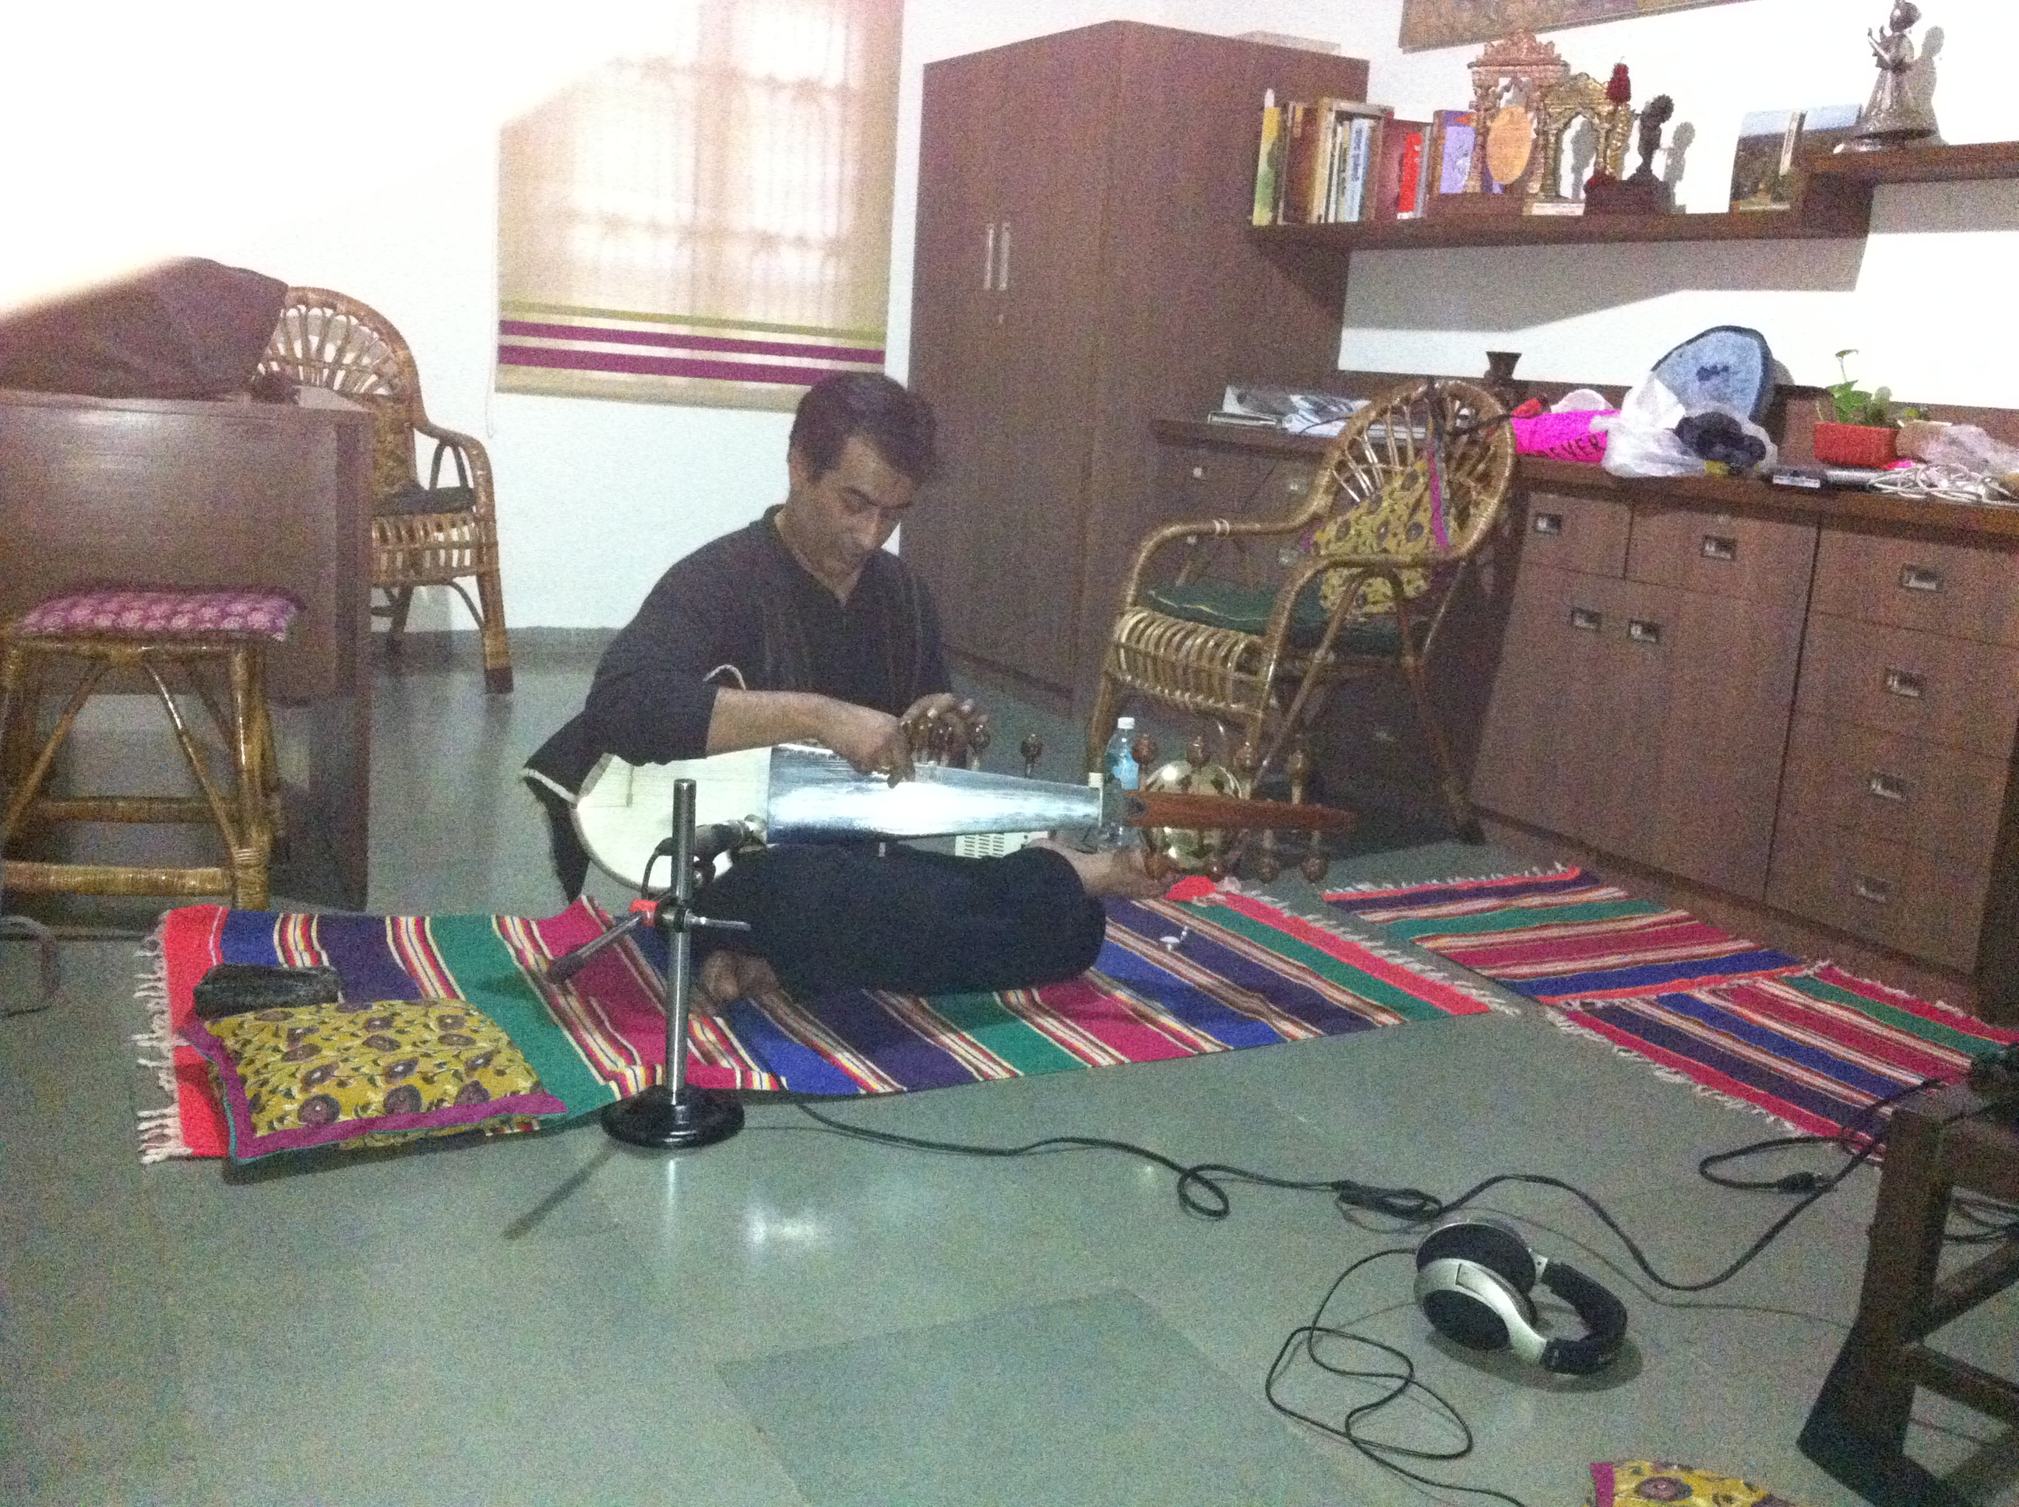

Figure 1, Recording session with Rajeeb Chakraborty in Delhi, India (2013)

This particular example of sharing audio demonstrates a complex and multifaceted trail of borrowing that relies on musical and cultural traditions, performance instruction, sound editing and composer preferences. Figure 2 demonstrates this trail of borrowing.

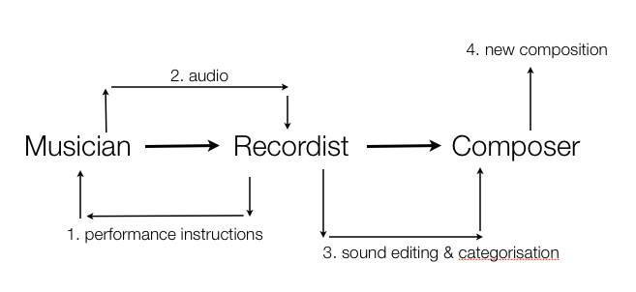

Figure 2, Trail of borrowing

**5.0 Benefits of using other people’s sounds**

Access to other people’s recordings via archives, sound libraries and artistic projects not only gives composers creative license to work with precious or hard-to-obtain materials, but also provides understanding of different sound recording practices. Pedagogically, giving student composers sound libraries to work with as they start their first electroacoustic music projects may be viewed as good practice in acclimatizing students to good quality soundfiles from the start of their compositional careers. Good quality sound recordings function as templates for future recording work later on. More experienced composers observe similar benefits when sharing sounds or borrowing for creative purposes. We can all marvel at the level of detail in professional environmental recordings. Listening and use other people’s sounds can inspire our own compositional work and fuel our curiosity about recording techniques and microphone placements and configurations.

**6.0 Conclusions**

Examining case studies of sound borrowing demonstrates the variety of perspectives and motivations composers have in selecting and integrating these materials into their own aesthetics. Seeking sounds from archives and libraries is certainly advantageous in the accessibility this affords the composer, however adopting these sounds also means adopting the quality issues the sound may carry with it.

This paper has discussed the factor of loss when it comes to bypassing the recording of one’s own sound material and how meaning, associations and memories all form in this initial step of the larger compositional process. The loss of sound identification is most at risk when sounds are borrowed – not knowing what a sound is, where it is from and what significance it carries is a potential problem especially so when the sound has a cultural origin.

The paper has also identified that having not recorded sounds personally, the composer goes into ‘decoding mode’ to source-bond the sound to something familiar, which leads to ‘filling in the gaps’ with imaginary context the composer assigns, based upon their own experiences of the sounding world. This type of listening is more acousmatic in nature and it could be suggested that the composer’s engagement with these borrowed sounds is closer and more akin to the ‘reduced listening’ mode some strive relentlessly to achieve as a means of hearing the sound for its qualities, rather than its origin. It could be concluded here that these types of sounds are unencumbered by the memories and knowledge of the physical source. We have also seen composers adapt their composing styles to accommodate sounds that they might have previously deemed imperfect, dated, and processed and have observed creative outcomes of these projects.

# References

BLACKBURN, Manuella, ‘Instruments INDIA: A sound archive for educational and compositional use, *Organised Sound Journal,* Vol.19 (2), 2014, 146-153.

BOSSIS, Bruno, UNESCO Knowledge Portal, Session 2: Recording Sounds,

<http://portal.unesco.org/culture/en/ev.php-URL_ID=27229&URL_DO=DO_TOPIC&URL_SECTION=201.html> (accessed: 19/05/16)

KIM, Suk Jun, Stollery, Pete, and Whyte, Ross, ‘Three types of engagement with place through acousmatic listening and composition’ in I Russell (ed.), Taking Part in Music: Case Studies in Ethnomusicology. vol. 9, Elphinstone Institute Occasional Publications, University of Aberdeen, Elphinstone Institute, (Aberdeen, 2013).

LANE, Cathy and Angus Carlyle, *In the Field: The Art of Field Recording*, (Devon, 2013).

MOORE, Adrian and Moore, Dave, *Sonic Art Recipes.*

ROADS, Curtis, *Composing Electronic Music: A New Perspective*, (Oxford, 2015).

SMALLEY, Denis. ‘Spectromorphology: Explaining Sound-Shapes’ *Organised Sound* 2(2), 1997, 107–26.

STOLLERY, Pete, ‘Capture, manipulate, project, preserve; a compositional journey’ *Journal of Music, Technology and Education*, Volume 6, (3), 2013, pp. 285-298

WATSON, Chris, online interview, <http://thequietus.com/articles/11222-chris-watson-interview-sound-recording-cabaret-voltaire> (accessed 02/02/16).

1. Chris Watson, online interview, <http://thequietus.com/articles/11222-chris-watson-interview-sound-recording-cabaret-voltaire> (accessed 02/02/16).
2. “the *natural* tendency to relate sounds to supposed sources and causes, and to relate sounds to each other because they appear to have shared or associated origins” (Smalley, 1997: 110).
3. “It is particularly important for acousmatic music where the sources and causes of sound-making become remote or detached from known, directly experienced physical gesture and sounding sources. The process of increasing remoteness I refer to as *gestural surrogacy*” (Smalley, 1997: 110).
4. Adrian Moore and Dave Moore, *Sonic Art: Recipes and Reasonings*, online resource p65-66, <https://sounddesignresource.wordpress.com/2013/11/13/sonic-art-recipes-and-reasonings-by-adrian-moore-and-dave-moore/> (accessed 03/05/17).
5. Lane, Cathy and Carlyle, A, ‘Interview with Antye Greie’, *In the Field: the art of field recording*, 2013, 43.
6. “All other recordings were made by myself mostly in the Carmanah Valley on Vancouver Island, as well as in forests near Cowichan Lake on Vancouver Island, on Galiano Island and in Lighthouse Park near Vancouver.” CD programme notes for *Beneath the Forrest Floor* (Westerkamp, 1992).
7. “…and you would be wrong in believing that such problems can be put right later on. It is usually unproductive to try and erase recording defects with filters, or through compression or similar devices; the result is almost always disappointing.” Practical seminar: Creating a simple electroacoustic piece in easy stages, UNESCO DigiArts: Training - online tutorial, <http://portal.unesco.org/culture/en/ev.php-URL_ID=27229&URL_DO=DO_TOPIC&URL_SECTION=201.html> (accessed 14/04/13), (Bossis 2013).
8. Curtis Roads, *Composing Electronic Music: A New Perspective*, (2015: 87).
9. Brunhild Ferrari, website quote, <http://lucferrari.com/en/presque-rien-prize/> (accessed 14/05/17).
10. Luc Ferrari sound archive contains files entitled: ‘*Musique Promenade - Eléments ponctuels brefs*’ and *Didactique – Sons pour etude morphologie + viol d'anne strauss’*. Both these soundfiles contain numerous brief ideas exploring gestural behavious and directional tendencies. Sounds courtesy of Brunhild Ferrari.
11. Programme notes for *le son de la lumière* <https://soundcloud.com/nfsaaustralia/le-son-de-la-lumi-re> (accessed 25/04/17).
12. Donal Sarsfield, PhD Commentary (2012: 20), <https://www.escholar.manchester.ac.uk/uk-ac-man-scw:227174> (accessed 20/02/17).
13. “Musicians, composers and audio buffs are invited to help celebrate 40 years of ESA’s tracking station network… Submissions should be creative and imaginative, and may include audio material from any ESA website/channel”, European Space Agency website: <http://www.esa.int/Our_Activities/Operations/Tracking_spacecraft_through_the_cosmos_contest_enter_and_win> (accessed 19/05/16).
14. Stollery, ‘Capture, manipulate, project, preserve; a compositional journey’, Journal of Music, Technology & Education, 2013, vol 6, no. 3, p292.
15. Ibid: 293.
16. Manuella Blackburn, ‘Instruments INDIA: A sound archive for educational and compositional use, *Organised Sound Journal,* Vol.19 (2), 2014, 146-153.