**Visual slippages between the picture plane and the painting surface in Richard Estes’ Double Self-Portrait (1976)**

Dr. Donal Moloney, Liverpool Hope University, UK

*Abstract:* *This paper focuses on a particular visual slippage that may occur at the point where the picture plane and the painting surface might intersect in Richard Estes’ “Double Self Portrait”. Firstly, I draw on one specific scopic regime, Cartesian perspectivalism, and, in particular, Leon Battista Alberti’s concept of the picture plane as an “open window” (Alberti 1967, 56). Secondly, I investigate how Richard Wollheim’s concept of twofoldness and Hal Foster’s writing on the Lacanian gaze might facilitate visual slippages between different scopic regimes associated with representational painting such as Estes’ (Wollheim 1980; Foster 1996). Throughout this paper, I look at how aspects of Cartesian perspectivalism, twofoldness and the Lacanian gaze might combine to form amalgamations of scopic regimes within a scopic field. This serves as a foundation for my hypothesis that there may be a particular oscillation between different ways of looking contained within Estes’ ‘Double Self-Portrait”: looking through the surface, looking across the surface and a form of being looked at from inside the surface.*

Keywords: Painting, Picture Plane, Painting Surface, Scopic Regime, Cartesian perspectivalism, Twofoldness, Lacanian gaze, Richard Estes

## **Scopic regimes,** **Cartesian perspectivalism and Alberti’s window**

T

he following paper focuses on what I perceive to be a point of visual slippage between conceptions of the picture plane and the painting surface in Richard Estes’ *Double Self-Portrait* (1976, Figure 1). Rather than eliminating Cartesian perspectivalism from the representational system of a painting, I aim to draw conclusions about the ways in which Estes’ painting can allow for an engagement with the picture plane which incorporates a hybrid of Cartesian perspectivalism, twofoldedness and the Lacanian gaze. Through this, I will argue that it is possible for multiple scopic regimes to be contained within a single painting; a form of complex looking that could be compared to a “conundrum”, as outlined by Hal Foster (Foster 1996, 141). Before discussing Estes’ *Double Self-Portrait* as a nexus for the amalgamation of several theories connected to looking at paintings it’s essential to firstly outline debates that frame Cartesian perspectivalism as a scopic regime. I will subsequently focus on discussions centered on the term twofoldness before returning to Estes’ paintings and the Lacanian Gaze.

The term scopic regime is often accredited to Christian Metz in his differentiation between cinema and theatre (Metz 1982). According to Campbell and Power, Metz argues that “a given sensory regime...(is) hegemonic in a particular historical period” (Campbell and Power 2010, 3). Similarly, Campbell and Power build on Gregory’s idea that each particular period in history produces its own “visibility” which, in a sense, organises how we see (Campbell and Power 2010, 3; Gregory 2003). Whilst the use of “scopic” was derived from Jacques Lacan’s “scopic field”, as well as from feminist film theory such as Laura Mulvely’s, Caplan views Metz as building on the “psychoanalytic basis of the concept” (Lacan 1987, 72; Mulvey 2009; Caplan 2011). Caplan also views Metz as developing the idea of the “scopic regime” as opposed to a “scopic field” (Caplan 2011).

Martin Jay followed on from Metz’s idea of a scopic regime in order to comprehend what might be the historical foundation of a contemporary scopic regime (Jay 1988; Metz 1982). Jay defines a scopic regime as a “model of vision” (Jay 1988, 16). This aligns with Pattison’s definition of a scopic regime as a “theory and practice of vision” (Pattison 2007, 34). As Jay points out in his essay “Scopic Regimes of Modernity”, there may not be one “unified “scopic regime” of the modern” but “several, perhaps competing ones” (Jay 1988, 3). Jay highlights three main scopic regimes starting with “Cartesian perspectivalism” (Jay 1988, 4). This scopic regime emerged from “Renaissance notions of perspective” and “Cartesian ideas of subjective rationality in philosophy” (Jay 1988, 4). Jay draws on the writings of Ivins and Rorty to show ways in which Leon Battista Alberti’s writing on the picture plane permeated through to modern ideas about vision (Jay 1988, 4–5; Ivins 1946; Rorty 1979; Alberti 1967).

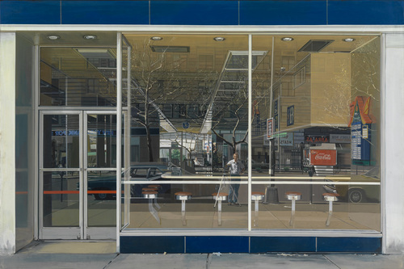

Figure 1: Richard Estes, Double Self-Portrait, oil on canvas, 1976

Source: Museum of Modern Art, New York.

Jay notes that “Cartesian perspectivalism” is the somewhat dominant scopic regime of “modernity”, because it most closely aligns with a very direct “experience of sight valorised by the scientific world view” (Jay 1988, 4–5). Jay highlights Erwin Panofsky’s critique of the “assumed equivalence between scientific observation and the natural world” (Jay 1988, 5; Panofsky 1991). However, Cartesian perspectivalism remained a dominant scopic regime due, in part, to ways in which Alberti‘s Della Pictura outlined methods of translating three-dimensional space on to a two-dimensional flat surface (Alberti 1967).

Central to Cartesian perspectivalism’s relationship to representational painting is the concept of the picture plane. The picture plane can be thought of as an imaginary, vertical, transparent window through which we see into the space depicted by a painting. This representation of space within this window is often depicted using linear perspective. As Friedberg notes: “As a representational system, linear perspective was a technique for reproducing the space of what was seen on the *virtual* plane of representation” (Friedberg 2006, 35). My definition of the picture plane comes from Alberti’s treatise on linear perspective called Della Pictura: “I inscribe a quadrangle of right angles, as large as I wish, which is considered to be an open window through which I see what I want to paint” (Alberti 1967, 56). When discussing Alberti’s Della Pictura Friedberg notes:

The “picture” was a surface, a plane that intersected the visual pyramid of sight at its perpendicular axis. The picture plane was thus imagined as a flat vertical surface between the artist (and viewer) and the scene depicted. The planar surface of the painting formed a material support for the painting’s virtual representation. (Friedberg 2006, 28)

For Alberti, a “plane” is where a “figure (is) located...so the eye can see it” (Alberti 1967, 43). A “figure” for Alberti is a “point...which cannot be divided into parts” (Alberti 1967, 19). Points can be extended into lines for Alberti and “More lines, like threads woven together in a cloth, make a plane” (Alberti 1967, 44). The painting’s “surface”, according to Alberti would: “rest like a skin over all the surface of the plane” (Alberti 1967, 45).

Alberti also defines the picture plane as “transparent and like glass”:

They should know that they circumscribe the plane with their lines. When they fill the circumscribed places with colours, they should only seek to present the forms of things seen on this plane as if it were of transparent glass. Thus the visual pyramid could pass through it, placed at a definite distance with definite lights and a definite position of centre in space and in a definite place in respect to the observer. Each painter, endowed with his natural instinct, demonstrates this when, in painting this plane, he places himself at a distance as if searching the point and angle of the pyramid from which point he understands the thing painted is best seen. (Alberti 1967, 51)

Clark notes that Alberti “believes that he sees a section of a pyramid of vision from which the rays converge on the eye” (Clark 1944, 8). Alberti’s “open window” is a vertical section of a pyramid imaginatively projected from the eye of the observer/painter (Alberti 1967, 56). Ivins also refers to Alberti’s idea of the picture plane as a combination of a “central projection and section” (Ivins 1973, 10). This “section” is formed from an imaginary plane similar to “transparent glass” (Alberti 1967, 51). Friedberg notes that Alberti’s use of transparency to describe how we look at paintings implies that there “are rays of vision passing-as if they were rays of light-through the picture plane toward a vanishing point” (Friedberg 2006, 29). On the other hand, Alberti also noted that: “visual rays...carry the form of the thing seen to the senses” (Alberti 1967, 45).

Panofsky’s interpretation of the Albertian “window” states that we negate the painting’s surface, which thus becomes “reinterpreted” as a “picture plane” (Panofsky 1991, 27). Panofsky, in his opening for *Perspective as Symbolic Form*, quotes Dürer: “*Perspective* is a Latin word which means ‘seeing through’” (Panofsky 1991, 27). Panofsky uses Dürer‘s definition of perspective throughout this text (Panofsky 1991). The “geometrical construction” created in the “Renaissance” that Panofsky refers to is as follows: “I imagine the picture-in accord with the “window” definition-as a planar cross section through the so-called visual pyramid: the apex of this pyramid is the eye, which is then connected with individual points within the space to be represented” (Panofsky 1991, 27–28). Panofsky’s definition of a “picture plane” is a “surface” that we look “through”, rather than look at or are blocked by: “We are meant to believe that we are looking into space, even if that space is still bounded on all sides...Upon this picture plane is projected the spatial continuum which is seen through it and which is understood to contain all the various individual objects” (Panofsky 1991, 55–56). The viewer, as Panofsky points out, either sees the surface or illusion, not both simultaneously (Panofsky 1991).

“Seeing through” the picture plane, or its transparency, is something that painting shares with “the window and the velo”, according to Friedberg (Friedberg 2006, 40). Whilst the picture plane is “materially opaque”, it is paint which transforms it into a transparent plane (Friedberg 2006, 40). This transparency is only “metamorphic”, a “virtual representation”, as Friedberg points out (Friedberg 2006, 40). The picture plane coexists with the painting’s surface and, together, they mark the point of contact between the real space occupied by the viewer and the illusionistic space within the painting.

Friedberg also notes that the window “metaphor” operates as “an opening in architectural space”, as well as being “an analogue for the perspectival frame of the painting” (Friedberg 2006, 5). Friedberg contrasts Alberti’s window metaphor with Brunelleschi’s “mirror” experiment (Friedberg 2006, 15). In 1425, Brunelleschi devised an experiment designed to demonstrate a correlation between perspectival painting and the two-dimensional reflection of an image in a mirror. In this experiment, the viewer held a panel painting of the Baptistery of San Giovanni of Florence close to one eye, with the painted surface facing away from him/her and peered through a small hole in the panel. With one’s back to the Baptistery and with one’s other hand outstretched, the viewer held up a mirror. This mirror reflected the panel painting of the Baptistery within the surrounding space. One could, therefore, align both the painting and the reflected image of the Baptistery in the mirror, so that they closely overlapped. Hence, the painted image would fit into the surrounding perspectival system: “The mirror served as a verifier of the “truth” in perspective” (Friedberg 2006, 15). Damisch notes that the mirror can be a “short cut” towards depicting space, or “a means of transferring to a plane the outlines of figures subject to diminution that bypasses the difficulties and awkwardnesses entailed by “rational” construction” (Damisch 1994, 63). However, the mirror’s “opacity, reflected light, and inverse image” produces “substitutive, deceptive, illusory vision”, whilst Alberti’s window’s “transparency, transmitted light, and seemingly unmediated image” creates “direct, veridical, unmediated vision”, according to Friedberg (Friedberg 2006, 15). Friedberg stated that both the metaphor of the window and of the mirror “imply very different epistemological consequences” for painting (Friedberg 2006, 15).

Masheck argues that “Alberti’s all too famous Renaissance idea of a painted image as window like does not simply apply to the (overall) surface of a painting, assumedly framed” (Masheck 1991, 35). Masheck states that Alberti’s “open window” only refers to the “rectangle” inscribed in the surface, not to the entire surface itself (Masheck 1991, 35). Masheck is keen to scrutinize assumptions relating to Alberti’s concept of the picture plane, stating that “the given conventionally flat format” of a painting support “neither entails nor implies Alberti’s “window”” (Masheck 1991, 35). Masheck states that only “*if*” one draws a rectangle on the painting’s surface “*may”* one decide to treat the “drawn rectangle”, not the entire “surface”, like a window (Masheck 1991, 35). Masheck observes that the painting’s surface is not a window to begin with, but an “invented, imposed figure, by no means an implicit structure” (Masheck 1991, 35–37). Masheck suggests that Alberti’s window is a “construct” (Masheck 1991, 35). Whilst the idea of Alberti’s “window” may be relevant to aspects of thinking about the picture plane, it should not be applied to all painting, but should be considered in conjunction with other scopic regimes pertinent to each particular painting (Alberti 1967, 56)).

Masheck also warns one not to conflate Alberti’s (1967: 56) “window” with his metaphor for the picture plane being “transparent and like glass” (Masheck 1991, 35; Alberti, 1967, 51). Masheck notes that glass, at the time Alberti wrote Della Pictura, was not entirely transparent (Masheck 1991, 36). A window in Alberti’s time would not provide an “undistorted, transparent view” (Masheck 1991, 36). Masheck states that Alberti has “specified it (the window) as open” rather than “closed” (Masheck 1991, 37). Since Alberti notes that his “window” is “open”, we must treat his idea of the picture plane as “transparent and like glass” if we consider that glass in Alberti’s time of writing Della Picturawas not entirely transparent (Alberti 1967, 56). The usefulness of the glass metaphor to Alberti may have been in closely aligning what one sees through the window with what one inscribes on the painting’s surface, in order to reconstruct a three-dimensional view observed through the glass on a flat, two-dimensional surface.

Masheck also outlines how Gombrich’s “Art and Illusion: A Study in the Psychology of Pictorial Representation” and John White’s “The Birth and Rebirth of Pictorial Space” had “proliferated” and assumed a direct connection between painting’s supposed primary purpose of “illusionistic representation” and Alberti’s “window” metaphor (Masheck 1991, 38–39; Gombrich 1977; White 1972; Alberti 1967). Masheck was more in agreement with Danto’s interpretation of Alberti’s “window”: “We look through the surface at the scene situated in the illusory space, *as if* through a window. Indeed, the entire technology of painting was bent upon making the experience of seeing something through a window and seeing something in a painting perceptually indistinguishable” (Masheck 1991, 39; Danto 1989, 317; Alberti 1967, 56). Danto’s use of “*as if”* allows us to draw parallels between looking through a window at a scene with making a painting, yet simultaneously appears to allow scope for other ways of looking (Danto 1989, 317). This could be said to reinterpret the relationship between the “window” and the painted surface (Alberti 1967, 56). Therefore, this becomes less about difference and more about a permeability or a slippage between the two.

Alberti’s concept of the picture plane as an “open window” outlines a method of translating three-dimensional space onto a two-dimensional, flat surface (Alberti 1967, 56). This also opens up ideas about the ways in which rays of light and sight appear to pass through this “window”, as they are projected from one side of the picture plane to the other, from our eyes to the vanishing point (Alberti, 1967, 56). Cartesian Perspectivalism may be an ideological construct, which does not fully encapsulate how many scopic regimes interact on a “contested terrain” (Jay 1988, 4). In the next section, I examine in detail, ideas comparable to both Panofsky’s “seeing through” the transparent picture plane and to Danto’s looking, “*as if*” through a window (Panofsky 1991, 27; Danto 1989, 317). In so doing, I consider more complex ideas concerning the oscillation between differing modes of perceiving the picture plane and the painting surface that may occur in Estes’ painting *Double Self-Portrait*.

Twofoldness

The relationship between the picture plane and the painting surface is one of interrelatedness, rather than disconnect, as noted by a number of theorists. Many argue that to think of one as independent of the other is to think of the experience of looking at painting in reductive terms. The relationship between the picture plane and the painting surface could, instead, be thought of as a dynamic one, each continually shifting and channelling the other.

Firstly, I will begin with a more reductive example. Alloa references Sartre’s somewhat oversimplified theory about how we perceive the image and the surface of a painting as separate (Alloa 2011, 8; Sartre 2004). Sartre’s writing on the relationship between image and surface in a painting involves the viewer having to negate or “deny” the surface, in order to see the image beyond it (Alloa 2011, 8). One can look at the surface and how it is constructed using a “perceptive attitude” or, on the other hand, one can shift one’s focus to the image in an “imaging attitude” (Alloa 2011, 8). However, Sartre posits the theory that one cannot see both simultaneously (Sartre 2004). Similarly, Panofsky suggests that, when we look at the space depicted in a painting, we distance ourselves from or negate the material qualities of the painted surface, in order to see through it:

We shall speak of a fully “perspectival” view of space not when mere isolated objects, such as houses or furniture, are represented in “foreshortening,” but rather only when the entire picture has been transformed-to cite another Renaissance theoretician-into a “window,” and when we are meant to believe we are looking through this window into a space. The material surface upon which the individual figures or objects are drawn or painted or carved is thus negated, and instead reinterpreted as a mere “picture plane”. (Panofsky 1991, 27)

Alloa contrasts Sartre’s theory of two separate “attitude(s)” with Merleau-Ponty’s less binary theory, whereby “an image does not emerge despite its material support, but thanks to it” (Sartre 2004; Merleau-Ponty cited in Alloa 2011, 8). Merleau-Ponty suggests a way of looking that is similar to Alloa’s concept of “oscillating” between ways of looking, whereby the image and the support channel one another (Alloa 2011, 7). They are inseparable, rather than independent.

Whilst Alloa critiqued Richard Wollheim’s concept of “twofoldness” as a “reduction” of the manifold ways of looking at representational painting, it is, nonetheless, a crucial component of the concept of “oscillating”, through many ways of looking simultaneously (Alloa 2011, 7; Wollheim 1980, 224). Wollheim describes one particular way in which we perceive paintings as “seeing in” (Wollheim 1980, 224). “Seeing in”, according to Wollheim, involves “twofoldness” (Wollheim 1980, 224). Wollheim notes that: “I am visually aware of the surface I look at, and I discern something standing out in front of or (in certain cases) receding behind, something else” (Wollheim 1987, 46). For one to experience “twofoldness”, one sees both the represented object and the “medium of representation” (Wollheim, 1980, 224; Nanay 2005, 248). As Nanay argues: “Whenever we look at a painting and see something in it, according to Wollheim, we are simultaneously aware of the canvas and the represented object” (Nanay 2005, 248). For Nanay Wollheim’s “twofoldness” involves “being aware simultaneously of two aspects of one single experience, namely the ‘recognitional and configurational aspects’” (Nanay 2005, 251).

One of Nanay’s main arguments is that Wollheim’s “twofoldness” is not the simultaneous experience of two separate elements of a painting: what is painted and the way it is painted, but twofoldness is “two different aspects of one single experience” (Nanay 2005, 251). This concept of “twofoldness”, drawn from his book “Painting as an Art”, 1987, differs from Wollheim’s earlier conception of twofoldness, which involves looking at a painting in two different or separate ways, rather than looking at two different elements that make up one “experience” (Nanay 2005, 251). One is inseparable from the other. As Nanay points out Wollheim’s concept of “twofoldness” shifts between two ways of looking; “the simultaneous visual awareness of the surface and of the represented object on the one hand and the simultaneous visual awareness of the represented object and the way it is represented on the other” (Nanay 2005, 248). Nanay is suggesting that Wollheim’s use of twofoldedness alternates between two different concepts. Wollheim alternates between the viewer knowing that there is a surface which facilitates the representation of an object and vice versa, as well as how the construction of that painted surface facilitates the viewing of the represented object and vice versa (Wollheim 1980). The difference between the two definitions of twofoldness is that one sees the represented object through the surface in the former and through the painted image’s construction in the latter. Nanay notes that the first is a “necessary condition for the perception of pictorial representations”, whilst the latter is a “necessary condition for the aesthetic appreciation of pictures” (Nanay 2005, 248). Both Nanay and Walton agree that interpreting or experiencing a representational painting might involve aspects of Wollheim’s concept of “twofoldness”, but it is not a “necessity”: “The aesthetic experience of a picture cannot be described without bringing in the twofoldness of this experience” (Nanay 2005: 248–249; Walton 2002, 33; Wollheim 1989, 224).

Nanay illustrates the discrepancies between Wollheim’s two different definitions of twofoldness with two examples (Nanay 2005). Firstly, Nanay states that cracks in a painting, such as in Petrus Christus’s *The Portrait of a Young Woman* (1470, Figure 2)are properties of the painting’s surface, rather than of the “way” that the face was painted: the “brushstrokes” etc (Nanay 2005, 251). This, according to Nanay, is one such occasion, where an element of the painting’s surface might be differentiated from the ways in which the represented object was constructed (Nanay 2005, 251). One is “visually aware” of the “surface” and not the “represented object”, when looking at cracks in a painting (Nanay 2005, 251). Whilst the “brushstrokes” are part of the construction of the “represented object” and the canvas, the cracks are solely “properties of the surface” (Nanay 2005, 251). This is an example of Wollheim’s concept of twofoldness as a simultaneous awareness of the represented object and of the painting’s surface, rather than of the way it was painted.

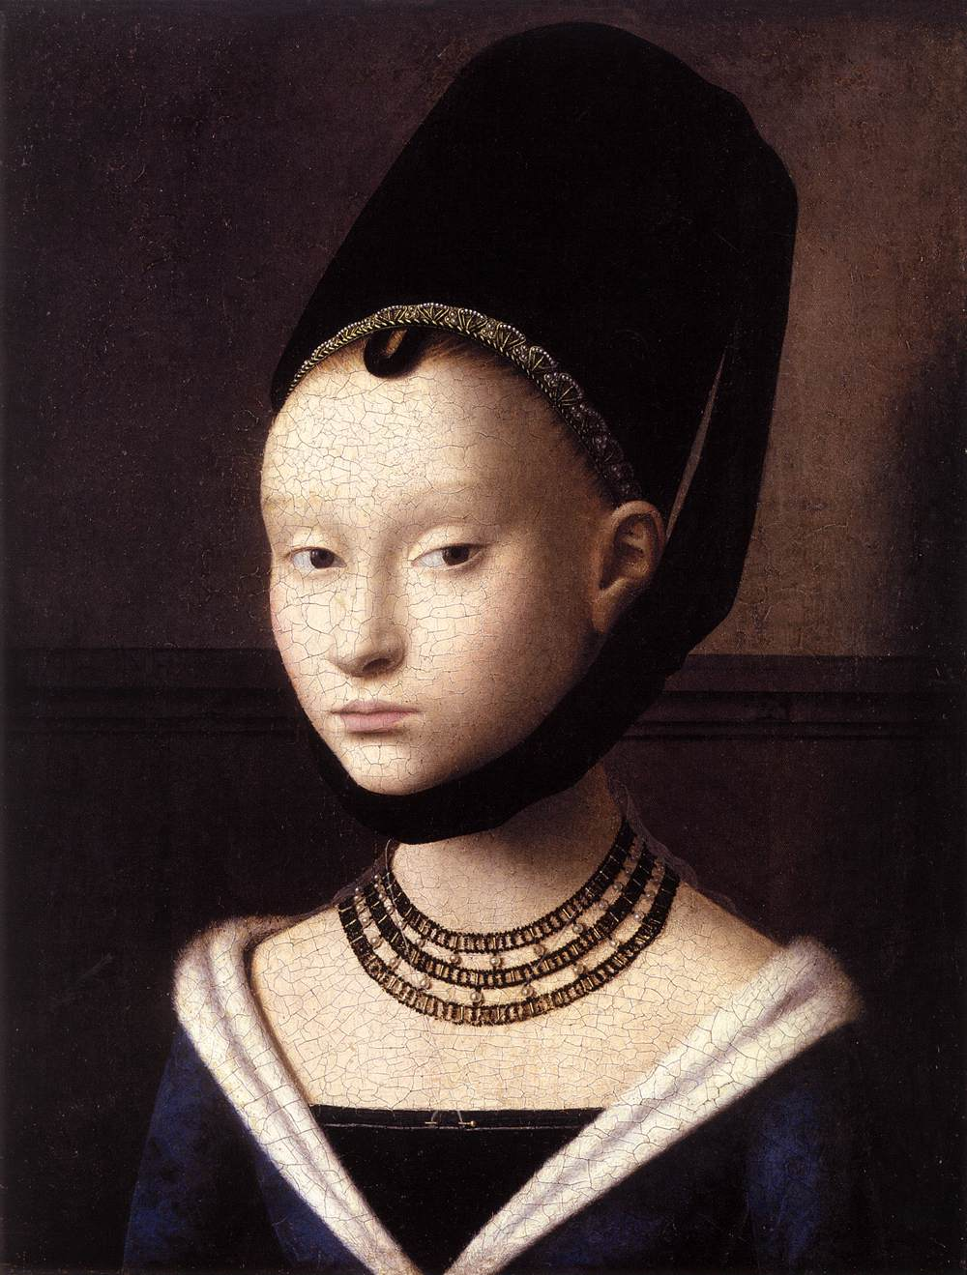

Figure 2: Petrus Christus, The Portrait of a Young Woman, oil on oak, 1470

*Source: Gemäldegalerie, Staatliche Museen zu Berlin.*

Secondly, Nanay notes that “part” of the way in which “something is represented” is not part of the “canvas” (Nanay 2005, 251). She uses the example of the viewer’s recognition of a violin in a Cubist painting, such as Georges Braque’s *Violin and Palette* (1909, Figure 3). In order to recognize the violin in the Cubist painting, we must see past the surface to identify that we are looking at the representation of a violin. In this case, the way the violin is represented “supervenes on the properties of the surface”, without being itself part of the surface (Nanay 2005, 251). Nanay’s example of the cracks in Christus’ portrait and Braque’s violin exemplify two different conceptions of twofoldness.

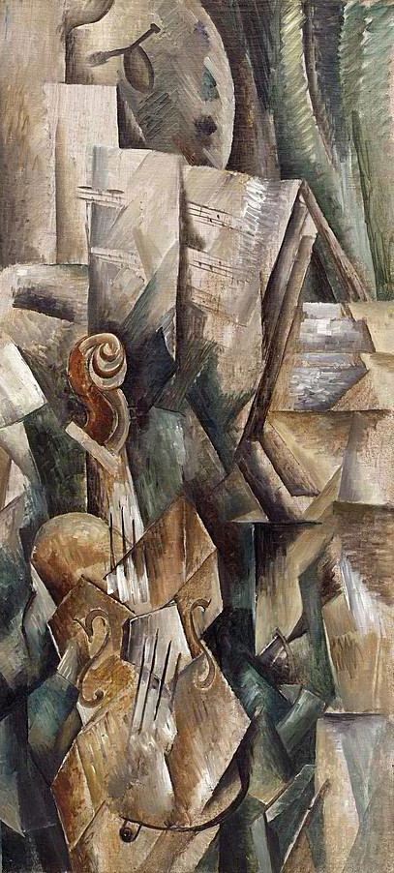

Figure 3: Georges Braque, Violin and Palette, oil on canvas, 1909

*Source: Solomon R Guggenheim Museum, New York.*

Levinson, like Nanay, agrees with aspects of Wollheim’s twofoldedness but not that it is applicable to all painted representations (Levinson 2001; Nanay 2005, Wollheim 1980). Whilst Levinson does agree with Wollheim that twofoldness, defined as simultaneously seeing the representation and how it was represented, is part of the aesthetic aspect of painting, he argues that Wollheim’s “twofoldness” is not applicable to all painted representations (Levinson 2001, 28–29). According to Levinson, whilst it may be true that we see the “marks” that make up an image of something, we do not have to “attend to” or “notice” or enter into a process of “consciously focusing on the picture’s surface or patterning” in order to perceive the object (Levinson 2001, 229). What Levinson points out is that, in some paintings, the image may significantly foreground itself against the medium through which it was represented (Levinson 2001). Nanay points out that Levinson does agree that, in order to acknowledge the “aesthetic qualities of a painting”, twofoldness may be necessary, but it is “not necessary for just recognizing something as being depicted” (Nanay 2005, 250; Levinson 2001). However, as Nanay points out, Wollheim gives two different definitions of twofoldness (Nanay 2005, 255). This might make it difficult to know where the focus of Levinson’s critique of Wollheim is situated (Levinson 2001). Nanay objects to Levinson’s critique, if it is addressed at Wollheim’s definition of twofoldness as the simultaneous perception of the represented object and the ways in which it was painted (Nanay 2005, 254; Levinson 2001). Her objection is that “in order to appreciate a picture aesthetically, one really does need to be attending to, taking notice of, or consciously focusing on the brush strokes and the composition” (Nanay 2005, 255). Nanay does acknowledge that Levinson’s statement may be more applicable to Wollheim’s definition of twofoldness as the simultaneous perception of the surface of a painting and what it represents (Levinson 2001).

Returning to Alloa’s critique of Wollheim’s concept of “twofoldness”, he paraphrases it thus: “Images are neither fully transparent with respect to their referential object nor totally opaque, exposing their material qualities of the medium” (Alloa 2011, 6). Even in paraphrasing Wollheim’s concept of twofoldness, Alloa notes a certain permeability between image and medium; one is seen with the other, never as entirely separate (Alloa 2011, 6). Alloa subsequently questions Wollheim’s theory of twofoldness: “Isn’t Wollheim’s ‘bivalence’ theory yet another reduction to a static simultaneity of what is, phenomenologically speaking, constantly oscillating?” (Alloa 2011, 7). What Alloa is suggesting is that to pin down how we oscillate between the representation of something and the painting’s surface is to lose out to more manifold ideas about looking on and through the painting’s surface over time (Alloa 2011). Perhaps, rather than a twofold relationship between surface and representation or a painting’s construction and representation, there may need to be open connections and extensions from Wollheim’s twofoldness, in order to incorporate other ways of seeing. These might include other ways of perceiving, such as seeing “with” or through images, which is a concept Alloa borrows from Merleau-Ponty (Alloa 2011, 8). For example, Alloa quotes Husserl’s “perceptive imagination” and how the image’s support “excites” the image (Alloa 2011, 10). According to Alloa a painting’s materiality is not a “purely neutral projective surface” (Alloa 2011, 10). Rather, there may be ways in which the surface “contrasts” with the image or sometimes “openly conflicts” with it (Alloa 2011, 10). For Alloa “images *generate* gazes”, if we are “*seeing-with*” them (Alloa 2011: 10).

Hal Foster’s writing on the “Lacanian gaze”

Whilst twofoldness suggests a way of looking that can incorporate both the material surface of the painting, as well as the image it represents, the scopic regime of the gaze presents another way of looking that might interconnect with twofoldness. If twofoldness is about seeing the picture plane and the picture surface as one visual experience; seeing one together with the other, the Lacanian gaze suggests a particular slippage at the point where the two intersect. At this point, there may be an exchange between the viewer looking through to the represented object and the object which itself appears to look back at the viewer.

For the purposes of this paper, I am specifically concerned with Hal Foster’s use of the Lacanian gaze (Foster 1996, 138). The Lacanian gaze is a scopic regime that incorporates Cartesian perspectivalism, but then partly reverses it. There are discrete overlaps between Foucault’s “panoptic” gaze, Joan Copjec’s feminist critique of the gaze and Foster’s analysis of Lacan’s concept of the gaze (Foucault 1991, 220; Copjec 1994, 13; Foster 1996, 138; Lacan 1987, 67). However, this paper is specifically concerned with how Foster develops a mode of perception associated with the surfaces of photorealist paintings, seen through Lacan’s gaze. The interaction between “luscious sheen”, the gaze and the surface of photorealist paintings that Foster outlines may involve a dynamic form of vision which creates continual visual shifts between the picture plane and the painting surface (Foster 1996, 142).

Hal Foster’s analysis of Richard Estes’ photorealist paintings is primarily concerned with “the tangled lines and lurid surfaces of capitalist spectacle”, as well as “the luscious sheen” that they depict (Foster 1996, 142). Foster links Estes’ layering of transparent, opaque and reflective surfaces with Jacques Lacan’s seminar on the “gaze” (Foster 1996, 138). As Foster points out, Lacan “challenges the old privilege of the subject in sight and self consciousness...as well as the old mastery of the subject in representation” (Foster 1996, 142). To illustrate the “gaze”, Lacan recounts an event from his youth in which he notices a sardine can floating on the sea, which is sparkling or “aglint in the sun” (Foster 1996, 139). According to Foster, Lacan finds himself “fixed in a double position” by the sardine can, which seems to look back at him “at the level of the point of light, the point at which everything looks back at me is situated” (Foster 1996, 139; Lacan cited in Foster, 1996: 139). Lacan overlays his theory of the gaze onto Cartesian perspectivalism. Foster notes that this complicates how we look at objects:

This seen as (s)he sees, pictured as (s)he pictures, the Lacanian subject is fixed in a double position, and this leads Lacan to superimpose on the usual cone of vision that emanates from the subject another cone that emanates from the object, at the point of light, which he calls the gaze. (Foster 1996, 139)

In the first cone of vision, Lacan has placed the image halfway between the geometrical point and the object. This image, according to Levine, can also be thought of as “where the easel of the painter might stand” and exemplifies Alberti’s “paradigm of linear perspective” (Levine 2008, 80). Levine notes that Lacan’s view of Alberti’s “paradigm” was of a “geometrical mapping of three-dimensional space rather than an adequate understanding of the libidinal dynamic of embodied vision” (Levine 2008, 80–81). Levine states that Lacan proposed that the second cone of vision comes, not from the viewer, but from “the emanating power of the point of light, which seems to flow outward from the object in the world toward the subject” (Levine 2008, 81). This light “illuminates” the viewer and makes them “a picture to be seen”, according to Levine (Levine 2008, 81). As we view an object Lacan proposes that the rays of light from the object move out towards us and make us a picture on the screen, which is merged with the image halfway along the overlapping cones.

Elkins describes the sardine can in Lacan’s anecdote about the gaze as “a kind of eye, a looking thing” (Elkins 2007, 22). As Elkins states, Lacan is using his anecdote to illustrate “the chiasmatic or crossed nature of vision: the way that the gaze proceeds from the subject and also to the subject from “outside”” (Elkins 2007, 22). Lacan, Elkins notes, is “transformed into a “picture,” looked at by a “point of light”” (Elkins 2007, 22). As viewers, we both view the object and are pictured by its “point of light” (Foster 1996, 139). Hal Foster notes that the subject is, not only “pictured” by the gaze of the object, but “photographed by its light” (Foster 1996, 139).

Both Elkins and Foster’s concept that the viewer is looked at and “photographed” by the gaze from the light of reflective surfaces might also occur when we look at representational paintings (Elkins 2007; Foster 1996, 139). This superimposition of looking and being looked at seems to occur frequently, and perhaps at times overwhelmingly, for the viewer in Richard Estes’ paintings. In particular, Foster notes that in Estes’ *Double Self-Portrait* “the structuring of the visual is strained to the point of implosion, of collapse onto the viewer” (Foster 1996, 142). The depiction of reflective and transparent surfaces layering on top of one another creates a “double perspective”, causing one to “feel under the gaze, looked at from many sides” (Foster 1996, 142). There is a suggestion here by Foster that light, as well as linear perspective, is bounced back from inside the picture plane, through the painting’s surface and into the viewer’s space. The viewer’s gaze, I would argue, reflects diffusely in a multitude of directions through the depiction of mirror-like surfaces in Estes’ painting and back through the picture plane repeatedly.

According to Foster’s analysis of Estes’ paintings, the “complete perplexity” of whether one is looking at glass, reflective chrome surfaces, inside the shop or the reflection of the street behind is a “visual conundrum with reflections and refractions of many sorts” (Foster 1996, 142). Foster uses Estes’ paintings *Union Square* (1985, Figure 4) and *Double Self-Portrait* to illustrate how, we, as viewers may feel looked at by the gaze from a number of different levels within the paintings (Foster 1996, 142). Estes’ paintings, such as Union Square, pressure the “Renaissance paradigm of linear perspective” or Cartesian perspectivalism (Foster 1996, 142). As Foster points out, the gaze “converges on us more than extends from us” in Estes’ paintings (Foster 1996, 142). This is because “in front of these paintings one may feel under the gaze, looked at from many sides...an impossible double perspective” (Foster 1996, 142). Foster notes that *Double Self-Portrait*, “pressures...a baroque paradigm of pictorial reflexivity like (Diego Velázquez’s) Las Meninas” (Foster 1996, 142). Similarly, Parmiggiani states that Estes manages to force “reality and illusion” to “contaminate” one another, which also has the effect of “stunning us” (Parmiggiani 2007, 70). This disorientation, which is similar to Foster’s use of “conundrum” earlier, may also cause viewers of the paintings to think that “we have lost our bearings of what can be actually seen and of what is artistical invention, of what is in front of us or is behind us, inside or outside the place” (Foster 1996, 141; Parmiggiani 2007, 70). This disruption of a “singular” and “static” Cartesian perspectivalism by the scopic regime of the gaze may appear as a “conundrum”, because the act of looking becomes channeled by a way of looking, emanating from the represented object (Jay 1988, 7; Foster 1996, 141). As we continue to look, the “tangled lines and lurid surfaces” of Estes’ paintings “often distend, fold back, and so flatten pictorial depth”, according to Foster (Foster 1996, 142). This sense of a tangled, complicated scopic regime echoes Jay’s discussion of a “baroque” scopic regime (Jay 1988, 16–17). Although Estes’ paintings do not completely align with this scopic regime alone, there are overlaps with the “dazzling, disorientating, ecstatic surplus of images in baroque visual experience...(emphasising) its rejection of the monocular geometricalization of the Cartesian tradition”, together with the ways in which the Baroque “revels in the contradictions between surface and depth” (Jay 1988, 16).

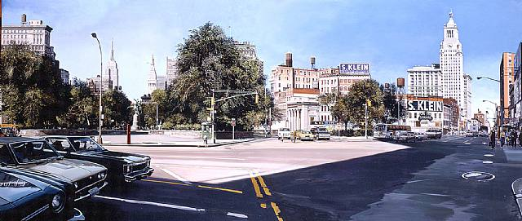

Figure 4: Richard Estes, Union Square, oil on canvas,1985.

Source: Marlborough Gallery, New York.

Foster’s suggestion of light emitting from the painting surface and a similarly reflected gaze draws attention to the particular interplay at the point where the picture plane and the painting surface intersect. Whilst this complex series of transactions, through Estes’ painted surfaces, imply an “implosion” of the space depicted by the painting, in Foster's opinion, it never completely collapses (Foster 1996, 142). By continually animating the interplay between the remnants of Cartesian perspectivalism and Lacan’s gaze, back and forth between the picture plane and the painting surface, Estes’ depictions of reflective surfaces suggest a combination of scopic regimes that are interwoven and dynamic, rather than singular and static. This dynamism appears to discreetly apply pressure on any one scopic regime in Estes’ paintings, in order to mediate other scopic regimes through the painting’s smooth, perhaps slippery, surface. The smooth surfaces of Estes’ paintings, with their self-effacing brushwork, could be said to mediate this “double perspective” quite seamlessly (Foster 1996, 142). This may partly be due to the way in which the surface treatment erases the surface itself, smoothing the transaction between the viewer and the gaze. In looking at the painting surface, the viewer looks through the picture plane, only for his/her gaze to be reversed back through the picture plane towards himself/herself. Cartesian perspectivalism might be somewhat entwined with and reversed by the gaze.

Conclusion: Multiple Scopic Regimes

As we have seen, there are several scopic regimes that, arguably, interconnect with Alberti’s concept of Cartesian perspectivalism through Estes’ *Double Self-Portrait* (Alberti 1967). As we address such a painting, many ways of looking may be suggested through dynamic slippages between the picture plane and the painting surface, which could be simultaneously channelled by the scopic regimes of Cartesian perspectivalism and the Lacanian gaze. *Double Self-Portrait* could be said to somehow hold these multiple scopic regimes, in place for the viewer to orchestrate.

Regarding multiple, rather than singular scopic regimes, both Jay and Pattison have noted that a more contemporary “model of vision” may, in some ways, work against a “detached, disembodied Cartesian perspectivalism”, towards a “multi-perspectivalism” and away from Cartesian Perspectivalism as an ideological construct (Jay 1988, 16; Pattison 2007, 34). However, according to Pattison, the “Cartesian idea of sight continues to underlie many of the assumptions many Western people have about sight” (Pattison 2007, 35). Jay suggests that there may have been theories of perception that incorporated single scopic regimes in the past (Jay 1988, 4). These are now “repressed”, but can be “discerned” in modern ideas about scopic regimes (Jay 1988, 4). Jay calls “modernity” a “contested terrain” in which many different scopic regimes relate and respond to one another (Jay 1988, 4). Jay is keen to stress that this relationship between scopic regimes is dynamic, rather than a “harmoniously integrated complex of visual theories and practices” (Jay 1988, 4).

In conclusion, Jay notes that, since the twentieth century, Cartesian perspectivalism has not been replaced entirely by other scopic regimes (Jay 1988, 18). Whilst it has been “denaturalized and vigorously contested, in philosophy as well as the visual arts”, it still somewhat continues to be part of the scopic field of vision (Jay 1988, 18). Jay is keen to stress an alternative to a “hierarchy” of scopic regimes and proposes a “plurality of scopic regimes now available to us” (Jay 1988, 20). As Jay points out “In so doing, we won’t lose entirely the sense of unease that has so long haunted the visual culture of the West, but we may learn to see the virtues of differentiated ocular experiences” (Jay 1988, 20). This, Jay notes, will halt us from falling for the “fiction of a “true” or ideological vision and revel instead in the possibilities opened up by the scopic regimes we have already invented and the ones, now so hard to envision, that are doubtless to come” (Jay 1988, 20). Estes’ *Double Self-Portrait* might suggest that we should replace the notion of individual scopic regimes with the idea of a scopic field, containing multiple scopic regimes. *Double Self-Portrait* may thus embody and encourage a particular oscillation or visual slippage between different ways of looking through the painted surface, looking across the surface and a form of being looked at from inside the surface.

Acknowledgement

The author would like to acknowledge the support of Manchester School of Art and Liverpool Hope University, enabling this paper to be developed from his PhD thesis (2015), available from University of the Arts London.

Full peer reviewed version of this paper is available in ‘The International Journal of the Arts in Society’: https://cgscholar.com/bookstore/works/visual-slippages-between-the-picture-plane-and-the-painting-surface?category_id=common-ground-publishing

REFERENCES

Alberti, Leon B. 1967. On Painting, translated with an introduction and notes by John R. Spencer. London: Routledge and Kegan Paul.

Alloa, Emmanuel. 2011. “Seeing-in, Seeing-as, Seeing-with: Looking through Pictures.” Image and Imaging in Philosophy, Science, and the Arts, Proceedings of the 33rd International Wittgenstein Symposium 1(1): 179–190­­.

Campbell, David and Power, Marcus. 2010. “The Scopic Regime of Africa.” In Observant States: Geopolitics and Visual Culture, edited by Fraser MacDonald, Rachel Hughes, and Klaus J. Dodds, 167–195. London: I.B. Tauris.

Caplan, Paul. 2011. “Lingering Scopic Regimes.” The Internationale. Accessed October 2, 2014. http://theinternationale.com/blog/2011/01/lingering-scopic-regimes/

Clark, Kenneth. 1944. Leon Battista Alberti On Painting, Annual Italian Lecture of the British Academy 1944. Oxford: The University Press.

Copjec, Joan. 1994. Read My Desire: Lacan against the Historicists. Harvard: MIT Press.

Damisch, Hubert. 1994. The Origin of Perspective. London: The MIT Press.

Danto, Arthur C. 1989. “Art: Sienese Painting.” The Nation, March 6.

Elkins, James. 2007. “The End of the Theory of the Gaze.” James Elkins. Accessed March 2, 2015. http://www.jameselkins.com/images/stories/jamese/pdfs/the-visual-gaze.pdf

Foster, Hal. 1996. The Return of the Real. London: The MIT Press.

Foucault, Michel. 1991. Discipline and Punish; The Birth of the Prison. London: Penguin.

Friedberg, Anne. 2006. The Virtual Window: From Alberti to Microsoft. London: MIT Press.

Gombrich, Ernst H. 1977. Art and Illusion: A Study in the Psychology of Pictorial Representation, Volume 5. London: Phaidon.

Gregory, Derek. 2003. “Emperors of the Gaze: Photographic Practices and Productions.” In Space in Egypt, 1839-1914 in Picturing Place: Photography and the Geographical Imagination, edited by Joan Schwartz and James Ryan, 195–225. London: I.B. Tauris.

Ivins, William M. 1946. Art and Geometry: A Study of Space Intuitions. Massachusetts: Harvard University Press.

Ivins, William M. 1973. On the Rationalization of Sight. New York: Da Capo Press Inc.

Jay, Martin. 1988 “Scopic Regimes of Modernity.” In Vision and Visuality, edited by Hal Foster, 3–23. Seattle: Bay Press.

Lacan, Jacques. 1987. The Four Fundamental Concepts of Psycho-Analysis. Harmondsworth: Penguin.

Levine, Stephen Z. 2008. Lacan Reframed: Interpreting Key Thinkers for the Arts. London: I.B. Tauris.

Levinson, Jerrold. 2001. “Wollheim on Pictorial Representation.” In Richard Wollheim on the Art of Painting: Art as Representation and Expression, edited by Rob Gerwen, 28–38. Cambridge: Cambridge University Press.

Masheck, Joseph. 1991. “Alberti’s “Window”: Art-Historiographic Notes on an Antimodernist Misprision.” Art Journal 50 (1): 34–41.

Metz, Christian. 1982. The Imaginary Signifier: Psychoanalysis and the Cinema. Indiana: Indiana University Press.

Mulvey, Laura. 2009. Visual and Other Pleasures. Basingstoke: Palgrave Macmillan.

Nanay, Bence. 2005. “Is Twofoldness Necessary for Representational Seeing?” British Journal of Aesthetics 45 (3): 248–257.

Panofsky, Erwin. 1991. Perspective as Symbolic Form. New York: Zone Books.

Parmiggiani, Sandro. 2007. “The Sensuousness of the Real.” In Richard Estes/ comisarios=curators, edited by Sandro Parmiggiani, 9–26. Milan: Skira.

Pattison, Stephen. 2007. Seeing Things: Deepening Relations with Visual Artefacts. London: SCM Press.

Rorty, Richard. 1979. Philosophy and the Mirror of Nature. Princeton: Princeton University Press.

Sartre, Jean–Paul. 2004. The Imaginary: A Phenomenological Psychology of the Imagination. London: Routledge.

Walton, Kendall L. 2002. “Depiction, Perception, and Imagination.” Journal of Aesthetics and Art Criticism 60 (1): 27–35.

White, John. 1972. The Birth and Rebirth of Pictorial Space. London: Faber and Faber.

Wollheim, Richard. 1980. Art and its Objects. Cambridge: Cambridge University Press.

Wollheim, Richard. 1987. Painting as an Art. Princeton: Princeton University Press.

ABOUT THE AUTHOR

Dr. Donal Moloney: Senior Lecturer in Fine Art, Department of Fine and Applied Art, Faculty of Arts and Humanities, Liverpool Hope University, UK