Prosociality and Life Satisfaction: A Daily-Diary Investigation among Spanish University Students

Antonio Zuffianò1

Manuel Marti-Vilar2

Belén López-Pérez1

1Liverpool Hope University

2University of Valencia

This is the accepted version of an article published in *Personality and Individual Differences*.

<https://doi.org/10.1016/j.paid.2017.10.042>

© 2017. This manuscript version is made available under the CC-BY-NC-ND 4.0 license <http://creativecommons.org/licenses/by-nc-nd/4.0/>

Abstract

With a diary study, we tested the positive effect of prosociality on life satisfaction. Fifty-six Spanish undergraduate students (45 females; *M*age= 21.08 years) rated their life satisfaction, prosociality, self-esteem, and physical appearance for 5 consecutive days. Multilevel results indicated that within-individual positive deviations in prosociality (i.e., behaving more prosocial than usual) were uniquely and significantly associated with higher life satisfaction on that specific day. Students’ self-esteem, physical appearance, and positive daily events were also predictive of life satisfaction. Exploratory analyses revealed that the positive effect of prosociality on life satisfaction was significant only for those students with low or medium levels of satisfaction with their physical appearance. The findings are discussed in relation to the individual determinants of subjective well-being during early adulthood.

*Keywords:* prosociality; life satisfaction; self-esteem; physical appearance; multilevel modeling.

**1. Introduction**

Understanding the individual factors underlying subjective well-being (SWB) is at the core of the research agenda of many personality psychologists (Diener, 1984). Research conducted in the last decades has shown the importance of personality traits (DeNeve & Cooper, 1998) and self-esteem (Diener & Diener, 1995) as individual determinants of SWB. Noteworthy, previous studies also reported the role of prosociality (i.e., the tendency to behave in favor of others; Batson, 2011) as an *other-oriented disposition* associated with higher psychological well-being across the life-span (e.g., Caprara & Steca, 2005). In line with this tradition of research, the aim of the present study was to investigate whether prosociality was a significant predictor of one major component of SWB, life satisfaction (a general evaluation about one’s own life; Diener, 1984). Specifically, we investigated the positive effect of prosociality on life satisfaction (LS) by using a daily-diary framework and while controlling for (1) *self-oriented* predictors usually associated with higher LS (self-esteem and physical appearance), and (2) daily life events.

*1.1. LS: Development and Predictors*

LS is considered the cognitive component of SWB, with higher scores linked to many positive outcomes such as physical health and optimism (e.g., Diener, 1984). In terms of developmental trajectories, longitudinal studies indicated an overall stability of life satisfaction, although contextual factors (e.g., life events) may be responsible for changes at specific time points (Lucas & Donnellan, 2007). Besides its stability, authors investigated what factors may predict higher LS. For instance, self-esteem has been consistently found to exert a positive effect on LS, as the positive evaluation of one’s own self is a major source on which people rely on when judging their life (Ye, Yu, & Li, 2012). Another self-oriented variable linked with LS is physical appearance. In fact, people who are satisfied with their body tend to report higher self-esteem and LS (Frederick, Sandhu, Morse, & Swami, 2016).

Besides self-oriented factors, researchers also analyzed the possible link between LS and other-oriented tendencies such as prosociality (Caprara & Steca, 2005). Behaving prosocially, indeed, entails many benefits not only for the target but also for the actor (Batson, 2011). Specifically, prosociality may foster LS by promoting reciprocity and social integration as well as a sense of competence and meaning in life (Van Tongeren, Green, Davis, Hook, & Hulsey, 2015). For instance, Caprara and Steca (2005) found a consistent positive effect of prosociality on LS from early adulthood to the elderly period.

*1.2. The Present Study*

Although the positive effects of self-oriented (i.e., self-esteem and physical appearance) and other-oriented tendencies (i.e., prosociality) on LS were already highlighted in the literature, previous studies did not analyze these the variables in a comprehensive framework, thereby failing to properly distinguish their effective contribution. In the present work, we investigated these variables simultaneously with a daily-diary approach. This allowed us to evaluate the dynamic, daily-based effects of prosociality on LS as well as to disentangle between-person effects (i.e., if being more prosocial than others was associated with higher life satisfaction) from within-person effect (i.e., behaving more prosocial than usual at the personal level was associated with higher LS on that day). Additionally, we controlled for daily events to partial out their effects. From a developmental perspective, we focused on early adulthood as it is a phase characterized by several challenges (e.g., succeeding in higher education, romantic relationships, etc.) that have a deep impact on individuals’ life (Arnett, 2000). Finally, we also tested all interactions between self-oriented predictors and prosociality to explore the presence of possible moderation effects.

**2. Methods**

*2.1. Participants*

Participants were 56 students enrolled in an introductory psychology course (45 females; *M*age= 21.08 years, *SD*= 3.64) in a Spanish university (participants were compensated with partial course credit).

*2.2. Procedure*

After providing informed consent, students filled an online questionnaire from Monday to Friday. In line with previous daily-diary studies (e.g., Alessandri, Zuffiano, Vecchione, Donnellan, & Tisak, 2016), on each day, participants reported their LS, prosociality, self-esteem, physical appearance, and daily events (each scale was adapted and preceded by the wording “Think about today…”). Participants were asked to provide the response that best reflected how they felt on that specific day. These reports were collected online at 24-h (approximately from 8:00 pm to 12:00 pm). Thirty-two participants (57%) provided daily measures for all 5 days, whereas 14 (25%) participants missed 1 day. We handled missing data with full information maximum-likelihood estimation.

*2.3. Measures*

*2.3.1. LS*

Participants rated their LS (from 1=*strongly disagree* to 7=*strongly agree*) using the 5-item ‘‘Satisfaction with Life Scale’’ (Diener, 1984; “In most ways my life was close to my ideal”). Across the five days, omega reliabilities (ω) ranged from .88 to .91.

*2.3.2. Prosociality*

Participants rated their prosociality (from 1=*never/almost never* to 5=*always/almost always*) using the 16-item scale developed by Capara, Steca, Zelli and Capanna (2005; “I tried to help others”; ω*s* from .90 to .93).

*2.3.3. Self-esteem*

Participants rated their self-esteem (from 0=*strongly disagree* to 3=*strongly agree*) using the 10-item Rosenberg Self-esteem Scale (1965; “On the whole, I was satisfied with myself”; ω*s* from .90 to .93).

*2.3.4. Physical Appearance*

Participants rated their physical appearance (from 1=*strongly disagree* to 5=*strongly agree*) using 1 item from Moss and Rosser’s (2012) scale of appearance valence (“I was satisfied with my physical appearance”).

*2.3.4. Daily Events*

Participants completed (from 0=*it did not happen* to 5=*it happened and it was extremely important*) an 18-item checklist adapted from Gable, Reis, and Elliot (2000) tapping into social-related, achievement-related, financial-related, and health-related events. Nine eventswere negative (e.g., “heavy study/work load”) and nine events were positive (e.g., “good interaction with my parents”). Given the simultaneous occurrence of both positive and negative events in daily life, we computed an overall score given by the ratio of positive events over the sum of positive and negative events.

**3. Results**

*3.1. Correlations*

LS was positively related to self-esteem, physical appearance, and prosociality (partially). Overall, correlations (Table 2; Online Appendix) were as expected, thereby supporting the construct validity and rank-order consistency of our scales.

*3.2. Multilevel Modeling (MLM)*

Given the nested structure of our data (daily measures nested within students), we used MLM with maximum-likelihood estimation in SPSS 24. First, we identified the best-fitting trajectory of LS over time by using the likelihood-ratio test (*LR*; West, Ryu, Kwok, & Cham, 2011). The random intercept model (-2logLikelihood= 652.541, three parameters; ICC=.720) was not statistically different from the linear (*LR*= 2.722, *df*= 3, *p*=.436), quadratic (*LR*= 5.810, *df*= 4, *p*=.214), and cubic model (*LR*= 5.861, *df*= 5, *p*=.320). Thus, students’ LS was best captured by an overall mean-level stability characterized by significant inter-individual variability (MLM-1; Table 1).

Next, to test the positive effect of prosociality, we used the centering within-context (i.e., student) approach (West et al., 2011). At Level-1, (1) prosociality, (2) self-esteem, and (3) physical appearance were person-mean centered to create daily deviations scores (e.g., by computing the average of each student’s *own* prosociality across 5 days and subtracting it from his/her daily prosociality scores). We left uncentered (4) life events because the zero meant lack of positive daily events. At Level-2, average levels of (5) prosociality, (6) self-esteem, and (7) physical appearance were grand-mean centered, and (8) sex was coded as -1 (girls) and +1 (boys).[1] As reported in Table 1 (MLM-2), daily deviations in prosociality (level-1) were associated with higher LS (i.e., being more prosocial than usual was associated with higher LS on that day). Positive life events (level-1), physical appearance (level-2), and self-esteem (at both levels) also positively predicted LS. Compared to MLM-1, MLM-2 greatly reduced the amount of unexplained residual variance at level-1 (*Pseudo-R2* =.392).

Finally, we explored possible moderation effects by including all cross-level interaction terms. When these terms were entered simultaneously, only the cross-level interaction “*daily prosociality deviations*average physical appearance*” was significant (*b* =-.331, *SE*= .115, *p*=.005). To ease model interpretation, we dropped nonsignificant interactions (*p*-values from .137 to .856). The interaction “*daily prosociality deviations*average physical appearance*” was still significant in MLM-3 (*Pseudo-R2* =.449). Simple slopes indicated that the positive effect of daily prosociality deviations on LS was significant only for students with low (-1*SD*) and medium (*mean*) average levels of physical appearance, but not for those with high levels (Figure 1).

**4. Discussion**

Although previous studies clearly identified the positive contribution of self-oriented variables such as self-esteem and physical appearance in promoting LS, the role played by other-oriented tendencies, such as prosociality, has been partly under-investigated in the literature. The present research aimed to fill this gap. To offer a more compelling picture of the relations among the variables, we adopted a daily-dairy approach in which we clearly distinguished between-person and within-person effects. As hypothesized, daily spikes in prosociality (i.e., positive deviations from average prosociality levels) uniquely predicted higher LS while controlling for level-1 differences in self-oriented variables and life events. However, inter-individual differences in prosociality (level-2) did not predict LS. Hence, only when students behaved more prosocial than usual they also reported higher LS on that day. This result is in line with a consistent part of the literature indicating the psychological benefits of behaving prosocially for the actor (e.g., Caprara & Steca, 2005). As previous studies highlighted, self-transcending actions, such as sharing and caring, may increase individuals’ LS by helping them enhance their meaning in life and building positive relationships in which they feel valued and supported (Van Tongeren et al., 2015). This result is especially important if we consider that young adults (as in our sample) often face many challenges (academic, relational, etc.) that can cause drops in their LS (Arnett, 2000).

Our findings also confirmed the positive effects of self-esteem, physical appearance, and positive daily events on LS. Furthermore, we found an interaction between students’ average levels of satisfaction with their physical appearance and their daily prosocial actions. Specifically, the beneficial effect of prosociality on LS was significant only for those students who reported low or medium levels of satisfaction with their physical appearance. Although this finding is exploratory and, therefore, caution must be taken in drawing conclusions, it may suggest that prosociality may compensate for the students’ lack of satisfaction with their own body. For instance, behaving prosocially could help those students who are not fully satisfied with their physical appearance to receive positive recognition from others for their positive actions (rather than for their appearance). This could also be relevant during the elderly period (Caprara & Steca, 2005), when drops in satisfaction with aging may compromise the SWB of older people. Furthermore, future studies should elucidate the link with other components of SWB (e.g., meaning) as well as whether prosocial actions that involve a direct contact with the target might be stronger related to LS than anonymous prosocial behavior (e.g., donating money to a charity).

We acknowledge several limitations, such as the small sample size (which could be responsible for the lack of consistent significant correlations between prosociality and LS), the use of psychology students, and the lack of assessment of the motivations underlying the prosocial actions. Furthermore, we also recognize that our results should be replicated in future independent studies because they might be specific to those cultural contexts (e.g., Spain) that attribute high relevance to other-oriented behaviors and feelings of belongingness. Finally, future research would benefit from more gender-balanced studies. Since both physical appearance and prosociality are gender-typed constructs (e.g., girls are more prosocial than boys; Caprara & Steca, 2005), we cannot rule out the possibility that the protective effect of prosociality could be stronger for females. Notwithstanding with these limits, our findings suggest that behaving more prosocial than usual might be an additional factor that may help people enjoy their life on a daily basis.

References

Alessandri, G., Zuffianò, A., Vecchione, M., Donnellan, B. M., & Tisak, J. (2016). Evaluating the temporal structure and correlates of daily self-esteem using a trait state error framework (TSE). *Self and Identity*, *15*, 394-412. doi:10.1080/15298868.2015.1137223

Arnett, J.J. (2000). Emerging adulthood: A theory of development from the late teens through the twenties. *American Psychologist*, *55*, 469–480. doi:10.1037//0003066X.55.5.469.

Batson, C.D. (2011). *Altruism in humans*. New York, NY: Oxford University Press.

Caprara, G.V., & Steca, P. (2005). Self-efficacy beliefs as determinants of prosocial behavior conducive to life satisfaction across ages. *Journal of Social and Clinical Psychology, 24*, 191–217. doi:10.1521/jscp.24.2.191.62271.

Caprara, G.V., Steca, P., Zelli, A., & Capanna, C. (2005). A new scale for measuring adult’s prosociality. *European Journal of Psychological Assessment, 21*, 77–89. doi:10.1027/1015-5759.21.2.77

DeNeve, K.M., & Cooper, H. (1998). The happy personality: a meta-analysis of 137 personality traits and subjective well-being. *Psychological Bulletin, 124*, 197-229. doi:10.1037/0033-2909.124.2.197

Diener, E. (1984). Subjective well-being. *Psychological Bulletin, 95*, 542-575. doi: 10.1037//0033-2909.95. 3.542.

Diener, E., & Diener, M. (1995). Cross-cultural correlates of life satisfaction and self-esteem. *Journal of Personality and Social Psychology, 68*, 653-663. doi:10.1037/0022-3514.69.1.120

Frederick, D.A., Sandhu, G., Morse, P.J., & Swami, V. (2016).Correlates of appearance and weight satisfaction in a U.S. national sample: Personality, attachment style, television viewing, self-esteem, and life satisfaction. *Body Image, 17*, 191–203. doi:10.1016/j.bodyim.2016.04.001

Gable, S.L., Reis, H.T., & Elliot, A.J. (2000). Behavioral activation and inhibition in everyday life. *Journal of Personality and Social Psychology, 78*, 1135-1149. doi:10.1037/0022-3514.78.6.1135

Lucas, R.E., & Donnellan, M.B. (2007). How stable is happiness? Using the STARTS model to estimate the stability of life satisfaction. *Journal of Research in Personality, 41*, 1091-1098. doi:10.1016/j.jrp.2006.11.005

Moss, T.P., & Rosser, B.A. (2012). The moderated relationship of appearance valence on appearance self consciousness: development and testing of new measures of appearance schema components. *PloS one, 7*, doi:10.1371/journal.pone.0050605.

Rosenberg, M. (1965). *Society and adolescent self-image*. Princeton, NJ: Princeton University Press.

Van Tongeren, D.R., Green, J.D., Davis, D.E., Hook, J.N., & Hulsey, T.L. (2016). Prosociality enhances meaning in life. *The Journal of Positive Psychology, 11*, 225-236. doi:10.1080/17439760.2015.1048814

West, S. G., Ryu, E., Kwok, O., & Cham, H. (2011). Multilevel modeling: Current and future applications in personality research. *Journal of Personality, 79*, 2-50. doi:10.1111/j.1467-6494.2010.00681.x

Ye, S., Yu, L., & Li, K. K. (2012). A cross-lagged model of self-esteem and life satisfaction: Gender differences among Chinese university students. *Personality and Individual Differences*, 52, 546-551. doi:10.1016/j.paid.2011.11.018.

Table 1

|  |  |  |  |  |  |  |  |  |  |  |  |
| --- | --- | --- | --- | --- | --- | --- | --- | --- | --- | --- | --- |
|  | MLM-1 | | |  | MLM-2 | | |  | MLM-3 | | |
|  | Coefficient | *SE* | *p* |  | Coefficient | *SE* | *p* |  | Coefficient | *SE* | *p* |
| Fixed effects |  |  |  |  |  |  |  |  |  |  |  |
| Intercept(b00) | 4.793 | .157 | <.001 |  | 3.082 | .343 | <.001 |  | 3.224 | .335 | <.001 |
| Sex(b01) | ─ | ─ | ─ |  | 0.087 | .322 | .789 |  | 0.083 | .322 | .797 |
| Average_RSE(b02) | ─ | ─ | ─ |  | 0.551 | .273 | .048 |  | 0.564 | .273 | .043 |
| Average_PA(b03) | ─ | ─ | ─ |  | 0.398 | .132 | .004 |  | 0.400 | .132 | .004 |
| Average_PRO(b04) | ─ | ─ | ─ |  | 0.300 | .184 | .107 |  | 0.300 | .184 | .108 |
| Life Events(b10) | ─ | ─ | ─ |  | 2.386 | .433 | <.001 |  | 2.185 | .421 | <.001 |
| Daily_RSE_deviations(b11) | ─ | ─ | ─ |  | 0.375 | .174 | .040 |  | 0.426 | .177 | .022 |
| Daily_PA_deviations(b12) | ─ | ─ | ─ |  | -0.017 | .055 | .764 |  | -0.024 | .053 | .653 |
| Daily_PRO_deviations(b13) | ─ | ─ | ─ |  | 0.329 | .107 | .002 |  | 0.269 | .104 | .010 |
| Daily_PRO_deviations*Average PA(b14) | ─ | ─ | ─ |  | ─ | ─ | ─ |  | -0.327 | .085 | <.001 |
| Random effects |  |  |  |  |  |  |  |  |  |  |  |
| *Level-2* |  |  |  |  |  |  |  |  |  |  |  |
| Intercept(r0) | 1.260 | .259 | <.001 |  | 0.670 | .146 | <.001 |  | 0.707 | .146 | <.001 |
| Daily_RSE_deviations slope(r1) | ─ | ─ | ─ |  | 0.541 | .263 | .039 |  | 0.614 | .261 | .019 |
| *Level-1(e)* | 0.490 | .051 | <.001 |  | 0.298 | .035 | <.001 |  | 0.270 | .031 | <.001 |

*MLMs (Life Satisfaction)*

|  |
| --- |
|  |

*Note.* RSE= self-esteem; PA= Physical appearance; PRO= Prosociality. Average= average levels across 5 days.

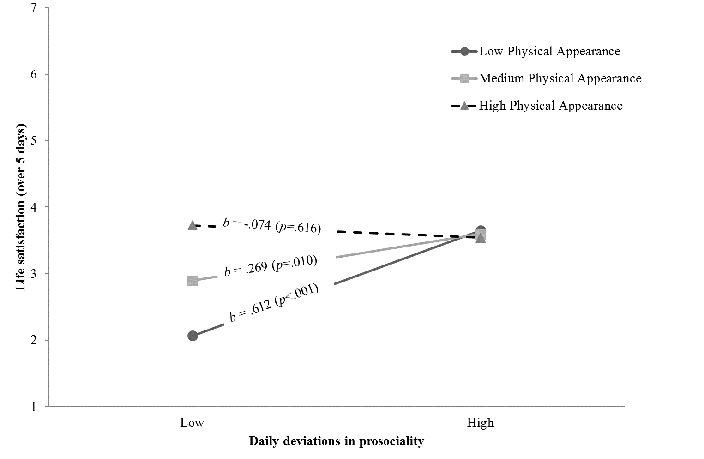

*Figure 1.* Simple slopes at low (-1*SD*), medium (*mean*), and high (+1*SD*) levels of physical appearance.

1. Since only daily self-esteem deviations showed a significant random effect, all the other level-1 predictors were treated as fixed effects for the sake of model parsimony.