Running title: Super-capacity and the self

**Super-capacity me! Super-capacity and violations of race independence for self- but not for reward-associated stimuli**

**Jie Sui1, 2, Alla Yankouskaya1 and Glyn W. Humphreys1**

**1 Department of Experimental Psychology**

**University of Oxford,**

**South Parks Road, Oxford OX1 3UD, UK**

**2 Department of Psychology,**

**Tsinghua University,**

**Beijing, PR China.**

Correspondences:

Jie Sui or Glyn W. Humphreys

Email: jie.sui@psy.ox.ac.uk or glyn.humphreys@psy.ox.ac.uk

**Abstract**

Participants are biased in responding to stimuli associated with themselves compared with stimuli related to other people. This self-bias may reflect the reward value of self-related stimuli (Sui, He & Humphreys, 2012, Journal of Experimental Psychology: Human Perception and Performance). In this paper we examined the identification of self- and reward-associated stimuli under conditions in which either single or redundant stimuli were presented. The redundant stimuli could be the same shape or they could be different shapes both associated with either the self/a friend or high/low reward. We formally tested whether the redundant stimuli violated the independent race model for the identification of multiple stimuli (Miller, 1982) and whether the redundant stimuli were processed with super- or limited-capacity (Townsend & Eidels, 2011). We found that redundant self stimuli alone both violated the independent race model and were processed with super-capacity. In contrast, the redundant high reward stimuli did not show race inequality and were associated with limited capacity processing. The data advance our theoretical understanding of self bias both by demonstrating that it can be distinguished from effects of reward, and by suggesting that self-bias can result from the enhanced integration of stimuli associated with the self. The implications for understanding self bias effects are discussed.

**Keywords**: self-bias, reward-bias, redundancy gain, race model, capacity coefficient

**Introduction**

**Self-bias in perception**

People show enhanced perception to stimuli associated to themselves relative to stimuli associated with other people (Keenan, McCutcheon, Sanders, Freund, Gallup, & Pascual-Leone, 1999; Moray, 1959). This occurs even with newly associated items (Cunningham, Turk, & Macrae, 2008; Sui, Liu, Wang, & Han, 2009). For example, Sui, He and Humphreys (2012) had participants learn an association between shapes and labels for the self, a best friend (or mother, in other experiments) and a stranger. Following this, the task was to judge whether shape-label pairings matched (e.g., circle-you, square-friend, from the learning trials) or whether mis-matching pairings were presented (circle-friend, square-you). After just a few learning trials, individuals were markedly faster and more accurate at matching self-related pairings than pairings related to other people (friend, stranger). This self-advantage also interacted with the contrast of the shape. For example, reducing the contrast of the shape disrupted responses to the friend-associated stimuli but not to self-associated items. This suggests that self-association facilitates stimulus perception. Sui et al. found similar results when shapes were associated with high relative to low reward values and suggested that the self advantage itself may reflect the intrinsic high reward value of self-associated stimuli.

Northoff and Hayes (2011) proposed the idea that self-biases in information processing can reflect reward values associated with the self. They distinguished between accounts in which self- and reward are fully overlapping factors, partially overlapping factors or parallel and independent. Data such as those reported by Sui et al. (2012) suggest that self and reward may be at least partially overlapping. A similar conclusion can be drawn from the results of Enzi and colleagues (2009). These authors conducted fMRI on healthy participants as they performed (i) reward gambling (win/lose) and (ii) personal relevance attribution (high/low) tasks. They found overlapping regions of activity across these tasks in the ventromedial-prefrontal cortex (vmPFC), ventral striatum and ventral tegmentum. In the present paper we examined whether effects of the self and of reward are identical by assessing whether each factor can modulate perceptual integration between stimuli. To do this we examined performance under conditions in which redundant shapes were presented. Responses to redundant stimuli can be more efficient than to single stimuli (Miller, 1982; Raab, 1962; Wenger & Townsend, 2006), and this ‘redundancy gain’ is greater when elements are part of a common configuration (Yankouskaya, Booth, & Humphreys, 2012) or object (Mordkoff & Danek, 2011). Thus the magnitude of redundancy gains can be used to assess how well stimuli integrate together. We tested this here by examining the magnitude of redundancy gains when participants receive two shapes that are both associated with the self (compared with when the association is to other people) and when the shapes are associated to high reward (relative to associations to lower reward). We ask whether the redundancy gains show a similar pattern across self- and reward-associated stimuli. A specific contrast here was between conditions where the stimuli on a trial are physically identical. Participants had to learn two shape exemplars for each label (circle, hexagon – you/high reward value; triangle, square – friend/low reward value). They then subsequently saw one or two shapes and they had to decide if the stimuli were associated with (i) the self or a friend or (ii) high or low reward. With these conditions we can contrast two redundant conditions (when in both cases both stimuli on a trial link to the same response). The redundant stimuli can be physically identical (e.g., two circles) or they could be conceptually but not physically linked (circle & hexagon). Greater redundancy gains for physically identical stimuli will reflect benefits at a perceptual level, over and above redundancy gains at a conceptual level generated between stimuli that are conceptually but not physically linked (see Ben-David & Algom, 2009). We ask whether self- and reward-associations modulate both perceptual and conceptual level redundancy gains, which can be informative about the level of representation at which self- and reward-biases affect performance. We also used fine-grained tests of the nature of the redundancy gains, using precise mathematical analyses of the redundancy effects to provide novel information about the dynamics of performance within a trial (Townsend & Altieri, 2012).

**Formal analyses of redundancy gains**

When redundant stimuli are presented, both linked to the same response, performance may be speeded for several reasons. The independent race model (Raab, 1962) proposes that stimuli are processed separately, but that a redundancy gain can nevertheless emerge if there is overlap in the distributions of the responses to each item and if responses are made to whichever stimulus is processed first. Under these conditions, the mean response times to redundant stimuli (taking the first stimulus to finish) will be faster than to single stimuli. Miller (1982) presented a formal test of this model. He compared the probability of responses being made within particular time bins on redundant targets trials relative to sum of the probabilities for responses in the same bins when either single target was present. The independent race model holds that the cumulative distribution functions for responses to redundant targets should not exceed the sum of the probabilities for responses to either single target (Miller, 1982). Miller showed that this prediction of the independent race model could be violated and suggested that, rather than being processed independently, stimuli could co-activate a common representation. This co-activation process would lead to a gain in the accumulation of information that was greater than the independent summation of the probability of responses to single stimuli. Other authors have argued that violation of the independent race model alone does not provide evidence for co-activation, since cross-talk between stimuli, as each is processed independently, could also lead to performance that is better than the sum of each stimulus processed in isolation (see Mordkoff & Yantis, 1991). A somewhat different approach has been taken by Townsend and colleagues. Townsend and Nozawa (1995), for example, defined processing in terms of workload capacity where fully independent processing of two stimuli would be associated with unlimited capacity (C(t) = 1). In contrast, limited capacity processing (C(t) < 1) is associated with interference between stimuli as they are processed, while super- capacity (C(t) > 1)) is associated with integrated processing of features. Evidence for super-capacity violates the predictions made by the independent race model (Townsend & Eidels, 2011).

In this paper we examined whether redundancy gains with stimuli associated to the self or a best friend (Experiment 1) or to high or low reward (Experiment 2) violated the independent race model, using both the analysis procedure introduced by Miller (1982; the so-called Miller inequality test) and that introduced by Townsend and colleagues (the capacity coefficient model; Townsend & Eidels, 2011). The Miller procedure provides a qualitative analysis of whether the independent race model is violated using probability distributions across trials. Capacity coefficient measures differ from this by testing the dynamic processing of information. This latter approach enables us to monitor the changes in information processing over time, for different inputs (in our case, whether the redundant shapes are the same or different and whether they are associated with the self, a best friend, high or low reward).

**Experiment 1: Self-bias and redundancy gain**

**Methods[1]**

*Participants*. There were 20 college students (7 male; 20 to 24 years of age, M=21.60±1.05). All participants were right-handed and had normal or corrected-to-normal vision. Informed consent was obtained according to procedures approved by a local ethics committee.

*Stimuli and tasks*. Four geometric shapes (circle, hexagon, square, and triangle) were randomly assigned to two conditions. Two shapes were associated with the self and two with the participant’s best friend (whom the participant named when the initial instructions were given). Participants were asked to identify whether the display contained a shape associated with the self or a friend. One or two shapes, each subtending 3.8°×3.8°, were presented in the left or/and right visual fields. The distance between the center of the shape and the central fixation cross (itself 0.8°×0.8°) was 3.0° of visual angle. The background was grey. The experiment was run on a PC using E-prime software (Version 1.1) and displayed on a 19-in monitor (1024 × 768 at 60 Hz).

*Procedure*. The experiment had two stages. First participants were asked to code two geometric shapes as a named best friend and two as the self. This pre-test lasted just 60s (see Sui et al., 2012). For example, a participant might be told, “The triangle and hexagon represent your best friend - Mary; you are the circle and square”. The shapes themselves were not presented at this stage. Subsequently, one or a pair of stimuli was presented in the left and/or right visual fields. Participants judged whether the display was the self or friend. On each trial a central cross appeared for 500 ms followed by one or two shapes in the left or/and right visual field for 100 ms. There then followed a variable duration, blank interval (ranging from 900 to 1100 ms). Participants had to press one of two response buttons as quickly and accurately as possible within this time frame (to encourage immediate responding) to discriminate the shape(s) (self vs. friend). Feedback (correct or incorrect) appeared on the screen for 500 ms at the end of each trial.

Each participant carried out six blocks of 120 trials following 8 practice trials, where self and friend shapes were presented either alone or in a redundant pair, equally often, in a random order. The accuracy of performance after each block was reported. There were two within-subjects variables - association (friend vs. self), and shape (single shape in the left or right visual field, two same, or two different shapes in the left and right visual fields) and on two-item trials the shapes were always redundant in relation to the response. There were 120 trials in each of 6 conditions (two same self, two different self, single self presented on the left or right, two same friend, two different friend, single friend presented on the left or right).

*Data analyses*.

*Race Inequality*. We conducted analyses of the race model using RTs for correct trials to examine whether the independent race model inequality was violated for self- and friend-associations, for same and different shapes. A standard procedure introduced by Miller (1982) was adopted here and extended later for a group level analysis (Ulrich, Miller, & Schroter, 2007). The Miller test allows a direct assessment of the independent race model without the need to meet specific assumptions about response time distributions or the experimental paradigm. To increase the diagnostic power of the procedure, the individual RT distributions were corrected for ‘fast guesses’ when responses may be given without processing the stimuli (here RTs < 150 ms) and the ‘kill-the-twin’ procedure was applied to the data (Gondan & Heckel, 2008; Ulrich et al., 2007)[2].

The Miller test makes use of the cumulative probability density functions (CDFs) of the latencies obtained for the redundant targets and for each of the single targets, and can be expressed as follows:

G-redundant(t) ≤ G-left(t) + G-right(t), (1)

where G(t) – is the probability that a response has been made by time t, left and right refer to a target defined by each single display in the left or right visual field, and redundant refers to redundant targets either with 2 same or 2 different shapes. The right hand side of inequality 1, defined by the sum of G-left and G-right, sets an upper bound on the cumulative probability function of a correct response at any time t given redundant targets. According to the independent race model, the redundant target (redundant) cannot exceed this upper bound, because the mean of the minimum of two random variables (redundant) is less than or equal to the sum of smaller means for the two single variables (left and right). Violations of the upper bound then may indicate co-activation between the stimuli, because responses to co-activated target representations may be faster than the fastest responses to either single target (Miller, 1982). We conducted two tests, one for same shapes and one for different shapes, to assess whether redundancy gains occurred at a perceptual level (shared by the same but not by different shapes), or at a conceptual/response level (shared irrespective of whether the shapes were the same or different).

Empirical CDFs were estimated for every participant and every target condition. All calculations followed the algorithm for testing the independent race model inequality given by Ulrich et al. (2007). First, the RTs generated by each participant for all target trials were sorted in ascending order to estimate 19 percentiles (5th through the 95th at 5% intervals). Subsequently these numbers were averaged across participants to produce the composite CDF for redundant targets and each single target conditions. To produce the sum of the CDFs for single targets – G-left(t) + G-right(t), RTs for these trials were pooled together and 19 quintiles were estimated based on only the fastest trials. All calculations were conducted using a MatLab script for computing the independent race model test (Ulrich et al., 2007).

The 19 percentiles points and CDFs were calculated for each participant and then averaged. Paired two-tailed t-tests were used to assess the reliability of any differences between the G-redundant and the sum of G-left and G-right CDFs at each percentile point. In order to control Type 1 errors caused by multiple comparisons, our strategy was to perform the test at two percentiles (10% and 15%) using paired t-tests but with a strict significance level adopted (0.1% instead of 5%) (see Yankouskaya et al., 2012).

*The Capacity Coefficient* C(t). The capacity coefficient proposed by Townsend and Eidels (2011) was used both to verify the results in race model analyses and to provide details on the different stages of information processing. The capacity coefficient can be estimated by taking a negative of the logarithm of the value for the empirical survivor function at each time bin (see Wenger & Townsend, 2000, for a discussion):

-log[Ss1s2(t)]

COR(t) = ______________

-log[Ss1(t) * Ss2(t)]

Where the redundant targets condition (s1s2) is in the numerator and the two single target conditions (s1 and s2) are in the denominator. Ss1s2, Ss1, Ss2 are survivor functions for the redundant and single targets.

First, for each condition we calculated the empirical CDF using small time window bins (10ms) (note that this differs from the Miller test, where the number of bins is fixed). Then the empirical survivor function was computed for each condition at each time bin - this is simply the complement of the cumulative distribution (the proportion of trials that were slower than the specified RT). All computations were performed using Matlab codes (Townsend & Eidels, 2011). After averaging the CDFs for the redundant targets and each single target, the data were converted into survivor functions in order to create integrative hazard functions. Subsequently the capacity coefficients for each participant and each condition were generated by creating a ratio of the averaged hazard functions at each time bin (Hugenschmidt, Hayasaka, Peiffer, & Laurienti, 2010). Confidence intervals were defined for each condition-capacity coefficient using a bootstrapping technique (Townsend & Eidels, 2011).

**Results**

*Redundancy gains*

The accuracy analysis showed no evidence of any speed-accuracy trade-off (Figure 1A) (range of accuracy: 95% - 98%). The analysis for RTs showed a significant main effect of association, *F*(1, 19) = 41.69, *p* < .001,η2 = .69; participants had faster responses to the self-association than to the friend-association. There was also a significant main effect of shape, *F*(2, 38) = 68.60, *p* < .001, η2 = .78; there were faster responses on two shape relative to single shape trials (*p*s < .001); same and different shape trials did not differ (*p* = .29). The interaction of association and shape was also significant, *F*(2, 38) = 34.84, *p* < .001, η2 = .65 (Figure 1B). Pairwise t-tests showed that there were faster responses to the self- than to the friend-trials both with two identical (*p* < .001) and two different shapes (*p* < .001). There was no difference between the self and friend responses on single item trials (*p* = 1.0) (Figure 1C). Analyses were performed on the redundancy gains (RTs to the appropriate single stimulus baseline minus RTs on redundant stimulus trials) for the same and different shape conditions. A one-sample t test revealed that there were redundancy gains for both the self- and the friend-association conditions, for both same and different shapes (*p*s < .005) (Figure 1D). We then examined the magnitude of the redundancy gains with two factors – the association (friend vs. self) and the shape (two different vs. two same shapes). There was a significant main effect of association, *F*(1, 19) = 51.71, *p* < .001, η2 = .73; there was a larger redundancy again in the self- than friend-association condition (Figure 1D). There was no significant main effect of shape (*p* = .10) and no interaction (*p* = .78).

*Race Inequality*

To test the independent race account of the redundancy gains, we conducted separate Miller inequality tests for same and different shapes for the self- and friend-associations respectively. The latency distributions are shown in Figure 2 derived from the group average of the latency distributions (Ulrich et al., 2007). Violations of the independent race model occur when the CDF for redundant targets falls to the left of the summed CDF for single targets. There was evidence of violation of the independent race model for redundant shapes associated with the self (Figure 2C and 2D) but not for redundant shapes associated with a friend (Figure 2A and 2B).

Previous studies have reported violations of the Miller inequality (1982) for percentile bins 10%-25% (Cavina-Pratesi, Bricolo, Prior, Marzi, 2001; Miller, 1982; Miller, Ulrich, & Lamarre, 2001). In order to conduct the Miller test (1982), but to control for Type 1 errors due to multiple comparisons, we examined performance using paired t-tests with a strict significance level (*p* = .001) (Kiesel, Miller, & Ulrich, 2007). For same-shape, friend-associations, the CDF did not reliably differ from the sum of the two single friend shapes in first percentile bin (*p* = .13), and it fell to the right of the sum of the two single targets for the remaining percentile bins (Figure 2A). Similarly, the CDF for different-shape, friend-associations fell to the right of the sum of the two single targets (Figure 2B). In contrast, for same-shape, self-associated targets the CDF exceeded the CDF of the sum of the single targets for the first three percentile bins (5%, 10%, and 15%: *p*< .0001, .0001, and .0007 respectively), and there were similar trends at later bins (20%, 25%, and 30%: *p* = .003, .034, and .265) (Figure 2C). Likewise, for different-shape, self-associated targets the CDF exceeded that of the sum of single targets for the first two bins (5% and 10%: *p* < .0001 and .0006), and showed a similar trend at later bins (15% and 25%: *p* = .021 and .171) (Figure 2D).

We then calculated the number of participants showing the violation of the race inequality for the same and different shape conditions and the data were subject to chi-square analyses with association (self vs. friend) and violation (violation vs. non-violation) as factors. Participants were more likely to show the race violation in the same-shape self-associated condition than in the same-shape friend-associated condition (20/20 vs. 9/20 participants respectively showing a violation of the race inequality, with at least one point in the CDF for redundant stimuli falling to the left of the CDF for the sum of single item trials), χ2 = 15.17, *p* < .0001. Likewise, there was a significant difference between the different-shape self-associated condition and the different-shape, friend-associated condition (20/20 vs. 8/20 showing a violation, χ2 = 17.14, *p* < .0001).

The data indicated that the redundancy gains observed for self-associated stimuli violated the independent race model, whilst those for friend-associations did not. This held for both same-shape and different-shape displays, consistent with self-association affecting both perceptual (same-shape redundant targets) and conceptual/response levels (different-shape redundant targets) of processing.

*The Capacity Coefficient*

To further explore the dynamics of processing redundant stimuli, we computed the capacity coefficient for self- and friend-associations. The overall capacity coefficient across the group of participants is presented in Figure 3 which illustrates that there was super-capacity for both the same-shape and different-shape trials with self-associated redundant stimuli. This was observed through time bins from 380 to 480 ms. In contrast, the results indicate that, for both types of trial with friend-associated stimuli, there was limited capacity though the whole time window. The data for individual participants are shown in Figure 4.

We calculated the number of participants showing super-capacity in each redundant condition and assessed effects of the conditions using chi-square analyses. The analyses showed that, when the shapes were the same, participants were more likely to show super-capacity to self-associated than to friend-associated stimuli (19/20 vs. 5/20 respectively; χ2 = 20.42, *p* < .0001). Similarly in the different-shape condition participants were more likely to show super-capacity to self-associated shapes than to friend-associated shapes (19/20 vs. 6/20; χ2 = 18.03, *p* < .0001). Additional analyses of the capacity data are given in the Supplementary materials.

**Discussion**

For self-associated stimuli there were violations of race inequality and demonstrations of super-capacity when redundant shapes were present relative to when single items appeared. This was not the case for friend-associated items. Though these stimuli showed a mean redundancy effect there was no evidence for violation of the independent race model and the stimuli were processed with limited rather than super-capacity. The results generally held both when the shapes were the same and when they differed. This last result is consistent with super-capacity being demonstrated at both perceptual and conceptual levels for self-associated shapes.

**Experiment 2: Reward-bias and redundancy gain**

**Methods**

There were 19 college students (2 male; 20 to 26 years of age, M=22.79±2.23). Experiment 2 was identical to Experiment 1 except that participants were asked to form low vs. high reward value associations (￥1 vs. ￥9) to each of two shapes – a procedure previously shown to modulate perceptual matching performance (Sui et al., 2012). Participants were instructed to judge whether one or two shapes presented in the left and/or right visual field represented the high or the low reward value, and on two-item trials the stimuli were always redundant for the response. Participants were rewarded an extra differential bonus according to their correct responses to high and low reward shapes, in addition to being given a participating fee. The maximal account was ￥9 plus ￥1, and each correct response was awarded ￥9/￥1 × 1%. There were two within-subjects factors – association (low vs. high reward) and shape (single, two same or two different shapes). In all other respects Experiment 2 was identical to Experiment 1. There were 120 trials in each of 6 conditions (two same high-reward, two different high, single high-reward presented on the left or right, two same low-reward, two different low-reward, single low-reward presented on the left or right).

**Results**

*Redundancy gains*

The accuracy analysis showed the same trends as the RT data (Figure 5A) and were not analysed further (range of accuracy: 95% - 99%). The analysis for RTs showed a significant main effect of shape, *F*(2, 36) = 14.49, *p* < .001, η2 = .45. There were faster responses in the two shape conditions than in the single shape condition (*p*s < .005) but there was similar overall performance for same- and different-shape trials (*p* = 1.0). The effect of association was not significant (*p* = .20) but the interaction of shape and association was significant, *F*(2, 36) = 4.68, *p* = .02, η2 = .21 (Figure 5B). Pairwise t-tests showed that there was an advantage for high over low reward stimuli when two different shapes appeared (*p* < .02), but not for trials with two same shapes or for trials with single shapes (*p*s > .19) (Figure 5C). We then tested the redundancy gains (RTs to the appropriate single stimulus baseline minus two stimuli) in the high and low reward conditions. One-sample t tests showed that redundancy gains occurred for the high-reward associations with both same and different targets (*p*s < .001). There was also a reliable redundancy gain for low-reward associated stimuli when the shapes were the same (*p* < .01) but not when the shapes were different (*p* = .12). We then examined the magnitude of the redundancy gains between the high- and low-reward associations with two factors – association (low vs. high reward value) and shape (two different vs. two same shapes). There was a significant main effect of association, *F*(1, 18) = 6.16, *p* < .03, η2 = .26, indicating a greater redundancy gain for the high- than the low-reward stimuli. There was also a marginally significant interaction, *F*(1, 18) = 3.86, *p* = .07, η2 = .18. The interaction arose because the redundancy gain for high-reward stimuli was higher than for low-reward stimuli when the shapes were different, *t*(18) = 3.21, *p* = .005, but not when they were the same, *p* = .46 (Figure 5D).

*Race Inequality*

The data were also used to test the Miller inequality. Although Figure 6 visually demonstrates violation of independent racing processing for high-reward targets, paired-samples t-tests between the redundant targets and the sum of two single targets failed to reveal any significant violation of the independent race model, for any of the redundant target conditions. For the low-reward stimuli the CDF for redundant shapes failed to exceed that of the summed CDF for two single stimuli at the first two percentile bins, both when the shapes were the same (5% and 10%: *p* = .64 and .64, Figure 6A), and when they were different (5% and 10%: *p* = .011 and .017, n.s. for multiple comparisons; Figure 6B). Likewise, there was no violation for redundant high-reward targets (for same-shapes at the 5% and 10% percentiles: *p* = .25 and .31, Figure 6C; for different-shapes at the 5% and 10% percentiles: *p* = .12 and .11, Figure 6D). There were no grounds to reject the independent race model.

Next we calculated the number of participants who showed violations of race inequality in each redundant condition (CDF for redundant trials falling to the left of the summed CDFs on appropriate single item trials). Chi-square analyses, with association (high vs. low reward value) and shape (two same vs. two different shapes) as factors, failed to reveal any significant differences between the high- and low-reward associations, both when the shapes were the same (high vs. low: 13/19 vs.10/19) and when they differed (high vs. low: 12/19 vs. 13/19), *p* = .32 and .73 respectively.

*The Capacity Coefficient*

The overall capacity coefficients across the group of participants are presented in Figure 7 and the individual data are presented in Figure 8. Figure 7 illustrates that there was super-capacity across time bins from 350 to 400ms for high- and low-reward redundant stimuli, both when the shapes were the same and when they were different.

We calculated the number of participants showing super-capacity for redundant stimuli. The chi-square analyses showed that participants were no more likely to show super-capacity for high-reward stimuli than for low-reward stimuli, both when the shapes were the same (9/19 for both high- and low-reward) and when they differed (9/19 vs. 8/19 for high- and low-reward respectively), *p*s > .74. Additional analyses of the capacity data are presented in the Supplementary materials.

**Discussion**

The analyses of the mean redundancy gains indicated greater benefits for high-reward stimuli particularly when the shapes differed. There were reliable redundancy gains too when the shapes were the same but these effects were not modulated by reward and likely reflect visual grouping between identical shapes (see Mordkoff & Miller, 1993). The data on violations of race inequality and on super-capacity failed to provide evidence that any modulation of the redundancy gains by reward were due to stronger integration of multiple high-reward stimuli. There were no reliable violations of the race inequality, for either high- or low-reward items. Also, although there were suggestions of super-capacity for high-reward stimuli, there were no more participants who showed super-capacity for high-reward over low-reward items and there was no evidence for high-reward generating a relatively longer maintenance of super-capacity across time.

**Cross-experiment analyses**

*Loglinear analyses*

Comparisons of performance in Experiments 1 and 2 were conducted using loglinear analyses on the numbers of participants showing violations of the race inequality and super-capacity with redundant stimuli. There were three factors - experiment (self vs. reward), association (self or high reward value vs. friend or low reward value), and effect (number of participants showing a violation of the race inequality or super-capacity vs. the number who did not).

*Violation of race inequality*. The analysis revealed significant three-way interactions both when the stimuli were the same and when they differed, χ2 = 8.54 and 14.74, *p* = .003 and .001, respectively. There was a greater difference between the number of participants violating the race inequality in the identical self and friend conditions when compared with the high- and low-reward conditions, for identical and non-identical shapes alike. The direct comparison between self and high-reward revealed that more participants showed violation of the independent race model for self- than for high-reward stimuli, with same-shapes (χ2 = 7.46, *p* = .006) and different-shapes (χ2 = 8.98, *p* = .003). In contrast, there were no differences between the friend and low-reward stimuli (*p*= .63 and .08 for same- and different-shapes).

*Super-capacity*. In line with the results on the violation of race inequality, there were significant three-way interactions both when the shapes were the same and when they differed, χ2 = 11.38 and 11.31, *p*s = .001; more participants showed super-capacity for redundant self- relative to redundant friend trials, when compared with the numbers showing super-capacity for the high- and low-reward redundant conditions. The direct comparison between the self- and high-reward trials revealed that, for both same- and different-shape trials, more participants demonstrated super-capacity for self- than for high-reward associated shapes, χ2 = 10.92 and 10.92, *p*s = .001. In contrast, there were no differences between the friend- and the low-reward stimuli, irrespective of whether the shapes were the same or different, *p* = .27 and .26.

The cross-experimental analyses confirm the differences between the self-associated stimuli and both friend-associated and high-reward associated items, both when violations of the race inequality and when super-capacity were measured. Both violations of the race inequality and super-capacity were more prevalent for self-associated stimuli than for the other conditions.

**General Discussion**

In the present paper we report data from detailed analyses which tested whether redundancy gains from stimuli associated with the self- and with high-reward violated the assumption that there is independent processing of redundant shapes. We used two approaches. First we examined whether there were violations of the independent race account, using Miller’s (1982) inequality test. We found strong evidence for violations of the model when redundant self-associated shapes were presented, both when the shapes were the same and when they differed. In no other condition (with friend-associated shapes or with shapes associated with high or low reward) were these violations reliable. Second, we employed the capacity coefficient approach proposed by Townsend and Eidels (2011). Consistent with the results using the Miller inequality test we found that self-associated stimuli were consistently processed with super-capacity, both in the same- and in the different-shape condition. With high-reward stimuli there was not strong evidence for super-capacity, though performance on average fell at a level close to that expected if there were fully independent processing of the shapes associated with high reward. With friend-associated shapes and low-reward stimuli the capacity analyses suggested that the shapes were each processed with limited capacity, so that there was interference when both were present. Alternatively, limited resources may be distributed across the two channels represented by each reward-associated shape as the processing work load increased from one to two items (Eidels, Houpt, Altieri, Pei, & Townsend, 2011). Thus the limited capacity may stem from constraints on parallel processing as well as from possible serial processing of each shape (Eidels et al., 2011).

A key theoretical contribution from this is in demonstrating that the effects of self-association can differ from those of reward. For example, self-association but not high-reward generated mean redundancy gains with identical shapes and only self-associations consistently violated the independent processing model and produced evidence of super-capacity processing. In contrast, there was an apparent qualitative shift in the processing of reward-related items, where limited capacity processing was evident. These results are consistent with self-association uniquely facilitating the integration of information at both perceptual and conceptual levels of representation (e.g., given modulation of effects for identical as well as non-identical shapes). In contrast high-reward may lead to gains at a conceptual level but these stimuli do not escape capacity limitations in processing.

One way to think of the results is that self-representation provides a form of associative ‘glue’ that helps bind together elements. In the present study we provide evidence for enhanced integration at both perceptual and conceptual levels of representation, demonstrated through violations of race inequality and the finding that there is super-capacity in processing self-related items. This enhanced binding may also take place at other levels of representation. For example, there is good evidence that self-associations can facilitate memory as well as perceptual representations and that there is enhanced clustering of elements when they are self-associated (Cunningham et al., 2008; Sui & Humphreys, 2013). It would be interesting to assess if the gains at a memory level also reflect non-independent processing of the elements making up the memory representation.

The argument that we have made about the nature of redundancy gains, and the greater effects when shapes have the same identity and are linked to the self, is similar to that made in the literature on perceptual processing (e.g., Ben-David & Algom, 2009; Mordkoff & Danek, 2011) – namely that, in the redundant target condition, participants may be responding to an emergent Gestalt representation that encompasses the two separate shapes rather than there being independent processing of the shapes. In studies of face processing there is evidence for super-additive redundancy gains when facial features combine (Wenger & Townsend, 2006; Yankouskaya et al., 2012). These redundancy gains reduce when faces are invested (Yankouskaya et al., 2012). This fits with the idea that participants are then responding to emergent configural information in faces (cf. Yin, 1969). We suggest that, in the present case, there was an emergent, integrated perceptual representation of the stimuli which was stronger between shapes with the same identity and when they were associated to the self.

Sui, Rotshtein and Humphreys (2013) have recently reported data on the neural substrates of matching labels and shapes associated with the self vs. other people. They reported evidence of involvement of the ventromedial pre-frontal cortex (vmPFC) and the posterior, superior temporal sulcus (pSTS) when participants matched labels and shapes corresponding to the self compares with others. They suggested that the vmPFC activity reflected activation of a core self representation linked to the self-label while the left pSTS activity was associated with social attention which the shape and the label both activate together and which might serve as an integrator of different forms of information linked to the self. Here we might speculate that such a representation plays a key role in integrating the different shapes linked to the self, and, through this, gives rise to the violations of independent shape processing and the evidence for super-capacity. This requires further study.

Prior studies have also shown that both self- and reward-associations can modulate the saliency of stimuli for attention (e.g., Anderson, Laurent, & Yantis, 2011; Sui et al., 2012). These studies have typically only used single stimuli, however, and the effects on the integration and co-processing of multiple items has not been examined. Our data are consistent with the idea that reward may facilitate the independent processing of the components of stimuli while self-association facilities integration. It will be of interest to examine whether the effects of reward and self-association operate differently on attentional saliency in a similar way to the stimulus identification tasks examined here, so that there are more integrative effects of self- than reward-association.

Rather than arguing for a qualitative difference in the effects of self and reward, it may also be possible to hold that the difference is more quantitative. Perhaps if the differential reward values had been greater than those used here, we may have been able to establish violations of the race model and super-capacity for high reward stimuli too. Though this account is possible, we note that, in other studies we have conducted, varying the differential magnitude of the reward has failed to impact on the relative size of the reward-bias effect. Indeed, when self-bias is pitted against reward (self-related stimuli receive no reward, other associated stimuli receive high reward), self-associated stimuli are still advantaged (Sui & Humphreys, sub., b). The data suggest that effects of self-bias and reward-bias are distinct and impact on different levels of representation.

One final point to note is that we failed to observe any benefits for self and high-reward associated stimuli on trials where a single shape was presented. This is an interesting demonstration of a possible boundary condition on self- and reward-bias effects. In the original studies on self-association (Sui et al., 2012, 2013), the experiments always used shape-label pairings and the task was to match previously seen pairings. On trials with a single shape and a label, large effects of self- and reward-bias emerged. This suggests that the bias effects are modulated by the presence of the label as well as the associated shape. Our fMRI results, discussed above, also point to this. We (Sui et al., 2013), found that activity in the vmPFC was based on the presence of the self label while the presence of the self shape activated the LpSTS. Furthermore, the stronger the functional connectivity from the vmPFC to the LpSTS, the greater the self bias effect. This result is consistent with the label providing a top-down setting that primes attentional responses to self-associated shapes. This does not necessarily mean that the top-down settings from the label are based on conscious expectancies. In a recent paper (Sui, Sun, Peng & Humphreys, 2014) we showed that the self advantage remains in self-label matching even when participants have no expectancies for self-related stimuli, whereas biases for other people (e.g., for friend-related stimuli over stimuli linked to a stranger) disappear. Nevertheless there is good reason to think that the presence of the label does play a role in driving self bias effects with single stimuli. Here we presented shapes in the absence of the label and this may have weakened the self-bias effect. In addition, the data here were collected using Chinese rather than Western participants, and Chinese participants may have closer perceived relations to their best friend than Western individuals (Markus & Kitayama, 1991). This too may have lessened the self advantage for single shapes. Even though self- and reward-bias effects were not found with single shapes, our current data show that the presence of the label is not necessary once multiple shapes are present. A similar conclusion can be drawn from the results of Sui, Liu, Mevorach and Humphreys (2013). These authors presented hierarchical shapes in which a shape associated with a stranger could appear at one level and a shape associated with either the self or a friend appeared at the other level. There was differential interference on responding to the stranger-associated shape when the self was a distractor compared with when the friend was a distractor. Again, there was evidence for a self-bias when multiple shapes were present. At least one reason for this is the argument we presented here, that self-association helps to integrate the shapes – and this effect emerges with multiple but not with single items. The present evidence, for violation of the independent race model and for super capacity associated with self stimuli, strongly supports this proposal.

**Acknowledgements**

This work was supported by grants from the ERC (Pepe Grant 323883), the ESRC (UK, ES/K013424/1) and the National Science Foundation of China (Project 31371017). We thank Jim Townsend for comments on the paper and guidance on the analyses of processing capacity.**References**

Anderson, B. A., Laurent, P. A., & Yantis, S. (2011). Value-driven attentional capture. Proceedings of the National *Academy of Sciences of the United States of America, 108*, 10367-10371.

Ben-David, B. M., & Algom, D. (2009). Species of Redundancy in Visual Target Detection. *Journal of Experimental Psychology. Human Perception and Performance, 35*, 958-976.

Cavina-Pratesi, C., Bricolo, E., Prior, M., Marzi, C.A. (2001). Redundancy gain in the Stop-Signal Paradigm: Implications for the locus of coactivation in simple reaction time. *Journal of Experimental Psychology. Human Perception and Performance, 27*(4), 932-941.

Cunningham, S. J., Turk, D. J., & Macrae, C. N. (2008). Yours or mine? Ownership and memory. *Consciousness &Cognition, 17*, 312–318.

Enzi B, de Greck M, Prosch U, Tempelmann C, Northoff G (2009): Is our self nothing but reward? Neuronal overlap and distinction between reward and personal relevance and its relation to human personality. *PLoS ONE 4*:e8429.

Eidels, A., Houpt, J. W., Altieri, N., Pei, L., Townsend, J. T. (2011). Nice guys finish fast and bad guys finish last: Facilitatory vs. inhibitory interaction in parallel systems. *Journal of Mathmatical Psychology, 55*, 176-190.

Gondan, M., & Heckel, A. (2008). Testing the race inequality: A simple correction procedure for fast guesses. *Journal Of Mathematical Psychology, 52*, 322-325.

Hugenschmidt, C. E., Hayasaka, S., Peiffer, A. M., & Laurienti, P. J. (2010). Applying capacity analyses to psychophysical evaluation of multisensory interactions. *An International Journal on Information Fusion, 11*, 12-20.

Keenan, J. P., McCutcheon, B., Sanders, G., Freund, S., Gallup, G. G., & Pascual-Leone, A. (1999). Left hand advantage in a self-face recognition task. *Neuropsychologia, 37*, 1421-1425.

Kiesel, A., Miller, J. O., & Ulrich, R. (2007). Systematic biases and Type I error accumulation in tests of the race model inequality. *Behavior Research Methods, 39*, 539-551.

Markus, H. R., & Kitayama, S. (1991). Culture and the self: Implications for cognition, emotion, and motivation. *Psychological Rewiew, 98*, 224-253.

Miller, J. (1982). Divided attention: evidence for coactivation with redundant signals. *Cognitive Psychology, 14*, 247-279.

Miller, J., Ulrich, R., & Lamarre, Y. (2001). Locus of the redundant-signals effect in bimodal divided attention: a neurophysiological analysis. *Perception & Psychophysics, 63*, 555-562.

Moray, N. (1959). Attention in dichotic listening: Affective cues and the influence of instructions. *Quarterly Journal of Experimental Psychology, 11*, 56-60.

Mordkoff, J. T., & Yantis, S. (1991). An interactive race model of divided attention. *Journal of Experimental Psychology. Human Perception and Performance, 17*, 520-538.

Mordkoff, J. T., & Danek, R. H. (2011). Dividing attention between color and shape revisited: redundant targets coactivate only when parts of the same perceptual object. *Attention, Perception & Psychophysics, 73*, 103-112.

Mordkoff, J. T., & Miller, J. (1993). Redundancy gains and coactivation with two different targets: the problem of target preferences and the effects of display frequency. *Perception & Psychophysics, 53*, 527-535.

Northoff, G., & Hayes, D. J. (2011). Is our self nothing but reward? *Biological Psychiatry, 69*, 1019–1025.

Raab, D. H. (1962). Statistical facilitation of simple reaction times. *Transaction of the New York Academy Sciences, 24*, 574-590.

Sui, J., He, X., & Humphreys, G. W. (2012). Perceptual effects of social salience: Evidence from self-prioritization effects on perceptual matching. *Journal of Experimental Psychology, Human Perception and Performance, 38*, 1105-1117.

Sui., J., & Humphreys, G. W. (2013). Self-referential processing is distinct from semantic elaboration: Evidence from long-term memory effects in a patient with amnesia and semantic impairments. *Neuropsychologia*. doi: 10.1016/j.neuropsychologia.2013.07.025.

Sui, J., Liu, C. H., Wang, L., & Han, S. (2009). Attentional orientation induced by temporarily established self-referential cues. *Quarterly Journal of Experimental Psychology, 62*, 844-849.

Sui, J., & Humphreys, G. W. (sub. a). More of me! Self-bias modulated redundancy gains in shape perception.

Sui, J. & Humphreys, G.W. (sub. b). The interaction between self-bias and reward: Evidence for common and distinct processes.

Sui, J., Liu, M., Mevorach, C. & Humphreys, G.W. (2013) The salient self: The left intra-parietal sulcus responds to social as well as perceptual-salience after self-association. *Cerebral Cortex*. doi: 10.1093/cercor/bht302.

Sui, J., Sun, Y., Peng, K. & Humphreys, G.W. (2014) The automatic and the expected self: Separating self- and familiarity bias effects by manipulating stimulus probability. *Attention, Perception & Psychophysics*. DOI 10.3758/s13414-014-0631-5.

Sui, J., Rotshtein, P., & Humphreys, G. W. (2013). Coupling social attention to the self forms a network for personal significance. *Proceedings of the National Academy of Sciences of the United States of America, 110*, 7607-7612.

Townsend, J. T., & Altieri, N. (2012). An accuracy-response time capacity assessment function that measures performance against standard parallel predictions. *Psychological Review, 119*, 500-516.

Townsend, J. T., & Eidels, A. (2011). Workload capacity spaces: a unified methodology for response time measures of efficiency as workload is varied. *Psychon Bulletin & Review, 18*, 659-681.

Townsend, J. T., & Nozawa, G. (1995). Spatio-temporal properties of elementary perception: An investigation of parallel, serial and coactive theories. *Journal of Mathematical Psychology, 39*, 321-360.

Ulrich, R., Miller, J., & Schroter, H. (2007). Testing the race model inequality: an algorithm and computer programs. *Behavioural Research Methods, 39*, 291-302.

Wenger, M. J., & Townsend, J. T. (2000). Spatial frequencies in short-term memory for faces: a test of three frequency-dependent hypotheses. *Memory & Cognition, 28*, 125-142.

Wenger, M. J., & Townsend, J. T. (2006). On the costs and benefits of faces and words: process characteristics of feature search in highly meaningful stimuli. *Journal of Experimental Psychology. Human Perception and Performance, 32*, 755-779.

Yankouskaya, A., Booth, D. A., & Humphreys, G. (2012). Interactions between facial emotion and identity in face processing: Evidence based on redundancy gains. *Attention, Perception & Psychophysics, 74*, 1692-1711.

Yin, R. K. (1969). Looking at upside-down faces. *Journal of Experimental Psychology, 81*, 141–145.

**Figure legends**

**Figure 1**. Redundancy gains in self association in Experiment 1. (A) The mean accuracy as a function of the association (friend vs. self) and shape (single, two different, or two same shapes). (B) The mean RTs as a function of the association (friend vs. self) and shape (single, two same, or two different shapes). (C) The magnitude of the self advantage (vs. responses to friend-associated stimuli) in RTs as a function of the shape (single, two different, or two same shapes). (D) The redundancy gains (two stimuli vs. single stimulus baselines) as a function of the association (friend vs. self) and shape (two different vs. two same shapes). Error bars represent standard errors.

**Figure 2**. CDFs for the group mean in the person-associations in Experiment 1. The top row illustrates effects with friend-associations (A. redundancy gain for two identical shapes; B. redundancy gain for two different shapes). The bottom row illustrates the violation of the independent race model for self-associations (C. redundancy gain for two identical shapes; D. redundancy gain for two different shapes).

**Figure 3**. The overall capacity coefficient across the group of participants in the person-associations in Experiment 1.The horizontal line at C(t) = 1 indicates the reference value for unlimited capacity. The capacity coefficients are depicted with the solid line; the confidence interval for the capacity coefficient is illustrated in the dashed line. The top row illustrates the friend-association, while the bottom row illustrates the results for the self- association.

**Figure 4.** Capacity coefficients for individual participants in the person-association conditions in Experiment 1. The horizontal line at C(t) = 1 indicates the reference value for unlimited capacity. The capacity coefficients are depicted with the solid line; the confidence interval for the capacity coefficient is illustrated in the dashed line. The top row illustrates the friend-association across participants, while the bottom row illustrates the results for the self- association across participants.

**Figure 5**. Redundancy gains in the reward association conditions in Experiment 2. (A) The mean accuracy as a function of the association (low- vs. high-reward) and shape (single, two different, or two same shapes). (B) The mean RTs as a function of the association (low- vs. high-reward) and shape (single, two same, or two different shapes). (C) The magnitude of the high-reward advantage (vs. responses to low-reward-associated stimuli) in RTs as a function of shape (single, two different, or two same shapes). (D) The redundancy gains (two stimuli vs. single stimulus baselines) as a function of the association (low- vs. high-reward) and shape (two different vs. two same shapes). Error bars represent standard errors.

**Figure 6**. CDFs for the group means in the reward association in Experiment 2. The top row illustrates the low-reward association (A. the redundancy gain for two identical shapes; B. the redundancy gain for two different shapes). The bottom row illustrates the high-reward association condition (C. the redundancy gain for two identical shapes; D. the redundancy gain for two different shapes).

**Figure 7**. The overall capacity coefficient across the group of participants in the reward association conditions in Experiment 2. The horizontal line at C(t) = 1 indicates the reference value for unlimited capacity. The capacity coefficients are depicted using a solid line; the confidence interval for capacity coefficient is shown using the dashed line. The top row illustrates the in low-reward association condition, and the bottom row illustrates the high-reward association condition.

**Figure 8**. Capacity coefficients for individual participants in the reward association conditions in Experiment 2. The horizontal line at C(t) = 1 indicates the reference value for unlimited capacity. The capacity coefficients are depicted using a solid line; the confidence interval for capacity coefficient is shown using the dashed line. The top row illustrates the in low-reward association condition across participants, and the bottom row illustrates the high-reward association condition across participants.

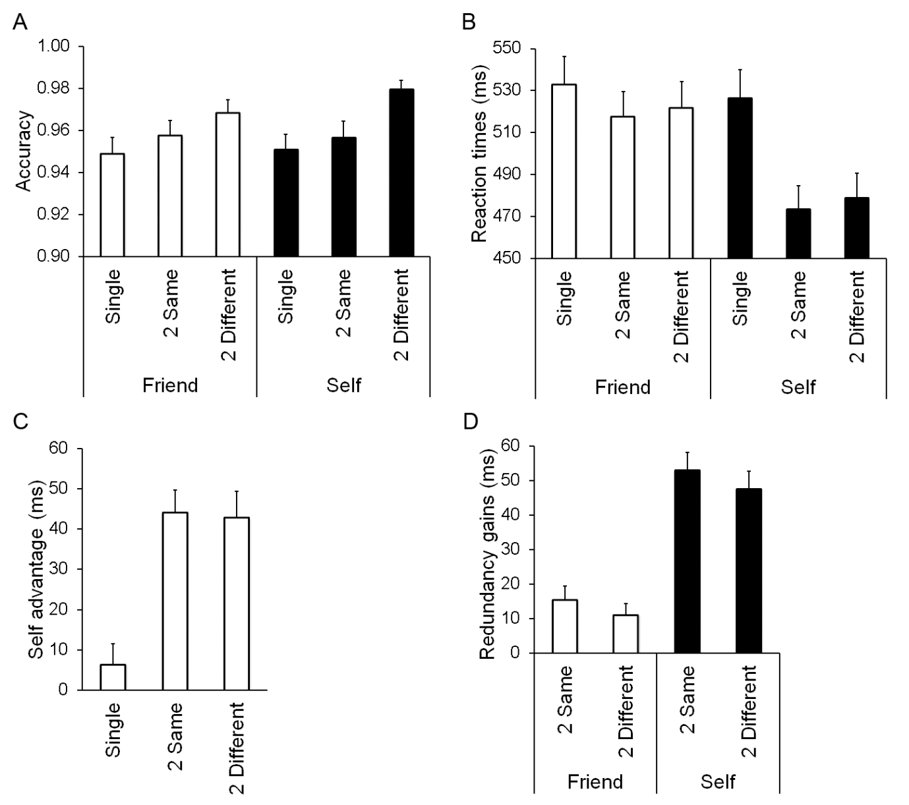

Figure 1

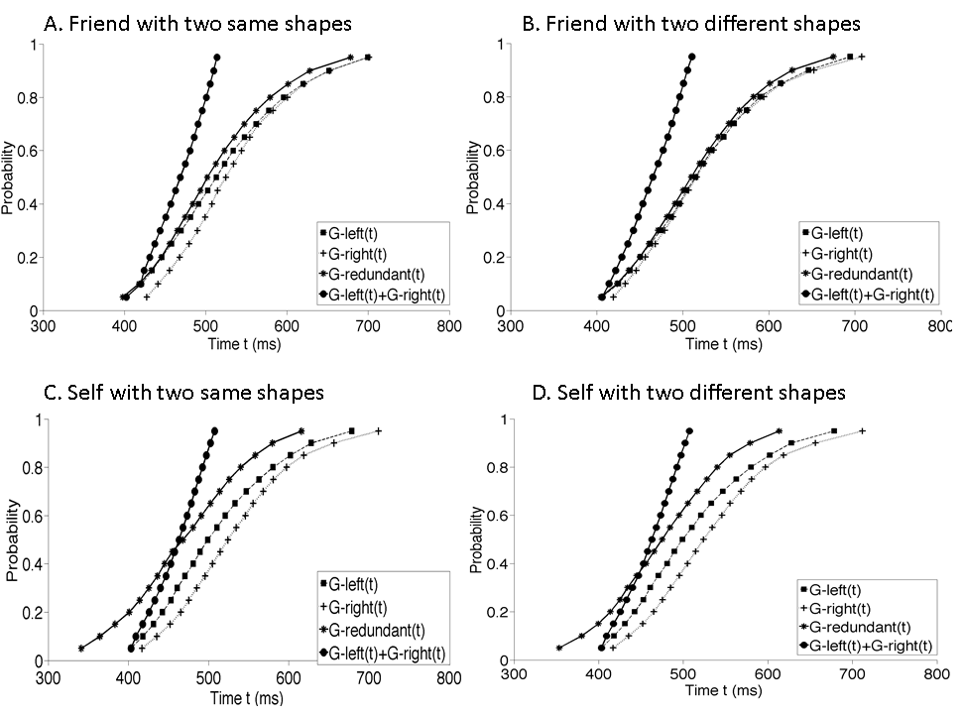

Figure 2

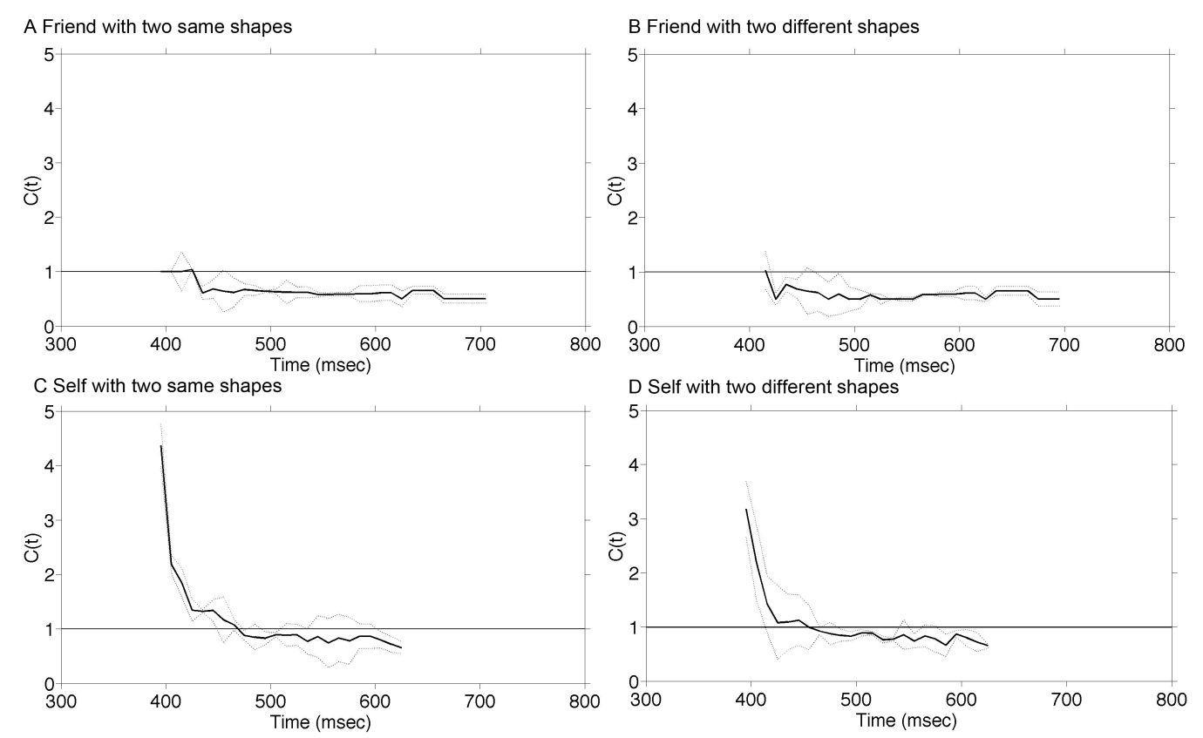

Figure 3

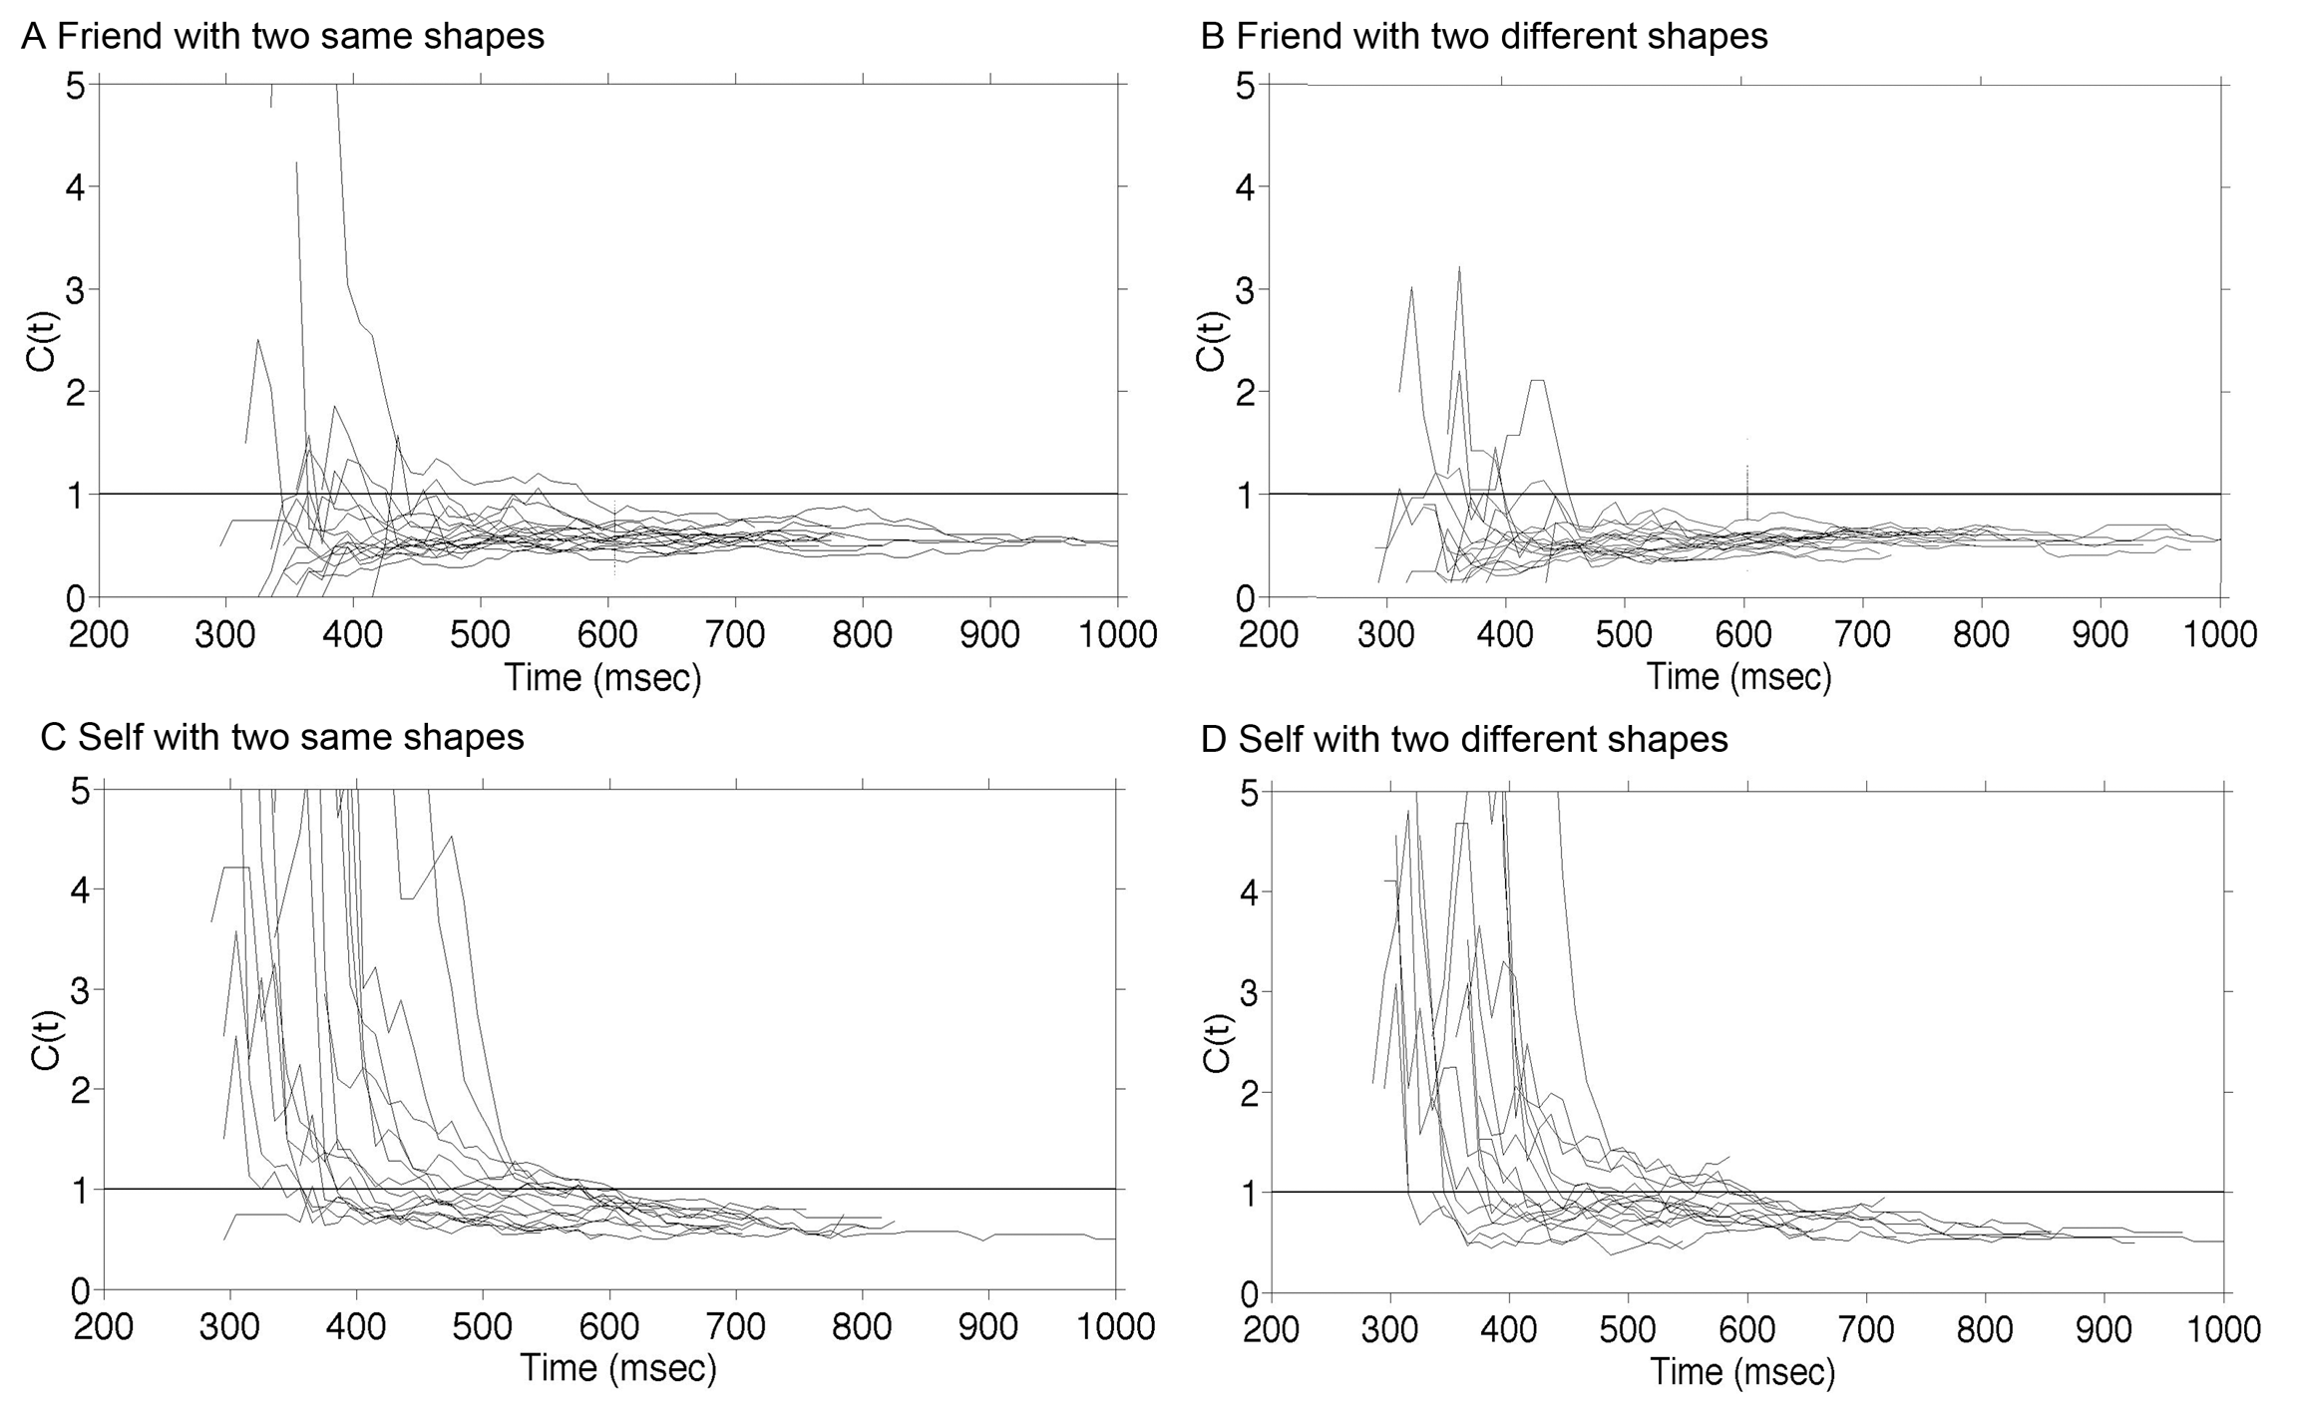

Figure 4

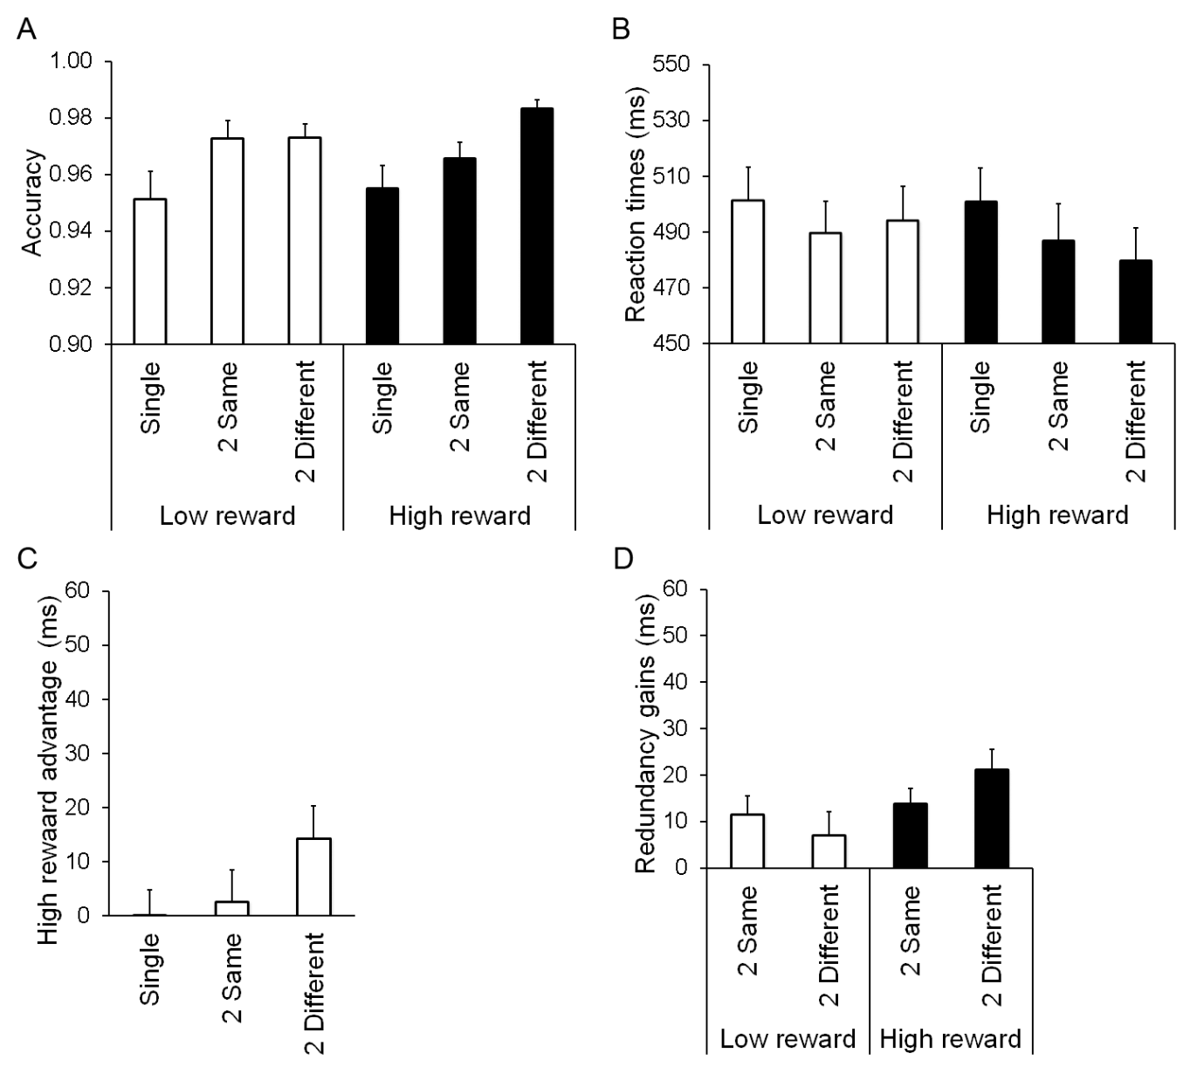

Figure 5

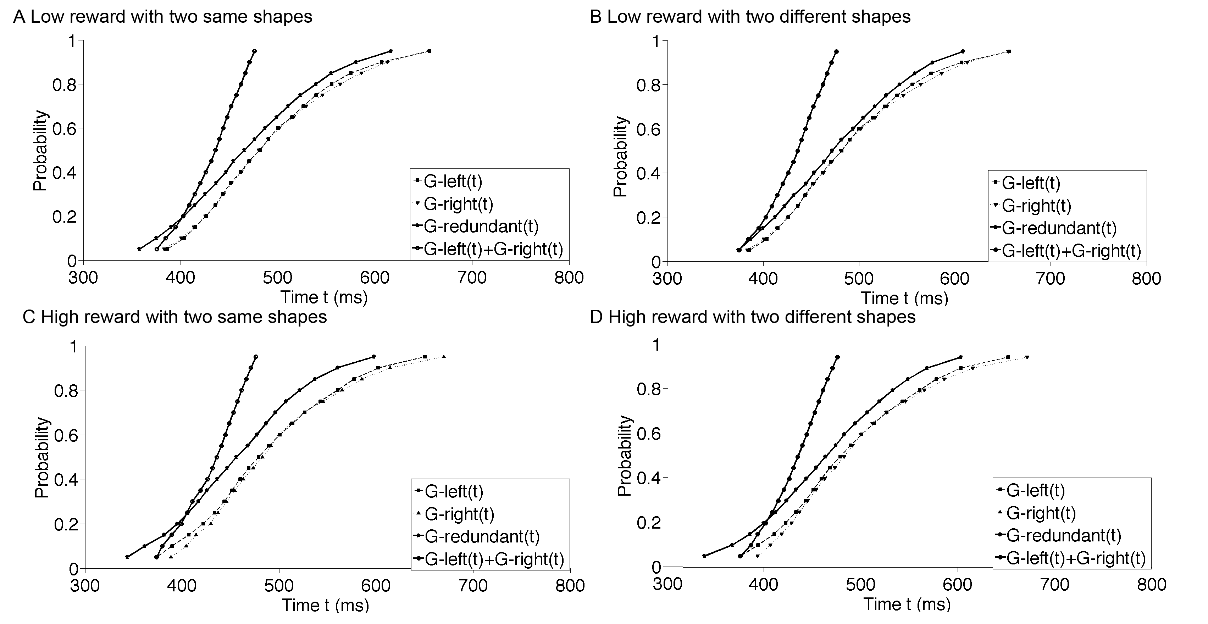

Figure 6

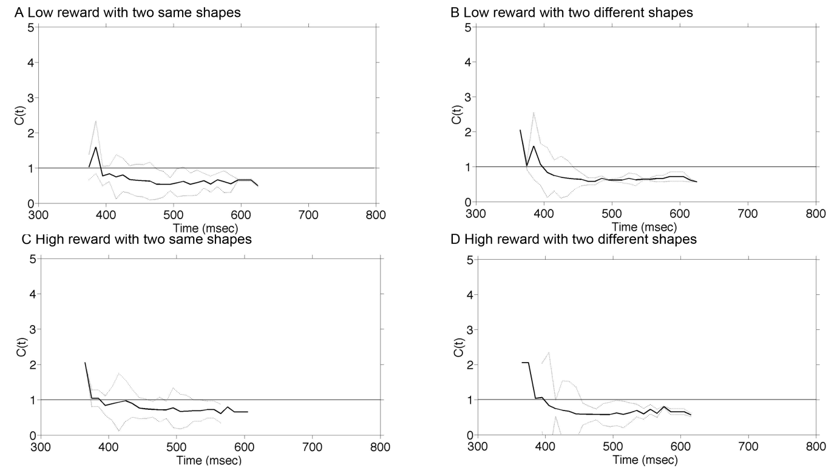

Figure 7

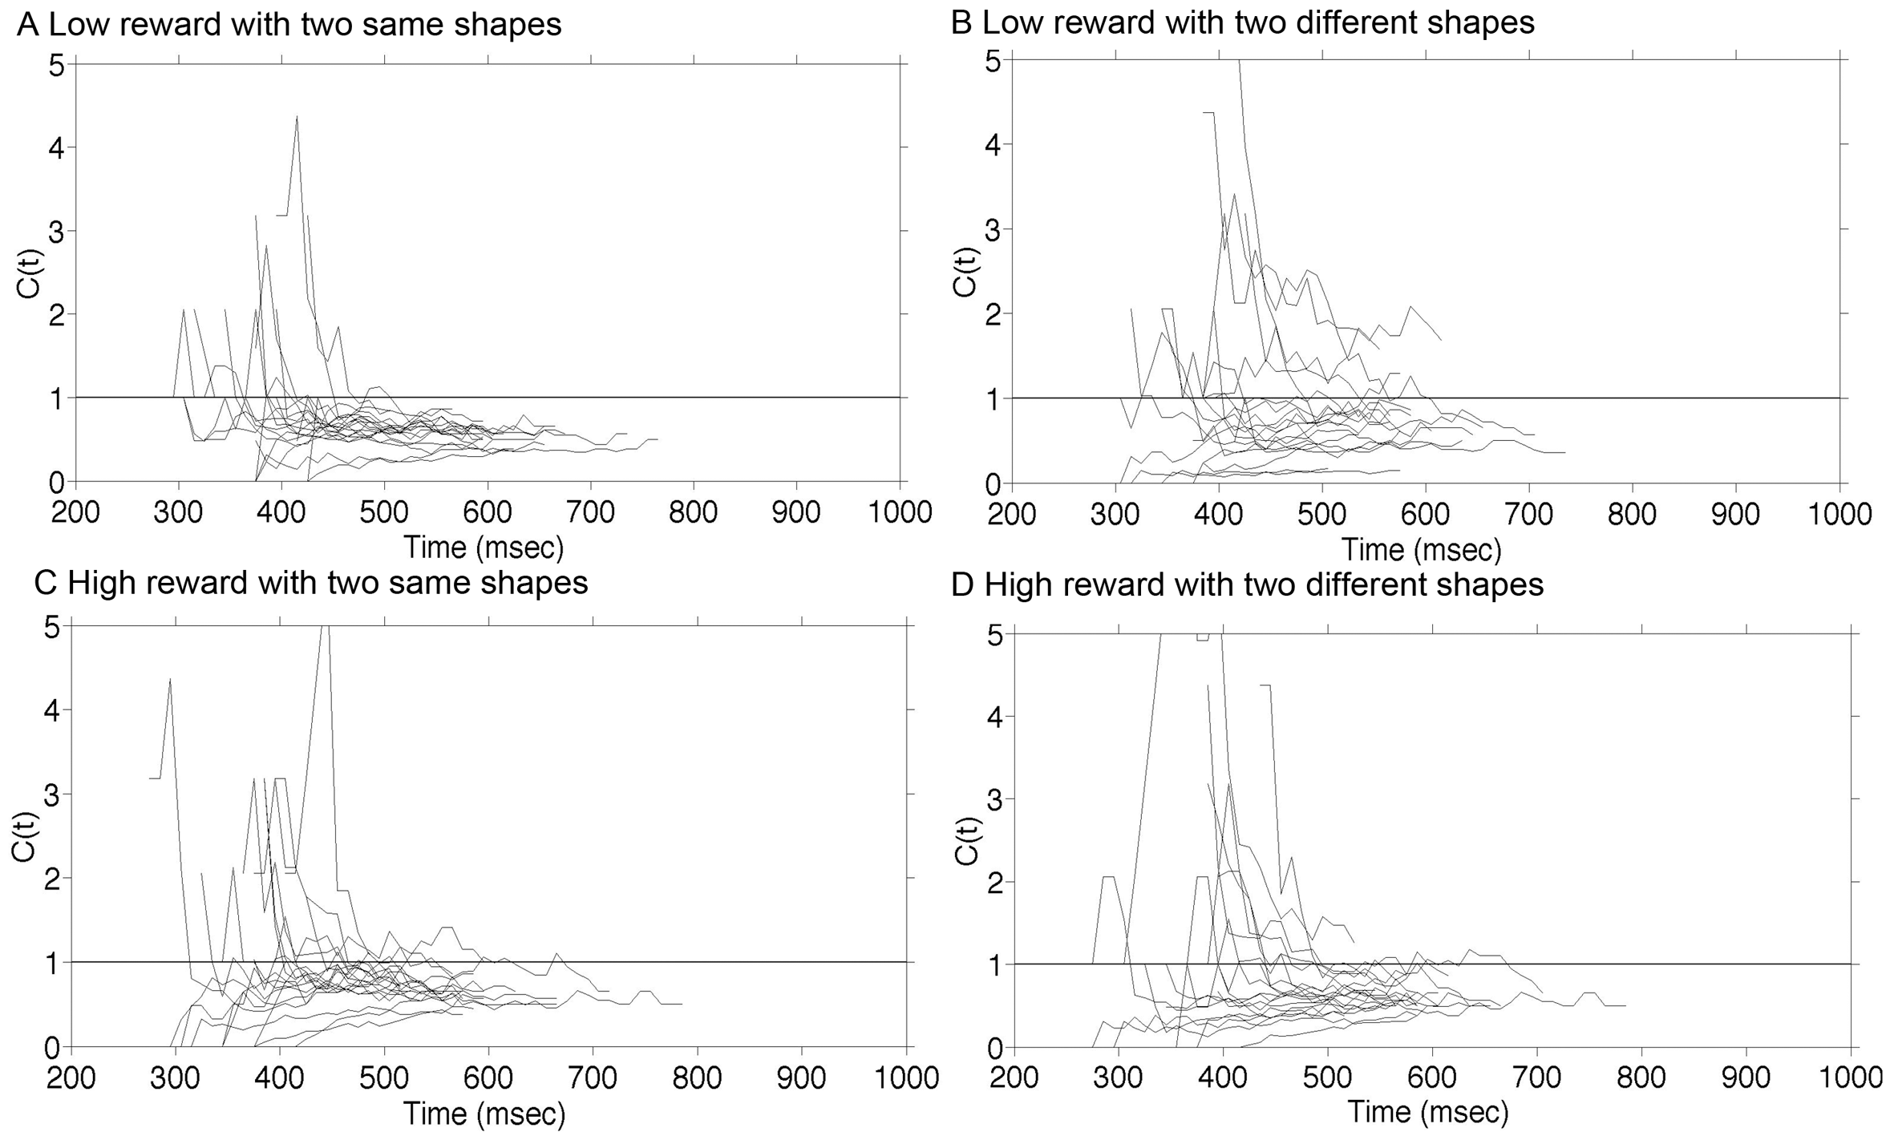

Figure 8

1. Experiments 1 and 2 are adapted from Experiments 2 and 3 in Sui and Humphreys (sub. a). What is novel here are the data analyses we perform to provide detailed tests of the dynamics of the redundancy gains for the various stimuli. However, the Method is reported in order to enable readers to replicate the study without referring back to the earlier paper. By using the detailed mathematical analyses, the present study focuses on the relations between self- and reward-biases. In contrast, the paper of Sui and Humphreys (sub. a) focuses on the role of expectancy in self bias, contrasting additional conditions in which self information was primed.
2. Note that these procedures were not applied in Sui and Humphreys (sub.a).