Chapter 3

Imprisonment and Arrest

A recurring theme in our discussions with young people across the West Bank, whether it was in isolated villages, the camps, or in the larger cities and towns, was imprisonment and arrest. In every group we met there were always some young people who had been arrested at one time or another and there were very few indeed who did not have a close relative – a brother, an uncle, a father, more rarely a sister, aunt or mother – who was either in prison or had been in prison. Saed, a 15 year old boy living in the Jenin camp told us it was more a matter of when rather then if he or his friends would be arrested:

We live in fear always of arrest. We know they will catch us one day. It is inevitable but we don’t know when. It is incredible.
(Jenin, Sept. 2006)

There are over 1,500 military regulations governing the Palestinian population in the West Bank. These regulations cover all manner of ‘infringements’ and as a result hundreds of thousands of Palestinians have been detained by Israel during the occupation and colonisation of Palestine. Indeed:

Often Israeli military commanders in particular regions issue military orders which remain unknown by the Palestinian population subject to them, who in turn only find out about them once they are implemented or ‘broken’.

The military regulations include, for example, Military Order 101 which forbids taking part in a political march or a meeting (of more than 10 people) without the prior approval of the Military Commander. The same order prohibits the distribution of political pictures, articles or newspapers, whilst Military Order 938 prohibits holding the flag of ‘a hostile organisation’ (such as Fatah, Hamas or the PFLP) and makes it clear that singing or listening to a nationalist song can be considered a ‘hostile action’.
Only a minority of the young people we met had been arrested and imprisoned for direct political activity, but young Palestinians are not defeated or cowed into submission by the occupation of their land and resistance at many levels – rarely within organised political parties – is part of their daily life. It takes many forms, from throwing stones at soldiers, tanks and jeeps, defacing the Wall or other Israeli installations, to looking into the eyes of the soldiers who question them as they pass through the checkpoints. For the Israelis all these actions are sufficient reason to detain Palestinians and to categorise them as a threat to the security of Israel. For the Palestinians resistance is not an option but a necessity for their very survival and humanity. It is enshrined in international law and conventions. As article 51 of the UN Charter makes clear "a state which forcibly subjugates a people to colonial or alien domination is committing an unlawful act as defined by international law, and the subject people, in the exercise of its inherent right of self-defense, may fight to defend and attain its right to self-determination.” Likewise in the 1977 article 1(4) of the First Additional Protocol (IAP) to the Geneva Conventions , international humanitarian law was expanded to include, "…armed conflicts in which peoples are fighting against colonial domination and alien occupation and against racist regimes in the exercise of their right of self-determination...". Interestingly Israel is not a signatory to this protocol, but as we shall see, being a signatory or not to a swathe of international conventions and laws has never been a hindrance to the Israeli occupation of the West Bank or Gaza.
The consequence is that vast numbers of Palestinians find themselves in Israeli jails. The Palestinian prisoners’ organisation, Addameer, suggests that since the end of the 1967 War, over 650,000 Palestinians have been detained by Israel. This equates to approximately 20 per cent of the total Palestinian population in the Occupied Palestinian Territories (OPT). The majority of prisoners are male and this means that somewhere in the region of 40 per cent of the total male population of the OPTs have been imprisoned at some point. This makes the Palestinians one of the most imprisoned peoples in the world.
For Ibrahim, a 16 year old boy in the Al-Amari refugee camp, the daily incursions of the Israeli army made the prospect of prison almost inevitable and very much shaped his immediate outlook on life:

My brother is in prison, he is 18 years old. He was a worker and he tried to save money to build a flat over the family home and get married. This was his dream and his expectation for the future. But then they came and arrested him – now all his dreams have disappeared.
Why should I study, and train to get a good job and money because there are no jobs and anyway the Israelis are going to come for us and put us in prison? Many of my friends in Amari think the same.
(Al-Amari, Feb 2008)

Like many, there was no evident reason for his brother’s arrest other than that he was deemed a ‘security’ threat which in his case appears to be that he was a member of the youth centre’s sword fencing team!

Arrest

In most cases … arrests happen during house raids, often conducted after midnight, and in which no reason is given for the detention. The soldiers frequently open fire against the building before entering, raid the family home, beat the family members or use them as human shields during the arrests. Arrests are often carried out in a humiliating way; … the person is … beaten or forced to strip in public, before being taken away to a location undisclosed to either the detainee or their family.

Arrests are often random. Young people can be picked up on a series of pretexts, but often their only crime is to be in the wrong place at the wrong time. Hassan told us what happened to him:

There was no reason for my arrest. The soldiers came to my house at night and turned the place over, breaking many things including doors and cupboards. They never spoke or said what they were looking for. I was sure they had made a mistake and had come for the wrong people. Neither my father nor my brothers had ever been arrested and I had done nothing. At first I thought they were looking for my cousin who was ‘wanted’ at the time. But when they finished the search they arrested me. I was cuffed behind my back and blind-folded and taken to a centre for interrogation. They questioned me about whether I had guns or whether I had ever been involved on an attack on Israel - I had done nothing! When I came to the Military Court they asked me similar questions and then said I’d been throwing Molotov Cocktails. It was ridiculous! I thought it was a joke! But the judge gave me six months in administrative detention. (Qalqilya Feb 2008)

Ibrahim was arrested because he went out without his ID:

I came to the checkpoint and the soldier asked me my name. I gave it and he then asked me for my ID but I told him that I had left it by mistake at home. With this he and three other soldiers started hitting me and then shouting at me to make the noises of donkeys. I was then arrested, put in the jura and later taken away. I got 6 months administrative detention. (Jenin, Sept 2006)

Maman’s friend’s small act of defiance was enough to get him arrested:

At the Hawara checkpoint when we were going on a trip an officer and three soldiers were provoking us. They stood very close and pushed their faces towards ours. As soon as my friend looked back into the officer’s eyes the soldiers grabbed him, handcuffed his hands behind his back and took him. (Nablus, Sept 2006)

Amal was a member of a youth theatre group in Balata refugee camp. In 2005 the group got permits to leave Palestine and tour Britain over the summer. But

One of our members of the dance band was arrested at the Bridge [Allenby Bridge] as we were on our way. He was 16 years old and they refused to let him leave. He got seven years in prison. It’s a long sentence … and we all knew … he had done nothing. This is how it is. Whenever you are arrested you never know what they are going to say or do. (Balata, Sept 2006)

Amal, Maman, Ibrahim and Hassan all cite cases where young people have been arrested without any obvious cause – a defiant look (in the case of Maman’s friend), or the minor infringement of forgetting an ID card (in the case of Ibrahim) represent the full extent of the young men’s ‘crimes’.

Box 3.1
Mahmoud’s story

Mahmoud comes from the Jenin refugee camp. He was arrested by the Israeli Defence Force in Jenin in April 2002 – as part of the events now known as the Jenin Massacre.
In April 2002 the Israelis launched a fierce attack against the camp. Tanks, Humvees, bulldozers and troops descended on the camp from all angles. People retreated to their homes in panic - yet that was to prove an insignificant barrier to the troops as they implemented a policy called 'walking through walls': the troops would enter a home, kick out, arrest or kill the inhabitants before blowing a hole in the wall adjoining their neighbours’ home, where they would start the process again.
The troops pushed on relentlessly forcing people into the central camp area.
The defenders (affectionately known as the Shabab) tried everything to protect the women, children and elders of the camp. They often deliberately drew fire upon themselves to divert attacks from the homes of the defenceless - and they paid a huge price in terms of loss of life, and arrest.
After two days of fierce fighting the Israelis announced over tannoys that there would be a brief cease-fire. Mahmoud and his family left their home and were immediately arrested. Men were separated from women and children. The men were forced to take their clothes off, down to their underpants, and then had their hands cuffed behind their back and their eyes blindfolded.
In this state Mahmoud was marched off to a field at the edge of Jenin - about 2 km away. From there he was put on a military bus and taken to prison. After a few days of interrogation he and a few of his mates were let out. But they were now just over 15 km away from Jenin and had to walk back to their homes - dressed in only their underwear. But as they got closer to home they realised that Jenin was still 'locked-down' and there would be no way into the city or the camp for them.
Luckily at a neighbouring village they were taken to the local school and given a blanket to cover themselves and, later, a track suit sent in from a Palestinian village from within Israel.

Others we spoke to were arrested or placed on ‘wanted lists’ because of where they lived or because of family connections. Omar was detained because of his family name. He was a student travelling from his home town to Nablus to study at university. One day he was arrested, though he’d done nothing wrong, other than refuse to collaborate:

The officers came and started to question me. They told me that they knew my uncle and my cousins who are in prison. They told me they could make my life hard or easy. They said if I didn’t help them they would make sure I missed University and fell behind in class. They told me they had informers at the University who would keep an eye on everything I did and that my life would be very difficult. But if I would work with them, if I would just tell them little bits about what my friends and relatives were doing they would get me a car, a house – even a wife.
Of course I refused to help. But when I got released I decided I had to change University. It is now too dangerous for me to travel to Nablus.
(Tulkarm Feb 2008)

Some find themselves arrested because of their involvement in political campaigning – and this marks them out as ‘suspect’. Adeeb is a young community activist who had spent one year in administrative detention. He spoke to us at the Jenin Disability Project offices:

I have just spent one year in administrative detention, though I am innocent and I am not a fighter. They came for me during the night. I was living in a flat in the old city because our house had been destroyed during the incursion in April 2002. About 20 vehicles turned up – APC’s, jeeps, and tanks – and about 250 soldiers. … The soldiers shouted for everyone to come out of the building without any delay. They then started to break the windows and doors and let off explosives against the walls. I came out with others, we had out hands up. One of the soldiers asked me for my ID and he just said ‘you’re wanted’. I was blind-folded and had my hands fastened behind my back and I was pushed onto the floor of an APC. There were a few of us in the APC. I had no idea of where we were going and we must have driven for about 2 to 3 hours – but later I found out we were held at Salem military base, not far from Jenin. They had driven around to confuse us.
(Jenin, Feb 2008)

As we were to discover, not only are many of the arrests arbitrary and random, but as in Adeeb’s case involve disproportionate force. Such large mobilisations can only have one purpose: to terrify and frighten not only the targeted victim but their families and neighbours. This was 15 year old Jumana’s experience:

The soldiers came to my village late at night looking for the son of our neighbour. First they ordered the owner of the house to come out, naked. They made him stand under a water pipe which they turned on. It was winter. Then when other family members came out of the house the soldiers used some as human shields as they threw grenades into the house. All the time the owner was naked and wet and cold. They didn’t capture his son. The Israelis want to make us frightened.
(Jenin, Sept 2006)

But she added “when I saw all this I did not become more scared but more determined to fight and to resist the occupation”. It is a telling comment, as it reveals the counter-productive nature of many of the Israeli strategies which so often fuel rather than extinguish resistance.
Thirteen year old Omar had a lucky escape. When there was an incursion into his village he joined his friends, throwing stones at the soldiers – a common response from young men defending their homes, villages and towns from IDF incursion.

I was with three of my friends in my village when some soldiers came in a jeep. We threw stones and the soldiers chased us. I got away but my friend was arrested. (Biet Leed, Sept 2006)

Some of the young people we met were arrested because they had decided to get more directly involved in the liberation campaign. Jamal was 16 when he decided to undertake a mission with the Al Aqsa Brigades, the main Fatah paramilitary force of the Second Intifada. He lived in Nablus and had been radicalised by the occupation and lock-down of the Old City – including the death and injury of friends, some family members and neighbours. He had been prepared by the Brigade for his mission – one that he was not expected to return from – but at the last minute it was called off.

After it was cancelled I returned home. Later that night, at 1a.m., the Israeli soldiers came to my home. There were many soldiers in jeeps and when they arrived they began to shoot towards our home. The soldiers grabbed one of our neighbours and used him as a human shield – and then they came into my home. When my brother opened our door the soldiers smashed a rifle butt into his face. They arrested me and took me into the yard where an army captain began to interrogate me and beat me on the spot. My hands were tied behind my back and my feet were also bound. … After a while I was put on the floor of a jeep with the soldiers resting their feet and legs on my body. I was taken to the Huwarra interrogation centre.
(Nablus, Sept 2006)

Two young people we spoke to were arrested as a result of isolated, unplanned episodes that were ‘out of character’. Classified by the Israelis as ‘terrorists’ and a threat to the State, the reality is that they were driven to an act of despair, which can only be understood within the context of the Occupation. Both Riham and Rouwa were ‘normal’ students, performing well at school until they witnessed horrific events that triggered the acts that led to their arrest: as a result of mental anguish and torment, both took a small knife and went to the local checkpoint to confront numbers of heavily armed Israeli soldiers.

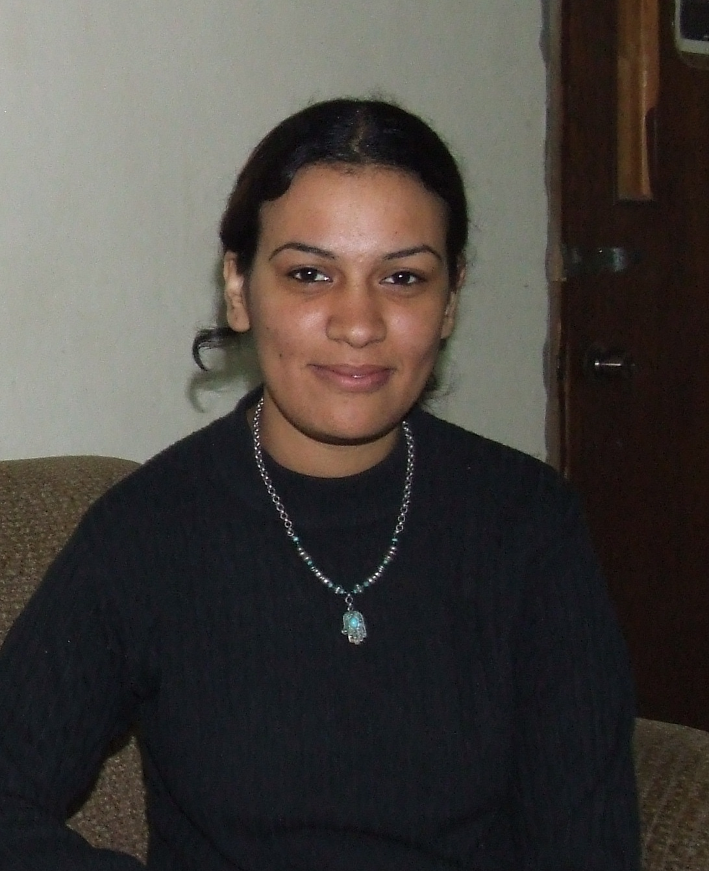
Riham at home, Feb 2008

Riham is from Tulkarm, which witnessed a major incursion and much fighting in 2003. She was 16 years old at the time. Here is what she had to say:

It was a Thursday in February 2003. It was cold and wet. Nobody knew what I planned. I put a small vegetable knife in my bag. I left home at 6pm and walked to the check-point. I arrived at about 7pm. I got to the check-point – I was a 10th grader and they didn’t suspect me – but when I got to the check-point I became afraid. I felt confused I was a child but I had big dreams of helping my country. I hesitated, felt afraid and was surrounded by soldiers. The soldiers didn’t have any protection vests, but I hesitated, and started to look at them … I was frightened. They asked me to go back from them – I heard but I didn’t obey.
They surrounded me and started to shoot. I remember many bullets going all around me. I was injured – I took two bullets in my stomach and one in the leg. I fell down on the ground – I was still conscious – they left me bleeding for 30-45 minutes as they searched the area. It was raining and I was lying there.
(Tulkarm Feb 2008)

Rouwa was arrested in 2005. Her story has some similarities:

Sometimes you have emotions that are difficult to control. The atmosphere, what is happening to us, what has happened to my family, our community, our friends – everything just presses on you.
Our camp was under curfew. I was going to school, but this was very difficult because of the soldiers. One day I ended my classes for the day and was coming home when we came under attack from the soldiers. They were just firing randomly. A small boy next to me got shot in the head. I got a taxi and took him to the hospital. They took him for emergency treatment.
But I was deeply affected by the events of the day. I had blood all over my clothes and all over my hands. So I went to the check-point at Netania .
The checkpoint was frightening. The soldiers started to shout at me and encircled me and they took my bag – inside I had a knife – and so they arrested me, hand-cuffed me behind my back and put me in the jura at the checkpoint. … I got sentenced to 2 years and 9 months in prison. (Tulkarm, Feb 2008)

For Rouwa and Riham the horror of occupation – death, injury, arrest, humiliation – provoked an unthinking moment of retaliation that was doomed to failure and led to several years of imprisonment for both and, for Riham, a life-time of disability.

Interrogation

Box 3.2
Razik’s story

I was beaten very badly when I was arrested by Israeli Defense Forces soldiers. I was kept in the back of a jeep for over four hours in the freezing cold. During detention my head was covered with a foul-smelling dirty sack as I was shackled to a chair with my hands handcuffed behind my back in a stressful position. Periodically, between punches and slaps, the interrogator would suddenly pull me forward causing extreme pain to my wrists and back.

Razik was eventually sentenced to 4 years for being a member of the al-Aqsa Martyr's Brigades.

After arrest most Palestinian young people will face some form of interrogation. Interrogation is normally conducted in one of seven centres (Huwarra [near Nablus], Etzion [near Bethlehem], Salem [near Jenin], Askelon [within Israel, near Gaza], Jalama [in Israel, near Haifa], Mascobiyya [known as ‘the Russian compound’ in Jerusalem] and Petah Tikva [in central Israel]). It is worth noting that the removal of prisoners to another country (from the Occupied Territories to Israel) is a breach of international law.

Normally interrogation lasts for many days. A Palestinian child can be detained by the IDF for up to eight days before being brought before a military judge; during this period interrogation will have taken place.

The interrogation takes place in the absence of a lawyer and, according to Military Order 378, a military judge can prohibit a child from seeing a lawyer for 15 to 90 days.
After eight days the military judge will normally extend the child’s detention until the end of the court process. Under military orders, a Palestinian child can be detained for up to 188 days before being charged with an offence and can be held for up to two years between being charged and brought to trial.

It is now well documented that Israel routinely uses torture and other cruel methods when interrogating its prisoners. Firas told us:

I was arrested when I was 19 and taken to the Jenin interrogation centre where they charged me with killing a collaborator. I spent 48 hours in interrogation. I was very scared and intimidated. I was alone and couldn’t talk to anyone. They were shouting and roughing me up. I thought many times that I should just admit it, but admit what? I thought to say okay I killed him with a knife even though I hadn’t. Then they started to say I’d killed him with a gun, but I don’t have a gun. (Balata, Sept 2006)

Mohammed’s story was similar:

The Israelis put a lot of pressure on you when they catch you. They want to scare you; to make you very afraid. They threaten your mother, your sisters, they say they will demolish your house – and this is hard when you are young. You are alone and isolated when they have you. You don’t know how your family is and have no contact with anyone. People react in different ways and not everyone can be strong. The Israelis try to trick you when you are frightened. They tell you ‘if you sign the confession you will be free or receive only a short sentence’. They give you statements that are in Hebrew and so you don’t know what you are signing – it could have all sorts of charges. (Balata, Sept 2006)

Jamal was 16 when he was arrested. He was taken to the Huwarra interrogation centre and held there for 10 days:

Although I was not interrogated at Huwarra I found it very tough. I was young, I was scared of the soldiers and I knew what they did to prisoners. I was kept in isolation the whole time. There were no windows in my cell and so I didn’t see the sun and was confused about the time. The guards were always insulting me and my family – saying awful things about them. And when I did manage to get some sleep they would come in and shout and kick my legs.
(Nablus, Old City, Sept 2006)

But this was just the start of Jamal’s ordeal. After 10 days he was sent to an interrogation centre inside Israel, he was there for a further 40 days.

When I first arrived they sent me to a clinic for a medical check-up. Alongside other new prisoners I was taken to a room full of prison guards and we were made to take all our clothes off. They then made us stand and crouch, up and down, many times. After some time they made us dress again and then I was taken away to start my interrogation.
In the first session the interrogators behaved in a good way. They took off my hand cuffs, they asked me to relax, they talked in a friendly way and they offered me tea, coffee and cigarettes. But when I didn’t respond they turned nasty. They cuffed my hands behind my back and pushed my arms over the back of the chair – so it was painful to sit. … A new interrogator came who was much tougher. He came with a really big guard and they started to shout at me and created a frightening atmosphere. I was interviewed from 12 noon until about 6pm. After that I had to go back to my cell, strip and try and get some sleep. At 2am I was woken with shouts and kicks.
The next day was the same. This time they put black glasses on me, so I couldn’t see anything or really know who was in the room. They strapped me to a lie detector. And they questioned me again and again wanting to know the names of people I knew. All this psychological pressure – the isolation, no sleep, the awful food, the shouting, the insults and the humiliation.
After 40 days I told them I had been planning a mission. After that they sent me to prison inside Israel, but the interrogation stopped. I got a four year sentence. (Nablus Old City, Sept 2006)

Ahmed was arrested at the Allenby Bridge. He was part of a student delegation on their way to an Arab Youth Congress in Sudan. He told us:

The Israelis arrested me and said that I was wanted for being an activist in the military wing of Fatah. I was held at the Bridge for 12 hours before being transferred to the Qadim custody centre. I was there for five days before being taken to a military court. At the court they told me they had secret files and secret papers about me and that I was to go back to the interrogation centre.
On the day I went back to Qadim they came for me at night and took me for interview. For the first two days they didn’t ask me a question! But there were plenty of questions after that – they kept me 45 days at the interrogation centre.
When you are being held in interrogation you cannot shower, I never saw the sun; I had no chance to shave. We had 5 really poor cigarettes a day. We had little time to eat the food which was always too little and bad. I had no shower for 45 days.
The interrogation sessions lasted 7 hours a day. At the beginning they made all sorts of allegations about what groups I was in and what I had done. … They said unless we get a result we will keep you for 90 days and then for another 90 days. … This was the pressure, not direct violence.
(Qalqilya, Feb 2008)
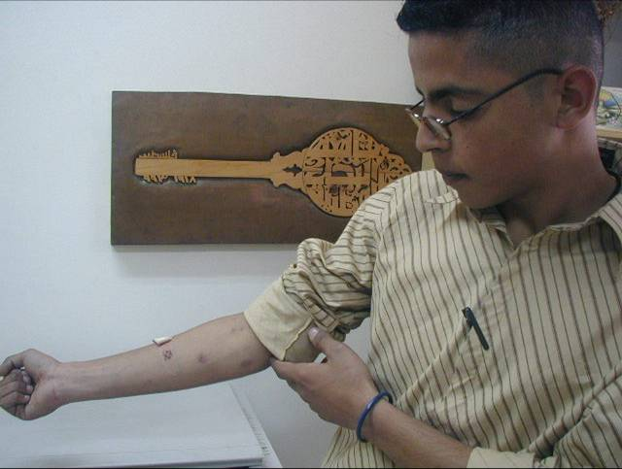

Above, Ahmed, from Balata, shows us his arm where interrogators made cuts as part of the ‘questioning’ process. Below is a close up of his right arm.

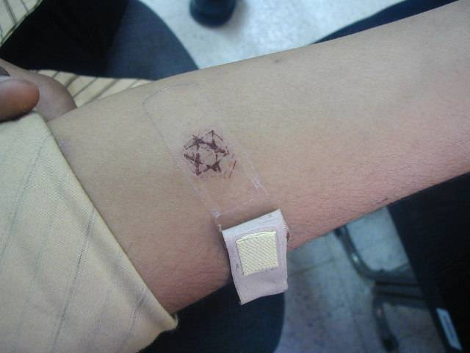

A few of the young men also told us about their experiences with the ‘canaries’. These are ‘prisoners’ sent inside the cells by the Israelis to try and win the confidence of the young people and then get them to talk. Ahmed told us about his experience:

After some days the guards bring some other prisoners into your cell. It is a real psychological pressure because you know that these ‘prisoners’ are really spies. We call them canaries. But you may have been isolated for three or five days. Spoken to nobody. You want some contact. They say the same. They say they have been isolated too. They start to make contact, to speak. They always come over as heroes. “We’ve been here before” “We were let out last time and we’d said nothing” “Don’t admit anything” they say. “Don’t confess.” Then, when they have built up your spirits, they try and get you to talk about why you are inside, what you did, and so on. But I knew about this trap beforehand so I was very careful about what I said. (Qalqilya, Feb 2008)

Fear, isolation, sensory deprivation and psychological torture, these become the staple methods of Israel interrogation of the young. But it is also the case that sometimes they just resort to down-right brutality – as Zeeb’s story reveals.

Box 3.3
Zeeb’s Story

I was in my third trimester when I was arrested and they wanted to perform an abortion on me. I did not let them. They took me to Majdal prison and did an ultra-sound to check the gender of the baby. When they knew that the baby was a boy, they started screaming at me, “You are going to bring a Fedae” (freedom fighter). They put me in a cell that was one and a half by two meters. They kicked my stomach with their huge military boots, spitting and cursing at me. They left me there for four days with no food or water. They did not allow me to use the bathroom for one week. I was very weak, my feet were swollen, and my entire body was aching.

Between 2001 and 2008 the Israeli State Attorney’s Office received over 500 complaints of ill-treatment on the part of Shin Bet [ie Israeli state security] interrogators. Not a single criminal investigation was carried out – the decisions (against criminal investigation) being based on the findings of an initial review of conduct carried out by an inspector who was himself a member of the Shin Bet.
Once the interrogation phase is completed, Palestinian detainees from the West Bank are processed for trial, sentencing and imprisonment in one of the two Israeli military courts currently in operation in the West Bank. The period of time between the issuing of charges and the actual trial is often prolonged, with detainees sometimes waiting for months before being tried before a military court. The military tribunals are presided over by a panel of three judges appointed by the military. Most of the judges do not have long term judicial training and as such the court procedures rarely fall within the required international standards for a ‘fair trial’. When we visited the Ramallah offices of Defence of Children International- Palestine in September 2009 we were given a number of examples where in the absence of the requisite ‘judge’ military officers were simply brought in to sit ‘on the bench’ even though they had no legal training or experience.
Such a cavalier approach to the law and due process characterises much of the occupation of the West Bank where there is a blatant disregard of international law and conventions even when the Israeli state is a signatory. Nowhere is this more evident than the 1989 United Nations Convention on the Rights of the Child which is the first legally binding international instrument to incorporate the full range of human rights—civil, cultural, economic, political and social rights. Despite being a signatory, Israel flouts virtually all its principles. Thus whereas the Convention defines children as all those below 18 years in the West Bank a different series of thresholds prevail:
The Israeli Military Order No.132 contravenes the internationally accepted definition of a child as anyone below the age of 18. The Israeli domestic law defines a child as anyone under 18 which is in accordance with the international standard. The Military Order No.132 is a discrimination against Palestinian children. This Military Order defines a Palestinian child as follows:
A child is a person under 12 years
A teenager is a person above 12 years ands under 14 years
An adolescent is a person above 14 years and under 16 years
An adult is a person 16 years and above.
From the standpoint of the Palestinians, the Convention is little more than waste paper with virtually every legally binding principle disregarded, from the rights of children to security, to legal representation, to protection from torture, to separate courts and so on. Moreover, whereas many young people across the world might be unaware of the Convention and the protections it is supposed to afford them, this is not the case in much of the West Bank. Young people here know of the Convention, just as they know that Israel is blatantly in breach, as it is with so many other resolutions and rulings whether from the United Nations or the World Court. So many times we were asked why and how it was possible for Israel to behave so criminally and with such impunity, although they knew the answer well enough. As long as Israel enjoyed the unconditional support of the United States, a state which also has a distinguished track record of ignoring international law when it suits its interests, it could and would continue to be above and beyond the law.

Administrative Detention

Administrative Detention is a procedure under which detainees are held without charge or trial. In the occupied Palestinian West Bank, the Israeli army carries out administrative detention on the basis of Military Order 1226. This order empowers military commanders to detain an individual for up to six months if they have “reasonable grounds to presume that the security of the area or public security require the detention.” On or just before the expiry date, the detention order is frequently renewed. This process can be continued indefinitely.

Administrative detention is arrest and imprisonment without charge or trial. It is authorised by administrative order rather than judicial decree. Although incarceration under these circumstances is allowed under international law, the conditions of its use are, in theory, restricted by tight controls. Essentially states have to show that the internment process is required for ‘state security’. Israel regularly uses Administrative Detention, yet it has not defined the criteria of ‘threat to state security’ that might ‘justify’ its use. The relevant section from Military order 1226 states:

If a Military Commander deems the detention of a person necessary for security reasons he may do so for a period not in excess of 6 months, after which he has the right to extend the detention period for a further six months according to the original order. The detention order can be passed without the presence of the detainee...

According to DCI/Palestine Section:

Administrative detention is permitted under international law in strictly limited circumstances and only if “the security of the state … makes it absolutely necessary” and only in accordance with “regular procedure.” Further, international law to which Israel is bound, provides that “No child should be deprived of his or her liberty arbitrarily and detention should only be used as a measure of last resort for the shortest appropriate period of time.” Administrative detention should never be used as a substitute for criminal prosecution where there is insufficient evidence to obtain a conviction.

The possibility of becoming an administrative detainee is an ever-present threat in the daily life of all Palestinians and severely impacts the lives of Palestinians living in the West Bank. Omar told us about his experience:

I was taken to the military court which is also inside Offa. I had no lawyer. Here I heard the charges for the first time and they were completely random and unknown to me. Indeed it was crazy as they said I had been involved in the assassination of Sadat! You see how they don’t care about any truth. There was no evidence given. The only questions I had been asked before the court were simple personal details, name, age etc. The case against me was all in the secret file. I can never see that or my lawyer if I had one. The Judge said that I was a danger to Israeli security that I had to serve 6 months administrative detention. (Omar, Jenin June 2008)

Administrative detention orders are often based on “secret evidence” collected by the Israeli Security Agency (ISA). Neither the detainee, nor the detainee’s lawyer is given access to the evidence, and therefore they have no effective means of challenging the detention – as is required under international law. Thus Omar didn’t know that he was accused of being involved in the assassination of President Sadat of Egypt – interestingly, an event which took place in 1981, before Omar was born – until he appeared before the military judges. The confidential materials determine the period of detention and its extension thereafter. As Table 2 shows significant numbers of detainees have their detention orders repeatedly extended.

Box 3.4
Length of time Palestinians held in Administrative detention (April 2009)
Duration | Number of detainees
Under 6 months | 176
6 mths – 1 year | 154
1 – 1.5 years | 120
1.5 – 2 years | 56
2 – 2.5 years | 19
2.5 – 3 years | 18
3 – 3.5 years | 2
3.5 – 4 years | 0
4 – 4.5 years | 1
Over 4.5 years | 2
Total | 548

Hassam talked to us about the renewal of detention orders.

With admin detention you can never be sure if or when you are going to be released. There appears to be no logic to it. You can get right to the end, have no trouble and then you are told it is being extended – no reasons given. There was a guy inside with me who was released after three years on administrative detention. He had had 6 consecutive terms. They let him out and he got to Jericho when he was phoned by a prisoner, who had an illegal mobile, who told him that his detention had been renewed yet again but the order arrived after he had been released. The poor guy was picked up at the checkpoint and bought back. When you hear these things you have no expectations about your release.
(Hassam, Jenin June 2008)

Hamdi Tamri’s story reveals more about the administrative detention system.

Box 3.5
Hamdi Tamri
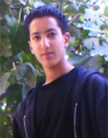
Date of birth: 20 August 1992
Age at arrest: 16
Place of residence: Bethlehem
Occupation: 11th grade student
Date of arrest: 18 December 2008
Place of detention: Ofer Prison
At 2:00 am on 18 December 2008, Hamdi was woken up by a loud banging on the family home’s front door. The Israeli soldiers had come to arrest him again, just one month after his release from prison. Hamdi was only 16.
Hamdi was tied and blindfolded by a group of five soldiers, and was taken to Etzion Detention centre in a military jeep. On 21 December 2008, three days after his arrest, he was transferred to Ofer for interrogation. While under interrogation, he was questioned about the display of flags on the family house roof, the people he had encountered since the moment of his release and his political activities. Hamdi maintained that he was not involved in any activities and had only met with relatives and neighbours.
On 28 December 2008, at the Administrative Detainees Court in Ofer, Hamdi was informed that a four month administrative detention order was issued against him based on ‘secret evidence’ and that he would be held without charge or trial. Hamdi was accompanied neither by a lawyer, nor by his family, whose presence is banned in the Administrative Detainees Court. The administrative detention order was confirmed at the judicial review for a period lasting until 15 April 2009. An appeal hearing also confirmed the order. On 15 April, however, Hamdi was not released. Instead, a second administrative detention order was issued against him for a period of four months, and was set to expire on 14 August 2009. Again, however, on 14 August 2009, a third administrative detention order was issued against Hamdi. The order was confirmed six days later, on 20 August 2009 at the Administrative Detainees Court in Ofer. It was the date of his 17th birthday.
Background
On 12 March 2008, Hamdi’s family learned of the killing of Hamdi’s father by the Israeli Occupying Forces along with three other people in what seems to have been an extra-judicial execution, also known as targeted assassination. Only a few months later, on 6 June 2008, the Tamri home was demolished in Bethlehem as a punitive measure against Hamdi’s father’s alleged activities. The soldiers gave the family only one hour to gather some of their belongings before they executed the demolition order. Both events had a huge impact on the mental well-being of all the children in the family and were reflected in the subsequent deterioration of their educational achievements. Hamdi’s mother relates that, before the murder of his father and the loss of their family home, Hamdi had been an outstanding student, and was very active in extra-curricular activities, especially musical activities. He volunteered with the school’s radio station as a host and used to sing at school events and parties. The family had a number of recordings of his performances, but these were all destroyed during the house demolition.
Following these devastating events, his grades dropped, and he became noticeably more introverted.
When Hamdi was first arrested in July 2008, one of the soldiers told him that his father was killed because “he was a terrorist and that they were going to kill all terrorists”.

Administrative detention is an especially nasty form of oppression as its terms are so arbitrary and everything is stacked against the victims in true Kafka fashion as they rarely get to know the grounds of their incarceration. For many of those we interviewed who had been in administrative detention this was completely consistent with so many other aspects of the occupation. Curfews lock downs, closure of check points, removal of permits to work or access olive trees and lands were all characterised by the same features – arbitrary acts with little or no warning and all legitimised in the name of ‘security’. Collectively they constitute the form of the Israeli occupation of the West Bank and are an assertion of power. But not withstanding their collective brutality and the distress, hurt, and misery caused, we got no sense that they were successful in undermining resistance. If the Israelis were intent on raising the cost of resistance, it seemed that they had sorely under-estimated the Palestinian people for whom it was never a matter of cost but of their inalienable rights.

Imprisonment

Box 3.6

Prisoners are held in one of approximately 30 detention centres (21 prisons, 5 detention centres, 4 interrogation centres, and at least one secret interrogation facility) located within the 1967 borders of Israel.

In January 2006, a report by the United Nations Special Rapporteur found that:

Prison conditions [for Palestinian prisoners] are harsh: prisoners live in overcrowded and poorly ventilated cells which they generally leave for only two hours a day. Allegations of torture and inhuman treatment of detainees and prisoners continue. Such treatment includes beatings, shackling in painful positions, kicking, prolonged blindfolding, denial of access to medical care, exposure to extreme temperatures and inadequate provision of food and water.

The claims made in the UN report were supported by the young people we spoke to: inadequate and overcrowded conditions, brutality from the guards, and both the poor quality and inadequate quantity of food were constant themes in our discussions with young ex-prisoners. Mohammed described what the overcrowded cells were like:

My cell was 2 metres square. There were 3 of us inside. It had 2 small beds and the third slept on the floor between the beds. There was also a shower in the cell. We were very crowded.
We were in our cells 21 hours out of 24. We only saw the sun in the 3 hours we spent outside of our cells. Our cell was so small that it was only possible for one of us to stand and move. The 3 of us could never stand at the same time. We would take it in turns when we did our exercises. We took our meals in the cell. (Mohammed, Jenin Sept 2006)

Meals were taken inside the cells, but this was the least of the prisoners’ complaints. Again Mohammed describes the problem:

We had 2 meals a day, one at 12 noon the other at 6pm. The food was very little and very bad. Rice and beans which were the main food was very little, just one plate for 3 of us. We only had one bread a day. It was just enough to keep you alive. I lost weight. When I was arrested I was 90kgs when I was released I was 63 kgs (Jenin Sept 2006)

More recently the Israelis have tried to push the costs of feeding their Palestinian prison population back onto Palestinian families and the Palestinian Authority. As Hassam told us:

We now pay for our food in prisons. The Israelis did not want to pay all the costs of imprisonment so they reduced the quality and quantity of food to such an extent that we were forced to buy our food in the canteens. This costs our families something like 1,000 NIS a month. (Jenin, Feb 2008)

This is a situation that Hassam believes should not be tolerated – and he blames both the Israelis and the PA for allowing this situation to develop:

But this is a situation we cannot simply put on the Israelis. Our own organizations are failing to resist and fight on the issues of prisoners. This was always a central part of our resistance for 40 years of occupation: the struggle against the humiliation and suffering of prisoners. We should not have allowed the Israelis to push this burden of prisoner’s food on to the Palestinians. (Jenin Feb 2008)

Mahmoud and Omar both spent time in prison in the Negev – the desert in the south of Israel. Conditions there were even worse.

I was in prison in Israel – in the desert. We had to live in tents. The tent was 15 square metres and for 20 people. In the winter it was tough as the tents would flood. We had rats, insects, snakes. But at least we didn’t have to stay in the tent all day, like you do in the cells.
(Mahmoud, Tulkarm, Sept 2006)

After 3 months in Ofer I was transferred to the Negev. The conditions were terrible. There were no mattresses in the tents, we had no covers. All we were given at first was some plastic sheeting to put on the ground.
In the desert it was like being in a hot shower in the day and a cold shower at night. We were made to sit in a particular, uncomfortable position many times during the day when they counted us. All the time surrounded by soldiers armed with rubber and live bullets. These guards seemed very rough to us as if they had been criminals themselves and they had no hesitation in beating us. (Omar, Jenin, June 2008)

Omar here alludes to two important features of the prison regime: first, the mundane routine and endless counting of prisoners, and second the constant threats and intimidation that Palestinians face from the guards. Rouwa also described the daily routine of the prison regime:

Everyday we are woken at 7am for counting. Then we have one and a half hour break. Morning break is used for study. We then go back to the cells which are locked and we have breakfast – and they give us breakfast and lunch together, its just one meal.
At 1.30 there is another break. This time we use to play with the youngest prisoners – those that are 13, 14 and 15 years old. We play sports and other games. There were around 25 young children in the prison with us.
One of the women in our prison had a son who was 15 and he was sentenced to 15 years.
At 3pm we go back to the cells and are locked in again.
The dinner is pushed through a small window in the cell door – we eat in the cell.
From 3pm we are locked in till 7am again. We were locked in for 21 hours a day. (Tulkarm, Feb 2008)

But as Ahmed points out, into the prison regime the prisoners have inserted their own educational and cultural activities.

Each day has a routine. Cleaning the rooms, making the beds, getting counted, some exercise, then some cultural sessions. After a poor lunch, you have to clean your plates. Then rest, then workshops in groups organized around different topics. These workshops last for one month. If you pass your exam you can go onto the next level. But if you fail you have to do it again. And in the evening maybe cultural events such as a play. Everyday we listen to Egyptian singers on the Israeli radio between 6.30pm to 7.30pm. (Qalqilya, June 2008)

The fact that the prisoners organise their own cultural and educational activities raises one other important aspect. Palestinian prisoners locked away inside Israeli prisons are not cut off from the resistance struggle but remain a central part of the fight for Palestinian freedom. And this means, of course, that the prisoners are under constant surveillance and threat from the prison guards and wider regime. Jamal discussed an element of this when he discussed the constant threat, both real and implied, from the prison guards.

I was sent to a prison near Netayana where I spent 7 months. It is a prison mainly for young people and very tough. The guards were always provoking and insulting us and they used lots of punishments like putting you in isolation and stopping visits from your family. (Nablus Old City, Sept 2006)

Hamad points out that the privatisation of the Israeli prison system has made things worse. Private prison guards were definitely the worst he argued:

In the prison I was in there were two types of administration. One run by the military and the other a private company which provided guards contracted by the Israeli prison commission. The private guards they had very hard strike teams who used dogs, electric prods, tear gas and pepper bullets. Whenever we protested about anything, some brutality for example, or the food they would send in these teams.
(Hamad, Nablus, Feb 2008)

The guards are often brutal and threatening. But for young women another aspect of their imprisonment is the threat of sexual harassment. Rouwa told us of her experiences.

We faced a lot of problems with one Druze guard. He was harassing our women and he used to beat women in sensitive spots and take off her clothes.
But it wasn’t just the men. We also had these problems with women guards. Some of the women guards who have to take prisoners to court or doctor or dentists or administration – they strip search the prisoners and sometimes behave inappropriately. If any prisoner goes anywhere they have to be stripped and searched before going.
(Rouwa, Tulkarm, Feb 2008)

The sexual harassment and abuse of Palestinian women in prisons is an issue that has been explored by Elham Bayour. She argues:

As punishment for their participation in resisting the occupation … Palestinian women … [have been] imprisoned, humiliated, sexually assaulted and physically and mentally tortured … Palestinian women political prisoners were targeted by policies designed to … humiliate women through physical, mental and sexual torture. They seek to exercise control over women’s spirit as well as their bodies, sexuality and reproduction. These policies are designed to dishonour Palestinian men through the brutalisation of Palestinian women’s bodies.

Visits
The Israelis will not allow anyone who has ever been a prisoner or in any way regarded as a ‘security’ threat to visit someone in jail. Given the numbers of Palestinians who have had a period in jail, this has a huge impact on visits, especially for young prisoners whose parents were commonly refused permission to visit. Further, many of the prisons are in Israel – and this puts further restrictions on who can visit. According to the UN Special Rapporteur, “family visits remain a serious problem. As prisons are held in Israel and many Palestinians are denied admission to Israel, a majority of prisoners receive no family visits.”
All the ex-prisoners we spoke to repeated the same tale – visits, letters and contacts with their families were difficult at best, impossible at worst.

When I was in prison my family were not allowed to visit, not once. I couldn’t phone. And most of the letters from my family never got to me. (Riham, Tulkarm, Feb 2008)

I had little contact with my family. I was imprisoned in June 2003 and it was not until 2005 that I received a visit from my younger brother. Other than that I got some short letters – 5 or 6 lines from my family through the Red Cross. This was every 6 months. That was all.
(Jamal, Nablus Old City, Sept 2006)

They wouldn’t let my father visit me because he was an ex-prisoner. He tried 5 times and each time they threw him back. I did have a visit, from my sister, it was just one day before my release. (Ahmed, Qalqilya, June 2008)

Contact with our families was difficult. There was one time when the ICRC collected letters from us to send to our families. My letter arrived 6 months after my release! (Omar, Jenin, June 2008)

If contact with families is hard for prisoners, it is equally difficult for family members trying to visit a relative. Manal told us of her experience:

My father is in prison. When we go to visit him we have to leave at 1am. We wait in the buses for a very long time – hours - and then we eventually get a short visit with him. They want to make the visit a big burden. (Manal, Nablus, Sept 2006)

Even when she got to visit Manal told us how she was separated from her father by a glass screen and had to speak through a phone handset which was so poor that they could hardly hear one another and were constantly having to repeat themselves. We were constantly reminded of the extent to which the Israelis seek any means however small to assert their power and to add additional layers of humiliation and suffering. In the case of imprisonment this process continues beyond the point of release; Mohammed describes his release:

When I came to be released they dropped me at a checkpoint 15kms from Hebron. It was August and very hot and I then had to walk to Hebron. I was very scared and thought they would pick me up again. When we got into Hebron we went to the municipality and were given 100 shekels to pay for our fares back to Nablus. The taxi drivers were very kind. I had 24 hours to get home. This was set down on the paper to get me through the checkpoints. (Nablus, Sept 2006)

Riham’s parents were informed that she was going to be released – but the authorities changed the notified location of her drop-off.

On the day of my release the authorities told my family I would be at the check point at Nablus. My family went there. But they actually let me out between Tulkarm and Nablus. So there was nobody there to meet me. (Tulkarm, Feb 2008)

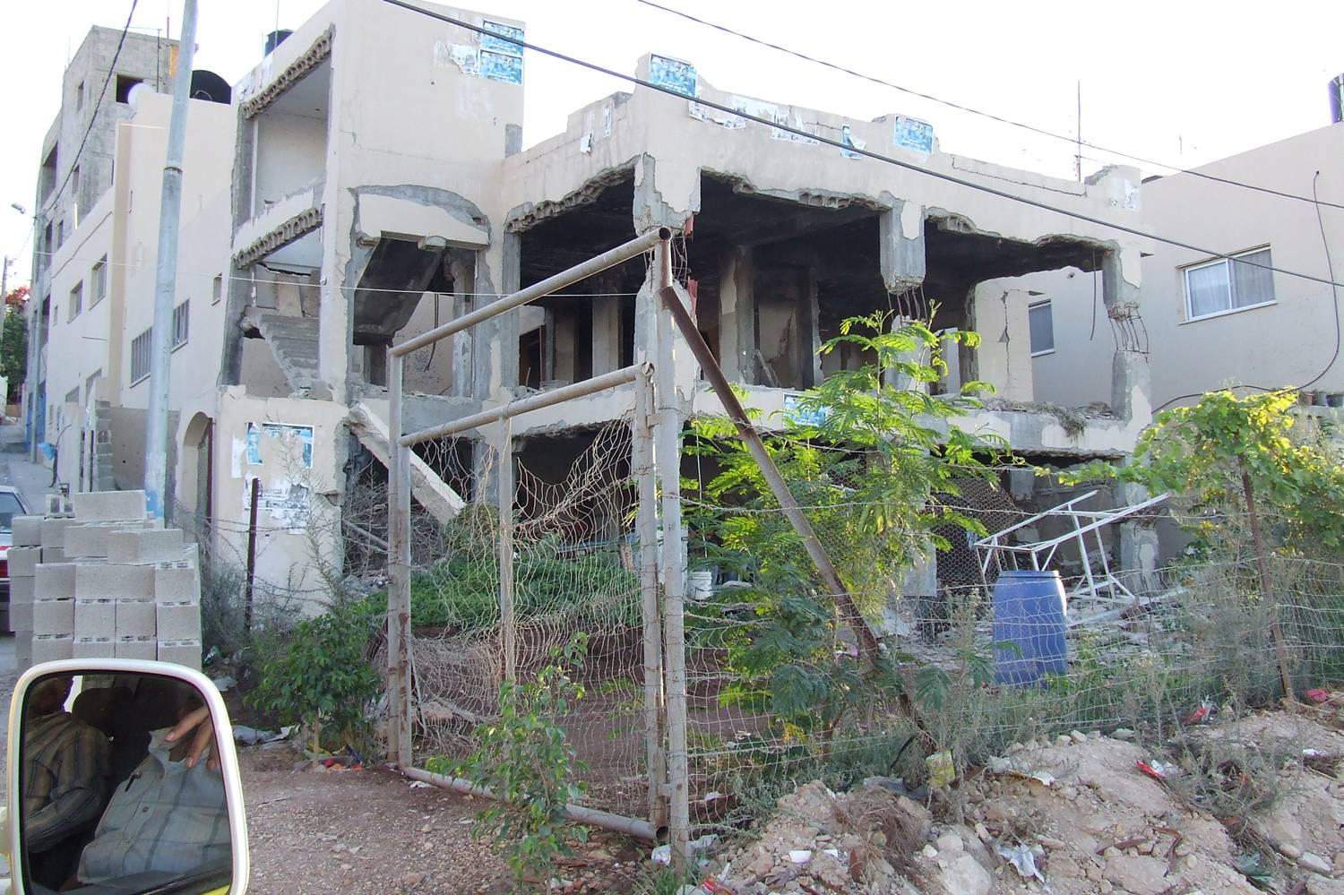
Another form of collective punishment – the family homes of those who are imprisoned are often destroyed. This is from Jenin. The eldest son was imprisoned, the family home blown up.

Political Organisation and Palestinian Prisoners

In the face of constant threats the prisoners respond by organising collectively to offer support to each other. Such solidarity networks are vital to help the prisoners through their time in prison. Riham told us of her experience:

[After I left the hospital] they transferred me to the women’s prison. I was the youngest person in the women’s prison; I was 15 years and 4 months old. I was very afraid. I had no experience of prisons or political organisations in the prisons. I didn’t know that political prisoners were separate from the criminals. … [But] after a few days they [the other prisoners] made me welcome. I built strong friendships, they looked after me. You feel as if you are one of them – we are all together. My psychological and medical condition was very bad. I had a colostomy. But they made me feel I was among ‘family’ and comrades. They gave me support and solidarity. We were able to create a bit of life in the prison, to create our own space. We had religious and political sessions. There was teaching, culture, language learning. I learnt Hebrew. I learned about our history. There were sports. Once I left, I missed my friends. They were very close to me, they looked after me and I was sorry to leave them. And I think, in a sense, they were sorry for me to go. (Tulkarm Feb 2008)

Rouwa made similar comments.

There is a very strong feeling that we are one, we are a unified group of Palestinian prisoners. We stand together and we fight together and struggle together for our rights as prisoners – no matter which organisation we are affiliated to. (Tulkarm, February 2008)

Support and solidarity is embedded within the prisoners’ culture. All the main Palestinian political organisations are represented within the prisons and prisoners nominate which organisation they want to look after their interests on entry.

Box 3.7
Political affiliation of Palestinian Prisoners (%)
Fatah | 44
Hamas | 26
Islamic Jihad | 14
Popular Front | 5
Democratic Front | 1
undefined. | 10

Within the cramped confines of the prison regime the political organisations play a highly significant role in the day to day life of the prisoners and are the source of the cultural and educational activities mentioned by Ahmed, Omar and Rouwa. The political parties for example determine who should perform which jobs on the wing – collecting and distributing food, laundry work, keeping the communal areas clean etc – and also co-ordinate the various acts of resistance carried out by prisoners.

In the Negev all the groups were present and active. For me it was like being in a family again and my spirits were lifted. All the autonomous groups were represented on a central prisoners committee and this made decisions for all the prison and were binding on all the groups and prisoners.
Of course we would take account of differences amongst the prisoners. Those who were sick or children were not expected to take part in hunger strikes. Others were expected to strike for a certain number of meals and no more. Then there were those who worked in the kitchens or laundries who were expected to take action at certain times. For those coming to the end of a period of administrative detention we would keep them low. In this way it was possible for everyone to have a role in the resistance. (Omar, Jenin, June 2008)

Hassam makes some very similar points:

Each prisoner nominates a political organisation to look after their interests (Fatah, Hamas, PFLP etc). Each organisation has a camp committee and links with the outside world and each organisation views the prison as just another site of struggle. As part of that struggle we act collectively to push our demands – for better food, for more access to phones for longer and more frequent visits, against the brutality of the guards. The comradeship, solidarity and steadfastness of the prisoners allow us to survive these difficult days. (Jenin, June 2008)

The activism within the prisons places a great emphasis on education, ranging from basic literacy and numeracy to the learning of languages, Palestinian history and culture. Mohammad, for example, our erstwhile guide and translator had learnt his excellent English whilst in prison; Saeed who we met in Qalqilya in 2008 had learnt to read and write whilst in administrative detention as well as his considerable talent in origami! For Kareem, his five years in prison was his university education:

I got to read books on politics and history in prison that I would have never been able to get hold of in Nablus where the Israelis stop such books from being sold. I was amazed at the stuff that got smuggled in to the prison. When the book was popular some of the prisoners would write them out so we had extra copies and even then we might have to wait for weeks before we could see them. In the prison we had so many educated people who could teach us things from science to politics to poetry. I was educated in prison.
(Nablus, 2008)

Box 3.8
Khaled’s Story

I was first imprisoned in 1982 at the age of sixteen. In prison I found what I was not expecting to find: I found inside the prison what I could not find outside of it. In prison I found Palestine's political, national, revolutionary university. It was in prison that I realized that knowledge is what paves the road to victory and freedom…….

Through the will and perseverance of the prisoners, prison was transformed into a school, a veritable university offering education in literature, languages, politics, philosophy, history and more. The graduates of this university excelled in various fields. I still remember the words of Bader al-Qawasmah, one of my compatriots who I met in the old Nablus prison in 1984, who said to me, “before prison I was a porter who could neither read nor write. Now, after 14 years in prison, I write in Arabic, I teach Hebrew, and I translate from English.” I remember the words of Saleh Abu Tayi' [Palestinian refugee in Syria who was a political prisoner in Israeli jails for seventeen years before being released in the prisoner exchange of 1985] who told me vivid stories of prisoners' adventures smuggling books, pieces of paper, and even the ink-housing tubes of pens.

Prisoners passed on what they knew and had learned in an organized and systematic fashion. Simply put learning and passing on knowledge and understanding, both about Palestine and in general, has been considered a patriotic duty necessary to ensure steadfastness and perseverance in the struggle to defend our rights against Zionism and colonialism. There is no doubt that the Palestinian political prisoners' movement has played a leading role in developing Palestinian national education.

From arrest to release the Israeli authorities attempt to isolate, humiliate, intimidate and break the spirit of those they incarcerate. The experience of Palestinian political prisoners is traumatic, but the solidarity and support inside the prison regime means that most prisoners survive the experience and come out more educated, more politicised and more aware of their collective plight than they were before they entered prison. The prisons act as a ‘university in the struggle’. Of those we spoke to, Hossan and Saed used the experience of prison to learn to read and write, Riham to decide to pursue a career as a lawyer (and to fight for prisoner rights), Rouwa joined the Palestinian security services, Ahmed became an activist within Fatah, and Mohammed and Omar community activists within their refugee camps. None of those we spoke to was ashamed or embarrassed that they had spent time in prison; indeed they were proud that their period in prison marked them out as resistance activists. Prisoners like martyrs are highly revered in the West Bank and are never forgotten.

Addameer “Political detention - The Infinite Violation of Human Rights’ http://www.addameer.org/detention/background.html (accessed 14 May 2009)
Palestine Monitor 2009 Fact Book (p32) http://www.palestinemonitor.org/spip/IMG/pdf/factbook_Final_online-2.pdf (accessed 1 Oct 2009)
PLO Negotiations Affairs Department Palestinian Political prisoners. Available at www.nad-plo.org/facts/others/Political20%Prisoners%20-%20August%202008.pdf (accessed 1 Oct 2009)
‘Resistance to Israeli occupation – a right?’ Information Clearing House, Dec 29, 2008, http://www.informationclearinghouse.info/article21559.htm (accessed 1 Jan 2009)
Addameer “Political detention - The Infinite Violation of Human Rights’ http://www.addameer.org/detention/background.html (accessed 14 May 2009)
Palestine Monitor 2009 Fact Book p 33 http://www.palestinemonitor.org/spip/IMG/pdf/factbook_Final_online-2.pdf (accessed 1 Oct 2009)
That the Israeli army was raiding his house so soon after his return from the aborted mission was put down to the work of collaborators who are a ubiquitous presence across the West Bank. For many of the young people we met the issue of collaboration was sensitive and complex and it was an area that we were never able to explore in any depth.
Mel Frykberg “Israelis continue to abuse Palestinian prisoners” The Electronic Intifada, 17 December 2008 http://electronicintifada.net/v2/article10034.shtml (accessed 13 May 2009)
Trojan, V (2008) Child Rights Situation Analysis: Right to protection in the occupied territory – 2008 Defence of Children International/Palestine Section and Save the Children (Sweden) p.64 http://www.dci-pal.org/english/publ/research/SRSAReport.pdf (accessed 15 May 2009)
There are countless sources which provide detailed evidence and testimony to the use of torture by the Israeli state against Palestinians. Useful starting points are Adameer (www.addameer.org) and Defence of Children International Palestine (DCI-Palestine) .
Elham Bayour (2005) “Occupied territories, resisting women: Palestinian women political prisoners” in Julia Sudbury (ed) Global Lockdown: Race, Gender and the Prison-Industrial Complex (London, Routledge) p.208
Mel Frykberg “Israelis continue to abuse Palestinian prisoners” The Electronic Intifada, 17 December 2008 http://electronicintifada.net/v2/article10034.shtml (accessed 13 May 2009)
International Commission of Jurists (2005), Swedish Section , Palestinian Children Behind Bars, Gothenburg, Sweden,http://www.dci-pal.org/english/doc/reports/2005/apr03.pdf
Addameer http://addameer.info/ (accessed 1 Oct 2009)
Defence for Children International/Palestine Section Palestinian Child Detainees, Administrative Detention, Briefing Paper October 2008 http://www.welfareassociation.org.uk/forms/DCI_Briefing_Paper.pdf (accessed 8 Oct 09)
Defence for Children International/Palestine Section Palestinian Child Detainees, Administrative Detention, Briefing Paper Oct 2008 http://www.welfareassociation.org.uk/forms/DCI_Briefing_Paper.pdf (accessed 8 Oct 09)
B’Tsalem “Statistics on Administrative detention” http://www.btselem.org/english/Administrative_Detention/Statistics.asp (accessed 14 May 2009)
Addameer Case-studies and Testimonies http://addameer.info/?p=1321#more-1321 (accessed 1 Oct 2009)
Palestine Monitor 2009 Fact Book p32 http://www.palestinemonitor.org/spip/IMG/pdf/factbook_Final_online-2.pdf (accessed 1 Oct 2009
United Nations, Report of the Special Committee to Investigate Israeli Practices Affecting the Human Rights of the Palestinian People and Other Arabs of the Occupied Territories, September 26, 2005 (para. 96)
Elham Bayour (2005) “Occupied territories, resisting women: Palestinian women political prisoners” in Julia Sudbury (ed) Global Lockdown: Race, Gender and the Prison-Industrial Complex (London, Routledge) p202
United Nations, Report of the Special Committee to Investigate Israeli Practices Affecting the Human Rights of the Palestinian People and Other Arabs of the Occupied Territories, Sept 26, 2005 (para 91-96)
Palestine Monitor “Palestinian Prisoners: The Facts” http://www.palestinemonitor.org/spip/spip.php?article9 (accessed 19 May 2009)
Khaled al-Azraq (2009) ‘The Prison as University: The Palestinian Prisoners' Movement and National Education’, Badil Resource Centre; http://www.badil.org/en/al-majdal/item/1267-the-prison-as-university-the-palestinian-prisoners%5C'-movement-and-national-education

