Chapter 1

LAUGHTER AND TEARS: LIFE IN THE WEST BANK

Imagine yourself as a bird flying around. But there are hunters all around. You never know when you are going to be shot down. This is our life under occupation. (Hassan, aged 16, Nablus 2006)

Life in the West Bank is anything but normal, but neither is it completely bizarre or unnatural. Children and young people by their sheer presence in the population give daily life a sense of normality which is not superficial but neither is it secure. Walk through any West Bank town and village and you will see hundreds of children and young people playing, laughing and having fun. There are few fancy toys and bikes and even fewer play areas of any kind, but that is no deterrence. Sixty nine per cent of the population of the West Bank are under 19 years old and the youthfulness of the population is evident in the sight of so many children and young people in public; babies in prams and pushchairs; young people going to and from school or university, walking the streets and playing games. Their play and their presence and energy provides a sense of normality – at least during the daylight hours – in the most abnormal of circumstances.

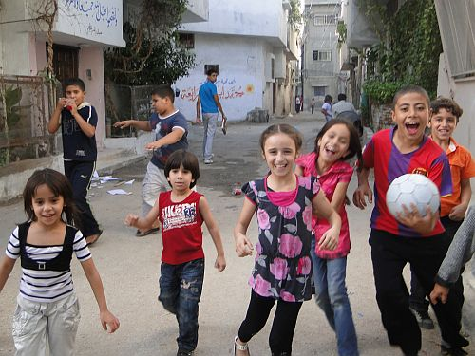
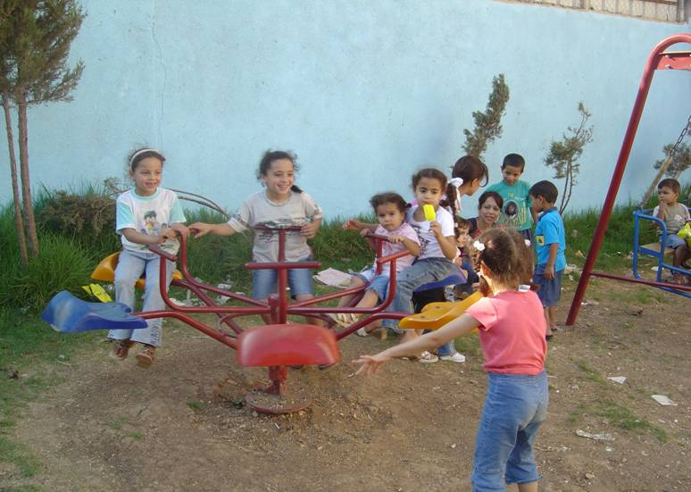
Kids in the Balata Camp Kids in Al Mari Camp

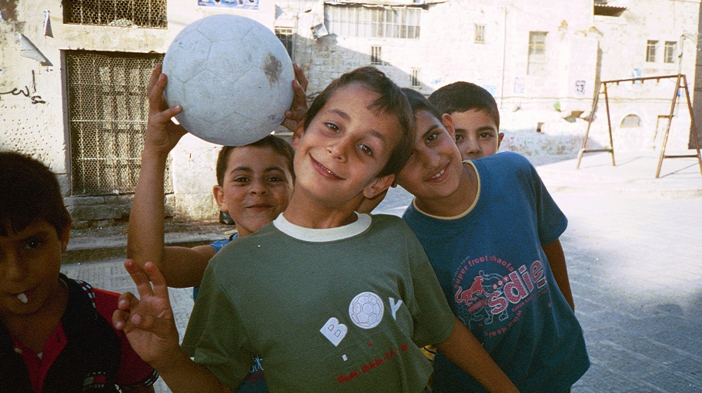

In the old city of Nablus

Much of what follows in this chapter concerns children and young people’s experiences of the diverse ways in which the Israeli occupation disrupts Palestinian lives and well being. It also looks at the ways in which their resistance has allowed them to endure without being defeated.
In any conversation it is almost inevitable that we are drawn to the brutalising aspects of the occupation. But amidst the dangers of occupation, young people continue to laugh and joke and play:

You know, despite all the hardships of our situation, we do live. We go out – we love, we live, we laugh and have fun. It’s in that sense I meant that we are like any teenagers anywhere. We are not just the angry teenagers throwing rocks at the Israelis which has how the international media presents us. (Mariam, Ramallah, June 2008)

But we didn’t need to be told this. Through all our travels and in all meetings we met engaged and engaging young people, who did not appear to be destroyed by their experiences of the occupation. Their jokes were some of the best we had heard in years and there is a high comedy quotient in daily West Bank life. But at the same time there is the never ending tragedy of the occupation. It is a combination that can be unsettling, as in the case when we were laughing and joking with Ibrahim, a postgraduate in business studies in Nablus. Much of the banter was about Ibrahim’s fascination with Western fashion trends. Then we got round to his diet with him laughing about his mother’s baking before a complete change of tone when he told us that his mother began serious biscuit making only after his brother, 3 years senior, had been shot and killed outside their home two years earlier by an IDF patrol. “But we can’t cry all the time. We must live our lives” (Tulkarm 2009) was how Ibrahim concluded that conversation.
We had many similar conversations. It was common for us to discover, for example, that the people we were talking with often had close family members and friends in prison with all its attendant anxieties. Such personal catastrophes are commonplace and shared in the West Bank in such a way that it strengthens people to endure and survive. Walls in towns and villages are covered with poster sized pictures of prisoners and martyrs; their names are painted on buildings; and of course in their family homes their photographs are always prominent. People are not forgotten.

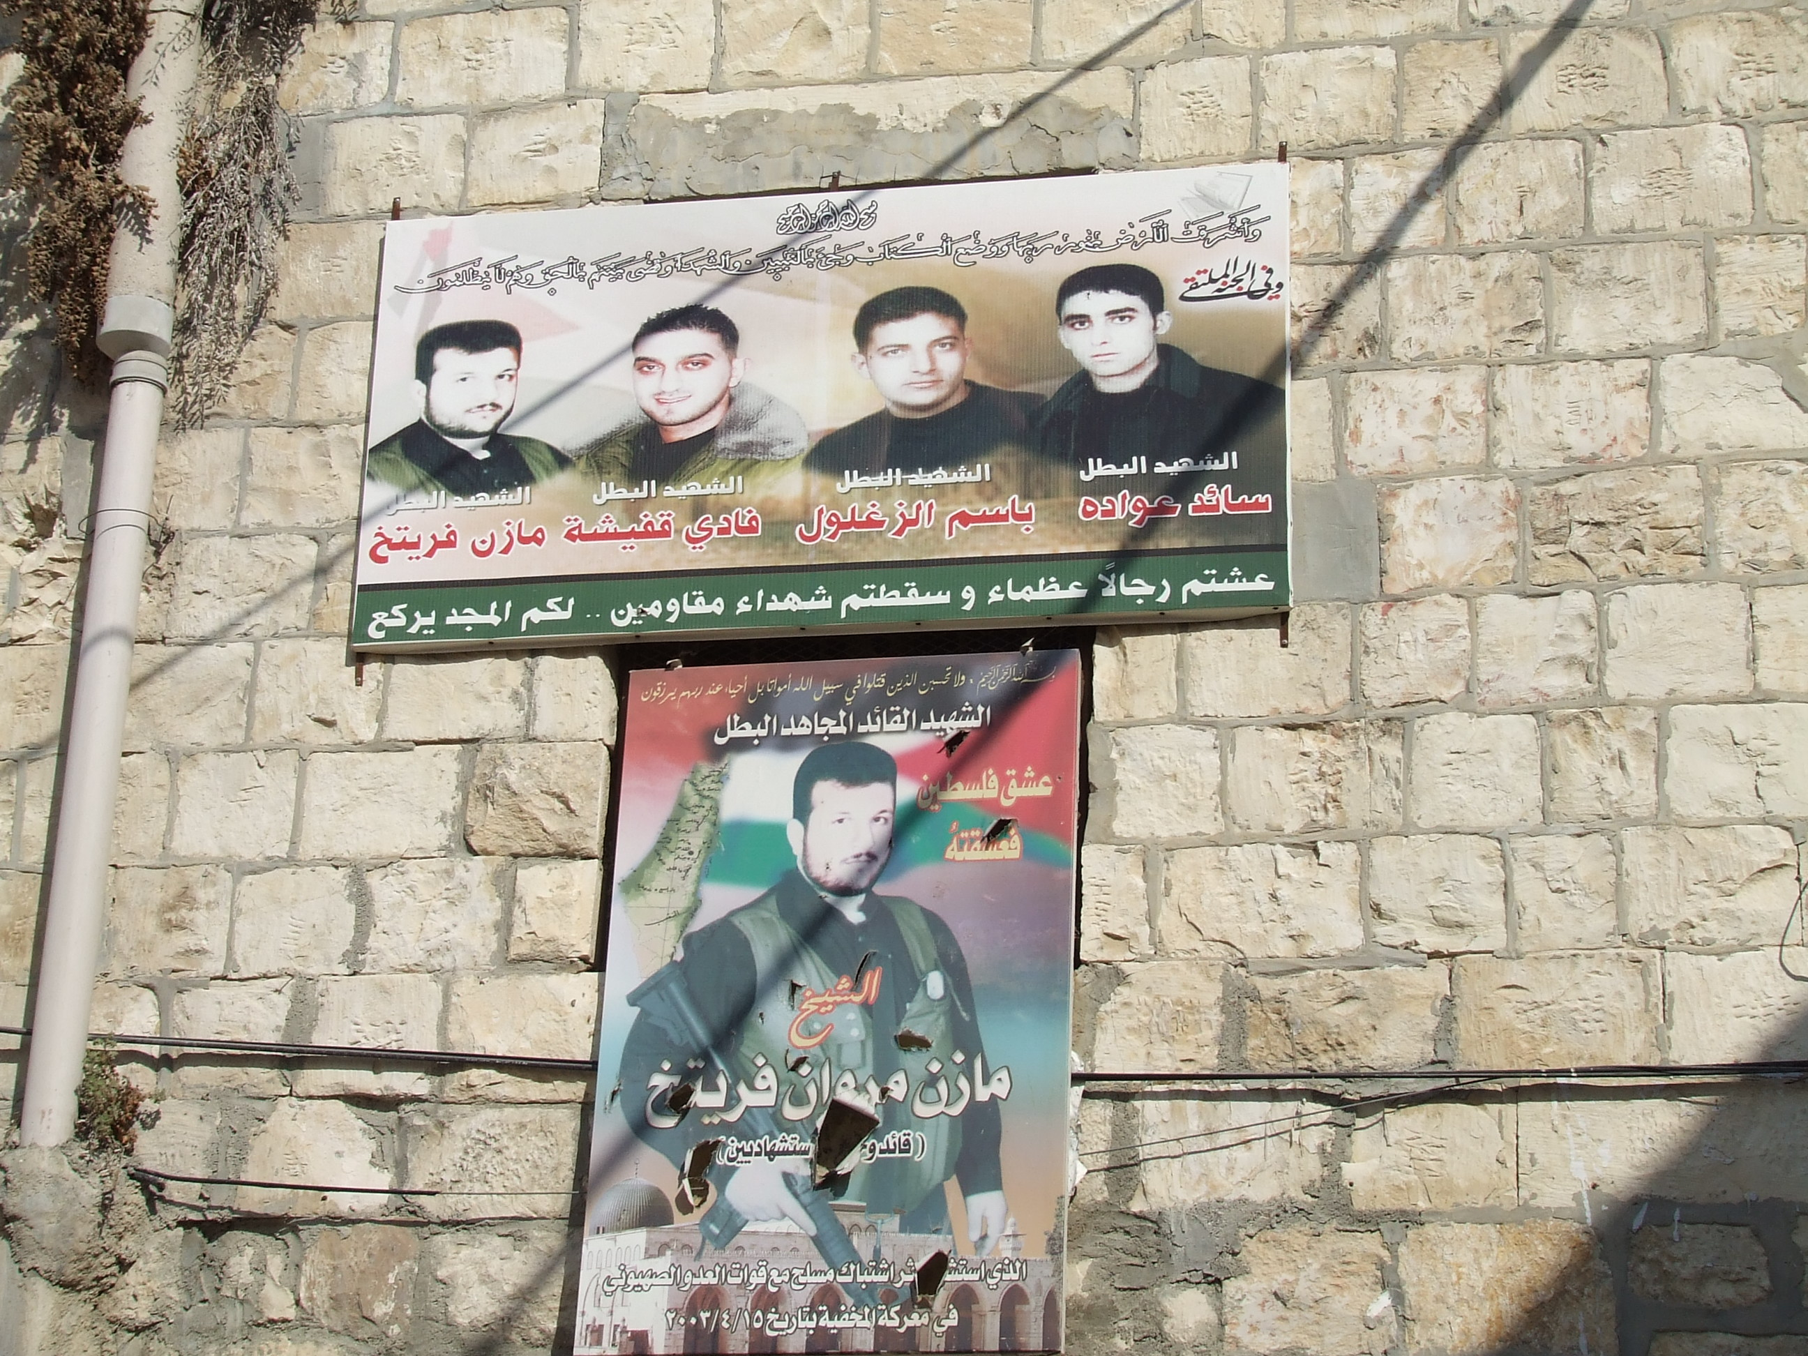

Martyr Photographs of those imprisoned and killed, Bi’iln April 2009

The solidarity of the people is tangible, and we were by no means the first outsiders to be overwhelmed by the dignity and humanity of West Bank society. In our discussions with Rouwa in Tulkarm about her own prison experiences, she was very clear that you were never alone with your anxiety and fears and that the bonds of solidarity and friendship helped keep her strong. Intangible as they may be, the quality of so many of the social relationships we witnessed in the daily living in the West Bank was clearly a source of enormous strength and happiness. Jamal, a sixteen year old boy from the Balata Camp in Nablus spoke for many when he told us in 2006 that he did not want to live anywhere else in the world other than in the camp. He had just returned from a visit to his brother in Cairo, who had been pressing him to stay and start a new life in Egypt. He returned because, he said, “it is the best place in the world. The friendships I have and the things we do together make me want to stay. I can imagine no other home.” We were joined by some of his friends in the camp who all agreed with Jamal’s view on the depth and quality of their friendships which had been forged through a common experience and a shared resistance to the occupation.
Suha, a 15 year old girl in Nablus was also clear that despite all the problems there was something special about life in the West Bank: “the people here make you want to stay and love the place” she said; although:

It’s like living in a prison. It is so difficult to get out and visit. But having said that I love living in Nablus and I can’t imagine wanting to live anywhere else. I had the opportunity to go to Turkey for a holiday and I enjoyed it but I was so happy to return. (Nablus, Sept 2006)

Young Palestinians through films, TV, internet, and so forth are not isolated from global youth cultures although the West Bank is free of the fast food chains and coffee shops which are ubiquitous throughout much of the world (though there is a Star and Bucks café network across the West Bank!) In the West Bank you will hear rap alongside popular Arab music and see saggers as well as bare midriffs. Mobile phones are everywhere and we can’t recall ever meeting a young Palestinian who did not have an e mail address. Many had Facebook accounts. They had many references against which to assess their lives and recognize both the differences and similarities between themselves and other young people not living under occupation. A small number had also travelled to summer camps in Europe where they met their peers from other countries. When we talked with Ali, a sixteen year old boy active in the Jaffa Centre who had recently returned from a visit to Britain with his band, he told us how different his life was to that of the young people he met abroad:

I am a member of a dance band and was able to visit Britain recently with the band. I saw and met young people there and I saw some of the differences between the children of Britain and Palestine. I saw British children going to school in the morning with their friends. They did not have anxieties about checkpoints, about soldiers, killing and wounds. They went freely and happily. It was the same with the university students even when they had to travel far. They never were stopped. They could live freely out of the home. All of these things are not possible for us. When they meet I saw that they had many things to say, about what was good in the cinema, where to swim, places to hang out and things like that. It was free talking about their free time and lives. And when we meet what do we talk about? Incursions, occupation, who has been arrested, wounded and how we might support people we know who are suffering. Our lives are so very different. (Nablus, June 2008)

It was often more in anger than sadness that young people talked of how the occupation stole their childhood. They may have idealised what they were missing but they knew that many of their peers elsewhere had some fundamental freedoms which were completely denied to them.

Box 1.1
But, [when Jamil aged 12 years was] asked what he wants to be when he grows up, he says he doesn’t know….’ It’s because I don’t know if I will be alive’ he says. ‘The Israelis are always shooting at us.”

Fear and uncertainty, in addition to direct threats of violence, were major themes of many of our discussions about daily life. The occupation fundamentally disrupts your life. You can never be sure from one day to the next the extent to which you can go about your usual routines of going to school, university, work, family visits and whatsoever. Ibrahim told us of some of the consequences:

We learn, as young people, that in the future we shouldn’t expect good things because daily life has nothing. For example, today it is calm; tomorrow we could have an incursion, the day after a mix. So we can’t plan, we don’t think too far in the future. And if you are a student it is hard too. You have to travel about and the soldiers may let you get to university today, but tomorrow they might stop you. These issues affect us all, from the very young to the very old. Even workers who have to travel to their work – they face the same problems. As young people we make plans and have projects and then we find that part of our group is arrested, or the teacher or professor is arrested – all these things impact on all our lives and all our plans. These disruptions affect all the family. For example if a father is turned back at a checkpoint it means he has no job and no money that day. So what is all the family to do? Even psychologically we are affected. If you are a student and you study hard and then you go to the exam to find it is postponed, or you can’t get there. This is an immense frustration for young people. All these things push the Palestinian young people to look at life in this way: just live for the moment.
(Ibrahim, Balata, Feb 2008)

Nearly all of the young people told us the same thing. The unpredictable character of the occupation made it impossible to think of, let alone plan, a future. They lived day to day or for the moment as Ibrahim recalled. But of course they thought about the future and made plans such as going on to university, what to do about marriage and so on. Their insistence that they only lived day to day seemed sometimes like a way of handling the constant dismay and disappointment that the occupation guaranteed for the Palestinians. Disappointments that came when they could not make planned visits to family; go on school or club trips; saw their degree course double in length; had family members and friends arbitrarily arrested, jailed or shot; couldn’t get to the olives because of the Settlers. The list is endless and does not even include the wider political context of ever deepening Israeli colonisation of the West Bank. It is hardly surprising then that to survive the dismay brought about by endless disappointments and disruptions that so many keep their focus on surviving one day at a time.
The collective and individual punishment of the people of the West Bank is largely kept hidden from western gaze. In part this is due to the consistent Israeli invocation of ‘security’ as the one and only reason for its oppressive actions in the West Bank and Gaza. Refugee camps are daily invaded because they harbour those who are deemed a security threat; people are shot because they threaten the security of soldiers, or settlers; checkpoints ensure security by making it difficult for suicide bombers to get through to Israel, and the Wall, of course, is only about protecting the security of Israel and nothing else. The security exhortations are many and varied and all feed on an Israeli propagated myth that all Arabs want to see the Israeli Jews kicked into the sea and pose a real existential threat to the security of the country. Drawing on widespread revulsion and guilt over the holocaust, Israel has both justified its presence in Palestine and argued that it is entitled to secure, at whatever cost, a homeland that will be safe for all Jews, worldwide, and that never again will Jews be threatened with annihilation. This Israeli perspective has prevailed for much of the period since the formation of Israel in 1948. It has been taken up and further honed, with only a few dissenting voices, by Israel’s key allies in the west both in government and in all branches of the media. Since the horrors of the Gaza War in 2008/9, Israel’s moral authority is no longer Teflon proofed by the Holocaust and as we shall see later, this has significant implications for Israel’s development. Nevertheless, even as Israel’s own claim of high ethical values is being daily eroded, the Palestinian perspective remains neglected, distorted, and fragmented. The collective punishment of an entire group of people by another, as was the case of the Nazi extermination of six million European Jews during the Second World War, is now being experienced by Palestinians at the hands of Israeli colonisation. And, yet again, now as then, the ‘West’ does not want to know.
Whilst the western media focus on episodic acts of violence, the more telling and fundamental story is the collective daily resistance of the Palestinians and their determination not to let the occupation destroy every aspect of their lives. The West Bank population starts each day determined to live their daily lives which, in the case of many young people, involves negotiating checkpoints and barriers as they go to work, school or university (see chapter 2). They are not passive victims. The insistence on their right to everyday routines and life is expressed daily and as Jamal told us:

Despite all these provocations and all the difficulties of the checkpoints we insist that we must continue with our education and our lives. The Israelis want us to surrender. Never! They want to make our lives miserable so we will leave. Never! (Jamal, Jenin, Sept. 2006)

Daily life is shaped by a relationship between occupation and resistance. For some Palestinians, as we shall see, it leads them to leave and seek their fortunes elsewhere. But for the majority, who not only stay but marry and have children, their dogged determination to secure education, work and family life is to confound the occupation.
Even where occupation fractures and destroys friends and families it so often leads not to defeat and despair but to renewed determination as 18 year old Samira exemplified:

When I was in my last year of secondary school the Israelis arrested four of my brothers. This made it very hard for me. I was upset and worried. I was really disturbed and anxious. I kept on thinking that they were going to come and take me. So as I was trying to study I was distracted by this fear. But I managed to sit my final exams and I was determined to get a good mark that would allow me to go to university. I thought if I can achieve this it will show the Israelis that they can’t destroy our family. My education is part of my struggle. (Samira, Tulkarm, Feb 2008)

Between 2004 and 2006 many of the towns and villages we visited had been subjected to extensive periods of closure which included curfews extending to nearly a month at a time when you weren’t allowed to leave your home. There were many days when checkpoints were closed to isolate towns and villages and of course there were endless Israeli invasions and attacks. But, even during these difficult days, when the soldiers were in the towns and refugee camps, young Palestinians told us how they would check their radios every morning to see if their schools were open and if so would break the curfew to attend. In 16 year old Mohammed’s case, his school was on the other side of Nablus and as his area of town was completely sealed off he had no chance of getting to school. He told us that there were around 15 of them in this situation so the school decided to set up a ‘branch’ in a nearby empty flat for duration of the curfew (22 days in this case). Mohammed continued:

We didn’t even have chairs so we had to carry our own from home all the time avoiding the soldiers. The teacher lived close to the flat so it wasn’t difficult for him to get there and we had three hours of classes every day. It was better than sitting at home and I didn’t lose all my classes.
(Mohammed, Nablus Sept. 2009)

Stories such as these are common in the West Bank and testify to the determination of the people to not only endure the occupation but to strive to counter its corrosive impact.

Making us Suffer

That the occupation seeks to demoralize, humiliate and harm well-being was well understood by the Palestinian young people we met and we were given countless examples which illustrated that this was not the sole preserve of the checkpoints or prisons. Najwa told us how:

The soldiers were in our house for 21 days. When we were allowed to return everything inside our home was destroyed and thrown outside. Why? For nothing. It is just to humiliate us and make us suffer.
(Najwa, Jenin, Sept. 2006)

Her friend from university, Ranya, told us that:

At the time of the first big incursion in Nablus in 2002, soldiers came to our house. It was dark and it was raining. They told my father that we should all come out of the house. But he said it was raining and that he had young children. Out! he was told and use some blankets to cover the young children. We stood outside for nearly 2 hours in the rain and in the dark. Then the officer came and said you can go back in, and ‘goodnight’!
(Ranya, Jenin, Sept. 2006)

And in the same discussion in Jenin, Fareeda recounted how:

The soldiers came in to my village late at night looking for the son of our neighbour. First they ordered the owner of the house to come out, naked. They made him stand under a water pipe which they then turned on. It was winter. Then when other family members came out of the house the soldiers used some as human shields as they approached the house to throw grenades. All the time the owner was naked and wet and cold. They didn’t capture his son. The Israelis want to make us frightened. But when I saw all this I did not become more scared but more determined to fight and to resist the occupation. (Jenin, Sept. 2006)

Periodic invasions of IDF soldiers into Palestinian homes are widely experienced, especially in the refugee camps. In the case of some from the Jenin camp they had been terrified by soldiers bursting through the walls of their homes during the massacre of 2002. For those whose houses or apartments occupy ‘strategic’ positions, military incursions are a more regular feature of their lives as their homes are turned into observation posts or sniper positions. Jumana lives with her family of six in such an apartment in Nablus. She is 16 years old and told us that the Israelis often use their flat as an observation post and they can have four or five soldiers there for days at a time. At these times, the family is moved into one room and made to sit on the floor in the dark. When they need to use the toilet they are escorted there and have to leave the door open. “My father gets so angry with the soldiers, especially when I or my sisters need the toilet. They deliberate humiliate us and my father can’t protect me then” (Nablus, Sept, 2009).

(Testimonies from soldiers?)

During the period of our research in the West Bank the army’s incursions into the camps, villages and towns were largely restricted to the early hours of the morning, often between 2am and 4am. This gave the night-time a heightened sense of anxiety as people knew with almost certainty, especially in the camps, that the army would be coming, but for whom, when and in what numbers was never known. Although the Israeli military always argues that its incursions are driven by specific security needs, the reality was that many of the raids were not targeted but rather random. “They shake the tree” and see what falls, after all in the Israeli mindset all Palestinians are their enemies. The consequences are many and predictable. For all there is anxiety, as Usama a teenage girl in Nablus told us:

At night there are many times when you are lying in bed waiting for sleep and then you hear the noise of an incursion, the jeeps, APCs, the random firing. Do children in Britain wake up to such noises frightened and scared by incursions? For us it is every night.
(Nablus Sept. 2006)
Disturbed sleep, nightmares, bed-wetting, aggression, muteness were all mentioned as being amongst the most prevalent consequences, especially for the young. It was common for us to hear brothers and sisters worrying about their younger siblings as typified by 14 year-old Rasha:

My father is in prison. My younger brother is very young and he can’t understand where our father is. He doesn’t like to eat now and I am very worried. (Rasha, Jenin, Sept. 2006)

The overwhelming reality of life in the West Bank is that it is dangerous and unpredictable for its entire people. As Kareem, a 17 year old student from Jenin told us “I don’t believe that young people are particular targets for the Israelis. The occupation affects everyone here without exception” (Sept. 2006).
Whilst it is true that the occupation is universalizing, it is also differential in its impact as we came to discover. The most obvious example being those crowded into the refugee camps who, as we shall see, are hardest hit by all aspects of the occupation from the psychological to the social and economic.
Young people are not singled out. Vulnerability either because of age, gender or illness provides no protection from the occupation. Thus in the case of children for example we found that not even their play areas are safe:

Last Friday night the Israelis spread ‘chocolates’ around some of our playgrounds near the school, for the kids to pick up. My 8 year old brother found one and picked it up. It was shining in silver foil and he thought it might be a toy or a sweet. It exploded in his hands as he opened it and he got seriously burnt. This is how the Israelis target the kids. Why is this never reported? (Kareem, Balata, Sept 2006)

That so many young people are injured, killed and traumatized by the Israeli occupation is in large measure due to their sheer presence in the West Bank coupled with their greater public exposure either going to and from school or university or simply being out on the streets. Between 2000 and 2007 a total of 974 children were killed in Gaza and the West Bank, with the second most common cause of death being “random Israeli gunfire”. Or, to put it more bluntly, being in the wrong place at the wrong time.

Box 1.2

Salim’s Story

Salim: There were five of us [teenage boys] and we were together walking home at about 9pm in the evening. It was dark. There were under-cover forces in the area but we didn’t know that at the time. They were hiding behind a wall and there were no street lights. We had started to cross the street when they started to fire at us and I got shot. The bullet went through me and then hit my friend as well. They then shot my friend with another bullet.

CJ: There was no warning or shouting?

Salim: No nothing. No shouting, there were no lights, we didn’t see them – they just shot at us.

ML: Then what happened?

Salim: I didn’t feel anything at first. But the bullet that went through me broke my friend’s leg and he couldn’t move. I then felt the blood and I couldn’t move.
We were puzzled, scared and confused. We didn’t know what had happened. Who had shot us? Where were they?
The neighbours around the area started to shout and there were volunteers who came to help us.
Then a taxi came and we were dragged in. All the ambulances were busy, so they sent a taxi.
I was off school for two months. But my friend who was shot twice was in bed for three months, and missed taking his final school exams.
(Feb 2008 Qalqilya)

For younger people this exposure to random violence is heightened by the shifting boundaries of physical space due principally to the construction of the Wall and the expansion of settlements and their inter-connecting road systems. We heard many stories of children in particular being caught up in these boundary changes where a once favourite hill side for playing becomes a forbidden place because of its proximity to a settlement, or the Wall or because settlers have fenced off their water hole. In all such cases, the children entering these areas make them liable to being shot at or arrested or both. We too experienced roads that we had previously travelled on now being closed to all Palestinian traffic, either by checkpoints, concrete blocks and piles of earth and rubble, or by being re-designated as roads reserved for Israelis.
These are not minor shifts. Even in the five years of our visits the landscape of the West Bank has changed significantly as Israel writes ‘its facts’ on the ground with military areas, nature reserves, settlements, roads, checkpoints and the Wall which all devour Palestinian land and push the Palestinians into smaller and smaller urban enclaves around the major towns and cities of the West Bank. Some sense of the scale of these changes is provided by Raja Shehadeh in his evocative book Palestinian Walks: Notes on a Vanishing Landscape:

When Israel began establishing settlements, opening roads through the hills, flattening hilltops and connecting far-flung places with water and electricity I was filled with awe. And fear. The countryside I grew up in was being transformed so rapidly I could hardly keep up……Vast areas of my beloved country were being fenced to become off limits to us.

In our discussions with young people these kinds of impacts, especially on young children, were amongst their principle concerns and often motivated their involvement as volunteers in the many youth centres across the West Bank. Sami’s comments informed by his experience as a youth worker in the Balata Refugee Camp reflected the views of many we met:

All the youth workers in the Centre were brought up in the refugee camp and still live here. We know what it is like and we know what difficulties the children face. You know the children here are brought up in such strange and difficult circumstances. They have all seen dead bodies and body parts. They have all witnessed shootings, bombings and attacks from the Israeli forces. They all have brothers, cousins, uncles or fathers who are martyrs or prisoners. Many of them have been hurt – if not physically, then at least mentally and emotionally. As a result, we have a lot of angry children. We have a lot of aggressive children. We have a lot of depressed children. We have a lot who behave in a crazy way because they have no way of releasing their anger and anxieties. Sometimes it is difficult to talk to them, they are often nervous. (Balata, June 2008)

The youth centre in Balata, like those elsewhere in the West Bank, is explicit that its purpose is to minimize the Israeli theft of Palestinian childhood through its occupation.

As Jamal told us:

We have to find a way to give our young people a glimpse of a better life. To run classes and groups which take them, even for a short while, away from the horrors of our lives in the camps.
(Jamal, volunteer, Yaffa Centre, Balata Feb 2008)

The centres we visited were impressive, not in terms of their facilities which were always over-used and under-resourced, but with respect to their achievements. They were able to create oases of childhood which were not dominated by the occupation and sooth some of its frustrations and anxieties. We didn’t see rocket science but children drawing and painting, playing sport, dancing, and making music together. We met those who had literally found their voice again after muteness and many told us that the activities helped relieve their frustrations.
During the course of our research we witnessed a growing concern to help those children with profound individual psychological reactions to the occupation, whether it was bed wetting or nightmares. Youth workers and social workers told us that parents’ growing trust in their work, meant that more and more were turning to the centres for help with problems that had previously remained firmly closed within the family. As Liana Badr wrote, courage and bravery are highly esteemed throughout Palestine. According to another Palestinian writer:

Palestinians are hard and they work hard. They have faced many problems but they keep rebuilding their lives, they don’t give in …. Palestinians have huge strength (mubaadira aasimiya )….Although walking on thorns, he maintained his image in front of the world that he is very strong, that he can beat anything.

Such values and beliefs were evident amongst all the people we met. It was a source of great pride that they were able to withstand all the brutalities of the occupation, and keep going in the face of extraordinary hardships and violence. But in turn this can also have negative consequences for behaviour which is perceived as weakness which often includes a range of psycho-social responses to trauma and stress. We were told by some social workers in Nablus that this led to such problems often being ‘hidden’ within families who from shame were reluctant to seek help for either themselves or their children. But the social workers we met were unequivocal in seeing the psychologically related reactions to persistent fear as much as wounds of occupation as the wounds and injuries caused by fire arms:

Today I have seen a young boy and his sister. Both can’t control their peeing. These two are both casualties of the daily incursions of the Israeli army. We will work with them now
(Ahmed, social worker, Nablus, 2006)

These are difficult and sensitive issues in a society where hope and courage are so central to their very survival. We were unable to probe as deeply as we would have hoped, for in common with many societies, psycho-social difficulties are still widely considered in West Bank society to be ‘private’ matters for the individual and their family. Nevertheless, the number of activities we witnessed that involved art and music work with young children suggested an awareness of the importance of such activities in combating high levels of stress and anxiety amongst children and young people. But there again, in a context of almost perpetual stress and anxiety, it would have been surprising if such a common and shared feature of Palestinian life had been neglected. In 2002 for example, one West Bank survey showed that “at least half of the school children showed psychological symptoms such as crying and fear from loneliness, darkness and loud noises. About a third showed symptoms of sleep disorder, nervousness, decrease in eating and weight, feelings of hopelessness and frustration, and abnormal thoughts of death. About half of the children showed deterioration in their schoolwork and one-third were unable to concentrate”.
We talk in more detail later in the book about the multi-layered resistance and solidarities that characterize life in the West Bank. The concern with young children is but one example of that solidarity and extends from social work projects with individuals to the youth work of the many community centres and organizations. There are not the same inter-generational divisions that are visible in some western European societies. Young people spend time with their elders whether from the family or from the neighbourhood. Many told us how much they learnt of their history from older relatives and family friends. The Yaffa Centre in Balata was not alone amongst West Bank youth centres in positively valuing the testimonies of older people and set about recording them in print and on video and using them as a basis for their youth work activities. Likewise students at An-Najah University in Nablus have for many years been collecting stories and testimonies from older people, especially those with personal experience of the Nakba and its immediate aftermath. These peoples’ histories take on further significance given the sanitised nature of the school curriculum.
For slightly different reasons, the two main providers of schooling – UNWRA for the refugees and the PA for the rest – steer clear of recent Palestinian history and politics. The UN on account of its avowed ‘neutrality’ and the PA because Israel monitors the curriculum and course content. Much of what we heard from young people about the Palestinian struggle and its background, some in close detail going back to the British mandate and the Balfour Letter, was learnt in the family. This was a history that was personal and for those in the camps, accounted for why they were there and had been for over 60 years. It is a history as important as the ancient land ownership documents and keys they retained of their lost properties in Israel. And it is a history which would seem to bind generations closely together.
Such close relationships and friendships combine to form solidarities that mitigate some of the worst excesses of the Israeli regime and provide young people with the sort of perspectives and broader political understandings that help them understand what is happening and how to manage. What it cannot do is shield children and young people from the occupation.
This was particularly evident when young people talked about their concerns for their younger siblings and those other youngsters around them. Again and again we heard Palestinian youth express their anxiety that the occupation was leading to a generation of boys obsessed with guns and war.

When we run a work shop for children between 5 and 16 years old I normally ask them to draw a picture. But they don’t draw trees or flowers or a lunar park. Instead they draw pictures of jeeps, APCs, guns, and battles. This is one of the difficulties that we face – how do we break this psychological barrier? Their lives lead them to thinking this way – we cannot change this in a few hours of a course.
(Hamed, young male volunteer, Balata, Sept. 2006)

I don’t think our children play like other children in the world. All their games involve war, weapons and blood. This is not a normal life, it is a disaster life. (Suha, (16) Nablus 2006)

We hear similar talk in the West with some commentators suggesting that violent computer games and movies are having a similar impact on their youth. But rarely in the West will you meet, as a matter of course, so many young boys who (appeared to us at least) to have a comprehensive knowledge of the main guns and armaments of the Israeli forces. Many young people can identify a military vehicle by its engine noise alone. Planes and helicopters are readily identified. But this knowledge is not just part of a ‘boys with toys’ syndrome but useful survival knowledge. We had a fascinating hour with five cousins, all boys from Qalqilya and Tulkarm who tried to explain how we could recognize a rifle that fired plastic bullets as against one shooting live ammunition; what action to take in the event of a tear gas attack, and the calibre of shells from this or that tank or APC. Similarly during an evening in Biet Leed, an agricultural village, the children of one large family fetched the shell which landed on their roof but did not explode. It was a magnificent trophy for them.

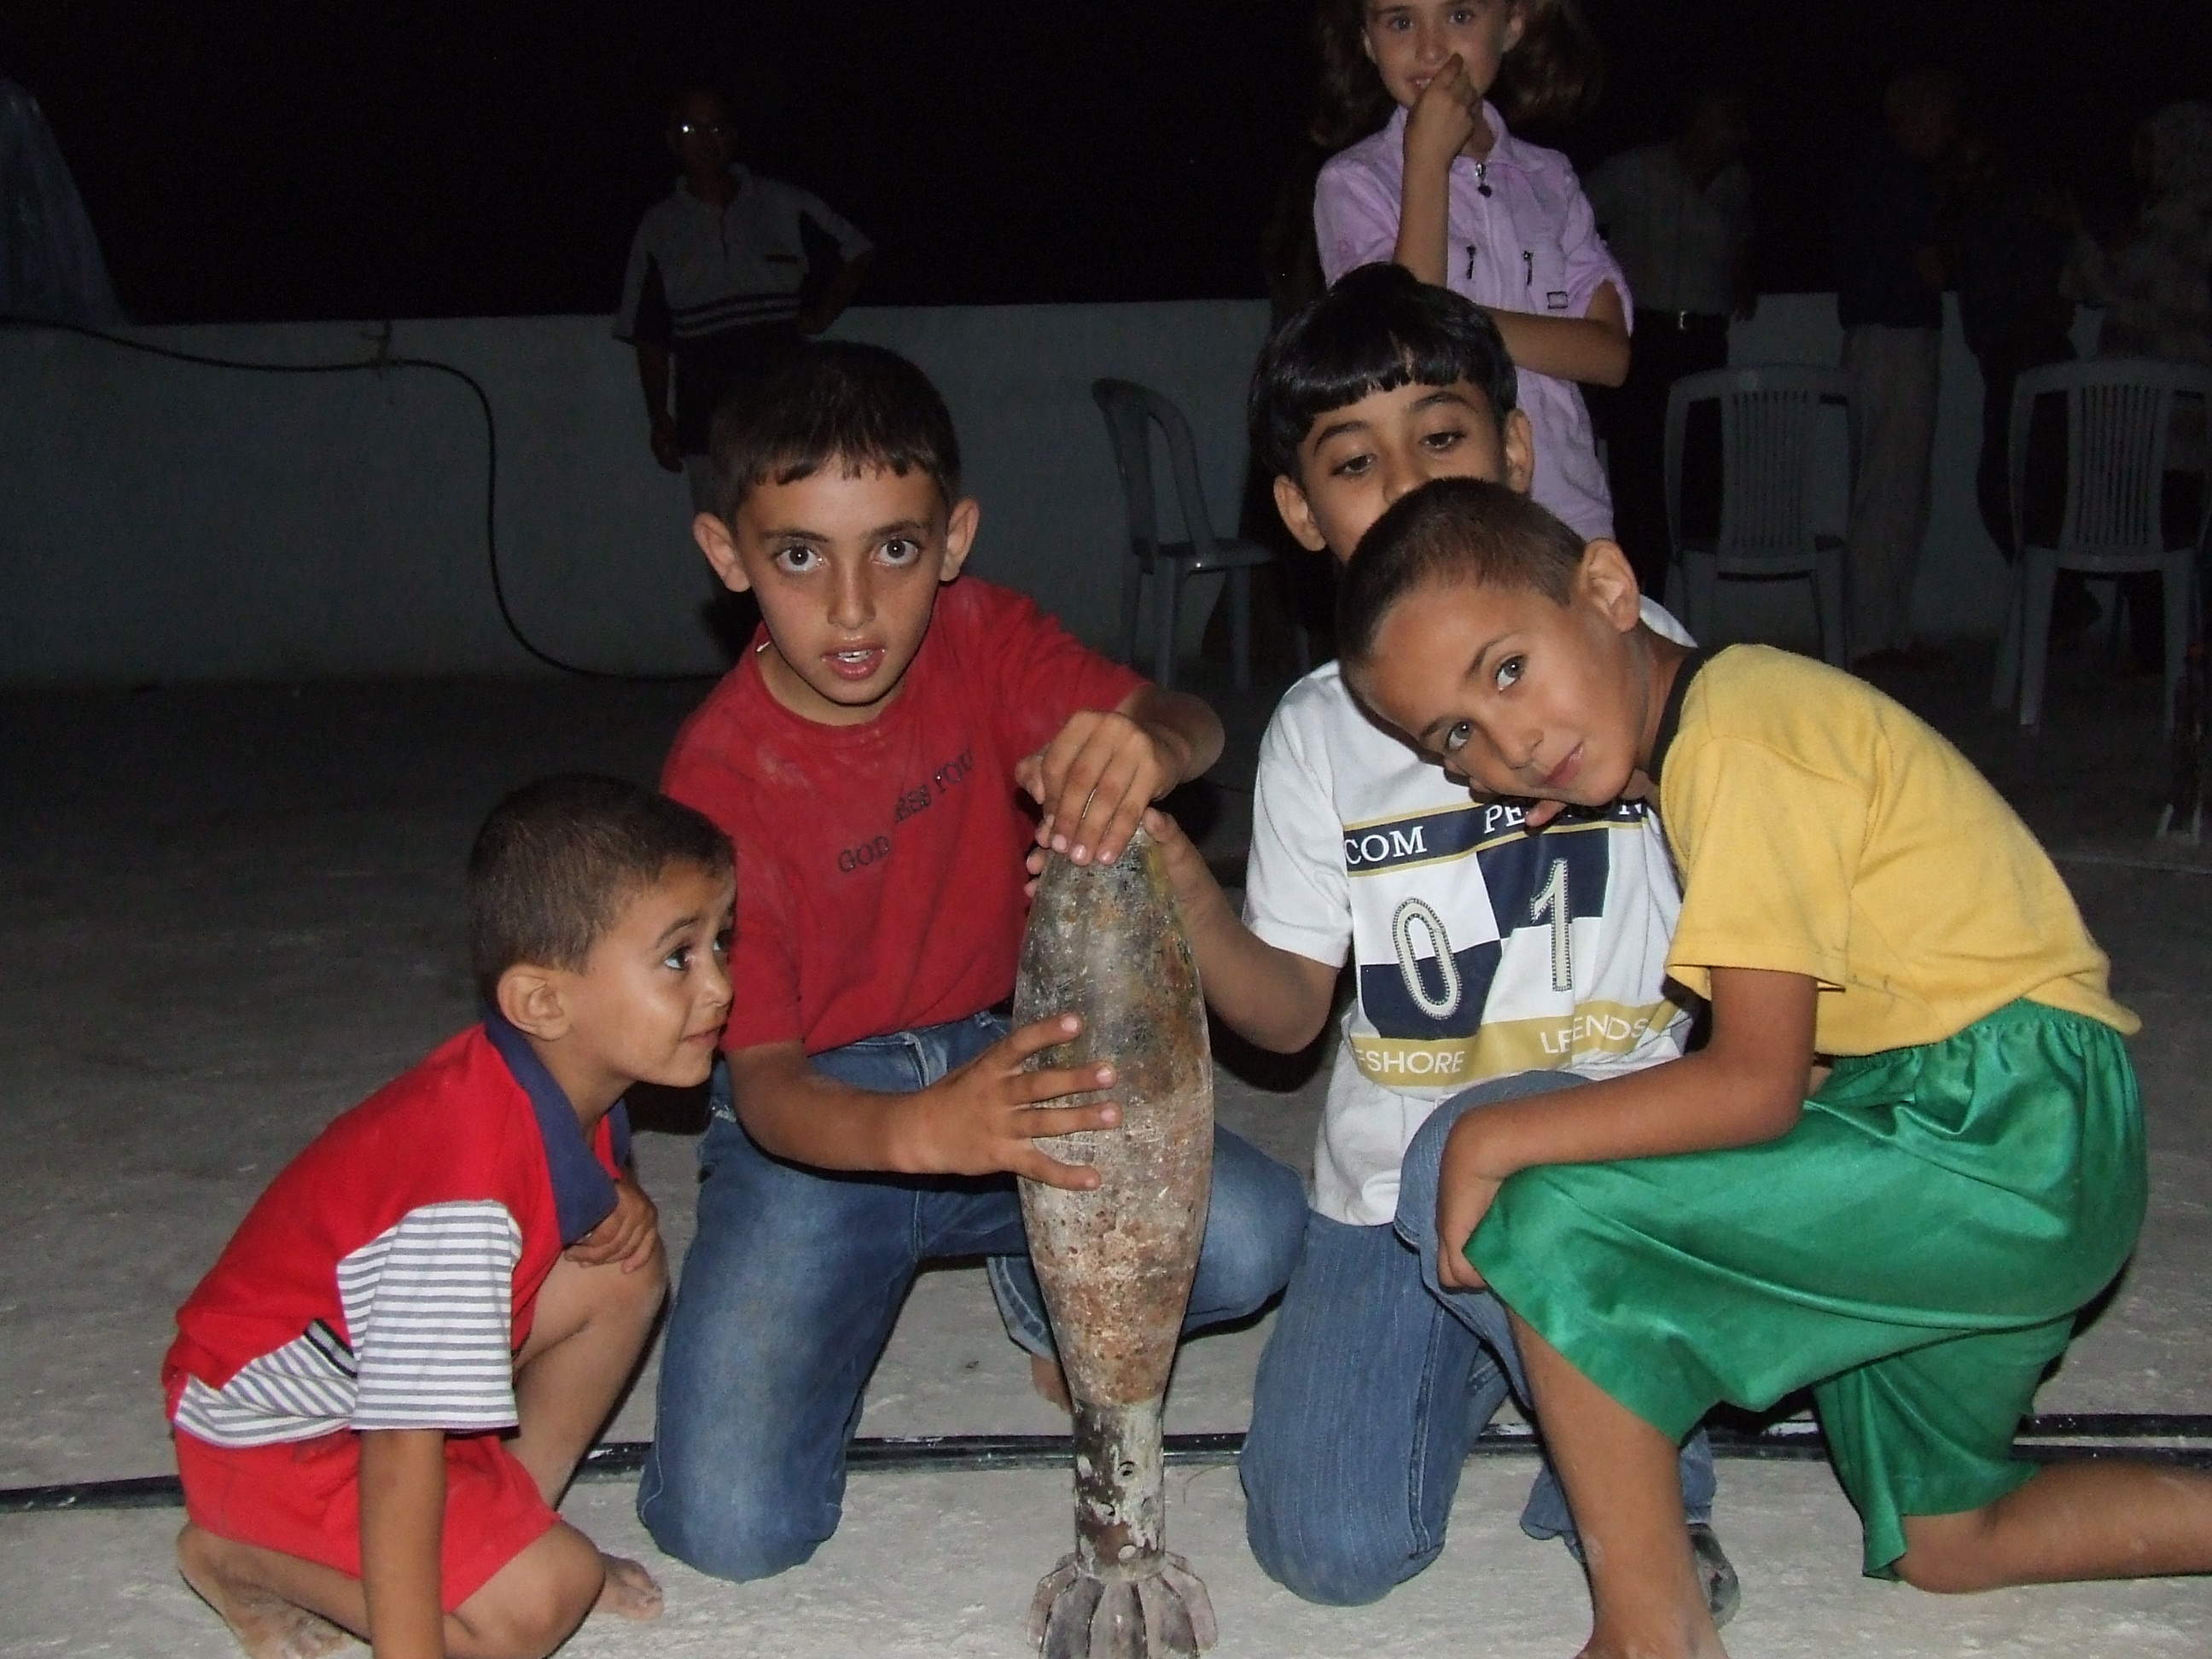

The paradoxes of life in the West Bank abound. For some Palestinian children and young people there are moments of acute excitement and adventure alongside the fears and depression of occupation as 17 year old Tariq from the Friends School told us:

For me the 21 day curfew [2002] was kind of fun. I was lucky in that my house has a back garden and it was possible to get outside of the house and friends and neighbours would visit. Sometimes me and my friends would go out on to the streets; get shot at and then rush home. Then there were times when jeeps would chase us bunch of boys. It was exciting. I know we missed school and all that but for me I had some fun too in the curfew. I was caught and beaten three times by the soldiers during the curfew but it didn’t stop me. But in 2002 we were kids. Riding our bikes and looking for fun. Our parents weren’t happy but that’s how I was as a young kid. (Ramallah, June 2008)

We heard many similar stories. It wasn’t just stone throwing, or dodging the military which exhilarated but many less conspicuous everyday activities such as visiting friends or getting to school which under curfew carried considerable dangers. Mohammed for example, was excited by getting to his ‘ad hoc’ school in Nablus during one of the long curfews; whilst the two sisters Rima and Manal were excited by crawling through their bedroom window and over the narrow divide to visit their friends in the next building. (Nablus Sept. 2009) Such events take on greater significance as they dramatically puncture the monotony of much daily life in the West Bank where restrictions on movement combined with extreme poverty for many youngsters entail long periods, ‘knocking about’ in or near to the home.

People spend most of their time just around the home; perhaps in the street but never far away. And this makes the pressures of home life very great.
(Firas, Tulkarm, June 2008)

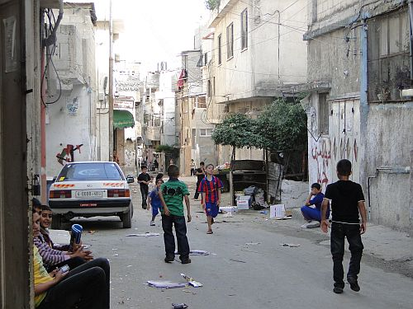
Balata Camp

In the already over-crowded refugee camps such pressures are amplified:

The Balata camp is very over-crowded. We have 22,000 people living in 1 km square. In the camp we have Mosques, schools, some shops, and we also have the Social and Cultural Centres like ours. All these are important, but they eat into the space of the camp. So each house is now reduced to 60-70 square metres where you often find a family of 10 people living there. Some of the houses in the middle of the camp are built so close together - and they are all 2 or 3 stories high - that there is no natural light, no sun and little ventilation.
People in the camp live in these circumstances because they have no choice. They are too poor to move out of the camp. Many of the families in the camps don’t even go out of the camp for even one day. They don’t go to the nearby park even, because they think about the cost of a drink or an ice-cream their children will want and have no money for - they simply don’t have the money. So the result is that the kids just spend all their time running around the streets and near their homes.
(Sami, Yaffa Centre, Balata Camp, June 2008)

Box 1.3

“Life here has a lot of pressure – economic, social and personal,” explains Nooreddin Amara, 14. “The economy is usually very bad. There is a lot of unemployment.” And, he said explaining how overcrowded the camps were, “here is the club, and here is a house. If I make any noise at all, they can hear it.”
“The camp is small,” says Muhammad Libdeh, 15, a youth representative of the management committee at the Tulkarm after-school programme. “Your life is limited by what is here.”

But it is not only young people who now spend most of their time in the streets or at home when they are not at school or university. It now applies to large numbers of adults who have no work. As Firas said, “if you don’t work, life will be miserable – but where can you work?” (Tulkarm, June 2008). Mohammad thought that as a result of unemployment the people of the West Bank spent more hours watching (satellite) TV than anywhere else in the world. For men there are also the ubiquitous coffee shops where you could pass the time at very little cost in the company of other men. For women there were no such opportunities for socializing in public without appropriate chaperones. Although we came across variations from town to town and certainly between the villages with respect to gender conservatism, the general rule was that the space for young women at least was much more domestically confined than was the case for boys. The variations within a small geographical area such as the West Bank are marked; hence, Qalqilya was much more conservative than Tulkarm, which in turn is less liberal than Nablus and certainly does not compare with Ramallah for the freedoms it affords young women to go out with their friends – both male and female. In common with many societies, villages and rural areas tend to be more conservative on a wide range of issues including gender freedoms than the urban areas and larger towns.
When not at school or visiting family, girls and young women spend their time in the home, helping with the household – cleaning, cooking, caring for younger siblings – as well as watching TV. When we met a group of 4 girl friends in Tulkarm in September 2009 who had just graduated from university, they gave no sense of being locked into domestic drudgery. Rather for them it was a matter of making their contribution to the household which also allowed them time to socialize and meet one another – which they did on a daily basis visiting each others’ homes. Their friendship was intense and they told us that they often spent their time laughing and giggling over the sort of husbands they hoped to marry and simply discussing what was going on in their lives. (look at tape for quotes from this group).

The home is also the place where many hours are filled by women embroidering intricate and decorative tapestries, the most common seeming to be the map of historic Palestine, Handala the cartoon character symbolizing Palestinian aspirations and the Al Aqsa Mosque which decorate their homes in addition to other handicraft arts such as beaded flowers. Such activities consume hours of time and from our observations, are often social events involving female neighbours and relatives working alongside one another. Moreover, they were one more example of the inter-generational solidarity which is a characteristic of West Bank society, with three generations of women and girls working and talking together. And as ever, we discovered that occupation brings new twists to even these activities as when we spent an evening with Rasha and her two teenaged daughters, Minel and Nisreen. They were expert paper folders and in a few minutes were producing birds with flapping wings and frogs that could be made to jump! This, they told us is the consequence of curfew when they filled the hours making toys from paper. We subsequently came across a range of other quirky skills all learnt either in prison or under curfew and requiring little or no space or resources. These included elaborate finger contortions and animal sculptures from the foil of cigarette packets!

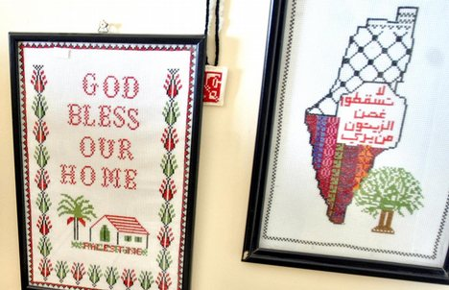

Mobile phones and the internet, both widely used by young people, do allow for some of the acute physical barriers to travel and communication imposed by the occupation to be circumvented. Through mobiles and e-mails, friends can stay in touch even during the curfews and close downs. In some cases, they allowed families to have contact with friends and relatives in prison. We also learnt that mobiles allowed some young women to breach some of the traditional conventions that limited their contact with boy friends. Even if they couldn’t meet easily they could at least text.
In the minority of homes which had an internet connection we suspect that our limited observations of heavy and continual use would hold true more generally. When we stayed in the Tulkarm refugee camp in 2006 not only was the internet in continual use but a tight rota allocating times had to be operated to ensure that all of the family’s six siblings (and their friends) could have some time, either to play games, download music or email.
It is, in our view, remarkable the extent to which everyday life is sustained in such adverse circumstances. The sheer density of population in the camps alone, for example would strain any social system, but add the haunting uncertainties created by occupation and its damage to people and communities then it is even more remarkable that so much of daily life is characterized by good humour and grace.
Yet there can be no getting away from the dark shadow of occupation. As Reem, who in June 2008 had just completed her secondary education at the Friends School in Ramallah, told us: “everything we do is affected by the occupation from the smallest to the biggest thing.”

Box 1.4
According to a survey undertaken by Sharek Youth Forum and funded by UNDP, over half of 1,220 respondents between 16 and 25 years old [in the West Bank and Gaza] said they did not feel secure. The great majority described themselves as either extremely depressed or depressed; more than half said they spend their spare time at home, with friends or relatives; and a limited proportion said they attended youth centres and clubs. Low morale was especially pronounced among Gaza refugee camp residents.

That the occupation is uncompromising and universal gives it a particularly brutal character, and hardly surprisingly, unifies rather than divides the West Bank population. There are no subtleties to the Israeli strategy: no attempt to win hearts and minds; no deployment of softer strategies of control and containment in an attempt to divide one section against another. The result for the Palestinians at least, over the years, has been the development of a common understanding of the Israeli position which was articulated by Mustapha a young social worker we met with in Nablus in February 2008:

The Israeli occupation is calculated fully to destroy – or to try and destroy – our psychological well-being as well as our physical well-being. It is clear in all their behaviour and in all their activities that they want to degrade and humiliate us. They want to de-motivate us. To give up.
(Mustapha, social worker, Nablus, Feb 2008)

As Noam Chomsky argued in his characterization of the Israeli occupation:

The point [of occupation] is to teach the Palestinians that every aspect of their life is controlled by the authorities, and the master will do what he likes with impunity. They must be taught not to ‘raise their heads’…

But after over 60 years of occupation it is becoming clearer that the strategy of making the life of the Palestinians as miserable as possible, in the belief that it will lead to their defeat and departure from the West Bank, is not working. The West Bank is dangerous but it is not a miserable place. The hardships are extreme but the Israelis have not destroyed totally the day to day life of the people. The population of the West Bank has grown and not diminished since 1948. The occupation ironically has solidified the population despite all their suffering. Popular consciousness is clear – the more they want us to go the more determined we are to stay; the more they try to destroy and distort our lives the more determined we are to laugh and play.
It is a ubiquitous resilience played out at many levels from the university students who attempt to travel daily to university and arrive at checkpoints not knowing whether they will be allowed to pass. It is expressed in the formation of sports teams and cultural clubs in a context where travelling to the next village for a match can never be assured. It is about the myriad ways and means that Palestinians live their daily lives.
It is a durable resistance too, because there is collective understanding. Palestinians know what the Israelis want – their land without their presence. And they know how they are seeking to achieve this goal. As a result, the Palestinian pre-occupation with all aspects of trying to live as much a ‘normal’ life as possible is consciously understood as part of their resistance and hence survival. This was exemplified for us by Ali, a 15year old school boy in Jenin, who in 2006 told us that:

Naturally all our parents are nervous for us when we leave the home in the morning and go out to school or the university. But my parents never show me their nerves even though I know this is how they feel. Instead they want us to be calm and relaxed. They so much want us to have a normal life so we can move forward. It is like a culture of survival.
(Jenin September, 2006)

His insight helped us make better sense of what we saw and witnessed; the laughter as well as the tears; the many layered solidarities; the determination to go to school, to play games, to visit family and friends; to go out with the family for a walk or a picnic, to harvest the olives, all of which are so mundane in other countries but so perilous and difficult there.

Palestine Monitor Children Factsheet - Updated: 18 December 2008
Palestine Monitor (2010) ‘The Children Of Balata: Putting Faces To Statistics’ Photogapher: Brynn Utela, 18th October; http://www.palestinemonitor.org/spip/spip.php?article1571
There are many examples of the ways in which cross national youth cultures interact. See for example, ‘Refugee camp kids and Rappers’ a photo essay published by Palestine Monitor July 19 2009, http://www.palestinemonitor.org/spip/spip.php?article1015
Cited, R. Walker 2007, ‘Another Brick in the Wall,’ Independent Newspaper, Education, 22 Nov, pp 4-5
See Shlaim, A. (2000) The Iron Wall: Israel and the Arab World, London, Penguin. In the case of former prime minister Menachem Begin for example, Shlaim observed that because of the Holocaust, Begin “saw the world as profoundly anti-Semitic, extremely hostile and highly dangerous environment. He perceived Arab hostility as an extension of the anti-semiticism that had resulted in the annihilation of European Jewry.” P.553.
Within the mainstream press there are some exceptions such as Robert Fisk and Patrick Coburn of The Independent.
According to the UNRWA Population Census of 2007 the West Bank population grew 25.47% between 1997 and 2007, from 1,873,476 to 2,350,583 people, not including the Palestinians living in Jerusalem. UNRWA Briefing Paper, January 2010, p. 9. http://www.unrwa.org/userfiles/2010012035949.pdf
Palestine Monitor Children Factsheet - Updated: 18 December 2008
Raja Shehadeh (2008) Palestinan Walks: Notes on a Vanishing Landscape ( Town and publisher) p.114
“That day her elderly mother in law had discovered her shaking with fear. The old woman with her rotting teeth and smoky breath, had personally chosen Umm Hasan from among her relatives in Amman as a bride for her son…..Her head bobbed in its flowery scarf as she exclaimed: “This isn’t right! Stop it girl! Don’t be a coward, because cowardice is the most despicable thing in the world”…She used to have panic attacks, but her dread of being the coward her mother-in-law called her was even stronger.”(Lian Badr, ‘Other Cities’ in J. Glanville, 2006, p.40)
Al Rais N. (1998) Suicide in the Time of Ashes , cited N. T. Dabagh (2005) Suicide in Palestine Hurst, London , p.80.
Halileh, S. (2002) ‘The effects of Israel's "Operation Defensive Shield" on Palestinian children living in the West Bank’, Spotlight, 29 June, http://www.redress.btinternet.co.uk/shalileh.htm
For example, Morgan, L. and Morris, L. (eds) (2007) Nakba Eyewitnesses: Narrations of the Palestinian 1948 Catastrophe An-Najah University, Nablus
UNWRA schools are continuously monitored for anti-Israeli bias by Israeli right groups and pro-Israelis in the US Congress. The consistent message is that UNRWA is pro Palestinian and promotes terror. For a typical example see, ‘Israeli refugee program a ‘stack of lies’ Palestine Note 11th August 2010, http://palestinenote.com/cs/blogs/news/archive/2010/08/11/unrwa-israeli-tv-s-depiction-of-palestinian-refugees-a-quot-stack-of-lies-quot.aspx
Palestine Monitor (2010) ‘The Children Of Balata: Putting Faces To Statistics’ Photogapher: Brynn Utela, 18th October; http://www.palestinemonitor.org/spip/spip.php?article1571
UNICEF oPt Monthly Update 15 May 2009, p.5
95.3% of households have a TV set and 80.4% have a satellite dish, in 2006. This Week in Palestine, Issue 121, May 2008, p.82
In 2006, 81% of households had a mobile phone whereas only 15.9% had access to the internet at home. This Week in Palestine, Issue 121, May 2008, p.82
UNICEF Pt Monthly Update 15 April 2009 p.4
N. Chomsky (1999) p.480

