Title: Straight-line and change of direction intermittent running in professional soccer players

Submission Type: Original Investigation

Authors:
Mohamed S. Fessi^{1, all}, Fayçal Farhat^{1,b}, Alexandre Dellal^{2,3,b}, James J. Malone^{4,c}, and Wassim Moalla^{1, all}.

Institutions:
¹UR 15JS01 EM2S: Education, Motricity, Sport and Health, High Institute of Sport and Physical Education, Sfax University, Tunisia.
²Inter-university Laboratory of human Movement Biology, University Claude Bernard Lyon 1, University of Lyon, Lyon, France.
³FIFA Medical Excellence Centre, Santy orthopedicae clinical, Sport Science and Research department, Lyon, France.
⁴School of Health Sciences, Liverpool Hope University, Liverpool, United Kingdom.

Corresponding Author:
Dr. Wassim MOALLA
UR 15JS01 EM2S, High Institute of Sport and Physical Education.
Airport Road, 3000, Sfax, Tunisia
Phone: 0021699299253; Fax: 0021674230904
Email: wassim.moalla@gmail.com

Preferred Running Head: Change of direction ability in soccer

Abstract word count: 234 words
Text-only word count: 3551 words
Number of figures: 3
Number of tables: 2
No sources of funding were used to assist the preparation of this article. The authors have no conflicts of interest that are directly relevant to the content of this article.
Straight-line and change of direction intermittent running in professional soccer players

Abstract
Purpose: The present study aimed to investigate the difference between straight-line (STL) and change of direction (COD) intermittent running exercises in soccer players. Methods: Seventeen male professional soccer players performed the agility T-test and 6 intermittent running exercises: 10s at 130% of maximal aerobic speed (MAS) alternated with 10s of rest (10-10), 15s at 120% of MAS alternated with 15s of rest (15-15) and 30s at 110% of MAS alternated with 30s of rest (30-30) both in STL and with COD. All exercises were monitored using a global positioning system. Heart rate (HR) was measured during exercises and the rate of perceived exertion (RPE) was collected post-exercise. Delta (Δ) between covered distance in STL and COD exercises at a similar load was calculated and relationships between T-test and Δ distance were analysed. Results: COD intermittent exercises showed a significantly decreased distance covered and an increased number of accelerations, HRpeak and RPE value compared to STL intermittent exercises at a similar load. High relationships were observed between T-test performance and Δ distance in 10-10 (r=0.72, p<0.01) and 15-15 (r=0.77, p<0.01) whereas no significant relationships were observed between T-test performance and Δ distance in 30-30 (r=-0.37, p=0.2). Conclusion: Intermittent COD exercises were associated with higher acceleration, HRpeak and RPE compared to STL during 10-10 and 15-15 exercises. The ability to rapidly change direction is a crucial quality to perform intense sport-specific running in professional soccer players.

Keywords: Intermittent exercise, agility T-test, GPS, soccer players
Introduction
Physical performance in elite soccer matches is characterized by high-intensity running in both linear and multiple directions with recovery periods differing in nature and duration.¹⁻³ The most decisive actions in soccer are often preceded by changes of pace and occur after sprints, challenges, tackles and changes of directions.¹⁻³ Intermittent high-intensity training, using straight-line (STL) or change of direction (COD) running conditions is largely used by coaches to improve aerobic fitness and the ability to accelerate and change direction.³⁻⁵ Previous findings^{3,5} suggest that COD running reduced distance covered, increased exercise intensity and induced an increase in anaerobic metabolism. This may be due to a higher glycolytic contribution, post-exercise blood lactate and perceived physiologic ratings of exertion.³⁻⁵
Agility is an important quality in successful actions in team sports.⁶⁻⁸ It is defined as the ability to rapidly change direction, without losing balance, in response to a stimulus using a combination of strength, power and neuromuscular coordination.⁹ According to the agility model proposed by Sheppard & Young⁹, straight sprinting speed, lower-limb reactive strength, concentric strength and power, and left-right strength balance were identified as key markers of COD ability. In this context, it has been previously reported that soccer players perform nearly 700 COD per game.^{1,2,7} However, the ability to perform COD actions while running at high intensity is recognized as a crucial factor to compete at the highest level in soccer and thus, this ability should be assessed.^{2,6,7}
The systematic monitoring of training load is crucial within soccer to understand the external load and subsequent internal load response to specific drills/matches.^{10,11} Common methods include time motion analysis (such as video¹¹ and global positioning systems, (GPS))^{12,13,14}, heart rate kinetics^{10,15} and Rating of Perceived Exertion (RPE).^{10,16} Usually, GPS technology is used to measure the distance covered or time spent at different movement velocities.^{12,13,14} Recently, the metabolic power (MP) concept^{10,11} was suggested as a new GPS parameter estimated from acceleration and deceleration phases according to the theoretical approach introduced by di Prampero et al.¹⁶ This new approach could assist coaches to better understand the positional demands of matches, the distribution of work and the energy requirement following competition and training in different team sports.^{12,17-19} Previous studies using GPS have focused on evaluating the distance covered at different velocities and the energetic cost on soccer training¹³ and different small-sided games.^{14,20} However, few studies have investigated intermittent running training using GPS technology in professional soccer players. To the best of our knowledge, no data has been published on how the ability to rapidly COD may influence the distance covered and the MP. The aims of the present study were therefore (1) to investigate STL and COD intermittent running in professional soccer players, and (2) to study the influence of COD ability on the covered running distance according to various modalities.

Methods
Participants
Seventeen male professional soccer players (age: 26.1 ± 2.3 years; body mass: 75.1 ± 7.1 kg; height: 184.2 ± 7.1 cm) from the same team of the Qatar Stars League took part in this study across a 30 day period during the winter break of the 2013-2014 season. Each player was informed about the study including the risks and benefits and provided written informed consent. The study was approved by the local Ethics Committee in accordance with the principals outlined in the Declaration of Helsinki.

Design
Prior to the beginning of the of the data collection protocol, anthropometric measurements were taken from all participants. Players performed on different days various intermittent running exercises in STL or COD shuttle running according to their maximal aerobic speed (MAS). All exercises were monitored using a portable GPS device to obtain covered distance, acceleration and estimated MP. Likewise, the RPE and maximal HR (HRpeak) were collected after each exercise. Players’ agility performance was determined one week before the beginning of the data collection using the agility T-test to explore the influence of agility performance on the distance covered between STL and COD intermittent running at a similar load.

Agility T- test
Players’ COD ability was determined one week before the beginning of the data collection using the agility T-test.²¹ Four cones were arranged in a T-shape (Figure 1), with a cone placed 10 m from the starting cone and 2 further cones placed 5 m on either side of the second cone. Players were asked to sprint forward 10 m from the start line to the first cone and touch the tip with their right hand, shuffle 5 m left to the second cone and touch it with their left hand, then shuffle 10 m right to the third cone and touch it with their right hand. The player then had to shuffle 5 m left to the middle cone and touch it with their left hand before finally backpedaling to the start line. Trials were deemed unsuccessful if participants failed to touch a designated cone, crossed their legs while shuffling, or failed to face forward at all times. Electronic timing gates (Photo Cell Kit Speed Brower, USA) placed 1 m above the ground, were positioned on the start-finish line for timing the T-test. The ICC and the SEM for test-retest reliability of the T-test were 0.95 (95% CI, 0.81-0.98) and 0.18 s as reported by Pauole et al.²¹
---Please enter Figure 1 near here---

Maximal aerobic speed test
The MAS for each player was determined one week before the beginning of the data collection. The results were used to individualise the intensity of the intermittent exercise. The test took place on a football pitch on 200 m track with cones placed every 20 m. A pre-recorded soundtrack indicated with brief sounds the instant when the subject had to pass the nearest cone to maintain the imposed speed. The initial speed was 8.5 km.h⁻¹ and increased by 0.5 km.h⁻¹ every minute until exhaustion. A longer sound marked a change of stage. The velocity at the last completed stage was increased by 0.5 km.h⁻¹ if the subject was able to run a half stage, and was assumed to represent the MAS.²² This test has demonstrated good levels of validity to estimate the VO2max (r=0.96, SEE=2.81 ml.kg⁻¹.min⁻¹) and strong reliability (r=0.97, SEE=1.92 ml.kg⁻¹.min⁻¹).²² The subjects were encouraged to exert their maximum effort. The test was stopped when the player could not maintain the required speed (i.e., when he failed twice to reach the cone in time). Heart rate was continuously monitored during the test by short-range radio telemetry (Polar Team Sport System, Polar Electro Oy, Finland) with heart rate values averaged every 5 s. The heart rate obtained during the end of the test was considered as the HRpeak.

Intermittent running exercises
Players performed three intermittent running exercises: 10 s at 130% of MAS alternated with 10 s of rest (10-10), 15 s at 120% of MAS alternated with 15 s of rest (15-15), 30 s at 110% of MAS alternated with 30 s of rest (30-30). Each exercise was performed in STL and COD in shuttle running with a 180° angle of direction according to their MAS (Table 1). No instruction was given to the player about the use of right or left foot during shuttle. During the COD exercises, the calculation of the distance allowed the researchers to define only one COD for all players and exercises. The players were accustomed to these types of exercises in their standard training. Intermittent exercises were randomly performed in two sets at the same time of the day to avoid any effect of circadian rhythms and separated by at least 72 hours to avoid the effects of fatigue. All exercises were performed on the same natural grass soccer field and players wore the same soccer shoes for each exercise. An appropriate and specific standardized warm-up was performed before each exercise session. The same coaches provided standard verbal encouragement during all exercise sessions to ensure the maintenance of a consistently high work-rate.

---Please enter Table 1 near here---

GPS monitoring
Intermittent running exercises were monitored using a portable GPS technology with integrated accelerometer (GPSports SPI Pro X, Canberra, Australia). GPS devices were placed into a harness between the player’s shoulders blades. This device provides position, velocity and distance at a sampling rate of 5-Hz which is extrapolated to 15-Hz using the manufacturer’s specific algorithm. GPS systems have been shown to provide valid and reliable estimates of distance and velocity during linear, multidirectional activities in field-based team sports.^{12-14,17} All devices were activated 15-min before the data collection and checked to ensure connection to satellites prior to data collection.^{12,23} The number of available satellites during data collection was 8-11.^{12,23} Players wore the same GPS device for each exercise sessions in order to avoid inter-unit error.²³ Acceleration and deceleration efforts were classified as two consecutive samples (0.2 s) exceeding the threshold of 2.78 m.s⁻².²³ Following each exercise sessions, GPS data were downloaded using the adequate software package (GPSports Team AMS software v 2011.16) and were exported to a customized Microsoft Excel spreadsheet in which the equations for estimating instantaneous energy cost and MP^{11,16-19} were integrated to estimate average MP (W.kg⁻¹) for each intermittent exercise.

Heart rate measurement
HR was recorded at five-second intervals during different all testing using short-range radio telemetry (Polar Team Sport System, Polar Electro Oy, Finland). The HRpeak during each intermittent exercise and the MAS test was recorded for further analysis.

Rating of perceived exertion (RPE)
RPE was collected 30-min after each intermittent exercise using a modified 10-point Borg scale.²⁴ Each player was asked “How did you perceive your exertion exercise?” to record a subjective estimation of the physiological load during each exercise. This scale has been previously validated in soccer.¹⁰

Statistical Analysis
All data are expressed as means ± standard deviation (SD). All statistical analyses were conducted using the statistical package for the social sciences (SPSS, Version 18.0, SPSS Inc., Chicago, IL, USA). The normality of data was checked by the Kolmogorov–Smirnov test completed by the Lilliefors’ method. Student’s paired t-test was used to explore mean differences in covered distance (m), acceleration (n), MP (W.kg⁻¹), HRpeak and RPE between STL and COD intermittent running at a similar load. Effect size (ES) was quantified and classified to indicate the meaningfulness of the difference as trivial (<0.2), small (>0.2–0.6), moderate (>0.6–1.2), large (>1.2–2.0), and very large (>2.0) based on guidelines from Batterham and Hopkins.²⁵ Delta (Δ) distance was computed as a symmetric difference between covered distance in STL and COD intermittent running at a similar load. One-way analysis of variance (ANOVA) tests were used to compare Δ distance between 10-10, 15-15 and 30-30 with Bonferroni post hoc tests used to verify pairwise comparisons. As data were normally distributed, Pearson’s product moment correlation coefficients were used to examine the relationships between agility performance and Δ distance. The magnitude of the correlation was interpreted as: trivial: r < 0.1; low: 0.1-0.3; moderate: 0.3-0.5; high: 0.5-0.7; very high: 0.7-0.9; nearly perfect > 0.9; and perfect: 1.²⁶ The level of significance was set at p<0.05.

Results
The mean T-test timing and MAS performed by the players were 9.5 ± 0.9 s and 17.6 ± 2.3 km.h⁻¹, respectively. The mean HRpeak during the MAS test was 186.6 ± 5.3 bpm. The comparison of the different intermittent exercises demonstrated significant higher covered distance in STL compared to COD at a similar load (Table 2). Moreover, acceleration, HRpeak and RPE were significantly higher in the COD compared to STL at a similar load (Table 2). MP showed a significant difference between STL and COD of both intermittent 10-10 at 130% and 15-15 at 120%. No significant differences were observed of MP between STL and COD in 30-30 at 110% (p= 0.13). The Δ distance between STL and COD intermittent running at a similar load are shown in Figure 2.

---Please enter Table 2 near here---
---Please enter Figure 2 near here---

Pearson’s product moment correlation demonstrated very high correlations between T-test performance and Δ distance in 10-10 at 130% (r = 0.72, p<0.01, Figure 3.A) and 15-15 at 120% (r = 0.77, p<0.01, Figure 3.B). However, no significant relationships were observed between T-test performance and Δ distance in 30-30 at 110% (r = -0.37, p=0.2).

---Please enter Figure 3 near here---

Discussion
The present study examined the influence of agility performance in two different types of high-intensity intermittent exercises at a similar load in professional soccer players. The main findings demonstrated that COD exercise is characterized by higher acceleration, HRpeak, and RPE values in comparison to STL exercise. Furthermore, the current data showed significant relationships between T-test performance and Δ distance of high-intensity intermittent running (10-10 at 130% and 15-15 at 120%) indicating that players COD ability’ reduces the Δ distance in high-intensity intermittent running.
The ability to change direction during high-intensity running has been recognized as an important factor for a successful participation in team sports.^{2-4,6-9} The players of the current study showed a similar agility T-test performance reported in previous literature.^{8,9} Göral⁸ reported in soccer players that defenders, midfielders and strikers demonstrated a mean T-test of 9.8 ± 0.3, 9.7 ± 0.1 and 9.8 ± 0.2 s, respectively. Despite the fact that technique, straight-line speed and muscle qualities (i.e., strength, power) are the crucial factors that could influence the ability to change direction,⁹ the impact of agility on intermittent running exercises remains unclear. Traditionally, the T-test aimed at measuring the COD ability has largely been used in the routine assessment of field team sports athletes.⁸ However, to the best of our knowledge, this is the first study that tries to explore the influence of agility performance in Δ distance covered STL and COD intermittent running exercises. The higher magnitude relationship found between the T-test and Δ distance in high-intensity intermittent running (10-10 at 130% and in 15-15 at 120%) suggests that the ability of the players to produce fast-paced actions will reduce the Δ distance. This finding confirmed the importance of agility as a decisive quality in elite soccer players since the COD represented around 11% of player movement during games⁷ and that accelerations/decelerations were strongly demanding during the match.² Nevertheless, a variation of distance in 30-30 at 110% was not influenced by COD performance. This result could be explained by an increase in aerobic system involvement and cardiovascular workload associated with a reduction of exercise intensity.⁴ Moreover, the longer distance run before making a COD during 30-30 compared to both 10-10 and 15-15 intermittent exercises could also support in part this finding.
The MAS performed by the players is similar to the values reported in the literature in elite soccer players.¹ It is well known that a MAS of 17 km.h⁻¹ is the minimum required for professional soccer players,¹ which corroborate with our findings (17.6 ± 2.3 km.h⁻¹). The present study investigated three of the most used intermittent running modalities in soccer. These exercises are known to improve the ability to perform high-intensity intermittent efforts, cause an enhancement of cardiorespiratory adaptations and muscle tissue oxygenation.^{4,5,15} They also induce a greater physiological and psychologically perceived load.³ Furthermore, the modalities of these exercises could be adjusted and elaborated by modifying the distance, number, intensity and the nature of the runs, the duration and intensity of recovery.⁴ Previous studies in soccer,^{3,4,15} highlighted the effectiveness of intermittent training as one of optimal stimulus to elicit both maximal cardiovascular and peripheral adaptations. Therefore, it will be interesting to investigate the training effect on both STL and COD intermittent exercises.
Although different approaches are frequently used to monitor the internal load of intermittent exercises and small sided games in soccer,¹⁰⁻¹⁵ the approaches for external load are still in its infancy.¹⁰ Recently, GPS technology has emerged as a tool to allow practitioners to quantify external load.¹²⁻¹⁴ The results of the present study showed a very large higher acceleration and a moderate higher MP, associated with COD exercise compared to STL exercise during high-intensity intermittent running (10-10 at 130% and 15-15 at 120%). The present findings are in agreement with previous studies^{3,5,27} and could be explained by the fact that players are required to accelerate and decelerate on more occasions during COD exercise compared to STL exercise. In fact, the accelerations and decelerations, the run-blockings, the involvement of additional upper-body muscles and the eccentric muscular contraction,^{6,8,9} as well as the increased O2 uptake^{5,32} and the extend duration of the effort induce a higher energy expenditure' during COD than during the STL running.^{3,5,27}
Although the present data showed a significant difference in the distance covered and the number of accelerations between STL and COD at 30-30 at 110%, the MP was not significantly different between STL and COD despite the meaningfulness of the means difference. In this context, Buchheit et al.²⁷ reported a higher oxygen uptake in 60 and 75% of the velocity associated with maximal O2 uptake while not significantly different at 45% of the velocity measured during STL and COD protocols.²⁷ The lack of significance at 30-30 could be explained by firstly, an increase in aerobic metabolic and cardiovascular strain to such exercises and secondly, by the reduction of exercise intensity.^{4,15,27} Consequently, the concept or notion of “power” may be reduced since it is contribution is limited in these kind of exercises.⁴ In the present study, the mean of MP associated with intermittent running exercises (~14 and 15 W.kg⁻¹) were higher compared to the mean of MP (~7 W.kg⁻¹) observed during the overall training soccer session and a variety of training drills (often in the form of small-sided games) undertaken by elite soccer players.^{13,14} These findings confirm that intermittent running exercises are one of the most effective training tools in improving the physical performance of athletes in intermittent sport.⁴ In the same context, Dellal et al.¹⁵ found that the HR reached at the end of COD intermittent running exercise (15-15 at 115% and 30-30 at 100%) are higher than those found after small-sided games. Unfortunately, we didn’t investigate the small-sided games in the present study and we had focused only on intermittent running exercises. Future work should look to compare physical and physiological training responses of both intermittent running exercises and small-sided games using GPS technology and appropriate tests to better understand the effect of COD during small-sided games.
Recent studies have criticized the MP and reported an underestimation and a non reliable measure.^{5,28,29} Hader et al.³⁰ have reported that while GPS are commonly-used, they have limited validity and reliability for short and intense movement patterns. Conversely, Osgnach et al.¹⁹ tried to lend further support to the general validity of MP and O2 consumption estimate via GPS. However, previous studies highlighted the importance of MP as useful metric parameter in the assessment of soccer players^{10,13,14} and other team sport players.^{12,17,18} Malone et al.¹⁸ concluded that the reduction in MP and traditional running based variables are comparable across match play and that MP may contribute to the understanding of Gaelic football match-play. Akenhead and Nassis¹⁰ provided information on the practices and practitioners' perceptions of monitoring in professional clubs. In fact, they found that the top five ranking training loads variables were acceleration, total distance, distance covered above 5.5 m/s, estimated MP, and HR exertion. On the other hand, various GPS device and technologies were developed and marketed in the few years. However, GPS technology sampling rate that may induce error should be taken into consideration. For example, Buchheit et al.²⁸ and Stevens et al.⁵ investigated metabolic demands in collected data with GPS of 4 and 10Hz, respectively, and reported a mismatching and confusion for GPS technology and particularly for MP data. Consequently, the controversial literature stressed the importance and the needs of further studies regarding MP to state its usefulness in team sports. The MP of the current study doesn’t allow us to confirm its utility and we assume that it could be used as another metric parameter from GPS.
The current results showed that the players covered more distance during STL compared to COD of the same load and demonstrated a decreased in distance when the speed of running increases. The HRpeak and RPE presented higher values (moderate to very large; Table 2) for all intermittent exercises intensities of COD compared to STR. These results illustrate the greater physiological and psychological load generated by the succession of the shuttles as highlighted by Dellal et al.³ In fact, they reported that the COD induced an increase in anaerobic metabolism and consequently generate higher lactate accumulation. The lack of lactate measurement as an indicator of physiological demands and energy expenditure could be considered as a limitation of the present study due to the difficulty to access and perform invasive tests to professional soccer players.
In conclusion, the present study demonstrated a significant relationship between T-test performance and Δ distance of high-intensity intermittent running of 10-10 at 130% and 15-15 at 120%. Furthermore, the data showed a higher acceleration, HR peak and RPE in intermittent exercises in COD conditions compared to STL conditions at a similar load. These findings highlight the importance of COD ability to succeed high intense running in professional soccer players. Strength and conditioning coaches should emphasize and assert agility and COD exercises during their training programs.
References

- StØlen T, Chamari K, Castagna C, Wisloff U. Physiology of soccer: An update. Sports Med. 2005;35:501-536.
- Schimpchen J, Skorski S, Nopp S, Meyer T. Are "classical" tests of repeated-sprint ability in football externally valid? Nnew approach to determine in-game sprinting behaviour in elite football players. J Sports Sci. 2016;34:519-526.
- Dellal A, Keller D, Carling C, Chaouachi A, Wong del P, Chamari K. Physiologic effects of directional changes in intermittent exercise in soccer players. J Strength Cond Res. 2010;24:3219-3226.
- Buchheit M, Laursen PB. High-intensity interval training, solutions to the programming puzzle. Part II:anaerobic energy, neuromuscular load and practical applications. Sports Med. 2013;43:927-954.
- Stevens TG, de Ruiter CJ, van Maurik D, van Lierop CJ, Savelsbergh GJ, Beek PJ. Measured and Estimated Energy Cost of Constant and Shuttle Running in Soccer Players. Med Sci Sports Exerc. 2015;47:1219-1224.
- Brughelli M, Cronin J, Levin G, Chaouachi A. Understanding change of direction ability in sport: a review of resistance training studies. Sports Med. 2008;38:1045-1063.
- Mirkov D, Nedeljkovic A, KukoljM, Ugarkovic D, Jaric S. Evaluation of the reliability of soccer-specific field tests. J Strength Cond Res. 2008;22:1046-1050.
- Göral Kemal. Examination of agility performances of soccer players according to their playing positions. The sport journal Contemporary Sports Issues. 2015;6.
- Sheppard JM, Young WB. Agility literature review: Classifications, training and testing. J Sports Sci. 2006;24:919-932.
- Akenhead R, Nassis GP. Training Load and Player Monitoring in High-Level Football: Current Practice and Perceptions. Int J Sports Physiol Perform. 2016 Jul;11(5):587-593.
- Osgnach C, Poser S, Bernardini R, Rinaldo R, di Prampero PE. Energy cost and metabolic power in elite soccer: a new match analysis approach. Med Sci Sports Exerc. 2010;42:170-178.
- Rampinini E, Alberti G, Fiorenza M, et al. Accuracy of GPS devices for measuring high-intensity running in field-based team sports. Int J Sports Med. 2015;36:49-53.
- Gaudino P, Iaia FM, Alberti G, Strudwick AJ, Atkinson G, Gregson W. Monitoring training in elite soccer players: systematic bias between running speed and metabolic power data. Int J Sports Med. 2013;34:963-968.
- Gaudino P, Iaia FM, Alberti G, Hawkins RD, Strudwick AJ, Gregson W. Systematic bias between running speed and metabolic power data in elite soccer players: influence of drill type. Int J Sports Med. 2014;35:489-493.
- Dellal A, Casamichan D, Castellano J, Haddad M, Moalla W, Chamari K. Cardiac Parasympathetic Reactivation in Elite Soccer Players During Different Types of Traditional High-Intensity Training Exercise Modes and Specific Tests: Interests and Limits. Asian J Sports Med. 2015;6(4):[Epub ahead of print]
- di Prampero PE, Fusi S, Sepulcri L, Morin JB, Belli A, Antonutto G. Sprint running: a new energetic approach. J Exp Biol. 2005;208:2809-2816.
- Kempton T, Sirotic AC, Rampinini E, Coutts AJ. Metabolic power demands of rugby league match play. Int J Sports Physiol Perform. 2015;10:23-28.
- Malone S, Solan B, Collins K, Doran D. The metabolic power and energetic demands of elite Gaelic football match play. J Sports Med Phys Fitness. 2016;31 [Epub ahead of print].
- Osgnach C, Paolini E, Roberti V, Vettor M, di Prampero PE. Metabolic Power and Oxygen Consumption in Team Sports: A Brief Response to Buchheit et al. Int J Sports Med. 2016;37(1):77-81.
- Dellal A, Jannault R, Lopez-Segovia M, Pialoux V. Influence of the numbers of players in the heart rate responses of youth soccer players within 2 vs. 2, 3 vs. 3 and 4 vs. 4 small sided games. J Hum Kinet. 2011;28:107-114.
- Pauole K, Madole K, Garhammer J, Lacourse M, Rozenek R. Reliability and validity of the t-test as a measure of agility leg power, and leg speed in college-aged men and women. J Strength Cond Res. 2000;14:443-450.
- Dupont G, Defontaine M, Bosquet L, Blondel N, Moalla W, Berthoin, S. Yo-Yo intermittent recovery test versus the Universite de Montreal Track Test: Relation with a high-intensity intermittent exercise. J Sci Med Sport. 2010;13:146-150.
- Jennings D, Cormack S, Coutts AJ, Boyd L, Aughey RJ. The Validity and Reliability of GPS Units for Measuring Distance in Team Sport Specific Running Patterns. Int J Sports Physiol Perform. 2010;5:328-341.
- Foster C, Florhaug JA, Franklin J, et al. A new approach to monitoring exercise training. J Strength Cond Res. 2001;15:109-115.
- Batterham AM, Hopkins WG. Making meaningful inferences about magnitudes. Int J Sports Physiol Perform. 2006; 1:50-57.
- Hopkins WG, Marshall SW, Batterham AM, Hanin J. Progressive statistics for studies in sports medicine and exercise science. Med Sci Sports Exerc. 2009;41:3-13.
- Buchheit M, Haydar B, Hader K, Ufland P, Ahmaidi S. Assessing running economy during field running with changes of direction: application to 20 m shuttle runs. Int J Sports Physiol Perform. 2011;6:380-395.
- Buchheit M, Manouvrier C, Cassirame J, Morin JB. Monitoring locomotor load in soccer: Is metabolic power, powerful? Int J Sports Med. 2015;36:1149-1155.
- Brown DM, Dwyer DB, Robertson SJ, Gastin PB. Metabolic Power Method Underestimates Energy Expenditure in Field Sport Movements Using a GPS Tracking System. Int J Sports Physiol Perf. 2016. [Epub ahead of print].
- Hader K, Mendez-Villanueva A, Palazzi D, Ahmaidi S, Buchheit M. Metabolic Power Requirement of Change of Direction Speed in Young Soccer Players: Not All Is What It Seems. PLoS One. 2016;1; [Epub ahead of print].
Figures captions
Figure 1. Agility T-test
Figure 2. Mean ± SD of Δ distance between STL and COD high-intensity running at a similar load. ** p<0.01.
Figure 3. Correlation between the timing of T-test and Δ distance in 10-10 at 130% and 15-15 at 120%.

Table 1: Characteristics of different performed intermittent high-intensity exercises.

Exercise |  | Work |  | Recovery
 |  | Duration | Repetitions | Duration | Type
10-10 at 130% | STL | 6 | 2 | 5 | Passive
10-10 at 130% | COD | 6 | 2 | 5 | Passive
15-15 at 120% | STL | 8 | 2 | 5 | Passive
15-15 at 120% | COD | 8 | 2 | 5 | Passive
30-30 at 110% | STL | 8 | 2 | 4 | Passive
30-30 at 110% | COD | 8 | 2 | 4 | Passive
STL: straight-line intermittent exercise; COD: change of direction intermittent exercise
Table 2: Mean ± SD of covered distance, acceleration, metabolic power, HR peak and rating of perceived exertion during different intermittent high-intensity exercises.

 |  | Covered distance(m) | Accelerations (n) | MP (W.kg⁻¹) | HR peak | RPE
10-10 | STL | 2193.6±105.2** | 48.5±5.4 | 14.8±0.6 | 183.2±5.0 | 8.0±0.6
10-10 | COD | 2039.5±94.4 | 67.1±6.6** | 15.3±0.5** | 185.2±5.5* | 8.6±0.5*
10-10 | ES | 1.6 | >2.0 | 0.9 | 0.37 | 1.07
15-15 | STL | 2705.3±130.7** | 43.7±5.3 | 14.5±0.5 | 180.8±5.2 | 7.6±0.6
15-15 | COD | 2582.5±118.8 | 59.9±4.4** | 15.1±0.7** | 184.9±6.8* | 8.2±0.6**
15-15 | ES | 1 | >2.0 | 1 | 0.7 | 1
30-30 | STL | 2482.8±26.6** | 24.3±0.8 | 14.3±0.2 | 181.3±1.4 | 7.1±0.1
30-30 | COD | 2411.6±29.9 | 39.1±0.8** | 14.6±0.1 | 183.5±1.5* | 7.5±0.2*
30-30 | ES | >2.0 | >2.0 | 1.7 | 1.5 | >2.0
Mean significant difference between straight-line (STL) and change of direction (COD) intermittent exercises at a similar load load. ** p<0.01, * p<0.05. ES: Effect size as trivial (<0.2), small (>0.2–0.6), moderate (>0.6–1.2), large (>1.2–2.0), and very large (>2.0).

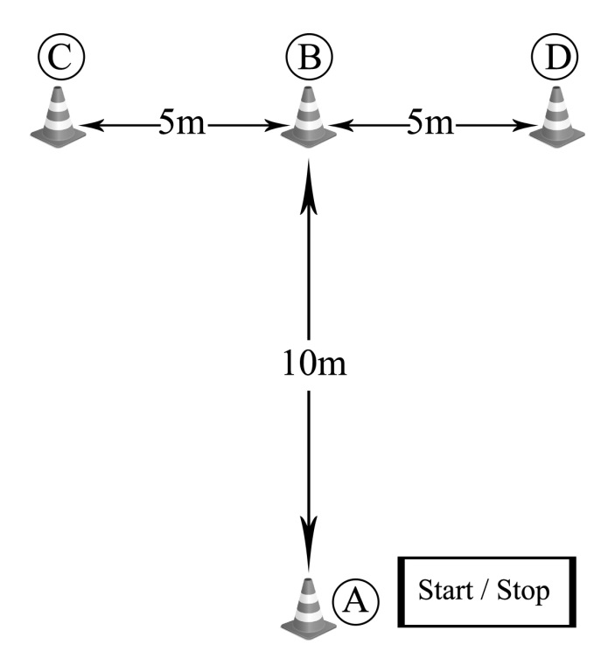

Figure 1.

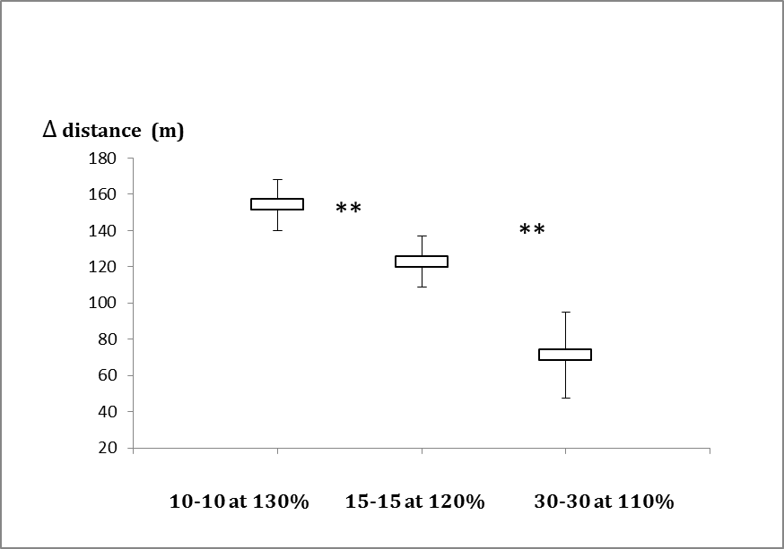
Figure 2.

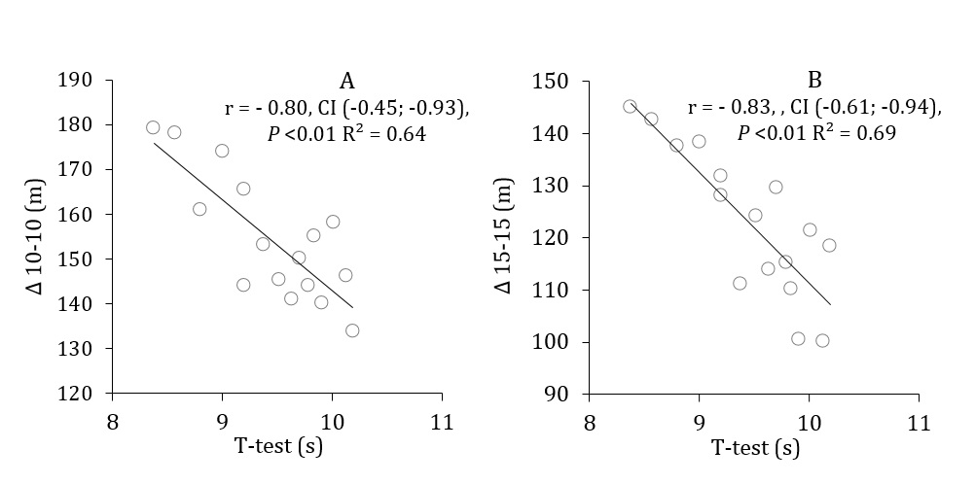
Figure 3.

