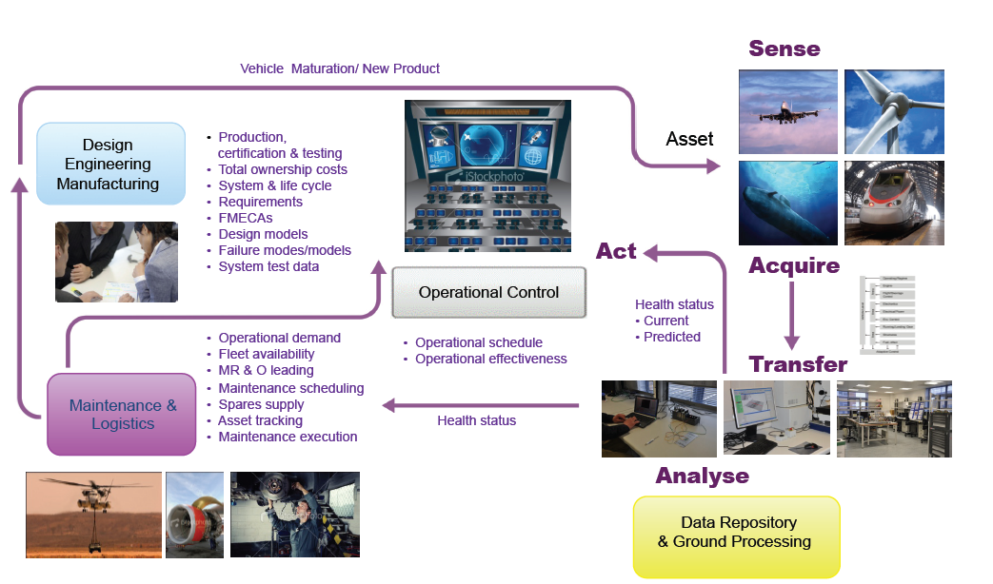
Figure 1. Remote monitoring technology (right hand side of figure) as part of an overall service delivery (Jennions, 2011)

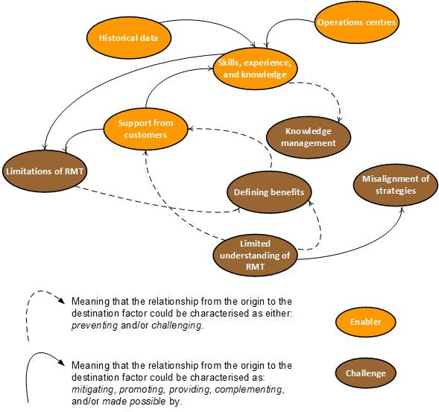
Figure 2. Challenges and enablers of RMT – examples from the case studies and literature
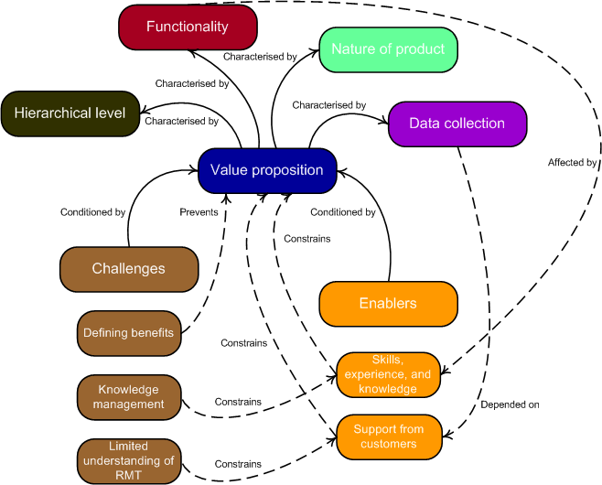
Figure 3. Complex nature of RMT and servitized strategies - examples

