Title: The violation of Fitts’ Law: an examination of displacement biases and corrective submovements

James W. Roberts,ª Jarrod Blinch,^{b}
Digby Elliott,^{a,c,e} Romeo Chua,^{b} James L. Lyons,^{a,e} Timothy N. Welsh^{d,e}

ª: Motor Behaviour Laboratory, Department of Kinesiology, McMaster University,
Hamilton, ON, L8S 4L8, Canada

^{b}: School of Kinesiology, University of British Columbia,
Vancouver, BC, V6T 1Z1, Canada

^{c}: Brain and Behaviour Laboratory, Liverpool John Moores University,
Liverpool, L3 5AF, UK

^{d}: Faculty of Kinesiology and Physical Education, University of Toronto,
Toronto, ON, M52 2W6, Canada

^{e}: Centre for Motor Control, University of Toronto,
Toronto, ON, M52 2W6, Canada
Corresponding author:
Timothy N. Welsh
Faculty of Kinesiology and Physical Education, University of Toronto, Toronto, ON, M52 2W6, Canada
t.welsh@utoronto.ca
Acknowledgements
These works were supported by several grants awarded from the Natural Sciences and Engineering Research Council (NSERC) of Canada. We thank Dr. Steve Hansen for his ideas on how best to present the data.

The final publication is available at Springer via http://dx.doi.org/10.1007/s00221-016-4618-4
Abstract
Fitts’ Law holds that, to maintain accuracy, movement times of aiming movements must change as a result of varying degrees of movement difficulty. Recent evidence has emerged that aiming to a target located last in an array of placeholders results in a shorter movement time than would be expected by the Fitts’ equation – a violation of Fitts’ Law. It has been suggested that the violation emerges because the performer adopts an optimized movement strategy in which they partially pre-plan an action to the closest placeholder (undershoot the last placeholder) and rely on a secondary acceleration to propel the limb toward the last location when it is selected as the target (Glazebrook et al., Hum Mov Sci, 39:163-176, 2015). In the current study, we examine this proposal and further elucidate the processes underlying the violation by examining limb displacement and corrective submovements that occur when performers aim to different target locations. For our Main Study, participants executed discrete aiming movements in a five-placeholder array. We also reanalysed data from a previously reported study in which participants aimed in placeholder and no placeholder conditions (Blinch et al., Exp Brain Res, 223: 505-515, 2012). The results showed the violation of Fitts’ Law unfolded following peak velocity (online control). Further, the analysis showed that movements to the last target tended to overshoot and had a higher proportion of secondary submovements featuring a reversal than other categories of submovement (secondary accelerations, discontinuities). These findings indicate that the violation of Fitts’ Law may, in fact, result from a strategic bias towards planning farther initial displacements of the limb which accommodates a shorter time in online control.

Keywords:
Fitts’ Law, movement optimization, reversal submovements, pre-planning, online control
Introduction
Fitts’ Law (Fitts, 1954; Fitts and Petersen, 1964) elegantly captures how movement times (MTs) of aiming movements change to maintain accuracy to targets of varying difficulty. It holds that the shortest MT required to maintain endpoint accuracy can be predicted from movement amplitude (A) and target width (W): MT = a + b(ID), where a and b are empirically derived constants (intercept and slope, respectively), and ID refers to the index of difficulty, which is calculated as log₂(2A/W). Recent evidence has emerged that there may be a violation of Fitts’ Law in some instances of target-directed aiming. Specifically, a growing number of studies have revealed that MTs for aiming movements to the last target in an array of placeholders are shorter than predicted by the Fitts’ equation (e.g., Adam, Mol, Pratt and Fischer, 2006; Keulen, Adam, Fischer, Kuipers and Jolles, 2002). In this paradigm, the performer executes discrete aiming movements to one of a number of possible target locations within a block of trials with each target being the same size, but at different amplitudes. In the placeholder condition, there are square outlines (placeholders) that indicate each potential target location in advance of the target being presented. The target for a given trial is subsequently indicated by the appearance of a solid square in one of the placeholders. In the no placeholder condition, there are no placeholders present and the target is indicated by the sudden appearance of a solid square in an otherwise blank space. It has been repeatedly reported that, although the MT for the farthest target location is consistent with that predicted by Fitts’ Law in the no placeholder condition, the MT for this farthest target is shorter than predicted by Fitts’ Law in the placeholder condition. Although this violation has been observed and reported many times, it remains unclear as to why this violation occurs only in the placeholder condition.
Recently, researchers have strived to investigate the relative contribution of the planning and control processes underlying the violation of Fitts’ Law by measuring and analysing the kinematics of the movement during early and late phases of the trajectory. This approach follows from the principle that the time spent reaching early kinematic landmarks (peak acceleration, peak velocity) is primarily associated with planning-based processes that occur prior to movement initiation (initial impulse phase). This portion is frequently associated with the use of an efference copy courtesy of the motor command, along with previous ‘state’ information, to form both forward dynamic and sensory models. Thereafter, an estimate of the new ‘state’ and associated reafferent signals is respectively generated (Wolpert and Ghahramani, 2000; Wolpert, Miall and Kawato, 1998, see also Desmurget and Grafton, 2000, and Elliott et al., 2010). Corrections to the movement may still occur during these early stages, but these adjustments arise from assessments of error pertaining to motor efference and the consequent reafferent signals. Meanwhile, the time spent near the end of the movement is associated with the use of online sensory feedback to amend any movement errors (current control phase) (see Woodworth, 1899 and Elliott, Helsen and Chua, 2001). This portion primarily relies on external sources of afferent information and is constrained by a feedback processing time-lag (Elliott et al., 2010; Meyer, Abrams, Kornblum, Wright and Smith, 1988). To date, the research assessing the early and late phases of movements to the farthest target indicate that the violation of Fitts’ Law does not manifest in the time spent in the initial impulse, but instead, manifests in the time spent toward the end of the movement (Blinch, Cameron, Hodges and Chua, 2012; Glazebrook, Kiernan, Welsh and Tremblay, 2015). These data implicate online control processes in the violation of Fitts’ Law.
Based on the finding that the violation of Fitts’ Law emerges in the late stages of the movement, Glazebrook et al. (2015) suggested that the shorter than predicted MTs to the last-placed target emerged because the initial response was planned to undershoot the last-placed target followed by a correction to the movement via a secondary acceleration (i.e., negative-to-positive acceleration zero-crossing). Indeed, the secondary acceleration may provide the essential drive to the limb to reach the target sooner than usual. This strategy presents a potentially “ambitious” (Glazebrook et al., 2015, p. 174) attempt of the performer to land on the last-placed target by adopting a correction procedure that is more time- and energy-efficient than other forms of correction. To elucidate, Glazebrook et al. noted that in the presence of placeholders, the performer knows of all the potential target locations prior to target onset. As a result, when forming a strategy to complete an accurate aiming movement in as short a time as possible, they weigh the cost of an error and the subsequent corrective submovements required to amend for this error (i.e., undershoot/overshoot). If the performer mistakenly moves beyond the desired target location, then they would have to engage in a large deceleration or even a reversal submovement to land on the target. According to the view of movement optimization (Elliott, Hansen, Mendoza and Tremblay, 2004; Lyons, Hansen, Hurding and Elliott, 2006; Oliveria, Elliott and Goodman, 2005; cf. Meyer et al., 1988), the performer attempts to avoid this particular scenario because they would then have to expend more time and energy to overcome inertia and switch the roles of agonist-antagonist muscle groups to reverse the limb. Hence, performers plan their initial response to the closest location. When the farthest location ends up being the target, the initially planned movement will be too short and the limb position would be amended by re-accelerating onto the target. Presumably, the secondary acceleration serves only to efficiently advance the movement toward the last-placed target because re-accelerating toward the preceding shorter-amplitude targets may risk a terminal overshoot. In the instance of a shorter-amplitude location being selected as the target, then the performer would most likely have to amend via more prolonged discontinuities (i.e., inflection points in negative acceleration). Although this proposed strategy can account for the data reported thus far, the proposal has yet to be empirically evaluated.
Thus, the aim of the current study was to examine the planning and control processes underlying the violation of Fitts’ Law by assessing the nature of the corrective submovements. Such a detailed analysis is critical to evaluating the strategic movement approach suggested to result in a violation of Fitts’ Law (Glazbrook et al. 2015). In our Main Study, we report on the amplitude displacement and terminal biases, along with the submovement kinematics, that are associated with the violation of Fitts’ Law for aiming in a five-placeholder array (similar to Blinch et al., 2012). In addition, we sought to replicate and extend our initial findings, while assessing the specific influence of placeholders, by reanalysing data collected and reported by Blinch and colleagues (Blinch, et al., 2012). In the Blinch et al. study, there was a similar five-placeholder array condition (as in our Main Study) as well as a no placeholder condition. Therefore, we were able to examine whether the violation in Fitts’ Law, and accompanying displacement effects, could also be found in other empirical accounts and specifically in the presence of placeholders.

Main Study
Introduction
Although the finding of a violation in Fitts’ Law is rather robust, its aetiology has yet to be determined. Of interest, the recent suggestion of a violation coinciding with an optimized movement approach designed to prevent the cost of a potential error (Glazebrook et al., 2015) goes beyond the possibility of a perceptual antecedent (Adam et al., 2006; Pratt, Adam and Fischer, 2007) and potentially explains the influence of placeholders directly on motor processes (Bradi, Adam, Fischer and Pratt, 2009; Radulescu, Al-Aidroos, Adam, Fischer and Pratt, 2011). Previous accounts of the violation have brokered the contribution of planning and control processes to the violation of Fitts’ Law using at least some assessments of the kinematics (e.g., Blinch et al., 2012; Glazebrook et al., 2015). To date, however, no studies have directly examined the potential role of movement optimization and the associated nature of submovement kinematics (i.e., reversal/secondary acceleration/discontinuities). The following experiment explores this possibility by measuring the terminal biases and the nature of secondary submovements, in addition to the temporal performance measures typically used to indicate a violation. Based on previous work (e.g., Blinch et al., 2012; Glazebrook et al., 2015), we predicted a violation of Fitts’ Law when aiming toward the last-placed target in a placeholder array, and that this violation should unfold mainly within the time after peak velocity. Moreover, the terminal biases underlying the violation of Fitts’ Law may reflect a potentially longer amplitude displacement. In accordance with Glazebrook et al. (2015), it was expected that these reported displacement biases would coincide with an increased number of secondary accelerations following the primary movement.

Method
Participants
Sixteen participants (11 males, 5 females, age range = 22-38 years) from McMaster University agreed to take part in the study. All participants were self-declared right-handed and had normal or corrected-to-normal vision. Remuneration of $5 (CAD) was provided to each participant. The study was designed and conducted in accordance with the Declaration of Helsinki and approved by the University ethics committee.

Apparatus, Task and Procedures
The stimuli were presented on a 57 cm x 34 cm monitor with a temporal resolution of 60 Hz and a spatial resolution of 1024 x 768 pixels. The monitor surface was protected by a 5 mm-thick piece of Plexiglas. Aiming movements were recorded via an infrared sensor placed on the index finger of the right hand of the performer and detected using Optotrak (Northern Digital Instruments). Movements were sampled at 200 Hz for duration of 2 s, and triggered via a serial port connection from the computer.
The experimental procedure was controlled by a routine run in E-prime (Psychology Software Tools Inc). The movement environment featured a white background with five black outline square placeholders (10 mm x 10 mm) that were equidistant to each other (17 mm from centre-to-centre; 5 mm spacing, 5 mm target area and 1 mm border for each set of adjacent targets). The amplitudes from home position were 182, 199, 216, 233, and 250 mm for targets 1 to 5, respectively. The associated indices of difficulty were 5.19, 5.31, 5.43, 5.54, and 5.64 bits. The short range indices of difficulty were consistent with previous studies featuring the same paradigm (e.g., Adam et al., 2006). This stimulus arrangement was used because the allocentric information gleaned from the close-proximity placeholders, each of equal size, may subsequently influence the planning and control processes underlying the violation (e.g., Keulen et al., 2002; Pratt et al., 2007; see also Glover & Dixon, 2002 and Mendoza, Elliott, Meegan, Lyons and Welsh, 2006;). Together, it was imperative that small incremental changes to the movement amplitude be made. The task required participants to position their finger over the home location, and on target onset, move as quickly and accurately as possible to the target located on the right.
A trial commenced by positioning the index finger of the right hand at the highlighted home position (grey filled square). Following an 800-2800 ms random foreperiod, one of five possible target locations would turn on (black filled square) signalling the participant to move. Once the movement was completed and the trial duration ran its course, the screen display was extinguished for a period of 2000 ms. Thereafter, the target array was displayed once again with the home position highlighted and target locations unfilled. Target selection was randomized with the caveat that each location was selected once every set of five trials. There were a total of 100 trials with a short break after 50 trials. If necessary, additional breaks were provided to the participant throughout the experiment.

Data processing and analysis
Position data were filtered using a dual-pass second-order Butterworth filter with a low-pass cut-off frequency of 10 Hz. Data were differentiated and double-differentiated to obtain velocity and acceleration, respectively. Movement onset was identified as the first moment in which the velocity rose above +10 mm/s for at least 40 ms (8 samples) in the primary direction of movement (x-axis). Movement offset was identified as the moment in which the velocity fell within +10 mm/s and -10 mm/s for at least 40 ms. The point of a secondary submovement was identified for each trial by one of three criteria: reversals, secondary accelerations, and discontinuities in acceleration (Burkitt, Staite, Yeung, Elliott and Lyons, 2015; Chua and Elliott, 1993; Fradet, Lee and Dounskaia; Khan et al., 2006). Reversals were identified by a positive-to-negative velocity zero-crossing that fell below -10 mm/s for at least 40 ms. Secondary accelerations were identified by a negative-to-positive acceleration zero-crossing featuring a velocity inflection that reached a relative maxima of 5 mm/s, and upheld a velocity magnitude greater than the point of inflection for at least 40ms. Finally, discontinuities were identified by an inflection in the negative acceleration trace that resulted in a relative magnitude of 10% of the greatest absolute acceleration for at least 40 ms. In the event there was more than one of these submovement criteria within a single trial, the marker earliest in time was selected as the moment of a secondary submovement (and primary movement endpoint).
As a measure of the violation of Fitts’ Law, we calculated linear regression equations (MT = a + b(ID)) for each participant based on their mean MT toward the first four targets. Using the intercept (a) and slope coefficient (b), we extrapolated the predicted MT for the last-placed target (ID) and then calculated the difference between this predicted MT and the actual MT. A violation in Fitts’ Law would be indicated by a negative mean difference score that is significantly different from zero (i.e., shorter MT than expected). Thus, we conducted a one-tailed single-sample t-test comparing the mean difference score to a theoretical value of zero. In addition, we determined the relative contribution of planning and control processes to the violation of Fitts’ Law by brokering differences into the times to, and after, peak velocity using the same procedure of extrapolating time for the last-placed target based on MTs of the first four targets. These differences were analysed by conducting one-tailed single-sample t-tests using a theoretical value of zero, as well as a one-tailed paired sample t-test directly comparing difference scores between the time to and after peak velocity.
As an adjunct to the difference scores, we performed bivariate correlations on each individual participant to assess the linear relation between the indices of difficulty and MTs for the first four targets, as well as MTs for all five targets. The correlation coefficients were then Fisher-z transformed. A violation of Fitts’ Law would be indicated by a poorer linear fit, or lower mean z-score, for the relation involving MTs to targets 1 to 5 compared to the relation involving movements to targets 1 to 4. Once more, to determine the contribution of planning and control processes, the linear relations for the times to, and after, peak velocity in targets 1 to 4 and targets 1 to 5 were also calculated. For each of these linear relations, we conducted one-tailed paired-sample t-tests comparing z-scores for targets 1 to 4 with targets 1 to 5.
Due to the potential of a violation resulting in a trade-off between speed and accuracy, we assessed the proportion of trials in which the finger terminated on the target (i.e., an accurate movement endpoint). A successful target hit was defined as a terminal position that landed within the correct target location (> -5 mm and < +5 mm from target centre). Terminal biases and dispersion were determined by calculating the mean constant error (signed differences between movement end position and target centre; negative scores indicating undershoots) and variable error (standard deviation of the signed error differences) at each individual target location. The propensity for secondary submovements was determined by calculating the proportion of trials with two-component submovements for each of the target locations. Moreover, we categorised the submovement trials by calculating the proportion of submovements marked by a reversal, secondary acceleration, or discontinuities in acceleration.
Trials that exceeded a MT of 800 ms and/or reaction times less than 100 ms, or more than 1000 ms, were deemed to violate the task objectives and thus removed prior to analyses. In addition, we removed trials indicating an incorrect target selection (> +10 mm or < -10mm from target centre) (see Glazebrook et al., 2015). In total, there were only 3.38% of trials removed prior to the analysis. Hit rate, constant error, variable error and proportion of trials with a secondary submovement were all analysed using a one factor repeated-measures ANOVA. The proportional category of submovements were analysed using a 3 category (reversal, second acceleration, discontinuities) by 5 target (T1, T2, T3, T4, T5) repeated-measures ANOVA. A significant interaction between category and target was decomposed using one factor repeated-measures ANOVA comparing targets at each level of submovement category. Significant effects emerging in these simple effect ANOVAs were subsequently decomposed using a Tukey HSD post-hoc procedure (p < .05).

Results and Discussion
Target hit rate indicated no significant main effect of target, F(4, 60) < 1, (M = 77.6%, SE = 4.13). Thus, performers were equally successful at contacting the different target locations. The absence of differences in the rate of target successes validates our MT analysis because there was no evidence of a difference in the speed/accuracy trade-off accounting for the potential violation of Fitts’ Law.

Violation of Fitts’ Law
The actual-to-predicted MT difference for movements to the last-placed target indicated a difference score that was significantly lower (M = -16 ms, SE = 7) than a theoretical value of zero, t(15) = 2.21, p = .02, partial ƞ² = .25 (Fig. 1A). The actual-to-predicted difference in the separate phases of the trajectory revealed no significant violation for the time to peak velocity, t(15) = .43, p =.33, partial ƞ² = .01, although there was a violation for the time after peak velocity, t(15) = 2.14, p = .02, partial ƞ² = .23 (Fig. 1B). The one-tailed paired-sample t-test directly comparing these separate phases revealed a significantly greater violation for the time after peak velocity, t(15) = 2.02, p = .03, partial ƞ² = .22.
The comparison between z-transformed linear relations revealed a trend toward a higher positive relation for targets 1 to 4 (M = .97, SE = .15) compared targets 1 to 5 (M = .74, SE = .12), t(15) = 1.45, p = .08, partial ƞ² = .12. Moreover, there was no significant difference in the linear relations for the time to peak velocity (1 to 4: M = 1.40, SE = .19; 1 to 5: M = 1.50, SE = .19), t(15) = 1.24, p = .12, partial ƞ² = .09, and the time after peak velocity, (1 to 4: M = .83, SE = .16; 1 to 5: M = .62, SE = .11), t(15) = 1.28, p = .11, partial ƞ² = .10.

Insert Fig. 1 about here

Terminal biases and endpoint dispersion
For constant error, there was a significant main effect of target, F(4, 60) = 2.84, p < .05, partial ƞ² = .16, indicating a greater overshoot for the farthest location, T5, compared to the middle location, T3 (Fig. 2A). Meanwhile, there was no significant effect of target for variable error, F(4, 60) < 1 (M = 2.82 mm, SE = .16). Therefore, performers tended to extend their terminal endpoint toward the last-placed target, while exhibiting similar levels of dispersion. This finding may point to a more efficient online control process geared toward the last-placed target because faster than predicted movements at longer amplitudes would typically coincide with increases in dispersion (Schmidt, Zelaznik, Hawkins, Frank and Quinn, 1979). To further examine this possibility, we calculated the Coefficient of Variation (CoV) in which endpoint dispersion was normalized with respect to amplitude displacement (endpoint dispersion / endpoint displacement) (see Khan et al., 2006). The rationale being that more efficient online control would manifest in lower levels of normalized dispersion. The ANOVA revealed a significant effect of target, F(4, 60) = 6.68, p < .001, partial ƞ² = .31, indicating a lower CoV at T5 (M = .011, SE = .001) compared to T1 (M = .017, SE = .001) and T2 (M = .016, SE = .001).

Insert Fig. 2 about here

Proportion of submovements
The mean number of trials featuring corrective submovements was 89.27% ± 2.16. The ANOVA revealed no significant effect of target, F(4, 60) = 2.47, p = .072, partial ƞ² = .14. The analysis of submovement categories revealed a significant main effect of category, F(2, 30) = 32.06, p < 001, partial ƞ² = .68, indicating a larger number of trials featuring a reversal (M = 69.49%, SE = 5.14) compared to a secondary acceleration (M = 14.61%, SE = 2.14), and discontinuities (15.90%, SE = 5.50), with no difference for the latter two categories (Table 1). There was no significant main effect of target, F(4, 60) = 1.57, p >.05, partial ƞ² = .10, although there was a significant category by target interaction, F(8, 120) = 7.21, p < 001, partial ƞ² = .32.
The simple effect ANOVA for each level of submovement category showed a significant effect of target for the reversals, F(4, 60) = 9.84, p < 001, partial ƞ² = .40, with a greater proportion for the farther targets (T4, T5) compared to the initial targets (T1, T2), and more for the last-placed target, T5, than the middle-placed target, T3. The secondary accelerations also revealed a significant effect of target, F(4, 60) = 5.99, p < 001, partial ƞ² = .29, indicating a lower proportion for T5 compared to T1, T2 and T3. There was a significant effect of target for the discontinuities, F(4, 60) = 3.88, p < 05, partial ƞ² = .21, although further comparisons failed to isolate the differences between target locations (ps > .05).

Table 1 Proportion of submovement categories (%) (positive-to-negative velocity zero-crossing, negative-to-positive acceleration zero-crossing, non-positive acceleration minimums) for separate target locations (T1-T5).1
 | T1 | T2 | T3 | T4 | T5
Velocity  zero-crossings | 63.53  (5.42) | 60.66  (6.60) | 68.28  (5.64) | 75.35  (4.85) | 79.63  (5.42)
Acceleration zero-crossings | 18.78  (3.16) | 18.02  (3.40) | 17.98  (3.10) | 11.96  (2.80) | 6.33  (1.81)
Acceleration minimums | 17.69  (5.10) | 21.33  (6.62) | 13.74  (6.02) | 12.69  (4.89) | 14.04  (5.87)
- To indicate whether the large proportion of reversals was not a result of a conservative offset threshold (< 10 mm/s and > -10mm/s) the mean velocity magnitudes at the moment of reversal were identified. A substantial mean velocity of 79.98 mm/s ± 8.09 suggested a suitable parsing procedure for detecting reversal submovements.

Overall, there was a violation of Fitts’ Law when the performer was presented with a placeholder array. The violation appeared to unfold near the end of the movement following peak velocity. This pattern of results is consistent with previous findings indicating that the violation occurs during the online control phase of the movement (Blinch et al., 2012; Glazebrook et al., 2015). Though hit rates were similar, the terminal biases reflect a tendency for a greater overshoot toward the last-placed target. Moreover, this location was predominantly reached following a secondary submovement that saw the performer reverse limb direction. Therefore, when the last location in the placeholder array was selected as the target, the performer appeared to make a large amplitude movement before finally reversing the limb in order to reach the target. This finding conflicts with suggestions of an optimal movement response strategy featuring an initial movement that comes short of the array followed by a secondary acceleration (Glazebrook et al., 2015).
The potential for greater amplitude biases followed by a reversal however seems counter-intuitive given the cost of an overshoot followed by a reversal requires more time and energy to reach the desired target location (Elliott et al., 2004). Therefore, we conducted an additional analysis involving the parsing of MTs for trials featuring a reversal submovement vs. non-reversal submovement (i.e., secondary acceleration, deviations). We analysed the MTs using a 2 category (reversal, non-reversal) by 5 target (T1, T2, T3, T4, T5) repeated-measures ANOVA.¹ There were no significant main effects of category, F(1, 10) < 1, target, F(4, 40) = 1.11, p > 05, partial ƞ² = .10, nor a category by target interaction, F(4, 40) > 1 (reversal MT: M = 429 ms, SE = 16; non-reversal MT: M = 437 ms, SE = 16). Therefore, in the context of a placeholder array, it would appear there is little or no cost of a reversal submovement on overall temporal performance.

Reanalysis of Blinch et al. 2012
Introduction
To corroborate the findings and conclusions of our Main Study, we revisited and reanalysed a previous data set featuring a similar protocol with a detailed recording of movement trajectories (i.e., Blinch et al., 2012). Though these data have been reported previously, the following analysis was not previously conducted and, as such, may garner greater understanding of the strategy adopted by performers by elaborating on the nature of submovement kinematics. With these data, we conducted the same set of analyses we conducted for the data set from the Main Study and were also able to compare a placeholder condition with a no placeholder condition (i.e., target location in isolation but occupying the same absolute location as the placeholder). Our aim was to determine if we could reproduce the findings from our Main Study, and most importantly, assess the specific role of the placeholders in the movement trajectories.
In the Blinch et al. (2012) study, there was a violation of Fitts’ Law that was isolated toward the end of the movement (i.e., time during which secondary submovements are executed). Moreover, the violation was evident only when the upcoming target location remained unknown to the performer. That is, pre-cuing the target location in a placeholder condition reinstated Fitts’ linear relation between MT and ID. Therefore, we limited our analyses to the placeholder and no placeholder conditions without a precue.

Method
Participants
Twenty participants (13 males, 7 females, mean age = 27 years) from the University of British Columbia took part in the study. All participants were self-declared right-handed and had normal or corrected-to-normal vision. The study was designed and conducted in accordance with the Declaration of Helsinki and approved by the University of British Columbia ethics committee.

Apparatus, Task and Procedures
Stimuli were presented via an LCD monitor held above a table-top with a half-silvered mirror in between. Light was reflected from under the mirror so participants could perceive their limb moving on the projected stimulus. Trials commenced by highlighting the home position to signal the participant to relocate the hand-held stylus. Following a 1-2 s variable foreperiod, the target appeared on the screen signalling participants to move. The target was presented either in isolation with no surrounding placeholders or featured four other adjacent placeholders. The target (and placeholder) dimensions were 10 x 10 mm, and each separated by 5 mm. The amplitudes from home position were 160, 175, 190, 205 and 220 mm for targets 1 to 5 respectively. The associated indices of difficulty were 5.00, 5.13, 5.25, 5.36, and 5.46 bits. For further methodological detail, please refer to Blinch et al. (2012).

Data processing and analysis
Processing of triangulated position data and identification criteria for onset/offset and secondary submovements were the same as in our Main Study. In addition, kinematic landmarks including peak acceleration (PA), peak velocity (PV), peak deceleration (PD) and movement end (END) were extracted. These landmarks provide further details of the trajectory characteristics underlying the violation of Fitts’ Law. This assessment was afforded by the introduction of the no placeholder condition because it draws comparisons between conditions (placeholder vs. no placeholder) at each level of target location (T1-T5).
The violation of Fitts’ Law was again indicated by measures of actual-to-predicted MT differences and differences in the linear relations between targets 1 to 4 and targets 1 to 5. In addition to the analyses that were also conducted in our Main Study, a series of one-tailed paired-sample t-tests were used to directly compare the actual-to-predicted differences between placeholder and no placeholder conditions. Hit rate, constant error, variable error, displacement at kinematic landmarks, and the proportion of trials with secondary submovements were all analysed using a 2 placeholder (placeholder, no placeholder) by 5 target (T1, T2, T3, T4, T5) repeated-measures ANOVA. Spatial variability at kinematic landmarks was analysed using a 2 placeholder by 5 target by 4 kinematic landmark (PA, PV, PD, END) repeated-measures ANOVA. The proportion of submovement categories were analysed using a 3 category (reversal, secondary acceleration, discontinuities) by 2 placeholder by 5 target repeated-measures ANOVA. An interaction featuring the factor of category was subsequently decomposed using a 2 placeholder by 5 target repeated-measures ANOVA at each level of submovement category. Post hoc analyses were conducted using Tukey HSD post hoc procedure (p < .05).

Results and Discussion
Target hit rate revealed no significant main effect of placeholder, F(1, 19) < 1, target, F(4, 76) = 2.26, p > .05, partial ƞ² = .11, nor a placeholder by target interaction, F(4, 76) = 1.47, p > .05, partial ƞ² = .07 (M = 94.98%, SE = .69). Consistent with the first experiment, the absence of any differences in contacting the different target locations would suggest potential differences in MTs were not due to a speed-accuracy trade-off.²

Violation of Fitts’ Law
The actual-to-predicted MT difference for movements to the last-placed target indicated a close to significant difference compared to a theoretical value of zero for the placeholder condition, t(19) = 1.45, p = .08, partial ƞ² = .10, and no difference for no placeholder condition, t(19) = 1.09, p = .29, partial ƞ² = .06 (Fig. 1C). The one-tailed paired sample t-test comparing difference scores in each of the placeholder conditions revealed a significantly lower score for the placeholder compared to no placeholder condition, t(19) = 1.93, p = .03, partial ƞ² = .16.
The actual-to-predicted difference in the separate phases of the trajectory revealed no significant violation for the time to peak velocity in both the placeholder, t(19) = .73, p = .24, partial ƞ² = .03, and no placeholder conditions, t(19) = .36, p = .36, partial ƞ² = .01 (Fig. 1D). Moreover, the paired-sample t-test revealed no significant difference between the placeholder and no placeholder conditions, t(19) = .10, p = .46, partial ƞ² = .00. However, there was a close to significant violation for the placeholder condition in the time after peak velocity, t(19) = 1.63, p = .06, partial ƞ² = .12, but no difference for the no placeholder condition, t(19) = 1.01, p = .16, partial ƞ² = .05. The comparison between placeholder conditions revealed a significantly lower score for the placeholder compared to no placeholder condition, t(19) = 2.15, p = .02, partial ƞ² = .20. In addition, a comparison between the separate phases of the trajectory revealed a significantly greater violation for the time after, compared to the time to, peak velocity for the placeholder condition, t(19) = 1.75, p = .048, partial ƞ² = .10, but no difference for the no placeholder condition, t(19) = .88, p = .19, partial ƞ² = .04.
The z-transformed linear relations showed a significantly higher positive relation at targets 1 to 4 (M = 1.39, SE = .21) compared to targets 1 to 5 (M = 1.08, SE = .15) for the placeholder condition, t(19) = 2.38, p = .01, partial ƞ² = .23, but no difference for the no placeholder condition, t(19) = 1.07, p = .15, partial ƞ² = .06 (targets 1 to 4: M = 1.05, SE = .12; targets 1 to 5: M = .95, SE = .13). Although there were no significant differences for linear relations in the time to peak velocity for the placeholder, t(19) = .30, p = .39, partial ƞ² = .01 (1 to 4: M = 1.78, SE = .15; 1 to 5: M = 1.74, SE = .09), and no placeholder conditions, t(19) = .80, p = .22, partial ƞ² = .03 (1 to 4: M = 1.77, SE = .19; 1 to 5: M = 1.68, SE = .14), there was a significantly higher positive relation in the time after peak velocity at targets 1 to 4 compared to targets 1 to 5 for the placeholder condition, t(19) = 2.36, p = .01, partial ƞ² = .23 (1 to 4: M = 1.15, SE = .17; 1 to 5: M = .74, SE = .11), but no difference for the no placeholder condition, t(19) = .21, p = .42, partial ƞ² = .00 (1 to 4: M = .91, SE = .16; 1 to 5: M = .88, SE = .12).

Displacement biases and spatial dispersion
For constant error, there was a significant main effect of target, F(4, 76) = 11.14, p < .001, partial ƞ² = .37, though this was superseded by a significant placeholder by target interaction, F(4, 76) = 8.32, p < .001, partial ƞ² = .31 (Fig. 2B). Post hoc analysis revealed greater undershoots at T1, T2 and T3, and an overshoot at T5, for the placeholder compared to no placeholder condition. For the most part, the displacement at kinematic landmarks was consistent with the terminal biases. That is, there was a significant placeholder by target interaction for displacements at peak acceleration, F(4, 76) = 2.76, p < .05, partial ƞ² = .13, peak deceleration, F(4, 76) = 5.76, p < .001, partial ƞ² = .23, and movement end, F(4, 76) = 9.40, p < .001, partial ƞ² = .33. Post hoc analyses indicated a larger amplitude displacement for T5 at each of the respective landmarks for the placeholder compared to no placeholder condition. Moreover, there was a shorter amplitude displacement at peak deceleration in T1 and T2 for the placeholder condition. The displacement at peak velocity revealed a placeholder by target interaction that failed to reach significance, F(4, 76) = 2.34, p = .075, partial ƞ² = .11, though indicating a similar pattern of results.
For variable error, there was no significant main effect of placeholder, F(1, 19) > 1, and target, F(4, 76) = 1.68, p > .05 partial ƞ² = .08, nor a placeholder by target interaction, F(4, 76) = 2.17, p > .05, partial ƞ² = .10 (M = 2.29 mm, SE = .10). The spatial variability at kinematic landmarks revealed a significant main effect of placeholder, F(1, 19) = 53.54, p < .001 partial ƞ² = .74, target, F(4, 76) = 14.55, p < .001 partial ƞ² = .43, and kinematic landmark, F(3, 57) = 109.62, p < .001 partial ƞ² = .85, which indicated increasing dispersion from peak acceleration to peak deceleration before decreasing toward the end of the movement. In addition, there was no significant placeholder by target by kinematic landmark interaction, F(12, 228) = 2.03, p = .072 partial ƞ² = .10, while further decomposing using a placeholder by target repeated-measures ANOVA at each level of kinematic landmark also revealed no significant placeholder by target interactions [PA: F(4, 76) = 1.13, p > .05, partial ƞ² = .06; PV: F(4, 76) = 1.78, p > .05, partial ƞ² = .09, PD: F(4, 76) > 1, END: F(4, 76) = 2.22, p = .075, partial ƞ² = .11].

Proportion of submovements
The mean number of trials featuring secondary submovements was 91.91% ± 2.56. The ANOVA revealed no significant main effect of placeholder, F(1, 19) < 1, target, F(4, 76) < 1, nor a placeholder by target interaction, F(4, 76) < 1.
The analysis of submovement categories revealed a significant main effect of category, F(2, 38) = 23.50, p < .001, partial ƞ² = .55, indicating a greater proportion of reversals (M = 60.1%, SE = 5.4) compared to secondary accelerations (M = 7.7%, SE = 1.2) and discontinuities (M = 32.2%, SE = 5.2) (Table 2). There was a significant category by placeholder by target interaction, F(8, 152) = 3.34, p < .01, partial ƞ² = .15. Placeholder by target repeated-measures ANOVAs at each level of submovement category revealed a significant placeholder by target interaction for reversals, F(4, 76) = 5.07, p > .01, partial ƞ² = .21, which indicated a lower proportion at the first-placed target, T1, and a higher proportion at the last-placed target, T5, for the placeholder compared to no placeholder condition. There was no significant placeholder by target interaction for secondary accelerations, F(4, 76) < 1. Meanwhile, there was a significant placeholder by target interaction for discontinuities, F(4, 76) = 1.82, p > .05, partial ƞ² = .09, with an increased proportion at T1 for the placeholder compared to no placeholder condition.

Table 2 Proportion of submovement categories (%) (positive-to-negative velocity zero-crossing, negative-to-positive acceleration zero-crossing, non-positive acceleration minimums) for separate placeholder (placeholder, no placeholder) and target conditions (T1-T5).
 |  | T1 | T2 | T3 | T4 | T5
Velocity  zero-crossings | No Placeholder | 62.90  (6.32) | 63.06  (5.79) | 58.17  (6.01) | 56.47  (5.48) | 60.93  (6.64)
Velocity  zero-crossings | Placeholder | 52.74  (5.61) | 60.22  (5.53) | 57.80  (6.52) | 60.93  (5.88) | 67.54  (6.07)
Acceleration zero-crossings | No Placeholder | 7.73  (2.19) | 7.19  (1.54) | 8.40  (2.65) | 9.07  (2.23) | 6.16  (2.11)
Acceleration zero-crossings | Placeholder | 11.03  (2.22) | 6.92  (1.77) | 8.64  (1.82) | 7.85  (1.54) | 4.38  (1.31)
Acceleration minimums | No Placeholder | 29.37  (6.29) | 29.75  (5.71) | 33.42  (5.64) | 34.46  (5.43) | 32.91  (6.33)
Acceleration minimums | Placeholder | 36.23  (5.96) | 32.86  (5.36) | 33.56  (5.99) | 31.22  (5.87) | 28.08  (6.09)

Similar to our Main Study, we examined the temporal cost of a reversal vs. non-reversal submovements (secondary acceleration, discontinuities). The MTs were analysed using a 2 category (reversal, non-reversal) by 2 placeholder (placeholder, no placeholder) by 5 target (T1, T2, T3, T4, T5) repeated-measures ANOVA.³ There was a significant main effect of target, F(4, 56) = 9.35, p < .001, partial ƞ² = .40, and a category by placeholder interaction that failed to reach significance, F(4, 76) = 1.82, p = .05, partial ƞ² = .09 (reversal MT: no placeholder M = 509 ms, SE = 11, vs. placeholder M = 502 ms, SE = 12; non-reversal MT: no placeholder M = 512 ms, SE = 12, placeholder M = 516 ms, SE = 11). In sum, there appeared to be little or no cost to temporal performance following the predominant tendency to execute reversal submovements compared to non-reversal submovements at the last-placed target.
Together, there was a violation of Fitts’ Law when moving to the last-placed target, but only within a placeholder array. This violation appeared isolated toward the end of the movement following peak velocity. The violation shown in the placeholder condition was coincident with an increased tendency to undershoot the initial target locations and overshoot the last-placed target. These terminal biases were also reflected in the nature of the secondary submovements as the placeholder increased the proportion of discontinuities and reversals at the first- and last-placed targets, respectively. Therefore, there was a ‘repulsion effect’ where the performer moves even further away from the adjacent middle placeholders (T2, T3, T4). This finding replicates previous evidence from aiming in a placeholder context (Adam et al., 2006), and opposes the typical ‘range effect’ found in a no placeholder context (i.e., longer movement amplitude toward the first target, shorter movement amplitude toward the last target; see Pepper and Herman, 1970). This effect may unfold because the performer tries to avoid the competition of potential movement responses geared toward the middle-placed targets (Adam et al., 2006; Welsh and Elliott, 2004). Moreover, the examination of MTs for reversal and non-reversal submovements showed a limited impact of having moved farther and reversing limb direction following an overshoot compared to undershooting the target.
Of interest, the increased terminal biases and greater proportion of reversals directed toward the last-placed target failed to have an influence on spatial dispersion. These findings are clearly illustrated in an endpoint distribution plot for the terminal endpoints at target 5 (see Fig. 3). Noteworthy are the similar levels of spatial dispersion, although the form of the distribution plot (indicating tendency) differs substantially between placeholder and no placeholder conditions. More specifically, the no placeholder condition (black bars) shows a more symmetrical profile in which participants generally landed short of or on the target (as indicated by ‘0’). Alternatively, the placeholder condition (white bars) demonstrates a rather positive skew featuring a greater number of overshoots. This finding is rather unexpected because shorter MTs for longer amplitude movements typically lead to increases in dispersion (Schmidt et al., 1979). It may be that despite increases in amplitude displacement the placeholder array somehow enhances online control for later decreases in dispersion.

Insert Fig. 3 about here

General Discussion
The aim of the present studies was to garner a greater understanding of the processes underlying the violation of Fitts’ Law by examining the associated amplitude displacement and terminal biases, along with the nature of secondary submovements. It was predicted that there would be a violation exhibited in MTs to the last-placed target location and that this violation would unfold specifically near the end of the movement. Moreover, it was predicted there would be a slight overshoot for the last-placed target that could potentially follow a secondary acceleration (Glazebrook et al., 2015). Moreover, we predicted these results would unfold specifically for the placeholder rather than no placeholder condition. In part, the results are consistent with our hypotheses. That is, participants showed a violation of Fitts’ Law including a shorter MT than expected for the last-placed target in a placeholder array. The violation was isolated toward the end of the movement following peak velocity. In addition, there was an increased tendency to overshoot the last-placed target. This overshoot, however, predominantly unfolded following a reversal submovement, as opposed to a secondary acceleration or a discontinuity in negative acceleration. These effects were shown to emerge only when movements were executed in the presence of placeholders. The evidence of a violation in Fitts’ Law being isolated toward the end of the movement (i.e., after peak velocity), or during online control, is consistent with previous findings of a violation unfolding after the primary movement (Blinch et al., 2012), and following peak velocity (Glazebrook et al., 2015). Therefore, it would appear the presence of placeholders helps to ease the negative temporal impact of visual feedback processing associated with late online control. This phase of the trajectory is typically associated with using sensory information for the amendment of errors (Elliott, Helsen and Chua, 2001). This conjecture is supported by findings from our Main Study because the Coefficient of Variation (i.e., variability/end position) was lower at the last-placed target compared to the initial two targets (T1, T2). Due to the fact that faster movements at longer amplitudes typically lead to increased dispersion (Schmidt et al., 1979), the lower Coefficient of Variation is taken as evidence of greater and more efficient online control for these movements (Proteau, Roujoula and Messier, 2009; see also Khan et al., 2006). Though the violation of Fitts’ Law found at the end of the movement may already be well-established; why it takes place remains to be fully elucidated.
Interestingly, the terminal biases reflected a stronger tendency for participants to overshoot at the last-placed target in a placeholder array. The differences in terminal bias appeared to manifest as early as peak acceleration. This difference was compounded by the increased propensity to correct an overshoot with a reversal. These findings appear to conflict with suggestions that the performer initially biases their pre-planned movement to the closer location of the array before eliciting an additional accelerative burst (i.e., secondary acceleration) toward the desired farther target location (Glazebrook et al., 2015). Note that Glazebrook et al.’s suggestion was adapted from a view of movement optimization (Elliott et al., 2004; Lyons et al., 2006; Oliveria et al., 2005; see Sparrow and Newell, 1998 and Worringham, 1991) in which the performer selects to undershoot the desired target location to avoid a potential overshoot error that requires more time and energy to amend. Indeed, this idea complements the notion of performers planning for the ‘worse-case scenario’ outcome (Elliott et al., 2004). In keeping with this view, however, when the performer in the placeholder condition knows all the potential target locations in advance, that individual may prioritise and consequently bias their planning toward the last-placed location because it features the largest possible amplitude to be selected. In turn, we argue that this ‘prioritising’ of the last-placed location may lead to a smaller chance of a target undershoot compared to a more typical aiming circumstance, such as in the no placeholder condition. This conjecture is supported by previous evidence of movement endpoint locations being strongly influenced by the pre-planning processes that follow the reinforcement of upcoming trial proceedings (i.e., prior knowledge) (Elliott et al., 2014; Khan, Elliott, Coull, Chua and Lyons, 2002; Khan, Lawrence, Buckolz and Franks, 2006). Though this proposal is consistent with the idea that the violation reflects a strategic movement bias, the nature of the bias is quite different from the one suggested by Glazebrook et al. (2015).
Of note, our detailed analysis revealed that the increased proportion of reversals failed to result in a cost to MT when compared to other categories of submovement (secondary acceleration, discontinuities). This finding may indicate that the type of overshoot and subsequent reversal associated with the placeholder condition may be different from the overshoots and reversals that occur because of the stochastic principles associated with impulse variability (see Elliott et al., 2010; Meyer et al., 1988; Schmidt et al., 1979). Specifically, these overshoots and reversals reflect unexpected errors in the limb trajectory that must be corrected. Because they are not planned, they can take extra time to correct (Elliott et al., 2004). If the placeholder condition creates a strategic foundation for an overshoot at the last target, the subsequent reversal may actually be part of the pre-planning process. For example, the performer may take advantage of the same muscular forces used to decelerate the limb (i.e., antagonist) by transitioning to a reversal toward the target location (i.e., agonist) (Adam, van der Bruggen and Bekkering, 1993; Guiard, 1993; Roberts, Elliott, Lyons, Hayes and Bennett, 2016). In this instance, though the temporal advantage served by placeholders for the last-placed target unfolded near the end of the movement, it most likely manifested because of the earlier phases where a forward model estimates the new ‘state’ (e.g., an overshoot), and thus more easily amends the position of the limb (e.g., movement reversal).
In conjunction with the displacement effects at the last-placed target, the Reanalysis of Blinch et al. (2012) showed an increased undershoot and a greater proportion of deviations at the first target location. In combination with the opposing effect found at the last-placed target, there is clear evidence of a ‘repulsion effect’ (Adam et al., 2006; Fischer and Adam, 2001). That is, there was a tendency to repel away from the outside targets within the array by shortening the amplitude to the first-placed target and reaching beyond the last-placed target. The fact there was an effect for the first-placed target, as well as the last-placed target, would suggest the violation found for the last-placed target was not a result of coding it in egocentric space, and thus separate to all the other placeholders (see Blinch et al., 2012). Instead, it may be argued that the placeholders are coded via an allocentric reference frame, and the potential for responses toward the adjacent middle placeholders (T2, T3, T4) leads to a covert avoidance of these non-target locations. This conjecture is based on evidence surrounding ‘distractor interference’ in aiming movements in which the performer’s movement may become hindered by the simultaneous presentation of a distractor object that potentiates an alternative movement response (Tipper, Lortie and Bayliss, 1992). Of interest, the movement trajectories associated with this interference effect have gathered much debate with some indicating a tendency to veer toward (Welsh, Elliott and Weeks, 1999) and away (Howard and Tipper, 1997; Keulen et al., 2002) from the non-target location (see also Tresilian, 1999). Welsh and Elliott (2004) presented a novel insight into the dichotomy between movements deviating toward and away from adjacent non-target locations. They showed that movements could be biased toward a non-target location when presented near or at the same time as the intended target, whereas movement away from the non-target location could unfold when the distractor was presented before the target (750 ms; see also Neyedli and Welsh, 2012; Welsh and Elliott, 2005). Therefore, the movement trajectories for competing adjacent locations are underpinned by the preparation of intended target-directed responses, as well as the inhibition of unintended movements. In the context of the current study featuring a series of placeholders, it is possible that when planning and initiating a movement to the extreme target locations (T1 and T5), the performer selectively inhibits competing responses to adjacent placeholders in the response-programming phase. This argument is primarily based on empirical evidence featuring the simultaneous presentation of target and non-target (or distractor) locations, although the current paradigm features only a single target. Thus, further work is required to address the potential role of response competition and selective inhibition in the context of a placeholder array. Further still, it remains to be seen whether the previously mentioned ‘prioritising’, which is suggested to cause an overshoot and reversal for the last-placed target, may also inform or operate in-tandem with the currently proposed role of response competition. Indeed, it is important to garner a greater understanding of the displacement effects within a placeholder array as it may further elaborate on how the allocentic information pertaining to the presence of placeholders influences the sensorimotor processes underlying a violation of Fitts’ Law.
In conclusion, aiming within a placeholder array leads to a violation of Fitts’ Law toward the last-placed target. This violation appears to manifest in late online control phase of the movement. These temporal effects are accompanied by differences in amplitude displacement and the nature of secondary submovements as the performer generates a longer movement to overshoot the target, and then reverses the position of the limb. Though the explanation as to why these temporal and spatial effects unfold remains unknown, we suspect the advanced position of the limb toward the last target location during the early-mid phases of the movement may have downstream consequences for online control (see Blinch et al., 2012 and Hansen, Glazebrook, Anson, Weeks and Elliott, 2006). That is, the performer reaches spatial landmarks early within the trajectory, and therein, alleviates the temporal cost of sensory feedback processing in late online control. This suggestion is consistent with evidence that the violation results from planning-based processes (Bradi et al., 2009; Fischer, Pratt and Adam, 2007). The increased movement amplitude was likely afforded by the performer’s knowledge of its reduced impact on spatial dispersion. Consistent with forward models of limb control (Wolpert & Ghahramanani, 2000), we suggest this procedure unfolds because the performer estimates the impact of the parameterisation of muscle forces on limb dispersion, which can then allow for more rapid online adjustments in the event of an error. Therefore, the violation of Fitts’ Law results from the so-called initial impulse phase associated with movement planning, although is only reflected in the temporal domain during the current control phase near the end of the movement.
References
Adam JJ, Mol R, Pratt J, Fischer, MH (2006) Moving farther but faster: an exception to Fitts’s Law. Psychol Sci 17:794-798. doi: 10.1111/j.1467-9280.2006.01784.x

Adam JJ, van der Bruggen DPW, Bekkering H (1993) The control of discrete and reciprocal target aiming responses: Evidence for the exploitation of mechanics. Hum Mov Sci 12:353-364. doi:10.1016/0167-9457(93)90025-K

Blinch J, Cameron BD, Hodges NJ, Chua R (2012) Do preparation or control processes result in the modulation of Fitts’ law for movement to targets with placeholders? Exp Brain Res 223:505-515. doi: 10.1007/s00221-012-3277-3

Bradi AC, Adam JJ, Fischer MH, Pratt J (2009) Modulating Fitts’ Law: the effect of disappearing allocentric information. Exp Brain Res 194:571-576. doi: 10.1007/s00221-009-1733-5

Burkitt JJ, Staite V, Yeung A, Elliott D, Lyons JL (2015) Effector mass and trajectory optimization in the online regulation of goal-directed movement. Exp Brain Res 233:1097-1107. doi: 10.1007/s00221-014-4191-7

Chua R, Elliott D (1993) Visual regulation of manual aiming. Hum Mov Sci 12:365-401. doi: 10.1016/0167-9457(93)90026-L

Desmurget M, Grafton S (2000) Forward modelling allows feedback control for fast reaching movements. Trends Cogn Sci 4:423-431. doi: 10.1016/S1364-6613(00)01537-0
Elliott D, Dutoy C, Andrew M, Burkitt JJ, Grierson LEM, Lyons JL, Hayes SJ, Bennett SJ (2014). The influence of visual feedback and prior knowledge about feedback on vertical aiming strategies. J Mot Behav 46: 433-443. doi: 10.1080/00222895.2014.933767

Elliott D, Hansen S, Grierson LEM, Lyons JL, Bennett SJ, Hayes SJ (2010) Goal-directed aiming: two components but multiple processes. Psychol Bull 136:1023-1044. doi: 10.1037/a0020958

Elliott D, Hansen S, Mendoza J, Tremblay L (2004) Learning to optimize speed, accuracy, and energy expenditure: A framework for understanding speed-accuracy relations in goal-directed aiming. J Mot Behav 36:339-351. doi: 10.3200/JMBR.36.3.339-351

Elliott D, Helsen WF, Chua R (2001) A century later: Woodworth’s two-component model of goal directed aiming. Psychol Bull 127:342-357. doi: 10.1037/0033-2909.127.3.342

Fradet L, Lee G, Dounskaia N (2008) Origins of submovements in movements of elderly adults. J Neuroeng Rehabil 5:28 doi:10.1186/1743-0003-5-28

Fischer MH, Adam JJ (2001) Distractor effects on pointing: the role of spatial layout. Exp Brain Res 136:507-513. doi: 10.1007/s002210000596

Fischer MH, Pratt J, Adam JJ (2007) On the timing of reference frames for action control. Exp Brain Res 183:127-132. doi: 10.1007/s00221-007-1104-z

Fitts PM (1954) The information capacity of the human motor system in controlling the amplitude of movement. J Exp Psychol 47:381-391. doi: 10.1037/h0055392

Fitts PM, Peterson JR (1964) Information capacity of discrete motor responses. J Exp Psychol 67:103-112. doi: 10.1037/h0045689

Glazebrook CM, Kiernan D, Welsh TN, Tremblay L (2015) How one breaks Fitts’ Law and gets away with it: Moving farther and faster involves more efficient online control. Hum Mov Sci 39:163-176. doi: 10.1016/j.humov.2014.11.005

Glover S, Dixon P (2002) Dynamic effects of the Ebbinghaus illusion in grasping: support for a planning/control model of action. Percept Psychophys 64: 266-278.

Guiard Y (1993) On Fitts’s and Hooke’s law: Simple harmonic movement in upper-limb cyclical aiming. Acta Psychol 82:139-159. doi:10.1016/0001-6918(93)90009-G

Hansen S, Glazebrook C, Anson JG, Weeks DJ, Elliott D (2006) The influence of advance information about target location and visual feedback on movement planning and execution. Can J Exp Psychol 60:200-208. doi: 10.1037/cjep2006019

Howard LA, Tipper SP (1997) Hand deviations away from visual cues: indirect evidence for inhibition. Exp Brain Res 113:144-152.

Khan MA, Elliott D, Coull J, Chua R, Lyons JL (2002) Optimal control strategies under different feedback schedules: kinematic evidence. J Mot Behav 34: 45-57. doi: 10.1080/00222890209601930

Khan MA, Franks IM, Elliott D, Lawrence GP, Chua R, Bernier P, Hansen S, Weeks DJ (2006) Inferring online and offline processing of visual feedback in target-directed movements from kinematic data. Neurosci Behav Rev 30:1106-1121. doi: 10.1016/j.neubiorev.2006.05.002

Khan MA, Lawrence GP, Buckolz E, Franks IM (2006) Programming strategies for rapid aiming movements under simple and choice reaction time conditions. Q J Exp Psychol 59:524-542. doi: 10.1080/02724980443000809

Keulen RF, Adam JJ, Fischer MH, Kuipers H, Jolles J (2002) Selective reaching: evidence for multiple frames of reference. J Exp Psychol Hum Percept Perform 28:515-526. doi.org/10.1037/0096-1523.28.3.515

Lyons JL, Hansen S, Hurding S, Elliott D (2006) Optimizing rapid aiming behaviour: movement kinematics depend on the cost of corrective modifications. Exp Brain Res 174:95-100. doi: 10.1007/s00221-006-0426-6

Mendoza JE, Elliott D, Meegan DV, Lyons JL, Welsh TN (2006) The effect of the Müller-Lyer illusion on the planning and control of manual aiming movements. J Exp Psychol Hum Percept Perform 32:413-422. doi: 10.1037/0096-1523.32.2.413

Meyer DE, Abrams RA, Kornblum S, Wright CE, Smith JEK (1988) Optimality in human motor performance: Ideal control of rapid aimed movements. Psychol Rev 95:340-370. doi: 10.1037/0033-295X.95.3.340

Neyedli H, Welsh TN (2012) The processes of facilitation and inhibition in a cue-target paradigm: insight from movement trajectory deviations. Acta Psychol 139:159-165. doi: 10.1016/j.actpsy.2011.11.001

Oliveira FTP, Elliott D, Goodman D (2005) The energy minimization bias: compensating for intrinsic influence of energy minimization mechanisms. Motor Control 9:101-114.

Pepper RL, Herman LM (1970) Decay and interference effects in the short-term retention of a discrete motor act. J Exp Psychol 83:1-18.

Pratt J, Adam JJ, Fischer MH (2007) Visual layout modulates Fitts's law: the importance of first and last positions. Psychon Bull Rev 14:350-355.

Proteau L, Roujoula A, Messier J (2009) Evidence for continuous processing of visual information in a manual video-aiming task. J Mot Behav 41:219-231. doi: 10.3200/JMBR.41.3.219-231

Radulescu PV, Al-Aidroos N, Adam JJ, Fischer MH, Pratt J (2011) Modulating Fitts’ Law: Perceiving targets at the last placeholder. Acta Psychol 137:101-105. doi: 10.1016/j.actpsy.2011.03.005

Roberts JW, Elliott D, Lyons JL, Hayes SJ, Bennett SJ (2016) Common vs. independent limb control in sequential vertical aiming: the cost of potential errors during extensions and reversals. Acta Psychol 163:27-37. doi:10.1016/j.actpsy.2015.10.004

Schmidt RA, Zelaznik HN, Hawkins B, Frank JS, Quinn JT (1979) Motor output variability: A theory for the accuracy of rapid motor acts. Psychol Rev 86:415-451. doi:10.1037/0033-295X.86.5.415

Sparrow WA, Newell KM (1998) Metabolic energy expenditure and the regulation of movement economy. Psychon B Rev 5:173-196. doi 10.3758/Bf03212943

Tipper SP, Lortie C, Bayliss GC (1992) Selective reaching: evidence for action-centered attention. J Exp Psychol Hum Percept Perform 18:891-905. doi 10.1037/0096-1523.18.4.891

Tresilian JR (1999) Selective attention in reaching: when is an object not a distractor? Trends Cogn Sci 3:407-408.

Welsh TN, Elliott D (2004) Movement trajectories in the presence of a distracting stimulus: evidence for a response activation model of selective reaching. Q J Exp Psychol A 57:1031-1057. doi: 10.1080/02724980343000666

Welsh TN, Elliott D (2005) The effects of response priming on the planning and execution of goal-directed movements in the presence of a distracting stimulus. Acta Psychol 119:123-142. doi: 10.1016/j.actpsy.2005.01.001

Welsh TN, Elliott D, Weeks DJ (1999) Hand deviations toward distractors. Evidence for response competition. Exp Brain Res 127:207-212. doi: 10.1007/s002210050790

Wolpert DM, Ghahramani Z (2000) Computational principles of movement neuroscience. Nat Neurosci 3:1212-1217. doi: 10.1038/81497

Wolpert DM, Miall RC, Kawato M (1998) Internal models in the cerebellum. Trends CognSci 2:338-347. doi: 10.1016/S1364-6613(98)01221-2

Woodworth RS (1899) The accuracy of voluntary movement. Psychol Rev 3(Monograph Suppl.):1-119.

Worringham CJ (1991) Variability effects on the internal structure of rapid aiming movements. J Mot Behav 23:75-85. doi: 10.1080/00222895.1991.9941595
Figure Captions
Fig. 1 MTs for target 1 to target 5 with lines of best fit determined by the linear equation assigned the first four targets for the Main Study (A) and the Reanalysis of Blinch et al. (solid and dotted lines indicate best fit for no placeholder and placeholder conditions respectively) (C). Actual-to-predicted MTs for the time to peak velocity (TPV) and the time after peak velocity (TAPV) for the Main Study (B) and the Reanalysis of Blinch et al. (D). Error bars represent standard error of the mean. The difference between the actual and predicted MT for target 5 indicated the violation of Fitts’ Law.

Fig. 2 Constant error (mm) as a function of target for the Main Study (A) and the Reanalysis of Blinch et al. (B). Error bars represent standard error of the mean.

Fig. 3 Frequency distribution plot as a function of constant error in no placeholder and placeholder conditions for target 5.
Figures
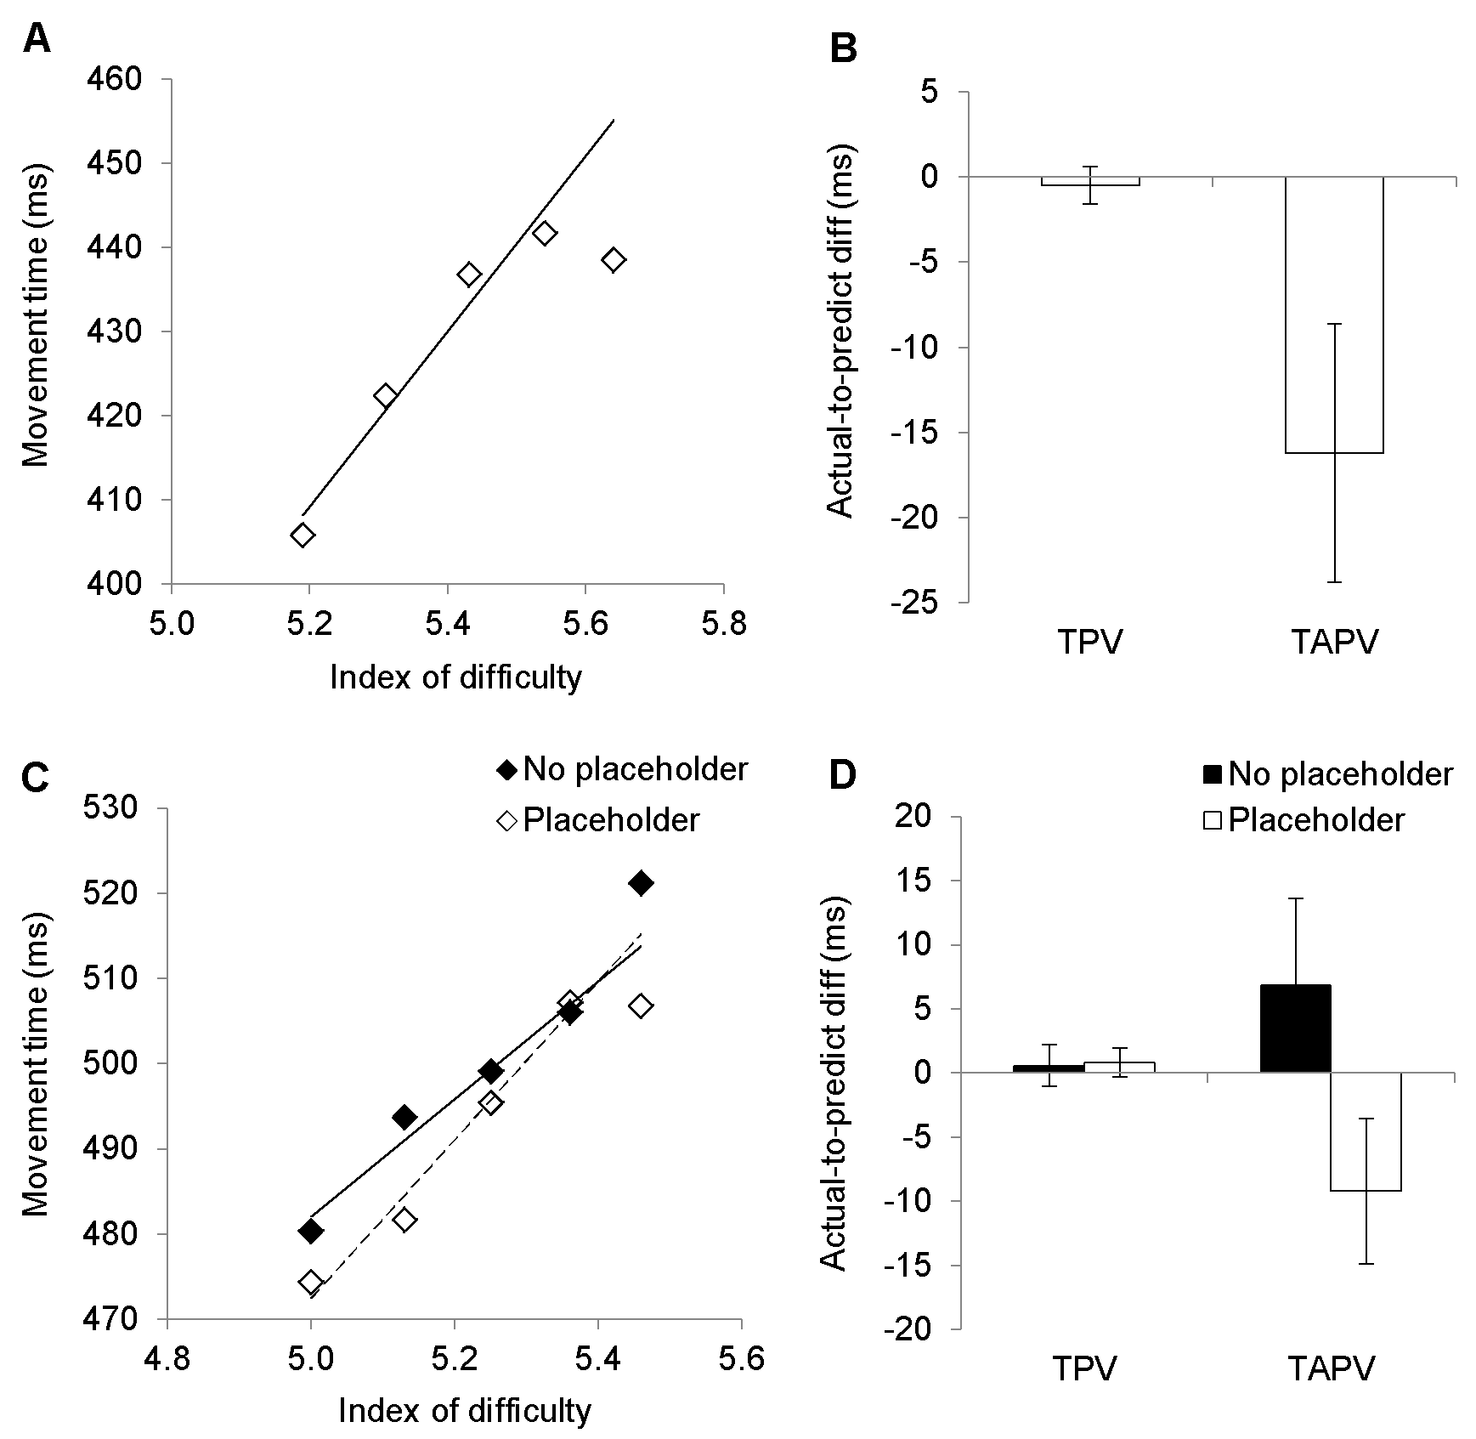
Figure 1
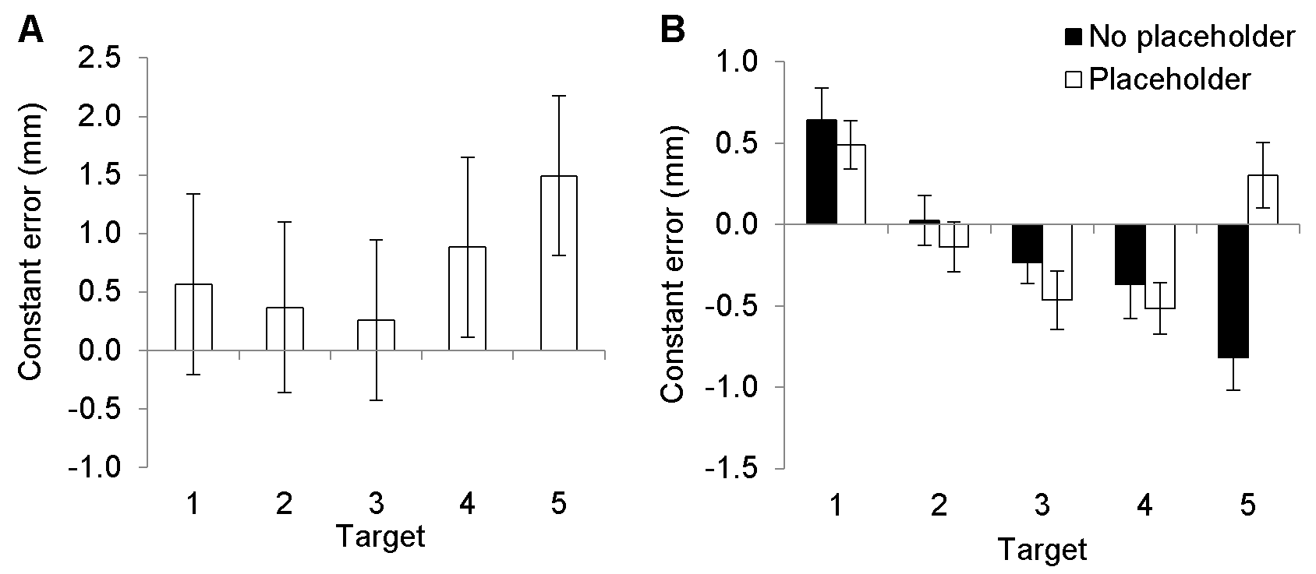
Figure 2

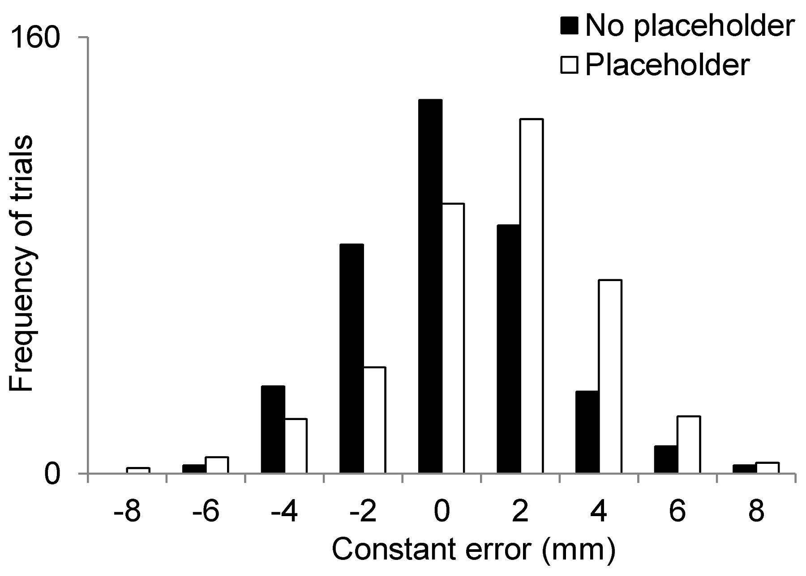
Figure 3
Footnotes
- Only 11 of the 16 participants were featured in the reversal vs. non-reversal MT analysis of the Main Study. This was because the 5 participants that were omitted failed to register a reversal/non-reversal submovement for at least one of the target locations.
- There was a lower hit rate and greater tendency to overshoot in our Main Study compared to the Reanalysis of Blinch et al. (2012). It is noteworthy that the hit rate in the Main Study was similar to previous studies exploring the violation of Fitts’ Law (e.g., 85-90%, Adam et al., 2006; Pratt et al., 2007), while the seminal work of Fitts and Peterson (1964) indicated a hit rate of approximately 90% (intermediate to both studies). The reason for the differences between the studies remains elusive, although we suspect it is due to subtle methodological differences. For example, there was an extended practice phase in the Blinch et al. (2012) study, where in the event a participant was inaccurate they were encouraged to properly land on the target before they could start the experiment for real. There was no such practice phase for the Main Study. These differences are of limited theoretical significance as our main aim was to explore the differences between the conditions held within a single set of participants. In this respect, both studies demonstrated a similar pattern of results (i.e., limited differences between targets for hit rate and a greater terminal overshoot at the last-placed target).
- Only 15 of the 20 participants were featured in the reversal vs. non-reversal MT analysis of the Reanalysis of Blinch et al. There were 5 participants that failed to register a reversal/non-reversal submovement for at least one of the target locations.

