**RESEARCH ARTICLE**

**The ‘real value’ of field trips in the early weeks of higher education: The student perspective**

Larsen C., Walsh C., Almond N.1, Myers C.,

*School of Health Sciences; 1 Faculty of Education;*

*Liverpool Hope University, Hope Park, Liverpool L16 9JD UK*

**Abstract**

The benefits attributed to field trips by science educators are:social development; observation and perception skills; giving meaning to learning; providing first-hand experience and stimulating interest and motivation. Arguably, the ‘real value’ of field work is attributed by students. In this study, 100 first year students took part in an analysis of the value of a residential field trip. The field trip was a purposeful combination of personal development and academic activities. Pairwise comparison showed that the attributed value score for ‘Personal and Social Development’ was significantly higher than scores for ‘Provide First-hand Experience’ and ‘Observation and Perception Skills’. The attributed value for ‘Stimulate Interest and Motivation in the Subject’ also scored more highly than ‘Provide First-hand Experience’, and ‘Observation and Perception Skills’; ‘Give meaning to Learning’ was significantly higher than that for ‘Observation and Perception Skills’. In addition, the ‘educator’ was also able to significantly improve students’ scores for ‘Stimulate Interest and Motivation’. This insight into students’ perceptions of field work recasts our thinking as educators; social capital is a key factor in student persistence and subsequence academic success. Field trips should be considered a valuable addition to retention strategies in a way that is tangible for students themselves.

**Keywords: field trip; student perception; social capital; motivation**

**Correspondence details: Carl Larsen,** [**larsenc@hope.ac.uk**](mailto:larsenc@hope.ac.uk)**; TEL: +44 0151 291 3097**

**Introduction**

A field trip may be defined as “any journey taken under the auspices of the school for educational purposes” (Sorrentino and Bell 1970 pg. 233). In this early work, almost half a century ago, the authors reported that science educators consider field trips to be beneficial to students in five key areas: social development; observation and perception skills; giving meaning to learning; providing first-hand experience and stimulating interest and motivation in the subject. Since 1970 much has been written about field trips but there has not, to date, been an empirical study that directly compares the perceived values of educators detailed by Sorrentino and Bell with the actual value perceived by students. Whilst an exhaustive review of papers relating to field trips is outside the scope of this paper, there are some key works that should be included to contextualise the study reported here.

Whilst Kuh (1995) recognises that the organised curriculum is the cornerstone of student learning, there is a clear role for learning outside the classroom in particular in areas of lifelong learning. Particular recognition is given to the value of out of class experiences in developing students who are critical thinkers able to work as members of teams and organise their learning. In the context of geography education Fuller (2001), noted that in the absence of field work students reported that they had valued their previous experiences out of the classroom as a means to enhance their geographical reality, their technical skills and their inter-personal skills. Similarly, in 2011 Houser reported that field trips enabled students to develop in three particular areas: cognitive ability, technical skills in experimental and research methods and finally in social and inter-personal skills. More recently, Walsh, Larsen and Parry (2014) reported that fieldwork enhances student’s ability to form a community of learning with staff and peers, in turn empowering them as active learners. Boud, Cohen and Sampson (1999) in their key paper, point out that peer-peer interactions benefit the development of life-long learning skills that other methods of learning do not readily embrace. It can therefore be argued that field trips provide an opportunity for peer-peer learning which should be valued as a pivotal mechanism through which to enhance lifelong skills including teamwork, collaboration and learning to learn.

Juxtaposed to the broad concept of personal development, are skills of observation and perception skills. In the context of medical education, it has been reported that despite their importance in clinical practice, the skills of observation and perception are rarely taught (Jasani and Saks, 2013). To the contrary, Falk, Martin and Balling (1978) stated that working in an unfamiliar environment outside the classroom is distracting from the task at hand which in turn inhibits learning to an extent. The role of field trips in developing these difficult to teach skills, and the value that students place on these skills, is somewhat underrepresented in the literature to date.

Providing first-hand experience is a priority for educators when designing field trips into the curriculum. Theories originally proposed by Piaget, Lewin and Dewey were developed into a four stage model by Kolb (1984, pg. 38) and summarised into a definition of experiential learning as [a mechanism] “whereby knowledge is created through the transformation of experience”. In the concrete learning part of the experiential learning model Kolb emphasises the importance of practical activities, including field work, as a mechanism to enhance adult learning. Foundational to experiential learning is student motivation; students who are motivated are driven to become engaged and successful (Williams and Williams, 2011). In their paper Williams and Williams (pg.1) state that there are “five key ingredients impacting student motivation: student, teacher, content, method/process, and environment”. In the context of field trips, these five ingredients are in abundance, in particular there is purposeful connection with their work and close working with a tutor with extensive knowledge in a learning environment that is driven by team work and shared goals. Kern and Carpenter (1984) reported that students perceived interest levels and enjoyment of a subject were significantly higher in a field-orientated laboratory setting than a traditional laboratory setting. Similarly, Nadelson and Jordan (2012) report the enhanced motivation of sixth form students to learn through the medium of an off-site visit.

As this brief summary of the literature highlights much of the work around the value of field trips has been studied within the context of geography or environmental education. The research reported here was underpinned by two pivotally relevant studies; the educator’s values of field trips proposed by Sorrentino and Bell (1970) and the more recent thoughts of Scott, Fuller and Gaskin (2006) who noted that lecturers and students may place different emphasis on the value of field trips in developing learning.

With two specific questions in mind “Do students agree that the five attributed values of field trips are important?” and “Do students value certain attributed values of field trips more than others?” a mixed methods approach was used to gain both qualitative and quantitative data and therefore explore the two research questions in a large cohort of science first year students in their early, transitional weeks in higher education.

**Methods**

A cohort of first year students, studying within the School of Health Sciences at a post 92 University, was the subject of this study. The cohort, divided randomly into four groups due to limitations in accommodation, took part over four consecutive weeks in a residential fieldtrip. All students travelled to the field centre together; on arrival the students were divided into small working groups, each group being assigned an instructor. The instructor, based at the field centre, was not known to the students at the start of the trip.

The field trip was purposefully aimed at both personal development and subject-specific skills (in this case those related to sport science). At the end of the field trip, every student was invited to participate in this research study; an ‘opt-out’ was available for those who did not wish to take part in accordance with the BERA ethical guidelines for educational research (2011). The study has Ethical Approval following the University policies and processes for research of this nature.

The qualitative questionnaire administered (Appendix 1) was prefaced with questions relating to demography (age, gender, place of residence, etc.); environment and context (weather, prior experience, field instructor etc.). An adapted version of the validated Australian Course Experience Questionnaire (CEQ) (Curtin University, 2010) was produced in order to direct questions towards the subject of field trips and to incorporate Sorrentino and Bell’s (1970) attributed values. Two similar quantitative questions were asked for each of the five values creating ‘paired questions’, in order to increase the validity of the questionnaire. However, paired questions were then distributed randomly rather than juxtaposed in the final questionnaire. The paired questions, and their relationship to the five values attributed to field trips by science educators are detailed:

* The field trip developed my confidence/The field trip helped me develop my ability to work as a team member (Personal/social development)
* The field trip stimulated my enthusiasm for further learning/The field trip made the subject interesting (Stimulating interest and motivation in the subject)
* I learned to apply principles from the field trip to new situations/As a result of this field trip, I feel confident about tackling unfamiliar problems (Providing first-hand experience)
* The field trip sharpened my perception skills/The field trip sharpened my observation skills (Observation and perception skills)
* I consider what I learned valuable for my future/The field trip provided me with a broad overview of my field of knowledge (Giving meaning to learning)

Five qualitative questions then followed, each relating to one of the attributed values of fieldwork to facilitate triangulation of quantitative data. These questions were open-ended to encourage participants to write freely (Agee, 2009). The following is a short description of each of the qualitative questions.

* Social development – Participants were asked about their group work, if they enjoyed it and if they learned from it.
* Providing first-hand experience – Participants were asked about working outdoors and to compare that to the classroom.
* Observation and perception skills – Participants were asked what skills that they thought they had developed from the field trip.
* Giving meaning to learning – Participants were asked to reflect on the field trip and what it meant to them.
* Stimulating interest and motivation in the subject –Participants were asked if they feel they can now engage more in their subject.

All data analyses were subsequently performed using SPSS (version 21.0).

**Results**

Of one hundred questionnaires distributed to students, seventy were returned with sufficient data; of the remainder some questionnaires were not returned and some questionnaires were returned blank. Of the seventy questionnaires returned, twenty one participants were female (30%) and forty nine participants were male (70%). The range of ages of participants was between eighteen and twenty nine years old, with the majority of participants being eighteen or nineteen (64%).

Data was not normally distributed so to test the validity of student responses to paired-questions a related samples Wilcoxon Signed Rank test was performed. There was no significance difference in the median value within each of the five sets of paired questions at p<0.01 (Table 1). This strongly suggests a good level of internal validity in the sampling tool and that paired questions were measuring the respective attributed value.

**Table 1**: Median response to Likert questions was 4 (agree), except for ‘stimulating interest and motivation in the subject’ which was 5 (strongly agree).

|  |  |  |
| --- | --- | --- |
| **Attributed value** | **Question pairing** | **Significance level** |
| Personal/social development | The field trip developed my confidence/The field trip helped me develop my ability to work as a team member | 0.104 |
| Stimulating interest and motivation in the subject | The field trip stimulated my enthusiasm for further learning/The field trip made the subject interesting | 0.557 |
| Providing first-hand experience | I learned to apply principles from the field trip to new situations/As a result of this field trip, I feel confident about tackling unfamiliar problems | 0.362 |
| Observation and perception skills | The field trip sharpened my perception skills/The field trip sharpened my observation skills | 0.649 |
| Giving meaning to learning | I consider what I learned valuable for my future/The field trip provided me with a broad overview of my field of knowledge | 0.202 |

Subsequently, a number of independent sample non-parametric tests were performed on the data to investigate whether students’ responses to the five paired value questions were affected by demographics, and other characteristics of the respondent. A Mann-Whitney *U* Test demonstrated that the value attributed to field trips by students was not affected by gender (p>0.05). Similarly, Kruskal-Wallis analysis showed that age, prior fieldwork experience, where they lived, employment status, level of fitness and anxiety about doing fieldwork had no significant effect on student responses to the five paired questions (p>0.05 in all cases). The field trip instructor who co-ordinated the activities that students took part in and was the ‘educator’ for this field trip, had a significant effect on questions relating to ‘stimulating interest and motivation’ (p = 0.006 when comparing participant responses against their ‘educator’.

**Figure 1 Kruskal-Wallis analysis of participants’ responses to the five paired value questions analysed against ‘educator’. Black bars represent median; boxes represent the interquartile range and whiskers represent the upper and lower ~25% of scores.**

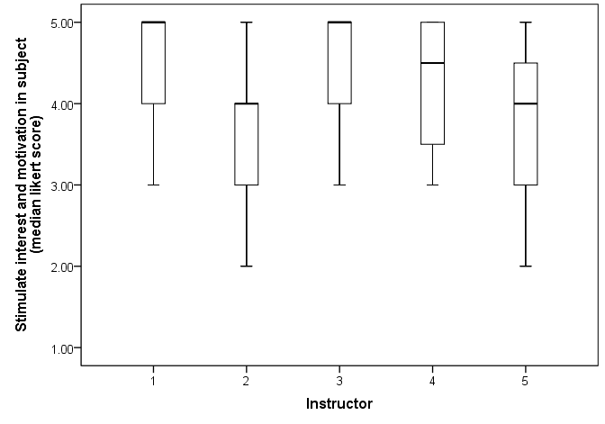

Instructors 1 and 3 had a significant and positive influence on participant’s interest and motivation in the subject.

Finally, considering the effect of weather conditions on students’ perceptions of their learning and development (Figure 2). Weather was categorised as; clement – warm and dry or inclement – cold and wet. Mann-Whitney showed a significant positive effect of clement weather on student perception of whether the fieldwork ‘gave meaning to learning’ (*U* = 794, z = 2.43, *p* = .015) and there was a non-significant tendency for students to perceive their social development more positively if the weather during the field trip was clement (*U* = 739, z = 1.76, *p* = 0.069).

**Figure 2 Mann-Whitney analysis of the effects of weather conditions on the perceived benefits of fieldwork ‘giving meaning to learning’. Black bars represent median; boxes represent the interquartile range and whiskers represent the upper and lower ~25% of scores.**

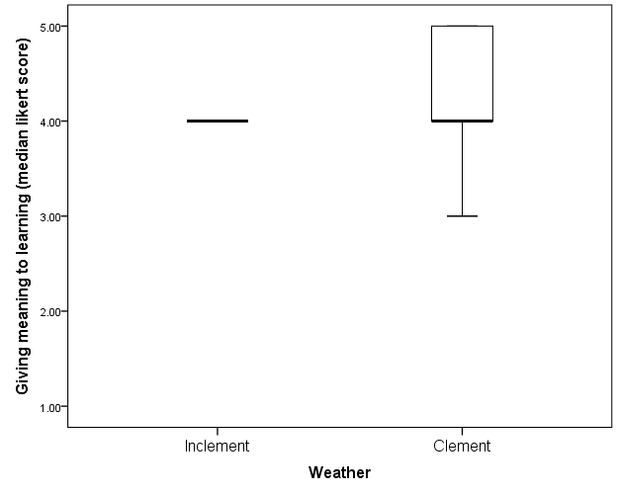

In order to compare the five attributed values and control for the effects of respondents a non-parametric related samples Friedman’s ANOVA was carried out. There was a significant difference in the distribution of participants’ responses when comparing the median Likert scores for the attributed values χ2(4)=19.44, p<0.001. Post hoc analysis using Wilcoxon signed-rank test and Bonferroni adjustment showed that the attributed value score for ‘Personal and Social Development’ was significantly higher than scores for ‘Provide First-hand Experience’ p=0.003 and ‘Observation and Perception Skills’, p=0.001. The attributed value ‘Stimulate Interest and Motivation in the Subject’ also scored more highly than ‘Observation and Perception Skills’, p=0.009. All other scores were non-significant at p<0.01. (Figure 3).

**Figure 3: Friedman’s analysis of the median Likert scores attributed to fieldwork values by students.**

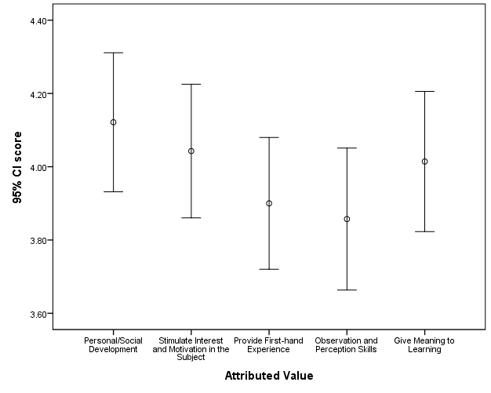

Visual analysis of the qualitative data also supported the fact that social development is valued highly among students on field trips, with several key themes occurring throughout students’ responses. Themes such as ‘friendship’ ‘communication skills’ and ‘confidence’ reoccurred in the answers to the open ended questions; no new themes or values were identified from the qualitative comments.

**Discussion**

Returning to the questions asked at the start of this study “Do students agree that the five attributed values of field trips are important?” and “Do students value certain attributed values of field trips more than others?” the data reported here indicates that students do share the same values as their educators in terms of the benefits of field trips, but with significant emphasis on certain lifelong skills.

Orion and Hofstein (1991) carried out a similar study in which they investigated the ‘importance and educational effectiveness’ of field trips in secondary school children. In their study they noted that the differences in perceptions of field trips differed very little between girls and boys. They report some minor differences with boys valuing the opportunity to take part in adventurous activities more highly, whilst girls placed more value on the learning opportunities. These findings, all be it in a different age group, support our findings that both male and female students value field trips, with no significant gender differences. Orion and Hofstein also comment that student’s perceptions of a field trip may be pre-determined by their previous experiences of such activities; those who have enjoyed learning experiences in the outdoor environment may subsequently take forward a more positive attitude towards field trips. Similarly, a student’s interpretations of the natural environment can be significantly shaped by their early experiences (Bixler and Carlisle 1994). Those who experience nature through residence, family holidays or recreational trips form a more positive attitude towards working in the outdoor setting than those whose only exposure is contrived through television, zoos or other artificial means. However, these concerns were not reflected in our study since no significant differences were reported in the value students placed on field trips and their prior feelings towards and experiences of field work. Therefore, when designing field trips into the curriculum, our data would suggest that concerns about prior experience and gender imbalance can largely be excluded provided that the trip is carefully embedded as part of the learning experience.

The motivational impact of ‘the teacher’ has already been referenced in the introduction to this paper. Williams and Williams (2011) include the teacher as the second ingredient in motivating students, of particular relevance here is the role of the field instructor in promoting practical experience, responding to and valuing the needs of individual students whilst capturing their interests, sharing relevant personal experience and instilling effort into learning. The pivotal role played by the educator in a field trip setting is reflected in the data represented in Figure 1. Students valued the field trip as a mechanism through which to enhance their interest and motivation significantly more when their educator was either ‘Instructor 1’ or ‘Instructor 3’. None of the instructors had previously had contact with the student group and it is therefore important is an important message from this study that tutors are in fact the ‘gate-keepers’ to what can be achieved by students when learning outside the classroom. Tutors can both positively and negatively impact the learning experience; two of the educators in our study had a positive impact on the students’ interest and motivation to learn. Since the qualitative comments made by students did not clarify the quantitative data it is not possible to add commentary about the specific strengths of the instructors which impacted so positively on students learning experience. Student motivation depends, in part, on the interpersonal relationships with their educator. In turn, the instructional behaviour of educators can vary across a spectrum of styles, ranging from those that encourage autonomy through to those that potentially discourage student independence (Reeve and Jang, 2006). The level of student motivation is therefore likely to reflect the interpersonal relationship developed with the students, and the extent to which the educators’ style encouraged students to increase their intrapersonal motivation.

To the authors’ knowledge this is the first report of a direct comparison of first year student’s perceived values of field work with that of science educators. In addition, further novelty is added by the hierarchy of values determined from the quantitative analysis of mean Likert scores for the paired questions. Tinto’s interactionalist model of student persistent (1975) places social integration at the heart of student success in higher education. Tinto affirms that the greater the student’s academic and social development the more likely they are to move forward towards their goal of graduation. The value of field trips as a mechanism through which to enhance student engagement early in the transition period to higher education has previously been reported (Walsh, Larsen and Parry 2014). In this study the Krause and Coates (2008) Engagement Scale proved a valuable tool through which to study the long held belief that field work enhanced student engagement. The study demonstrated that early residential field work can act as a catalyst for peer-peer support networks; the study did not however quantify the value that students placed upon their social development.

Analysis of the participant’s responses in this study demonstrated that students valued the field trip as a mechanism through which to develop their social integration more highly than the other educator-perceived benefits of field work. A non-parametric related samples Friedman’s ANOVA (Figure 3) demonstrated that in fact the attributed value score for ‘Personal and Social Development’ was significantly higher than scores for ‘Provide First-hand Experience’ and ‘Observation and Perception Skills’, p=0.001. The attributed value for ‘Stimulate Interest and Motivation in the Subject’ was also higher than that for ‘Observation and Perception Skills’(Figure 2). This is interesting; in previous studies by Nabors, Edwards and Murray (2009) first-hand experience was considered to be a pivotal value attributed to field trips by educators; in another study in which both educators and students were included the most significant value of the field trip was reported as increased interest in learning (Shakil, Faizi and Hafeez 2011). In a large scale questionnaire-based study Fuller (2006) reported that students consider that the value of fieldwork lies in providing “a better sense of real-world environments and processes” (pg. 215). The student group included in the Fuller study were largely experienced in techniques-based specialist geography field courses; in the study reported here students experienced a more broad-ranging learning experience, incorporating team-building activities alongside more subject-specific tasks.

There is therefore an important message emerging from our study within the context of previous studies; the social development of students is valued more highly when the field trip is purposely designed to include both personal and subject-specific development. For first year students, early in their university careers, this is a clear value; as discussed earlier engagement, motivation and persistence are clear markers of student success. The recommendation, from this study, would be to use a blended approach for early-career field work, enabling students to achieve a greater degree of social integration as part of the transition to higher education.

The skills valued least by the first year students in this cohort were those of observation and perception. This may be a reflection of the academic context of this field trip; students may simply not have recognised that these skills were being developed. In field trips where the academic context hinges around technical detail of using particular methodologies in the field these skills are more explicit; the activities carried out by students on this occasion were related more to participation in particular activities which are somewhat different to those undertaken by geography or environmental science students in the field. Therefore, one of the interesting follow-ups to this study would be a direct comparison of a first year group of students undertaking technical methodological surveys in the environment without any overt inclusion of personal development tasks.

A significant theme emerges from this study; the purposeful design of an early-residential field trip, to include a blend of personal development and academic theory can enhance the social integration of students into the learning community. Furthermore, students themselves value the increase in their social capital more highly than some of the other outcomes of field trips attributed as favourable by educators. It would be useful to extend this study to include detail qualitative interviews that would allow further expansion of the student’s perceptions of the benefits of field work beyond the open questions. For example, it would be useful to drill down into which aspects of the social capital are most valued. Across the higher education spectrum, not just in science and related disciplines, field trips should perhaps be considered an integral part of strategies to smooth transition to the university habitus and therefore enhance student retention.

# References

Agee, J. (2009) Developing qualitative research questions: a reflective process. *International Journal of Qualitative Studies in Education*, 22(4):431-447.

Bixler, R.D. Carlisle, C.L (1994) Observed fears and discomforts among urban students on field trips in to wildland areasJournal of Environmental Education. 26(1):24-33.

Boud, D. Cohen, R. and Sampson, J. (1999) Peer learning and assessment. *Assessment & Evaluation in Higher Education*, 24(4):413-426.

British Educational Research Association (2011) Ethical guidelines for educational research [online]. British Educational Research Association. Available from: <<https://www.bera.ac.uk/wp-content/uploads/2014/02/BERA-Ethical-Guidelines-2011.pdf>> [accessed 17 February 2015].

Curtin University (2010) Course Experience Questionnaire [online]. Curtin University. Available from: <<http://planning.curtin.edu.au/local/docs/CEQ_questionnaire2010.pdf>> [accessed 13 November 2014].

Edwards, L.C. Murray, R.K. and Nabors, M.L. (2009) Making the case for field trips: what research tells us and what site coordinators have to say. *Education* 129(4):661-667.

Falk, J.H. Martin, W.W. and Balling, J.D. (1978) The novel field-trip phenomenon: adjustment to novel settings interferes with task learning. *Journal of Research in Science Teaching*, 15(2):127-134.

Fuller I., Gaskin S., Scott I., 2006 Student Perceptions of Geography and Environmental Science Fieldwork in the Light of Restricted Access to the Field, Caused by Foot and Mouth Disease in the UK in 2001 *Journal of Geography in Higher Education*, 30, (1):161-171.

Fuller, I., (2006) What is the value of ﬁeldwork? *New Zealand Geographer* 62:215–220.

Jasani, S.K. and Saks, N.S. (2013) Utilizing visual art to enhance the clinical observation skills of medical students. *Medical Teacher*, 35(7):1327-1331.

Kern, E.L. and Carpenter, J.R. (1984) Enhancement of student values, interests and attitudes in earth science through a field-oriented approach. *Journal of Geological Education*, 32(5):299-305.

Krause, K-L., & Coates, H. (2008) Students’ engagement in first-year university, Assessment and Evaluation in Higher Education 33:493-505.

Kuh, G.D. (1995) The other curriculum: out-of-class experiences associated with student learning and personal development. *The Journal of Higher Education*, 66(2):123-155.

Kolb, D.A. (1984): Experiential learning: experience as the source of learning and development Englewood Cliffs, NJ: Prentice Hall. URL: http://www.learningfromexperience.com/images/uploads/process-of-experiential-learning.pdf (31.05.2006)

Michie, M. (1998). Factors influencing secondary science teachers to organise and conduct field trips. *Australian Science Teacher's Journal,* 44(4):43-50.

Nadelson, L.S., and Jordan, J.R., 2012 Student Attitudes Toward and Recall of Outside Day: An Environmental Science Field Trip *The Journal of Educational Research* 105(3): 220-231.

Nabors, M.L., Edwards, L.C., and Murray, R.K. (2009). Making the case for field trips: What research tells us and what site coordinators have to say. *Education* 129(4):661-667.

Orion, N. and Hofstein, A. (1991) The measurement of students’ attitudes towards scientific field trips. *Science Education*, 75(5):513-523.

Reeve, J., and Jang H., 2006 What Teachers Say and Do to Support Students’ Autonomy During a Learning Activity Journal of Educational Psychology 2006, Vol. 98, No. 1, 209 –218

Shakil, A.F., Faizi, W., Hafeez, S., 2011 The need and importance of field trips at higher level in Karachi, Pakistan International *Journal of Academic Research in Business and Social Sciences* 2(1):1-16.

Sorrentino, A.V. and Bell, P.E. (1970) A comparison of attributed values with empirically determined values of secondary school science field trips. *Science Education*, 54(3):233-236.

Tinto V., (1975) Dropout from higher education: A theoretical synthesis of recent research. *Review of Educational Research* 45, 89-125.

Walsh, C. Larsen, C. and Parry, D. (2014) Building a community of learning through early residential fieldwork. *Journal of Geography in Higher Education*, 38(3):373-382.

Williams, K. C., and Williams, C. C. (2011) Five key ingredients for improving student motivation. *Research in Higher Education Journal*, 12 (August). Retrieved from http://www.aabri.comwww.aabri.com/manuscripts/11834.pdf

**Appendix 1**: **Questionnaire**

This part of the questionnaire will ask general questions about you; this data will be used to recognise patterns and trends for the benefit of the research please circle the answer that is most appropriate to you and answer to the best of your ability. All answers will remain anonymous. You may be asked for a follow-up interview to elaborate on answers and talk more in-depth about your thoughts on field trips.

1. Student I.D. Number:
2. Are you male or female? a) Male b) Female
3. Do you live in:

a) Halls of Residence

b) Shared student accommodation

c) Parent’s house/own house

1. How old are you?

1. Are you currently employed? a) No b) Yes, part-time c) Yes, full-time
2. Do you consider yourself physically fit? a) Very b) Moderately c) Not fit
3. Have you ever been on a residential field trip before?

a) No

b) Yes, 1-5 times

c) Yes, 6-9 times

d) Yes, over 10 times

1. Were you nervous/anxious to be going on a field trip? a) Yes b) No
2. Overall, did you enjoy the field trip? a) Yes b) No
3. What was the weather like?
4. What was your field trip instructor’s name?

**About the Field Trip**

The following questions are about the field trip itself; please tick the box that you feel best describes your field trip experience.

|  |  |  |  |  |  |
| --- | --- | --- | --- | --- | --- |
| **Question** | **Strongly disagree** | **Disagree** | **Neither agree nor disagree** | **Agree** | **Strongly agree** |
| The field trip helped me develop my ability to work as a team member |  |  |  |  |  |
| The field trip stimulated my enthusiasm for further learning |  |  |  |  |  |
| I learned to apply principles from the field trip to new situations |  |  |  |  |  |
| The field trip sharpened my observation skills |  |  |  |  |  |
| What I learned will be valuable for my future |  |  |  |  |  |
| The field trip developed my confidence |  |  |  |  |  |
| The field trip sharpened my perception skills |  |  |  |  |  |
| The field trip made the subject interesting |  |  |  |  |  |
| As a result of this field trip, I feel confident about tackling unfamiliar problems |  |  |  |  |  |
| The field trip provided me with a broad overview of my field of knowledge |  |  |  |  |  |

In the following five questions, please answer in as much detail as you can

1. Describe what group work you engaged in on the field trip. Did you enjoy the group work? How did you work successfully/unsuccessfully as a group? What did you learn from the group work and how can you improve?
2. Describe your experience in working outdoors. Did you feel you benefitted from it and why? Explain how learning outdoors is better/worse than the classroom.
3. What skills do you feel you have gained/improved upon on your field trip, what helped you to develop these skills?
4. Reflect upon your experience on the field trip. What stands out as a good experience to you? What has this field trip meant to you?
5. Has this field trip helped you to engage in your subject area better? Has the experience helped you to become more interested in your subject and if so, why?