A review of Computational Fluid Dynamics (CFD) airflow modelling over aeolian landforms

Abstract

Aeolian landforms occur on all earths’ continents as well as on Mars, Titan and Venus and are typically formed where sediment is eroded and/or deposited by near surface wind flow. As wind flow approaches an aeolian landform, secondary flow patterns are created that cause wind to deviate in both speed and direction, producing complex patterns of sediment erosion, deposition and transportation. Computational fluid dynamics (CFD) modelling of wind flow has become a common tool to predict and understand secondary wind flow and resulting sediment transport. This review attests to the advancement in CFD utilisation from simulating wind flow over simple two-dimensional dune shapes, to calculating a multitude of flow parameters over a range of increasingly complex landforms. Analysis of 25 peer reviewed journal articles, found that CFD has been crucial to providing additional insight to flow dynamics on the stoss slope of dunes, the structure and nature of wind flow separation in the lee of landforms and information on localised wind flow variations in large-scale dune fields. The findings of this assay demonstrate that further research is required regarding the parameterisation and modelling of surface roughness, the incorporation of accurate sediment transport to wind flow models, and the prediction of topographic surface changes. CFD is anticipated to be increasingly utilised in aeolian geomorphology and this work aims to be a starting point for aeolian geomorphologists wishing to better understand and review the utilisation of the technique to date.

Keywords: Computational Fluid Dynamics; CFD; Numerical Modelling; Dune; Wind Flow; Fluid Dynamics

1. Introduction

Aeolian landforms are created by the erosion, transportation and deposition of sediment by wind. Landforms range in spatial scale from centimetres to kilometres and incorporate a range of structures including ripples, ventifacts, yardangs, dunes and blowouts. They exist on all Earth’s continents as well as Mars, Titan and Venus (Craddock, 2011). The most dynamic activity occurs where there is a mobile sediment supply and strong winds. On Earth this is chiefly in deserts and sandy coastlines.

Wind flow over a flat surface can be described using a logarithmic velocity profile (Ellis and Sherman, 2013). As flow approaches an obstacle, such as a dune, changes in pressure cause wind flow to alter in both speed and direction depending on the topography of the obstacle. In general wind flow becomes accelerated as streamlines compress with height over the windward slope, though this process is seldom linear (Lancaster, 1994; p 484). In the lee of an obstacle, wind speed slows, streamlines expand and flow separation may occur (Walker and Nickling, 2002). As complex near surface winds drive sediment transport, considerable research has been devoted to boundary layer dynamics over dune and blowout topographies in an effort to understand erosion, deposition and sediment transport pathways. This research has been performed in the field (Hesp and Hyde, 1996; Walker, 1999; Baddock et al. 2011; Delgado-Fernandez et al. 2013), in wind tunnels (Walker and Nickling, 2003; Wiggs et al. 1996) and by numerical modelling (Parsons et al. 2004a; Zhang et al. 2012; Araújo et al. 2013). The majority of recent numerical modelling has been implemented by Computational Fluid Dynamic (CFD) simulations of flow.

The remainder of section 1 in this article presents the basic principles and governing equations used to calculate wind flow, discusses the most common methods of modelling turbulence, compares CFD to other methodologies that have been used to predict wind flow and outlines the key advantages of using CFD compared to measuring data in the field and wind tunnels. Section 2 examines the scope of previous investigations and provides a critical examination of model sensitivity analysis and validation. Section 3 provides insight to the advancements in understanding wind flow over aeolian landforms facilitated by CFD, focusing on flow over the stoss slope, wind flow separation, and localised wind flow spatial variation in dune fields. Finally section 4 reflects upon the future of CFD in aeolian geomorphology, expressing how it is likely to progress in the future with advances in computational power and faster algorithms. Section 4 also identifies and discusses the challenges of modelling surface roughness, sediment transport and topographic surface changes.

*1.1 What is CFD?*

CFD is a numerical method of solving fluid flow using the Navier-Stokes equations. The method uses numerical algorithms to integrate the Navier-Stokes equations over a meshed computational domain (Figure 1) by converting the integral equations to algebraic equations (a process called discretisation), before solving them iteratively (Versteeg and Malalasekera, 2006). The Navier-Stokes equations encompass the governing equations of fluid flow; the conservation of mass, conservation of momentum and conservation of energy. Within the computational domain wind flow is considered as a continuum i.e. the molecular motions and structure are ignored (Versteeg and Malalasekera, 2006). The wind flow is also considered as incompressible, as although gases are compressible, changes in density are negligible below Mach 0.3 (approximately 100 m s-1) (Sharpio, 1953; Ferziger and Perić, 2002).

When solving fluid flow using finite volume methods, the conservation laws are solved within discrete spatial control volumes, known as cells. To accurately solve fluid flow over a landform, cells may number many million (Jackson et al., 2011) and may increase in number with the turbulence model employed. Within each control volume, the conservation laws are obeyed. Mass can neither be created nor destroyed (a principle known as the conservation of mass), and therefore the rate of flow can be calculated by the equation of continuity, whereby inflow equals outflow. Momentum is conserved using Newton’s second law, which states that the rate of change of momentum of a fluid in a cell, equals the sum of the forces acting on the cell. Two types of forces act on cells within the computational domain, surface forces, and body forces (Versteeg and Malalasekera, 2006). Surface forces are exerted at cell faces, e.g. pressure forces, while body forces are those which act throughout the entire volume of the cell e.g. gravity. The conservation of energy is derived from the first law of thermodynamics which states that the rate of change of energy of a fluid particle is equal to the rate of heat addition to the fluid particle plus the rate of work done on the particle. The rate of work done is equal to the product of any surface force on the cell and the velocity component in the direction of the force (Versteeg and Malalasekera, 2006). The conservation of energy is only coupled with mass and momentum in problems which consider fluid as compressible, as variations in density are not considered for incompressible fluids. Therefore the flow field for most wind flows over aeolian landforms can be solved considering mass and momentum equations only.

*1.2 Turbulence*

Wind flow at speeds capable of moving sediment over aeolian landforms on earth can be considered fully turbulent (i.e. a Reynolds number greater than 10,000) (Reynolds. 1895). Turbulent fluid flow is chaotic, causing random changes in velocity and pressure over time. Turbulence is always three dimensional, even when mean velocities vary only in 1 or 2 dimensions (Ferziger and Perić, 2002). When turbulent flow is visualised, rotational flow structures known as eddies are revealed (Fig. 2b). These turbulent structures vary in space and time, and are important in boundary layer dynamics as they cause wind at different heights to mix, permitting the exchange of mass and momentum (Kaimal and Finnigan, 1994).

The physics of turbulence is governed correctly by the Navier-Stokes equations (discussed in section 1.1). However, the results are not linear and cannot be easily summarised statistically (Lane, 1998, p. 1134). Instead approximated solutions of the Navier-Stokes equations are applied that either describe turbulence as an average, or limit the spatial/temporal resolution that turbulence is calculated over. The turbulence modelling frameworks that have been employed over aeolian landforms to date are Reynolds-Averaged Navier-Stokes Equations (RANS) and Large Eddy Simulation (LES). RANS and LES are also the most common methods of turbulence modelling across all applications of CFD; including process industries, aerodynamics and medical device design.

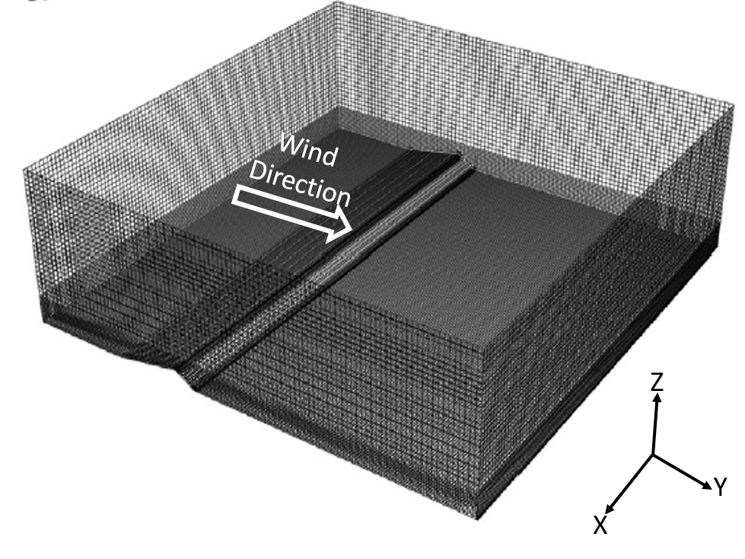

*Figure 1. Meshed computational domain of a three-dimensional transverse dune (Bruno and Fransos, 2015). Note how the resolution of the mesh becomes finer closer to the surface. (Image adapted from Bruno and Fransos, 2015)*

* + 1. RANS turbulence modelling

In RANS modelling, velocity and pressure are broken into mean and fluctuating components which are substituted into the original Navier-Stokes equations (Figure 2a). This reduces computational cost compared to LES significantly, as only the average properties are calculated negating the need to perform time consuming transient simulations. RANS equations do however introduce new unknown turbulent stresses and fluxes. These turbulent stresses, known as Reynolds stresses, must be modelled for the RANS equations to be closed*.* A multitude of RANS turbulence models have been developed. The most commonly used RANS model used to simulate flow over aeolian landforms is the Renormalised Group (RNG) κ- ε model, which has been employed in 14 of the 25 peer-reviewed articles examined in this review. The RNG κ- ε model, is a two-equation model which calculates turbulent kinetic energy (κ) and energy dissipation (ε), using renormalized group theory (Yakhot and Orszag, 1986) to close the Reynolds-averaged Navier-Stokes equations (Lane, 1998). The renormalisation process enables the Navier-Stokes equations to account for smaller scales of motion than the standard κ- ε model, which employs a single turbulence length scale*.* The (RNG) κ- ε model is preferred to the standard κ- ε model as it performs better in strongly separated flows which occur downwind of many aeolian landforms (ANSYS, 2013) and has been found to perform well at predicting wind flow over hills (Kim et al., 1997; 2000; Maurizi, 2000). It should be noted that κ- ε models are not valid in the near-wall region and therefore require a wall function to be employed (Blocken et al., 2007). Most standard wall functions employ a log-law correlation for wind flow closest to the surface. As a result, wall functions allow the use of a relatively coarse mesh in the near wall region, reducing computational time. Alternatively, κ-ω turbulence models (Wilcox, 1988), which model Reynold stresses using turbulent kinetic energy (κ) and the specific rate of turbulence dissipation (ω), are valid to the wall and are accurate for a range of boundary layer flows.

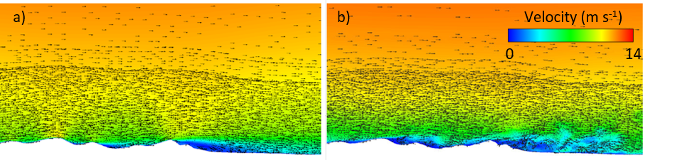*Figure 2. Modelled Velocity vectors and contours of wind flow over a foredune during offshore winds, (incident wind direction from left to right). The panels illustrate how RANS (a) calculates an averaged depiction of the flow, while LES (b) calculates the formation of individual eddies and flow structures at different sizes and scales in the lee of the dune (Image adapted from Jackson et al., 2011).*

* + 1. LES turbulence modelling

Direct Numerical Simulation (DNS) of the Navier-Stokes equations without any turbulence modelling is also possible. However, the computational power required to solve all scales of turbulence spatially and temporally makes the computational cost prohibitively expensive for use at high Reynolds numbers (Ferziger and Perić, 2002). To date the use of LES in studies of aeolian landforms remains rare, however, as high performance computing becomes more affordable, the author expects LES to become increasingly common in aeolian geomorphology.

Large eddy simulation (LES) applies a spatial filter to the Navier-Stokes equations. Vortices smaller than the filter scale are modelled (i.e. calculated using approximations of the Navier-Stokes equations), as they are close to homogeneous. *Larger-scale turbulence and coherent structures are simulated (i.e. the Navier-Stokes equations are solved), as they strongly depend on geometry and boundary conditions (Figure 2b), and cause the majority of changes in mass and momentum to fluid flow (Ferziger and Perić, 2002)*. The size of the filter distinguishing between measured and modelled variables in a LES model is determined by mesh resolution. *Although LES solves a greater spectrum of turbulent motion than RANS; due to its transient nature, LES remains much more computationally expensive to employ*. Only one study to date, Jackson et al., 2011, has employed LES over an aeolian landform (Figure 2a). Omidyeganeh et al. (2013), conducted a LES over a barchan dune at a Reynolds number of 25,160, which despite being fully turbulent (Reynolds, 1895), is more similar to the Reynolds number of flow conditions in the fluvial, than the aeolian environment. The Omidyeganeh et al. (2013) study was conducted at an extremely high resolution (approximately 160 million cells) and the results have been used by Pelletier et al. (2015), to quantify turbulent shear stresses that produce grain flows on the slip faces of aeolian barchan dunes. The use of LES in this manner highlights its ability to maintain a physical measure of turbulence which can be directly compared with measured data unlike RANS modelled turbulence (Smyth et al., 2012).

1.3 *Other numerical wind flow modelling*

Not all wind flow modelling over aeolian landforms has been performed in the manner described in section 1.2. The Jackson and Hunt (1975) model, and subsequent three-dimensional extension (Mason and Sykes, 1979) employed by Walmsley and Howard (1985) over a barchan dune, solve the Navier-Stokes equations, but they do so linearly. The linear employment of the Navier-Stokes equations can only be used where the windward slope is small and wind flow is not affected by nonlinear behaviour such as near surface jets or flow separation. Wippermann and Gross (1986), also numerically modelled wind flow over a barchan but they did so using the mesoscale meteorological model, FITNAH (Flow over Irregular Terrain with Natural and Anthropogenic Heat Sources). FITNAH is a non-hydrostatic model capable of resolving flow in three-dimensions but is limited by its maximum (finest) resolution of 2 m.

Van Boxel et al., 1999, simulated mean wind speed using forward integration with a deterministic equation, although because of the forward integration scheme employed, regions of flow separation and reversal could not be calculated. Wind flow modelling has also been incorporated into cellular automaton (CA) sediment transport modelling over barchan, transverse and star dunes (Narteau et al., 2009; Zhang et al., 2010; Zhang et al., 2012). In these examples, wind flow modelling was achieved by coupling the sediment transport CA model with another CA model that simulates fluid flow, known as lattice gas cellular automaton (LGCA). In two-dimensions LCGA is more efficient than CFD, primarily because it uses integer arithmetic instead of floating point operations; however, in three-dimensions it becomes prohibitively expensive to compute (Rothman and Zaleski, 2004). For this reason current simulations using LGCA around aeolian landforms remain constrained to uniformly spaced two-dimensional vertical planes which calculate wind flow properties parallel to the flow direction (Narteau et al., 2009; Zhang et al., 2010; Zhang et al., 2012).

*1.4 Advantages of CFD*

CFD has a number of advantages compared to field anemometry studies and wind tunnel experiments. A key advantage of CFD is the resolution at which data can be measured. Fluid flow is calculated for each cell and geometries are typically on a scale of several million cells for three-dimensional simulations. This high resolution of data permits detailed visualisation of wind flow, pressure, turbulence and shear stress throughout a landform without disrupting boundary flow conditions as you may in a field or wind tunnel experiment (Figure 3).

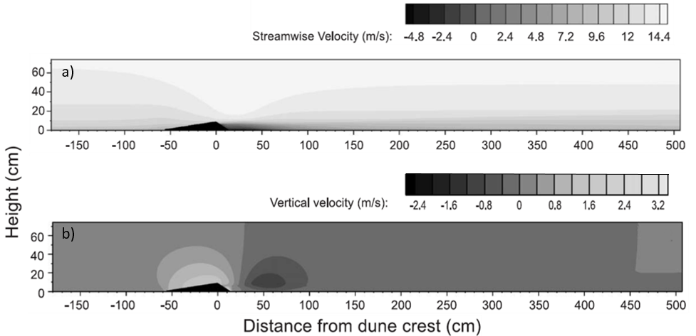

Figure 3. Streamwise velocity (a) and vertical velocity (b) over a dune 0.08 m high with stoss angle of 8.13° demonstrating the ability of CFD to visualise a range of variables without additional calculations (Image adapted from Parsons et al., 2004b).

An important advantage of CFD compared to other numerical methods is its ability to resolve zones of separation by solving turbulent non-linear flow. Wind flow separation occurs when streamlines become detached from the slope of the surface topography as a result of momentum loss near the surface and the presence of an adverse pressure gradient in the direction of the flow (as exemplified in lee of a dune in Figures 2 and 4). Separation may result in the direction of wind becoming reversed compared to its incident wind direction as observed in lee of aeolian landforms such as blowouts, foredunes, transverse dunes and nebhka (Gunatilaka and Mwango, 1989; Jackson et al., 2013a; Smyth et al., 2012; Walker and Nickling, 2002). The use of post processing techniques also permits visualisation of wind flow streamlines in these zones of complex flow (Figure 4), providing researchers rapid insight into a range of flow phenomena such as corkscrew vortices (Figure 4) (Smyth et al., 2012; Jackson et al., 2013a), wind flow steering (Hesp et al., 2015) and the formation of jets over a dune crest (Parsons et al., 2004b).

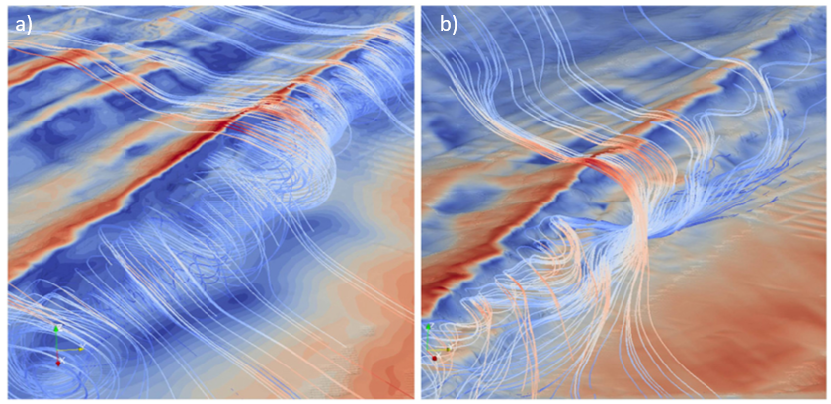

*Figure 4. Wind flow perpendicular to crest (a) and oblique to the crest (b) of a foredune at Magilligan Strand, Northern Ireland. Wind flow is illustrated by streamlines, the path traced out by a massless particle, where red demonstrates high wind speed and blue represents low wind speed. (Image: Jackson et al., 2013a)*

CFD is easily adaptable, for example, once a simulation is constructed, boundary conditions such as wind speed, wind direction and surface roughness can be quickly altered to test a range of hypotheses. Unlike wind tunnel experiments, CFD does not suffer from scaling issues and negates the need for complicated Reynolds number matching as the geometry can be simulated at the same dimensions as in the field. This makes validation with field anemometry relatively simple as wind speed and direction can be directly compared as ‘like for like’ as they are measuring flow conditions at the same spatial scale. Also unlike wind tunnel studies, wall edge effects are diminished as boundary conditions permit flow to exit the computational domain. Nevertheless boundary condition choice and resulting edge effects must still be considered at they can significantly affect predicted flow. CFD also provides the opportunity for quantitative analysis of flow in areas that are expensive or impossible to instrument, such as Martian dunes (Jackson et al., 2015) and can provide flow information on a range of spatial scales from individual bedforms to a landscape or regional scale.

CFD is becoming increasing affordable and accessible due to the growing number of open source and free CFD codes. Although these codes often lack the graphic user interface and post-sales support of commercial codes, they do allow the user to write custom solvers and models. With regards computational power, most simple two-dimensional cases can be performed on desktop computers, although three-dimensional and high resolution cases typically require parallel processing on high performance computers (HPCs). However, the increasing accessibility to HPCs institutionally, in tandem with the expansion of cloud computing (accessing remote servers typically via the internet), makes computational power an increasingly diminishing impediment.

1. CFD over aeolian landforms and its validation

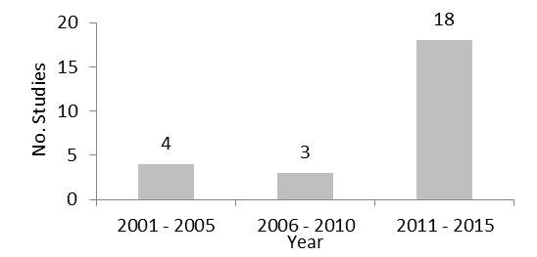

*Figure 5. Number of peer-reviewed articles that have used CFD to model wind flow over an aeolian landform*

To the authors knowledge, CFD has been used in 25 peer-reviewed journal articles relating to aeolian landform geomorphology (Figure 5, Table 1), with the majority of articles (18 of 25), published between 2011 and 2015 (Figure 5). Articles have been predominantly published in journals whose foci include earth-surface processes, although, 6 of the 25 articles are in journals who specialise in statistical mechanics and its application (Physica A), environmental modelling and software, wind engineering and industrial dynamics, and, environmental fluid mechanics. Analysis of wind flow and potential sediment transport/dust emission over storage piles (e.g. Badr and Harion, 2005; Turpin and Harion, 2009) and beach scraped ridge and dyke structures (Smyth and Hesp, 2015) have also been conducted, however, as these structures are not naturally occurring aeolian landforms, they have been omitted from this review. Wind flow has been simulated over barchans, blowouts, coastal dunes (including foredunes), linear dunes, Martian dunes, star dunes and transverse dunes (Table 1). Notably, studies focusing on ventifacts and yardangs remain absent. Wind flow over transverse dunes and coastal foredunes has been simulated the most frequently (Table 1). This is attributed to the simple two-dimensional longitudinal topographic profile of these dunes that is typically orthogonal to incident wind direction (Araújo et al., 2013). Lateral uniformity of an obstacle allows less expensive 2D simulations to have much more applicability than in complex three-dimensional landforms such as blowouts, or pyramid dunes, however, the validity of this approach is questionable as Liu et al. (2011) and Bruno and Fransos (2015) measured significant lateral wind flow in lee of a simple transverse dune. The relatively simple profiles of transverse dunes can also be experimentally measured readily in wind tunnel experiments and thus compared with modelled data.

Table 1. Peer reviewed journal articles of CFD simulations over naturally occurring aeolian landforms arranged in ascending order by year.

|  |  |  |  |
| --- | --- | --- | --- |
| **1st Author** | **Year** | **Landform** | **Journal** |
| Bourke | 2004 | Martian Dunes | J. Geophys. Res. |
| Parsons | 2004 | Transverse dune | Env. Modelling & Software |
| Parsons | 2004 | Transverse dune | Geomorphology |
| Herrmann | 2005 | Barchan and Transverse Dune | Physica A |
| Schatz | 2006 | Transverse dune | Geomorphology |
| Huang | 2008 | Transverse Dune | Earth Surf. Process. Landforms |
| Wakes | 2010 | Coastal Dunes | Env. Modelling & Software |
| Faria | 2011 | Transverse Dune | Aeolian Research |
| Jackson | 2011 | Foredune | Earth Surf. Process. Landforms |
| Liu | 2011 | Transverse Dune & Star Dune | J. Wind Eng. Ind. Aerodyn. |
| Pattanapol | 2011 | Foredune | Journal of Coastal Research |
| Petersen | 2011 | Coastal Dunes | New Zealand Geographer |
| Smyth | 2011 | Blowout | Journal of Coastal Research |
| Hart | 2012 | Coastal Dunes | Journal of Coastal Research |
| Joubert | 2012 | Linear Dune | Environ. Fluid Mech |
| Smyth | 2012 | Blowout | Geomorphology |
| Araújo | 2013 | Transverse Dune | Scientific Reports |
| Jackson | 2013b | Coastal Dunes | Journal of Coastal Research |
| Jackson | 2013a | Foredune | Geomorphology |
| Smyth | 2013 | Blowout | Aeolian Research |
| Wakes | 2013 | Coastal Dunes | Journal of Coastal Research |
| Bruno | 2015 | Transverse Dune | J. Wind Eng. Ind. Aerodyn. |
| Hesp | 2015 | Foredune | Geomorphology |
| Jackson | 2015 | Martian Dunes | Nature Communications |
| Pelletier | 2015 | Dune Field | J. Geophys. Res. Earth Surf. |

The accuracy of RANS models at calculating wind flow over hilly terrain had been demonstrated in a range of scenarios prior to its use in aeolian research (Kim et al., 1997; 2000; Maurizi, 2000). Nevertheless, due to the complex flow patterns over aeolian landforms and their geomorphic significance, a number of articles have provided specific comparisons with measured data both from field and wind tunnel experiments. This process, often referred to as model validation, determines the degree to which a model is accurate compared to measured data. Several articles have also performed model verification (Parsons et al., 2004; Wakes et al., 2010; Pelletier, 2015). Verification tests whether the model has been correctly implemented, investigating variables such as grid resolution, which greatly affect computational time and solution accuracy. Simulations are regarded as complete, and thus comparable, when the calculated variables are judged to have sufficiently converged. Convergence criteria are typically satisfied when calculated residuals decrease by several orders of magnitude (Schatz and Hermann, 2006) or when the state variables change by less than a prescribed percentage (Pelletier, 2015).

Only limited sensitivity analysis, where a variable (e.g. surface roughness) is altered to gauge its effect on wind flow, has been performed for aeolian CFD models. The most extensive study to date has been performed by Wakes (2013) who tested three variables: The distance of the inlet upwind of the region interest (in this case a foredune), surface roughness heights and mesh resolution. Wakes (2013) found that changing the inlet boundary from 10 m to 40 m, upwind of the foredune, makes some difference to the calculated flow particularly at the top of the foredune. With regards surface roughness heights, a surface with variable heights, with different values for the beach, stoss slope, and deflation plane was found to fit best with field data. Wakes (2013) reported that a roughness height of zero, as used by Jackson et al. (2011) in 3 of their 4 models, overestimated near surface flow, and that changing roughness height had the greatest impact of the stoss slope of the foredune. Mesh size was found to have profound impact on turbulent kinetic energy (TKE) values. As mesh size increased (became finer) TKE decreased and in lee of the foredune the TKE vertical profile changed in form.

Parsons et al. (2004a) was the first to validate modelled flow over an aeolian landform, comparing 2D wind flow over a transverse dune with experimental wind tunnel data (Figure 3). Using a total of 415 measurements points, most of which were concentrated in the lee of the 0.08 m high structure, results indicated that the model was capable of accurately predicting flow patterns over the dune, demonstrated by a high correlation coefficient of r = 0.98 for downstream velocity. This agreement, while still strong, weakened to r =0.83 for values of vertical velocity. Parsons et al. (2004a) also conducted a verification study of the CFD model, investigating solution accuracy with variable grid resolution. Results indicated there was little difference between the three finest grid resolutions (0.5 – 2 cm) but that at the two coarsest grid resolutions (4 cm and 8 cm) accuracy of the solution was significantly reduced.

Liu et al. (2011) also performed a validation study of wind flow over a transverse 2D dune model in a wind tunnel with CFD data. In this case, the accuracy of the model in relation to measured data was established using 6 vertical profiles, containing 12 points each, over the profile of a transverse dune (Figure 6 in Liu et al., 2011). Like Parsons et al. (2004a), simulated and measured (wind tunnel) agreed well on the dune stoss slope, crest and lee regions. Regarding near surface wind flow upstream of the dune (Figure 7 in Liu et al., 2011), only reasonable agreement was found. This discrepancy was attributed to overestimation of the measuring equipment. Liu et al. (2011) also compared the results of equivalent two-dimensional and three-dimensional transverse dune CFD simulations. The results found that there was good agreement between the two-dimensional model and a cross section of the three-dimensional model. Importantly the three-dimensional model displayed significant lateral airflow which cannot be determined in a two-dimensional model. Following the validation of the CFD methodology in the wind tunnel, the authors also modelled wind flow around a pyramid dune. With reference to this study and others, it should be noted that the transferability of models between different scenarios, must be performed with great caution. Validation of boundary conditions and turbulence models in one setting do not guarantee accuracy in another (Lane, 1998). In Liu et al. (2011) the validity of transferring a model that was tested on a 2.5 cm simple dune structure, to a scenario investigating flow over a 19.2 m high complex landform with different roughness lengths and boundary conditions, requires further investigation. Similarly, the mesh resolution of a computational domain should not be automatically transferred between investigations, as resolution requirements vary with landform scale, processes of interest and turbulence model used.

Instead of comparing flow velocity, Faria et al. (2011) compared friction velocity calculated by a 2D CFD model with friction velocity measured in a wind tunnel. Flow was measured and modelled over transverse triangular piles with stoss slope angles of 10°, 20° and 32° at 4 different wind speeds ranging from 8.3 m s-1 to 10.7 m s-1. Comparisons between measured and modelled data were made at 7 points along the stoss slope of each transverse pile. Results demonstrated a reasonable agreement between measured and modelled data with an average deviation for all the slopes and wind speeds tested of 7%. Deviation between measured and modelled results was greatest when the stoss slope was 10° and got gradually smaller for steeper windward surfaces. Computationally derived values of friction velocity at the pile crest were also greater than experimental ones. The shorter than expected recirculation zones (compared to Parsons et al. 2004a; 2004b) may be due to the use of the standard κ- ε turbulence model, which performs poorly for flow with strong separation, substantially under predicting the length of the separation bubble compared to the RNG κ- ε and Relizable κ- ε turbulence models (Kim et al., 1997; 2000; ANSYS, 2013).

A number of articles have also validated CFD performance with wind flow measured in the field. Wind flow measured in the field is much more dynamic than data collected in a wind tunnel as incident wind conditions cannot be prescribed, the topographic surface is seldom homogeneous, surface roughness length can vary dramatically and the number of validation points is typically much fewer due to the limited availability of anemometry. These studies are vital as they permit assessment of the models performance in natural conditions.

Despite the challenges, a number of studies have reported good agreement between modelled and measured data in the field. Wakes et al. (2010), tested a number of 2D modelling scenarios against measured wind speed over a coastal foredune and parabolic dune system. Wind speed was sampled at 8 sites over a coastal foredune and parabolic dune complex in Stewart Island, New Zealand. At each location cup anemometers were placed at 5 heights between 0.2 m and 5 m above the ground. Modelled and measured data compared well. The only site that a significant discrepancy between measured and modelled consistently occurred was at the foot of the foredune. Wakes et al. (2010) also noted that below 1 m the agreement between measured and modelled data decreased. The authors attributed this decline in model performance with the presence of Marram grass at the dune surface. Hart et al. (2012), comparing measured data and a CFD simulation at the same site, also found the level of agreement between measured and modelled data was significantly lower below 0.4 m; in contrast to Wakes et al. (2010), Hart et al. (2012) attribute this increase in error to the relatively large cell size close to the surface (discussed in section 4).

Jackson et al. (2011) compared offshore wind flow over a foredune measured with three-dimensional ultrasonic anemometry with a range of CFD models. The results found that models which did not account for terrain roughness performed poorly compared to measured data as they over-predicted wind velocity close to the dune surface. An LES model which did take account of surface roughness agreed best with measured data.

Smyth et al. (2012) modelled wind flow within a complex bowl blowout and for the first time compared modelled wind direction and turbulence, as well as wind speed, with measured data over an aeolian landform. Results demonstrated good agreement between measured and modelled data in general. Anomalies between the measured and modelled data were noted in the lee of the erosional walls, where the model over predicted the extent of the separation zone, and at the crest of the depositional lobe, where predicted flow remained attached whereas the wind flow measured in the field experienced separation. No agreement was found between measured and modelled turbulence parameters, demonstrating the inappropriateness of RANS turbulence modelling for studies where turbulent kinetic energy (TKE) is the focus of the investigation. Smyth et al. (2013) at the same site compared flow at 15 locations, 1m above the surface of the blowout at 5 stages of the Beaufort scale from fresh breeze to strong gale. Linear regression demonstrated a good fit (R2 ≥0.95) between the measured and modelled wind speed at 11 of the 15 locations for the 5 incident wind speeds. The model performed less well at locations sited in the lee of the erosion walls and at the toe of an erosional wall. Calculated percentage error at the 15 locations where measured and modelled data was compared, averaged 21% for wind speed and 4% for wind direction. In both Jackson et al. 2011 and Smyth et al. 2012; 2013, the lowest anemometers were located at 1 m above the surface. Although this height was necessary to ensure that the Marram grass which vegetated the dunes did not impede the sonic anemometry, the strength of fit between measured and modelled data may not reflect the relationship closer to the ground where sediment transport occurs.

Hesp et al. (2015), compared wind direction but on the stoss slope of a foredune at 7 locations between 0.66 m and 2.05 m above the surface from the dune toe to the crest. In this case, an average error of only 1% for wind direction was calculated and like Wakes et al. (2010), the greatest discrepancy existed at the toe of the foredune.

In contrast to the studies over vegetated coastal dunes where surface roughness dramatically affects near surface flow, Joubert et al. (2012) conducted an experiment on the stoss slope of a transverse desert dune on which the surface was assumed to be smooth. Modelled and measured data compared well at the 8 points on the stoss slope (Figure 7, in Joubert et al., 2012) however, the closest measurement comparison of data to the surface was at 2.5 m. Joubert et al. (2012) also modelled how *Stipagrostis sabulicola* seeds may be transport over the dune using a particle tracking solver. Seeds were represented as spheres with a prescribed mass, density and drag. The particle tracking showed once seeds were transported over the crest they were recirculated in the lee of the dune, however the accuracy of the results were not tested.

These studies indicate that overall CFD compares well with measured wind flow over aeolian landforms. Nevertheless, there is evidence to suggest that the model may underperform at the toe of a stoss slope and at the point of flow separation, particularly when compared to data collected in the field (Smyth et al., 2012; 2013; Wakes et al., 2010). To help counter these inaccuracies, particular attention should be given to accurately replicating changes in slope when recording topographic data in the field and creating a computational domain.

1. What advancements in understanding wind flow over aeolian landforms have been facilitated by CFD?

CFD has been an important tool in increasing understanding of secondary wind flow behaviour over a range of aeolian landforms. Although often used as proxy for experimentally measured wind flow, it is particularly effective where a range of variables are iteratively tested (Parsons et al., 2004b; Schatz and Hermann, 2006; Arajuo et al., 2013; Hesp et al., 2015) or over landforms that are difficult to adequately instrument (Bourke et al., 2004; Jackson et al., 2013b; Jackson et al. 2015; Smyth et al., 2011; 2012; 2013; Pelletier 2015).

* 1. *Stoss slope*

Wind flow over the stoss slope (windward slope) of a dune can be conceptually described by flow deceleration at the dune toe and acceleration along the windward slope which increases to a maximum immediately before the dune crest (Wiggs et al., 1996). Parsons et al. (2004b), replicated this behaviour when iteratively simulating flow over idealised transverse dune topography of varying height and stoss slope length. Parsons et al. (2004b) further demonstrated that as a dune increases in height, streamwise and vertical velocity increases at the crest. Conversely, streamwise velocity at the dune toe decreases with dune height. On the stoss slope of a three-dimensional foredune at Prince Edward Island, Hesp et al. (2015) simulated oblique wind flow in 10° increments from parallel to the dune crest, to perpendicular to the dune crest. The results show that at the toe of the dune, where a small scarp (cliff) was present, wind flow was steered along the beach parallel to the crest. As wind flow progressed over the windward slope it became steered increasingly perpendicular to the crest. This process of flow deflection perpendicular to the dune crest was found to be greatest for incident winds that are 30° to 70° oblique to the dune crest. The extent of flow deflection was also found to be related to elevation from the ground, with greatest wind flow steering occurring closest to the dune surface. Topographic acceleration of wind flow over the crest of the dune was also greatest for winds approximately perpendicular to the crest and significantly declined with increasing incident wind direction obliquity (Figure 6). Although these iterative studies provide specific values regarding the amount and nature of flow steering, these exact values are only valid for the particular location where the model was applied. Features such as dune scarps at the toe of the foredune, will dramatically alter the degree of steering.

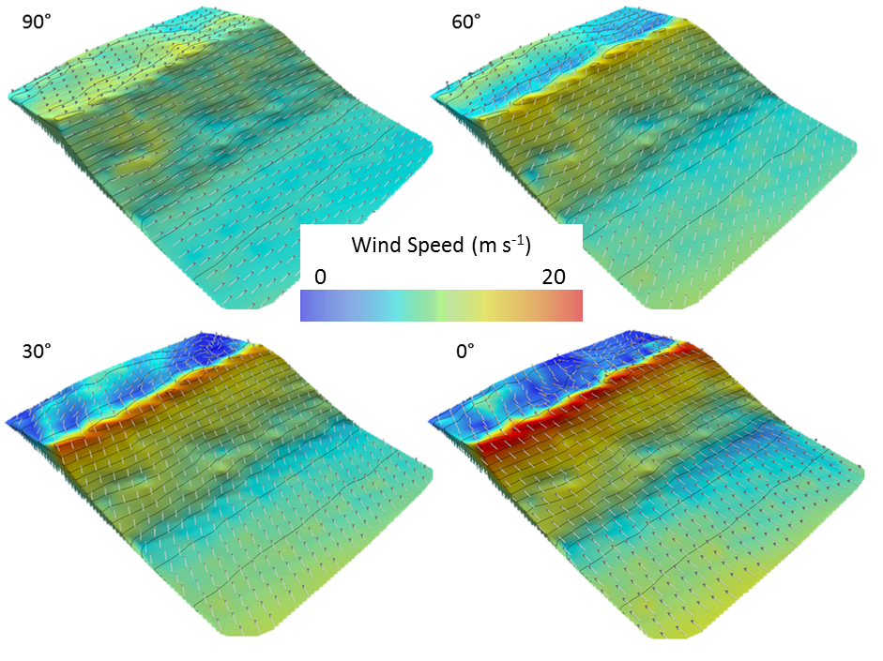

*Figure 6. Modelled wind speed at 0.66 m above the dune surface. Incident wind direction at 0° is perpendicular to the crest orientation. Arrows spaced at 2 m intervals represent wind flow direction. Greatest topographic acceleration of wind flow occurs for onshore winds (0°). The greatest degree of wind flow deflection occurs between 30° and 60° where wind can be steered crest perpendicular in excess of 20° (Image: Hesp et al., 2015).*

*3.2 Flow separation*

Flow separation has been the focus of a number of studies. Parsons et al. (2004b) found that as a dune increased in height the extent and strength of separated wind flow in the dune lee increased, as well as the length until wind flow had recovered to upwind velocity. Herrmann et al. (2005) and Schatz and Hermann (2006) discovered that when comparing transverse dunes of similar height the separation bubble is greater where dunes have a defined, less rounded, crest. Schatz and Hermann (2006) also proposed an equation which expresses the extent of the separation zone based on the numerical simulations performed and suggested that the shape of the separation zone can be approximated by an ellipse. Where flow separation occurs over a series of transverse dunes, rather than an isolated landform, Schartz and Hermann (2006) noted that the separation bubble became progressively smaller with dune number until becoming uniform in size at approximately 25% the extent of the separation bubble over a single dune.

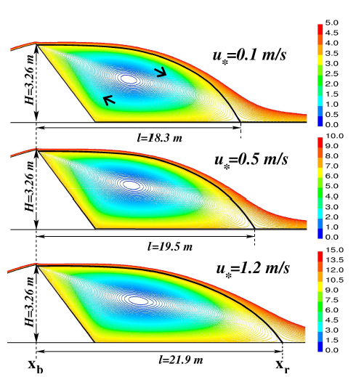

*Figure 7. Araújo et al. (2013) demonstrated that the reattachment length marginally increases with incident wind speed in the lee of a transverse dune (Image Araújo et al., 2013). Colours indicate mass flux per unit time, associated with each streamline (kg/s). The zone of separation for each incident wind speed is indicated by the continuous, thick line in each figure (Image: Araújo et al. 2013.)*

In contrast investigations that also employed CFD (Smyth et al., 2011; 2013), anemometry (Masons and Skyes, 1979; Jackson et al., 2011; Smyth et al., 2013) and a wind tunnel (Bowen and Lindley, 1977) found that velocity ratios and patterns of wind flow steering were independent of incident wind speed, Araújo et al. (2013), demonstrated that the length of the separation bubble in lee of a transverse dune increased with shear velocity (Figure 7). For shear velocities between 0.1 m s-1 and 0.8 m s-1 the extent of the separation bubble increased only marginally, however, for shear velocities above 0.8 m s-1, the extent of the separation bubble increased linearly (Figures 3 and 4 in Araújo et al., 2013). Pelletier (2015) as part of a broader study investigating spatial variations on a barchanoid dune field, documented that the occurrence and extent of a separation zone in lee of a dune increased with surface roughness length, corroborating studies investigating flow over subaqueous dunes (Engel, 1981; Best, 2005) and low hills (Britter et al., 1981) . Bruno and Fransos (2015) using Liu et al. (2011) as reference, investigated the presence of 3D coherent flow structures in lee of a transverse dune, comparing the results with a number of experimental and wind tunnel measurements available in the literature. Using Line Integral Convolution (LIC), post-processing of the CFD data, Bruno and Fransos (2015) visualised mushroom like coherent flow structures in lee of the dune, demonstrating that 3D structures are formed even for a structure that does not change longitudinally.

Not all studies investigating flow separation have used transverse dunes. Jackson et al. (2013a) numerically calculated wind flow in three-dimensions over an idealised coastal foredune and measured coastal foredune. By adding 0.3 m high ‘bumps’ to the idealised dune the spatial extent of flow reversal was increased by 5 – 10 m when incident wind flow was directly perpendicular to the crest (Figure 8). Wind flow was also simulated at a 45 degree angle oblique to the dune crest. During this scenario the zone of flow reversal and wind speed at the dune crest was reduced. Liu et al., 2011 similarly concluded that for simulated wind flow over a star dune, the location, shape and magnitude of the zone of separation all change corresponding to the dune topography.

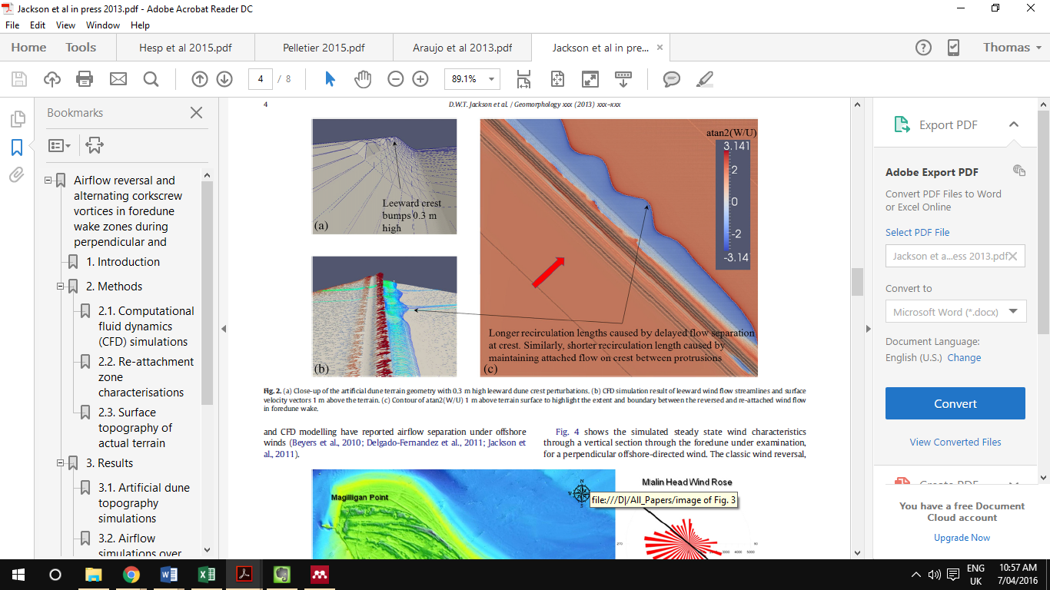

*Figure 8. Artificial appendages to the dune crest in Jackson et al. (2013a) were found to increase the extent of wind flow separation and delay wind flow reattachment (Image: Jackson et al., 2013a)*

*3.3 Localised wind flow spatial variation in dune fields*

Where large dune fields or inaccessible locations, such as Mars (Bourke et al., 2004; Jackson et al., 2015), are being investigated, CFD is useful as it offers an accurate, high resolution proxy for localised wind flow when comprehensive instrumentation of the study area is impossible. CFD has been employed in this manner by a number of studies (Petersen et al., 2011; Pattanapol et al., 2011; Hart et al., 2012; Smyth et al., 2012; Jackson et al., 2013). Most notably Pelletier (2015) implemented a series of CFD models to investigate large-scale spatial variations of dune field properties in White Sands dune field, New Mexico. In addition to examining how surface roughness and dune height related to wind flow separation, CFD was employed to test how bed shear stress responded to a change in surface roughness length, establish where localised erosion occured in the dune field and quantify spatial variations in flux associated with deviations in long-wavelength topography and effective aerodynamic roughness.

1. *The future of CFD in aeolian research*

Advances in computational power, better algorithms and strategic collaborations have been important stimuli for the increase of CFD usage in aeolian research. To date this research has been predominantly performed on Earth, although, as planetary aeolian research continues to grow, CFD will be increasingly used to understand near surface wind flow on celestial bodies such as Mars (Jackson et al., 2015) and Titan (Cisneros et al., 2015). In the wider scope, as computational power continues to increase, particularly with the integration of graphics processing units (GPUs) in high performance computers, numerical calculation of fluid flow will continue to become more sophisticated and ubiquitous in research relating to earth surface processes.

At present wind flow dynamics have been validated with experimental measurements in numerous articles while comparison with erosion, deposition and topographic change remains largely absent. Although Faria et al. (2011) have observed that predicted friction velocity correlated well over transverse dunes in a wind tunnel, more studies are required, particularly in natural environments to understand and validate the relationship between simulated near wind flow and topographic change. Once established, this relationship could potentially predict areas of topographic change by altering the surface mesh in relation to zones of erosion and deposition, ultimately, simulating landform evolution over time. As processing power increases it may be possible to couple CFD with cellular automaton (CA) models, similar to Narteau et al. 2009, or model topographic change by adaptive meshing, which has previously been applied to replicate the meandering characteristics of water flow from an initially straight alluvial channel (Olsen, 2003), and the accumulation of snow around a 3D cube (Beyers et al., 2004; Beyers and Waechter, 2008)

A second progression is the use of unsteady turbulence modelling such as LES, as employed by Jackson et al. (2011). With the exception of Jackson et al. (2011) current wind flow simulations over aeolian landforms have employed steady state turbulence models. The advantage of unsteady flow modelling, particularly when paired with a sediment transport model, is that it permits unstable boundary layer structures such as bursts and eddies, to be investigated, allowing their origin and role in aeolian sediment transport to be better understood. Detailed analysis of this nature has been performed on a flat erodible surface by Dupont et al. (2013), who coupled a saltation model with a LES airflow model. Using this coupled model Dupont et al. (2013) were able to reproduce sand streamers near the sediment surface, interpreting them to be the footprint of elongated eddies near the bed that changed with wind conditions and particle size. LES has similarly been coupled with a dust mobilisation scheme (Klose and Shao, 2013) to investigate the stochastic process of turbulent dust emission created by the transfer of momentum to the surface by large eddies for different atmospheric conditions. Although performed in a RANS model, the insertion of particles into wind flow models over an aeolian landform has been successfully utilised by Joubert et al. (2012). Joubert et al. (2012) used lagrangian particle tracking to examine seed dispersal patterns over a three-dimensional transverse dune. Lagrangian particle tracking is useful when investigating the dispersion of small amounts of material, however, the addition of a sediment transport model in a CFD simulation that accurately simulates the complex physics of grain to grain and bed to grain interaction, as well as the resulting topographic change, has not yet been demonstrated. Incorporating sediment dynamics to fluid flow simulations is challenging as entrained sediment affects the mass and momentum properties of the fluid, as well as the production and dissipation of turbulence. The deposition and erosion of sediment also changes the surface of the computational domain requiring an adaptive meshing solution, further increasing computational cost. Prediction of the erosion and deposition of windblown snow surrounding a three-dimensional cube has been achieved, although discrepancies between measured and modelled snow accumulation occurred near the walls of the cube (Beyers et al, 2004).

To date several investigations have modelled wind flow on a landscape/dunefield scale to determine how changes in surface roughness and dune height affect the mean flow characteristics of the internal boundary layer (Jackson et al., 2013b; Pelletier 2015). In contrast, no studies have yet investigated the effect of large-eddy energy transfer on landform dynamics. While field measurements of this nature are difficult to collect, synthetic data produced by LES over a 12 hour period has compared well with ground based and airborne measurements (Shao et al., 2013). The examination of process-response relations in respect to boundary layer dynamics and landform genesis/evolution may prove valuable to improving understanding of aeolian geomorphology at a macro-scale through space and time.

The accurate modelling of surface roughness poses a substantial problem to simulations over vegetated landforms. In most cases vegetation is characterised as a surface roughness length. This parameter dictates the vertical resolution of a model as the cell closest to the surface must equal twice the aerodynamic roughness length (Pelletier 2015), when using a wall function. Franke et al. (2004) also recommends that at least two cells are between the surface and area of interest within the computational domain, potentially dramatically reducing the near surface resolution of calculated wind flow, particularly over very rough surfaces. Furthermore the accuracy of using present surface roughness constants (e.g. Maun, 2009, Table 1.2) in CFD models is untested and requires further research. The modelling of vegetation as discrete roughness elements would notably improve both wind flow resolution and near surface wind flow dynamics, particularly in areas of roughness length transition, however, the computational cost remains prohibitive, especially for dune scale landforms.

In river channels, where vegetation also has a profound influence on flow dynamics, a range of alternative methods that account for the surface roughness produced by vegetation have been developed, including momentum sink terms to RANS models (Fishcher-Antze et al. 2001); discrete element modelling whereby vegetation has been represented by discrete circular cylinders (Stoesser et al., 2006; 2010); biomechanical models which consider plant flexibility (Ikeda et al. 2001; Majoribanks et al. 2014) and individual complex plant morphologies (Boothroyd et al. 2016). Similar boundary problems have also been tackled in the atmospheric boundary-layer literature. Where flow dynamics over forests has been investigated, the canopy has been represented as a porous body (Shaw and Schumann, 1992), a drag term in the Navier-Stokes equations (Kanda and Hino, 1994) and poroelastic medium which takes into account plant motion (Py et al. 2006; Dupont et al. 2010). These alternative treatments for vegetation roughness have yet to be tested in the context of wind flow over an aeolian landform, and comparison with experimental data measured over complex vegetated dune landforms has yet to be performed.

1. Conclusion

This review demonstrates that CFD can be used to model the wind flow around natural aeolian landforms and replicate field and wind tunnel measurements. The technique has been evidenced as a valuable tool to aeolian researchers investigating wind flow separation, steering and acceleration over isolated landforms and landforms integrated within a landscape. CFD is likely to be an increasingly utilised tool in aeolian research and future research is expected to include the prediction of erosion and deposition by CFD, increased integration of LES turbulence modelling and the use of discrete roughness elements to examine the boundary layer dynamics in vegetation.

References

ANSYS, 2013. ANSYS Fluent Theory Guide, 15.0 ed, ANSYS Inc., 2013.

Araújo, A., Parteli, E.J.R., Thorsten, P., Andrade, J.S., Herrmann, H.J., 2013. Numerical modeling of the wind flow over a transverse dune. Scientific Reports 3, 1–11. doi:10.1038/srep02858

Baddock, M.C., Wiggs, G.F.S., Livingstone, I., 2011. A field study of mean and turbulent flow charactersitics upwind, over and downwind of barchan dunes. Earth Surface Processes and Landforms 36, 1435-1448.

Badr, T., Harion, J.L., 2005. Numerical modelling of flow over stockpiles: Implications on dust emissions. Atmospheric Environment 39, 5576–5584. doi:10.1016/j.atmosenv.2005.05.053

Best, J., 2005. The fluid dynamics of river dunes: A review and some future research directions. Journal of Geophysical Research, 110, doi:10.1029/2004JF000218

Beyers, J.H.M., Sundsbo, P.A., Harms, T.M., 2004. Numerical simulation of three-dimensional, transient snow drifting around a cube. Journal of Wind Engineering and Industrial Aerodynamics 92, 725-747.

Beyers, M., Waechter, B., 2008. Modeling transient snowdrift development around complex three-dimensional structures. Journal of wind Engineering and Industrial Aerodynamics 96, 1603-1615.

Blocken, B., Stathopoulous, T., Carmeliet, J., 2007. CFD simulation of the atmospheric boundary layer: wall function problems. Atmospheric Environment, 41, 238-252.

Boothroyd, R.J., Hardy, R.J., Warburton, J., Majoribanks, T.I., 2016. The importance of accurately representing submerged vegetation morphology in the numerical prediction of complex river flow. Earth surface processes and lanforms 41, 567-576.

Bourke, M.C., Bullard, J.E., Barnouin-Jha, O.S., 2004. Aeolian sediment transport pathways and aerodynamics at troughs on Mars. Journal of Geophysical Research 109, 1–16. doi:10.1029/2003JE002155

Bowen, A.J., Lindley, D., 1977. A wind-tunnel investigation of the wind speed and turbulence characteristics close to the ground over various escarpment shapes. Boundary-Layer Meteorology 12, 259-271.

Britter, R.E., Hunt, J.C.R., Richards, K.J., 1981. Air flow over a two-dimensional hill: studies of velocity speed-up, roughness effects and turbulence. Quarterly Journal of the Royal Meteorological Society 107, 91-110.

Bruno, L., Fransos, D., 2015. Sand transverse dune aerodynamics: 3D coherent flow structures from a computational study. Journal of Wind Engineering and Industrial Aerodynamics 147, 291-301.

Cisneros, J., McDonald, G.D., Hayes, A.G., Smyth, T.A.G., Ewing, R.C., 2015. Morphologic and compuational fluid dynamic analysis of sand dune topographic obstacle interactions on Earth and Titan, in: 46th Lunar and Planetary Science Conference.

Craddock, R. A., 2011. Aeolian processes on the terrestrial planets: Recent observations and future focus. Progress in Physical Geography 36, 110–124. doi:10.1177/0309133311425399

Delgado-Fernandez, I., Jackson, D.W.T., Cooper, J.A.G., Baas, A.C.W., Beyers, J.H., Lynch, K., 2013. Field characterization of three-dimensional lee-side airflow patterns under offshore winds at a beach-dune system. Journal of Geophysical Research Earth Surfaces 118, 706-721.

Dupont, S., Bergametti, G., Marticorena, B., Simoëns, S., 2013. Modeling saltation intermittency. Journal of Geophysical Research: Atmospheres 118, 7109–7128. doi:10.1002/jgrd.50528

Dupont, S., Gosselin, F., Py, C., de Langre, E., Hemon, P., Brunet, Y., 2010. Modelling waving crops using large-eddy simulation: comparison with experiments and a linear stability analysis. Journal of Fluid Mechanics 652, 5-44.

Ellis, J.T., Sherman, D.J., 2013. Fundamentals of aeolian sediment transport: wind-blown sand, in: Shroder, J.F., Lancaster, N., Sherman, D.J., Baas, A. C. W. (Eds.), Treatise in Geomorphology. Academic Press, pp. 85–108.

Engel, P., 1981. Length of flow separation over dunes. J. Hydraul. Div. Am. Soc. Civ. Eng. 107, 1133-1143.

Faria, R., Ferreira, A.D., Sismeiro, J.L., Mendes, J.C.F., Sousa, A.C.M., 2011. Wind tunnel and computational study of the stoss slope effect on the aeolian erosion of transverse sand dunes. Aeolian Research 3, 303–314. doi:10.1016/j.aeolia.2011.07.004

Ferziger, J.H., Perić, M., 2002. Computational Methods for Fluid Dynamics. 3rd Edition, Springer, Berlin

Franke, J., Hirsch, C., Jensen, A.G., Krüs, H.W., Schatzmann, M.,Westbury, P.S., Miles, S.D.,Wisse, J.A., Wright, N.G., 2004. Recommendations on the use of CFD in wind engineering. In: van Beeck, J.P.A.J. (Ed.), COST Action C14, Impact of Wind and Storm on City Life Built Environment. Proceedings of the International Conference on Urban Wind Engineering and Building Aerodynamics, 5–7 May 2004. von Karman Institute, Sint-Genesius-Rode, Belgium.

Fishcher-Antze, T., Stoesser, T., Bates, P., Olsen, N.R.B., 2001. 3D numerical modelling of open-channel flow with submerged vegetation. Journal of Hydraulic Research 39, 3. doi:10.1080/00221680109499833

Gunatilaka, A., Mwango, S.B., 1989. Flow separation and the internal structure of shadow dunes. Sedimentary Geology 61, 125–134.

Hart, A.T., Hilton, Mike J., Wakes, Sarah J., Dickinson, K.J.M., 2012. The Impact of Ammophila arenaria Foredune Development on Downwind Aerodynamics and Parabolic Dune Development. Journal of Coastal Research 279, 112–122. doi:10.2112/JCOASTRES-D-10-00058.1

Herrmann, H., Andradejr, J., Schatz, V, Sauermann, G., Parteli, E., 2005. Calculation of the separation streamlines of barchans and transverse dunes. Physica A: Statistical Mechanics and its Applications 357, 44–49. doi:10.1016/j.physa.2005.05.057

Hesp, P.A., Hyde, R., 1996. Flow dynamics and geomorphology of a trough blowout. Sedimentology 43, 505-525.

Hesp, P.A., Smyth, Thomas A G, Nielsen, P., Walker, I.J., Bauer, B.O., Davidson-Arnott, R., 2015. Flow deflection over a foredune. Geomorphology 230, 64–74. doi:http://dx.doi.org/10.1016/j.geomorph.2014.11.005

Huang, N., Shi, F., Pelt, R.S. Van, 2008. The effects of slope and slope position on local and upstream fluid threshold friction velocities. Earth Surface Processes and Landforms 33, 1814–1823. doi:10.1002/esp

Ikeda, S., Yamada, T., Toda, Y., 2001. Numerical study on turbulent flow and honami in and above flexible plant canopy. International Journal of Heat and Fluid Flow 22, 3, 252-258.

Jackson, D. W. T., Beyers, J.H.M., Lynch, K., Cooper, J. A. G., Baas, A. C.W., Delgado-Fernandez, I., 2011. Investigation of three-dimensional wind flow behaviour over coastal dune morphology under offshore winds using computational fluid dynamics (CFD) and ultrasonic anemometry. Earth Surface Processes and Landforms 36, 1113–1124. doi:10.1002/esp.2139

Jackson, D.W.T., Beyers, M., Delgado-Fernandez, Irene, Baas, Andreas C.W., Cooper, A.J., Lynch, Kevin, 2013a. Airflow reversal and alternating corkscrew vortices in foredune wake zones during perpendicular and oblique offshore winds. Geomorphology 187, 86–93. doi:10.1016/j.geomorph.2012.12.037

Jackson, D.W.T., Bourke, M.C., Smyth, T.A.G., 2015.[The dune effect on sand-transporting winds on Mars. Nature Communications](http://www.nature.com/ncomms/2015/151105/ncomms9796/full/ncomms9796.html), 6, 8796.

Jackson, D.W.T., Cruz-Avero, N., Smyth, T.A.G, Hernandez-Calvento, L., 2013b. 3D airflow modelling and dune migration patterns in an arid coastal dune field. Journal of Coastal Research 1301–1306. doi:10.2112/SI65-220.1

Jackson, P.S., Hunt, J.C.R., 1975. Turbulent wind flow over a low hill. Quarterly Journal of the Royal Meteorological Society 101, 929–955.

Joubert, E.C., Harms, T.M., Muller, A., Hipondoka, M., Henschel, J.R., 2012. A CFD study of wind patterns over a desert dune and the effect on seed dispersion. Environmental Fluid Mechanics 12, 23–44. doi:10.1007/s10652-011-9230-3

Kanda, M., Hino, M., 1994. Organized structures in Developing Turbulent Flow within and above a Plant Canopy, Using a LES. Boundary-Layer Meteorology 68, 237-257.

Kaimal, J.C., Finnigan, J.J., 1994. Atmospheric Boundary Layer Flows: Their Structure and Measurement. Oxford University Press, New York.

Kim, H. G., Lee, C. M., Lim, H. C., Kyong, N. H., 1997. An experimental and numerical study on the flow over two-dimensional hills. Journal of Wind Engineering and Industrial Aerodynamics 66, 17-33.

Kim, H. G., Patel, V. C., Lee, M. L., 2000. Numerical simulation of wind flow over hilly terrain. Journal of Wind Engineering and Industrial Aerodynamics 87, 45-60.

Klose, M., Shao, Y., 2013. Large-eddy simulation of turbulent dust emission. Aeolian Research 8, 49–58.

Lancaster, N., 1994. Dune Morphology and Dynamics, in: Abrahams, A.D., Parsons, A.J. (Eds.), Geomorphology of Desert Environments. pp. 474–505.

Lane, S.N., 1998. Hydraulic modelling in hydrology and geomorphology: A review of high resolution approaches. Hydrological Processes 12, 1131-1150.

Liu, B., Qu, J., Zhang, W., Qian, G., 2011. Numerical simulation of wind flow over transverse and pyramid dunes. Journal of Wind Engineering and Industrial Aerodynamics 99, 879–888. doi:10.1016/j.jweia.2011.06.007

Majoribanks, T.I., Hardy, R.J., Lane, S.J., Parsons, D.R., 2014. High-resolution numerical modelling of flow-vegetation interactions. Journal of Hydraulic Research 52, 6, 775-793.

Mason, P.J., Sykes, R.I., 1979. Flow over an isolated hill of moderate slope. Quarterly Journal of the Royal Meteorological Society 105, 383–395.

Maun, M.A., 2009. The Biology of Coastal Sand Dunes. Oxford Univ Press, 265pp.

Maurizi, A., 2000. Numerical simulation of turbulent flows over 2-D valleys using three versions of the kappa-epsilon closure model. Journal of Wind Engineering and Industrial Aerodynamics 85, (1) 59-73.

Narteau, C., Zhang, D., Rozier, O., Claudin, P., 2009. Setting the length and time scales of a cellular automaton dune model from the analysis of superimposed bed forms. Journal of Geophysical Research 114, 1–18. doi:10.1029/2008JF001127

Olsen, N., 2003. Three-Dimensional CFD Modeling of Self-Forming Meandering Channel. Journal of Hydraulic Engineering 129, 366–372.

Omidyeganeh, M., Piomelli, U., Christensen, K.T., Best, J.L., 2013. Large eddy simulation of interacting barchan dunes in a steady, unidirectional flow, Journal of Geophysical Research: Earth Surface 118, 2089-2104

Parsons, D., Wiggs, G., Walker, I.J., Ferguson, R., Garvey, B., 2004a. Numerical modelling of airflow over an idealised transverse dune. Environmental Modelling & Software 19, 153–162. doi:10.1016/S1364-8152(03)00117-8

Parsons, D.R., Walker, I.J., Wiggs, G.F.S., 2004b. Numerical modelling of flow structures over idealized transverse aeolian dunes of varying geometry. Geomorphology 59, 149–164. doi:10.1016/j.geomorph.2003.09.012

Pattanapol, W., Wakes, S J, Hilton, M., 2011. Using Computational Fluid Dynamics to determine suitable foredune morphologies in New Zealand. Journal Of Coastal Research Special Issue 64, 298–302.

Pelletier, J.D., 2015. Controls on the large-scale spatial variations of dune field properties in the barchanoid portion of White Sands dune field, New Mexico. Journal of Geophysical Research: Earth Surface 120, 1–21. doi:10.1002/2014JF003314.

Pelletier, J.D., Sherman, D.J., Ellis, J.T., Farrell, E.J., Jackson, N.J., Li, B., Nordstrom, K.F., Parente Maia, L., Omidyeganeh, M., 2015. Dynamics of sediment storage and release on aeolian dune slip faces: A field study in Jericoacoara, Brazil. Journal of Geophysical Research: Earth Surface 120, 1911-1934 doi: 10.1002/2015JF003636

Petersen, P.S., Hilton, Michael J., Wakes, Sarah J., 2011. Evidence of aeolian sediment transport across an Ammophila arenaria-dominated foredune, Mason Bay, Stewart Island. New Zealand Geographer 67, 174–189. doi:10.1111/j.1745-7939.2011.01210.x

Py, C., de Langre, E., Mouila, B., 2006. A frequency lock-in mechanism in the interaction between wind and crop canopies. Journal of Fluid Mechanics 568, 425-449.

Reynolds, O., 1895. `On the dynamical theory of incompressible viscous ¯uids and the determination of the criterion', Phil. Trans. R. Soc., 186A, 123±164

Rothman, D.H., Zaleski, S., 2004. Lattice-Gas Cellular Automata: Simple Models of Complex Hydrodynamics, Cambridge University Press, Cambridge, UK.

Schatz, Volker, Herrmann, H.J., 2006. Flow separation in the lee side of transverse dunes: A numerical investigation. Geomorphology 81, 207–216. doi:10.1016/j.geomorph.2006.04.009

Shao, Y., Liu, S., Schween, J.H., Crewell, S., 2013. Large-Eddy Atmosphere–Land-Surface Modelling over Heterogeneous Surfaces: Model Development and Comparison with Measurements. Boundary-Layer Meteorology 148, 333–356.

Sharpio, A.H., 1953. The dynamics and thermodynamics of compressible fluid flow, Volume 1. 672 pp

Shaw, R.H., Schumann, U., 1992. Large-Eddy Simulation of Turbulent Flow above and within a Forest. Boundary-Layer Meteorology 61, 1-2, 47-64.

Smyth, T.A.G, Jackson, D.W.T., Cooper, J.A.G., 2011. Computational Fluid Dynamic modelling of Three-Dimensional airflow over dune blowouts. Journal of Coastal Research SI 64, 314–318.

Smyth, T.A.G, Jackson, D.W.T., Cooper, J.A.G., 2012. High resolution measured and modelled three-dimensional airflow over a coastal bowl blowout. Geomorphology 177-178, 62–73. doi:10.1016/j.geomorph.2012.07.014

Smyth, T.A.G, Jackson, D.W.T., Cooper, J.A.G., 2013. Three dimensional airflow patterns within a coastal trough – bowl blowout during fresh breeze to hurricane force winds. Aeolian Research. doi:10.1016/j.aeolia.2013.03.002

Smyth, T.A.G., Hesp, P.A., 2015. Aeolian dynamics of beach scraped ridge and dyke structures. Coastal Engineering 99, 38–45. doi:10.1016/j.coastaleng.2015.02.011

Stoesser, T., Kim, S.J., Diplas, P., 2010. Turbulent flow through idealized emergent vegetation, Journal of Hydraulic Engineer 136, 12, 1003-1017.

Stoesser, T., Liang, C., Rodi, W., Jirka, G., 2006. Large eddy simulation of fully-developed turbulent flow through submerged vegetation, in: Ferrerira, R.M.L., Alves, E.C.T.L., Leal, J.G.A.B., Cardoso, A.H., River Flow 2006, 227-234.

Turpin, C., Harion, J.-L., 2009. Numerical modeling of flow structures over various flat-topped stockpiles height: Implications on dust emissions. Atmospheric Environment 43, 5579–5587. doi:10.1016/j.atmosenv.2009.07.047

Van Boxel, J.H., Arens, S.M., Van Dijk, P.M., 1999. Aeolian processes across transverse dunes. I: Modelling the air flow. Earth Surface Processes and Landforms 24, 255–270.

Versteeg, H.K., Malalasekera, W., 2006. An Introduction to Computational Fluid Dynamics, Second ed. Pearson, Harlow.

Wakes, S.J, 2013. Three-dimensional Computational Fluid Dynamic experiments over a complex dune topography. Journal of Coastal Research, SI 50, 1337–1342. doi:10.2112/SI65-226.1

Wakes, S.J., Maegli, T., Dickinson, K.J., Hilton, M.J., 2010. Numerical modelling of wind flow over a complex topography. Environmental Modelling & Software 25, 237–247. doi:10.1016/j.envsoft.2009.08.003

Walker, I.J. 1999. Secondary airflow and sediment transport in the lee of a reversing dune. Earth Surface Processes and Landforms 24, 437-448.

Walker, I.J., Nickling, W.G., 2002. Dynamics of secondary airflow and sediment transport over and in the lee of transverse dunes. Progress in Physical Geography 26, 47–75. doi:10.1191/0309133302pp325ra

Walker, I.J., Nickling, W.G., 2003. Simulation and measurement of surface shear stress over isolate and closely spaced dunes in a wind tunnel. Earth Surface Processes and Landforms 28, 1111-1124.

Walmsley, J.L., Howard, A.D., 1985. Application of a boundary-layer model to flow over an eolian dune. Journal of Geophysical Research 90, 631–640.

Wiggs, G.F.S., Livingstone, I., Warren, A., 1996. The role of streamline curvature in sand dune dynamics: evidence from field and wind tunnel measurements. Geomorphology 17, 29–46.

Wilcox, D.C., 1988. Reassessment of the Scale-Determining Equation for Advanced Turbulence Models, AIAA J 26, 1299-1309

Wipperman, F.K., Gross, G., 1986. The wind-induced shaping and migration of an isolated dune: A numerical experiment. Boundary-Layer Meteorology 36, 319–334.

Yakhot, V., Orszag, S.A., 1986. Renormalization group analysis of turbulence: Basic theory. Journal of Scientific Computing, 1, 3-51.

Zhang, D., Narteau, C., Rozier, O., 2010. Morphodynamics of barchan and transverse dunes using a cellular automaton model. Journal of Geophysical Research 115, 1–16. doi:10.1029/2009JF001620

Zhang, D., Narteau, C., Rozier, O., Courrech du Pont, S., 2012. Morphology and dynamics of star dunes from numerical modelling. Nature Geoscience 5, 463–467. doi:10.1038/ngeo1503