**Imagery Intervention to Increase Flow State: A Single-Case Study with Middle-Distance Runners in the State of Qatar**

**Abstract**

The purpose of this study was to examine the effect of an imagery intervention on flow state in elite junior middle-distance runners based at a high-performance academy in Doha, Qatar. The study consisted of a nonconcurrent, single-case, multiple baseline A-B design. Theory-guided interviews on proximal conditions of flow state, including challenge-skills balance, clear goals, and unambiguous feedback, were conducted with athletes and coaches forming the basis of the intervention. The baseline phase was completed once each participant had met the stability criterion for flow state. Three participants worked with individualised, tailored imagery scripts during a four-week intervention phase. The results of the post-intervention phase showed a mean increase in flow state for all participants. The results have cross-cultural relevance and outline the challenges and potential barriers associated with working with elite junior athletes in ‘emerging countries’ in the Middle East, in comparison to working with Western athletes in ‘emerged countries’. Positive effects and some of the pitfalls associated with forming work collaborations between sport psychologists, working in research and applied areas, are considered in the discussion.

Words (abstract): 176

Words (manuscript): 6124

Keywords: Flow, intervention, Arabic athletes, cross culture.

**Introduction**

People performing at their best have characterised this state as being totally absorbed in and focused on the task at hand, feeling confident and in control, while their body works effortlessly and automatically (Csikszentmihalyi, 2000; Jackson & Csikszentmihalyi, 1999). Csikszentmihalyi (1975) called this state of optimal experience flow. Flow theory consists of nine dimensions, including challenge-skills balance, action-awareness merging, clear goals, unambiguous feedback, concentration on the task at hand, sense of control, loss of self-consciousness, time transformation, and autotelic experience. Sport specific research generally corroborated the nine-dimensional flow structure as evidenced by qualitative and quantitative findings (cf. Swann, Keegan, Piggott, & Crust, 2012). On a conceptual level, Csikszentmihalyi (1988) proposed flow to be a universal construct indicating that the flow experience should not be substantially different between individuals of Western, Eastern, or Middle-Eastern cultures. Indeed, on a measurement level, factorial validity of the nine-dimensional flow model has been found with English- (from Australia; Jackson et al., 2008), French- (from Canada and France; Fournier, Gaudreau, Demontrond-Behr, Visioli, Forest, & Jackson, 2007), Greek- (Stavrou & Zervas, 2004), Japanese- (Kawabata, Jackson, & Mallett, 2008), and Turkish-speaking (Koehn, Aşçı, & Caglar, 2015) samples. From a cross-cultural perspective, flow appears to be a rather stable construct. The purpose of this study was to examine the effectiveness of a four-week intervention program to increase optimal experience, as defined and operationalised by flow state, in Qatar-based, elite junior middle-distance runners.

Athletes in flow described their experience as effortless and being in the moment (Jackson, 1995, 1996). All actions appear to be happening spontaneously and automatically – athletes are mentally and physically at one with their performance. These reports support theoretical propositions by Csikszentmihalyi (1975), underlining that flow is self-contained and is more readily experienced through a focus on the task at hand. One construct that is closely linked to flow is mindfulness. Having its origins in Eastern meditational use (Bernier, Thienot, Codron, & Fournier, 2009), the common characteristic of both mindfulness and flow is being in the moment (Swann et al., 2012). Research has shown the benefits of being mindful for the experience of flow. Using a cluster-analytic approach, Kee and Wang (2008) found that athletes in the high-mindfulness clusters scored significantly higher on a majority of flow dimensions, including challenge-skills balance, clear goals, and concentration on the task, than low-mindfulness clusters. Applying a mindfulness intervention to increase flow state, Ahern, Moran, and Lonsdale (2011) found that the experimental, in contrast to the control group increased on all nine flow dimensions from pre- to post-intervention. Being in the present seems advantageous as athletes may be easily distracted by past events or possible events that may occur in the future, for instance through ‘what-if’ thoughts (Jackson & Csikszentmihalyi, 1999). Being in flow allows athletes to be in the moment and fully focus on the task at hand, therefore mindfulness and flow state may induce a stronger performance experience and may facilitate a better performance outcome.

**Increasing Flow State through Interventions**

Research has provided evidence that interventions can effectively increase flow state during sport performances. Previous studies can be broadly categorised into using two different intervention types to enhance flow state either employing hypnosis (e.g., Pates, Cummings, & Maynard, 2002; Pates, & Maynard, 2000: Pates, Oliver, & Maynard, 2001) or imagery (e.g. Koehn, Morris, & Watt, 2014; Pates Karageorghis, Fryer, Maynard, 2003) interventions. The results showed that hypnosis and imagery interventions were generally effective in increasing flow state. Although imagery type did not present as a moderating variable in regard to the effectiveness of the intervention, the performance setting appeared to have a stronger impact on athletes’ flow state. Interventions applied in training settings have generally shown a sustained increase in flow state after the hypnosis (e.g., Pates et al., 2001, 2002) or imagery (Pates et al., 2003) treatment with little overlap to pre-intervention measurements. On the other hand, in a competition setting results showed a number of overlapping data points for flow scores between baseline and post-intervention phases (Koehn et al., 2014; Lindsay, Maynard, & Thomas, 2005). Following the intervention phase, Koehn et al. (2014) reported that flow state even decreased for one of the participants following the intervention. The controlled training environment appears to involve fewer distractions than the competition setting. This could have facilitated a stronger impact on flow state and is potentially preferable for intervention research to increase flow during performance.

Previous intervention studies generally lacked the provision of a rationale as to why one intervention method was preferable over the other. In contrast to hypnosis interventions, imagery techniques appear to have a higher usability as hypnosis is generally used by experts who have undergone hypnosis training. Pates et al. (2002) highlighted the importance of acquiring hypnosis skills in order to perform the correct techniques, as well as to prevent the unethical use or misuse of hypnosis. This may include specialized training and experience in clinical settings. Therefore, interventions aiming to increase flow state it would be beneficial for athletes and coaches to consider the use of imagery over hypnosis techniques. Imagery is frequently used by sport psychologists and can be readily incorporated into training and competition preparation providing a suitable alternative to enhance flow state (Koehn et al., 2014).

Another limitation of previous intervention studies was the lack on how the intervention was developed. Jackson and Csikszentmihalyi (1999) stated that visualisation will help athletes to focus on crucial performance aspects, to focus on their goals, and to make their performance more effortless. Morris, Spittle, and Watt (2005) advocated that “imagery, which is specifically directed at the antecedents in a particular sport context, should enhance the experience of flow” (p. 327). Based on this rationale, Koehn et al. (2013) developed an imagery script to increase flow state in junior tennis players based on cross-sectional data. In a sample with 261 athletes, Koehn et al. (2013) found challenge-skills balance, clear goals, concentration on the task, and sense of control to be key dimensions for flow experience in tennis competition; the imagery intervention targeted these specific dimensions in order to increase flow state and performance in tennis tournaments. The results showed a sustained increase of both dependent variables following the intervention phase (Koehn et al., 2014). Although the methodology of using a two-part study was helpful for the development of an imagery script, this research-based approach was rather specific and limited to the sport of tennis.

An alternative approach for the development of flow interventions could be theory-based. Csikszentmihalyi (1997, 2000) and Nakamura and Csikszentmihalyi (2002) proposed that some flow dimensions are crucial for getting into flow. More specifically, challenge-skills balance, clear goals, and unambiguous feedback are considered proximal conditions of flow, whereas the remaining dimensions reflect characteristics of flow that individuals experience while being in flow (Nakamura & Csikszentmihalyi, 2002). Kawabata and Mallett (2011) tested the association between preconditions of flow and flow state. The higher-order model provided evidence for the two categories of flow dimensions, indicating a potential sequential relationship between flow conditions and flow characteristics. Ideally, theoretical and empirical evidence should guide future interventions to increase flow state during performance.

**Working with Middle-Eastern Athletes**

Tailoring an intervention with Arabic athletes presents some challenges on a sociocultural level (Galloway, 2009). Western coaches and practitioners may have acquired personal, educational, and professional experiences that divert from the athletes’ expectations (Parham, 2005). Following Parham’s (2005) considerations understanding the differences between Western and other cultural contexts is vital for a successful intervention outcome, but the coach-athlete relationship can create difficulties if coaches and athletes originate from different cultural backgrounds.

Jowett and Poczwardowski (2007) advocated that psychological well-being and performance enhancement are at the centre of the coach-athlete relationship. The connection between coaches and athletes is critical to enhance athletes’ feelings (e.g., closeness), thoughts (e.g., commitment and interpretations), and behaviours (e.g., reciprocity), which, in turn, affects athletes’ motivation and performance (Jowett & Poczwardowski, 2007). Galloway (2009) outlined further that the speed and the depth with which a relationship develops is generally slower than practitioners may have experienced in Western societies. Middle-Eastern athletes are generally part of larger families. Athletes’ self-identity may be closely linked to family norms and values, as well as religious values (Galloway, 2009). Putting a stronger emphasis on family and religion Middle-Eastern athletes may be less inclined to form strong relationships with Western coaches, whereas Western athletes may be willing to develop a closer one-on-one relationship with their coach (Oates, Lewis, & Lamb, 2009). Galloway (2009) highlighted that a key factor in building rapport with Middle-Eastern athletes is based on ‘communication cleaning’ (p. 158), involving clear definitions of the terminology used to increase understanding and commitment in athletes who may not use English as their first language.

Working in Kuwait, Galloway (2009) highlighted that the use of the English language between practitioner and athlete does not always guarantee a clear understanding of the subject matter. Semantics and effective communication must be considered, for example by repeating the information, using synonyms or Arabic words (Galloway, 2009).On a research level the assessment of flow in Arabic countries can be difficult if athletes are not bilingual and may not have a strong command of the English language. At present, there is no validated measure of flow in the Arabic language. Although this issue does not only pertain to the assessment of flow, difficulty with quantitative assessments is a general limitation when it comes to the measurement of a number of research variables, such as motivation, anxiety, or confidence in Arabic-speaking parts of the world.

**Interventions Aiming to Increase Flow State in Middle-Eastern Athletes**

The experience of flow state may not be substantially different between athletes from different parts of world, as psychometric testing of translated flow scales into various languages revealed the same nine-factor structure (e.g., Jackson et al., 2008; Kawabata et al., 2008; Stavrou & Zervas, 2004). On the other hand, Kimiecik and Stein (1992) emphasised that the coach-athlete relationship or the practitioner-athlete relationship in the wider sense is crucial for the experience of flow. The way the coach or practitioner structures the training environment affects athletes’ flow state. For instance, providing the athlete with choices creates a motivating setting, making joint decisions on relevant goals provides athletes with goal clarity and goal commitment, which also enhances a clear focus and optimal challenge (Kimiecik & Stein, 1992). Therefore, the coach-athlete relationship is of particular importance as it, ideally, facilitates an optimal “flow structure” (Kimiecik & Stein, 1992, p. 153).

A recent review outlined a number of methodological advantageous when using interventions in conjunctions with single-case designs (Barker, Mellalieu, McCarthy, Jones, & Moran, 2013). The review based on 66 studies in sport psychology between 1997 and 2012 found that elite athletes have been underrepresented as participants in single-case studies. This is an interesting aspect; accreditation bodies in North America (e.g. Association for Applied Sport Psychology) and the United Kingdom (e.g., British Association of Sport and Exercise Sciences, British Psychological Society) promote professional development and the evaluation of intervention programs, which are ideally conducted with elite athletes (Barker et al., 2013). Working collaboratively with athletes and coaches, sport psychologist are given the opportunity to objectify and validate their work, although the review showed that no coaches provided input into the intervention program. Furthermore, a number of single-case studies applied standardised rather than individual interventions (e.g., Lindsay et al., 2005; Pates et al., 2003), which may limit the effectiveness of the intervention. Barker et al. (2013) highlighted that using single-case designs is of high importance and benefits particularly elite athlete groups, which would ‘demonstrate the true value of sport psychology interventions to athletes, coaches, and fellow practitioners’ (p. 26).

In this study, imagery was used as a vehicle to increase flow state in middle-distance runners based at a high-performance academy in Doha, Qatar. Developing the intervention incorporated theoretical contentions proposed by Csikszentmihalyi (2000), single-case methodology used in recent research (Koehn et al., 2014), input provided by the coaches, and qualitative reflections on flow by the individual athletes. This information was gathered and evaluated by two sport psychologists, based in the UK (main expertise in conducting research) and Qatar (main expertise in applied work). The aim of the study was to increase flow state of three elite junior middle-distance runners in a training setting.

**Method**

This research was carried out at a sport academy in Doha in the State of Qatar. The academy was founded in 2004, has state-of-the-art football, swimming, basketball, athletics and other sports facilities, and it is currently the training centre for approximately 200 elite junior athletes, mainly from Qatar, but also for athletes from other Muslim countries in the Middle East and Africa. Athletes training at the academy are aged between 12 and 18 and are part of a holistic programme which provides home base, educational, sports training, sports science and sports medicine support. Performance is also improved through the frequent use of overseas’ training camps in preparation for national and international competitions. All coaching and science support staff generally have extensive experience in their field and have been working with athletes at an elite level who have participated in the Asian games, world championships, or Olympic Games. The athletics’ sport psychology programme has been running since 2008. The sport psychology programme accommodates the Arabic culture and values, for example athletes’ need to develop and practice their religious identity by allowing time for daily prayers and downtime during Ramadan. Sport psychology practitioners work with a number of athletes from Arabic cultures on a daily basis and apply evidence and best practice that has been developed and established in Western countries. Between the priorities of application and research, the academy in Doha has put a strong emphasis on the application of sport psychological concepts in order to enhance athletes’ performance.

**Participants**

Three male middle-distance athletes, between 14 and 18 years of age, participated in this study. All participants had at least three years of experience in training and competition. All the participants competed at the indoor and outdoor national championships in Qatar in their respective categories, and internationally during training camps abroad with the athletics’ squad. Previous interventions mainly focused on increasing flow in young adults (e.g., Lindsay et al., 2005; Pates & Maynard, 2000; Pates et al., 2003), but rarely examined positive effects in adolescent age groups (Koehn et al., 2014). So far, we are not aware of any interventions aiming to increase flow in track athletes. Nonetheless, the participants’ young age and involvement in a self-paced sport setting appear to be beneficial for their personal development and a successful intervention.

**Design**

In this study, a nonconcurrent, single-case A-B multiple-baseline design (Barlow & Herson, 1984; Kazdin, 2011) was employed to evaluate the efficacy of an imagery intervention to increase flow state during training performance. Barker et al. (2013), Hrycaiko and Martin (1996), and Patrick and Hrycaiko (1998) advocated that using single-case designs facilitates the examination of intervention effects as it has the advantages of involving a small sample size, participants act as their own controls and small changes in the outcome variables can be observed. This design also provides flexibility in testing athletes, because their training schedules required that baseline and post-intervention phases could be implemented individually for each participant at different points in time. Each athlete completed the baseline phase in about four weeks. Reaching a stability criterion, that is attainment of flow state scores, reflected a steady horizontal trend or a trend that was opposite to the intended treatment effect (Hrycaiko & Martin, 1996; Kazdin, 2011; Patrick & Hrycaiko, 1998). Previous studies have demonstrated that this type of design is beneficial for applied research which tests intervention effects on variables, such as flow and performance, in real-world contexts (e.g., Koehn et al., 2014; Lindsay et al., 2005).

**Measure**

The Flow State Scale-2 Short Form (FSS-2 SF; Jackson et al., 2008)examines the intensity of flow state in one specific activity or event. The FSS-2 SF consists of nine items, each item measuring one subscale of the flow model (Jackson & Csikszentmihalyi, 1999). The response format is a 5-point Likert scale anchored by 1 (*strongly disagree*) and 5 (*strongly agree*), with 3 as *neither agree nor disagree*. The subscales have shown acceptable internal consistency (Jackson et al., 2008). The overall flow score per trial was calculated by adding up the score for each of the nine subscales.

The nine FSS-2 SF items were translated into Arabic, using a back translation procedure (Hambleton & Kanjee, 1995). Initially, a bilingual researcher with expertise in clinical and sport psychology and who is fluent in English and Arabic, carried out the item translation from the original version into Arabic. A second bilingual translator whose native language was Arabic and who had not seen the original English version of the FSS-2 SF, translated the items from Arabic back to English. The back-translated version was then compared with the original English version and any inconsistencies or incongruences were discussed among the researchers and translators. Potential inconsistencies were removed in the comparison process until mutual agreement that the item wording and meaning was captured and reflected in the final Arabic version. A sport psychologist and co-author of this study, was present and explained the measure and methods to the participants at the beginning of the data collection phase. Participants discussed the meaning of several items, such as challenge-skills balance, clear goals, and unambiguous feedback, as part of the pre-intervention interview.

**Performance Task**

The 60-metres sprint was chosen as a performance task to improve movement and flow experience. The short distance allows athletes to closely focus on the specific performance element they aimed to improve, and coaches confirmed the relevance of the task to improve middle-distance running times. Therefore, we chose to increase flow state on this performance task in a training setting.

**Adherence Log**

An adherence log was handed out to the participants at the beginning of the intervention phase to keep track of their experiences during the imagery sessions. The booklet provided space to provide information regarding the session date, starting time, and duration, as well as ratings of their personal (a) experience during performance, and (b) ratings of the vividness and clarity of the images during the imagery session. The responses were recorded on 11-point Likert scales (-5 = *much weaker*; +5 = *much stronger*, for performance-related questions, and -5 = *very weak*; +5 = *very strong* for the imagery question).

**Imagery Intervention**

For the development of the individualised imagery scripts we interviewed the coach and each of the participants separately. The questions were guided by theoretical considerations, aiming to get a better understanding of the proximal conditions that lead to flow. Coach and athletes were asked what specific goals they set for their short-term development. In addition, what are the specific performance goals that are most relevant for each athlete (e.g., running technique, such as stride rhythm, arm swing, acceleration response), what feedback would be crucial to allow them to gauge their experience and what skills do they need to acquire to be optimally challenged. The content of the interviews were analysed and input by the athlete and the coach transferred into an imagery script. The imagery was associated with positive experience reflecting key aspects of the proximal flow conditions.

The script consisted of three parts, (a) general instructions, (b) relaxation, and (c) imagery. Participants were asked to follow the instructions by starting each session by using relaxation techniques. The imagery session should take approximately 10 to 15 minutes and was conducted at home in a comfortable environment. After reading the script, athletes were asked to imagine the running performance in real time, that is imagine the speed and rhythm of the movements, at the speed that they actually happen. In each imagery session, participants were instructed to imagine at least five 60m sprints. Beyond that, participants were encouraged to imagine as many performances per session as they liked.

Relaxation is an important precondition for inducing altered states that aim to change individuals’ experiences and thought processes (Kirsch, 1994). Previous intervention studies have frequently used relaxation and imagery in order to enhance the intervention effect on flow state (e.g., Koehn et al., 2014; Pates et al., 2003). At the start of each session, relaxation was induced through the use of progressive muscle relaxation and breathing techniques. Once a comfortable and relaxed state was obtained, participants slowly read through the instructions of the imagery script. Following the detailed imagery, participants were instructed to image their performance in real time and taking into account the actual speed and movements of their own performance. Beyond a minimum of using imagery for five performances, participants could imagine as many sprints as they wished.

**Procedure**

As part of the Academy’s curriculum, student-athletes are required to partake in a number of routine medical assessments and sports science activities across the year. Ethical approval for this research was granted through a blanket consent form signed by the parents upon their children entering the Academy. The research was approved by the academy’s Research Committee. Access to the athletes was agreed between the sport psychologist and the senior endurance coach at the academy. The sport psychologist had a long standing working relationship with the coach and the athletes since he delivered a comprehensive psychological skills training on a weekly basis during the entire season. The sport psychologist was well integrated in the team, which also included traveling on training camps twice a year. This long-standing work relationship was helpful to deliver the intervention, for instance, there was no need to gain trust or rapport with the coach and athletes at the start of the project. The baseline data consisted of six to nine records of the athletes’ 60m sprint times, after which they completed the short form of the FSS-2. This baseline data was collected within a period of one month. After the conclusion of the baseline phase, the imagery script was developed with the help of a sport psychologist who interviewed athletes and coaches regarding their performance experiences and how challenges and skills, goals, and feedback could facilitate their development and experience to a higher performance level.

The individualized script was introduced to each participant separately and explanations as to how to work independently with the script were provided. All participants received the same information and instructions, both orally and in written form, on how to use the script. To enhance understanding of the intervention, a practice session was conducted in order to familiarise participants with all parts of the script. In addition, participants were encouraged to ask questions and clarify any difficulties they experienced during the introductory session, as well as making modifications to the script if they wished. No significant modifications were added as there was a clear understanding and agreement from the athletes’ side on what they and their coach were looking to achieve. In order to monitor adherence, participants used a log book to comment on their experience throughout the intervention phase. The intervention phase lasted for four weeks. Participants were asked to use the script three times per week. This methodology is similar to previous intervention studies using imagery to increase flow (e.g., Koehn et al., 2014). Athletes’ perception in the context of cultural sensitivity is an important aspect when working with Middle-Eastern participants (Galloway, 2009). Athletes and coaches were interviewed before the intervention. Both provided information on performance aspects in regard to balancing personal skills and situational challenge and formulating clear goals and unambiguous feedback. The sport psychology practitioner was aware of the importance of communication clarity and incorporated an education phase before the intervention. The post-intervention phase lasted for another four weeks, in which the athletes completed another seven to eight trials. Finally, participants were debriefed on their flow experience and thanked for their participation.

**Data Analysis**

Visual inspection was used to assess graphs, applying the split-middle technique (Kazdin, 2011; White, 1971, 1974) to investigate changes in flow scores across baseline and post-intervention phases. To determine intervention effects the celeration or trend line was assessed in each phase (Barlow & Hersen, 1984; Kazdin, 2011) as well as changes in mean scores across phases. Several assessment characteristics need to be present to draw accurate inferences from the interventions. The intervention effect is stronger when (a) the replication of the effect is evident across a number of participants, (b) the overlapping data points between baseline and post-intervention phase are minimal and (c) an effect is detected near the onset of the post-intervention phase, followed by a sustained increase (Hrycaiko & Martin, 1996; Kazdin, 2011). In addition to the visual inspection of the celeration lines, Binominal tests were implemented to calculate statistical differences between baseline and post-intervention phases. For this analysis the celebration line is extended from the baseline into the post-intervention phase, showing the number of the data points that fall above the line following the intervention. Based on the Binominal test formulas provided by Callow, Hardy, and Hall (2001), the main calculations examined whether the intervention significantly increased participants’ flow state. In addition, effect sizes between baseline and post-intervention data were calculated following instructions by Lenz (2013).

**Results**

**Intervention Adherence**

All participants confirmed in the adherence log that they frequently practiced imagery during the intervention period. The log entries confirmed that participants conducted three imagery sessions per week (*MP1* = 17.16 minutes; *MP2* = 16.67 minutes; *MP3* = 17.5 minutes), completing a minimum of twelve imagery sessions over a period of four weeks. The imagery sessions were conducted in the afternoon or evenings due to participants’ training- and school-related commitments. All participants reported a general increase in subjective performance (*MP1* = +1.75; *MP2* = +1.50; *MP3* = +2.00), experience during performance (*MP1* = +2.25; *MP2* = +1.00; *MP3* = +4.00) and in imagery vividness and clarity (*MP1* = +1.50; *MP2* = +2.50; *MP3* = +3.75) from beginning to end of the intervention phase.

[Figure 1 near here]

**Flow State before and after the Intervention**

Figure 1 illustrates the intensity of flow state across phases for all three participants. The vertical line signifies the break between baseline and post-intervention phases. Solid lines reflect the trend of flow state in each phase, the dotted celeration lines indicate the ongoing trend from the baseline phase and dashed lines signify the mean values (M) of flow state in the baseline and post-intervention phases.

In the baseline phase, mean flow scores varied between 24 and 43 with mean scores of 35.67, 31.00, and 31.43 for Participants 1, 2, and 3. Overall, participants’ mean flow scores increased from baseline to post-intervention phase between 1.43 and 3.13 points on average. The baseline trend lines were either stable across trials (e.g., Participant 1 slope of 0.06) or opposite to the intended effect (Participant 2 slope of -1.33; Participant 3 slope of -0.08). Therefore, all participants met the stability criterion to progress to the intervention phase. Interestingly, the effect of the intervention could not be detected near the onset of the post-intervention phase, although a sustained increase in flow state was detected for Participant 1 whereas Participant 2 showed a reversed trend from negative to relatively stable. Participant 3 revealed two negative trend lines which, in the post-intervention phase, was mainly due to the final three performances.

In addition to visual inspection of the data, we employed statistical tests to examine significant differences between phases, using Binominal tests (for a calculation see Callow et al., 2001, see Appendix B), and an effect size measure (Lenz, 2013) to assess the amount of change. The Binominal test calculates whether there is a significant difference in flow scores between the baseline and the post-intervention phase. When comparing both phases, the Binominal tests showed a significant increase in flow for Participant 1 (*p* < .01), Participant 2 (*p* < .01) and Participant 3 (*p* < .01) following the intervention. Similarly, the effect size calculation (Lenz, 2013) is based on overlap data points between baseline and post-intervention data. The procedure involved the following steps to identify change, (a) the median score of the baseline was calculated, (b) the number of post-intervention flow state data points falling above extended median line, (c) dividing the number of data points above or below the median line with the total number of data points in the post-intervention phase will provide the effect size. For Participant 1, the baseline median of 36.00 separated the post-intervention data points into five above and three below the median line. The effect size for Participant 1 was .63. Following the same calculation for Participants 2 (Median = 31.50) and 3 (Median = 32.00), the effect sizes showed values of .88 and .57, respectively. The effect sizes were moderate to large.

**Discussion**

The purpose of this study was to examine the effectiveness of a four-week intervention program to increase flow in Qatar-based, elite junior middle-distance runners. The results indicated a positive effect of the imagery intervention on flow state in a training setting for all three participants. This may be partly due to the methodological approach taken in this study. The development of the intervention took into consideration key aspects of flow theory (Csikszentmihalyi, 1997) and transferring research methodologies into a new cultural context and synthesising practical information from coaches and athletes into tailored, individualized scripts. On the other hand, conducting research with athletes from Doha created a number challenges and barriers that contributed to the limitations of this study and which may be attributed to Qatar being an emerging country in terms of sport psychology research.

The findings showed a general mean increase in flow state for all three participants from baseline to post-intervention phase, confirming previous research results (e.g., Koehn et al., 2014; Pates et al., 2003). The replication of the outcome, indicating a positive intervention effect as suggested by Hrycaiko and Martin (1996) and Kazdin (2001), has been demonstrated across participants. In comparison with previous intervention research, the performance setting appears to have a moderating effect on the experience of flow state. Similarly to this study, conducting interventions in a training setting generally resulted in stronger flow states for all athletes tested (e.g., Pates et al., 2001; Pates et al., 2002; Pates et al., 2003). In a competition setting, however, the patters in athletes’ flow scores are less clear, as indicated by a larger amount of overlapping data points between pre- and post-intervention phase (e.g., Lindsay et al., 2005), or a decrease in flow from pre to post intervention (e.g., Koehn et al., 2014). The use of the imagery script appeared to be helpful, although the intervention effect was not detectable at the beginning of the post-intervention phase (e.g., Participants 1 and 3) and showed a number of overlapping data points (e.g., Participant 2). The script incorporated the description of new movement aspects, as agreed by athletes and coaches, which needed to be incorporated into the running performance. It is possible that this learning element may have impacted on athletes’ experiences. On the other hand, several factors may have contributed to this positive outcome; notably adducing and synthesizing information based on theoretical contentions (i.e., Csikszentmihalyi, 1997, 2000), replicating methodological procedures (e.g., Koehn et al., 2014) and gathering practical information from coaches and athletes. In order to develop the intervention, this triangulated approach incorporating theoretical, research, and applied levels appeared to be helpful for athletes to improve their experience during performance.

This study used a strong theoretical approach for the development of the imagery intervention, whereas previous studies did not distinguish between flow dimensions but tried to directly enhance flow state (e.g., Pates et al., 2003) or used cross-sectional data to elicit key flow dimensions to increase flow state (Koehn et al., 2014). The current approach differed substantially by specifically focusing on proximal flow conditions (Csikszentmihalyi, 1997, 2000; Nakamura & Csikszentmihalyi, 2002), namely challenge-skills balance, clear goals, and unambiguous feedback. A crucial link was to make a connection between the psychological and the technical level. For instance, in order to find a challenge-skills balance and clear goals, athletes and coaches were tasked to specifically define most relevant, meaningful, personal goals for the current training period. These goals included technical (e.g., ‘starting with small steps’, ‘lean forward’, ‘increase stride frequency’, ‘coordinated arm swing’) as well as experiential (e.g., ‘to feel in control’, ‘running relaxed’, ‘get good pace and rhythm’) aspects. Using a limited number of flow dimensions in order to increase flow state may reflect the importance of these dimensions for the experience of flow. This finding also provides support the universality of these dimensions and the construct of flow state. With challenge-skills balance, clear goals, and unambiguous feedback, as defined and used in a meaningful way by athletes and coaches, at the heart of the intervention may have facilitated a flow structure (Kimiecik & Stein, 1992), as athletes partly reflected on important components, such as commitment and clarity.

Scrutinizing the results, the intervention effect did not in all cases occur near the start of the post-intervention phase and overlapping data points in baseline and post-intervention phases (as proposed by Hrycaiko & Martin, 1996; Kazdin, 2011). These outcomes might indicate some limitations of this study. Specific limitations of this study were the use of a rather short performance task, i.e. a 60-metres sprint and potential communication issues that may have affected the results. Researchers may select a performance task that constitutes of a self-paced, closed-skill performance, but is of longer duration. Performing continuously for longer durations may be more conducive to flow. Athletes varied in their command of the English language. In order to select the sample we employed a translated version of the FSS-2 SF. Previous studies (e.g., Koehn et al., 2014) have also used imagery ability measures to assure participants’ capability to make effective use of the script. Instead of making amendments to the intervention group, imagery ability assessments would substantiate the decision as to whether or not athletes may require additional training in the lead up to the intervention. In this study’s context, these options were not feasible without extensive additional translation and validation work. The lack of valid, reliable, and translated questionnaires is not only a limitation of this study per se, but appears to be a general limitation when it comes to conducting sport psychology research with athletes who are used to communicate in their first language. From this point of view, the Middle East and other Arabic countries may be currently seen as emerging countries in sport psychology but, hopefully, these barriers in terms of testing and measurement may be overcome with help and collaboration between local experts and colleagues within the sport psychology community from around the world.

Future studies examining the impact of imagery interventions in emerging countries can be developed by evaluating theoretical, methodological, and applied aspects of cross cultural examinations. Future interventions could test athletes’ imagery ability and how often it is used. This would allow practitioners to increase the effectiveness of the intervention by extending the education phase, if deemed necessary. It may be necessary to develop foundational research on imagery measures in order to advance to a more effective intervention level when working with athletes from the Middle East. Methodologically, measuring sport psychology constructs requires rigorous psychometric testing and validation studies to examine the invariance of measures across cultures. This study included components of motivational (e.g., setting clear goals) and cognitive (e.g., improving technical performance aspects) imagery. Further interventions could define more clearly imagery functions and potential effects (Morris et al., 2005). For instance, Koehn, Stavrou, Young, and Morris (2015) found a full mediation model between motivational imagery use, motivational imagery ability, and flow, whereas partial mediation emerged for cognitive imagery. Researchers using motivational or cognitive imagery that address specific flow antecedents, for instance motivational imagery and clear goals, or cognitive imagery and concentration on the task, could further enhance the experience of flow state.

In conclusion, the results of the study showed a general trend that the intervention enhanced the experience of flow in elite junior athletes. Considering theoretical and applied information for the development of the intervention may have been fruitful in at least two ways. Athletes showed a strong adherence to the intervention. Personal input, as well as input from significant others including coaches and sport psychologists, could have contributed to the effectiveness of the intervention. The interview results indicated that the athlete-coach-sport psychologist relationship can be helpful in conducting an intervention in an applied context. The key element relating to how the sport psychologist bridges the theoretical and research knowledge is to fully appreciate the athletes’ needs and the coach’s aim for athletic development. This often requires knowledge of local training systems, underlying theories and crucially, an understanding of the individual athlete they are working with. Incorporating and combining practical information from local coaches and athletes may have reduced a potentially negative effect of cross-cultural differences when conducting research with Middle-Eastern athletes that is based on theories and methodologies used in Western countries.

**References**

Ahern, C., Moran, A. P., & Lonsdale, C. (2011). The effect of mindfulness training on athletes’ flow: An initial investigation. *The Sport Psychologist, 25*, 177-189.

Barker, J. B., Mellalieu, S. D., McCarthy, P. J., Jones, M. V., & Moran, A. (2013). A review of single case research in sport psychology 1997-2012: Research trends and future directions. *Journal of Applied Sport Psychology, 25*, 4-32. **doi:10.1080/10413200.2012.709579**

Barlow, D. H., & Hersen, M. (1984). *Single case experimental designs – Strategies for studying behavior change* (2nd ed.). Elmsford, NY: Pergamon Press.

Bernier, M. Thienot, E., Codron, R., & Fournier, J. (2009). Mindfulness and acceptance approaches in sport performance. *Journal of Clinical Sports Psychology, 4*, 320-333.

Callow, N., Hardy, L., & Hall, C. (2001). The effects of a motivational general-mastery imagery intervention on the sport confidence of high-level badminton players. *Research Quarterly for Exercise and Sport, 72*, 389–400. **doi:10.1080/02701367.2001.10608975**

Csikszentmihalyi, M. (1975). *Beyond boredom and anxiety*. San Francisco, CA: Jossey-Bass Publishers.

Csikszentmihalyi, M. (1988). The flow experience and its significance for human psychology. In M. Csikszentmihalyi & I. S. Csikszentmihalyi (Eds.), *Optimal experience: Psychological studies of flow in consciousness* (pp. 15–36). New York, NY: Cambridge University Press.

Csikszentmihalyi, M. (1997). Finding flow: The psychology of engagement with everyday life. New York: Harper Collins.

Csikszentmihalyi, M. (2000). The contribution of flow to positive psychology. In M. E. P. Seligman and J. Gillham (Eds.), *The science of optimism and hope* (pp. 387–395). Philadelphia: Templeton Foundation Press.

Fournier, J., Gaudreau, P., Demontrond-Behr, P., Visioli, J., Forest, J., & Jackson, S. (2007). French translation of the Flow State Scale-2: Factor structure, cross-cultural invariance, and associations with goal attainment. *Psychology of Sport and Exercise, 8*, 897–916. **doi:10.1016/j.psychsport.2006.07.007**

Galloway, S. (2009). A Canadian sport psychologist in Kuwait. In R. J. Schinke and S. J. Hanrahan (eds.), *Cultural Sport Psychology* (pp. 153-164). Champaign, IL: Human Kinetics.

Hambleton, R. K., & Kanjee, A. (1995). Translating tests and attitude scales. In T. Husen & T. N. Postlethwaite (Eds.), *International Encyclopedia of Education* (2nd ed.; pp. 6328-6334). New York: Pergamon Press

Hrycaiko, D., & Martin, G. L. (1996). Applied research studies with single-subject designs: Why so few? *Journal of Applied Sport Psychology, 8*, 183–199. **doi:10.1080/10413209608406476**

Jackson, S. A. (1995). Factors influencing the occurrence of flow state in elite athletes. *Journal of Applied Sport Psychology, 7*, 138–166. **doi:10.1080/10413209508406962**

Jackson, S. A. (1996). Towards a conceptual understanding of the flow experience in elite athletes. *Research Quarterly for Exercise and Sport, 1*, 76–90. **doi:10.1080/02701367.1996.10607928**

Jackson, S. A., & Csikszentmihalyi, M. (1999). *Flow in sports*. Champaign, IL: Human Kinetics.

Jackson, S.A., Martin, A.J., & Eklund, R.C. (2008). Long and short measures of flow: The construct validity of the FSS-2, DFS-2, and new brief counterparts. *Journal of Sport & Exercise Psychology, 30*, 561–587.

Jowett, S., & Poczwardowski, A. (2007). Understanding the coach-athlete relationship. In S. Jowett, & D. Lavallee (Eds.), *Social Psychology in Sport* (pp. 3-14). Champaign, IL: Human Kinetics.

Kawabata, M., & Mallett, C. J. (2011). Flow experience in physical activity: Examination of the internal structure of flow from a process-related perspective. *Motivation and Emotion, 35*, 393–402.

Kawabata, M., Mallett, C. J., & Jackson, S. A. (2008). The Flow State Scale-2 and Dispositional Flow Scale-2: Examination of factorial validity and reliability for Japanese adults. *Psychology of Sport and Exercise, 9*, 465-485. **doi:10.1016/j.psychsport.2007.05.005**

Kazdin, A. E. (2011). *Single-case research designs: Method for clinical and applied settings* (2nd ed.). New York, NY: Oxford University Press.

Kee, Y. H., & Wang, C. K. J. (2008). Relationships between mindfulness, flow dispositions and mental skills adoption: A cluster analytic approach. *Psychology of Sport and Exercise, 9*, 393–411. **doi:10.1016/j.psychsport.2007.07.001**

Kilgallen, C. (2013). Developing elite sporting talent in Qatar: The Aspire academy for sports excellence. In S. O’Connor & D. Hassan (ed.), *Sport management in the Middle East: A case study analysis*. New York, NY: Routledge.

Kimiecik, J. C., & Stein, G. L. (1992). Examining flow experiences in sport contexts: Conceptual issues and methodological concerns. *Journal of Applied Sport Psychology, 4*, 144–160. **doi:10.1080/10413209208406458**

Kirsch, I. (1994). Defining hypnosis for the public. *Contemporary Hypnosis, 11*, 142–143.

Koehn, S., Aşçı, H., & Caglar, E. (2015). Cross-cultural differences in the experience flow: Comparing Australian, Scottish, and Turkish samples. In Proceedings of the *14th European Congress of Sport Psychology, FEPSAC*, Bern, Switzerland.

Koehn, S., Morris, T., & Watt, A. P. (2013). Correlates of dispositional and state flow in tennis competition. *Journal of Applied Sport Psychology*, *25*, 354-369. **doi:10.1080/10413200.2012.737403**

Koehn, S., Morris, T., & Watt, A. P. (2014). Imagery intervention to increase flow state and performance in competition. *The Sport Psychologist*, *28*, 48-59. **doi:10.1123/tsp.2012-0106**

Koehn, S., Stavrou, N. A. M., Young, J. A., & Morris, T. (in press) The applied model of imagery use: Examination of moderation and mediation effects. *Scandinavian Journal of Medicine and Science in Sports*. **doi:10.1111/sms.12525**

Lenz, A. S. (2013). Calculating effect size in single-case research: A comparison of nonoverlap methods. *Measurement and Evaluation in Counseling and Development, 46*, 64-73. **doi:10.1177/0748175612456401**

Lindsay, P., Maynard, I., & Thomas, O. (2005). Effects of hypnosis on flow states and cycling performance. *The Sport Psychologist, 19*, 164–177.

Nakamura, J., & Csikszentmihalyi, M. (2002). The concept of flow. In C. R. Snyder & S. J. Lopez (Eds.), *Handbook of positive psychology* (pp. 89–105). New York: Oxford University Press.

Oates, J., Lewis, C., & Lamb, M. E. (2009). Parenting and attachment. In S. Ding and K. Littleton (eds.), *Children’s Personal and Social Development* (pp. 11-52). Blackwell Publishing: The Open University.

Parham, W. D. (2005). Raising the bar: developing an understanding of athletes from racially, culturally and ethnically diverse backgrounds. In M. B. Andersen (ed.), *Sport Psychology in Practice* (pp. 201-216). Champaign, IL: Human Kinetics.

Pates, J., Cummings, A., & Maynard, I. (2002). The effects of hypnosis on flow states and three-point shooting performance in basketball players. *The Sport Psychologist, 16*, 34–47.

Pates, J., Karageorghis, C. I., Fryer, R., & Maynard, I. (2003). Effects of asynchronous music on flow states and shooting performance among netball players. *Psychology of Sport & Exercise, 4*, 415–427. **doi:10.1016/S1469-0292(02)00039-0**

Pates, J., & Maynard, I. (2000). Effects of hypnosis on flow states and golf performance. *Perceptual and Motor Skills, 91*, 1057–1075. **doi:10.2466/pms.2000.91.3f.1057**

Pates, J., Oliver, R., & Maynard, I. (2001). The effects of hypnosis on flow states and golf-putting performance. *Journal of Applied Sport Psychology, 13*, 341–354. **doi:10.1080/104132001753226238**

Patrick, T., & Hrycaiko, D. (1998). Effects of a mental training package on an endurance performance. *The Sport Psychologist, 12*, 283–299.

Stavrou, N. A., & Zervas, Y. (2004). Confirmatory factor analysis of the flow state scale in sports. *International Journal of Sport & Exercise Psychology, 2*, 161–181. **doi:10.1080/1612197X.2004.9671739**

Swann, C., Keegan, R. J., Piggott, D, & Crust, L. (2012). A systematic review of the experience, occurrence, and controllability of flow states in elite sport. *Psychology of Sport and Exercise, 13*, 807-819. **doi:10.1016/j.psychsport.2012.05.006**

White, O. R. (1971). *A glossary of behavioral terminology*. Champaign, IL: Research Press.

White, O. R. (1974). *The “split middle”: A “quicky” method of trend estimation*. Seattle, WA: University of Washington, Experimental Education Unit, Child Development and Mental Retardation Center.

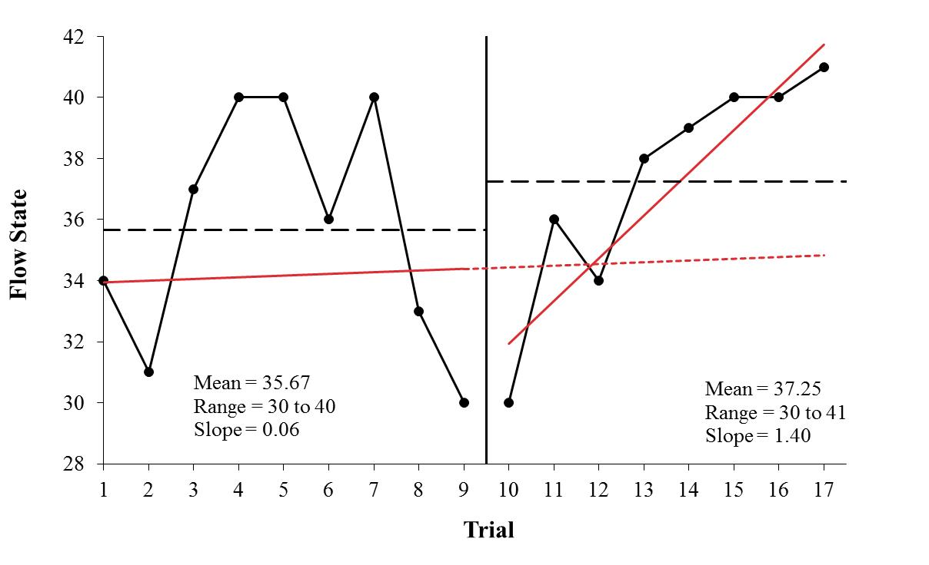

Participant 1

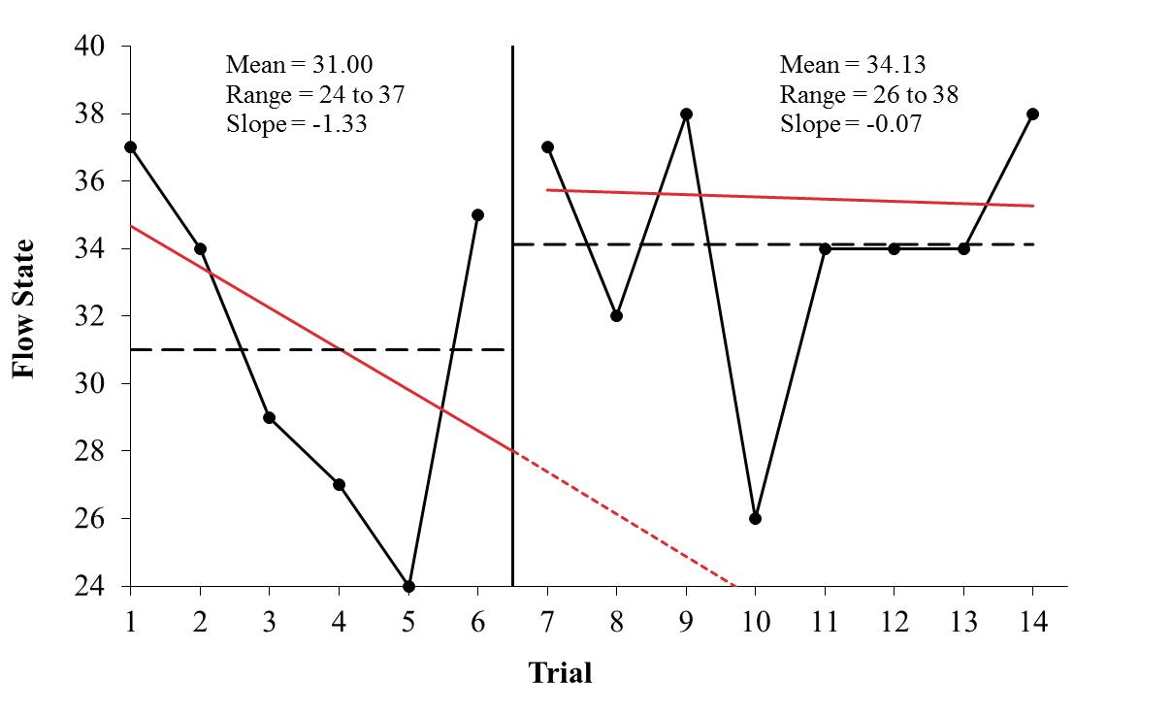

Participant 2

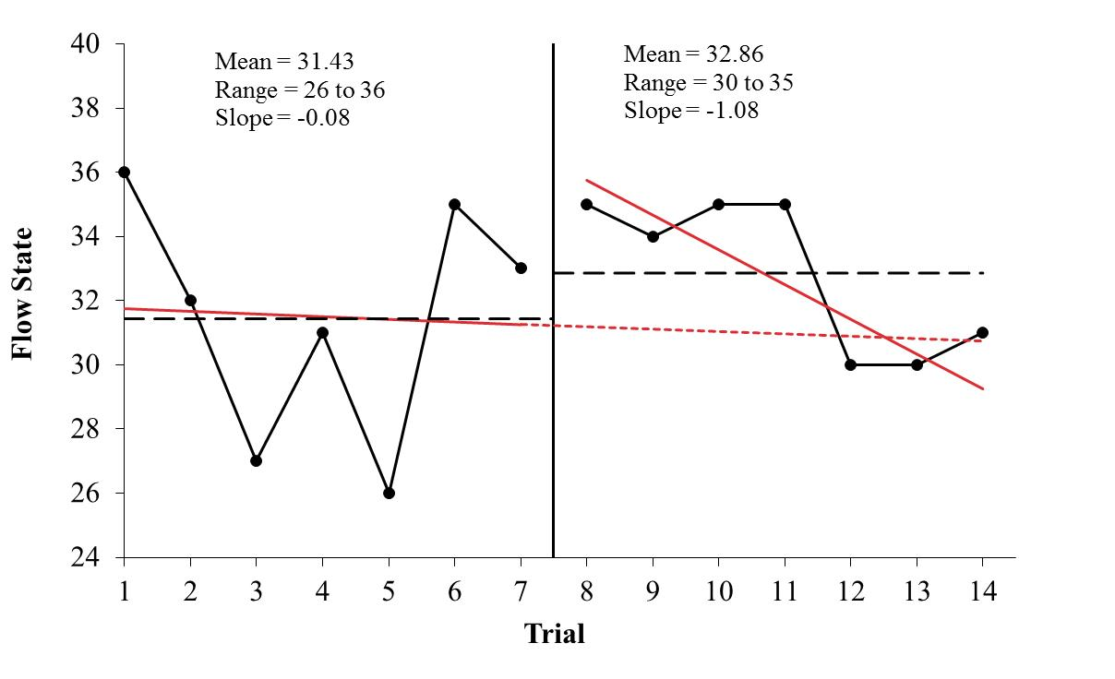

Participant 3

*Figure 1*. The intensity of flow state before and after the intervention.

Participant 2 Hafiz

Participant 3 Saleem