Biopolitics and boredom in the waiting room. On the power of being bored in the context of preventive family support.

Abstract

In this article, we take a concrete case study as a starting point for a reflection on preventive family support. More specifically, we conducted a fieldwork in the setting of a waiting room of a child care consultation office for parents with young children. The writings of the philosopher Giorgio Agamben allowed us to come to an alternative understanding of both the room as such, and the behaviors of adults and children in this room. This article can be read as the result of an experiment with fieldwork in philosophy of education: an attempt to enrich Agamben’s philosophical account of biopolitics with an everyday example, as well as an attempt to reread what actually happens in the case we have studied from an Agambenian perspective.

Keywords: Agamben, biopolitics, profound boredom, potentiality, preventive family support, fieldwork in philosophy of education.

Introduction

How are the lives of parents with young children governed today? How does policy address these parents? And under which conditions could parents become deaf to this address? In this article, we want to explore these questions in the setting of a waiting room of a child care consultation office for parents with young children (0-3 years old). These consultations are not only meant for a biometrical check-up, but also offer parents the opportunity for a talk about the development of their child and everyday child-raising issues (care, nutrition, hygiene, safety, sleeping habits, etc.) with a nurse. Occasionally, children undergo a medical examination by a doctor (and eventually receive vaccinations). The setting is part of the preventive family support system in Flanders (Belgium), organized by Kind & Preventie (Child and Prevention), and subsidized by Kind & Gezin (Child and Family) – two governmental agencies. The consultations are not obligatory and not focused on at-risk families. However, parents are stimulated to go to these consultations, not only formally but also informally, to the extent that one is considered an irresponsible parent if one doesn’t.

Actually, these agencies have a broader mission than child care narrowly defined. Since a couple of years they have taken a more integral view, facilitating both professional and informal parenting support. It is against this background that that they have created Huizen van het Kind (Family centers). Here all actors involved in childrearing - parents, professionals, representatives of non-profit organizations, etc. - have the opportunity to meet in order to exchange ideas, give support, detect problems at an early stage, and provide appropriate aid. It is believed that these encounters are beneficiary, and moreover, as Buysse (2008) has shown, parents point out that they are in need of informal support. This is because many parents experience direct advice by experts as patronizing, and because they prefer more informal support from family, friends and above all parents who have had similar experiences and who are in a position to reaffirm that the things they do as parents are just fine. In short, parents just need an approving pat on the back, instead of the often overwhelming professional advices by experts (which make parents most of the time only insecure about their parental actions) (Buysse, 2008; Furedi, 2001; Ramaekers & Vandezande, 2013). Moreover, all this is part of the larger Public Health, Welfare and Family policy of the Flemish government, which emphasizes the importance of informal social networks for preventive family support. Waiting rooms of child care agencies are precisely informal meeting places. In this article we report on an anthropological study of one of those places. The consultation office where this research was conducted has been selected because it is recently created in accordance with the latest demands of the Public Health, Welfare and Family police of the Flemish government. As such it is a typical case of what the Flemish government wants these waiting rooms to be (Vandeurzen, 2014).

In this article, we investigate this case along two lines. On the one hand, we are interested in how the Public Health, Welfare and Family policy is implemented in the concrete setting of the waiting room. How, if at all, does the room materialize a policy of prevention and encounter into a distinct spatial arrangement? On the other hand, we are interested in how the arrangement of the room affects the interactions taking place within the room. How, if at all, does the room structure the sayings and doings occurring in the waiting room? These two lines of interest correspond with two movements we make in this article. In a first movement we are concerned with the room as such. We describe the room and afterwards reread the room from the perspective of Agamben’s notion of biopolitics. In a second movement we consider the different interactions and behaviors taking place within the room and, continuing our Agambenian analysis, try to come to a critical understanding of what actually happens in the waiting room. At the same time we want to investigate inherent possibilities for change and transformation. As such, our study situates itself in the emerging field of research on power and discipline in the context of child raising. Other studies have focused on ADHD, mother-blame, risk, etc. (Bailey, 2014; Jackson & Scott, 1999; Singh, 2002, 2004). Our study will focus on the specific workings of biopolitics in a healthcare context.

In the past, scholars have already made a call for a more informal approach to parent support, both from the perspective of the parents themselves (Buysse, 2008; EXPOO, 2010, Furedi, 2001), and inspired by a more ethical commitment (Ramaekers, 2010; Noens & Ramaekers, 2011). And since a few years these pleas are (to a greater or lesser extent) taken up by policy makers, for instance in the Huizen van het Kind. What we want to do here is, by conducting an experiment in what we would like to call ‘fieldwork in philosophy of education’, to explore how the existing policy actually ‘works’ in the concrete setting of the waiting room. Instead of arguing ethically or ideologically for or against parenting support initiatives, our focus is on mapping the concrete effects these initiatives have on what it means to be a parent with young children. The lexicon elaborated by the Italian philosopher Agamben allowed us to reread the sayings and doings of the waiting room, and to come to a different understanding of what happens there. Before turning to our descriptions and analyses, we will first provide more detailed information concerning the research we conducted and elucidate fieldwork in philosophy of education.

An experiment in fieldwork in philosophy of education

The intent of our research is to investigate the questions mentioned above in such a way that it both does justice to concrete everyday educational practices, and offers us the possibility of rereading these practices in an innovative way. As such, what we do can be called ‘fieldwork in philosophy of education’ because this allows us to stay close to very specific observations (fieldwork) and at the same time to come to a profound analysis (philosophy) of what happens in the fieldwork setting. Fieldwork in philosophy of education inhabits the intermediate zone between ethnographic description and philosophical thought. However, instead of aiming at closing the gap between two banks - ethnographic description and philosophical thought -, our research is to be situated in the stream that meanders through the riverbed shaped by these two sides (Ingold, 2011). In other words, we don’t want to apply some theoretical framework to a concrete setting, nor do we want to illustrate a philosophical theory with some practical examples. What we want to do instead is what Tim Ingold (2011, 2013) calls an anthropological inquiry, an investigation into the conditions and potentials of human life. What makes it an anthropological inquiry, and not an ethnography, according to Ingold, is that it is a way of doing our thinking ‘in the open’ (Ingold, 2011, p. 15). This line of inquiry is not some kind of armchair philosophy, but ‘a lively philosophy with the people in the world’, instead of ‘about the people of the world’ (Ingold, 2011, 2013, 2014). It is our conviction that the interstices between philosophical thought and ethnographic description is a very fruitful locus to do our thinking. From our interest in how policy actually ‘works’ we want to analyze how a field of possibilities, the waiting room, is actually structured and how this induces people to act in specific ways while rendering other actions less likely to take place. At the same time we want to keep our eyes open for moments when these less probable courses of action do take place, and thus, how this field of possibilities not only structures - to a greater or lesser extent - what is taking place, but also allows - to a greater or lesser extent - for new, and perhaps unforeseen, possibilities.

The fieldwork, conducted by one of the two authors of this article, started with an exploratory visit to get acquainted with the research setting, during which the room as such was explored (by drawing maps and taking pictures). A detailed and fixed protocol was designed in order to sharpen attention for the room and what is happening there. This protocol comprised of two parts. During the first stage of the research, a set of three consecutive visits of three hours each (during consultation hours) was conducted in which behaviors, interactions between people in the room, and interactions with the room were observed and taken down as written field notes. The focus of attention was the interactions: Who interacts with whom? How do people interact with the room (e.g. reading brochures, playing with toys, etc.)? Afterwards, in a second stage, another series of three consecutive observations were conducted, during which the trajectories made by people in this room were the focus of attention. As a principle, whenever a family entered, one person was singled out to be observed and to map his or her movements. The young child him/herself was never chosen. When the child was only accompanied by one person, this person was singled out. When the child was accompanied by more persons (two or more adults, siblings, etc.) the choice was made arbitrarily. As such maps of lines were drafted (Ingold, 2007, 2011). At this stage, making notes on behaviors and interactions was no longer the main focus. During a last observation session, pictures were made of some characteristic interactions and behaviors. We had intended not to talk to the observees. However, as interaction with the researcher is unavoidable in such a situation, brief talks and conversations with the visitors of the waiting room took place. In a rare case, the researcher enquired about the parents’ vision on informal parenting support and the policy of Child & Family (but only after the adult herself had started to talk about it to the researcher). By closely observing both the waiting room and the people visiting and moving about this room, it was possible to come to a detailed understanding of the specific architecture and organization of the room as well as the different practices and interactions given shape in and by it.

For the sake of clarity we present our descriptions and analyses in two distinct movements. In a first movement we explore and analyze the room as such with a specific interest in how policy is translated into a concrete material arrangement. In a second movement we focus on what actually happens in the setting. As such, we hope to shed some light on the in-between of what the room makes people do and what people actually do. In line with Foucault (2000a and 2000b), we start from the assumption that today people are governed through their freedom (cf. Rose, 1999). This means that people are not forced to act in this way or another but that they are, through the governmental arrangement they are part of, induced to act in this way, rather than another. For this Foucault coined the term ‘conduct of conduct’ (conduire les conduites): when power is executed, this isn’t a matter of pure force (as in the manipulation of mere objects); rather those under power are always addressed as free agents, and moreover in so far they possess agency (Foucault 2000b). As Foucault says, the exercise of power ‘operates on the field of possibilities in which the behavior of active subjects is able to inscribe itself. It is a set of actions on possible actions; it incites, it induces, it seduces, it makes easier or more difficult’ (Foucault, 2000b, p. 341). Besides, this means that in a certain sense any traditional concept of direct resistance to the governing discursive regime is pointless. As it works through our freedom, our freedom to resist risks always to become itself included in the reigning system and to become a part for its optimal functioning. The exercise of power is a management of possibilities. Likewise, as will become clear in this article, the waiting room exercises this kind of power, because it incites people to act in one way rather than another, leaving their own sense of agency – their freedom to conduct their own lives - intact. In the first movement we will analyze the room as such. In the second movement we will analyze the actual actions, interactions and behaviors taking place within the waiting room.

Movement I: The space of the waiting room

We begin our description with an analysis of the room as such. The waiting room has a rectangular shape. The door which gives access to the room is next to the corner on one of the shorter sides. Both the door and the wall of this shorter side are made out of glass, and therefore one can immediately see what is happening in the room, even before entering. The opposite wall has two openings. The left one leads towards the toilets and towards a dressing room, where babies are undressed in preparation for their biometric check-up. A visual connection between dressing room and waiting room is established by a big window. The right passage in the same wall gives access to a small kitchen meant for the volunteer workers. One of the longer sides has three large windows, whereas the other side only has four small windows. The room is divided in two parts by one sofa and five regular chairs, where parents can wait. The part of the room closest to the entrance clearly is destined for playing purposes. Here one finds, amongst other things, a ball pit, a playhouse, a small wooden castle with a slide, and many pedal cars. The other part of the room, i.e. the one closest to the dressing room, is actually the place where volunteers check babies’ biometrical features (weight and length). For this there are two large tables on which a balance and a measuring vessel can be found. The chairs and sofa are facing these tables. In one of the corners there is a bookshelf which displays brochures for parents, but which also contains booklets designed for young children. This room is clearly identified as an informal meeting place for parents, as there is a sign on the wall too which welcomes parents in this Huis van het kind. This room is thus not only a waiting room, but also a place where volunteers measure the physical characteristics of children, a playroom as well as a space for informal encounters. After the weighing and the measurement, parent and child (sometimes accompanied by a second parent, a friend or a sibling) continue their visit by consulting the nurse and the physician whose offices are on another corridor.

On the wall behind the two large tables there are some posters issued by the governmental agency Kind & Gezin which convey messages (in Dutch) such as ‘Shaking equals harming’ and ‘Sleeping safely’. Another poster reads: ‘First time on the potty. Is your child ready for it? Is your child aware that it needs to pee, and does it have control over its urges? Does your child understand what is expected of her? Is your child ready to accept the challenge?’ The message is printed on a background depicting a mother asking her child to sit on the potty. Another poster reads ‘Goed gezien!’ (which in Dutch can be both translated as ‘good eye-sight’ and ‘rightly spotted’). It goes on: ‘The eye-test provided by Child & Family is safe, painless, child-friendly and free. The test is meant for children 12 and 24 months and carried out during the consultation at the age of 12 and 24 months. Making an arrangement isn’t required. This eye test detects factors causing lazy eyes [amblyopia] and some other serious visual disorders.’ On the background of this poster one can see a mother with her child on her lap. She is pointing towards something outside the poster and directing the gaze of the child. The brochures to be consulted in the waiting room convey similar messages. In a leaflet on vaccinations one reads: ‘By vaccinating your child, you are not only protecting your own child, you will also be contributing to the group protection of the whole population and to helping eradicate infectious diseases.’ Another brochure regarding the initiative Boekbaby’s (book babies) says: ‘We want both parents and little children to enjoy books. Children who get acquainted with books from an early age improve on their linguistic skills, they will become faster readers and better at doing sums and they frequently own a membership of a library. Leafing through a book together strengthens the bond between adult and child, and it will bring about lifelong memories of warm moments and safety.’

On the basis of this detailed account of the waiting room, and what happens in it, it is clear that it is a structured field of possibilities in which an assemblage of human, spatial as well as discursive elements ‘conduct the conducts’ (Foucault 2000b) of parents, and their children. As we noted, this room is divided into functionally specialized zones (i.e. for playing, for waiting and informally meeting, and for biometrical monitoring), and has moreover a public inside (i.e. the space were parents and children meet other parents, volunteers and nurses) and two private outside annexes (i.e. the place where children are being undressed and the place reserved for volunteers to drink coffee). More specifically, and inspired by the work of Agamben (1998), we argue that a biopolitical power regime is in operation here. For the sake of clarity we will first paraphrase some points of Agamben’s analysis of biopolitics before rereading the room using his concepts. As Foucault (2003) already argued, since the late 18th century social and political power has consisted first and foremost of a detailed control over the lives of the individual members of a population, with the aim of making them maximally productive. Agamben has elaborated this biopolitical view, claiming that it actually goes back to the origins of Western civilization, and more precisely to Aristotle’s attempts to define life. Instead of coming with a true definition, what he essentially did was opposing two modes of life, viz. segregating meaningful life from merely biological life, and segregating. This actually implied a profound political operation with major consequences (Agamben, 1998).

From then on life is split in bios (the good life, truly human life, the politically significant life) and zoé (bare life, naked life, the politically irrelevant dimension of humanity), two terms that only make sense as far as they refer to one another. The excluded part is, inevitably, always included, as the whole point of defining something like bios is logically dependent upon the existence of zoé. It is only because biological life (zoé) is singled out, that it can become an object of political debate and government. Mutatis mutandis is it only because political existence places itself outside and above the mere biological life, that it can claim the right to regulate bare life. In their interconnectedness they constitute the two poles of an operation that structures, shapes and also limits how we experience life. Furthermore, Agamben (2004) describes the workings of biopolitics using the metaphor of the ‘anthropological machine’. With this he means, first, that there is a dimension of automaticity to the way in which we experience life under the reign of biopolitics: it is most difficult to escape, and attempts to escape it are doomed to fail. Even if we try and do our best to include as much as possible life that is merely life and to acknowledge it the value of meaningful life, then the machinery is still in operation, as the whole opposition between the ‘merely’ biological and the truly ‘meaningful’ life is still at work. In order to really jam the machine, we need to come experiencing life as beyond any possibility to make such distinctions (Agamben, 2011; cf. Erkins, 2007). Second, the machine is indeed an anthropological one, as what is at stake is the definition of the humane. Looking at the history of philosophy (but more recently, also the history of biology) it is clear that the humane has always been defined by excluding (and thus including) the merely animalistic. The fascination of drawing a precise line between humankind and animals testifies to that. But, any effort to do so gives rise to inescapable difficulties which arise (e.g. what to do with humans who don’t seem to be human, e.g. severe coma patients, or less human than very bright animals such as chimpanzees) (Agamben, 2004).

Returning to our description of the waiting room, today parents with young children are, in different ways, being addressed to be concerned about elementary functions of life, such as vision, health and excretion, as the posters and brochures make clear. First, these advices are formulated as geared at preventing a certain danger, viz. a risk for health and a threat to well-functioning. Even if cognitive and linguistic dimensions (reading, counting, bonding) are the focus of attention, they are regulated in a most typical way: as biological resources which can remain underdeveloped, and which therefore should be maximally exploited . As such, the child-parent interaction, i.e. the complex challenge of living together with children, has become reduced to the straightforward and one-dimensional task of taking optimal care after bare life (life as such). At the same time this concentration on the purely functional, animalistic and productive aspects of life is in fact the result of a political decision: the aim is to live well, i.e. to secure public well-being (a good life for all). It is important that bare life is singled out as an object of concern and rightfully (i.e. on the basis of medical expertise) taken care of. Zoé is produced at the same time that bios is object of concern.

Furthermore, this biopoliticization of life isn’t a matter of direct control. Rather, parents are completely left free to let their children take an eye test, to instruct them to use the potty at the right time, etc. However, after reading posters and brochures, there shouldn’t be any doubt left in their mind that, if they would decide not to follow these expert advices, they risk harming the physiological, cognitive and emotional development of their child. Moreover, they are not only (potentially) bringing harm to their own child. They would also be bad parents because they put the prosperity of society as a whole at risk. Not taking serious Child and Family’s good advice means that their child actually becomes a public risk. As such, parents are being governed through their freedom. This is because all these advices are presented as having self-evidence: after all, who can reasonably be against these vaccinations, eye tests, potty training, etc.? And, taking up this individual responsibility is at the same time beneficial at a societal level: safeguarding the well-functioning of one’s child is simultaneously supporting the well-functioning of the whole of society (cf. Foucault, 2000a). In that sense, the discourse on parenting support clearly effectuates biopolitical seizure over life. It determines to a large extent what it means to be a good parent, and how adults should give shape and order to their life with children: the child appears as naked life, and the parent appears as the safe-keeper of this life.

Intermezzo: The quest for encounters in contemporary parenting support

Whereas the examples of the posters and brochures that deal with the well-functioning of babies constitute a rather explicit case of biopolitics, this regime also works in more surreptitious ways. The government’s interest in facilitating informal encounters as a way to support parents could also be seen as underpinned by the very same logic: everyday encounters aren’t any longer ‘spontaneous’ interactions but become part of a governmental strategy which put to work these encounters within a preventive program to diminish child-rearing problems. On the one hand, this initiative seems to empower parents, as it reduces the role professionals and experts play in deciding on how to rear one’s child. Parents are stimulated just to chat with other parents about nutrition, sleeping habits, etc. On the other hand, however, it could be said that actions that are at first sight free and spontaneous become an instrument for a clear purpose, viz. raising healthy and well-educated children for the benefit of a healthy and well-educated society. As such the function of mere speaking becomes a paramount aspect of parenting that, in the end, will secure individual and collective well-being. In a sense, parents too become trapped in the anthropological machine: their chattering is no longer a spontaneous behavior that they just do. Rather, it has become a privileged target point for biopolitics.

First, the category of informal meeting becomes singled out as an aspect of parental life (i.e. an aspect of zoé): it appears as a source of knowledge we had forgotten about in view of the prevailing expert discourses, but which – so we are told by the same experts – we should put at work right now. And so, second, in view of the general well-being (i.e. bios) parents are well advised to benefit from informal meeting, being a means to contribute to a greater public good. At the same time that a new definition of what it means to be a parent comes about (i.e. a parent who wholeheartedly accepts the need for informal meetings and chattering), the parent is made productive for society at large. Again, it should be noted, first, that parents are ruled here through their freedom: who could be against informally talking with other non-expert parents? Second, the discourse of expertise remains to play a role in the background, as the knowledge and skill (competences) gained through informal encounters are seen as a special kind of expertise (instead of as common sense).

In the next section we will return to the second movement of our case study of fieldwork in philosophy of education, viz. the observations of behaviors and interactions, sayings and doings taking place in the waiting room. We will explore to what extent this spatial arrangement actually structures the interactions and behaviors taking place in the waiting room.

Movement II: Adults and children in the waiting room

Again, we will start of purely descriptively with an account of the behaviors and interactions, the sayings and doings that took place. After that we will bring in again some notions we draw from Agamben to come to an alternative understanding of what happens in the room. Not only did we focus on how people interact with each other, we also paid attention to how they interacted with the room itself (e.g. leafing through a brochure, playing with a pedal car, etc.).

In the room, two volunteers are always present. They welcome parents and children, and make them feel at ease. During our observations, most visits involved only one parent (typically more mothers than fathers) coming to this consultation office with his/her child. In some cases other adults accompanied the baby (we suppose that they’re family or friends), and sometimes they also brought with them other children. Most of the time, there were only one or two families present in the waiting room. Towards the end of the day however, especially when the nurse or the doctor is delayed and the circulation of people through the building gets difficult, the waiting room can become a bit crowded.

On the one hand there is a stereotypical pattern to be observed: the same lines are being walked. When parents enter the room they first hand over to the volunteers a small file which contains biometric information and reports on the last check-ups. After that they usually go to the dressing room to undress their baby (although some parents undressed children in the waiting room). Then they come back and await their turn. Usually they assist the volunteers in performing the biometrical check-up (registering weight and body measures). They comfort their children when they cry. Then, parents regain their seats, waiting a while for a nurse to come. She accompanies them to her office which is in another corridor. During the periods of waiting, on the other hand, different patterns of behavior can be observed. Some parents take their child on their arm and start walking through the room, they read or play with a booklet, wrap children in blankets, put their coats on, etc. Most of the parents just sit next to one another, with their child on their lap. While just sitting and waiting, most of them don’t talk to each other. Nor do they address the volunteers. Some adults who happen to know other parents present in the room engage in small talk. The largest part of the conversations that take place actually consist in just babbling and talking playfully to one’s own child (imitating animal sounds, peek-a-boo, etc.). In response to the volunteers who were promoting the Boekbaby’s brochures, some parents took a booklet to read to their child - sometimes from the Boekbaby’s booklet itself, sometimes from a book from the shelf next to the sofa. They point at the images and change their voice (‘Look!’). Next to this, some mothers spent their time in the waiting room (breast)feeding. When the room gets crowded and most of the chairs are occupied, more people tend to start playing with their child in the room. In general, each family sitting in the waiting room creates a small place of its/their – a safe spot.

Only now and then they interact with one another. As the waiting room becomes more crowded, more people start exploring the other parts of the room, looking for a toy not already used by other children and/or parents (when there are only one or two families, people most of the time don’t play). Some parents push a pedal car, others guide their child through the wooden castle. Brothers and sisters are more inclined to start playing from the moment they enter the room. They immediately take place in a pedal car or ride a bike. As we said, whenever parents speak to each other, it is mostly because they know each other. Alternatively, this might also happen when one of their children attracts the attention of another parent (by smiling or pointing at them, giggling, being very polite, etc.). In that case, they have a rather superficial conversation in which they exchange the names and the ages of their children. Sometimes they also ask if the other child already has started talking or walking. As such, parents won’t talk to others directly. Conversations are always triggered by something their children do or say. For instance, when two children play with the same toy or in the same playhouse, it is more likely for parents to start talking to one another.

These patterns of behavior are, now and then, disrupted by something out of the ordinary – bringing about a kind of more dynamic atmosphere. Sometimes parents just begin to address others, no matter what their or another child does. They initiate a certain dynamism in the waiting room. One day, a father and a mother started talking to each other right after entering the waiting room. The mother was only accompanied by her child. The father was in company of his child and a sick older brother. It was not clear whether they knew each other, which moreover related to the fact that they spoke what we could identify as Mandarin – a language unknown to us. After a few minutes the mother put her own child on the sofa and took the other child so that the father could help his ill son to go to the toilet. As such, this mother was sitting next to her own child, having a stranger’s child on her lap. What is more, she provoked a conversation between the two children in which she took part. Then the father and his ill son returned, the mother lied down on the sofa and started to wave towards the sick child. A moment later, she took her child on her arm and walked towards the boy in order to talk to him.

During another observation, there was a couple with a child, of whom the mother remained sitting silently on a chair, whereas the father was constantly playing with his child and talking to other mothers that were present about their children having a penchant for playing with buttons (of remote controls, cell phones, washing machines etc.). This particular father also waved at other children, read a brochure about the benefits of reading, walked a lot in the room, talked to the volunteers, looked through the window, etc. It needs to be stressed that these situations were quite exceptional. In general, it is also children (and especially the older ones) moving about the place which blur the rather rigid functional distinction in the room between zones for playing, for waiting, and for biometrical monitoring. They might bike through the waiting zone, or drag their parents to come and play with them, leaving the sofa/chairs behind. The more people are present in the room, the more movement is taking place. At one such moment, a parent observed: ‘well, today everything here seems a bit messy’.

It was striking to see how little parents actually read or looked at the posters on the wall. It seems that parents don’t bother much about the messages and good advices Child and Family wants to convey. Sometimes, in the rare case that we asked parents or volunteers about their views on Child and Family, they were mostly quite critical towards this organization and, particularly, towards the expectations it puts on them as parents. One mother, for instance, explained that she came to the consultation office because ‘it is easy to access and well-organized, and because children are well monitored.’ In relation with the Huis van het Kind, she said that it is ‘a good system to detect and isolate problems’, but also that ‘most people don’t need it’ because, in her opinion, they don’t encounter problems. She explained that she doesn’t feel the need to meet other parents here neither, because she already has a lot of friends with babies. She explained that Child and Family often acts in ways that are a bit pushy and that this organization sometimes decides in her place how to raise her child. For instance, she has been told that a child should not sleep under a blanket. However, she added that if she doesn’t give her child a blanket it won’t sleep and will cry all the time. So, she concluded, one has to decide for oneself how to raise one’s child. She also stated that ‘there are no rules about childrearing.’ A volunteer who was present actually agreed with her and substantiated this mother’s view by adding that the answer to the question whether a child should sleep on its belly, back or side seems to change throughout the years. She said: ‘In the past, a child had to sleep on his belly. Now it is prohibited. Probably, in twenty years, a child has to sleep on his belly again.’

Sometimes the volunteers also criticized existing practices of parenting support while performing their tasks. For instance, after monitoring a child’s weight another volunteer remarked that this child is hasn’t gained enough weight. So, she asked the parent whether this baby eats enough and advised her to speak with the doctor about this. However, the parent replied that the child ate well, but that ‘it has always been a light weight: 2.4 kilograms at birth.’ Hereupon, the volunteer replied that she would better not mention it to the doctor, as in that case the child could be put on a diet. At another occasion, right after the researcher entered the room, still another volunteer passed on to him a lot of brochures, but she also added: ‘Immediately get rid of this stuff, parents don’t read it anyway.’ One of them actually casted a most critical remark vis-a-vis the contemporary discourse on parenting: ‘Today one almost needs to have had a training in order to raise one’s children. Are we so badly educated then? It seems more like it is the parents rather than the children who have to be educated.’ It should be said, nonetheless, that most volunteers try and do their best, and that some were wholeheartedly supportive of Child and Family’s policy. For instance, another volunteer stated that only since the brochures about reading were present in the room, it has struck her ‘how babies are fond of reading a book’ (while in fact she was always pushing the parents, who would otherwise not even think about reading, to read).

As we argued, the waiting room has a micro-architecture which determines the possibilities of freely moving around. More specifically, there is lot of regularity, and there are patterned lines being followed, time and again. At the same time, our small case study also shows that the workings of this anthropological machine can be jammed. At an overt level, it is clear that some of the parents and also the volunteers, at times go against the way in which they are supposed to act according to the prevailing biopolitical arrangements and discourse. For instance, good advice is countered by pointing out its redundancy (one already knows everything there is to know by consulting friends and family or by just trusting common sense), its inconsistency (within a span of a few years experts claim exactly opposite ‘truths’) or its lack of good sense (no longer children, but parents become the object of education). In one case a purely pragmatic argument was used to go against established expectations (don’t tell the doctor, or she will put your child on a diet). However, these small interruptions of the reigning order also result from much more implicit actions. Mostly, this concerns the concrete doings and sayings of parents and children, which are often quite spontaneous and banal: common things such as playing, babbling with children, chatting with other parents about completely insignificant things, walking around, breastfeeding, etc. As we pointed out, this sometimes resulted in a suspension of the functional ordering and three-part division of the waiting room.

More importantly, there is a whole set of behaviors that could be categorized as non-doings: not reading brochures one is supposed to consult, not looking at posters with precious advice, and not speaking with one another in a room meant for informal chattering. Waiting and remaining silent. These moments of suspension of the biopolitical seizure over life relate to living the life of a parent in such a way that one is just doing that: one is just living with small children and as such life is no longer susceptible to be ordered in terms of the zoé-bios divide: one is utterly disinterested in being addressed to take care after the well-functioning of mere life in order to help securing the good life of the larger society. Rather than seeing these as acts of freely chosen resistance, we would like to think about these moments of interruption by turning to Agamben’s work on potentiality, and especially to his musings on Heidegger’s phenomenological account of boredom.

Agamben’s philosophy of potentiality is a life-long attempt to come to terms with the idea that we are creatures of possibility rather than of necessity (Agamben, 1999). However, the term potentiality is not referring to any ordinary sense in which we normally understand the word possibility (i.e. just actualizing what one already is able to do). Instead what he has in mind is a pure state of possibility. The emblem of this is the scribe, not in the act of writing, but precisely at the very moment that she is not writing, i.e. at the moment that she doesn’t bring her potential for writing into actualization. Here, ‘[…] potentiality maintains itself in relation to actuality in the form of its suspension; it is capable of the act in not realizing it, it is sovereignly capable of its own im-potentiality [impotenza] (Agamben, 1998, p. 32). Potentiality is thus fundamentally im-potentiality. If this might sound somewhat inconsistent or arcane, what Agamben tries to articulate here is what being-able is fundamentally all about. When we are in the process of actualizing abilities, we may of course experience that we can do this and that we can do that. However, what remains of out of reach under such conditions is the possibility of experiencing that we actually can do this and that only when the concrete actualization of our powers is suspended, we might come and realize what it means to be a creature of abilities in the first place. Im-potentiality is thus, most profoundly, the possibility not to do what one can do, and more positively: the possibility to do what one cannot do, the potential-not-to. So, to be clear, the emphasis here is not merely on a lack or an absence. Rather, im-potentiality is itself a positive force (Agamben, 2015), and as such it makes sense to say – even if this cannot be expressed adequately in the English language – that we can not. In so far a relationship with non-actualization is being maintained, im-potentiality potentializes. Only a creature that is capable of its own incapability is fundamentally free. Indispensably, im-potentiality is also a political category.

On the one hand, it is the im-potential side of our existences that turns us into beings who are faced with the question and the challenge to give shape to our individual and collective lives. If being-able was only the actualization of pre-established dispositions, we would only have tasks to fulfill. And then there would be no contingency, no history and therefore neither need for ethics, nor for politics. On the other hand, and more importantly for us, im-potentiality has become the core target of the insidious ways in which biopolitics operates today. In a reply to Deleuze’s well-known text on societies of control, Agamben makes clear that the most important menace today is not that we are restricted in our freedom to do what we can, so much as that we are narrowed down in our ability not to do what we can (Agamben, 2011). This is a very subtle reformulation of Foucault’s thesis that the workings of power are most perilous because we are governed in ways that leave our freedom intact. The target of current biopolitics is not the realm of our possibilities, as we are left free to do what we can. Instead, by being left free in such a way, we are no longer free not to actualize these possibilities. We are no longer allowed to remain in touch with our im-potentiality. As Agamben comments:

Nothing makes us more impoverished and less free than this estrangement from impotentiality. Those who are separated from what they can do, can, however, still resist; they can still not do. Those who are separated from their own impotentiality lose, on the other hand, first of all the capacity to resist. And just as it is the burning awareness of what we cannot be that guarantees the truth of what we are, so it is only the lucid vision of what we cannot, or can not, do that gives consistency to our actions (Agamben, 2011, p. 45).

Therefore, affirming freedom in any trivial way won’t help us escape from this situation. In fact, what Agamben calls for is not really a form of escape, as much as it is a temporary interruption and suspension of the existing biopolitical order. This suspension is dependent upon retrieving and experiencing im-potentiality. In this sense Agamben is very close to Heidegger (1962), who has pointed out that a true sense for what it means to be a creature of possibilities rather than of necessities (das eigentlichste Seinkönnen; Ibid, p. 217) is only present with full accuracy at those moments in which we are faced with the maximal foundering of these possibilities. This is clearly the case in his famous analysis of the existential consciousness of death – the end of all possibilities –, which tears us away from living inauthentically and which awakens us to live a life in our own name. In the face of death we have no choice but to agree with our own finitude and groundlessness, which is - more positively speaking - a condition of absolute freedom towards the future.

Likewise, Heidegger has explored in detail the phenomenon of boredom as a situation during which we both encounter the limits of our possibilities and experience the very meaning of possibility itself. In order to explore this Stimmung (emotional tonality), Heidegger analyses the example of having to wait for hours on the platform of a desolate train station; although one could spend this time fruitfully (e.g. by reading the books one has in one’s rucksack), one just can’t prompt oneself to take out the book and start reading. Nothing appeals our attention or desire; everything leaves us indifferent. One finds oneself in a situation of acute but total paralysis. On the one hand this could be termed a state of extreme inability, which could be adequately termed one of captivity: there is no way to escape it by oneself (the only way to escape it is to be set free by something unexpected that possesses the force to capture one’s attention and to stimulate one to start pursuing something fruitful). On the other hand, it is exactly an experience like this that might reveal something about ability as such - about pure ability or im-potentiality. As Agamben comments: ‘This deactivation of […] concrete possibilities makes manifest for the first time what generally makes pure possibility possible (das Ermöglichende) – or, as Heidegger says, “the originary possibilization” (die ursprüngliche Ermöglichung)’ (Agamben, 2004, p. 66). Many of the concrete gestures and doings by the parents we observed in the waiting room could be analyzed in these terms: parents are just waiting, they keep silent, are not interested in talking to fellow parents, remain indifferent to posters and brochures filled with precious advice, etc. They are profoundly bored. Their forthright passive behavior can be understood as an affirmation of their im-potentiality. Their potentiality for acting, speaking, reading, encountering and caring remains in a pure state: they are not-acting, not-speaking, not-reading, not-encountering, not-caring, etc. On the one hand, what parents do (or do not) are very commonplace and mundane things, which come about while merely living with one’s children. On the other hand, these trivial non-doings have the power to actually interrupt the societal order which is in operation.

Conclusion

As we have been claiming throughout this article, this societal order is biopolitical, and could be analyzed along the lines of the workings of an anthropological machine, viz. an ordering of life which draws from separating bare life and the good life, animalistic life and the truly humane – in an ‘inclusive exclusion’, which always presupposes the existence and mutual dependence of both categories (no bios without zoé and vice versa). We argue that the inertia, indifference and silence as displayed by parents in the waiting room are somehow beyond any division the anthropological machine draws. Of course, it could be easily objected that these behaviors are mere expressions of life, and even mere animalistic life-forms: the image of a lion just lazily dozing in the sunshine, or even of the cow just idly grazing in the field comes to mind. And the whole animal-human divide has been, since Greek Antiquity, constantly articulated around the duality of possessing and not possessing the power of speech (as in Aristotle’s famous definition of humankind as the only creature that is able to speak, whereas animals can only produce noises). In that sense our analysis could be said to be trapped in the anthropological machine itself, as we presuppose the whole opposition between bios and zoé. Our parents have returned from humanity to animality. And yet, as Agamben indicates, the jamming of this machine consists precisely in affirming bare life to the full (cf. Edkins, 2007). With this he means that we live our lives to the full but in such a way that it isn’t experienced as ‘just’ life in opposition to the ‘good’ life. Silence is no longer the opposite of speaking, idleness no longer the negation of action, remaining alone is no longer the lack of encountering one another, etc. What is at stake is to experience life as no longer susceptible to divisions and separations that oppose naked life to a higher form of life. Then, it has become meaningless to identify something as ‘just’ bare life. Likewise, the whole animal-human divide no longer makes sense.

At this precise moment biopolitics is suspended, because the very categories that underpin it are all forgotten about. As such the waiting room in the consultation office is just that: a place for waiting. Not merely in the negative sense of waiting for something more relevant to come, but positively as not bothering about expectations regarding good parenthood related to the discursive and non-discursive elements we analyzed. This is a place where living-with-children is entirely affirmed, in all its banality. In a sense this is a true liberation or emancipation, because it allows for a different way of life, a way which we normally are not inclined to take when we want to be good parents.

References:
Agamben, G. (1993). Infancy and History. The Destruction of Experience. (L. Heron, Trans.). London: Verso.
Agamben, G. (1998). Homo Sacer: Sovereign Power and Bare Life. (D. Heller-Roazen, Trans). Stanford (CA): Stanford University Press.
Agamben, G. (1999). Potentialities. Collected essays in philosophy. (D. Heller-Roazen, Trans.). Stanford: Stanford University Press.
Agamben, G. (2004). The open. Man and animal. (K. Attell, Trans.). Stanford (CA): Stanford University Press.
Agamben, G. (2011). Nudities. (D. Pishik & S. Pedatella, Trans.). Stanford (CA): Stanford University Press.
Agamben, G. (2015). Le feu et le récit. (M. Rueff, Trans.). Paris: Payot & Rivages.
Bailey, S. (2014). Exploring ADHD. An ethnography of disorder in early-childhood. London: Routledge.
Buysse, A. (2008). Opvoedingsondersteuning. Ondersteuning van gezinnen vandaag [Parenting support. Supporting parents today]. Gent: UGent.
Edkins, J. (2007). Whatever politics. In M. Calarco & S. DeCaroli (Eds.), Giorgio Agamben. Sovereignty and Life (pp. 70-91). Stanford (CA): Stanford University Press.
EXPOO (2010). Ontmoetingsplaatsen. Eindverslag dialoogmoment. Retrieved from http://www.expoo.be/sites/default/files/kennisdocument/eindverslagdialoogmomentontmoetingsplaatsen.pdf
Foucault, M. (2000a). Omnes et singulatim. In J. Faubion (Ed.), Essential works of Foucault 1954-1984. Volume 3: Power (pp. 298–325). London: Penguin Books.
Foucault, M. (2000b). The subject and power. In J. Faubion (Ed.), Essential works of Foucault 1954-1984. Volume 3: Power (pp. 326–348). London: Penguin Books.
Furedi, F. (2001). Paranoid parenting. Abandon your anxieties and be a good parent. London: Penguin Books.
Heidegger, M. (1962). Being and time. (J. Macquarrie & E. Robinson, Trans.). Oxford: Blackwell.
Ingold, T. (2007). Lines. A brief history. London: Routledge.
Ingold, T. (2011). Being alive. Essays on movement, knowledge and description. London: Routledge.
Ingold, T. (2013). Making. Anthropology, archaeology, art and architecture. London: Routledge.
Ingold, T. (2014). That’s enough about ethnography! Hau: Journal of Ethnographic Theory, 4(1), 383–395. http://doi.org/10.14318/hau4.1.021
Jackson, S., & Scott, S. (1999). Risk, anxiety and the social construction of childhood. In: D. Lupton (Ed.). Risk and sociocultural theory. New directions and perspectives (pp. 86-107). Cambridge: Cambridge University Press.
Noens, P., & Ramaekers, S. (2011). Opvoedingsondersteuning in Ontmoeten: Onderzoeksverslag ter ontwerp van een bronnenboek. Leuven: Laboratorium voor Educatie en Samenleving, K.U.Leuven.
Rabinow, P. (2003). Anthropos today. Reflections on modern equipment. Princeton (NJ): Princeton University Press.
Ramaekers, S. (2010). Pedagogy of the encounter? Philosophical notes on the idea of "meeting places" as forms of parent support [Conference presentation]. New College, Oxford, 26 - 28 March 2010. Oxford: Philosophy of Education Society of Great Britain.
Ramaekers, S., & Vandezande, A. (2013). "Parents need to become independent problem solvers": a critical reading of the current parenting culture through the case of Triple P. Ethics and Education, 8(1), 77-88.
Rose, N. (1999). Powers of freedom. Reframing political thought. Cambridge: Cambridge University Press.
Singh, I. (2002). Bad boys, good mothers and the "miracle" of Ritalin. Science in Context, 15(4), 577-603.
Singh, I. (2004). Doing their jobs: mothering with Ritalin in a culture of mother-blame. Social Science & Medicine, (59), 1193-1205.
Vandeurzen, J. (2014). Welzijn, volksgezondheid en gezin. Beleidsnota 2014-2019 [Wellbeing, public health and family. Policy document 2014-2019]. Retrieved from http://www.jovandeurzen.be/sites/jvandeurzen/files/Beleidsnota_2014_2019_Welzijn_Volksgezondheid_Gezin%20%281%29.pdf

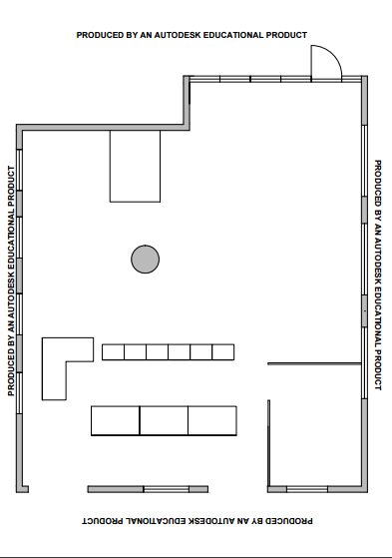

Figure 1
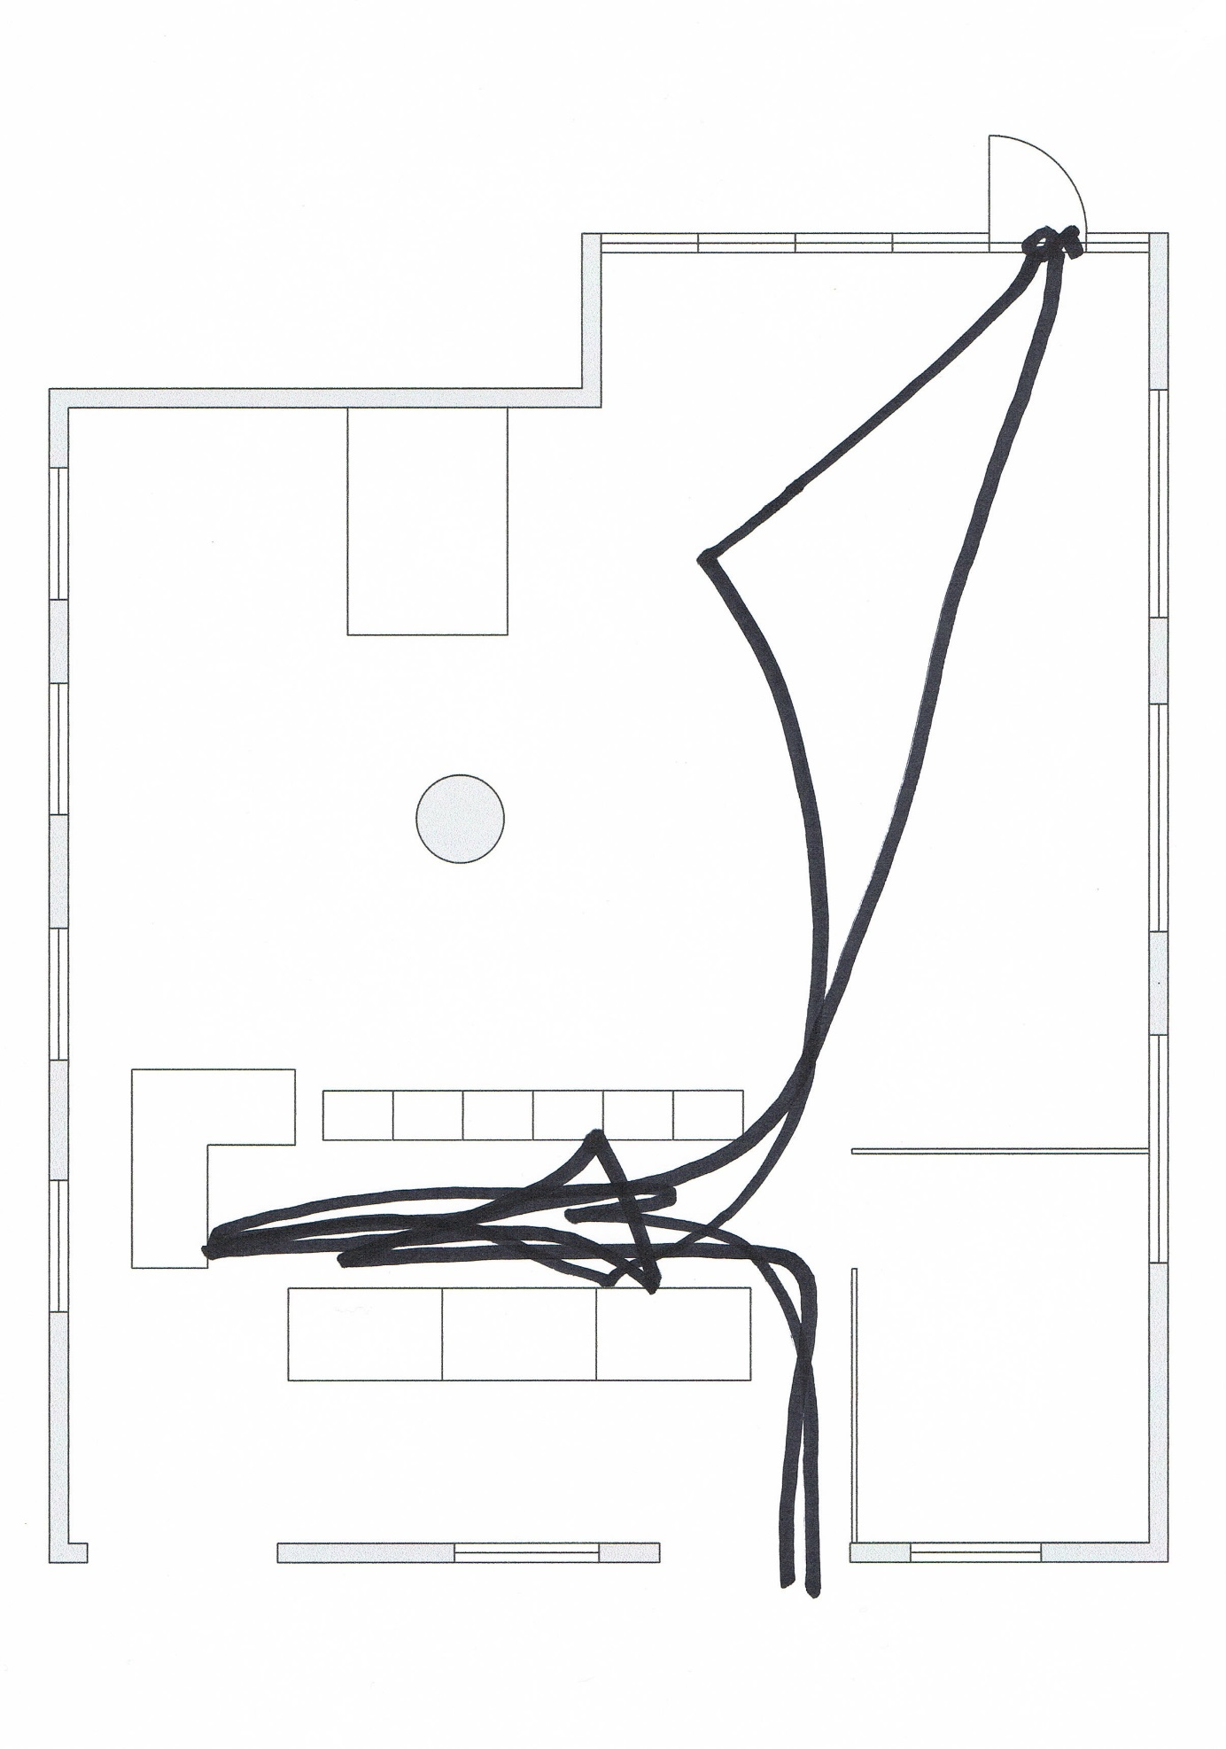
Figure 2
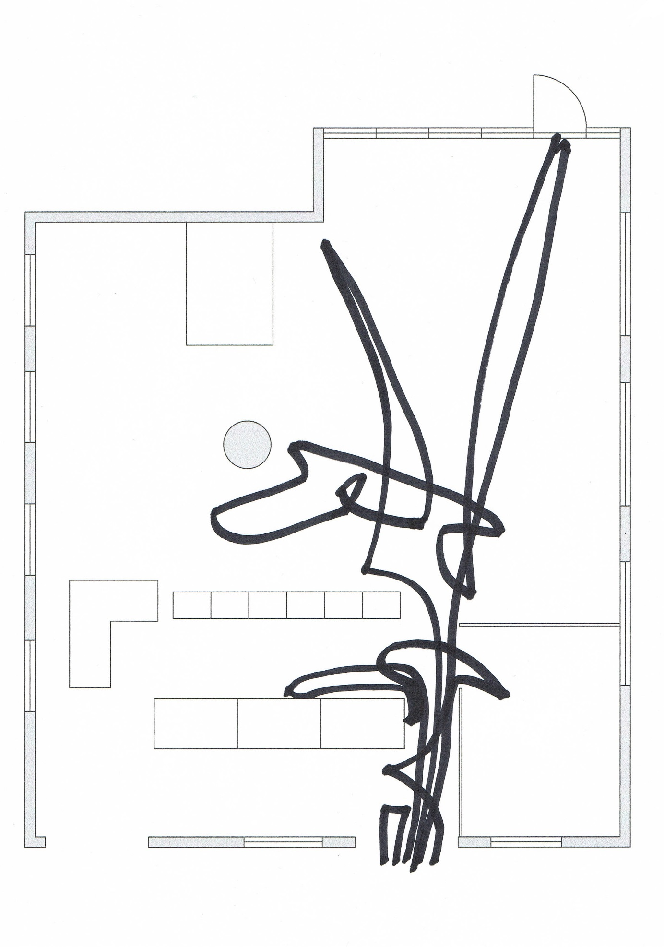
Figure 3

The following webpage (in Dutch) is about the consultation offices of Child and Prevention: http://www.kindenpreventie.be/onze-werking/consultatiebureaus/
In the following webpage (in Dutch) the aims and objectives of Child and Family are summarized: http://www.kindengezin.be/over-kind-en-gezin/missie-en-waarden/visie/
Huizen van het Kind would be literally translated as “Houses of the Child”, stressing the strong focus on the development of the individual child. For the sake of clarity however, we translated the term as “Family centers” in order to avoid confusion with, for instance, orphanages.
Paul Rabinow (2003) argued already for fieldwork in philosophy. In the next section, we elaborate on how we conceive of fieldwork in philosophy of education.
The fieldwork was done as part of an introductory course on ethnography at a Belgian university. We thank both the professor who taught the course and our personal supervisor for their assistance in conducting this fieldwork, including giving advice on ethical issues such as consent in a setting like a waiting room. We decided to make an informed consent form for the organisation since it would be impossible to let all parents sign such a form. We wanted however to give parents the opportunity to refuse participation so we attached a note to the entrance door to inform them about the research being conducted (“The research aims at getting a better understanding of consultation offices as (potential) meeting places. The researcher will observe the different actors in the consulation office such as parents, children, doctors, volunteers and nurses but also spatial features and material objects.”) and the possibility to inform the researcher in the case they wouldn’t like to participate. This message was translated to Dutch, French and English. From the moment the researcher entered the setting, the note was attached to the door. At every moment, the researcher was open to questions and remarks of the people in the setting.
For a map of the room see Figure 1. For an example of such a trajectory see Figure 2 and Figure 3.

