Air Pollution in Bangalore, India: An Eight-Year Trend Analysis

A.K. Chinnaswamy¹, M.C. Galvez², H. Balisane³, Q.T. Nguyen^{4,5}, R.N.G. Naguib^{4,6}, N. Trodd¹, I.M. Marshall¹,
N. Yaacob¹, G.N. Santos², E.A. Vallar², M.H. Shaker⁷, N. Wickramasinghe⁸ and T.N. Ton⁹
¹Faculty of Engineering, Environment and Computing, Coventry University, UK
(E-mail: chinnasa@uni.coventry.ac.uk; n.trodd@coventry.ac.uk; i.marshall@coventry.ac.uk; n.yaacob@coventry.ac.uk)

²Physics Department, De La Salle University, The Philippines
(E-mail: maria.cecilia.galvez@dlsu.edu.ph; gil.santos@dlsu.edu.ph; edgar.vallar@dlsu.edu.ph; )

³Faculty of Education, Soran University, Kurdistan, Iraq
(E-mail: hewa.balisane@soran.edu.iq)

⁴BIOCORE Research & Consultancy International, UK
⁵Department of Management, BITL and Law, RMIT University Vietnam, Vietnam
⁶Faculty of Science, Liverpool Hope University, UK
(E-mail: q.nguyen@biocoreinternational.com; r.naguib@biocoreinternational.com)

⁷Ecology & Environment, Inc., USA
(E-mail: mohyishaker@gmail.com)

⁸Epworth HealthCare, and Deakin University, Australia
(E-mail: n.wickramasinghe@deakin.edu.au)

⁹Environmental Health Unit, World Health Organization Representative Office, Vietnam
(E-mail: tont@wpro.who.int)

Abstract:
Bangalore is one of India’s fastest growing metropolises and, although benefitting economically due to its fast development, has a rapidly deteriorating environment. This paper provides a critical analysis of the air pollution trend in the city over the period 2006-2013 at 6 specific locations where measurements have been consistently recorded. It also discusses the potential health implications pertaining to exceeding levels of pollutants where these are applicable. In order to attain informed decisions on the protection of the health of populations from elevated levels of air pollution, an understanding of spatial-temporal variance of air pollutant patterns is necessary. The study highlights the fact that Bangalore and other similar developing cities do not have an adequate number of fixed monitoring stations that could provide a complete coverage of the air pollution levels for the entire city. It is suggested that this can be overcome by using geospatial interpolation techniques that provide a complete coverage of the levels of pollutants, as well as assist in mapping health characteristics of the population, in order to reach evidence-based decisions and target effective interventions.

Keywords:

Geographical Information Systems; Spatial Interpolation; Air Quality Monitoring; India

Biographical Notes:
Anitha K. Chinnaswamy (PhD) is a Lecturer in Information Systems at the Faculty of Engineering, Environment and Computing, Coventry University UK. She received her Masters degree and PhD from Coventry University. She is actively involved in Environmental Health research and her other research interests include healthcare informatics, data quality and management and knowledge management in healthcare. She is an Associate Fellow of the UK Higher Education Academy.

Maria Cecilia D. Galvez (PhD) is a Full Professor at the Physics Department, De La Salle University, Manila, Philippines. Her current research interests include laser remote sensing (LIDAR), Sunphotometry, and air quality measurement and modelling using different methods.

Hewa Balisane (PhD) is the Dean of the Faculty of Education at Soran University, Kurdistan (Iraq). He obtained his Master’s degree from Salford University, UK, in 2008, and his Doctorate degree from Manchester Metropolitan University, UK, in 2011. Prior to his position at Soran University he was an Associate Lecturer at Manchester Metropolitan University. His research interests lie in advanced information technology, multimedia technology, data telecommunications and networks, and biometrics.

Quynh T. Nguyen (PhD) is a IBM-certified SPSS specialist and statistician, having obtained her Master’s degree (with Distinction) and PhD from Coventry University, UK, in 2007 and 2011, respectively. Over the last 10 years, she worked on the integration of different datasets within geographical information systems, health informatics, environmental systems and web site defacement detection. She currently works with BIOCORE Research & Consultancy International, UK, and has been recently appointed as Lecturer at RMIT University Vietnam, as well as Visiting Professor at Dai Nam University, Vietnam. She published 30 peer reviewed journals and conferences papers and is an invited speaker at De La Salle University, Manila, Philippines. In addition to the above areas of work, her research interests include information retrieval, data extraction and mining, and environmental health in developing countries.

Raouf N.G. Naguib (PhD) obtained both his Master’s degree (with Distinction) and Doctorate degree from Imperial College, University of London, UK, in 1983 and 1986, respectively. He is the Director of BIOCORE Research and Consultancy International, UK and Visiting Professor at Liverpool Hope University, UK. He has published two books and over 360 journal and conference papers and reports in many aspects of health informatics, environmental health, social health, biomedical and digital signal/image processing, and the applications of artificial intelligence and evolutionary computation in cancer research. He was awarded the Fulbright Cancer Fellowship in 1995–1996 when he carried out research in the USA on the applications of artificial neural networks in breast cancer diagnosis and prognosis. He is a member of several national and international research committees, boards and review panels, an Adjunct Research Professor at the University of Carleton, Canada, a Visiting Professor at Dai Nam University, Vietnam and an Honorary Professor at De La Salle University, Philippines.

Nigel Trodd (PhD) is Associate Head of Environmental GIS and Remote Sensing at Coventry University, UK. He is an advocate for the intelligent use of location in the study of environmental problems. With over two decades of experience in research and technical development in geoimaging and geoinformatics, he provides expertise on the design and creation of interoperable geoinformation services. He is also an educator in GIS, satellite navigation systems and Earth observation by remote sensing with more than 13 years practice in distance/e-learning. Nigel’s specialties include International and multidisciplinary research in the environmental and social sciences; Image processing for the analysis of land cover dynamics; remote sensing of drylands; GIS for regeneration, development and disaster risk reduction; multidisciplinary fieldwork in the UK, Europe, China, West and Southern Africa.

Ian Marshall (PhD) was Dean of Engineering & Computing until January 2007 and is currently Deputy Vice-Chancellor (Academic) at Coventry University, UK. His applied research interests are focused around the use of games in education and training and in development effort estimation for multimedia and other interactive courseware. He has worked extensively as a computer and information systems consultant, flexible learning material developer and trainer. His client list includes BP Exploration, World Health Organisation, TSB plc, B&Q plc, Shell plc, Hydro Electric plc, Scottish Power plc, GEC Marconi 3SI, British Gas TransCo, WL Gore and Associates, NCR/AT&T Financial Services. In addition, he has extensive experience of working with small to medium sized enterprises as well as city councils and regional development agencies.

Norlaily Yaacob (PhD) is a Senior Lecturer in the Faculty of Engineering, Environment and Computing, Coventry University, UK. She obtained her PhD in computer science from the University of Exeter, UK. Her research interests include Grid Computing, Concurrent Programming, Quality of Service of Grid Applications and E- Learning.

Gil Nonato C. Santos is a Full Professor and the Chairman of the Physics Department, De La Salle University, Manila, Philippines. He has a Master’s degree in Physics and Doctorate degree in Materials Science and Engineering from the University of the Philippines. He is a Research Fellow at the University of Fukui, and a Visiting Professor at Osaka and Howard Universities. He is the Research Head of the Solid State Physics Research Laboratory and published local and international publications in nanomaterials. He is the author of several textbooks in science, maths and computer technology. He is a member of the International Association of Engineers, Samahang Pisika ng Pilipinas, Philippine Physics Society and Ex-Officio Chair of the Microscopy Society of the Philippines. He was awarded the Most Outstanding Service in Physics award in 2010 by the Philippine Physics Society.

Edgar A. Vallar (PhD) is a faculty member of the Physics Department of De La Salle University, Manila, Philippines, where he currently co-chairs the Environment And RemoTe sensing researcH (EARTH) Group. He is the president of the Researchers for Clean Air (RESCUEAIR, Inc.), a non-governmental organisation composed of academics and researchers from the Philippines’ top research and educational institutes. His current research focuses on clouds, aerosols and air quality (using LIDAR, Earth-Observing Satellites, Sunphotometry, DOAS, Air Sampling, SEM/EDX and Modeling) along with their correlations with human health. The EARTH group is also developing fluorescence setups for bioaerosols, water quality, and plant studies. Moreover, the group is building reliable, robust, and cost-effective weather and air quality instrumentation. The EARTH group is also part of a University-wide group implementing climate change and disaster preparedness projects for the Philippine government.

Mohyi Shaker (MD) is a Cardiologist with nearly 20-year professional background, which spans cardiology and internal medicine, emergency medical support and intensive care, health systems and administration, and medical facility management.

Professor Nilmini Wickramasinghe (PhD) is Professor – Director Health Informatics Management at Epworth HealthCare and Professor of Health Informatics Management at Deakin University, Australia. She actively researches and teaches with a particular focus on developing suitable models, strategies and techniques for patient centric healthcare delivery. She has collaborated with leading scholars at various premier healthcare organizations throughout Australasia, US and Europe and has published over 300 refereed scholarly articles, over 10 books, numerous book chapters, an encyclopaedia and a well established funded research track record. Professor Wickramasinghe is the editor-in-chief of two scholarly journals published by InderScience: Intl. J. Biomedical engineering and Technology and Intl. J. Networking and Virtual Organisations.

Tuan Nghia Ton (MSES) earned his Master’s Degree in Environmental Science from Indiana University in Bloomington, Indiana, USA, under a Fulbright Scholarship programme in 1995–1997. Since joining the WHO Representative Office in Vietnam in 2006, he has been a national professional officer in charge of environmental health covering water and sanitation, air pollution, climate change, chemical safety and healthcare waste management. One of his main recent interests is to successfully implement a Water Safety Plan in the urban water supply sector in Vietnam. He currently also works closely with the Vietnamese National Institute for Occupational and Environmental Health (NIOEH) in conducting research on health impacts of indoor air pollutants and setting up standards on indoor air quality.

INTRODUCTION

Air Pollution is a growing problem in the world today and the WHO ranks air pollution as the 13th leading cause of worldwide mortality [1]. It is believed that pollution due to air quality is more harmful as opposed to pollution caused by either water or land. Breathing polluted air can considerably decrease the life span of humans. Air pollution may have mild effects on health, such as itchy eyes, sore throat, etc, or severe effects such as breathing problems, lung cancer, etc, and inhaling severely polluted air may also result in death.

Currently developing countries face the major brunt of air pollution problems in the world. Asia reportedly is the worst affected with a large number of Asian cities having critical levels of pollution. Asia also houses the world’s worst polluted cities and it is estimated that 65% of deaths occurring in all of Asia are due to air pollution [2].

India is a fast growing economy but is burdened by increasing levels of air pollution that pose a serious threat to the environment and the wellbeing of its citizens. In a study conducted by [3], the authors estimated that exposure to ambient air pollution resulted in 627,000 premature deaths and nearly 17.8 million DALYs in India.

Air quality monitoring (AQM) is essential to assess levels of air quality and impact on health. The goal of AQM is to protect human health, the environment and the overall welfare of animal and plant lives [4]. A map of air pollution levels for an entire region can assist in the management of air quality and its subsequent effects. However, in most developing cities, AQM stations are not available to cover the entire area or region, mainly due to the costs involved in their setting up. But to understand the effects of air quality on health, it is vital to quantify the levels at all locations.

Based on data obtained from the Karnataka State Pollution Control Board (KSPCB) for the eight years 2006-2013, the aim of this paper is to critically analyse the trend of pollutants identified by the six (and only) AQM stations managed by the KSPCB, within their respective areas of coverage and, based on that analysis, alert both researchers and local authorities to the necessity of overcoming the limitations of insufficient monitoring. Action to be considered can be either through an increase of AQM stations to allow for a wider and more comprehensive coverage, or through the use of spatial interpolation techniques whereby, through the use of buffers and reliable spatial interpolation methods to determine distribution patterns, it may be possible to obtain statistically predicted, but accurate, values at unmonitored locations and determine their corresponding hotspots.

METHODS

Study Area
Bangalore is located at 12.97◦N, 77.56◦E covering an area of 741 km² or 286 square miles. It is the third largest city in India and one of the fastest growing cities in the country, with a population of about 8.4 million. It is the nation’s leading information technology exporter and is popularly known as the ‘Silicon Valley of India’ [5]. Due to its high average elevation of 900 m (2,953 feet), the city usually enjoys a more moderate climate throughout the year, compared to other cities in India. The temperatures range from an average of 15◦C in the winter months to a high of 36◦C in the summer.

Air pollution is a growing problem in the city and, according to a report by TERI [6], it is said to be high, severe or critical in most of its areas. The main sources of pollution in the city are the exponential growth in the number of vehicles, contributing to almost 50% of the pollution, construction activities, paved and unpaved road dust, domestic pollution and the increased use of diesel generator sets.

Data Collection
As mentioned above, air quality in the city of Bangalore is monitored through the National Ambient Air Quality Monitoring Programme and recorded by the KSPCB [7] at 6 fixed locations outlined on the map of Fig. 1:

- Graphite India Limited, Whitefield Road
- KHB Industrial Area, Yelahanka
- Peenya Industrial area, Regional Office Peenya
- Victoria Hospital, Chamrajpet
- AMCO batteries, Mysore Road
- Yeshwanthpur Police Station (YPR)

Air pollutants were measured over the study period in the above locations using Respirable Dust Samplers (RDS) by conventional methods. The sites were identified on the basis of their representation of the various characteristics of the city, i.e., Industrial, Commercial, Residential and Sensitive areas. Four air pollutants, namely SO₂, NO_{x}, Suspended Particulate Matter (SPM) and Respirable Suspended Particulate Matter (RSPM/PM₁₀), are regularly monitored at all locations.

The monitoring of pollutants is carried out for 24 hours (4-hourly sampling for gaseous pollutants and 8-hourly sampling for PM) with a frequency of twice a week. The KSPCB laboratories are fully equipped with experienced analysts, sophisticated equipment and approved standard test methods to carry out comprehensive analyses of ambient air [7]. It is worthy to note that, in India, the Central Pollution Control Board (CPCB) coordinates the AQM network and is responsible for national pollution control [8]. The CPCB sets the standards that are followed by the State Pollution Control Boards.

EIGHT-YEAR DATA ANALYSIS

Annual average levels of SO₂, NO_{x} and RSPM/PM₁₀ collected at the 6 monitoring locations for eight years (2006-2013) are given for each pollutant in both Table form (Tables 1-3) and bar chart (Figs. 2, 3, 6), as well as discussed in their respective section (A-C below). The bar charts give a representation of the data collected by the KSPCB during those years for each of the pollutants under consideration.

Concentration ranges for the different pollutants, based on the Notification Standards and area classes described by the Central Pollution Control Board (CPCB), can be calculated through an Exceedence Factor (EF) as follows [8]:

$EF=$ $\frac{Observed annual mean concentration of a criterion pollutant}{Annual standard for the respective pollutant and area class}$

Using the above expression for EF, air pollution during the years 2006 to 2013 with respect to each pollutant measured is also given in Tables 1-3. Such air pollution can be expressed in terms of Low, Moderate, High or Critical index according to the following criteria, based on the EF of the various sites monitored:

- Critical pollution (C): EF > 1.5
- High pollution (H): EF 1.0 - 1.5
- Moderate pollution (M): EF 0.5 - 1.0
- Low pollution (L): EF < 0.5

A. Analysis of SO₂ Levels

SO₂ is a colourless gas that is soluble, having a pungent odour and taste, and is formed during the combustion of fuels containing sulphur, such as coal, and is emitted in significant quantities from thermal power plants, smelting process of sulphide ores to produce copper, lead and zinc and also petroleum refining processes. Moreover, diesel-driven vehicles are specific sources of SO₂ [9].

The sources of SO₂ applicable to Bangalore are mainly due to the burning of fossil fuels and diesel exhaust, and the salient health effects attributable to it are known to be inflammation of the respiratory tract, dysfunction of lungs and irritation of the eyes, mucous membranes and the skin [10]. SO₂ is also known to be responsible for increased asthma attacks, aggravation of heart and lung disease and lowered resistance to respiratory disease in children and vulnerable groups [11]. It is usually in lower concentrations in indoor than in outdoor settings, but the use of kerosene space heaters can have a significant impact on concentrations even in indoor settings [10].

Studies have identified an association between SO₂ and mortality [12]. A study carried out in 16 Canadian cities demonstrated that SO₂ and NO_{x} are important risk factors for Sudden Infant Death Syndrome [13]. Since SO₂ was recognised as a major health concern, policies were formulated to mitigate it and, as a result, its levels have been decreasing in most parts of the world mainly due to the use of low sulphur content in fuels.

As can be seen from Fig. 2 and Table 1, generally the levels of SO₂ tend to be decreasing in all areas and throughout the 8 years under analysis. The respective percentage decrease in all 6 areas between the years 2006-2013 was:

- Yeshwanthpur (YPR) 26.3%
- AMCO 29.3%
- Peenya 12.6%
- KHB 26.1%
- Graphite 22.3%
- Victoria 28.0%

In the Yeshwanthpur Police Station (YPR) residential area, the SO₂ level in 2006 was 21.7µg/m³. Over the subsequent 3 years it sustained a gradual decrease by 30.4% to 15.1µg/m³, but rose again in 2009 and 2010. Perhaps more significant is the fact that, compared to 2012, there has been an increase in concentration level of 29% in 2013. Despite this increase, there is a noticeable overall reduction of 26.3% from 2006 to 2013, and the levels have remained well below the standard 50µg/m³. Indeed, despite its 2013 increase, the concentration level of SO₂ in YPR was a third of that of the standard set by the CPCB. The other residential area, AMCO batteries, sustained a consistent reduction in SO₂ levels from 2006 to 2011, slightly rising again in 2012 and 2013.

In the case of the industrial areas, Peenya, although having decreasing levels of SO₂ from 18.3µg/m³ in 2006 to 15.4µg/m³ in 2011 (an overall reduction of 15.8%), has nevertheless seen a slight (6.7%) increase in SO₂ levels over the period 2009-13. The other industrial areas, KHB and Graphite, saw an overall reduction in SO₂ levels of 26.1% and 22.3%, respectively, during the 8 years under consideration.

Similarly, the SO₂ levels in Victoria, the only sensitive area, sustained a general decreasing trend, however there was a slight increase of 3.2% in 2013 over the previous year. Victoria, being a sensitive area, has an SO₂ standard set at 20µg/m³, and thus has an EF that puts it in the Moderate category for air pollution. Surprisingly, amongst all 6 areas under consideration, this is the only area that has consistently shown a Moderate air pollution exceedance factor over the 8-year period.

Generally speaking, and since fuel type and quality are one of the major contributors to SO₂, the overall decreasing trend may be attributed to various regulatory measures recently taken, such as the reduction of sulphur in diesel fuel and the wider use of liquefied petroleum gas (LPG), instead of coal, as domestic fuel.

According to the WHO, a study conducted in Hong Kong in 2002 suggested that a two-week intervention to reduce sulphur content in fuels resulted in a substantial reduction in childhood respiratory diseases, all age mortalities and related health effects over an increasingly extended period of time [12]. It is expected that this will also be the case given the downward trend of SO₂ levels in Bangalore, in general. Our team is indeed currently engaged in carrying out a comprehensive study assessing the health impacts of air pollution in the city in order to corroborate those findings.

B. Analysis of NO_{X} Levels

NO and NO₂ are artificially generated pollutants and the sum of their concentrations is referred to as Nitrogen Oxides and are expressed as NO_{x} [14]. These include:

- Nitric Oxide [NO]
- Nitrogen dioxide [NO₂]
- Nitrogen Trioxide [NO₃]
- Nitrogen Tetroxide [N₂O₄]
- Dinitrogen Pentoxide [N₂O₅]

NO_{x} emissions result from all types of combustion sources and motor vehicle exhausts (petrol, diesel, liquid petroleum gas (LPG) and compressed natural gas (CNG)) [10]. In indoor settings, in particular, gas burning appliances, kerosene space heaters and tobacco smoke are some of the common sources of NO_{x} [10].

Exposure to NO_{x} is linked to adverse respiratory effects and airway inflammation in healthy people, and increased respiratory symptoms in people with asthma. It reacts with other compounds such as ammonia and moisture to form small particles that penetrate deeply into sensitive parts of the lungs. This can either induce or worsen respiratory diseases, or aggravate existing heart disease, leading to increased hospital admissions or even premature death [11].

As can be seen from Fig. 3 and Table 2, in both the YPR and AMCO residential areas of Bangalore, the NO_{x} concentration levels over the year 2009 were at their highest, with a Moderate air pollution classification. However, over the subsequent years to 2013, there has been a consistent decrease in NO_{x} pollution and, indeed, its concentration levels decreased by 24.4% and 23.8% in YPR and AMCO, respectively.

Interestingly, the three industrial areas of KHB, Graphite and Peenya saw similar peaks in NO_{x} concentration levels in 2009 (except for Graphite, where the highest level of 50.7µg/m³ was reached in 2006) before assuming a generally downward trend.

Likewise, in the case of the sensitive area of Victoria, a similar pattern to that of the residential and industrial areas was exhibited, with 2009 marking a peak value in NO_{x} concentration level, followed by a downward trend. Having said that, there was an increase of 6.8% in NO_{x} level from 2012 to 2013 and, in 2013, the CPCB standard maximum value of 30µg/m³ was reached.

A possible explanation for the universal increased NO_{x} concentration level in 2009 may be attributed to vehicular number. Although the number of vehicles (whether registered or not) has been generally increasing in Bangalore, the number of registered vehicles, particularly over 2007-09, saw an exponential increase of over half a million additional vehicles (from an estimated 3.1 million to 3.65 million [15]). As motor vehicle exhaust emissions are one of the major contributors to NO_{x} dispersion, this noticeable increase in vehicular traffic could have contributed to the significant increase in level in all areas in 2009. The explanation for the subsequent downward trend can also be supported the same arguments that applied to SO₂, i.e. reduction of sulphur in diesel and wider use of liquefied petroleum gas (LPG) as fuel, would result in reduced NO_{x} concentration levels.

C. Analysis of RSPM/PM₁₀ Levels

Airborne particulate matter (PM) is a suspension of a heterogeneous mixture of solid and liquid particles of various sizes and chemical compositions [10]. PM comprises primary and secondary particles. Primary particles result from direct emissions, such as diesel soot, into the atmosphere. Secondary particles result from a physicochemical transformation of gas such as nitrate and sulphate [16]. Due to its complex nature, PM is measured and regulated based on mass and has been distinguished into 3 groups based on size ranges [17]:

- PM₁₀ - < 10µm in diameter, referred to as thoracic particles
- PM_{2.5 to 10} - coarse particles
- PM_{2.5} - < 2.5µm in diameter, referred to as fine particles

As mentioned above, primary PM consists of carbon (soot) emitted from cars, trucks, heavy equipment, burning waste, material from unpaved roads, stone crushing, construction sites and metallurgical operations. In urban areas, PM is composed of carbon and hydrocarbons. A major part of PM existing in the air also comes from natural sources, including ground, oceans and volcanoes [16]. Furthermore, PM can travel over long distances and even remain suspended in the atmosphere over time [18].

The WHO described the way particulate matter affects health [19]. Particles initially penetrate within the respiratory tract by entering the nasal passages and into the alveoli. Due to their excessive penetrability, they then enter deep into the lungs, causing decreased lung function, increased respiratory symptoms, aggravated asthma, development of chronic bronchitis and can even result in premature death [19]. In general, PM causes a wide range of diseases and its presence is said to be more dangerous to human health than any other common air pollutant.

Fig. 4 and Table 3 show the levels of PM₁₀ in Bangalore over the years 2006-2013 at the 6 sites under consideration. All 6 areas have varying levels of PM₁₀, with pollution classifications as mainly High or Critical. Between 2006-2013, the overall respective percentage increase in each location was:

- Yeshwanthpur (YPR) 80.3%
- AMCO 161.2%
- Peenya 17.5%
- KHB 216.0%
- Graphite 76.5%
- Victoria 119.3%

The 3 industrial areas varied in air quality classification from Moderate to Critical, with the KHB industrial area generally having fluctuating levels of pollution. In 2013, the level of PM₁₀ in KHB alarmingly reached its highest value (182µg/m³) across the 8 years under consideration. The Graphite industrial area is also alarming with Critical levels of pollution throughout 7 out of the 8-year period. The PM₁₀ values of 194µg/m³, in 2007, and 184µg/m³, in 2009, were over 3 times above the recommended standard. The level in 2013 stood at 162µg/m³, or 2.7 times the recommended standard.

Victoria consistently maintained a high level of PM₁₀ pollution during the 7-year period 2006-2012. However, in 2013 this level shot up to 152µg/m³, or 3 times that of the previous year and over 2.5 times the recommended CPCB standard. This is even though Victoria is considered as a sensitive area in Bangalore.

The same observation applies to the two residential areas of Yeshwanthpur (YPR) and AMCO where there was a respective significant increase in concentration in 2013, in comparison with the 7 previous years.

CONCLUSIONS AND DISCUSSION

Bangalore is experiencing varying levels of pollution, with certain areas having either High or Critical levels of one or more of the pollutants analysed in this study. The KSPCB has deployed many initiatives to improve the quality of air, and the reduction in SO₂ and NO_{x} levels in the city may be a consequence of a combination of various interventions, such as implementing stringent emission norms for vehicles, improving the quality of fuel and introducing alternate fuels (e.g., LPG), improving traffic management and promoting the use of green fuel by industries. However, the levels of PM over the eight years under investigation have almost invariably been either High or Critical in most areas of Bangalore, and it is worthy to note that in all of the six areas – including residential and sensitive – analysed in this study, the concentration level of PM₁₀ in 2013 was Critical.

Exposure to elevated concentrations of PM, especially fine PM, can trigger health risks and can reduce life expectancy by several months to few years. In the case of PM₁₀, the all-cause daily mortality is estimated to increase by 0.2-0.6% per 10µg/m³ [20]. There are no studies or evidence pointing to safe levels of PM, or a threshold, below which there are no adverse effects on health. However, studies have demonstrated that average life expectancy increases by reducing levels of air contaminants through targeted interventions. For example, in Utah Valley, USA, the closure of a steel mill led to a decrease of 50% of PM₁₀ levels that resulted in a reduction of hospital admissions by 3 times, and admissions for asthma and bronchitis illnesses halved. Furthermore, a general decrease in levels of PM₁₀ by 15µg/m³ led to a 3.2% drop in the daily number of deaths [21, 22].

For Bangalore, the critical levels of PM are likely to have a damaging effect on the health of the citizens that may result in a tremendous burden on the public health system. Additionally, if this were to affect the skilled young human resource, it would pose a threat to the city’s economy. Therefore it is of vital importance that the government addresses the issue of health impact due to air pollution by adhering to stringent measures of pollutants’ control.

Although there are mobile stations intermittently distributed across many locations in Bangalore [7], the KSPCB does not currently deploy an adequate number of fixed monitoring stations that could more reliably provide a complete coverage of the air pollution levels for the entire city. Since 2006, as best estimate, the number of fixed AQM stations has neither exceeded 6 nor been relocated to areas other than the ones outlined in Fig. 1 and analysed in this study. Most assessments rely on acquiring recorded pollution levels from the 6 monitoring stations and averaging them for the whole city. But the nature of pollution and particulate matter, in particular, is such that they are spatially variable, based on various factors, such as size of particle, wind and other meteorological conditions, as well as location of structures. Averaging the particulate matter values over the entire city, based on just 6 monitors, will not provide a representative picture of the local pollution conditions. Indeed, one study suggests that the effects of PM should be examined in a ½ mile radius buffer [23].

One suggestion to overcome the limitations of insufficient fixed monitoring stations can be through the use of spatial interpolation techniques. Spatial interpolation is a procedure to predict the pollutants’ concentrations of unmonitored regions based on values at measured locations within the proximity of the area [24]. Tools such as Geographic Information Systems (GIS) have gained popularity in environmental analysis, especially in relation to health effects, providing reliable and visual means of identifying health dispositions and air quality mapping and analysis. Furthermore, tools such as ArcGIS Geospatial Analyst facilitate the creation of a statistically valid prediction surface, allowing analysts to go beyond the confined areas delimited by the 6 monitoring stations.

Such coverage can be achieved through spatial interpolation methods where the spatial distributions of the pollutants can be modelled and determined using Inverse Distance Weighted (IDW) interpolation techniques. IDW is very useful in this scenario as it allows the computation to be undertaken as a function of the distance between observed sample sites and the site at which the prediction has to be made [25]. Moreover it has the capability to assign more weight to nearby points than to distant points, allowing for a more reliable interpolation estimate.

Our research team is currently in the process of investigating the above methods, amongst others, to reliably estimate the coverage beyond the 6 fixed AQM stations and obtain statistically predicted, but accurate, values at unmonitored locations. This, in turn, will allow stakeholders (researchers, analysts and regulatory bodies) to determine hotspots that reflect the mapping of air pollutant concentrations and health characteristics within any location of the city.

The development and provision of such a reliable and comprehensive evidence base would equip the KSPCB (in Bangalore) and the CPCB (across India) with the capability to take informed actions that should ultimately lead to the reduction of the significant burden of air pollution on health.

ACKNOWLEDGMENT

The authors wish to express their sincere thanks and gratitude to the Karnataka State Pollution Control Board (KSPCB), Bangalore, India, for compiling and releasing the data used for analysis in this study.

REFERENCES

[1] The World Health Report 2002 - Reducing Risks, Promoting Healthy Life, 2015.
[2] Conserve-Energy-Future, '40 Facts about Air Pollution - Conserve Energy Future', 2013. [Online]. Available: http://www.conserve-energy-future.com/various-air-pollution-facts.php. [Accessed: 30- Jun- 2015].
[3] K. Balakrishnan, A. Cohen and K. Smith, 'Addressing the Burden of Disease Attributable to Air Pollution in India: The Need to Integrate across Household and Ambient Air Pollution Exposures', Environ. Health Perspect., vol. 122, no. 1, pp. A6-A7, 2014.
[4] Stockholm Environment Institute, 'Urban Air Pollution in Asia', Stockholm, Sweden, 2008.
[5] H. Sudhira, T. Ramachandra and M. BalaSubrahmanya, 'City Profile Bangalore', Cities, vol. 24, no. 5, pp. 379-390, 2007.
[6] CPCB, 'Air Quality Assessment, Emission Inventory and Source Apportionment Study for Indian Cities.', 2010.
[7] KSPCB, 'Ambient Air Quality Monitoring', 2012. [Online]. Available: http://kspcb.gov.in/ambient_air_quality.htm. [Accessed: 30- Jun- 2015].
[8] CPCB, 'Air Quality Trends and Action Plan for Control of Air Pollution from Seventeen Cities', Ministry of Environment & Forests, India, 2006.
[9] M. Rao and H. Rao, Air Pollution. New Delhi, India: Tata McGraw Hill, 2005.
[10] R. Brook, 'Air Pollution and Cardiovascular Disease: A Statement for Healthcare Professionals from the Expert Panel on Population and Prevention Science of the American Heart Association', Circulation, vol. 109, no. 21, pp. 2655-2671, 2004.
[11] WHO, 'Ambient (outdoor) air quality and health', 2011. [Online]. Available: http://www.who.int/mediacentre/factsheets/fs313/en/index.html. [Accessed: 15- Jun- 2015].
[12] A. Medley, C. Wong, T. Thach, S. Ma, T. Lam and H. Anderson, 'Cardiorespiratory and all-cause mortality after restrictions on sulphur content of fuel in Hong Kong: an intervention study', The Lancet, vol. 360, no. 9346, pp. 1646-1652, 2002.
[13] R. Dales, R. Burnett, M. Smith-Doiron, D. Stieb and J. Brook, 'Air Pollution and Sudden Infant Death Syndrome', Pediatrics, vol. 113, no. 6, pp. e628-e631, 2004.
[14] J. Colls, Air pollution. London: Spon Press, 2002.
[15] Bangalore Traffic Police, 'Bengaluru City Traffic Police', 2007. [Online]. Available: http://www.bangaloretrafficpolice.gov.in. [Accessed: 10- Jan- 2014].
[16] S. Limaye and S. Salvi, 'Ambient Air Pollution and the Lungs: What do Clinicians Need to Know?', Breathe, vol. 6, no. 3, pp. 235-244, 2010.
[17] K. Kim, E. Kabir and S. Kabir, 'A review on the human health impact of airborne particulate matter', Environment International, vol. 74, pp. 136-143, 2015.
[18] J. Londahl, A. Massling, J. Pagels, E. Swietlicki, E. Vaclavik and S. Loft, 'Size-Resolved Respiratory-Tract Deposition of Fine and Ultrafine Hydrophobic and Hygroscopic Aerosol Particles During Rest and Exercise', Inhalation Toxicology, vol. 19, no. 2, pp. 109-116, 2007.
[19] WHO, 'Health Aspects of Air Pollution with Particulate Matter, Ozone and Nitrogen Dioxide', WHO, Bonn, Germany, 2003.
[20] E. Samoli, R. Peng, T. Ramsay, M. Pipikou, G. Touloumi, F. Dominici, R. Burnett, A. Cohen, D. Krewski, J. Samet and K. Katsouyanni, 'Acute Effects of Ambient Particulate Matter on Mortality in Europe and North America: Results from the APHENA Study', Environ. Health Perspect., vol. 116, no. 11, pp. 1480-1486, 2008.
[21] C. Pope, 'Respiratory disease associated with community air pollution and a steel mill, Utah Valley', Am J Public Health, vol. 79, no. 5, pp. 623-628, 1989.
[22] C. Pope, J. Schwartz and M. Ransom, 'Daily Mortality and PM 10 Pollution in Utah Valley', Archives of Environmental Health: An International Journal, vol. 47, no. 3, pp. 211-217, 1992.
[23] J. Maantay, 'Asthma and air pollution in the Bronx: Methodological and data considerations in using GIS for environmental justice and health research', Health & Place, vol. 13, no. 1, pp. 32-56, 2007.
[24] US EPA, 'Developing Spatially Interpolated Surfaces and Estimating Uncertainty', US EPA, 2004. [Online]. Available: http://www.epa.gov/airtrends/specialstudies/dsisurfaces.pdf. [Accessed: 14- Jun- 2015].
[25] L. Tecer and S. Tagil, 'Spatial-Temporal Variations of Sulphur Dioxide Concentration, Source and Probability Assessment Using a GIS-Based Geostatistical Approach.', Polish Journal of Environmental Studies, vol. 22, no. 5, pp. 1491-1498, 2013.
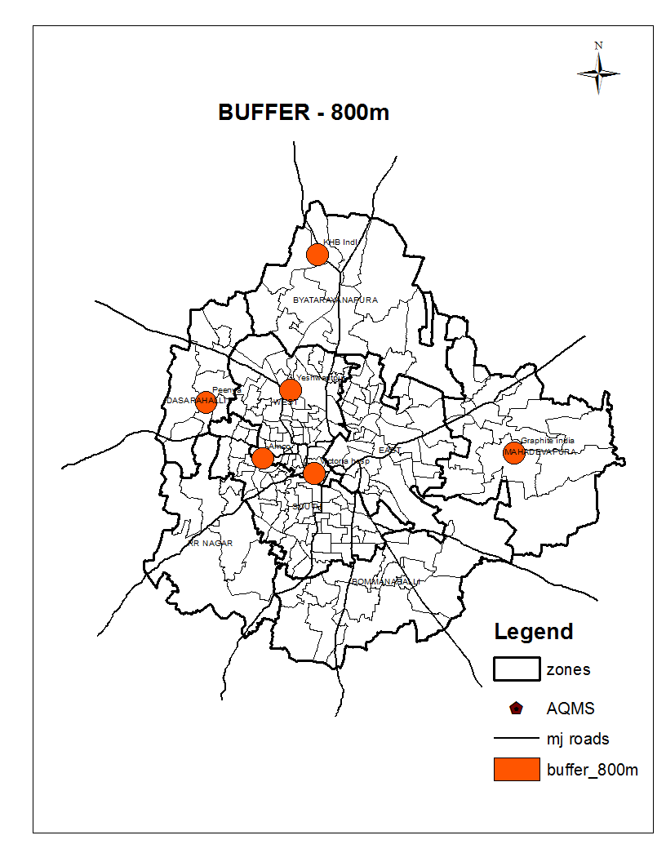

Fig. 1. Bangalore AQM Stations

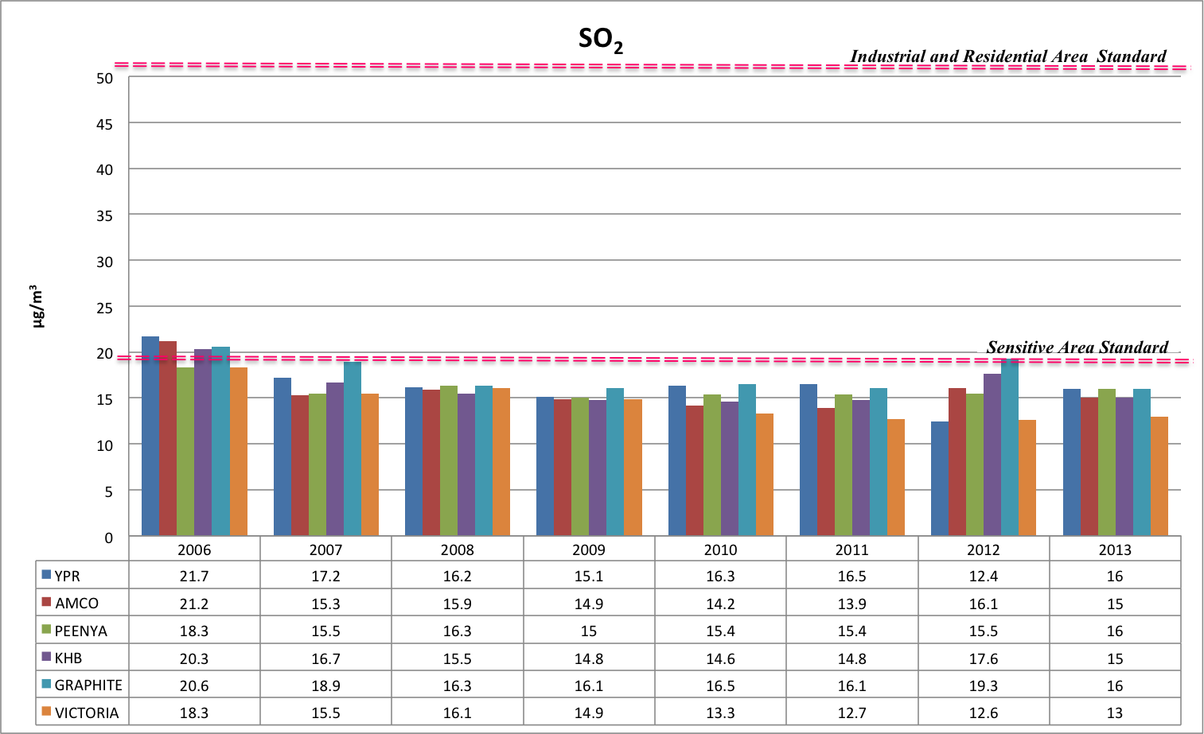

Fig. 2. SO₂ Levels at 6 sites in Bangalore, 2006-2013 (KSPCB Data)

Table 1. SO₂ Levels, EF and Air Pollution Classification, 2006-2013

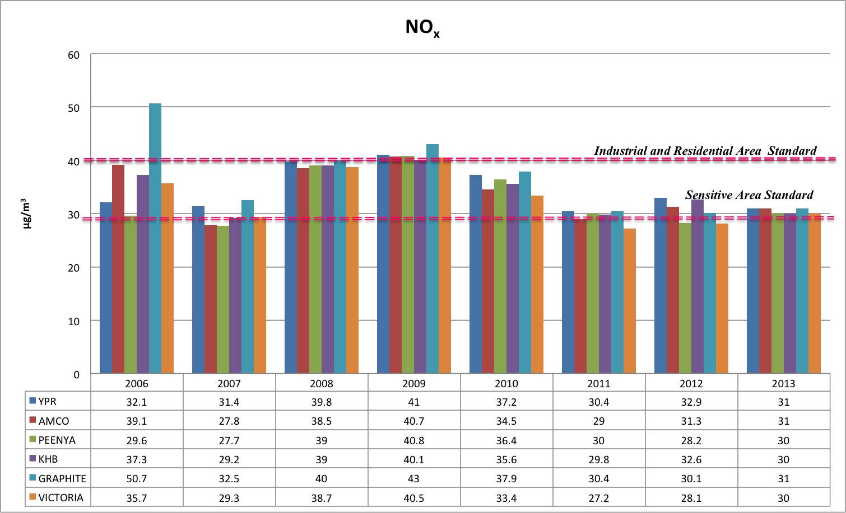

Fig. 3. NO_{x} Levels at 6 sites in Bangalore, 2006-2013 (KSPCB Data)

Table 2. NO_{x} Levels, EF and Air Pollution Classification, 2006-2013

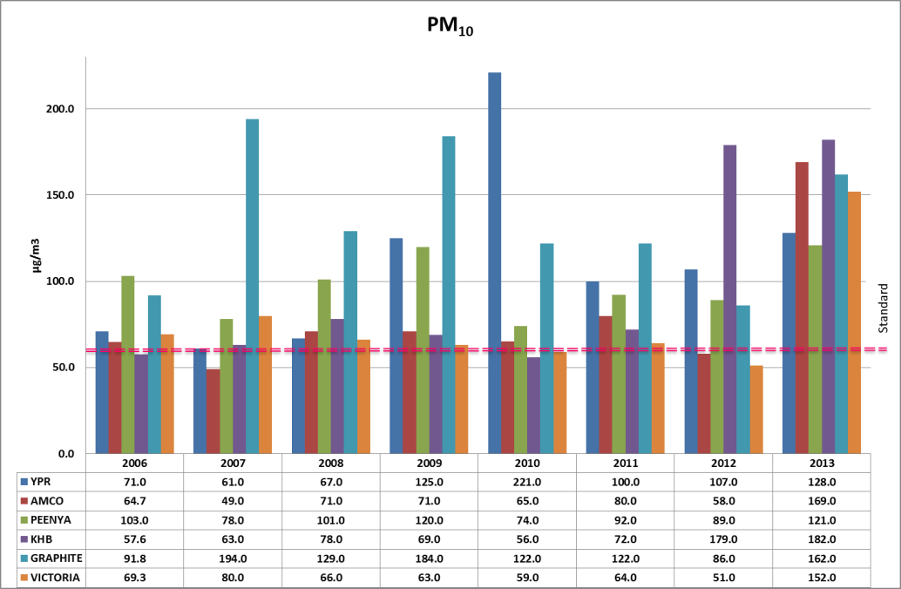

Fig. 4. PM₁₀ Levels at 6 sites in Bangalore, 2006-2013 (KSPCB Data)

Table 3. PM₁₀ Levels, EF and Air Pollution Classification, 2006-2013

