‘It is riskier’: preschoolers’ reasoning of risky situations

Zoi Nikiforidou
nikifoz@hope.ac.uk
Liverpool Hope University
Early Childhood

Risk is a fundamental component of well-being and is interconnected with all aspects of child development. The aim of this paper is to explore children’s (N=50) own perspectives and perceptions of risky situations. Semi-structured interviews and images as props were used. Children aged 5-6 years were asked to identify and discuss about five risky activities based on Sandseter’s (2007) categorisation of risky outdoor play. Responses indicated as risk causes situational aspects of the contexts, the age of the actor and natural hazards. The presence/absence of other/s seemed to have an impact on identifying risky vs riskier conditions and physical harm was recorded as a negative outcome. Such findings reveal that causal strength, probabilistic inference, future reasoning and linguistic capacity are connected with children’s reasoning of risk; in this direction, pedagogical activities on risk could be implemented from the ‘safe’ early childhood classroom.

Le risque est un composant fondamental du bien-être et est interconnecté avec tous les aspects du développement de l'enfant. Le but de cet article est d'explorer les propres perspectives et perceptions des enfants (N = 50) concernant situations à risque. Des entretiens semi-directifs et des images ont été utilisés. On a demandé aux enfants âgés de 5-6 ans de identifier et discuter cinque activités de risque sur la catégorisation des jeux avec risque proposée par Sandseter (2007). Les réponses des enfants ont indiqué que les causes du risque sont des aspects contextuels, l'âge de l'acteur et les risques naturels. La présence / absence d'autres / s semblent avoir un impact sur l'identification des conditions à risque ou à plus risque et le physique mal a été rapporté comme la conséquence négative. Ces résultats révèlent que l’ intensité de la causalité, l'inférence probabiliste, le raisonnement futur et la capacité linguistique sont connectés avec le raisonnement du risque des enfants; dans ce sens, des activités pédagogiques sur le risque pourraient être mises en œuvre à partir de la «sûre» classe préscolaire.

Risiko ist ein grundlegender Bestandteil des Wohlbefindens und ist mit allen Aspekten der Entwicklung des Kindes verbunden. Das Ziel dieser Arbeit ist es für Kinder (N = 50), eigene Sichtweisen und Wahrnehmungen von riskanten Situationen zu erkunden. Bilder von risiko-relevanten Situation wurde den Probanden gezeigt, gefolgt von semi-strukturierten Interviews. Kinder zwischen 5 und 6 Jahren wurden gebeten fünf risikoreiche Freiluftaktivitäten, basierend auf Sandseters (2007) Kategorisierung, zu identifizieren und darueber zu Auskunft zu geben. Antworten der Interviewanalyse zeigten ein Reihe von Gruenden die fuer Risikoverhalten verantwortlich sind, dies beinhaltet kontext-relevante situative Aspekte, das Alter der Person, und natuerliche Gefahrenzusammenhaenge. Das Vorhandensein beziehungsweise das Nichtvorhandensein von anderen Personen schien einen Einfluss auf die Identifizierung von moderaten und hohen Risiko Bedingungen zu haben; körperlicher Schaden wurde als negative Ergebnis bewertet. Solche Ergebnisse zeigen, dass kausale Kraft, probabilistische Inferenz, zukuenftige Denkweisen und sprachliche Fähigkeiten mit dem von Kindern gegenwaertig praktizierten risiko-bezogenen Denkweisen verbunden sind; in diese Richtung könnten pädagogischen Aktivitäten bezueglich der Foerderung des Risikobewusstseins aus dem "sicheren" frühen Kindheit-Klassenzimmer durchgeführt warden.

El riesgo es un componente fundamental del bienestar y está interconectado con todos los aspectos del desarrollo de los niños. El objetivo de este trabajo es explorar de los niños (N = 50) propias perspectivas y percepciones de las situaciones de riesgo. Se utilizaron semi-estructuradas entrevistas e imágenes como accesorios. Se pidió a los niños de 5-6 años para identificar y discutir alrededor de cinco actividades de riesgo basado en Sandseter (2007) categorización de los juegos de riesgo al aire libre. Las respuestas indicaron que el riesgo es causado por los aspectos situacionales de los contextos, la edad del actor y los riesgos naturales. La presencia / ausencia de otra gente parecía tener un impacto en la identificación de las condiciones de riesgo o de mayor riesgo y daño físico se registró como un resultado negativo. Tales resultados ponen de manifiesto que la fuerza causal, la inferencia probabilística, el razonamiento futuro y la capacidad lingüística están conectados con el razonamiento de riesgo de los niños; en este sentido, las actividades pedagógicas en el riesgo podrían implementarse desde el aula 'segura' infancia.

KEY WORDS: risk, reasoning, probabilistic thinking, causal knowledge, early childhood

INTRODUCTION
Risk and growth
Growth involves taking risks and moving out of the comfort and secure zone in order to gain novel experiences and perspectives (Dweck, 2000). Children enjoy challenges and driven by curiosity they learn to interact with their environment; physical, personal and socio-cultural. Through their mistakes or achievements, children learn to cope with uncertainty and novelty, they experiment with their boundaries, and become creative, independent and decisive (Tovey, 2007; Ball, 2002); they learn through their experiences to understand their capacities and limitations. Therefore, risk taking is significant in children’s wellbeing as it empowers their physical proneness and autonomy (Stephenson, 2003), their self-esteem, emotional vigilance and broader learning and development (Eichsteller & Holthoff, 2009).
Under the psychosocial development proposed by Erikson (1959), during the ages of 3 to 6, children go through the ‘initiative vs. guilt’ stage. During this stage children assert themselves more frequently and carry out risk-taking behaviours in order to test their self-limits. They begin to plan actions, make up games, initiate activities with others, and prepare for leadership and achievement roles. If given opportunities, children develop a sense of inventiveness, purpose and independence; they do not imitate only and feel confident in their capacity to lead others and make decisions. Conversely, if this tendency is suppressed, as might be the case in modern overly safety-regulated societies (Sandseter, 2010; Little 2008), children develop a sense of guilt about their needs and desires and remain followers, risk-averters, lacking in self-initiative. According to Bee and Boyd (2004), children during this stage face the complexities of planning a task and developing a sense of judgment through the emergence of autonomy. Thus, it is crucial for children, at this age, to undergo experiences in order to make mistakes, dare and discover.
Usually young children experience risks and challenges during play. Risky play is a crucial part of their development and evolutionary growth in the long run of lifespan (Sandseter and Kennair, 2011). In children’s risky play there should be a separation between the risks that foster learning and the hazards that can result in serious injury (Little&Wyner, 2008). Through risky play children try out new strategies and actions, they develop their personality traits, self-esteem, creativity, and aspirations, and familiarize themselves with failure, success, mistakes and satisfaction. They can develop their persistence and learning abilities (Dweck, 2000) and they experiment and construct awareness of themselves, their environments and others.

Two tiers: risk perception (cognition) and risk-taking (behaviour)
Children’s own understanding and reasoning of risk form a core part of risk perception (in terms of cognition) and risk-taking (in terms of action and behaviour). The differentiation between cognitively processing and confronting a risk and between either pursuing or avoiding a risk shows that there are two tiers of risk; a tier of thinking and understanding risk and another tier of actual involvement or avoidance of risk, no matter what the outcome is. This first tier can be objective, based on facts and rationality but also subjective, based on personal beliefs, attitudes and prior experiences. Theoretically and empirically risk perceptions and risky behaviours are strongly correlated; interestingly, both negatively and positively (Mills, Reyna, and Estrada, 2008). Thus, this correlation between thinking and doing is not always straightforward and directional and there are cases where, for instance, intuitions (Fishcbein, 1975) or heuristics and biases (Kahneman, Slovic, Tversky, 1982) come in place leading to doing and/without thinking.
Risk-taking, the second tier, is a multi-determined outcome of a variance of factors and Morrongiello and Lasenby-Lessard (2007) propose an integrated model. Based on empirical data, they support that at a micro-level, children’s risky choices and behaviors are influenced by individual characteristics, like temperament/personality, age, gender, cognitions, emotions, motivations and prior experiences; family/parent factors, like parent modeling and beliefs, parenting style, sibling effects and social-situational factors like peer interactions, media and immediate contextual demands. Indeed, young children get or do not get involved in risky situations for a number of reasons. These could be sensation-seeking and emotional arousal (Apter, 2007; Sandseter, 2010), or imitation and modelling of others such as peers and parents (Morrongiello & Dawber, 2004; Little 2010), or personality traits and the inherent tendency to explore and discover (Boyer, 2006), or parents’ expectations and reactions (Morrongiello, Zdzieborski & Normand, 2010), or on the whole, because of the subjective perception anyone develops about risk through experience (Adams, 2006).
For the purpose of this paper, it is children’s reasoning and cognition of risk (the first tier) that is explored. Risk cognition can be defined as the ability to understand and judge a risk by processing the available information, balancing the odds, predicting the uncertain outcomes and linking the current situation with future consequences. The cognitive mechanisms and processes of causal reasoning, future likelihood, statistical and probabilistic thinking underpin the mental representations of a risky or riskless situation. In this direction, Lavrysen, Bertnands, Leyssen, Smets, Vanderspikken and De Graef (2015) found that risk perception and risk competence can be facilitated, improved and measured within the preschool classroom through an experiential, learning environment. The current study investigates whether children at the age of 5 evidence such reasoning-based strategies while discussing about risky scenarios.

Risk: reasoning and thinking
A number of studies have shown that young children can employ statistical and probabilistic thinking. Preschoolers, at the age of 4, have been found to understand the likelihood of events by making predictions in probabilistic games with disks (Nikiforidou, Z., Pange, J., Chadjipadelis, 2013) and with cards (Nikiforidou & Pange, 2010) that are based on the most probable outcome. In another study, carried out by Girotto & Gonzalez (2008), it was found that young children correctly revise their decisions when given new sets of information about single, non-repeatable events; they make use of additional information and reveal a capacity to proceed posterior probabilities. Also, it is supported that children at the age of 4 have good intuitive understanding of probability and expected value (EV) (see review in Schlottmann & Wilkening, 2011). Kushnir and Gopnik (2005) found in their study that children at the ages of 4-6 apply probabilistic evidence, the frequency of co-occurrence, in order to elaborate on causal relationships. Children used probabilistic information to make judgments not just on causal structure (Did X cause Y?) but also on causal strength (How strongly did X cause Y?). Denison and Xu (2014) argue that even infants, younger than 12 months, show sensitivity to probabilities based on proportions in single random draws. Through 4 experiments they found that infants use prediction and action computations, aspects that highlight the origins of probabilistic reasoning.
In addition, 3-4 year olds have been found to be able to make statistical inferences while identifying the future preference of an agent based on prior information (Kushnir, Xu & Wsellman, 2010). In another study, Buchsbaum, Gopnik, Griffiths and Shafto (2011) recorded that children are sensitive to statistical information and can balance prior knowledge with new evidence in order to formulate causal hypotheses. Conditional probabilities are also implemented by young children in a range of domains like visual perception (Fiser and Aslin, 2002), word meaning (Xu and Tenembaum, 2007), action processing and causal inference (Gopnik and Schulz, 2007).
Furthermore, between the ages 3 to 5, researchers propose there is a developmental change related to temporal thinking, the ability to set aside the current state of affairs and mentally re-locate to a different time in past or future (McCormack & Hanley, 2011; Suddendorf, 2010; Russell, Alexis & Clayton, 2009). Specifically, children have been found able to linguistically code the temporal locations of events with respect to various points in time and they use the terms ‘before’, ‘after’ (Weist, 1989) in their speech. Another study by Lagattuta & Sayfan (2011) showed that children at the age of 4-5 can order events according to future likelihood and use the verbal labels of ‘might, probably, definitely will happen’ with accuracy. As such, children have the cognitive and perceptual capacities to use current data in order to verbalize and infer for unknown future consequences that may lead to either a success or a failure.
Overall, research supports that children at the age of 4 can develop their probabilistic/statistic thinking, temporal reasoning and linguistic references to future events. In this direction, the aim of this study is to explore how children’s personal understandings and oral justifications link to particular risky vs riskier situations. The current study investigates children’s reasoning of risk within connotations and risk scenarios. Through paired interviews and the use of visual stimuli do children identify specific causes in explaining why a situation is risky? Do children view a difference in the severity of risk based on the presence of a sole actor vs the presence of an actor and other figures? With the use of images, can children see the probable future consequences? Do they use linguistic indications to express this?

METHODOLOGY
Research approaches to children and risk
Children’s risk awareness and understanding are usually examined through actual rate methodologies, like observations and interviews; however, there are studies based on experimental, empirical methods (Boyer, 2006). The purpose for this later methodological approach is to eliminate any sort of external or explicit variables that may intervene on children’s cognitive thinking and reasoning. Furthermore, there are tasks based on choice methodology; in these tasks children are asked to select the most advantageous option amongst two or more sets or children are observed on behaviors of their choice. In addition, there are tasks based on choice and judgment methodology, where children are asked to justify and reason their choices. In this case, children may be asked to choose between a safe (riskless) option and a single gamble (risky) option (i.e. Levin & Hart 2003) or they may be asked to select between two risky options and identify the less risky (i.e. Garon and Moore, 2004).

Design, methods and tools
The study took place in two nurseries in a rural city of North-Western Greece. Participants (N=50) were aged 5-6 years, both girls and boys. After their parents’ and their own consent were given, children were interviewed and audio recorded in pairs, in a separate room within their setting.
Parents and children were informed about the study and their right to withdraw at any stage. Ethical considerations were taken into account (BERA, 2011) and children were approached with care. During their participation a familiar to them staff member was also present. Children who were happy to participate filled in a child-friendly consent form with smiley faces both before and at the end of the task. Participation in pairs aimed at making children feel comfortable and actively involved in the discussions about risk as co-researchers (Broström, 2015).
The current study was empirical based on semi-structured interviews. The tools used were; pairs of images and four questions per test. A choice and judgment methodology was implemented and children engaged with scenarios initiated by visual inputs. Images were used as prompts (Margas-Malet, M. et al., 2010) that provided stimulation for discussion. The themes of the visual stimuli were based on Sandseter’s (2007) categorisation of risky outdoor play. Precisely, 5 pairs of images were used, presenting scenes related to high speed (test 1); getting lost (test 2); dangerous elements (test 3); dangerous tools (test 4); great heights (test 5). Sandseter (2007) developed this categorization of risky play, including a sixth category ‘rough-and-tumble’, through observations and semi-structured interviews with practitioners and children aged 3-5 years in Norway. Under these lines, risky play consists of ‘thrilling and exciting forms of play that involve a risk of physical injury’ (Sandseter and Kennair, 2011:258). In this study, the 6th category of ‘rough-and-tumble’ was not used because this term does not exist explicitly in the greek language; as such children would find difficulty in defining and linguistically explaining the situational aspects of this type of play. Nonetheless, in practice and reality rough-and-tumble play is really common in Greece.
As soon as children were at ease with the researcher they were shown 5 pairs of black and white images, sized 10x7cm each. Each pair represented two conditions; in Condition 1 (riskier) the actor was illustrated alone and in Condition 2 (risky) the actor was illustrated with the presence of an adult or peers (figure 1). The Conditions were counterbalanced and each pair of images was presented at once. The images were pre-trialed in advance with 5 children and 5 adults, so as to ensure clarity and parity in terms of the broader scene of each pair. Representations were found to be accurate and the images were downloaded from the Internet through open access. The main actor and the figures in the images were alternatively males and females in order to avoid gender bias.

Figure 1: Example of the methodological tools
Test | Action | Pairs of images (alone vs with the presence of other/s)
1 | high speed | 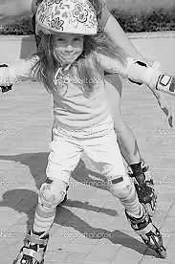  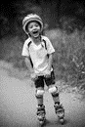
4 | dangerous tools | 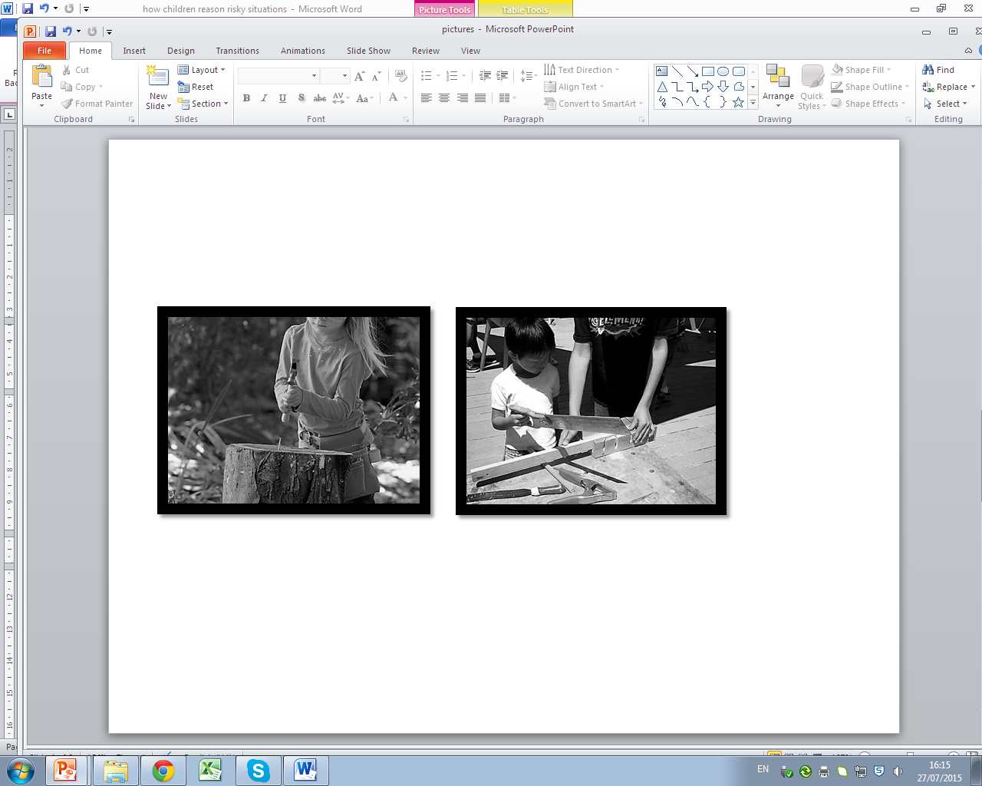
5 | great heights | 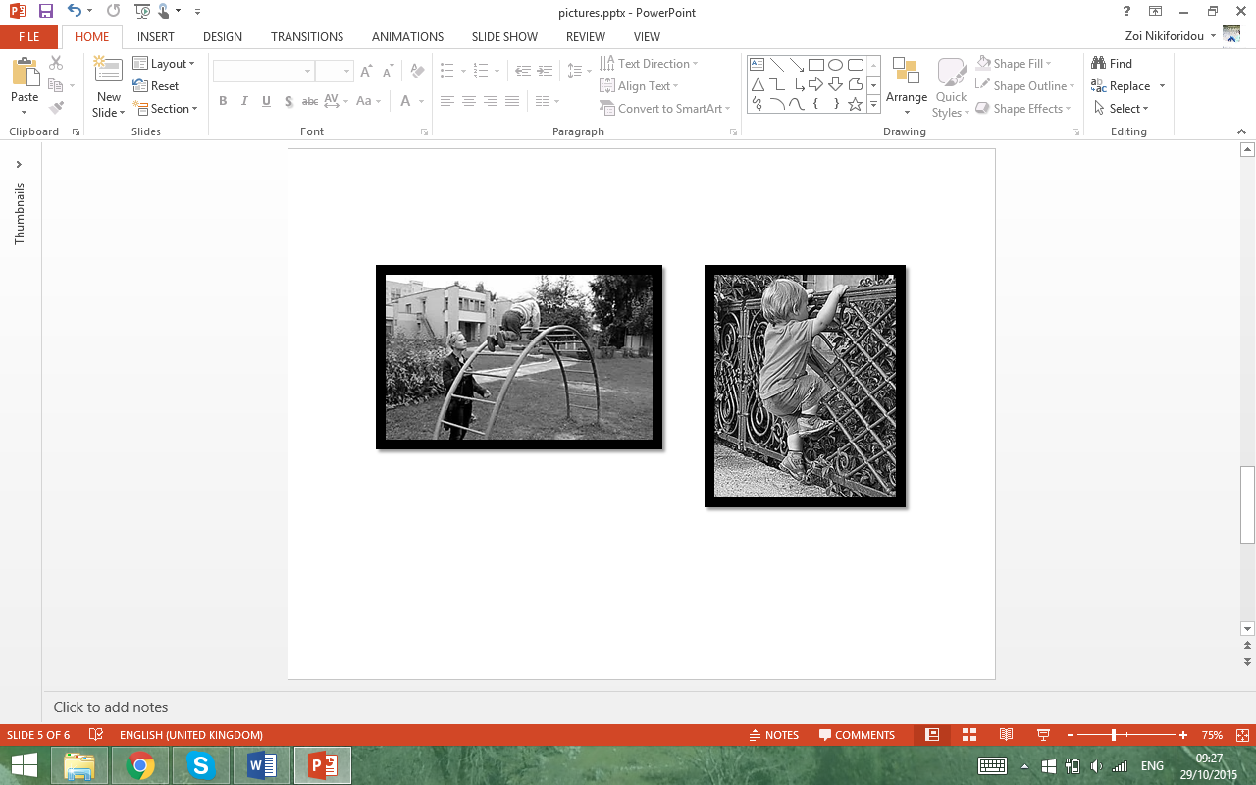

After an introductory brief chat, children were encouraged to describe what they see and to encounter whether and why each situation is risky by mentioning the possible reasons and consequences. At a second level, children were encouraged to compare the pairs of images in suggesting and explaining which, if any, situation is riskier than the other; this was a choice and judgment paradigm based on two risky options. The four questions used were; q1: what do you see in these pictures?, q2: do you find this risky/dangerous and why? (cause), q3: do you find any of the two pictures more risky and why? (causal strength), q4: what can happen to this child? (consequence).
Through the whole task children were encouraged to discuss and engage with discourses on risk based on their own perspectives and understandings. Children had ownership of the dialogue and the intention was to have conversation with them instead of telling them what is risky and what is riskier (Smith, 2014). Children’s opinions were recorded and the semi-structured interview was based on open-ended questions allowing time and space to elaborate on the given justifications and discourses. As soon as the interview ended children would join their peers and routine activities. Their responses were used for further analysis under the principles of thematic analysis and a reflexive semantic approach (Braun, and Clarke, 2006).

FINDINGS
The key findings are summarised in Figure 2 and the themes that emerged from children’s discourses are identified with bullet points. Preschoolers recognised the 5 risky scenarios as ‘risky’ by drawing upon aspects of the situational context, age and natural hazards as causes and by considering harm and injuries as consequences. They also identified riskier vs risky situations (causal strength) and used related linguistic connotations: future-past tense and probabilistic language.

Figure 2: Key themes from preschoolers’ reasoning of risky situations

Causes of risky situations: causal reasoning, probabilistic/statistical thinking
All 50 children identified the predefined categories of the selected risky play situations (Sandseter, 2007). Namely, they referred to aspects of the situational context as causes of risk and accident: high speed (test 1); getting lost (test 2); dangerous elements (test 3); dangerous tools (test 4); great heights (test 5).
In addition, age was found to be, according to the participants, a factor of rendering a situation risky. In Test 1, 48 children considered age in combination to high speed as risky; ‘he is a baby, he doesn’t know how to do it’ (P₃). In Test 2, 19 children referred to age in relation to getting lost. In each of tests 3 and 4, 36 children mentioned each time age and in test 5, 46 children stated age to be the cause of falling down from great height; for instance, ‘He is a baby (P₂₂)’, ‘Babies don’t climb fences (P₆)’.
Finally natural hazards were named in some cases as causes of risk. In test 2, 31 children identified alerts related to nature; ‘it will become night’ (P₂₇), ‘there might be a snake’ (P₁₅), ‘she might step on a branch’ (P₃₀); ‘she will meet a fox’ (P₁₃). In Test 3, natural hazards occurred again as causes of danger ‘A sharp will come (P₁)’, ‘Waves will turn them over (P₄)’, in 23 instances.

Risky vs riskier: causal strength
The presence/absence of other/s was mentioned in 76% of children’s responses as a factor of having an impact on the severity of riskiness. Children indicated that the presence of someone else, either an adult or a peer, makes the risky context less dangerous. In particular, only in 12 utterances children did not consider the presence of someone else as a ‘safety net’ within the given risky situations-tests.
In Test 1, in comparing the 2 Conditions (riskier vs risky) 44 children identified that the presence of an adult (condition 2) made the situation less risky; ‘she has help, even if she falls (P₃₉)’; ‘her mummy will help her’ (P₃₃). In Test 2, nearly all children defined condition 1 (when the actor was alone) as riskier. 45 responses indicated the situation with the family (condition 2) less risky and safer and acknowledged a sense of protection; ‘his parents will take care of him’ (P₂₄); ‘they are together’ (P₃). In Test 3, 21 children referred to the presence of others as less risky, ‘they will help each other’ (P₁₂). In Test 4, only 26 children referred to the absence of another person as riskier in using a dangerous tool. Finally, in Test 5 children explained that height makes both situations (conditions 1 and 2) dangerous and 29 of them considered the presence of the mother (condition 2) as a ‘safety’ figure; ‘his mother watches him (P₁₆)’, ‘will help him if he falls (P₁₇)’.

Consequences of risky situation: future reasoning, probabilistic thinking
Children recognised as possible consequences of the risky scenarios aspects of harm, injury and physical pain. In test 1, 39 children justified the chosen activities-scenarios as risky because of the chances to ‘fall down (P₂₅), get injured (P₁₂), go to the hospital (P₃₁), bleed (P₁₉)’. In Test 2, 42 children recognised the possibility of the actor/s to ‘get hurt’. In Test 3, 29 preschoolers justified the riskiness of the situation with references to ‘falling in the water (P₄₁)’, ‘getting hurt (P₉)’. In terms of Test 4, children predicted injuries and physical harm as a possible consequence in both conditions (with and without the presence of someone else); ‘can bang her finger (P₇)’, ‘can bleed (P₉)’, ‘can cut his hand (P₁₈)’. Again, in test 5 the possible effects of this risky situation were linked to injuries and pain in 39 responses.

Linguistic connotations
Children were found to have the linguistic ability to express reason, cause and consequence by using ‘appropriate’ connotations. Through the semi-structured interviews, children showed the capacity to infer and linguistically express the consequences of an event by using future tense; ‘… will fall (P₃₃)’, ‘… will get hurt (P₁₇)’; out of 250 utterances in total, children used future tense by 81.2%. They also referred to words that indicate temporal relations: ‘before, after, when, as’ in a sum of 750 utterances by 85.6%. In addition, children used terms aligned to probabilistic language by 68.4%; ‘maybe… (P₂₆)’, ‘it is likely… (P₄₁)’, ‘the child may…’ (P₂₂).

DISCUSSION
Children’s risk reasoning
Overall, children showed awareness of identifying a situation as risky, accordingly to the categorisation of risky play developed by Sandseter (2007). This supports the idea that these risky situations can be understood and cognitively processed by children at the age of 5, namely; high speed, disappear/get lost, dangerous elements, dangerous tools, great heights. With the exception of ‘rough-and-tumble’ play that was not included, preschoolers were found able to provide justifications and make links between causes and effects for each risky activity. Preschoolers showed appraisal of the risky situation by expressing risk competence (Lavrysen et al, 2015).
In providing possible causes, apart from the situational characteristics, preschoolers considered natural hazards and age as a ‘risk’ indicator, by implying that the younger one is, the more prone to accidents she/he is; ‘he doesn’t know, he is a baby (P₁₉)’. They used this cause in more than one cases implying causal knowledge that is generalizable (Kushnir and Gopnik, 2005; Buchsbaum et al, 2011). Children came up with justifications of cause and consequence by recognizing the results of the actors’ actions in correlation to the reasons why these actions are ‘risky’. The contextualization of risk within a cause and effect structure is an important factor in framing risk as a mental state. Moreover, children showed elements of probabilistic thinking (Nikiforidou et al, 2013; Schlottmann & Wilkening, 2011; Girotto & Gonzalez, 2008) by foreseeing the possible dangers and by justifying the probable outcomes. Such findings support the notion that children possess intuitive accounts of probabilities (Fishbein, 1975), as such notions are not formally ‘taught’ at this age, and can make predictions of uncertain events based on current information.
In addition, children used future tense in their responses and referred to phrases like ‘might’, ‘maybe’, ‘before’, ‘then’ that indicated their understanding of likelihood of events and temporal location of events (Weist, 1989; Lagattuta & Sayfan, 2011). They linguistically associated the current state of the images with the potential outcomes and dangers. While predicting and inferring possible consequences on what might happen in the future (Suddendorf, 2010; Russell et al, 2009), children identified injuries and harm as a source of risk. In each test, children used the available information and considered what might happen in the near and more extended future; this adds to the field of children’s temporal thinking (McCormack & Hanley, 2011) with regards to future events. At the age of 4-5 children can reason and estimate hazards through causal reasoning, probabilistic thinking, statistical inferring and future thinking (Kusnir et al, 2010; Gopnik and Schulz, 2007; Buchsbaum et al, 2011; McCormack & Hanley, 2011; Denison and Xu, 2014).
Furthermore, the impact of the presence or absence of another person in the scene was evident in children’s reasoning. While comparing identical situations, children claimed that the existence of other figures would be a source of help, rescue or comfort to the actor in case of an emergency. In spite of having a pair of the same ‘risky’ contexts in each test, children acknowledged that a sole actor is in a more ‘dangerous’ position than when with others. This differentiation in responses indicates children’s understanding of causal strength (Kushnir and Gopnik, 2005). Preschoolers verified that being alone is riskier than being with others in a hazardous situation.

Methodological and future implications
From a methodological point of view, children were asked to make risk-based judgements and choose among a risky and a riskier situation (Boyer, 2006). The visual representations were supportive in encouraging discussions around the provided context; these prompts are used more and more often in research with children nowadays as an interactive research tool (Margas-Malet, M. et al., 2010). The images provided a common context for each pair of participants to facilitate discussion and conversation on their own perspectives and understandings (Smith, 2014) of whether, why and how each illustrated situation is risky. This visual-discursive design allows flexibility and can be effective in encouraging children to express their views and understandings of various themes and concepts.
Even though risk-taking and risk-avoidance are influenced by a variety of combinatory factors within children’s micro level (Morrongiello and Lasenby-Lessard, 2007), their personal understanding and individual cognition of risk form the basis of encountering whether a condition is riskless, risky or riskier. This subjective construct of risk (Adams, 2006) varies and starts to get shaped through very early experiences and realities. The current study supports that children at the age of 5 have the cognitive capacity to reason and justify risks, especially in situations of risky play. In this direction, further research is needed to investigate how children act and behave in similar risky situations; what is the correlation between risk perception and risk taking (Mills et al, 2008) in young children and infants.
Moreover, an extension of the current scenarios considering emotional, personal, environmental, social, moral risks could be taken into account. Risk is not only physical; thus, it can be related to diverse issues that matter to young children. For example, the risk of not recycling, the risk of eating excessively sweets, the risk of not sharing with peers and so on. It is proposed that a risky situation can be approached with young children through linguistic connotations, the exploration of causes and consequences and the consideration of causal strength. For this purpose, implications in designing and embedding risk education and risk literacy (Nikiforidou et al, 2012) amongst early childhood practices and pedagogies is a field of further investigation (Lavrysen et al, 2015). In fact, Tovey (2007) argues that safe environments are not those that ensure safety from all possible harm but those that instead offer ‘safety to explore, experiment, try things out and … take risks’ (102). Such safe environments could be the classrooms where children can be given opportunities to manage their own risks and ideas.
In conclusion, children need risk-taking experiences as part of their development and well-being. They need to resolve the initiative vs guilt conflict (Erikson, 1959) by experiencing responsibility and independence in their decisions and actions. At the age of 5, children indicated connections between causal knowledge, probabilistic and verbal responses and future likelihood in risky scenarios. These cognitive interwoven mechanisms enable children to verbalize their representations of risk by drawing upon causes-effects within particular situational contexts. Preschoolers, anyway, experience risk and challenge; the proposal is that, given their capacities and cognition, risk-awareness could be promoted through more structured and pedagogical ways from early childhood.

REFERENCES
Adams, J. 2006. Risk. Taylor & Francis: Routledge.
Ball, D. J. 2002. Playgrounds - risks, benefits and choices. HSE Contract Research Report 426/2002. Sudbury: HSE Books
Bee, H. and Boyd, D. 2004. The Developing Child. Boston: Pearson.
British Educational Research Association (BERA), 2011. Ethical guidelines for educational research. London: BERA.
Boyer, T. 2006. The development of risk-taking: A multi-perspective review, Developmental Review, 26 (3): 291-345.
Braun V, Clarke V. 2006. Using thematic analysis in psychology. Qualitative Research in Psychology, 3(2): 77–101.
Broström, S. 2012. Children's participation in research, International Journal of Early Years Education, 20:3, 257-269, DOI: 10.1080/09669760.2012.715407
Buchsbaum D., Gopnik A., Griffiths T. L., Shafto P. (2011). Children's imitation of causal action sequences is influenced by statistical and pedagogical evidence. Cognition, 120: 331-340.
Denison S., Xu F. 2014. The origins of probabilistic inference in human infants. Cognition, 130: 335–347
Dweck, C. 2000. Self-Theories: Their Role in Motivation, Personality, and Development. Philadelphia: Psychology Press.
Eichsteller, G. & Holthoff, S. 2009. Risk Competence - Towards a Pedagogic Conceptualization of Risk. Children Webmag, 9.
Erikson, E. 1959. Identity and the Life Cycle. New York: International Universities Press.
Fargas, M., McSherry, D., Larkin, E., Robinson, C. 2010. Research with children: Methodological issues and Innovative techniques. Journal of Early Childhood Research, 8(2): 175-192.
Fargas-Malet, M. et al., 2010. Research with children: methodological issues and innovative techniques. Journal of Early Childhood Research, 8(2): 175 -192.
Fischbein, E. 1975. The intuitive sources of probabilistic thinking in children. Dordrecht, The Netherlands: Reidel.
Fiser, F., & Aslin, R. 2002. Statistical learning of new visual feature combinations by infants. Proceedings of the National Academy of Sciences, 99: 15822–15826.
Garon, N., Moore, C. 2004. Complex decision-making in early childhood. Brain and Cognition, 55: 158–170.
Girotto, V. & Gonzalez, M. 2008. Children’s understanding of posterior probability. Cognition, 106: 325-344.
Gopnik, A., & Schulz, L. 2007. Causal learning: Psychology, philosophy, computation. New York: Oxford University Press.
Kahneman, D., Slovic, P. and Tversky, A. 1982. Judgment under uncertainty: Heuristics and biases. Cambridge: Cambridge University Press
Kushnir, T., and Gopnik, A. 2005. Young children infer causal strength from probabilities and interventions. Psychological Science, 16(9): 678–683.
Kushnir, T., Xu, F., & Wellman, H. M. 2010. Young children use statistical sampling to infer the preferences of other people. Psychological Science, 21: 1134-1140.
Lagattuta, K.H., & Sayfan, L. 2011. Developmental changes in children’s understanding of future likelihood and uncertainty. Cognitive Development: Special Issue on Future Episodic Thinking, 26: 315-330.
Lavrysen, A., Bertrands, E., Leyssen, L., Smets, L., Vanderspikken, A., & De Graef, P. (2015). Risky-play at school. Facilitating risk perception and competence in young children. European Early Childhood Education Research Journal: 1-17 doi:10.1080/1350293X.2015.1102412
Levin I., Hart S. 2003. Risk preferences in young children: early evidence of individual differences in reaction to potential gains and losses. Journal of Behavioral Decision Making 16: 397–413
Little, H. 2008. Outdoor play. Does avoiding the risks reduce the benefits? Australian Journal of Early Childhood, 33(2): 33-40.
Little, H., & Wyver, S. 2008. Outdoor play – does avoiding the risks reduce the benefits? Australian Journal of Early Childhood, 33(2): 33-40
Little, H. 2010. Relationship between parents’ beliefs and their responses to children’s risk-taking behaviour during outdoor play. Journal of Early Childhood Research, 8(3): 315–330.
McCormack T., Hanley M. 2011. Children's reasoning about the temporal order of past and future events. Cognitive Development 26: 299–314
Mills B, Reyna VF, Estrada S. 2008. Explaining contradictory relations between risk perception and risk taking. Psychological Science, 19(5):429–433
Morrongiello B A, Zdzieborski D, Normand J. 2010. Understanding gender differences in childrens’ risk taking and injury: A comparison of mothers’ and fathers’ reactions to sons and daughters misbehaving in ways that lead to injury. Journal of Applied Developmental Psychology 31:322–329.
Morrongiello BA, Lasenby-Lessard J. 2007. Psychological determinants of risk taking by children: An integrative model and implications for interventions. Injury Prevention 13(1): 20–25.
Morrongiello, B.A. & Dawber, T. 2004. Identifying factors that relate to children’s risk taking decisions. Canadian Journal of Behavioural Science, 36(4): 255-266.
Nikiforidou, Z. and Pange, J. 2010. Τhe notions of chance and probabilities in preschoolers. Early Childhood Education Journal, 38 (4): 305-311.
Nikiforidou, Z., Pange, J., and Chadjipadelis, T. 2012. Risk literacy in early childhood education under a lifelong perspective. Procedia - Social and Behavioral Sciences, 46: 4830- 4833.
Nikiforidou, Z., Pange, J., Chadjipadelis, T. 2013. Intuitive and informal knowledge in preschoolers’ development of probabilistic thinking. International Journal of Early Childhood 45 (3): 347-357
Russell, J., Alexis, D. & Clayton, N. S. 2009. Episodic future thinking in 3- to 5-year old children: The ability to thinking of what will be needed from a different point of view. Cognition, 114: 56–71.
Sandseter, E. and Kennair, L. 2011. Children’s risky play from an evolutionary perspective: the anti-phobic effects of thrilling experiences. Evolutionary Psychology, 9: 257–284
Sandseter, E. B. H. 2007. Categorizing risky play: How can we identify risk-taking in children’s play? European Early Childhood Education Research Journal, 15: 237-252.
Schlottmann, A. & Wilkening, F. 2011. Judgment and decision-making in young children. In Judgement and Decision-making as a skill: Learning, Development, Evolution, ed. Dhami, MK., Schlottmann A. & Waldmann MR., 55-83. Cambridge University Press.
Smith, K. 2011. Discourses of childhood safety: what do children say? European Early Childhood Education Research Journal, 22 (4): 525-537
Stephenson, A. 2003. Physical risk-taking: Dangerous or endangered? Early Years, 23(1): 35-43.
Suddendorf, T. 2010. Linking yesterday and tomorrow: Preschoolers’ ability to report temporally displaced events. British Journal of Developmental Psychology, 28: 491–498
Tovey, H. 2007. Playing outdoors: Spaces and places, risk and challenge. Maidenhead: Open University Press.
Weist, R. M. 1989. Time concepts in language and thought: Filling the Piagetian void from two to five years. In Time and human cognition: A life-span perspective, ed. Levin, I & Zakay, D., 63–118. Amsterdam: Elsevier.
Xu, F., & Tenenbaum, J. B. 2007. Word learning as Bayesian inference. Psychological Review, 114(2): 245–272

